MEDSYS
Information System

User Manager Program
User's Manual



MEDSYS
Kaiser dela Cruz Consulting Incorporated
July 30, 2026

Copyright©

ALL RIGHTS RESERVED

No part of this document may be reproduced through photocopying or in any means, stored into a retrieval system, and transmitted in any form without the express written permission of Kaiser dela Cruz Consulting Incorporated.
Permission is hereby granted to Medsys Information System to copy and distribute this document in any of the above means provided this is for its exclusive on site use.
Although every precaution has been taken in the preparation of this manual, the company assumes no responsibility for errors or omissions. Neither is any liability assumed for any damages resulting from the use of the information contained here.

Table of Contents

Introduction 4
Overview 4
Objectives 5
Features 5

GETting Started 6
How to Start the Program? 6
How to Change Password? 7
How to SEnd the Program ? 8
Program Operation 9
User’s Account 9
Adding of User’s Account 9
Editing of User’s Account 12
Viewing of User’s Account 12
Deactivating of User’s Account 13
Department 16
Adding of Department 16
Editing of Department 18
User’s Rights 19
Adding of User’s Rights 19
Editing of User’s Rights 21
Index 22

Introduction

Overview

The User Manager Program is a utility program of Visual Medsys for making password maintenance accounts easier. This program helps eliminate the hassle of having so many different passwords for different modules, as it provides one click to select the assigned module(s) per user with privileges or restrictions within the assigned module.
All program users need to register their employee number into the EDP department to enter their own password to have an access to their respective MEDSYS program. Data such as employee number, first name, last name, middle initial, birth date, department and position are needed to enter into the program. These data are required so that whenever a transaction occurs, the user will be held responsible for all his actions.

Objectives
- To help eliminate the hassle of having so many different passwords for different modules, as it provides one click assignment of modules and rights / restrictions.

Features
- User-Accessibility Control – Each user has its own password and rights. He can only use the program intended for him.
- On-Line Help Guide – By just pressing F1, the online help will be displayed containing topics about the program transactions. Users can easily learn the flow of a particular transaction because of the step-by-step procedure written into it.
- Password Administrator – is given privileges to add and remove user accounts as well as to edit the user accounts (by changing the profile or the password without knowledge of the user’s current password).
- Data-entry restriction - Warning messages are flashed for possible invalid entries. This ensures all data inputted would be made useful for any transaction that may occur.
- Password-protected - The use of password is necessary to restrict unauthorized access. Thus the program only accepts passwords which are registered into it. This feature ensures the confidentiality and integrity of data entered in the program.
- Auto-report generation - The program is capable of generating reports and can be readily printed
- User-friendly - The program user is guided by instructions in doing the next step providing an easy-use to process transactions. Tool-tips are also incorporated to give users an idea of what a particular button does.

Getting Started

How to Start the Program
1 Click on  User Manager program executable file icon located in your computer desktop.
2 The Login window will display asking you to type your employee number and password for security purposes.
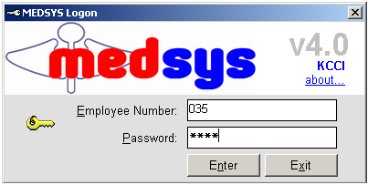
Figure 1: Login Window
3 If the program has validated your employee number and password, the Cashier Setting Window will be displayed. This window serves as the data entry for principal O.R., collection date, remittance date and shift.

Changing of User’s Password
It is advisable to change your password frequently for security reasons. To change your current password, follow these steps.
1 From the Login window, type your employee number and then press <Enter>.

2 Under the password entry, press <F12> Pressing this function key will invoke the Change Password window.
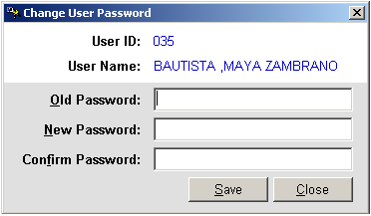
Change Password Window
3 Under the Change Password Window, type the following data.
Old Password – Type your existing password
New Password – Type your new password not exceeding to 15 characters
Confirm Password – Retype your new password to confirm and then press <Enter> or you can click the Save button.

How to End the Program
It is important for users to close the program when they are done to end-up their session. Other users might use the open program using the same password.
To close the program:

1 Click on at the upper right corner of the screen or
2 Click File > Exit.

Program Operation

User’s Account

Adding of User’s Account

This option is used to register a new user to gain access to MEDSYS programs.

1 Click the Add/Edit User toolbar button to open its window (refer to figure below).

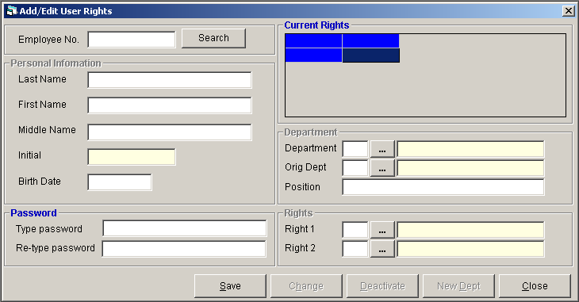
Figure 2: User's Account Entry Window

2 Enter the following data.
Employee No. - Type the user’s employee number and then press <Enter>. Click the Change button afterwards.
Under Personal Information
Last Name - Type the employee's last name and the press <Enter>.
First Name - Type the employee's first name and then press <Enter>.
Middle Name - Type the employee's middle name and then press <Enter>.
Initial - This will be automatically displayed by the program.
Birth Date - Type the employee's birth date following the format mm/dd where mm is the month and dd is the year

Under Password - The employee should type a password not exceeding to 15 characters. He should re-type it to confirm the new password.
Under Department
Department - Type the employee's department. You can press <Enter> if it is still blank to display the complete list of departments. Just double-click on the department to select.

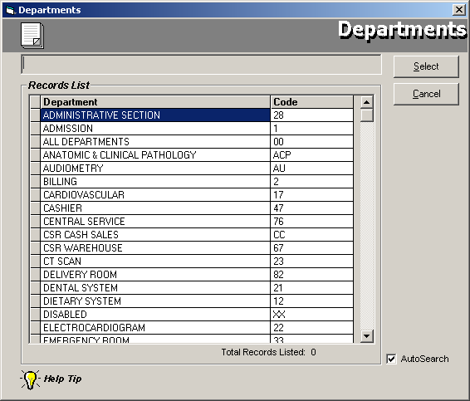
Figure 3: List of Departments

Orig Dept - This is similar with the department entered. This is intended for nurse-users who belong to one original department which is Nursing Station but working in a different ward. You can press <Enter> if it is still blank to display the complete list of departments. Just double-click on the department to select.
Position - Type the employee's position.
Under Rights
Right 1 - Type the employee's first right. You can press <Enter> if it is still blank to display the complete list of rights. Just double-click on the department to select.

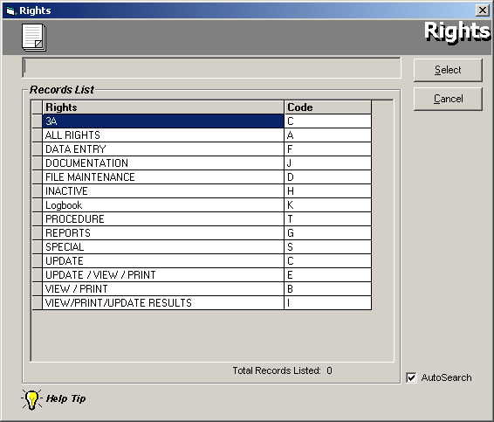
Figure 4: List of Rights
Right 2 - Type the employee's second right. You can press <Enter> if it is still blank to display the complete list of rights. Just double-click on the department to select.

3 Click the Save button when done.

Editing of User’s Account

Use this option to change user’s password and other important data.

1 Click the Add/Edit User toolbar button to open its window (refer to figure 3).

2 Type the employee’s number and then press <Enter>. Or type the employee’s last name and then press <Enter>. A window displaying the matched last names will appear. Double-click on the employee name to select. Click the Change button afterwards.

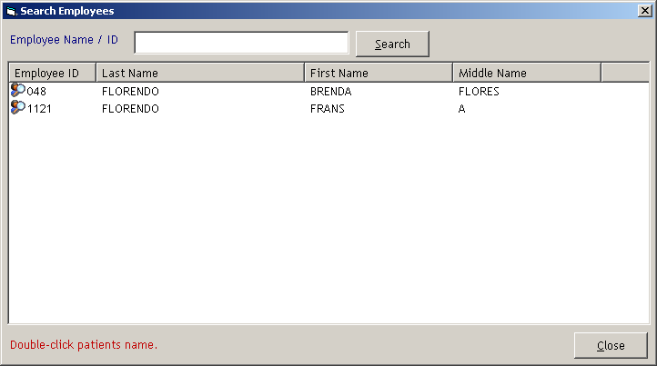
Figure 5: List of Searched Users

3 You can now edit the employee’s information. Click the Save button to update the changes entered.

Viewing of User’s Account

This helps you view user’s accounts in general, by department, and individual.

1 Click the All Passwords toolbar button to open its window (refer to figure below).

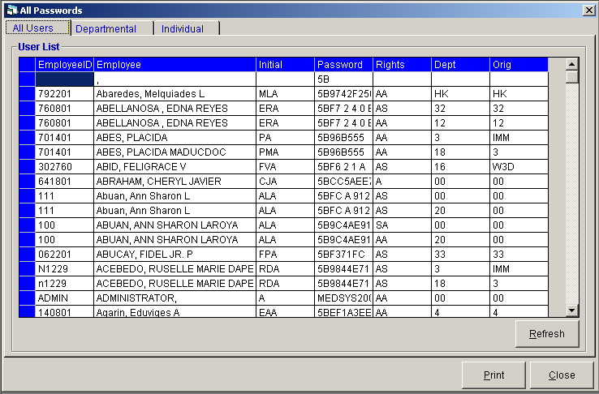
Figure 6: All User's Password Window

2 To view all users' account, click the All Users tab (default tab).
To view users' account by department, click the Departmental tab. Under Department, click the drop-down arrow to display the list of all departments. Click the department you want to view. All users under the selected department will be displayed.
To view an individual account, click the Individual tab. Under employee, type the employee number in the code textbox and then press <Enter>. Or you can type the user’s last name and then press <Enter>. A window displaying the matched last names will appear (refer to figure 6). Double-click on the employee name to view his account.

3 Click the Close button to close the window.

Deactivating of User’s Account

For users not to gain access to a specific department, the EDP can deactivate one’s account. This feature is necessary for security purposes.

1 Click the Add/Edit User toolbar button to open its window (refer to figure 3).

2 Type the employee number and then press <Enter>.

3 Click the Deactivate button. The list of employee’s departments will be displayed.

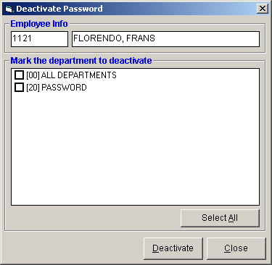
Figure 7: Deactivate Password Window

Click the box beside the department you want to deactivate. Click the Deactivate button afterwards. A message will appear if deactivation process has been successfully committed.

Adding of New Department to an Existing User’s Account

This is the counterpart of deactivating user’s account. Use this to add a new department so that the user can gain access into the new department entered.

1 Click the Add/Edit User toolbar button to open its window (refer to figure 3).

2 Type the employee number and then press <Enter>.

3 Click the New Dept button.

4 Under Department entry, type new department and original department. You can press <Enter> if it is still blank to display the complete list of departments (refer to figure 4). Just double-click on the department to select.

5 Click the Save button to add user’s new department. The list of user’s existing departments can be seen at the top part of the window.

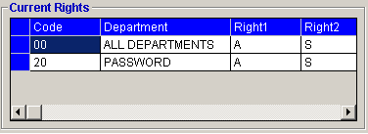
Figure 8: Current User's Rights

Department

Adding of Department

Use this option to add or build a new department.

1 Click the Departments toolbar button to open its window (refer to figure below).

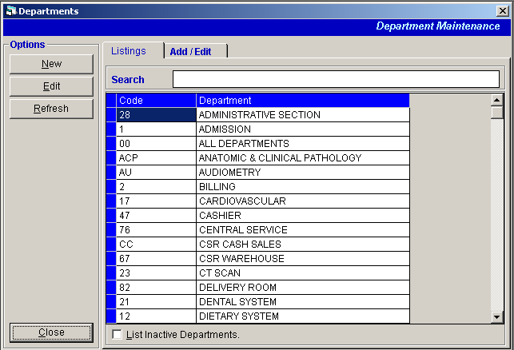
Figure 9: List of Departments

2 Click the New button to open the department data-entry.

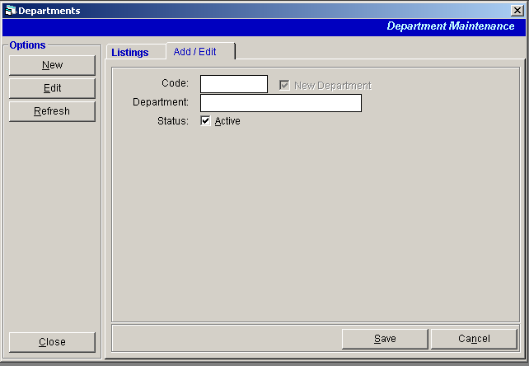
Figure 10: Adding of Department Window
Enter the following data.
Code - Type the code of the department and then press <Enter>. The program will prompt a message if the entered code is already in-use.
Department - Type the description of the department and then press <Enter>.
Status - This is initially checked. Uncheck it to make it inactive.

3 The following button options can be clicked from.
Click the Save button to save the newly entered department.
Clicking the Cancel button will display a message asking you to continue saving it or not.
Click the Close button to close the window.

Editing of Department

This option is used to modify or change an existing department particularly its description or status.

1 Click the Departments toolbar button to open its window (refer to figure 10).

2 Click the department from the list under the Listings tab and then click the Edit button. You can only change the department description and status.

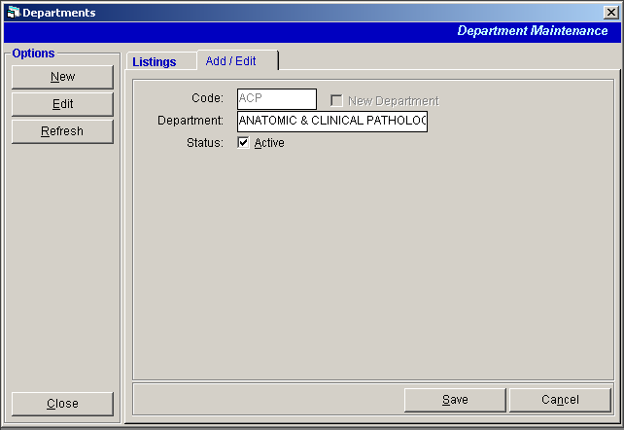

3 The following button options can be clicked from.
Click the Save button to save the changes made.
Clicking the Cancel button will display a message asking you to continue saving the changes or not.
Click the Close button to close the window.

User’s Rights

Adding of User’s Rights

A user’s right corresponds to a particular access. This feature is necessary to limit one’s right in using a particular program.

1 Click the Rights toolbar button to open its window (refer to figure below).

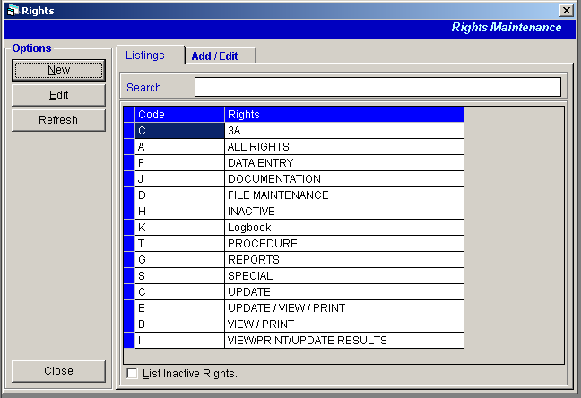
Figure 11: List of Rights Window

2 Click the New button to open the user’s right data-entry. Enter the following data.

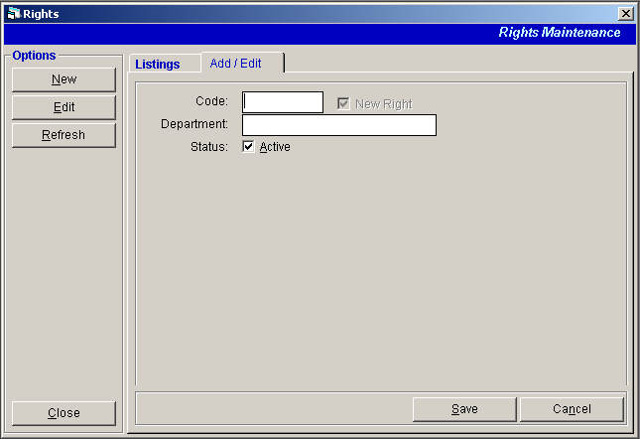
Figure 12: Adding of Right Window
Code - Type the code of the user’s right and then press <Enter>. The program will prompt a message if the entered code is already in-use.
Department - Type the description of the user’s right and then press <Enter>.
Status - This is initially checked. Uncheck it to make it inactive.

3 The following button options can be clicked from.
Click the Save button to save the newly entered right.
Clicking the Cancel button will display a message asking you to continue saving it or not.
Click the Close button to close the window.

Editing of User’s Rights
This option allows you to change an existing user’s right(s).

1 Click the Rights toolbar button to open its window (refer to figure 12).

2 Click the user’s right from the list under the Listings tab and then click the Edit button. You can only change the right description and status.

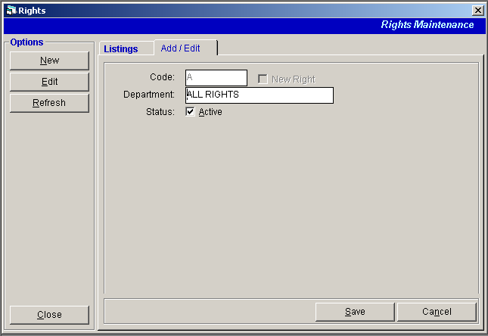
Figure 13: Editing of Right Window

3 The following button options can be clicked from.
Click the Save button to save the changes made.
Clicking the Cancel button will display a message asking you to continue saving the changes or not.
Click the Close button to close the window.

Index

—A—
adding of department, 16
adding of user's account, 9
adding of user's new department, 15
adding of user's right, 19
—C—
change password, 12
changing of password, 7
close the program, 8
—D—
deactivating of user's account, 14
department entry, 16
—E—
editing of user's account, 12
end the program, 8
—F—
features, 5
—O—
objectives, 5
overview, 4
—P—
password (changing of), 7
password disabling, 14
password editing, 12
password entry, 9
—R—
right entry, 19
—S—
start the program, 6
—U—
user's account deactivating, 14
user's account viewing, 13
user's new department entry, 15
user's right entry, 19
—V—
viewing of user's account, 13

