MEDSYS
Information System

Radiology ( X-ray ) Program
User's Manual



MEDSYS
Kaiser - dela Cruz Consulting, Inc.
July 31, 2026
Copyright© 2009
ALL RIGHTS RESERVED

No part of this document may be reproduced through photocopying or in any means, stored into a retrieval system, and transmitted in any form without the express written permission of Kaiser - dela Cruz Consulting, Incorporated.
Permission is hereby granted to Medsys Information System to copy and distribute this document in any of the above means provided this is for its exclusive on site use.
Although every precaution has been taken in the preparation of this manual, the company assumes no responsibility for errors or omissions. Neither is any liability assumed for any damages resulting from the use of the information contained here.

Table of Contents

Table of Contents 3
Introduction 5
Overview 5
Objectives 6
Features 6
Getting Started 7
How to Start the Program 7
How to Change Password 8
How to End the Program 9
Program Operation 10
How to Enter Cash-basis Patient Request 10
How to Add Walk-in Patient 12
How to Enter Charge-basis Outpatient Request 13
How to Enter Inpatient Request 15
How to Clear Patient for Discharge 17
Who is Merlin? 19
How to Process Pending Request 20
How to Enter Exam Result 22
How to Retrieve, Inquire or Edit Exam Result 24
How to Verify Exam Result 26
How to Borrow / Return Film 27
How to Add Films 29
How to Add/Edit Exam Interpretation 30
How to Set the Default Radiologist 31
How to Cancel Request 32
How to Search/Edit Walk-in Patients 33
How to Reprint Charge-slip 34
How to Verify Charge-slip 35
How to View Patient’s Ledger 36
How to View File Numbers Used 37
How to View Inpatient Census 38
How to View Request(s) Status 39
How to Print Standard Operating Procedure 40
How to Print Request Form(s) of InPatients 42
How to Print Request Form(s) of Outpatients 43
Reports 44
Other Reports 46
Index 51

Introduction

Overview



The Radiology Program is a computerized processing of C. T. Scan, Ultrasound, and X-ray examinations posted in the Nursing Stations, Emergency Room, Intensive Care Unit, and other hospital departments. Exam result is entered using the program and will be automatically sent thru a computer network in all receiving departments that are connected with Radiology.
Authorized users can only access the Radiology Program because it is protected with password to secure the confidentiality of data especially in posting exam results.

Objectives

To keep data confidential especially in posting exam results.
To communicate with other hospital departments via a computer network in the least time required.
To process exam requests and to automatically send the result into the receiving departments once validated.
To automatically generate reports about exams requested and others.
To maintain data correctly through using the maintenance feature.

Features

Data-entry restriction - The program automatically checks inputs. Warning messages are flashed for possible invalid entries.
Data maintenance- It has a maintenance option to modify saved data.
Build file option - It can add and modify films, exams, and interpretations.
Password-protected - Only program users with registered employee number and password can access the program
User-friendly - Help file is incorporated into the program that guides program users.

Getting Started

How to Start the Program

1 Click on Radiology Program executable file icon located in your computer desktop.
2 The Radiology departments will display. Click on the department you want to work with.

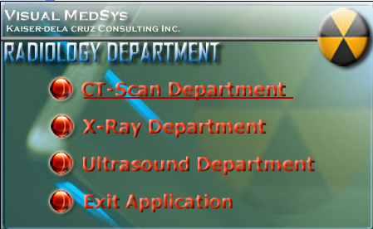
List of Radiology Departments

3 The Login window will display asking you to type your employee number and password for security purposes.

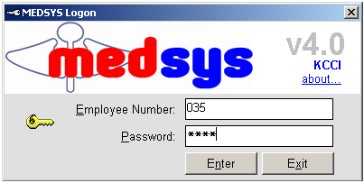
Login Window

How to Change Password

1 From the Login window, type your employee number and then press <Enter>.

2 Under the Password entry, press <F12>. Pressing this function key will invoke the Change Password window.

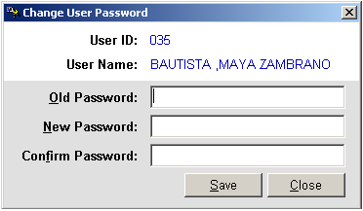
Change Password Window
3 Under the Change Password window, type the following data.
Old Password - Type your existing password.
New Password - Type your new password not exceeding to 15 characters.
Confirm Password - Retype your new password to confirm and then press <Enter> or you can click the Save button.

How to End the Program

It is important for users to close the program when they are done to end-up their session. Other users might use the open program using the same password.

There are two ways to close the program.
Click on button located at upper right corner of the main window (if no other window is open) or
Click on button located at the lower left part of the main window.

Program Operation

How to Enter Cash-basis Patient Request

This option lets you request exam/procedure to cash-basis patients

1 Under Request option, click Assessment. The window below will display.

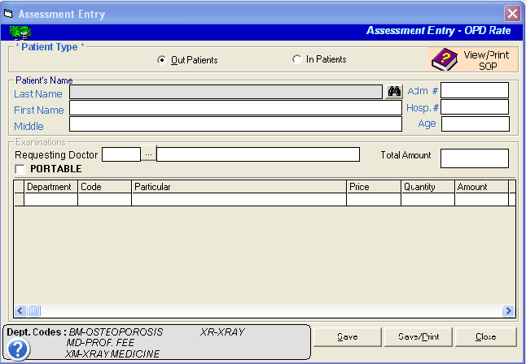
Cash-basis Request Entry Window

The following data are needed to enter.
Patient-type- Select one from the three options namely Out Patients and InPatients.
Patient’s Name- Type patient’s last name then press <Enter>. A window will display with patients listing matching your query. Double-click on the patient’s name to select. The patient’s first name and middle name will be then automatically displayed.
Examinations- Under department, type its code or you can press <Enter> if it is still blank to display revenue codes. Just double-click on the description you want. Under Code, type the code of the item or you can press <Enter> if code is still blank to display the list in reference with the selected department. Double-click on the item to select. Particular and Price will be automatically displayed in reference with the selected item. Under Quantity, type the number of item then press <Enter> to know the Amount. Follow the same procedure when adding examinations. The total amount can be viewed at the top part.

2 After completing the data, the following button options can be clicked from.
Click on Save button to save the cash basis request entry.
Click on Save/Print to save and print.
Click on Close button to close the window without saving the requested items entered.

How to Add Walk-in Patient

If cash-basis patient’s record cannot be seen in the list, you may use this option to save permanently his record.

1 Under Request option, click Assessment. Under Patient Type, choose Walk-in. Type the patient’s last name and then press <Enter>. A window will display matching your query. (The patient’s name should not appear in the list).

2 Click on Add Cash Patient Type button located just below the window. Its window will display. Type the following data.

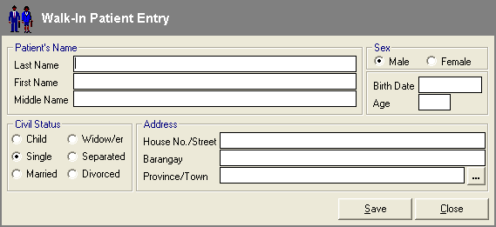
Figure 1: Walk-in Patient Entry Window
Patient’s Name - Type patient’s last name then press <Enter>. Type patient’s first name then press <Enter>. Type patient’s middle name.
Sex - Choose patient’s gender
Birthdate - Type patient’s date of birth. (<format: mm/dd/yyyy> e.g. 10/14/2002)
Age- Type the patient’s age
Civil Status - Choose patient’s civil status from the list.
Address - Type patient’s house #/street then press <Enter>. Type patient’s barangay then press <Enter>. Type patient’s province/town or you can click on to display zip codes list.

3 After completing the data, the following button options can be clicked from.
Click on Save button to save the entry.
Click on Close button to close the window.

How to Enter Charge-basis Outpatient Request
This option allows you to enter charge-basis outpatient exam request. (Charges in here will be accumulated)
1 Under Request option, click Out-Patient Request > Charge Patient Entry
2 A window will display for searching. You can search for a patient by his last name or admission number. Just click on the drop-down arrow to select. Then type the patient’s last name or admission number in reference with the chosen key for searching and then press <Enter>. A window will display and the following data are needed to enter.
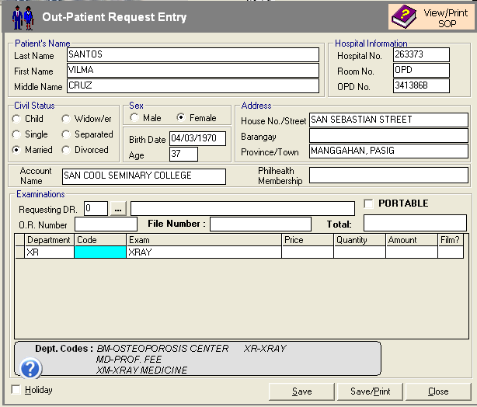

Outpatient Request Entry Window
Requesting Doctor – Type the first few letters of the doctor’s last name and then press <Enter>. A window with doctors list will appear. Double-click the doctor’s name to select. If doctor is not seen in the list, type ‘0’ as doctor’s code and then type the doctor’s name in the text box provided. If doctor is not seen in the list, type ‘0’ as doctor’s code and then type the doctor’s name in the text box provided.
Code - You can directly type the code or you can press <Enter> to display the complete list of items and its codes. Double-click on the item to select.
Exam - This will display automatically.
Price - This will display automatically in reference with the selected item.
Quantity - Type the number of the selected item then press <Enter>.
Amount - This will be computed automatically but may changed if necessary. (The total amount of the entered items can be seen just above the amount)
Film - This is only applicable for X-ray. Click on to display the complete list of films.

3 After completing the needed data, the following button options can be clicked from.
Click on Save button to save.
Click on Save/Print button to save and print.
Click on Close button to close the window.

How to Enter Inpatient Request
This option allows you to request exam(s) for inpatient. The amount of charged items will be automatically reflected to the patient’s bill.
1 Under Request option, click Inpatient Request. The window below will display.
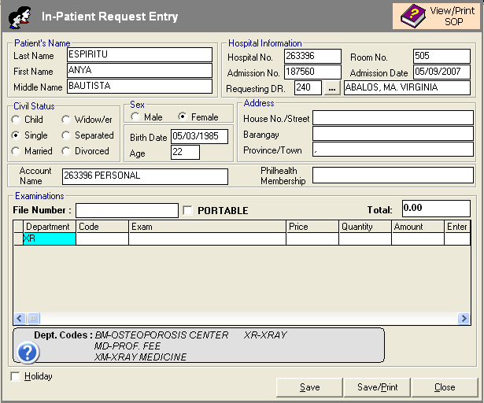
Inpatient Request Entry Window
Patient’s Name - Type patient’s last name then press <Enter>. A window will display with patients listing matching your query. Double-click on the patient’s name to select. The patient’s first name and middle name will be automatically displayed.
Hospital Information - This will be automatically displayed.
Civil Status - This will be automatically displayed.
Sex - This will be automatically displayed.
Address - This will be automatically displayed.
Examinations - Enter the following data.
Code - Type the code or you can press <Enter> to display the list. Double-click on the item to select.
Exam - This will display automatically.
Price - This will display automatically in reference with the selected item.
Quantity - Type the quantity of the selected item then press <Enter>.
Amount - This will be computed automatically but may changed if necessary. (The total amount of the entered items can be seen just above the amount)
Film - This is only applicable for X-ray. Click on to display window for film entry.

2 After completing the data, the following button options can be clicked from.
Click on Save button to save.
Click on Save/Print button to save and print.
Click on Close button to close the window without saving the entered requested items.

How to Clear Patient for Discharge

1 Double-click on . Its window will display showing the list of cleared and not cleared patients. (The legend of “Cleared” and “Not Cleared” patients can be seen at the bottom part of the window)

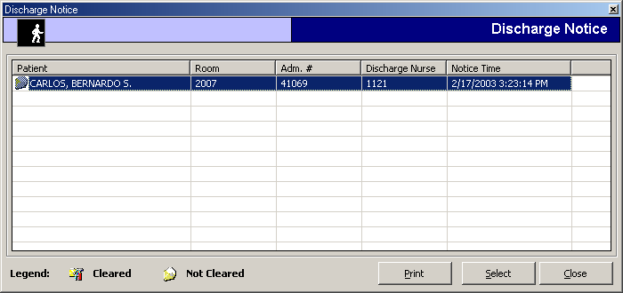
List of Discharge Notice(s) Window

2 Select an uncleared patient from the list and then click the Select button

3 A window for clearing patients will display. Just type your remarks for clearing the patient.

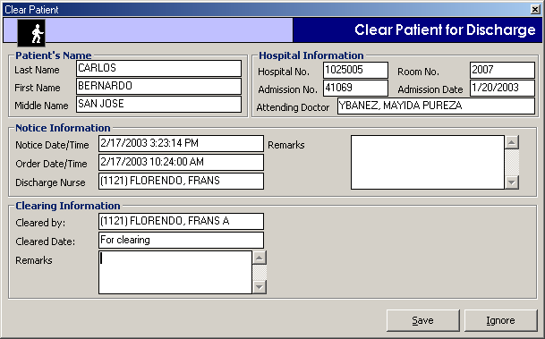
Clearing of Patient for Discharge Window

4 The following button option can be clicked from
Save - Click this button to clear the patient in your department.
Ignore - Click this button to ignore clearing the patient.

Who is Merlin?


Merlin is an agent used to signal program users whenever there are discharge orders to process. Merlin comes out upon entering the program’s main window. To open the list of discharge orders, just double-click Merlin.

How to Process Pending Request

1 Click on 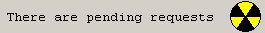 to display list of patient with pending requests.

2 The Pending Request window will display. Double-click the patient from the list to process the request.

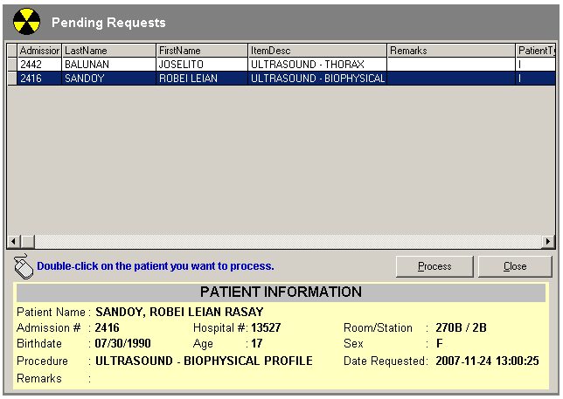
Pending Request Window
- The Process Communication window will display. The requested exam(s) can be seen under the list of examinations.

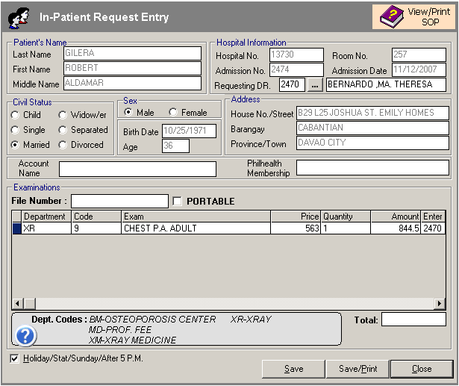
Process Communication Window
To cancel the request, double-click the exam from the list and then click ‘Yes’ button.

4 The following button options can be clicked from.
Save - Click this button to accept and save the request.
Save/Print - Click this button to accept/save and print the charge-slip.
Close - Click this button to close the window.

How to Enter Exam Result

- Under Results option, double click on the Result Entry button. Enter patient(s) name then list of patients with procedures will be loaded on the screen. Double click on the specific patient then the result entry window will be loaded on the screen.
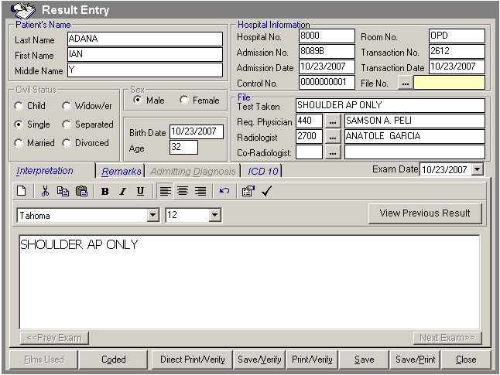

- Patient’s Name - Type the patient’s last name then press <Enter>. A window will display with patients listing matching your query. Double-click on the patient’s name to select. First name and middle name will display automatically. Note: Don’t forget to enter the file number. You can enter the file number of the patient under Maintenance Option.

- Enter the Interpretation in the Interpretation tab
- Enter the Remarks in the Remarks tab
- You can view the admitting diagnosis of the patient by clicking the Admitting Diagnosis tab
- You can enter the ICD 10 of patients diagnosis by clicking the ICD 10 tab
- You can also choose from the list of coded interpretation by clicking the Coded button
- After completing the data, the following button options can be clicked from.
Click on Direct Print/Verify button to automatically save and verify the results save the result entry.
Click on Save button to save result entered
Click on Save/Print to save and print the result.
Click on Save/Verify button to save and verify result. Once verified, stations can view patient’s exam result on their own computer.
Click on Print/Verify button to save, print and verify result. Once verified, stations can view patient’s exam result on their own computer.
Click on Close button to close the window without saving the result.

* You can view patient(s) previous results by clicking the View Previous Result button.

How to Retrieve, Inquire or Edit Exam Result

1 Under Results option, click Inquiry/Retrieve. A window for searching patients will display.
2 Type the patient’s last name then press <Enter>. Patient listings will display matching your query. Double-click on the patient’s name to select. A window will display containing the list of exams taken. Double-click the exam you want to retrieve. (Note: You can no longer edit a result once it was verified unless you have the rights to do so) The window below will display.

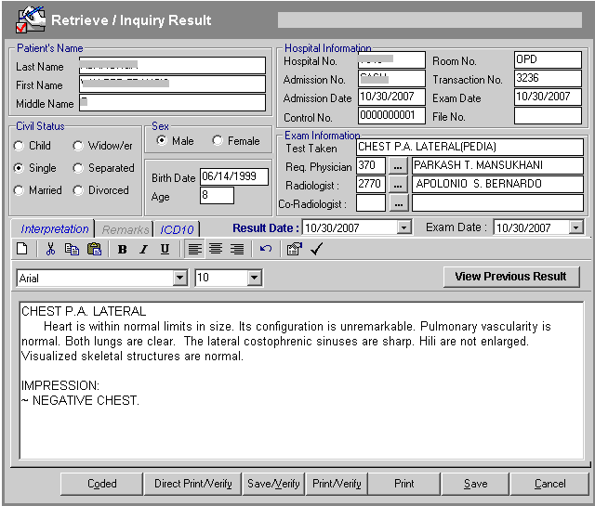
Edit Exam Result Window

3 The following button options can be clicked from.
Click on Direct Print/Verify button to automatically save and verify the results save the result entry.
Click on Save button to save result entered
Click on Save/Print to save and print the result.
Click on Save/Verify button to save and verify result. Once verified, stations can view patient’s exam result on their own computer.
Click on Print/Verify button to save, print and verify result. Once verified, stations can view patient’s exam result on their own computer.
Click on Close button to close the window without saving the result.

* You can view patient’s previous results by clicking the View Previous Result button.

How to Verify Exam Result
- Under Results option, click Verification. Type the code and password of the reader to proceed. Refer to the figure below.
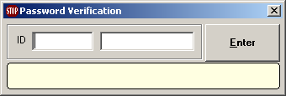
- A window for searching patients will display.
2 Type the patient’s last name and then press <Enter>. Patient listings will display matching your query. Double-click on the patient’s name referring to the code of the exam you want to verify. A window will display containing the patient information and exam result.
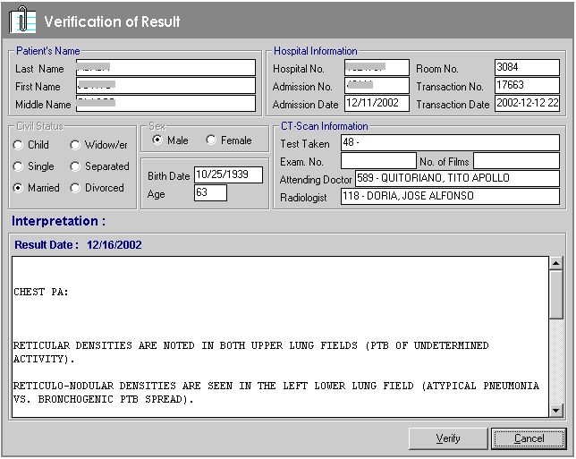
Exam Verification Window
3 The following button options can be clicked from.
Click on Verify button to verify the result. Once verified, stations can view patient’s exam result on their own computer
Click on Cancel button close the window.
How to Borrow/Return Film

1 Under Results option, click Borrowed Film. A window for searching patients will display.
2 Type the patient’s last name then press <Enter>. Patients listing will display matching your query. Double-click on the patient’s name to select. A window will display containing the list of exams taken.
3 Double-click on the exam code to select. The Borrow/Return Film Window will display. The following data are needed to enter.

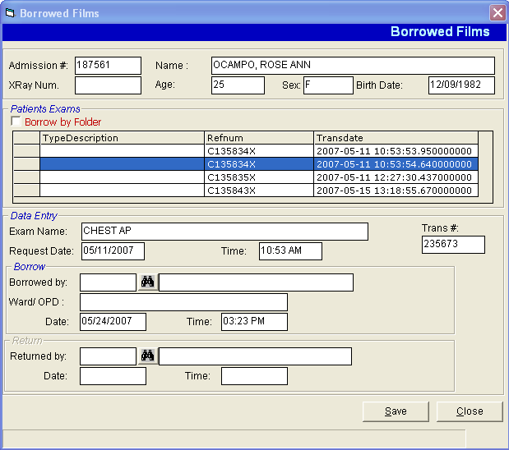
Borrow/Return Film Window
For borrowing:
Borrowed by - Type the borrower’s name.
Location - Type the borrower’s address.
For returning:
Returned by - Type the name of the person who returned the film

4 After completing the needed data, the following button options can be clicked from.
Click on Save button to save.
Click on Close button to close the window.

How to Add Films

Under Build File option, click Films. A window for film entry will display. The following data are needed to enter.

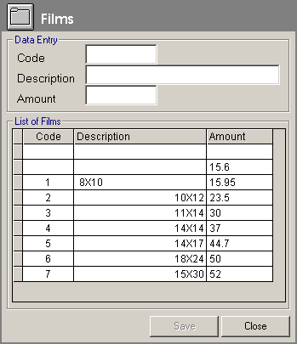
Film Entry Window

Data Entry - Type a code and then press <Enter>. Type a description of the code and then press <Enter>. Type the amount of code and then click on Save button. Click on Close button to close the window.
List of Films - You can view here all the films entered.

How to Add/Edit Exam Interpretation

1 Under Build File option, click Interpretation. Its window will display.
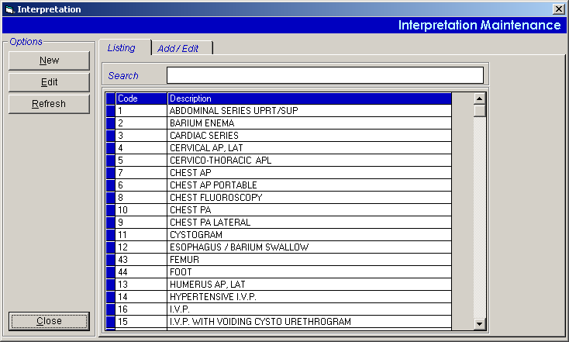
Interpretation Maintenance Window
To add new interpretation:
Click on New button at the upper left side of the window. A window for adding interpretation will display. Type the following data.
Code - a program-generated code
Description - type the name of the exam
Section - Click on to display list of sections. Double-click on the section name to select.
Interpretation - Type the exam’s interpretation.
Click on Save button to save interpretation.
To edit interpretation:
Click on Edit button at the upper left side of the window or double-click on the exam name under the Listings tab. A window for editing will display.
Click on Save button to update changes.
To refresh the list of examinations:
Click on Refresh button located at the upper left side of the window. (Clicking on Refresh button will display the latest updates from the database)

- Click on Close button at the lower left side of the window.

How to Set the Default Radiologist

1 Under Build File option, click Default Radiologist. Its window will display.

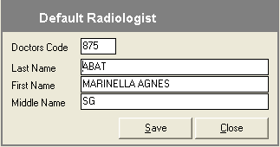
Default Radiologist Entry Window
2 Type the radiologist’s last name in the last name textbox entry and then press <Enter>. A window with doctors listing will display matching your query.
3 Double-click on the doctor’s name to select.
- Click on Save button to use the selected radiologist as the default entry.

How to Cancel a Request

1 Under Maintenance option, click Request Cancellation. A window for searching patients will display.
2 Type the patient’s last name then press <Enter>. Patients listing will display matching the query typed. Double-click on the patient’s name to select. A window will display for charge-slip cancellation.

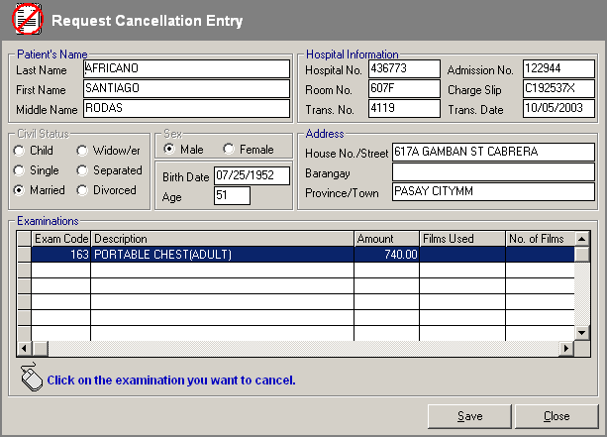
Charge-slip Cancellation Window

- Click on the examination you want to cancel then click on Save button.

How to Search/Edit Walk-in Patients

1 Under Maintenance, click Other Options and then click Update Walk-In File Update. A window for searching will display afterwards. Type the patient’s last name then press <Enter>. Patients listing will display matching your query. Double-click on the patient’s name to select.
2 A window for editing will display. You can now edit the patient’s information.

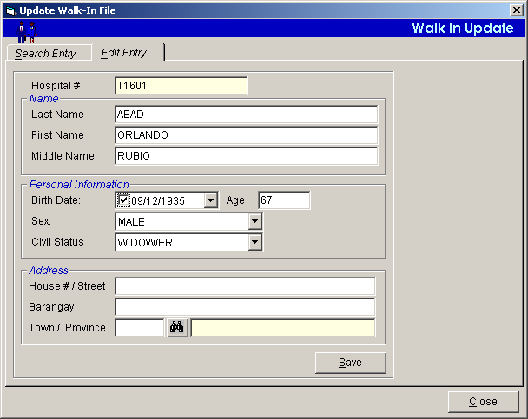
Update Walk-in File Window

3 The following buttons can be clicked from.
Click on Save button to update changes.
Click on Close button to close the window.

How to Reprint Charge-slip

1 Under Maintenance option, click Other Options and then click Charge-Slip Duplicate. A window will display.
2 Under patient code, select one from the list. Type the patient’s admission no. or patient’s last name then press <Enter>. A window will display matching your query.
3 Double-click on the patient’s name to select. The patient’s list of examinations will display. Refer to the figure below.
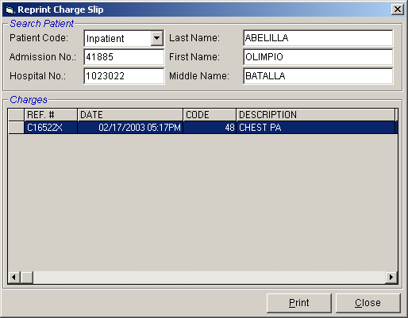
Charge-slip Reprinting Window

Double-click on the exam or click on Print button to select.

- Click on to print the slip.

How to Verify Charge-slip

1 Under Maintenance option, click Other Options and then click Slip Verification. A window will display afterwards.
2 Type the charge-slip number and then press <Enter>. Its details will display afterwards.

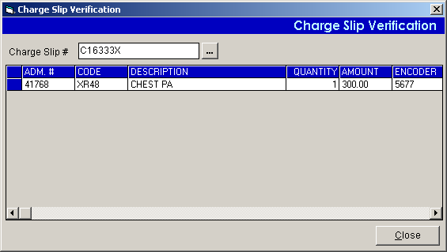
Charge-Slip Verification Window

- Click on Close button to close the window.

How to View Patient’s Ledger

This option allows you to view patient’s X-ray charges.

1 Under Maintenance, click Other Options and then click Patient’s Ledger. A window will display for searching patients.
2 Under Patient Code, select one from the list by clicking the drop-down arrow. Type the patient’s admission number or type the patient’s last name and then press <Enter>. A window will display matching your query. Double-click on the patient’s name to select.
3 The patient’s information will display. Click on View button to display the printable patient’s ledger of X-ray, C.T. Scan or Ultrasound charges.
- Click on to print.

How to View File Numbers Used

1 Under Maintenance, click Other Options and then click File Numbers Used. Its window will display afterwards.

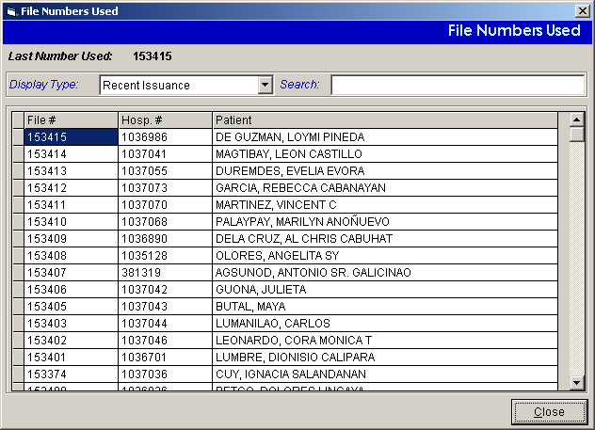
File Numbers Used Window
Select one from the list under Display Type.
To search for a patient:
Select Search by Patient under Display Type.
Type the patient’s last name then press <Enter>. You can view the patient’s file number in the list.

- Click on Close button to close the window.

How to View Inpatient Census

1 Under Maintenance, click Other Reports and then click Inpatient Census. An option window will display afterwards.

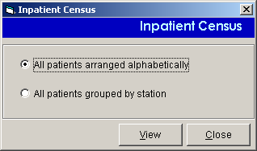
Inpatient Census Option Window

2 Select one from the options. <All patients arranged alphabetically or All patients grouped by station>. Click on View button to display the printable inpatient census.
3 The following data can be viewed.
Patient - the patient’s name
Admission # - the patient’s admission number
Admission Date - the date when the patient was admitted.
Account Name - the hospitalization plan of the patient.
Room - the room where the patient was confined.
Doctor - the name of the patient’s doctor.
4 Click on to print.

How to View Request(s) Status
This option allows the user to view status of request(s). To do this, click on 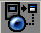 button in the main menu r to load the window below

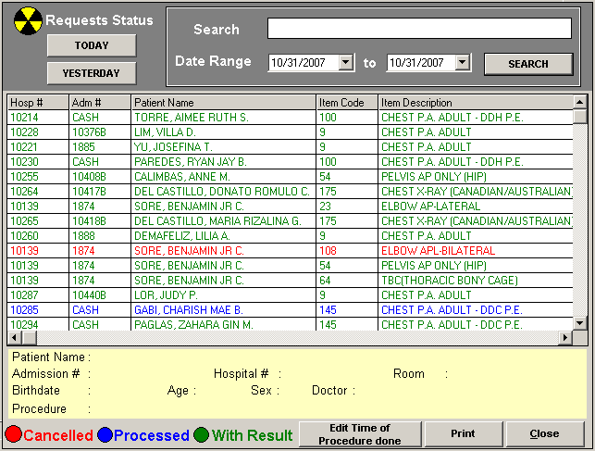
Request(s) status are color coded

Red Labeled Patient(s) – Cancelled Request(s)
Blue Labeled Patient(s) – Processed Request
Green Labeled Patient(s) – Request(s) with Results

How to Print Standard Operating Procedures
Click on  button located in the Outpatient Charge Request Entry and Inpatient Request Entry to display the window below
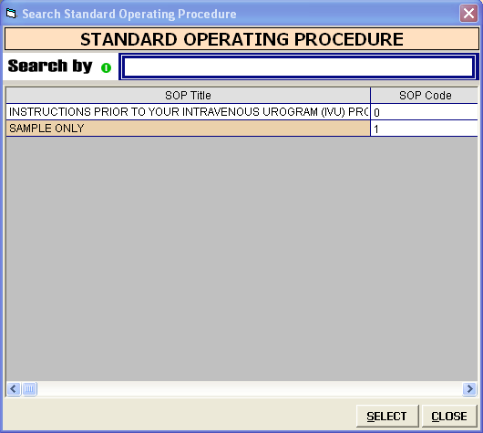
Double click from the list the specific SOP to load a sample window below

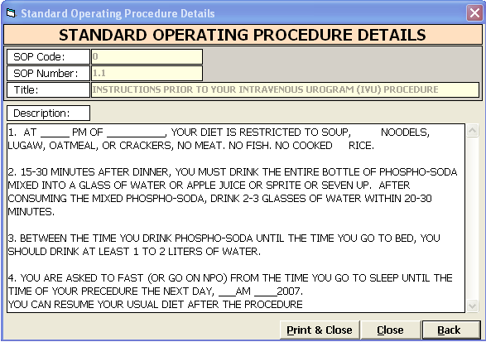
  - To print SOP, click on Print & Close button
  - To go out from this window, click on Close or Back button

How to Print Request Form(s) of Inpatients
This option allows the user to print request forms for inpatients. To do this, click on 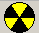 button to print request form for inpatients..

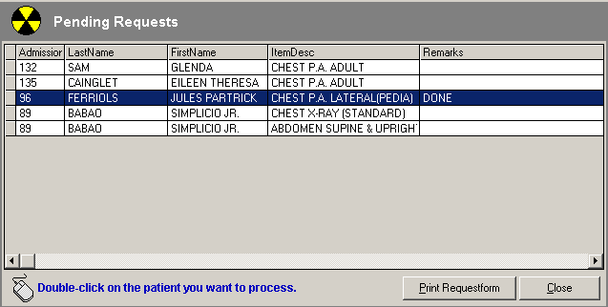

Highlight on the specific patient then click on Print RequestForm button to print request form.
Click on Cancel button to go out from the window.

How to Print Request Forms of OutPatients
To do this, click on 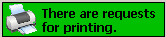 located in the main menu of the program. Double click to load the window below.

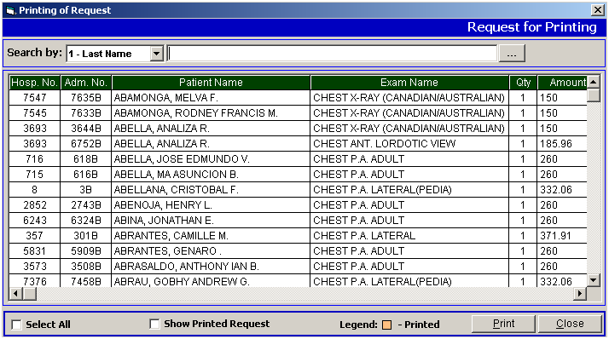

List of outpatients with x-ray request(s) will be listed. Highlight or single click on the patient name then click on PRINT button to print request form or click on CANCEL button to go out from this window.

Reports

Monthly Transaction Report

This displays a report of requested exams since the entered beginning to ending dates; the number of usage of each size of films for a particular exam (for x-ray only); the number of usage and amount of a particular exam in inpatient and out-patient then totaling the quantity and amount accumulated for a particular examination in inpatient and out-patient.

1 Under Reports option, click Monthly Transaction Report. A window for date entry will display afterwards. Type the beginning and ending dates of the report and then click on OK button (<format: mm/dd/yyyy> e.g. 10/14/2002). A printable report will display.
2 Click on to print the report.

Daily Census Report

Inpatient Daily Census Report

This displays a report of daily list of inpatients who have requested for medicines, supplies and exams; the number of usage of each size of films for a particular exam, the amount for a particular medicine, supply or exam totaling the number of usage for a particular size of film and the amount accumulated of all requested medicines, supplies and exams.

1 Under Reports option, click Daily Census Reports. A pop-up window will display, click Inpatient Daily Census. A window will display for date entry. Type the date to query (<format: mm/dd/yyyy> e.g. 10/14/2002) A printable report will display.
- Click on to print the report.

Outpatient Daily Census Report

This displays a report of daily list of outpatients who have requested for medicines, supplies and exams; the number of usage of each size of films for a particular exam, the amount for a particular medicine, supply or exam totaling the number of usage for a particular size of film and the amount accumulated of all requested medicines, supplies and exams.

1 Under Reports option, click Daily Census Reports. A pop-up window will display, click Outpatient Daily Census. A window will display for date entry. Type the date to query (<format: mm/dd/yyyy> e.g. 10/14/2002) A printable report will display.
2 Click on to print the report.

Other Reports

Assessment Status
This allows you to revoke or view the status of the assessment posted under the Request option.
1 Under Reports option, click Other Reports. A pop-up window will display, click Assessment Status
2 The Assessment Status window will display containing all assessments posted arranged in ascending order on the date of assessment.
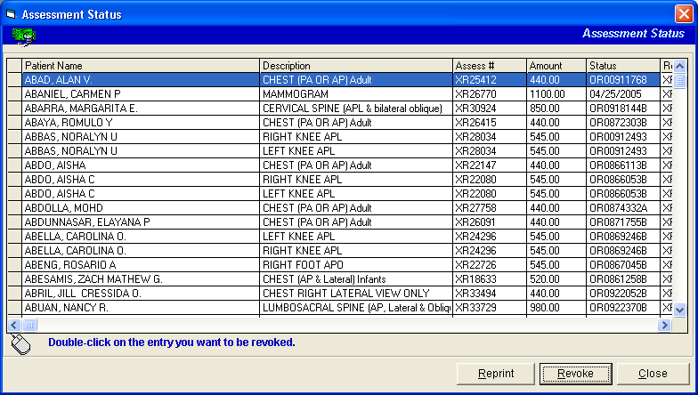
Under the status column, items having official receipt number are already paid; the rest are still unpaid.
3 The following button options can be clicked from.
To revoke a particular assessment, select it from the list and then click on Revoke button. The status of the assessed item will then change to Revoke.
To print the charge- slip of the assessed item, select it from the list and then click on Re-print button.
Click on Close button to close the window.

Audit Report
It generates a report of inpatients and outpatients who have requested for exam and the name of the exam requested and its corresponding amount.

1 Under Reports option, click Other Reports. A pop-up window will display, click Audit Report. A window for date entry will display. Type the beginning and ending dates of the report. (<format: mm/dd/yyyy> e.g. 10/14/2002) Click on OK button.
2 To print, click on .

Income Report
This generates a report of requested exams since the entered beginning to ending dates; the quantity and amount accumulated for a particular exam in inpatient and out-patient then totaling the quantity and amount accumulated for a particular exam both and each inpatient and out-patient; and totaling the quantity and amount of all exams.

1 Under Reports options, click Other Reports. A pop-up window will display, click Income Report. A window for date entry will display. Type the beginning and ending dates of the report you want to view. (<format: mm/dd/yyyy> e.g. 10/14/2002). Click on OK button. A printable report will display.
- To print, click on .

Borrowed Films Report

This generates a report of borrowed films arranged by patient’s name, examination, result date, borrower’s name, date borrowed, location or encoder.

1 Under Reports options, click Other Reports. A pop-up window will display, click Borrowed Films Report. A window will display afterwards. Select one from the list then click on View button. A printable report will display.
- Click on to print the report.

Returned Films Report

This generates a report of returned films arranged by patient’s name, examination, result date, returned by, Date Returned, Encoder (return), Borrower, Date Borrowed, Location or Encoder (borrowed).

1 Under Reports options, click Other Reports. A pop-up window will display, click Borrowed Films Report. A window will display afterwards. Select one from the list then click on View button. A printable report will display.
- Click on to print the report.

X-ray Film Consumption Reports
This generates a report on x-ray film consumption.
1 Under Reports options, click Other Reports. A pop-up window will display, click X-ray Film Consumption Reports. A window for date entry will display. Type the beginning and ending dates of the report you want to view. (<format: mm/dd/yyyy> e.g. 10/14/2002). Click on OK button. A printable report will display.
- To print, click on .

X-ray Film Wastage reports ( Daily and Monthly Report )
This generates a report on x-ray film wastage.
1 Under Reports options, click Other Reports. A pop-up window will display, click X-ray Film Wastage Reports. A window for date entry will display. Type the beginning and ending dates of the report you want to view. (<format: mm/dd/yyyy> e.g. 10/14/2002). Click on OK button. A printable report will display.
- To print, click on .

X-ray film Inventory Report
This generates a report on x-ray film inventory
1 Under Reports options, click Other Reports. A pop-up window will display, click X-ray Film Inventory Report. A window for date entry will display. Type the beginning and ending dates of the report you want to view. (<format: mm/dd/yyyy> e.g. 10/14/2002). Click on OK button. A printable report will display.
- To print, click on .

X-ray Monthly/Weekly Report

This generates a report on x-ray income, x-ray diagnostic and x-ray professional fee
1 Under Reports options, click Other Reports. A pop-up window will display, click X-ray monthly / weekly report. A window for date entry will display. Type the beginning and ending dates of the report you want to view. (<format: mm/dd/yyyy> e.g. 10/14/2002). Click on OK button. A printable report will display.
- To print, click on .

Statistical Report by Referring Doctor

This generates report of requested exams with patient’s referring doctor since the entered beginning to ending dates. It also display list of exams without patient’s referring doctor.
1 Under Reports option, click Other Reports. A pop-up window will display, click Statistical Report by Referring Doctor. A window for date entry will display. Type the beginning and ending dates of the report. (<format: mm/dd/yyyy> e.g. 10/14/2002) Click on OK button. A printable report will display.
2 Click on to print.

Doctors Contribution

This generates a report on Doctor’s Contribution and can either be by doctor, by procedure, by gender and by date.
1 Under Reports options, click Other Reports. A pop-up window will display, click Doctors Contribution. A window for date entry will display. Type the beginning and ending dates of the report you want to view. (<format: mm/dd/yyyy> e.g. 10/14/2002). Click on OK button. A printable report will display.
- To print, click on .

Mammogram Reports

This generates Mammogram reports such as Audit Report, Income Report, Diagnostic Report and Professional Report.

1 Under Reports options, click Other Reports. A pop-up window will display, click Mammogram Reports. A window for date entry will display. Type the beginning and ending dates of the report you want to view. (<format: mm/dd/yyyy> e.g. 10/14/2002). Click on OK button. A printable report will display.
- To print, click on.

Index

—A—
add films, 29
add interpretation, 30
add walk-in patient, 13
audit report, 42
—B—
borrow film, 28
borrowed films report, 44
—C—
cancel request, 32
cash basis status report, 48
cash-basis patient request, 11
charge slip re-printing, 34
charge slip verification, 35
charge-basis inpatient request, 16
charge-basis outpatient request, 14
close the program, 9
—D—
default radiologist, 31
discharge order (processing), 18
—E—
edit exam result, 25
edit interpretation, 30
edit walk-in patients, 33
end the program, 9
enter exam result, 23
exam result editing, 25
exam result entry, 23
exam result verification, 26
—F—
features, 7
file number used (viewing), 37
film (borrowing/returning), 28
film entry, 29
—I—
income report, 43
inpatient census (viewing), 38
inpatient daily census report, 40
inpatient request (charge-basis), 16
interpretation (adding/editing), 30
—M—
merlin, 20
monthly transaction report, 39
—O—
objectives, 7
outpatient daily census report, 41
outpatient request (charge-basis), 14
overview, 6
—P—
patient request (cash-basis), 11
patient's ledger, 36
pending request (processing), 21
print charge slip, 34
process discharge order, 18
process pending request, 21
—R—
radiologist (setting the default), 31
report (audit), 42
report (borrowed films), 44
report (cash-basis status), 48
report (income), 43
report (inpatient daily census), 40
report (monthly transaction), 39
report (outpatient daily census), 41
report (returned films), 45
report (statistical by referring doctor), 47
report (statistical), 46
re-print charge slip, 34
request cancellation, 32
result editing, 25
result entry, 23
result verification, 26
return film, 28
returned films report, 45
—S—
search walk-in patients, 33
set default radiologist, 31
start the program, 8
statement of accounts, 36
statistical report, 46
statistical report by referring doctor, 47
—V—
verify charge slip, 35
verify exam result, 26
view file number used, 37
view inpatient census, 38
view patient's ledger, 36
—W—
walk-in patient (adding), 13
walk-in patients (searching/editing), 33

