MEDSYS
Information System

Visual Nurse Program
User's Manual



MEDSYS
Kaiser - dela Cruz Consulting, Inc.
July 30, 2026

Copyright© 2009
ALL RIGHTS RESERVED

No part of this document may be reproduced through photocopying or in any means, stored into a retrieval system, and transmitted in any form without the express written permission of Kaiser - dela Cruz Consulting, Incorporated.
Permission is hereby granted to Medsys Information System to copy and distribute this document in any of the above means provided this is for its exclusive on site use.
Although every precaution has been taken in the preparation of this manual, the company assumes no responsibility for errors or omissions. Neither is any liability assumed for any damages resulting from the use of the information contained here.

Table of Contents

Introduction 5
Overview 5
Objectives 6
Features 7
Getting Started 8
How to Start the Program 8
How to Change Password 10
How to End the Program 11
Program Operation 12
Patient Searching 12
How to Request Laboratory Exam 14
How to Request X-ray Exam 17
How to Request Ultrasound Exam 19
How to Request C.T. Scan Exam 18
How to Request Heart Station Procedures 20
How to Request Magnetic Resonance Imaging 21
How to Request Nuclear Procedures 22
How to Request Pulmonary Medicine 23
How to Request Rehabilitation Medicine 24
How to Request Medicine 25
How to Request Supplies 29
How to Request Patient’s Diet 31
How to Transfer a Patient 33
How to View List of Newly Admitted Patient 34
How to Send Discharge Notice 35
How to Stop Medicines 37
How to Discharge a Patient 38
How to Enter Administered Medicines 40
How to Enter Admitting Diagnosis and Chief Complaint 43
How to Enter Height and Weight 44
How to Enter Charges of Inpatient 45
How to Enter Charges of Cash-basis Patient 47
Nurses Activity Request 49
Viewing of Laboratory Exam Result 51
Viewing of X-ray Exam Result 52
Viewing of Ultrasound Exam Result 53
Viewing of Heart Station Exam Result 54
Viewing of C. T. Scan Exam Result 55
How to Enter Vital Signs 56
How to Enter Nurses Notes 57
How to View Patient’s Profile 58
How to Co-Manage or Additional Doctors 59
How to Update Room Status 60
How to Print Claim Slip 61
How to View Clinical Summary 61
How to Schedule Operation 62
Viewing of Reports 63
Shortcuts 63
Index 65

Introduction

Overview



The Visual Nurse Program reduces the workload of the nursing staff due to its link to other departments. All patients’ requests for examinations and prescriptions can be done through the computer network. Program users can view current test results and other clinical information. Thus, users can use this program to stay abreast of any clinical activity concerning a patient. Relevant information is readily available for nurses with less effort or legwork.
This program is user-friendly. It is menu-driven with detailed guidelines constantly provided for the user’s benefit.
Passwords secure the program from unauthorized access.

Objectives

1 To link other departments such as Laboratory, X-ray, Ultrasound, C.T. Scan, Heart Station, Hemodialysis, Pulmonary Laboratory, Pharmacy, Central Supply, Nutrition and Dietetics, Operating Room, and Billing and other hospital departments connected to Visual Nurse Program.

2 To speed up and help organize the workflow by creating less work for the staff.
Reports such as list of processed requests, list of requests/orders, list of medicine posted, list of supplies posted, discharges for the day and diet list are generated by the program

Features

1 Data-entry restriction - The program automatically checks for inputs. Warning messages are flashed for possible invalid entries.

2 Updated and reliable - The program is capable of generating accurate reports. Databases are interconnected to other departments and latest updates are accessed.

3 User-friendly - The user is guided by instructions in doing the next step providing an easy-use to process transactions.

4 Password-protected - The use of password is necessary to restrict unauthorized access. Thus the program only accepts passwords which are registered into it. This feature ensures the confidentiality and integrity of data entered into the program.

Getting Started

How to Start the Program

1 Double-click the Visual Nurse Program executable file icon in your computer's desktop.
2 The Login window will be displayed. Type employee number and then press <Enter>. Type password and then press <Enter>.

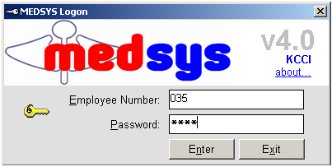
Figure 1: Login Window
The asterisk (*) in the password textbox is displayed instead of the data entered in order to keep the password confidential.
After typing the employee number and password correctly, the user can proceed into the main window. If one of the two is invalid then an error message will be displayed prompting “Unauthorized User”.

How to Change Password

It is advisable to change your password as often as possible for security reasons. To change you current password, follow these steps.

1 From the Login window (refer to figure 1), type your employee number and then press <Enter>.

2 Under the Password entry, press <F12>. Pressing this function key will invoke the Change Password window.

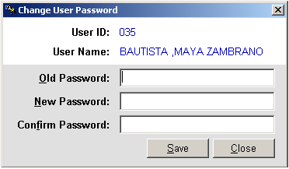
Figure 2: Change Password Window
3 Under the Change Password window, type the following data.
Old Password - Type your existing password.
New Password - Type your new password not exceeding to 15 characters.
Confirm Password - Retype your new password to confirm and then press <Enter> or you can click the Save button.

How to End the Program

It is important for users to close the program when they are done to end-up their session. Other users might use the open program using the same password.

Click on Exit button which can be seen in almost all of the tab options.

Program Operation

Patient Searching

After entering the user’s employee number and password correctly, list of patients under the user’s station will be displayed. Under the Enter Lastname entry, type the patient’s last name or first few letters of his last name and then press <Enter>. Double-click on the patient’s name to select. All transactions to be done will be accounted to the selected patient.
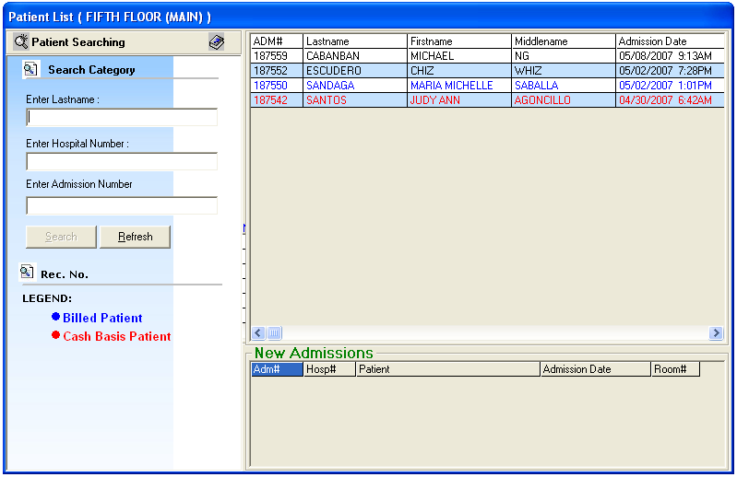
Figure 3: Patients List Window
Note: You can view at the bottom of the window the list of newly admitted patients.
To select a patient within the program, click Send Request tab and then click the Next Patient button located at the right side of the window. Patients listing will be displayed. Double-click on the patient’s name to select. The main window will be displayed. Any transaction to be done will be accounted to the selected patient.

How to Request Laboratory Exam

This option allows you to request laboratory examinations in the Laboratory department

1 Click on Send Requests tab option (default menu).

2 Under Laboratory column, select the exam(s) to be requested by clicking the small box beside it. When clicked, the Remarks Entry Window will be displayed. Enter the necessary data and then click on “Enter” button. Follow the same procedure when adding exam(s).
The exam to be requested cannot be found in the list. Click on “Search Laboratory Exams” button. The Laboratory Request Entry Window will be displayed and the following data are needed to enter.

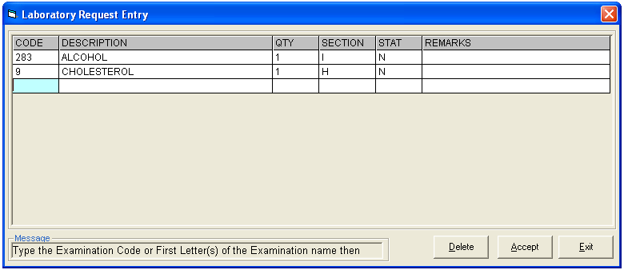
Figure 4: Laboratory Request Entry Window

CODE - Type the examination code or first letter(s) of the examination name then press <Enter>. Or you can press <Enter> key if CODE is still blank to display the list of examination codes. If <enter> key was pressed, a window will be displayed showing the list of examination codes.
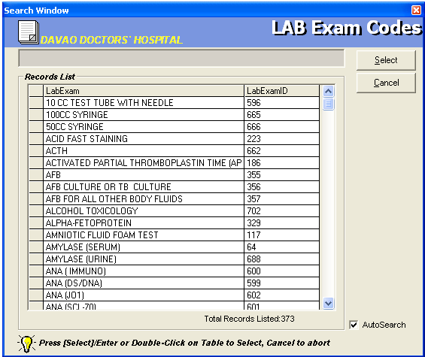
Figure 5: Laboratory Exam Codes Window
To select from the list, click on the desired exam and click on Select button or simply double-click on the desired exam. The Remarks Entry Window will be displayed afterwards. Enter the following data.

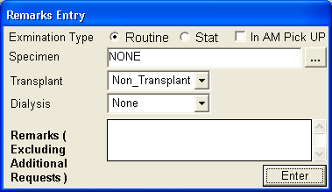
Figure 6: Remarks Entry Window
Specimen - e.g. blood, urine...
Examination Type - Choose one from the list <Routine, Stat, or In Am Pick-up>
Transplant - Choose one from the drop-down list either Transplant or Non-transplant
Dialysis - Choose one from the drop-down list either None, Pre-Dialysis or Post- Dialysis.
Remarks - Type additional remarks.
When done, click on Enter button. Follow the same procedure when you want to add an examination.
DESCRIPTION - This will be automatically displayed in reference with the selected exam.
QTY - This will be automatically displayed in reference with the selected exam.
SECTION - This will be automatically displayed in reference with the selected exam.
STAT - The data that were entered in the examination type under the Remarks Entry window will be displayed here. To change it, type Y if the exam is STAT or N if it is Routine.
REMARKS - The data that were entered in the remarks data entry under the Remarks Entry window will be displayed here.
3 Under the Laboratory Request Entry Window, the user can do the following options.

To include the requested laboratory exam in the Order’s list, click on Accept button.

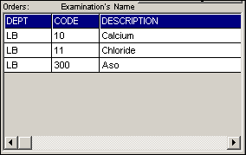
Figure 7: Orders List
To remove requested laboratory exams in the list, click on the desired exam and then click on Delete button.
To close the Laboratory Request Entry window, click on Exit button.
4 After clicking the Accept button, the user can do the following options.

The user can view all the requested exams in the Order’s list.
To send the requests, click on Save button. A pop-window will appear asking you to type the requesting doctor. See figure below. Click OK button to proceed. (Same procedure is applied to requesting of other exams)
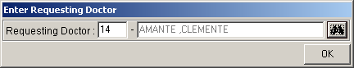

To remove requested exam from the list, double-click on the desired exam or click on the desired exam then click on Delete button.

How to Request X-ray Exam

This option allows you to request X-ray examinations in the Radiology department.

- Under X-ray column, click the small box beside the exam. The same steps with requesting laboratory exam are followed. Please refer to How to Request Laboratory Exam to know the request procedure.
- How to tag PORTABLE procedures.
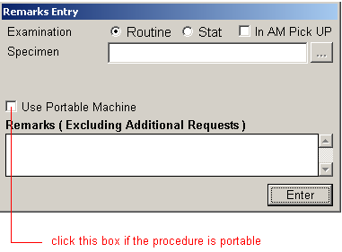

How to Request Ultrasound Exam

This option allows you to request Ultrasound examination in the Radiology department.

Under Ultrasound column, click the small box beside the exam. The same steps with requesting laboratory exam are followed. Please refer to How to Request Laboratory Exam to know the request procedure.

How to Request Ct-SCAN Procedures

This option allows you to request REHAB Examination in the Radiology department.

1 Click on Send Requests tab option.

2 Under Other Departments, click on the small box beside CT-Scan. The list of examinations will be displayed.

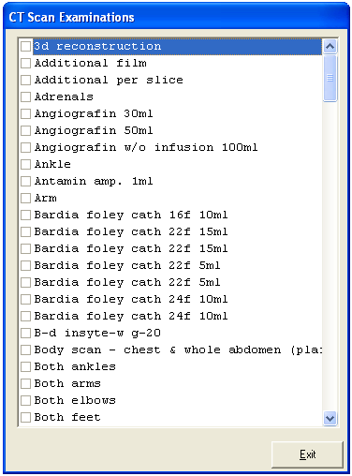
Figure 8: List of Ct-Scan Exams
To select from the list, click on the small box beside the desired exam. Upon clicking, the Remarks Entry Window will be displayed. Enter the following data.
Examination Type - Choose one from the list <Routine, Stat, or In Am Pick-up>
Specimen - example blood, urine...
Transplant - Choose one from the drop-down list either Transplant or Non-transplant
Dialysis - Choose one from the drop-down list either None, Pre-Dialysis or Post-Dialysis.
Remarks - Type additional remarks.
When done, click on Enter button. Follow the same procedure when you want to add an examination.

3 After selecting all the examinations for the patient, click on Exit button.

4 After clicking the Exit button, the user can do the following options.
The user can view all the requested exams in the Order’s list.
To send the request, click on Save button.
To remove requested exams in the list, double-click on the desired exam or click on the desired exam then click on Delete button.

How to Request Heart Station Procedures

Under Other Departments, click on the small box beside Heart Station. The list of examinations will be displayed. The same steps with requesting Ct-Scan are followed. Please refer to How to Request Ct-Scan Exam to know the request procedure.

How to Request MRI Procedures

Under Other Departments, click on the small box beside Magnetic Resonance Imaging. The list of examinations will be displayed. The same steps with requesting Ct-Scan are followed. Please refer to How to Request Ct-Scan Exam to know the request procedure.

How to Request Nuclear Procedures

Under Other Departments, click on the small box beside Nuclear Medicine. The list of examinations will be displayed. The same steps with requesting Ct-Scan are followed. Please refer to How to Request Ct-Scan Exam to know the request procedure.

How to Request Pulmonary Medicine Procedures

Under Other Departments, click on the small box beside Pulmonary Medicine. The list of examinations will be displayed. The same steps with requesting Ct-Scan are followed. Please refer to How to Request Ct-Scan Exam to know the request procedure.

How to Request Rehabilitation Medicine Procedures

Under Other Departments, click on the small box beside Rehabilitation Medicine. The list of examinations will be displayed. The same steps with requesting Ct-Scan are followed. Please refer to How to Request Ct-Scan Exam to know the request procedure.

How to Request Medicine

Request on medicine to patient could not be posted in the computer if:
    - Billing department has closed patient's account. The message that will appear on the screen, "The patient's account has already been closed by _____ (Department). If you have charges to make, notify the Billing staff immediately for further instructions..."
    - Credit and Collection staff has placed the patient's account on cash basis. The message that will flash on the screen, "The patient's account has been placed under cash basis by the Billing Officer. Please refer to Billing Department for further Instructions."

1 Click on Send Requests tab option

2 Click on Pharmacy button at the right side of the window then Click the Charge Request Entry button or F6 key.

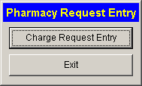
Figure 9: Pharmacy Options

The Pharmacy Request Entry window will be displayed.
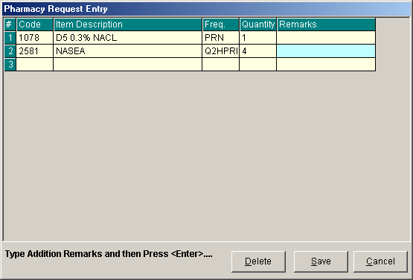
Figure 10: Charge Request Entry Window

Code - Type item code or first letter(s) of item name then press <Enter>. Or you can press <Enter> key if code is still blank to display the list of medicines. If <enter> key was pressed, the list of medicines window will be displayed. To select from the list, click “All Items” to display all supplies or you can categorize by clicking “Suppliers” or “Classification” then double-click on the desired item.
Item Description - This will be automatically displayed in reference with the selected item.
Dosage - Press <Enter> key if dosage is still blank to display the list of dosage codes. If <enter> key was pressed, a window will be displayed showing the list of dosage codes. To select from the list, double-click on the desired code or click on the desired code and click on Select button. To abort the selection, click on Cancel button.
Quantity - This will be automatically displayed in reference with the selected dosage. Note that quantity should be greater than zero.
Remarks - An optional entry.

Just follow the same procedure when adding transcription requests.

After completing the desired items to request, the user can do the following options.

Click on Save button to send the request into the Pharmacy department.
To remove requested items in the list, click on the desired item then click on Delete button.
Click on Cancel button to close the Charge Request Entry Window.

How to Request Supplies

This option allows you to request nursing supplies in the Central Supply Department. Charging will be done by the CSR department after processing the request.

Request on supplies to patients could not be posted in the computer if:
    - Billing department has closed patient's account. The message that will appear on the screen, "The patient's account has already been closed by _____ (Department). If you have charges to make, notify the Billing staff immediately for further instructions..."
    - Credit and Collection staff has placed the patient's account on cash basis. The message that will flash on the screen, "The patient's account has been placed under cash basis by the Billing Officer. Please refer to Billing Department for further Instructions."

1 Click on Send Requests tab option.

2 Press F7 (Central Supply) or click on Central Supply button at the right side of the window. When clicked, the Central Supply Request Entry Window will be displayed and the following data are needed to enter.

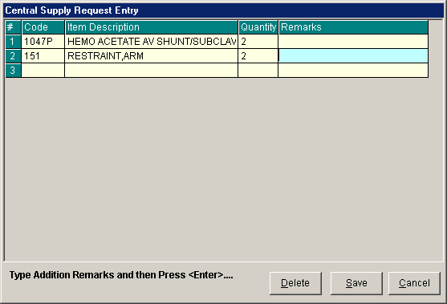
Figure 11: Central Supply Request Entry Window
Code - Type item code or first letter(s) of item name then press <Enter>. Or you can press <Enter> key if code is still blank to display the list of supplies. If <Enter> key is pressed, a window will be displayed showing list of supplies.

To select from the list, click “All Items” to display all supplies or you can categorize by clicking “Suppliers” or “Classification” then double-click on the desired item.

Item Description - This will be automatically displayed in reference with the selected item.
Quantity - Type the number of the item to request. Note that quantity should be greater than zero.
Remarks - An optional entry.

Follow the same procedure when adding items to request.

3 After completing the items to request, the user can do the following options.

To send the request in the Central Supply department, click on Save button.
To remove an item in the list, click the row of the desired item then click on Delete button.
Click on Cancel button to abort the entered items.

How to Request Patient’s Diet

This is where you can request and change the patient’s diet for the next meal.

1 Click on Send Requests tab option.

2 Click on Change Diet button at the right side of the window. When clicked, the Post New Diet Window will be displayed asking you to enter the following data.

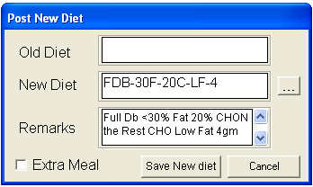
Figure 12: Diet Request Window

Old Diet - This will be automatically filled-up by the program.
New Diet - Type a new diet of the patient. To do it, press <Enter> key if New Diet textbox is still blank or click on . When clicked, a window will be displayed showing the diet codes listing.

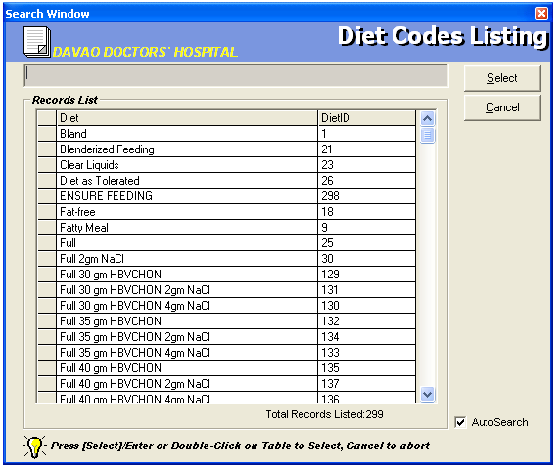
Figure 13: Diet Codes Listing Window

To select from the list, just double-click on the desired diet or click on the desired diet then click on Select button. Clicking on Cancel button will abort all your selected diets.

Remarks - Automatically filled-up in reference with the selected diet.

3 After completing the data to be entered, the user can do the following options.
Click the check box to have an extra meal for the patient.
Click on Save New Diet button to send the request.
To abort the request entered, click on Cancel button.

How to Transfer a Patient

1 Click on Send Requests tab option.

2 Click on Discharge/Room Transfer button at the right side of the window. When clicked, a window will be displayed.
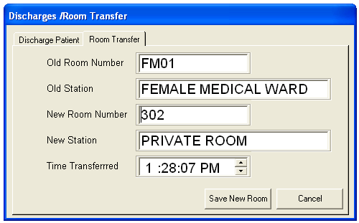
Figure 14: Room Transfer Window

Click on Room Transfer tab to open its window. The following data are needed to enter:

Old Room Number - Automatically filled-up by the program in reference with the patient’s current room.
Old Station - Automatically filled-up by the program in reference with the patient’s current station.
New Room Number - Type a new room number. To do it, press <Enter> key if new room number is still blank. If <Enter> key was pressed, a window will be displayed showing the list of rooms. Click on “All Rooms” to display list of all rooms or you can categorize by clicking on “Station” or “Accommodation”.
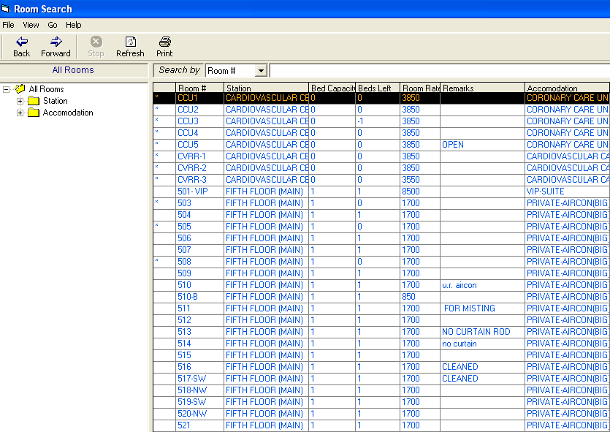
Figure 15: List of Rooms Window

New Station - Automatically filled-up by the program in reference with the selected new room.
Time Transferred - The server’s current time is used as the default entry. To set a time, click on the up and down arrows.

3 After completing the data, the user can do the following options.
Click on Save New Room button to transfer the patient into a new room.
Click on Cancel button to abort transferring the patient.

How to Confirm Room Transfer
For Incoming patients from another station, the target station should confirm the room transfer entered. The Wizard will appear, informing the station that there are incoming patients.

Double click on the wizard to display lists of patients transferred.
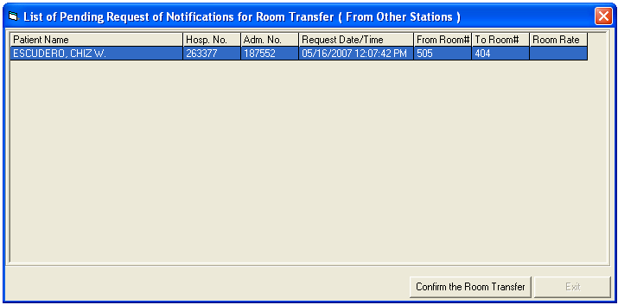
Click on the patient name then click on Confirm the Room Transfer button.

How to View List of Newly Admitted Patient
At the bottom of the patient’s list window, you can view the names of the newly admitted patients in your station.
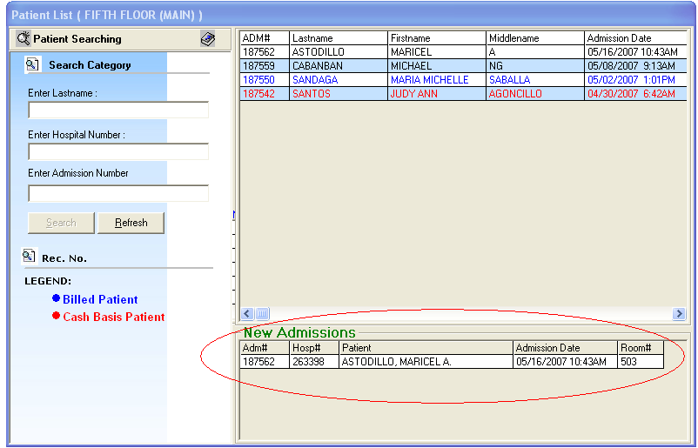

How to Send Discharge Notice

This option allows you to send discharge notice/processing sheet to Billing Department to inform that the patient is already cleared from charges from your department.

Nurse will send discharge notice to cost centers after receiving discharge order from patient's doctor. Visual Nurse program will not allow the user to send discharge notice if there are still pending requests from different cost-centers.

1 Click on Send Requests tab option.

2 Click on Send Clearance at the right side of the window. When clicked, the Discharge notice Window will be displayed. Complete the following information:

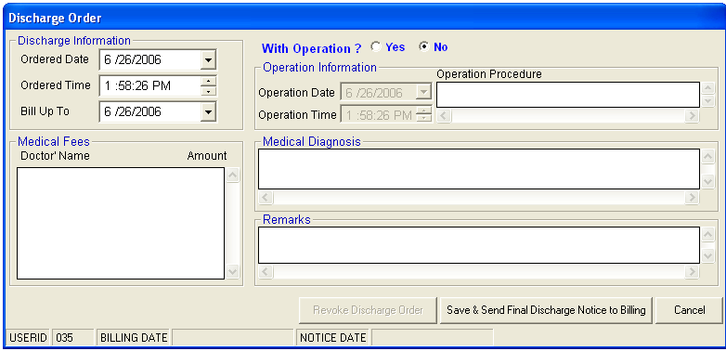
Figure 16: Discharge notice Window
Discharge Information
Ordered Date - Use the drop-down combo box to select the ordered date
Ordered Time - Use the up and down arrows to select the ordered time
Bill up to - Sets the deadline for the payment of the patient’s bill. To do it, use the drop-down combo box to select a date.
Operation Information - Click the "Yes" option if the patient has undertaken an operation.

Operation Date - Use the drop-down combo box to select an operation date.
Operation Time - Use the up and down arrows to select an operation time.
Operation Procedure - Type the operation procedure of the patient.

Medical Fees

Doctor’s Name - the name of the doctor
Amount - the medical fee of the doctor

Medical Diagnosis - Type medical diagnosis of the patient

Remarks - An optional entry

3 After completing the data, the user can do the following options.

Click on Save as Preliminary Data button to send the discharge notice.
Click on Save & Send Final Discharge Notice to Billing button to print. You must click this button to signal the Billing Department that the patient is already cleared from your department.
Click on Cancel button to abort discharge notice.

How to Stop Medicines

This option allows you to discontinue patient's medicine.

1 Click on Send Requests tab option.

2 Click on Stop Medicines button at the right side of the window. When clicked, the List of Medicines for Unit Dose Window will be displayed. The following data can be viewed.

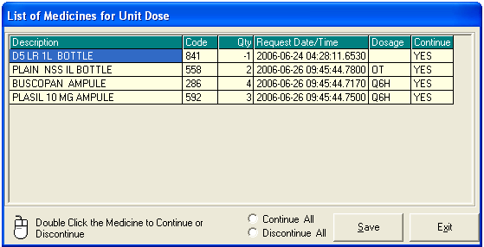
Figure 17: Stop Medicines Window
Description - description of the medicine
Code - the code of the item requested
Quantity - the number of item requested
Request Date/Time - the date and time when the item was requested
Dosage - the dosage of the medicine
State - continue or discontinue

3 The user can do the following options.
To change the state of the medicine, double-click on the desired medicine or to continue all or discontinue all, just click on the option box.
Click on Save button when completed.
Click on Exit button to close the List of Medicines for Unit Dose window.

How to Discharge a Patient

This option allows you to remove the patient physically from the list in order to monitor the availability of rooms.

Note: Before discharging a patient, a discharge notice should be sent first to the Billing department. Please refer to How to Send Discharge notice to know the request procedure.

1 Click on the encircled button of the figure displayed below
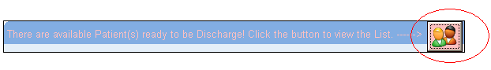.

2. After clicking, the window below will be loaded on the screen with the list(s) of patients to be discharged.
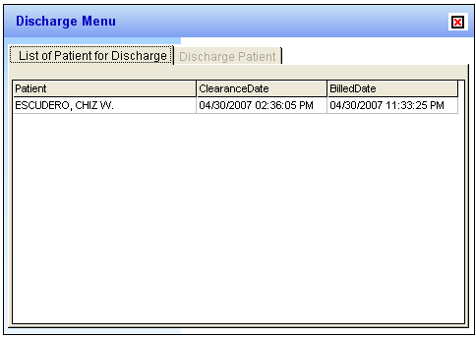
Double click on the patient name you want to discharge to display the discharge patient window below.
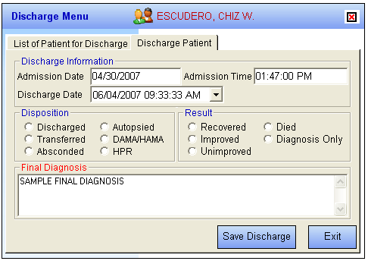

Admission Date - Automatically filled-up by the program in reference with the patient’s day of admission.
Admission Time - Automatically filled-up by the program in reference with patient’s time of admission.
Discharge Date - You can set the discharge date by clicking on the drop-down combo box. Note that discharge date should not go beyond the current date.
Discharge Time - You can set the discharge time by clicking on the up and down arrows.
Disposition - Click one from the list.
Result - Click one from the list.
* FINAL DIAGNOSIS – Type the diagnosis given by the doctor

3 After completing the data, the user can do the following options.
Click on Save Discharge to remove the patient physically from the list.
Click on Exit button to abort discharging the patient.

How to Enter Medicines Administered
This option allows you to enter the medicines administered to the patient.
To do this, click on Send Requests tab then Entry for Medicines Administered button. Enter your access code to load the window below

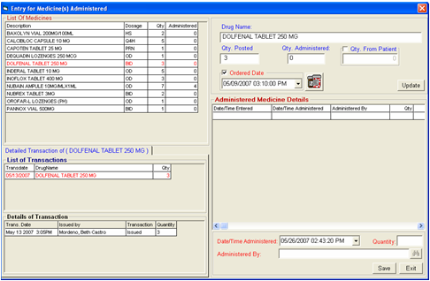
- To Enter the medicine administered, in the quantity box enter the total quantity of the medicines administered to the patient. The window where to enter the quantity is displayed below, the encircled part is where to enter the total quantity administered on a specific date and time.
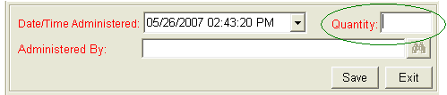

To view detailed transaction of a specific medicine, double click on the specific item then go to the Detailed Transaction window for the details of the item, a sample window is displayed below. It is where you can see the transaction done to a specific item such as the date issued, date returned or date adjusted.

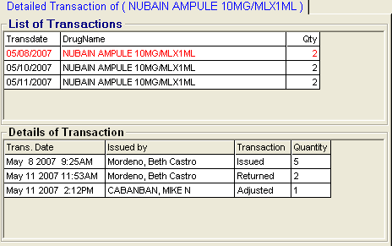

To view details of the medicines administered for the specific item, a sample window is displayed below. The qty column is the total quantity administered on a specific date and item and the person who administered the item is also displayed.

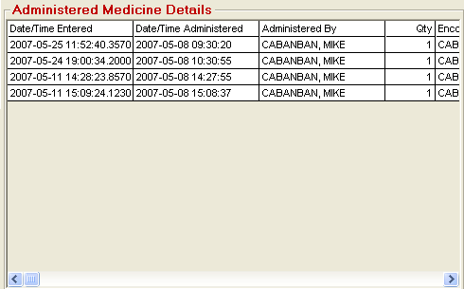

To enter the specific order date and time of the doctor for the specific medicine, go to the Ordered Date option. A sample window is displayed below.

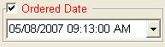

To enter quantity given by the patient if the specific medicine is purchased / bought outside, go to Qty. From Patient. Check on to activate the entry box then enter the quantity in the encircled part of the window displayed below then click on Update button to update the medicine transaction.
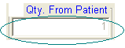

To print the medication sheet, click on 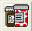 button.

How to Enter Admitting Diagnosis and Chief Complaint

1 Click on Send Requests tab option.

2 Click on Admitting Diagnosis/Chief Complaints Entry button. When clicked, a window will be displayed asking you to complete some missing information. The following data can be viewed.

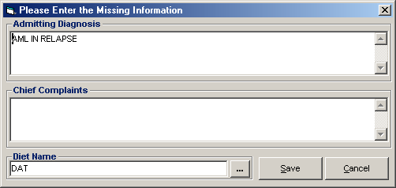
Figure 18: Admitting Diagnosis/Chief Complaints Window
Admitting Diagnosis - type the admitting diagnosis of the patient.
Chief Complaints - type the complaint of the patient.
Diet Name - press <Enter> key if diet is still blank or click on to display the Diet Code Listing.

3 After completing the data, the user can do the following options.
Click on Save button to save the information.
Click on Exit button to close the window.

How to Enter Height and Weight

This option allows you to enter the height and weight of the patient for clinical reference.

1 Click on Send Requests tab option.
2 Click on Height and Weight Entry button located at the right side of the window.
3 Its window will be displayed.

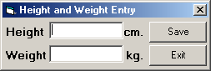
Figure 19: Height and Weight Entry Window
Enter the following data.
Height - Type patient’s height in centimeter.
Weight - Type patient’s weight in kilograms.

4 The following button options can be clicked from.
Save - This will save the entry.
Exit - This will close window without saving the entry.

How to Enter Charges of Inpatient

In this option is where you can enter charges of nursing services and supplies.

1 Click on Send Requests tab option.

2 Click on Post Charges button at the right side of the window. When clicked, the Post Charges Window will be displayed. Complete the following data.

Department Code - Refer to the list of department codes written at the bottom of the window.
Item Code - Type the service code or first letters of the service name then press <Enter> key. Or you can press <Enter> key if item code is still blank. When pressed, the Revenue Code window will be displayed showing all revenue codes.
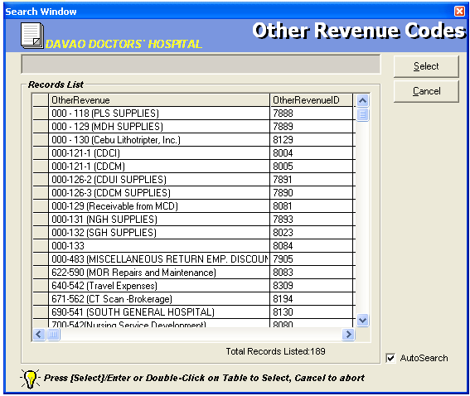
Figure 20: Revenue Codes Window

To select from the list, double-click on the desired item or click on the desired item then click on Select button. Clicking on Cancel button will abort the selection.

Item Description - Automatically filled-up by the program in reference with the selected item.
Quantity - Automatically filled up by the program in reference with the selected item but this can still be edited.
Unit Price - Automatically filled up by the program in reference with the selected item.
Amount - Automatically filled up by the program in reference with the selected item and its quantity.

3 After entering the items to be charged, the user can do the following options.
Click on Save button to save entered items. When clicked, a printable form will be displayed. Click on to print. Entered items will be automatically charged to the patient’s bill.
To remove the selected item, click on the desired item then click on Delete button.
Clicking on Exit button will close the Post Charge window.

4 At the bottom of the window, the user can also do the following options.

To view list of charges entered, click on List of Charges Entered button.
To cancel requested charges, double-click on the requested item or click on the desired item then click on Cancel Charges button.
To have a copy of charge slip of the requested item, click on Re-print Charge Slip button.

How to Enter Charges of Cash-basis Patient
This option allows you to enter charges of nursing services and supplies to a selected cash-basis patient.

1 Click on Send Requests tab option.

2 Click on Cash Assessment Entry button at the right side of the window. When clicked, the Cash Assessment Entry Window will be displayed. Complete the following data.

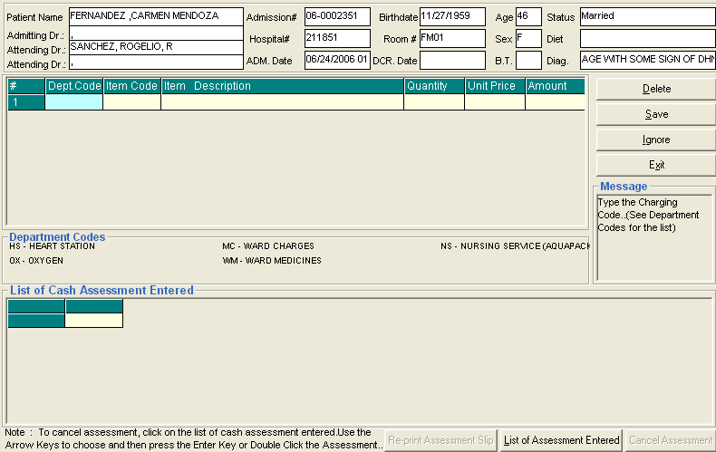
Figure 21: Cash Assessment Window

Department Code - Refer to the list of department codes written at the bottom of the window.
Item Code - Type the service code or first letters of the service name and then press <Enter> key. Or you can press <Enter> key if item code is still blank. When pressed, the Revenue Code window will be displayed showing all revenue codes.

To select from the list, double-click on the desired item or click on the desired item then click on Select button. Clicking on Cancel button will abort the selection.

Item Description - Automatically filled-up by the program in reference with the selected item.
Quantity - Automatically filled up by the program in reference with the selected item but this can still be edited.
Unit Price - Automatically filled up by the program in reference with the selected item.
Amount - Automatically filled up by the program in reference with the selected item and its quantity.
3 After entering the items to be charged, the user can do the following options.
Click on Save button to save entered items. When clicked, a printable form will be displayed. Click on to print.
To remove the selected item, click on the desired item then click on Delete button.
Clicking on Exit button will close the Post Charge window.
4 At the bottom of the window, the user can also do the following options.

To view list of charges entered, click on List of Charges Entered button.
To cancel requested charges, double-click on the requested item or click on the desired item then click on Cancel Charges button.
To have a copy of charge slip of the requested item, click on Re-print Charge Slip button.

How to Cancel an Item that is already PAID
In the List of Cash Assessment Entered window, click on the List of Assessment Entered to display list(s) of charges entered for the specific patient.
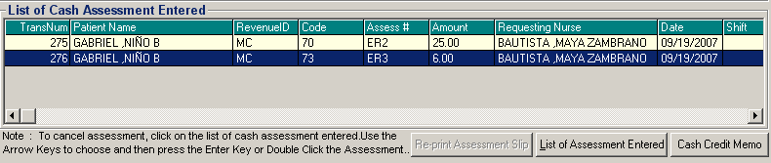
To cancel an item, highlight the specific item then click on Cash Credit Memo to load the window below.

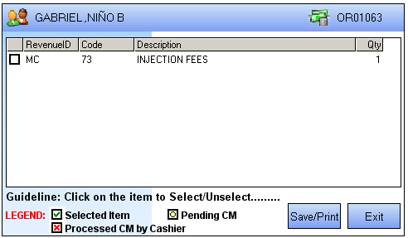
Click on the check box ( ) to select an item to be returned then click on Save/Print button.

Nurses Activity Request

From the requests posted in the Send Requests tab option, you can view here the status of each request.

Nurses Activity Request is where you can view list of processed requests, list of pending requests, list of exam with results, and reports such as diet list, census report by station, discharges for the day, list of requests/orders, list of medicine posted and list of supplies posted.

1 Click on Nurses Activity Request tab option.

2 Its window will be displayed showing the following data.

List of Processed Requests - These are the lists of requests that were already processed by the department in response to the requests done in the Send Requests tab option.

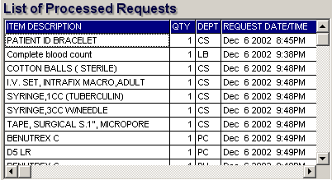
Figure 22: List of Processed Requests

List of Pending Requests - These are the lists of requests posted in the Send Requests tab option which are not yet acknowledged by the receiving department.

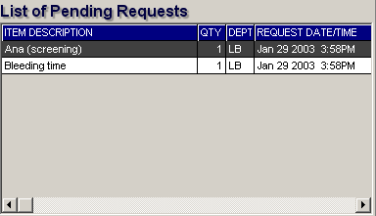
Figure 23: List of Pending Requests

To cancel a request, double-click on the desired item.

List of Exams with Result - These are the list of exams posted in the Send Request tab option that already have result and its details can be viewed in the View Results tab option.

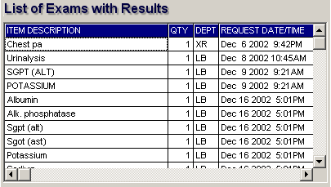
Figure 24: List of Exams with Result

3 The following button options can be clicked from.

Click on Refresh button to view the latest update from the database.
Click on Exit button to close the program.

Viewing of Laboratory Exam Result

This option allows you to view result of laboratory tests and exams.

1 Click on View Result tab option.
2 Its window will be displayed.
3 Click the Laboratory tab to view laboratory exams with result.

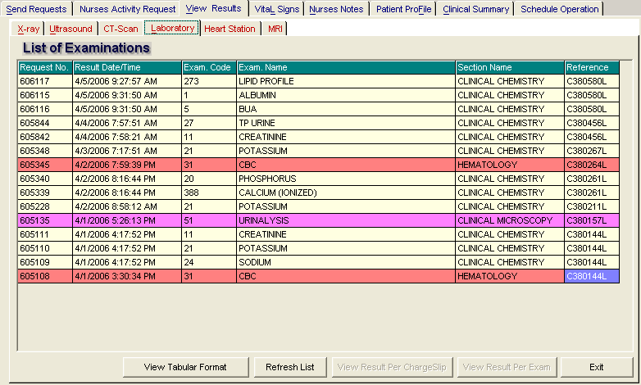
Figure 25: Laboratory View Exam Result Window
To view, click the exam and then click on View button. The Refresh button is used to view the latest updates of laboratory exams with results from the database. While the Exit button is used to close the program.

Viewing of X-ray Exam Result

This option allows you to view result of x-ray exams.

1 Click on View Results tab option.
2 Its window will be displayed.
3 Click X-ray tab to view x-ray exam result. (X-ray window is the default window).

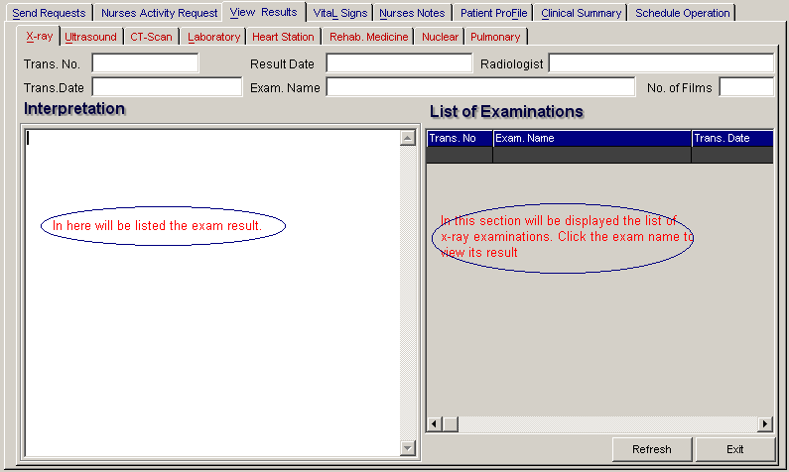
Figure 26: X-ray Exam View Exam Result Window

The list of examinations is displayed at the right side of the window. Just click the desired exam to view its result. The exam result can be viewed at the left side of the window.

4 The following buttons can be clicked from.
Refresh - This will view latest updates of exams with result from the database.
Exit - This will close the program.

Viewing of Ultrasound Exam Result

This option allows you to view result of Ultrasound exams.

Click Ultrasound tab to view exams with result. The same steps with viewing of x-ray exam are followed. Please refer to Viewing of X-ray Exam Result to know the procedure.

Viewing of Heart Station Exam Result
This option allows you to view result of Heart Station exams.

1 Click on View Result tab option.
2 Its window will be displayed.
3 Click Heart Station tab to view exams with result.

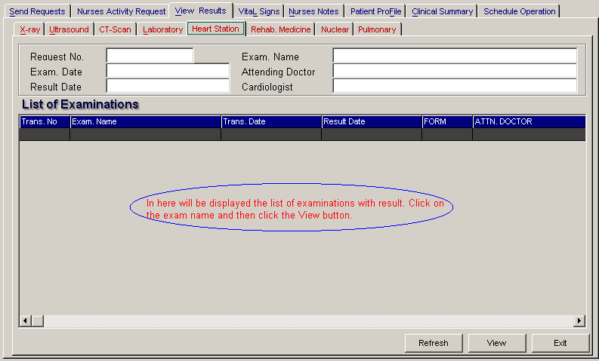
Figure 27: Heart Station View Exam Result Window

To view, click the exam and then click on View button. The Refresh button is used to view the latest updates of laboratory exams with results from the database. While the Exit button is used to close the program.

Viewing of C. T. Scan Exam Result

This option allows you to view result of C. T. Scan exams.

Click C.T.-Scan tab to view exams with result. The same steps with viewing of x-ray exam are followed. Please refer to Viewing of X-ray Exam Result to know the procedure.

How to Enter Vital Signs

In here, it is where you can enter vital signs of the patient. Vital signs data entry includes blood pressure, body temperature, respiratory rate, and pulse rate.

1 Click on Vital Signs tab option.

2 On the left side, you can see the previous vital signs of the patient. The following data can be viewed.

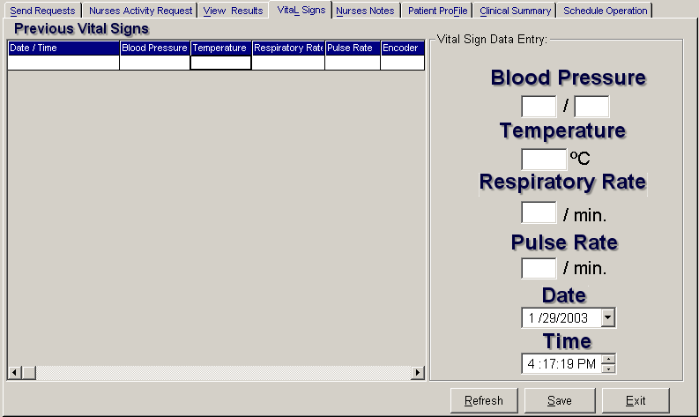
Figure 28: Vital Sign Data Entry Window
Date/Time - the date and time when vital sign was entered.
Blood pressure
Respiratory rate
Pulse rate

And on the other side is the vital sign data entry. The following data needed to enter.

Blood pressure
Body temperature
Respiratory rate
Pulse rate
Date
Time

3 The following button options can be clicked from.

Click on Save button to save entry.
Click on Refresh button to view the latest update from the database.
Click on Exit button to close the program.

How to Enter Nurses Notes

Nurses Notes window is where you can type down notes or remarks about the condition of the patient. It works like an electronic notebook because you can retrieve the saved data of a particular date and shift of the day.

1 Click on Nurses Notes tab option.

2 To view past patient’s chart, click on Past Notes written vertically. The following data can be viewed.

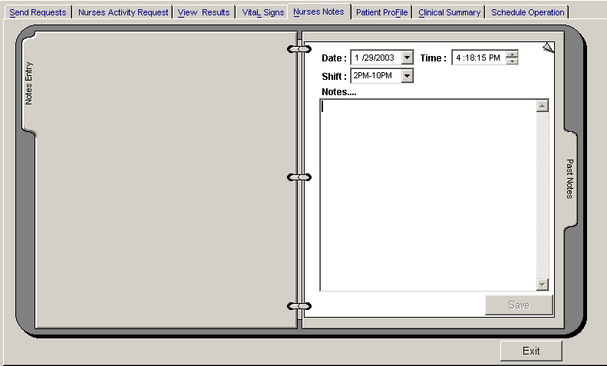
Figure 29: Nurses Notes Window
Date/Time - the date and time when the remarks were entered
Day shift - the shift of the day
Entered by - the program user who entered the remarks
Notes - the content of the remarks

To enter patient’s chart, click on Notes entry written vertically. Enter the following data.
Date/Time - current date and time is used
Day shift - select from the following choices listed (6am-2pm, 2pm- 10pm, 10pm-6am)
Notes - Type remarks on the multi-line textbox.

3 The following button options can be clicked from.

Click on Save button to save the notes entered.
Click on Exit button to close the program.

How to View Patient’s Profile

Patient Profile is where you can view the latest patient’s information throughout patient's current confinement. It includes admitting diagnosis, chief complaints, manner of admission, past medical history, allergies, personal and social history and family history.

1 Click on Patient Profile tab option.

2 The Patient Profile Window will be displayed.

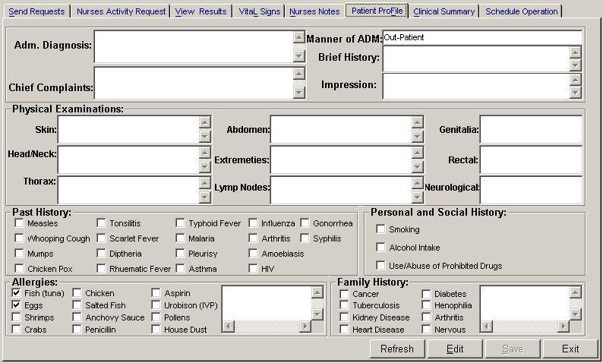
Figure 30: Patient Profile Window
3 The following button options can be clicked from.

To edit the patient’s profile, click on Edit button. The user can now make necessary modifications on the patient’s profile.
When completed, click on Save button to save the changes.
Click on Refresh button to undo the changes done.
Click on Exit button to close the program.

How to Enter Co-Manage / Additional Doctors?
This option allows the nurses to add additional doctors or co-manage.
To do this, choose patient then click on button located at the patient’s personal information or press F12. A sample window is displayed below

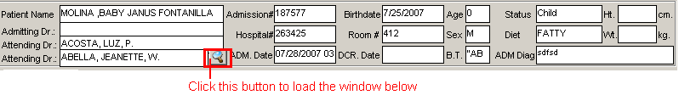

After clicking , a sample window is displayed below for the entry of additional doctors.
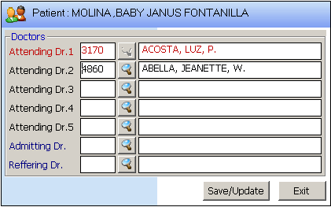
Enter doctors last name or press Enter key to display list(s) of doctors.
Click on Save/Update button to update patient data or click on Exit button to go out from this option

How to Update Room Status
This option allows the user to update the status of room if it is really for occupancy, for cleaning, for repair and occupied. To go on this option, press F4 to load the window below.

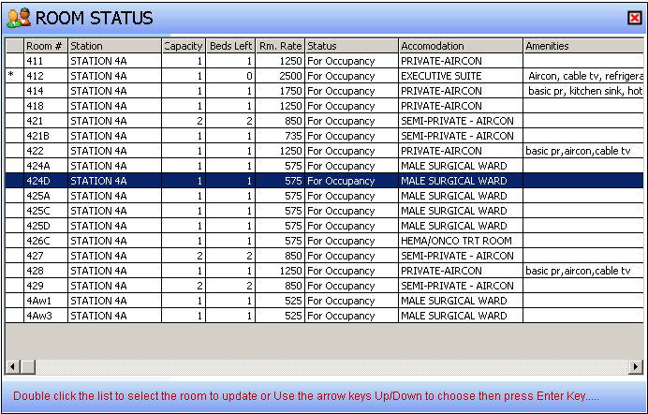

Double click on the room you want to update and a window will be loaded. A sample window is displayed below.

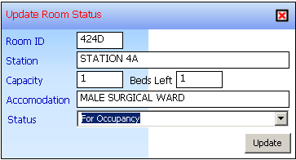
Choose status of room then click on Update button to save status entered.

How Print Claim Slip
This option allows the user to print the claim slip sent by AMS Department if patients bill is ready for pick-up. Sample window is displayed below.
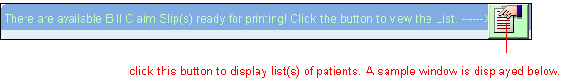
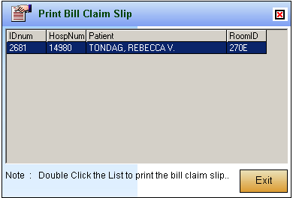

How to View Clinical Summary

Clinical summary is where you can view for a particular clinical summary of a patient’s confinement.

1 Click on Clinical Summary tab option.

2 The Clinical Summary Window will be displayed. The following data can be viewed.

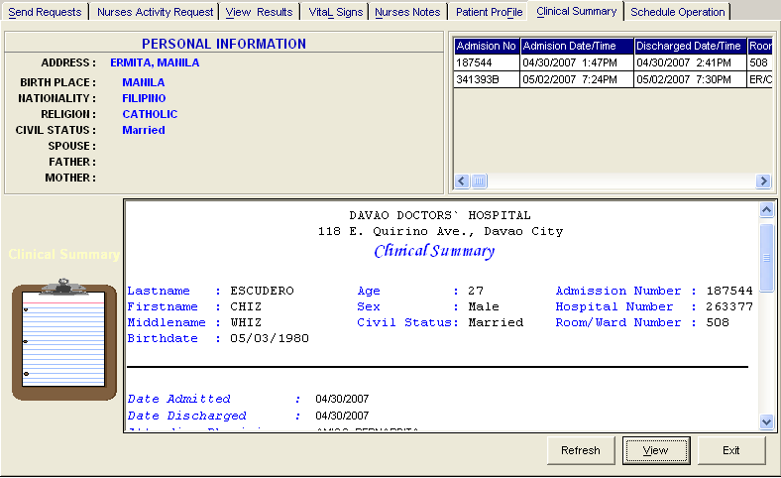
Figure 31: Clinical Summary Window

Admission number - a program-generated number during patient’s admission
Admission date/time - the date and time when the patient was admitted
Discharge date/time - the date and time when the patient was discharged
Room number - the room number of the patient during his confinement

3 To view for a particular clinical summary of patient, click on the desired exam then click on View button. The following data can be viewed.

Date admitted - the date when the patient was admitted
Date discharged - the date when the patient was discharged
Attending physician - the name of the attending physician
Admitting doctor - the name of the admitting doctor
Admitting diagnosis - the admitting diagnosis of the patient
Chief complaints - the complaint of the patient
Final Diagnosis - the final diagnosis of the patient

4 Click on Exit button to close the program.

How to Schedule Operation

This option allows you to schedule an operation for the patient through sending a request into the Operating Room department.

1 Click on Schedule Operation tab option.

2 The Schedule Operation Window will be displayed. Enter the following data.

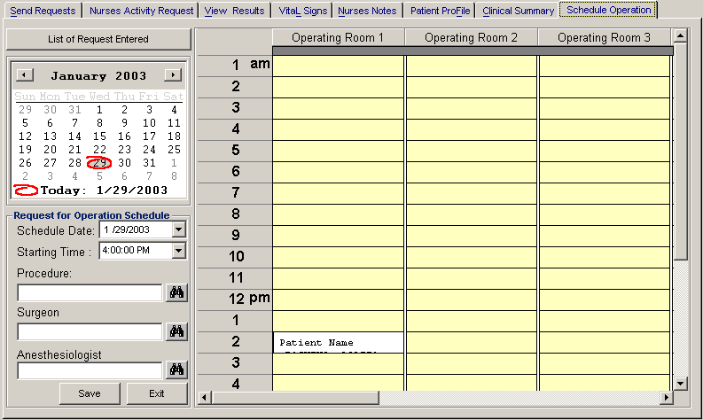
Figure 32: Schedule Operation Window
Schedule Date - Click on the drop-down combo box to select a date for the patient’s operation. Note that date to be scheduled should be later than the current date and time.
Starting Time - Click on the drop-down combo box to select a starting time for the patient’s operation in reference with the selected date.
Procedure - Press <Enter> key to display the list of procedures or click on button. A window will be displayed afterwards. Just double-click on the desired procedure to select.
Surgeon - Click on button to display the list of doctors. A window will be displayed afterwards. Just double-click on the desired surgeon to select.
Anesthesiologist - Press <Enter> key to display the list of doctors or click on button. A window will be displayed afterwards. Just double-click on the desired doctor to select.
3 The grid at the right side of the window is used to view the scheduled operation of the patient when the Operating Room department has already acknowledged the request. Just click the day of the scheduled operation then scroll the vertical or horizontal bar of the grid to view the scheduled operation.

Viewing of Reports

1 Click on Nurses Activity Requests tab option.

2 At the lower right corner of the window is listed the different reports that can be generated.

Diet List
Census Report
Discharges for the Day
List of Requests/Orders
List of Medicines Posted
List of Supplies Posted
List of Processed Requests
Click on the option you want to display a printable report. Click to print.

Shortcuts

Shortcut keys are useful to users for they lessen the time of opening a particular window. These shortcut keys can be seen at the bottom of the main window. Below is listed the commonly used shortcut keys.

F5 - Next Patient
F6 - Pharmacy Request (Charge Patient)
F7 - CSR Request
F8 - Discharge/Room Transfer
F9 - Discharge Notice
F10 - ICD 10
F11 - Statement of Account

Index

—A—
activity request, 48
admission history, 61
—B—
blood pressure, 58
—C—
c.t. scan exam, 18
cancel pending request, 48
cardiovascular exam (heart station exam), 20
cardiovascular exam result (heart station exam result), 53
cash-basis patient, 45
changing of password, 9
charge-basis patient (charging of services & supplies), 43
charging of nursing services and supplies (cash-basis patient), 45
charging of nursing services and supplies (charge-basis patient), 43
clinical summary, 61
closing the program, 10
complaint, 41
—D—
diagnosis and chief complaint, 41
diet, 33
discharge, 40
discharge order, 37
drug, 29
—E—
ending the program, 10
—F—
features, 7
—H—
height and weight, 42
hemodialysis exam, 24
history, 61
—L—
laboratory exam, 13
laboratoryexam result, 50
—M—
medicine, 29
—N—
Nuclear Lab. exam result, 54, 55
nuclear medicine exam, 21
nurses activity request, 48
nurses notes, 59
—O—
objectives, 6
operation, 62
overview, 5
—P—
password (changing of), 9
patient chart, 59
patient searching, 11
patient transfer, 35
patient's diet, 33
physical med. and rehab. exam (p.t. exam), request physical med. and rehab. exam (p.t. exam), 22
print request form of laboratoryexam, 47
profile, 60
pulmonary laboratory(rts) exam, 23
pulmonary laboratoryexam result (rts exam result), 56
—R—
rehabilitation exam result (p.t. exam result), 57
reports, 63
re-print request form of laboratoryexam, 47
request (cash-basis), 45
request (charge-basis patient), 43
request c.t. scan exam, 18
request cancellation, 48
request cardiovacular exam (heart station exam), 20
request form of laboratoryexam, 47
request laboratory exam, 13
request medicine, 29
request nuclear medicine exam, 21
request pulmonary laboratoryexam (rts), 23
request supplies, 31
request ultrasound exam, 17
request x-ray exam, 16
room transfer, 35
—S—
schedule operation, 62
search patient, 11
shortcut keys, 63
starting the program, 8
status of requested items, 48
stop medicines, 39
supplies, 31
—T—
temperature, 58
transfer, 35
—U—
ultrasound exam, 17
ultrasound exam result, 52
—V—
view cardiovascular exam result (heart station exam result), 53
view laboratoryexam result, 50
view Nuclear Lab. exam result, 54, 55
view Physical Therapy Exam result, 57
view pulmonary laboratoryexam result (rts exam result), 56
view reports, 63
view utrasound exam result, 52
view x-ray exam result, 51
vital signs, 58
—W—
weight, 42
—X—
x-ray exam, 16
x-ray exam result, 51

