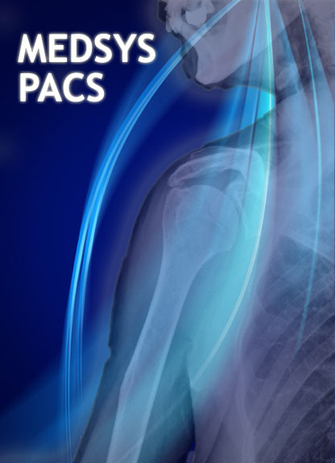

Conformance Statement



Information System for Hospitals
And Corporate Clinics



Kaiser–dela Cruz Consulting, Inc.

Supported Modalities:
CR | DR | CT | MR
NM | US | XC | MG

Capabilities
Patient Modality Worklist | Yes – MEDSYS
CINE | Yes
Browser (ActiveX & Jpeg) | Yes
Dicom Film Print | Yes
E-mail, and SMS | Yes
Voice Dictation, and Voice to text | Yes
Result Entry and Print | Yes
Burn CD (Multi-Patient) | Yes
Tools:
Smoothing & Sharpness | Yes
Windowing & Predefined W&L / Invert | Yes
Flip, Zoom, and Magnify | Yes
Measure / Ratio / Cobbs / Angle | Yes
Slice Viewer | Yes

Operations:
 | SCP | SCU
C-FIND | Yes | Yes
C-GET | Yes | Yes
C-MOVE | Yes | Yes

Supported image formats are:
MONOCHROME1
MONOCHROME2
PALETTE COLOR
RGB
YBR
YBR422_FULL
YBR422_PARTIAL

Supported Network transmission formats:
1.2.840.10008.1.2 Little-endian Implicit VR
1.2.840.10008.1.2.1 Little-endian Explicit VR
1.2.840.10008.1.2.2 Big-endian Explicit VR
1.2.840.10008.1.2.5 Little-endian Explicit VR : Run-Length Encoding of pixel data
1.2.840.10008.1.2.4.50 Little-endian Explicit VR : Baseline JPEG encoding of pixel data
1.2.840.10008.1.2.4.51 Little-endian Explicit VR : Extended JPEG encoding of pixel data
1.2.840.10008.1.2.4.57 Little-endian Explicit VR : Lossless JPEG encoding of pixel data
1.2.840.10008.1.2.4.70 Little-endian Explicit VR : Lossless JPEG encoding of pixel data (psv=1)
1.2.840.10008.1.2.4.90 Little-endian Explicit VR : Lossless JPEG 2000 encoding of pixel data
1.2.840.10008.1.2.4.91 Little-endian Explicit VR : Lossly JPEG 2000 encoding of pixel data

