MEDSYS
Information System

Time Keeping Program
User's Manual



MEDSYS
Kaiser dela Cruz Consulting Incorporated
July 29, 2026

Copyright©

ALL RIGHTS RESERVED

No part of this document may be reproduced through photocopying or in any means, stored into a retrieval system, and transmitted in any form without the express written permission of Kaiser dela Cruz Consulting Incorporated.
Permission is hereby granted to Medsys Information System. to copy and distribute this document in any of the above means provided this is for its exclusive on site use.
Although every precaution has been taken in the preparation of this manual, the company assumes no responsibility for errors or omissions. Neither is any liability assumed for any damages resulting from the use of the information contained here.

Table of Contents

Copyright© 2
Overview 3
Objectives 4
Features 4
Getting Started 6
How to Start the Program 6
Changing of User’s Password 7
How to End the Program 8
Program Operation 9
duction

Overview

The Visual Time Keeping Program provides routine tracking of employee log-in/log-out times. Employee simply swipe a magnetic card through a reader or employees user their fingerprints or handprints. At the end of the pay period, each employee’s hours are automatically reported to Personnel system, eliminating errors and reducing paper work.

Objectives
- To have more accurate time tracking and less work for HR department.
- To provide easy access to employee data, plus tools to audit the information for accuracy.

Features
- User-Accessibility Control – Each user has its own password and rights. He can only use the program intended for him.
- Schedule Management – Allows supervisors to create and maintain a schedule for each employee. Supervisors can set rules for scheduling staffers, including setting break times, holidays, and even whether overtime is allowable.
- Tracking report – Can track tardiness and patterns of absenteeism.
- Data-entry restriction - Warning messages are flashed for possible invalid entries. This ensures all data inputted would be made useful for any transaction that may occur.
- Password-protected - The use of password is necessary to restrict unauthorized access. Thus the program only accepts passwords which are registered into it. This feature ensures the confidentiality and integrity of data entered in the program.
- Auto-report generation - The program is capable of generating reports and can be readily printed
- User-friendly - The program user is guided by instructions in doing the next step providing an easy-use to process transactions. Tool-tips are also incorporated to give users an idea of what a particular button does.

Getting Started

How to Start the Program
1 Click on  User Manager program executable file icon located in your computer desktop.
2 The Login window will display asking you to type your employee number and password for security purposes.
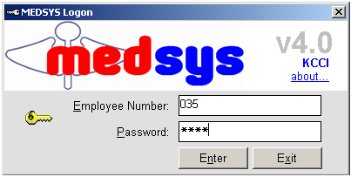
Figure 1: Login Window
3 If the program has validated your employee number and password, the Cashier Setting Window will be displayed. This window serves as the data entry for principal O.R., collection date, remittance date and shift.

Changing of User’s Password
It is advisable to change your password frequently for security reasons. To change your current password, follow these steps.
1 From the Login window, type your employee number and then press <Enter>.

2 Under the password entry, press <F12> Pressing this function key will invoke the Change Password window.
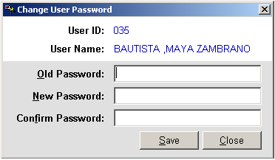
Change Password Window
3 Under the Change Password Window, type the following data.
Old Password – Type your existing password
New Password – Type your new password not exceeding to 15 characters
Confirm Password – Retype your new password to confirm and then press <Enter> or you can click the Save button.

How to End the Program
It is important for users to close the program when they are done to end-up their session. Other users might use the open program using the same password.
To close the program:

1 Click on at the upper right corner of the screen or
2 Click File > Exit.

Program Operation
Visual Time Keeping Menu
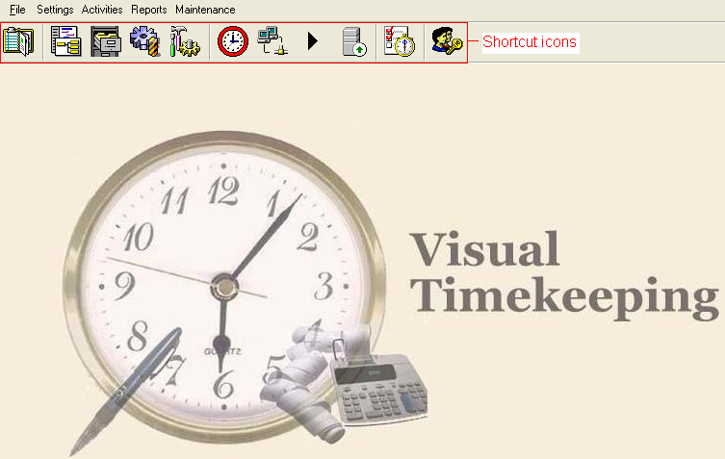
This is the Visual Timekeeping main menu. Users are provided with shortcut icons for faster use of the program

 - Multiple Schedules 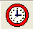 - DTR Inquiry
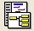 - Shifts 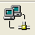 - Import DTR
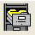 - Holidays  - Process DTR
 - Timekeeping Settings  - Upload to Payroll
 - Department Cutoff 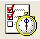 - DTR Report
 - User Settings
A. DATA ENTRY

HOW TO ENTER EMPLOYEE’S SCHEDULE

On the main menu, go to File – Data Entry.

1.1 Fixed Schedule – This option allows you to enter employee’s schedule that are fix. For example, if an employee has a schedule of 8:00 am to 5:00 pm straight from Monday to Saturday, then this is where you will enter the schedule of that employee.

Fig. 1.1: Fixed Schedule
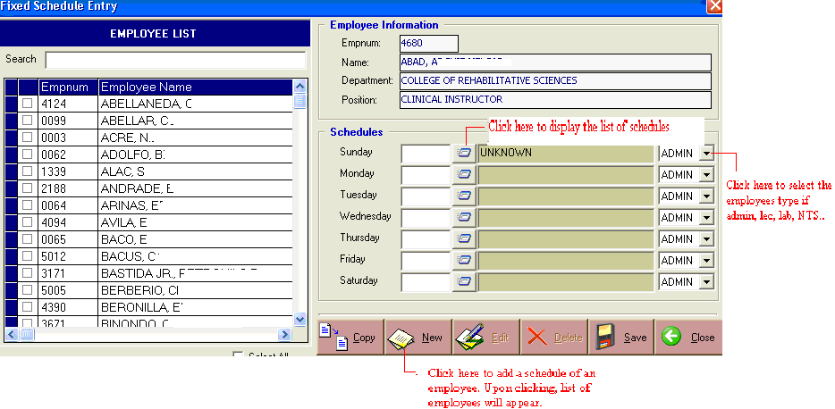

Click the ‘New’ button and the list of employees will appear. Select the desire employee and then enter the schedule and the employee type if admin, lec, lab, or non-teaching. And then click ‘Save’ afterwards.

- Other buttons include Copy (when you’re going to copy the schedules to Schedule option), Edit (when editing schedule), and Close (when closing the entire window).

  - Fixed Schedule (Multiple) – This is where you will enter the employee’s schedules that are broken. For instance, an employee has a schedule of 8:00-9:30, then 10:30-11:30, followed by 2:30-4:30 on the same day.

Fig.1.2: Fixed Schedule (Multiple)
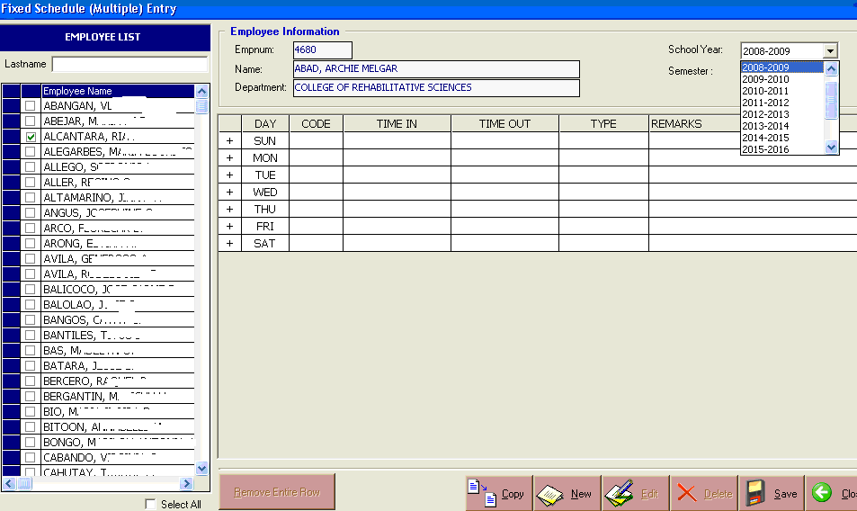

Click the ‘New’ button and the list of employees will appear. Select the desired employee, the ‘School Year’ and the ‘Semester’. Enter the schedule and the employee type if admin, lec, lab, RLE, or non-teaching. And then click ‘Save’ when finished.

  - Multiple Schedule – This is where the copied schedules from the Fixed Schedule and
Fixed Schedule (Multiple) entry will appear. All you have to do is counter check if the schedule is correct. You still have the option to edit it.

Multiple Schedules
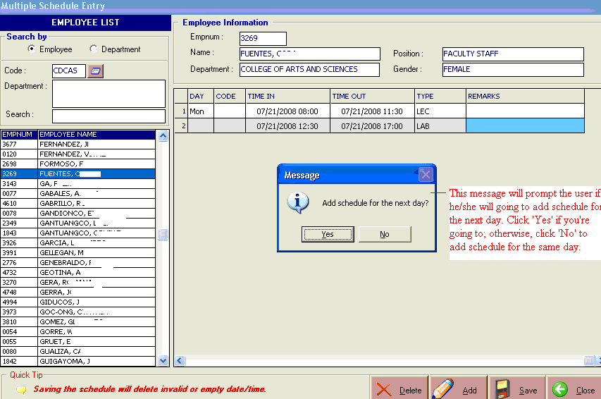

Once you have copied the schedules entered on the Fixed Schedule entries, it will just appear in Schedule/Multiple Schedule. Click the ‘Add’ button to add employee’s schedule that were not entered yet on the Fixed Schedule entry. The employee’s list is located on the left side of the window. You can search an employee by typing his/her lastname on the search bar. You have two options when searching – Search by Employee, or Search by Department.

- Overtime
Overtime is the amount of time someone works beyond normal working hours. Normal hours may be determined in several ways:
- by custom (what is considered healthy or reasonable by society),
- by practices of a given trade or profession,
- by legislation,
- by agreement between employers and workers or their representatives.

This is where you will enter the employee’s overtimes.

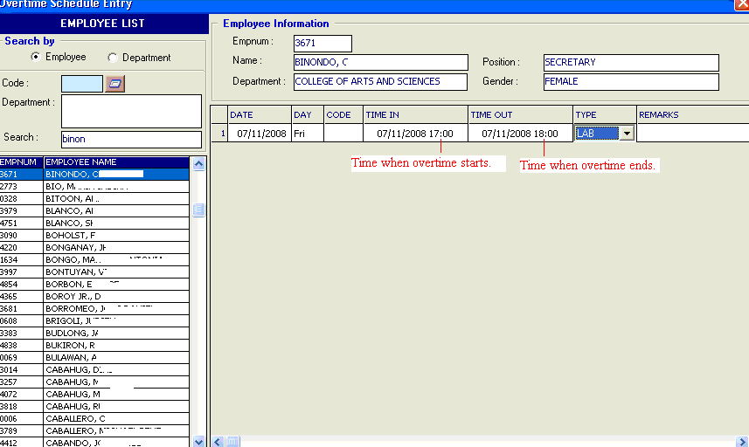

Select an employee on the list located on the left side and click the ‘Add’ button, enter the date and time in/time out, and click the ‘Save’ button when finished.

3. Late Filed Overtime

This is where you will enter the late filed overtime.
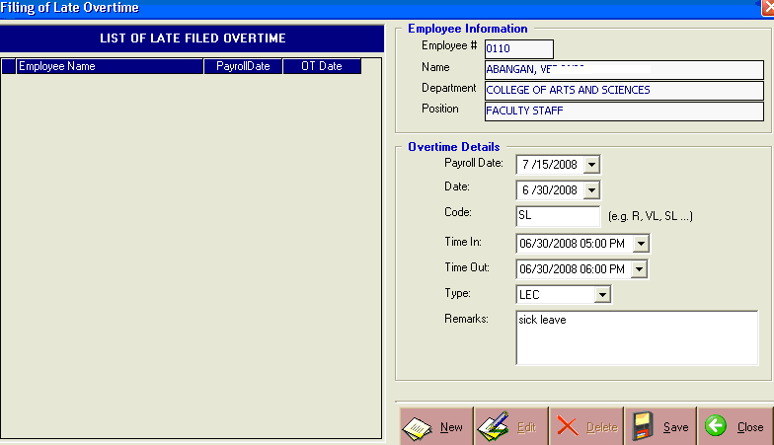
Click the ‘New’ button and the list of employees will appear. Choose an employee by double-clicking his/her name and the window above will appear. Fill up the necessary fields and click ‘Save’ button when finished.

4. Pass Slip

This option is used when a particular employee goes out of the school vicinity for official or
personal purposes.
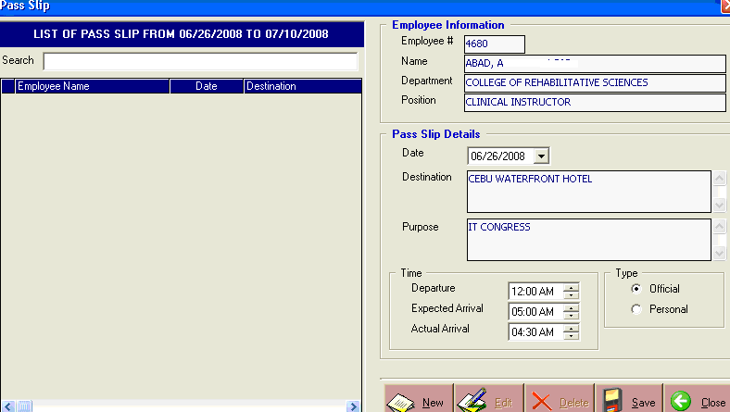
Fill up the pass slip details which include destination, purpose, time, and purpose type.

Note: If it is an official purpose, the employee has no need to time in/time out. If it is a personal purpose, the employee needs to time in/time out in order for the system to capture the exact time in/time out of an employee.
5. Out based DTR

This is where the employees who don’t use the Timed In/Timed Out system and only uses DTR’s to manually write their Time in/Time out will going to be entered.
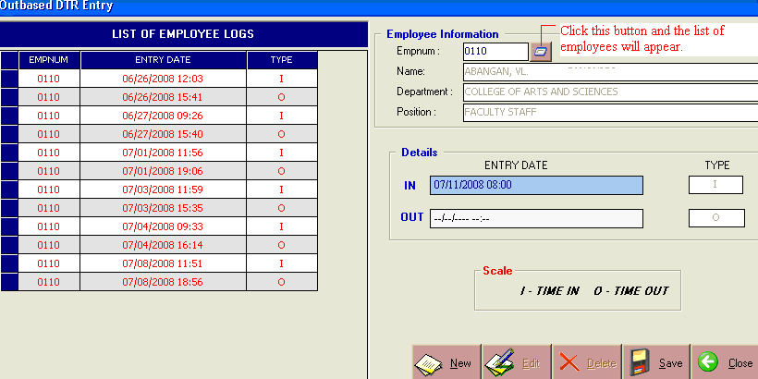
Click and the list of employees will appear. Choose an employee and fill up the entry date which includes the Time In, Time Out, and the Date. ‘I’ for Time In and ‘O’ for Time Out. When finished, click ‘Save’ and the list of entered employee logs will appear on the left side.

6. Batch Update Schedule

This option is used when there is a need to re-tag employee’s schedule. For example, the president announced that July 11, 2008 is a special holiday. You have the option to change the schedule of all employees at once on that particular day by entering the Date, Code, and employee Type on the New Schedule and then click ‘Update’ to update the schedule.
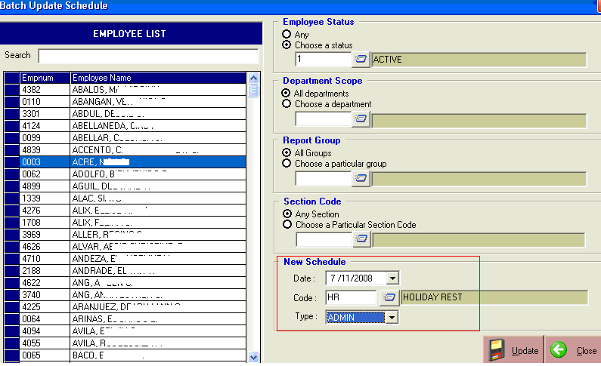

B. SETTINGS

Shift Schedule

This is where the shift schedules are going to be built.

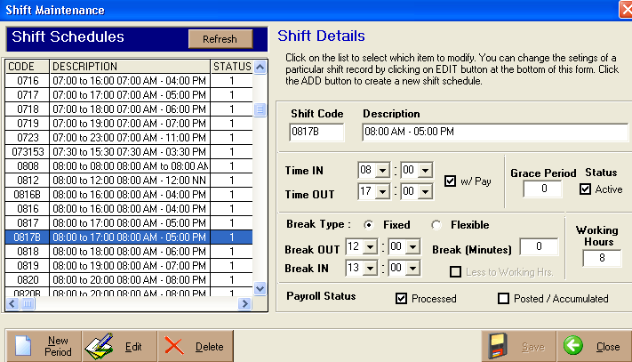

To add new shift schedule, just click the ‘New Period’ located at the lower left part of the window below.

Holidays

This is where the holidays are going to be built.

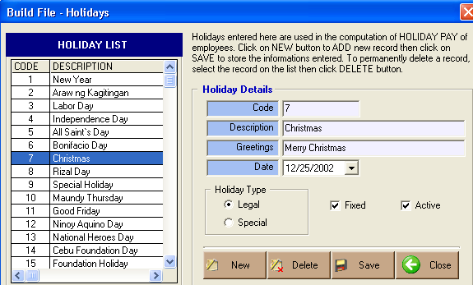

To add holiday, just click on the ‘New’ button, fill up the holiday details, and then click ‘Save’ when finished. You also have an option to delete a particular holiday by clicking on the ‘Delete’ button.

Timekeeping Settings

This option allows you to enter the settings of timekeeping.

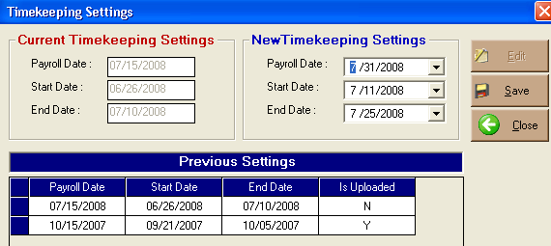

For the payroll date 07/15/2008, the start date is 06/26/2008 and the end date is 07/10/2008. The new timekeeping settings will automatically be generated.

C. ACTIVITIES
DTR INQUIRY

This option is where you could see the employee’s logs from 06/25/2008-07/11/2008. You will notice that it is one day delayed (cut-off starts at 06/26/2008) and one day advance (cut-off ends at 07/10/2008). This is to make sure that the system will capture the exact time of logs of employees from the start date to the end of the cut-off date.

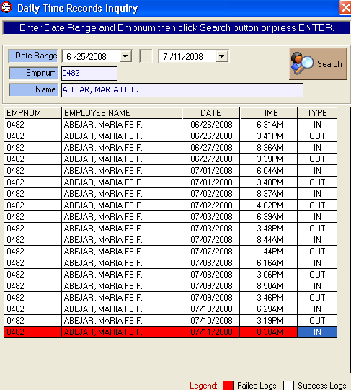

The red tag means that the employee has log-in but failed to log-out or vice versa.

IMPORT DTR

This option allows the user to import DTR records from the time-in time-out system (fingerprint).

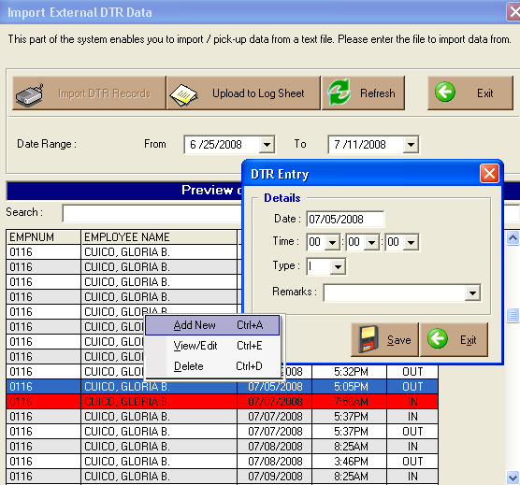

The red mark indicates that the employee has Timed Out but was not able to Time In on the same day. You can Add the time in of that employee on that day, View/Edit it, or Delete it. To do it, just right click on the mouse.

Click on the ‘Upload to Log Sheet’ button to upload the log sheet of employees that will be needed in processing the DTR’s of employees.

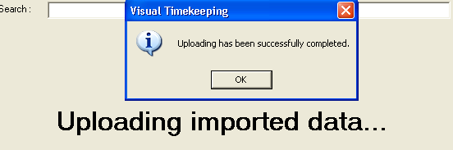

Process DTR

This part of the system allows the user to process the imported and uploaded DTR’s.

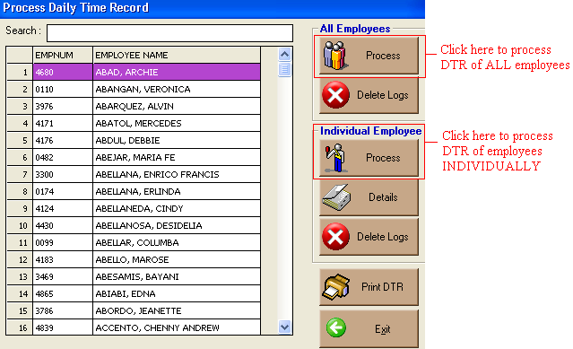

You can also view/print the DTR of employees individually or by all employees by clicking the ‘Print DTR’ button.

Upload to Payroll

This option allows the user to upload the processed DTR data to payroll. The message below will prompt the user asking if he/she is sure in uploading processed DTR to payroll. Click ‘Yes’ to continue the transaction; otherwise, click the ‘No’ button.

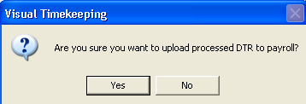

Note: Before uploading to payroll, be sure that you already countered check the logs of employees, especially those who have Time In but didn’t have Time Out or vice-versa and all the necessary data like the schedules, the employees leave, the outbased DTR’s and the like.

D. MAINTENANCE

Exempted to Log

Allows the user to enter the employees who are exempted to log. These may include those who are in higher or powerful positions.

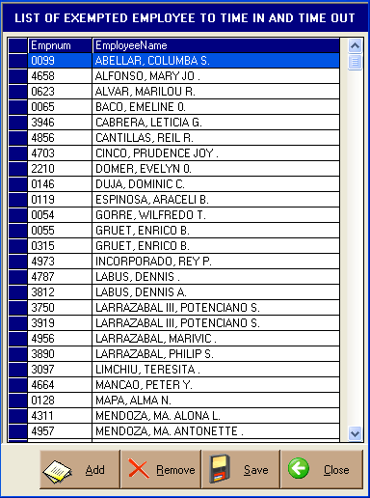

Just click the ‘Add’ button and list of employees will appear. Choose an employee and then click ‘Save’ when finished. You also have an option to remove an employee on the list by clicking the ‘Remove’ button.

E. REPORTS

The following reports can be generated from the system.

- Logs Report
- Tardiness
- Undertime
- Absences
- Overtime
- Holiday
- Leaves Report
- Schedule Report
- DTR
- Questionable Logs Report
- Pass Slip Report

