MEDSYS
Information System

Visual Pulmonary Program
User's Manual



MEDSYS
Kaiser - dela Cruz Consulting, Inc.
July 28, 2026
©Copyright
ALL RIGHTS RESERVED

No part of this document may be reproduced through photocopying or in any means, stored into a retrieval system, and transmitted in any form without the express written permission of Kaiser - dela Cruz Consulting, Incorporated.
Permission is hereby granted to Medsys Information System to copy and distribute this document in any of the above means provided this is for its exclusive on site use.
Although every precaution has been taken in the preparation of this manual, the company assumes no responsibility for errors or omissions. Neither is any liability assumed for any damages resulting from the use of the information contained here.

Table of Contents
Overview 4
Features 5
Getting Started 6
How to Start the Program 6
How to End the Program 7
Program Operation 8
Cash Basis Patient Request 8
Charge Basis Outpatient Request 10
Inpatient Request 12
Pharmacy Request 14
Result Entry 16
Result Inquiry 18
Processing of Pending Requests 20
Clearing of Patients for Discharge 22
Request Cancellation 24
Reprinting of Charge Slip 26
Assessment Status 27
Pharmacy Request Status 28
Patient’s Ledger 29
Updating of Walk-in Master File 30
Report 32
Index 33

Overview


The Visual PULMONARY Program is a computerized processing of PULMONARY procedure request. This is connected to other Medsys programs such as Visual Nurse to receive and process request and to enter the exam result into the computer which can be accessible to all stations once it is verified.
The use of password protects the program by disallowing the access of authorized users. Only program users with a registered employee number and password can gain access into it.

Objectives
- To improve the process involved in requesting PULMONARY procedures from stations and in entering results accessible to all stations.
- To computerize the use of charge slip and assessment slip resulting into a smooth communication with the Cashier and Billing.

Features
- Data-entry restriction - Warning messages are flashed for possible invalid entries. This ensures all data inputted would be made useful for any transaction.
- Password-protected - The use of password is necessary to restrict unauthorized access. Thus the program only accepts passwords which are registered into it. This feature ensures the confidentiality and integrity of data entered in the program.
- Auto-report generation - The program is capable of generating report Pulmonary and can be readily printed.
- User-friendly - The program user is guided by instructions in doing the next step providing an easy-use to process transactions. Tool-tips are also incorporated to give users an idea of what a particular button does.

Getting Started

How to Start the Program
- Click on PULMONARY program executable file icon located in your computer desktop.
- The Login window will display asking you to type your employee number and password for security purposes.
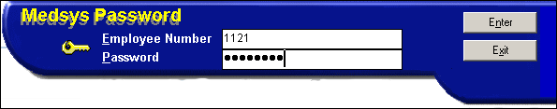
Figure 1: Login window

- If the program has validated your employee number and password, you may now start a transaction. Otherwise, a message will display prompting “Unauthorized User”.

How to End the Program
It is recommended to close your program when you are done to end-up your session. Other users might use the open program using the same password.

To close the program:
- Click on button located at the right corner of the main window (possible only if no other window is open)

Program Operation

Cash Basis Patient Request
This option allows you to request PULMONARY procedures to a cash basis patient. Saved items are automatically forwarded to Cashier for patient’s payment.

- Click 'Data Entry' > 'Assessment' or click on  button to display the window below.
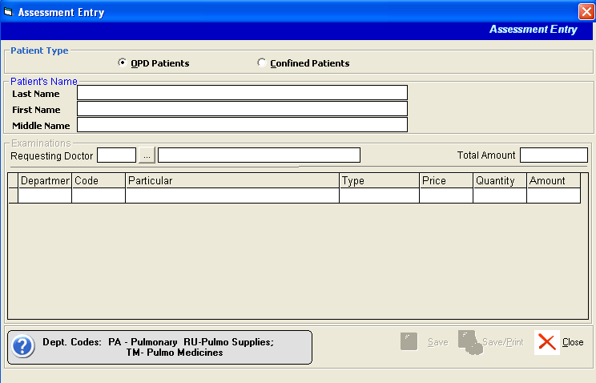
Figure 2: Assessment Entry window

- Under 'Patient Type' entry, choose either from ‘OPD Patients’ or 'Confined Patients'. These options are treated as cash basis.
- To search the patient, type in the patient’s last name under the 'Last Name' entry. To do, type the first few letters of the patient’s last name and then press the <Enter> key. A window will appear matching your query. Double-click the patient’s name to select.
- Enter the patient’s requesting doctor.
- To request the procedure(s):
  - Department - This is the code of the department to which the procedure belongs. The department code is listed at the bottom of the window. E.g. 'PA' for Pulmonary'
  - Code - Type the code of the procedure or press Enter key to display the complete list(s) of the selected department.
  - Particular - This is the description of the procedure.
  - Type - Choose either from 'Routine' or ’stat'
  - Price - This is the price of the selected procedure.
  - Quantity - Type the quantity of procedure to request.
  - Amount - This is automatically computed in reference with the entered quantity and price.

The total amount of the requested procedure(s) can be seen just above the 'Amount'.

- To save:
- Click on 'Save' button (to save) or 'Save/Print' button (to save and print the assessment slip).

Charge Basis Outpatient Request
This option allows you to request PULMONARY procedures to a charge basis outpatient.

    - Click 'Data Entry' > 'Charge Entry' or click on button to display the window below. The patients displayed in the list are currently registered outpatients. To search a previously registered outpatient, uncheck the checkbox 'Current Registration Only'.
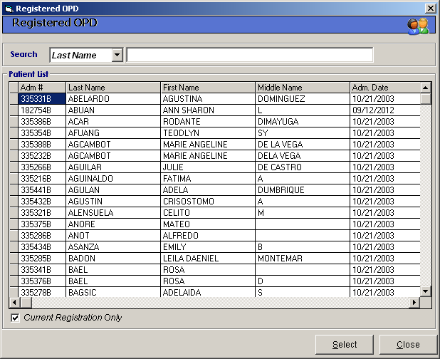
Figure 3: Charge basis Outpatient Request: Patient Searching

    - You can search a patient by his last name or admission number. To select, double-click the patient name from the list. The window below will appear.
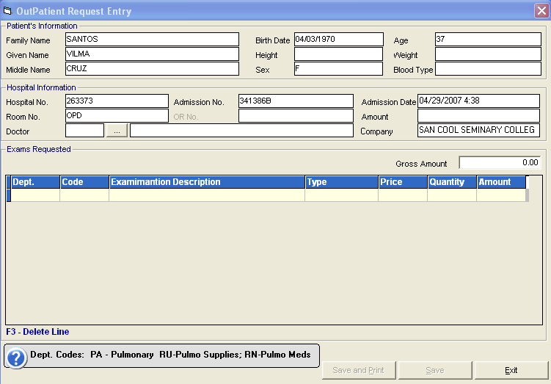
Figure 4: Charge basis Outpatient Request: Request Entry
    - Enter the patient’s doctor.
    - To request the procedure(s):
  - Department - This is the code of the department to which the procedure belongs. The department code is listed at the bottom of the window. Example is 'PA' for 'Pulmonary'
      - Code - Type the code of the procedure or press on Enter key to display the complete list(s) of items of the selected department.
      - Particular - This is the description of the procedure.
      - Type - Choose either from 'Routine' or ’stat'
      - Price - This is the price of the selected procedure.
      - Quantity - Type the quantity of procedure to request.
      - Amount - This is automatically computed in reference with the entered quantity and price.
The total amount of the requested procedure(s) can be seen just above the 'Amount'.
- To save:
  - Click on Save button (to save) or Save/Print button (to save and print the charge slip).

Inpatient Request
This option allows you to request PULMONARY procedures to an inpatient. This is an alternative way if stations missed to enter the PULMONARY procedure using their own MEDSYS program.

- Click 'Data Entry' > 'In-Patient Request Entry' or click on  button to display the window
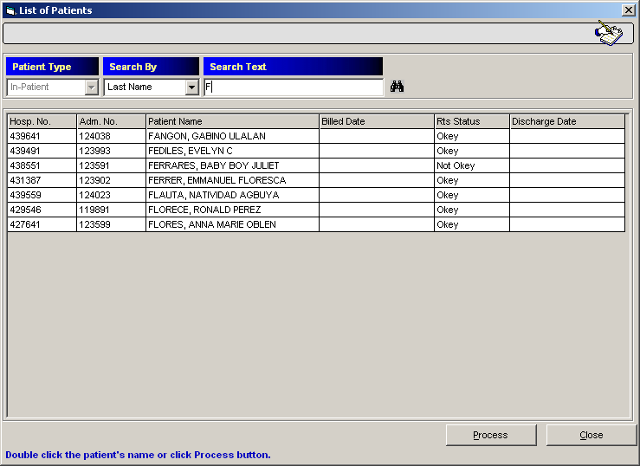
Figure 5: Inpatient Request: Patient Searching

- You can search the patient by his last name, admission number, or hospital number. To select the patient from the list, double-click it. The window below will appear.
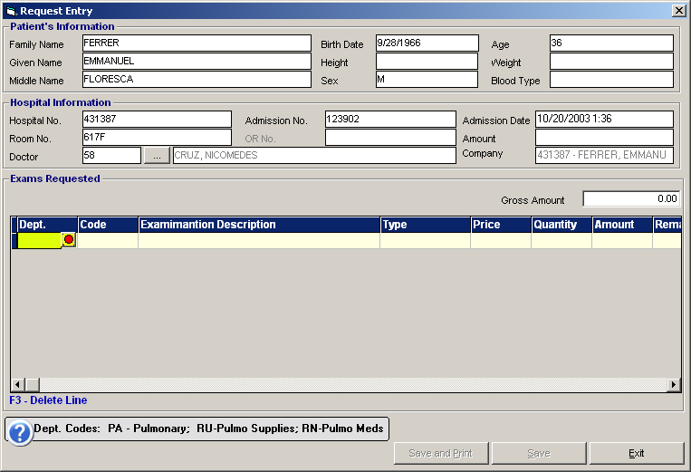
Figure 6: Inpatient Request: Request Entry

- To request the procedure(s):
  - Department - This is the code of the department to which the procedure belongs. The department code is listed at the bottom of the window. Example is 'PA' for Pulmonary'
  - Code - Type the code of the procedure or press Enter key to display the complete list(s) of items of the selected department.
  - Particular - This is the description of the procedure.
  - Type - Choose either from 'Routine' or ’stat'
  - Price - This is the price of the selected procedure.
  - Quantity - Type the quantity of procedure to request.
  - Amount - This is automatically computed in reference with the entered quantity and price.

The total amount of the requested procedure(s) can be seen just above the 'Amount'.

- To save:
- Click on Save button (to save) or Save/Print button (to save and print the charge slip).

Pharmacy Request
This option allows you to send medicine request to the Pharmacy department. The request shall only be charged if the pharmacy clerk has accepted it in the computer.

- Click 'Data Entry' > 'Pharmacy Request Entry' to display the window below.
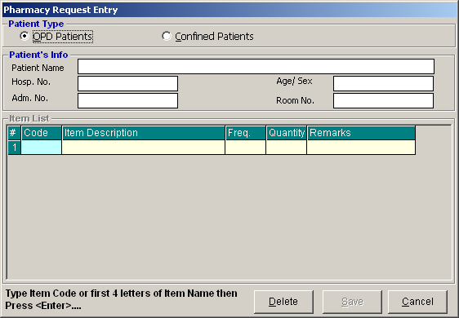
Figure 7: Pharmacy Request Entry window

- Under 'Patient Type' entry, choose either from 'OPD Patients' or 'Confined Patients'.
- Under 'Patient Name' entry, type in the patient's last name and then press <Enter>. A window will appear matching the query typed.
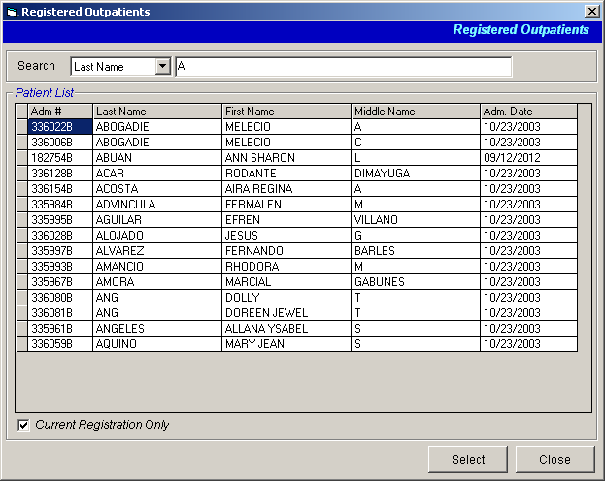
Figure 8: Pharmacy Request: Patient Searching

- Double-click on the patient name to select.

- Back to the 'Pharmacy Request Entry' window, enter the following data to enter the request.
  - Code - This is the code of the medicine. Press <Enter> to display the list of items.
  - Item Description - This is the description of the item code you have typed.
  - Frequency - Press <Enter> to display the list of dosage codes. Double-click it to select.
  - Quantity - Type the quantity of the item.
  - Remarks - Type your supporting data regarding on your request.

    - To save:
      - Click on Save button.
- To delete:
  - Click on the row you want to remove and then click on Delete button.

Result Entry
In this option is where you can enter the result of PULMONARY procedure. Cash basis patients need to pay first the amount of the procedure before the result can be entered into the computer. For charge basis outpatient and inpatient, once the procedure is done, the result can now be entered into the computer.

    - Click 'Results' > 'Result Entry' or click on  button to display the window below.
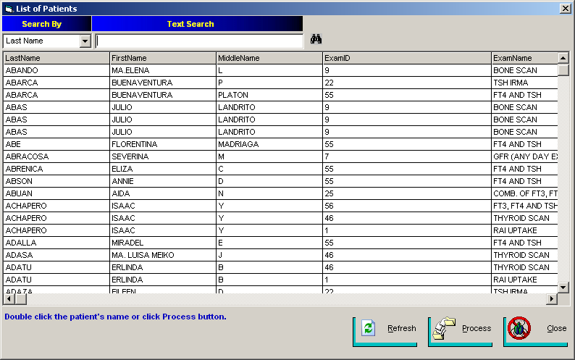
Figure 9: Result Entry: Patient Searching

    - You may search the patient by his last name or admission number. Patients who can be searched in here are those who already paid the amount of the requested procedure and charge basis outpatient and inpatient. Double-click the patient name in reference with the procedure to select. The window below will appear. Depending on the procedure, each has its own exam result format. See sample below.
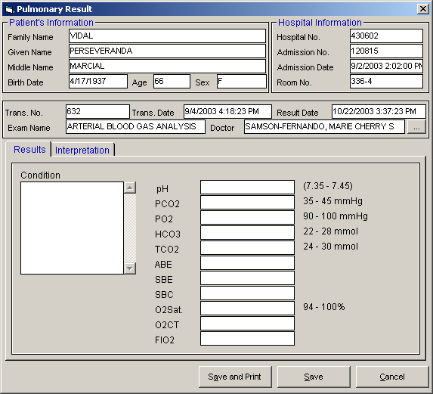
Figure 10: Result Entry

    - You may now type the result of the procedure. Click on Save and Print button or Save button when done.

Result Inquiry
In this option is where you can inquire and edit saved result of procedure.

- Click 'Results' > 'Result Inquiry' or click on  button to display the window below.
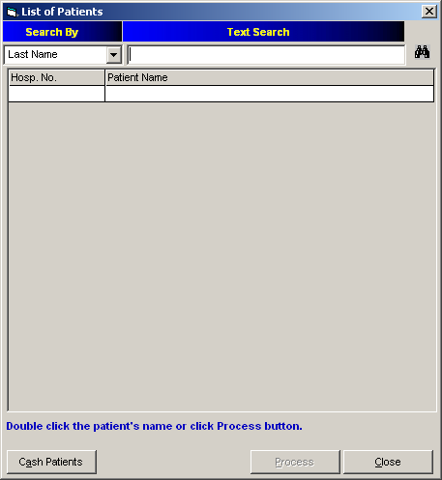
Figure 11: Result Inquiry: Patient Searching

- You may search the patient by his last name or admission number. Patients who can be searched in here are those whose results have been saved. Double-click the patient name to select. A window will appear showing the list of patient's procedures.
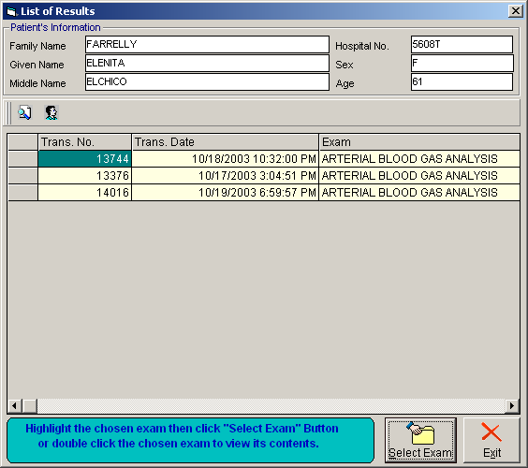

- Double-click on the procedure you want to edit.
- You may now edit the necessary correction. Just click on 'Save and Print' button to update the changes made.

Processing of Pending Requests
This option allows you to acknowledge requests from stations. The request will be charged once it is accepted and saved.

- Click on 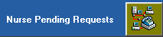 blinking button. The window below will display.
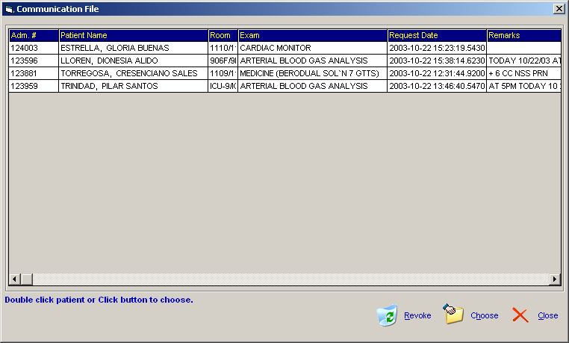
Figure 12: List of Patients with Requests from Stations

- To revoke the request, select the patient from the list and then click on 'Revoke' button.
- To acknowledge the request, select the patient from the list and then click on 'Choose' button. The window below will appear.
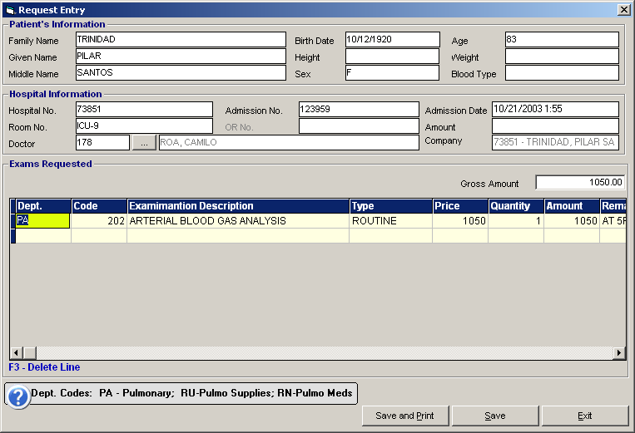
Figure 13: Saving Entry of Request

- Click on ’Save and Print' button or ’Save' button to accept and save the request.

Clearing of Patients for Discharge
Before the patient’s bill will be processed by the Billing clerk, all cost-centers should have entered all the patient’s charges. Once the patient’s station has sent a discharge order, cost-centers will be notified thru a computer agent as shown below.


Figure 14: Merlin
Merlin is an agent used to signal program users whenever there are discharge orders to process. Merlin comes out upon entering the program’s main window. To open the list of discharge orders, click 'Data Entry' > 'Discharge Notice'. The window below will display listing all the patients with discharge orders.

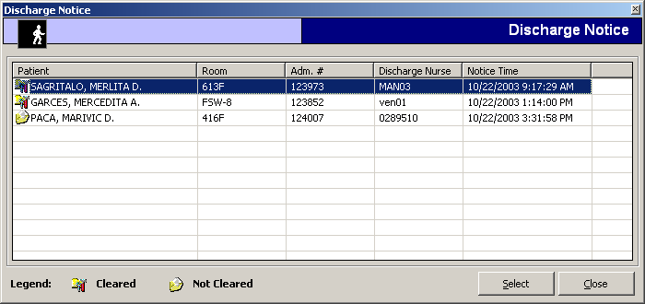
Figure 15: List of Patients with Discharge Order

- Just double-click on the patient name to select. Refer to the bottom of the window to know the patients who are cleared and not cleared.
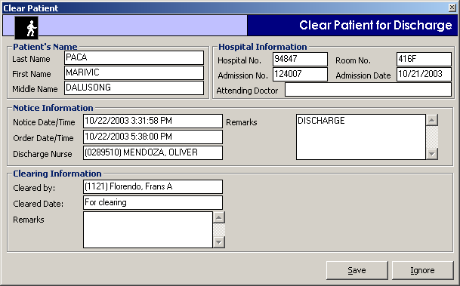
Figure 16: Clear Patient for Discharge window

- Under the 'Remarks' entry, enter remarks of clearing the patient. Click on Save button to clear the patient in your department.

Request Cancellation
This option allows you to cancel PULMONARY procedures request of charge basis outpatient or inpatient.

- Click 'File Maintenance' > 'Request Cancellation' to display the window below.
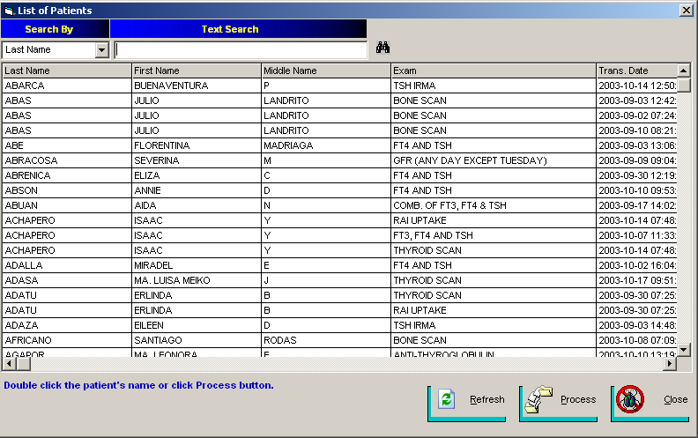
Figure 17: Request Cancellation: Patient Searching

- You may search the patient by his last name, admission number, or hospital number.
- Double-click on the patient name to select. The window below will appear.
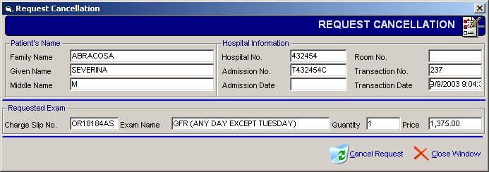
Figure 18: Request Cancellation: Patient's Request to Cancel

- Click on 'Cancel Request' button. Amount of cancelled items is automatically deducted from the patient’s bill.

Reprinting of Charge Slip
This option allows you to reprint charge slip of requested PULMONARY procedures to charge basis outpatient or inpatient.

- Click 'File Maintenance' > 'Re-print Chargeslip' to display the window below.
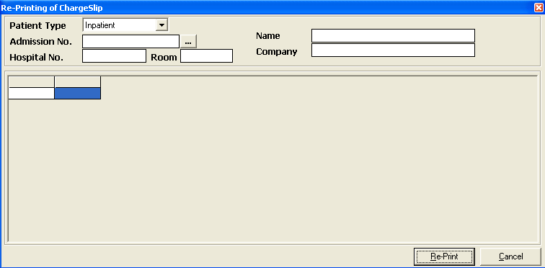
Figure 19: Reprint Charge slip: Patient Searching

- Under 'Patient Type', choose either from 'Inpatient' or 'Outpatient'.
- Under 'Admission No.', type in the patient’s last name or admission number and then press <Enter>. Patient’s charges will be displayed.
- Select the item from the list and then click on Print button.

Assessment Status
This option allows you to view the status of the cash basis patient’s request. You can also reprint the assessment slip or revoke the request in here.

- Click 'Reports' > 'Assessment Status' to display the window below.
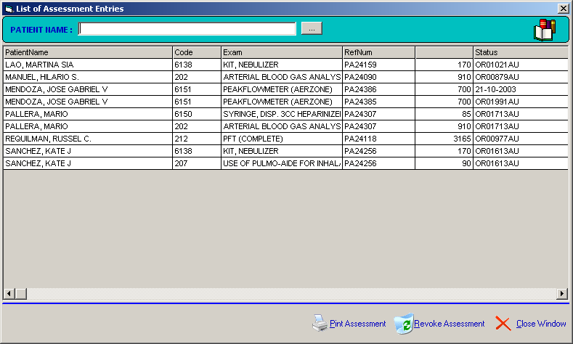
Figure 20: List of Assessed Patients

- Listed in the list are cash basis patients who have requested PULMONARY procedures.
- To reprint the assessment slip, select the patient first and then click on 'Print Assessment' button.
- To revoke the cash basis request, select the patient first and then click on 'Revoke Assessment' button.

Pharmacy Request Status
This option allows you to view the status or revoke the medicine request.

- Click 'Reports' > 'Pharmacy Request Status' to display the window below.

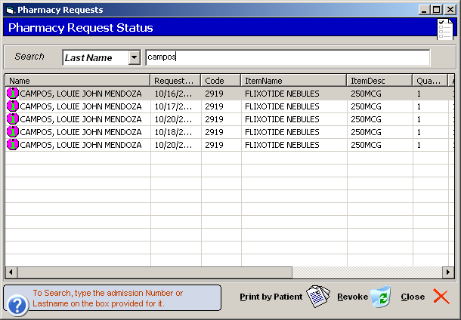
Figure 21: Pharmacy Request Status window

- You can search the patient by his last name or admission number.
- To revoke the request, click on the patient from the list and then click on 'Revoke' button.

Patient’s Ledger
This option allows you to view the patient’s ledger showing the breakdown of PULMONARY charges.

- Click 'File Maintenance' > 'Patient’s Ledger'. The window below will display.
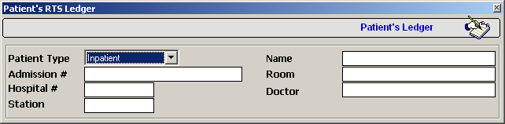
Figure 22: Patient's Ledger: Patient Searching

- Under 'Patient Type' entry, choose either from 'Inpatient' or 'Outpatient'.
- Under 'Admission No.', type in the patient’s last name or admission number and then press <Enter>. Double-click on the patient’s name to select.

Updating of Walk-in Master File
This option allows you to update the saved record of walk-in patients. You may also add a record of a new walk-in patient in here.

- Click 'File Maintenance' > 'Update Walk-in Master File' to display the window below.
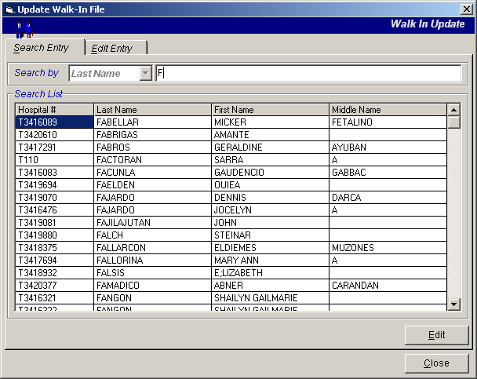
Figure 23: Update Walk-in Patient: Patient Searching

- You can search the patient by his last name, or hospital number.
- To edit, select the patient from the list and then click on 'Edit' button. The window below will appear.
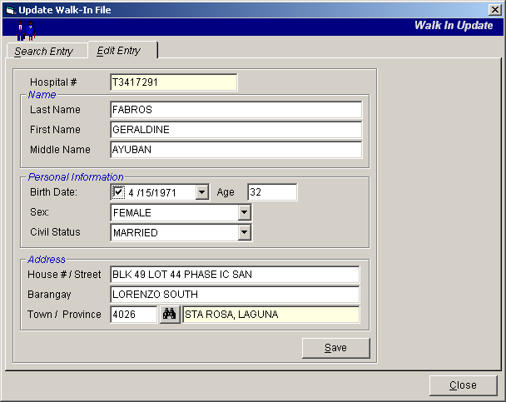
Figure 24: Update Walk-in Patient: Edit Entry

- You may now edit the patient’s record. Just click on ’Save' button to update the changes made.

Report
The following reports are generated by the program. Click on 'Reports' and then click on the desired report to view.

- Audit Report
- Statistical Report
- Monthly Report
- Daily Income Report
- Assessment Status
- Pharmacy Request Status

Index

—A—
assessment request, 9
assessment status, 28
audiometry charges, 30
—C—
cash basis patient request, 9
charge basis outpatient request, 11
clear patient for discharge, 23
closing the program, 8
—E—
end the program, 8
—F—
features, 6
—I—
inpatient request, 13
—O—
outpatient (charge basis) request, 11
overview, 5
—P—
patient's ledger, 30
process pending requests, 21
—R—
reports, 33
reprint assessment slip, 28
reprint charge slip, 27
request cancellation, 25
result entry, 17
result inquiry, 19
revoke assessment, 28
—S—
start the program, 7
starting the program, 7
—U—
update walk-in master file, 31

