MEDSYS-HIS

PHILHEALTH Module
User's Manual

MEDSYS
Kaiser dela Cruz Consulting Incorporated
July 28, 2026
Copyright© 2003 ALL RIGHTS RESERVED

No part of this document may be reproduced through photocopying or in any means, stored into a retrieval system, and transmitted in any form without the express written permission of Kaiser dela Cruz Consulting, Incorporated.
Permission is hereby granted to Medsys Medical Center to copy and distribute this document in any of the above means provided this is for its exclusive on site use.
Although every precaution has been taken in the preparation of this manual, the company assumes no responsibility for errors or omissions. Neither is any liability assumed for any damages resulting from the use of the information contained here.
Table of Contents
Introduction 4
Overview 4
Objectives 5
Features 5
Program Operation 6
How to Start the Program 6
How to End the Program 7
Getting Started 8
Steps in Processing PhilHealth …………………………………………………………………………………………… 8
Patient Searching …………………………………………………………………………………………………………… 9
Automatic PhilHealth Computation ……………………………………………………………………………………… 12
Slashing of Items ……………………………………………………………………………………………………………. 18
PhilHealth Data Entry ………………………………………………………………………………………………………. 19
Phic Form 1 ………………………………………………………………………………………………………………….. 22
Printing of Form III and IV ………………………………………………………………………………………………… 23
Printing of Form II ( PhilHealth Claim Form ) ………………………………………………………………………… 23
Transmittal Report ………………………………………………………………………………………………………… 25
PhilHealth Payment Entry ( Individual Entry ) …………………………………………………………………………. 28
PhilHealth Payment Entry ( Batch Entry ) ……………………………………………………………………………….. 31
PhilHealth Information Update ……………………………………………………………………………………………. 33
Direct Filing ………………………………………………………………………………………………………………….. 36
Statement of Accounts ……………………………………………………………………………………………………... 44
Tagging of Medicare Items ………………………………………………………………………………………………... 45
Hospital Information Entry ………………………………………………………………………………………………… 46
Signatory Entry ………………………………………………………………………………………………………………. 48
Reports ……………………………………………………………………………………………………………………… 50
Index 51

Introduction

Overview



The PHILHEALTH Program is an approach to a better processing of PHILHEALTH computation. This is connected to Billing Program to retrieve the consolidated patient’s charges. Computation is done automatically based on the rate conditions that are programmed in the computer in line with the rules of PHILHEALTH computation.
Needed forms to be submitted in PHILHEALTH are also incorporated in the program. Its printout is automatically generated once needed.
To maintain the confidentiality of data, the program only accepts users who are registered to PHILHEALTH program. This is the importance of using password and assigning defined rights to users to prevent unauthorized access.

Objectives

1 To automatically compute the amount to be covered by PHILHEALTH and how much would be charged to the patient
2 To computerize forms needed in processing PHILHEALTH
3 To generate reports automatically when needed
4 To computerize PHILHEALTH payment

Features

Data entry restriction - Warning messages are flashed for possible invalid entries. This ensures all data inputted would be made useful for any transaction that may occur.
Password-protected - The use of password is necessary to restrict unauthorized access. Thus the program only accepts passwords which are registered into it. This feature ensures the confidentiality and integrity of data entered in the program.
Auto-report generation - The program is capable of generating reports and can be readily printed.
User-friendly - The program user is guided by instructions in doing the next step providing an easy-use to process transactions.

Program Operation

How to Start the Program

1 Click the Medicare Program  executable file icon located in your computer desktop.

2 The Login window will be displayed asking you to type your employee number and password for security purposes.

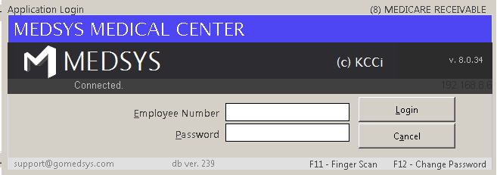
Figure 1: Login Window

3 If accepted, you can now start a transaction. Otherwise, a message will be displayed prompting “Unauthorized User”.

How to End the Program

It is important for users to close the program when they are done to end-up their session. Other users might use the open program using the same password.

To close the program:
1 Click located at the upper right corner of the main window or
2 Click 'Data Entry' > 'Exit'

Getting Started

Steps in Processing PHILHEALTH

After searching the patient, you can follow the steps below to process PHILHEALTH.

1 PHILHEALTH Automatic Computation
2 PHILHEALTH Data Entry
3 Print Form III & IV
4 Print Form II (PHILHEALTH Claim Form)
5 Transmittal Report
6 PHILHEALTH Payment Entry

Patient Searching
The main window is divided into five clickable tabs. Just click the tab to search the patient.

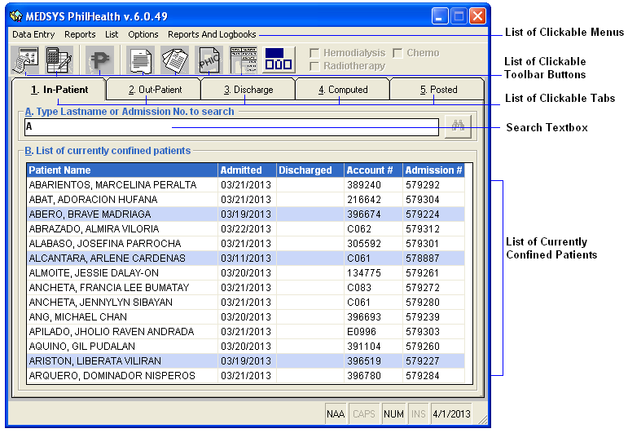
Figure 2: Parts of the Main Window

1. In-Patient' tab - This will display list of currently confined patients. To search the patient from the list, type the patient’s last name or admission number in the ’search' textbox and then press <Enter>. To select the patient from the list, click the row where the patient is aligned. Selected patient is always highlighted. The following buttons can be clicked from.
'Automatic Computation’ toolbar button to automatically compute PHILHEALTH.

’Statement of Accounts' toolbar button to view or print patient’s statement of accounts.

2. Out-Patient' tab - This will display list of currently and previously registered outpatients. To search the patient from the list of current registrations (to search past registration, click the option box 'Past' under the 'Registration' entry), type the patient’s last name or OPD number in the ’search' textbox and then press <Enter>. To select the patient from the list, click the row where the patient is aligned. Selected patient is always highlighted. The list can be arranged by the patient’s gender by clicking the option listed in 'List by'. The following buttons can be clicked from.
'Automatic Computation' toolbar button to automatically compute PHILHEALTH.
’Statement of Accounts' toolbar button to view or print patient’s statement of accounts.

3 '3. Receivable' tab - This will display list of discharged patients. To search the patient from the list, type the patient’s last name or hospital number in the ’search' textbox and then press <Enter>. To select the patient from the list, click the patient under the 'List of discharged/billed patients' and below it will display the list of patient’s confinements. Just click the patient having the correct confinement under the 'List of Confinements'. Selected patient is always highlighted. The following buttons can be clicked from.
'Automatic Computation' toolbar button to automatically compute PHILHEALTH.
’Statement of Accounts' toolbar button to view or print patient’s statement of accounts.

4. Computed' tab - This will display list of patients whose PHILHEALTH was already computed. To search the patient from the list (verify first the type of patient under 'Patient Type'), type the patient’s last name or admission number in the ’search' textbox and then press <Enter>. To select the patient from the list, click the row where the patient is aligned. Selected patient is always highlighted. The following buttons can be clicked from.
 'Data Entry' toolbar button to complete the data to be reflected in Form 2.
’Statement of Accounts' toolbar button to view or print patient’s statement of accounts.
 'Form III and IV' toolbar button to print Form III and IV.

5. Posted' tab - This will display list of posted patients whose PHILHEALTH was already computed and whose forms are ready for submission. To search the patient from the list, type the patient’s last name or admission number in the ’search' textbox and then press <Enter>. To select the patient from the list, click the row where the patient is aligned. Selected patient is always highlighted. The list can be arranged by the type of patient and membership. The following button options can be clicked from.
 'Medicare Claim (Form II)' toolbar button to print Form II.
'Medicare Information Update' toolbar button- to update Medicare/PHILHEALTH information.
'Payment Entry'- toolbar button to enter payment from PHILHEALTH to the selected patient.

Automatic PHILHEALTH Computation
This option allows you to automatically compute the total amount to be paid by PHILHEALTH based on the covered items under the categories 'Room and Board', 'Drugs', 'Xray/Lab/Others', and 'Operating Room' and the total amount of charges to be paid by the patient as well.

1 Select the patient from the list under the 'Inpatient' tab, 'Outpatient' tab, or 'Receivables' tab depending on the patient type. Please refer to 'Patient Searching' on how to search the patient.
2 Click the 'Automatic Computation' toolbar button to open the Medicare Computation Window.
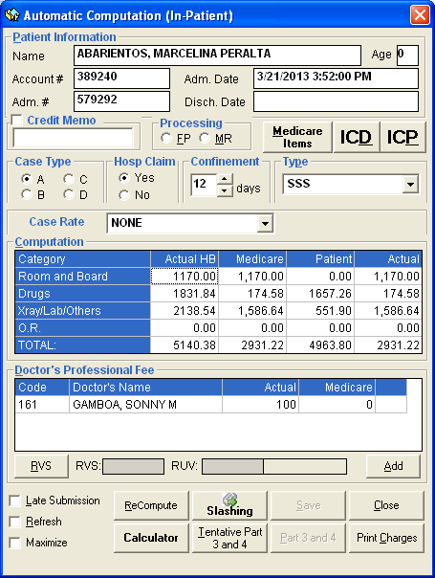
Figure 3: “Sample Medicare Computation” Window

3 Enter the following data.
Patient Information - The data shown here are patient’s name, account number, admission number, admission date and discharge date based from what were saved into the database. These data are automatically displayed by the program.
Case Type - Click the case type of the patient from the given options ('Ordinary', 'Intensive' or 'Catastrophic'). Each case type has its corresponding rate.
Case Rate - Click the case rate to display lists of packages. Choose from the lists if there’s any package use by the patient.
Relationship - Click the relationship-option that is related to the patient from the given lists ('None', ’spouse', 'Child', 'Parent').
Confinement - The program automatically counts the number of days of patient’s confinements. This can be edited.
Type - Select the type of membership by clicking the drop-down arrow. Options to choose from are ’SSS', 'GSIS', 'ECC', 'OWWA' and 'Indigent'.
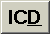 - Click this button to view patient’s admission and final (written) diagnoses, and ICD from what were posted at the Medical Records.

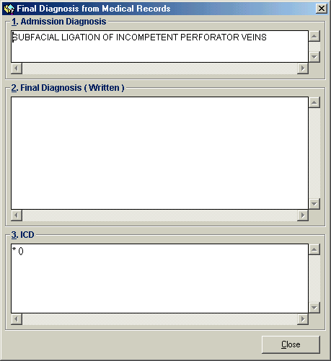
Figure 4: “Sample Final Diagnosis from Medical Records” Window

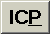 - Click this button to view the patient’s procedure (written) and ICD from what were posted at the Medical Records.

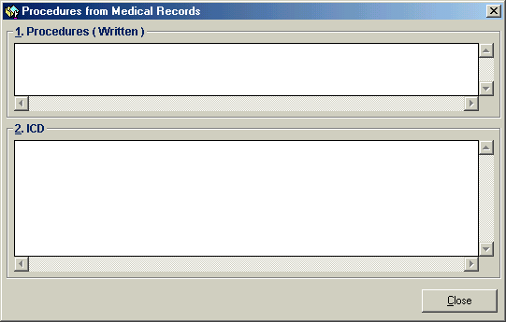
Figure 5: “Procedures from Medical Records” Window

Click the check box(es) that is/are related to the patient. Options to choose from are 'Pensioner', ’self-Employed', 'Voluntary', and ’self-Employed'.
Computation - The data shown here are automatically computed. The Medicare computation is divided into four categories namely 'Room and Board', 'Drugs', 'X-ray/Laboratory/Others', and 'Operating Room'. Each category has its corresponding rate. The computed amount is divided into 'Actual Charges', 'Medicare' (can be edited), 'Patient' (can be edited) and 'Actual Hospital Bill'. Below it is displayed the total amount to be covered by PHILHEALTH.
Doctor’s Professional Fee - This section is for the data entry of patient’s doctor’s professional fee. Under 'Code', type the first few letters of the doctor’s last name and then press <Enter>. A window with doctors list will appear matching the query typed.

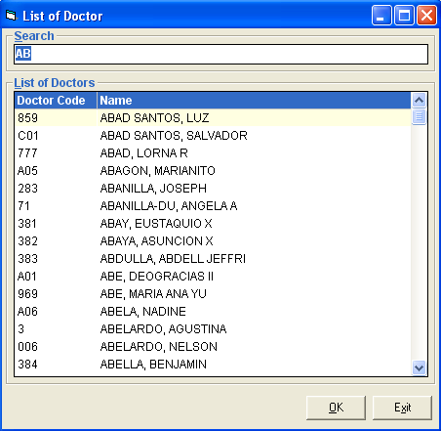
Figure 6: “Sample List of Doctors” Window

Double-click the doctor’s name from the list to select. The actual professional fee will be displayed. Enter the amount under 'Medicare' to be covered by PHILHEALTH. (Click the 'Add' button for the next entry of professional fee)
Relative Value Scale - Click the 'RVS' button to open the 'Relative Value Scale' window.

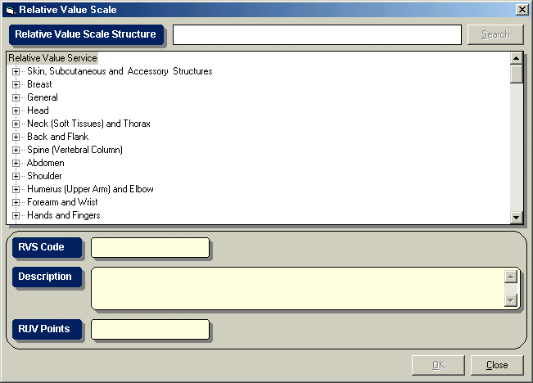
Figure 7: “Relative Value Scale” Window

This window contains list of relative value services to choose from. Just click on the service to display its RVS code, description and RUV points. Click the 'OK' button afterwards to select.
Remark - You can enter here your remarks (if any)
Recompute – Click this button to recomputed patient charges
Tentative Part 3 and 4 – Click this button to print patients Part 3 and 4.
Print Charges – Click this button to print patient’s charges.
Slashing – Click this button to display the window below. Click on the ‘ Activate ’ button to enable slashing. Review patient’s charges and click if it is ‘compensable’ or ‘non-compensable’. Click on button to go out from the slashing window.

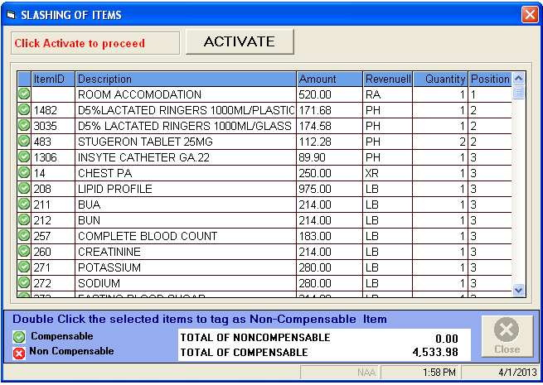
Figure 8: “Slashing” Window

4 You can click the following button options.
Save - Click the ’save' button to save the computed amount.
Close - Click the 'Close' button to undo computation and to close the Medicare Computation window.

PHILHEALTH Data Entry
This is used to enter supporting patient’s data to be reflected in Form II (PHILHEALTH Claim Form).

1 Select the patient from the list under the 'Computed' tab.
2 Click the  'Data Entry' toolbar button to open the Medicare Data Entry Window.

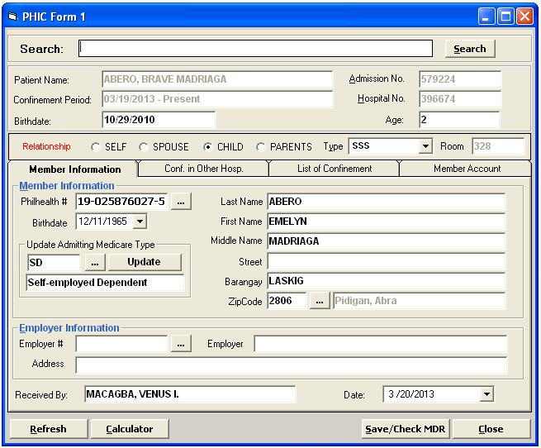
Figure 9: “Sample Medicare Data Entry” Window

3 Enter the following data.
Member Information Tab – You can enter here the patient’s personal information and employers information

PhilHealth # - You can click to open the complete list of PHILHEALTH members. If the PhilHealth number is found in the list, you can double-click it to select. The member information such as first name, last name, middle name, birth date, street, barangay, town and province will be automatically shown. Otherwise if the PhilHealth number is not in the list, you need to type the PhilHealth number and the rest of the data to complete the PHILHEALTH Member Information.

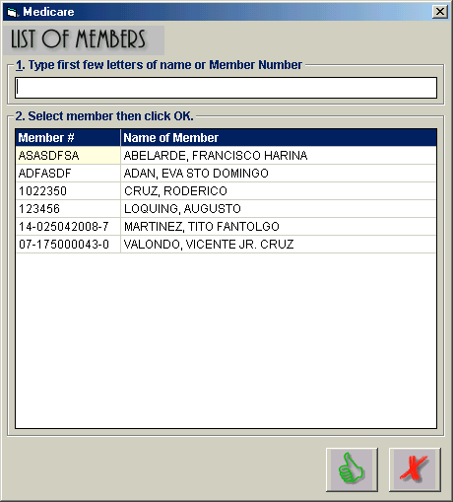
Figure 10: ’Sample List of PHILHEALTH Members“ Window

Employer Information
Employer # - You can click to open the complete list of employers. If the employer is found in the list, double-click it to select. Information about the selected employer will be automatically shown. Otherwise if not found in the list, you need to type the employer number, employer name and employer’s address.
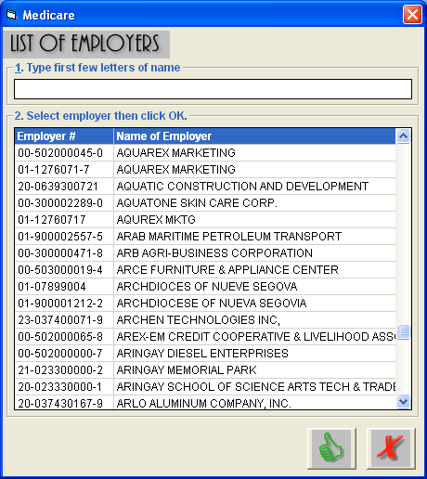
Figure 11: “List of Employers” Window
Conf. in other Hosp. tab– Click this tab to view patient’s confinement from other hospital.
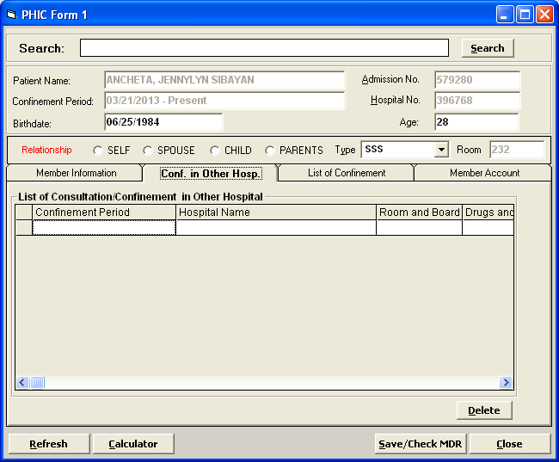
Figure 12: “PHIC Form 1” Window
List of Confinement – Click this tab to view patient’s lists of confinement.
Member Account – Click this tab to view all the member’s dependents who used the member’s PhilHealth Account.

4 After completing the necessary data, you can click the following button options.
Save / Check MDR - Click this button to save all the data entered and goes directly to E-claims module for easier tracking of PhilHealth status and processing of claims.
Calculator - Click this button to display the calculator window.
Close - Click this button to close the PHIC Form 1 Data Entry Window

Printing of Form III & IV
After the patient’s PhilHealth automatic computation, you can now print the patient’s Form III and IV. This form contains list of items and their amounts that are to be covered by PHILHEALTH from 'Drugs and Medicines Expenses', and 'Xray/Laboratories/Others' categories.

1 Click the patient from the list under the 'Computed' tab.
2 Click the 'Form III and IV' toolbar button to generate Form III and IV.

3 To print, just click the icon at the top part of the window.

Printing of Form II (PHILHEALTH Claim Form)
After the patient’s PHILHEALTH data entry, you can now print the patient’s Form II which serves as the PHILHEALTH Claim Form. This is the Heath Care Provider’s Certification which contains the hospital and professional data and charges.

1 Select the patient from the list under the 'Posted' tab.
2 Click 'Medicare Claim (Form II)' toolbar button to generate Form II. If the selected patient has more than one physician, surgeon, or anesthesiologist, the window below will be shown which means that the patient needs two printouts for Form II. Click the '1st Form' button to generate and then click the '2nd Form' button afterwards.

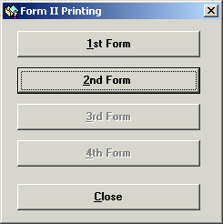
Figure 13: ”Form II Printing“ Window

3 To print, just click the icon at the top part of the window.

Transmittal Report
This contains list of patients whose forms II, III and IV are already printed which serves as an attachment to be submitted to PHILHEALTH.

1 Click the  'Transmittal Report' toolbar button to open the Transmittal Report Window.

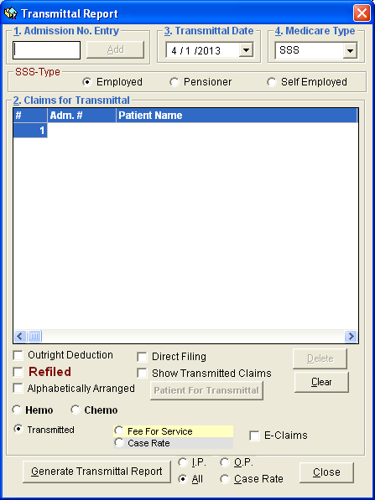
Figure 14: Transmittal Report Window

2 Under the 'Admission No. Entry', enter the patient’s admission number and then press <Enter>. If found, the patient name will be added in the list.

3 Under the 'Transmittal Date Entry', select the date of transmittal. The current date is used as the default entry.

4 Under the 'Medicare Type Entry', select the Medicare type. This will display searched patients bearing the selected Medicare type.

5 SSS Type – Choose patient’s SSS type if ‘ Employed’, ‘Pensioner’, ‘ Self-Employed’

6 Patient Type – click on patient type to be transmitted if ‘InPatient’, ‘OutPatient’, ‘Case Rate’ or ‘ All’ to transmit different type of patient

7 The following button options can be clicked from.
Delete - Click this button to remove a patient from the list. Click first the patient from the list and then click the 'Delete' button.
Generate Transmittal Report - Click this button to generate the transmittal report.
Add by Tagging - Click this button to search for patients since the date of Medicare computation to be added in the Transmittal Report.
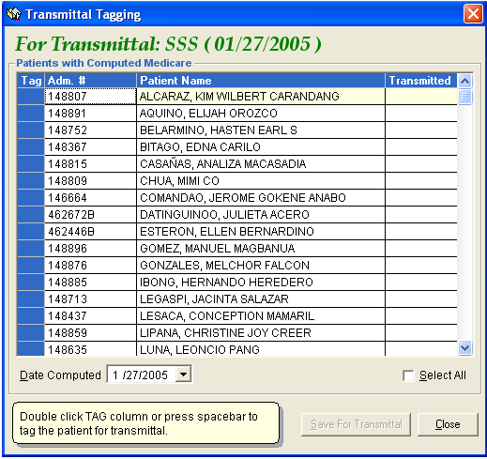
Figure 15: ”Transmittal Tagging“ Window

Under the 'Date Computed' Entry, select the date of PhilHealth computation. Patients whose PhilHealth was computed since the selected date will be displayed in the list. Just double-click the 'TAG' column or press spacebar to tag the patient for transmittal provided that the patient has a PHILHEALTH Member Information (entered in the Medicare Data Entry) The sign '!!!' means that the patient was already included in the transmittal report. Click the ’save for Transmittal' button to add in the list.

Close - Click this button to close the Transmittal Report Window.

PHILHEALTH Payment Entry

Payment Entry (Individual Entry)
This option allows you to enter PHILHEALTH payment to the selected patient. This is for single entry of payment.

1 Click the 'Payment Entry' toolbar button to open the Medicare Payment Window. You can view here the patient’s payment status, total hospital claim and his balance.

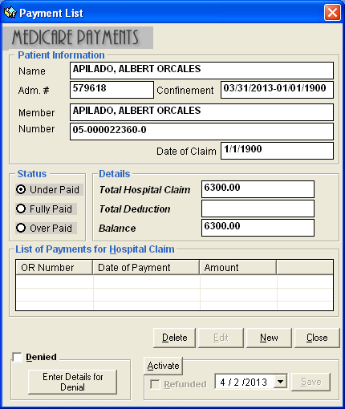
Figure 16: Medicare Payment Window

2 To enter payment, click the 'New' button. The Payment Entry Window will be displayed. Under 'Hospital Payment Entry', type the official receipt number under the 'OR Number' entry and then the amount under the 'Payment' entry. The current server date is the default entry for Payment Date. You may change it if necessary. Click the ’save' button to save payment.

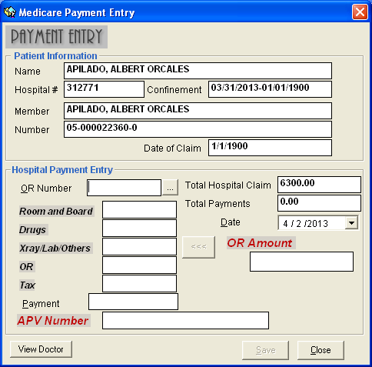
Figure 87: Payment Entry Window

3 Back to the Medicare Payment Window, you can now view the entered amount, balance, and the current status of payment. (See figure below) To edit the entered amount, click the 'Edit button'. You may now change the necessary data. Just click the ’save' button to save changes.

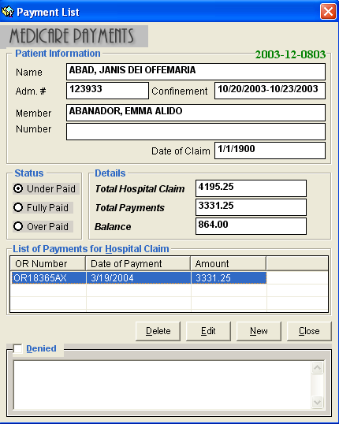
Figure 18: “PhilHealth Payment Entry” Window

Note: To set the status of payment to 'Denied', click the check box beside 'Denied'. When clicked, verify if you want to delete previous payment(s). Click the 'Yes' button to proceed. Then type your remarks under the textbox.

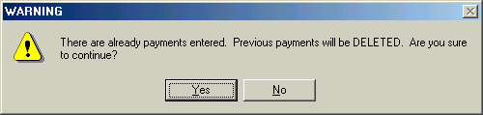

Payment Entry (by Batch)

This option allows you to enter PHILHEALTH payment per batch. One official receipt is used for batch of payments.

1 Click the 'Batch Payment Entry' toolbar button to open the Batch Payment Window.

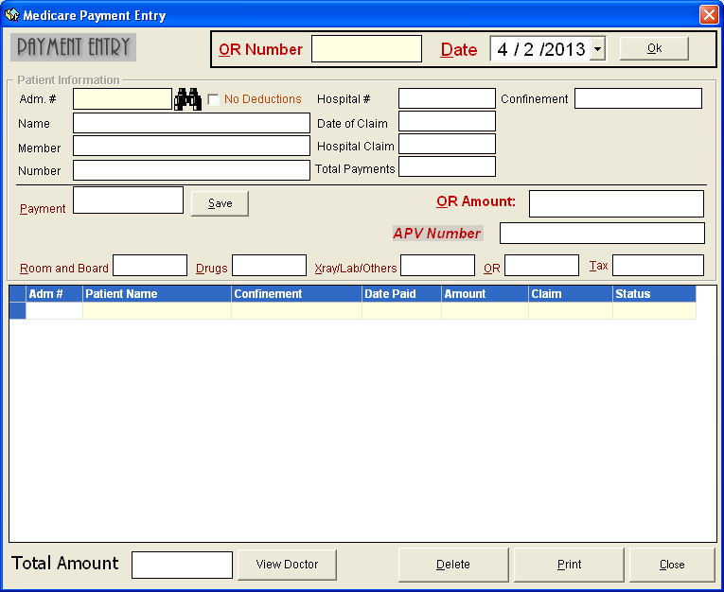
Figure 99: Batch Payment Window

2 Enter the official receipt number under the 'Enter O.R. #' entry and then press <Enter>. This O.R. number will be used to all patients to be searched for the payment entry.

3 Verify the Date of Payment under the 'Date of Payment' entry. You may change it if necessary.

4 Under the 'Adm. #' entry, enter the patient’s admission number and then press <Enter>. Or you can type the first few letters of the patient’s last name and then press <Enter>. A window with patients list will appear matching the query typed. Double-click the patient name to select. The selected patient’s information such as the total hospital claim, and payment status will be displayed.

5 To enter payment, type the amount under the 'Amount Paid' entry.

Note: To set the status of payment to 'Denied', click the check box beside 'Denied'.

6 The following button options can be clicked from.
Save - Click this button to save the current payment and to proceed with another payment.
Delete - Click this button to remove a specific patient from the lists of names entered.
Print - Click this button to print a copy of patients entered for that specific receipt.
Close – Click this button to go out from the Batch Payment Entry window.

PHILHEALTH Information Update
Use this option to update date of transmittal, refile date, and to mark for purging the Medicare payment of the selected patient.

1 Select the patient from the list under the 'Posted' tab.

2 Click the 'Medicare Information Update' toolbar button to open the Medicare Information Update.

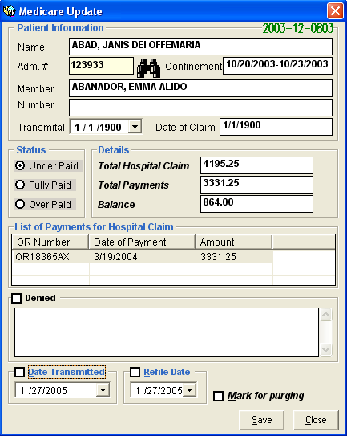
Figure 20: Medicare Information Update

3 You can do the following updates.
To update the date of transmittal, click the check box beside 'Date Transmitted' and then click the drop-down arrow to select the date.
To update the refile date, click the check box beside 'Refile Date' and then click the drop-down arrow to select the date.
To purge, click the checkbox beside 'Mark for Purging'.

4 Click the ’save' button to save changes entered.

Direct Filing
This option allows you to enter patient’s information, PHILHEALTH member information, diagnosis, charges, and doctors of cash-basis patients for direct filing.

1 Press 'Ctrl + N' or click 'Data Entry' > 'Direct Filing' to open the Direct Filing Window.

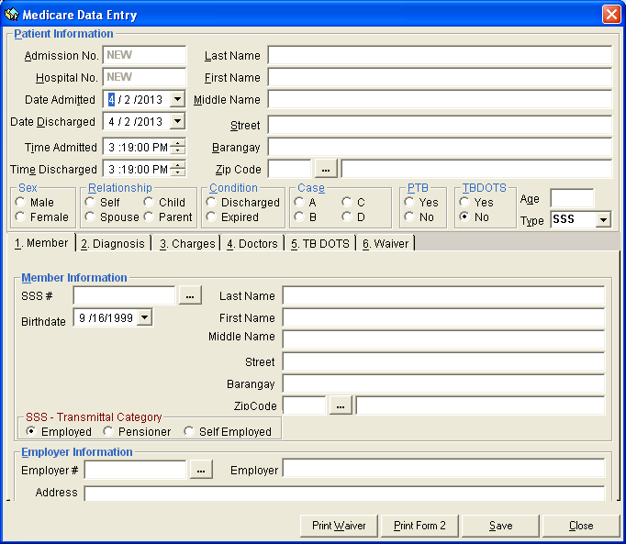
Figure 21: Direct Filing Window

The following data will be generated by the program so you don’t need to enter them.
Admission Number
Hospital Number
Date Admitted - Current server date is used as the default entry. You may edit it if necessary.
Date Discharged - Current server date is used as the default entry. You may edit it if necessary.
Time Admitted - Current server time is used as the default entry. You may edit it if necessary.
Time Discharged - Current server time is used as the default entry. You may edit it if necessary.

Complete the necessary data.

Last Name - Type the patient’s last name and then press <Enter>.

First Name - Type the patient’s first name and then press <Enter>.

Street - Type the patient’s house street and the

Middle Name - Type the patient’s middle name and then press <Enter>.

Barangay - Type the patient’s barangay and then press <Enter>.

Zip Code - Type the first few letters of patient’s town and then press <Enter>. Or you can click to display the complete list of towns and provinces together with their zip code. Just double-click the town to select.

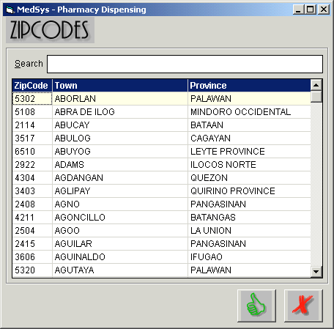
Figure 22: ”List of Towns/Provinces“ Window

Sex - Select the patient’s gender.
Relationship - Click the relationship-option that is related to the patient from the given lists ('None', ’spouse', 'Child', 'Parent').
Condition - Options to choose from are 'Discharged' and 'Expired'. Click the patient’s condition.
Case - Options to choose from are 'Ordinary', 'Intensive', and 'Catastrophic'. Each case has its corresponding rate. Just click the patient’s case.
PTB - Click the option 'Yes' if the patient has paid the total amount of hospital bill. Otherwise, click the option 'No'.
Type - Options to choose from are ’SSS', 'GSIS', 'ECC', 'OWWA' and 'Indigent'. Just select the patient’s membership type.

2 PHILHEALTH Member Information - Click '1. Member' tab to open its data entry.
Member Information
SSS # - You can click to open the complete list of PHILHEALTH members. If the SSS number is found in the list, you can double-click it to select. The member information such as first name, last name, middle name, birth date, street, barangay, town and province will be automatically shown. Otherwise if the SSS number is not in the list, you need to type the SSS number and the rest of the data to complete the PHILHEALTH Member Information.
Employer Information
Employer # - You can click to open the complete list of employers. If the employer is found in the list, double-click it to select. Information about the selected employer will be automatically shown. Otherwise if not found in the list, you need to type the employer number, employer name and employer’s address.

3 Diagnosis - Click '2. Diagnosis' tab to open its data entry.
Admission Diagnosis - Type the patient’s admission diagnosis.
Diagnosis - Type the patient’s final diagnosis.
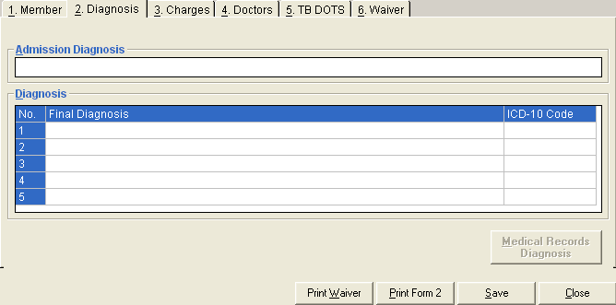
Figure 23: “Direct Filing - Diagnosis Entry ” Window

4 Charges - Click '3. Charges' tab to open its data entry. Under 'Actual Charges and Medicare Claim Entry', complete the following data.
Room and Board – Type the actual charges, hospital claim, and patient claim.
Drugs and Medicines - Type the actual charges, hospital claim, and patient claim.
Xray/ Lab/Others - Type the actual charges, hospital claim, and patient claim.
O.R. Fee - Type the actual charges, hospital claim, and patient claim.
Medicines bought and Laboratory performed outside hospital during confinement - Type the actual charges, hospital claim, and patient claim.

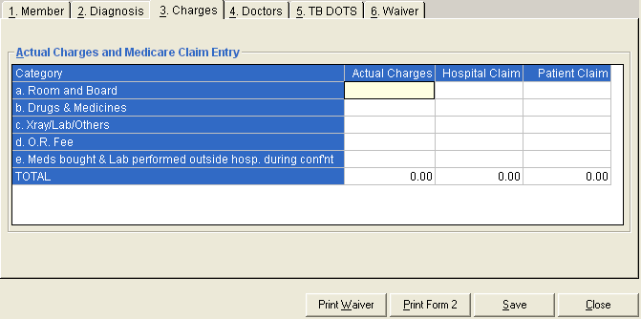
Figure 24: “Direct Filing - Charges Entry” Window

You can view the total amount of actual charges, hospital claim, and patient claim under the TOTAL row.

5 Doctors - Click '4. Doctors' tab to open its data entry. Under 'Physicians/Surgeons/ Anesthesiologist', complete the following data.
Type the patient’s physician, surgeon, and anesthesiologist. The number of Form II (PHILHEALTH Claim Form) printouts depends on the number of physician, surgeon, or anesthesiologist entered here.
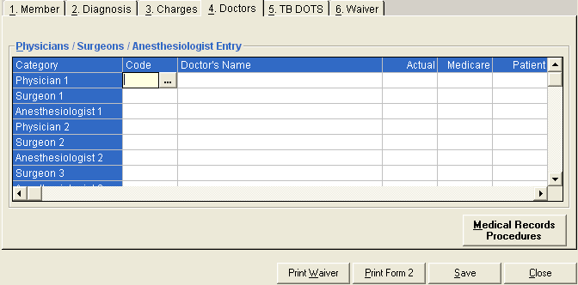
Figure 25: “Direct Filing - Doctors Entry” Window

6 TB DOTS – Click ‘5. TB DOTS’ tab to open its data entry. Click the Date of Registration Enrollment, Classification of TB, Type of Patient and Category.
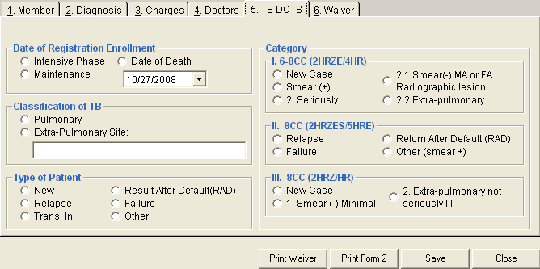
Figure 26: “Direct Filing – TB DOTS Entry” Window

7 Waiver – Click ‘6. Waiver’ tab to enter its data.
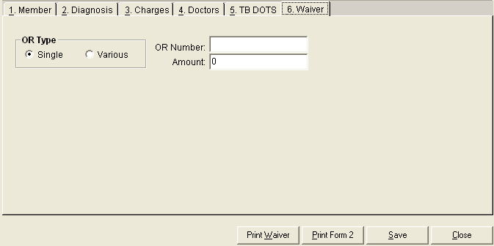
Figure 27: “Direct Filing - Diagnosis Entry” Window

8 After completing the necessary data, you can click the following button options.
Print Waiver – Click the ‘ Print Waiver’ button to print the patient’s waiver.
Print Form II (PHILHEALTH Claim Form) - Click the 'Print Form 2' button to save and print the PHILHEALTH Claim Form.
Save - Click the ’save' button to save the data entered.
Close - Click the 'Close' button to close the Medicare Data Entry Window.

Note: After saving the data of the patient, it will be added directly to the list of posted patients under the 'Posted' tab.

Statement of Accounts

This option lets you view the selected patient’s statement of accounts. This is the summary of charges incurred during patient’s confinement or consultation with reflected deductions (e.g. deposits, PHILHEALTH)

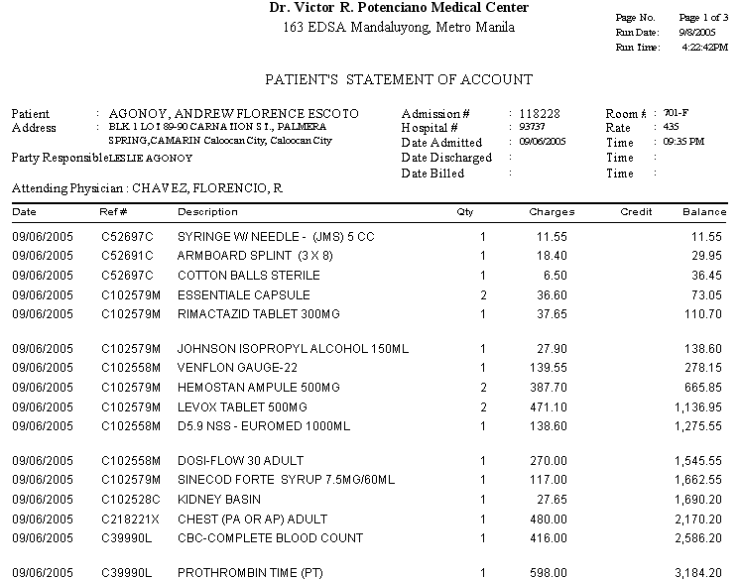

Tagging of Medicare Items
Use this option for tagging Medicare items.

1 Click 'Options' > 'Build Files Classification' > 'Medicare Items' to open the Medicare Build File Maintenance.

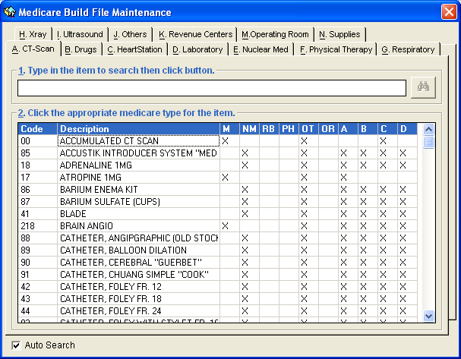
Figure 28: Medicare Build File Maintenance Window

2 Just click tab of the revenue you want to work with. Its items arranged by name will be displayed.

3 To search for a particular item, type the first few letters of the item name and the program will automatically display the item if found.

4 Here are the following columns of the grid.
Code - This is the code of the item.
Description - This is the item name.
RB - Room and Board
PH - Pharmacy
OT - Others
OR - Operating Room
NM - Non-medicare
A - Xray/Lab
B - Supplies
C - Miscellaneous

5 Item marked with 'X' means that it is a Medicare item in the column it is placed. To tag, click the column you want the item to be a Medicare item.

Hospital Information Entry
This option allows you to update your hospital information such as hospital address, accreditation number, number of beds, hospital category, and PCF.

1 Click 'Options' > 'Hospital Information' to open the Hospital Information Entry Window.

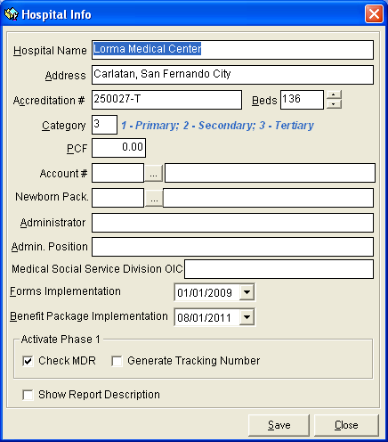
Figure 29: Hospital Information Entry Window

2 You can now make necessary changes on the hospital information. Click the ’save' button to save changes entered. Click the 'Close' button to close the Hospital Information Window.

Signatory Entry
This option allows you to add a new signatory, and edit or delete existing signatories. Signatories entered here will be reflected at the bottom part of the Transmittal Report.

1 Click 'Options' > ’signatories' to open the Signatories Build File Window.

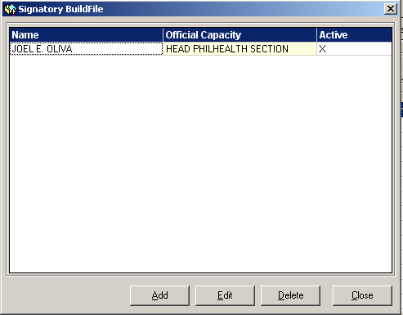
Figure 30: Signatories Build File Window

2 To add, click the 'Add' button. Type the name and official capacity of the signatory. Click the ’save' button to save and add the new entry.

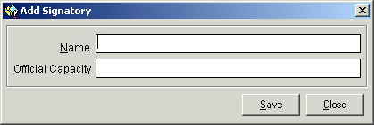
Figure 31: 'Add Signatory' Window

3 To edit existing signatory information, click the signatory in the list and then click the 'Edit' button. You can now edit the signatory information. Just click the ’save' button to save changes entered.

4 To delete existing signatory, click the signatory in the list and then click the 'Delete' button.

Reports
The reports listed below are generated by the program. Click the 'Reports' menu to display options and then click the report you want to generate.

- Medicare Deductions / Claims Report
- PHIC Summary of Payment
- Payment Summary Report
- Payment Collection Received
- Payment Register
- Claims Register Summary
- Schedule of UnderPayment per OR
- Receivable Status
- Aging Report
- Denied Claims
- Refunded Claims
- Blank Form
- Refundable Patients Per Company
- Summary of PHIC UnderPayment
- Monthly Transmittal Report
- Classification of Medicare Claims
- Daily Medicare Summary
- Doctor’s Receivable
- List of Untransmitted Claims
- Monthly Summary Report – PhilHealth
- Total Medicare Receivable
- General Ledger
- DOH Yearly Report
- PHIC Licensing Report
- Doctor’s Patient with PhilHealth
- Doctor’s Patient with PhilHealth per Doctor
- Monthly PHIC Report
- CEWS Patient List
- Claim Form 2 Print Tracking
- Claims without Payments
- Credit Memo Report
- Summary of Patients with Operations
- Summary of PHIC Patients Based on Membership Category
- PhilHealth Adjustment

Logbooks
- New PHIC Logbook
- Medicare Logbook
- Laboratory Logbook
- X-ray Logbook
- Operating Room Logbook
- Patient with Medicare Claims ( Daily Discharges )
- Patient with Medicare Claims ( Logbook )
- List of Hospital Consultants
- Monthly Summary of Activities
- Monthly OR Reports
- Filed Medicare Claims
- Discharge on the day
- Monthly Statistical Report

Special Reports
- Claims in Progress Report
- Claims Payment Performance
- Unpaid Report
- Under Paid Report
- Phic Unclaimed Refunds

Index

—A—
Automatic PHILHEALTH Computation, 12
—D—
Direct Filing, 32
—F—
Features, 5
—H—
Hospital Information Entry, 39
How to End the Program, 7
How to Start the Program, 6
—M—
Medicare Information Update, 30
—O—
Objectives, 5
Overview, 4
—P—
Patient Searching, 9
PHILHEALTH Data Entry, 17
PHILHEALTH Payment Entry, 25
Printing of Form II (PHILHEALTH Claim Form), 21
Printing of Form III & IV, 20
—R—
Reports, 42
—S—
Signatory Entry, 40
Statement of Accounts, 36
Steps in PHILHEALTH Processing, 8
—T—
Tagging of Medicare Items, 37
Transmittal Report, 22

