- How to get into Computation for PhilHealth Patient ?

STEPS:
- Search for patient. (see Figure 1)
- Click on the patient that will have to compute for Case rate. (see Figure 1)
- Then, Click the button of Automatic Computation. (see Figure 1)

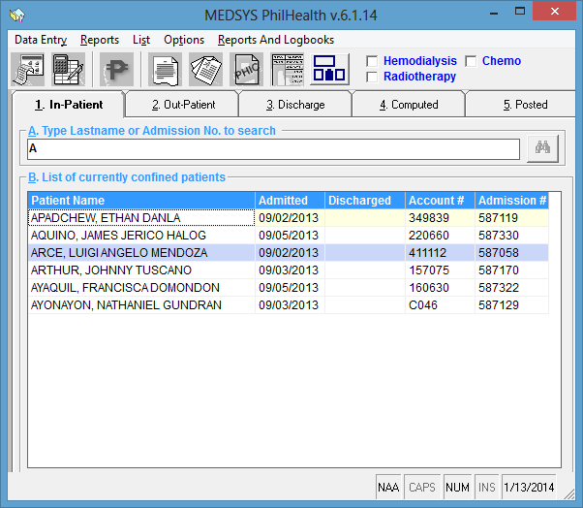
1
2
3
(Figure 1)

STEPS:
- Click “Ellipse[…]” button to select the appropriate package or case type for the patient.
(see Figure 2.1)

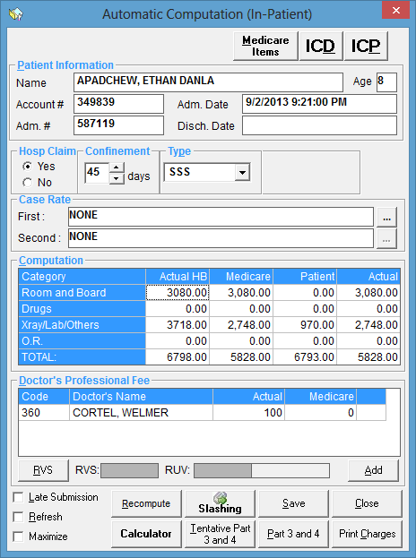
4
(Figure 2.1)

The figure shown above is the updated case rate type computation base on the new guidelines given by PhilHealth. It automatically computes for the medical case rates and the procedure case rates. For the computation of the Medical Case Rates, the 1st Case Rate claim is 100% (HCI Fee = 70% and Prof Fee = 30%). If there is a 2nd Case Rate the claim is 50% (HCI Fee = 20% and Prof Fee = 30%). For the computation of the Procedure Case Rates, the 1st Case Rate claim is 100% (HCI Fee = (fixed depending on the RVU) and Prof Fee = (RVU x 56 x 1.5)). If there is a 2nd Case Rate the claim is 50% (HCI Fee = 10% and Prof Fee = 40%). The table below are the exemptions to the 50% rule on 2nd Case Rate and shall be paid in full case rate amount even as 2nd Case Rate. The HCI fee and PF shall follow the 1st Case Rate distribution for the procedure.

Table 1. List of Exemptions to the 50% Rule on 2nd Case Rate
 | Procedure
1 | Bilateral tubal ligation
2 | Blood transfusion
3 | Brachytherapy
4 | Chemotherapy
5 | Simple debridement
6 | Dialysis other than Hemodialysis
7 | Hemodialysis
8 | Paracentesis, abdominal
9 | Radiotherapy
10 | Vasectomy
11 | Cataract

Aside from being exempted from the 50% rule, claims of multiple sessions of the following procedures under Procedure List A shall be reimbursed even if claimed as 2nd Case Rate subject to other reimbursement rules.

Table 2. Procedure List A
 | Procedure
1 | Blood transfusion, outpatient
2 | Brachytherapy
3 | Chemotherapy
4 | Dialysis other than Hemodialysis
5 | Hemodialysis
6 | Radiotherapy
7 | Simple debridement

- Search for the package or case type. (see Figure 2.2)
- Then, Click “Select” button. (see Figure 2.2)

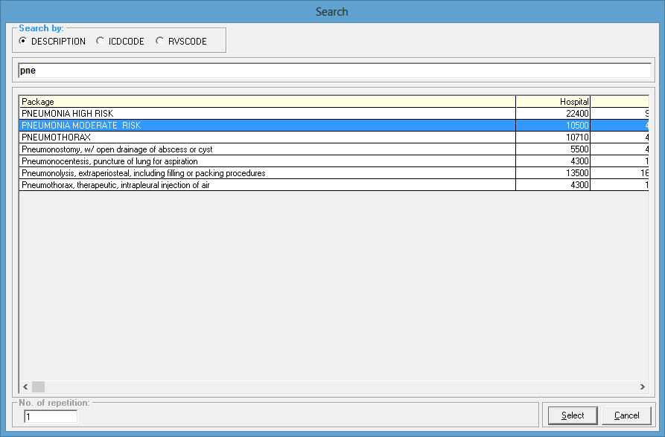
6
5
(Figure 2.2)

- Enter amount Under Medicare Column, amount that would be paid by PHIC. (see Figure 2.3)
- Then, Click “Save” button.

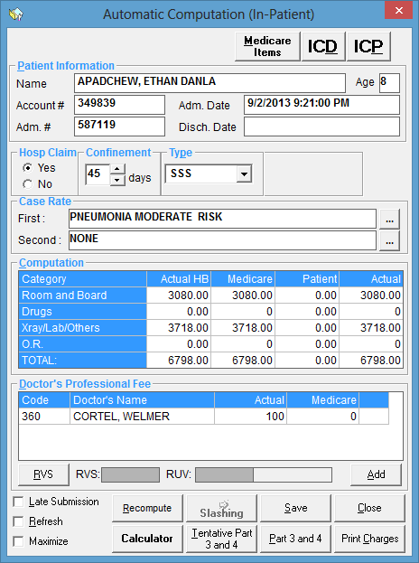
76
8
(Figure 2.3)

- How to print Claim Form 2 (page 1) ?

STEPS:
- Click “Computed” tab. (see Figure 3.1)
- Then, search for the patient that we had computed for package. (see Figure 3.1)
- Click on the patient that we want to print patient CF2. (see Figure 3.1)
- Then, Click the button of Data Entry. (see Figure 3.1)

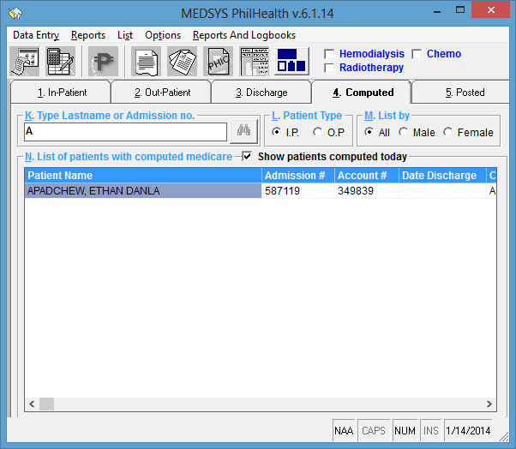
1

2

3
4
(Figure 3.1)

- Click “Print Form 2” button. (see Figure 3.2)

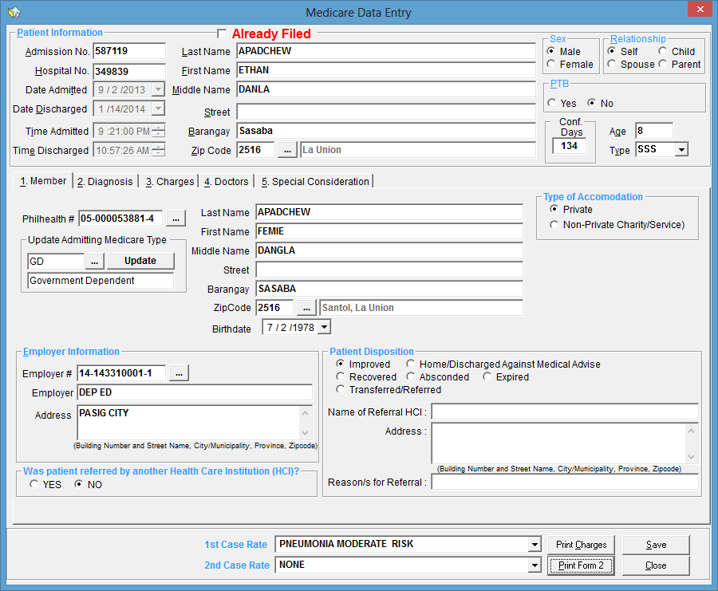
5
(Figure 3.2)

Then we have it, page 1 of Claim Form 2.
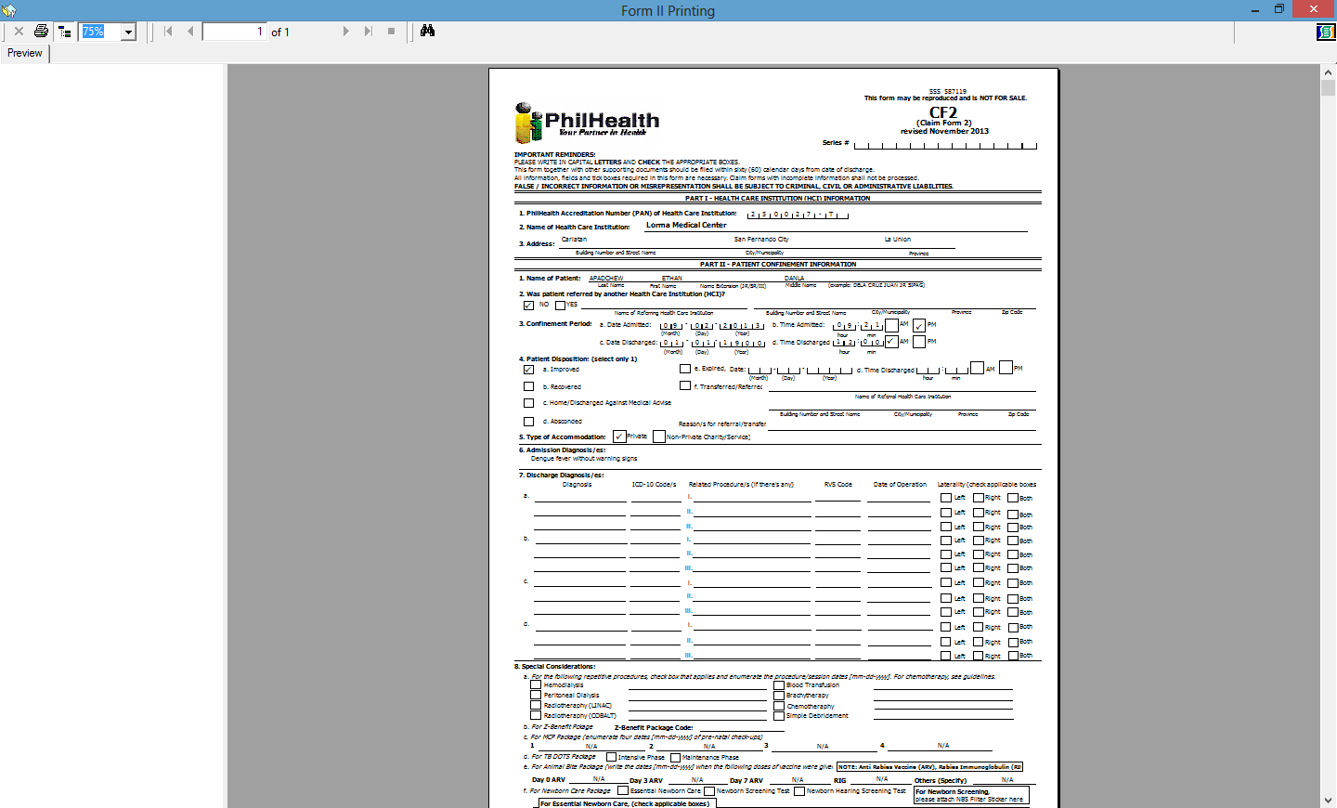

- How to print Claim Form 2 (page 2) ?

STEPS:
- On the “Computed” tab with patient selected, Click “Reports” menu. (see Figure 4.1)
- Hover in “Form III and IV” sub menu. (see Figure 4.1)
- Then, click on “ACR Format”. (see Figure 4.1)
1
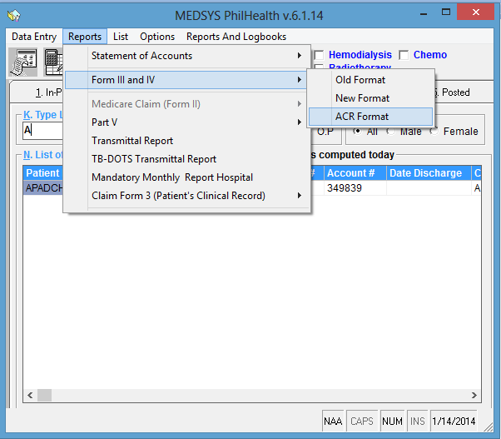
2
3
(Figure 4.1)

Then we have it, page 2 of Claim Form 2.
