MEDSYS
Information System

Pharmacy Dispensing Program
User's Manual



MEDSYS
Kaiser dela Cruz Consulting Incorporated
July 28, 2026

Copyright© 2009
ALL RIGHTS RESERVED

No part of this document may be reproduced through photocopying or in any means, stored into a retrieval system, and transmitted in any form without the express written permission of Kaiser dela Cruz Consulting Incorporated.
Permission is hereby granted to Medsys Information Systemto copy and distribute this document in any of the above means provided this is for its exclusive on site use.
Although every precaution has been taken in the preparation of this manual, the company assumes no responsibility for errors or omissions. Neither is any liability assumed for any damages resulting from the use of the information contained here.

Table of Contents

Introduction 4
Overview 4
Objectives 5
Features 5
Getting Started 6
How to Start the Program 6
How to Change Password 7
How to End the Program 8
Program Operation 9
Changing of Shift and Entry of Charge Slip Series 9
Manual Posting of Inpatient Request 10
Manual Posting of Outpatient Request 12
Processing of Inpatient Pending Request 14
Processing of Outpatient Pending Request 16
Cash-basis Patient Request Entry (Assessment) 18
Revoking of Cash-basis Request 20
Viewing of Revoked Assessments (Cash-basis) 21
Post Returned Medicines (Inpatient) 24
Post Returned Medicines (Outpatient) 277
Credit Advise 299
Correction Entry (Inpatient) 31
Correction Entry (Outpatient) 33
Clearing of Patient for Discharge 35
Drugs Inquiry 36
Reports 38
Index 39

INTRODUCTION

OVERVIEW



The Pharmacy Dispensing Program deals with the automation of general workflow and administration management process of a pharmacy. It keeps track of all your charged sales for inpatient and outpatient type of transactions. It’s got all the features you will need to manage your hospital pharmacy department in an easy to use and intuitive design. Also, reports are automatically generated when needed. It creates a work order for the patient \ nurse and tracks it to completion. There are many more features in the Visual Medsys Pharmacy Dispensing module but the most important is ease of use. It won’t take you long to get comfortable with the system. The online prescription or requesting facility assists and facilitates the physicians and nurses to track the patient’s prescription details and as well reflects the medication billing details in the Billing module.

Objectives

- To create a work order for the patient \ nurse and tracks it to completion
- To help the pharmacists in rendering to doctor and patient the best and most efficient services.
- To provide business (financial) information to management and process
- To provide quality control monitoring and performance reports

Features
- Pharmacy Dispensing program is tailored made according to specific hospital client’s policy, internal controls and standards
- Pharmacy Dispensing program’s interfacing features with different clinical modules help make the posting of charges fast, easy, efficient, completely traceable electronic process that saves time, reduces cost, minimizes effort and eliminates potential for error and oversights.
- Data-entry restriction - Warning messages are flashed for possible invalid entries. This ensures all data inputted would be made useful for any transaction that may occur.
- Password-protected - The use of password is necessary to restrict unauthorized access. Thus the program only accepts passwords which are registered into it. This feature ensures the confidentiality and integrity of data entered in the program.
- Auto-report generation - The program is capable of generating reports and can be readily printed
- User-friendly - The program user is guided by instructions in doing the next step providing an easy-use to process transactions. Tool-tips are also incorporated to give users an idea of what a particular button does.

Getting Started

How to Start the Program

1 Click the Pharmacy Dispensing Program executable file icon located in your computer desktop.

2 The Login window will be displayed asking you to type your employee number and password for security purposes.

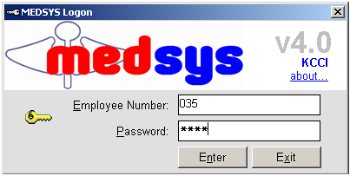
Figure 1: Login Window

3 If accepted, you can now start a transaction. Otherwise, a message will be displayed prompting “Unauthorized User”.

How to Change Password

1 From the Login window, type your employee number and then press <Enter>.

2 Under the Password entry, press <F12>. Pressing this function key will invoke the Change Password window.

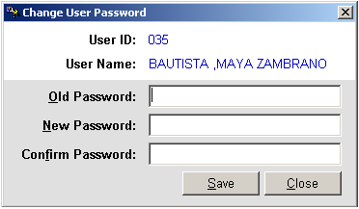
Figure 2: Change Password Window

3 Under the Change Password window, type the following data.
Old Password - Type your existing password.
New Password - Type your new password not exceeding to 15 characters.
Confirm Password - Retype your new password to confirm and then press <Enter> or you can click the Save button.

How to End the Program

It is important for users to close the program when they are done to end-up their session. Other users might use the open program using the same password.

To close the program:

Click located at the upper right corner of the main window.

Program Operation

Changing of shift and Entry of Chargeslip series
This allows the staff to tag the specific shift they are in and enable them to enter the starting series of the charge slip to be used during her shift as well as the checker. A sample window is loaded below.

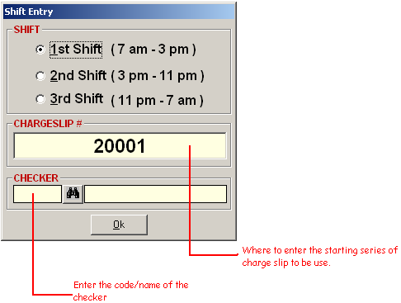

Manual Posting of Inpatient Request

This option allows you to enter medicine if request from nursing station module is not available.

1 Click the Manual Posting toolbar button to open the window.

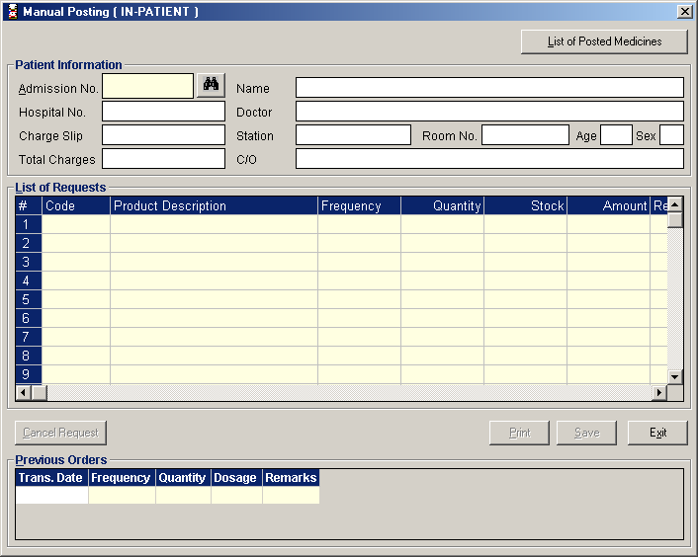

2 Under Admission No., entry, enter the patient’s admission number and then press <Enter>. Or you can type the first few letters of the patient’s last name and then press <Enter>. A window with patients list will appear matching the query typed. Double-click the patient name to select. The patient information will be automatically displayed also with the charge-slip number to be used.

3 To enter patient request, complete the following data.
Code - Type the item code and then press <Enter>. Or type the first few characters of the item name and then press <Enter>. A window with items list will appear matching the query typed. Double-click the item name to select. Its product description will be automatically displayed. The item’s previous order will also be automatically shown under Previous Orders at the bottom part of the window.
Frequency - Press <Enter> while entry is still blank to display the complete list of dosages. Double-click the dosage to select.
Quantity - Enter the number of item to request and then press <Enter>. The program will automatically display a message if the item stock is unavailable. Just press <Enter> to proceed. The remaining stock and amount will be automatically displayed.

To cancel entered item, click the item from the list and then click the Cancel Request button at the bottom part of the window.
Click the Save button to save entered item(s).
Click the Print button to save entered item(s) and to print its charge-slip.
Clicking the Exit button will display a message. Click the Yes button to close the window without saving the entered item(s) or click the No button to go back to the window.

Note: You can view the list of posted medicines of the selected patient’s confinement by clicking the List of Posted Medicines button at the upper right corner of the window. In there, you can print the patient’s drug file, list of posted medicines, and a particular charge-slip.

Manual Posting of Outpatient Request

This option allows you to enter medicine request of outpatient.

1 Click the Manual Post drop-down arrow and then select Out-Patient. Or you can click Post Prescriptions > Manual Posting > Out-Patient to open the window.

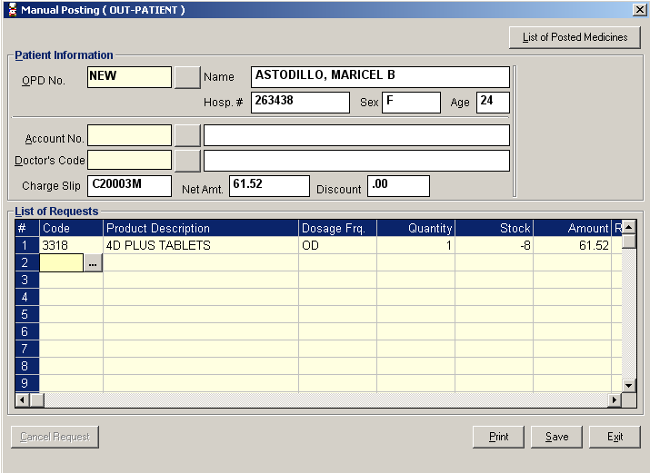

2 Under OPD No. entry, enter the patient’s OPD number and then press <Enter>. Or you can enter the first few letters of the patient’s last name and then press <Enter>. A window with patients list will appear matching the query typed. Double-click the patient name to select. The patient information and the charge-slip number to be used will be automatically displayed.

3 Under Doctor’s Code entry, enter the patient’s doctor. Type the first few letters of the doctor’s last name and then press <Enter>. A window with doctors list will appear matching the query typed. Double-click the doctor’s name to select.

4 To enter patient request, complete the following data.
Code - Type the item code and then press <Enter>. Or type the first few characters of the item name and then press <Enter>. A window with items list will appear matching the query typed. Double-click the item name to select. Its product description will be automatically displayed.
Dosage Frequency - Press <Enter> while entry is still blank to display the complete list of dosages. Double-click the dosage to select.
Quantity - Enter the number of item to request and then press <Enter>. The program will automatically display a message if the item stock is unavailable. Just press <Enter> to proceed. The remaining stock and amount will be automatically displayed.

To cancel entered item, click the item from the list and then click the Cancel Request button at the bottom part of the window.
To enter patient’s discount, click the box either beside Discount Type A or Discount Type B. You can change the discount percentage by clicking the drop-down arrow. Click the Apply button to include the discount. The amount of item(s) from the list will be automatically changed upon clicking the Apply button.
Click the Save button to save entered item(s).
Click the Print button to save entered item(s) and to print its charge-slip.
Clicking the Exit button will display a message. Click the Yes button to close the window without saving the entered item(s) or click the No button to go back to the window.

Note: You can view the list of posted medicines of the selected patient’s consultation by clicking the List of Posted Medicines button at the upper right corner of the window. In there, you can print the list of posted medicines, and a particular charge-slip.

Processing of Inpatient Pending Request

Use this option to process inpatient request(s) posted from the different nursing stations and other cost-centers.

1 Under the Communication File, click In-Patient. To view all inpatient pending requests, click All or to view pending requests by station, click By Station. See figure below.

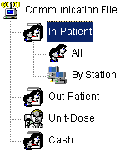

2 The list of pending requests is shown under Patient List. Double-click the patient name you want to process.

3 The Communication File Entry window will be displayed.

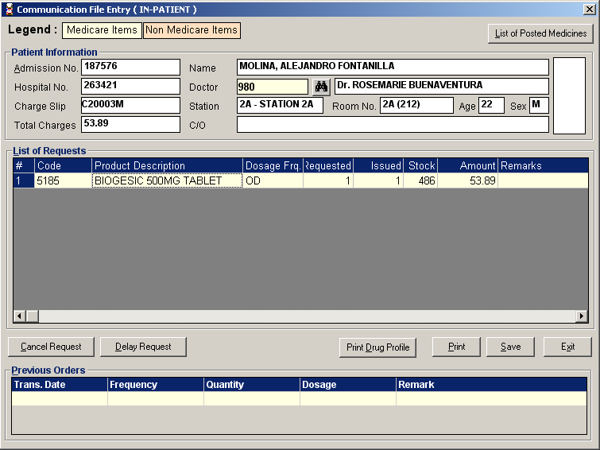

You can cancel a pending item by selecting the item from the list and then click the Cancel Request button located at the bottom part of the window.
To view a medicine history, click the item name from the list and then the list of medicine transaction will be shown under Previous Orders.
To process and save the request, click the Save button.
To print and save the request, click the Print button
Clicking the Exit button will display a message. Click the Yes button to close the window without processing the request or click the No button to go back to the window.

Note: You can view the list of posted medicines of the selected patient’s confinement by clicking the List of Posted Medicines button at the upper right corner of the window. In there, you can print the patient’s drug file, list of posted medicines, and a particular charge-slip.

Processing of Outpatient Pending Request

Use this option to process outpatient pending request(s) from Emergency Room and other cost-centers.

1 Under the Communication File, click Out-Patient. Click All to view all outpatient pending requests. See figure below.

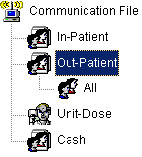

2 The list of pending requests is shown under Patient List. Double-click the patient name you want to process.

3 The Communication File Entry window will be displayed.

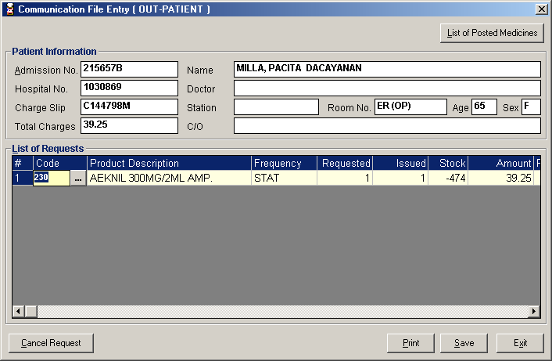

You can cancel a pending item by selecting the item from the list and then click the Cancel Request button located at the bottom part of the window.
To process and save the request, click the Save button.
To print and save the request, click the Print button
Clicking the Exit button will display a message. Click the Yes button to close the window without processing the request or click the No button to go back to the window.

Note: You can view the list of posted medicines of the selected patient’s consultation by clicking the List of Posted Medicines button at the upper right corner of the window. In there, you can print the patient’s drug file, list of posted medicines, and a particular charge-slip.

Cash-basis Patient Request Entry (Assessment)

This option allows you to enter medicine request of cash-basis patient.

1 Click the  Assessment Entry - Cash toolbar button to open its window.

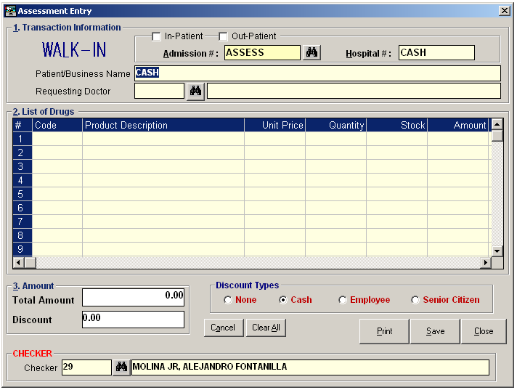
Assessment Entry Window

2 Under Patient Type entry, choose the patient type from “In-patient” or “Regular”. The default patient type is “Cash”.

3 To enter request, complete the following data.
Code - Type the item code or first few characters of the item name and then press <Enter>. A window with items list will be displayed matching the query typed. Double-click the item name to select. Its product description and unit price will be automatically displayed.
Quantity - Type the number of item to request and then press <Enter>. The program will automatically display a message if the item stock is unavailable. Just press <Enter> to proceed. The stock and amount will be automatically displayed.

You can view the total amount of the entered items at the upper right part of the window.
To delete entered item, click the row where the item is aligned and then click the Cancel button at the bottom part of the window.
To delete all entered items, click the Clear All button at the bottom part of the window.

- Tag Discount Type ( None, Cash, Employee, Senior Citizen )
- Check the name of the checker displayed. You can change it by changing the code or type the last name of the checker.
6 Click the Save button to save the entered item(s).
Click the Print button to save the entered item(s) and to print the charge-slip.
Click the Close button to close the Assessment Entry window.

Revoking of Cash-basis Request

Use this option to revoke assessment entry (cash-basis patient request).

1 Under the Communication File, click Cash and then click Unpaid Assessments. Click Current to display current unpaid assessments or Previous to display all previous unpaid assessments. See figure below.

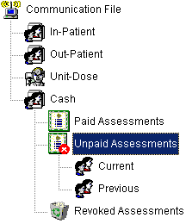

2 The list of unpaid assessments is shown under List of Patients. Select the assessment number you want to revoke and then click the Revoke Assessment Request toolbar button. A message will appear for confirmation. Click the Yes button to proceed or No to abort.

Viewing of Revoked Assessments (Cash-basis)

This option lets you view current and previous revoked assessments.

1 Under the Communication File, click Cash and then click Revoked Assessments. Click Current to display current revoked assessments or Previous to display all previous revoked assessments. See figure below.

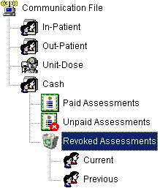

2 The list of revoked assessments is shown under Patients List.

Revoking of Paid Cash-Basis Request
This option allows the user to process cancellation of patient’s request(s) that is already paid. To do this, go to OTHERS > POST RETURNED MEDICINES > CASH to load the window below

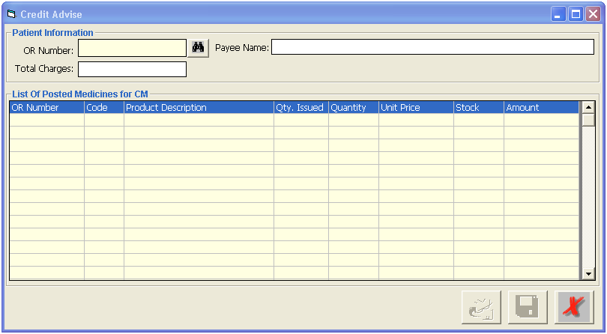

Enter the OR Number of the item paid then press Enter key. In the code column, press ENTER key to load a sample window below that display lists of items paid on that specific OR.

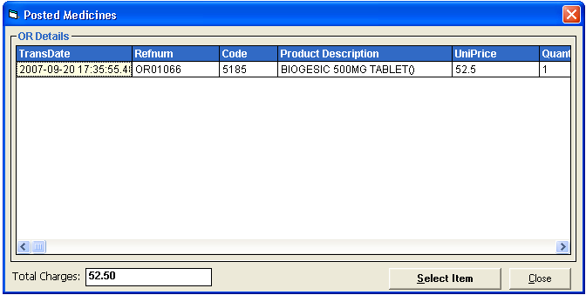
On the item(s) displayed, double click on the specific item to be returned. A sample window is displayed below once the item is selected.
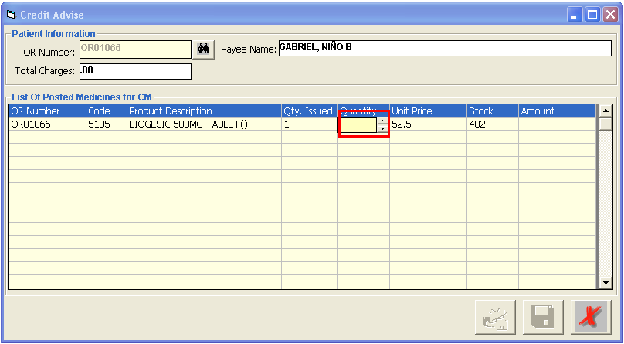
In the Quantity column, enter the number of items to be returned.
Click on button to save entries.

Post Returned Medicines (Inpatient)

Use this option to enter returned medicines of inpatient.

1 Click the Post Returned Medicines toolbar button to open its window.

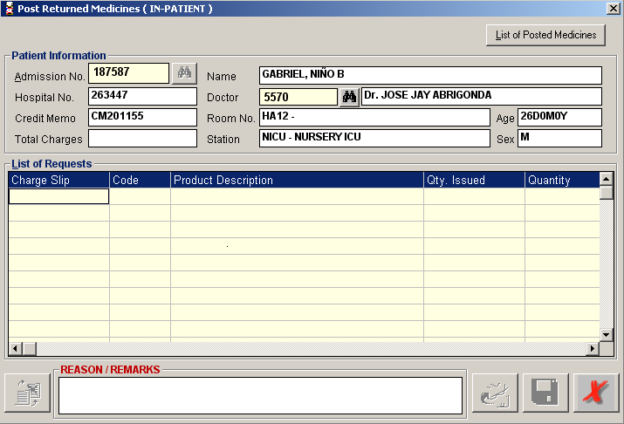

2 Under Admission No. Entry, enter the patient’s admission number and then press <Enter>. Or you can enter the first few letters of the patient’s last name and then press <Enter>. A window with patients list will appear matching the query typed. Double-click the patient name to select. The patient information will be automatically displayed.

3 To enter returned medicine(s), complete the following data.
Charge Slip - Press the <Enter> key to display list of charge-slips issued.

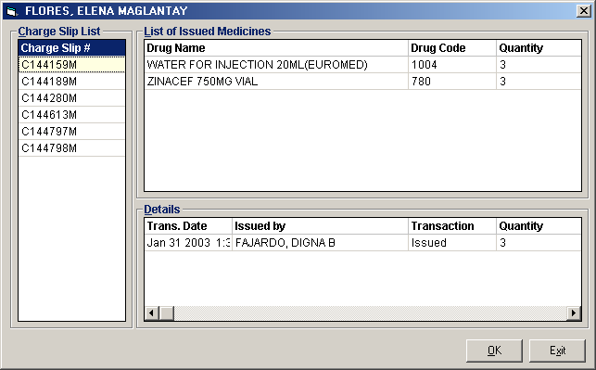

Click the charge-slip number at the left side of the window to display issued medicines and its details. To select, double-click the charge-slip number.

Code - Press the <Enter> key to display issued medicines. Double-click the item name to select. Its description, quantity issued and stock will be automatically displayed.

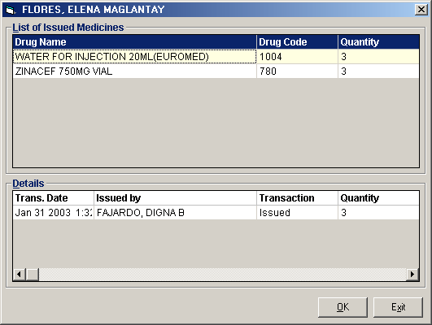
Quantity - Type the number of item to return. This should not be greater than the number of item issued.

You can view the total amount of the medicine returned just above the List of Requests.
To delete entered returned medicine from the list, click the item name and then click the Clear Row button at the bottom part of the window.
* Reason / Remarks why returning the medicine can be entered in the REASON / REMARKS text box.

4 Click the Save button to save the returned medicine.
Click the Print button to save the returned medicine and to print the charge-slip.
Clicking the Exit button will display a message. Click the Yes button to close the window without saving returned medicine or click the No button to go back to the window.

Note: You can view all posted medicines since the start of the selected patient’s confinement by clicking the List of Posted Medicines button at the upper right corner of the Post Returned Medicine window. To reprint a charge-slip, click the reference number you want to reprint and then click the Reprint button.

Post Returned Medicine (Outpatient)
Use this option to enter returned items of outpatient.
1 Click the Post Returned Medicine drop-down arrow and then select Outpatient or click Others > Post Returned Medicines > Outpatient to open its window.
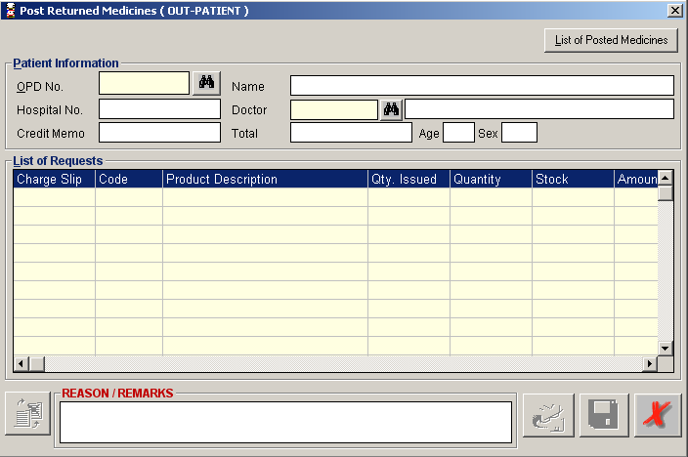
2 Under OPD No., type the first few letters of the patient’s last name and the press <Enter>. A window with patients list will appear matching the query typed. Double-click the patient name to select. The patient information will be automatically displayed afterwards.
3 To enter returned medicine, complete the following data.
Charge Slip - Press the <Enter> key to display list of charge-slips issued.
Click the charge-slip number at the left side of the window to display issued medicines and its details. To select, double-click the charge-slip number.
Code - Press the <Enter> key to display issued medicines. Double-click the item name to select. Its description, quantity issued and stock will be automatically displayed.

Quantity - Type the number of item to return. This should not be greater than the number of item issued.

You can view the total amount of the medicine returned just above the List of Requests.
To delete entered returned medicine from the list, click the item name and then click the Clear Row button at the bottom part of the window.
* Reason / Remarks why returning the medicine can be entered in the REASON / REMARKS text box.

4 Click the Save button to save the returned medicines.
Click the Print button to save the returned medicines and to print the charge-slip.
Clicking the Exit button will display a message. Click the Yes button to close the window without saving returned medicines or click the No button to go back to the window.

Note: You can view all posted medicines since the start of the selected patient’s consultation by clicking the List of Posted Medicines button at the upper right part of the Post Returned Medicines window. To reprint a charge-slip, click the reference number you want to reprint and then click the Reprint button.

Post Returned Medicine (Credit Advise)
Use this option to enter returned items of outpatient.
1 Click the Others 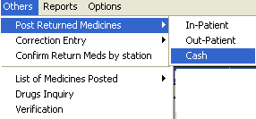 Post Returned Medicine drop-down arrow and then select Cash to open this window
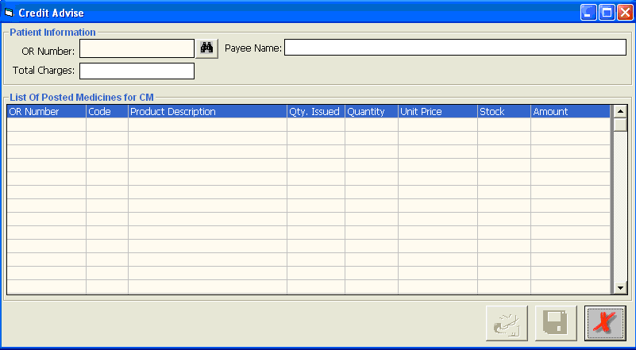
2 Type in the official receipt number of the item to return then press enter or Search option. Program will search for existing document number, once located, payee name will automatically display on the screen.
3 Click on the 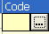 option to list the items included charged with the given official receipt number.

4 Select from the list the specific item to return as shown on the window below:
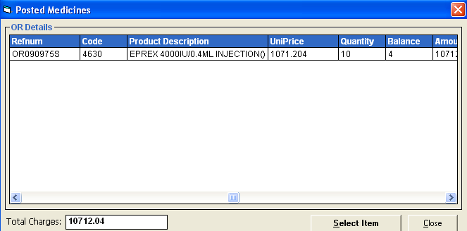
- To choose for the item to return, click the item name and then click the button at the bottom part of the window.

- Type in the number of quantity to return as shown below

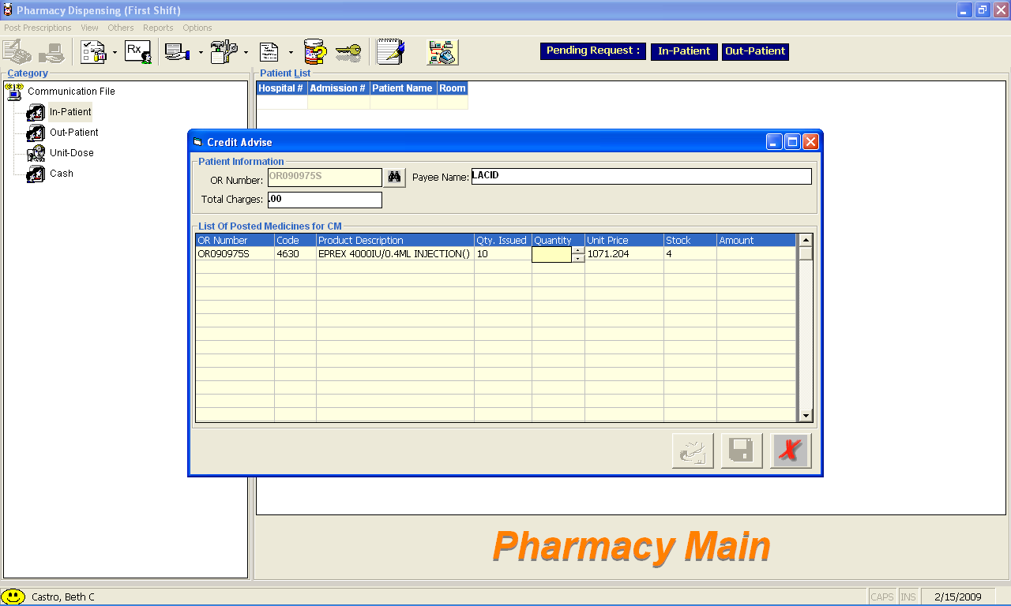
6 Click the 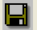Save button (without printing) or 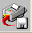 save button (with printing of credit advise form).

Note: The above process once saved will not immediately add back the returned quantity of the returned item to the pharmacy dispensing inventory stock balance. It will be the cashier module that will trigger the update of the stock balance once the credit advise is processed.

Correction Entry (Inpatient)
Use this option to adjust posted medicine of inpatient.
1 Click the 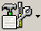 Correction Entry toolbar button to display the window.
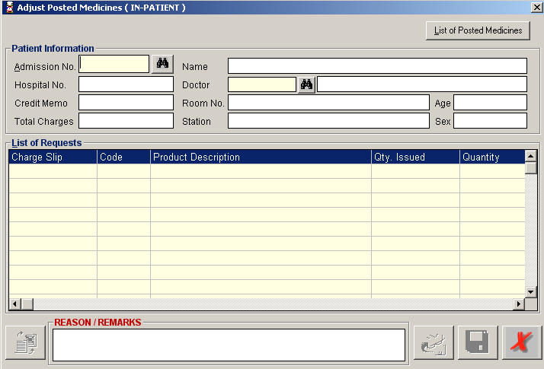
2 Under Admission No. entry, enter the patient’s admission number and then press <Enter>. Or you can enter the first few letters of the patient’s last name and then press <Enter>. A window with patients list will appear matching the query typed. Double-click the patient name to select. The patient information will be automatically displayed.
3 To adjust posted medicine(s), complete the following data.
Charge Slip - Press the <Enter> key to display list of charge-slips issued.
Click the charge-slip number at the left side of the window to display issued medicines and its details. To select, double-click the charge-slip number.
Code - Press the <Enter> key to display issued medicines. Double-click the item name to select. Its description, quantity issued and stock will be automatically displayed.

Quantity - Type the number of item to adjust. This should be greater than the number of item issued.

You can view the total amount of the medicine adjusted just above the List of Requests.
To delete entered adjusted medicine from the list, click the item name and then click the Clear Row button at the bottom part of the window.
* Reason / Remarks why adjusting the medicine can be entered in the REASON / REMARKS text box.

4 Click the Save button to save the adjusted medicine.
Click the Print button to save the adjusted medicine and to print the charge-slip.
Clicking the Exit button will display a message. Click the Yes button to close the window without saving adjusted medicine or click the No button to go back to the window.

Note: You can view all posted medicines since the start of the selected patient’s confinement by clicking the List of Posted Medicines button at the upper right corner of the Adjust Posted Medicine window. To reprint a charge-slip, click the reference number you want to reprint and then click the Reprint button.

Correction Entry (Outpatient)
Use this option to adjust posted medicines of outpatient.
1 Click the Correction Entry drop-down arrow and then click Out-Patient. Or you can click Others > Adjust Posted Medicine > Out-Patient to open the window.
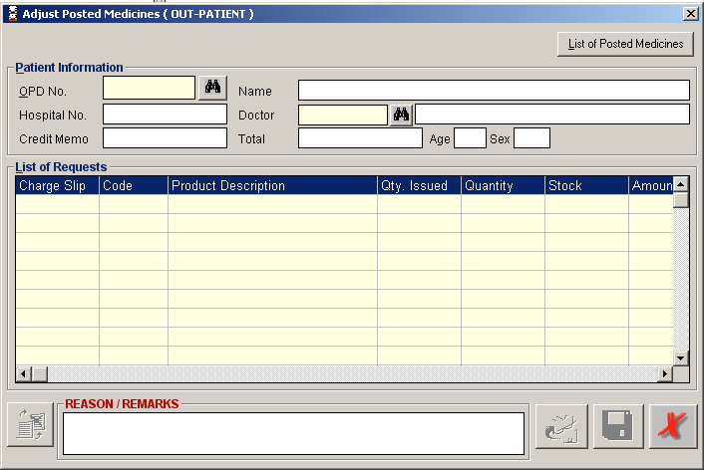
2 Under OPD No., type the first few letters of the patient’s last name and the press <Enter>. A window with patients list will appear matching the query typed. Double-click the patient name to select. The patient information will be automatically displayed afterwards.
3 To enter returned medicine, complete the following data.
Charge Slip - Press the <Enter> key to display list of charge-slips issued.

Click the charge-slip number at the left side of the window to display issued medicines and its details. To select, double-click the charge-slip number.
Code - Press the <Enter> key to display issued medicines. Double-click the item name to select. Its description, quantity issued and stock will be automatically displayed.

Quantity - Type the number of item to adjust. This should be greater than the number of item issued.

You can view the total amount of the medicine adjusted just above the List of Requests.
To delete entered adjusted medicine from the list, click the item name and then click the Clear Row button at the bottom part of the window.
* Reason / Remarks why adjusting the medicine can be entered in the REASON / REMARKS text box.

4 Click the Save button to save the adjusted medicines.
Click the Print button to save the adjusted medicines and to print the charge-slip.
Clicking the Exit button will display a message. Click the Yes button to close the window without saving adjusted medicines or click the No button to go back to the window.

Note: You can view all posted medicines since the start of the selected patient’s consultation by clicking the List of Posted Medicines button at the upper right part of the Adjust Posted Medicines window. To reprint a charge-slip, click the reference number you want to reprint and then click the Reprint button.

Clearing of Patient for Discharge
1 Double-click on. Its window will be displayed showing the list of cleared and not cleared patients. (The legend of “Cleared” and “Not Cleared” patients can be seen at the bottom part of the window)

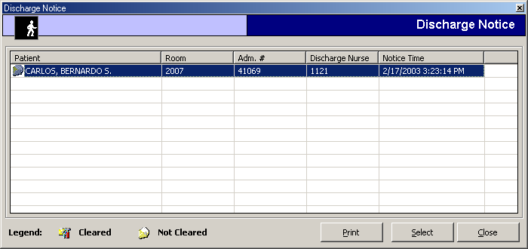
2 Select an un-cleared patient from the list and then click the Select button
3 A window for clearing patients will be displayed. Just type your remarks for clearing the patient.
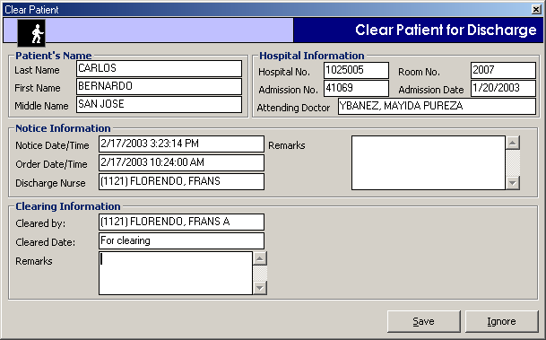
4 The following button option can be clicked from
Save - Click this button to clear the patient in your department.
Ignore - Click this button to ignore clearing the patient.

Drugs Inquiry

This option allows you to view medicine information particularly on its available stock, inpatient and outpatient selling price, generic class, and classification.

1 Click the  Drug Inquiry toolbar button to display the window.

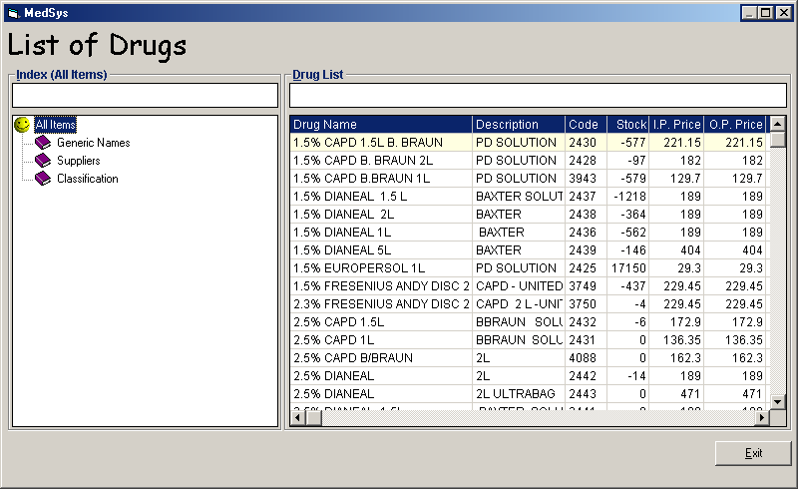

You can arrange the list of drugs by its generic name, supplier or classification. Just double-click the option at the left side of the window.

Reports
To open a report, click Reports to display the list and then click the report you want to view.
- Admission List
2. Census by Station
3. Daily Discharge Report
4. Patient’s Unit Dose Report
5. Patient’s with Discharge Notice
6. Daily Income Report
- Inpatient
  - Detailed
  - Summary
- Outpatient
  - Detailed
  - Summary
- Cash Sales
7. Monthly Income Report
- Inpatient
  - Detailed
  - Summary
- Outpatient
  - Detailed
  - Summary
8. Cash Pharmacy Discount Report
9. Income Report Summary
10. Drug Distribution Report
11. Dispenser Report
12. Additional Report
- Doctors Drug Consumption For the Month
- Doctors Patient Confinement
13. Daily Prescription Census
14. Income Report (By Transaction Date)
- Inpatient
- Outpatient
- Cash
15. PHIC List of Available Medicines
16. Employees Medicines

Index

—A—
adjust medicine (inpatient), 27
adjust medicine (outpatient), 30
assessment - revoked (viewing of), 20
assessment (revoking of), 19
assessment request entry, 17
—C—
cash-basis (revoking of), 19
change password, 7
clear patient for discharge, 33
close the program, 8
—D—
discharge order, 33
discharge patient, 33
drug inquiry, 35
—E—
end the program, 8
—F—
features, 5
—I—
inpatient (requesting of medicine), 9
inpatient pending request (processing of), 13
—M—
medicine (inpatient adjusting of), 27
medicine (inpatient returning of), 21
medicine (outpatient adjusting of), 30
medicine (outpatient returning of), 24
medicine inquiry, 35
medicine request (inpatient), 9
medicine request (outpatient), 11
—O—
objectives, 5
outpatient (requesting of medicine), 11
outpatient pending request (processing of), 15
overview, 4
—P—
password (changing of), 7
process inpatient request, 13
process outpatient request, 15
—R—
reports, 36
request (cash-basis) entry, 17
request (inpatient processing of), 13
request (outpatient processing of), 15
return medicine (inpatient), 21
return medicine (outpatient), 24
revoked assessment (viewing of), 20
—S—
start the program, 6

