MEDSYS
Information System

Visual Personnel Program
User's Manual


MEDSYS
Kaiser dela Cruz Consulting Incorporated
July 31, 2026

Copyright© 2009

ALL RIGHTS RESERVED

No part of this document may be reproduced through photocopying or in any means, stored into a retrieval system, and transmitted in any form without the express written permission of Kaiser dela Cruz Consulting Incorporated.
Permission is hereby granted to Medsys Information System to copy and distribute this document in any of the above means provided this is for its exclusive on site use.
Although every precaution has been taken in the preparation of this manual, the company assumes no responsibility for errors or omissions. Neither is any liability assumed for any damages resulting from the use of the information contained here.

Table of Contents
Introduction Error: Reference source not found
Overview Error: Reference source not found
Objectives 5
Features Error: Reference source not found
Getting Started 6
How to Start the Program Error: Reference source not found
How to Change Password Error: Reference source not found
How to End the Program Error: Reference source not found
Program Operation Error: Reference source not found
How to Enter Employee Data 9
How to End Employee Dependents 11
How to Enter Employee Other Details 12
How to End Employee Employment Record 13
How to Enter Employee Special Skills 14
How to End Employee Leaves 15
How to Enter Employee Offenses 16
REPORTS 17

Overview
The Personnel Program allows you to manage your employee data throughout the entire employment cycle. This software is customized to fit your human resource departments. With this software you will be able to easily manage your human resource department, the personal records, certifications, training and even more. This program enables easy viewing of personnel information. It is extremely user-friendly and easy to use, and any authorized person, whether in human resources or any other section, may access it. Foolproof of access security prevents any unauthorized person from viewing confidential information.

Objectives
- To have more accurate HR data tracking like education, qualifications and skills of the employees.
- To provide easy access to employee data, plus tools to audit the information for accuracy.
- To capture / record basic demographic and address data, training and development, capabilities and skill of employees.

Features
- User-Accessibility Control – Each user has its own password and rights. He can only use the program intended for him.
- Integrated – Designed for use in the healthcare industry that seamlessly integrates staff scheduling and payroll systems into a single database.
- Data-entry restriction - Warning messages are flashed for possible invalid entries. This ensures all data inputted would be made useful for any transaction that may occur.
- Password-protected - The use of password is necessary to restrict unauthorized access. Thus the program only accepts passwords which are registered into it. This feature ensures the confidentiality and integrity of data entered in the program.
- Auto-report generation - The program is capable of generating reports and can be readily printed
- User-friendly - The program user is guided by instructions in doing the next step providing an easy-use to process transactions. Tool-tips are also incorporated to give users an idea of what a particular button does.

Getting Started

How to Start the Program
1 Click on Personnel program executable file icon located in your computer desktop.
2 The Login window will display asking you to type your employee number and password for security purposes.
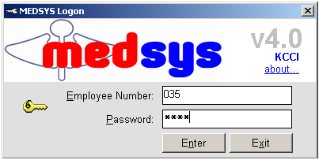
Figure 1: Login Window
3 If the program has validated your employee number and password, you may now start a transaction. Otherwise, a message will display prompting “Unauthorized User”.

Changing of User’s Password
It is advisable to change your password frequently for security reasons. To change your current password, follow these steps.
1 From the Login window, type your employee number and then press <Enter>.

2 Under the password entry, press <F12> Pressing this function key will invoke the Change Password window.
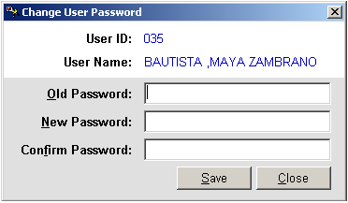
Change Password Window
3 Under the Change Password Window, type the following data.
Old Password – Type your existing password
New Password – Type your new password not exceeding to 15 characters
Confirm Password – Retype your new password to confirm and then press <Enter> or you can click the Save button.

How to End the Program
It is important for users to close the program when they are done to end-up their session. Other users might use the open program using the same password.
To close the program:

1 Click on at the upper right corner of the screen or
2 Click File > Exit.

Program Operations
How to Enter Employee’s Personal Data?

Click on File in the Main Menu then choose Employee File to display the window below.
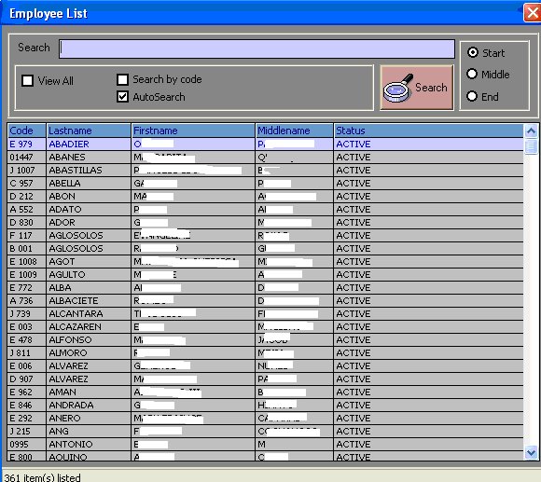

Double click on the employee you want to update information. This would display the window below

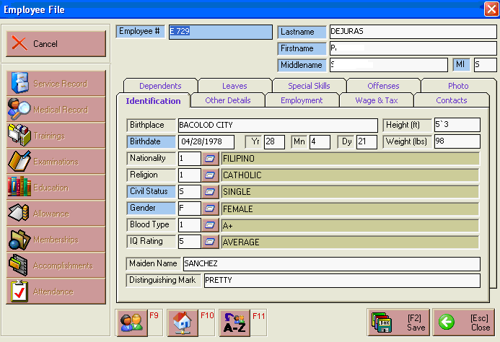
The default tab is for the Employees Personal data. In here, you can update the following information:
- Birthplace
- Birthdate
- Nationality
- Religion
- Height and weight
- Civil Status
- Gender
- Blood type
- IQ rating
- Maiden Name
- Distinguishing

Click the Save button if you want to update or save employee data entered.
Click the ESC button to go out from the window.

How To Enter Employee Dependents?

To do this, click on Dependents tab in the Employee File menu. This will enable you to enter employee’s active or qualified dependents.
Double click on the specific employee and this will display the window below.
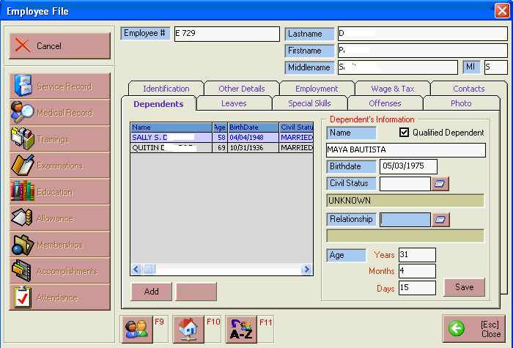
Click on the Qualified Dependent box.
Enter the following data or information
- Dependent Name
- Birthdate
- Civil Status
- Relationship
- Age: It is automatically computed based on the birthdate entered.

Click the Save button to update or save the data entered.
Click the Esc button to go out from the window.

To add another dependent, click on the ADD button or to remove a dependent on the employee data, highlight the dependent name then click the REMOVE button.
How to enter Employee’s Other Details?

This will allow the HRD staff to enter employees other data. Double click on the employee name then click on the Other Details tab in the Employee File menu to display the window below
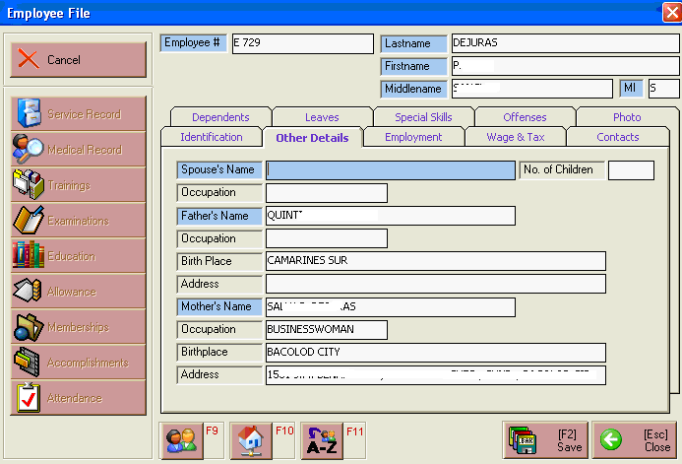

Enter the following information:
- Spouse Name and No. of Children
- Occupation
- Father’s Name, Occupation, Birthplace and Address
- Mother’s Name, Occupation, Birthplace and Address
To save the data entered, click on the SAVE button.
To go out from the window, click on the Esc button.

How to Enter Employee’s Employment Record?

This will enable the HRD staff to enter employee’s employment record in the hospital. To do this, click on the Employment tab in the Employee file menu. This will display the window below.
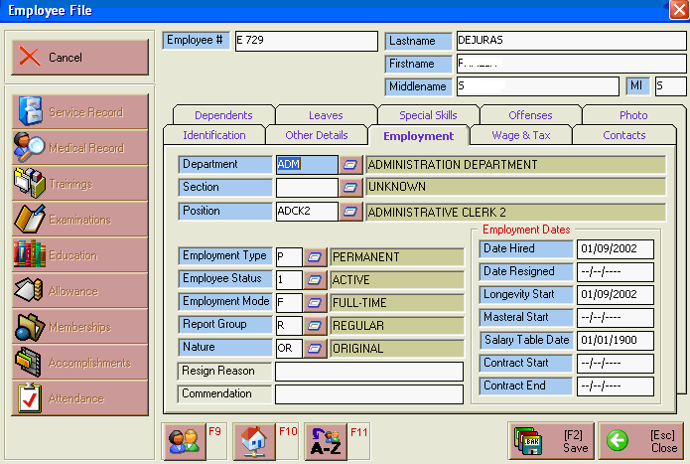

Enter the following information:
- Department
- Section
- Position
- Employment type, Employment Status, Employment Mode, Report Group and Nature of Work
- Date Hired
- Longevity Start
- Salary Table Date
- If contractual, enter Contract Start and Contract End
- If resigned, enter Date Resigned and Reason for Resigning
Click the Save button to update or save employee data
Click the Esc button to go out from the window.

How to Enter Employee’s Special Skills?
This will enable the HRD staff to enter employee’s special skills they have. To do this, double click on the employee then click the Special Skills tab in the Employee File main menu to display the window below.
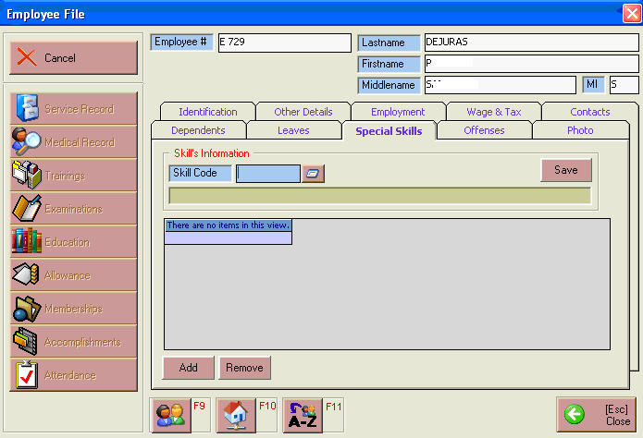

Click on the Skill Code ( ) button to display list of special skills. Double click on the item.

To update / save the data entered, click on Save button.

To add new skill, click on Add button.
To remove a specific skill added to employee data, click on Remove button.

To go out from the special skills window, click on Esc button

How to Enter Employee Leaves?

This will enable the HRD staff to enter the allowed and consumed leaves by an employee. To do this, click on Leaves tab in the Employee File menu. This will display the window below
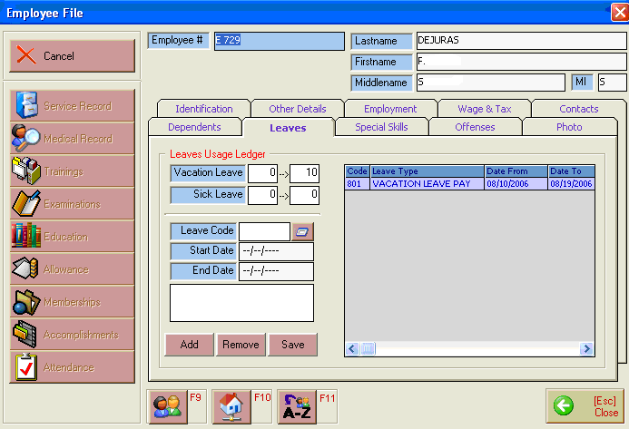

Enter the following information
- No. of Vacation leave allotted to the employee
- No. of Sick Leave allotted to the employee
- Enter the Leave consumed by the employee by entering the Leave Code, Start and End date of Leave

To Save the data entered, click the SAVE button.
To Add new leave consumed by employee, click on Add button.
To delete an entered leave, highlight the leave then click on Remove button.
To out from the leave window, click on Esc button

How to Enter Employee Offenses?

This will allow the HRD staff to enter the offense/s violated by an employee. To do this, double click on the employee name then click on the Offenses tab in the Employee file menu. This will display the window below
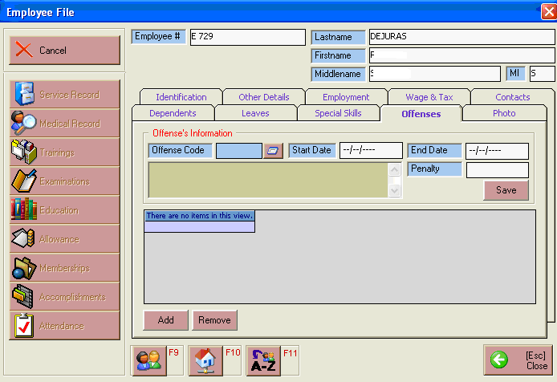

In the Offense’s information, enter the following information
- the offense violated by the employee by clicking on the Offense Code ( ) button to display lists of offenses.
- The Start and End date of Suspension
- The penalty

To update / save the data entered, click on Save button
To add new offense, click on Add button.
To remove an offense entered, click on Remove button.
To go out from the Offense window, click on Esc button.

Reports
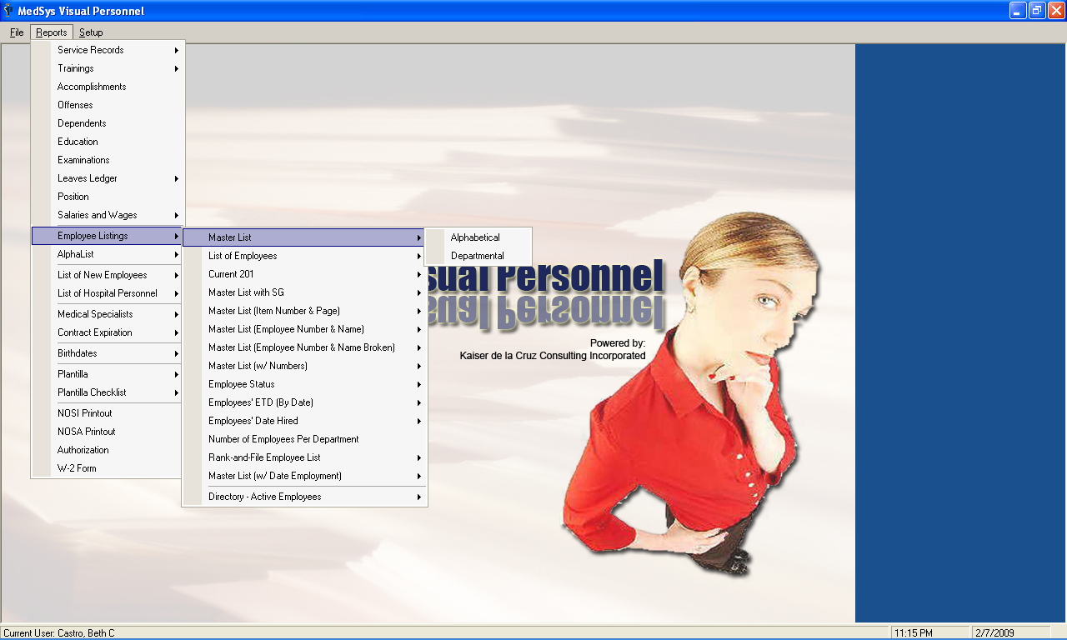
The following reports can be generated from the system.
- Service Records
- Standards
- Without Signatory
- Trainings
- Master List
- Per Individual
- Accomplishments
- Offenses
- Dependents
- Education
- Examinations
- Leaves Ledger
- Paternity Leave
- Maternity Leave
- Sick Leave
- Vacation Leave
- Study Leave
- Suspension
- Emergency Leave
- Official Business
- All Leaves
- Position
- Salaries and Wages
- Alphabetical
- Departmental
- By Salary
- Employee Listings
- Master List
- Alphabetical
- Departmental
- List of Employees
- Alphabetical
- Departmental
- By Job Level
- Current 201
- Alphabetical
- Departmental
- Master List with SG
- Alphabetical
- Departmental
- Master List (Item Number and Page )
- Alphabetical
- Departmental
- Master List (Employee Number and Name)
- Alphabetical
- Departmental
- Master List (Employee number and Name broken)
- Alphabetical
- Departmental
- Master List (W/ Numbers)
- Alphabetical
- Departmental
- Employee status
- Alphabetical
- Departmental
- Employees’ ETD (By Date)
- Alphabetical
- Departmental
- Employees’ Date Hired
- By Month
  - Alphabetical
  - Departmental
- By Years of service
  - Alphabetical
  - Departmental
- Number of Employees per Department
- Rank-and-File Employees List
    - Alphabetical
    - Departmental
- Master List (with Date Employment)
- Casual Date
  - Alphabetical
  - Alphabetical Order by Month
  - Alphabetical Order by Year
  - Departmental
  - Departmental Order by Month
  - Departmental Order by Year
- Probationary Date
  - Alphabetical
  - Alphabetical Order by Month
  - Alphabetical Order by Year
  - Departmental
  - Departmental Order by Month
  - Departmental Order by Year
- Regularization Date
  - Alphabetical
  - Alphabetical Order by Month
  - Alphabetical Order by Year
  - Departmental
  - Departmental Order by Month
  - Departmental Order by Year
- Directory- Active Employees
    - Alphabetical
    - Departmental
  - Alpha List
  - TIN Numbers
  - Philhealth Numbers
  - Pag-Ibig Numbers
  - SSS/GSIS Numbers
  - PERAA Numbers
  - Bank Account Numbers
  - Tabulated / Summary
- List of New Employees
- Alphabetical
- Departmental
- List of Hospital Personnel
- Alphabetical
- Departmental
- Medical Specialists
- Alphabetical
- Departmental
- Contract Expiration
- Alphabetical
- Departmental
- Birthdates
- Order by Month
- Order by Year
- Master List
- Plantilla
- By Item Number
- Departmental
- Plantilla Checklist
- By Position
- Departmental
- Vacant Positions
- NOSI Print out
- NOSA Print Out
- Authorization
- W-2 form

