MEDSYS
Information System

Payroll Program
User's Manual



MEDSYS
Kaiser dela Cruz Consulting Incorporated
July 28, 2026

Copyright© 2009
ALL RIGHTS RESERVED

No part of this document may be reproduced through photocopying or in any means, stored into a retrieval system, and transmitted in any form without the express written permission of Kaiser dela Cruz Consulting Incorporated.
Permission is hereby granted to Medsys Information System to copy and distribute this document in any of the above means provided this is for its exclusive on site use.
Although every precaution has been taken in the preparation of this manual, the company assumes no responsibility for errors or omissions. Neither is any liability assumed for any damages resulting from the use of the information contained here.

Table of Contents
Introduction 5
Overview 5
Objectives 6
Features 6
Getting Started 7
How to Start the Program 7
Changing of User's Password 8
How to End the Program 9
Program Operation 10
How to set payroll date 10
How to Add/Edit Payroll data Error! Bookmark not defined.1
Payroll Data Entry 19
How to Process Payroll Data 23
Payslip File 26
Post Salary Deduction 27
Longevity 28
Loan Entry 29
Insurance Entry 30
Other Earnings Entry 31
Deduction Entry 32
Loan Entry (Tabular) 33
Other Earnings Entry (Tabular) 34
Deduction Entry (Tabular) 35
Allowance Entry 36
Service Record 38
O. R. remittance 39
Company Profile 40
Employee Selection 44
Build Files 45
Departments 45
Positions 47
Leave Type 48
Report Groups 49
Employee Status 50
Civil Status 51
Holidays 51
Contact Types 51
Address List 51
Religions List 51
Gender List 52
IQ Rates 52
Nationality List 52
Relationship List 52
Payroll Tables 53
How to view General Tax Table 53
How to view Annual Tax Table 53
How to view SSS Table 54
How to view PHIC Table 54
How to view Salary Table 55
View Processed Data 56
View Negative Net Pays 57
Manual Data Entry 58
Accumulated Data 59
Close Year (Year-End) 59
Reports 60

Introduction

Overview


The Payroll System facilitates and simplifies the preparation of total amount required to pay workers and employees during a week, month or other period of the institution. It allows faster and more accurate computation of monthly gross income, deductions and net salary.
The program is password-protected. Each user is assigned with an employee number, an encrypted password, and defined rights to control the access of users to program operations.

Objectives

- To increase staff production while reducing overtime
- To prepare payroll reports fast, easy and accurate
- To help human resource professionals as well as finance and accounting personnel to manage employee compensation, deductions, allowances, and benefits in the institution.

Features

- Medsys Payroll program is tailored made according to specific hospital’s formula, policy, internal controls and standards
- The system is integrated with the Personnel System to provide detail information.
- It is linked to Employee Accounts Receivable and Payable system.
- Data-entry restriction - Warning messages are flashed for possible invalid entries. This ensures all data inputted would be made useful for any transaction that may occur.
- Password-protected - The use of password is necessary to restrict unauthorized access. Thus the program only accepts passwords which are registered into it. This feature ensures the confidentiality and integrity of data entered in the program.
- Auto-report generation - The program is capable of generating reports and can be readily printed
- User-friendly - The program user is guided by instructions in doing the next step providing an easy-use to process transactions. Tool-tips are also incorporated to give users an idea of what a particular button does.

Getting Started

How to Start the Program
1 Click on  Payroll program executable file icon located in your computer desktop.
2 The Login window will display asking you to type your employee number and password for security purposes.
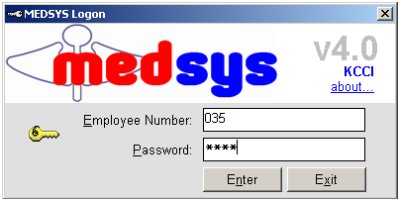
Figure 1: Login Window
3 If the program has validated your employee number and password, the Cashier Setting Window will be displayed. This window serves as the data entry for principal O.R., collection date, remittance date and shift.

Changing of User’s Password
It is advisable to change your password frequently for security reasons. To change your current password, follow these steps.
1 From the Login window, type your employee number and then press <Enter>.

2 Under the password entry, press <F12> Pressing this function key will invoke the Change Password window.
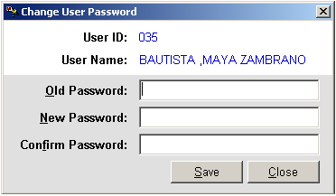
Change Password Window
3 Under the Change Password Window, type the following data.
Old Password – Type your existing password
New Password – Type your new password not exceeding to 15 characters
Confirm Password – Retype your new password to confirm and then press <Enter> or you can click the Save button.

How to End the Program
It is important for users to close the program when they are done to end-up their session. Other users might use the open program using the same password.
To close the program:

1 Click on at the upper right corner of the screen or
2 Click File > Exit.

Program Operation
How to set Payroll Date

This option is the first step of the payroll program flow after building all the necessary build files and we are now ready to process the payroll of the month. Since the payroll setup is on a semi-monthly basis it is required to enter two dates, one for the first half of the month and one for the second half. Set the payroll date once every month. These dates are used in generating semi-monthly dated reports like Bank Remittance and Cash Remittance Reports.

1. Click on Activities on the menu bar, from the pull-down menu click on Switch Month Half to display the window below.
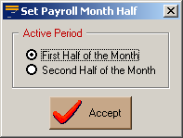
Set Payroll Month Half Window

Chose on the half to process then click on the accept button.
This option allows the user to switch between the first half and second half of payroll.

How to Add/Edit Employee Data

Add new or edit existing employees. This file includes Employee Identification, Employment Record, Wage and Tax, Contacts, Dependents, Leaves, Special Skills, Offenses, Photo, and Other Details, which include the spouse, father and mother information.
This option also lets you check for the employees that are not to be included in the payroll and set their Status to Leave/Resigned.

1. Click on button from the toolbar and the Employee List Window will appear
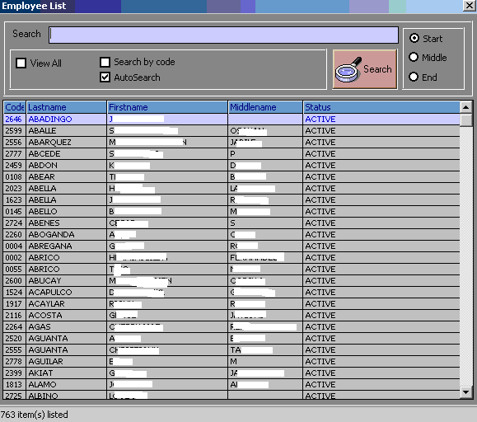
Employee List Window
2. Press Enter and the window below will appear Click on or just press F5 to that will lets you input a new employee. To edit an employee data select the name of the employee from the list. Refer to the figure below
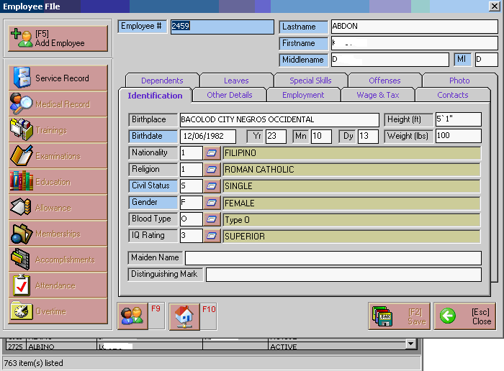

. Employee File Window

4. Enter the necessary data under Identification tab.
· Birth Place
· Birth Date
· Nationality
· Religion - click on to display the complete list of Religion and just click the religion selected and it will automatically displayed.
· Civil Status - click on to display the complete list of Civil Status and just click the Civil Status selected and it will automatically displayed.

· Blood Type - click on to display the complete list of Blood Type and just click the Blood Type selected and it will automatically displayed.

· IQ Rating - click on to display the list of IQ Rating and just click the IQ selected and it will automatically displayed.

· Maiden Name
· Distinguishing Mark

5. Enter the necessary data under Other Details tab.

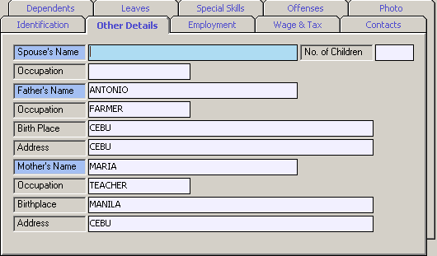
Other Details Tab
· Spouse’s Name
· Occupation – Occupation of the Spouse
· Father’s Name
· Occupation – Occupation of the father
· Birth Place (father)
· Address – Current Address of the father
· Mother’s Name
· Occupation - occupation of the Mother
· Birth Place (mother)
· Address – Current Address of the mother

6. Enter the necessary information under the Employment tab.

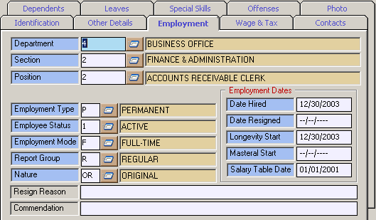
Employment Tab

· Department - click on to display the list of Department and just click the Department selected and it will automatically display.
· Section - click on to display the list of Sections and just click the Section selected and it will automatically display.
· Position - click on to display the list of Positions and just click the Position selected and it will automatically display.
· Employee Type - click on to display the Employee Type List and just click the Type selected and it will automatically display.
· Employee Status - click on to display the Employee Status List and just click the Status selected and it will automatically display.
· Employee Mode - click on to display the Employee Mode List and just click the Mode selected and it will automatically display.
· Report Group - click on to display the Report Group List and just click the Report Status selected and it will automatically display.
· Nature - click on to display the Remarks Status List and just click the Status selected and it will automatically display.

7. Entry the necessary Information under Wage and Tax tab.

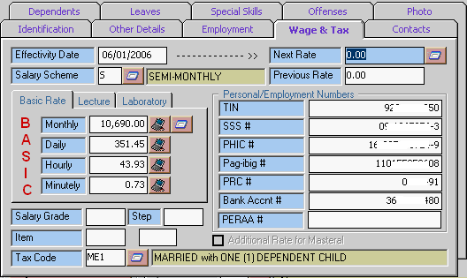
Wage & Tax Tab

· Salary Scheme - click on to display the Pay Cycle List and just click the Cycle selected and it will automatically display.
· Basic Rate - click on besides monthly to display the list of Salary Grade Table and just click the Salary selected and it will automatically display the daily, Hourly and minutely rates, same with the salary grade, and Step.
· Tax Code - click on to display the Tax code List and just click the Tax Code selected and it will automatically display.
· TIN #
· SSS #
· PHIC #
· Pag-ibig #
· PRC #
· Bank Account #
. PERAA #

8. Enter the necessary information under Contacts tab
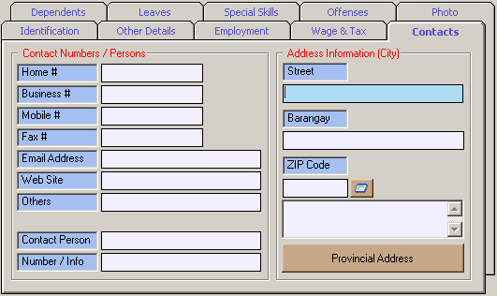
Contacts Tab

Contact Numbers / Persons
· Home #
· Business #
· Mobile #
· Fax #
· Email #
· Web Site # (if any)
· others
· Contact Person
· Number / info (of the Contact Person)
· Street
· Barangay
· ZIP Code - - click on to display the ZIP Code List and just click the Zip Code selected and it will automatically display
· Provincial Address

9. Enter on the information under the dependents tab.

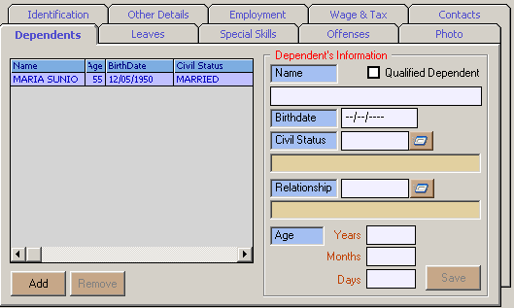
Dependents Tab

· Name - name of the dependent
· Birth date - birthday of the dependent (mm-dd-yy). The age of the dependent will automatically display.
· Civil Status – civil status of the dependent. Click on to display the Status List and just click the Status selected and it will automatically display
· Relationship – relationship of the employee and the dependent . You can click on to display the Relationship List and just click the relationship selected and it will automatically display.

- Click on the Save button to save the information entered
- Click on the Add button to add another dependent.

- You can also upload a photo of the Employee on the Photo tab.
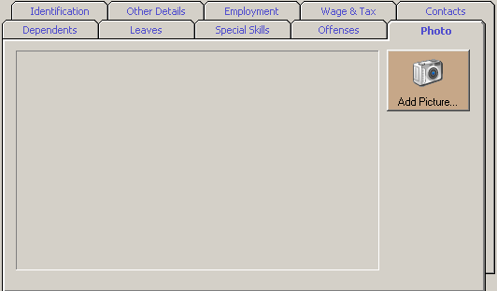
Photo Tab

Click on  button and browse the picture of the employee.

Click on save button or just press F12 and click Yes.

Payroll Data Entry

After choosing the month half you can now make a payroll on the selected half of the month.
This Option is where data from the daily time record such as number of days worked, absences, tardiness, overtimes, night differential pay and holidays are entered. User can also activate or deactivate here the computation of basic deductions such as Withholding Tax, SSS, PHIC, Pag-ibig and Union Dues, and the computation of additional earnings such as 13th Month Pay, PERAA, and Longevity Pay.

- Click on the 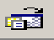 button from the toolbar or Click Activities on the menu bar, from the pull-down menu click on Payroll Data Entry. Search on the employee from the list by typing few letters on the search bar. Click on the Selected Employee.
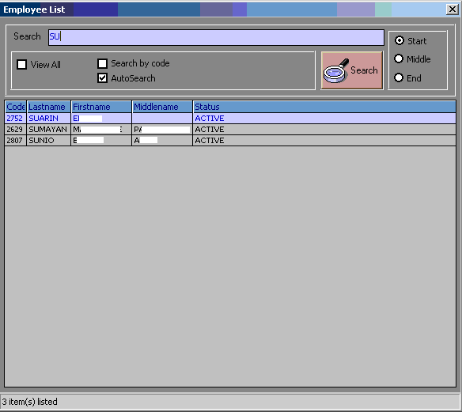

Employee List Window
- After selecting the window below will display.
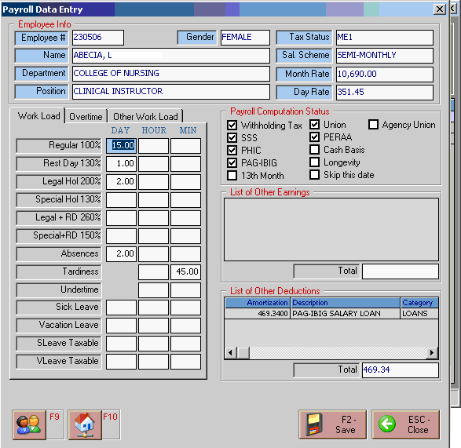

Enter the workload of the employee.
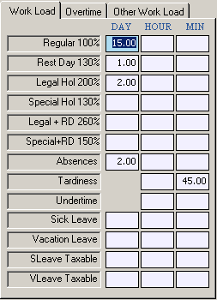

Enter on overtime of the employee (if any)
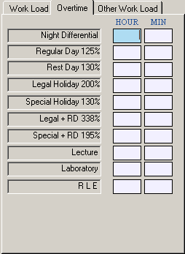

Enter on other workload of the employee (if any)
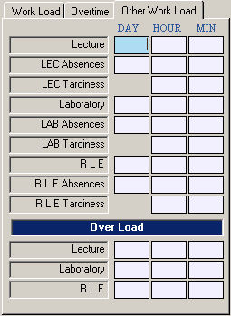

Check/ togged (click) on the computations to be included on the employee’s payroll.
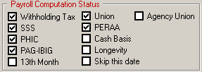

Displays the list of earnings of the employee.
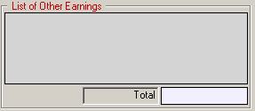

Displays the list of deductions of the employee.
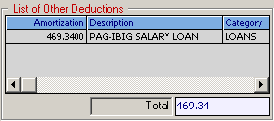

- Click on the 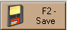 button or press F2 to save the data entered.
- Click on the 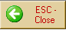 button or press ESC to disregard the data entered.
- Click on the 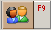 button or F9 to search or select a new employee.

How to Process Payroll Data
- After entering all the data, you are now ready to Process the payroll data. Click Activities on the menu bar, from the pull-down menu click on Process Payroll or click on button on the toolbar to display the window below.
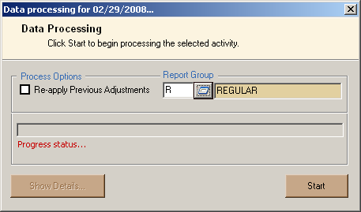
. Report Group – click the button to display the Report Group List and just click the relationship selected and it will automatically display.
- Click Start to begin processing payroll.
- Click the Show Details to view the Employees on which data are being process

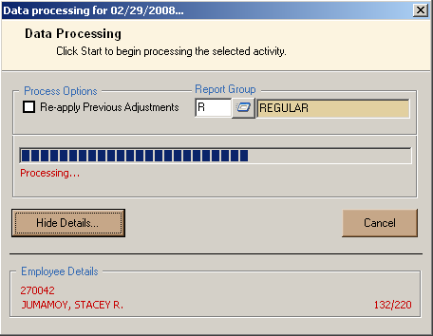

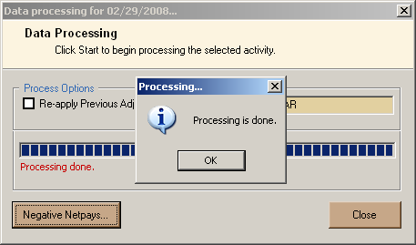

When the process is done click the OK button.
Click on Negative NetPays button to view the window below. The list of Employees with Negative Net Pay. . Alternatively, click Activities on the menu bar, from the pull-down menu click on View Negative Netpays.

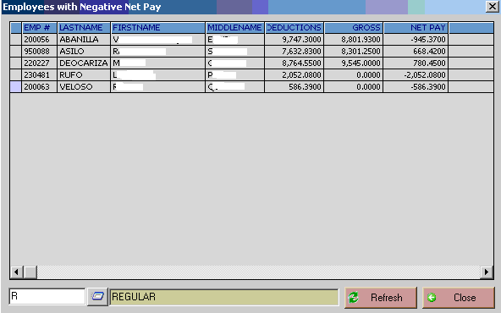

In case of Negative net pay, adjust the payroll data by clicking the employees’ name to view the window below.
(The Adjustment Entry Form)
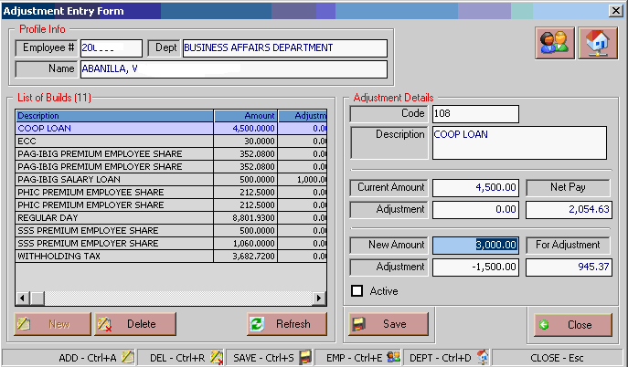
Select the payslip file to adjust from list. Enter the new amount then click save button. Check if processed payroll data is already correct.

- You can also process payroll by selecting the name of the employee that you wish to process. Click Activities on the menu bar, from the pull-down menu click on Process Payroll (Individual) to display the window below. 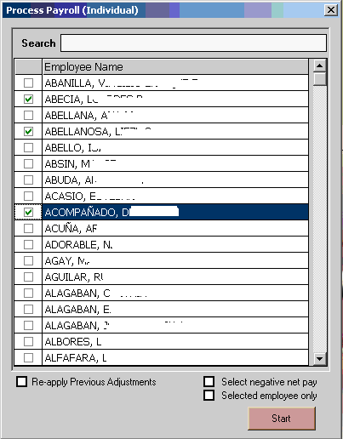
- Click Start to begin processing the payroll of the selected employee.
- NOTE: It is strongly recommended that you finalize the processing for computed data before you enter Manual Payroll data Entries to avoid messing up with the Reports that has already been finalized and printed.

Pay Slip File

Pay slip is a document an employee receives either as a notice that the direct deposit transaction has gone through, or as part of their paycheck. It will detail the gross income and all taxes and any other deductions, contributions taken out of the gross amount to arrive at the final net amount of the pay.
This option is where Earnings and Deductions are tagged whether it is included in the 13th Month Computation. To do this, click File on the menu bar, on the pull-down menu click on Pay Slip File.

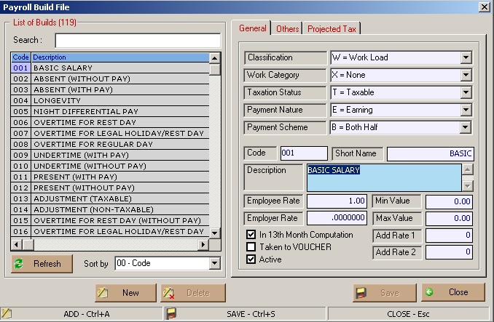

Earnings and Deductions should be tagged whether, which should be included in the 13th Month Computation.
Click the box beside “In 13th Month Computation” to toggle whether the selected Pay Slip file will be included in the 13th Month Computation.

Post Salary Deduction
This option will post employees’ receivable for salary deduction.
Click File on the menu bar, on the pull-down menu click on Post Salary Deduction.
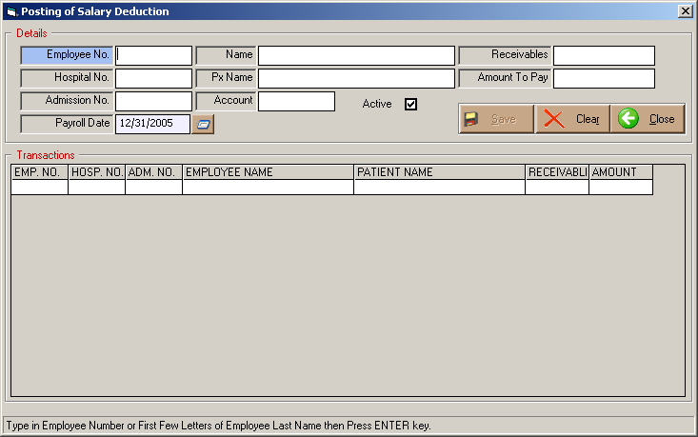

      - Enter Employee Number or type few letters of Employee Last name then press Enter.
- Select the employee name.
- Enter the necessary information
- Emp. No.
- Hospital No.
- Adm. No.
- Employee Name
- Patient Name
- Receivable
- Amount
Click on Save button to save the data entered.

Longevity

This option keeps track of the date where the employee's effectively date(s) for longevity take effect. All the dates registered are listed here.

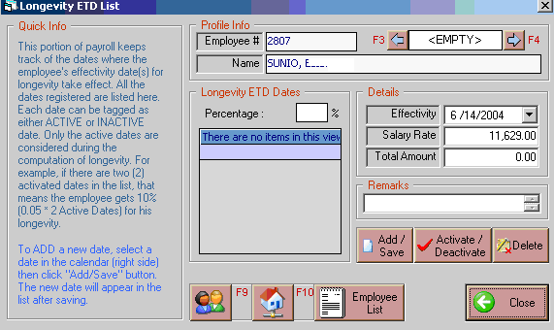

*To add a new date, select a date on the effectively box.
Click "ADD/Save" button. The new date will appear in the list after saving.

Loan Entry (Individual)

Click on button or Click File on the menu bar, from the pull-down menu click on Employee Payroll Data select Loan then Individual.
Select from the Employee list by typing few letters of employee’s last name.
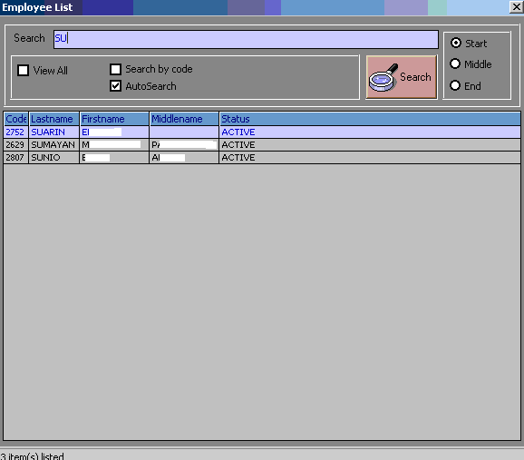
After selecting the employee from the list the window below will appear.
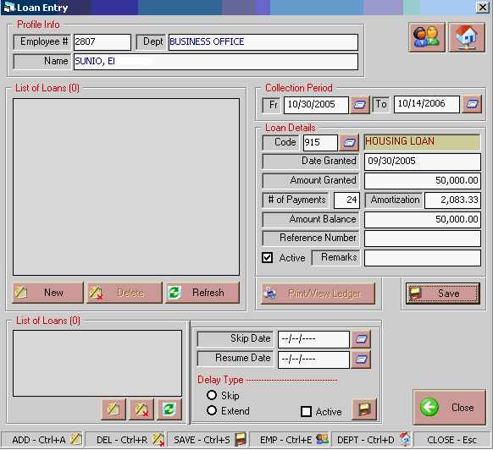

To add a new loan. Click on the New button
Enter the necessary data.
Collection Period - date of deduction
Fr. - the first pay date of the deduction
To – last date of deduction.
Loan Details
- Code – code of the loan. Click on to display the list of Loans just click the Loan selected and it will automatically display.
- Date Granted
- Amount Granted
- # of Payments
- Press Enter and the Amortization and Amount Balance will automatically display.
- Click on Save button to save the date entered.

Insurance Entry

Click on button on the toolbar or Click File on the menu bar, from the pull-down menu click on Employee Payroll Data select Insurance > Individual. The list of employees will be displayed. Follow the same steps with Individual Loan Entry. Refer on the step in Individual Loan Entry to enter Individual Insurance.
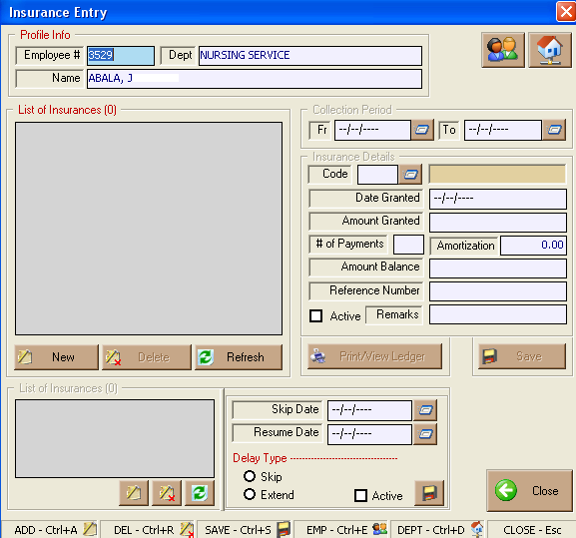

Other Earnings Entry
Click on button on the toolbar or Click File on the menu bar, from the pull-down menu click on Employee Payroll Data select Other Earnings > Individual. The list of employees will be displayed. Follow the same steps with Individual Loan Entry. Refer on the step in Individual Loan Entry to enter Individual Other Earnings.
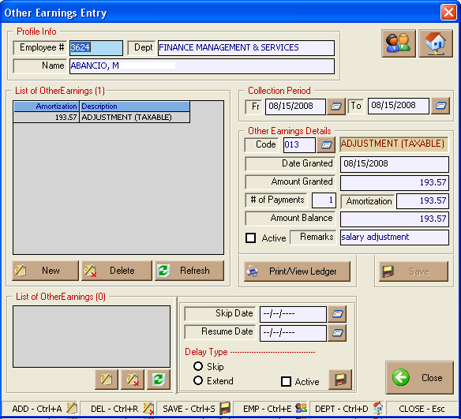

Deduction Entry
Click on button on the toolbar or Click File on the menu bar, from the pull-down menu click on Employee Payroll Data select Other Deduction > Individual. The list of employees will be displayed. Follow the same steps with Individual Loan Entry. Refer on the step in Individual Loan Entry to enter Individual Deduction.

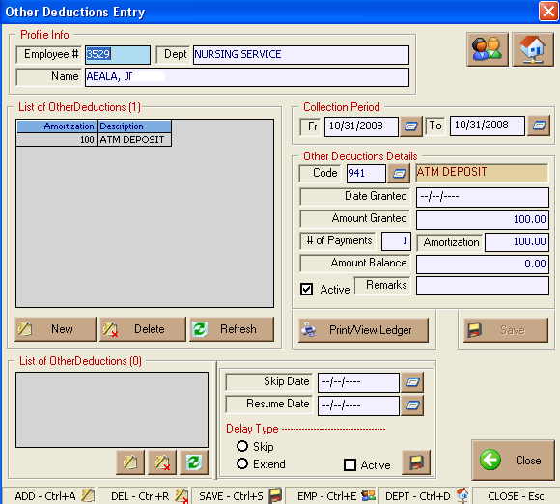

Loan Entry (Tabular)
Click File on the menu bar, from the pull-down menu click on Employee Payroll Data select Loan then Tabular.
Select from Loan list by typing few letters of loan’s name.
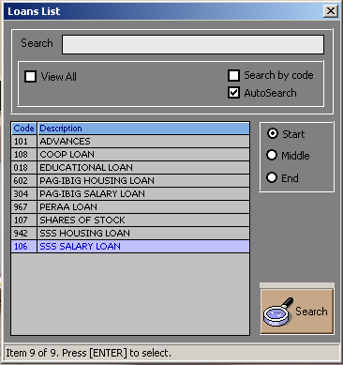
The list the window below will appear after choosing from the loan list.
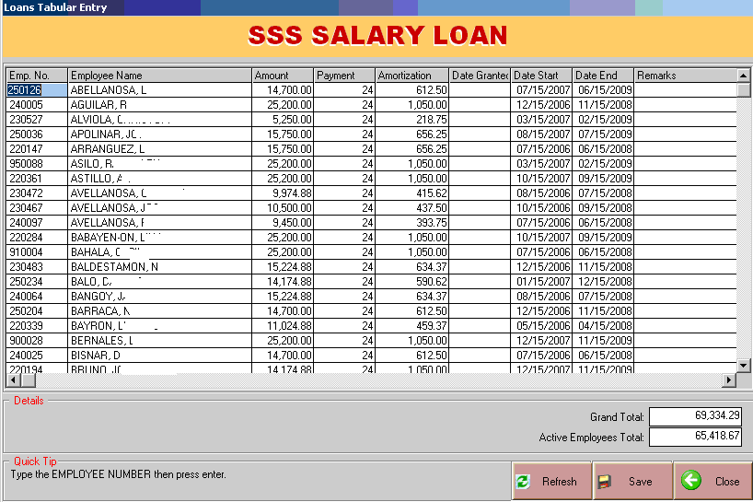
To add new loan, enter the employee’s lastname or employee number in the Emp. No. field.
Enter the necessary field.
Other Earnings Entry (Tabular)

Click File on the menu bar, from the pull-down menu click on Employee Payroll Data select Other Earnings> Tabular. The list of loans will be displayed. Follow the same steps with Loan Entry Tabular. Refer on the step in Loan Entry (Tabular) to enter Other Earnings.

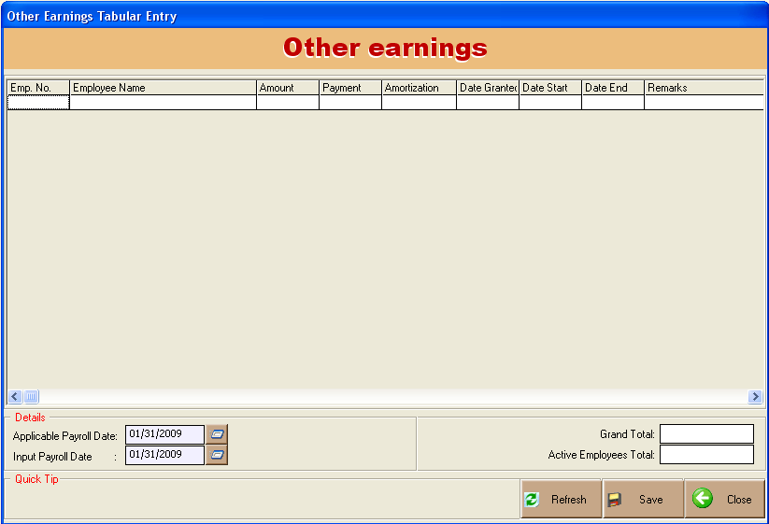

Deductions Entry (Tabular)

Click File on the menu bar, from the pull-down menu click on Employee Payroll Data select Other Deductions> Tabular. The list of loans will be displayed. Follow the same steps with Loan Entry Tabular. Refer on the step in Loan Entry (Tabular) to enter Other Deductions.

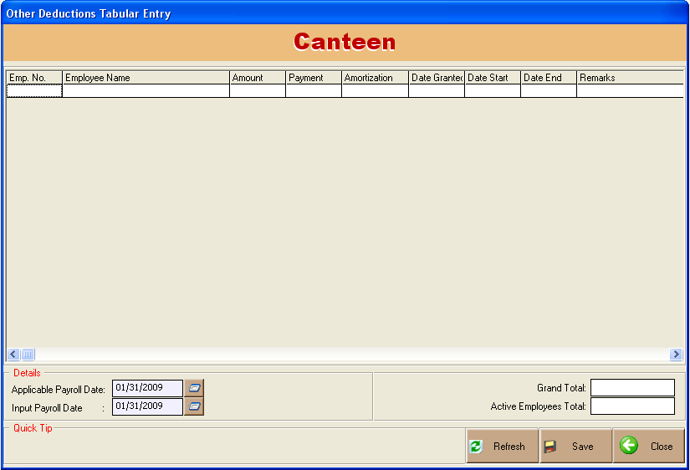

Allowances Entry

This option is where pay slip files classified under allowance is entered.
Click File on the menu bar, on the pull-down menu click on Allowances. Select from the Employee list by typing few letters of employee’s last name. After selecting the employee the window below will appear.
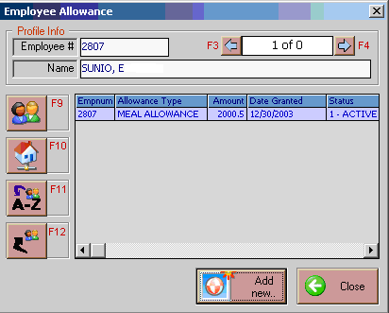

Click on Add New button to display the list of allowances.
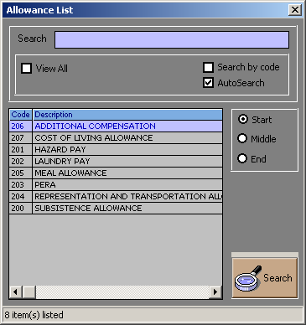
Allowance List Window
Select the Description on the list by clicking and the window below will be displayed.

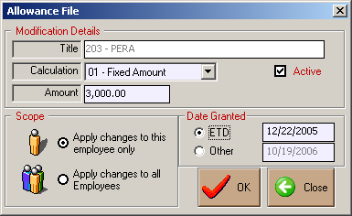

Enter the necessary information
- Calculation
- Amount
- Scope – Click on ‘Apply the charge to all Employees’ and it will automatically applied to all employees.
- Date Granted
- ETD
- Other
Click on OK button to apply the data you entered.
Click on Close button to disregard the data entered.

Service Record

This option is used to view and monitor employees employment history such as promotion, change of department, salary increase, etc.

1. Click File on the menu bar, on the pull-down menu click on Service Record. Select from the employees list and the window below will appear.

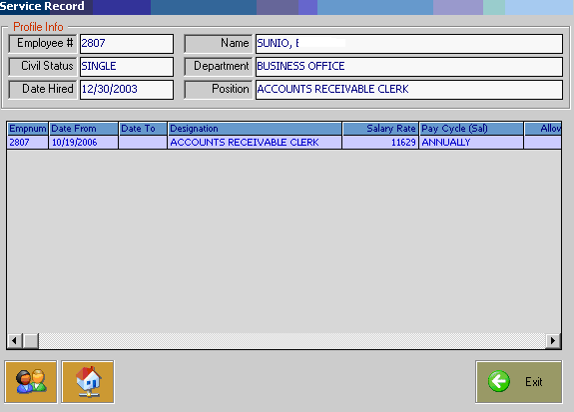

O.R Remittance
This option lets you enter Official Receipt Remittances.
Click File on the menu bar, on the pull-down menu click on O.R Remittance.

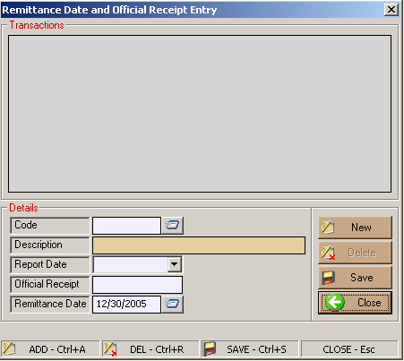

Enter the necessary information
- Code
- Report Date
- Official Receipt
- Remittance Date
Click on Save button to save the data you entered.
Click on Close button to disregard the data entered.

Company Profile
This option the users to Add / Update or edit the payroll set-ups.
Click SetUp on the menu bar, on the pull-down menu click on Company Profile to display the window below.

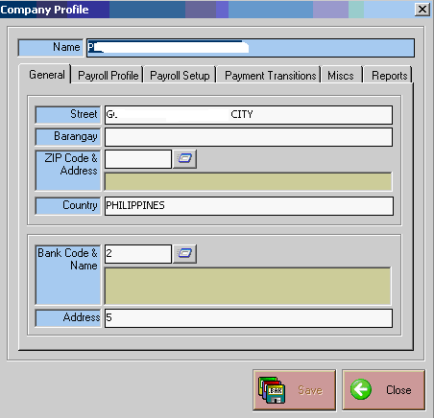
Company Profile Window
This option allows you to edit the Company Profile. Like the Address etc.

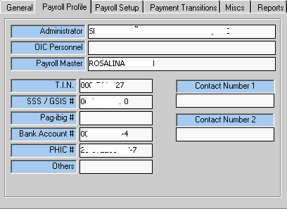
Payroll profile window

This allows you to view and edit on the Payroll Profile.

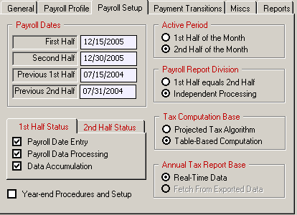
Payroll Setup Tab
The Payroll Setup tab let you view and or edit Payroll Status, Payroll dates, Active Period of the Payroll, Payroll Report Division, Tax Computation Base and annual Tax Report Base.
*Tag on year-end Procedures and setup to initialize payroll – from the current year to the following year. This must be checked/ tag before executing Close Year (Year-End)

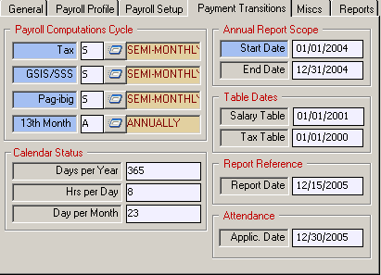
Payment Transactions Tab

This tab lets you view and edit Payroll Computation Cycle, Annual report Scope, Table dates , Calendar status, Report References, Attendance.

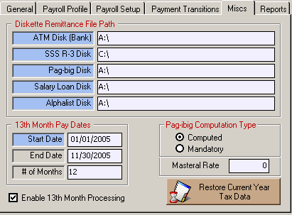
Miscs Tab
This tab lets you view and or edit Diskette Remittance File Path, 13th Month Pay dates and pag-ibig Computation Type
- CHECK the “Enable 13th Month processing” box, otherwise, the system won’t allow you to do this activity.
- End date - Enter the ending date of tht 1st Annual Half Date Range.
- Start date – The Starting sate of the 2nd Annual Half Date Range
- # of Month -. Number of Months

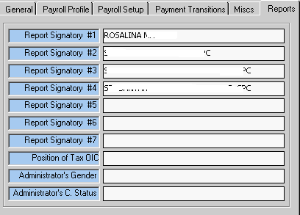
Reports tab
* This tab lets you add and or edit Report Signatories for the Payroll.

Employee Selection

This is a utility wherein the user can update employee data in the master file for multiple employees at the same time.
Click on button on the toolbar or Click SetUp on the menu bar, on the pull-down menu click on Employee Selection to display the window below.

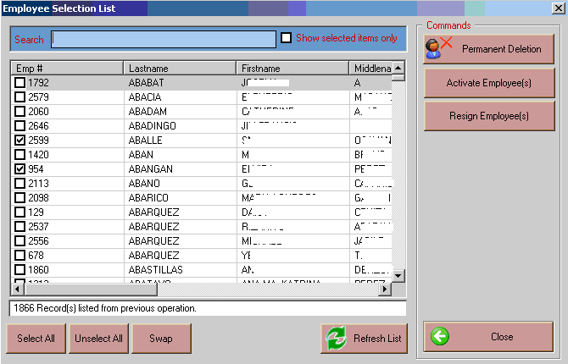

Select/togged the employees by putting a CHECK mark beside the Emp #. When you have selected all the employees you want to set, click on the button to execute the changes to the selected employees.
- Click on Permanent Deletion button to permanently delete the togged employees
- Click on Activate Employee(s) button to re activate or to activate the togged employees.
- Click on Resign Employees button to change the status of the employees.
- Click on Close button to close the window

Build Files
          - This option is where files needed in the employee file entry are being build to avoid duplication of data, minimize encoding, etc. It includes Departments, Position, Leave Types, Report Groups, Employee Status, Civil Status, Holidays, Contact Types, Address, Religion, Gender, IQ Rates, Nationality and Relationships.

Departments
This option allows you to view or add new department list and/or edit existing departments.
Click SetUp on the menu bar, on the pull-down menu click on Build Files > Departments to display the window below

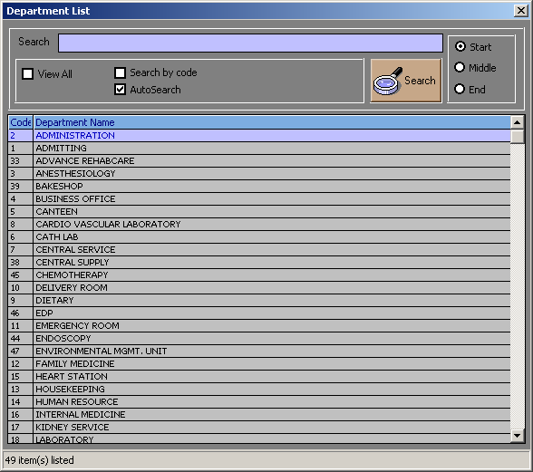
Department List Window

      - How to Add - right-click on the list, click on Add to display the window below
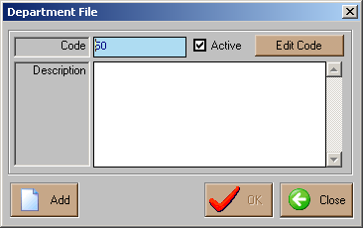
Enter the following information:
- Code - is auto-generated
- Description – this is the description of the department
- Click on Ok button to save

      - How to Edit – Select the department you want to edit. Right-click on the list, click
View/Edit. You can now enter necessary changes on the department description. Click on OK button afterwards to save changes entered.

Positions
This option allows you to view or add new position on the list and/or edit existing positions.
Click SetUp on the menu bar, on the pull-down menu click on Build Files > Positions to display the window below
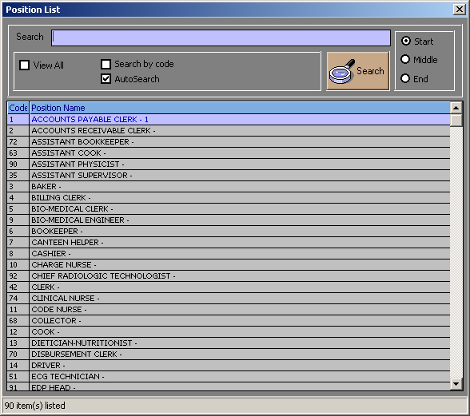
Position List Window
      - How to Add - right-click on the list, click on Add to display the window below.
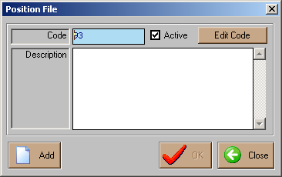
Position File Window
Enter the following information:
- Code - is auto-generated
- Description – this is the description of the Position
- Click on Ok button to save
- How to Edit – Select the Position you want to edit. Right-click on the list, click
View/Edit. You can now enter necessary changes on the Position description. Click on OK button afterwards to save changes entered.
Leave Type
This option allows you to view or add new Leave Type on the list and/or edit existing leave type.
Click SetUp on the menu bar, on the pull-down menu click on Build Files >Leave Type to display the window below
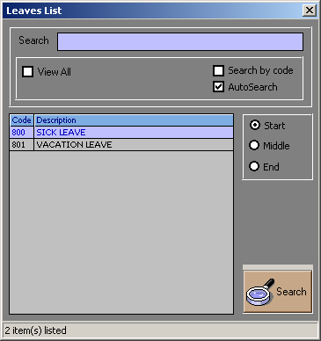
Leave List Window
1. How to Add - right-click on the list, click on Add to display the window below.
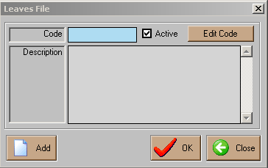
Leave File Window
Enter the following information:
- Code - is auto-generated
- Description – this is the description of the Leave
- Click on Ok button to save
      - How to Edit – Select the leave type you want to edit. Right-click on the list, click View/Edit. You can now enter necessary changes on the Leave description. Click on OK button afterwards to save changes entered
Report Groups
This option allows you to view or add new Report Group on the list and/or edit existing groups.
Click SetUp on the menu bar, on the pull-down menu click on Build Files > Report Groups to display the window below
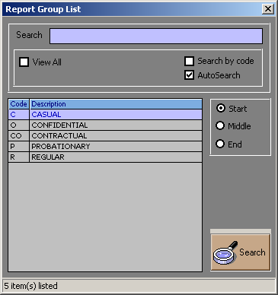
Report Group List Window

- How to Add - right-click on the list, click on Add to display the window below.
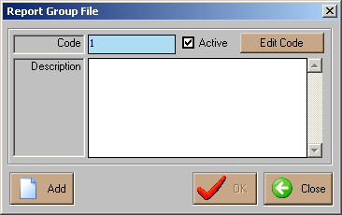
Report Group File Window
Enter the following information:
- Code - is auto-generated
- Description – this is the description of the Leave
- Click on Ok button to save

- How to Edit – Select the Group you want to edit. Right-click on the list, click
View/Edit. You can now enter necessary changes on the report group description. Click on OK button afterwards to save changes entered
Employee Status
This option allows you to view or add new Employee Status on the list and/or edit existing groups.
Click SetUp on the menu bar, on the pull-down menu click on Build Files > Employee Status to display the window below
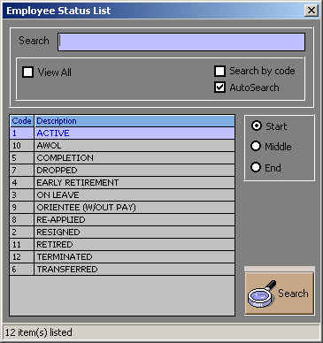

- How to Add - right-click on the list, click on Add to display the window below.

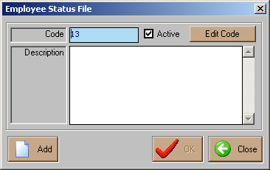

Enter the following information:
- Code - is auto-generated
- Description – this is the description of the Leave
- Click on Ok button to save

- How to Edit – Select the Status you want to edit. Right-click on the list, click
View/Edit. You can now enter necessary changes on the Status description. Click on OK button afterwards to save changes entered.
Civil Status
This option allows you to view or add new Civil Status on the list and/or edit existing status.
Click SetUp on the menu bar, on the pull-down menu click on Build Files > Civil Status.
To View/Add/Edit Follow the same steps with Employee Status. Refer on how to add or Edit on the step in Employee Status.

Holidays
This option allows you to view or add new Holiday on the list and/or edit existing holidays.
Click SetUp on the menu bar, on the pull-down menu click on Build Files > Holidays.
To View/Add/Edit Follow the same steps with Employee Status. Refer on how to add or Edit on the step in Employee Status.

Contact Types
This option allows you to view or add new Contact Types on the list and/or edit existing contacts.
Click SetUp on the menu bar, on the pull-down menu click on Build Files > Contact Types.
To View/Add/Edit Follow the same steps with Employee Status. Refer on how to add or Edit on the step in Employee Status.

Address List
This option allows you to view or add new Address List on the list and/or edit existing list of Address.
Click SetUp on the menu bar, on the pull-down menu click on Build Files > Address List.
To View/Add/Edit Follow the same steps with Employee Status. Refer on how to add or Edit on the step in Employee Status.

Religions List
This option allows you to view or add new Religions List on the list and/or edit existing Religions.
Click SetUp on the menu bar, on the pull-down menu click on Build Files > Religions List.
To View/Add/Edit Follow the same steps with Employee Status. Refer on how to add or Edit on the step in Employee Status.

Gender List
This option allows you to view or add new Gender List on the list and/or edit existing genders.
Click SetUp on the menu bar, on the pull-down menu click on Build Files > Gender List.
To View/Add/Edit Follow the same steps with Employee Status. Refer on how to add or Edit on the step in Employee Status.

IQ Rates List
This option allows you to view or add new IQ Rates List on the list and/or edit existing Rates.
Click on SetUp on the menu bar, on the pull-down menu click on Build Files > IQ Rates List.
To View/Add/Edit Follow the same steps with Employee Status. Refer on how to add or Edit on the step in Employee Status.

Nationality List
This option allows you to view or add new Nationality List on the list and/or edit existing Nationality.
Click SetUp on the menu bar, on the pull-down menu click on Build Files > Nationality List
To View/Add/Edit Follow the same steps with Employee Status. Refer on how to add or Edit on the step in Employee Status.

Relationship List
This option allows you to view or add new Relationship List on the list and/or edit existing relationship.
Click SetUp on the menu bar, on the pull-down menu click on Build Files > Relationship List.
To View/Add/Edit Follow the same steps with Employee Status. Refer on how to add or Edit on the step in Employee Status.

Payroll Tables
This option allows you to view Payroll Tables such as General Tax Table, Annual Tax Table, SSS Table, PHIC Table, and Salary Table. These tables are the basis of computation of the above basic deductions as enumerated respectively excluding the salary table.
.
How to View General Tax Table
To view the General Tax Table Click SetUp on the menu bar, on the pull-down menu click on Payroll Table > General Tax Table or click on button on the toolbar to display the window below.

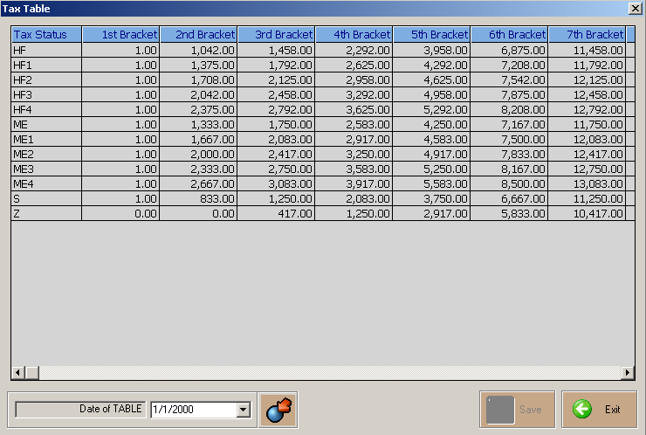
General Tax Table Window
How to View Annual Tax Table
To view the Annual Tax Table Click SetUp on the menu bar, on the pull-down menu click on Payroll Tables > General Tax Table or click on button on the toolbar to display the window below.
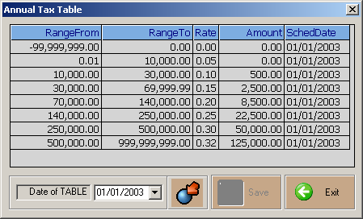
Annual Tax Table Window
How to View SSS Table
To view the SSS Table Click SetUp on the menu bar, on the pull-down menu click Payroll Tables > SSS Table or click on button on the toolbar to display the window below.

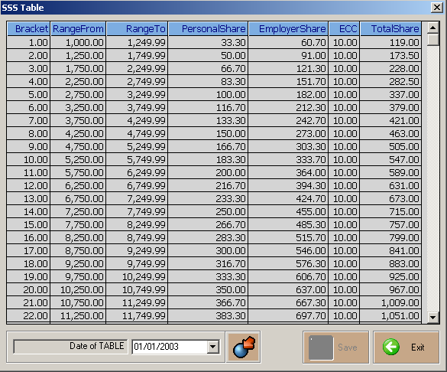
SSS Table Window
How to View PHIC Table
To view the PHIC Click SetUp on the menu bar, on the pull-down menu click on Payroll Tables > PHIC Table or click on button on the toolbar to display the window below.
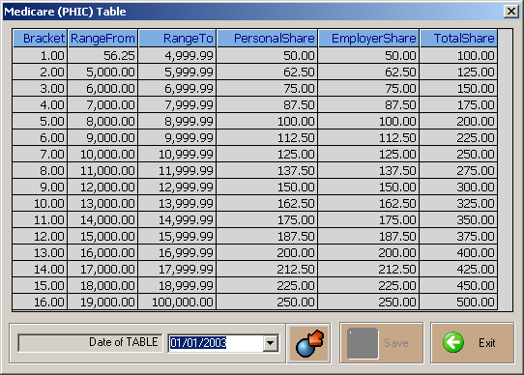
PHIC Table Window

How to View Salary Table
To view the Salary Table Click SetUp on the menu bar, on the pull-down menu click on Payroll Tables > Salary Table to display the window below.

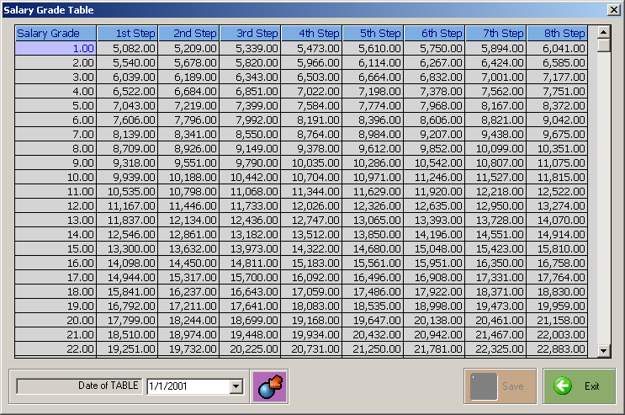
Salary Table Window

View Processed Data

This option can be use to view the computed earnings and deductions of employees individually after processing the payroll data. It can help in random checking or auditing without viewing or printing the payroll journal report.
Click (Activities) on the menu bar, on the pull-down menu click on View Processed Data. Select on the Employee you are to view and the window below will appear.

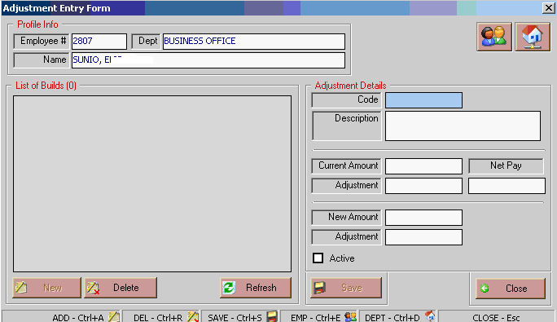

View Negative Net Pays

Allows user to view all employees who has net pay lesser than zero. User can directly go back to payroll data entry by double-clicking the selected employee in the list for the necessary adjustments in the salary.

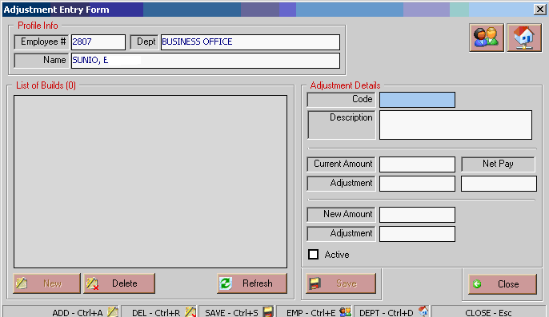

- Make the necessary adjustments. Click on Save to save the changes.

Manual Payroll Data Entry
This option is use to enter all manually computed salaries. This option should only be use in entering manual computed data after finalizing the computed payroll to avoid re-entering data.

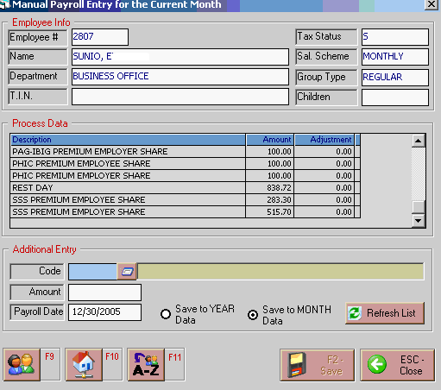
Manual Payroll Entry Window
1. To add enter the code of the Additional salary or you can click on to display the PaySlip file list and just click the code selected and it will automatically display.
2. Enter the Amount to be added.
3. Enter the payroll date
Click on the button or press F2 to save the data entered.
Click on the button or press ESC to disregard the data entered.
Click on the button or F9 to search or select a new employee.

Accumulate Data

This option is use to close the current payroll after generating all the necessary reports and get ready for the next payroll. After accumulation, all adjustments that are not entered will be applied on the next payroll.

Close Year (Year-End)

This option is executed once a year at the end of the year before setting the payroll dates for the month of January of the following year. This is to initialize all tables needed for the new year and redirect data for the user to be able to process annual tax reports of the previous year while processing payroll for the new year.

Reports
The following reports are generated by the program. Click the Report pull-down menu to display list and then click on the desired report you want to view and print.

- Payroll Time Form
-This is a report that prints blank payroll time form of the employees per department to be use by department heads.
- Certificates
- It is printable document that certifies employee’s contributions or payment
- DTR Reports
– A report that shows the absences, overtimes and night differential of the employees.
Absences
- It shows a report on the on the absence of all employees. It can be view by month or order by Entry
Overtime
- It shows a report on the on the overtime of all employees. It can be view by month or order by Entry

Night Differential
- It shows a report on the on the overtime of all employees. It can be view by month or order by Entry

- Payroll Data
- It shows the employees’ data that were use in payroll computation
- Payroll Journal
- A report that shows the employee processed or computer data per employee
- Payroll Journal Summary
- A report that shows the employee processed or computer data summarized by department.
- Payslips
- It shows the total earning, deductions and net pay of employees
- Payroll Schedule
- It shows total allowances and regular pay per department
- Employee Journal
- A report that shows on the summary of employees’ earnings and deductions per payroll date.

- Payroll Breakdown
- A report that shows on the earnings on debit and deductions on credit.
- Bank Remittance
- A report that shows net pay of employees that are submitted to the bank..
- Cash Report
- A report that shows the net pay of cash basis employees.
- Tax Report
- A report that shows tax of the employees and it can be view by following:
- Monthly Tax Report
- Monthly Tax Summary
- Projected Tax Report
- Annual Tax Report
- View/Adjust tax Due
- Alpha list Report
- Company Copy
- BIR Copy
- Diskette
- W2 Form
- Joint Certification

- SSS Report
- A report that shows SSS contributions and loans of the employees and it can be view by following:
- SSS Monthly Report
- SSS Monthly Summary
- Monthly Diskette Remittance
- SSS loan Monthly Report
- SSS Loan Monthly Remittance
- SSS Quarterly Reports

- PHIC Reports
- A report that shows Phil Health contributions of the employee and it can be view by following:
- PHIC Monthly Reports
- PHIC Monthly Summary
- PHIC Quarterly Reports – it has an option to print RF1, M5 summary and transmittal report
- First Quarter
- Second Quarter
- Third Quarter
- Fourth Quarter

- Pag-ibig Reports
- It is a report that shows Pag-ibig contributions and loans of the employee and it can be view by following:
- Old reports
- New Reports
- Pag-ibig Loan Remittance

- Projected 13th Month Report
- A report that shows the projected 13th month pay of employees.
- Other Monthly Reports
- It shows the all payroll file report
- Adjustment Report
- It shows the adjustment made in processing the payroll
- Other Semi-Monthly Reports
- 13th Month Reports
- A report that shows 13th month pays; it can be view by following:
- Process/Export Computed Data
- 13th Month Journal
- Alphabetical
- Departmental
- Summary
- 13th Month Bank Remittance
- 13th month cash Reports

- Employee Master List
  - A report that displays the list of all employees and information like salary rate, tax status and others.

