MEDSYS
Information System

Patient’s Account Receivable System
User's Manual



MEDSYS
Kaiser dela Cruz Consulting Incorporated
July 29, 2026

Copyright© 2009

ALL RIGHTS RESERVED

No part of this document may be reproduced through photocopying or in any means, stored into a retrieval system, and transmitted in any form without the express written permission of Kaiser dela Cruz Consulting Incorporated.
Permission is hereby granted Medsys Information System to copy and distribute this document in any of the above means provided this is for its exclusive on site use.
Although every precaution has been taken in the preparation of this manual, the company assumes no responsibility for errors or omissions. Neither is any liability assumed for any damages resulting from the use of the information contained here.

Table of contents
Copyright© 2008
Table of Contents
Introduction 5
Overview 5
Objectives 6
Features 7
Getting Started 8
How to Start the Program 8
How to Change Password 9
How to End the Program 10
Program Operation 11
Important Toolbar Buttons 11
Patient Searching 12
Recompute Bill 13
Statement of Accounts 14
Certificatification 16
Receivable Ledger 18
Transaction Entry 18
Discount Computation 20
Letters / Reports 21
Refund Voucher 24
Transaction Correction 25
Package Deal Entry 26
Master File Entry 27
Block Listing / Revoke Block List Patient 28
Manual Posting of Receivables 29
Updating of Patients Account 30
Partitioning / Multiple Company 32
Charge Slip Verification 34
Payment Allocation 35
Invoicing 38
Reports 40

Introduction

Overview

Accounts Receivable (A/R) is one of a series of accounting transactions dealing with the billing of customers who owe money to a person, company or organization for goods and services that have been provided to the customer.
The Patient’s Account Receivable System provides functionality to process and to keep track accounts receivables. It allows you enter amounts due or credit memos for individual AR accounts. It generates AR aging reports for monitoring outstanding balances and forecasting more accurate cash flow management
The program is password-protected. Each user is assigned with an employee number, an encrypted password, and defined rights to control the access of users to program operations.

Objectives

- To increase staff production while reducing overtime
- To prepare Invoicing fast, easy and accurate
- To provide business (financial) information to management and process
- To provide quality control monitoring and performance reports

Features

- Patients Accounts Receivable System (PARS) covers Personal/Self Pay, Private or Government or Semi-Government, HMO, Insurance, Employees and other type of receivable accounts.
- It is customized according to specific hospital client’s policy, internal controls and standards
- PARS program’s interfacing features with different clinical modules help make the posting of charges fast, easy, efficient, completely traceable electronic process that saves time, reduces cost, minimizes effort and eliminates potential for error and billing oversights.
- Data-entry restriction - Warning messages are flashed for possible invalid entries. This ensures all data inputted would be made useful for any transaction that may occur.
- Password-protected - The use of password is necessary to restrict unauthorized access. Thus the program only accepts passwords which are registered into it. This feature ensures the confidentiality and integrity of data entered in the program.
- Auto-report generation - The program is capable of generating reports and can be readily printed
- User-friendly - The program user is guided by instructions in doing the next step providing an easy-use to process transactions. Tool-tips are also incorporated to give users an idea of what a particular button does.

Getting Started

How to Start the Program

- Double-click the  Patient’s Account Receivable System executable file icon located in your computer desktop.
2 The Login window will be displayed for employee number and password entries.

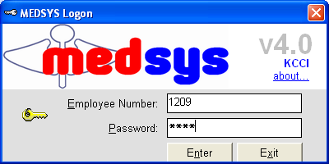
Figure 1: Login Window

3 After validating the employee number and password, a transaction can now be started. Otherwise, the message, “Unauthorized User” will be displayed.

How to Change Password

1 From the Login window, type your employee number and then press <Enter>.

2 Under the Password entry, press <F12>. Pressing this function key will invoke the Change Password window.

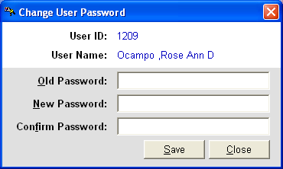
Figure 2: Change Password Window
3 Under the Change Password window, type the following data.
Old Password - Type your existing password.
New Password - Type your new password not exceeding to 15 characters.
Confirm Password - Retype your new password to confirm and then press <Enter> or you can click the Save button.

How to End the Program

It is important for users to close the program when they are done to end-up their session. Other users might use the open program using the same password.
To close the program:
Click at the upper right corner of the main window.

Program Operation

Important Toolbar Buttons
- - Recompute Bill
- - Statement of Account
- - Certification
- - Receivable Ledger
- - Transaction Entry
- - Discount Computation
- - Transaction Correction
- - Multiple Company
- - Charge Slip Verification
- - Block List / Revoke Block Listing
- - Update Account Number
- - Patient Ledger
- - Manual Posting of Receivables
- - Charge Slip Reprinting

Patient Searching
How to Search a Patient
1 Select which patient type to use <Inpatient, Outpatient, Both>. Both is the default filter.
2 Type in either one of the search categories.
- Last Name - Type the first few letters of the patient’s last name and then press <Enter>. Patients having the last name typed and currently confined will be displayed in the grid. Select the patient to enter in the transaction window.
- Hospital Number - Type the patient’s hospital number and then press <Enter>. All confinements with same hospital number will display in the grid. Select the patient’s confinement to select and to enter in the transaction window.
- Admission Number - Type the patient’s admission number and the press <Enter>. Select the patient from the grid to enter in the transaction window.
Patient Searching Window
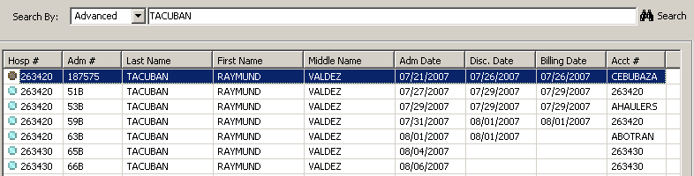
Patient’s Ledger Window
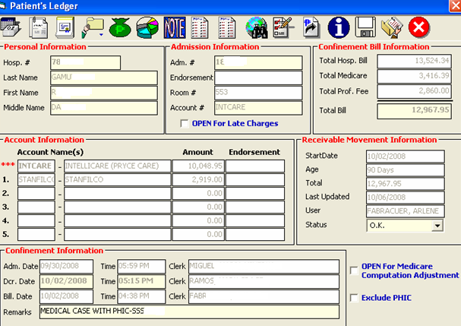
Here are the transactions that can be done after searching the patient.

Re-compute Bill
- Viewing of Statement of Account
- Certification
- Receivable Ledger
- Transaction Entry
- Discount Computation
- Letters / Reports
- Listing of AR Entries
- Transaction Corrections
- Multiple Company

Re-Compute Bill
This is a utility option in correcting one confinement/consultation receivable balance. The normal billing process, billing outstanding balance is automatically transferred to PARS at the end of the day once the account has been closed and discharged. All transactions posted on or before the billing date will be marked as transactions within confinement and the computed outstanding balance will be forwarded to PARS.
There are situations wherein miscommunication is unavoidable. The patient billing record was erroneous closed/billed and discovered after a day or two when the account was already recorded as receivable. Once the billing date is altered, the receivable balance has to be recomputed thus the need for this option.
Click on  to re-compute patient’s account

Statement of Accounts
This option allows you to view and generate copy of patient’s billing statement of account. Statement of Accounts (SOA) is the document given to patient that summarizes the items used/given, procedures conducted and services rendered from time patient was admitted up to discharged date.
You may print the original copy (given to patient) which includes the transactions made within confinement period or the complete SOA (including late charges or adjustments after billing date).
Click the Statement of Account button () then the SOA window will be displayed on the screen.

To open the window, click on Statement of Account tab. See figure 4 below.
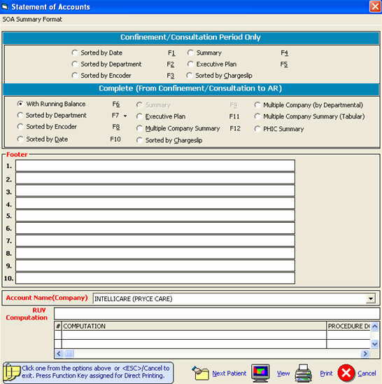
Figure 3: Statement of Account Options Window
Here are the following options.
    - Sorted by Date - This generates patient’s statement of account arranged by transaction date.
    - Sorted by Department - This generates patient’s statement of account arranged by charging department (cost center).
      - By Specific Department (Transactions under a specific revenue code will be included in the statement of accounts)
      - All Departments (all transactions will be printed)
      - Package (all transactions included within the package will be printed)
    - Sorted by Encoder - This generates patient’s statement of account arranged by encoder
    - Summary - This generates patient’s statement of account by summary (applicable if patient has only one account number).
    - Executive Plan - This generates patient’s statement of account by package.
    - Sorted by charge slip – It presents the patient’s billing statement arranged by charge slip / reference number
For patient receivable with multiple accounts, the outstanding balance was distributed or partitioned to different / multiple accounts thus you have to choose the account name to appear in the heading of the SOA as shown below.
The receivable amount for another company will be deducted and will only show the outstanding balance intended for the company/HMO selected as the Primary account.

    - Multiple Company Summary – It presents the patient’s complete Statement of Account in a summary format.
    - Multiple Company Summary (Tabular) – It presents the patient’s complete Statement of Account in a Tabular summary format.
    - Multiple Company Summary (Departmental) – It presents the patient’s complete Statement of Account by department and with different summary format.

Certification

This option is a pre-formatted certification of patient’s confinement with breakdown of total charges per department / revenue centers.
Click the CERTIFICATION button () and the image below will appear. You may type in other remarks you wish to include in the document to be printed.
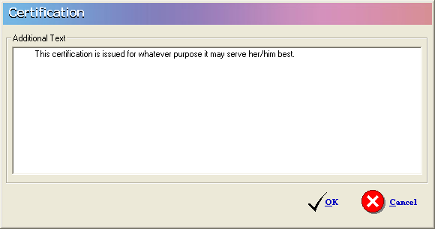
Click the OK button to view the certificate and click the to generate a hard copy of the certificate as shown below.
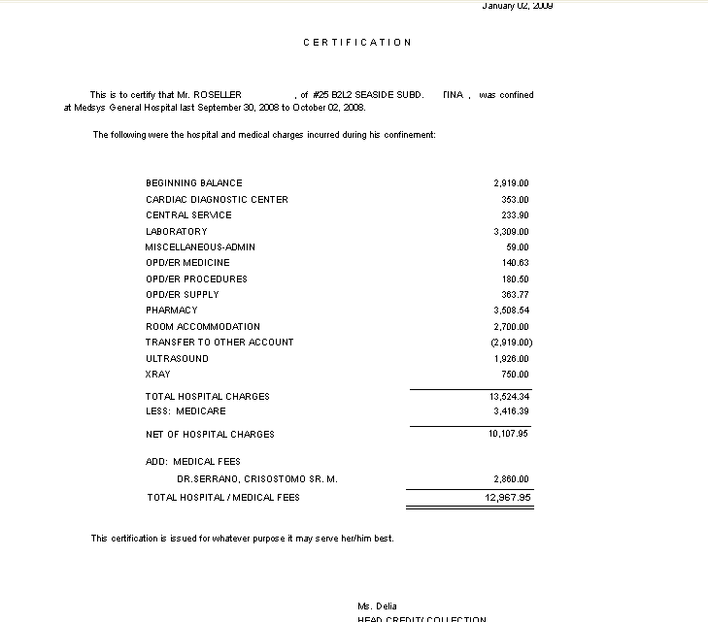

Receivable Ledger
It Is the summary of patient’s confinements and consultation balances from different accounts with same hospital number.
Click on Receivable Ledger () and the following options will appear:
- Excluding Employees Medicines-This is applicable to employee of the hospital and has another employee medicine allowance account in the business class build file. This option will show all receivables excluding balances classified as Employees Medicines Account.
- Complete – This option will show all receivables excluding professional fees.
- Employees Medicines- This is applicable to hospital employee and has another employee medicine allowance account in the business class build file. This option will show only medicines charged to Employee Medicines Account number.
- Complete with professional Fee – It will show all receivables including professional fees.
- Confinement Balances- The receivable summary is presented in tabular format.
Transaction Entry
This feature allows you to add charges incurred by the patient after confinement. This is an alternative way if cost -centers missed to enter charges of the patient during confinement. Added charges will be included to patient’s receivable ledger and complete statement of accounts.
To enter transaction:
  - Click the  Transaction Entry button to open the window below.
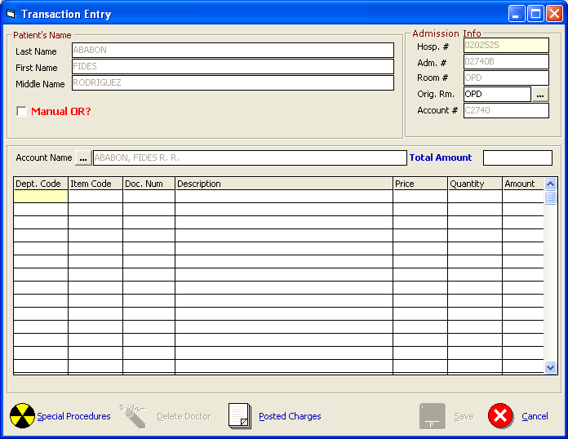
  - the following data should be filled up:
- Dept. Code – Type the Department Code and then press <Enter> or to display the complete list of department. To select, double-click on the department name.
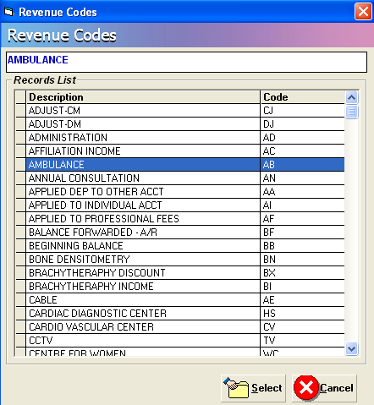
- Item Code – Type the Item code and then press <Enter>. Or you can type the first three(3) characters of the item name and then press <Enter> or to display the complete list of items, press <Enter>. To select, double click on the item name
- Doc. Num – Type the document number or reference number
- Description – This is automatically displayed in reference with the selected item.
- Price – This is automatically provided with built-in rates or else user has to manually supply the amount. User may overwrite the amount if the rate for a particular item was tagged as variable in the build file.
- Quantity – Type the number of item to be charged and then press <Enter>.
- Amount – This is automatically computed and displayed in reference with the selected item, price and supplied quantity data.
c.) Click the SAVE button to save and clear the current entry or CANCEL to abort the entries.
To display list(s)of charges posted for the patient, click on  button to display all the charges.
Discount Computation
This option allows you to compute for the discount. To do this, go to Discount Entry option then click on  icon.
1 Click the arrow down on the Discount Type option to display lists of discount. Choose from the list then click the GO button.

- Two ways of selecting discount rate:
  - Enter the discount rate in the discount rate tab 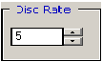 or click the up-down arrow to choose for specific rate.
  - By pass the discount rate and let the rates per department defined within the discount type be the basis of computation
3 Click the Compute button  to automatically compute for the patient’s discount.

4 Click the Save button to save the computed discount, the Save/Print button to save and generate print-out for the computed discount, Reprint button to generate another print-out or Cancel button to disregard all entries entered.

Letters / Reports
Click on () button to generate reminder letter or promissory note and retrieve other billing
information.
- Reminder Letter is a short formal letter reminding the customer of the details of the debt left, telling that nothing more will be supplied and that unless it is paid within a defined period that court action will follow.
- Promissory Note is a written promise by a person (patient/maker) to pay a specific amount of money(called “principal”) to another (payee/hospital) usually to include a specified amount of interest on the unpaid principal amount (what he/she owes)
This option allows the user to generate or re-print promissory note. To do this, select a patient and go to Reports option then click on Promissory Note as shown below.

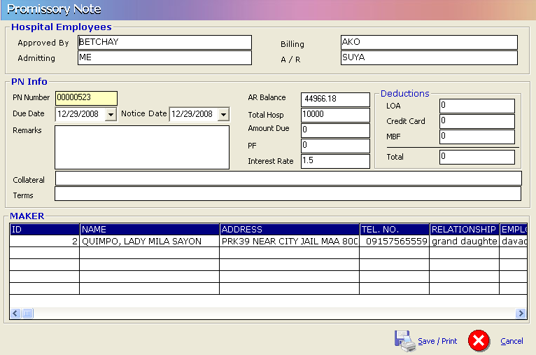 Provide the following information:
1 Employee name who approved the promissory Note
2 Due Date
3 Notice Date
4 Remarks
5 Collateral if available and terms
6 Hospital Amount or/and Professional Fee
Click on 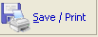 to save and print the Promissory Note.

- History of Room Accommodation is a transaction log of patient’s occupied rooms during his confinement period and it shows room rates and transferred date and time
- Patient Admission Information – shows summary of patient’s confinement.
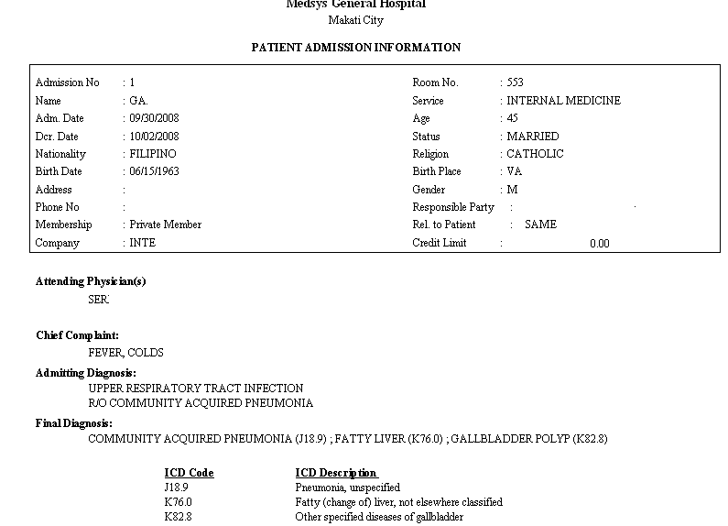
- Update Account History – it is an audit trail on the changes of account name. It shows the encoder, date and time the account code was modified / changed.
- HBPS Hospital Bill Processing Sheet (HBPS) or May Go Home sheet (MGH) is the billing supporting document that signals the billing to process patient’s bill. The MGH was sent by nurse and confirmed by different cost centers.
This option allows the AR staff‘s to view content of patient’s HBPS/MGH sheet

Refund Voucher
This option allows the user to record and print refund voucher. Click on Refund button ().
Click on to auto generate Refund Voucher Number. This will activate the following fields for the user to fill in:
1 Amount to Refund
2 Refund Type
3 Description
4 Recipient
5 Relationship
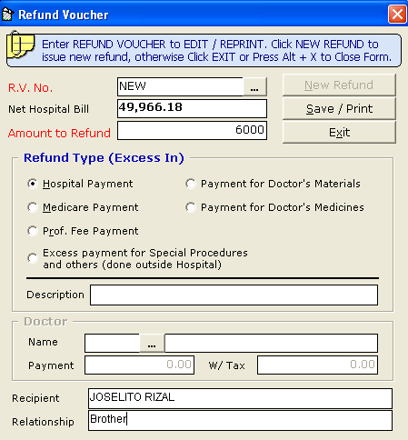
Click on to save and print the Refund Voucher.

Transaction Correction
This option allows you to adjust or correct charges from the saved transactions of the patient. Changes made will be automatically deducted from the patient’s bill.
1 Click Trans.Correction button. The window below will display.
2 Type the department code and then press <Enter>. Example: LB for Laboratory.
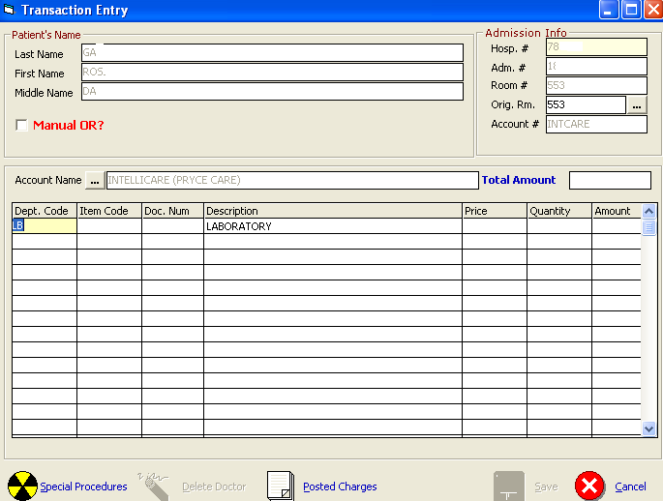
After typing the department code, all charges under it will be displayed.
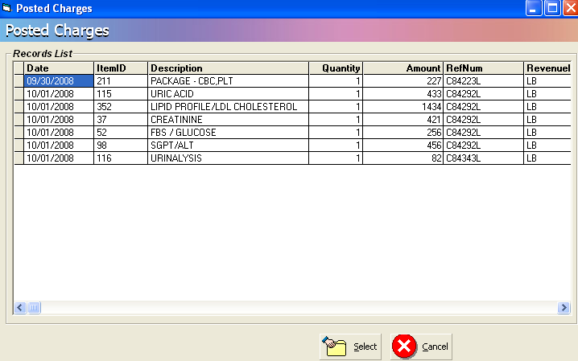
3 Double-click the item to select
4 Click the Save button to save the adjustment or corrections done or the CANCEL button to go out from the window.

Package Deal Entry
This option automatically identifies actual charges within the package deal profile.
1 Click the Option icon on the Package Code to display List of Packages. Choose from the list then click the SELECT button.
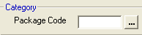
- Choose from the list then click the SELECT button as shown below.
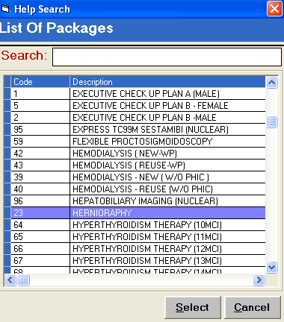
- Actual Charges are compared and tagged in the Package profile column thro highlighted color.
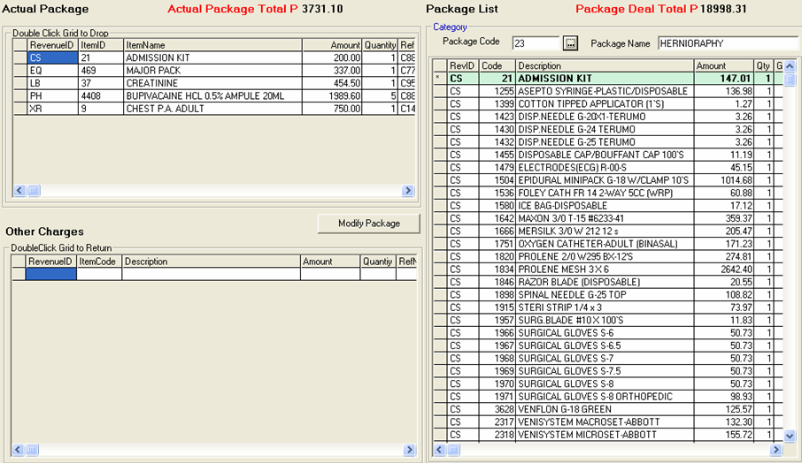
4 Click the button to save the items not consumed within the package.
Master file Entry
Master file refers to patient’s primary data included in the central database of Medsys hospital information system. It refers to patient’s complete last name, first name, middle name, date of birth, hospital number, sex and address. In the regular data flow, these primary data are entered in the admitting or outpatient registration module and a unique hospital number (for new record) is generated or assigned to the said patient. This hospital number is a primary key in consolidating all patient’s confinements and consultation records (Medical and financial data).
This Master file entry is useful for data build up of hospital’s past receivable balances before computerization (if conversion of past data to Medsys is not possible). Unlike in the Outpatient Registration and Admission modules wherein the hospital number is automatically generated by the system, here the hospital number has to be provided. It will be validated by the program for any duplicate/existing number in the central database before proceeding to the next entry.
In the main menu of PARS (Patient’s Accounts Receivable System) as shown below, select the File then Master file.
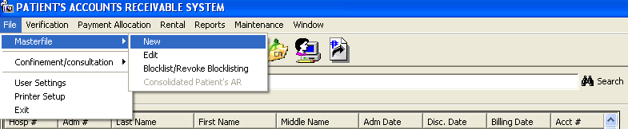
. For new record, choose New option and data entry will appear like this:
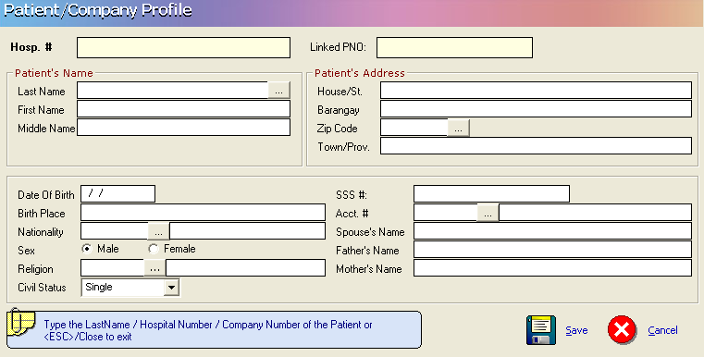

Block Listing / Revoke Block List Patient

This option allows you block list or revoke the block list status of a specific patient

1 In the patient searching, type the last name or admission number or hospital number of the specific patient you want to block list or remove the block list status of a patient.
2 After choosing the patient, Click to display the confirmation window if you want to proceed with the transaction.

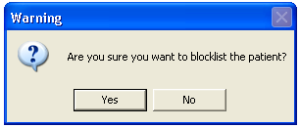
3 Click YES if you want to block list the patient or NO to cancel transaction.

Manual Posting of Receivables
Manual Posting of Receivables option is a utility program to build up past (before Medsys computerization) AR balances in the MEDSYS database. This option expects that hospital number of patient is already in the central database.
1 Click () icon to display the Manual Posting window.
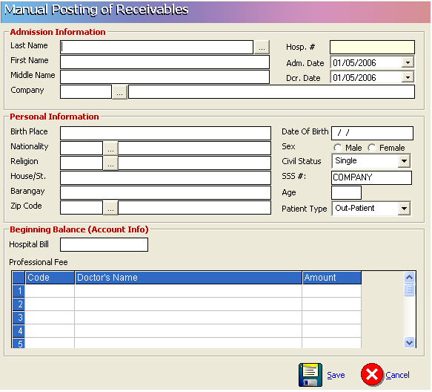

2 Enter Admission Information, personal information, beginning balance and the professional fees
3 Click the Save button to save the patient’s data and Cancel to disregard any data entered.

Updating of Patient’s Account
Use this option to update or change the existing patient’s account number. Account number is the code assigned to specific company, HMO, institution or individual. Correct account number is very important for the automatic computation of possible discount, privileges or transfer of patient’s remaining balance to specific Receivable account.
NOTE: Use this option if a patient has only one account number (company). If patient account balance will be distributed to multiple accounts do not use this option. Multiple partitioning should be used.
1 Click on  Update Acct. # button to display the window below.
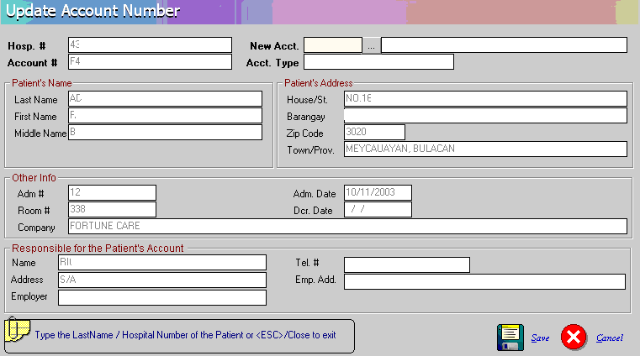
Updating of Patient's Company Window

2 Under the 'New Acct' entry, press the <Enter> key to display the list of companies as seen below. Search the company and then double - click it from the list.

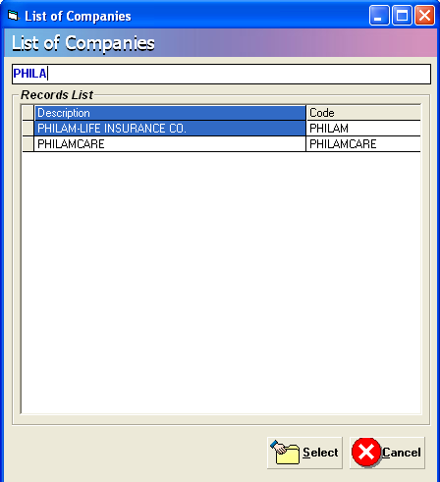
List of Companies
3 Back to the Update Account Number window then click on (Save) button to update the patient’s company.

Partitioning or Multiple Company Entry
This option is use to transfer or partition the patient’s account to additional companies.
To do this, choose patient then click on icon to display the Multiple Company window.
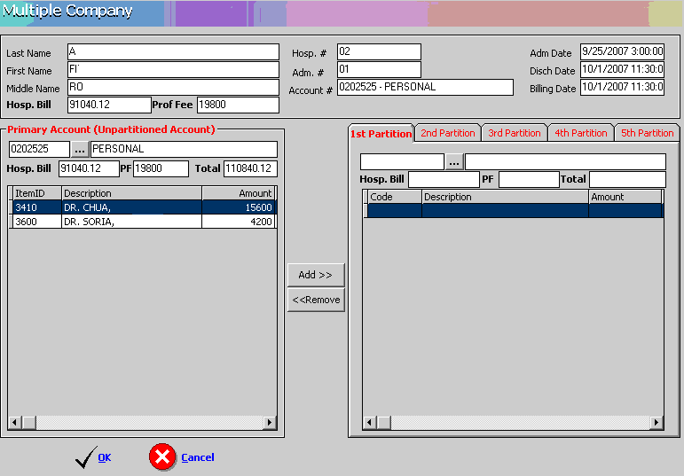

      - Select the company wherein you will transfer the account.

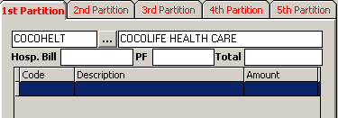
      - Enter the amount to be transferred to the selected company then press enter key. The amount posted will automatically be deducted from the primary account.
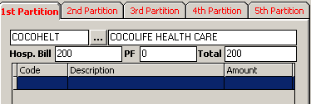

3. To add professional fee click on
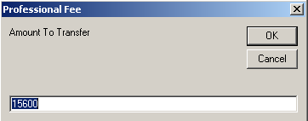
4. Enter the professional fee that will be transfer to selected company then click OK button

5. Do step 1,2 and 3 for the 2nd partition and 3rd partition if the patient’s balance has to be distributed up to 4 accounts.

5. Click on button to save the transaction made. Otherwise click on  to disregard.

Charge Slip Verification

This option allows you to display the transaction details of a specific charge slip number.

1 Click Verification button to display the verification window.

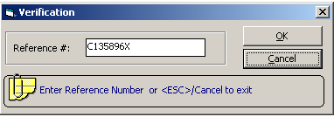

- Under the Reference # entry, type the charge slip number you want to view then click OK

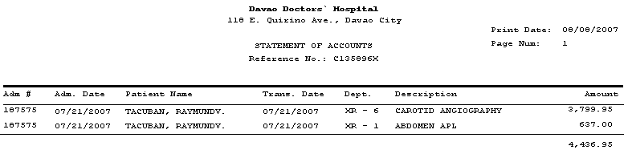

You can view here the reference #, amount, hospital #, admission #, patient’s name, transaction date, revenue code and item description
- Click CANCEL to close the window

Payment Allocation
This option is use to allocate payments from companies. To do this, click on Payment Allocation in the main menu to load the window below

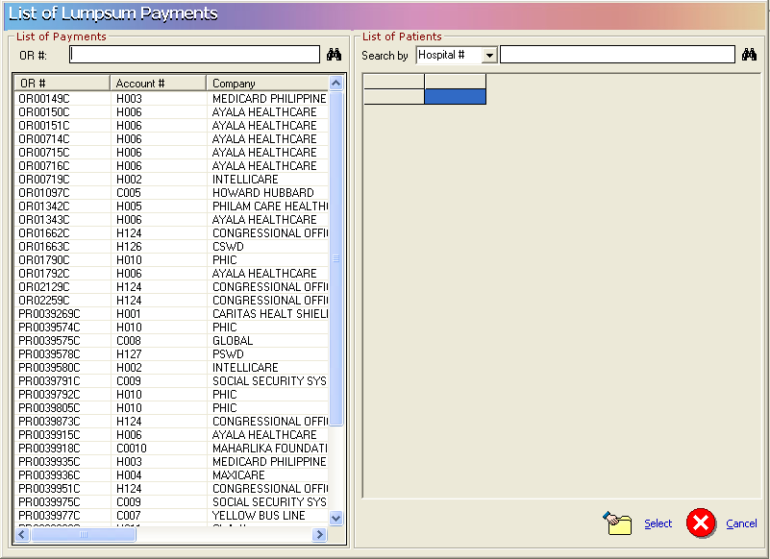

Enter the OR number issued to the company upon payment. Click on the icon to display list(s) of patients. Double click on the patient name to load the window below
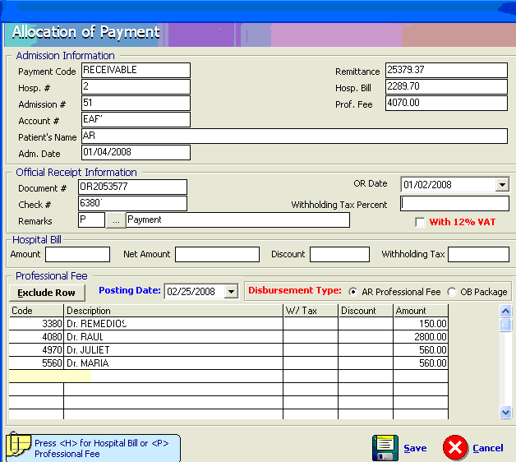
Enter the total Hospital amount paid by the Company for that patient.

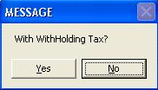
Click on Yes if with withholding Tax otherwise click no.

Click on Save button to save the data entered.
Click on Cancel button to disregard the data entered.
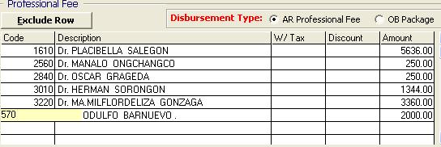

To exclude the doctor from the particular company payment, just click the name of the doctor and click on button

Click on Save button to save the data entered.
Click on Cancel button to disregard the data entered.

Invoicing

This option allows you to make endorsement or invoices to companies. To do this, go to REPORTS then Transmittal option then NEW and this will display the window below.
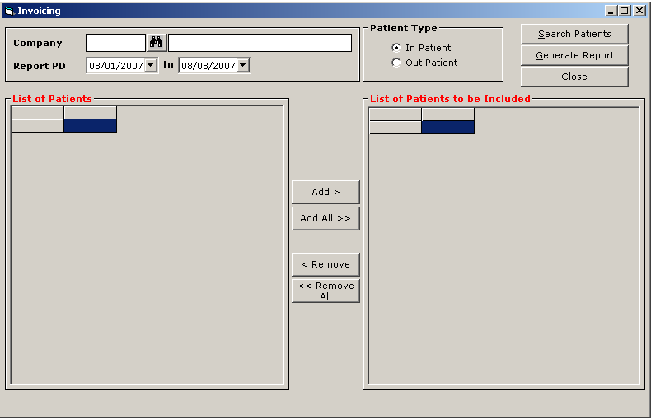
Enter the Company name and report period. Choose patient type ( Inpatient or Outpatient ) then click the SEARCH PATIENTS button to display list(s) of patients under the company entered on a selected period of time. Click ADD button if you want that the patient will be included in the list or click ADD ALL if all patients listed will be included. To remove a patient from the lists, click the REMOVE or REMOVE ALL button.
To enter additional remarks, click on REMARKS button.
To print the endorsement done, click on GENERATE REPORT button.
To go out from this window, click on CLOSE button.

To reprint an endorsement or an invoice, go to REPORTS then TRANSMITTAL and choose REPRINT to display the window below.

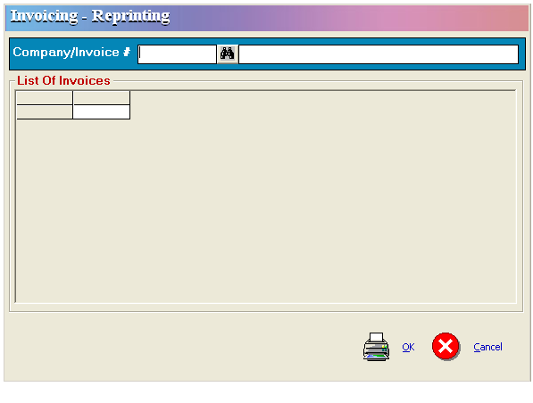
Enter the Company or the Invoice # you want to re-print then click the OK button. To go out from this window, click CANCEL.

To Cancel an endorsement or invoice, go to Reports then Statement of Account, go to Invoicing then Cancellation. Enter the Company or invoice # you want to cancel. Click on OK button to cancel it or Cancel button to go out from this option.

Reports
Available reports within the PARS module. Click on Reports menu to display the list of reports.
- Summary of Accounts
NO CUT-OFF TYPE
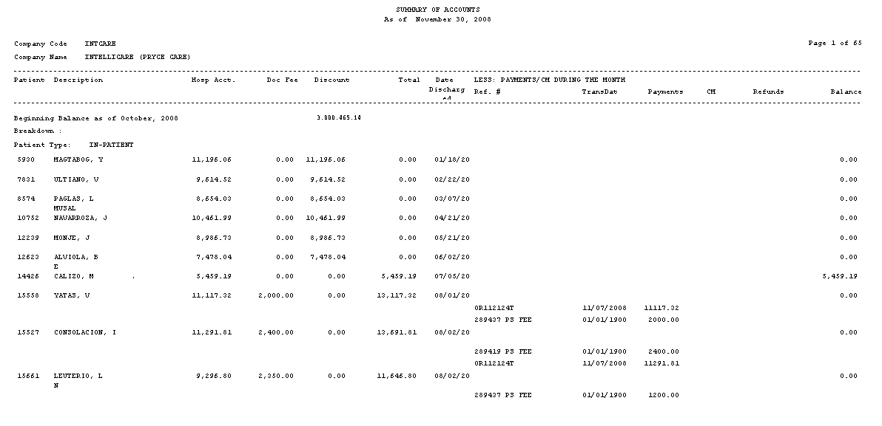
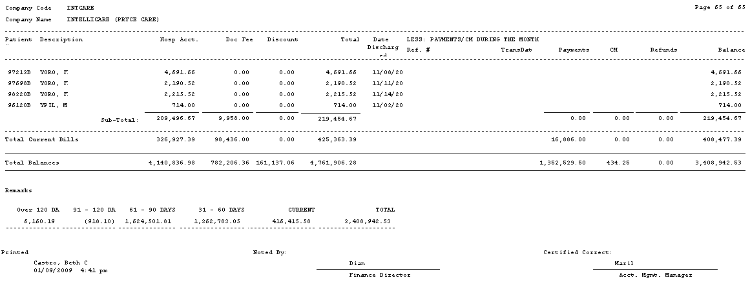
TRANSACTION
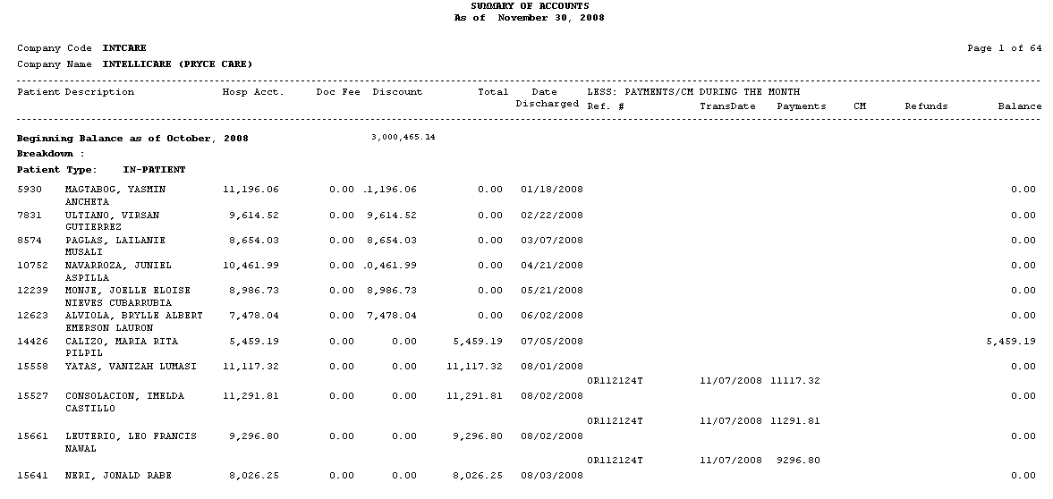
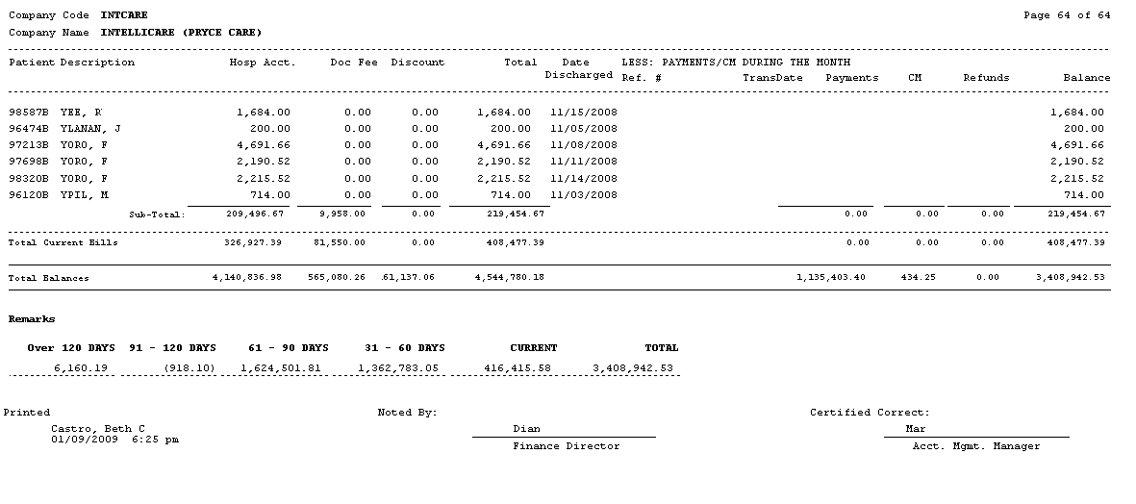
PAYMENT
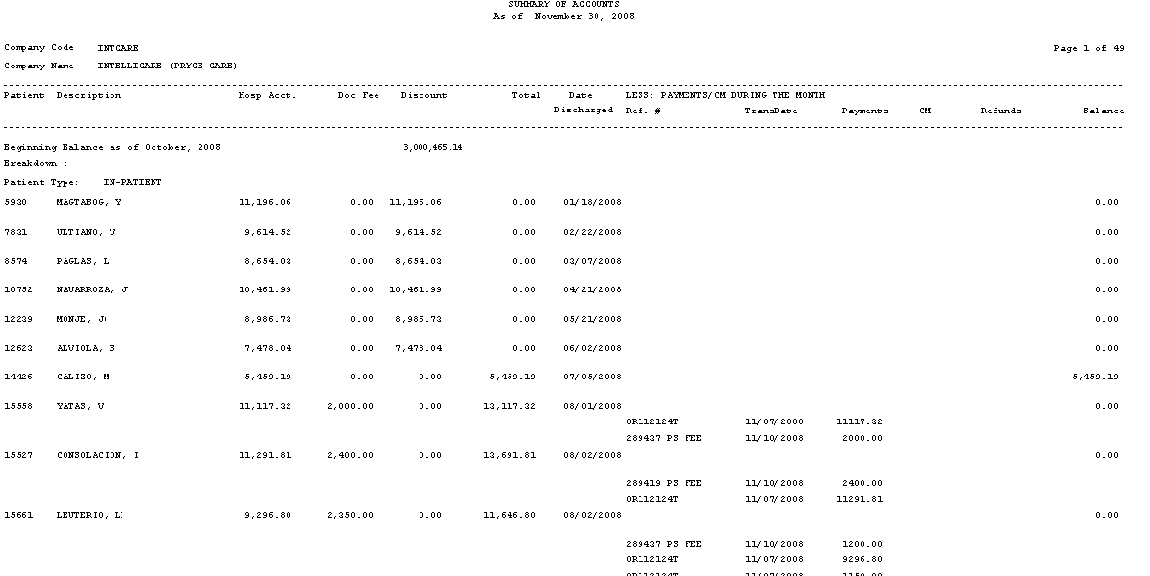
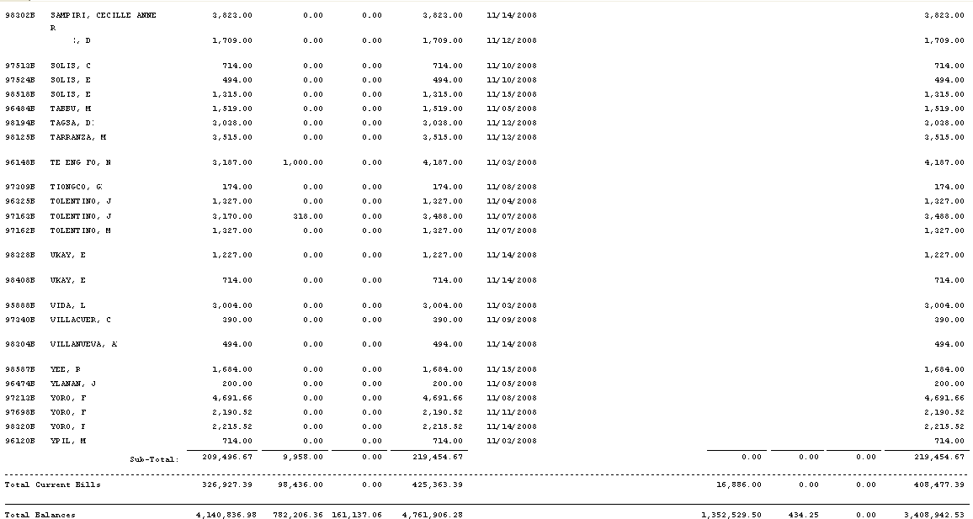
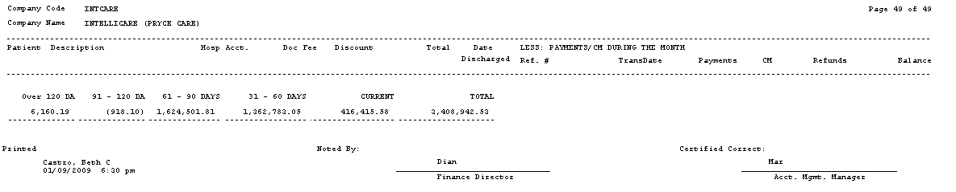

- Accounts Receivable
  - Summary Report – It shows the beginning AR balance, current charges, current credits and ending AR balance per Business Classification, Company, Personal or All
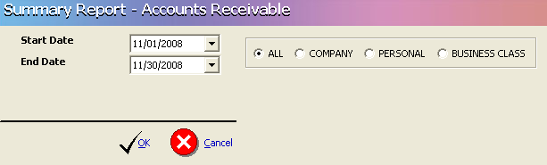
A- ALL
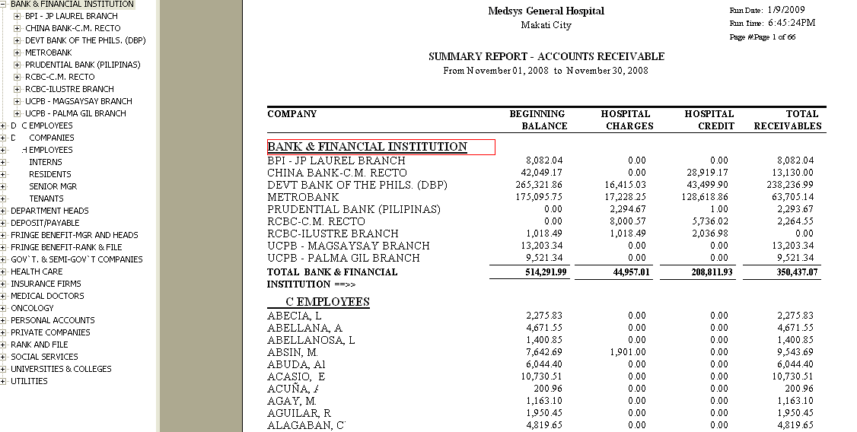

B- Company
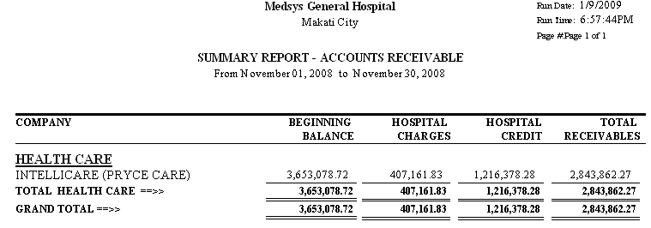
C- Personal
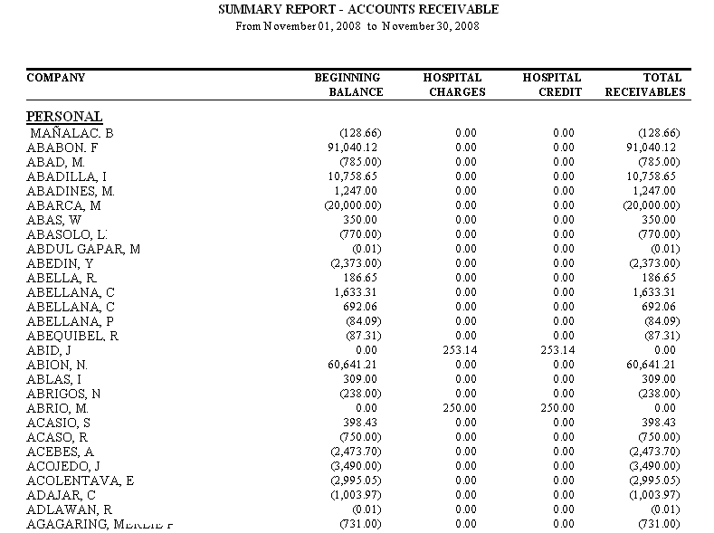
D- Business Class
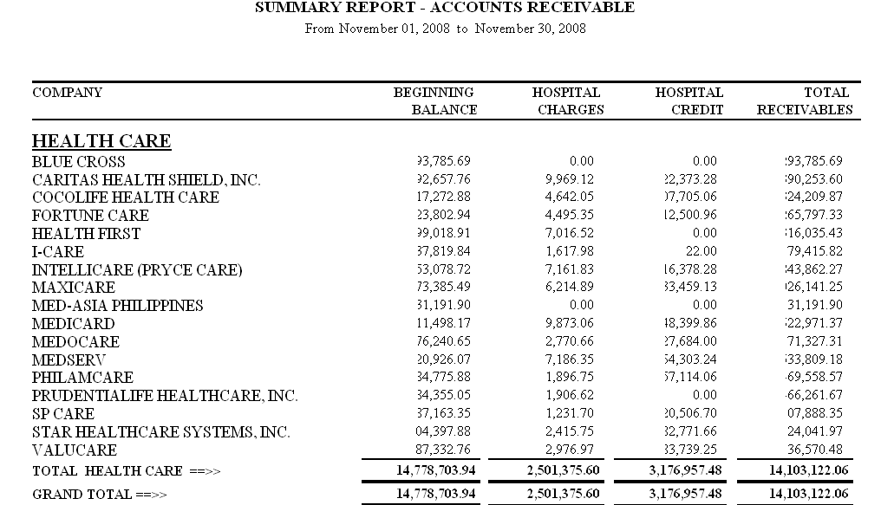

  - Detail Report – It shows the beginning AR balance, current charges, current credits and ending AR balance per company with list of patients and grouped as to Inpatient and Outpatient
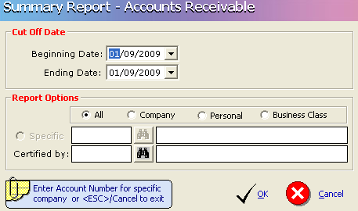
A- ALL
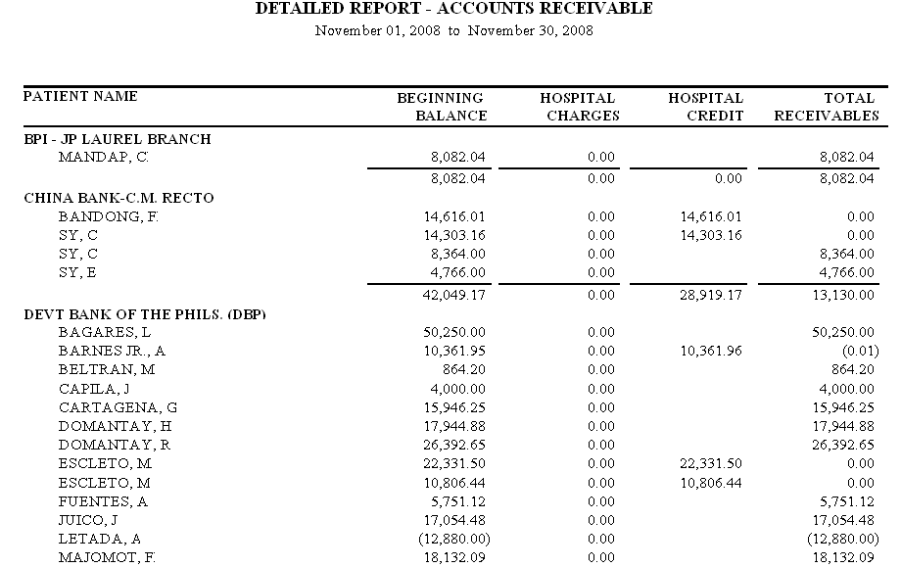
  - By Classification

  - Monthly Summary
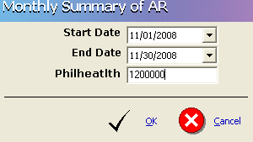
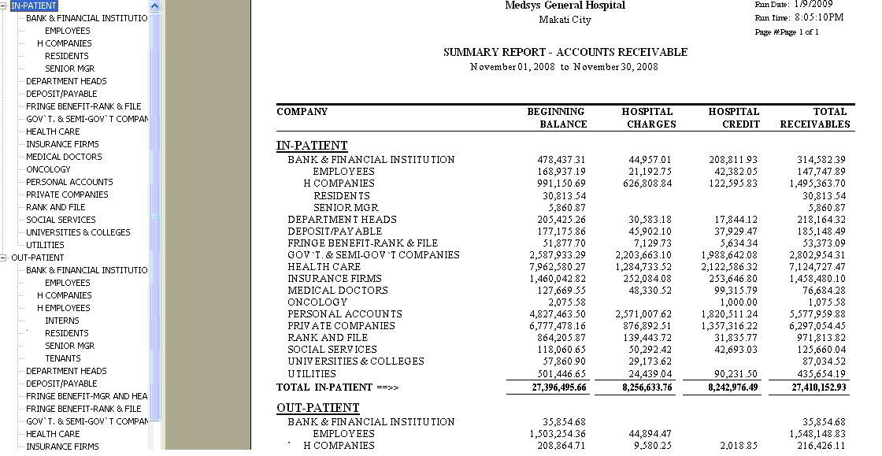

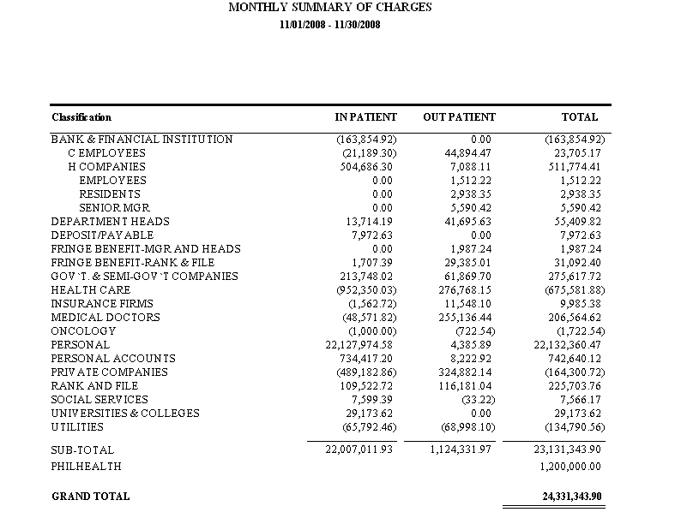
  - Schedule – It shows the total receivables per company and could be presented by year, by month or by aging (Tabular presentation per month)

A- BY YEAR

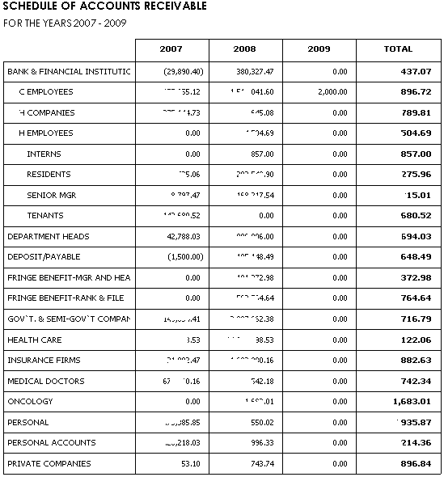
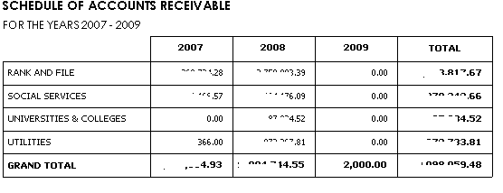
B- BY MONTH (DETAILED)
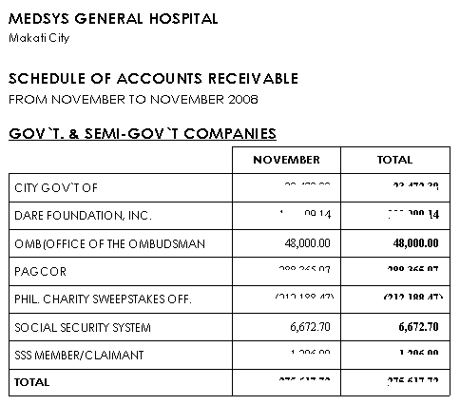
C- BY MONTH (SUMMARIZED)
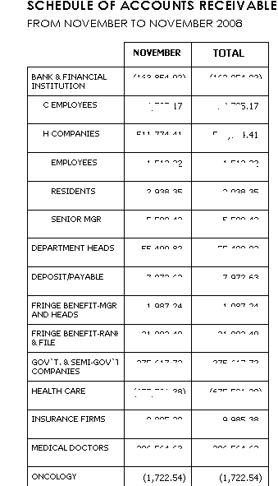
D- BY AGING
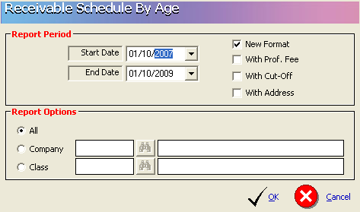
BY AGING (NEW FORMAT) (ALL)
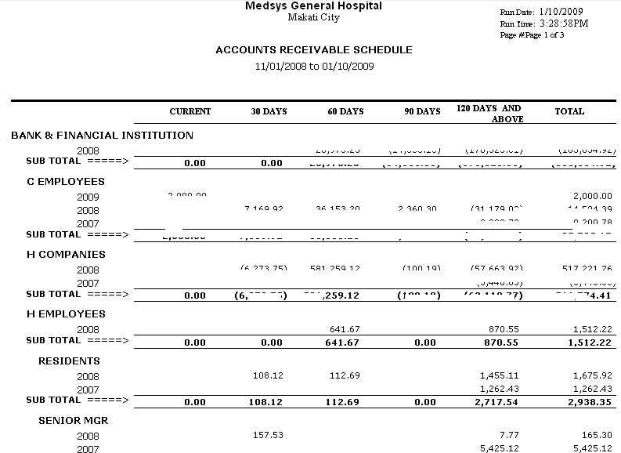

BY AGING (NEW FORMAT) (CLASS)
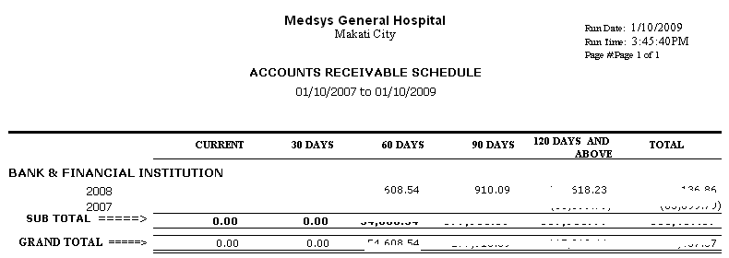

- Collection Reports
- Payment Allocation Summary – It shows the daily company collection with the following information: Account number, Hospital number, Discharge date, Amount due, Official Receipt number, Payment date, Amount paid, Remarks (Underpaid or paid) and Balance.
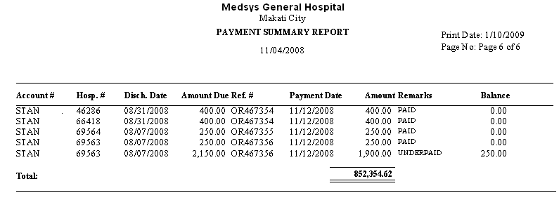
- Payment Allocation Verification
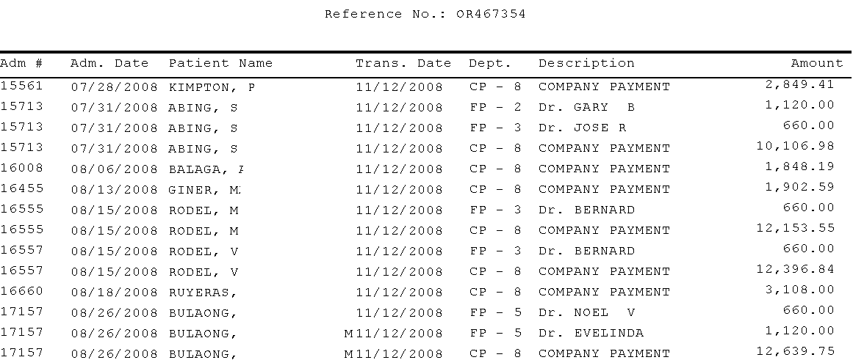
- Doubtful Accounts Payment
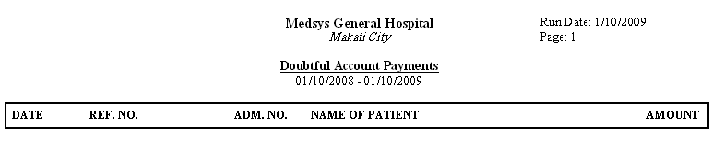
- Bad Debt Account Payments
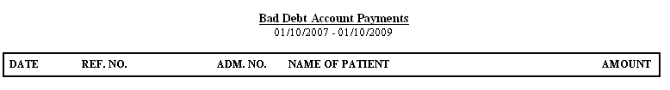
- Medical Fee Collection
- COMPANY PAYMENT
A- COMPANY PAYMENT (DETAIL)
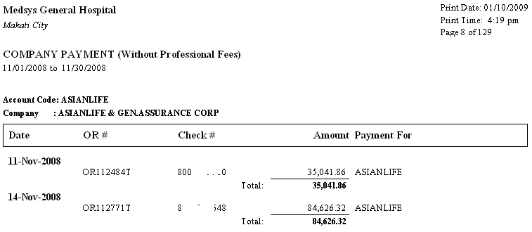
B- COMPANY PAYMENT (SUMMARY)

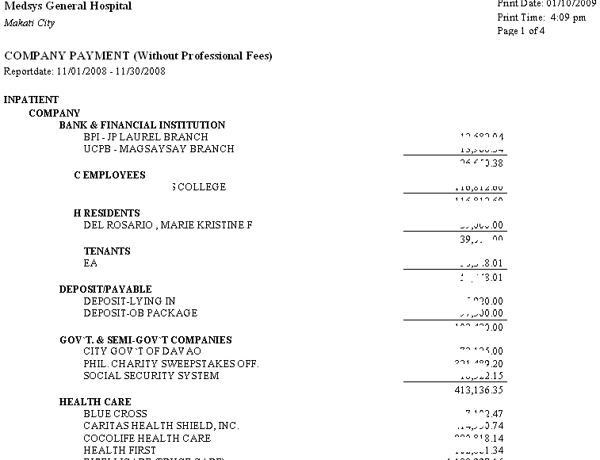
- Over All Collection – It shows the total collection per company with list of patients in a given month
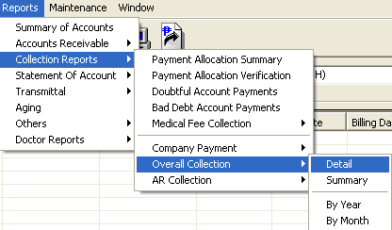
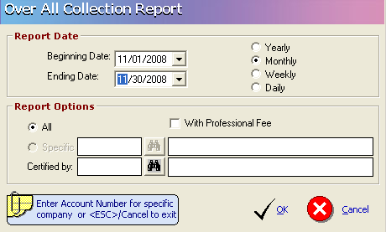
A- Overall Collection (Detail) (Monthly) (All)(Without Professional Fee)
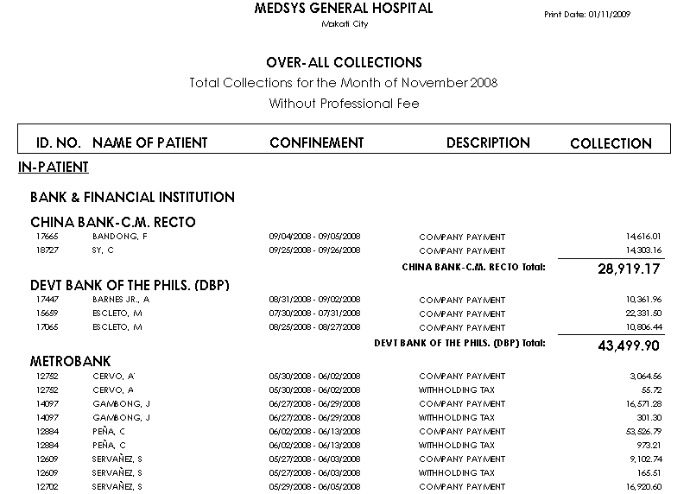
B- Overall Collection (Detail) (Monthly) (All)(Without Professional Fee)
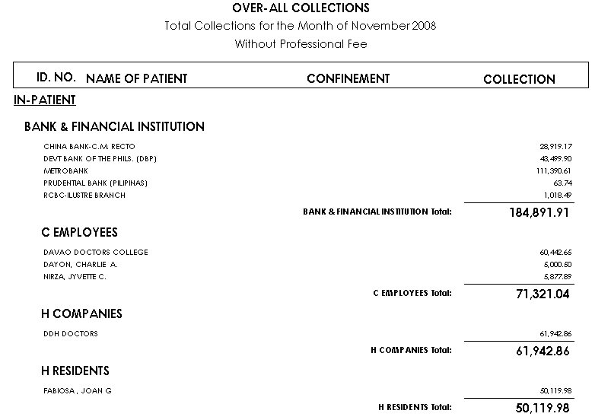
- Statement of Accounts
  - Open Items (Inpatient) – It shows all company’s inpatient receivables with detailed AR transactions (deductions and charges) of patients.
  - Open Items (Outpatient) – It shows all company’s outpatient receivables with detailed AR transactions (deductions and charges) of patients.
  - Open Items (All) – It shows all company’s inpatient & outpatient receivables with detailed AR transactions (deductions and charges) of patients
  - Statement of Accounts (Inpatient) – It shows company’s inpatient receivables with detailed AR transactions (deductions and charges) of patients for a particular period.
  - Statement of Accounts (Outpatient) – It shows company’s outpatient receivables with detailed AR transactions (debits and credits) of patients for a particular period.
  - Statement of Accounts (All) – It shows company’s inpatient & outpatient receivables with detailed AR transactions (deductions and charges) of patients for a particular period.
  - Summary of Unpaid Bills (inpatient) – It is similar with the Statement of Accounts for Inpatient where it shows company’s inpatient receivables with detailed AR transactions of patients. It only differs in the presentation of the amount. Deduction is enclosed with parenthesis.
  - Summary of Unpaid Bills (outpatient) – It is similar with the Statement of Accounts for outpatient where it shows company’s inpatient receivables with detailed AR transactions of patients. It only differs in the presentation of the amount. Deduction is enclosed with parenthesis.
  - Summary of Unpaid Bills (All) – It is similar with the Statement of Accounts for inpatient & outpatient where it shows company’s inpatient receivables with detailed AR transactions of patients. It only differs in the presentation of the amount. Deduction is enclosed with parenthesis.
  - Summary of Unpaid Bills (No Negative Amount) – It only reports all receivables per consultation/confinement (not showing the refundable account)
  - Summary of Unpaid Bills (By Period) – It shows all patients balances for a particular period
  - Medicare Underpayment – It is a report that shows all patients Philhealth balances for a particular period. It shows the actual philhealth deductions, Philhealth actual payments and remaining balances.
  - Invoicing (Inpatient, Outpatient & All) – Invoicing is the tagging of AR statement to be forwarded to Company for billing/collection. After identifying the accounts to be included, an Invoice Letter will automatically be printed/viewed in this option with a computer generated invoice number. .
  - Invoicing (Reprint) – It allows the user to reprint previously generated Invoice letter
  - Invoicing (Cancellation) – It allows the user to revoke the previously prepared Invoice letter.
  - Aging by Company (All) – All Patients balances with invoice numbers are aged using discharge date. It shows the patient’s name, confinement, amount and age (Current, 30 Days, 60 Days, 90 Days and 120 Days and above) of the account.
  - Aging by Company with Invoice – Inpatients balances with invoice numbers are aged using discharge date. It shows the patient’s name, confinement, amount and age (Current, 30 Days, 60 Days, 90 Days and 120 Days and above) of the account.
  - Aging by Company (OPD Invoice) – Outpatients balances with invoice numbers are aged using discharge date. It shows the patient’s name, confinement, amount and age (Current, 30 Days, 60 Days, 90 Days and 120 Days and above) of the account.
  - Monthly Summary of Accounts Receivable – It shows the Philhealth Receivables for Inpatient and Outpatient for a given month.
  - Daily OPD Services – It is one type of a Statement of Account that could be sent to company. It reports the patients with outstanding balance in the hospital for a particular period. It shows the transaction date, hospital number, reference number, patient name, particulars, debit amount, credit amount and total
  - Refund – It is a report that shows the AR balances with negative sign. It shows the name of patients, admission & hospital numbers, confinement date and the amount to be refunded per company / account name.
  - Employees Medicines – It shows all the medicines issued under the Employees Medicine account number.
- Aging
- It is a standard Aging report wherein all patients balances (including negative balances and with/without invoice numbers) are aged based on discharge date. It shows the patient’s name, confinement, amount and age of account (Current, 30 Days, 60 Days, 90 Days and 120 Days and above).
- It is grouped per business classification and per account name.
- OTHERS
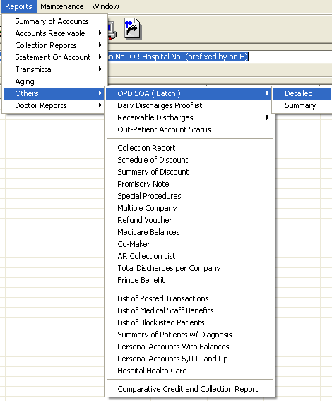
  - OPD SOA (BATCH)(DETAILED) – It shows all the outpatient transactions and reported in a Statement of Account format.

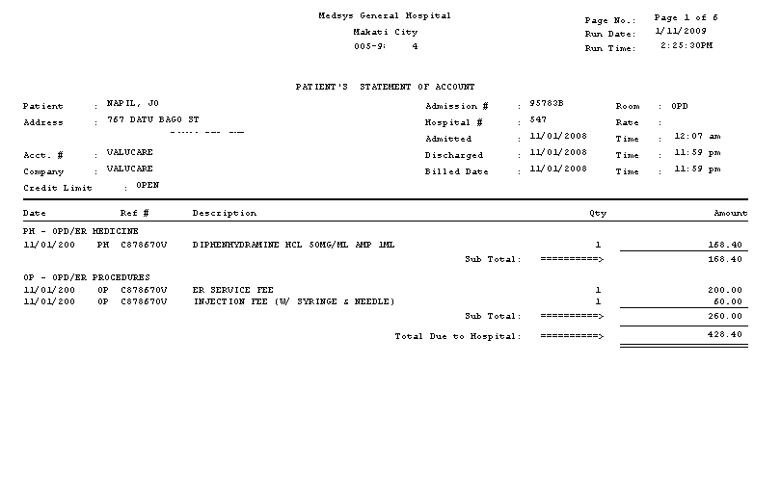
  - DAILY DISCHARGES PROOFLIST

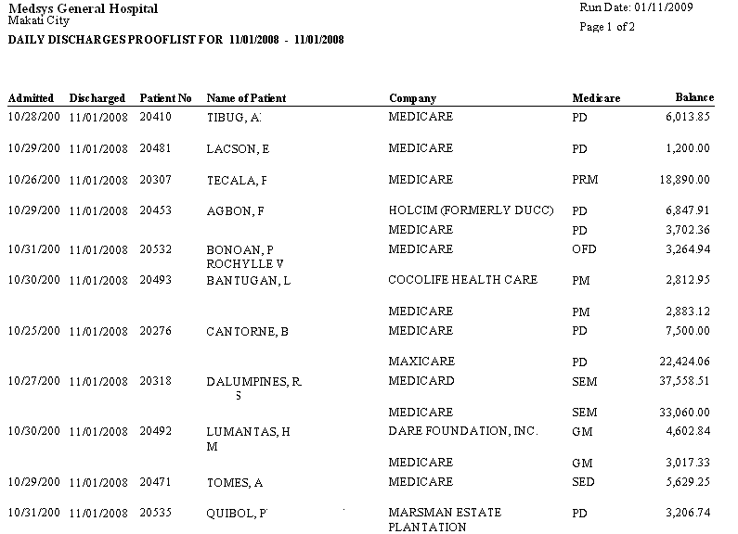
  - RECEIVABLE DISCHARGES DETAILED
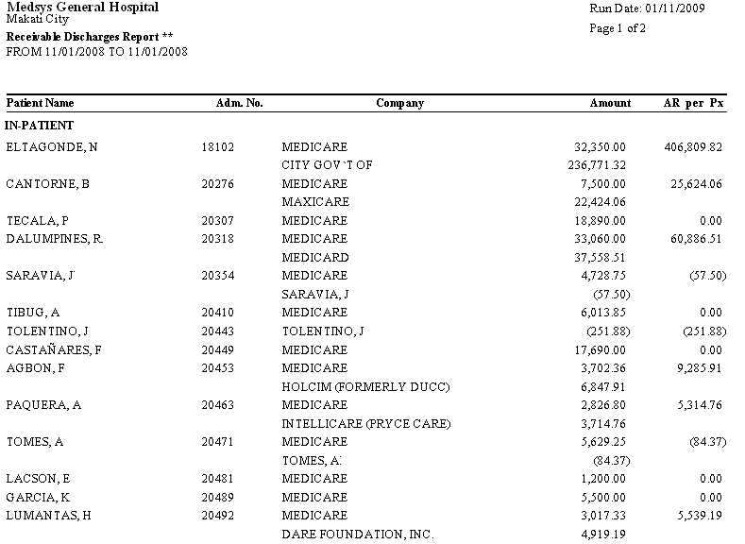

  - OUTPATIENT ACCOUNT STATUS

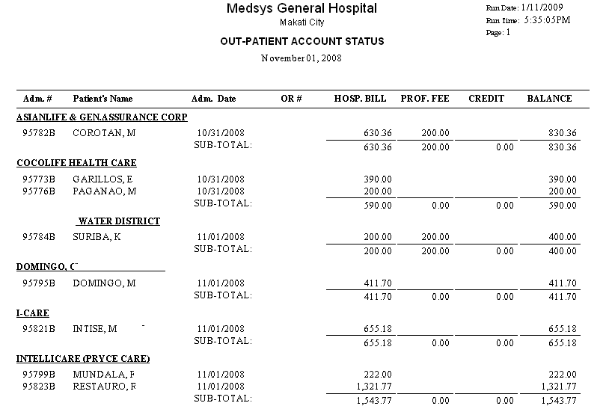
  - Collection Report
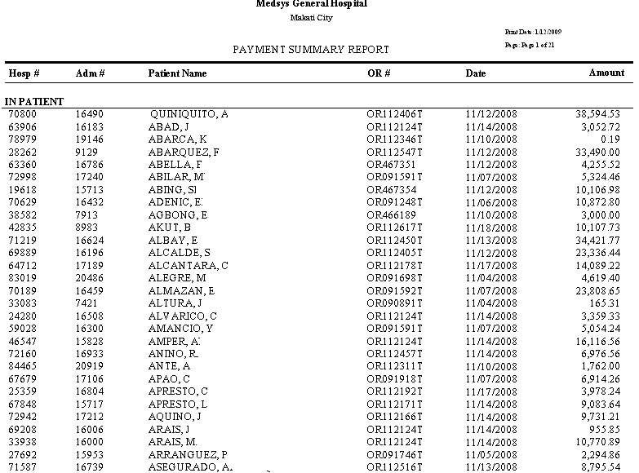
  - Schedule of Discount. It is a detailed discount transaction report. It shows patients who were given discounts, type of discount, transaction date and discount amount per department. This is the supporting report of Discount Summary.
  - Summary of Discount summarizes the total discount per department and per type of discount in a given period.
  - Promissory Note - It shows the list of discharged patients with promissory notes. It shows the patient’s name, hospital number, promissory note number, admission number, Discharge date, AR balance, deduction, Promissory Note amount for hospital and professional fee, total amount with promissory note, interest charge, total amount due, due date and remarks.
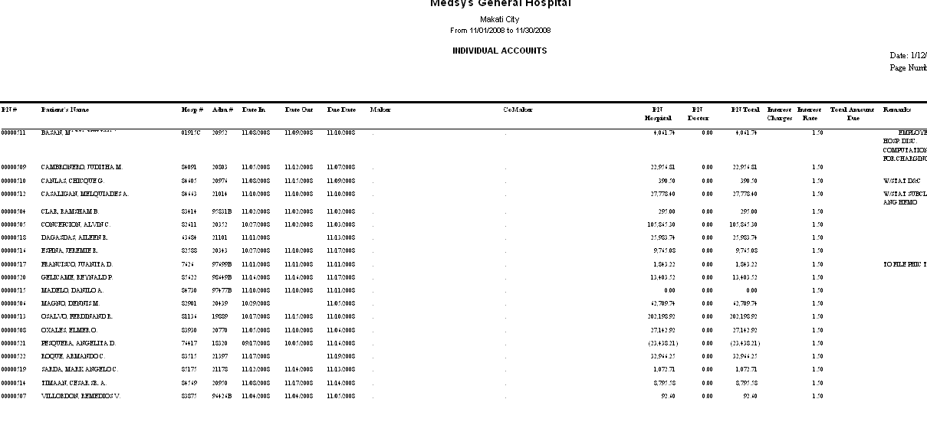
- Multiple Company Report It shows patient’s confinement / consultation balances distributed to multiple companies. It shows patient’s name, hospital and admission number, account number, account name and receivable amount per account

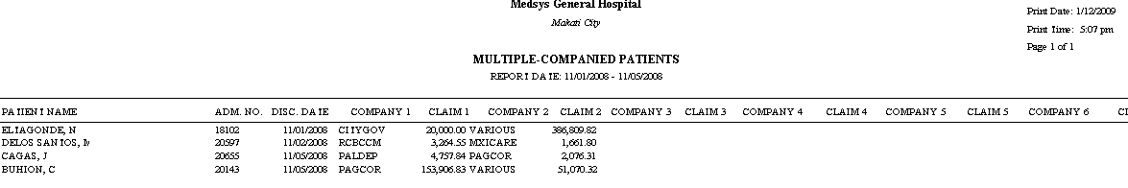
  - Refund Voucher
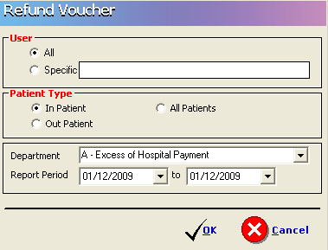
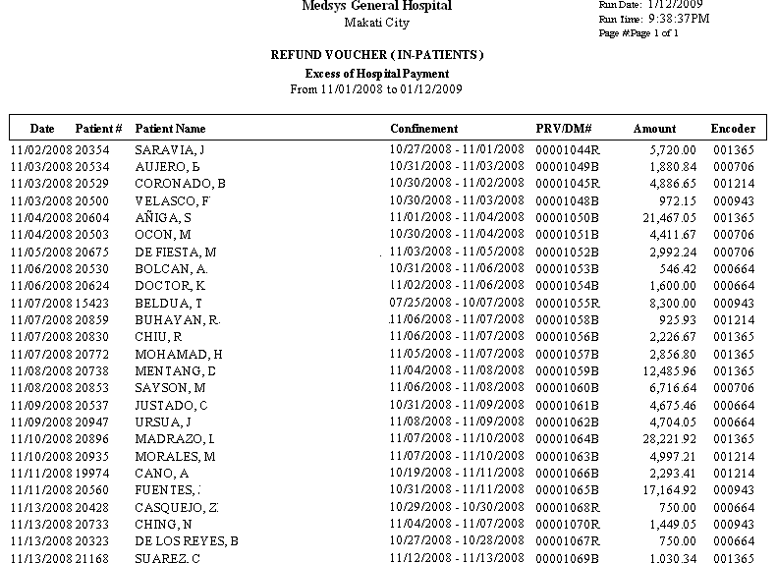
  - Medicare Balances (Companies with PHIC Underpayments)-It is a list that shows all company and personal accounts with Philhealth balances. It shows the name of company and remaining underpaid philhealth balance.

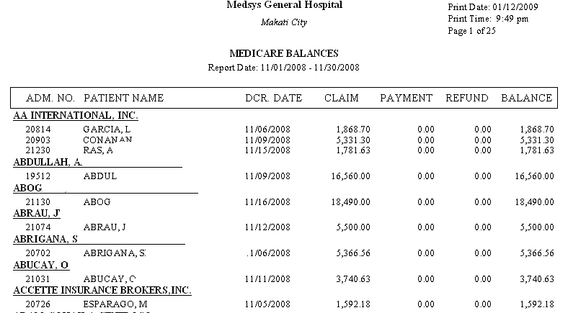
  - Co-Maker Report
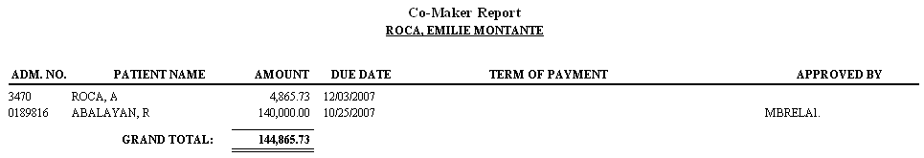
  - AR Collection List
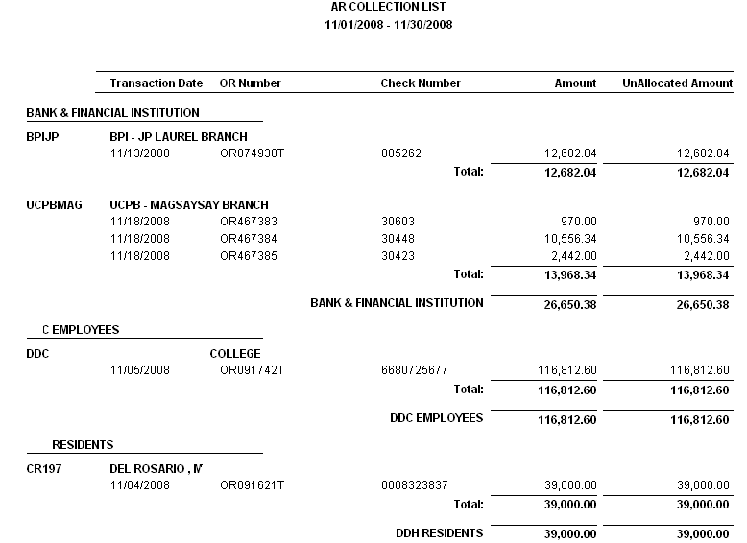
  - Total Discharges Per Company
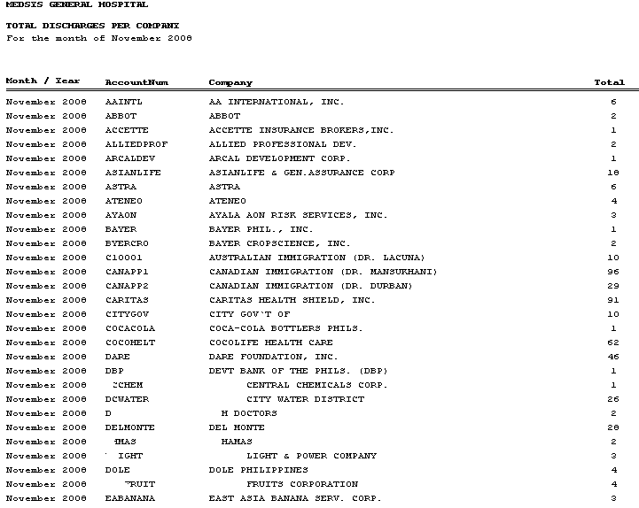
  - Fringe Benefit
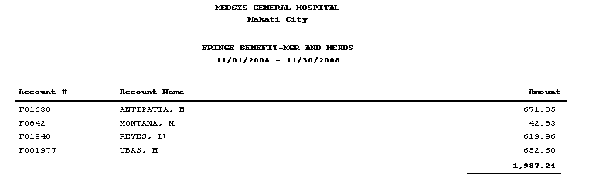
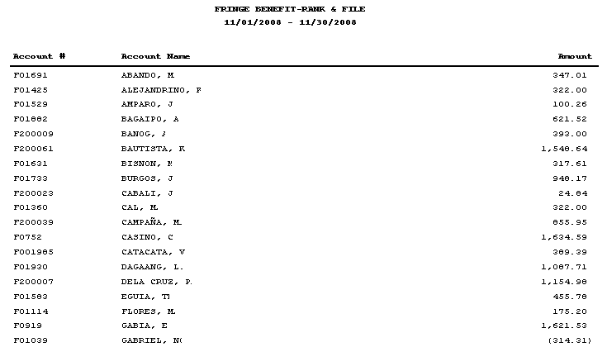
  - List of Posted Transactions- It shows all charges posted for a particular revenue code. It is grouped per Account name (personal and company accounts), reference number, patient name, transaction date, admission number, item description and amount. May also print transactions posted by a particular encoder in a given period.
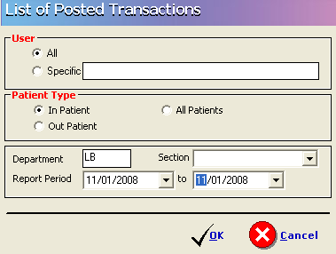

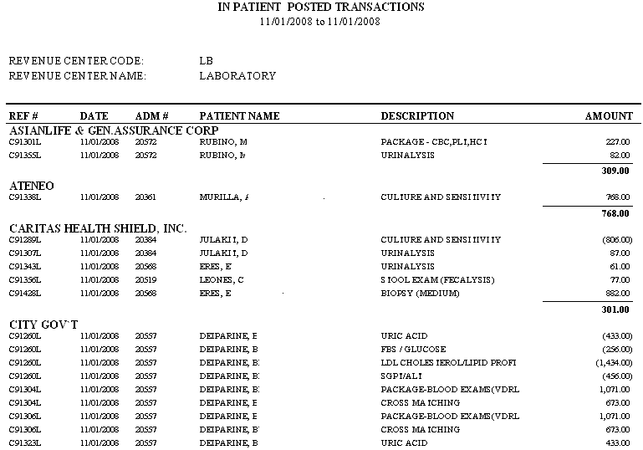
  - Medical Staff Benefit- It shows the list of patients who were given Medical Staff discount/benefit for their inpatient and/or outpatient accounts for a particular revenue code/account. It shows the patient name, discount and confinement date.
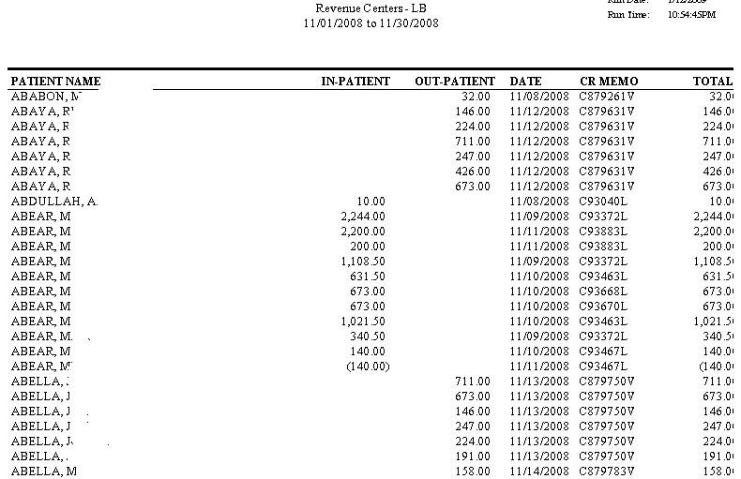
  - List of Block Listed Patients- It is a report that will show the patients with outstanding balance in the hospital and were marked as block listed. It shows the patient’s name, admission and hospital number, maker and address of maker, and co-maker’s name and address.
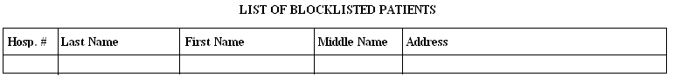
  - Summary of Patients with Diagnosis- It is a report that could be submitted to a company with patient’s diagnosis. It shows the patient’s name, admission number, confinement date and final diagnosis
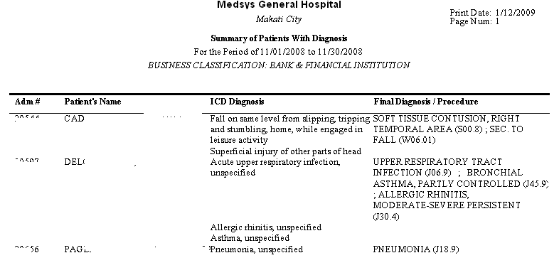
  - Personal Accounts With Balances- It reports all accounts balances chargeable to individual or personal accounts. It shows the patient name, admission & account numbers, hospital bill, professional fee, deduction, AR balance and remarks.
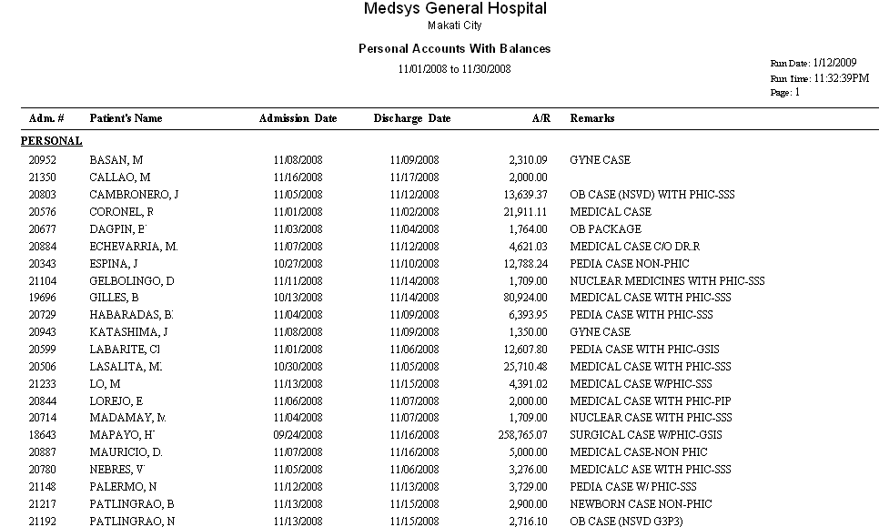

  - Comparative Credit and Collection Report
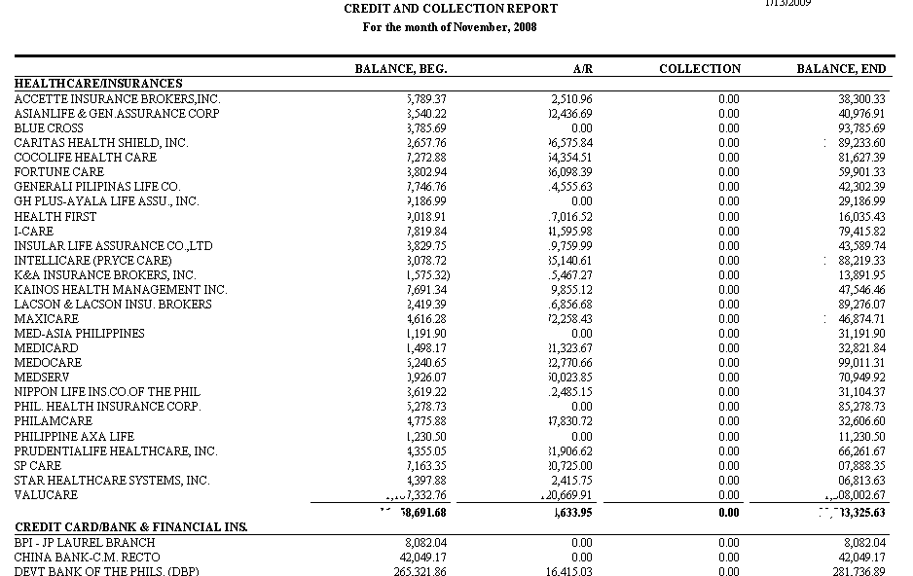
- Aging With Invoice
- It is a standard Aging report wherein all patients’ balances and with invoice numbers (including negative balances) are aged based on discharge date. It shows the patient’s name, confinement, amount and age of account (Current, 30 Days, 60 Days, 90 Days and 120 Days and above).
- It is grouped per business classification and per account name.
- Payment Report
- It shows the actual collection of company per patient. It shows the Official receipt number, admission & hospital numbers, patient’s name, discharge date and amount
- List of Late Transactions
- It shows all charges / adjustment posted to patient’s account after billing/consultation date. It shows patient name, account name, revenue code, revenue description and amount.
- Patients With No Invoice Number
- It is a list that shows the remaining patients accounts with no invoice number. It means, the accounts are not yet transmitted for collection. It shows the patient’s name, confinement period, amount and grouped per account name.
- List of Loyal Patients
- It lists the name of patients with their number of visits in the hospital
Doctors Report

- Doctors Charges
- Outstanding Balance
- Payments to Doctors
- Commission
- Disbursement
- P. S, Disbursement
To view this report follow this:

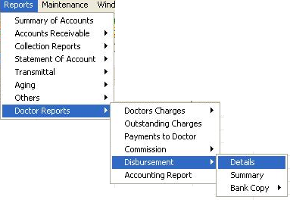

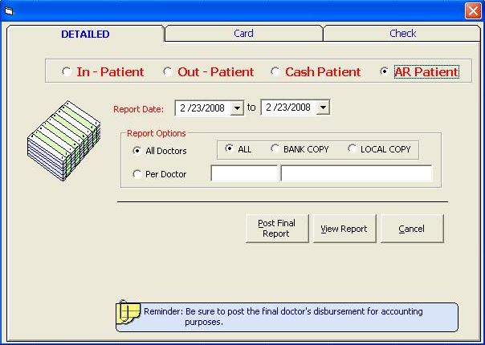
Enter the report date. You can view either All Doctors or Per Doctor. Below is a sample reports on P.S. Disbursement.
Sample P.S. Disbursement - ALL Doctors
