MEDSYS
Information System

Operating Room Program
User's Manual



MEDSYS
Kaiser - dela Cruz Consulting, Inc.
July 31, 2026
Copyright© 2009
ALL RIGHTS RESERVED

No part of this document may be reproduced through photocopying or in any means, stored into a retrieval system, and transmitted in any form without the express written permission of Kaiser - dela Cruz Consulting, Incorporated.
Permission is hereby granted to Medsys Information Systemto copy and distribute this document in any of the above means provided this is for its exclusive on site use.
Although every precaution has been taken in the preparation of this manual, the company assumes no responsibility for errors or omissions. Neither is any liability assumed for any damages resulting from the use of the information contained here.

Table of Contents
INTRODUCTION 4
Overview ………………………………………………………………………………………… 5
Objectives .……………………………………………………………………………………… 6
Features………………………………………………………………………………………….. 7
Getting Started 8
How to Start the Program 8
How to Change Password 9
How to End the Program 9
Program Operation 10
How to Search Inpatient/Outpatient 10
Inquiry (Personal Information, Request Status, Patient’s Ledger) 12
Personal Information 12
Request Status 13
Patient’s Ledger 14
Receivable Updates 15
Clinical Operation 17
How to View List of Confirmed Operation Schedules ? 21
How to Process /Revoke Pending Request ? 23
How to Print Scheduled Operations ? 24
Room Maintenance 25
How to Set Schedule Parameters ? 26
Clinical Procedures 27
How to Request Laboraotry Exam? 27
How to Request X-ray Exam? 32
How to Request Ultrasound Exam ? 32
How to Request C.T. Scan Exam ? 33
How to Request Heart Station (Cardio) Exam ? 35
How to Request Nuclear Exam ? 36
How to Request P.T. Exam ? 36
How to Request Pulmonary (RTS) Exam ? 36
How to Request Laser ? ……………………………………………………………………35
How to Request Magnetic Resonance Imaging ( MRI ) Exam ? …………………….36
How to Request Medicine ? ……………………………………………………………….37
How to Request Supplies ? 40
How to Send May Go Home (MGH) / Discharge Notice ? ………………………….. 39
How to Post Charges ? 44
How to Post Charges to Cash-basis?.......................................................................45
How to Process Credit Memo Advice? ………………………………………………….45
Nurses Activity Request 49
Viewing of Laboratory Exam Result 51
Viewing of X- ray Exam Result 52
Viewing of Ultrasound Exam Result 53
Viewing of Heart Station Exam Result 53
Viewing of C.T. Scan Exam Result ...…………………………………………………….53
Viewing of Nuclear Exam Result…………………………………………………………53
Viewing of Pulmonary (RTS) Exam Result 543
Vital Signs Data Entry 554
Nurses Notes Data Entry 565
Viewing of Patient’s Profile 576
Viewing of Clinical Summary 587
Scheduling of Operation 59
Reports 70
Audit Report 70
Monthly Report 70
Statistical Report 71
Schedule of Operation 71
Index 72

Introduction

Overview


The Operating Room Program aims to help the Operating Room staff in carrying out doctors orders in a fastest and accurate way thru its computer network connection to other departments. All patients’ requests for clinical procedures, supply and medications can be done through electronic communication. Authorized users can view verified clinical results and status of requested items in the computer. Thus, users can use this program to stay abreast of any clinical activity concerning a patient. Relevant information is readily available for nurses with less effort or legwork.
This program is user-friendly. It is menu-driven with detailed guidelines constantly provided for the user’s benefit.
Password protects the program from unauthorized access. Only program users with registered employee number and password can access it.

Objective:

- To use the interconnecting feature to other departments such as Laboratory, X-Ray, Ultrasound, CT-Scan, Heart Station, Hemodialysis, Pulmonary, Pharmacy, Central Supply, Operating Room, and Billing and other hospital departments to provide a higher level of care and service.
- To become a seamless part of the hospital’s operations whereby staff will have immediate access to patient information whenever and wherever required
- To reduce clerical workload
- To improve service and management will have a powerful new information tool for decision making purposes

Features

- Data-entry restriction - Warning messages are flashed for possible invalid entries. This ensures all data inputted would be made useful for any transaction to be done. All financial related transactions (requesting / charging) require user’s access per data entry
- Password-protected - The use of password is necessary to restrict unauthorized access. Thus the program only accepts passwords which are registered into it. This feature ensures the confidentiality and integrity of data entered in the program.
- Auto-report generation – The program automatically generates printable reports when needed
- User-friendly - The program user is guided by instructions in doing the next step providing an easy-use to process transactions. Toolbar buttons are also incorporated with tool tips so whenever a user positions the cursor just above the toolbar buttons; a tool tip will pop out. Ability to monitor status of requests sent to different revenue departments. Results could be viewed in tabular and graphical presentation for historical laboratory results.
- Control – Adjustment entry requires explanation / remarks and updates own Medicine & CSSR stock files
- Electronic Communication – system has electronic sending of discharge notice, staff may view verified results from laboratory, x-ray, ultrasound and Ct-Scan departments

Getting Started

How to Start the Program

1 Click on O.R. Program executable file icon located in the desktop.

2 The Login window will be displayed asking you to type your employee number and password for security purposes.

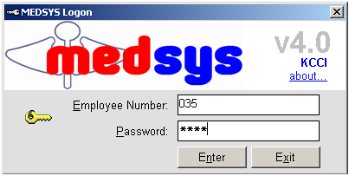
Figure 1: Login Window

3 If accepted, you can now start a transaction. Otherwise, a message will be displayed prompting “Unauthorized User”.

How to Change Password

It is advisable to change your password as often as possible for security reasons. To change you current password, follow these steps.

1 From the Login window (refer to figure 1), type your employee number and then press <Enter>.
2 Under the Password entry, press <F12>. Pressing this function key will invoke the Change Password window.

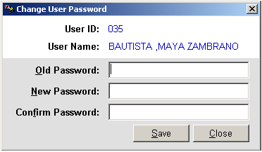
Figure 2: Change Password Window
3 Under the Change Password window, type the following data.
Old Password - Type your existing password.
New Password - Type your new password not exceeding to 15 characters.
Confirm Password - Retype your new password to confirm and then press <Enter> or you can click the Save button.

How to End the Program

It is important for users to close the program when they are done to end-up their session. Other users might use the open program using the same password.
To close the program:
Click on located at the upper right corner of the main window or
Click Exit Application from Exit menu or
Click Exit Application from Exit Application drop-down toolbar button.

Program Operation

How to Search Inpatient/Outpatient

Upon loading the program, patient searching window will be the first window to be displayed. You can activate patient searching by clicking on toolbar button or by clicking the Open menu.
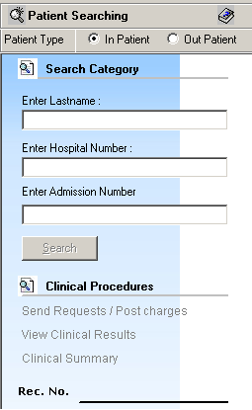
Figure 3: Patient Searching

1 Patient Type - Click on the option box “In Patient” to search for inpatients or “Out Patient” to search for outpatients.

2 Search Category - Choose one search category from the list below. It is advisable to just enter the full last name of the patient when searching.

Enter Last Name: Type the full last name of the patient or type the first letters of the last name then press <Enter> or click on Search button or
Enter Hospital Number: Type the hospital number of the patient then press <Enter> or click on Search button or
Enter Admission Number: Type the admission number of the patient then press <Enter> or click on Search button.
Afterwards, patient listing(s) will be displayed at the right side of the window. Patient lists is color coded, BLUE is Billed Patients and RED is Cash Basis Patient.Select a patient from the list to use for your transaction. (The selected patient is highlighted with gray color when clicked) Here are the actions you can do after selecting a patient.
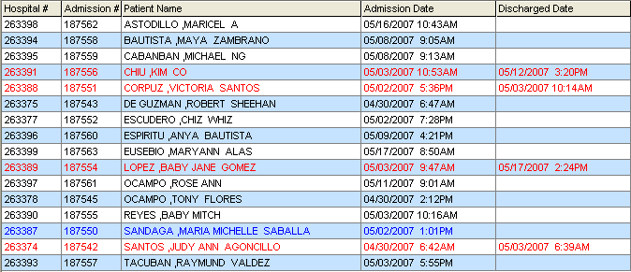
Figure 4: Patient List Window
Right-click -You can right-click on the patient name to display options such as personal information, request status or patient’s ledger.
Double-click - When double-clicked, the clinical procedure window will be displayed. Clinical procedure includes:

Send Requests
Nurses Activity Request
View Results
Vital Signs
Nurses Notes
Patient Profile
Clinical Summary
3 Clinical Procedures - You can activate this after selecting a patient from the list. The most common clinical procedures are as follows:

Send Requests/ Post Charges
View Clinical Results
Clinical Summary

Inquiry (Personal Information, Request Status, Patient’s Ledger)

If the patient is right-clicked from the patient list, three options will be displayed to choose from which are listed below.

Personal Information
The personal information to be viewed includes patient name, hospital number, admission number, admission date, and room number. To view patient’s information:

1 Select a patient from the list then right-click. A pop-up window will be displayed. Click Personal Info or click Personal Info from the Inquiry pull down menu.

2 The Personal Information window will be displayed and the following data can be viewed.

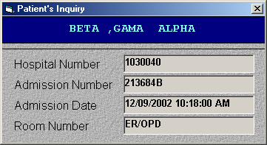
Figure 5: Personal Information Window

Patient Name
Hospital Number
Admission Number
Admission Date
Room Number

Request Status
This displays the status of the requested exam of the patient. To know the request status of the patient,

1 Select a patient from the list then right-click. A pop-up window will be displayed. Click Request Status or click Request Status from the Inquiry pull down menu.

2 A generated report window will be displayed. The following data can be viewed.

Description - the name of the exam requested
Qty - the number of exam(s) requested for a particular exam
Reference No. - a program generated number (charge-slip number)
Status - e.g. Pending, With Result, Charged…
Request Date - the date when the exam was requested
Request By - the program user who requested the exam

3 To print, click .

Patient’s Ledger

This displays the total amount of O.R. charges to be paid by the patient.

1 Select a patient from the list then right-click. A pop-up window will be displayed, click Patient’s Ledger. Or click Patient’s Ledger from the Inquiry pull down menu.

2 A generated report window will be displayed.

3 To print, click .

Receivable Updates

This option lets you enter patient charges that were not entered during his confinement.

1 Click on Receivable Update menu. The Receivable Update window will be displayed afterwards.

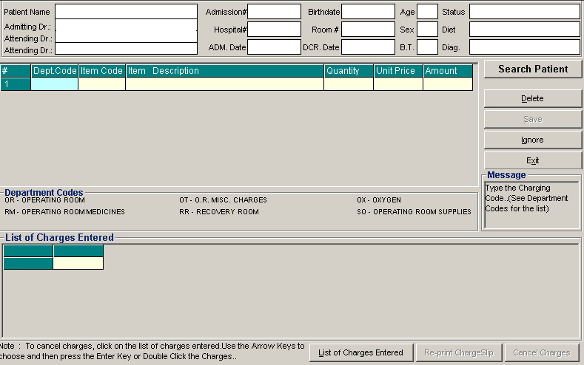
Figure 6: Receivable Update Window

2 Click on Search Patient button located at the right side of the window. The Search Patient window will be displayed. Type the following data.

Patient Type - Click on the option box “In Patient” to search for inpatients or “Out Patient” to search for outpatients.
Search Category - Choose one search category from the list below. It is advisable to just enter the full last name of the patient when searching.
Enter Last Name: Type the full last name of the patient or type the first letters of the last name then press <Enter> or click on Search button.
Enter Hospital Number: Type the hospital number of the patient then press <Enter> or click on Search button.
Enter Admission Number: Type the admission number of the patient then press <Enter> or click on Search button.
3 Afterwards, patient listing(s) will be displayed at the right side of the window. Select a patient from the list to use for your transaction by double-clicking on it. In the Receivable Update window, type the following data.
Department Code - Refer to the department code written just below the data entry.
Item Code - Type the service code or first letters of the service name and then press <Enter>. Or you can press <Enter> key if item code is still blank. When pressed, the Revenue Code window will be displayed showing the complete list of revenue codes.
Item Description - Automatically displayed by the program in relation with the selected item.
Quantity - Automatically displayed by the program in relation with the selected item but it can still be changed.
Unit Price - Automatically displayed by the program in relation with the selected.
Amount - Automatically displayed by the program in relation with the selected item and its quantity.

4 After completing the needed data, the following button options can be clicked from.
Click on Save button to save the items entered. When clicked, you have the option to print it.
To remove the selected item, click on the desired item then click on Delete button.
Clicking on Exit button will close the Receivable Update window.
An option is located below the window to view previous charges entered, re-print charge-slip or cancel the charges entered.

Clinical Operation

This is a data entry on the operation procedure of the patient. It includes result-entry, operation findings, diagnoses, techniques used, and other operation information (date & time of operation, operation performed, category of operation).

1 Choose a patient from the patient list then click on Clinical Oper. toolbar button.

2 Its window will be displayed.

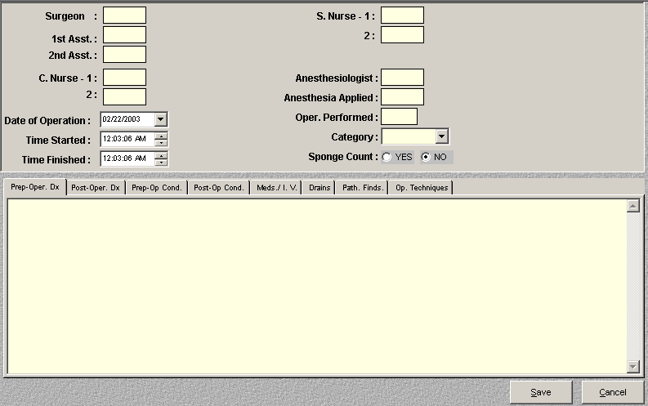
Figure 7: Clinical Operation Window
The following data are needed to enter.
Surgeon - ¹Type the doctor’s code and then press <Enter>. ²Or type the first few letters of doctor’s last name and then press <Enter>. A window will be displayed matching the query. ³Or You can press <Enter> if surgeon textbox is still blank to display the complete list of doctors. Just double-click the name of the doctor to select.
Figure 8: Doctors List
1st Asst. - This refers to the first assistant of the doctor first entered. ¹Type the doctor’s code and then press <Enter>. ²Or type the first few letters of doctor’s last name and then press <Enter>. A window will be displayed matching the query. ³Or you can press <Enter> if surgeon textbox is still blank to display the complete list of doctors. Just double-click the name of the doctor to select.
2nd Asst. - This refers to the second assistant of the doctor first entered. ¹Type the doctor’s code and then press <Enter>. ²Or type the first few letters of doctor’s last name and then press <Enter>. A window will be displayed matching the query. ³Or you can press <Enter> if surgeon textbox is still blank to display the complete list of doctors. Just double-click the name of the doctor to select.
Nurse (1 & 2) - This refers to the circulating nurse. ¹Type the first few letters of nurse’s last name (O.R. Staff) and then press <Enter>. A window will be displayed matching the query. ²Or you can press <Enter> if it is still blank to display the complete list of O.R. staff. Just double-click the name of the O.R. staff to select.
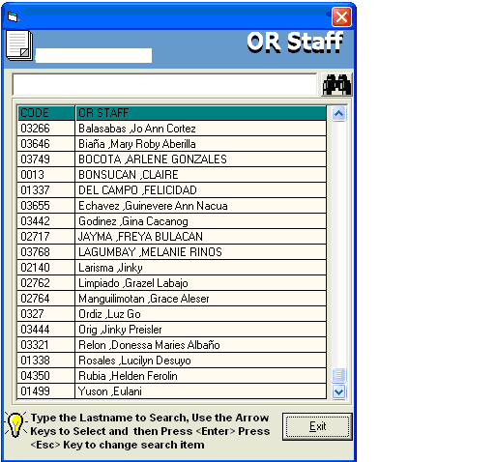
Figure 9: O.R. Staff Window
Nurse (1 & 2) - This refers to the scrub nurse. ¹Type the first few letters of nurse’s last name (O.R. Staff) and then press <Enter>. A window will be displayed matching the query. ²Or you can press <Enter> if it is still blank to display the complete list of O.R. staff. Just double-click the name of the O.R. staff to select.
Anesthesiologist - Type the anesthesiologist code and then press <Enter>. ¹Type the first few letters of doctor’s last name (O.R. Staff) and then press <Enter>. A window will be displayed matching the query. ²Or you can press <Enter> if it is still blank to display complete list of doctors. Just double-click the name of the doctor to select.
Anesthesia applied - Type the anesthesia applied.
Date of Operation - Click the drop-down list to display calendar. Click the date of operation. (format: mm/dd/yyyy where mm is month, dd is day, and yyyy is year)
Time Started - Type the time when the operation was started. Click the up-and-down arrow to select time.
Time Finished- Type the time when the operation was finished. Click the up-and-down arrow to select time.
Operation. Performed - This refers to the operating procedure. Type the code of the operating procedure and then press <Enter>. Or type the first few letters of the procedure and then press <Enter>. A window will be displayed matching the query. Or press <Enter> key if it is still blank to display the complete list of procedure. Just double-click the name of the procedure to select. 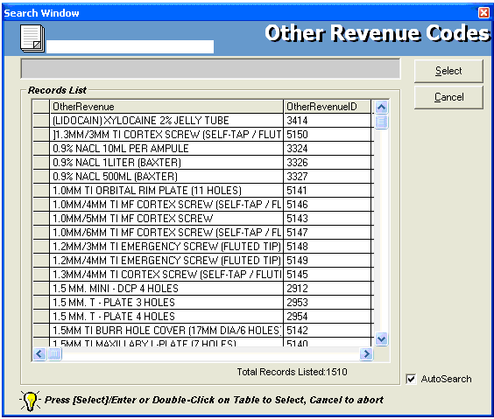
Figure 10: List of Procedures Window

Category - Click the drop-down arrow to select the category of operation. Options listed are major, medium, minor, and open heart).
Sponge Count - Click one from the two options <YES, NO>.
Prep.- Oper. Dx
Post-Oper. Dx
Prep-Op. Cond
Post-Op. Cond
Meds./I.V.
Drains
Path. Finds.
Op. Techniques
3 After completing the data, the following button options can be clicked from.
Save - This will save the current entry.
Cancel - This will close the window without saving the entered data.

How to View List of Confirmed Operation Schedules?

This displays list of confirmed operation schedules. It has an option to revoke the confirmed schedule and it will remove from the list.

1 Click on Operation Schedule menu. Its window will be displayed.

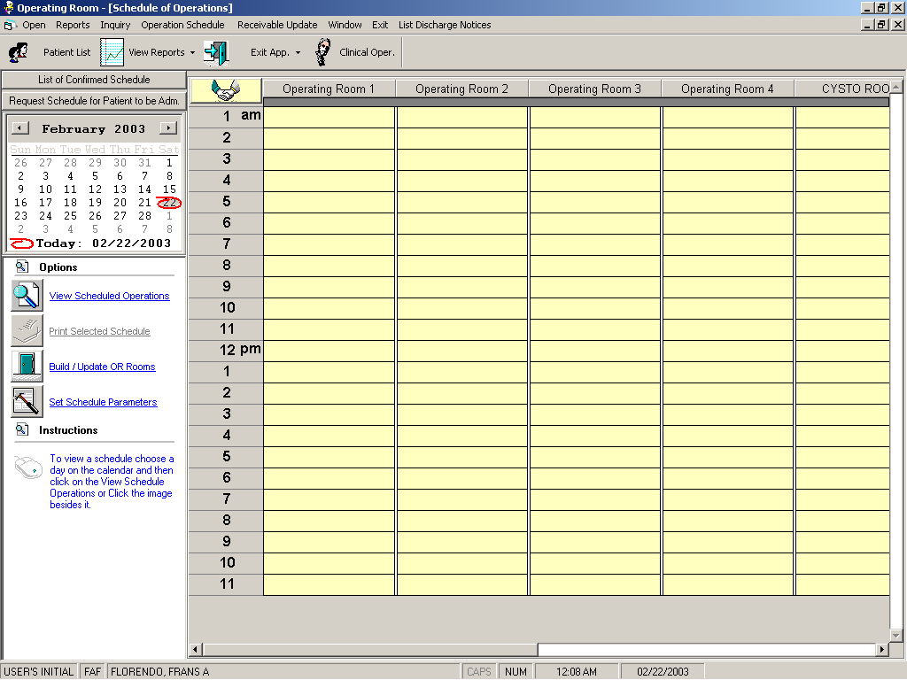
Figure 11: Operation Schedule Window

2 Click on List of Confirmed Schedule button. Its window will be displayed.

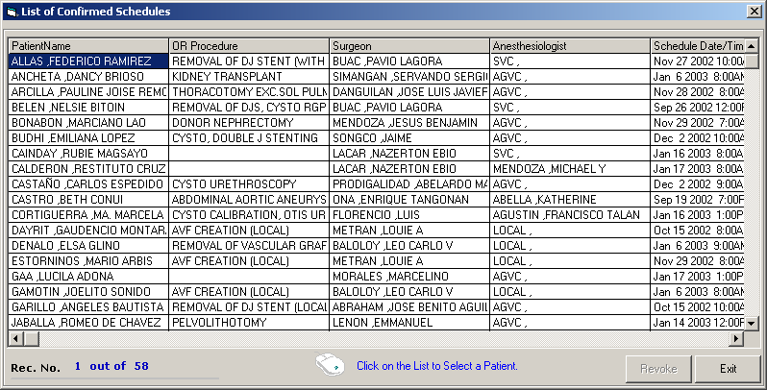
Figure 12: List of Confirmed Schedules

3 Click on the row where the confirmed schedule is aligned and then click on Revoke button. The revoked confirmed schedule will then be automatically removed from the list. Please note that you can only revoke dates that are beyond the current date.

How to Process /Revoke Pending Request?

This displays list of pending requests of operation schedules. It has an option to revoke pending request and it will automatically remove from the list.

1 Click on Operation Schedule menu. Its window will be displayed.

2 Click on button to display list of pending requests.

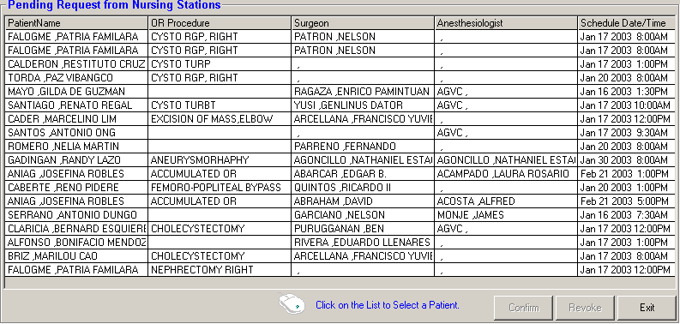
Figure 13: List of Pending Request(s)

3 The following button options can be clicked from.
Confirm - This button when clicked will confirm the request.
Revoke - This will revoke selected schedule from the list.
Exit - This will close the window.

How to Print Scheduled Operations?

This option allows you to print the selected scheduled operations.

1 Click on Operation Schedule menu. Its window will be displayed.

2 Choose a day in the calendar.

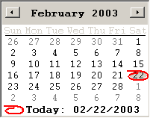
Figure 14: Calendar

3 Click View Scheduled Operations or click on button beside it. At the grid form, the list of scheduled patients will be displayed.

4 Click Print Selected Schedule or click on button beside it. A printable report will be displayed.

5 To print, click .

Room Maintenance

This option lets you to add, remove, and rename O.R. rooms.

1 Click on Operation Schedule menu. Its window will be displayed.

2 Click Build/Update O.R. Rooms or click on beside it. Its window will be displayed.

3 The following button options can be clicked from.
Add - This will build a new room.
Rename - This will rename selected rooms from the list.
Remove - This will remove saved room.
Cancel - This will close its window.

How to Set Schedule Parameters?

This option allows you to set the schedule increment of the grid form.

1 Click on Operation Schedule menu. Its window will be displayed.

2 Click Set Schedule Parameters or click on beside it. Its window will be displayed.
Enter the following datum.
Schedule Increment - Click on the drop-down arrow to display list. Just click on the option you want to use.

3 The following button options can be clicked from.
Ok - This will save changes done.
Cancel - This will close its window without saving any change done.

Clinical Procedures

After searching the patient (see page 9), you can do the following list of clinical procedures.

1 Send Request
How to Request Lab. Exam
How to Request X-ray Exam
How to Request Ultrasound Exam
How to Request C.T. Scan Exam
How to Request Heart Station (Heart Station) Exam
How to Request Nuclear Laboratory Exam
How to Request Physical Therapy and Rehabilitation Medicine Exam
How to Request Pulmonary Lab. (RTS) Exam
How to Request Medicine
How to Request Supplies
How to Send a Discharge Notice
How to Post Charges of O.R. Services and Supplies (charge patient)
How to Post Charges of O.R. Services and Supplies (cash patient)
How to Reprint Request Form of Lab. Exam
2 Nurses Activity Request
3 Viewing of Exam Result
4 Vital Signs Data Entry
5 Nurses Notes Data Entry
6 Viewing of Patient’s Profile
7 Viewing of Clinical Summary
8 Scheduling of Operation

How to Request Laboratory Exam ?
This option lets you request laboratory examinations in the Laboratory department. Charging will be done by the Laboratory department after processing the request.

1 Click on Send Requests tab option (default menu).

2 Under Laboratory column, select the exam(s) to be requested by clicking the small box beside it. When clicked, the Remarks Entry Window will be displayed. Enter the necessary data then click on “Enter” button. Follow the same procedure when adding exam(s).

The exam to be requested cannot be found in the list. Click on “Search Laboratory Exams” button. The Laboratory Request Entry Window will be displayed and the following data are needed to enter:

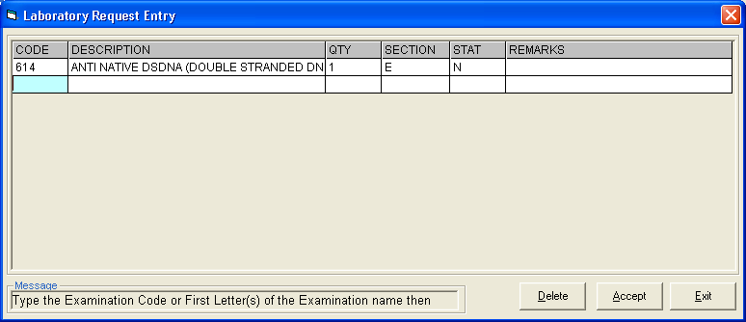
Figure 15: Laboratory Request Entry Window

CODE - Type the examination code or first letter(s) of the examination name then press <Enter>. Or you can press <Enter> key if CODE is still blank to display the list of examination codes. If <enter> key was pressed, a window will be displayed showing the list of examination codes.
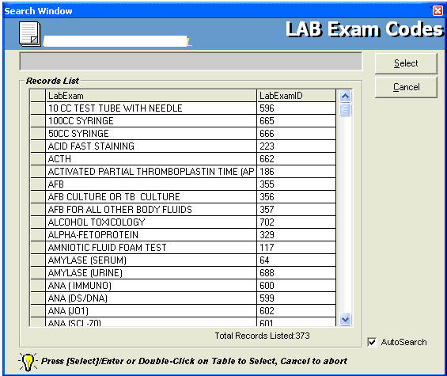
Figure 16: Laboratory Exam Codes Window
To select from the list, click on the desired exam and click on Select button or simply double-click on the desired exam. The Remarks Entry Window will be displayed afterwards. Enter the following data.

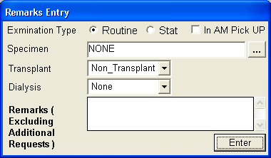
Figure 17: Remarks Entry Window
Specimen - e.g. blood, urine...
Examination Type - Choose one from the list <Routine, Stat, or In Am Pick-up>
Transplant - Choose one from the drop-down list either Transplant or Non-transplant
Dialysis - Choose one from the drop-down list either None, Pre-Dialysis or Post- Dialysis.
Remarks - Type additional remarks.

When done, click on Enter button. Follow the same procedure when you want to add an examination.

DESCRIPTION - This will be automatically displayed in reference with the selected exam.
QTY - This will be automatically displayed in reference with the selected exam.
SECTION - This will be automatically displayed in reference with the selected exam.
STAT - The data that were entered in the examination type under the Remarks Entry window will be displayed here. To change it, type Y if the exam is STAT or N if it is Routine.
REMARKS - The data that were entered in the remarks data entry under the Remarks Entry window will be displayed here.
3 Under the Laboratory Request Entry Window, you can do the following options.

To include the requested laboratory exam in the Order’s list, click on Accept button.

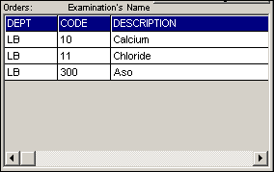
Figure 18: Orders List

To remove requested laboratory exams in the list, click on the desired exam and then click on Delete button.
To close the Laboratory Request Entry window, click on Exit button.

4 After clicking the Accept button, you can do the following options.

You can view all the requested exams in the Order’s list.
To send the requests, click on Save button. A pop-window will appear asking you to type the requesting doctor. See figure below. Click OK button to proceed. (Same procedure is applied to requesting of other exams)
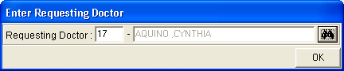
To remove requested exam from the list, double-click on the desired exam or click on the desired exam then click on Delete button.

How to Request X-ray Exam?
This option lets you request X-ray examinations in the Radiology department.

Under X-ray column, click the small box beside the exam. The same steps with requesting laboratory exam are followed. Please refer to How to Request Laboratory Exam for guidelines.

How to Request Ultrasound Exam?
This option lets you request Ultrasound examination in the Radiology department.

Under Ultrasound column, click the small box beside the exam. The same steps with requesting laboratory exam are followed. Please refer to How to Request Laboratory Exam for guidelines.

How to Request C.T. Scan Exam ?
This option lets you request C.T. Scan examination in the Radiology department.

1 Click on Send Requests tab option.

2 Under Other Departments, click on the small box beside C.T. SCAN. The list of examinations will be displayed.
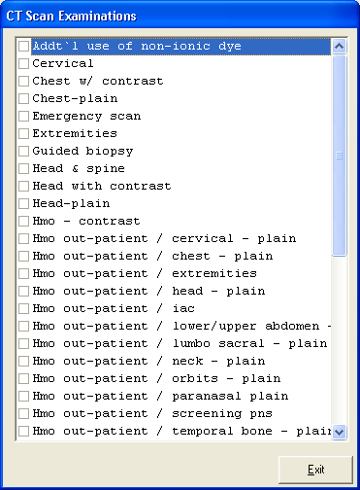
Figure 19: List of C.T. Scan Exams
To select from the list, click on the small box beside the desired exam. Upon clicking, the Remarks Entry Window will be displayed. Enter the following data.

Examination Type - Choose one from the list <Routine, Stat, or In Am Pick-up>
Specimen - example blood, urine...
Transplant - Choose one from the drop-down list either Transplant or Non-transplant
Dialysis - Choose one from the drop-down list either None, Pre-Dialysis or Post-Dialysis.
Remarks - Type additional remarks.
When done, click on Enter button. Follow the same procedure when you want to add an examination.

3 After selecting all the examinations for the patient, click on Exit button.

4 After clicking the Exit button, you can do the following options.
You can view all the requested exams in the Order’s list.
To send the request, click on Save button.
To remove requested exams in the list, double-click on the desired exam or click on the desired exam then click on Delete button.

How to Request Heart Station (Cardio) Exam?

This option lets you request Heart Station examination in the Cardio department.

Under Other Departments, click on the small box beside HEART STATION. The list of examinations will be displayed. The same steps with requesting C.T. Scan exam are followed. Please refer to How to Request C. T. Scan Exam for the guidelines.

How to Request Nuclear Exam ?

This option lets you request Nuclear Laboratory examination for the patient in the Nuclear Med department.

Under Other Departments, click on the small box beside NUCLEAR . The list of examinations will be displayed. The same steps with requesting C.T. Scan exam are followed. Please refer to How to Request C. T. Scan Exam for the guideline.

How to Request P.T. Exam ?

This option lets you request P.T. exam/procedure in the Physical department.

Under Other Departments, click on the small box beside Physical Therapy.. The list of examinations will be displayed. The same steps with requesting C.T. scan exam are followed. Please refer to How to Request C. T. Scan Exam for the guidelines.

How to Request Pulmonary (RTS) Exam ?

This option lets you request pulmonary examination in the Pulmonary department.

Under Other Departments, click on the small box beside PULMONARY SECTION. The list of examinations will be displayed. The same steps with requesting C.T. scan exam are followed. Please refer to How to Request C. T. Scan Exam for the guidelines.

How to Request Laser Exam?
This option allows you to request Oncology examination for the patient in the Oncology Department.

- Under Other Departments, click on the small box beside Center for Sight II. The list of examinations will be displayed. The same steps with requesting C.T. Scan exam are followed. Please refer to How to Request C.T. Scan Exam for the guidelines.

How to Request MRI Exam?
This option allows you to request MRI examination for the patient in the MRI Department.

- Under Other Departments, click on the small box beside Magnetic Resonance Imaging. The list of examinations will be displayed. The same steps with requesting C.T. Scan exam are followed. Please refer to How to Request C.T. Scan Exam for the guidelines.

How to Request Medicine ?
Request on medicine to patient could not be posted in the computer if:
    - Billing staff has closed patient's account. The message that will appear on the screen, "The patient's account has already been closed by _____ (Department). If you have charges to make, contact the Billing staff immediately for further instructions..."
    - Billing staff has placed the patient's account on cash basis. The message that will flash on the screen, "The patient's account has been placed under cash basis by the Billing Officer. Please advice the patient / watcher to see the billing staff immediately for further instructions."
    - May Go Home (MGH) notice was already sent to the different departments.

1 Click on Send Requests tab option.

2 Press F6 key or click on Pharmacy button at the right side of the window. The items to be entered here will be charged into the patient’s bill. Enter the following data.

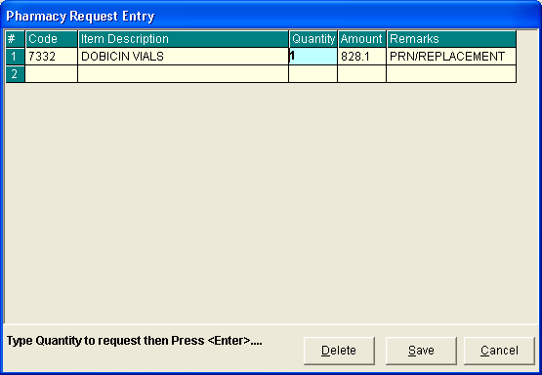
Figure 20: Charge Request Entry Window
Code - Type item code or first letter(s) of item name then press <Enter>. Or you can press <Enter> key if code is still blank to display the list of supplies. If <enter> key was pressed, the list of supplies window will be displayed. To select from the list, click “All Items” to display all supplies or you can categorize by clicking “Suppliers” or “Classification” then double-click on the desired item.
Item Description - This will be automatically displayed in reference with the selected item.
Dosage - Press <Enter> key if dosage is still blank to display the list of dosage codes. If <enter> key was pressed, a window will be displayed showing the list of dosage codes. To select from the list, double-click on the desired code or click on the desired code and click on Select button. To abort the selection, click on Cancel button.
Quantity - This will be automatically displayed in reference with the selected dosage. Note that quantity should be greater than zero.
Remarks - An optional entry.
Just follow the same procedure when adding transcription requests.

3 After completing the desired items to request, you can do the following options.

Click on Save button to send the request into the Pharmacy department.
To remove requested items in the list, click on the desired item then click on Delete button.
Click on Cancel button to close the Charge Request Entry Window..

How to Request Supplies ?

This allows you to request supplies in the Central Supply Department. Charging will be done by the CSR department after processing the request.

Request on supply to patient could not be posted in the computer if:
    - Billing staff has closed patient's account. The message that will appear on the screen, "The patient's account has already been closed by _____ (Department). If you have charges to make, contact the Billing staff immediately for further instructions..."
    - Billing staff has placed the patient's account on cash basis. The message that will flash on the screen, "The patient's account has been placed under cash basis by the Billing Officer. Please advice the patient / watcher to see the billing staff immediately for further instructions."
    - May Go Home (MGH) notice was already sent to the different departments.

1 Click on Send Requests tab option.

2 Press F7 key or click on Central Supply button at the right side of the window. When clicked, the Central Supply Request Entry Window will be displayed and the following data are needed to enter.

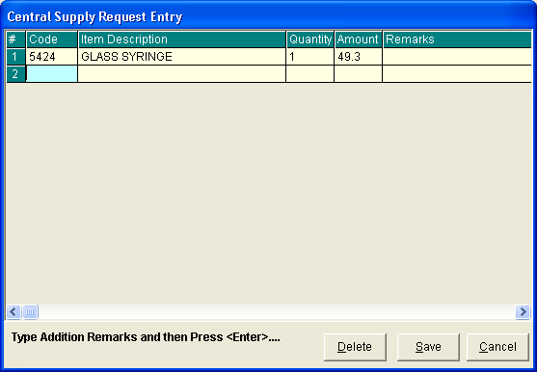
Figure 21: Central Supply Request Entry Window
Code - Type item code or first letter(s) of item name then press <Enter>. Or you can press <Enter> key if code is still blank to display the list of supplies. If <Enter> key is pressed, a window will be displayed showing list of supplies.

To select from the list, click “All Items” to display all supplies or you can categorize by clicking “Suppliers” or “Classification” then double-click on the desired item.

Item Description - This will be automatically displayed in reference with the selected item.
Quantity - Type the number of the item to request. Note that quantity should be greater than zero.
Remarks - An optional entry.

Follow the same procedure when adding items to request.

3 After completing the items to request, you can do the following options.

To send the request in the Central Supply department, click on Save button.
To remove an item in the list, click the row of the desired item then click on Delete button.
Click on Cancel button to abort the entered items.

How to Send May Go Home (MGH) / Discharge Notice?
Nurse will send discharge notice to cost centers after receiving discharge order from patient's doctor. Visual OR program will not allow the user to send discharge notice if there are still pending requests from different cost-centers.
1 Click on Send Requests tab option.

2 Click on Discharge Notice at the right side of the window. When clicked, the Discharge Notice Window will be displayed. Complete the following information.

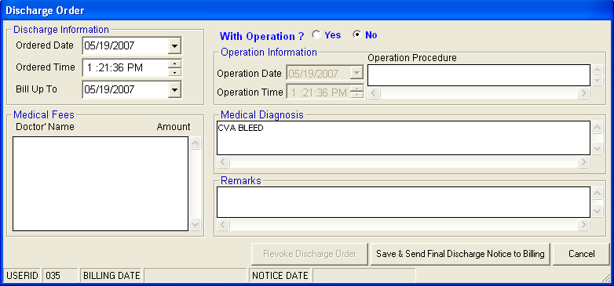
Figure 22: Discharge Notice Window
Discharge Information
Ordered Date - Use the drop-down combo box to select the ordered date
Ordered Time-Use the up and down arrows to select the ordered time
Bill up to - Sets the deadline for the payment of the patient’s bill. To do it, use the drop-down combo box to select a date.
Operation Information - This will enable if the patient has undertaken an operation.

Operation Date - use the drop-down combo box to select an operation date.
Operation Time - use the up and down arrows to select an operation time.
Operation Procedure - type the operation procedure for the patient.

Medical Fees

Doctor’s Name - the name of the doctor
Amount - the medical fee of the doctor
Medical Diagnosis - Type medical diagnosis of the patient

Remarks - An optional entry
3 After completing the data, you can do the following options.

Click on Save button to send the Discharge Notice.
Click on Final Printing button to print. This should be clicked by the user to signal the Billing department that the patient has been cleared in their station.
Click on Cancel button to abort Discharge Notice.

How to Post Charges?
In this option is where you can enter charges of Operating Room services and supplies.

1 Click on Send Requests tab option.

2 Click on Post Charges button at the right side of the window. When clicked, the Post Charges Window will be displayed. Complete the following data.

Department Code - Refer to the list of department codes written at the bottom of the window.
Item Code - Type the service code or first letters of the service name then press <Enter> key. Or you can press <Enter> key if item code is still blank. When pressed, the Revenue Code window will be displayed showing all revenue codes.
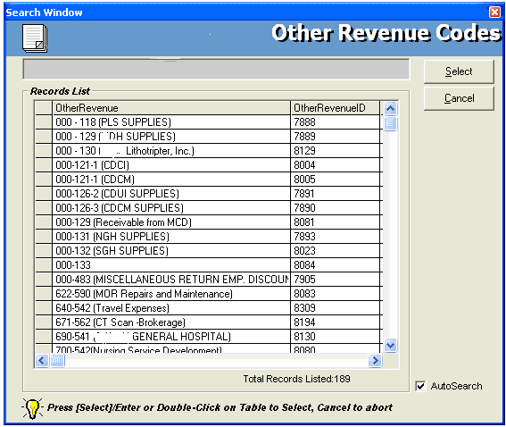
Figure 23: Revenue Codes Window

To select from the list, double-click on the desired item or click on the desired item then click on Select button. Clicking on Cancel button will abort the selection.

Item Description - Automatically filled-up by the program in reference with the selected item.
Quantity - Automatically filled up by the program in reference with the selected item but this can still be edited.
Unit Price - Automatically filled up by the program in reference with the selected item.
Amount - Automatically filled up by the program in reference with the selected item and its quantity.
3 After entering the items to be charged, you can do the following options.
Click on Save button to save entered items. When clicked, a printable form will be displayed. Click on to print. Entered items will be automatically charged to the patient’s bill.
To remove the selected item, click on the desired item then click on Delete button.
Clicking on Exit button will close the Post Charge window.
4 At the bottom of the window, you can also do the following options.

To view list of charges entered, click on List of Charges Entered button.
To cancel requested charges, double-click on the requested item or click on the desired item then click on Cancel Charges button.
To have a copy of charge slip of the requested item, click on Re-print Charge Slip button.

How to Charge OR Package?
Click on Send Request Tab then go to Post Charges button. To charge an OR Package, click on View OR Package button then Choose the specific package to display list(s) of items included in the package, a sample window is loaded below.
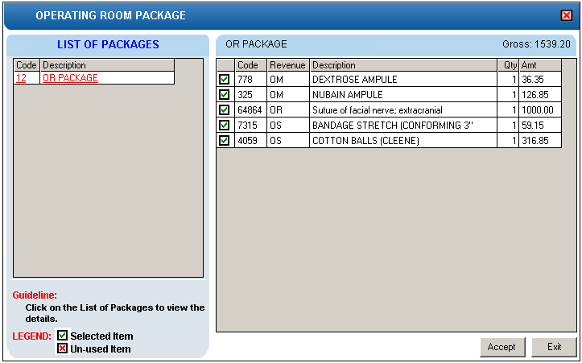

To charge all the items, click on the Accept button. If an item is unused, double click on the check box beside the item to mark it Un-Used.

How to Enter Charges for a Cash-basis Account?
This option lets you to enter charges of Operating Room services and supplies to a selected cash-basis patient.

1 Click on Send Requests tab option.

2 Click on Cash Assessment Entry button at the right side of the window. When clicked, the Cash Assessment Entry Window will be displayed. Complete the following data.

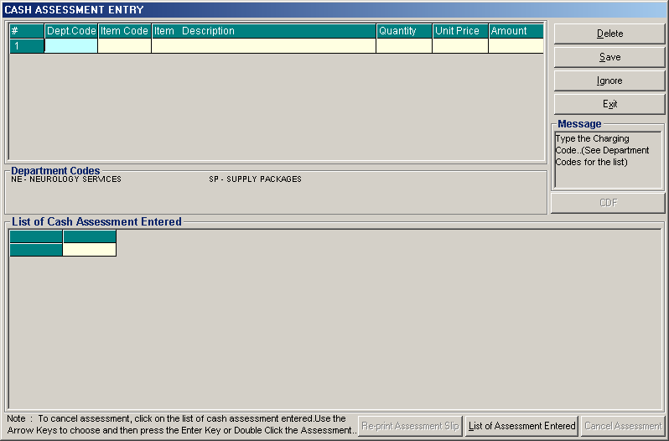
Figure 24: Cash Assessment Window

Department Code - Refer to the list of department codes written at the bottom of the window.
Item Code - Type the service code or first letters of the service name and then press <Enter> key. Or you can press <Enter> key if item code is still blank. When pressed, the Revenue Code window will be displayed showing all revenue codes.

To select from the list, double-click on the desired item or click on the desired item then click on Select button. Clicking on Cancel button will abort the selection.

Item Description - Automatically filled-up by the program in reference with the selected item.
Quantity - Automatically filled up by the program in reference with the selected item but this can still be edited.
Unit Price - Automatically filled up by the program in reference with the selected item.
Amount - Automatically filled up by the program in reference with the selected item and its quantity.

3 After entering the items to be charged, you can do the following options.
Click on Save button to save entered items. When clicked, a printable form will be displayed. Click on to print.
To remove the selected item, click on the desired item then click on Delete button.
Clicking on Exit button will close the Post Charge window.

4 At the bottom of the window, you can also do the following options.

To view list of charges entered, click on List of Charges Entered button.
To cancel requested charges, double-click on the requested item or click on the desired item then click on Cancel Charges button.
To have a copy of charge slip of the requested item, click on Re-print Charge Slip button.

How to Process Credit Memo Advice?
This is used to cancel assessed / paid items in the department. To do this, click on the List of Assessment Entered button then highlight the specific item to be processed. Click on Cash Credit Memo button to load the sample window below.
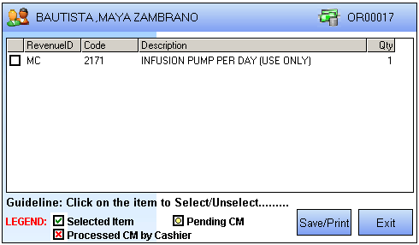
Select the item to be processed by clicking on the box beside the item then click on Save/Print for the cashier to be process the credit memo advice. Once credit memo advice is processed in the cashier, the checked box beside the item will be marked with X, a sample window is displayed below.

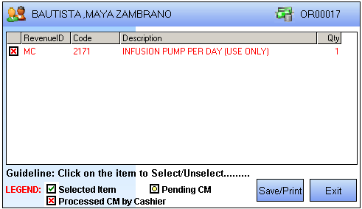

Nurses Activity Request
From the requests posted in the Send Requests tab option, you can view here the status of each request.

Nurses Activity Request is where you can view list of processed requests, list of pending requests, list of exam with results, and reports such as diet list, census report by station, discharges for the day, list of requests/orders, list of medicine posted and list of supplies posted.

1 Click on Nurses Activity Request tab option.

2 Its window will be displayed showing the following data.

List of Processed Requests - These are the lists of requests that were already processed by the department in response to the requests done in the Send Requests tab option.

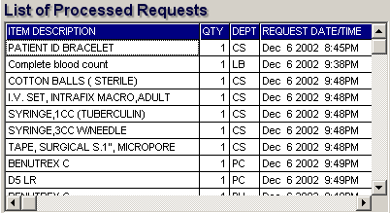
Figure 25: List of Processed Requests

List of Pending Requests - These are the lists of requests posted in the Send Requests tab option which are not yet acknowledged by the receiving department.

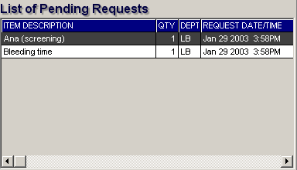
Figure 26: List of Pending Requests

To cancel a request, double-click on the desired item.

List of Exams with Result - These are the list of exams posted in the Send Request tab option that already have result and its details can be viewed in the View Results tab option.

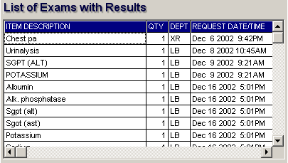
Figure 27: List of Exams with Result

3 The following button options can be clicked from.

Click on Refresh button to view the latest update from the database.
Click on Exit button to close the program.

Viewing of Laboratory Exam Result
This option allows you to view result of laboratory tests and exams.

1 Click on View Result tab option.
2 Its window will be displayed.
3 Click the Laboratory tab to view laboratory exams with result.

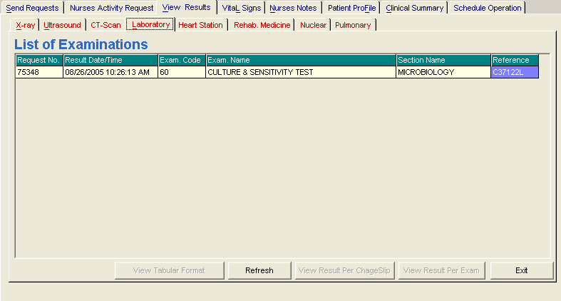
Figure 28: View Laboratory Exam Result Window
To view, click the exam and then click on View button. The Refresh button is used to view the latest updates of laboratory exams with results from the database. While the Exit button is used to close the program.

Viewing of X- ray Exam Result
This option allows you to view result of x-ray exams.

1 Click on View Results tab option.
2 Its window will be displayed.
3 Click X-ray tab to view x-ray exam result. (X-ray window is the default window).

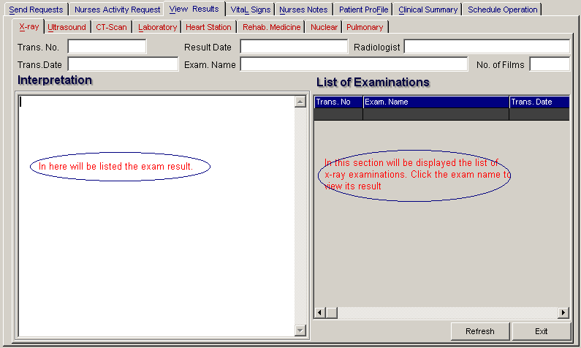
Figure 29: View X-ray Exam Result Window

The list of examinations is displayed at the right side of the window. Just click the desired exam to view its result. The exam result can be viewed at the left side of the window.

4 The following buttons can be clicked from.
Refresh - This will view latest updates of exams with result from the database.
Exit - This will close the program.

Viewing of Ultrasound Exam Result
This option allows you to view result of Ultrasound exams.

Click Ultrasound tab to view exams with result. The same steps with viewing of x-ray exam are followed. Please refer to Viewing of X-ray Exam Result) for the guidelines.

Viewing of Heart Station Exam Result?
This option allows you to view result of Heart Station exams.

1 Click on View Result tab option.
2 Its window will be displayed.
3 Click Heart Station tab to view exams with result.

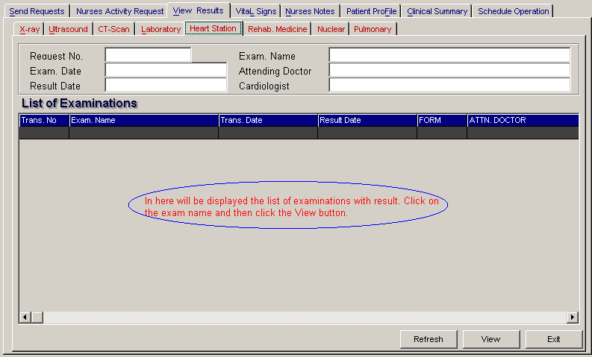
Figure 30: Heart Station View Exam Result Window

To view, click the exam and then click on View button. The Refresh button is used to view the latest updates of laboratory exams with results from the database. While the Exit button is used to close the program.

Viewing of C.T. Scan Exam Result?
This option allows you to view result of C. T. Scan exams.

Click C.T.-Scan tab to view exams with result. The same steps with viewing of x-ray exam are followed. Please refer to Viewing of X-ray Exam Result for the guidelines.

Viewing of Nuclear Medicine Exam Result
This option allows you to view result of Nuclear Laboratory exams.

Click Nuclear tab to view exams with result. The same steps with viewing of x-ray exam are followed. Please refer to Viewing of X-ray Exam Result for the guidelines.

Viewing of Pulmonary Exam Result
This option allows you to view result of Pulmonary Laboratory exams.

Click Pulmonary tab to view exams with result. The same steps with viewing of x-ray exam are followed. Please refer to Viewing of X-ray Exam Result for the guidelines.

Vital Signs Data Entry
In here, it is where you can enter the vital signs of the patient. Vital signs data entry includes blood pressure, body temperature, respiratory rate, and pulse rate.

1 Click on Vital Signs tab option.

2 On the left side, you can see the previous vital signs of the patient. The following data can be viewed.

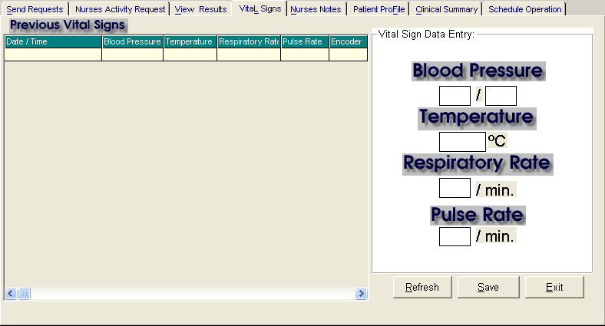
Figure 31: Vital Sign Data Entry Window
Date/Time - the date and time when vital sign was entered.
Blood pressure
Respiratory rate
Pulse rate
And on the other side is the vital sign data entry. The following data needed to enter.

Blood pressure
Body temperature
Respiratory rate
Pulse rate
3 The following button options can be clicked from.

Click on Save button to save entry.
Click on Refresh button to view the latest update from the database.
Click on Exit button to close the program.

Nurses Notes Data Entry
Nurses Notes window is where you can type down notes or remarks about the condition of the patient. It works like an electronic notebook because you can retrieve the saved data of a particular date and shift of the day.

1 Click on Nurses Notes tab option.

2 To view past patient’s chart, click on Past Notes written vertically. The following data can be viewed.

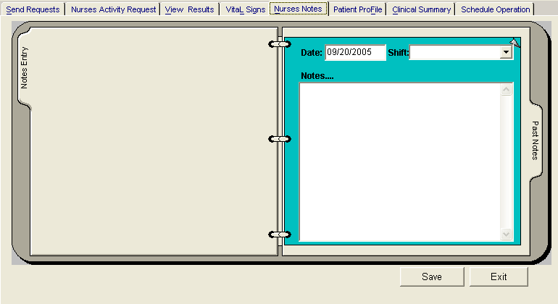
Figure 32: Nurses Notes Window
Date/Time - the date and time when the remarks were entered
Day shift - the shift of the day
Entered by - the program user who entered the remarks
Notes - the content of the remarks

To enter patient’s chart, click on Notes entry written vertically. Enter the following data.

Date/Time - current date and time is used
Notes - Type remarks on the multi-line textbox.

3 The following button options can be clicked from.

Click on Save button to save the notes entered.
Click on Exit button to close the program.

Viewing of Patient’s Profile ?
Patient Profile is where you can view the latest patient’s information throughout his current confinement. It includes admitting diagnosis, chief complaints, manner of admission, past medical history, allergies, personal and social history and family history.

1 Click on Patient Profile tab option.

2 The Patient Profile Window will be displayed.

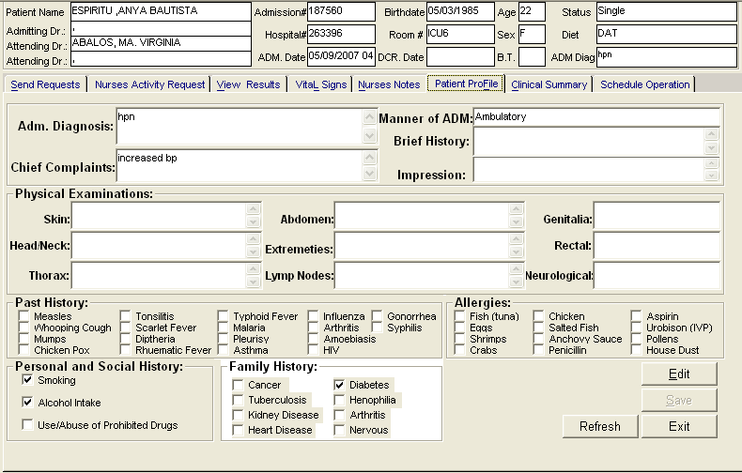
Figure 33: Patient Profile Window
3 The following button options can be clicked from.

To edit the patient’s profile, click on Edit button. You can now make necessary modifications on the patient’s profile.
When completed, click on Save button to save the changes.
Click on Refresh button to undo the changes done.
Click on Exit button to close the program.

Viewing of Clinical Summary

Clinical summary is where you can view for a particular clinical summary of a patient’s confinement.

1 Click on Clinical Summary tab option.

2 The Clinical Summary Window will be displayed. The following data can be viewed.

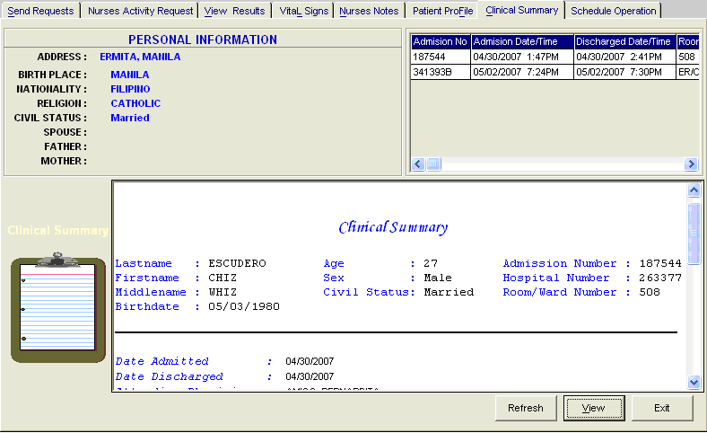
Figure 34: Clinical Summary Window

Admission number - a program-generated number during patient’s admission
Admission date/time - the date and time when the patient was admitted
Discharge date/time - the date and time when the patient was discharged
Room number - the room number of the patient during his confinement

3 To view for a particular clinical summary of patient, click on the desired exam then click on View button. The following data can be viewed.

Date admitted - the date when the patient was admitted
Date discharged - the date when the patient was discharged
Attending physician - the name of the attending physician
Admitting doctor - the name of the admitting doctor
Admitting diagnosis - the admitting diagnosis of the patient
Chief complaints - the complaint of the patient
Final Diagnosis - the final diagnosis of the patient
4 Click on Exit button to close the program.

Scheduling of Operation
This option lets you schedule an operation for the patient through sending a request into the Operating Room department.

1 Click on Schedule Operation tab option.

2 The Schedule Operation Window will be displayed. Enter the following data.

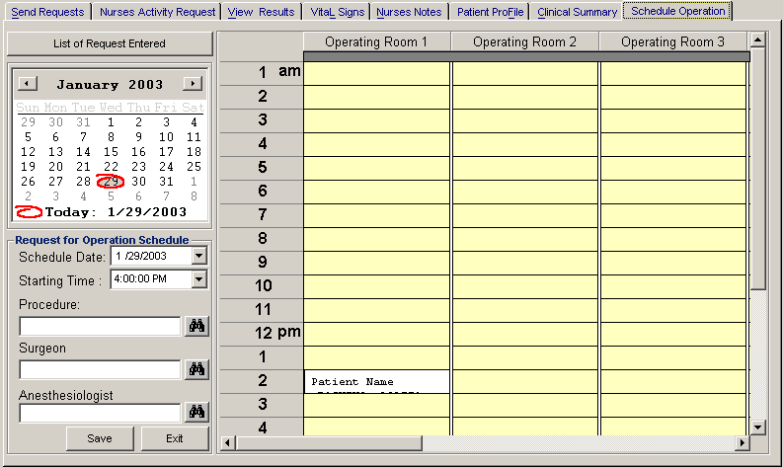
Figure 35: Schedule Operation Window

Schedule Date - Click on the drop-down combo box to select a date for the patient’s operation. Note that date to be scheduled should be later than the current date and time.
Starting Time - Click on the drop-down combo box to select a starting time for the patient’s operation in reference with the selected date.
Procedure - Press <Enter> key to display the list of procedures or click on button. A window will be displayed afterwards. Just double-click on the desired procedure to select.
Surgeon - Click on button to display the list of doctors. A window will be displayed afterwards. Just double-click on the desired surgeon to select.
Anesthesiologist - Press <Enter> key to display the list of doctors or click on button. A window will be displayed afterwards. Just double-click on the desired doctor to select.

3 The grid at the right side of the window is used to view the scheduled operation of the patient when the Operating Room department has already acknowledged the request. Just click the day of the scheduled operation then scroll the vertical or horizontal bar of the grid to view the scheduled operation.

Reports
Click the option you want (listed below) from the Reports pull-down menu. A window for date entry will be displayed. Select From and To dates by clicking the drop-down arrow and then click on OK button.

Audit Report
This displays a report of all items requested, how many quantities are used in a particular item requested and its corresponding amount totaling the accumulated amount of all items. This is arranged alphabetically by the reference number of each item.

The following data are displayed in the report.
Reference No. - program - generated number (charge-slip number)
Amount - the amount of item requested
Department - the department code
Quantity - the number of item requested
Code - the code of the item requested
Description - the name of the item requested
By - the program user who requested the item
Date - the date when the item was requested
Name of Patient - the name of the patient who requested the item
To print, click .

Monthly Report
This displays a report of all items requested, the quantity and amount accumulated each and both in inpatient and outpatients for a particular item then totaling the quantity and amount accumulated each and both in inpatient and outpatients for all the items requested. This is arranged alphabetically by the name of the item requested.

The following data are displayed in the report.
Description - the name of the item requested
Number (Inpatient) - the total number of the particular item requested in inpatient
Amount (Inpatient) - the total amount accumulated for the particular item in inpatient
Number (Outpatients) - the total number of the particular item requested in outpatients
Amount (Outpatients) - the total amount accumulated for the particular item in outpatients
Number (Total) - the total number of the particular item requested in inpatient and outpatients.
Amount (Total) - the total amount accumulated for the particular item in inpatient and outpatients.
To print, click .

Statistical Report
This generates a report of category of operation (major, minor, medium) statistics since the entered beginning to ending dates grouped into “Above 15 years old (male, female)” and “Below 15 years old (male, female)”.
To print, click .

Schedule of Operation
This generates a report of scheduled operations since the entered beginning to ending dates.
To print, click .

Index

—A—
activity request, 28, 29
add room, 26
admission history, 28, 29
—C—
cardiovascular exam result (heart station exam result), 57
changing of password, 9
charging of o.r. services & supplies to cash-patients, 28
charging of o.r. services & supplies to charge patients, 28
clinical operation, 18
clinical procedures, 28, 29
clinical summary, 28, 29
close the program, 10
—D—
diet request, 29
discharge notice/order, 29
discharge order, 28
discharge patient, 29
drug request, 28, 29
—E—
end the program, 10
exam request, 28, 29
exam result, 28, 29
—F—
features, 7
findings, 18
—H—
history, 29
—I—
inquiry (personal information, request status, patient's ledger), 13
—M—
medicine request, 28, 29
—N—
notes, 29
nurses activity request, 28, 29
nurses notes, 28, 29
—O—
objectives, 6
operation information, 18
operation schedules (confirmed), 22
operation scheduling, 28
overview, 5
—P—
parameters, 27
password (changing of), 9
patient profile, 28
patient profile (viewing), 29
patient searching, 11
patient's ledger, 13
pending request (processing), 24
personal information, 13
post charges (for cash patient), 29
post charges (for charge patient), 29
print request form of lab. exam, 28
print scheduled operations, 25
procedures, 29
profile (viewing), 29
—R—
receivable updates, 16
remove room, 26
rename room, 26
re-print request form, 29
reprint request form of lab. exam, 28
request exam, 29
request form reprinting, 29
request status, 13
result viewing, 28, 29
result-entry, 18
revoke confirmed operation schedules, 22
room maintenance, 26
—S—
schedule operation, 28
schedule parameters, 27
scheduled operations (printing), 25
search a patient (inpatient, outpatient), 11
send request, 29
set schedule parameters, 27
start the program, 8
supply request, 28, 29
—V—
view cardiovascular exam result (heart station exam result), 57
view exam result, 28
view list of confirmed operation schedules, 22
view patient profile, 29
view pending request, 24
view result, 29
vital sign, 28

