MEDSYS
Information System

OPD Registration Program
User's Manual



Visual Medsys
Kaiser dela Cruz Consulting Incorporated
July 28, 2026

Copyright© 2009
ALL RIGHTS RESERVED

No part of this document may be reproduced through photocopying or in any means, stored into a retrieval system, and transmitted in any form without the express written permission of Kaiser - dela Cruz Consulting, Incorporated.
Permission is hereby granted to Medsys Information System to copy and distribute this document in any of the above means provided this is for its exclusive on site use.
Although every precaution has been taken in the preparation of this manual, the company assumes no responsibility for errors or omissions. Neither is any liability assumed for any damages resulting from the use of the information contained here.
Table of Contents
Introduction 4
Overview 4
Objectives 5
Features 5
Getting Started 6
How to Start the Program ? 6
How to Change Password ? 7
How to End the Program ? 8
Program Operation 9
Important Icons and Button 9
New Registration 10
Patient Searching 14
Edit/Revoke/Unrevoke Patient Registration 15
Result Entry 16
Result Viewing 17
How to Post Charges ? 18
Cash Assessment Entry 20
Reports 23
Assessment Status 24
Index 25

Overview
The OPD Registration Program is the program used to record patient who is not hospitalized overnight but who visits the hospital or associated facility for diagnosis or treatment. Treatment provided in this fashion is called ambulatory care, outpatient surgery eliminates inpatient hospital admission, reduces the amount of medication prescribed, and uses a doctor’s time more efficiently.
The patient's data such as relevant personal information, hospitalization plan and consultation information are entered thru the computer. These data will be used by cost-centers when patient is to be charged of medicines, supplies, procedures and others. It serves as the entry-point of patient’s information to be linked to other departments.

Objective:

- To use the interconnecting feature to other departments such as Laboratory, X-Ray, Ultrasound, CT-Scan, Heart Station, Hemodialysis, Pulmonary, Pharmacy, Central Supply, Operating Room, and Billing and other hospital departments to provide a higher level of care and service.
- To become a seamless part of the hospital’s operations whereby staff will have immediate access to patient information whenever and wherever required
- To reduce clerical workload
- To improve service and management will have a powerful new information tool for decision making purposes
- To maintain accurate and centralize update of patient’s information

Features:
- Data-entry restriction - Warning messages are flashed for possible invalid entries. This ensures all data inputted would be made useful for any transaction that may occur. Users can post/review charges, adjustments, print reports according to the access rights given to them.
- Password-protected - The use of password is necessary to restrict unauthorized access. Thus the program only accepts passwords which are registered into it. This feature ensures the confidentiality and integrity of data entered in the program.
- Auto-report generation - The program is capable of generating reports and can be readily printed
- User-friendly - The program user is guided by instructions in doing the next step providing an easy-use to process transactions. Tool-tips are also incorporated to give users an idea of what a particular button does.
- Real-Time System – Tall entries reflected immediately
- Advance Feature – System is ready for Smart Card / Patient’s ID integration, capability to bar code patient’s Registration sheet.

.

Getting Started

Starting the Program
1 Click on  OPD Registration program executable file icon located in your computer desktop.
2 The Login window will display asking you to type your employee number and password for security purposes.

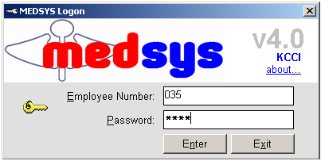

3 If the program has validated your employee number and password, you may now start a transaction. Otherwise, a message will display prompting “Unauthorized User”.

How to Change Password

1 From the Login window, type your employee number and then press <Enter>.

2 Under the Password entry, press <F12>. Pressing this function key will invoke the Change Password window.

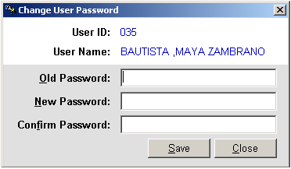
Figure 1: Change Password Window
3 Under the Change Password window, type the following data.
Old Password - Type your existing password.
New Password - Type your new password not exceeding to 15 characters.
Confirm Password - Retype your new password to confirm and then press <Enter> or you can click the Save button.

Closing the Program
It is recommended to close your program when you are done to end-up your session. Other users might use the open program using the same password.

There are three ways to close the program.
1 Click on button located at the right corner of the main window (possible only if no other window is open) or
2 Click Exit from the File pull-down menu or
3 Press <Ctrl + X>

Program Operations

Important Icons and Buttons
- New Registration
 - Edit/Revoke/Unrevoke
 - Result Entry
 - View Result
- Reports
- Outpatient and Emergency Room Record
 - Medical Certificate
- Search Button
- A special button used to display list of doctors, services, rooms and others.

New Registration
This option allows you to register a new patient. Whenever a patient is registered, his hospital number will be retained and a new admission number will be assigned to him. This program-generated admission number will hold all the patient’s records (clinical and financial) throughout his consultation period.
1 Click ‘ New Registration’ toolbar button.
2. The 'Master Patient Search' window appears. In here, the program has searched existing record of the patient. In the figure below, a record is found. Double-click the patient’s name to select. The saved information of the patient will be then retrieved. If record is not found (means new admission), click 'Close' button to continue entering patient’s data.
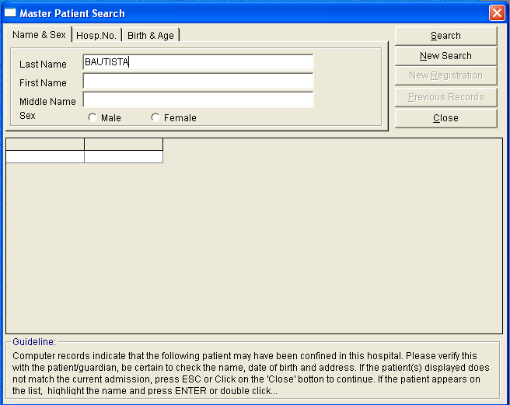
3 Click ‘‘Personal Information’ tab to display the window below
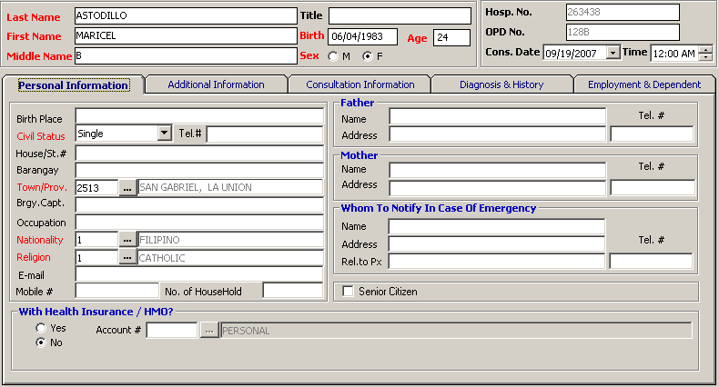
* Red labeled information such as the last name, first name, middle name, birthday, age is computed based on the birthday entered, sex, civil status, town/province, nationality and religion should be filled up.

4. Click on ' Additional Information ‘tab to display the window below
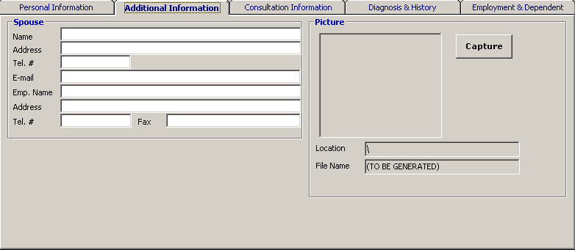
The following data should be entered.
- Spouse Name if the patient is married.
- Address
- Email Address.
- Employee Name
- Address
- Telephone number or Fax number
- Click on ' Consultation Information ‘ tab to display the window below
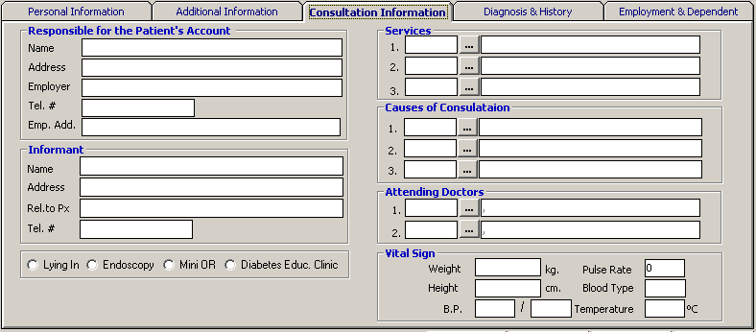
The following data should be entered:
- Responsible for the Patient’s Account
- Informant
- Services – click on button to display lists of services. Double click on the specific item
- Causes of Consultation - click on button to display lists of services. Double click on the specific item
- Attending Doctors – click on button to display lists of doctors. Double click on the specific doctor for the patient.
- Vital Sign ( weight, blood pressure, temperature, pulse rate, blood type )
6. Click on Diagnosis & History tab to display the window below
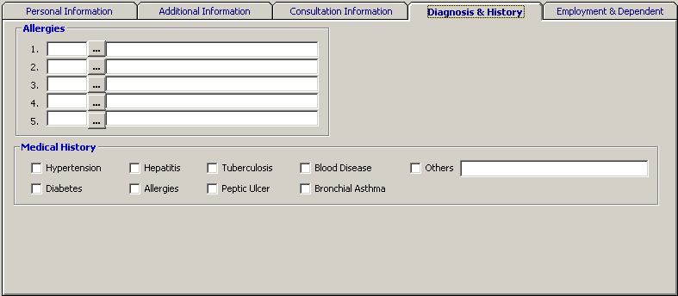
The following data should be entered
- Allergies – click on button to display lists of allergies. Double click on specific item that corresponds to patient’s allergy
- Medical History
7. Click on Employment & Dependent tab to display the window below
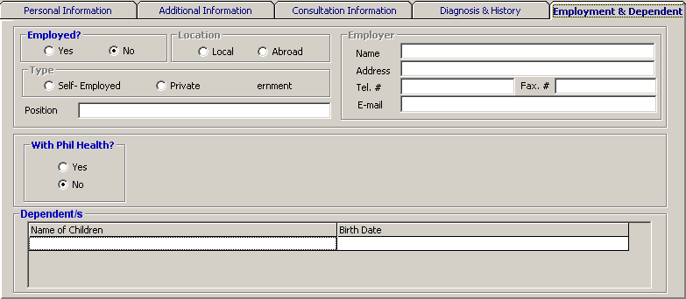
The following data should be entered or tagged.
- Employed? ( Yes / No )
- Location ( Local / Abroad )
- Type of Employment
- Position
- Employer
- With Phil Health? ( Yes / No )
- With Health Insurance / HMO? ( Yes/No )
- Dependent/s ( Name of Children and Birthdate)

Click ’Save & Print' to save and print the data sheet or ’Register’ to register patient or ‘Cancel’ to disregard all the entries entered.

Patient Searching

After entering the user’s employee number and password correctly, list of patients under the user’s station will be displayed. Under the Enter Lastname entry, type the patient’s last name or first few letters of his last name and then press <Enter>. Double-click on the patient’s name to select. All transactions to be done will be accounted to the selected patient.
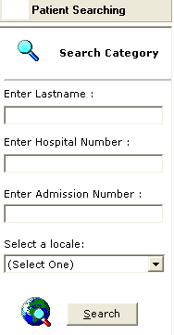
Users can use the Last Name of the Patient, Hospital Number and Admission Number as the Search Category in searching patients lname

Edit / Revoke / Un-revoke Patient Registration
This feature allows you to enter necessary correction on the patient’s consultation record for purposes of medical record.

1 Select the patient from the list.
2 Click 'Edit/Revoke/Un-revoke'  toolbar button or click 'File' > 'Edit Registration'
3 The 'Patient Registration' window appears displaying the patient’s registration record. You can now edit/revoke/ un-revoke patient information under 'Personal Information' and ‘Consultation Information’ tabs.
4 Click ‘Revoke’ ,’Save/Print' ,’Update’ ,’Cancel’ button when done to update changes entered.

Result Entry
This option allows you to enter result for the patient such as Diagnosis Id, Services, Doctor, Diagnosis / Findings, Medication, Remarks.
1 Select the patient from the list.
2 Enter Diagnosis ID. Choose from the International Classification of Diseases. Click on the ‘Tabular List’, ‘Alphabetical Index’ or the ‘Search’ tabs.
3 Enter the Service to be given to the patient. Click the button to show the list of services ( gynecology, medicine, obstetrics, pediatric and surgery )
4. Enter Diagnosis / Findings.
6. Enter medication for the patient.
7. Enter remarks if there are any.
8. Click the ‘Save’ button to save all the data entered or ‘Cancel’ to disregard the data entered.

Result Viewing
This option lets you view the results entered for the patient.
1 Select the patient from the list..
2 Click 'View Result'  toolbar button or click 'File' > 'Result Viewing' .
3 The 'Result Viewing' window appears.
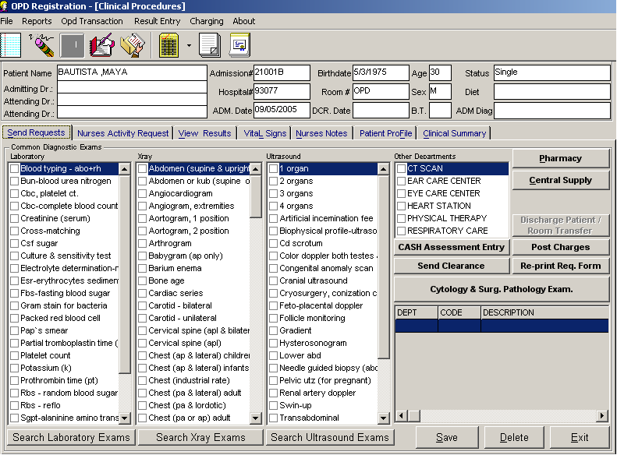

4 Click the ‘Send Requests’ tab to view list of requests entered for the patient; the ‘Nurses Activity Requests’ tab to view list of requests entered for the patient; the ‘View Results’ tab to view the examination results of patients; the ‘ Vital Signs’ tab to view the blood pressure, respiratory rate, pulse rate and temperature of patients; ‘Nurses Notes’ tab to view the remarks entered for the patient; the ‘Patient Profile’ tab to view other information about the patient and the ‘Clinical Summary’ tab to view previous consultation of the patient.
5 Click ‘Exit’ button to exit from the view result window.

How to Post Charges?
This option allows the user to enter charges for patients that is company / hmo charged. To do this, click on Post Charges option in Charging menu or press F12 to display the window below.
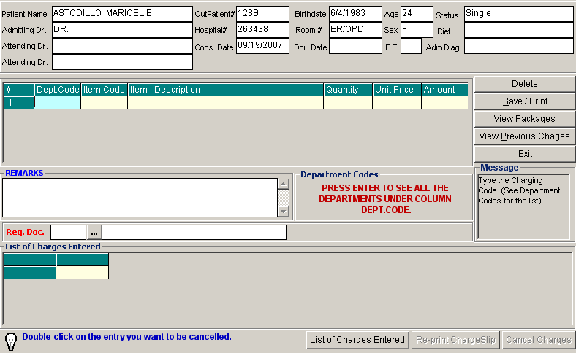
Enter the following data
1 Dept. Code – press Enter key to load all departments that can be charged or list of Charging Codes is displayed on right side. Just enter the two letter code of the department.
2 Item Code – type first few letters of the item you want to charge or press Enter key to display list(s) of charges. Double click on the specific item
3 Quantity – Enter how many times the procedure is done to the patient.
4 Remarks – Additional remarks can be entered
5 Requesting doctor – type first few letters of the doctors last name or press ENTER key to load the complete list(s) of doctors.
To remove an item to be charged to the patient, click on Delete button.
To save list of charges entered, click on Save/Print button
To view list of packages, click on View Packages button to display the window below.
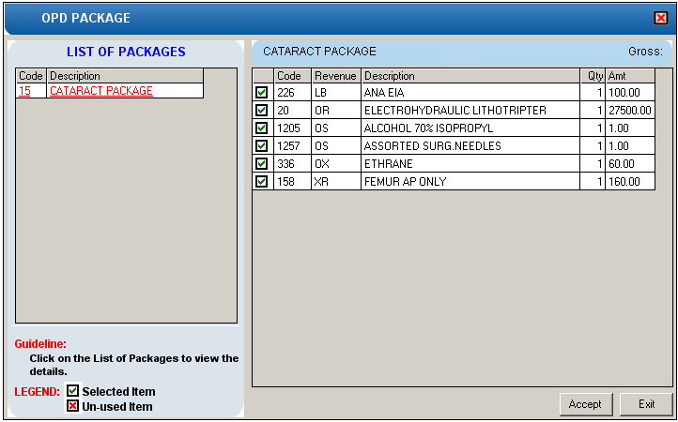

Double click on the item that is unused then click on ACCEPT button to charge the items of the selected package.
To view list of previous charges, click on View Previous Charges button.
To display list(s) of charges entered to specific patient, click on List of Charges Entered button in the List of Charges Entered window. A sample window Is displayed below.

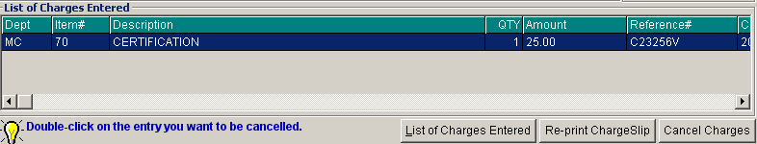

To reprint a specific charges, click on Re-Print ChargeSlip button.
To cancel charges, click on Cancel Charges button.
Cash Assessment Entry
This option allows the user to post charges to outpatients that is under cash basis. To do this, go to CHARGING option then ASSESSMENT ENTRY to load the window below.
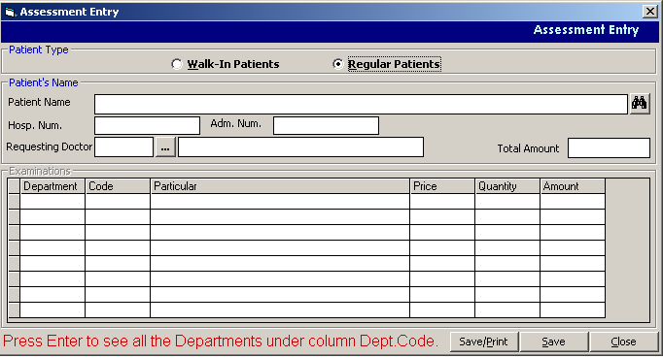
1 Choose patient type : Walk In Patients or Regular Patients
2 In the Patient Name, press Enter to display list(s) of names
3 Department Code – press Enter key to display list(s) of departments
4 Code – type first few letter(s) of the item to be charged or press Enter key to display the complete lists of charges of the department chosen then double click.
5 Quantity – enter how many times the procedure is done or given to the patient.

To save charges and print charge slip, click on Save/Print button
To save charges entered, click on Save button.
To go out from this window, click on Close button.

How to Cancel Charges that is NOT YET PAID?
To do this, click on Charging option in the main menu then choose Assessment Status to load the sample window below.
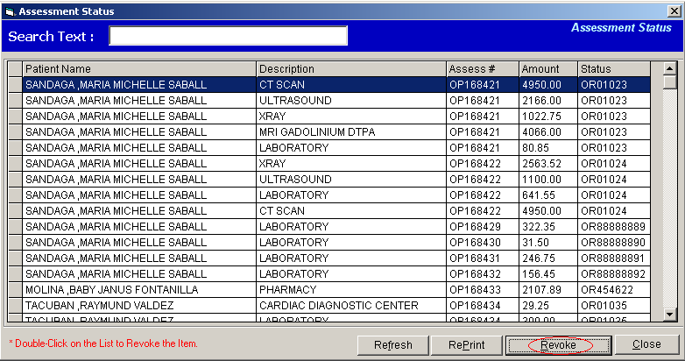
Items can be revoked by highlighting on the specific item to be cancelled then click on Revoke button
How to Cancel Paid Items?
This option allows the user to tag a paid item to be returned or cancelled. To do this, go to CHARGING option in the main menu then choose ASSESSMENT STATUS to display list of patients. Choose the patient you want to cancel charges, highlight the specific patient then click on Cash Credit Memo button.
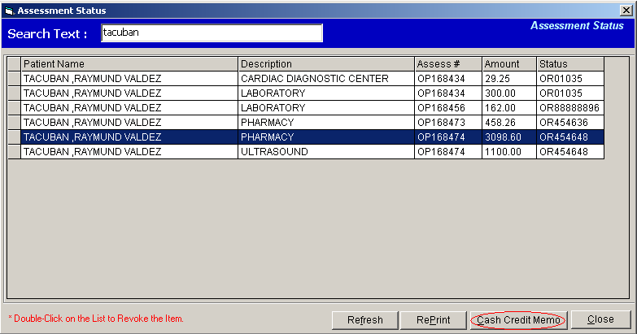
This will load the window below

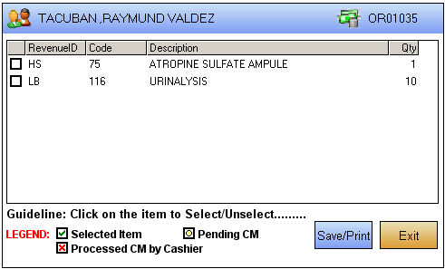
Tag the item that will be returned or to be cancelled by clicking on the check box () beside the item then click on Save/Print button
To go out from this window, click on Exit button.

REPORTS

Indexes
It includes Physician Index, Service Index and Disease Index
1 Physician Index – A report to generate the list of patients for a specific doctor on a selected date.
2 Service Index – A report to generate the list of patients for a specific service on a selected date.
3 Disease Index – A report to generate the list of patients for a specific disease on a selected date.
Daily Census Report
Report of Activities
A report to generate the census of patients based on services and grouped by 14 yrs and below and above 14 yrs of age during the day of the selected date.
Summary of Demography
A report to generate the census of patients based on the address and grouped by 14yrs below and above 14yrs of age during the day of the selected date.
Monthly Physician Index
A report to generate total number of patient of all physician during the selected month of report.
Outpatient Index Card
This allows you to enter the patient name for the verification of the patients OPD number.

Assessment Status
This option allows you to view the status of Walk-in patients: revoked or paid at the cashier.
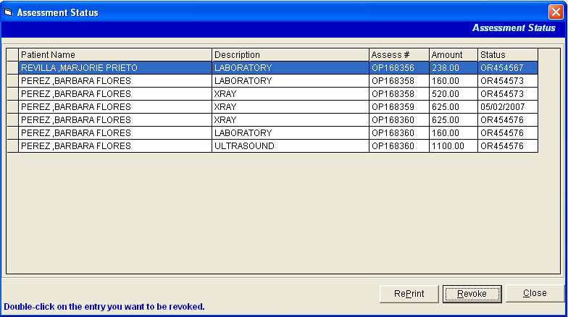

Index

—A—
accounts, 28
admission record, 27
admit new patient, 10
admit watcher, 25
—B—
bill, 16
button, 8
—C—
census reports, 31
closing the program, 7
—D—
daily reports, 30
data sheet, 27
discharge non-patient, 26
discharge patient, 22
discharge watcher, 26
—E—
edit patient admission, 15
—I—
icons, 8
—N—
non-patient admission, 25
—O—
other reports, 33
overview, 4
—P—
patient admission, 10
patient searching, 14
patient's old accounts, 28
—R—
revoke admission, 23
revoke discharge, 24
room transfer, 17
—S—
search a patient, 14
shortcut keys, 9
starting the program, 6
statistical reports, 32
—T—
total bill, 16
transfer patient, 17
transfer summary, 29
—V—
view admission information, 16

