MEDSYS
Information System

Visual Nursery Program
User's Manual



MEDSYS
Kaiser - dela Cruz Consulting, Inc.
July 28, 2026
Copyright© 2009
ALL RIGHTS RESERVED

No part of this document may be reproduced through photocopying or in any means, stored into a retrieval system, and transmitted in any form without the express written permission of Kaiser - dela Cruz Consulting, Incorporated.
Permission is hereby granted to Medsys Information System to copy and distribute this document in any of the above means provided this is for its exclusive on site use.
Although every precaution has been taken in the preparation of this manual, the company assumes no responsibility for errors or omissions. Neither is any liability assumed for any damages resulting from the use of the information contained here.

Table of Contents

Introduction 5
Overview 5
Objectives 6
Features …………...………………………………………………………………………………………7
Getting Started 8
How to Start the Program 8
How to Change Password 9
How to End the Program 9
Program Operation 10
How to Search a Patient (NURSERY Patients, All Patients) 10
Inquiry (Personal Information, Request Status, Patient’s Ledger) ……………………………12
Receivable Update …………………………………………………………………………………….14
How to Request Laboratory Exam?.........................................................................................16
How to Request X-ray Exam? .................................................................................................19
How to Request Ultrasound Exam ?........................................................................................19
How to Request C.T. Scan Procedures ? 20
How to Request Heart Station Procedures ? 22
How to Request Nuclear Procedures ? 22
How to Request Physical Therapy ? 22
How to Request Magnetic Resonance Imaging ? 22
How to Request Pulmonary Medicines / Procedures ? 22
How to Request Medicine? 23
How to Request Supplies?……………………………………………………………………………25
Now to Request Patient’s Diet ?...............................................................................................27
How to Discharge a Patient ? 28
How to Update Patient's Room (Room Transfer) ? 31
How to Send May Go Home (MGH) / Discharge Notice ? 34
How to Post Charges ? 36
How to Enter Charges for a Cash Basis Account ? 38
Nurses Activity Request 40
Viewing of Laboratory Exam Result 42
Viewing of X-ray Exam Result 43
Viewing of Ultrasound Exam Result 44
Viewing of Heart Station Exam Result 44
Viewing of C. T. Scan Exam Result 45
Viewing of Nuclear Exam Result 45
Viewing of Pulmonary Exam Result 45
Viewing of Physical Therapy Notes 46
How to Enter Vital Signs Info ? 47
How to Enter Nurses Notes ? 48
How to View Patient’s Profile ? 49
How to View Clinical Summary ? 50
How to Enter Height and Weight ? 51
How to Enter Administered Medicines ? 52
How to Print Claim Slip ? 54

REPORTS 55
Index 57

Introduction

Overview



The Visual Nursery Program aims to help the nursery staff in carrying out doctors orders in a fastest and accurate way thru its computer network connection to other departments. All patients’ requests for clinical procedures, supply and medications can be done through electronic communication. Authorized users can view verified clinical results and status of requested items in the computer. Thus, users can use this program to stay abreast of any clinical activity concerning a patient. Relevant information is readily available for nurses with less effort or legwork.
This program is user-friendly. It is menu-driven with detailed guidelines constantly provided for the user’s benefit.
Password protects the program from unauthorized access. Only program users with registered employee number and password can access it.

Objective:

- To use the interconnecting feature to other departments such as Laboratory, X-Ray, Ultrasound, CT-Scan, Heart Station, Hemodialysis, Pulmonary, Pharmacy, Central Supply, Operating Room, and Billing and other hospital departments to provide a higher level of care and service.
- To become a seamless part of the hospital’s operations whereby staff will have immediate access to patient information whenever and wherever required
- To reduce clerical workload
- To improve service and management will have a powerful new information tool for decision making purposes

Features

- Data-entry restriction - Warning messages are flashed for possible invalid entries. This ensures all data inputted would be made useful for any transaction to be done. All financial related transactions (requesting / charging) require user’s access per data entry
- Password-protected - The use of password is necessary to restrict unauthorized access. Thus the program only accepts passwords which are registered into it. This feature ensures the confidentiality and integrity of data entered in the program.
- Auto-report generation – The program automatically generates printable reports when needed
- User-friendly - The program user is guided by instructions in doing the next step providing an easy-use to process transactions. Toolbar buttons are also incorporated with tool tips so whenever a user positions the cursor just above the toolbar buttons; a tool tip will pop out. Ability to monitor status of requests sent to different revenue departments. Results could be viewed in tabular and graphical presentation for historical laboratory results.
- Control – Adjustment entry requires explanation / remarks and updates own Medicine & CSSR stock files
- Electronic Communication – system has electronic sending of discharge notice, staff may view verified results from laboratory, x-ray, ultrasound and Ct-Scan departments

Getting Started

How to Start the Program?

1 Click on NURSERY Program executable file icon located in the desktop.
2 The Login window will be displayed asking you to type your employee number and password for security purposes.

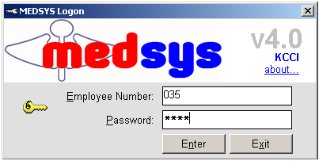
Figure 1: Login Window

3 If accepted, you can now start a transaction. Otherwise, a message will be displayed prompting “Unauthorized User”.

How to Change Password?

It is advisable to change your password as often as possible for security reasons. To change you current password, follow these steps.

1 From the Login window, type your employee number and then press <Enter>.

2 Under the Password entry, press <F12>. Pressing this function key will invoke the Change Password window.

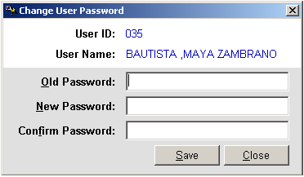
Figure 2: Change Password Window
3 Under the Change Password window, type the following data.
Old Password - Type your existing password.
New Password - Type your new password not exceeding to 15 characters.
Confirm Password - Retype your new password to confirm and then press <Enter> or you can click the Save button.

How to End the Program?

It is important for users to close the program when they are done to end-up their session. Other users might use the open program using the same password.

To close program, click on located at the upper right corner of the window or
Click on Exit App. toolbar button.

Program Operation

How to Search a Patient (NURSERY Patients or All Patients)?

Upon loading the program, patient searching window will be the first window to be displayed. You can activate patient searching by clicking on toolbar button or by clicking the Open menu.
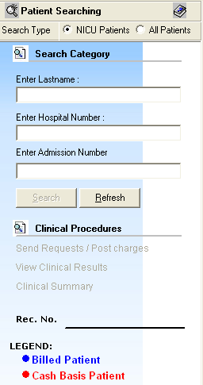
Figure 3: Patient Searching Window

1 Patient Type - Click on the option box “NICU Patients” to search for NURSERY patients or “All Patients” to search for all other patients.
2 Search Category - Choose one search category from the list below. It is advisable to just enter the full last name of the patient when searching.
Enter Last Name: Type the full last name of the patient or type the first letters of the last name then press <Enter> or click on Search button.
Enter Hospital Number: Type the hospital number of the patient then press <Enter> or click on Search button.
Enter Admission Number: Type the admission number of the patient then press <Enter> or click on Search button.
Afterwards, patient listing(s) will be displayed at the right side of the window. Select a patient from the list to use for your transaction. (The selected patient is highlighted with blue color when clicked) Here are the actions you can do after selecting a patient.

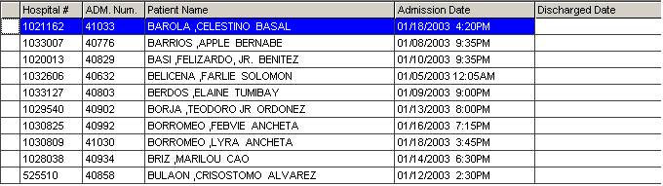
Figure 4: Patients Listing
Right-click -You can right-click on the patient name to display options such as personal information, request status or patient’s ledger.
Double-click - When double-clicked, the clinical procedure window will be displayed. Clinical procedure includes:
Send Requests
Nurses Activity Request
View Results
Vital Signs
Nurses Notes
Patient Profile
Clinical Summary
Any transaction to be done will be accounted to the selected patient. How to know if patient is tagged as "NICU"? From the main window's left corner, you can see the caption " Package Type: _______________(Type of Package)".

3 Clinical Procedures - You can activate this after selecting a patient from the list. The most common clinical procedures are as follows:
Send Requests/ Post Charges
View Clinical Results
Clinical Summary

Inquiry (Personal Information, Request Status, Patient’s Ledger)

If the patient is right-clicked from the patient list, three options will be displayed to choose from which are listed below.

Personal Information
The personal information to be viewed includes patient name, hospital number, admission number, admission date, and room number. To view patient’s information:
1 Select a patient from the list then right-click. A pop-up window will be displayed. Click Personal Info or click Personal Info from the Inquiry pull down menu.

2 The Personal Information window will be displayed and the following data can be viewed.
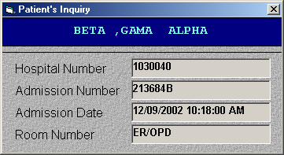
Figure 5: Personal Information Window

Patient Name
Hospital Number
Admission Number
Admission Date
Room Number

Request Status
This option displays the status of the requested exam for the patient. To know the request status of the patient:

1 Select a patient from the list then right-click. A pop-up window will be displayed. Click Request Status or click Request Status from the Inquiry pull down menu.
2 A generated report window will be displayed. The following data can be viewed.
Description - the name of the exam requested
Qty - the number of exam(s) requested for a partNurserylar exam
Reference No. - a program generated number (charge-slip number)
Status - e.g. Pending, With Result charged…
Request Date - the date when the exam was requested
Request By - the program user who requested the exam

3 To print, click.

Patient’s Ledger
This option displays the total amount of I.C.U. charges to be paid by the patient.

1 Select a patient from the list then right-click. A pop-up window will be displayed. Click Patient’s Ledger or click Patient’s Ledger from the Inquiry pull down menu.
2 A generated report window will be displayed.
3 To print, click.

Receivable Update

This option lets you enter patient’s charges that were not entered during his confinement.

1 Click on Receivable Update menu. The Receivable Update window will be displayed afterwards.
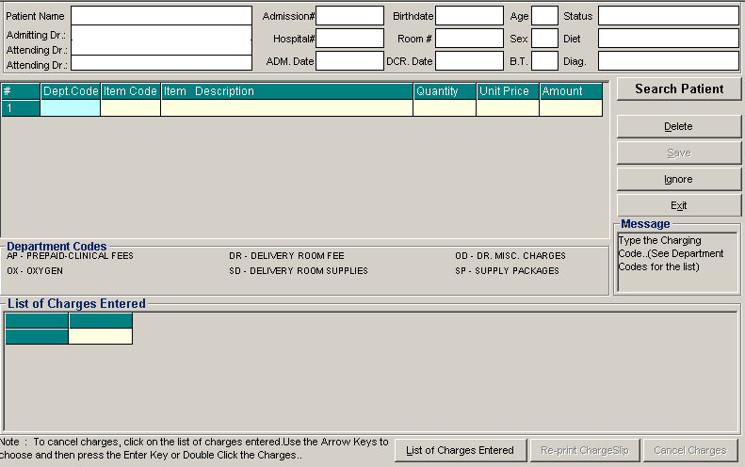
Figure 6: Receivable Updates Window

2 Click on Search Patient button located at the right side of the window. The Search Patient window will be displayed. Type the following data.

Patient Type - Click on the option box “In Patient” to search for inpatients or “Out Patient to search for outpatients.
Search Category - Choose one search category from the list below. It is advisable to just enter the full last name of the patient when searching.
Enter Last Name: Type the full last name of the patient or type the first letters of the last name then press <Enter> or click on Search button.
Enter Hospital Number: Type the hospital number of the patient then press <Enter> or click on Search button.
Enter Admission Number: Type the admission number of the patient then press <Enter> or click on Search button.

3 Afterwards, patient listing(s) will be displayed at the right side of the window. Select a patient from the list to use for your transaction by double-clicking on it. In the Receivable Update window, type the following data.
Department Code - Refer to the department code written just below the data entry.
Item Code - Type the service code or first letters of the service name and then press <Enter>. Or you can press <Enter> key if item code is still blank. When pressed, the Revenue Code window will be displayed showing the complete list of revenue codes.
Item Description - Automatically displayed by the program in relation with the selected item.
Quantity - Automatically displayed by the program in relation with the selected item but it can still be changed.
Unit Price - Automatically displayed by the program in relation with the selected.
Amount - Automatically displayed by the program in relation with the selected item and its quantity.

4 After completing the needed data, the following button options can be clicked from.
Click on Save button to save the items entered. When clicked, you have the option to print it.
To remove the selected item, click on the desired item then click on Delete button.
Clicking on Exit button will close the Receivable Update window.
An option is located below the window to view previous charges entered, reprint charge-slip or cancel the charges entered.

How to Request Laboratory Exam ?

This option lets you request laboratory examinations in the Laboratory department. Charging will be done by the Laboratory department after processing the request.

1 Click on Send Requests tab option (default menu).

2 Under Laboratory column, select the exam(s) to be requested by clicking the small box beside it. When clicked, the Remarks Entry Window will be displayed. Enter the necessary data then click on “Enter” button. Follow the same procedure when adding exam(s).

The exam to be requested cannot be found in the list. Click on “Search Laboratory Exams” button. The Laboratory Request Entry Window will be displayed and the following data are needed to enter:

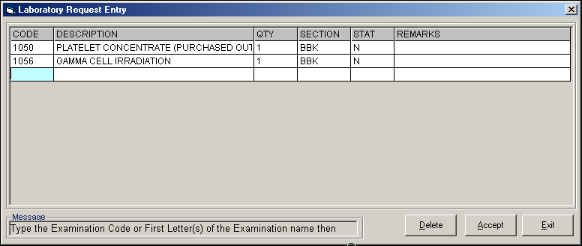
Figure 7: Laboratory Request Entry Window

CODE - Type the examination code or first letter(s) of the examination name then press <Enter>. Or you can press <Enter> key if CODE is still blank to display the list of examination codes. If <enter> key was pressed, a window will be displayed showing the list of examination codes.
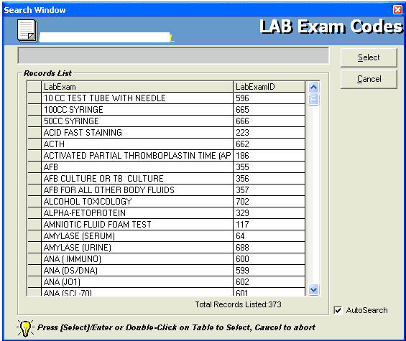
Figure 8: Laboratory Exam Codes Window
To select from the list, click on the desired exam and click on Select button or simply double-click on the desired exam. The Remarks Entry Window will be displayed afterwards. Enter the following data.
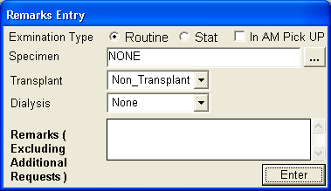
Figure 9: Remarks Entry Window
Specimen - e.g. blood, urine...
Examination Type - Choose one from the list <Routine, Stat, or In Am Pick-up>
Transplant - Choose one from the drop-down list either Transplant or Non-transplant
Dialysis - Choose one from the drop-down list either None, Pre-Dialysis or Post- Dialysis.
Remarks - Type additional remarks.
When done, click on Enter button. Follow the same procedure when you want to add an examination.
DESCRIPTION - This will be automatically displayed in reference with the selected exam.
QTY - This will be automatically displayed in reference with the selected exam.
SECTION - This will be automatically displayed in reference with the selected exam.
STAT - The data that were entered in the examination type under the Remarks Entry window will be displayed here. To change it, type Y if the exam is STAT or N if it is Routine.
REMARKS - The data that were entered in the remarks data entry under the Remarks Entry window will be displayed here.
3 Under the Laboratory Request Entry Window, you can do the following options.

To include the requested laboratory exam in the Order’s list, click on Accept button.
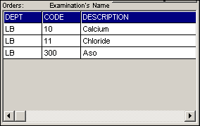
Figure 10: Orders List
To remove requested laboratory exams in the list, click on the desired exam and then click on Delete button.
To close the Laboratory Request Entry window, click on Exit button.
4 After clicking the Accept button, you can do the following options.

You can view all the requested exams in the Order’s list.
To send the requests, click on Save button. A pop-window will appear asking you to type the requesting doctor. See figure below. Click OK button to proceed. (Same procedure is applied to requesting of other exams)
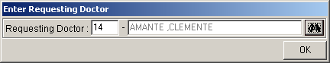
To remove requested exam from the list, double-click on the desired exam or click on the desired exam then click on Delete button.

How to Request X-ray Exam?

This option lets you request X-ray examinations in the Radiology department.

Under X-ray column, click the small box beside the exam. The same steps with requesting laboratory exam are followed. Please refer to How to Request Laboratory Exam for the instructions.

How to Request Ultrasound Exam?

This option lets you request Ultrasound examination in the Radiology department.

Under Ultrasound column, click the small box beside the exam. The same steps with requesting laboratory exam are followed. Please refer to How to Request Laboratory Exam for the instructions.

How to Request C.T. Scan Exam?

This option lets you request C.T. Scan examination in the Radiology department.

1 Click on Send Requests tab option.

2 Under Other Departments click on the small box beside C.T. SCAN. The list of examinations will be displayed.

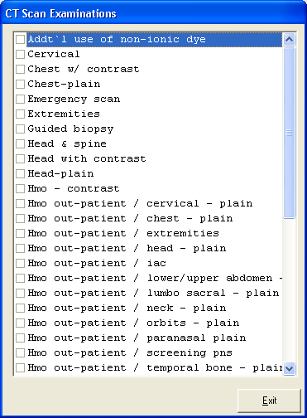
Figure 11: List of C.T. Scan Exams
To select from the list, click on the small box beside the desired exam. Upon clicking, the Remarks Entry Window will be displayed. Enter the following data.

Examination Type - Choose one from the list <Routine, Stat, or In Am Pick-up>
Specimen - example blood, urine...
Transplant - Choose one from the drop-down list either Transplant or Non-transplant
Dialysis - Choose one from the drop-down list either None, Pre-Dialysis or Post-Dialysis.
Remarks - Type additional remarks.
When done, click on Enter button. Follow the same procedure when you want to add an examination.

3 After selecting all the examinations for the patient, click on Exit button.
4 After clicking the Exit button, you can do the following options.
You can view all the requested exams in the Order’s list.
To send the request, click on save button.
To remove requested exams in the list, double-click on the desired exam or click on the desired exam then click on Delete button.

How to Request Heart Station Exam?
This option lets you request Heart Station examination in the Heart Station department.

Under Other Departments, click on the small box beside HEART STATION. The list of examinations will be displayed. The same steps with requesting C.T. Scan exam are followed. Please refer to How to Request C. T. Scan Exam to know the request procedure.

How to Request Nuclear Exam?
This option lets you request Nuclear Laboratory examination for the patient in the Nuclear Lab department.

Under Other Departments, click on the small box beside NUCLEAR MEDICINE The list of examinations will be displayed. The same steps with requesting C.T. Scan exam are followed. Please refer to How to Request C. T. Scan Exam to know the request procedure.

How to Request P.T. Procedure?
This option lets you request P.T. exam/procedure in the Physical Therapy and Rehabilitation Medicine department.

Under Other Departments, click on the small box beside REHABILITATION MEDICINE.. The list of examinations will be displayed. The same steps with requesting C.T. scan exam are followed. Please refer to How to Request C. T. Scan Exam to know the request procedure.

How to Request Magnetic Resonance Imaging Exam?
This option lets you request pulmonary examination in the pulmonary department.
Under Other Departments, click on the small box beside Magnetic Resonance Imaging. The list of examinations will be displayed. The same steps with requesting C.T. scan exam are followed. Please refer to How to Request C. T. Scan Exam to know the request procedure.

How to Request Pulmonary (RTS) Exam?

This option lets you request pulmonary examination in the Pulmonary department.
Under Other Departments, click on the small box beside PULMONARY SECTION. The list of examinations will be displayed. The same steps with requesting C.T. scan exam are followed. Please refer to How to Request C. T. Scan Exam to know the request procedure.

How to Request Medicine?

Request on medicine to patient could not be posted in the computer if:
    - Billing staff has closed patient's account. The message that will appear on the screen, "The patient's account has already been closed by _____ (Department). If you have charges to make, contact the Billing staff immediately for further instructions..."
    - Billing staff has placed the patient's account on cash basis. The message that will flash on the screen, "The patient's account has been placed under cash basis by the Billing Officer. Please advice the patient / watcher to see the billing staff immediately for further instructions."
    - May Go Home (MGH) notice was already sent to the different departments.

1 Click on Send Requests tab option.

2 Click on Pharmacy button at the right side of the window. The items to be entered here will be charged into the patient’s bill. Enter the following data.
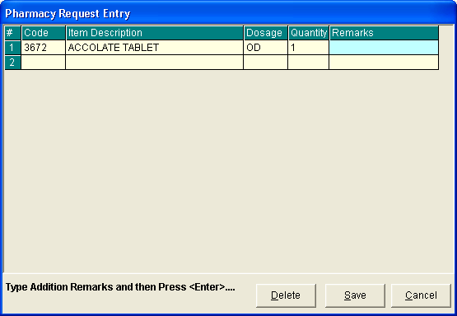
Figure 12: Charge Request Entry Window
Code - Type item code or first letter(s) of item name then press <Enter>. Or you can press <Enter> key if code is still blank to display the list of supplies. If <enter> key was pressed, the list of supplies window will be displayed. To select from the list, click “All Items” to display all supplies or you can categorize by clicking “Suppliers” or “Classification” then double-click on the desired item.
Item Description - This will be automatically displayed in reference with the selected item.
Dosage - Press <Enter> key if dosage is still blank to display the list of dosage codes. If <enter> key was pressed, a window will be displayed showing the list of dosage codes. To select from the list, double-click on the desired code or click on the desired code and click on Select button. To abort the selection, click on Cancel button.
Quantity - This will be automatically displayed in reference with the selected dosage. Note that quantity should be greater than zero.
Remarks - An optional entry.

Just follow the same procedure when adding transcription requests.

3 After completing the desired items to request, you can do the following options.

Click on Save button to send the request into the Pharmacy department.
To remove requested items in the list, click on the desired item then click on Delete button.
Click on Cancel button to close the Charge Request Entry Window.

How to Request for Supplies?

This lets you request supplies in the Central Supply Department. Charging will be done by the CSR department after processing the request.

Requesting of supply could not be posted in the computer if:
    - Billing staff has closed patient's account. The message that will appear on the screen, "The patient's account has already been closed by _____ (Department). If you have charges to make, advice the patient / watcher to see the Billing staff immediately for further instructions..."
    - Billing staff has placed the patient's account on cash basis. The message that will flash on the screen, "The patient's account has been placed under cash basis by the Billing Officer. Please advice the patient / watcher to see the billing staff immediately for further instructions."
    - May Go Home (MGH) notice was already sent to the different departments.

1 Click on Send Requests tab option.

2 Click on Central Supply button at the right side of the window. When clicked, the Central Supply Request Entry Window will be displayed and the following data are needed to enter.

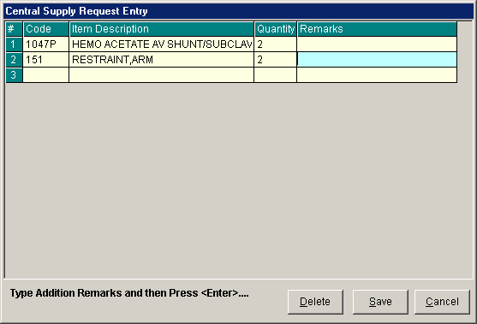
Figure 13: Central Supply Request Entry Window
Code - Type item code or first letter(s) of item name then press <Enter>. Or you can press <Enter> key if code is still blank to display the list of supplies. If <Enter> key is pressed, a window will be displayed showing list of supplies.

To select from the list, click “All Items” to display all supplies or you can categorize by clicking “Suppliers” or “Classification” then double-click on the desired item.

Item Description - This will be automatically displayed in reference with the selected item.
Quantity - Type the number of the item to request. Note that quantity should be greater than zero.
Remarks - An optional entry.

Follow the same procedure when adding items to request.

3 After completing the items to request, you can do the following options.

To send the request in the Central Supply department, click on Save button.
To remove an item in the list, click the row of the desired item then click on Delete button.
Click on Cancel button to abort the entered items.

How to Update Patient’s Diet?

This is where user can request and change the patient’s diet for the next meal.

1 Click on Send Requests tab option.

2 Click on Change Diet button at the right side of the window. When clicked, the Post New Diet Window will be displayed asking you to enter the following data.

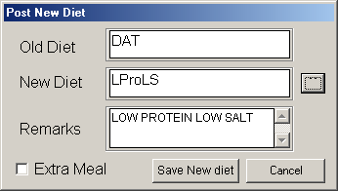
Figure 14: Diet Request Window

Old Diet - This will be automatically filled-up by the program.
New Diet - Type a new diet of the patient. To do it, press <Enter> key if New Diet textbox is still blank or click on . When clicked, a window will be displayed showing the Diet Code listing.

Figure 15: Diet Codes Listing Window

To select from the list, just double-click on the desired diet or click on the desired diet then click on Select button. Clicking on Cancel button will abort all your selected diets.

Remarks - Automatically filled-up in reference with the selected diet.

3 After completing the data to be entered, you can do the following options.
Click the check box to have an extra meal for the patient.
Click on Save New Diet button to send the request.
To abort the request entered, click on Cancel button.

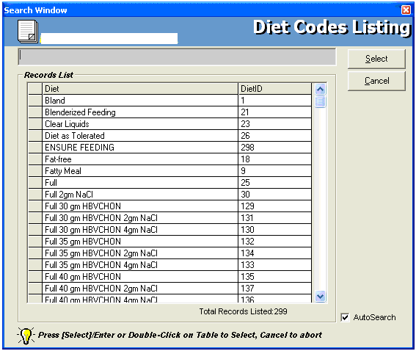

How to Discharge a Patient?

This option allows you to remove the patient physically from the list in order to monitor the availability of rooms.

Note: Before discharging a patient, a discharge notice should be sent first to the Billing department. Please refer to How to Send Discharge notice to know the request procedure.

- Click on 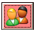button to display list(s) of patients to be discharged. The window below will be loaded on the screen.

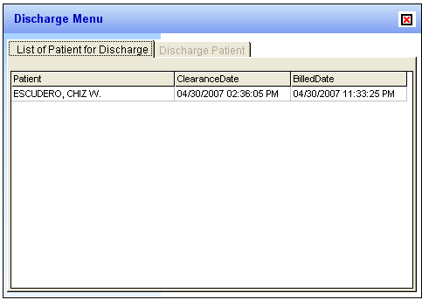

Double click on the patient name you want to discharge to display the discharge patient window below.
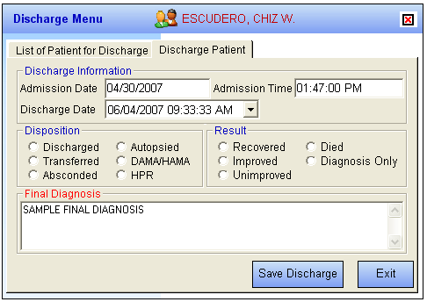

Admission Date - Automatically filled-up by the program in reference with the patient’s day of admission.
Admission Time - Automatically filled-up by the program in reference with patient’s time of admission.
Discharge Date - You can set the discharge date by clicking on the drop-down combo box. Note that discharge date should not go beyond the current date.
Discharge Time - You can set the discharge time by clicking on the up and down arrows.
Disposition - Click one from the list.
Result - Click one from the list.
* FINAL DIAGNOSIS – Type the diagnosis given by the doctor

2 After completing the data, the user can do the following options.
Click on Save Discharge to remove the patient physically from the list.
Click on Exit button to abort discharging the patient.

How to Update Patient’s Room (Room Transfer) ?

1 Click on Send Requests tab option.

2 Click on Discharge/Room Transfer button at the right side of the window. When clicked, a window will be displayed.

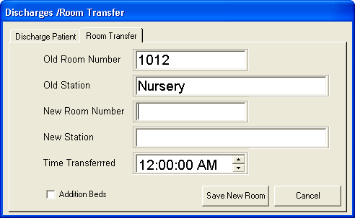
Figure 16: Room Transfer Window
Click on Room Transfer tab to open its window. The following data are needed to enter.

Old Room Number - Automatically filled-up by the program in reference with the patient’s current room.
Old Station - Automatically filled-up by the program in reference with the patient’s current station.
New Room Number - Type a new room number. To do it, press <Enter> key if new room number is still blank. If <Enter> key was pressed, a window will be displayed showing the list of rooms. Click on “All Rooms” to display list of all rooms or you can categorize by clicking on “Station” or “Accommodation”.
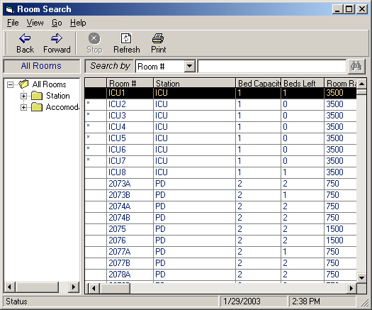
Figure 17: List of Rooms Window

New Station - Automatically filled-up by the program in reference with the selected new room.
Time Transferred - The server’s current time is used as the default entry. To set a time, click on the up and down arrows.
3 After completing the data, you can do the following options.
Click on Save New Room button to transfer the patient into a new room.
Click on Cancel button to abort transferring the patient.

How to Confirm Room Transfer
For Incoming patients from another station, the target station should confirm the room transfer entered. The Wizard will appear, informing the station that there are incoming patients.
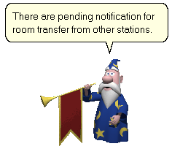
Double click on the wizard to display lists of patients transferred.
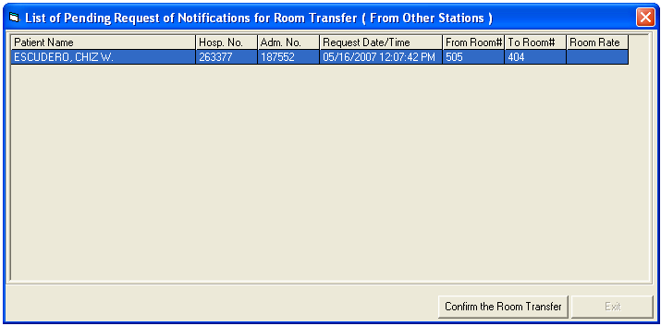
Click on the patient name then click on Confirm the Room Transfer button.

How to Send May Go Home (MGH) / Discharge Notice?

Nurse will send discharge notice to cost centers after receiving discharge order from patient's doctor. Visual NURSERY program will not allow the user to send discharge notices if there are still pending requests from different cost-centers.

1 Click on Send Requests tab option.

2 Click on Discharge Notice at the right side of the window. When clicked, the Discharge Notice Window will be displayed. Complete the following information.

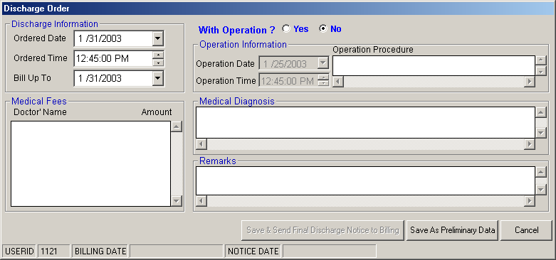
Figure 18: Discharge Notice Window
Discharge Information
Ordered Date - Use the drop-down combo box to select the ordered date
Ordered Time-Use the up and down arrows to select the ordered time
Bill up to - Sets the deadline for the payment of the patient’s bill. To do it, use the drop-down combo box to select a date.
Operation Information - This will enable if the patient has undertaken an operation.

Operation Date - use the drop-down combo box to select an operation date.
Operation Time - use the up and down arrows to select an operation time.
Operation Procedure - type the operation procedure for the patient.

Medical Fees

Doctor’s Name - the name of the doctor
Amount - the medical fee of the doctor
Medical Diagnosis - Type medical diagnosis of the patient

Remarks - An optional entry

3 After completing the data, you can do the following options.

Click on save button to send the Discharge Notice.
Click on Final Printing button to print. This should be clicked by the user to signal the Billing department that the patient has been cleared in their station.
Click on Cancel button to abort Discharge Notice.

How to Post Charges?

In this option is where you can enter charges of Nursery. services and supplies.

1 Click on Send Requests tab option.

2 Click on Post Charges button at the right side of the window. When clicked, the Post Charges Window will be displayed. Complete the following data.

Department Code - Refer to the list of department codes written at the bottom of the window.
Item Code - Type the service code or first letters of the service name then press <Enter> key. Or you can press <Enter> key if item code is still blank. When pressed, the Revenue Code window will be displayed showing all revenue codes.
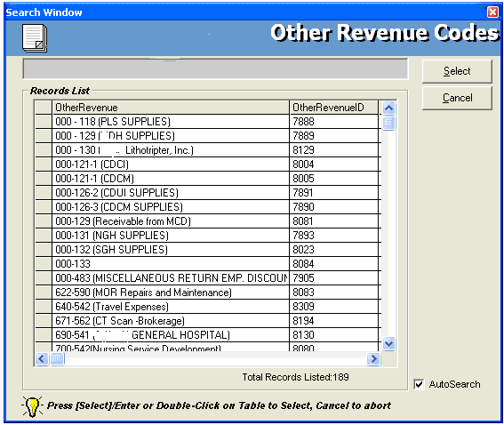
Figure 19: Revenue Codes Window

To select from the list, double-click on the desired item or click on the desired item then click on Select button. Clicking on Cancel button will abort the selection.

Item Description - Automatically filled-up by the program in reference with the selected item.
Quantity - Automatically filled up by the program in reference with the selected item but this can still be edited.
Unit Price - Automatically filled up by the program in reference with the selected item.
Amount - Automatically filled up by the program in reference with the selected item and its quantity.

3 After entering the items to be charged, you can do the following options.
Click on Save button to save entered items. When clicked, a printable form will be displayed. Click on to print. Entered items will be automatically charged to the patient’s bill.
To remove the selected item, click on the desired item then click on Delete button.
Clicking on Exit button will close the Post Charge window.

4 At the bottom of the window, you can also do the following options.

To view list of charges entered, click on List of Charges Entered button.
To cancel requested charges, double-click on the requested item or click on the desired item then click on Cancel Charges button.
To have a copy of charge slip of the requested item, click on Re-print Charge Slip button.

How to Enter Charges for a Cash-basis Account?

This option lets you enter charges of I.C.U. services and supplies to a selected cash-basis patient.

1 Click on Send Requests tab option.

2 Click on Cash Assessment Entry button at the right side of the window. When clicked, the Cash Assessment Entry Window will be displayed. Complete the following data.

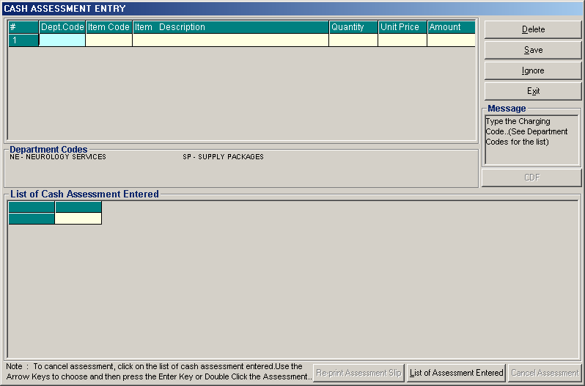
Figure 20: Cash Assessment Window

Department Code - Refer to the list of department codes written at the bottom of the window.
Item Code - Type the service code or first letters of the service name and then press <Enter> key. Or you can press <Enter> key if item code is still blank. When pressed, the Revenue Code window will be displayed showing all revenue codes.

To select from the list, double-click on the desired item or click on the desired item then click on Select button. Clicking on Cancel button will abort the selection.

Item Description - Automatically filled-up by the program in reference with the selected item.
Quantity - Automatically filled up by the program in reference with the selected item but this can still be edited.
Unit Price - Automatically filled up by the program in reference with the selected item.
Amount - Automatically filled up by the program in reference with the selected item and its quantity.

3 After entering the items to be charged, you can do the following options.
Click on Save button to save entered items. When clicked, a printable form will be displayed. Click on to print.
To remove the selected item, click on the desired item then click on Delete button.
Clicking on Exit button will close the Post Charge window.

4 At the bottom of the window, you can also do the following options.

To view list of charges entered, click on List of Charges Entered button.
To cancel requested charges, double-click on the requested item or click on the desired item then click on Cancel Charges button.
To have a copy of charge slip of the requested item, click on Re-print Charge Slip button.

Nurses Activity Request

From the requests posted in the Send Requests tab option, you can view here the status of each request.

Nurses Activity Request is where you can view list of processed requests, list of pending requests, list of exam with results, and reports such as diet list, census report by station, discharges for the day, and list of requests/orders, list of medicine posted and list of supplies posted.

1 Click on Nurses Activity Request tab option.

2 Its window will be displayed showing the following data.

List of Processed Requests - These are the lists of requests that were already processed by the department in response to the requests done in the Send Requests tab option.

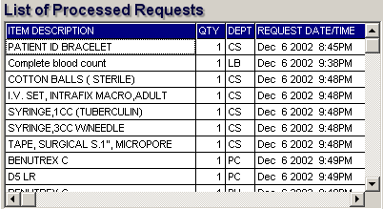
Figure 21: List of Processed Requests

List of Pending Requests - These are the lists of requests posted in the Send Requests tab option which are not yet acknowledged by the receiving department.

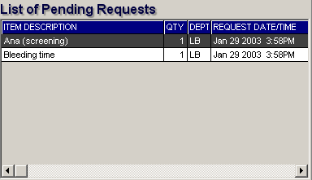
Figure 22: List of Processed Requests
To cancel a request, double-click on the desired item.

List of Exams with Result - These are the list of exams posted in the Send Request tab option that already have result and its details can be viewed in the View Results tab option.

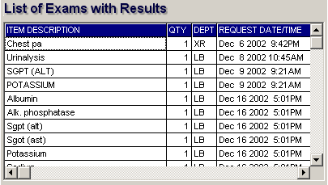
Figure 23: List of Exams with Result

3 The following button options can be clicked from.

Click on Refresh button to view the latest update from the database.
Click on Exit button to close the program.

Viewing of Laboratory Exam Result

This option allows you to view result of laboratory tests and exams.

1 Click on View Result tab option.
2 Its window will be displayed.
3 Click the Laboratory tab to view laboratory exams with result.

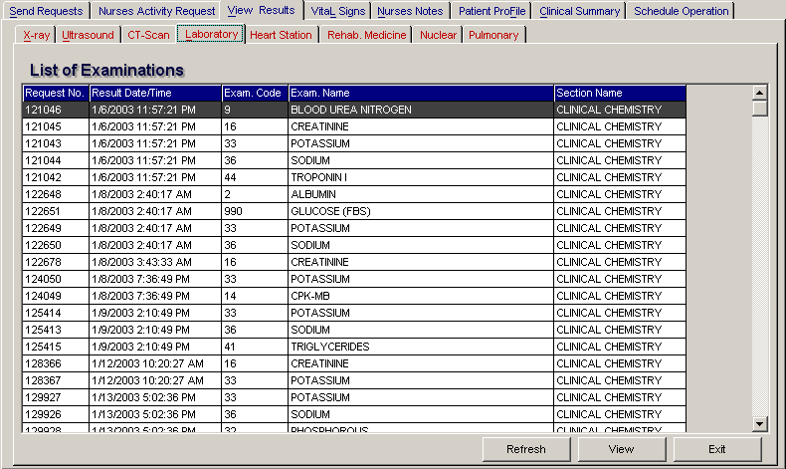
Figure 24: View Laboratory Exam Result Window
To view, click the exam and then click on View button. The Refresh button is used to view the latest updates of laboratory exams with results from the database. While the Exit button is used to close the program.

Viewing of X-ray Exam Result
This option allows you to view result of x-ray exams.

1 Click on View Results tab option.
2 Its window will be displayed.
3 Click X-ray tab to view x-ray exam result. (X-ray window is the default window).

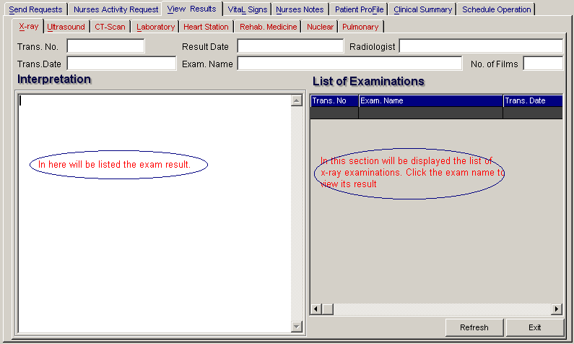
Figure 25: View X-ray Exam Result Window
The list of examinations is displayed at the right side of the window. Just click the desired exam to view its result. The exam result can be viewed at the left side of the window.

4 The following buttons can be clicked from.
Refresh - This will view latest updates of exams with result from the database.
Exit - This will close the program.

Viewing of Ultrasound Exam Result
This option allows you to view result of Ultrasound exams.

Click Ultrasound tab to view exams with result. The same steps with viewing of x-ray exam are followed. Please refer to Viewing of X-ray Exam Result to know the procedure.

Viewing of Heart Station Exam Result
This option allows you to view result of Heart Station exams.

1 Click on View Result tab option.
2 Its window will be displayed.
3 Click Heart Station tab to view exams with result.

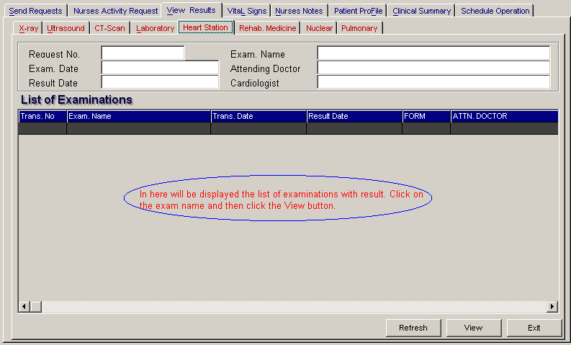
Figure 26: Heart Station View Exam Result Window

To view, click the exam and then click on View button. The Refresh button is used to view the latest updates of laboratory exams with results from the database. While the Exit button is used to close the program.

Viewing of C.T. Scan Exam Result
This option allows you to view result of C. T. Scan exams.

Click C.T.-Scan tab to view exams with result. The same steps with viewing of x-ray exam are followed. Please refer to Viewing of X-ray Exam Result to know the procedure.

Viewing of Nuclear Exam Result
This option allows you to view result of Nuclear Laboratory exams.

Click Nuclear tab to view exams with result. The same steps with viewing of x-ray exam are followed. Please refer to Viewing of X-ray Exam Result to know the procedure.

Viewing of Pulmonary Exam Result
This option allows you to view result of pulmonary exams.

Click Pulmonary tab to view exams with result. The same steps with viewing of Pulmonary exam are followed. Please refer to Viewing of Pulmonary result to know the procedure.

Viewing of P.T. Notes

This option allows you to view result of Physical Therapy Exams.

1 Click on View Result tab option
2 Its window will be displayed.

3 Click Rehab. Medicine tab to view exams with result.

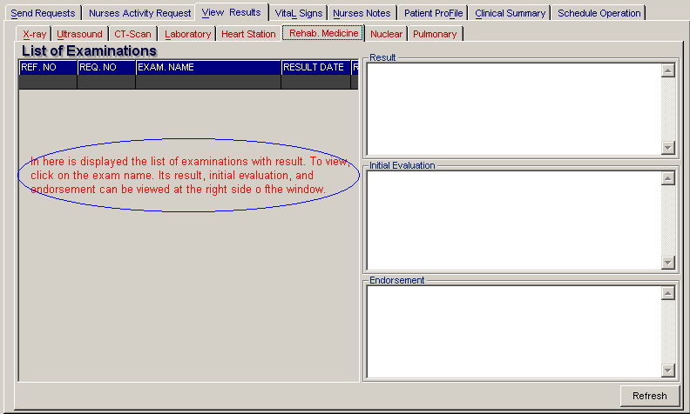
Figure 27: Rehabilitation Medicine View Exam Result Window
The list of examinations with result is displayed at the left side of the window. To view result, click the exam and then its result, initial evaluation and endorsement can be seen at the right side of the window.

4 Clicking on Refresh button will display the latest updates of exams with result from the database.

Vital Signs Data Entry

In here, it is where you can enter the vital signs of the patient. Vital signs data entry includes blood pressure, body temperature, respiratory rate, and pulse rate.

1 Click on Vital Signs tab option.

2 On the left side, you can see the previous vital signs of the patient. The following data can be viewed.

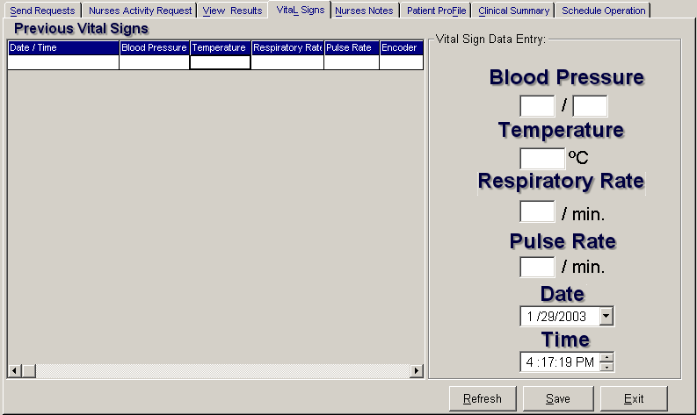
Figure 28: Vital Sign Data Entry Window
Date/Time - the date and time when vital sign was entered.
Blood pressure
Respiratory rate
Pulse rate

And on the other side is the vital sign data entry. The following data needed to enter.

Blood pressure
Body temperature
Respiratory rate
Pulse rate

3 The following button options can be clicked from.

Click on Save button to save entry.
Click on Refresh button to view the latest update from the database.
Click on Exit button to close the program.

Nurses Notes Data Entry
Nurses Notes window is where you can type in notes or remarks about the condition of a patient. It works like an electronic notebook because you can retrieve the saved data of a particular date and shift of the day.

1 Click on Nurses Notes tab option.

2 To view past patient’s chart, click on Past Notes written vertically. The following data can be viewed.

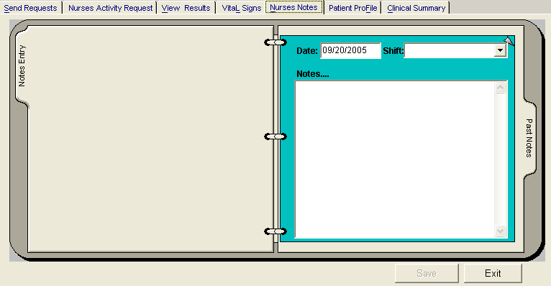
Figure 29: Nurses Notes Window
Date/Time - the date and time when the remarks were entered
Day shift - the shift of the day
Entered by - the program user who entered the remarks
Notes - the content of the remarks

To enter patient’s chart, click on Notes entry written vertically. Enter the following data.

Date/Time - current date and time is used
Day shift - select from the following choices listed (6am-2pm, 2pm- 10pm, 10pm-6am)
Notes - Type remarks on the multi-line textbox.

3 The following button options can be clicked from.

Click on Save button to save the notes entered.
Click on Exit button to close the program.

Viewing of Patient’s Profile

Patient Profile is where you can view the latest patient’s information throughout his current confinement. It includes admitting diagnosis, chief complaints, manner of admission, past medical history, allergies, personal and social history and family history.

1 Click on Patient Profile tab option.

2 The Patient Profile Window will be displayed.

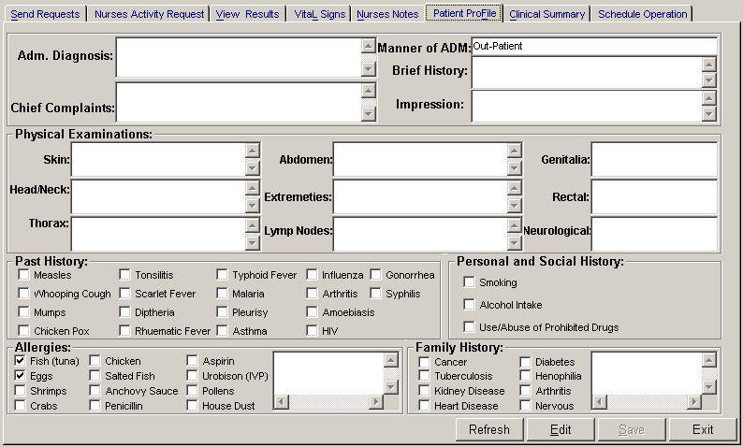
Figure 30: Patient Profile Window
3 The following button options can be clicked from.

To edit the patient’s profile, click on Edit button. You can now make necessary modifications on the patient’s profile.
When completed, click on Save button to save the changes.
Click on Refresh button to undo the changes done.
Click on Exit button to close the program.

Viewing of Clinical Summary

Clinical summary is where you can view the past clinical summary of a patient’s confinement.

1 Click on Clinical Summary tab option.

2 The Clinical Summary Window will be displayed. The following data can be viewed.

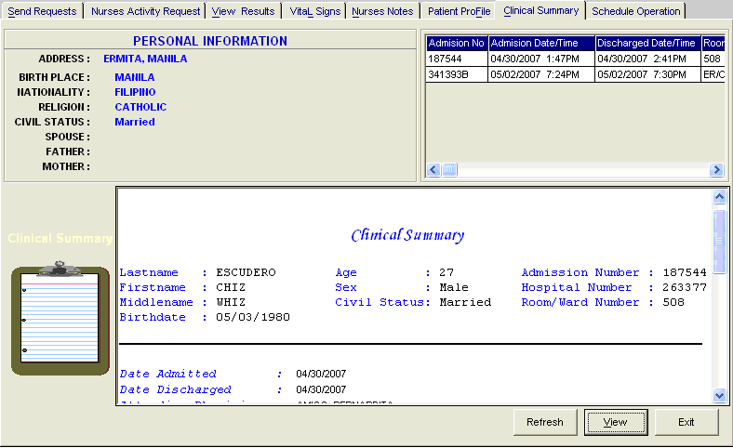
Figure 31: Clinical Summary Window

Admission number - a program-generated number during patient’s admission
Admission date/time - the date and time when the patient was admitted
Discharge date/time - the date and time when the patient was discharged
Room number - the room number of the patient during his confinement
3 To view for a partNurserylar clinical summary of patient, click on the desired exam then click on View button. The following data can be viewed.

Date admitted - the date when the patient was admitted
Date discharged - the date when the patient was discharged
Attending physician - the name of the attending physician
Admitting doctor - the name of the admitting doctor
Admitting diagnosis - the admitting diagnosis of the patient
Chief complaints - the complaint of the patient
Final Diagnosis - the final diagnosis of the patient

4 Click on Exit button to close the program.

How to Enter Height and Weight?

This option allows you to enter the height and weight of the patient for clinical reference.

1 Click on Send Requests tab option.
2 Click on Height and Weight Entry button located at the right side of the window.
3 Its window will be displayed.

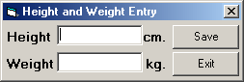
Figure 32: Height and Weight Entry Window
Enter the following data.
Height - Type patient’s height in centimeter.
Weight - Type patient’s weight in kilograms.

4 The following button options can be clicked from.
Save - This will save the entry.
Exit - This will close window without saving the entry.

How to Enter Administered Medicines?
This option allows you to enter the medicines administered to the patient.
To do this, click on Send Requests tab then Entry for Medicines Administered button. Enter your access code to load the window below

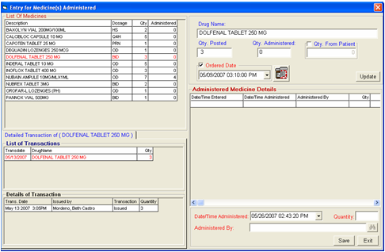
- To Enter the medicine administered, in the quantity box enter the total quantity of the medicines administered to the patient. The window where to enter the quantity is displayed below, the encircled part is where to enter the total quantity administered on a specific date and time and the person who administered the medicine.
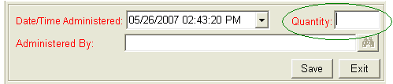

To view detailed transaction of a specific medicine, double click on the specific item then go to the Detailed Transaction window for the details of the item, a sample window is displayed below. It is where you can see the transaction done to a specific item such as the date issued, date returned or date adjusted.

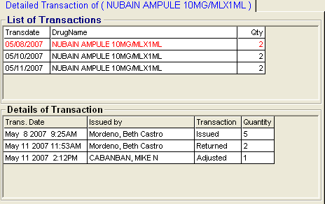

To view details of the medicines administered for the specific item, a sample window is displayed below. The qty column is the total quantity administered on a specific date and item and the person who administered the item is also displayed.

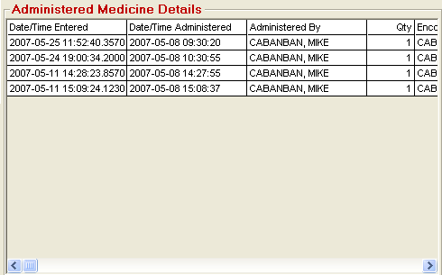

To enter the specific order date and time of the doctor for the specific medicine, go to the Ordered Date option. A sample window is displayed below.

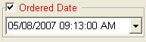

To enter quantity given by the patient if the specific medicine is purchased / bought outside, go to Qty. From Patient. Check on to activate the entry box then enter the quantity in the encircled part of the window displayed below then click on Update button to update the medicine transaction.
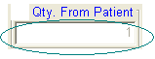

To print the medication sheet, click on 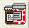 button.

How to Print Claim Slip?
This option allows the user to print claim slip of patients with processed bill. To do this, click on  icon to display list(s) of patients. A sample window is displayed below.
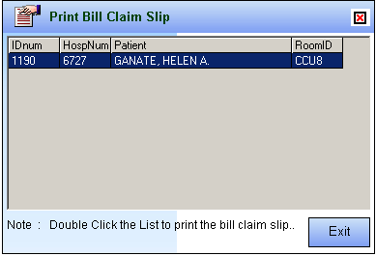

Reports

Click the option you want (listed below) from the Reports pull-down menu. A window for date entry (for audit and monthly reports) will be displayed. Select From and To dates by clicking the drop-down arrow then click on OK button.

1 Audit Report
This displays a report of all items requested, how many quantities are used in a partNurserylar item requested and its corresponding amount totaling the accumulated amount of all items. This is arranged alphabetically by the reference number of each item.
The following data can be viewed.
Reference No. - program - generated number (charge-slip number)
Amount - the amount of item requested
Department - the department code
Quantity - the number of item requested
Code - the code of the item requested
Description - the name of the item requested
By - the program user who requested the item
Date - the date when the item was requested
Name of Patient - the name of the patient who requested the item
To print, click .

2 Monthly Report
This displays a report of all items requested, the quantity and amount accumulated each and both in inpatient and outpatients for a partNurserylar item then totaling the quantity and amount accumulated each and both in inpatient and outpatients for all the items requested. This is arranged alphabetically by the name of the item requested.
The following data can be viewed.
Description - the name of the item requested
Number (Inpatient) - the total number of the partNurserylar item requested in inpatient
Amount (Inpatient) - the total amount accumulated for the partNurserylar item in inpatient
Number (Outpatients) - the total number of the partNurserylar item requested in outpatients
Amount (Outpatients) - the total amount accumulated for the partNurserylar item in outpatients
Number (Total) - the total number of the partNurserylar item requested in inpatient and outpatients.
Amount (Total) - the total amount accumulated for the partNurserylar item in inpatient and outpatients.
To print, click .

3 Diet List
This displays list of all patients in the station with patient’s room number, nationality, religion, admitting diagnosis and diet.

To print, click .

4 Census Report
This displays list of all patients in the station with patient’s room, admission date, admission number, case and attending doctor.

To print, click .

5 Discharges for the Day
This report displays list of patients who were discharged within the day. Data to be viewed are patient’s name, hospital number, admission date, account name, and room and bed number.
To print, click .

Index

—A—
activity request, 17
admission history, 17
audit report, 59
—C—
cardiovascular exam result (heart station exam result), 50
census report, 59
changing of password, 8
clinical procedures, 17
clinical summary, 17
—D—
diet list report, 59
diet request, 17
discharge notice/order, 17
discharge patient, 17
discharges for the day report, 59
drug request, 17
—E—
end the program, close the program, 9
exam request, 17
exam result, 17
—F—
features, 6
—H—
history, 17
—I—
icu patients (searching), 10
inquiry (personal information, request status, patient's ledger), 13
—M—
medicine request, 17
monthly report, 59
—N—
notes, 17
nurses activity request, 17
nurses notes, 17
—O—
objectives, 5
overview, 4
—P—
password (changing of), 8
patient profile (viewing), 17
patient searching, 10
patient's ledger, 13
personal information, 13
post charges (for cash patient), 17
post charges (for charge patient), 17
procedures, 17
profile (viewing), 17
—R—
receivable update, 15
reports, 59
re-print request form, 17
request exam, 17
request form reprinting, 17
request status, 13
result viewing, 17
—S—
search patient (icu, all patients), 10
send request, 17
start the program, 7
supply request, 17
—V—
view cardiovascular exam result (heart station exam result), 50
view patient profile, 17
view reports, 59
view result, 17

