MEDSYS
Information System

Medical Record Program
User's Manual



Visual Medsys
Kaiser dela Cruz Consulting Incorporated
July 28, 2026

Copyright© 2009

ALL RIGHTS RESERVED

No part of this document may be reproduced through photocopying or in any means, stored into a retrieval system, and transmitted in any form without the express written permission of Kaiser dela Cruz Consulting Incorporated.
Permission is hereby granted to Medsys Information System to copy and distribute this document in any of the above means provided this is for its exclusive on site use.
Although every precaution has been taken in the preparation of this manual, the company assumes no responsibility for errors or omissions. Neither is any liability assumed for any damages resulting from the use of the information contained here.

Table of Contents
Introduction 4
Overview 4
Objectives 5
Features 6
Getting Started 7
How to Start the Program 7
How to Change Password 8
How to End the Program 9
Program Operation 10
Patient Searching 10
Borrowing of patient's Medical Record 13
Updating of patient's Medical Record 15
Printing of Data Sheet (Admission and Discharge Record) 16
Printing of Medical Certificate and Certificate of Confinement 16
Printing of Inpatient Confinement Record 16
User Logbook 17
Updating of ICD 18
Consolidation of Hospital Number 20
Reports 23
Index 24b

Introduction

Overview


The Visual Medical Record Program provides immediate access to a patient’s historical medical information. Medical Records staff may track the users who have updated patient’s medical records and will benefit from the automated reporting procedure and generation of Certificates of Confinement and Medical Certificate. It has extensive built in reports. Diagnosis system coding is using ICD-10.

The use of password and defined rights disallow the access of authorized users. Only users with valid employee number and password can gain access into it.

Objectives
- To become a seamless part of the hospital’s operations whereby staff will have immediate access to patient information whenever and wherever required
- To reduce clerical workload
- To improve service and management will have a powerful new information tool for decision making purposes
- To maintain accurate and centralize update of patient’s information

Features

- Data-entry restriction - Warning messages are flashed for possible invalid entries. This ensures all data inputted would be made useful for any transaction to be done.
- Password-protected - The use of password is necessary to restrict unauthorized access. Thus the program only accepts passwords which are registered into it. This feature ensures the confidentiality and integrity of data entered in the program.
- Auto-report generation – The Medical Records department will benefit from the automated reporting procedure and generation of Certificates like Certificate of Confinement, Death and Birth Certificates and Medical Certificate
- User-friendly - The program user is guided by instructions in doing the next step providing an easy-use to process transactions.
- Control – Centralized update of patient’s information, may track the users who have updated patient’s medical records, Registry of borrowers of patients medical records/folders and have charging feature for Medical Certificate, photocopying & other medical records chargeable items and services at the Medical Records department
- Diagnosis system coding using ICD-10 and provide immediate access to a patient’s historical medical information

Getting Started

How to Start the Program

1 Double-click the Medical Record Program  executable file icon located in your computer desktop.

2 The Login window will be displayed asking you to enter your employee number and password for security purposes.

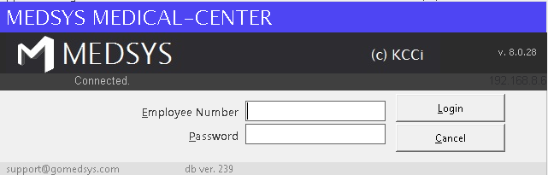
Figure 1: Login Window

3 If accepted, you can now start a transaction. Otherwise, a message will be displayed prompting “Unauthorized User”.

How to Change Password

It is advisable to change your password frequently for security reasons. To change you current password, follow these steps.

1 From the Login window, type your employee number and then press <Enter>.

2 Under the Password entry, press <F12>. Pressing this function key will invoke the Change Password window.

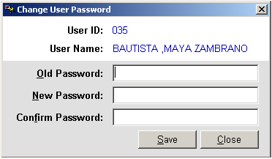
Figure 2: Change Password Window

3 Under the Change Password window, type the following data.
Old Password - Type your existing password.
New Password - Type your new password not exceeding to 15 characters.
Confirm Password - Retype your new password to confirm and then press <Enter> or you can click the Save button.

How to End the Program

It is important for users to close the program when they are done to end-up their session. Other users might use the open program using the same password.

To close the program:

1 Click File > Exit or
2 Click located at the upper right corner of the main window.

Program Operation

Patient Searching

This option lets you search an inpatient and displays the list of his confinement.

1 To open the Master Patient Search window,
Press Ctrl + O or
Click the Open toolbar button or
Click File > Open Patient Medical Record

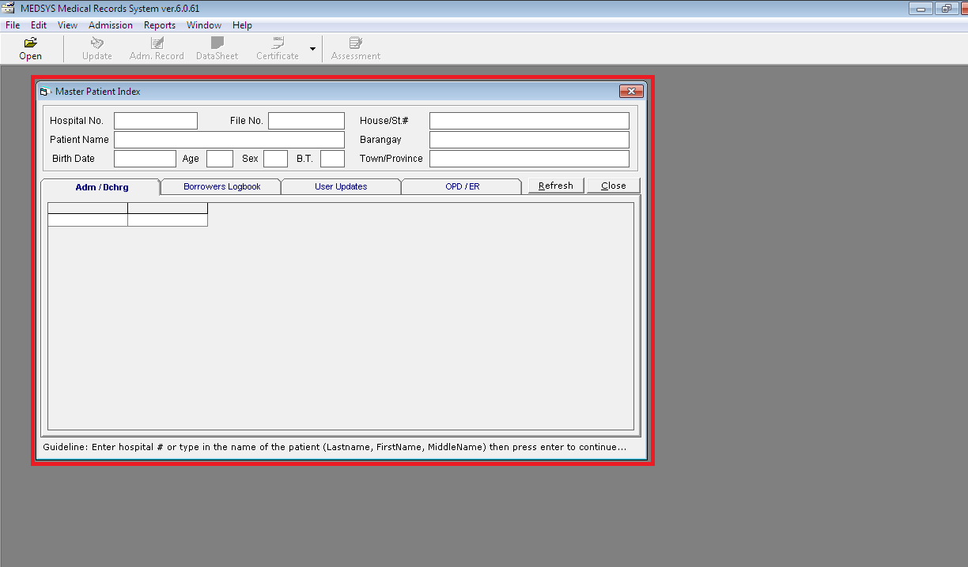
Figure 3: Master Patient Search Window

2 Enter the patient’s hospital number or first few letters of the patient’s last name and then press <Enter>. A window with patients list will appear matching the query typed. Double-click the patient’s name to select.

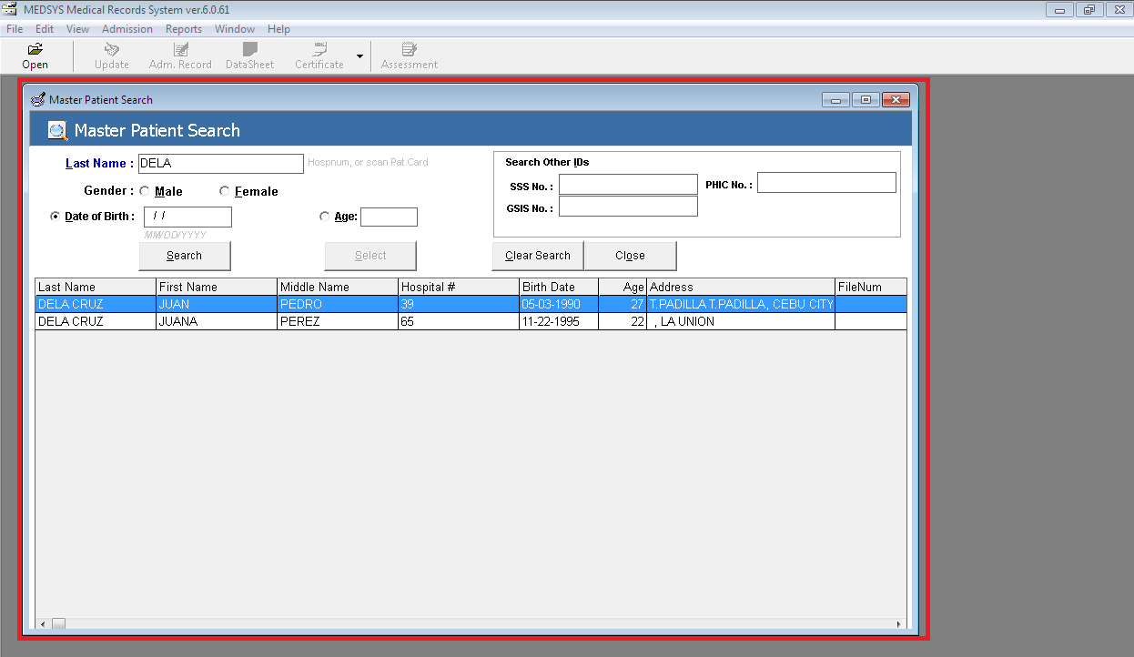
Figure 4: List of Patients Based on the Query Typed

3. After selecting the patient name in the patient list, the list of his confinements will be displayed.

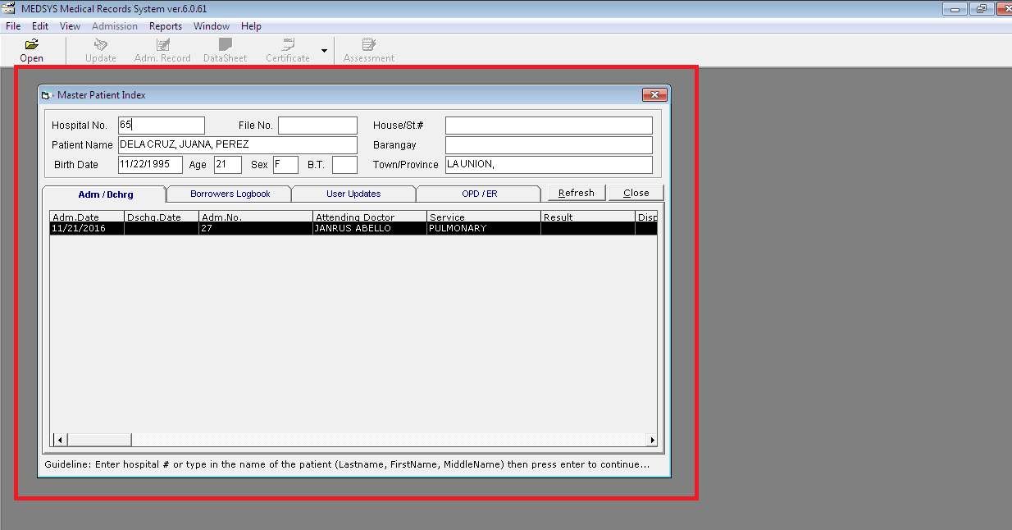
Figure 5: List of Patient’s Confinements

4 Click the patient’s confinement to work with. You can now click a toolbar button to start a transaction.

Borrowing of patient’s Medical Record

This option logs all the transactions done in borrowing inpatient medical record. It has options to borrow inpatient medical record, edit a borrowed inpatient medical record, and delete a borrowed inpatient medical record.

1 To open the window,
After searching the patient (see page 10), the list of his confinements will be displayed. Click the confinement to use and then click Borrowers Logbook tab. Transactions done on borrowed medical record with that confinement will be displayed.

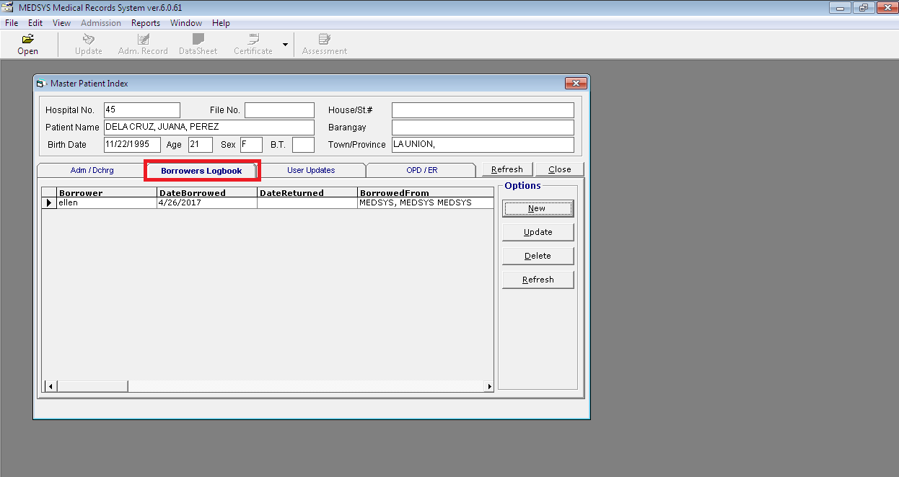
Figure 6: List of Transactions on Borrowed Medical Record
You can view here the borrower’s name, date borrowed, date returned and borrowed from.

- To edit or return a borrowed medical record, click the transaction from the list and then click the Update button. Its information will be displayed. You can now edit the data. Click the Save button to save the changes entered.
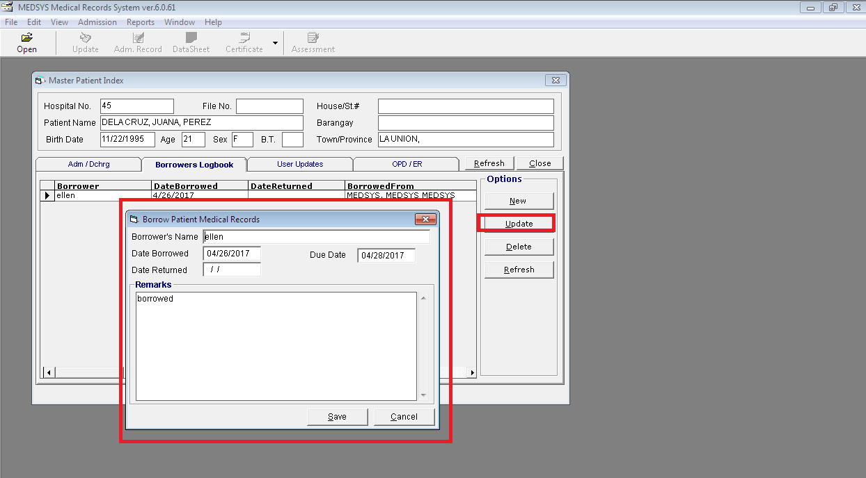
- To delete a borrowed medical record, click the transaction from the list and then click the Delete button. A message will appear. Click the Yes button to delete or No to undo and to go back to the window.
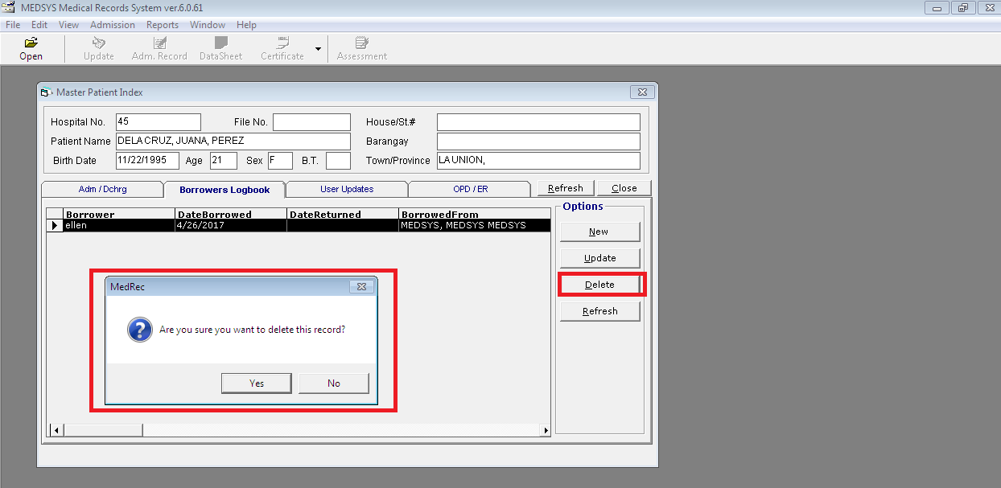

2 To borrow a medical record, click the new button to open its window.

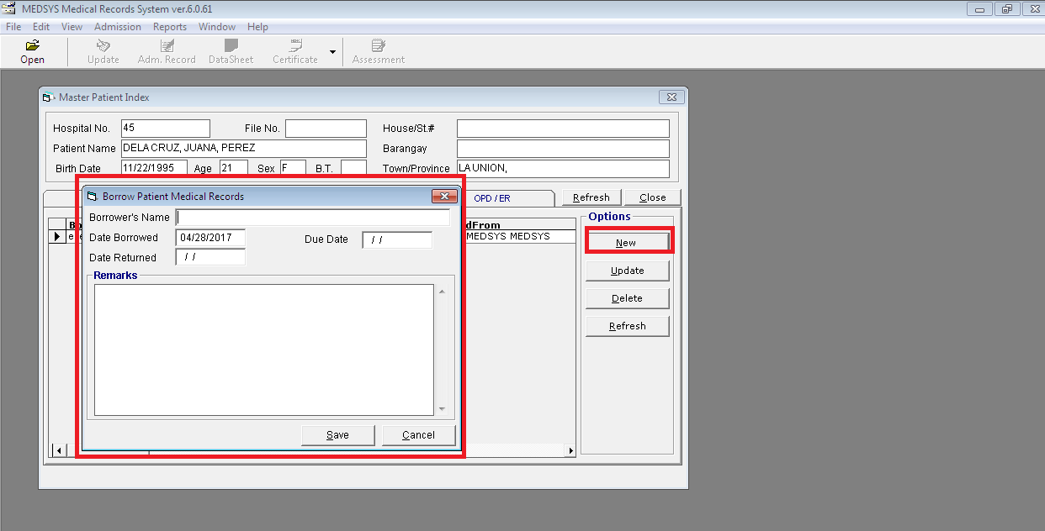
Figure 7: Borrow Medical Record Entry
Complete the following data.
Borrower’s Name - Type the borrower’s name and then press <Enter>.
Date Borrowed - Type the date of release following the format mm/dd/yyyy where mm is month, dd is day, and yyyy is year.
Date Returned - Type the date of return following the format mm/dd/yyyy where mm is month, dd is day, and yyyy is year.
Remarks - Type your remarks.
Click the Save button to save the borrowed medical record. Otherwise, click the Cancel button to close the window without saving the entered data.

Updating of patient’s Medical Record

This option allows you to edit the patient’s medical record.

1 After searching the patient (see page 10), his confinements will be displayed. Click the confinement you want to update and then click the Update toolbar button to open its window. The patient’s admission/discharge information, diagnosis and other relevant information will be displayed.
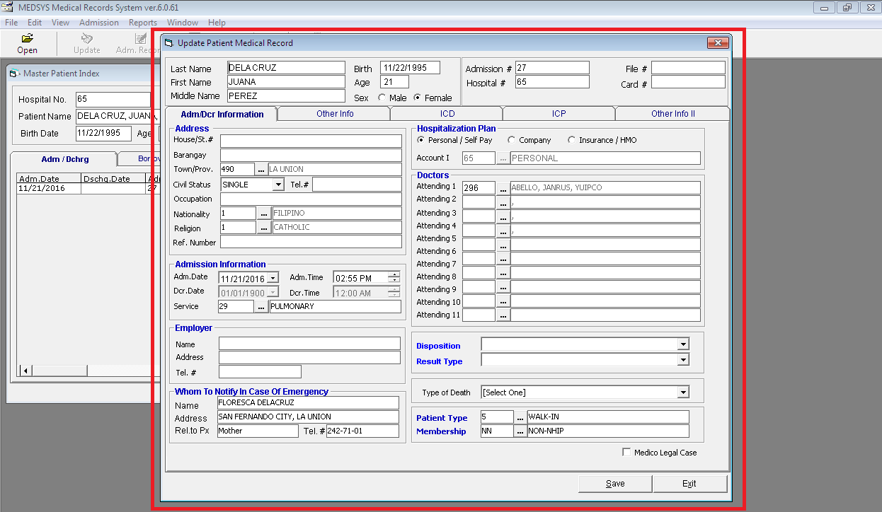
Figure 8: Update Patient Medical Record Window

You can now edit information under Adm/Dcr Information tab, Other Info tab, ICD and ICP tab.
Update also the Clinical Summary Information tab as shown below.
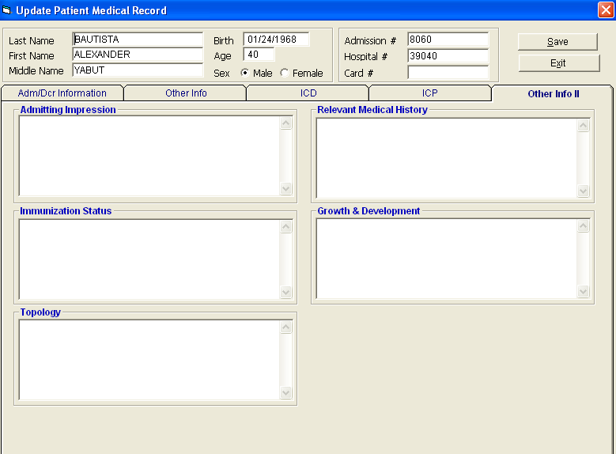
2 Click on Save button to save changes entered or click on Exit button to go out from this window

Printing of Data Sheet (Admission and Discharge Record)

This option lets you print the patient’s data sheet (admission and discharge record) of a particular confinement.
- After searching the patient (see page 10), his confinements will be displayed. Click the confinement you want to use to print data sheet and then click the Data Sheet toolbar button. A printable data sheet will be generated. Click the to print.

Printing of Medical Certificate & Certificate of Confinement

This option lets you print the patient’s medical certificate and certificate of confinement.

1 After searching the patient (see page 10), his confinements will be displayed. Click the confinement you want to use and then click the drop-down arrow in Certificate toolbar button to display options. Click Medical Certificate to print patient’s medical certificate or click Certification to print patient’s certificate of confinement. Click the to print.

Printing of Inpatient Confinement Record

This option lets you view and print the patient’s list of confinements.

1 After searching the patient (see page 10), his confinements will be displayed. Click a confinement and then click the Confinement Rec. toolbar button. A printable report will be generated. Click the to print.

User’s Logbook

This option logs the transactions done by the user to a particular patient.

1 After searching the patient (see page 10), click the User Updates tab to open its window.

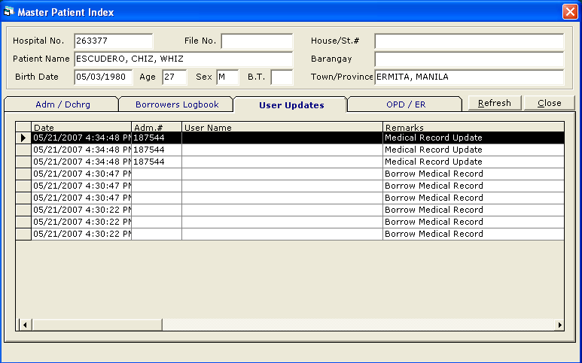
Figure 9: User Logbook Window
You can view here the user’s date of transaction, user name, patient’s admission number, remarks, and patient’s date discharge.

2 Click the Refresh button to get the latest update of user logbook.
Click the Close button to close the window.

Updating of ICD

This option allows you to edit a particular disease from the ICD list.

1 To open the window, click ICD tab
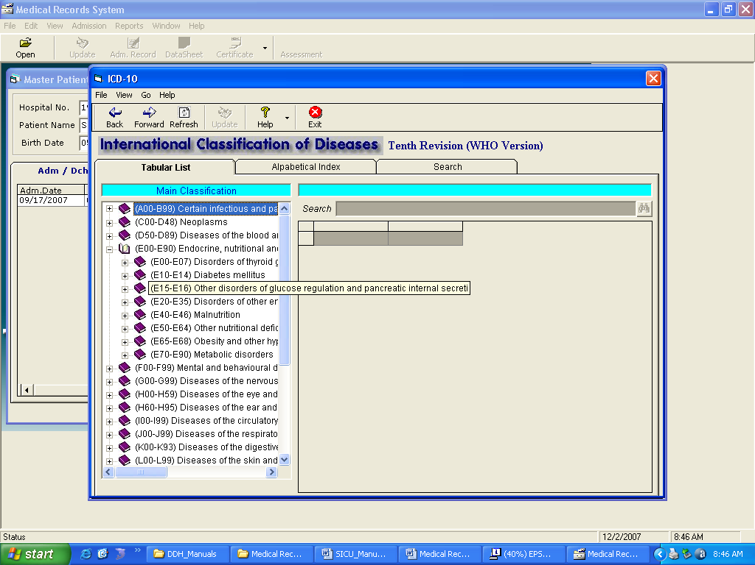

Figure 10: ICD Update Window

2 Under ICD 10 entry, enter the ICD code to automatically display description or type the first few characters of the disease name and then press <Enter>. The ICD window will appear matching the query typed.
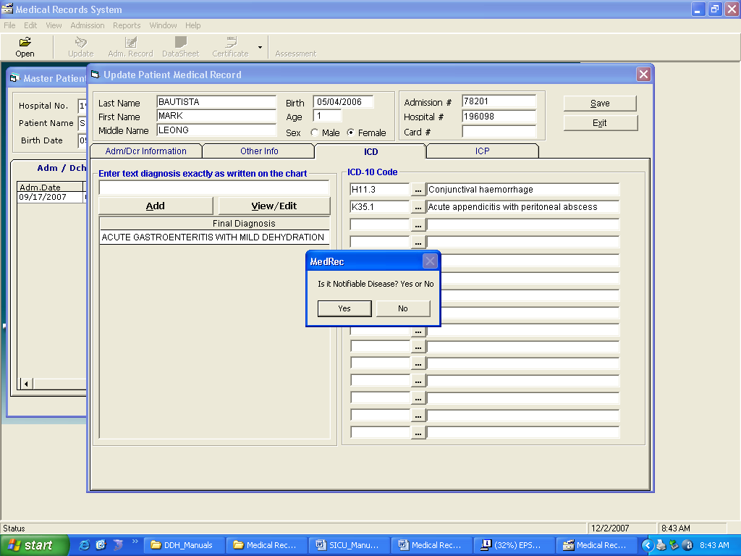

Figure 11: ICD Window

The ICD window displays all kinds of diseases. Just double-click on the disease name to select.

3 Back to the ICD Update window, under Options entry, click the check box beside the option you want to update for the selected disease. Options to choose from are Left, Right, and Bilateral.

4 Click the Save button afterwards to save changes entered.

Consolidation of Hospital Number

During admission registration, there are instances that patient’s name are typed incorrectly. The program validation can’t keep track duplicated hospital number if incorrect data are inputted as evidenced by GIGO (Garbage In, Garbage Out) principle. As a result, two hospital numbers are assigned to one patient. To correct this, the program has an option to merge two hospital numbers. Only patient information excluding charges will be consolidated.

1 Press Ctrl + H or click File > Consolidate Hospital Number.

2 The Consolidate Hospital Number window will be displayed. The following data are needed to enter:

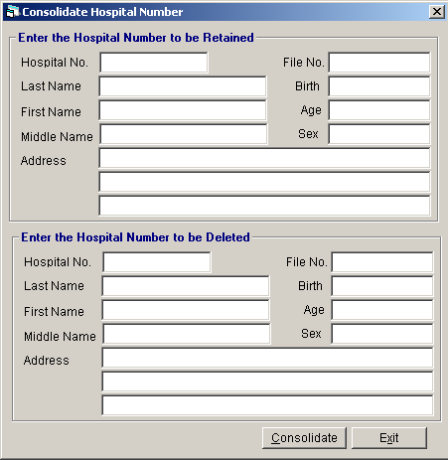
Figure 12: Merge Hospital Number of Patient Window

Hospital # to be Retained - Type the hospital number of the patient to be retained then press <Enter>. After enter key is pressed, the program will automatically retrieve the patient’s name , birthday , address, file no., sex and age.
Hospital # to be Deleted – Type the hospital number of the patient to be deleted then press <Enter>. After enter key is pressed, the program will automatically retrieve the patient’s name, birthday , address, file no., sex and age.

- To start consolidating, click on Consolidate button. The consolidating process may take long before its completion.

Reports

The following reports are generated by the program. Click the Report pull-down menu to display list and then click on the desired report you want to view and print.

Registers
- Admission
- Discharge
- Birth
- Death
Indexes
- Disease
- Operation
- Physician
Statistical Reports
- Doctor’s Patient Load ( By Status, By Service, By Consultant )
- Monthly Statistical Report
- Monthly Discharges by Demography
- Detailed Morbidity Report
- Detailed Mortality Report
- Morbidity Summary Report
- Mortality Summary Report
- Top 20 Leading Causes of Morbidity
- Top 20 Leading Causes of Mortality
- Top 10 Leading Diagnosis
- Top 10 Leading Procedures
Census Reports
- Daily Admission List
- Daily Discharge List
- Daily Census Report by Station
- Daily Hospital Statistics
- Monthly Hospital Statistics
- Hospital Statistics (By Period)
- ER Grand Census Report
- Yearly Procedure Centsus
- Yearly Final Diagnosis Census
- Total Admission & Patient Days Care
- Mortality Line Listing of Patients
- Admission Logbook
- Monthly statistical Report By Service
- Monthly Total Admission by Station
- Monthly Discharge by Station
- Monthly Total Confinement by Station
Others
- Annual Report
- List of Unreturned Charts
- List of Incomplete Medical Records
- Monthly – Total Outcome of Treatment
- Yearly – Total Outcome of Treatment
- Print Medical Certificate ( Old Patients )
- List of Transferred Patients
- List of DAMA Patients
- List of Absconded Patients
New DOH Formats
- Monthly Leading Causes of Mortality
- Monthly Leading Causes of Morbidity
- Yearly Leading Causes of Mortality
- Yearly Leading Causes of Morbidity

Index

—B—
borrowing of patients medical record, 12
—C—
certificate of confinement (printing of), 15
close the program, 8
consolidate hospital number, 19
—D—
data sheet(printing of), 15
—E—
end the program, 8
—F—
features, 5
—I—
ICD (updating of), 17
—L—
logbook, 17
—M—
medical certificate (printing of), 16
medical record (borrowing of), 12
medical record (updating of), 14
—O—
objectives, 5
overview, 4
—P—
password (changing of), 7
patient searching, 9
—R—
reports, 27
—S—
start the program, 6
—U—
user logbook, 17

