MEDSYS
Hospital Information System

Visual Laboratory Program
User's Manual



MEDSYS
Kaiser - dela Cruz Consulting, Inc.
July 28, 2026
Copyright© 2009
ALL RIGHTS RESERVED

No part of this document may be reproduced through photocopying or in any means, stored into a retrieval system, and transmitted in any form without the express written permission of Kaiser - dela Cruz Consulting, Incorporated.
Permission is hereby granted to Notre Dame De Chartres Hospital to copy and distribute this document in any of the above means provided this is for its exclusive on site use.
Although every precaution has been taken in the preparation of this manual, the company assumes no responsibility for errors or omissions. Neither is any liability assumed for any damages resulting from the use of the information contained here.

Table of Contents

Overview 5
Getting Started 6
Starting the Program 6
How to Change Password 7
Closing the Program 8
Program Operations 9

Holiday Tagging 9
Data Entry 10
Inpatient Request 10
Charge-basis Outpatient Request 12
Cash-basis Patient Request 14
Request Form Printout 16
Result Entry per Batch 18
Result Entry per Exam 200
File Maintenance 22
Result Editing/Verification 22
Charge-slip Reprinting 25
Charge-slip Verification 26
Exams List Printout 27
Patient’s Ledger 28
Request Cancellation/Charge-slip Reprinting 29
Changing of Specimen 30
Result 31
Result Inquiry 311
Result Verification 33
Urinalysis Daily Report 35
Communication File 36
Reports 38
Build Files 39
Build Laboratory Form Formats 40
Profile 41
Antibiotics 46
Walk-in Master File Update 48
Specimen 50
Exam/Procedure 52
Build Reagent Normal Values 54
References 55
References 55
Exam Form Format 57

Overview



The Visual Laboratory Program is a computerized posting of request on laboratory procedure. It is interlinked to nurse stations, cost-centers and financial departments mainly for the processing of entered requests and payments. Exam results are electronically retrieved thru Visual Programs connected to machines and can be displayed to nurse stations, intensive care unit, emergency room, and operating room once verified.
Its features ensure friendliness to user for them to understand the flow of the program from entering request until the posting of results. It is equipped with internal controls to warning users from their actions.
To maintain the integrity and confidentiality of data, a password is needed to enter before one can access the program. Defined rights are also imposed to limit the accessibility of the program’s processes.

Getting Started

Starting the Program

1 Double-click on Laboratory Program executable file icon located in your computer desktop.
2 The Login window will be displayed for you to type your employee number and password for security purposes.

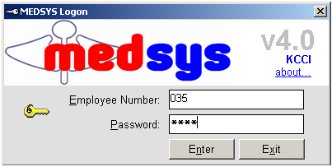
Figure 1: Login Window

3 After entering the employee number and password correctly, you may now start a transaction. Otherwise, a message will be displayed prompting “Unauthorized User”.

How to Change Password

1 From the Login window, type your employee number and then press <Enter>.

2 Under the Password entry, press <F12>. Pressing this function key will invoke the Change Password window.

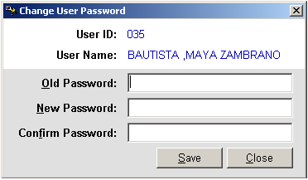
Figure 2: Change Password Window
3 Under the Change Password window, type the following data.
Old Password - Type your existing password.
New Password - Type your new password not exceeding to 15 characters.
Confirm Password - Retype your new password to confirm and then press <Enter> or you can click the Save button.

Closing the Program
It is important for users to close the program when they are done to end-up their session. Other users might use the open program using the same password. However, there is an option to lock the program while not in-use. Just press <Ctrl + L> to activate.

To close the program:
1 Click on button located at the upper right corner of the main window (possible only if no other window is open)

Program Operations

Holiday Tagging
This option will determine if the date is holiday not. The purpose of this is for the automatic computation of 50% mark up on charges. After entering employee number and password, the window below will appear for the tagging.

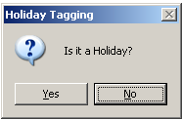

Click YES if Holiday and NO if not.

Data Entry

Inpatient Request
Use this option when stations or other cost-centers cannot post request using their own program due to program breakdown. It allows you to post inpatient request on laboratory procedures.

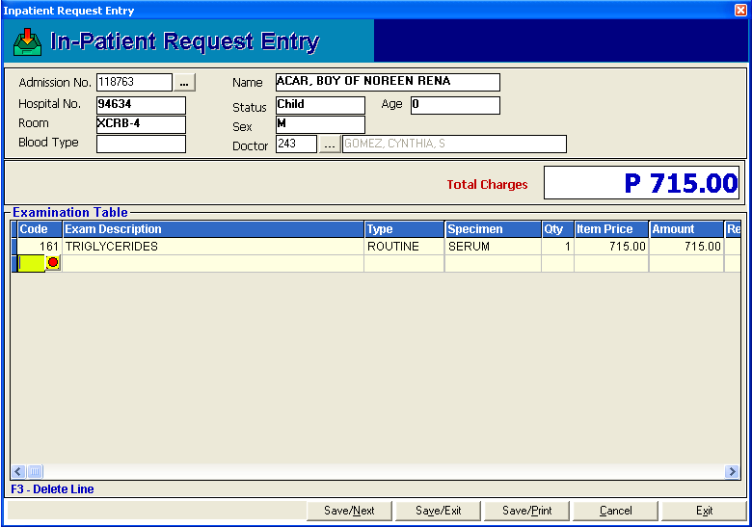
Figure 3: Inpatient Request Entry Window

Inputs:
Press <F4> to start

      - Type patient’s admission number and press <Enter>. To search by last name, type the first few letters of the patient’s last name and then press <Enter>. Double-click the patient’s name to select.
      - Enter item code of exam. To search by item name, type the first few characters of the item name and then press <Enter>. Just double-click it from the list to select.
      - Choose examination type: Routine or Stat
      - Choose specimen (for exams with more than one specimen)
      - Choose doctor (for exams with professional fee). To search by last name, type the first few letters of the doctor’s last name and then press <Enter>. Double-click the doctor’s name to select.
      - Choose saving option
- Save/Next - Saves currently entered items proceeding to other patient’s charges entry.
- Save/Exit - Saves currently entered items and closes the Inpatient Request Entry Window.
- Save/Print - Saves and prints currently entered items.

Note:
- The professional fee is automatically displayed based on the saved fee entered using the Build File program.
- For non-exam items, you may change the quantity under 'Qty' column.

Output:
Charge-slip printout

Charge-basis Outpatient Request
This is an option to enter charge-basis outpatient request on laboratory procedures.

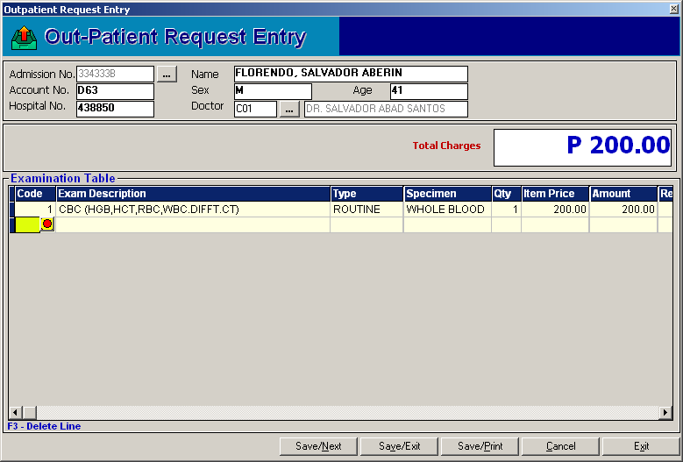
Figure 4: Charge-basis Outpatient Request Window

Inputs:
Press <F5> to start

- Enter patient’s admission number. To search by last name, type the first few letters of the patient’s last name and then press <Enter>. Double-click the name to select.
- Choose patient’s doctor. To search by last name, type the first few letters of the doctor’s last name and then press <Enter>. Double-click the doctor’s name to select.
- Enter item code. To search by item name, type the first few characters of the item name and then press <Enter>. Just double-click it from the list to select.
- Choose examination type: Routine or Stat
- Choose specimen (for exams with more than one specimen)
- Choose doctor (for exams with professional fee). To search by last name, type the first few letters of the doctor’s last name and then press <Enter>. Double-click the doctor’s name to select.

Choose saving option
- Save/Next - Saves currently entered items proceeding to other patient’s charges entry.
- Save/Exit - Saves currently entered items and closes the Charge-basis Outpatient Request Entry Window.
- Save/Print - Saves and prints currently entered items.

Note:
- The professional fee is automatically displayed based on the saved fee entered using the Build File program.
- For step #2, if doctor’s name is not in the list, type '0' as doctor’s code and then type the doctor’s name.
- For non-exam items, you may change the quantity under 'Qty' column.

Output:
Charge-slip printout

Cash-basis Patient Request
This provides an option to enter request of cash-basis patient on laboratory procedures.

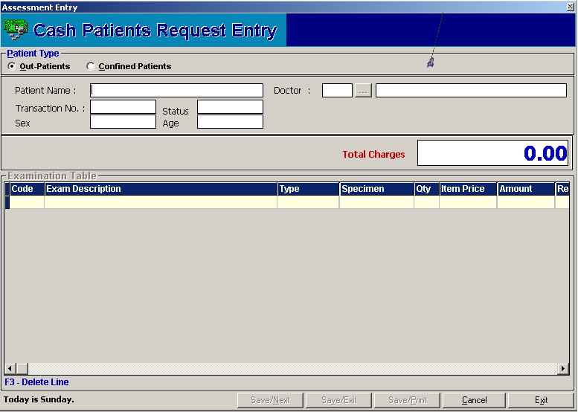
Figure 5: Cash-basis Patient Request Window
Inputs:
Press <F6> to start

- Choose patient type: Walk-in, OPD/Regular Patients, or Confined Patients
- Enter patient’s last name. To search, type the first few letters of last name and then press <Enter>. Double-click the patient’s name to select.
- Choose patient’s doctor. To search by last name, type the first few letters of the doctor’s last name and then press <Enter>. Double-click the doctor’s name to select.
- Enter item code. To search by item name, type the first few characters of the item name and then press <Enter>. Just double-click it from the list to select.
- Choose examination type: Routine or Stat
- Choose specimen (for exams with more than one specimen)
- Choose doctor (for exams with professional fee). To search by last name, type the first few letters of the doctor’s last name and then press <Enter>. Double-click the doctor’s name to select.
- Choose saving option
- Save/Next - Saves currently entered items proceeding to other patient’s charges entry.
- Save/Exit - Saves currently entered items and closes the Cash-basis Patient Request Entry Window.
- Save/Print - Saves and prints currently entered items.

Note:
- The professional fee is automatically displayed based on the saved fee entered using the Build File program.
- For step #2, if doctor’s name is not in the list, type '0' as doctor’s code and type the doctor’s name.
- For non-exam items, you may change the quantity under 'Qty' column.

Output:
Assessment-slip printout

Request Form Printout
This allows you to generate printout of request form of the entered charge-slip number.
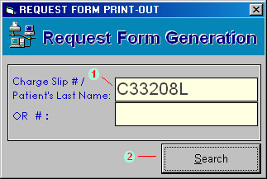
Figure 6: Request Form Printout: Charge-slip/Patient/OR Searching

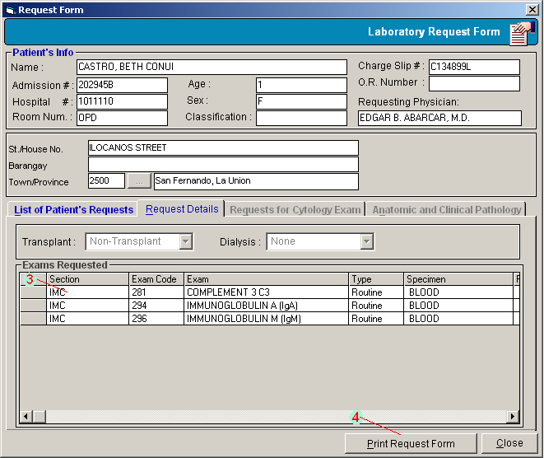
Figure 7: Request Form Printout: Request Details

Inputs:
Press <F7> to start

- Enter charge-slip number, patient’s last name or official receipt number. To search by last name, type the first few letters of the last name and then press <Enter>. Double-click the patient’s name to select.
- Click ’Search' button.
- Choose the exam from the list.
- Click 'Reprint Request Form' button.

Output:
Request Form Printout

Result Entry per Batch
This option allows you to enter exam result per batch. Only exams having the same charge slip number, result format, and section are allowed to enter in this option.
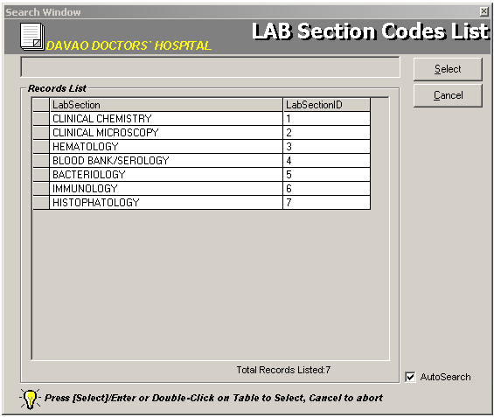
Figure 8: Result Entry per Batch: Laboratory Sections List Window

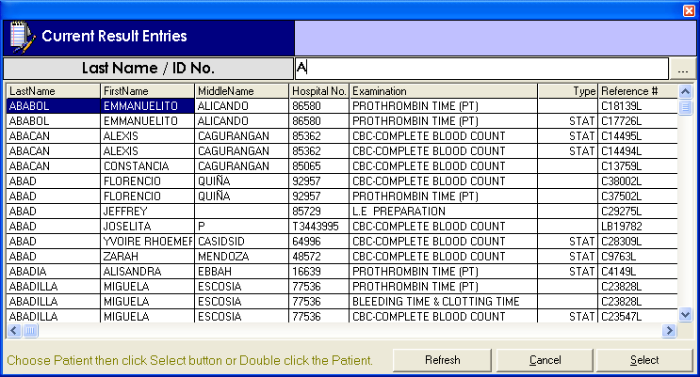
Figure 9: Result Entry per Batch: Lastname/Admission # Searching

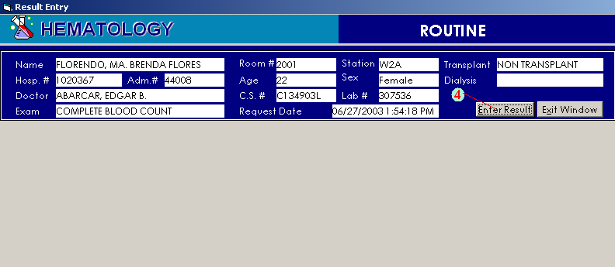
Figure 10: Result Entry per Batch: Result Entry
Inputs:
Press <Ctrl + H> to start.

1 Choose laboratory section. To choose, double-click the section name from the list.
2 Enter patient’s admission number. To search by last name, type the first few letters of the last name and then press <Enter>.
3 If last name was typed, double-click the patient’s name from the list
4 Click 'Enter Result' button. Each exam has its result format. Please refer to the Exam Result Format of this documentation

Result Entry per Exam
This option allows you to enter exam result. Its entry is done per exam.

Figure 11: Result Entry per Exam: Laboratory Sections List Window

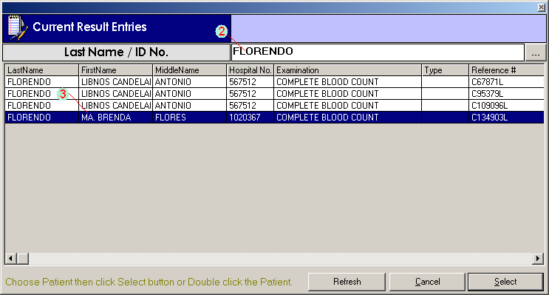
Figure 12: Result Entry per Exam: Lastname/Admission # Searching

Figure 13: Result Entry per Batch: Result Entry

Inputs:
Press <Ctrl + E> to start.

1 Choose laboratory section. To choose, double-click the section name from the list.
2 Enter patient’s admission number. To search by last name, type the first few letters of the last name and then press <Enter>.
3 If last name was typed, double-click the patient’s name from the list
4 Click 'Enter Result' button. Each exam has its result format. Please refer to the Exam Result Format section of this documentation.

File Maintenance

Result Editing/Verification
This feature allows you to enter modifications on the saved unverified/verified result. You can also verify exam result in here.

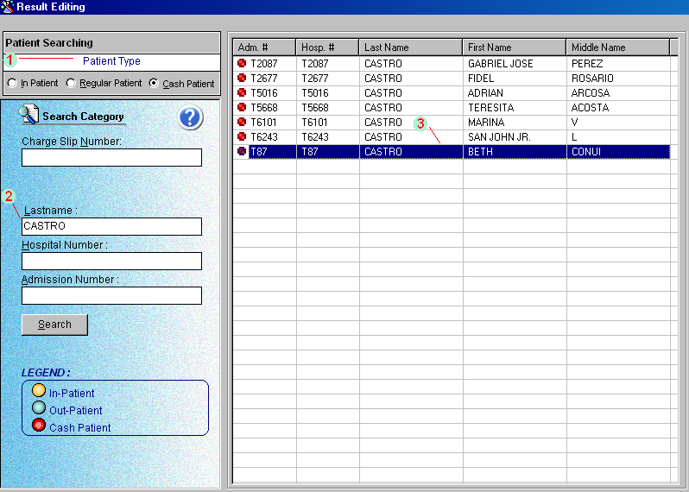
Figure 14: Result Editing/Verification: Patient Searching

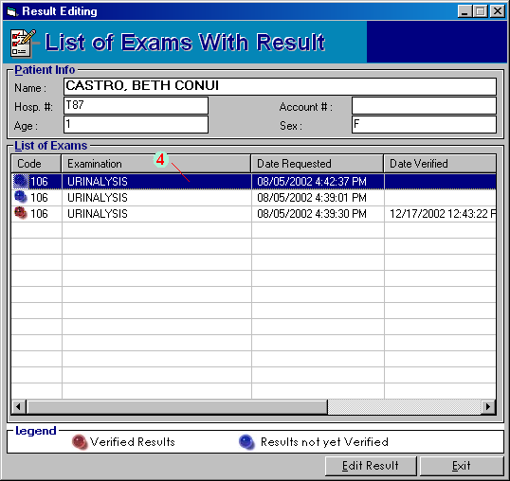
Figure 15: Result Editing/Verification: List of Exams

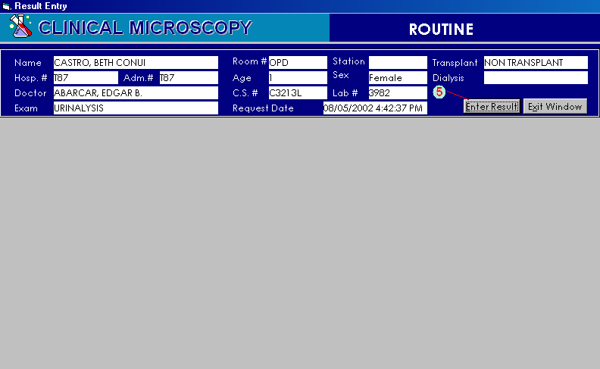
Figure 16: Result Editing/Verification Window
Inputs:
Press <F12> or click File Maintenance button and then click Result Editing/Verification to start.

1 Select patient type <Inpatient, Regular Patient, or Cash Patient>
2 Use one of the following search categories and then click Search button (Charge-slip, Lastname, Hospital Number, Admission Number)
3 Matches will be displayed. Double-click the patient’s name from the grid. Note: The color beside the row determines the type of patient. Refer to the lower left corner of the window to see legend of patient type.
4 List of exams of the selected patient will be displayed. Double-click the exam to select. Note: The color beside the row determines the classification of result as to verified or unverified.
5 The result entry window will appear. Click the Enter button. Depending on the exam name, each has its result format. Please refer to the result format section of this documentation.

Charge-slip Reprinting
This is allows you to produce a copy of charge-slip.

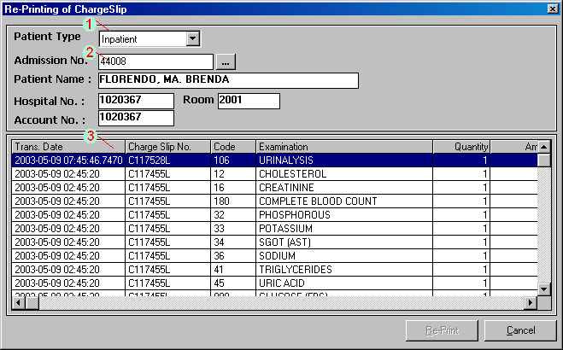
Figure 17: Charge-slip Reprinting Window

Inputs:
Press <Ctrl + D> or click File Maintenance button and then click Charge-slip Duplicate to start.

1 Select patient type (Inpatient, Charge Patients, Cash Patients)
2 Enter patient’s admission number. To search by last name, type the patient’s last name and then press <Enter>. Double-click the patient’s name to select.
3 Double-click the charge-slip from the list to select. The print preview will be generated afterwards.

Charge-slip Verification
This option allows you to view the details of the entered charge-slip.

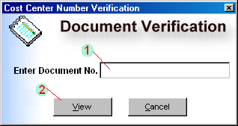
Figure 18: Charge-slip Verification Window

Inputs:
Press <Ctrl + V> or click File Maintenance button and then click Verification to start.

1 Type the document number (charge-slip)
2 Click View button.
3 The print preview will be generated afterwards showing the charge-slip details including the item name & amount, patient’s admission number & hospital number, date of request, and the user who requested the item.

Exams List Printout
This is an option to print the list of laboratory items/exams.

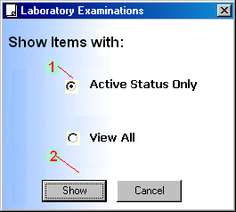
Figure 19: Exams List Printout Window

Inputs:
Press <Ctrl + L> or click File Maintenance button and then click List of Items/Exams to start.

1 Click the desired option.
2 Click Show button.
3 The print preview will be generated showing the list of laboratory examinations including the item code, charging name, short name, and format type.

Patient’s Ledger
This is an option to view patient’s laboratory ledger based on the posted charges on laboratory procedures.

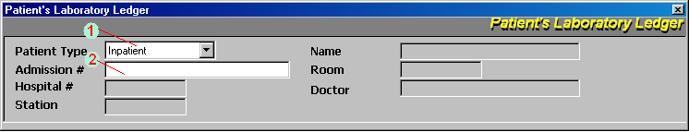
Figure 20: Patient’s Ledger: Patient Searching

Inputs:
Press <Ctrl + G> or click File Maintenance button and then click Patient’s Ledger to start.

1 Select patient type (Inpatient, Outpatient)
2 Enter patient’s admission number. To search by last name, type the first few letters of patient’s last name and press <Enter>. Double-click the patient’s name from the list to select.
3 The print preview will be generated showing the patient’s laboratory ledger (arranged by transaction date) including the charges-slip number, item code, description & quantity, amount, user who requested, and time of request.

Request Cancellation/Charge-slip Reprinting
This option is used to cancel entered laboratory exam request or reprint charge-slip.

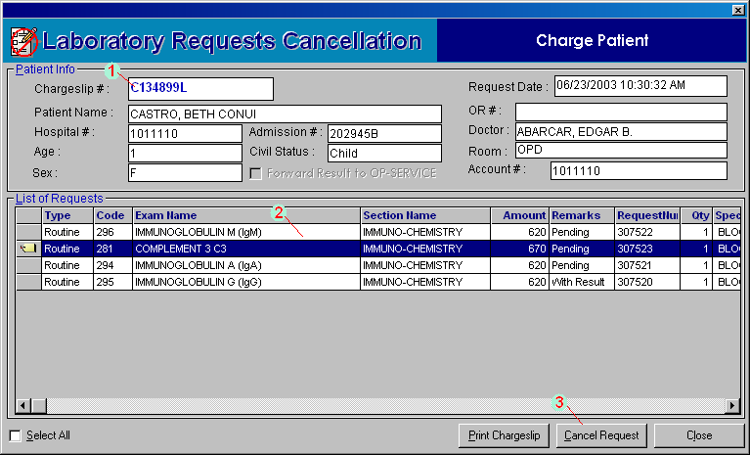
Figure 21: Request Cancellation/Charge-slip Reprinting Window

Inputs:
Press <F8> or click File Maintenance button and then click Request Cancellation/Reprint Charge-slip to start.

1 Enter charge-slip number and then press <Enter>. To search by last name, type the first few letters of patient’s last name and then press <Enter>. Double-click the patient’s charge-slip number to select.
2 List of items under the selected charge-slip will be displayed. Select the item from the list to select. You may click the check box beside ’select All’ at the bottom of the window to tag all items (yellow tag indicator) which can be cancelled.
3 Click ‘Cancel Request’ button. Remarks of cancelled items will be then changed to ‘Cancelled’.

Changing of Specimen
This option allows you to change specimen of requested laboratory exam.

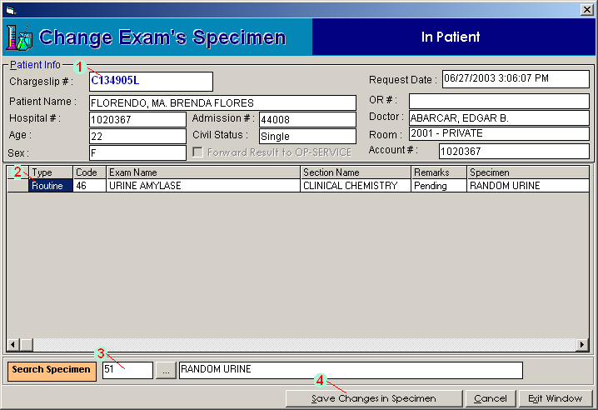
Figure 22: Changing of Specimen Window

Inputs:
Click File Maintenance button and then click Change Exam Specimen.

1 Enter charge slip number under ‘Chargeslip #’ textbox and then press <Enter>. To search by last name, type the first few letters of the patient’s last name and then press <Enter>. If found, patient listings will be displayed. Double-click the patient’s name to select.
2 Exams under the entered charge-slip will be displayed. Click the exam from the list to select.
3 Change the exam’s specimen by deleting the code under the ’Search Specimen' textbox. Press <Enter> to display the list of specimens under the selected exam. Double-click the specimen from the list to select.
4 Click ’Save Changes in Specimen' button to update changes.

Result

Result Inquiry
This feature provides an option to view and print verified or unverified exam result.
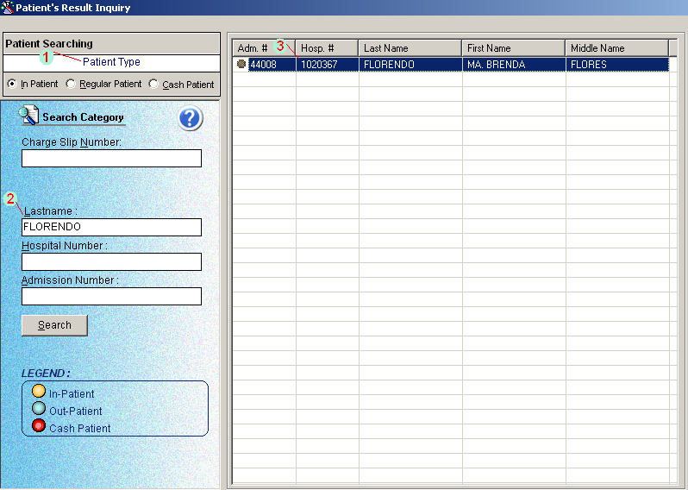
Figure 23: Result Inquiry: Patient Searching

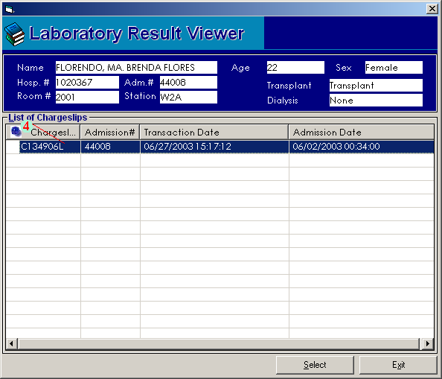
Figure 24: Result Inquiry: List of Charge-slips

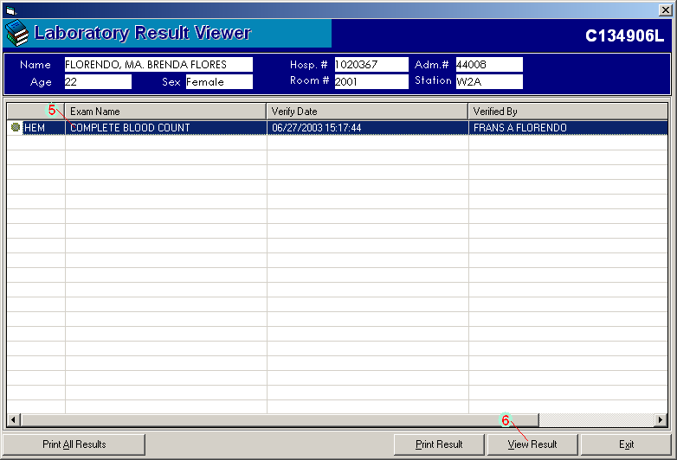
Figure 25:Result Inquiry: Exam Selection and Result Viewing/Printing

Inputs:
Press <Ctrl + I> to start

1 Select patient type (Inpatient Patient, Regular Patient, Cash Patient)
2 Use one of the following search categories and then click Search button (Charge-slip, Lastname, Hospital Number, Admission Number)
3 Matches will be displayed. Double-click the patient’s name from the grid.
4 Patient’s charge-slips will be displayed. Double-click the charge-slip to select.
5 Exams under the selected charge-slip will be displayed. Choose the exam from the grid.
6 Click ‘View Result’ button to view the print preview of the exam result.

Result Verification

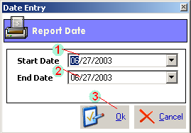
Figure 26: Result Verification: Date Entry

Figure 27: Result Verification: Laboratory Sections List Window

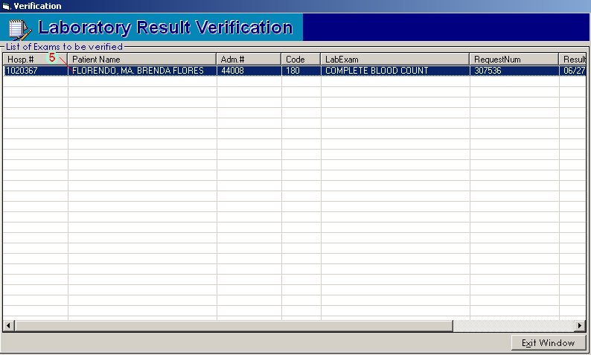
Figure 28: Result Verification: Exam Selection

Inputs:
Press <Ctrl + V> to start

1 Enter starting date.
2 Enter ending date.
3 Click ‘OK’ button.
4 The laboratory sections will be displayed. Double-click the section to select.
5 List of patients with exam results under the selected section will be displayed. Double-click it to select.

Urinalysis Daily Report

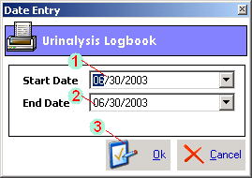
Figure 29: Urinalysis Daily Report: Date Entry

Inputs:
Press <Ctrl + U> to start.

1 Enter starting date.
2 Enter ending date.
3 Click ‘OK’ button. The print preview will be displayed from the entered starting to ending dates.

Communication File

This option serves as a way nurse stations and other cost centers requesting laboratory examinations to communicate with the laboratory department. The program will signal the laboratory department thru a blinking button to process the entered requests.
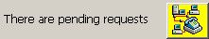
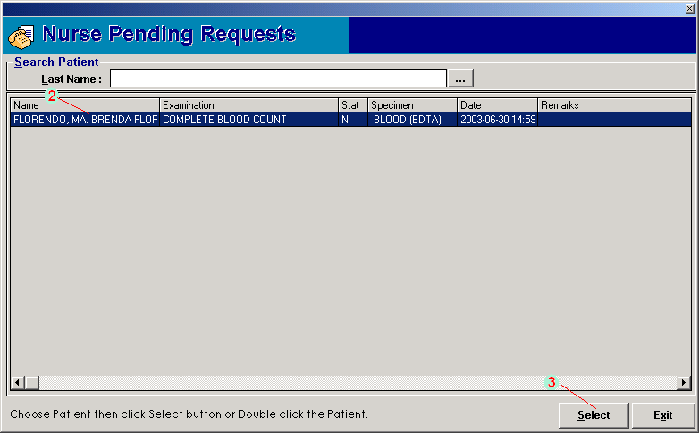
Figure 30: Communication File: Patient Searching

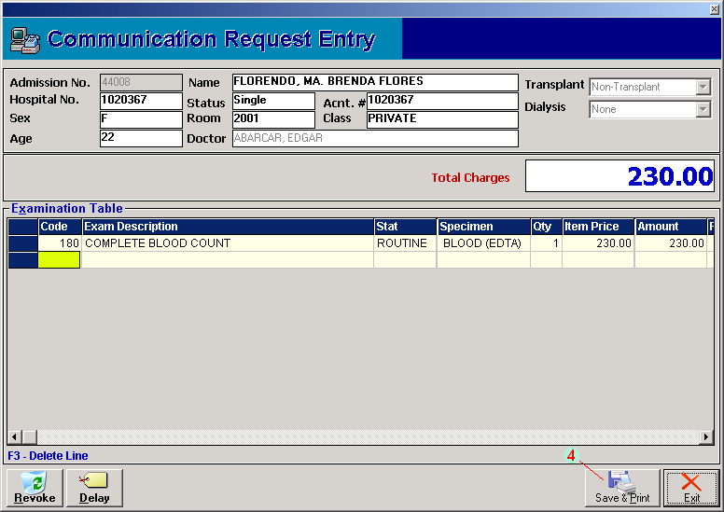
Figure 31: Communication File: Request Saving /Printing

Inputs:
Press <Ctrl + C> to start or

1 Click 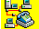 blinking button.
2 List of pending requests will be displayed. Select the request to process.
3 Click ’Select’ button.
4 The ‘Communication Request Entry’ window will be displayed. Click ’Save & Print’ button.

Note: You may revoke the request by clicking the ‘Revoke’ button in the ‘Communication Request Entry’ window.

Reports

Below is the list of reports being generated by the program. Just click 'Reports' > and then click the report you want to generate.

- Daily Transaction Report
- List of Exam and Specimens
- Daily Statistical Report
- Doctors Contribution
- List of Pending Results
- List of Finished Results
- Pending Requests from Nursing
- Processed Requests from Nursing
- Monthly Statistical Report
- Profile Exams Report
- List of Assessment
- Processed Requests from Communication

Build Files
This feature is protected by a password so only users having the rights to modify properties of exams are allowed.

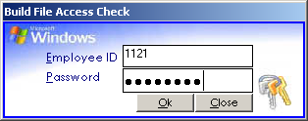

Build Laboratory Form Formats
This option assigns a particular exam the format to use in the result entry.

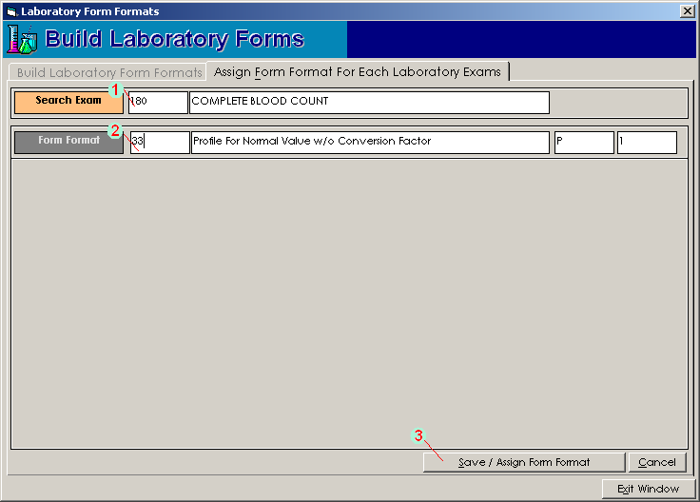
Figure 32: Form Format Entry Window
Inputs:
Press <Ctrl + N> to start

1 Search the exam. To search, type the first few characters of the exam name and then press <Enter>. Double-click the exam to select.
2 Search the form format. To search, type the first few characters of the form format name and then press <Enter>. Double-click the form format to select.
3 Click ’Save/Assign Form Format' button to save.

Profile
Use this option to add exams in a particular profile.

Inputs:
Press <Ctrl + P> to start

To add new profile in the list

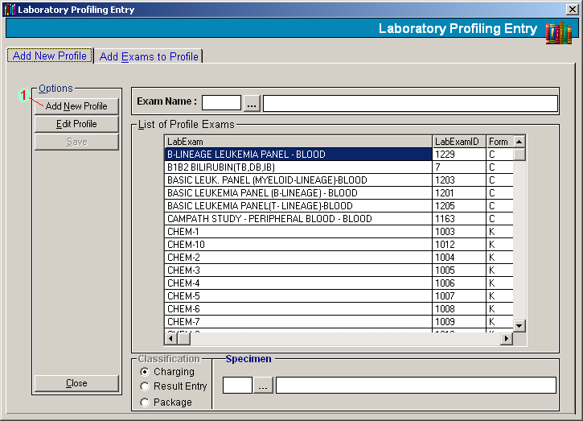
Figure 33: New Profile Entry

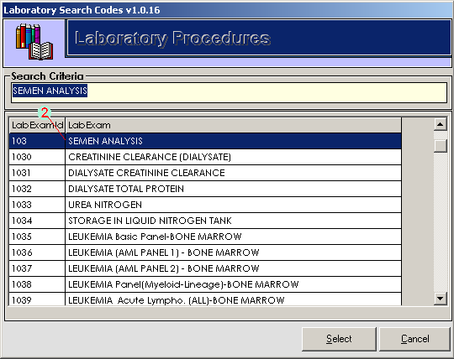
Figure 34: New Profile Entry: Exam Selection

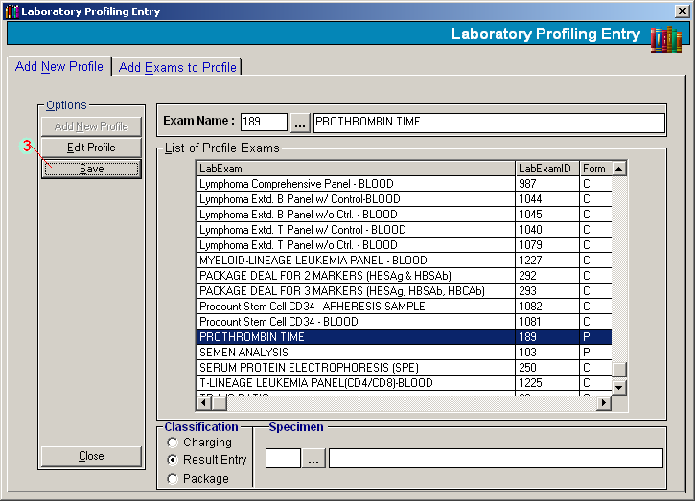
Figure 35: New Profile Entry: Save Entry

1 From the 'Add New Profile' tab, click 'Add New Profile' button under 'Options'.
2 List of laboratory profiles will be displayed. Double-click the exam to select.
3 Click ’Save' button to save.

To edit existing profile

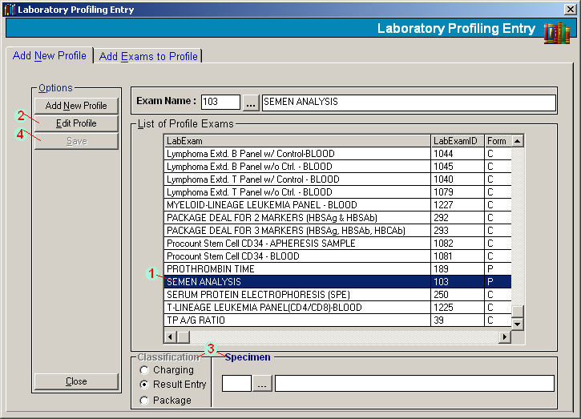
Figure 36: Edit Profile: Exam Selection

1 From the 'Add New Profile' tab, select the profile from the list to edit.
2 Click 'Edit Profile' button under 'Options'.
3 You may now change the profile classification and specimen.
4 Click ’Save' button to save changes.

To add exams to profile

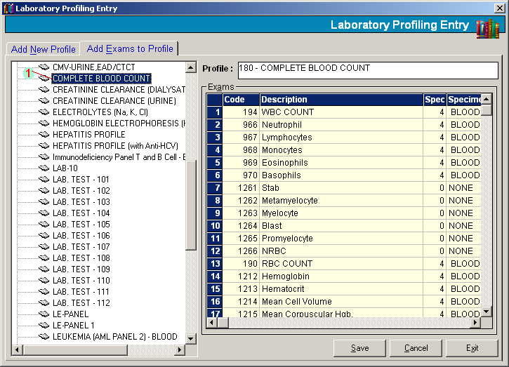
Figure 37: Add Exam to Profile: Profile Selection

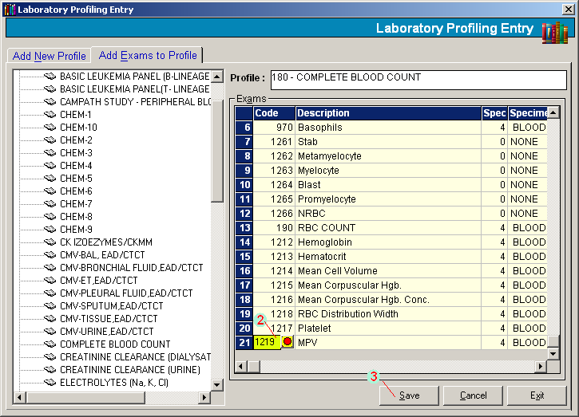
Figure 38: Add Exam to Profile: Exam Entry and Saving

1 From the 'Add Exams to Profile' tab, click the profile. List of exams under the selected profile will be displayed.
2 Click the last row of the grid and then press <Enter> until it reaches the next row. To search exam, type the first few characters of the exam name and then press <Enter>. Double-click the exam to select.
3 Click ’Save' button to save.

Antibiotics
This allows you to build antibiotics to be used by the form format “culture and sensitivity”.

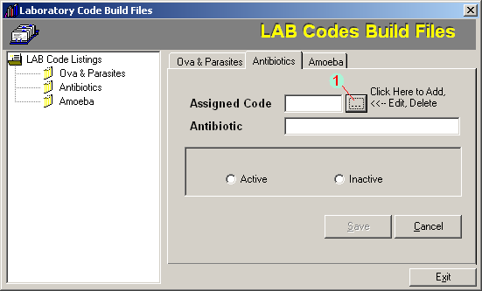
Figure 39: Antibiotics Entry

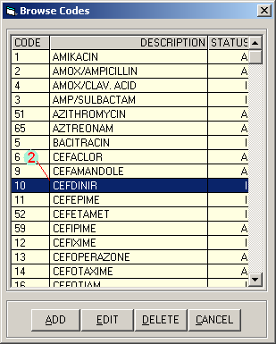
Figure 40: Antibiotics Selection

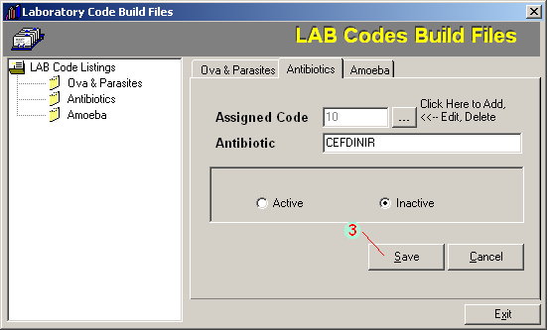
Figure 41: Antibiotics: Saving Entry

Inputs:
Press <Ctrl + B> to start

1 From the 'Antibiotics' tab, click beside 'Assigned Code'.
2 The list of antibiotics will be displayed. Click the antibiotics from the list to select.
- To add, click 'ADD' button then type the antibiotic name. Select 'Active' or 'Inactive'.
- To edit, click 'EDIT' button. You may now edit the antibiotic name.
- To delete, click 'DELETE' button.
3 Click ’save' button if selected button is 'ADD' or 'EDIT'

Walk-in Master File Update
This option allows you to update data of walk-in patients such as last name, first name, middle name, birth date, gender, civil status, house number and street, barangay, and town/province.

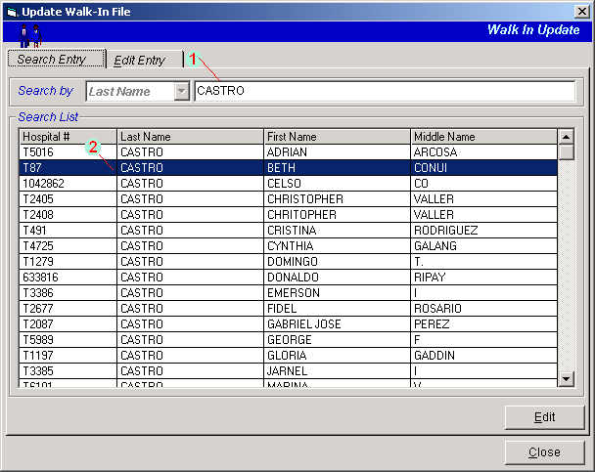
Figure 42: Walk - in Master File Update: Patient Searching

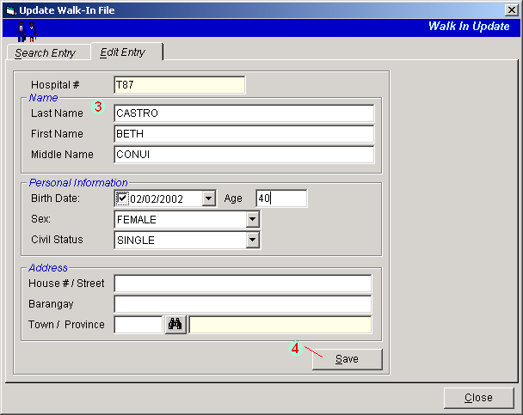
Figure 43: Walk - in Master File Update

Inputs:
Press <Ctrl + W> to start.

1 Type the patient’s last name and then press <Enter>.
2 Matches will be displayed. Double-click the patient’s name to select.
3 Patient’s information will be displayed. You may now edit necessary information.
4 Click ’Save’ button to update changes made.

Specimen
This provides the option to build specimen and to assign particular exam its specimens to be used in charging.

Inputs:
Press <Ctrl + S> to start

Laboratory Specimen Maintenance

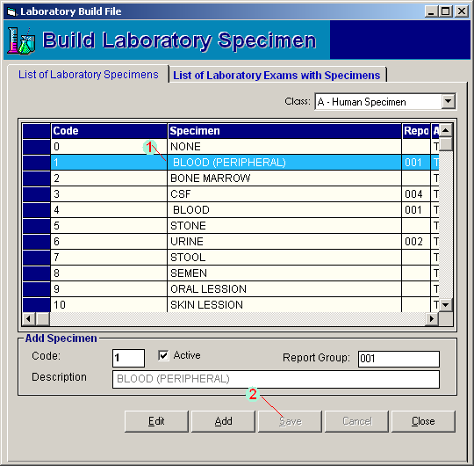
Figure 44: Laboratory Specimen Maintenance

1 Under 'List of Laboratory Specimens' tab, click the specimen to select.
- To edit, click 'Edit' button. You may now edit information on 'Description' and 'Report Group'.
- To add, click 'Add' button. Type the specimen description.
2 Click ’save' button if button selected is 'Add'.

Laboratory Exam with Specimen Maintenance

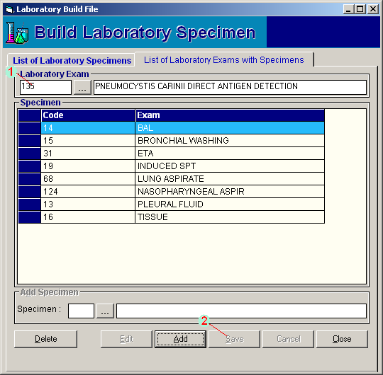
Figure 45: Laboratory Exam with Specimen Maintenance

1 Under 'Laboratory Exams with Specimen' tab, search the exam by typing the first few characters of exam name and then press <Enter>. Double-click the exam to select. Its specimen(s) will be displayed.
- To add, click 'Add' button. Under ’specimen' entry, press <Enter> if it is still blank to display the list of specimens. Double-click the specimen to select.
- To delete, click the specimen from the list and then click 'Delete' button.
2 Click ’Save' button if button selected is 'Add'

Exam/Procedure
Prerequisite: To build new laboratory procedure, use the Visual Build File Program. The exams entered there will be used and retrieved in the proceedings steps.

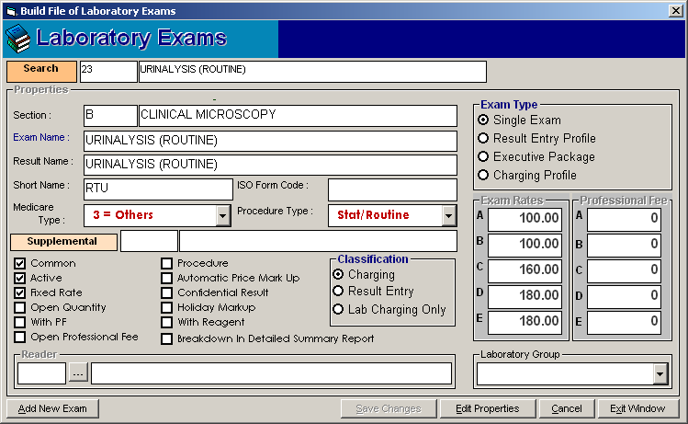
Figure 46: Exam/Procedure Entry

Inputs:
Press <Ctrl + F8> to start.
- Choose the laboratory exam. To search, type the first few characters of the exam name and then press <Enter>. Double-click the exam to select. Some of the information entered in the Visual Build File Program will be displayed in here.
- Click 'Edit Properties' button to modify exam properties.
  - Common
  - Active
  - Fixed Rate
  - Open Quantity
  - With PF
  - Open Professional Fee
  - Procedure
  - Automatic Price Markup
  - Confidential Result
  - Holiday Markup

Classification
  - Charging
  - Result Entry
  - Lab Charging Only

Exam Type
  - Single Exam
  - Result Entry Profile
  - Executive Package
  - Charging Profile

Laboratory Group
  - LRA
  - BBK

- Click ’Save Changes' button to save changes entered.

Build Reagent Normal Values
This option lets you enter the predefined normal values of exams under the specified reagent. This will be used as the basis of exam's result (for exams having normal values) during the result entry.

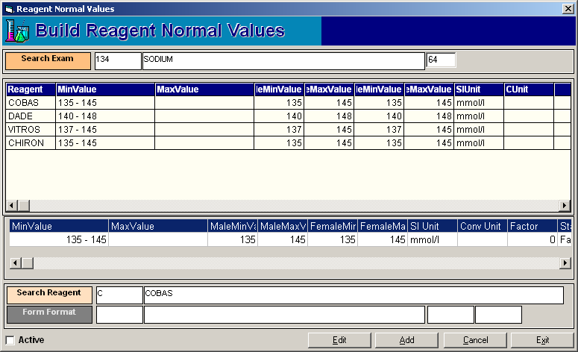
Figure 47: Build Laboratory Form Formats Window

Click 'Laboratory Build Files' > 'Build Laboratory Normal Values' to start.

- Search the exam by typing its code or name.

  - To edit the property of the exam, click the reagent from the list and then click the Edit button and you may now edit its data below. Click the Save button to update changes.
  - To add a reagent under the selected exam, click on Add button.
- Under 'Search Reagent' entry, select the reagent to use.
- Under 'Form Format' entry, select the format to use.
- Click Save button to save.

References

Shortcuts
Data Entry | Shortcuts
Inpatient Request Entry | <F9>
Inpatient Request Entry | <F4>
Out-Patient Request Entry | <F5>
Cash Patients Request Entry | <F6>
Build Reagent Normal Values | <Ctrl + F8>
Result Entry per Batch | <Ctrl + H>
Result Entry per Exam | <Ctrl + E>
File Maintenance
Result Editing | <F12>
Request Cancellation | <Ctrl + D>
List of Exams | <Ctrl + L>
Patients Laboratory Ledger | <Ctrl + G>
Inpatient Census | <Ctrl + J>
* Cancellation of Paid Assessments | <Ctrl + F1>
* Inpatient Credit Memo (for Blood Bank) | <Ctrl + F7>
Change Exam’s Specimen | <Ctrl + F9>
Results
Patient Result Inquiry | <Ctrl + I>
* Result Verification | <Ctrl + V>
Urinalysis Logbook | <Ctrl + U>
Nurse Pending Requests | <Ctrl + C>
Reports
Daily Transaction Report | <Ctrl + O>
List of Exams and Their Specimens | <Ctrl + Q>
* Daily Statistical Report | <Ctrl + R>
Doctor's Contribution Report | <Ctrl + T>
List of Pending Results | <Ctrl + X>
List of Finished Results | <Ctrl + Y>
List of Pending Requests | <Ctrl + F5>
* Processed Requests from Nursing | <Ctrl + F6>
Statistical Report | <Ctrl + Z>
Laboratory Profile Exams With Specimen | <Ctrl + F2>
* List of Assessments | <Ctrl + F3>
Inpatient Processed Requests | <Ctrl + F4>
Laboratory Build Files
Build Laboratory Forms | <Ctrl + N>
Build Laboratory Profile | <Ctrl + P>
Build Laboratory Antibiotics | <Ctrl + B>
Update Walk-In File | <Ctrl + W>
Build Laboratory Specimen | <Ctrl + S>
Build Laboratory Exams | <Shift + F8>

Exam Form Format
Each exam has its own form format that is being used in the result entry. Here are some examples of form formats.

- Exam/Profile Name: Complete Blood Count
Form Format: Profile For Normal Value w/o Conversion Factor
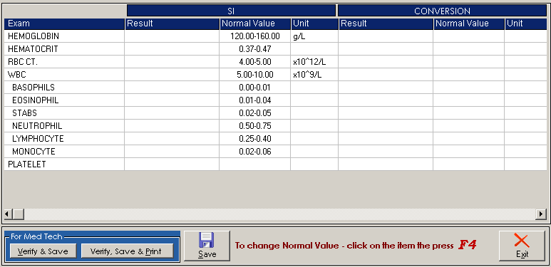
Figure 48: CBC Exam Form Format
- Exam: Urinalysis (Routine)
Form Format: Urinalysis Format
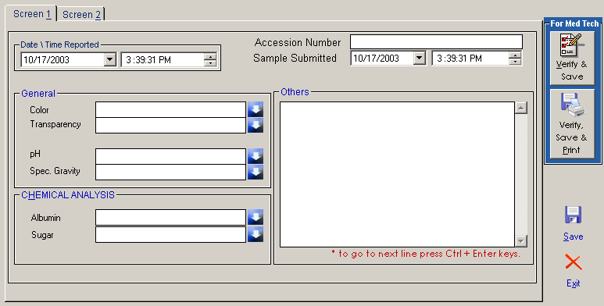
Figure 49: Urinalysis Format: Screen 1
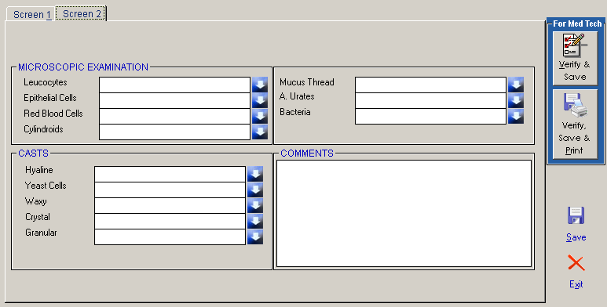
Figure 50: Urinalysis Format: Screen 2
- Exam: Urine Culture
Form Format: Culture and Sensitivity Format
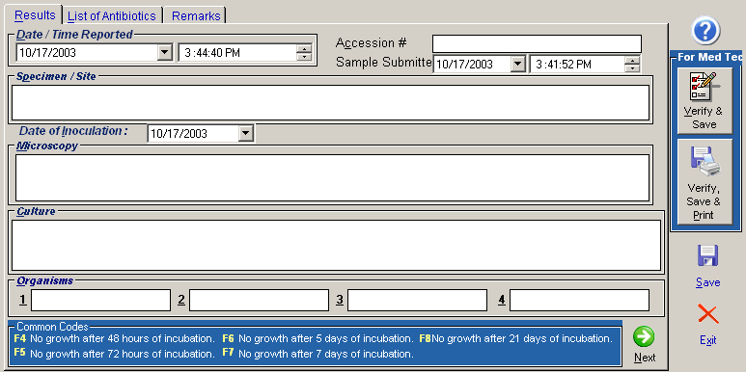
Figure 51: Culture and Sensitivity Format: Results tab

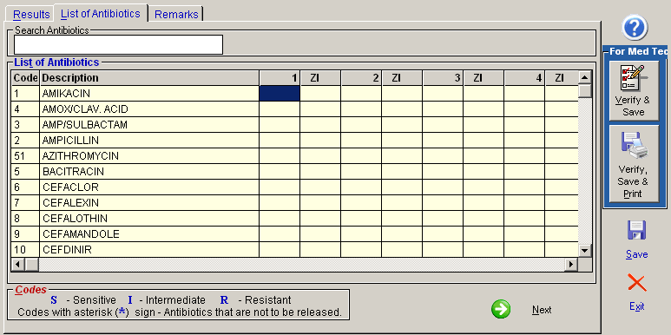
Figure 52: Culture and Sensitivity Format: List of Antibiotics tab

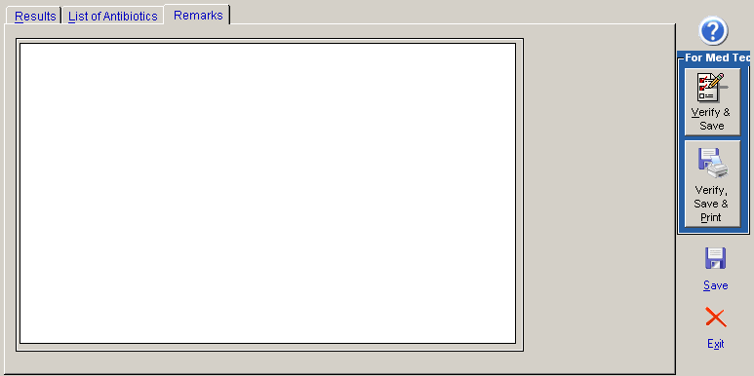
Figure 53: Culture and Sensitivity Format: Remarks tab

