MEDSYS
Information System

Visual Formulary Program
User's Manual

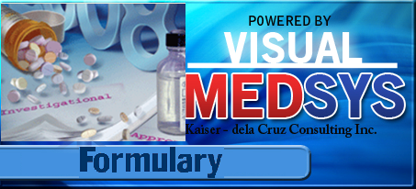

Copyright© 2009

ALL RIGHTS RESERVED

No part of this document may be reproduced through photocopying or in any means, stored into a retrieval system, and transmitted in any form without the express written permission of Kaiser dela Cruz Consulting Incorporated.
Permission is hereby granted to Medsys Information System to copy and distribute this document in any of the above means provided this is for its exclusive on site use.
Although every precaution has been taken in the preparation of this manual, the company assumes no responsibility for errors or omissions. Neither is any liability assumed for any damages resulting from the use of the information contained here.

TABLE OF CONTENTS
Introduction 4
Overview 4
Objectives 5
Features 5
Getting Started 6
How to Start the Program 6
Changing of User's Password 7
How to End the Program 8
Program Operations 9
Classification Maintenance 9
Generic Name Maintenance 11
Drug Maintenance 14

Introduction

Overview

The Formulary Program is the software used to add or update drugs classification according to formulary (List of prescription drugs covered by a particular drug benefit plan) structure.

Objectives

- To provide accurate and practical drug-related information to assist pharmacists in their drug-management responsibilities.
- To provide inventory consumption report based on a given formulary classification fast, easy and accurate

Features

- The formulary structure was designed to satisfy the PHIC and inventory reporting.
- Data-entry restriction - Warning messages are flashed for possible invalid entries. This ensures all data inputted would be made useful for any transaction that may occur.
- Password-protected - The use of password is necessary to restrict unauthorized access. Thus the program only accepts passwords which are registered into it. This feature ensures the confidentiality and integrity of data entered in the program.
- Auto-report generation - The program is capable of generating reports and can be readily printed
- User-friendly - The program user is guided by instructions in doing the next step providing an easy-use to process transactions. Tool-tips are also incorporated to give users an idea of what a particular button does.

Getting Started

How to Start the Program
1 Click on Formulary Program executable file icon located in your computer desktop.

2 The Login window will be displayed asking the user to type his employee number and password for security purposes.

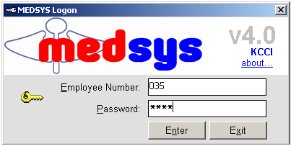
Figure 1: Login Window
3 After entering the employee number and password correctly, the user can now start a transaction. Otherwise, a message will be displayed prompting “Unauthorized User”.

How to Change Password
It is advisable to change your password as often as possible for security reasons. To change you current password, follow these steps.

1 From the Login window, type your employee number and then press <Enter>.
2 Under the Password entry, press <F12>. Pressing this function key will invoke the Change Password window.

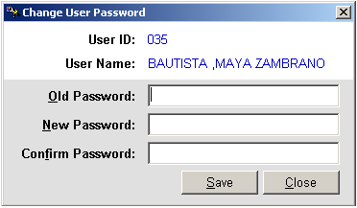
Figure 2: Change Password Window

3 Under the Change Password window, type the following data.
Old Password - Type your existing password.
New Password - Type your new password not exceeding to 15 characters.
Confirm Password - Retype your new password to confirm and then press <Enter> or you can click the Save button.

How to End the Program
It is important for users to close the program when they are done to end-up their session. Other users might use the open program using the same password.

There are two ways to close the program.

1 Click on button located at the right corner of the main or
2 Click Exit from the Formulary pull-down menu.

Program Operation

Figure 3: Formulary Structure (Tree View)
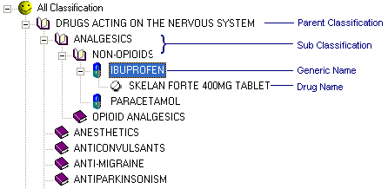

Classification Maintenance
Use this option to add a new drug classification, remove a classification from the current formulary structure or rename a classification.

How to add classification name
Before doing the proceeding steps, you should know where to add the new drug classification. It can be added as a main classification or as a sub-classification. To make it main, click and then follow the proceeding steps. To make it sub, click the parent-classification and then follow the proceeding steps.
1 Press <Ctrl + C> or
From the Formulary menu, select Add/Remove and then click Classification
2 The Drug Classification Entry window will appear.

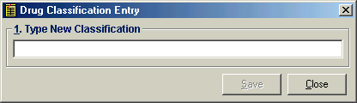
Figure 4: Drug Classification Entry
Type the drug classification name and then click Save button. Once saved, it will be automatically included in the formulary structure.

How to remove drug classification
Note: You can only remove a classification if no generic name is currently listed under it.
    - Click the classification name and then press <Delete> from keyboard. The message below will appear. Click Yes button to proceed. Otherwise, click No to cancel. If Yes was clicked, the classification name will be automatically removed from the structure.

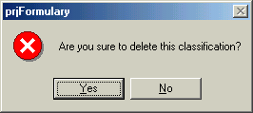

How to rename classification name
    - Click the classification name and then click 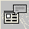 Rename toolbar button. You can now directly rename the classification from the structure.

Generic Name Maintenance
This option allows you to add a new generic name, delete a generic name, or rename a generic name, and add a new generic name under a drug classification or remove a generic name under a drug classification.

How to add/delete or rename generic name
1 Click 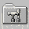 Generic Name Build File toolbar button. The window below will appear.

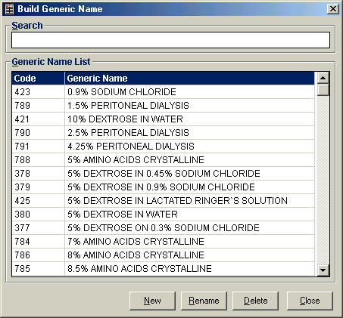
Figure 5: Build Generic Name Window

    - To add, click the New button. A pop-up window will appear. Enter the generic name and then click the Save button. The generic name will be automatically added in the list.
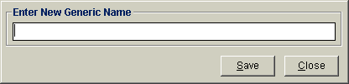
Figure 6: Add New Generic Name

    - To rename, search the generic name and then select it. A pop-up window will appear. You can now change the selected generic name. Click the Save button afterwards.
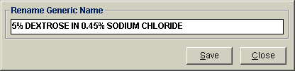
Figure 7: Rename Generic Name

    - To remove, search the generic name and then select it. Click the Delete button. The message below will appear. Click the Yes button to proceed. Otherwise, click the No button to cancel. If Yes was clicked, the generic name will be automatically removed from the list.
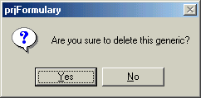

How to add/remove a generic name under a drug classification
    - Click the drug classification from the structure and then press <Ctrl + G>. The window below will appear.
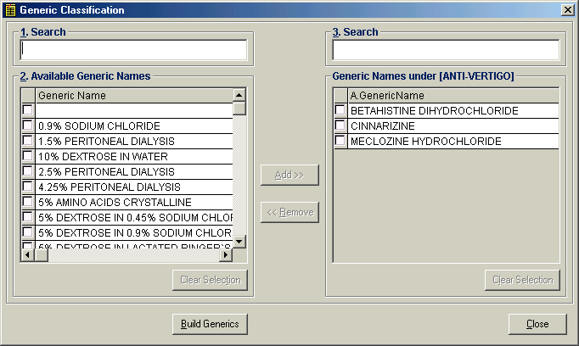
Figure 8: Add/Remove a Generic Name under a Drug Classification

    - The procedure is simple. Under '1. Search', enter the generic name and then press <Enter>. When searched, click the small box on its left side. If you want to add, just do the same step. After you have clicked all the small boxes of the desired generic names, click the Add>> button located at the center of the window. The selected generic names will be automatically moved to the right under the list of selected generic names. For wrong entries, you can remove a generic name from the list of selected generic names by clicking the small box beside it and then click the <<Remove button.

    - There is an option to build generic names at the bottom of the window if in case the generic name you want to add is not yet included in the list.

Drug Maintenance
This option is where you can add drugs under a generic name.

1 Search the Generic Name - You can search a particular generic name by clicking Option > Find Entry menu. The window below will appear. Just type in the key letters in the 'Enter search key' textbox and then press <Enter>. A parent classification, sub classification, generic name, or drug can be search in here. If found, matches will be displayed below it. Just double-click the item in the list to search in the formulary structure.
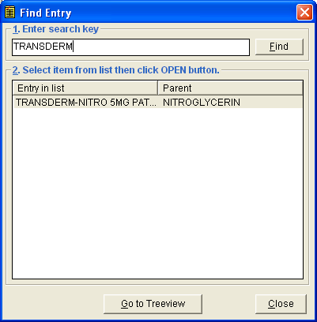
Figure 9: Search Generic Name

2 From the formulary structure, click the generic name and then press <Ctrl + D>. This will invoke the Drug Classification window. See figure below.
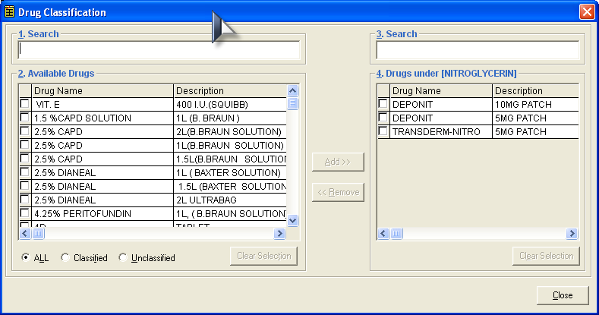
Figure 10: Drug Classification Window

To add drugs under the selected generic name (Refer to the left side of the window)
    - Type in the key letters of the drug you want to include in the '1. Search' textbox. Matches will be displayed below it.
    - Click the checkbox beside the drug. You can have multiple selections on the drugs you want to include.
    - Click the Add>> button at the center to include selected drugs.

To remove included drug(s) (Refer to the right side of the window)
    - Click the checkbox beside the drug. You can have multiple selections on the drugs you want to remove.
    - Click the <<Remove button at the center.

