Fixed Asset Program
User's Manual



MEDSYS
Kaiser - dela Cruz Consulting, Inc.
July 28, 2026

Copyright© 2018
ALL RIGHTS RESERVED

No part of this document may be reproduced through photocopying or in any means, stored into a retrieval system, and transmitted in any form without the express written permission of Kaiser - dela Cruz Consulting, Incorporated.
Permission is hereby granted to World Citi Medical Center to copy and distribute this document in any of the above means provided this is for its exclusive on site use.
Although every precaution has been taken in the preparation of this manual, the company assumes no responsibility for errors or omissions. Neither is any liability assumed for any damages resulting from the use of the information contained here.

Table of Contents
Introduction 4
Overview 4
Objectives 5
Features 5
Getting Started 6
How to Start the Program 6
How to Change Password 7
How to End the Program 8
Program Operation 9
Maintenance 10
General Settings 10
User Settings 12
Adding/Editing of Item in the Master File 12
Adding/Editing of Account Code 14
Adding/Editing of Major Category 16
Adding/Editing of Department 18
Adding/Editing of Section 20
Adding/Editing of Supplier 22
Fixed Asset Procedure 25
Step 1: Purchase Requisition Entry 25
Step 2: Purchase Order Entry 28
Step 3: Receiving Report Entry 30
Step 4: Property Acknowledgement 33
Step 5: Manual Posting of Assets 36
Property Tag............................................................. 37
Asset Management 39
A: Asset List 39
B: Asset Transfer 40
C: Asset Repair 41
Gate Pass 42
D: Asset Status 45
Reports 46
Reports 46

Introduction

Overview

The Fixed Asset Program aims to help personnel in governing a better control and reporting of assets. From acquisition, custody and disposition, it sets to record and monitor every assets of the company to ensure appropriate management and internal control.
The program itself is protected by the use of password and defined rights to secure all user-entered data and to maintain its confidentiality.

Objectives

- To provide an organized method of controlling fixed assets
- To reduce clerical workload
- To have a powerful new information tool for decision-making purposes

Features:

- Data-entry restriction - Warning messages are flashed for possible invalid entries. This ensures all data inputted would be made useful for any transaction that may occur.
- Password-protected - The use of password is necessary to restrict unauthorized access. Thus the program only accepts passwords which are registered into it. This feature ensures the confidentiality and integrity of data entered in the program.
- Auto-report generation - The program is capable of generating reports and can be readily printed
- User-friendly - The program user is guided by instructions in doing the next step providing an easy-use to process transactions.

Getting Started

How to Start the Program
1 Double-click the Fixed Asset Program executable file icon located in your computer desktop.
2 The Login window will be displayed asking you to enter your employee number and password for security purposes.

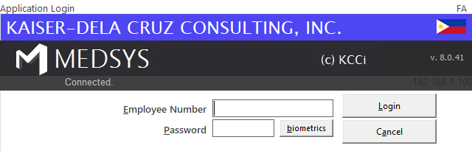
Figure 1: Login Window
3 If accepted, you can now start a transaction. Otherwise, a message below will be displayed
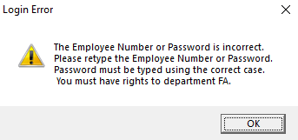

How to Change Password
It is advisable to change your password as often as possible for security reasons. To change you current password, follow these steps.

1 From the Login window, type your employee number and then press <Enter>.
2 Under the Password entry, press <F12>. Pressing this function key will invoke the Change Password window.
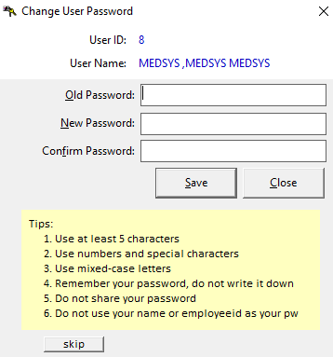
Figure 2: Change Password Window

3 Under the Change Password window, type the following data.
Old Password - Type your existing password.
New Password - Type your new password not exceeding to 15 characters.
Confirm Password - Retype your new password to confirm and then press <Enter> or you can click the Save button.

How to End the Program
It is important for users to close the program when they are done to end-up their session. Other users might use the open program using the same password.

To close the program:
Click which is located at the upper right corner of the main window or
Click Exit from Transaction Entry pull-down menu or
Press Ctrl + X

Program Operation

Maintenance

General Settings
Use this option to enter the default settings of data to be used in all transactions.

- Click Maintenance > General Setting to open the window below.
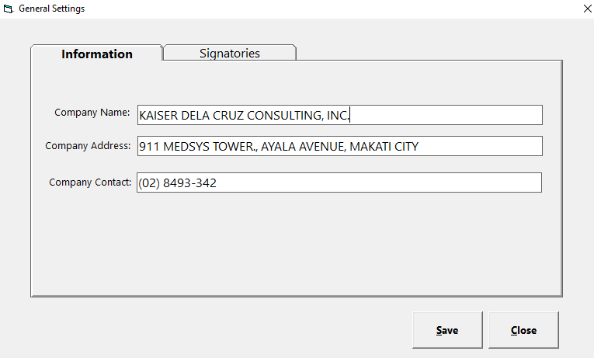
Figure 3.1: System Settings Window

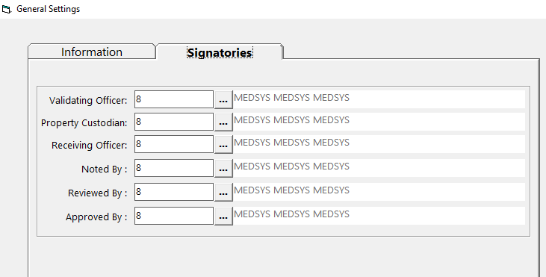
Figure 3.2: System Settings Window

- Enter company name, address and contact number
- Enter Signatories for reporting purposes
- Click Save button to save changes

User Settings
This option is where you can control the access rights of a particular user

- Click Maintenance > System Settings to open the window below
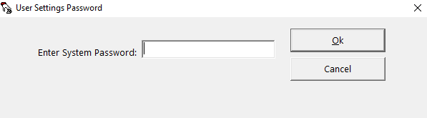
Figure 4: User Settings: Password Entry

This window asks for a password to restrict the access of unauthorized users. Just type the password and then click the OK button. If accepted, the User Setting window will be displayed. Search employee under User button and set the access rights needed. See figure below.
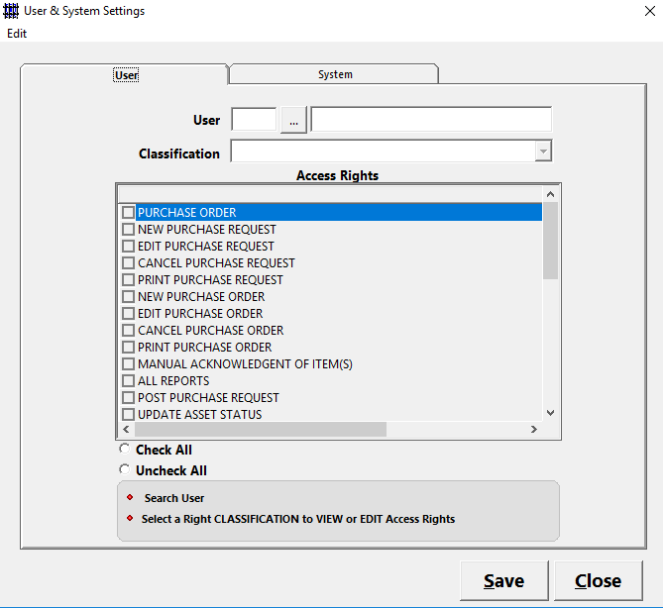
Figure 5: User and System Settings: Access Rights

Adding / Editing of Item in Master File
This option allows you to add or edit items in master file.

- To open its window,
Press F8 or
Click Maintenance > Master Item
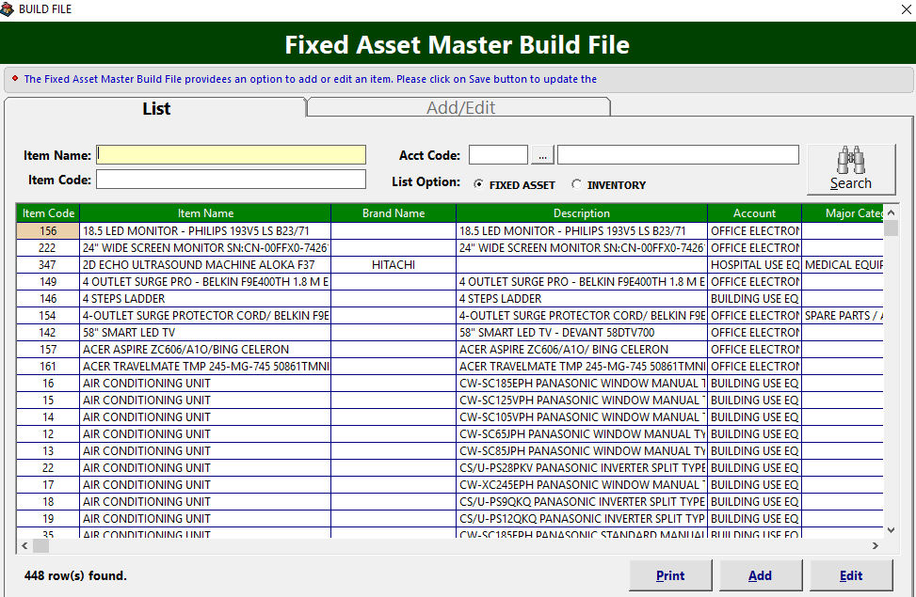
Figure 6: Adding/Editing of Item in the Master File: Main Window

- To search for a particular item, type its first few characters under ’Item Name' textbox and then press <Enter> or click Search button. Listings will be displayed just below it to match your query.
- To edit an item, double-click it to display its information. Click the Save button afterwards to save change(s) done.
- To add an item to the master file, click the Add button under the Options entry. The window below will be displayed.
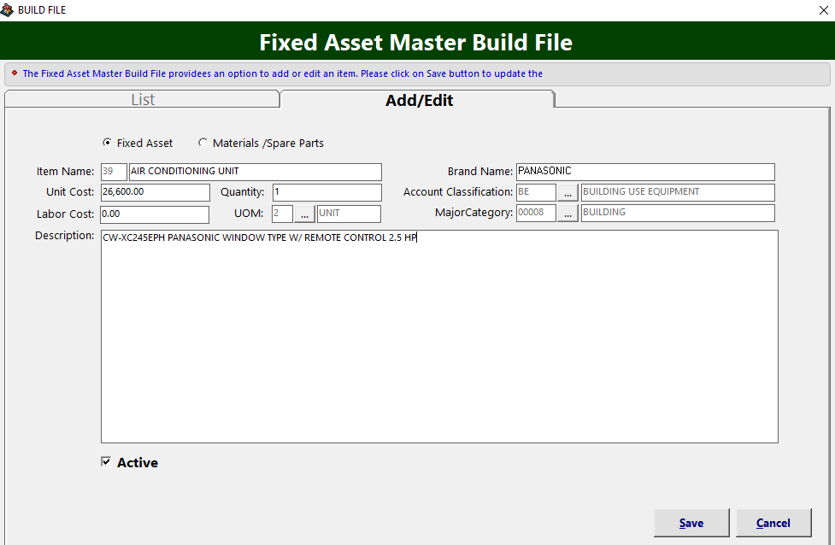
Figure 7: Item (Master File) Entry

Enter the following data:
- Item Code – A program - generated code
- Item Name – Asset/item name
- Unit Cost – Unit cost of item
- Quantity – Number of item
- Brand Name – The brand or model name of asset/item
- Account Classification – Type of account code in link to the accounting system
- Major Category - Type of account category in link to the accounting system
- Description – Details/specifications of item

The following button options can be clicked from:
Save - This will add and save the item classification.
Cancel - This will close the window without saving the entered item classification.

3 To close the window,
Click at the upper right corner of the window or
Click the Exit button on the lower left side of the window

Adding / Editing of Account Code
This option allows you to add/edit account codes in connection to accounting system.

- To open its window,
Click Maintenance > Account Code
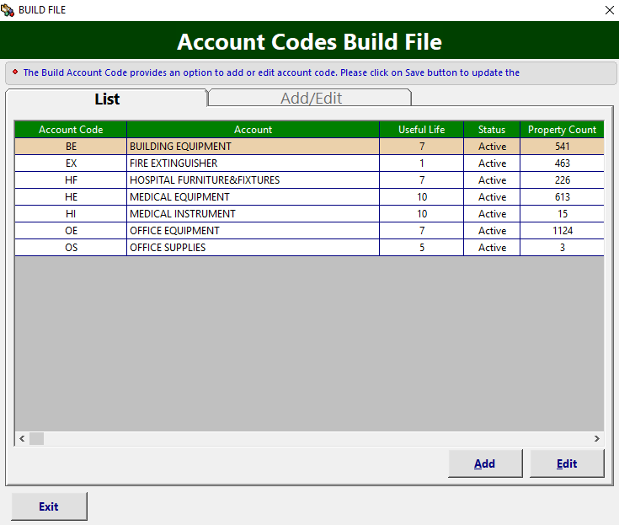
Figure 8: Account Codes Build File: Main Window

- To edit an account code, double-click the Account to display its information or you can click the Edit button on the lower right side of the window. Click the Save button afterwards to save change(s) done.

- To add an account code, click the Add button under the List tab. Its window will be displayed.
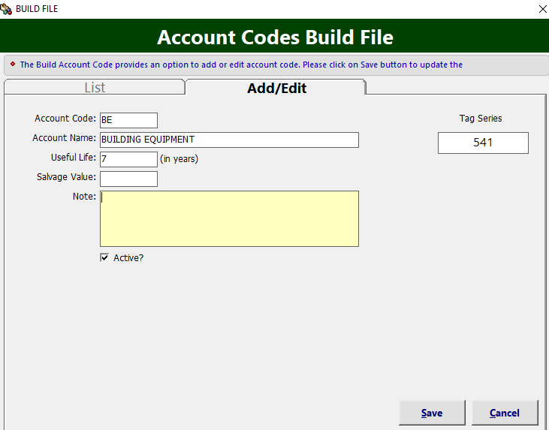
Figure 9: Account Codes Entry Window

Enter the following data:
Account Code – Two (2) digits code in reference to accounting
Account Name – Account name to be used for assets
Useful Life – Life in years of assets
Salvage Value – Estimated resale value of an asset at the end of its useful life
Note – Additional remarks for the account

The following button options can be clicked from:
Save - This will add and save the item classification.
Cancel - This will close the window without saving the entered item classification.

- To close the window,
Click at the upper right corner of the window or
Click the Exit button on the lower left side of the window

Adding / Editing of Major Category
This option is where you can add/edit asset major categories

- To open its window,
Click Maintenance > Major Category
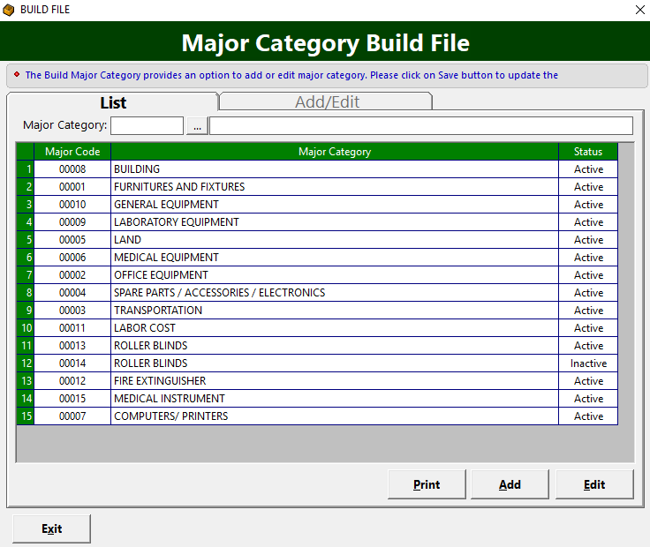
Figure 10: Major Category Build File: Main Window

- To edit a major category, double-click its name to display its information or you can click the Edit button on the lower right side of the window under the List tab. Click the Save button afterwards to save change(s) done.

- To add a major category, click the Add button under the List tab. Its window will be displayed.
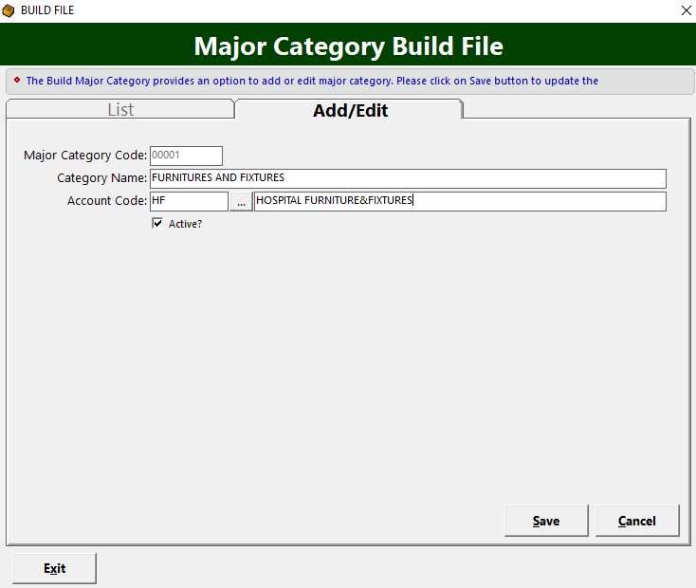
Figure 11: Major Category Entry Window

Supply the following data:
Major Category Code – A system-generated code.
Category Name – Name/description of category
Account Code – Tagging of account codes in reference to accounting

The following button options can be clicked from.
Save - This will add and save the location/department.
Cancel - This will close the window without saving the entered location/department.

- To close the window,
Click at the upper right corner of the window or
Click the Exit button on the lower left side of the window

Adding / Editing of Department
This option is where you can add/edit a department to be used in tagging asset’s accountability

- To open its window,
Click Maintenance > Section/Department
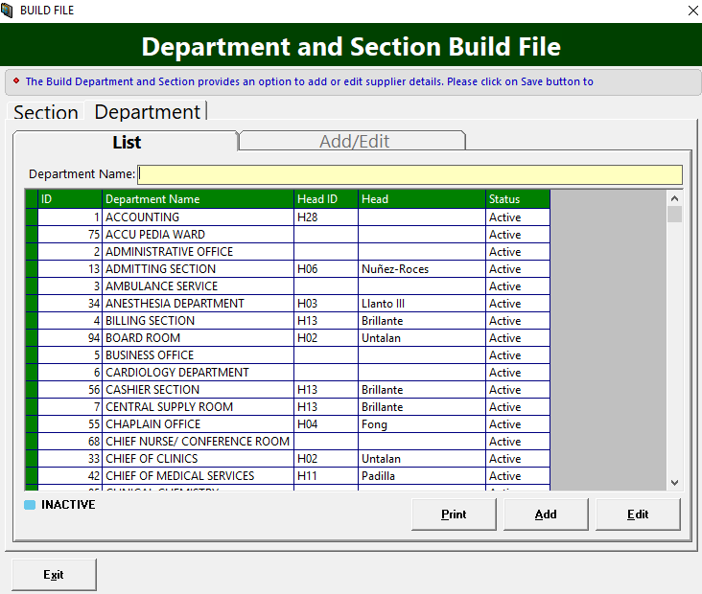
Figure 12: Department Main Window

- To edit a department, double-click the department name to display its information or you can click the Edit button on the lower right side of the window under the List tab. Click the Save button afterwards to save change(s) done.

- To add a department, click the Add button under the List tab. Its window will be displayed.
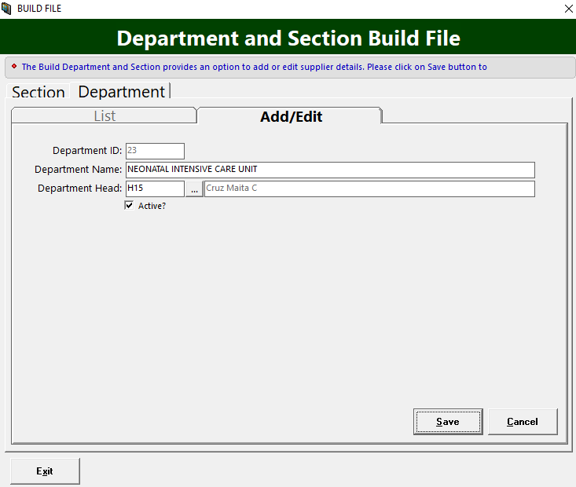
Figure 12.1: Department Entry Window

Supply the following data.
Department ID – A system-generated code
Department Name – Name of the department or location
Department Head – Head of the department

The following button options can be clicked from.
Save - This will add and save the location/department.
Cancel - This will close the window without saving the entered location/department.

- To close the window,
Click at the upper right corner of the window or
Click the Exit button on the lower left side of the window

Adding / Editing of Section
This option is where you can add/edit a section to be used in tagging asset’s accountability

- To open its window,
Click Maintenance > Section/Department. Go to Section tab.
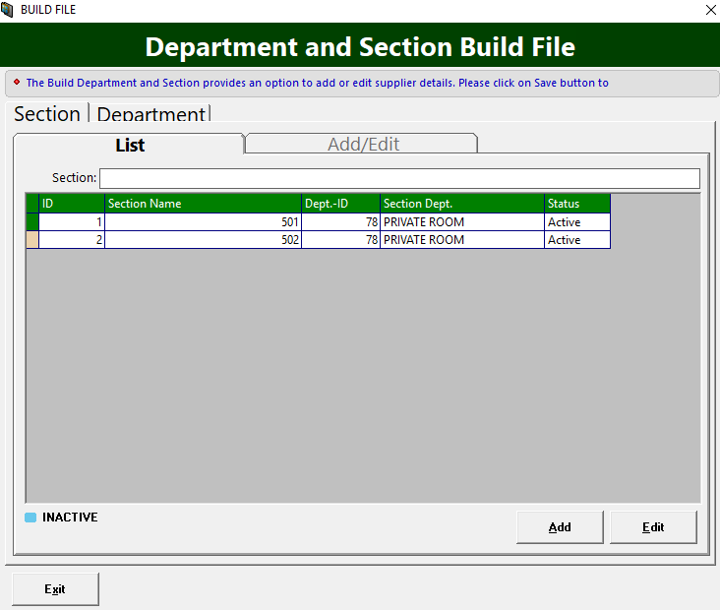
Figure 13: Section Main Window

- To edit a section, double-click it to display its information or you can click the Edit button on the lower right side of the window under the List tab. Click the Save button afterwards to save change(s) done.

- To add a section, click the Add button under the List tab. Its window will be displayed.
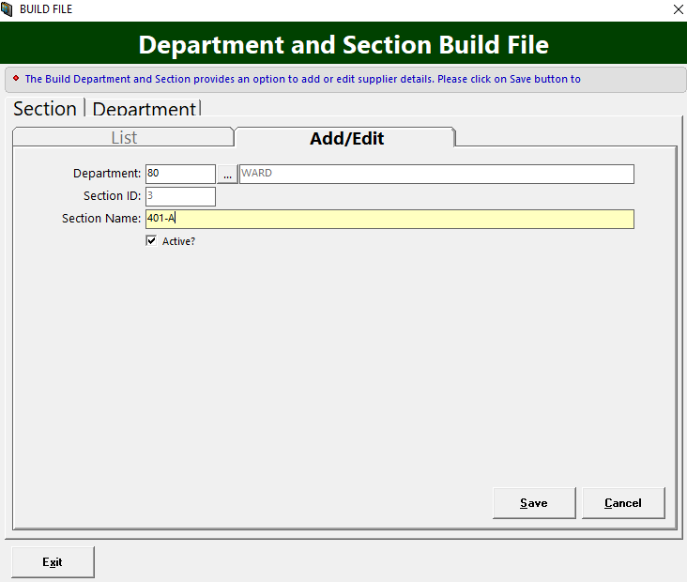
Figure 13.1: Section Entry Window

Supply the following data.
Department – Tag the department where the section belong
Section ID – A system-generated code
Section Name – Name of the section

The following button options can be clicked from.
Save - This will add and save the location/department.
Cancel - This will close the window without saving the entered section.

- To close the window,
Click at the upper right corner of the window or
Click the Exit button on the lower left side of the window

Adding / Editing of Supplier
This option is where you can add/edit a supplier

- To open its window,
Click Maintenance > Supplier
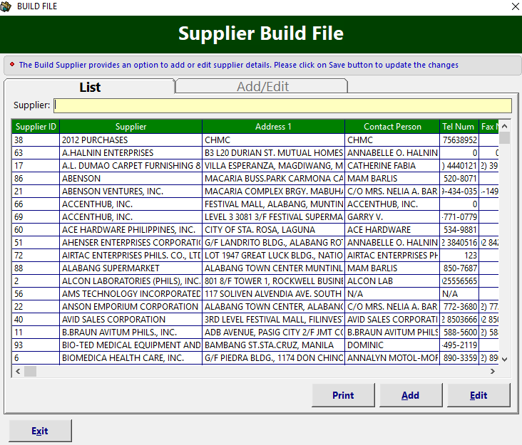
Figure 14: Supplier Build File: Main Window

- To search for a particular supplier, type its first few characters under ’Supplier' textbox and then press <Enter>. Listings will be displayed just below it to match your query.
- To edit a supplier, double-click it to display its information or you can click the Edit button on the lower right side of the window under the List tab. Click the Save button afterwards to save change(s) done.

- To add a supplier, click the Add button under the List tab. Its window will be displayed.
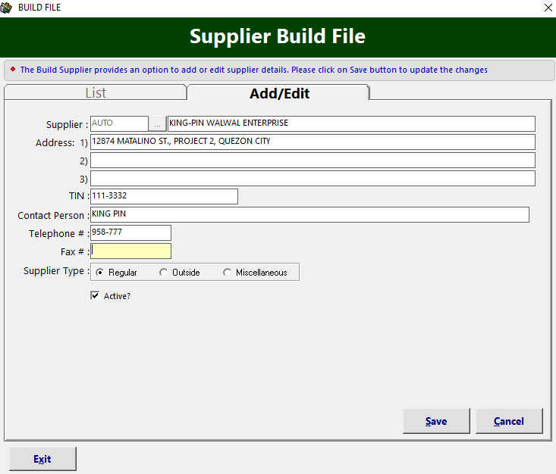
Figure 15: Supplier Entry Window

Enter the following data.
Supplier Code – A system-generated code.
Supplier Name – Name of supplier
Address - Supplier’s address
Contact Person - Supplier’s contact person
Telephone # - Supplier’s telephone number.
Fax # - Supplier’s fax number.
Supplier Type - Type of supplier

The following button options can be clicked from.
Save - This will add and save the supplier.
Cancel - This will close the window without saving the entered supplier.

- To close the window,
Click at the upper right corner of the window or
Click the Exit button on the lower left side of the window

Fixed Asset Procedure

Step 1: Purchase Requisition Entry
This option allows you to enter, edit or view purchase requests
1. Click Transaction Entry > Purchase Request Slip or hit <Ctrl + A>. The window below will appear
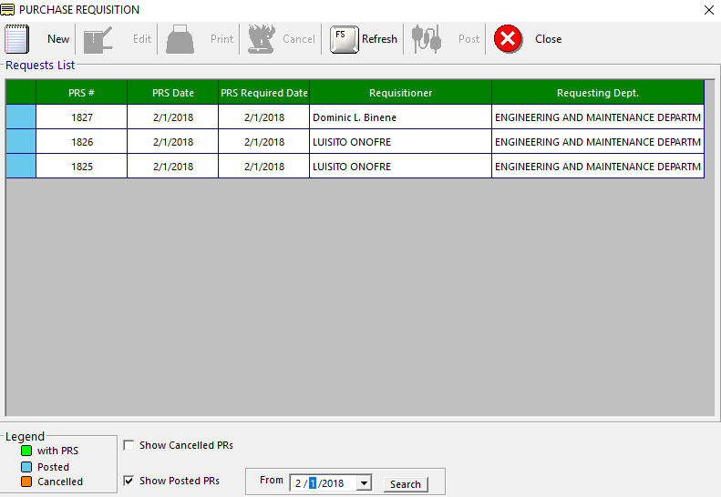
Figure 16: Purchase Requisition: Main Window
Note: You can view the status of purchase requisition at the bottom of the window. Green color indicates ‘Pending Order’; Blue color indicates ‘Posted’; Orange color indicates ‘Cancelled’

To edit purchase requisition
- Select the PRS number from the lists.
- Click  Edit button. The list of items under the selected PRS number will be displayed. You can now add or delete items from the grid.
- Click Save Entries button to update changes made.

To delete purchase request
- Select the PRS number from the lists
- Click  Cancel button. A message will appear. Choose Yes to confirm. The PRS number including its ordered items will be removed automatically from the list.

To create new purchase request
    - Click  New button. The window below will appear.
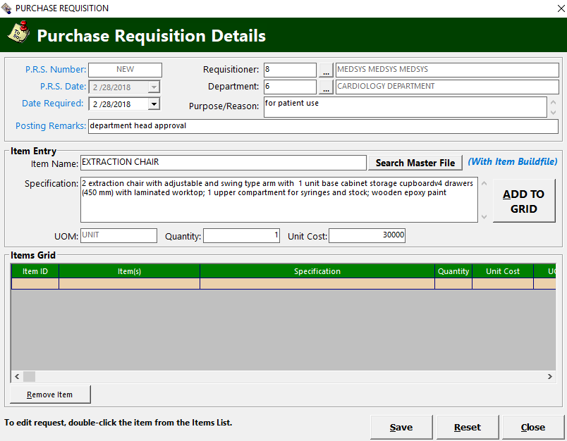
Figure 17: New Purchase Requisition Window

    - Enter Date Required (Current date by default).
    - Supply Posting Remarks.
    - Enter Requisitioner (Current user login by default)
    - Supply Department of the requisitioner.
    - Fill in Purpose/Reason
    - Search item to be purchased on the Item Name textbox. Click on Search Master File button once supplied.
    - Select item to be purchased by double-clicking it or clicking the ‘Select’ button
NOTE: If the item is not on the master list, create it by clicking on the Build File button located on the lower left side of the Search Listing window and supply the necessary information.
    - Enter Quantity and Unit Cost
    - Click ADD TO GRID to add item on the grid list of items to be purchased. Repeat step G to J if you wish to add more items. If you want to remove an item, click on Remove Item button located on the lower left side of the window.
    - Once completed, click on SAVE button.
    - To print the PRS, select it on the PR list window and click on the  Print button.
    - Finalized PR needs to be posted for the PO pending list communication. Select PR to be posted and click on 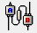 Post button. A warning message will appear:
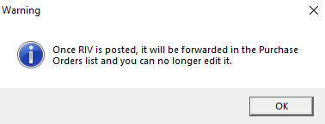
    - Click OK button. A prompt message below will appear.
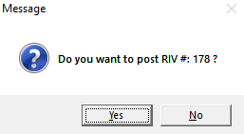
    - Click on Yes button to post it. Otherwise, click the No button to return to PR list window
    - A confirmation window will appear showing the successful posting of your PR

- To close the window,
Click at the upper right corner of the window or
Click the Close button on the lower right side of the window

Step 2: Purchase Order Entry
This option allows you to enter, edit or view Purchase Orders
    - Click Transaction Entry > Purchase Order or hit <Ctrl + B>. The window below will appear.
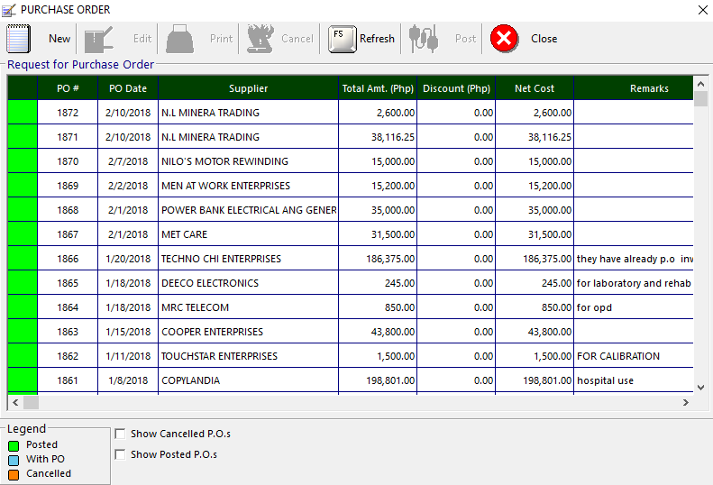
Figure 18: Purchase Order: Main Window
Note: You can view the status of purchase order at the bottom left of the window. Green color indicates ‘Pending Order’; Blue color indicates ‘Posted’; Orange color indicates ‘Cancelled’

To edit purchase order
    - Select the purchase order number from the list.
    - Click Edit button. The list of items under the selected purchase order number will be displayed. You can now add or delete items from the grid.
    - Click Save Only / Save&Print button to update changes made.

To delete purchase order
    - Select the purchase order number from the list.
    - Click Cancel button. A message will appear. Choose Yes to confirm. The PO number including its ordered items will be removed automatically from the list.

To create new purchase order

- Click New button. The window below will appear.

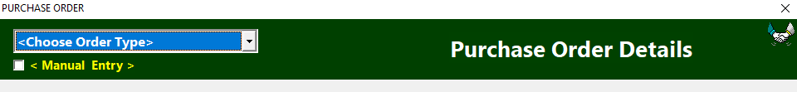
Figure 19: New Purchase Order Entry Window

Choose Order Type
* Regular
* Job Order
Note: If direct PO, click on Manual Entry checkbox and supply the necessary
data needed.
- Click on Purchase Requisition button located on the right side of the window. The list of purchase requisition will appear.
Note: Filter search by clicking on the ‘Search by’ drop-down and select the
preferred filter
- Double-click PRS on the ‘List of Requests’ grid and click the Add button. All items under the selected PRS will automatically enlist on the PO entry window
- Enter the Terms.
- Click the With VAT checkbox if with VAT. Otherwise, disregard it.
- Enter Supplier.
- Supply Warranty textbox if needed.
- Enter Remarks if necessary.
- If you wish to remove an item, select item and click on the Remove Row button.
- Click on Save Only button to save your final PO. A printout will be provided if you click on the Save&Print button
- Finalized PO needs to be posted for the Receiving Report (RR) communication. Select PO to be posted and click on Post button to post it. A confirmation message will appear.

Step 3: Receiving Report Entry
This option allows you to enter, edit or view receiving reports (RR).

- Click Transaction Entry > Receiving Report or hit <Ctrl + C>. The window below will appear.
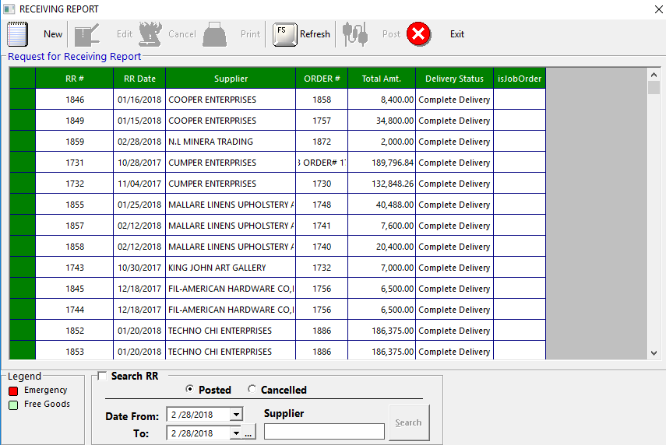
Figure 20: Receiving Report: Main Window

To edit RR
- Select the RR number from the list.
- Click Edit button. The list of items under the selected RR number will be displayed. You can now add or delete items from the grid.
- Click Save Only / Save&Print button to save change(s) made.
Note: Posted RR can no longer be edited. Please review entries before doing the
final posting.

To delete RR
- Select the RR number from the list.
- Click Cancel button. A message will appear. Choose Yes to confirm. The RR number including its items will be removed automatically from the list.

To create new RR
- Click New button. The window below will appear.
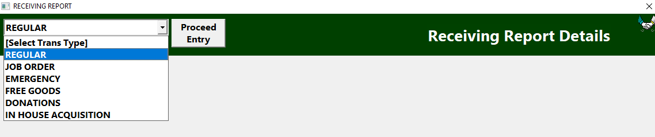
Figure 21: Receiving Report Entry Window

- Select Trans Type and click on Proceed Entry button.
- Enter Supplier.
- Fill in Remarks if necessary
- Enter Invoice No.
- Select Delivery Status by clicking on the drop-down
- Enter Warranty Period
- Fill in ERF No. if needed
- Locate PO by clicking on the PO button located on the right side of the window beside BO button. List of posted purchase orders for the selected supplier will appear. You can filter search by PO #, PR # and by Date Range.
- Double click on the grid to select item to be received.
- Enter Quantity.
- Enter Unit Cost.
- Enter Department.
- Fill in Officer.
- Click Add to List button to add it to your Item List for RR.
- Repeat from step I to O if the RR contains more than one (1) item.
- Once completed, click on Save button.
- To print the RR, locate it on the Receiving Report list window and click on the Print button.
- To post RR, click on the Post button. Make sure to review first the RR before doing the final posting. A confirmation message will appear.
NOTE: Posted RR will automatically be forwarded to Acknowledgment for posting to
Asset list

2. To close the window,
Click at the upper right corner of the window or
Click the Exit button

Step 4: Property Acknowledgement
This option allows you to post and print delivered and posted items from RR

1. Click Transaction Entry > Property Acknowledgement or click on the 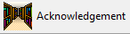 button. The window below will appear.
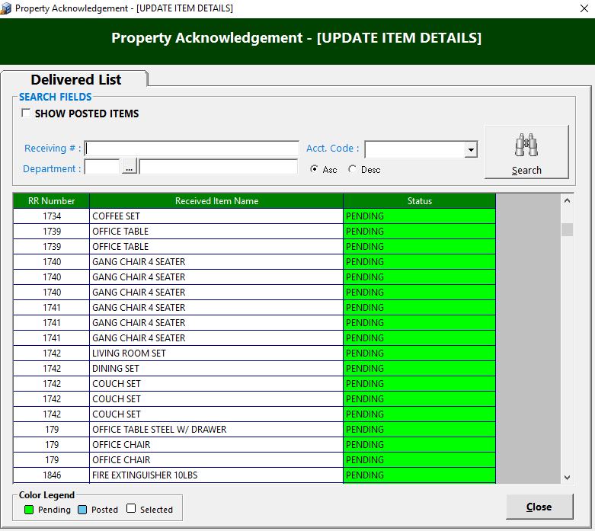
Figure 22: Property Acknowledgement: Main Window

To POST item
- Enter Receiving # and click on Search button.
NOTE: RR will only be searchable here if posted on the Receiving Report entry

- Double-click on the searched item. The window below will appear.
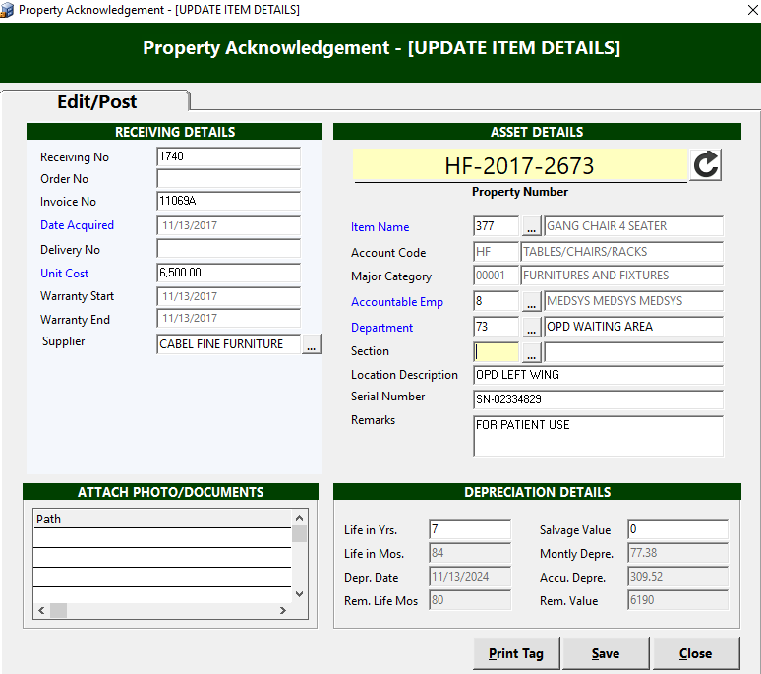
Figure 23: Property Acknowledgement Entry Window

- Fill in other data necessary before saving.
- Click Save button to save change(s) made.
Note: Once saved, it will be automatically added to Assets List.

The following button options can be clicked from.
Print Tag - This will print the property tag or sticker of the item
Save - This will save and post the item in asset master list
Close - This will close the window

To PRINT acknowledgement

- Click Acknowledgement drop-down menu and go to Print Delivered and Posted Item(s). The window below will appear:
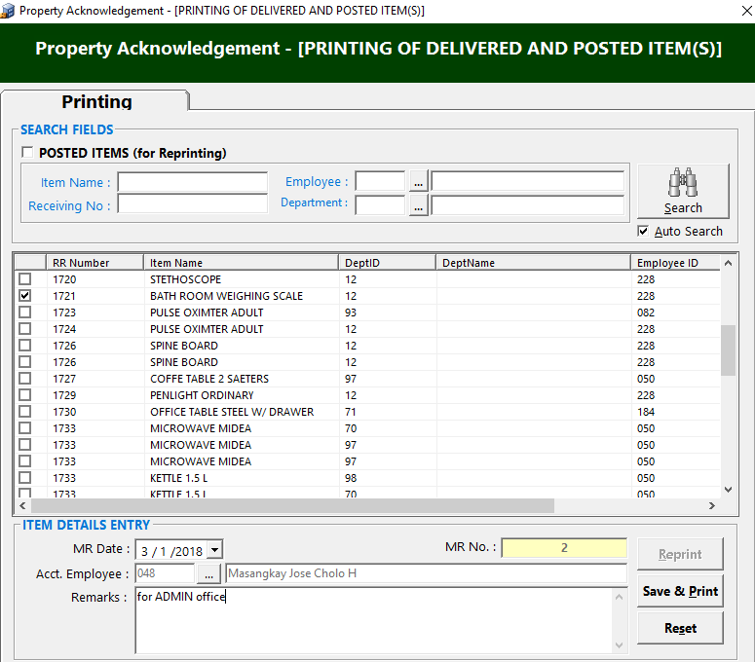
Figure 24: Property Acknowledgement: Print Delivered and Posted Items Window

- Enter item on the Item Name textbox. Click on Search button to search it.
- Click on RR Number checkbox to select it.
- Fill in the Acct. Employee.
- Enter Remarks if needed.
- Click on Save & Print button to save and print the acknowledgement form.

Manual Posting of Assets
This option allows you to enter assets manually in the system. These are the assets that don’t have PR-PO-RR.

    - Click Transaction Entry > Manual Add Asset or hit <Ctrl + N>. The window below will appear.
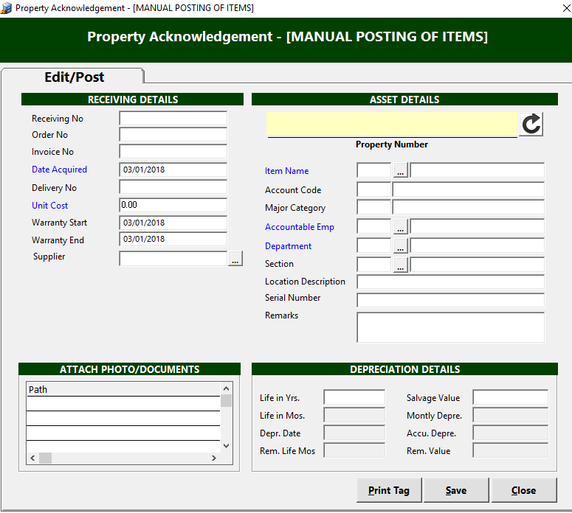
Figure 25: Property Acknowledgement: Manual Posting of Items Window

- Supply the necessary data needed before saving.
- Click on to generate property number.
- Click on Save button to save change(s) made.
Note: Once saved, it will be automatically added to Assets List.

The following button options can be clicked from.
Print Tag - This will print the property tag or sticker of the item
Save - This will save and post the item in asset master list
Close - This will close the window

2. To close the window,
Click at the upper right corner of the window or
Click the Close button

Property Tag / Sticker
This is used to identify assets using a unique property serial number or barcode
- To open its window,
Press <Ctrl + M) or
Click 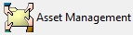 button
- To search for a particular item, type its first few characters under ‘Search By’ textbox and then press <Enter> or click Search button. Listings will be displayed just below it to match your query. You can also search by Property Number if you wish to be more specific.
- Double-click the item or asset. The window below appear:
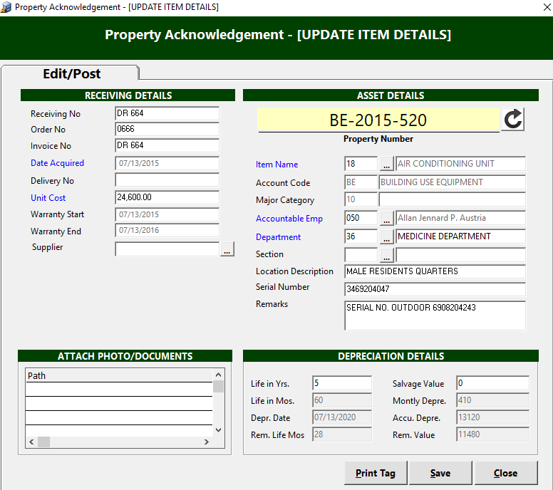
Figure 26: Property Acknowledgement Window
- Click on Print Tag button located just below the window to print property tag or sticker of asset.
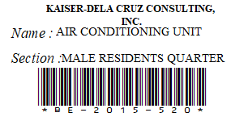
Figure 27: Property Tag / Sticker

Asset Management
A. Asset List
This is the master list of posted assets.
- To open its window,
Press <Ctrl + M) or
Click button
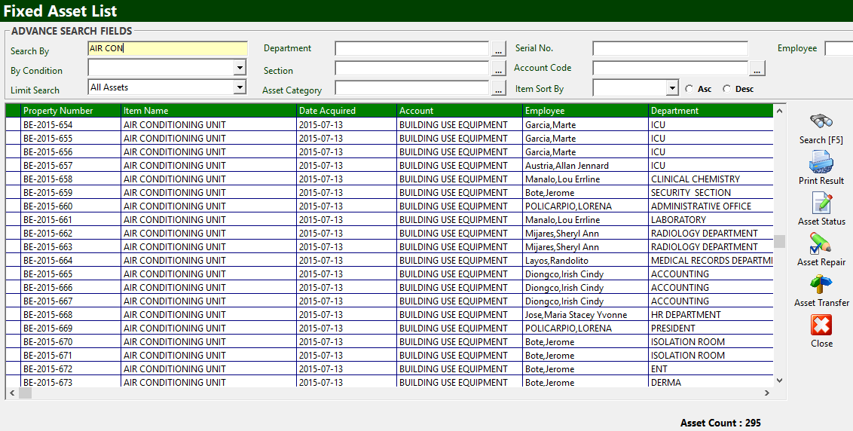
Figure 28: Fixed Asset List: Main Window

- To search for a particular item, type its first few characters under ‘Search By’ textbox and then press <Enter> or click Search button. Listings will be displayed just below it to match your query. You can also search by Property Number if you wish to be more specific.
Other Search Filters:
a. Department
b. Section
c. Asset Category
d. Serial No.
e. Account Code
B. Asset Transfer
This option allows you to transfer asset from one department to another.
- To open its window,
Press <Ctrl + M) or
Click button
- To search for item to be transferred, fill in the Search By textbox and click on Search button or hit <Enter> .
- Click on Asset Transfer button located on the icons at the right side of the window.
The window below will open.
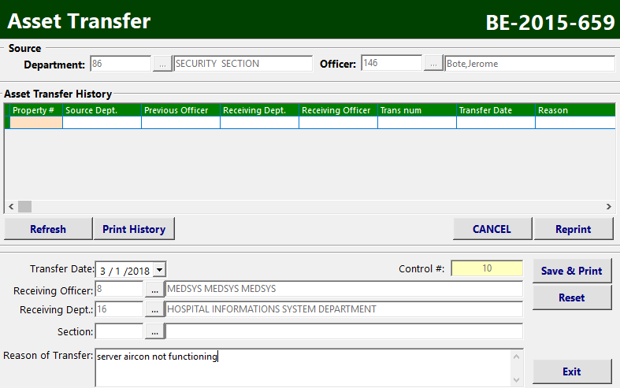
Figure 29: Asset Transfer Entry Window

3. Enter the following data:
- Transfer Date – Date of transfer (current date by default)
- Control # – A system-generated code
- Receiving Officer – Personnel of the receiving department
- Receiving Dept. – Tag the receiving department
- Section – The department section
- Reason of Transfer – Enter the reason of transfer

4. Click Save & Print to process the transfer. Otherwise, click Reset to clear entries
or Exit to close the window

C. Asset Repair
This option allows you enter assets for JOB ORDER
- To open its window,
Press <Ctrl + M) or
Click button
- To search for item to be repaired, fill in the Search By textbox and click on Search button or hit <Enter> .
- Click on Asset Repair button located on the icons at the right side of the window.
The window below will open.
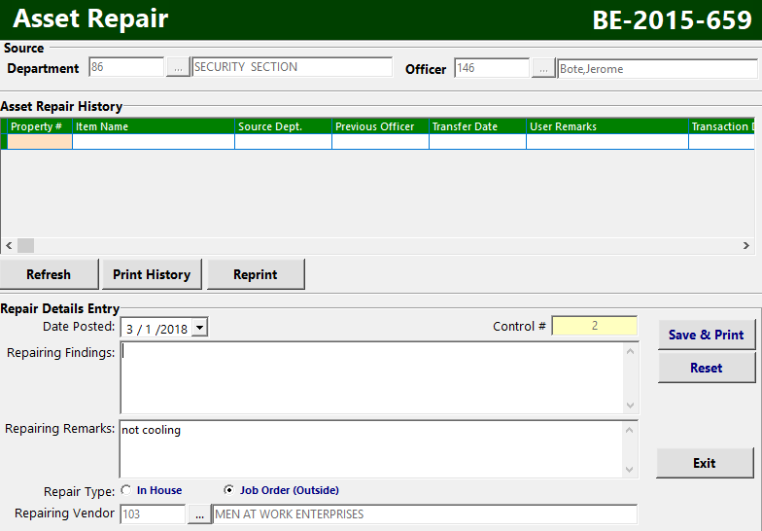
Figure 30: Asset Repair Entry Window
- Enter the following data:
- Date Posted – Date of posting (current date by default)
- Control # – A system-generated code
- Repairing Findings – Enter findings if necessary
- Repairing Remarks – Enter repairing remarks if needed
- Repair Type – Tag if In House or Job Order
If In House, tag the Receiving Dept.
If Job Order (Outside), tag the Repairing Vendor

- Click Save & Print to save and process the repairing form. Otherwise, click Reset to clear entries or Exit to close the window

Gate Pass
This option is used when bringing out items outside hospital premises.
- To open its window,
Click Transaction Entry > Fixed Asset Management > Gate Pass
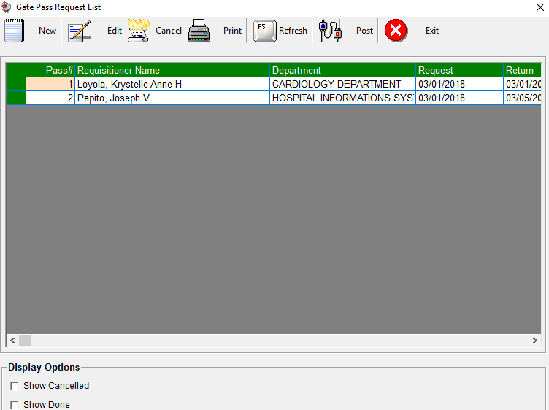
Figure 31: Gate Pass Request List: Main Window

To edit gate pass request
- Select the gate pass number from the lists.
- Click Edit button. The list of items under the selected gate pass number will be displayed. You can now add or delete items from the grid.
- Click Save Entries button to update changes made.

To delete gate pass
- Select the gate pass number from the lists.
- Click Cancel button. A message will appear. Choose Yes to confirm. The gate pass number including its items will be removed automatically from the list.

To post returned gate pass
- Select the gate pass number from the lists.
- Click 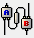 Post button. A confirmation message will appear. Choose Yes to confirm.

To create new gate pass
- Click New button. The window below will appear.
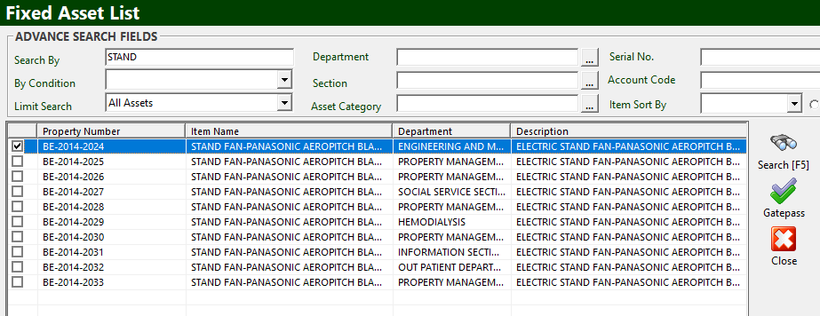
Figure 32: Gate Pass Request: Search Window

- To search for item you wish to pull out, fill in the Search By textbox and click on Search button or hit <Enter> .
- Click on the 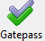 button to go to Gate Pass entry.
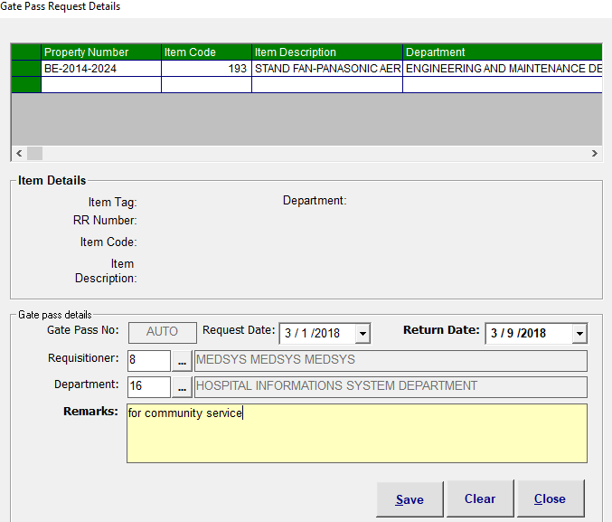
Figure 33: Gate Pass Request: Entry Window

Fill in the following data:
- Gate Pass No. – A system-generated code
- Request Date – Date of request
- Return Date – Estimated date of return
- Requisitioner – The personnel who requested
- Department – The department or section of requisitioner

Click on Save button to save change(s). Otherwise, click Clear to ignore entries or Close to close or exit the window

C. Asset Status
This option allows you to view and update asset status for inventory purposes.
- To open its window,
Press <Ctrl + M) or
Click button
- To search for item, fill in the Search By textbox and click on Search button or hit <Enter> .
- Click on Asset Status button located on the icons at the right side of the window.
The window below will open.

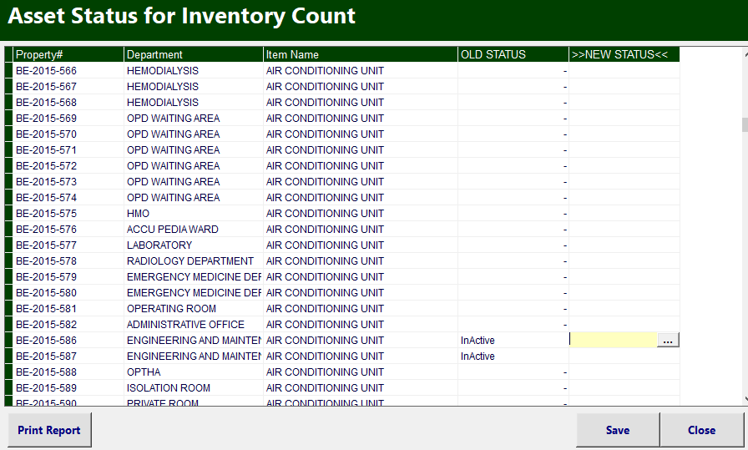
Figure 34: Asset Status Window
- To update status, click on button under NEW STATUS column. List of choices to choose: Active, Inactive, Dispose, Repair
- Click Save button to save change(s) made. Otherwise, click Close button to ignore change(s) and close the window
- To print report, click on Print Report button.

Reports

Reports
The following list of reports is generated by the program. Just click on the Reports menu and then select the desired report to be generated.

- Fixed Asset Countsheet
- DOH List of Equipment/Instrument
- Asset Report
a. Summary by Department
b. Summary by Category
c. Detailed by Department
- Depreciation Expense by Period
- PRS Report
a. Pending
b. Posted
c. Cancelled
- PO Report
- Equipment Received Report
a. Regular
b. Job Order
- Year End Report
- Gate Pass Report

