MEDSYS
Information System

Emergency Room Program
User's Manual



MEDSYS
Kaiser - dela Cruz Consulting, Inc.
July 28, 2026

Copyright© 2009

ALL RIGHTS RESERVED

No part of this document may be reproduced through photocopying or in any means, stored into a retrieval system, and transmitted in any form without the express written permission of Kaiser - dela Cruz Consulting, Incorporated.
Permission is hereby granted to Medsys Information System to copy and distribute this document in any of the above means provided this is for its exclusive on site use.
Although every precaution has been taken in the preparation of this manual, the company assumes no responsibility for errors or omissions. Neither is any liability assumed for any damages resulting from the use of the information contained here.

Table of Contents
COPYRIGHT
2
INTRODUCTION 5
Overview 2
Objectives…………………………………………………………………………………………6
Features…………………………………………………………………………………………...6
Getting Started 2
How to Start the Program ? 2
How to Change Password ? 8
How to End the Program ? 8
Program Operation 9
How to Register E. R. Patients ? 9
How to Search Inpatient/Outpatient ? 11
Patient Inquiry 13
How to Enter Result ? 15
Receivable Update 16
How to Request Laboratory Exam ? 18
How to Request X-ray Exam ? 21
How to Request Ultrasound Exam ? 21
How to Request CT-SCan Exam ? 22
How to Request Heart Station Exam ? 24
How to Request Nuclear Medicine Exam ? 24
How to Request P.T. Exam ? 24
How to Request RTS (Pulmonary Lab.) Exam? 24
How to Request Laser Exam ? 25
How to Request Medicine ? 25
How to Request Supplies ? 26
How to Send May Go Home (MGH) / Discharge Notice ? 28
How to Discharge a Patient ? 30
Nurses Activity Request ? 31
How to View X-ray Exam Result ? 32
How to View Ultrasound Exam Result ? 34
How to View C.T. Scan Exam Result ? 34
How to View Laboratory Exam Result ? 35
How to View Heart Station Exam Result ? 36
How to Update Vital Signs ? 37
How to Enter Nurses Notes ? 38
How to View Patient Profile ? 39
How to Post ER Charges ? 40
Cash Assessment Entry 41
How to View Clinical Summary 42
Posting of Packages to Patients 44
Reports 44
Index 48

Introduction

Overview



The Emergency Room Program aims to help the Emergency Room staff in carrying out doctors orders in a fastest and accurate way thru its computer network connection to other departments. All patients’ requests for clinical procedures, supply and medications can be done through electronic communication. Authorized users can view verified clinical results and status of requested items in the computer. Thus, users can use this program to stay abreast of any clinical activity concerning a patient. Relevant information is readily available for nurses with less effort or legwork.

Registered patients in the Admitting (inpatients) and OPD departments (outpatients) are accessible in here. It has its own E.R. registration and can oversee the status of its resources through generated reports provided by the program.

Objective:

- To use the interconnecting feature to other departments such as Laboratory, X-Ray, Ultrasound, CT-Scan, Heart Station, Hemodialysis, Pulmonary, Pharmacy, Central Supply, Operating Room, and Billing and other hospital departments to provide a higher level of care and service.
- To become a seamless part of the hospital’s operations whereby staff will have immediate access to patient information whenever and wherever required
- To reduce clerical workload
- To improve service and management will have a powerful new information tool for decision making purposes

Features

- Data-entry restriction - Warning messages are flashed for possible invalid entries. This ensures all data inputted would be made useful for any transaction to be done. All financial related transactions (requesting / charging) require user’s access per data entry
- Password-protected - The use of password is necessary to restrict unauthorized access. Thus the program only accepts passwords which are registered into it. This feature ensures the confidentiality and integrity of data entered in the program.
- Auto-report generation – The program automatically generates printable reports when needed
- User-friendly - The program user is guided by instructions in doing the next step providing an easy-use to process transactions. Toolbar buttons are also incorporated with tool tips so whenever a user positions the cursor just above the toolbar buttons; a tool tip will pop out. Ability to monitor status of requests sent to different revenue departments. Results could be viewed in tabular and graphical presentation for historical laboratory results.
- Control – Adjustment entry requires explanation / remarks and updates own Medicine & CSSR stock files
- Electronic Communication – system has electronic sending of discharge notice, staff may view verified results from laboratory, x-ray, ultrasound and Ct-Scan departments

Getting Started

How to Start the Program

1 Click on ER Program executable file icon located in the desktop.
2 The Login window will be displayed asking you to type your employee number and password for security purposes.

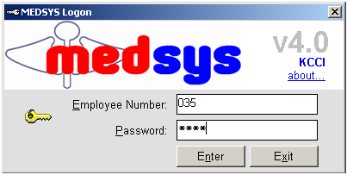
Figure 1: Login Window
3 The asterisk (*) in the password textbox is displayed instead of the data entered in order to keep the password confidential.
After typing the employee number and password correctly, the user can proceed into the main window. If one of the two is invalid then an error message will be displayed prompting “Unauthorized User”.

How to Change Password?
It is advisable to change your password frequently for security reasons. To change you current password, follow these steps.
1 From the Login window, type your employee number and then press <Enter>.
2 Under the Password entry, press <F12>. Pressing this function key will invoke the Change Password window.
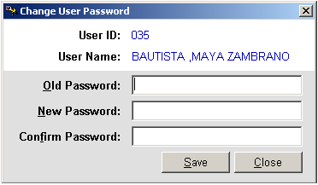
Figure 2: Change Password Window
3 Under the Change Password window, type the following data.
Old Password - Type your existing password.
New Password - Type your new password not exceeding to 15 characters.
Confirm Password - Retype your new password to confirm and then press <Enter> or you can click the Save button.

How to End the Program?
It is important for users to close the program when they are done to end-up their session. Other users might use the open program using the same password.
To close the program, click on located at the upper right corner of the window or
Click on Exit Application toolbar button.

Program Operation

How to Register ER case Patient?

To register E.R. patients, click on ER Registration toolbar button or click on Register Patient menu. The ER Registration window will be displayed.

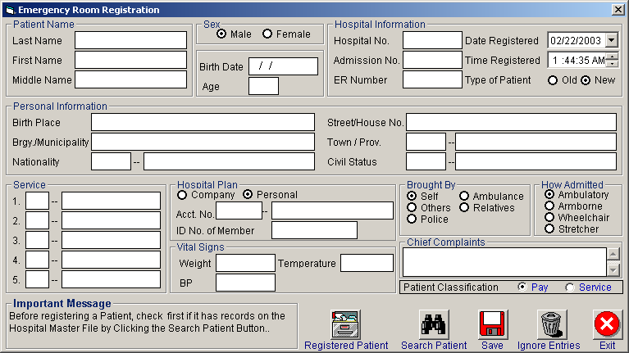
Figure 3: E.R. Registration Window

1 Patient Name - Type the last name of the patient to be registered as ER patient and then click on “Search Patient” button. This will check if he has record(s) in the Hospital Master File. A window with patient listing(s) will be displayed matching your query. Double-click on the patient name from the list to display his old record.
If there is no patient listing displayed, close the window to switch on the ER registration window. Continue completing the following data.
Type the first and middle names of the patient.

2 Sex - Choose one from the two options <Male, Female>.
3 Birth Date - Type the date of birth of the patient. The format is (<mm/dd/yyy> e.g. 10/14/1981).
4 Age - This will be automatically generated.
5 Hospital Information - The hospital, admission and ER numbers are program-generated numbers. The date and time of registration are also automatically displayed. Under type of patient, choose one from the two options <New, Old>.
6 Personal Information - Type the birthplace, barangay/municipality, nationality (press <Enter> when it is still blank to display nationality codes list), street/ house number, town/province (press <Enter> when it is still blank to display zip codes list), and civil status province (press <Enter> when it is still blank to civil status codes).
7 Service - You can type a maximum of 5 hospital services. Press <Enter> if it is still blank to display the service codes list.
8 Hospital Plan - Choose one from the two options <Company or Personal>. If a company supports the patient, type the account number (press <Enter> if it is still blank to display the service codes) then type the I.D. number of member.
9 Vital Signs - Type the weight, temperature and blood pressure of the patient.
10 Brought by - Choose one from the given options.
11 How Admitted - Choose one from the given options.
12 Chief Complaints - Type the complaint of the patient.
13 When completed, the following button options can be clicked.
Click on Save button to save the entry.
You can view the list of registered E.R. patients by clicking on Registered Patient button.
Clicking on Ignore Entries button will clear all the data typed.
Click on Exit button to close the ER registration window.

How to Search Inpatient/Outpatient?

After entering your employee number and password correctly, patient searching window be displayed. You can open patient searching window by clicking on  toolbar button or by clicking the Open menu.

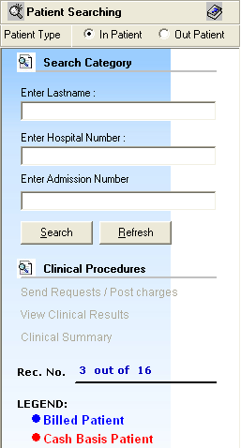
Figure 4: Patient Searching Window

1 Patient Type - Click on the option box “In Patient” to search for inpatients or “Out Patient” to search for outpatients.
2 Search Category - Choose one search category from the list below. It is advisable to just enter the full last name of the patient when searching.

Enter Last Name: Type the full last name of the patient or type the first letters of the last name then press <Enter> or click on Search button or
Enter Hospital Number: Type the hospital number of the patient then press <Enter> or click on Search button or
Enter Admission Number: Type the admission number of the patient then press <Enter> or click on Search button.

Afterwards, patient listing(s) will be displayed at the right side of the window. Patient lists is color coded, Blue is Billed patients while Red is Cash Basis patients. Select a patient from the list to use for your transaction. The selected patient is highlighted with gray color when clicked. Here are the actions you can do after selecting a patient.

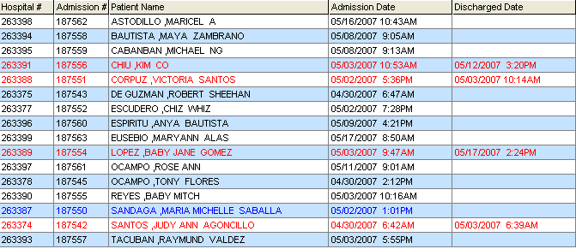

Figure 5: Patients List Window

- Right-click -You can right-click on the patient name to display options such as personal information, request status or patient’s ledger.
- Double-click - When double-clicked, the clinical procedure window will be displayed. Any transaction to be done will be accounted to the selected patient. How to know if patient is tagged as "ECU"? From the clinical procedure 's left corner, you can see the caption " Package Type: _______________(Type of Package)".

3 Clinical Procedures - You can activate this after selecting a patient from the list.

Patient Inquiry

If the patient is right-clicked from the patient list, three options will be displayed to choose from which are listed below.

Personal Information
The personal information to be viewed includes patient name, hospital number, admission number, admission date, and room number. To view patient’s information:

1 Select a patient from the list then right-click. A pop-up window will be displayed. Click Personal Info or click Personal Info from the Inquiry pull down menu.
2 The Personal Information window will be displayed and the following data can be viewed.

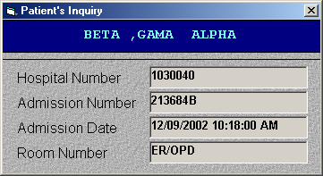
Figure 6: Patient Inquiry Window

Patient Name
Hospital Number
Admission Number
Admission Date
Room Number

Request Status

This will display the status of patient's requested exam. To know the request status of the patient,

1 Select a patient from the list then right-click. A pop-up window will be displayed. Click Request Status or click Request Status from the Inquiry pull down menu.
2 A generated report window will be displayed. The following data can be viewed.
Description - the name of the exam requested
Qty - the number of exam(s) requested for a particular exam
Reference No. - a program generated number (charge-slip number)
Status - e.g. Pending, With Result, Charged…
Request Date - the date when the exam was requested
Request By - the program user who requested the exam
3 To print, click

Patient’s Ledger
This displays the total amount of E.R. charges to be paid by the patient.

1 Select a patient from the list then right-click. A pop-up window will be displayed. Click Patient’s Ledger or click Patient’s Ledger from the Inquiry pull down menu.
2 A generated report window will be displayed.
3 To print, click .

How to Enter ER Result?
Whoever outpatient is selected from the list will be the one to use in the result entry. Click on Result Entry  toolbar button or click Result Entry menu. The Result Entry window will then be displayed.

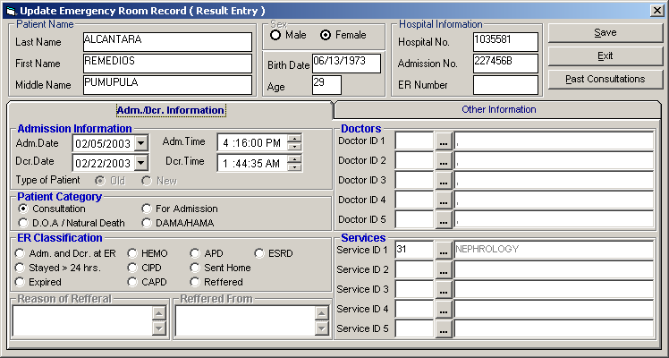
Figure 7: Result Entry Window

You can select the past consultation of the patient by clicking on Past Consultations button at the right side of the window.
Type the following data.

1 Service - Type the service code or you can press <Enter> if it’s still blank to display revenue codes.
2 Diagnosis - Type the code or you can press <Enter> if it’s still blank to display codes listing.
3 Doctor - Type the doctor’s code or you can press <Enter> to display doctor’s list.
4 Patient Category - Choose one from the list.
5 Diagnosis/Findings - Type the findings in the textbox area.
6 Medications - Type the medication in the textbox area.

After completing the needed data, the following button options can be clicked from.
Click on Save button to save the result entry.
Click on Exit button to close the Result Entry window.

Receivable Update

This option lets you enter patient charges that were not entered during his confinement.

1 Click on Receivable Update menu. The Receivable Update window will be displayed afterwards.

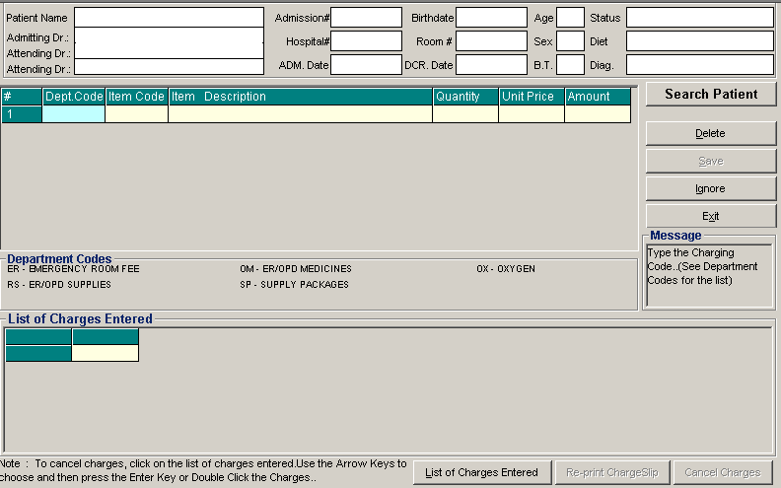
Figure 8: Receivable Update Window

2 Click on Search Patient button located at the right side of the window. The Search Patient window will be displayed. Type the following data.
Patient Type - Click on the option box “In Patient” to search for inpatients or “Out Patient to search for outpatients.
Search Category - Choose one search category from the list below. It is advisable to just enter the full last name of the patient when searching.

Enter Last Name: Type the full last name of the patient or type the first letters of the last name then press <Enter> or click on Search button.
Enter Hospital Number: Type the hospital number of the patient then press <Enter> or click on Search button.
Enter Admission Number: Type the admission number of the patient then press <Enter> or click on Search button.

3 Afterwards, patient listing(s) will be displayed at the right side of the window. Select a patient from the list to use for your transaction by double-clicking on it. In the Receivable Update window, type the following data.

Department Code - Refer to the department code written just below the data entry.
Item Code - Type the service code or first letters of the service name and then press <Enter>. Or you can press <Enter> key if item code is still blank. When pressed, the Revenue Code window will be displayed showing the complete list of revenue codes.
Item Description - Automatically displayed by the program in relation with the selected item.
Quantity - Automatically displayed by the program in relation with the selected item but it can still be changed.
Unit Price - Automatically displayed by the program in relation with the selected.
Amount - Automatically displayed by the program in relation with the selected item and its quantity.

4 After completing the needed data, the following button options can be clicked from.

Click on Save button to save the items entered. When clicked, you have the option to print it.
To remove the selected item, click on the desired item then click on Delete button.
Clicking on Exit button will close the Receivable Update window.
An option is located below the window to view previous charges entered, Reprint charge-slip or cancel the charges entered.

How to Request Laboratory Exam?

This option lets you request laboratory examinations in the Laboratory department.

After searching the patient (see page 11),
1 Click on Send Requests tab option (default menu).

2 Under Laboratory column, select the exam(s) to be requested by clicking the small box beside it. When clicked, the Remarks Entry Window will be displayed. Enter the necessary data then click on ”Enter“ button. Follow the same procedure when adding exam(s).
The exam to be requested cannot be found in the list. Click on ”Search Laboratory Exams“ button. The Laboratory Request Entry Window will be displayed and the following data are needed to enter.

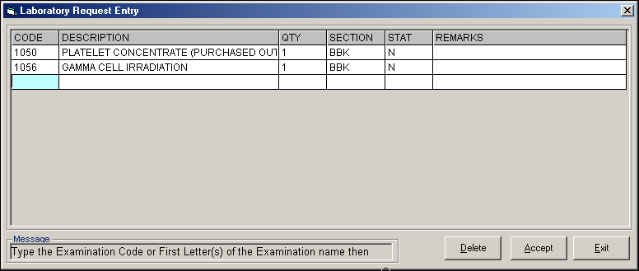
Figure 9: Laboratory Request Entry Window

CODE - Type the examination code or first letter(s) of the examination name then press <Enter>. Or you can press <Enter> key if CODE is still blank to display the list of examination codes. If <enter> key was pressed, a window will be displayed showing the list of examination codes.

Figure 10: Laboratory Exam Codes Window
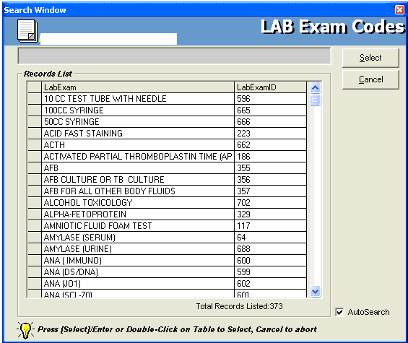
To select from the list, click on the desired exam and click on Select button or simply double-click on the desired exam. The Remarks Entry Window will be displayed afterwards. Enter the following data.

Examination Type - Choose one from the list <Routine, Stat, or In Am Pick-up>
Specimen - e.g. blood, urine...
Transplant - Choose one from the drop-down list either Transplant or Non-transplant
Dialysis - Choose one from the drop-down list either None, Pre-Dialysis or Post- Dialysis.
Remarks - Type additional remarks.

When done, click on Enter button. Follow the same procedure when you want to add an examination.

DESCRIPTION - This will be automatically displayed in relation with the selected exam.
QTY - This will be automatically displayed in relation with the selected exam.
SECTION - This will be automatically displayed in relation with the selected exam.
STAT - The data that were entered in the examination type under the Remarks Entry window will be displayed here. To change it, type Y if the exam is STAT or N if it is Routine.
REMARKS - The data that were entered in the remarks data entry under the Remarks Entry window will be displayed here.
3 Under the Laboratory Request Entry Window, you can do the following options.

To include the requested laboratory exam in the Order’s list, click on Accept button.
To remove requested laboratory exams in the list, click on the desired exam and then click on Delete button.
To close the Laboratory Request Entry window, click on Exit button.

4 After clicking the Accept button, you can do the following options.

      - You can view all the requested exams in the Order’s list.
      - To send the requests, click on Save button. A pop-window will appear asking you to type the requesting doctor. See figure below. Click OK button to proceed. (Same procedure is applied to requesting of other exams)
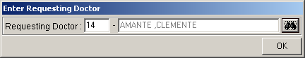
- To remove requested exam from the list, double-click on the desired exam or click on the desired exam then click on Delete button.

How to Request X-ray Exam?
This option lets you request X-ray examinations in the Radiology department.

Under X-ray column, click the small box beside the exam. The same steps with requesting laboratory exam are followed. Please refer to "How to Request Laboratory Exam" for the guidelines.

How to Request Ultrasound Exam

This option lets you request Ultrasound examination in the Radiology department.

Under Ultrasound column, click the small box beside the exam. The same steps with requesting laboratory exam are followed. Please refer to "How to Request Laboratory Exam" for the guidelines.

How to Request C.T. Scan Exam

This option lets you request C.T. Scan examination in the Radiology department.

After searching the patient
1 Click on Send Requests tab option.

2 Under Other Departments, click on the small box beside C. T. SCAN. The list of examinations will be displayed.

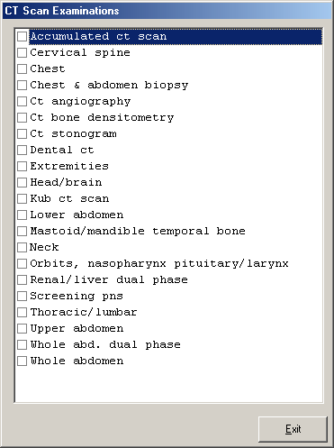
Figure 11: List of C.T. Exams Window

To select from the list, click on the small box beside the desired exam. Upon clicking, the Remarks Entry Window will be displayed. Enter the following data.

Examination Type - Choose one from the list <Routine, Stat, or In Am Pick-up>
Specimen - example blood, urine...
Transplant - Choose one from the drop-down list either Transplant or Non-transplant
Dialysis - Choose one from the drop-down list either None, Pre-Dialysis or Post-Dialysis.
Remarks - Type additional remarks.

When done, click on Enter button. Follow the same procedure when you want to add an examination.

3 After selecting all the examinations for the patient, click on Exit button.
4 After clicking the Exit button, you can do the following options.

You can view all the requested exams in the Order’s list.
To send the request, click on Save button.
To remove requested exams in the list, double-click on the desired exam or click on the desired exam then click on Delete button.

How to Request Heart Station Exam?

This option lets you request Heart Station examination in the Heart Station department.

Under Other Departments, click on the small box beside HEART STATION. The list of examinations will be displayed. The same steps with requesting c. t. scan exam are followed. Please refer to "How to Request C. T. Scan Exam" for the guidelines.

How to Request Nuclear Medicine Exam?

This option lets you request Nuclear examination in the Nuclear Lab department.

Under Other Departments, click on the small box beside NUCLEAR MEDICINE The list of examinations will be displayed. The same steps with requesting c. t. scan exam are followed. Please refer to "How to Request C. T. Scan Exam" for the guidelines.

How to Request P.T. Exam?

This option lets you request physical therapy in the Physical Therapy department.

Under Other Departments, click on the small box beside Rehabilitation Medicine. The list of examinations will be displayed. The same steps with requesting c. t. scan exam are followed. Please refer to "How to Request C. T. Scan Exam" for the guidelines.

How to Request RTS (Pulmonary) Exam?

This option lets you request pulmonary examination in the Pulmonary department.

Under Other Departments, click on the small box beside PULMONARY Section. The list of examinations will be displayed. The same steps with requesting c. t. scan exam are followed. Please refer to "How to Request C. T. Scan Exam" for the guidelines.

How to Request Laser Exam?

This option lets you request pulmonary examination in the Laser department.

Under Other Departments, click on the small box beside Center for Sight II. The list of examinations will be displayed. The same steps with requesting c. t. scan exam are followed. Please refer to "How to Request C. T. Scan Exam" for the guidelines.

How to Request Medicine?
Request on medicine to patient could not be posted in the computer if:
    - Billing staff has closed patient's account. The message that will appear on the screen, "The patient's account has already been closed by _____ (Department). If you have charges to make, notify the Billing staff immediately for further instructions..."
    - Billing staff has placed the patient's account on cash basis. The message that will flash on the screen, "The patient's account has been placed under cash basis by the Billing Officer. Please advice the patient / watcher to see the billing staff immediately for further instructions."
    - May Go Home (MGH) notice was already sent to the different departments.

1 Click on Send Requests tab option

2 Press on F6 key or Click on Pharmacy button at the right side of the window. The items to be entered here will be charged into the patient’s bill. Enter the following data.
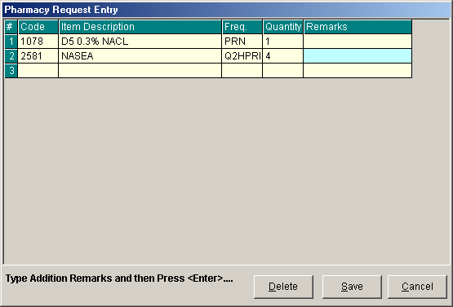
Figure 12: Charge Request Entry Window

Code - Type item code or first letter(s) of item name then press <Enter>. Or you can press <Enter> key if code is still blank to display the list of supplies. If <enter> key was pressed, the list of supplies window will be displayed. To select from the list, click ”All Items“ to display all supplies or you can categorize by clicking ”Suppliers“ or ”Classification“ then double-click on the desired item.
Item Description - This will be automatically displayed in relation with the selected item.
Dosage - Press <Enter> key if dosage is still blank to display the list of dosage codes. If <enter> key was pressed, a window will be displayed showing the list of dosage codes. To select from the list, double-click on the desired code or click on the desired code and click on Select button. To abort the selection, click on Cancel button.
Quantity - This will be automatically displayed in relation with the selected dosage. Note that quantity should be greater than zero.
Remarks - An optional entry.
Just follow the same procedure when adding transcription requests.

After completing the desired items to request, you can do the following options.
Click on Save button to send the request into the Pharmacy department.
To remove requested items in the list, click on the desired item then click on Delete button.
Click on Cancel button to close the Charge Request Entry Window.

How to Request Supplies?

This allows you to request for supplies in the Central Supply Department. Charging will be done by the CSR department after processing the request.

Request on supply to patient could not be posted in the computer if:
    - Billing staff has closed patient's account. The message that will appear on the screen, "The patient's account has already been closed by _____ (Department). If you have charges to make, notify the Billing staff immediately for further instructions..."
    - Billing staff has placed the patient's account on cash basis. The message that will flash on the screen, "The patient's account has been placed under cash basis by the Billing Officer. Please advice the patient / watcher to see the billing staff immediately for further instructions."
    - May Go Home (MGH) notice was already sent to the different departments.

1 Click on Send Requests tab option.

2 Press on F7 key or Click on Central Supply button at the right side of the window. When clicked, the Central Supply Request Entry Window will be displayed and the following data are needed to enter:

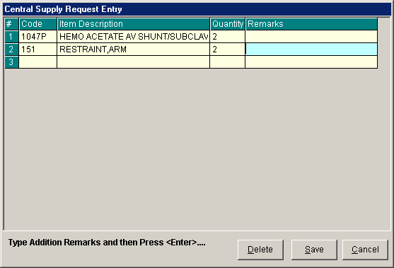
Figure 13: Central Supply Request Entry Window

Code - Type item code or first letter(s) of item name then press <Enter>. Or you can press <Enter> key if code is still blank to display the list of supplies. If <Enter> key is pressed, a window will be displayed showing list of supplies.

To select from the list, click ”All Items“ to display all supplies or you can categorize by clicking ”Suppliers“ or ”Classification“ then double-click on the desired item.

Item Description - This will be automatically displayed in relation with the selected item.
Quantity - Type the number of the item to request. Note that quantity should be greater than zero.
Remarks - An optional entry.

Follow the same procedure when adding items to request.

3 After completing the items to request, you can do the following options.

To send the request in the Central Supply department, click on Save button.
To remove an item in the list, click the row of the desired item then click on Delete button.
Click on Cancel button to abort the entered items.

How to Send May Go Home (MGH) / Discharge Notice?

This option allows you to send Discharge Notice/Processing Sheet to Billing Department to inform that the patient is already cleared from charges from your department.

Nurse will send discharge notice to cost centers after receiving discharge order from patient's doctor. Visual ER program will not allow the user to send discharge notice if there are still pending requests from different cost-centers.

1 Click on Send Requests tab option.

2 Click on Send Clearance at the right side of the window. When clicked, the Discharge Notice Window will be displayed. Complete the following information:

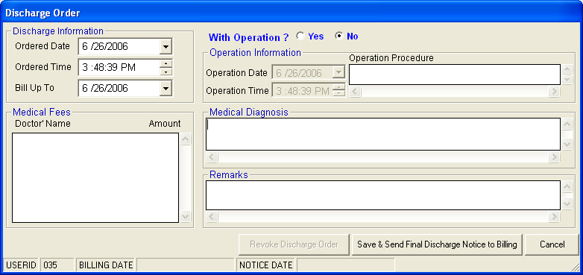
Figure 14: Discharge Notice Window
Discharge Information
Ordered Date - Use the drop-down combo box to select the ordered date
Ordered Time - Use the up and down arrows to select the ordered time
Bill up to - Sets the deadline for the payment of the patient’s bill. To do it, use the drop-down combo box to select a date.
Operation Information - Click the "Yes" option if the patient has undertaken an operation.

Operation Date - Use the drop-down combo box to select an operation date.
Operation Time - Use the up and down arrows to select an operation time.
Operation Procedure - Type the operation procedure of the patient.

Medical Fees

Doctor’s Name - the name of the doctor
Amount - the medical fee of the doctor

Medical Diagnosis - Type medical diagnosis of the patient

Remarks - An optional entry

3 After completing the data, you can do the following options.

Click on Save & Send Final Discharge Notice to Billing button to print. You must click this button to signal the Billing Department that the patient is already cleared from your department.
Click on Cancel button to abort Discharge Notice.

How to Discharge a Patient
This option allows you to remove the patient physically from the list in order to monitor the availability of rooms.
Note: Before discharging a patient, a discharge notice should be sent first to the Billing department. Please refer to ”How to Send Discharge Notice“ to know the request procedure.

1 Click on Send Requests tab option.
2 Click on Discharge/Room Transfer button at the right side of the window. When clicked, the Discharge Patient Window (default) will be displayed asking you to complete the following data:

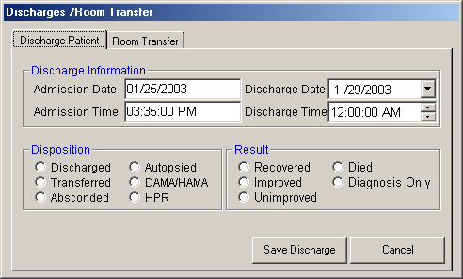
Figure 15: Discharge Patient Window

Admission Date - Automatically filled-up by the program in relation with the patient’s day of admission.
Admission Time - Automatically filled-up by the program in relation with patient’s time of admission.
Discharge Date - You can set the discharge date by clicking on the drop-down combo box. Note that discharge date should not go beyond the current date.
Discharge Time - You can set the discharge time by clicking on the up and down arrows.
Disposition - Click one from the list.
Result - Click one from the list.

3 After completing the data, you can do the following options.
Click on Save Discharge to remove the patient physically from the list.
Click on Cancel button to abort discharging the patient.

Nurses Activity Request

From the requests posted in the Send Requests tab option, you can view here the status of each request.

Nurses Activity Request is where you can view list of processed requests, list of pending requests, list of exam with results, and reports such as diet list, census report by station, discharges for the day, list of requests/orders, list of medicine posted and list of supplies posted.

1 Click on Nurses Activity Request tab option.

2 Its window will be displayed showing the following data:

List of Processed Requests - These are the lists of requests that were already processed by the department in response to the requests done in the Send Requests tab option.

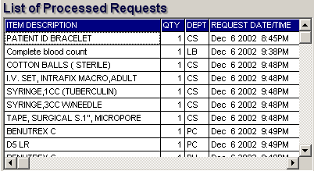
Figure 16: List of Processed Requests

List of Pending Requests - These are the lists of requests posted in the Send Requests tab option which are not yet acknowledged by the receiving department.

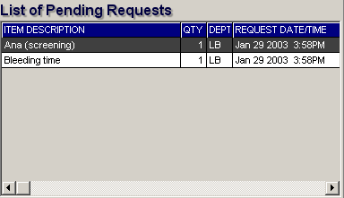
Figure 17: List of Pending Requests

To cancel a request, double-click on the desired item.

List of Exams with Results - These are the list of exams posted in the Send Request tab option that already have results and its details can be viewed in the View Results tab option.

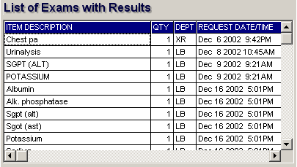
Figure 18: List of Exams with Results

3 The following button options can be clicked from.

Click on Refresh button to view the latest update from the database.
Click on Exit button to close the program.

How to View X-ray Exam Result?

This option allows you to view result of x-ray exams.

After searching the patient (see page 12),
1 Click on View Results tab option.
2 Its window will be displayed.
3 Click X-ray tab to view x-ray exam result. (X-ray window is the default window).

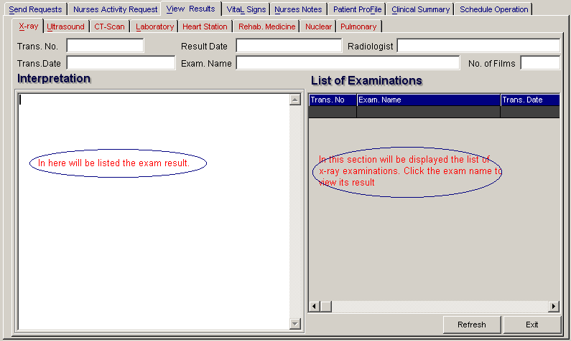
Figure 19: X-ray View Exam Result Window

The list of examinations is displayed at the right side of the window. Just click the desired exam to view its result. The exam result can be viewed at the left side of the window.

4 The following buttons can be clicked from.
Refresh - This will view latest updates of exams with result from the database.
Exit - This will close the program.

How to View Ultrasound Exam Result?

This option allows you to view result of Ultrasound exams.

Click Ultrasound tab to view exams with result. The same steps with viewing of x-ray exam are followed. Please refer to "Viewing of X-ray Exam Result" to know the procedure.

How to View C.T. Scan Exam Result?

This option allows you to view result of C. T. Scan exams.

Click C.T. Scan tab to view exams with result. The same steps with viewing of x-ray exam are followed. Please refer to "Viewing of X-ray Exam Result" to know the procedure.

How to View Laboratory Exam Result

This option allows you to view result of laboratory tests and exams.

After searching the patient (see page 12),
1 Click on View Result tab option.
2 Its window will be displayed.
3 Click the Laboratory tab to view Laboratory exams with result.

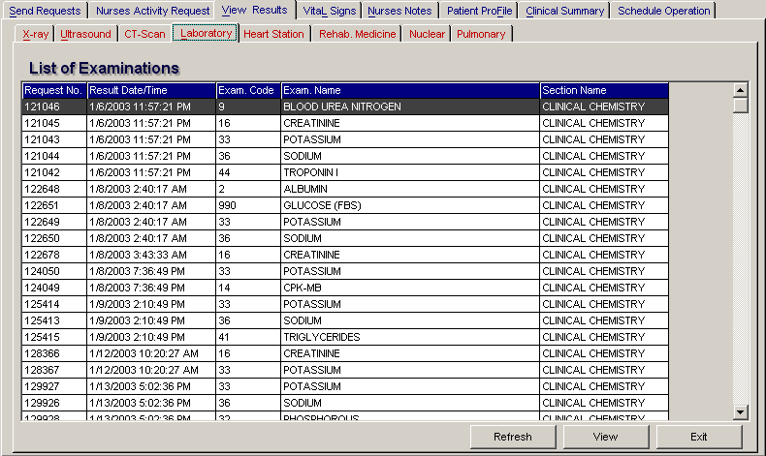
Figure 20: Laboratory View Exam Result Window

To view, click the exam and then click on View button. The Refresh button is used to view the latest updates of Laboratory exams with results from the database. While the Exit button is used to close the program.

How to View Heart Station Exam Result?

This option allows you to view result of Heart Station exams.

After searching the patient (see page 12),
1 Click on View Result tab option.
2 Its window will be displayed.
3 Click Heart Station tab to view exams with result.

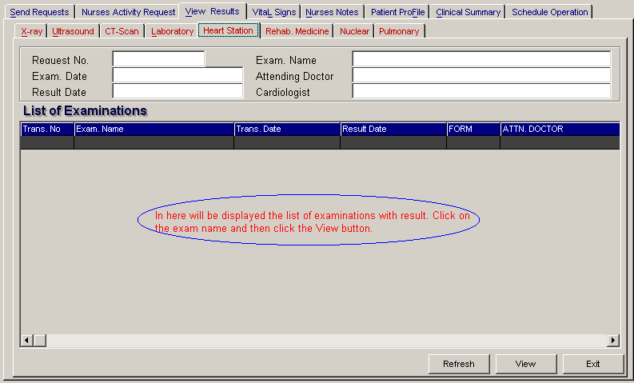
Figure 21: Heart Station View Exam Result Window

To view, click the exam and then click on View button. The Refresh button is used to view the latest updates of Laboratory exams with results from the database. While the Exit button is used to close the program.

How to Update Vital Signs info?
In here, it is where you can enter the vital signs of the patient. Vital signs data entry includes blood pressure, body temperature, respiratory rate, and pulse rate.

1 Click on Vital Signs tab option.

2 On the left side, you can see the previous vital signs of the patient. The following data can be viewed.

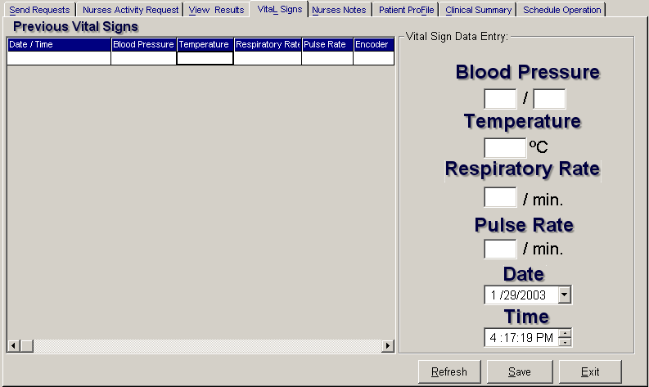
Figure 22: Vital Signs Data Entry Window

Date/Time - the date and time when vital sign was entered.
Blood pressure
Respiratory rate
Pulse rate

And on the other side is the vital sign data entry. The following data needed to enter.

Blood pressure
Body temperature
Respiratory rate
Pulse rate

3 The following button options can be clicked from.

Click on Save button to save entry.
Click on Refresh button to view the latest update from the database.
Click on Exit button to close the program.

How to Enter Nurses Notes?
Nurses Notes window is where you can type down their notes or remarks about the condition of the patient. It works like an electronic notebook because you can retrieve the saved data of a particular date and shift of the day.

1 Click on Nurses Notes tab option.

2 To view past patient’s chart, click on Past Notes written vertically. The following data can be viewed.

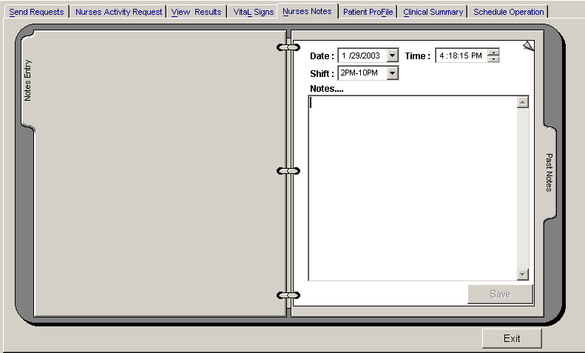
Figure 23: Nurses Notes Window

Date/Time - the date and time when the remarks were entered
Day shift - the shift of the day
Entered by - the program user who entered the remarks
Notes - the content of the remarks

To enter patient’s chart, click on Notes entry written vertically. Enter the following data.
Date/Time - current date and time is used
Day shift - select from the following choices listed (6am-2pm, 2pm- 10pm, 10pm-6am)
Notes - Type remarks on the multi-line textbox.

3 The following button options can be clicked from.
Click on Save button to save the notes entered.
Click on Exit button to close the program.

How to View Patient Profile

Patient Profile is where you can view the latest patient’s information throughout his current confinement. It includes admitting diagnosis, chief complaints, manner of admission, past medical history, allergies, personal and social history and family history.

1 Click on Patient Profile tab option.

2 The Patient’s Profile Window will be displayed.

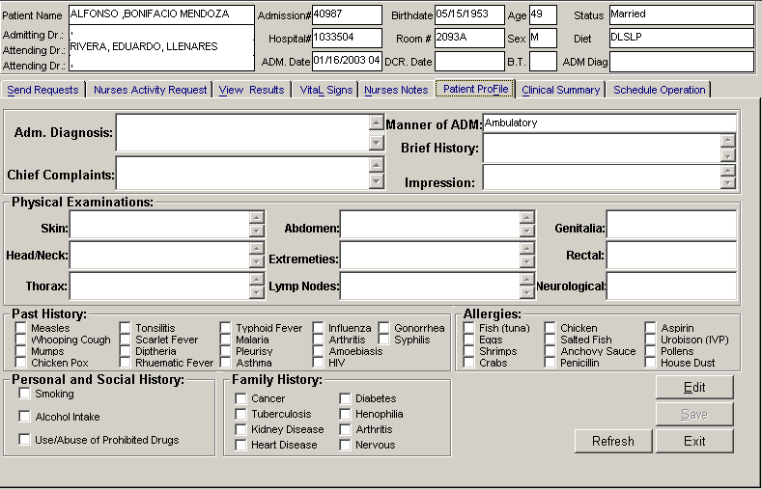
Figure 24: Patient's Profile Window

3 The following button options can be clicked from.

To edit the patient’s profile, click on Edit button. You can now make necessary modifications on the patient’s profile.
When completed, click on Save button to save the changes.
Click on Refresh button to undo the changes done.
Click on Exit button to close the program.

How to Post ER Charges?
1 click the Post Charges button on the Send Requests tab
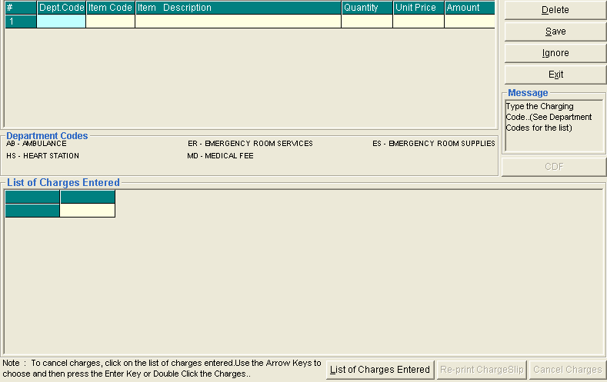
2 Choose from the list of Department Codes for the charges to be entered
> AB – Ambulance
> HS – Heart Station
> ER – Emergency Room Services
> MD – Medical Fee
> ES – Emergency Room Supplies
3 To save the charges entered, click the Save button
4 To remove or delete charge/s entered, click the Delete button
5 To disregard all the charge/s entered, click the Ignore button
6 To view list of previous entered, click the List of Charges Entered button
7 Click the Re-print chargeslip button to reprint charge slip

Cash Assessment Entry
This option allows the user to enter cash transactions for patients tagged as cash. To do this, click on Cash Assessment Entry button in the Send Requests tab. This will load the window below.

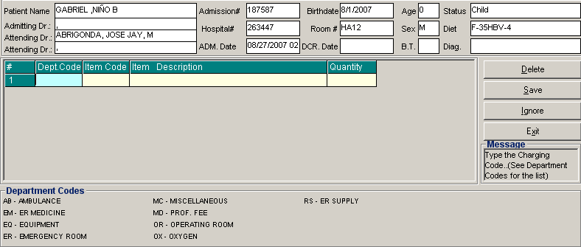
Enter the following data
- Dept. Code – choose from the list(s) displayed below (e.g. AB – Ambulance, EQ – Equipment )
- Item Code – type first few letter(s) of the item to be charged or press Enter key to display all charges. Double click on the item to be charged.
- Item Description – this is the description of the item selected
- Quantity – enter the quantity how many times the item / procedure is used or done.
To remove an item to be charged, highlight then click on Delete button.
Click on Save button to save charges entered.
Click on Ignore button to disregard the charges entered.
Click on Exit button to go out from this window.

To view list(s) of assessment entered, click on List of Assessment Entered button.

How to Cancel an Item that is already PAID?
In the List of Cash Assessment Entered window, click on the List of Assessment Entered to display list(s) of charges entered for the specific patient.
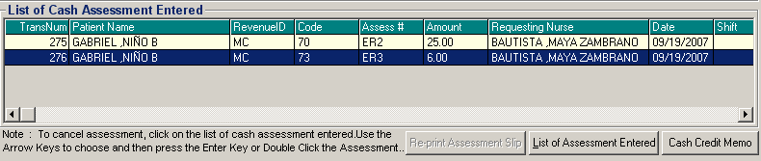
To cancel an item, highlight the specific item then click on Cash Credit Memo to load the window below.

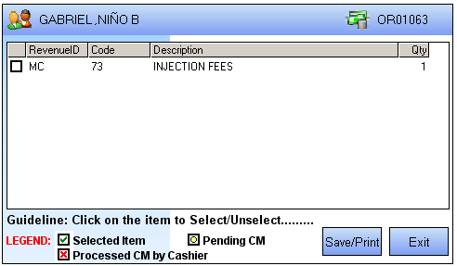

Click on the check box ( ) to select an item to be returned then click on Save/Print button.

How to View Clinical Summary?

Clinical summary is where you can view for a particular clinical summary of a patient’s
confinement.

1 Click on Clinical Summary tab option.

2 The Clinical Summary Window will be displayed. The following data can be viewed:

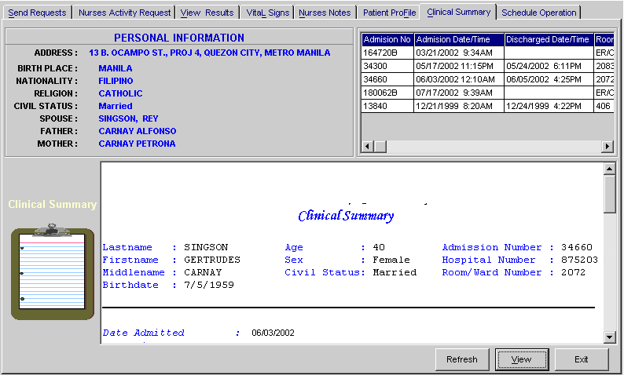
Figure 25: Clinical Summary Window

Admission number - a program-generated number during patient’s admission
Admission date/time - the date and time when the patient was admitted
Discharge date/time - the date and time when the patient was discharged
Room number - the room number of the patient during his confinement

3 To view for a particular clinical summary of patient, click on the desired exam then click on View button. The following data can be viewed.

Date admitted - the date when the patient was admitted
Date discharged - the date when the patient was discharged
Attending physician - the name of the attending physician
Admitting doctor - the name of the admitting doctor
Admitting diagnosis - the admitting diagnosis of the patient
Chief complaints - the complaint of the patient
Final Diagnosis - the final diagnosis of the patient

4 Click on Exit button to close the program.

Posting of Packages to Patients
This option allows the user to post packages to patients. To do this, choose patient then click on Post Charges then go to VIEW ER PACKAGE option to load a sample window below.
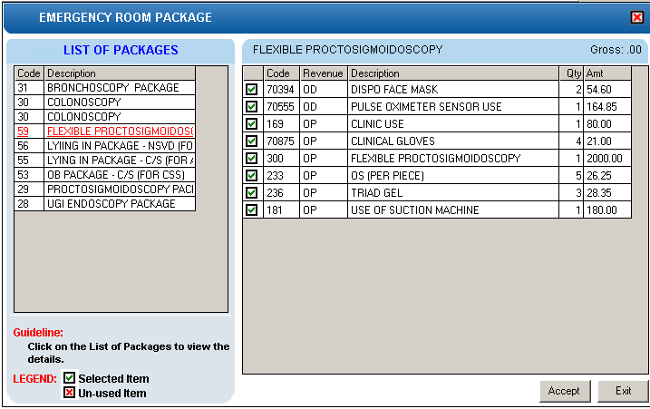
Check on the item used by the patient then click on Accept button to charge it to patient or click on Exit button to disregard entries.

Reports

Click the option you want (listed below) from the Reports pull-down menu. A window for date entry will be displayed. Select From and To dates by clicking the drop-down arrow then click on OK button.

Audit Report

This displays a report of all items requested, how many quantities are used in a particular item requested and its corresponding amount totaling the accumulated amount of all items. This is arranged alphabetically by the reference number of each item.

The following data can be viewed.

Reference No. - program - generated number (charge-slip number)
Amount - the amount of item requested
Department - the department code
Quantity - the number of item requested
Code - the code of the item requested
Description - the name of the item requested
By - the program user who requested the item
Date - the date when the item was requested
Name of Patient - the name of the patient who requested the item
To print, click .

Monthly Report

This displays a report of all items requested, the quantity and amount accumulated each and both in inpatient and outpatients for a particular item then totaling the quantity and amount accumulated each and both in inpatient and outpatients for all the items requested. This is arranged alphabetically by the name of the item requested.

The following data can be viewed.

Description - the name of the item requested
Number (Inpatient) - the total number of the particular item requested in inpatient
Amount (Inpatient) - the total amount accumulated for the particular item in inpatient
Number (Outpatients) - the total number of the particular item requested in outpatients
Amount (Outpatients) - the total amount accumulated for the particular item in outpatients
Number (Total) - the total number of the particular item requested in inpatient and outpatients.
Amount (Total) - the total amount accumulated for the particular item in inpatient and outpatients.
To print, click .

Daily Census
Daily Admission Census

This displays a report of all registered ER patients on a selected date of time. The following data can be viewed such as the OPD date and time, name of patient, age, sex, chief complaint, resident doctor, classification of the patient and the encoder name.
To print, click .

Daily Out Patient Consultation / Discharge

This displays a report of all OPD Consultations and Discharges on a selected date of time. The following data can be viewed such as the OPD Date and Time, name of patient, age, sex, chief complaints, resident on duty, attending doctor, classification of patient and the encoder name.
To print, click .

Daily Special Census

This displays a report of In and Out patient with Special Classification on a selected date of time. The following data can be viewed such as the OPD date and time, name of patient, age, sex, chief complaints, resident on duty, attending doctor, classification of patient and encoder name.
To print, click .

Daily Walk In Census

This displays a report of Walk In patient on a selected date of time. The following data can be viewed such as the OPD date and time, name of patient, age, sex, chief complaints, resident on duty, attending doctor and encoder name.
To print, click .

Census Statistics

This displays a report of ER Census grouped by date, service, patients classification (walk-in, private patient, company, special) and the total on a selected date of time.

To print, click .

Patient Discharge Notice Status

This displays a report on the status of patient discharge notice if cleared or not cleared in the department and it is grouped by station.
To print, click .

Income Report ( Detailed )

This displays a report on the detailed daily income of ER and it is grouped by patient and classification of ER charges. The following data can be viewed: patient name, IPACT #, item / description, amount, encoder, date charged, total per ER charges and the Grand total on a selected date.
To print, click .

Income Report ( Summary )

This displays a report on the monthly income of ER and grouped by classification of ER charges. The following data can be viewed: code of ER charges, description, amount and the Grand total income for the selected date.
To print, click .

Index

—A—
audit report, 56
—C—
c.t. scan exam request, 26
c.t. scan view exam result, 46
cardiovascular exam request, 28
changing of password, 9
clinical summary (viewing), 55
—D—
daily census report, 56
diet request, 36
discharge a patient, 40
discharge order, 38
drug request, 32
—E—
end the program, 10
enter nurses notes, 53
enter result, 17
enter vital signs, 52
exam result (viewing), 43
—F—
features, 7
—H—
heart station exam request, 28
heart station view exam result, 48
—L—
Laboratory exam request, 21
Laboratory exam request form (reprinting), 41
Laboratory view exam result, 47
—M—
medicine entry, 32
monthly report, 56
—N—
nuclear lab. exam request, 29
nuclear med. view exam result, 49
nurses activity request, 42
nurses notes entry, 53
—O—
objectives, 6
overview, 5
—P—
p.t. exam request, 30
p.t. view exam result, 51
password (changing of), 9
patient (e.r. registration), 11
patient profile viewing, 54
patient searching (inpatient, outpatient), 13
patient's diet request, 36
—R—
receivable update, 19
register e.r. patient, 11
reports, 56
reprint request form of lab, 41
request c.t. scan exam, 26
request cardiovascular (heart station) exam, 28
request form reprinting (Laboratory exam), 41
request Laboratory exam, 21
request medicine, 32
request nuclear medicine exam, 29
request p.t. exam (physical med. and rehab.), 30
request patient's diet, 36
request rts (pulmonary Laboratory) exam, 31
request status (nurse activity), 42
request supplies, 34
request ultrasound exam, 25
request x-ray exam, 24
result entry, 17
rts exam request, 31
rts view exam result, 50
—S—
search a patient (inpatient, outpatient), 13
start the program, 8
summary by service report, 56
supply (requesting), 34
—U—
ultrasound exam request, 25
ultrasound view exam result, 45
—V—
view c.t. scan exam result, 46
view clinical summary, 55
view exam result, 43
view heart station exam result, 48
view Laboratory exam result, 47
view nuclear med. exam result, 49
view patient profile, 54
view pulmonary Laboratory exam result (rts), 50
view rehab. med (p.t.) exam result, 51
view ultrasound exam result, 45
view x-ray exam result, 44
vital signs data entry, 52
—X—
x-ray exam request, 24
x-ray view exam result, 44

