Doctors Module Net Manual 

This module puts the doctor in touch with all clinical aspects of hospital activities. He can enter and receive laboratory, x-ray and other clinical orders. Prescriptions including dosages are indicated, and the doctor can even view on line drug inventory levels. Importantly a patient's past clinical record and medical history is immediately viewed. There are many different modules depending upon the doctor’s specialty. Besides general medicine, there are individual systems for dental, psychiatry, EENT, family planning, cardiology, etc.

Web Based

Linked to OPD registration, medical records & clinical departments

Provides 2 different methods of diagnosis entry

Transfer/referral of patients to other doctors

Entry of medical history, pre-employment/annual exam results
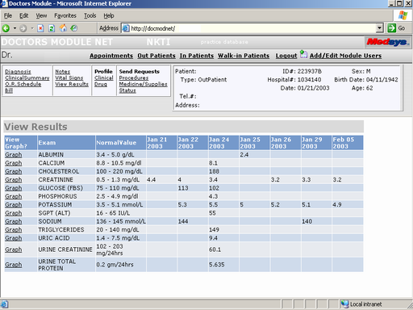
Laboratory Results viewed by date (can also be viewed in graphical form)

Requirements:
- Personal Computer with Microsoft Internet Explorer

To Connect
» Open Internet Explorer and enter “http:\\docmodnet\docmodnet” in the address bar then press the Enter key
.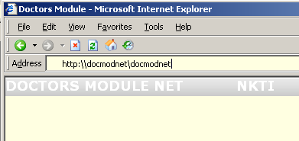
For quick access, a shortcut could be created on the desktop or added to the favorites of internet explorer.

» Enter your User ID and Password (given to you by the Computer Department) then click on Connect
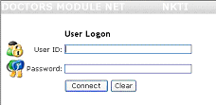

Features
Appointment Scheduling
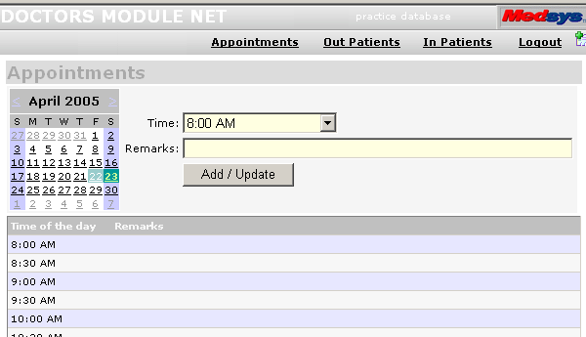 | Use:  - Click on calendar date to set appointment date  - Select time from drop Time drop down box  - Enter appointment description in Remarks box  - Click on Add/Update to save

For Patient Related features, first select a patient from the “Out Patients” or “In Patients” list…
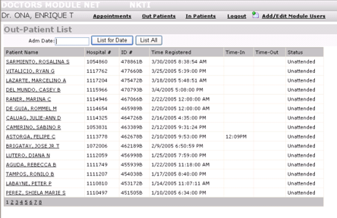 | Use:  - Click on “Out Patients” or “In Patients” link on the top to display the corresponding patient list  Out Patients  - Enter the Admission Date then press enter to search for patients  In Patients  - Click on “List In-Patients” to list currently confined patients or  - Enter last name on Search box to search for previously confined patients  - Click on the Name of the patient to be used

After an Out/In/Walk-in patient has been selected, the Patient Menu is displayed…
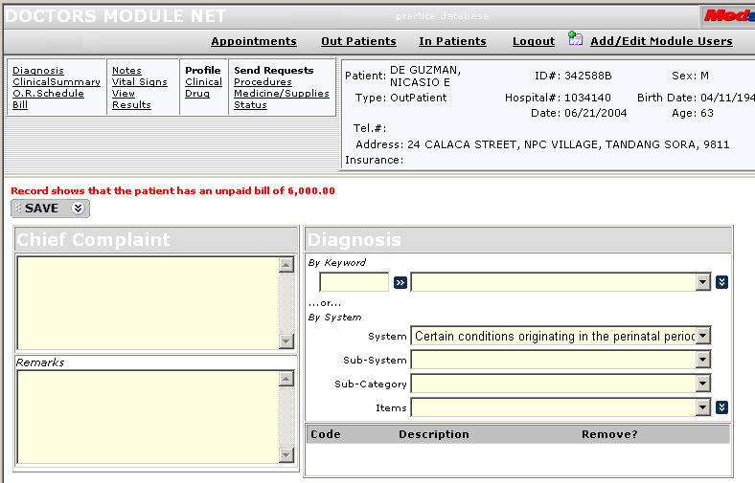

Diagnosis - Enter the Patient’s Diagnosis and Chief Complaint
Diagnosis can be entered by:
- Keyword – Searches diagnosis given a keyword
- ICD10 - Select a Diagnosis using a series of “drop-down” lists

Clinical Summary - View the patient’s admission history

Requests Procedures and view the status of these requests
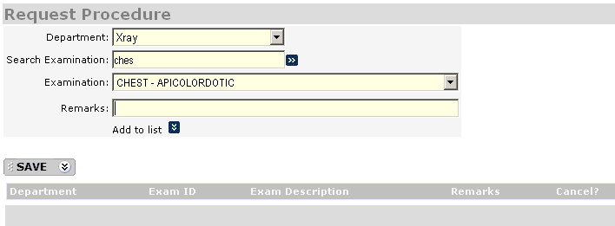 | Use:  - Select Department  - Type a keyword for the examination in the Search Examination box then press the Enter key  - Select an examination in the Examination drop down box  - Type in the remarks  - Click on Add to List  - Click on SAVE  Note: Laboratory procedures marked as “Stat” will cost patients an extra 5% charge

Request Medicine/Supplies to the CSR or Pharmacy department
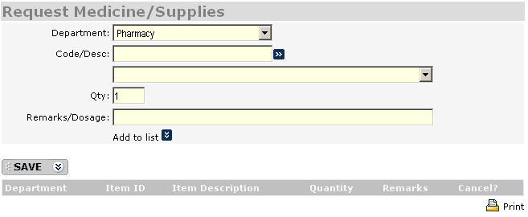 | Use:  - Select Department  - Enter the keyword in Code/Description box then press the Enter key  - Select the Medicine/Supply from the drop-down box  - Enter the remarks  - Click on “Add to list”  - Click on SAVE

Patients Bill - Enter the Patients Bill and view payment history on previous admissions (A reminder will be shown in main screen if patient has not paid the full bill from the previous visit)
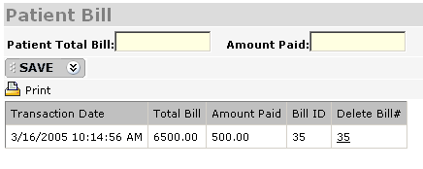 | Use:  - Enter the “Patient Total Bill” and “Amount Paid” in the corresponding boxes  - Click SAVE  To Delete a bill:  - Click on the Bill number to be deleted under the “Delete Bill#” column

Clinical Profile - Enter the patient’s Clinical Profile (e.g. Physical Examination, Medical History, Allergies)
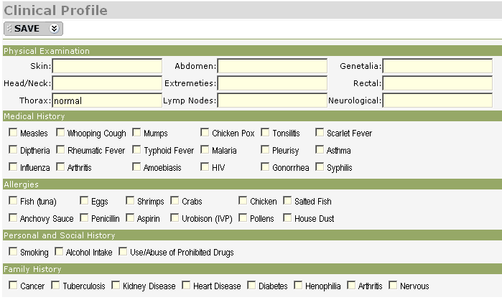 | Use:  - Enter descriptions in the Physical Examination group’s entry boxes  - Click on the check boxes on the rest of the groups for items that apply  - Click on SAVE

Drug Profile - View the history drugs administered to the Patient

View Results from the following departments: X-Ray, Laboratory, Ultrasound, CT-Scan, Cardiovascular, Rehab-Medicine, Nuclear, Pulmonary, and O.R.
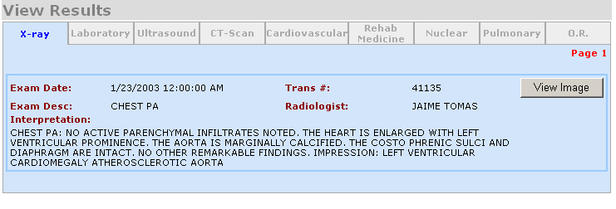 | Use:  Click on the Department tabs to view results from that department.  Note: Laboratory results can be graphed by clicking on the “View Tabular Format” link then “Graph” next to the item you wish to be graphed

Patient Notes - Enter miscellaneous notes regarding the patient
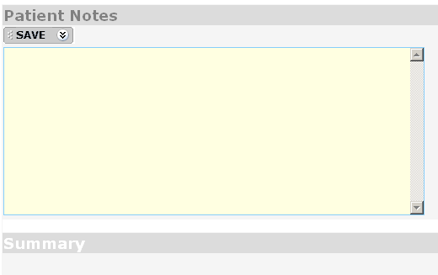 | Use:  - Enter any text on the entry box  - Click on SAVE  Patient Notes on previous admissions are shown on the Summary list below.

Vital Signs - Enter the patient’s (e.g. Blood Pressure, Temperature, Respiratory Rate, Pulse Rate, and Weight)
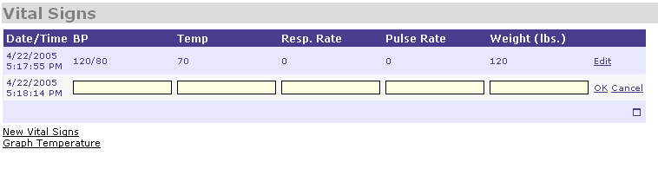 | Use:  - Click on “New Vital Signs”  - Enter the BP, Temp, Respiratory Rate, Pulse Rate, Weight  - Click on Ok to save  Once saved, the record can be Edited or Deleted by clicking on the corresponding button
Note: The temperature reading can be graphed

Operating Room Schedule - Request an Operating Room appointment
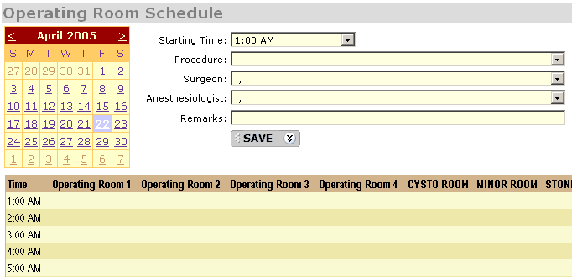 | Use:  - Click on the Operation date on the calendar  - Select the starting time on the “Starting Time” drop down box  - Select the Procedure, Surgeon, Anesthesiologist on the drop down boxes  - Enter the Remarks  - Click on SAVE  Note: The request would not appear on the Operating Room Schedule until the request has been approved by the O.R.

