MEDSYS
Information System

Visual Cardiology Program
User's Manual



MEDSYS
Kaiser - dela Cruz Consulting, Inc.
July 29, 2026
Copyright© 2009
ALL RIGHTS RESERVED

No part of this document may be reproduced through photocopying or in any means, stored into a retrieval system, and transmitted in any form without the express written permission of Kaiser - dela Cruz Consulting, Incorporated.
Permission is hereby granted to Medsys Information System to copy and distributes this document in any of the above means provided this is for its exclusive on site use.
Although every precaution has been taken in the preparation of this manual, the company assumes no responsibility for errors or omissions. Neither is any liability assumed for any damages resulting from the use of the information contained here.

Table of Contents

Copyright© 2003
Introduction 4
Overview 4
Objectives 5
Features 5
Getting Started 6
How to Start the Program? 6
How to Change Password? 7
How to End the Program? 8
Program Operation 9
Cash-basis Patient Request Entry 9
Outpatient Request Entry 11
Inpatient Request Entry 12
Result Entry 14
Result Editing / Result Inquiry 15
Request Cancellation 16
Re-Printing of Charge Slip 17
Viewing of Patients Ledger 18
Reports 19
Build File of Coded Normal Values 20

Introduction

Overview

The Visual Cardiology Program is a computerized processing of Heart procedure request. This is connected to other MEDSYS programs such as Visual Nurse to accept and process the request and to enter the exam result into the computer which can be accessible to all stations once verified.
The use of password protects the program by disallowing the access of authorized users. Only program users with a registered employee number and password can gain access into it.

Objectives

To improve transactions in the department by lessening the data-entry in processing Cardiology exam request through automating the communication between departments in Heart Station and Nurse Station, Heart Station and Cashier, and Heart Station and Billing.

Features

Data entry restriction - Warning messages are flashed for possible invalid entries. This ensures all data inputted would be made useful for any transaction that may occur.
Password-protected - The use of password is necessary to restrict unauthorized access. Thus the program only accepts passwords which are registered into it. This feature ensures the confidentiality and integrity of data entered in the program.
Auto-report generation - The program is capable of generating reports and can be readily printed.
User-friendly - The program user is guided by instructions in doing the next step providing an easy-use to process transactions.

Getting Started

How to Start the Program?

- Click the Heart Station Program executable file icon located in your computer desktop.
- The Login window will be displayed asking you to type your employee number and password for security purposes.

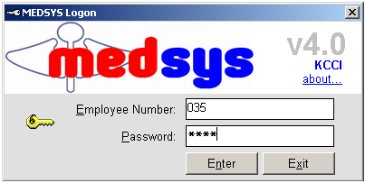
Figure 1: Login Window

- If accepted, you can now start a transaction. Otherwise, a message will be displayed prompting “Unauthorized User”.

How to Change Password?

1 From the Login window, type your employee number and then press <Enter>.

2 Under the Password entry, press <F12>. Pressing this function key will invoke the Change Password window.

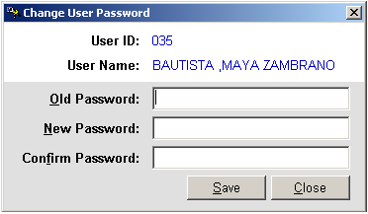
Figure 2: Change Password Window
3 Under the Change Password window, type the following data.
Old Password - Type your existing password.
New Password - Type your new password not exceeding to 15 characters.
Confirm Password - Retype your new password to confirm and then press <Enter> or you can click the Save button.

How to End the Program?

It is important for users to close the program when they are done to end-up their session. Other users might use the open program using the same password.

To close the program:
Click the Exit toolbar button or
Click the button located at the upper right corner of the main window.

Program Operation
Cash-basis Patient Request Entry
This option allows you to request Cardiology procedures and then charges the amount of the item(s) to the selected cash-basis patient.

- Choose the Assessment Entry ( OPD Rate ) in the Data Entry Option. The Assessment Entry window will be displayed. Enter the following data.
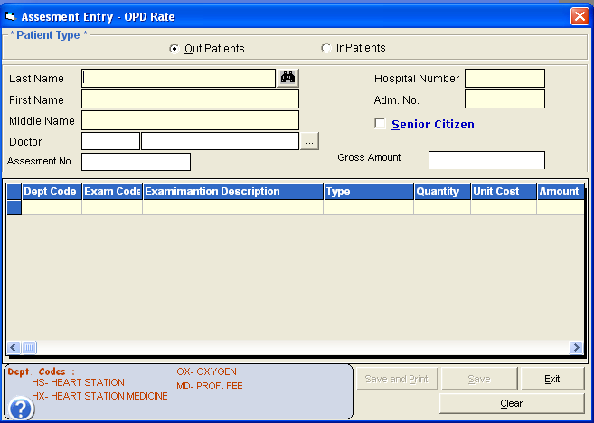
Assessment Entry Window

- Under 'Patient Type' entry, choose either from 'Inpatient' or 'Out Patient'.
- Enter the patient's requesting doctor.
- To request the procedure(s):
  - Exam Code - Enter the item code and then press <Enter>. A window with the list of procedures will be displayed. Double-click on the procedure to select.
  - Exam Description - This is the description of the procedure.
  - Unit Cost - This is the basic price of the procedure.
  - Quantity - Enter the quantity of procedure.
  - Amount - This is the amount of the procedure to be paid by the patient.

Tag if the patient is a Senior Citizen for automatic computation of senior citizen discount.
The total amount can be seen just above the 'Amount'.

- To save:
  - Click on 'Save' or 'Save Print' button.

To disregard the data entered, click on Clear button
To go out from this option, click on Exit button

Outpatient Request Entry

This option lets you request Cardiology examinations/procedures and then charges the item to the selected patient.

- After searching the patient, click the patient from the list and then the Outpatient Request Entry window will appear

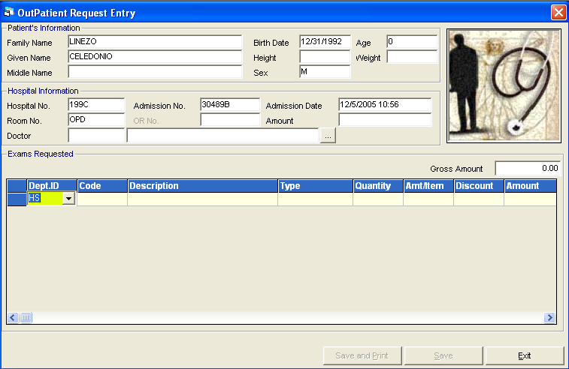
Outpatient Request Entry Window

2. To request the procedure(s):
  - Dept. ID - Refer to the bottom of the window to view the list of department codes.
  - Code - Enter the item code and then press <Enter>. The list of procedures will be displayed; double-click it select.
  - Description - This is the description of the procedure.
  - Quantity - Enter the quantity of the procedure.
  - Unit Price - This is the basic price of the procedure.
  - Amount - This is the amount of the procedure to be paid by the patient.
3. To save, click on 'Save' or 'Save/Print' button.

Inpatient Request Entry

This option lets you request Cardiology examinations/procedures and then charges the item to the selected patient.

- After searching the patient, click the patient from the list and then click Send Requests/ Post Charges.

- The Request Entry window will be displayed as shown below.
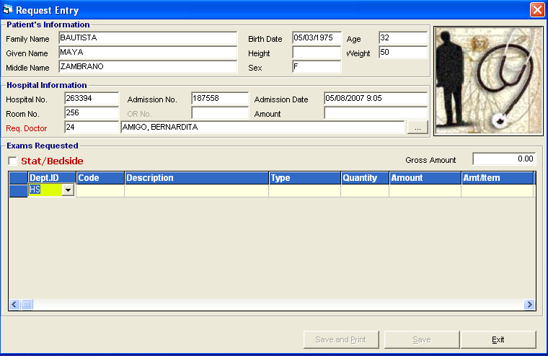
Request Entry window

- To request the procedure(s):
  - Dept. ID – Enter HS for Cardio Procedures, HX for Cardio medicines, MD for doctors professional fee and OX for oxygen charges.
  - Item Code - Enter the item code and then press <Enter> or press <Enter> key to display complete lists of procedures of the selected department.
  - Item Description - This is the description of the procedure.
  - Quantity - Enter the quantity of the procedure.
  - Unit Price - This is the basic price of the procedure.
  - Amount - This is the amount of the procedure to be paid by the patient.

- To save, click on 'Save' or 'Save/Print' button.
- To go out from this option, click on Exit button.

Result Entry

This option lets you enter results for Cardiology examinations/procedures charged to the selected patient.

- Click the button or choose the Result Entry in the Data Entry option.
- After searching the patient, click the patient from the list
- The Result Entry window for the specific examination will be displayed on the screen.
- To save the result entered, click the ‘Print/Save’ or the ‘Save’ button.
- To disregard or cancel the results entered, click the ‘Cancel’ button.

Result Editing / Result Inquiry

This option allows you to edit or view results of patients.

- Click the button or go to Result Inquiry option.
- Enter the patients last name then double click on the patients name.
- List of Results will be displayed on the screen.
- Double click on the examination to be edited or you want to view

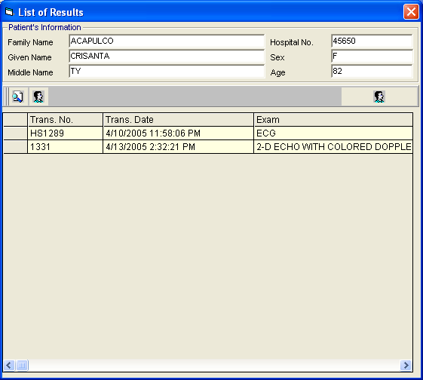

Request Cancellation
This option allows you to cancel requests to a specific patient.

- Go to File Maintenance then choose Request Cancellation.
- List of patient with requests is displayed on the screen. Double click on the patient name or click the process button.
- The Request Cancellation window is displayed on the screen.

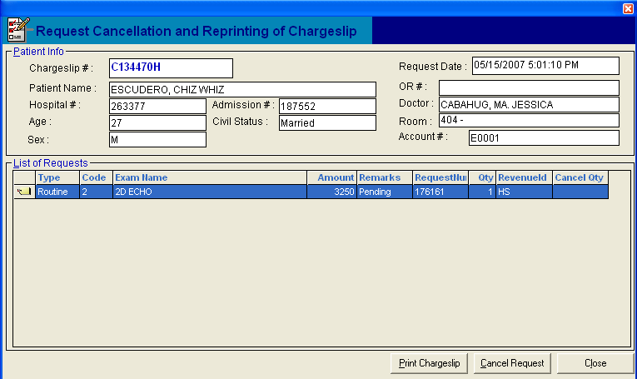
Request Cancellation Window

4. Click on Cancel Request button to revoke or cancel a specific item. To re-print charge slip, click on Print Chargeslip button. To go out from this option, click on Close button.

Re-printing of Charge Slip

This option allows you to reprint or have a duplicate of patients charge slip.

- Go to File Maintenance then choose Re-print Charge Slip option.
- The Reprinting of Charge slip Window will be displayed on the screen.

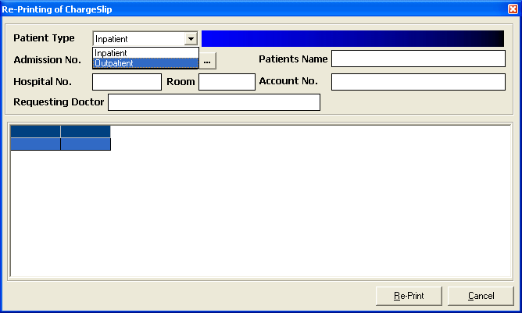
- Choose Patient Type : Inpatient or Outpatient
- Enter patients last name or admission number of patient
- List of patient charges will be displayed on the screen.
- Highlight the specific charges to be reprinted.
- Click the ‘Re-Print’ button to reprint charge slip or ‘Cancel’ button to go out from the window

Viewing of Patients Ledger
This option allows you to view all the charges of patient.

- Go to File Maintenance then choose Patient’s Ledger
- Choose patient type : Inpatient or Outpatient
- Enter patients last name then choose from the list.
- Double click on the patient name you want to view the charges
- Patients ledger will be displayed on the screen.

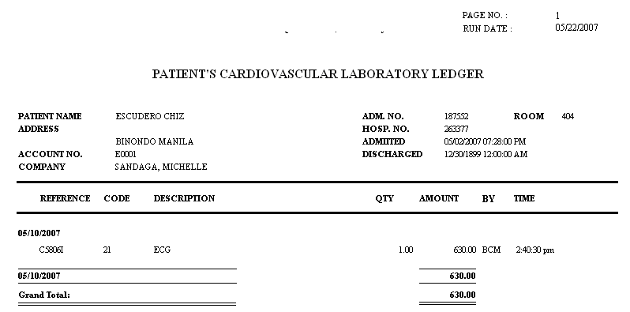

Sample Patient Ledger

Reports

The following reports are generated by the program. Click on Reports menu to display list of reports.

- Audit Report
- Monthly Report
- Monthly Income Report
- Statistical Report
- Daily Transaction Report
- Assessment Status

Build File of Coded Normal Values
Go to File Maintenance > Coded Normal Values to display the window below

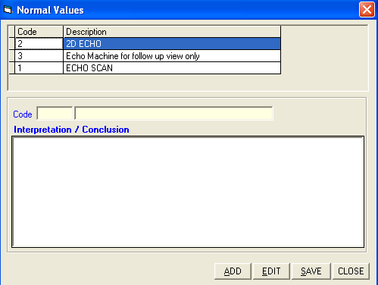
A – To ADD New Interpretation
Click on Add button to enter new coded values. Enter the name of the interpretation in the Code textbox and the normal interpretation in the Interpretation/Conclusion text box.
B – To EDIT New Interpretation
Click on Edit button to edit the existing interpretation. Double click on the specific interpretation to be edited.

To save the interpretation entered, click on Save button.
To go out from this option, click on Close button.

