MEDSYS
Information Sytem

CSR Dispensing Program
User's Manual



MEDSYS
Kaiser dela Cruz Consulting Incorporated
July 28, 2026

Copyright© 2009

ALL RIGHTS RESERVED

No part of this document may be reproduced through photocopying or in any means, stored into a retrieval system, and transmitted in any form without the express written permission of Kaiser dela Cruz Consulting Incorporated.
Permission is hereby granted to Medsys Information System to copy and distribute this document in any of the above means provided this is for its exclusive on site use.
Although every precaution has been taken in the preparation of this manual, the company assumes no responsibility for errors or omissions. Neither is any liability assumed for any damages resulting from the use of the information contained here.

Table of Contents

Copyright© 2003 2
Introduction 5
Overview 5
Objectives 6
Features 6
Getting Started 7
How to Start the Program 7
How to Change Password 8
How to End the Program 8
Program Operation 10
Changing of Shift and Entry of Chargeslip 10
Manual Posting of Inpatient Request 11
Manual Posting of Outpatient Request 123
Processing of Inpatient Pending Request 15
Processing of Outpatient Pending Request 16
Cash Basis Request Entry 18
Revoking of Unpaid Cash Basis Patient Request 20
Viewing of Revoked Assessment 21
Post Returned Supplies (Inpatient) 22
Post Returned Supplies (Outpatient) 25
Post Returned Supplies -Cash (Credit Advise) 28

Correction Entry - Inpatient 30
Correction Entry - Outpatient 33
Viewing of Posted Inpatient Supply 36
Viewing of Posted Outpatient Supply 38
Posting of Oxygen Charges 40
Clearing of Patient for Discharge 41
Processing of Paid Assessments 43
Supply Inquiry 44
Reports 45
Index 46

Introduction

Overview

The Central Supply Program deals with the automation of general workflow and administration management process of a supply. It is the program used for the issuances of sterile supplies and most of the special equipment needed in the care of patients. It keeps track of all your charged sales for inpatient and outpatient type of transactions. It’s got all the features you will need to manage your hospital Central Supply Room in an easy to use and intuitive design. Also, reports are automatically generated when needed. It creates a work order for the patient \ nurse and tracks it to completion. There are many more features in the Visual Medsys CSR module but the most important is ease of use. It won’t take you long to get comfortable with the system.

Objectives

- To create a work order for the patient \ nurse and tracks it to completion
- To help the CSR staff in rendering to doctor and patient the best and most efficient services.
- To provide business (financial) information to management and process
- To provide quality control monitoring and performance reports

Features
- CSR Dispensing program is tailored made according to specific hospital client’s policy, internal controls and standards
- CSR Dispensing program’s interfacing features with different clinical modules help make the posting of charges fast, easy, efficient, completely traceable electronic process that saves time, reduces cost, minimizes effort and eliminates potential for error and oversights.
- Data-entry restriction - Warning messages are flashed for possible invalid entries. This ensures all data inputted would be made useful for any transaction that may occur.
- Password-protected - The use of password is necessary to restrict unauthorized access. Thus the program only accepts passwords which are registered into it. This feature ensures the confidentiality and integrity of data entered in the program.
- Auto-report generation - The program is capable of generating reports and can be readily printed
- User-friendly - The program user is guided by instructions in doing the next step providing an easy-use to process transactions. Tool-tips are also incorporated to give users an idea of what a particular button does.

Getting Started

How to Start the Program

1 Click the Central Supply Program executable file icon located in your computer desktop.
2 The Login window will be displayed asking you to type your employee number and password for security purposes.

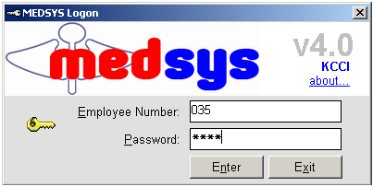
Figure 1: Login Window
3 If accepted, you can now start a transaction. Otherwise, a message will be displayed prompting “Unauthorized User”.

How to Change Password

1 From the Login window, type your employee number and then press <Enter>.

2 Under the Password entry, press <F12>. Pressing this function key will invoke the Change Password window.

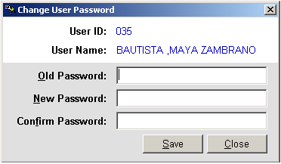
Figure 2: Change Password Window
3 Under the Change Password window, type the following data.
Old Password - Type your existing password.
New Password - Type your new password not exceeding to 15 characters.
Confirm Password - Retype your new password to confirm and then press <Enter> or you can click the Save button.

How to End the Program

It is important for users to close the program when they are done to end-up their session. Other users might use the open program using the same password.

To close the program:

Click Post Items > Exit or
Click located at the upper right corner of the main window.

Program Operation

Changing of shift and Entry of Chargeslip
This allows the staff to tag the specific shift they are in and enable them to enter the start of the charge slip to be used during her shift. A sample window is loaded below.

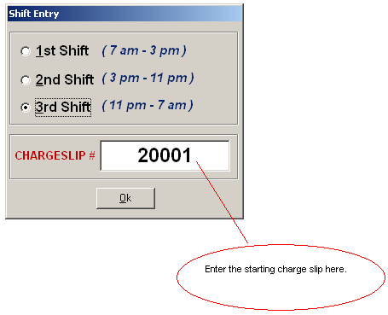

Manual Posting of Inpatient Request

This option allows you to enter supply request of inpatient.

1 Click the Manual Posting toolbar button to open its window.

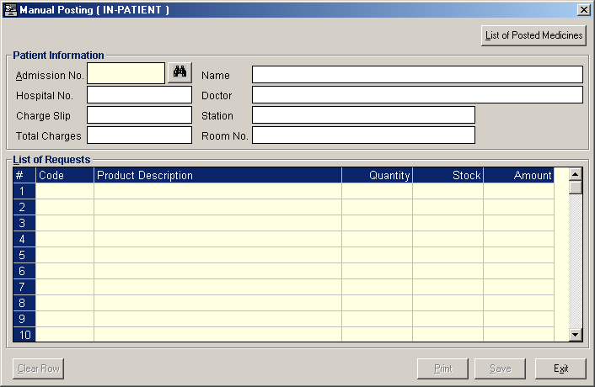
Figure 3: Manual Posting (Inpatient) Window
2 Under Admission No. entry, enter the first few letters of patient’s last name and then press <Enter>. A window with patients list will appear matching the query typed. Double-click the patient name to select. The patient’s information will be displayed afterwards.

3 To enter patient request, complete the following data.
Code - Type the item code or first few characters of the item name and then press <Enter>. A window with items list will be displayed matching the query typed. Double-click the item name to select. Its product description will be automatically displayed.
Quantity - Type the number of item to request and then press <Enter>. The program will automatically display a message if the item stock is unavailable. Just press <Enter> to proceed. The stock and amount will be automatically displayed.

You can view the total amount of the entered items just above the List of Requests.
To delete entered item, click the row where the item is aligned and then click the Clear Row button at the bottom part of the window.

4 Click the Save button to save the entered item(s).
Click the Print button to save the entered item(s) and to print the charge-slip.
Clicking the Exit button will display a message. Click the Yes button to close the window without saving entered item(s) or click the No button to go back to the window.

Note: You can view all posted items since the start of the selected patient’s confinement by clicking the List of Posted Items button at the upper right part of the Manual Posting window. To reprint a charge-slip, click the reference number you want to reprint and then click the Reprint button.

Manual Posting of Outpatient Request

This option allows you to enter supply request of outpatient.

1 Click the Manual Posting drop-down arrow and then select Out-Patient or click Post Items > Manual Posting > Out-Patient to display its window.

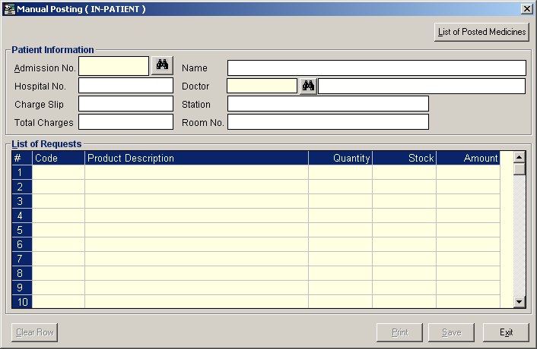
Figure 4: Manual Posting (Outpatient) Window

2 Under OPD No. entry, enter the patient’s OPD number and then press <Enter>. Or you can enter the first few letters of the patient’s last name and then press <Enter>. A window with patients list will appear matching the query typed. Double-click the patient name to select. The patient information will be automatically displayed afterwards.

3 Under Doctor’s Code entry, enter the first few letters of the doctor’s last name and then press <Enter>. A window with doctors list will appear matching the query typed. Double-click the doctor’s name to select.

4 To enter patient request, complete the following data.
Code - Type the item code or first few characters of the item name and then press <Enter>. A window with items list will be displayed matching the query typed. Double-click the item name to select. Its product description will be automatically displayed.
Quantity - Type the number of item to request and then press <Enter>. The program will automatically display a message if the item stock is unavailable. Just press <Enter> to proceed. The stock and amount will be automatically displayed.

You can view the total amount of the entered items just above the List of Requests.
To delete entered item, click the row where the item is aligned and then click the Clear Row button at the bottom part of the window.

5 Click the Save button to save the entered item(s).
Click the Print button to save the entered item(s) and to print the charge-slip.
Clicking the Exit button will display a message. Click the Yes button to close the window without saving entered item(s) or click the No button to go back to the window.

Note: You can view all posted items since the start of the selected patient’s consultation by clicking the List of Posted Items button at the upper right part of the Manual Posting window. To reprint a charge-slip, click the reference number you want to reprint and then click the Reprint button.

Processing of Inpatient Pending Request

Use this option to process inpatient request(s) posted from the different nursing stations and other cost-centers.

1 Under the Communication File, click In-Patient. To view all inpatient pending requests, click All or to view pending requests by station, click By Station. See figure below.
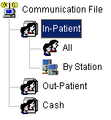
2 The list of pending requests is shown under Patient List. Double-click the patient name you want to process.

3 The Communication File Entry window will be displayed.
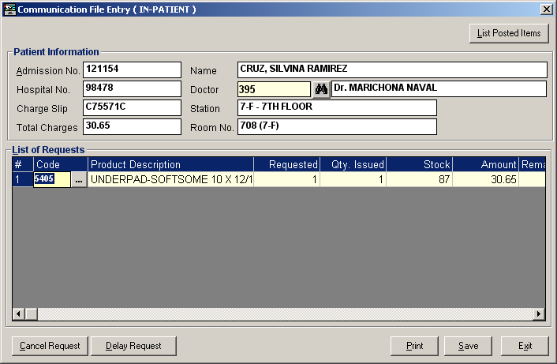
Figure 5: Communication File Entry (Inpatient) Window

- You can cancel a pending request by selecting the item from the list and then click the Cancel Request button located at the bottom part of the window.
- You can delay a request by selecting the item from the list and then click the Delay Request button located at the bottom part of the window.
- To process and save the request, click the Save button.
- To print and save the request, click the Print button
- Clicking the Exit button will display a message. Click the Yes button to close the window without processing the request or click the No button to go back to the window.

Processing of Outpatient Pending Request

Use this option to process outpatient pending request(s) from Emergency Room and other cost-centers.

1 Under the Communication File, click Out-Patient. Click All to view all outpatient pending requests. See figure below.
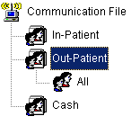
2 The list of pending requests is shown under Patient List. Double-click the patient name you want to process.

3 The Communication File Entry window will be displayed.

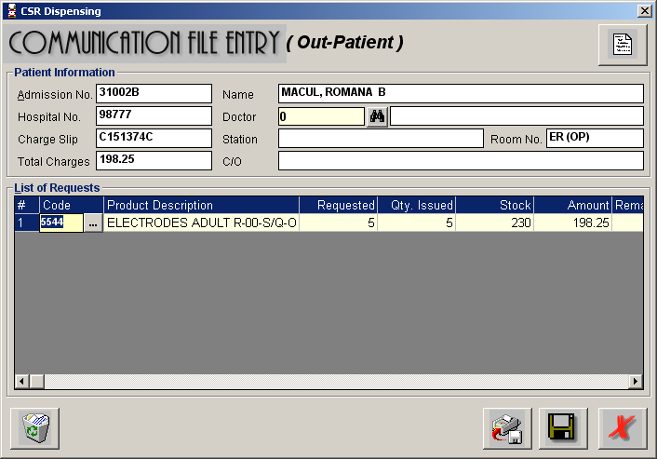
Figure 6: Communication File Entry (Outpatient) Window
To cancel a particular item, select it from the list and then click the Cancel Request button.
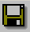 - Click this button to process and save the outpatient request.
 - Click this button to print and save the outpatient request.
- Clicking this button will display a message. Click the Yes button to close the window without processing the request or click the No button to go back to the window.

Cash-basis Request Entry (Assessment Entry)

This option allows you to enter supply request of cash-basis patients.

1 Click the 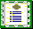 Assessment toolbar button to open its window.

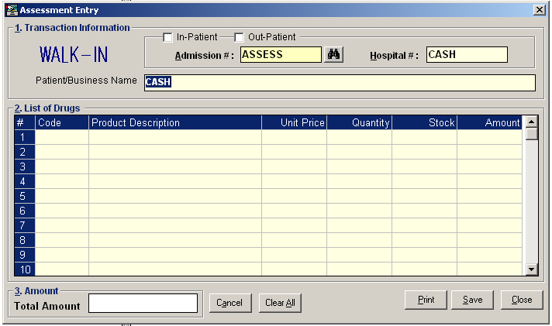
Figure 7: Assessment Entry Window
2 Under Patient Type entry, choose the patient type from “Out-Patient” or “In-patient”. The default patient type is “Walk-in”. For walk-in patient, you need to type the patient name under Patient/Business Name entry. If “In-patient” or “Outpatient” is selected, patients list will appear. Just double-click the patient name to select.

3 To enter request, complete the following data.
Code - Type the item code or first few characters of the item name and then press <Enter>. A window with items list will be displayed matching the query typed. Double-click the item name to select. Its product description will be automatically displayed.
Quantity - Type the number of item to request and then press <Enter>. The program will automatically display a message if the item stock is unavailable. Just press <Enter> to proceed. The stock and amount will be automatically displayed.

You can view the total amount of the entered items at the upper right part of the window.
To delete entered item, click the row where the item is aligned and then click the Cancel button at the bottom part of the window.
To delete all entered items, click the Clear All button at the bottom part of the window.

4 Click the Save button to save the entered item(s).
Click the Print button to save the entered item(s) and to print the charge-slip.
Click the Close button to close the Assessment Entry window.

Revoking of Unpaid Cash-basis Patient Request

Use this option to revoke assessment request entered (cash-basis patient request).

1 Under the Communication File, click Cash and then click Unpaid Assessments. Click Current to display current unpaid assessments or Previous to display all previous unpaid assessments. See figure below.

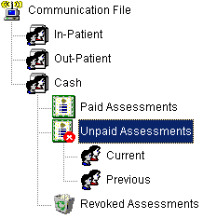

2 The list of unpaid assessments is shown under List of Patients. Select the assessment number you want to revoke and then click the Revoke Request Assessment toolbar button. A message will appear for confirmation. Click the Yes button to proceed or No to abort.

Viewing of Revoked Assessments

This option lets you view current and previous revoked assessments.

1 Under the Communication File, click Cash and then click Revoked Assessments. Click Current to display current revoked assessments or Previous to display all previous revoked assessments. See figure below.

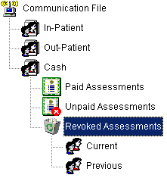

2 The list of revoked assessments is shown under Patients List.

Post Returned Supplies (Inpatient)

Use this option to enter returned supplies of inpatient.

1 Click the Post Returned Supply toolbar button to open its window.

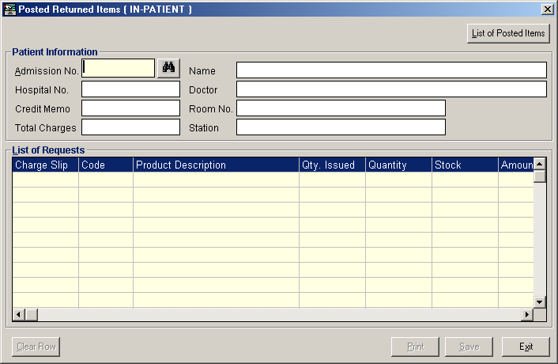
Figure 8: Post Returned Supply (Inpatient) Window

2 Under Admission No. entry, enter the patient’s admission number and then press <Enter>. Or you can enter the first few letters of the patient’s last name and then press <Enter>. A window with patients list will appear matching the query typed. Double-click the patient name to select. The patient information will be automatically displayed.

3 To enter returned supply, complete the following data.
Charge Slip - Press the <Enter> key to display list of charge-slips issued.

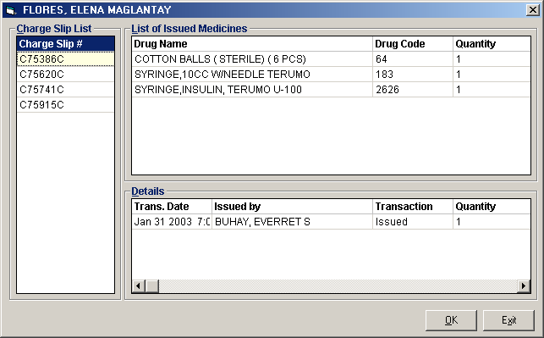
Figure 9: List of Charge-slips Issued
Click the charge-slip number at the left side of the window to display issued supplies and its details. To select, double-click the charge-slip number.

Code - Press the <Enter> key to display issued supplies. Double-click the item name to select. Its description, quantity issued and stock will be automatically displayed.

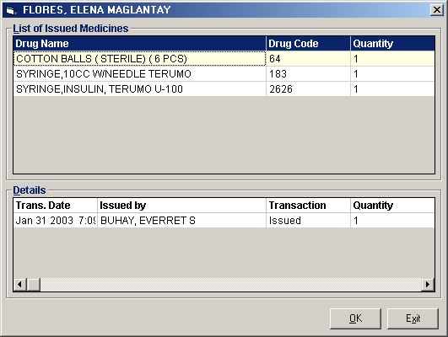
Figure 10: List of Issued Supplies under the Selected Charge-slip Number
Quantity - Type the number of item to return. This should not be greater than the number of item issued.

You can view the total amount of the supplies returned just above the List of Requests.
To delete entered returned supply from the list, click the item name and then click the Clear Row button at the bottom part of the window.

4 Click the Save button to save the returned supplies.
Click the Print button to save the returned supplies and to print the charge-slip.
Clicking the Exit button will display a message. Click the Yes button to close the window without saving returned supplies or click the No button to go back to the window.

Note: You can view all posted supplies since the start of the selected patient’s confinement by clicking the List of Posted Items button at the upper right corner of the Post Returned Supply window. To reprint a charge-slip, click the reference number you want to reprint and then click the Reprint button.

Post Returned Supplies (Outpatient)

Use this option to enter returned items of outpatient.

1 Click the Post Returned Supply drop-down arrow and then select Outpatient or click Others > Post Returned Supplies > Outpatient to open its window.

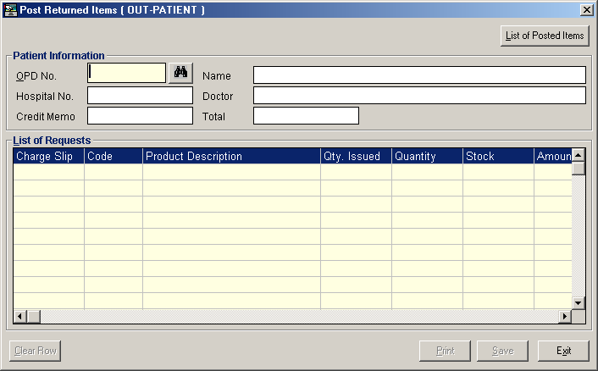
Figure 11: Post Returned Items (Outpatient) Window

2 Under OPD No., type the first few letters of the patient’s last name and the press <Enter>. A window with patients list will appear matching the query typed. Double-click the patient name to select. The patient information will be automatically displayed afterwards.

3 To enter returned supplies, complete the following data.
Charge Slip - Press the <Enter> key to display list of charge-slips issued.

Figure 12: List of Charge-slips Issued

Click the charge-slip number at the left side of the window to display issued supplies and its details. To select, double-click the charge-slip number.

Code - Press the <Enter> key to display issued supplies. Double-click the item name to select. Its description, quantity issued and stock will be automatically displayed.

Figure 13: List of Issued Supplies under the Selected Charge-slip Number
Quantity - Type the number of item to return. This should not be greater than the number of item issued.

You can view the total amount of the supplies returned just above the List of Requests.
To delete entered returned supply from the list, click the item name and then click the Clear Row button at the bottom part of the window.

4 Click the Save button to save the returned supplies.
Click the Print button to save the returned supplies and to print the charge-slip.
Clicking the Exit button will display a message. Click the Yes button to close the window without saving returned supplies or click the No button to go back to the window.

Note: You can view all posted supplies since the start of the selected patient’s consultation by clicking the List of Posted Items button at the upper right part of the Post Returned Supply window. To reprint a charge-slip, click the reference number you want to reprint and then click the Reprint button.

Post Returned Supplies-Cash (Credit Advise)
Use this option to enter returned items of outpatient.
1 Click the Others 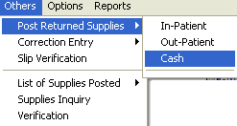 Post Returned Supplies drop-down arrow and then select Cash to open this window
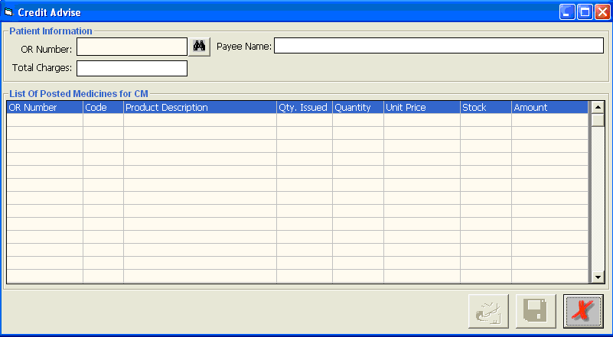
2 Type in the official receipt number of the item to return then press enter or Search option. Program will search for existing document number, once located, payee name will automatically display on the screen.
3 Click on the 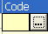 option to list the items included charged with the given official receipt number.
4 Select from the list the specific item to return as shown on the window below:
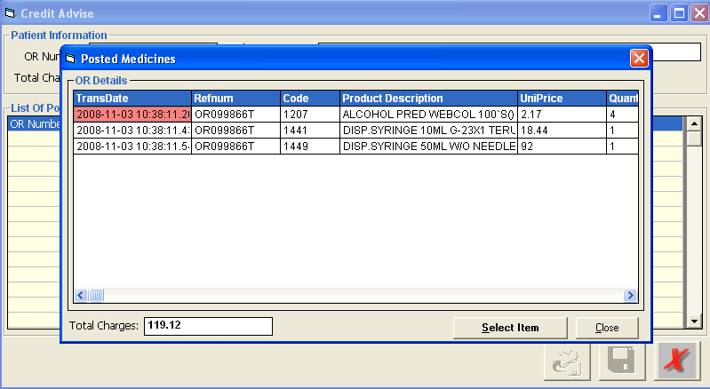

- To choose for the item to return, click the item name and then click the button at the bottom part of the window.

- Type in the number of quantity to return as shown below
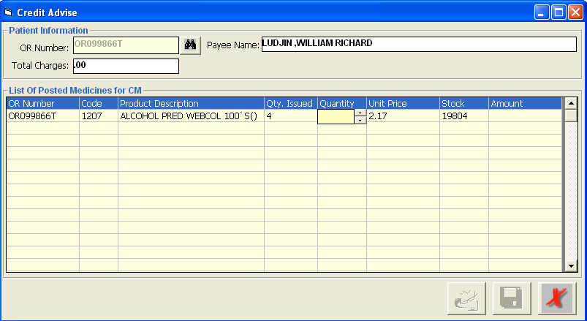
6 Click the 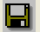Save button (without printing) or 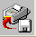 save button (with printing of credit advise form).

Note: The above process once saved will not immediately add back the returned quantity of the returned item to the CSR dispensing inventory stock balance. It will be the cashier module that will trigger the update of the stock balance once the credit advise is processed.

Correction Entry -Inpatient

Use this option to adjust posted supply of inpatient.

1 Click the 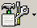 Correction Entry toolbar button to open its window.

Figure 14: Correction Entry (Inpatient) Window

2 Under Admission No. entry, enter the patient’s admission number and then press <Enter>. Or you can enter the first few letters of the patient’s last name and then press <Enter>. A window with patients list will appear matching the query typed. Double-click the patient name to select. The patient information will be automatically displayed.

3 To adjust posted item(s), complete the following data.
Charge Slip - Press the <Enter> key to display list of charge-slips issued.

Figure 15: List of Charge-slips Issued
Click the charge-slip number at the left side of the window to display issued supplies and its details. To select, double-click the charge-slip number.

Code - Press the <Enter> key to display issued supplies. Double-click the item name to select. Its description, quantity issued and stock will be automatically displayed.

Figure 16: List of Issued Supplies under the Selected Charge-slip Number
Quantity - Type the number of item to adjust. This should be greater than the number of item issued.

You can view the total amount of the item(s) adjusted just above the List of Requests.
To delete adjusted item from the list, click the item and then click the Clear Row button at the bottom part of the window.

4 Click the Save button to save the adjusted item(s).
Click the Print button to save the adjusted item(s) and to print the charge-slip.
Clicking the Exit button will display a message. Click the Yes button to close the window without saving adjusted item(s) or click the No button to go back to the window.

Note: You can view all posted items since the start of the selected patient’s confinement by clicking the List of Posted Items button at the upper right part of the Correction Entry window. To reprint a charge-slip, click the reference number you want to reprint and then click the Reprint button.

Correction Entry - Outpatient

Use this option to adjust posted supply of outpatient.

1 Click the Correction Entry drop-down button and then select Outpatient or click Others > Correction Entry > Out-patients.

Figure 17: Correction Entry (Outpatient) Window
2 Under OPD No., type the first few letters of the patient’s last name and the press <Enter>. A window with patients list will appear matching the query typed. Double-click the patient name to select. The patient information will be automatically displayed afterwards.

3 To adjust posted item(s), complete the following data.
Charge Slip - Press the <Enter> key to display list of charge-slips issued.

Figure 18: List of Charge-slips Issued
Click the charge-slip number at the left side of the window to display issued supplies and its details. To select, double-click the charge-slip number.

Code - Press the <Enter> key to display issued supplies. Double-click the item name to select. Its description, quantity issued and stock will be automatically displayed.

Figure 19: List of Issued Supplies under the Selected Charge-slip Number

Quantity - Type the number of item to adjust. This should be greater than the number of item issued.

You can view the total amount of the item(s) adjusted just above the List of Requests.
To delete adjusted item from the list, click the item and then click the Clear Row button at the bottom part of the window.

4 Click the Save button to save the adjusted item(s).
Click the Print button to save the adjusted item(s) and to print the charge-slip.
Clicking the Exit button will display a message. Click the Yes button to close the window without saving adjusted item(s) or click the No button to go back to the window.

Note: You can view all posted items since the start of the selected patient’s consultation by clicking the List of Posted Items button at the upper right part of the Correction Entry window. To reprint a charge-slip, click the reference number you want to reprint and then click the Reprint button.

Viewing of Posted Inpatient Supplies

This option allows you to display all posted supplies since the start of the selected patient’s confinement.

1 Click the List of Posted Supplies toolbar button to open its window.

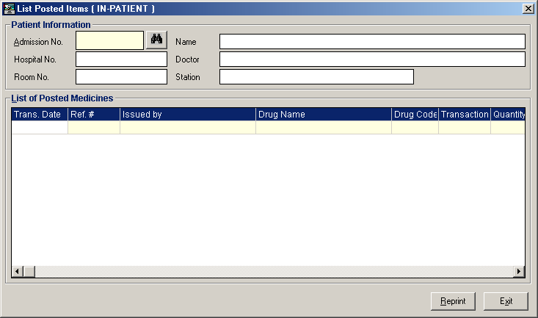
Figure 20: List of Posted Items (Inpatient) Window

2 Under Admission No. entry, enter the patient’s admission number and then press <Enter>. Or you can enter the first few letters of the patient’s last name and then press <Enter>. A window with patients list will appear matching the query typed. Double-click the patient-name to select. The patient information and list of posted items will be automatically displayed.

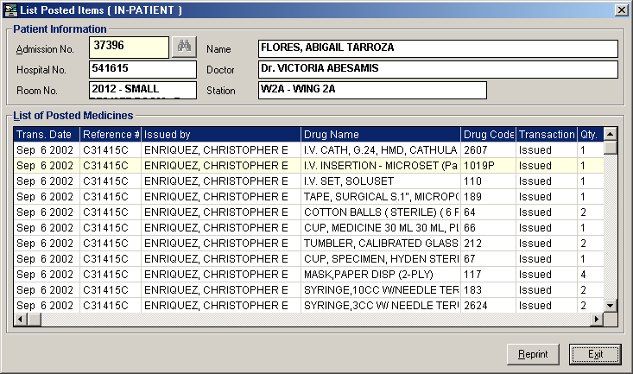
Figure 21: List of Posted Items Since the Selected Patient’s Confinement Window
To view and reprint a charge-slip, click the charge-slip number from the list and then click the Reprint button.
Click the Exit button to close the window.

Viewing of Posted Outpatient Supplies

This option allows you to display all posted supplies since the start of the selected patient’s consultation.

1 Click the List of Posted Supplies drop-down arrow and then select Outpatient or click Others > List of Posted Supplies > Out-patient to display its window.

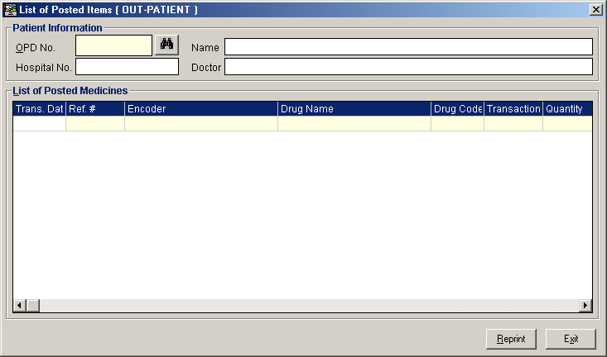
Figure 22: List of Posted Item (Outpatient) Window

2 Under OPD No., entry, enter the patient’s OPD number and the press <Enter>. Or you can enter the first few letters of the patient’s last name and then press <Enter>. A window with patients list will appear matching the query typed. Double-click the patient name to select. The patient information and list of posted items will be displayed afterwards.

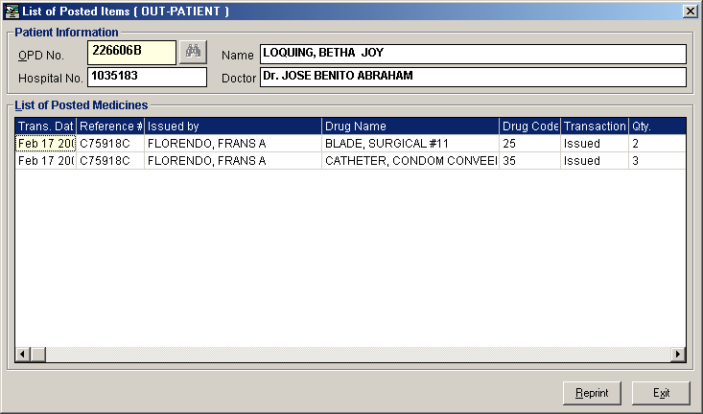
Figure 23: List of Posted Items Since the Start of the Selected Patient’s Consultation Window
To view and reprint a charge-slip, click the charge-slip number from the list and then click the Reprint button.
Click the Exit button to close the window.

Posting of Oxygen Charges
This option allows the user to post consumed oxygen. To do this, click on 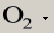 button then choose patient type, Inpatient or Outpatient to display the sample window below.
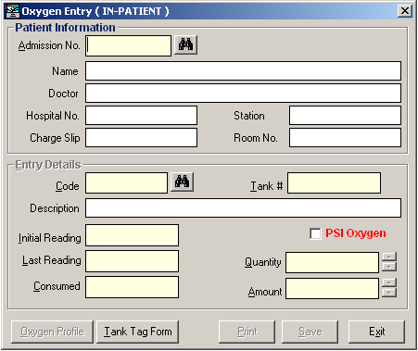
Enter the following data
- Admission No. – type patient last name or admission number then click on Enter button. Patient’s information will be displayed on the screen
- In the Entry Details window, press Enter key or enter the code of the oxygen then enter details of the oxygen used such as
  - Tank #
  - Initial Reading
  - Last Reading
  - Consumed ( amount of oxygen used )
  - Quantity Consumed
  - Amount (computed automatically)
* If the oxygen used is PSI, click on the box beside the PSI Oxygen
- Click on Print button to save and print data entered
- Click on Save button to save the data entered
- Click on Exit button to go out from this window.
Click on the Oxygen Profile button to display list of oxygen charges for the patient

Click on Tank Tag Form button to generate the form

Clearing of Patient for Discharge
1 Double-click on . Its window will be displayed showing the list of cleared and not cleared patients. (The legend of “Cleared” and “Not Cleared” patients can be seen at the bottom part of the window)

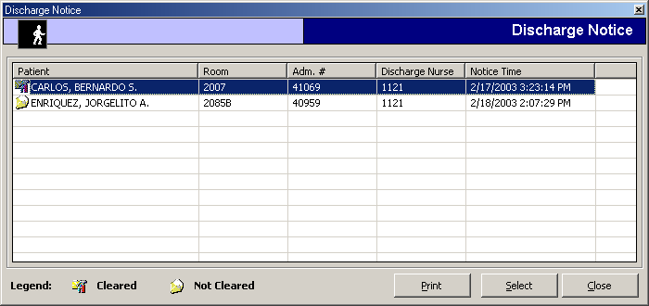
Figure 24: List of Discharge Notice(s) Window

2 Select an un-cleared patient from the list and then click the Select button

3 A window for clearing patients will be displayed. Just type your remarks for clearing the patient.

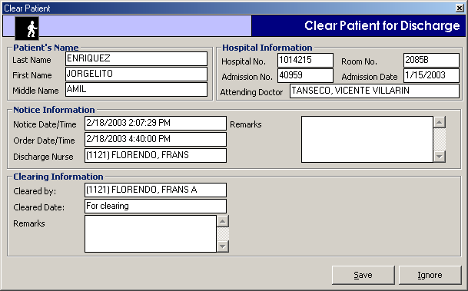
Figure 25: Clearing of Patient for Discharge Window

4 The following button option can be clicked from
Save - Click this button to clear the patient in your department.
Ignore - Click this button to ignore clearing the patient.

Viewing of Paid Assessments

Use this option to update the status of paid assessments in your department.

1 Under the Communication File, click Cash and then click Paid Assessments. Click Current to display current paid assessments or Previous to display all previous paid assessments. See figure below.

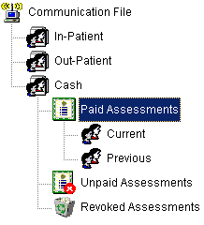

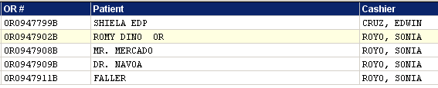
List of Paid Cash Patients
2. List of paid cash patients will be displayed on the screen.

Supply Inquiry

This option allows you to view supply information particularly on its available stock, inpatient and outpatient selling price, and classification.

1 Click the 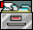 Supplies Inquiry toolbar button to display the window.

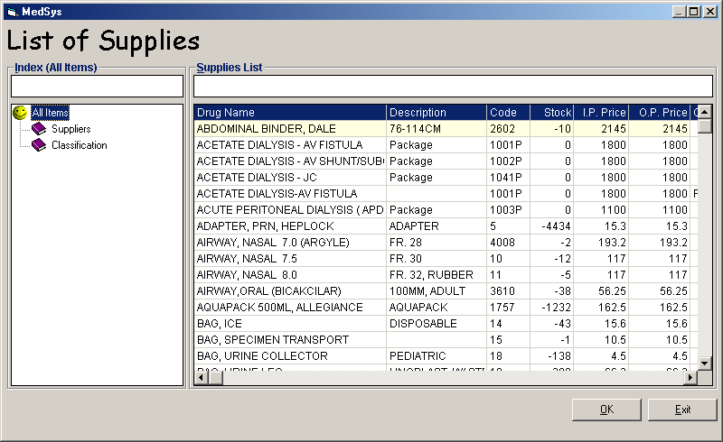
Figure 26: List of Supplies Window

You can arrange the list of supplies by its supplier or classification. Just double-click the option at the left side of the window.

Reports

Here is the list of reports that the program generates. To open a report, click Reports to display the list and then click the report you want to view.

- Daily Income Report
- Monthly Income Report
- Admission List
- Daily Discharges
- Patients with Discharge Order
- Cash Income Report
    - Monthly Income Report
    - Cash Daily Income Report Summarized
    - Cash Daily Income Report Detailed
    - Cash Daily Income by Shift Sumamrize
    - Cash Daily Income by Shift Detailed
- Clearance Report
- CSR Rentals Income Report
    - Details
    - Summary

Index

—A—
adjust supply (inpatient), 32
adjust supply (outpatient), 35
assessment entry, 18
assessment request (revoking of), 20
assessment-slip (reprinting of), 21
—C—
cash-basis patient request (revoking of), 20
clear patient for discharge, 42
close the program, 9
—D—
discharge order, 42
—E—
end the program, 9
—F—
features, 6
—I—
inpatient pending request (processing of), 14
—M—
manual posting (inpatient request), 10
manual posting (outpatient request), 12
—O—
objectives, 6
outpatient pending request (processing of), 16
overview, 5
oxygen request (inpatient), 23
—P—
paid assessments (processing of), 44
password (changing of), 8
—R—
reports, 47
request (cash-basis), 18
request (inpatient), 10
request (outpatient), 12
return supply (inpatient), 26
return supply (outpatient), 29
revoked assessments (viewing of), 22
—S—
start the program, 7
supply (inpatient adjusting of), 32
supply (inpatient returning of), 26
supply (inpatient viewing of), 38
supply (outpatient adjusting of), 35
supply (outpatient returning of), 29
supply (outpatient viewing of), 40
supply inquiry, 46
—V—
view posted supply (inpatient), 38
view posted supply (outpatient), 40

