MEDSYS
Information System

Billing Program
User's Manual



MEDSYS
Kaiser dela Cruz Consulting Incorporated

©Copyright
ALL RIGHTS RESERVED

No part of this document may be reproduced through photocopying or in any means, stored into a retrieval system, and transmitted in any form without the express written permission of Kaiser dela Cruz Consulting Incorporated.
Permission is hereby granted to Medsys Information System to copy and distribute this document in any of the above means provided this is for its exclusive on site use.
Although every precaution has been taken in the preparation of this manual, the company assumes no responsibility for errors or omissions. Neither is any liability assumed for any damages resulting from the use of the information contained here.

Table of Contents
Introduction 5
Overview 5
Objectives 6
Features 7
Getting Started 8
How to Start the Program 8
How to Change Password 9
How to End the Program 10
Program Operation 11
Patient Searching 11
Statement of Account 12
Clearance Slip 13
Updating of Bill 14
Adjusting of Bill 15
Closing of Bill 17
Recalling of Bill 18
Updating of Patients Account Number 19
Consolidate Outpatient Charges to Inpatient Charges 21
Revoke Admission Clearance 24
Request for Payment 25
Processing Sheet 26
Discount Computation 27
Package Deal Entry 28
Claim Slip Notice 30
How to Set Cut Off Clearance Time for MGH 31
How to Generate Promissory Note …… 32
How to Generate Refund Voucher …… 34
Deposit Allocation 36
Partitioning of Patients SOA Covered by HMO's or Company 37
Operating Room Approval 38
Reports 39

Introduction

Overview


The Medsys Billing program has been continuously refined over a period of more than 19 years to make it easy for billing staff to comply with procedures. Medsys billing streamlines and automates processes (discharging, bill processing, automatic discount computation etc.) thus increase staff production while reducing overtime.
Billing program’s connection to different departments (with Medsys modules) makes retrieval of patient’s bill fast, easy and accurate.
The level of detail, the extensive traceability and the powerful, flexible reports in Billing greatly ease the stress, time and effort associated with audit.

Objectives

- To increase staff production while reducing overtime
- To prepare patient’s bill fast, easy and accurate
- To provide business (financial) information to management and process
- To provide quality control monitoring and performance reports

Features

- Medsys Billing program is tailored made according to specific hospital client’s policy, internal controls and standards
- Billing program’s interfacing features with different clinical modules help make the posting of charges fast, easy, efficient, completely traceable electronic process that saves time, reduces cost, minimizes effort and eliminates potential for error and billing oversights.
- Data-entry restriction - Warning messages are flashed for possible invalid entries. This ensures all data inputted would be made useful for any transaction that may occur.
- Password-protected - The use of password is necessary to restrict unauthorized access. Thus the program only accepts passwords which are registered into it. This feature ensures the confidentiality and integrity of data entered in the program.
- Auto-report generation - The program is capable of generating reports and can be readily printed
- User-friendly - The program user is guided by instructions in doing the next step providing an easy-use to process transactions. Tool-tips are also incorporated to give users an idea of what a particular button does.

Getting Started

How to Start the Program
1 Click on Billing program executable file icon located in your computer desktop.
2 The Login window will display asking you to type your employee number and password for security purposes.
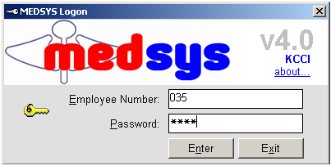
Figure 1: Login Window
3 If the program has validated your employee number and password, you may now start a transaction. Otherwise, a message will display prompting “Unauthorized User”.

How to Change Password

1 From the Login window, type your employee number and then press <Enter>.

2 Under the Password entry, press <F12>. Pressing this function key will invoke the Change Password window.

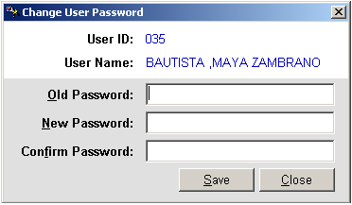
Figure 2: Change Password Window
3 Under the Change Password window, type the following data.
Old Password - Type your existing password.
New Password - Type your new password not exceeding to 15 characters.
Confirm Password - Retype your new password to confirm and then press <Enter> or you can click the Save button.

How to End the Program
It is important for users to close the program when they are done to end-up their session. Other users might use the open program using the same password.
To close the program:

1 Click on at the upper right corner of the screen or
2 Click File > Exit.

Program Operation

Patient Searching
How to Search a Patient
1 Select which patient type to use <Inpatient, Outpatient>. Inpatient is set to default.
2 Type in either one of the search categories.
- Last Name - Type the first few letters of the patient’s last name and then press <Enter>. Patients having the last name typed and currently confined will be displayed in the grid. Select the patient to enter in the transaction window.
- Hospital Number - Type the patient’s hospital number and then press <Enter>. All patient’s confinements will be displayed in the grid. Select the patient’s confinement to select and to enter in the transaction window.
- Admission Number - Type the patient’s admission number and the press <Enter>. Select the patient from the grid to enter in the transaction window.

Sample searching:

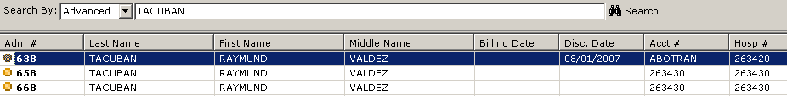

Figure 3: Patient Searching Window

Note: There are two types of patient which can be seen in the grid.
- Open Bill - Indicated by a yellow round button. These are patients who are open for charges.
- Billed - Indicated by a green round button. These are patients whose bill is already closed.

After searching the patient, you can now start a transaction.

Statement of Account
This option allows you to view and generate printed copy of patient’s statement of accounts.

To open the window, click on Statement of Account tab. See figure below.
Figure 4: Statement of Account Options Window

Here are the following options.
    - Sorted by Date - This generates patient’s statement of account arranged by transaction date.
    - Sorted by Department - This generates patient’s statement of account arranged by charging department (cost center).
      - By Specific Department (Transactions under a specific revenue code will be included in the statement of accounts)
      - All Departments (all transactions will be printed)
      - Package (all transactions included within the package will be printed)
    - Sorted by User - This generates patient’s statement of account arranged by encoder
    - Summary - This generates patient’s statement of account by summary.
      - With PHIC Estimate
      - Primary Account
      - Company (1-5)
      - Package Non-tabular format
      - PHIC Summary format
      - Package Deal Breakdown
    - Executive Plan - This generates patient’s statement of account by package.
    - Specific Date – This generates patient’s statement of account on a specific date.
Billing staff can enter any information on the Footer option which will be displayed on the SOA of the patient.
If the patient’s OPD charges have been consolidated with the inpatient charges, the OPD number is displayed on the Consolidated with OPD Number tab.

Clearance Slip
This option allows you to generate printed copy of patient’s clearance slip as a document signifying that the patient has settled or transacted with the Billing officer. This will be used as a waiver given by the patient to the guard in duty.

To open the window, click on Clearance Slip tab. See figure below.
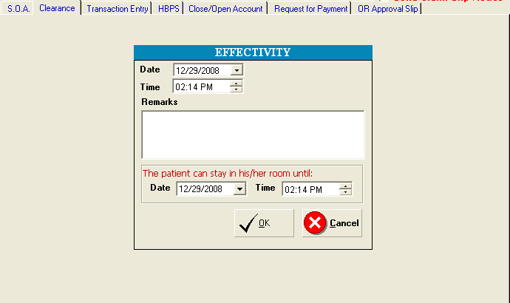

Figure 5: Clearance Slip Window

1 Date - The current date is set as default date. You may change it if necessary.
2 Time - The current time is set as default date. You may change it if necessary.
3 Remarks - Type your remarks to be included in the clearance slip.
4 Extension – Type in the allowed date and time for patient to stay in the assigned room
5 Click on OK button to generate the clearance slip.

Updating of Bill
This feature allows you to add charges incurred by the patient during admission. This is an alternative way if cost-centers missed to enter patient’s charges. Any changes made will be automatically added to the patient’s bill.
1 Click  Update Bill button. The window below will display.
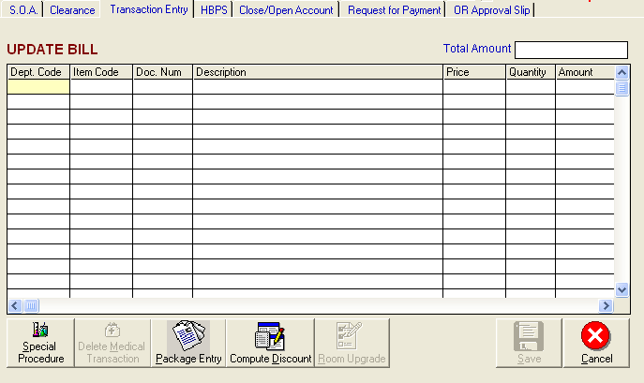
Figure 6: Updating of Bill
2 Type the department code and then press <Enter>. Example: LB for Laboratory.
3 Type the item code or item name and then press <Enter>.
4 Doc. Num - You can type here any document number related to the item.
5 Price - This is automatically provided with built-in rates or else user has to manually supply the amount. User may overwrite the amount if the rate for a particular item was tagged as variable in the build file.
6 Quantity - Type the number of item to charge.
7 Amount - This is automatically displayed. You may edit it if necessary.
8 Req Doctor – This refers to requesting doctor. If the procedure is encoded in this module, the requesting doctor has to be provided. This is important for doctor’s contribution report.
8 Click on Save button to add entered charges on patient’s bill.

Adjusting of Bill
This option allows you to adjust or correct charges from the saved transaction of the patient. Changes made will be automatically deducted from the patient’s bill.
1 Click  Adjust Bill button. The window below will display.
2 Type the department code and then press <Enter>. Example: LB for Laboratory.
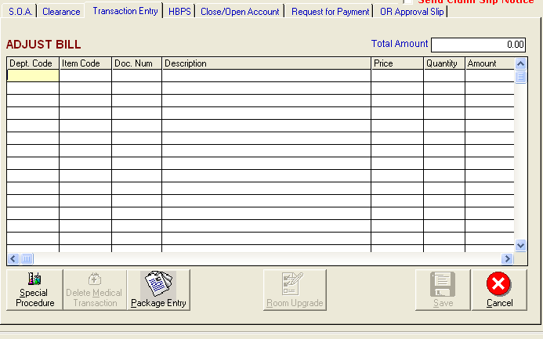
Figure 7: Adjusting of Bill
After typing the department code, all charges under it will be displayed. See figure below. Double-click the item to select.

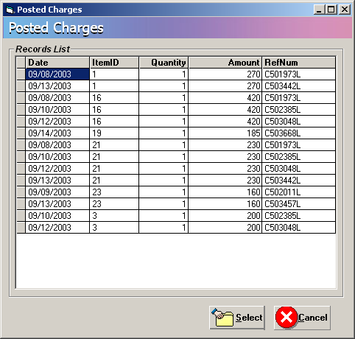
Figure 8: Patient's Posted Charges

3 Click on Save button to add entered charges on patient’s bill.

Closing of Bill
This option signifies the completion of patient’s transactions within the hospital. Billing staff will close the patient’s billing account after the station has sent the discharge order, departments made electronic clearance, corresponding discounts, phic benefits have been computed and all charges, returns, adjustments and payments have already been posted. Closing the patient’s bill within the discharge date is important so that cost-centers can no longer post charges to patient’s account.
1 Click 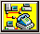 Notice for Billing button. This will display all patients who have discharge order from stations. See figure below. Select the patient from the list and then click on Print button. This will print patient’s processing sheet. (Once printed, the station can now discharge the patient.)
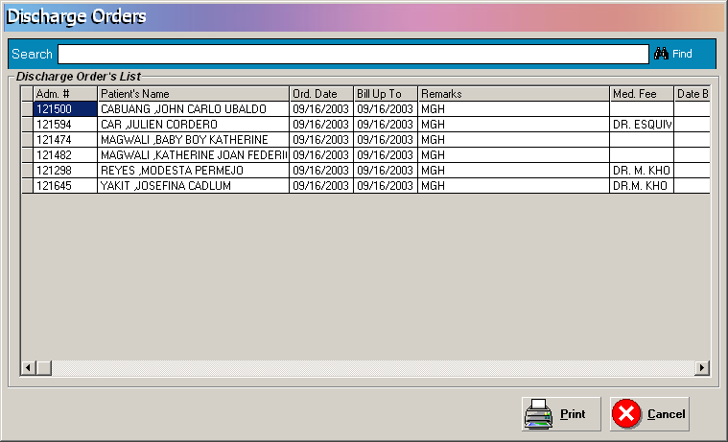
Figure 9: Discharge Orders Window

2 If patient is entitled for PhilHealth benefits, the clerk will compute it using the Medicare Program.
3 After computing, the Billing staff can now close the patient’s bill by clicking on  Discharge/Close Bill button.

Recalling of Bill
This option allows you to recall the patient’s bill. This is only possible within the day of the patient’s billing date. Once the patient’s bill is reopened, cost-centers can now post charges into his account.

To reopen patient’s bill:
1 Click on  Recall button.

Updating of Patient’s Account Number
Use this option to update or change the existing patient’s account number. Account number is the code assigned to specific company, HMO, institution or individual. Correct account number is very important for the automatic computation of possible discount, privileges or transfer of patient’s remaining balance to specific Receivable account.
NOTE: Use this option if a patient has only one account number (company). If patient account balance will be distributed to multiple accounts do not use this option. Multiple partitioning should be used.

1 Click on  Update Acct. # button to display the window below.
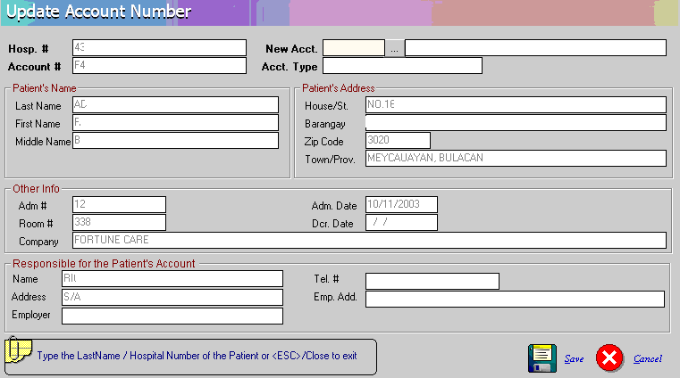
Figure 10: Updating of Patient's Company Window

2 Under the 'New Acct' entry, press the <Enter> key to display the list of companies as seen below. Search the company and then double - click it from the list.

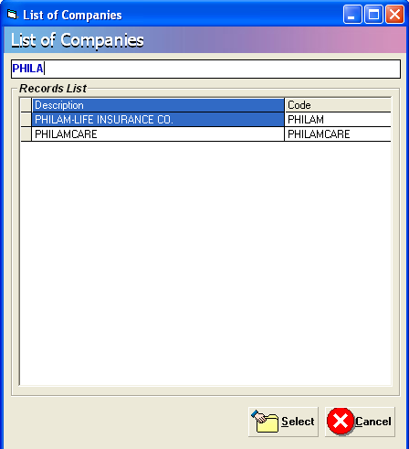

Figure 11: List of Companies

3 Back to the Update Account Number window then click on (Save) button to update the patient’s company.

Consolidate Outpatient Charges to Inpatient Charges
This feature allows the user to combine patient’s outpatient charges to inpatient account within the current patient’s confinement record. This will consolidate the charges into one inpatient billing statement of account.

1 Click on  Consolidate Inpatient to OPD Charges button to open the window below.

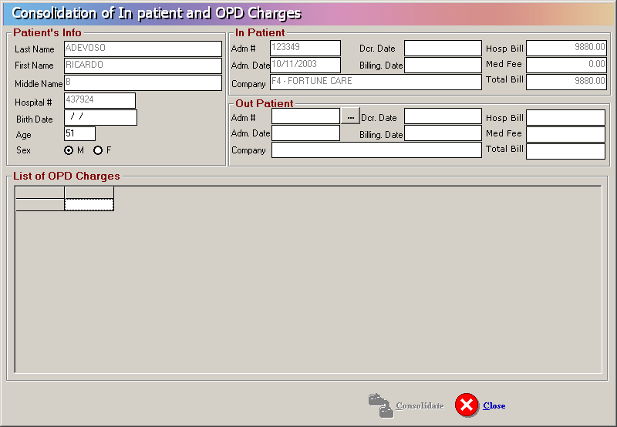
Figure 12: Consolidate Outpatient Charges to Inpatient Charges Window

2 Under 'Out Patient', 'Adm #' entry, press the <Enter> key to display the list of patient’s outpatient charges as seen below.

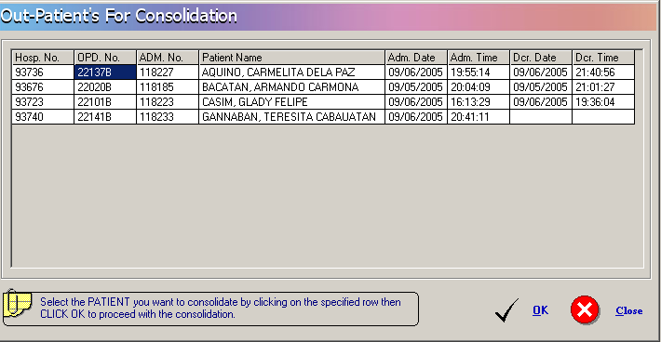
Figure 13: List of Outpatient's Consultation

3 Double-click the outpatient account from the list. Back to the Consolidation of Inpatient and OPD Charges window, the charges under the selected outpatient account will be displayed. Refer to the figure below.

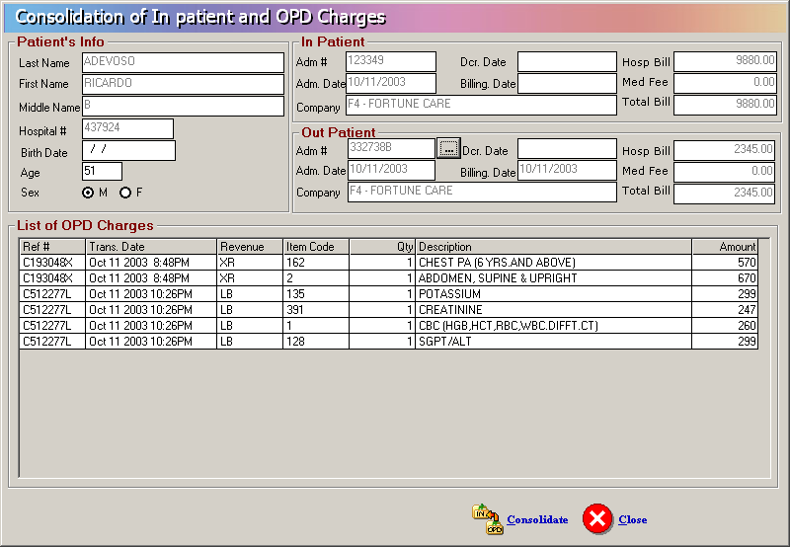
Figure 14: List of Outpatient's Selected Consultation's Charges

4 Click on Consolidate button to consolidate.

Note: To reverse the process of consolidating charges from outpatient to inpatient (that is to un-consolidate), click on Un-consolidate button.

Revoke Admission Clearance
This option signals the Admitting department that patient’s admission can now be revoked after the Billing department had click on this button. Since Admitting cannot revoke patient’s admission if there are existing charges, the Billing has to clear first these charges using the Billing program.

Click on  Rvk Adm. Clearance button

Request for Payment

To open window, click on Request for Payment tab. See figure below.
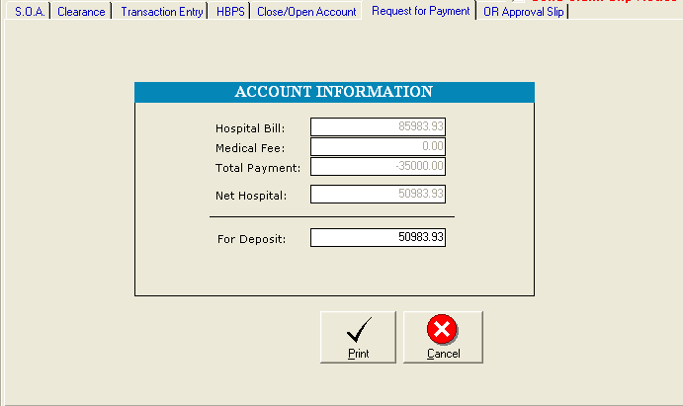
Figure 15: Request for Payment Window

1 Provide the amount for deposit.
2 Click the Print button to print the request for payment print-out.
3 Click the Cancel button to disregard the request for payment.

Processing Sheet
Hospital Bill Processing Sheet (HBPS) or May Go Home sheet (MGH) is the billing supporting document that will signal for the billing to process patient’s bill. The MGH was sent by nurse and confirmed by different cost centers.
This option allows the billing staff‘s to view content of patient’s HBPS/MGH sheet. It allows you to re-print or revoke it. Once revoked, the patient’s account will then be available to different department for charging.
To open the window, click on HBPS tab. See figure below.

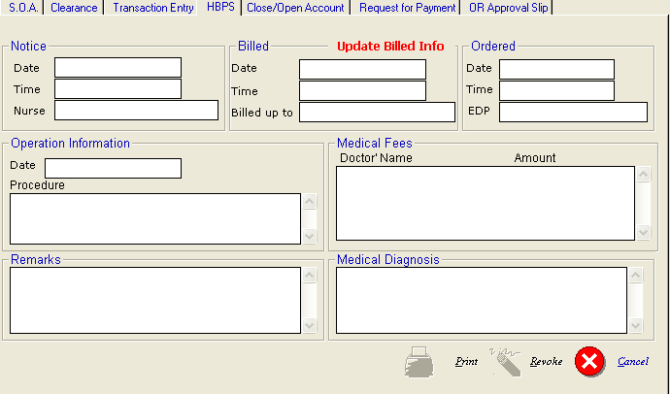
Figure 16: Processing Sheet Window
- To print the processing sheet, click on Print button.
- To revoke it, click on Revoke button.

Discount Computation
This option allows you to compute for the discount. To do this, go to Update Bill option then click on 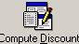 icon.
1 Click the arrow down on the Discount Type option to display lists of discount. Choose from the list then click the GO button.
- Two ways of selecting discount rate:
  - Enter the discount rate in the discount rate tab 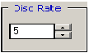 or click the up-down arrow to choose for specific rate.
  - By pass the discount rate and let the rates per department defined within the discount type be the basis of computation

3 Click the Compute button  to automatically compute for the patient’s discount.
4 Click the Save button to save the computed discount, the Save/Print button to save and generate print-out for the computed discount, Reprint button to generate another print-out or Cancel button to disregard all entries entered.

Package Deal Entry
This option automatically identifies actual charges within the package deal profile To do this, go to Update Bill option then click on 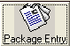 icon.
1 Click the Option icon on the Package Code to display List of Packages. Choose from the list then click the SELECT button.
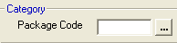

- Choose from the list then click the SELECT button as shown below.
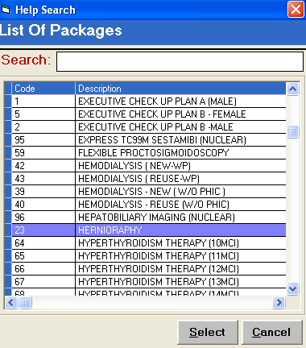
- Actual Charges are compared and tagged in the Package profile column thro highlighted color.
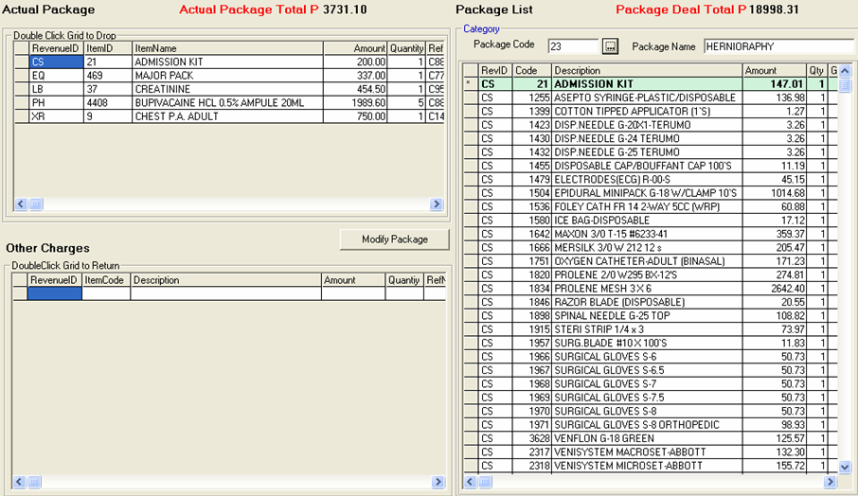
4 Click the button to save the items not consumed within the package. Once saved, the items will be included in the patient’s Billing Statement of Accounts.

Claim Slip Notice
Click on to display the window below.

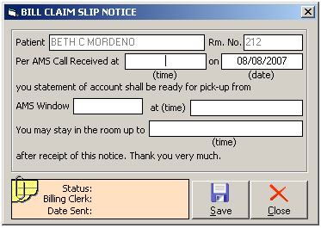

> Click on Save button save the data entered or Close button to go out from this option.
How to Set Cut-Off Clearance Time for MGH
This option allows the user to adjust the cut off clearance time for MGH patients. To do this, go to Build File Menu then Clearance Cut Off Time to load the sample window below.
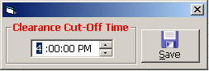
Edit the time then click on SAVE button to update the clearance time.

How to Generate the Promissory Note?
Promissory Note is a written promise by a person (patient/maker) to pay a specific amount of money (called “principal”) to another (payee/hospital) usually to include a specified amount of interest on the unpaid principal amount (what he/she owes)
This option allows the user to generate or re-print promissory note. To do this, select a patient and go to Reports option then click on Promissory Note as shown below.
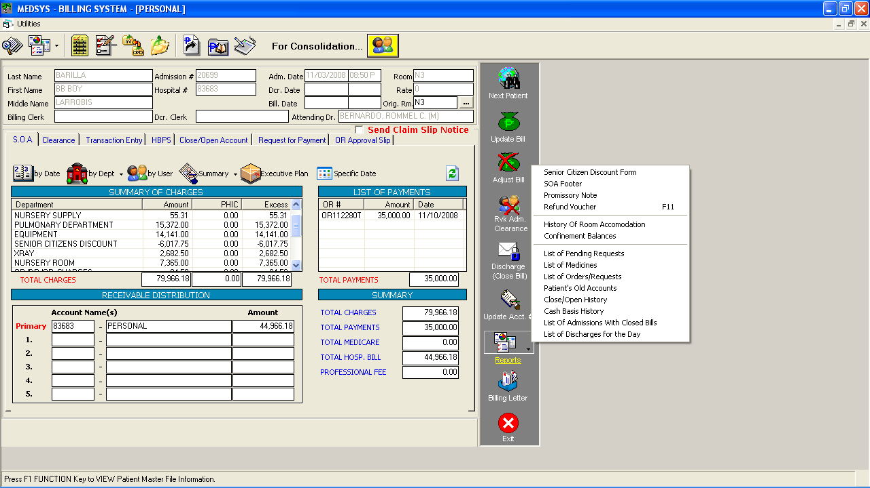

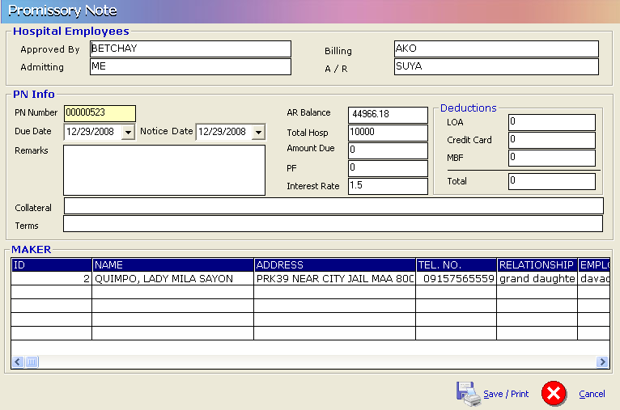 Provide the following information:
1 Employee name who approved the promissory Note
2 Due Date
3 Notice Date
4 Remarks
5 Collateral if available and terms
6 Hospital Amount or/and Professional Fee
Click on 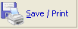 to save and print the Promissory Note.

How to Generate the Refund Voucher?

This option allows the user to record and print refund voucher. To do this, select a patient and go to Reports option then click on Refund Voucher or press F11 as shown below.

Click on to auto generate Refund Voucher Number. This will activate the following fields for the user to fill in:
1 Amount to Refund
2 Refund Type
3 Description
4 Recipient
5 Relationship
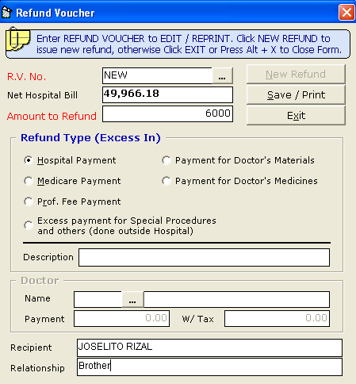
Click on to save and print the Refund Voucher.

Deposit Allocation
This option allows the user to allocate patients deposits. To do this, click on Deposit Allocation option in the main menu to load a sample window below.
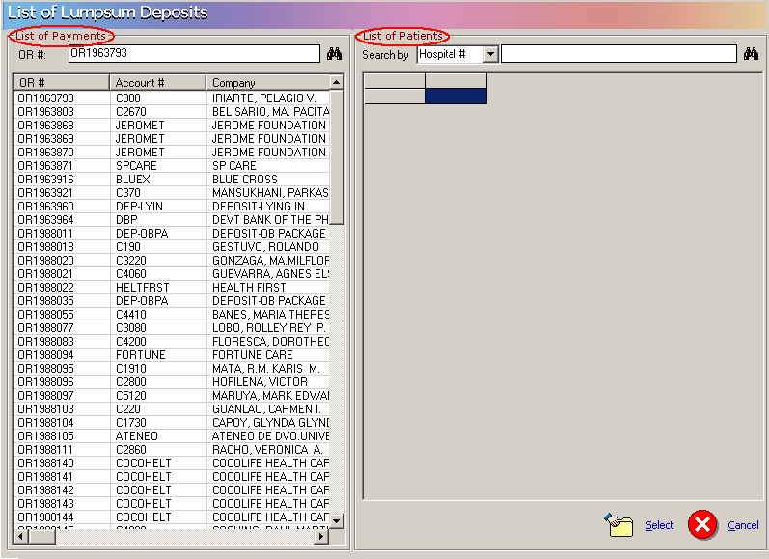
Enter the Official Receipt Number in the List Of Payments window then click on to search the OR entered. If found, go to List of Patients window to search for the patient name to load the sample window.

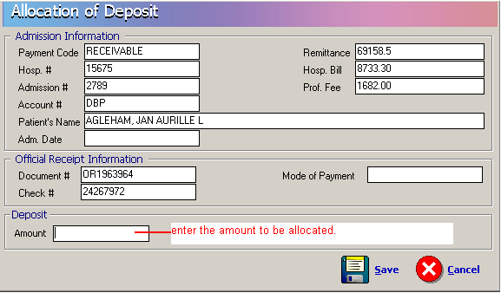
After entering the amount to be allocated, click on SAVE button to update patients account or click on CANCEL button to disregard entries

Partitioning of Patients Statement of Accounts Covered by HMOs or Company.
This option allows the user to enter the amount covered by HMO’s or companies to patients charges. To do this, choose specific patient then click on button to load a sample window.
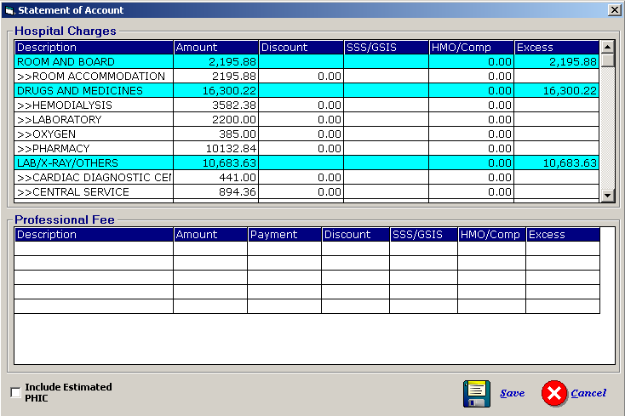
In the HMO/Comp column, enter the amount to be covered by the company or hmo per revenue. Click on Save button to save the data entered or Cancel button to disregard the data entered.

Operating Room Approval

This option will show the details of the scheduled operation as requested but the confirmation to procedure lies on the billing department after evaluating the capacity of patient to pay the cost of operation.
Click on to display the window below.

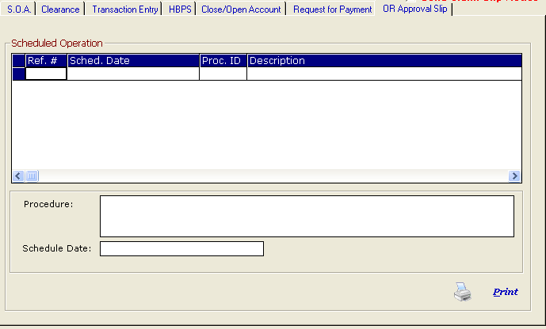
Click the Print button to inform the OR department that the requested schedule is approved.

Reports
The following are the available reports within the billing program. Click on  drop-down arrow button or click on Reports menu to display the list of reports.
A. IN-PATIENT BILLING REPORTS
1 Patient’s Account Status Report
- It shows all currently confined patients with their current gross hospital bills, professional fees, payments, balances after deductions, attending physicians and remarks.
2 Discharges with Open Bills
- It shows discharges made by admitting but have no billing date. It means, the patient’s record was already tagged as discharged/out by admitting by his billing papers/charges were not yet cleared/processed by billing. If left as is, at the end of the day, the patient will not be charged for room and board in the automatic room charging while patient is still in the hospital.
3 Personal Accounts with Balances
- It shows personal accounts balances for patients currently confined in the hospital. It is usually the personal accounts that require special attention to Credit & Collection department. This report will help the staff to screen the accounts with huge debt and hospital management may ask for a bigger deposit or put his account immediately on a cash basis status.
4 List of Admissions with Final/Closed Bills
- It shows the accounts with closed bill or with processed MGH but not yet discharged by the nursing nor admitting department.
5 List of Admissions by Company
- It shows all currently confined patients grouped according to account name (company, HMO etc)
6 List of Discharges for the Day
- It shows all discharges made by admitting/nursing station regardless if patient’s bill had been processed by billing or not). All discharges for the day will appear with or without billing date.
7 List of Daily Census
- It shows all currently confined patients with their assigned nursing stations, hospital numbers, admission numbers and account numbers
8 List of Patients with Discounts (By Discharge Date)
- It shows all discharged and billed patients with discounts in a given period
9 List of Patients with Balances of P100,000 or More
- It shows all currently confined patients with their outstanding hospital balance of P100,000.00 or more. It shows the patient’s name, admission number, admission date, length of stay, room, credit limit, gross bill, payment and account name
10 List of Cash Basis Patients
- It shows all currently confined patients placed under cash basis
11 Patients’ Discharge Notice Status Report
- It is a list of patients with discharge notices. It shows the response per cost center thru check mark or cross mark. A check mark means that particular department has cleared the patient’s record in the computer and all charges and adjustments were already posted in the computer.
12 Residents Fund Report
- Resident Fund refers to resident doctors’ share in the Emergency Room procedure. The share varies based on the built in rate in every procedure. It shows the transaction date, official receipt, amount and encoder’s code
13 Schedule of Discounts
- It is a detailed discount transaction report. It shows patients who were given discounts, type of discount, transaction date and discount amount per department. This is the supporting report of Discount Summary.
14 Summary of Discounts
- It summarizes the total discount per department and per type of discount in a given period.
15 Weekly Hospital Bill
- It shows the number of discharges and total amount per company/personal account in a given period
16 Doctors Performance Report
- It shows the doctors contribution to hospital in the form of discharged patients’ total gross bill for a given period of time and sorted from highest to lowest
17 List of Unused Package Items
- It reports the items included in the patient’s bill because they were part of the package but not used by the patient
18 Departmental Unused Package Items
- It reports the items included in the patient’s bill because they were part of the package but not used by the patient and grouped per Revenue (department) account.
19 Quality Objective Report
- It shows the billing department’s performance in processing patient’s bill. It measures the speed from discharge notice to completion of patient’s bill.
20 Revenue Transactions Report
IN-PATIENT
- It is the audit trail of all transactions posted in a day. Printing may be grouped as to Inpatient, outpatient, Cash or all.
- It could be presented in detailed or summary format.
- The amount could be shown at gross or at net.
Presentation of transaction at GROSS means the actual amount per item posted is shown as is. Any reversal or adjustment for the same transaction is posted as separate record and will show the exact adjusted figure.
Presentation of transaction at NET means the item posted for the day and adjusted at the same day will be computed and only the remaining balance will be presented for that particular item with the same reference number. If the net effect is zero, then it will not be presented in the report.
Examples:
- Inpatient (All) (Detailed)(Gross)
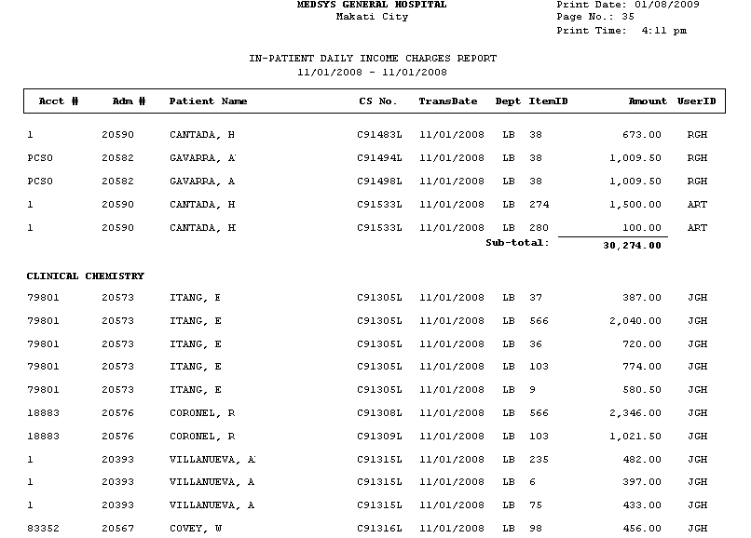
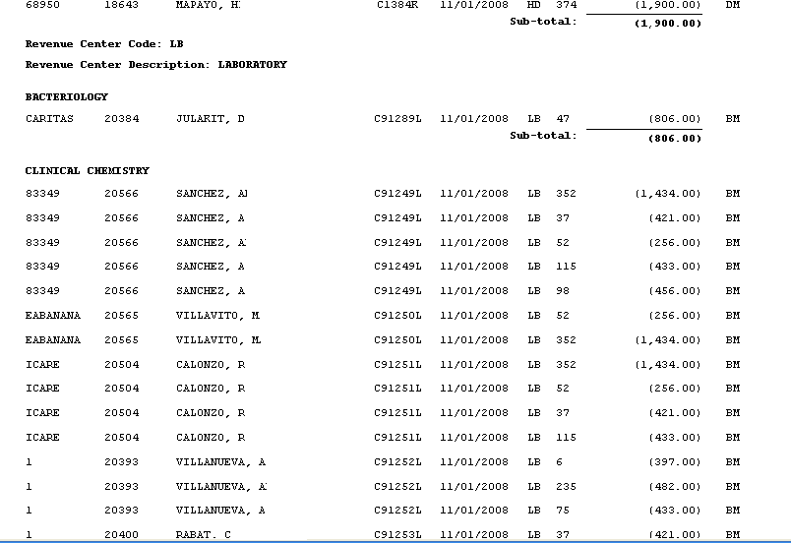
- Inpatient (Specific Department) (Detailed)(Gross)
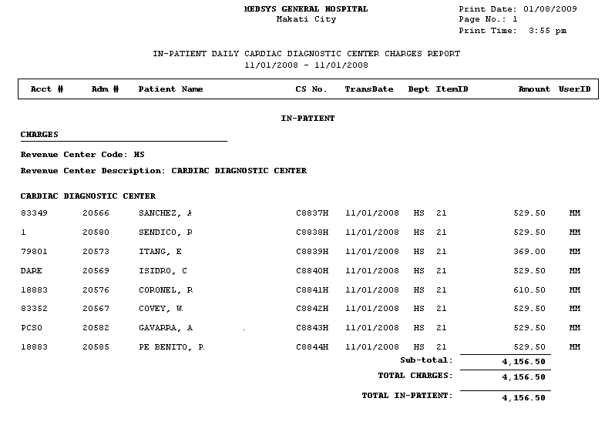

- Inpatient (All) (Summary)(Gross)
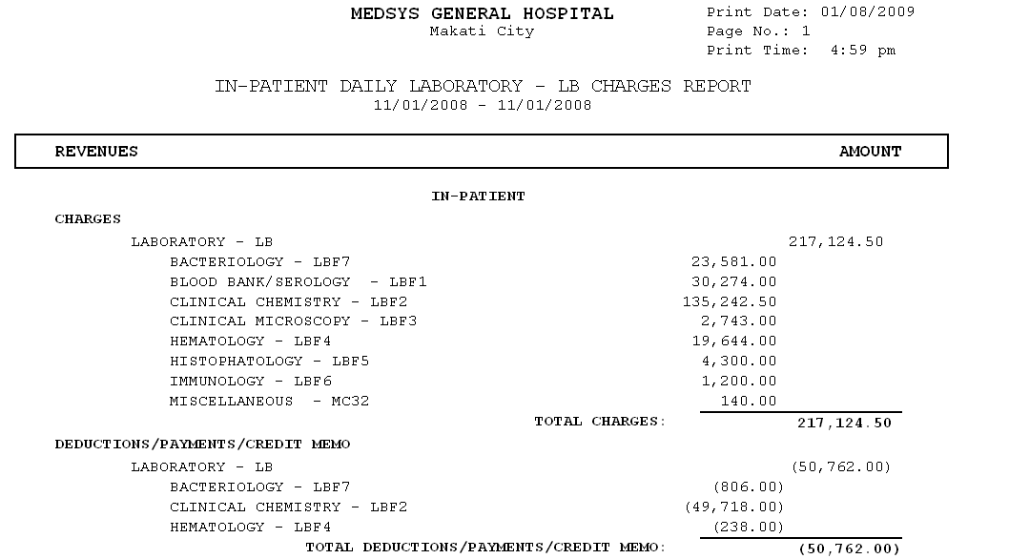
- Inpatient (Specific Department) (Summary)(Gross)
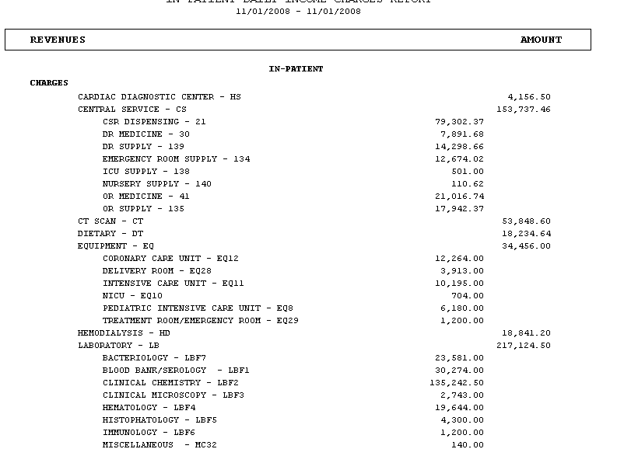
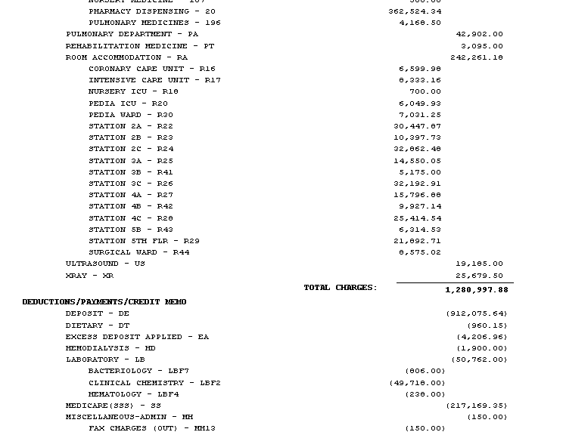

- Inpatient (All) (Detailed)(Net)
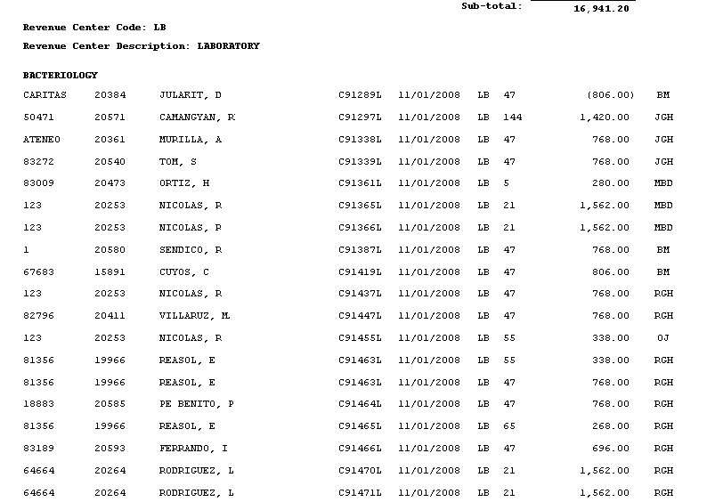

- Inpatient (Specific Department) (Detailed)(Net)
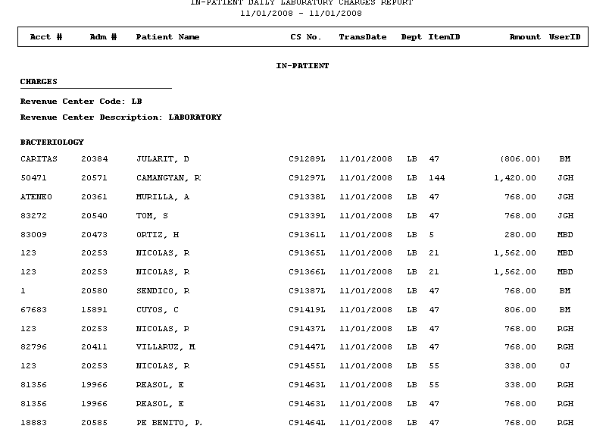
- Inpatient (All) (Summary)(Net)
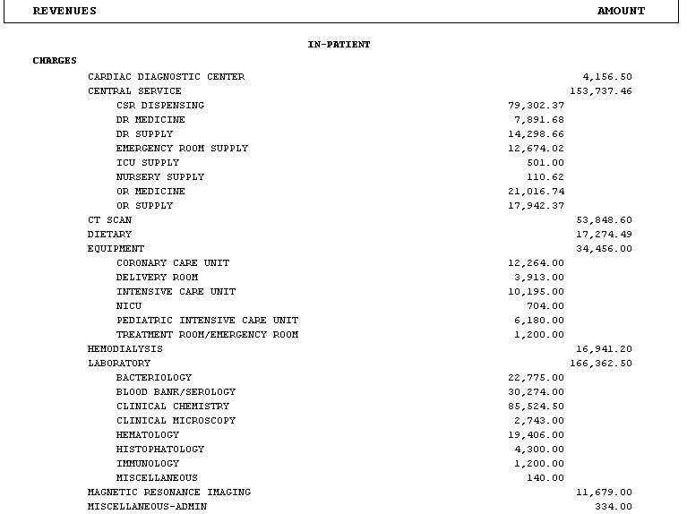

- Inpatient (Specific Department) (Summary) (Net)
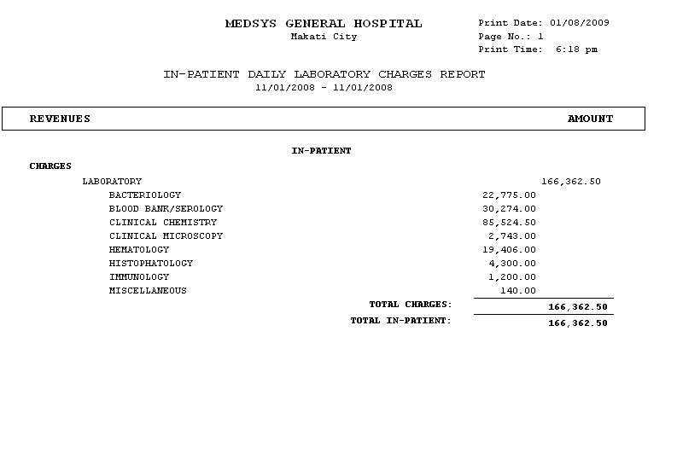
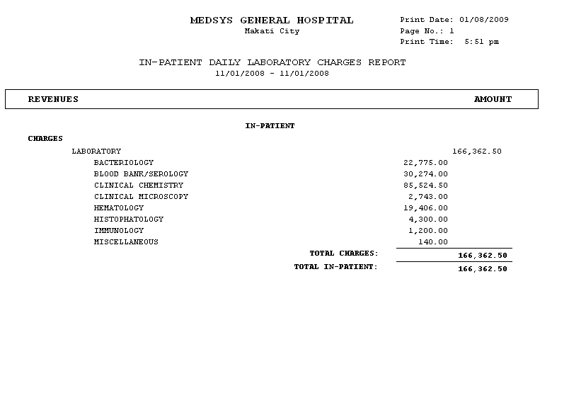

OUT-PATIENT
- Out-Patient (All) (Detailed)(Gross)
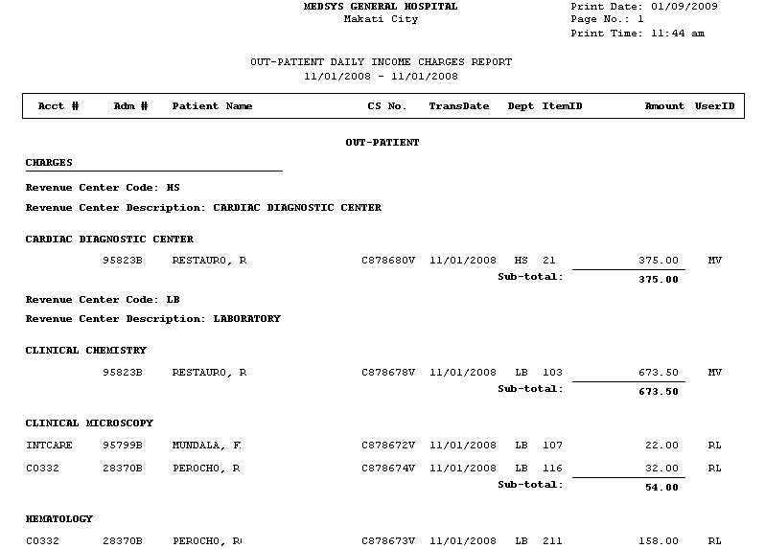
- Out-Patient (Specific Department) (Detailed)(Gross)
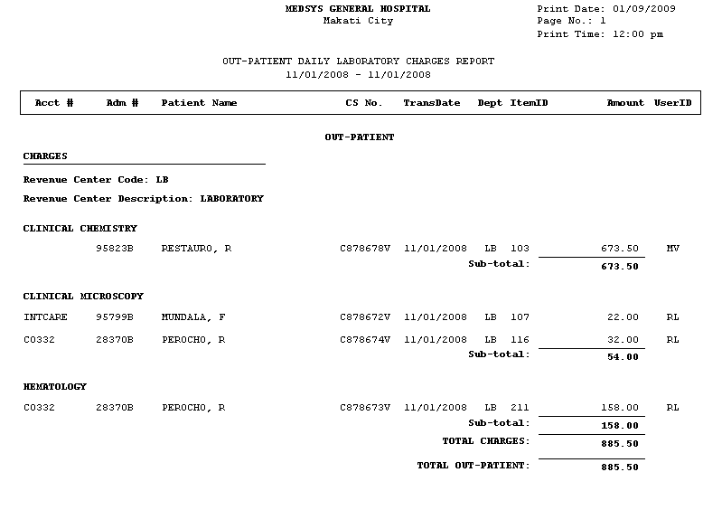

- Out-Patient (All) (Summary)(Gross)
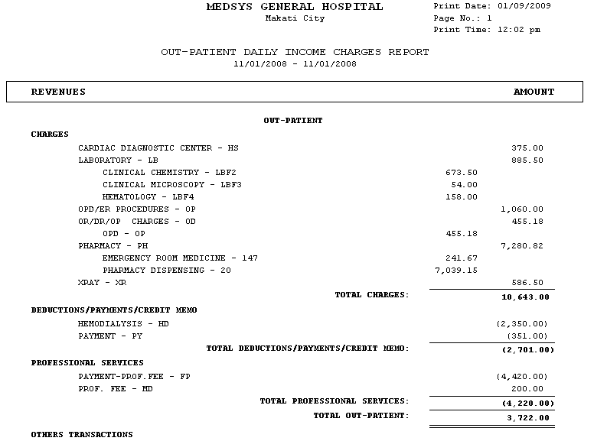
- Out-Patient (Specific Department) (Summary)(Gross)
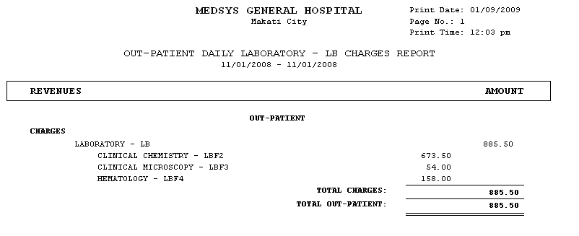
- Out-Patient (All) (Detailed)(Net)
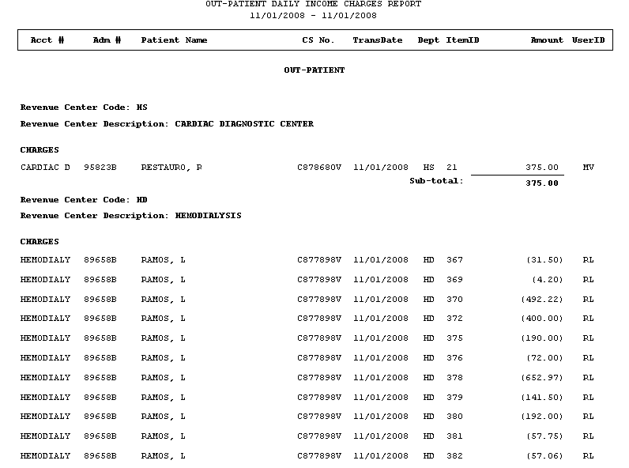
- Out-Patient (Specific Department) (Detailed)(Net)
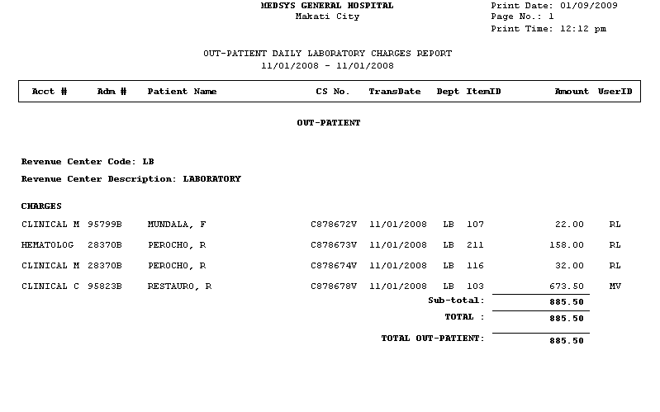

- Out-Patient (All) (Summary)(Net)
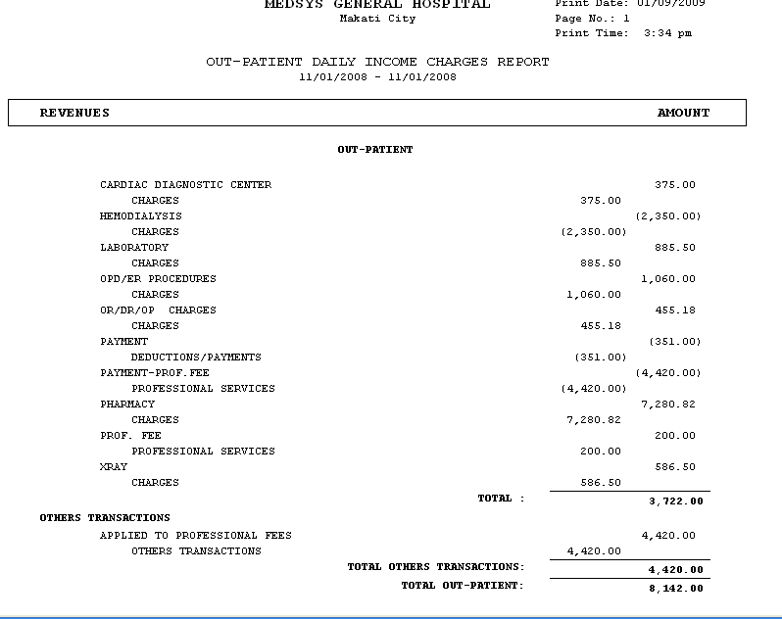
- Out-Patient (Specific Department) (Summary) (Net)
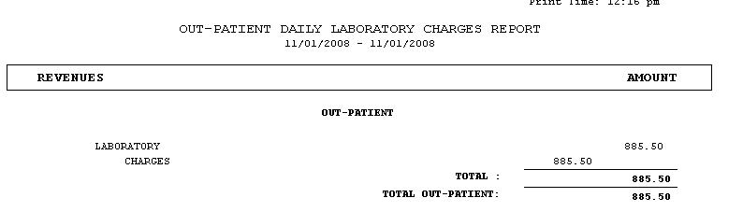

CASH
- Cash (All) (Detailed)(Gross)
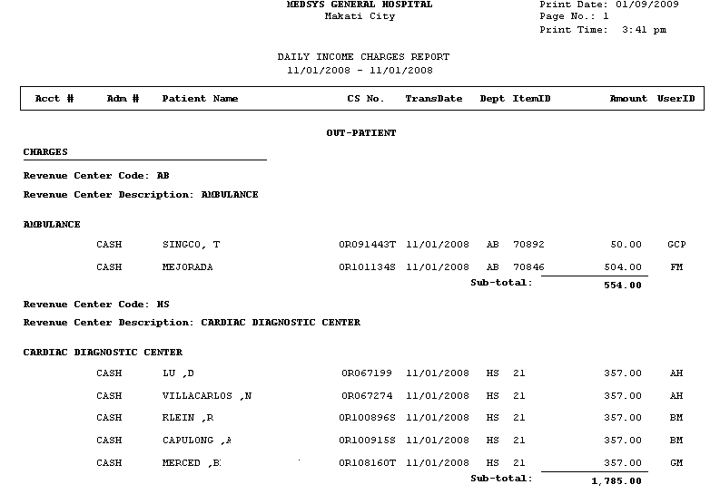

- Cash (Specific Department) (Detailed)(Gross)
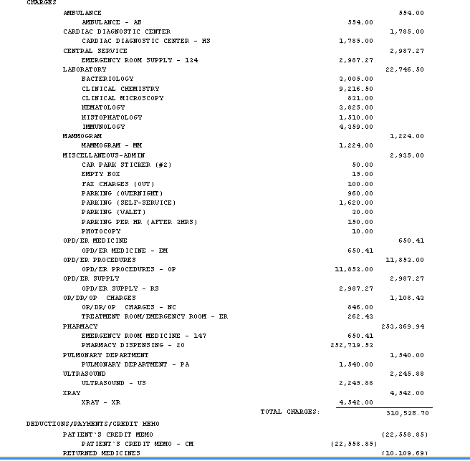

- Cash (All) (Summary)(Gross)

- Cash (Specific Department) (Summary)(Gross)
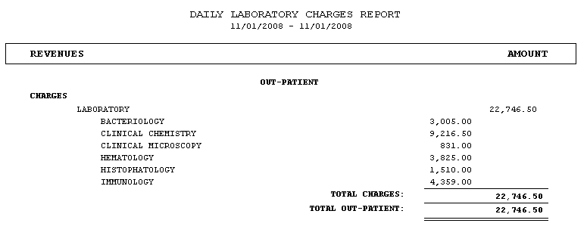
- Cash (All) (Detailed)(Net)
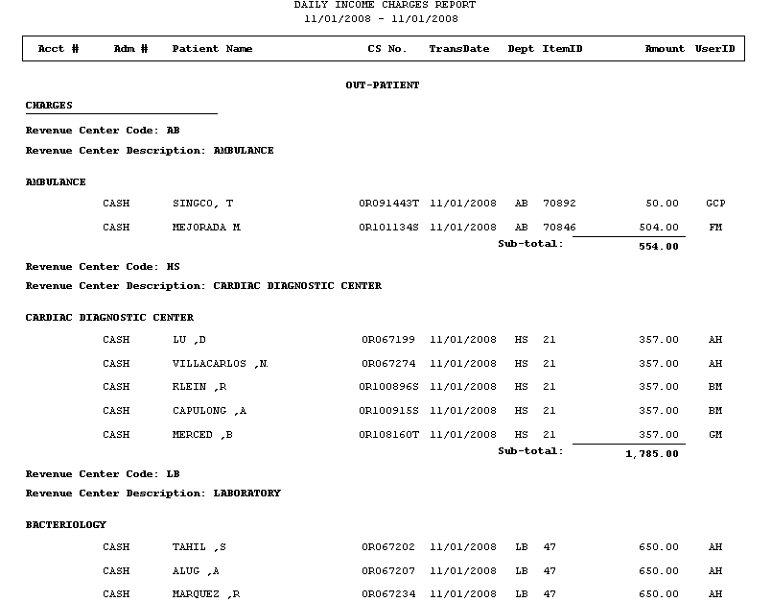

- Cash (Specific Department) (Detailed)(Net)
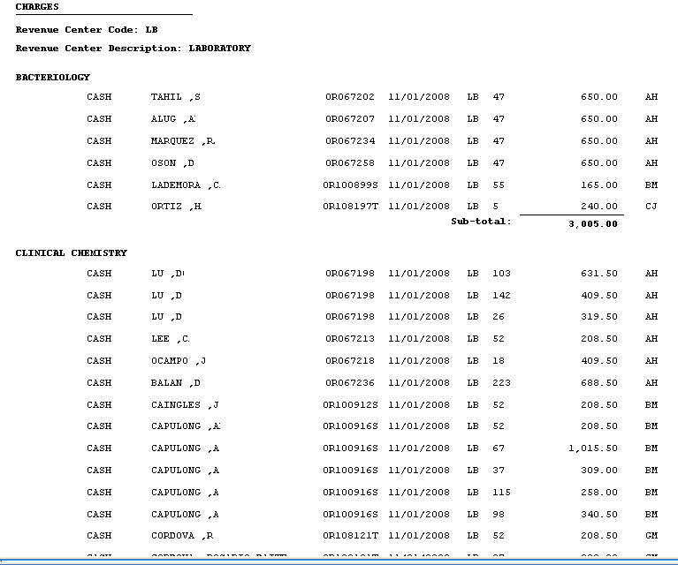

- Cash (All) (Summary)(Net)
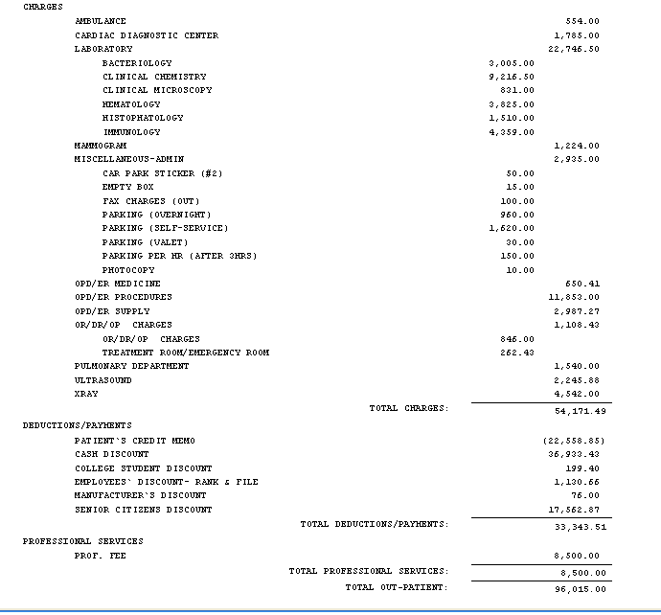
- Cash (Specific Department) (Summary) (Net)
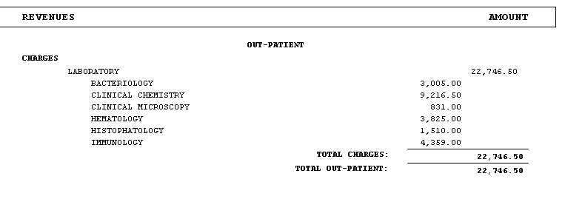

B. OUTPATIENT BILLING REPORTS
21 List of Daily Census (All Patients)
- It shows all active OPD Consultation Census. It shows patient names, visit date, hospital number, OPD number and account name
- It has option to present the census per account name or sorted by account balances
22 List of Daily Discharge/Completed Outpatient Transactions
- It shows all completed OPD Consultation records for the day.

C. PER PATIENT REPORT / INQUIRY
A- Senior Citizen Discount Form
- It shows the breakdown of items within the department and its corresponding discount
B- History of Room Accommodation
- It is a transaction log of patient’s occupied rooms during his confinement period and it shows room rates and transferred date and time
C- Confinement Balances
- It shows patient’s previous confinements/consultations with its balances
D- List of Pending Requests
- It shows nursing requests to department clinical departments still not recognized or charged to patient’s account
E- List of Medicines
- It shows posted medicines given to patients
F- List of Orders/Requests
- It shows status of nurse’s requests\orders.
G- Close / Open History
- It shows the user who closed or opened patient’s account.
H- Cash Basis History
- It shows the user who tagged/un-tagged patient’s cash basis account

