MEDSYS
Information System

Admission Program
User's Manual



Visual Medsys
Kaiser dela Cruz Consulting Incorporated
July 28, 2026

Copyright©
ALL RIGHTS RESERVED

No part of this document may be reproduced through photocopying or in any means, stored into a retrieval system, and transmitted in any form without the express written permission of Kaiser - dela Cruz Consulting, Incorporated.
Permission is hereby granted to Medsys Information Syatem to copy and distribute this document in any of the above means provided this is for its exclusive on site use.
Although every precaution has been taken in the preparation of this manual, the company assumes no responsibility for errors or omissions. Neither is any liability assumed for any damages resulting from the use of the information contained here.
Table of Contents
Overview 5
Getting Started 7
Starting the Program 7
How to Change Password 8
Closing the Program 9
Program Operations 10
Important Icons and Buttons 10
Shortcut Keys 11
Patient Admission 12
Patient Searching 17
Edit Patient Admission 18
View Admission Information 19
Room Transfer 20
Room Reservation 21
New Reservation 21
Edit Reservation 22
Cancel Reservation 23
Discharge Patient 24
Revoke Admission 25
Revoke Discharge 26
Admit Watcher 27
Discharge Watcher 28
Print Data Sheet 29
Patient’s Old Accounts 30
Transfer Summary 31
Reports 32
Daily Reports 32
Census Reports 33
Statistical Reports 34
Other Reports 35
Index 36

Overview


The Visual Admission Program handles the patient admitted to the hospital and stays overnight or for an indeterminate time, usually several days or weeks (though some cases, like coma patients, have stayed in hospitals for years). The patient's data such as relevant personal information, admission information, and diagnosis and history are entered thru the computer. These data will be used by cost-centers when patient is to be charged of medicines, supplies, procedures and services chargeable to patient’s account.
The use of password disallows the access of unauthorized users. This maintains that all data entered are kept secured and confidential.

Objective:

- To use the interconnecting feature to other departments such as Laboratory, X-Ray, Ultrasound, CT-Scan, Heart Station, Hemodialysis, Pulmonary, Pharmacy, Central Supply, Operating Room, and Billing and other hospital departments to provide a higher level of care and service.
- To become a seamless part of the hospital’s operations whereby staff will have immediate access to patient information whenever and wherever required
- To reduce clerical workload
- To improve service and management will have a powerful new information tool for decision making purposes
- To maintain accurate and centralize update of patient’s information

Features:
- Data-entry restriction – Users can post/review charges, adjustments, print reports according to the access rights given to them
- Real- Time system – All entries reflected immediately
- Warning \ Control Feature – System signals the admitting clerk if patient for admission is black listed, ability to inquire previous patient’s outstanding balances per confinement, flashes patient’s total receivable upon admission
- Electronic communication – Notifies patient’s for admission from Emergency Room module and allows for room reservation
- Advance feature – System is ready for Smart Card / Patient’s ID integration, capability to bar code patient’s admission sheet
- Tools to improve service – System has facility for printing of patient’s name, doctor’s name and room tags. Has optional title field for doctors, lawyers that will guide hospital staff on how the patient will be properly addressed. Includes a Patient’s Inquiry option for the front desk clerk.

Getting Started

Starting the Program
1 Click on  Admission program executable file icon located in your computer desktop.
2 The Login window will display asking you to type your employee number and password for security purposes.

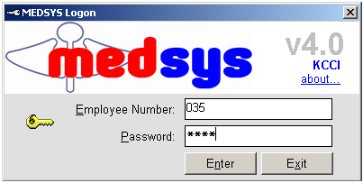

3 If the program has validated your employee number and password, you may now start a transaction. Otherwise, a message will display prompting “Unauthorized User”.

How to Change Password

1 From the Login window, type your employee number and then press <Enter>.

2 Under the Password entry, press <F12>. Pressing this function key will invoke the Change Password window.

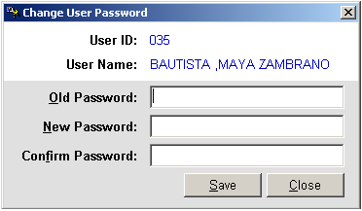
Figure 1: Change Password Window
3 Under the Change Password window, type the following data.
Old Password - Type your existing password.
New Password - Type your new password not exceeding to 15 characters.
Confirm Password - Retype your new password to confirm and then press <Enter> or you can click the Save button.

Closing the Program
It is recommended to close your program when you are done to end-up your session. Other users might use the open program using the same password.

There are three ways to close the program.
1 Click on button located at the right corner of the main window (possible only if no other window is open) or
2 Click Exit from the File pull-down menu or
3 Press <Ctrl + X>

Program Operations

Important Icons and Buttons
- New Admission
- Discharge Patient
- Edit Admission
- Print Data Sheet
- Refresh Patient List
- Revoke Admission
- Revoke Discharge
- Room Status
- Room Transfer
- Transfer Summary
- A special button used to display list of doctors, services, rooms and others.

Shortcut Keys
Shortcut keys are useful to users for they lessen the time of opening a particular window. These shortcut keys can be seen at the menu portion of the program. Below is listed the commonly used shortcut keys.

1 <Ctrl + A> - New Admission
2 <Ctrl + X > - Close Program
3 <Ctrl + E> - Edit Admission
4 <Ctrl + D> - Discharge Patient
5 <Ctrl + T> - Room Transfer
6 <Ctrl + R> - Revoke Admission
7 <Ctrl + K> - Revoke Discharge
8 <Ctrl + V > - View Admission Information
9 <Ctrl + P> - Print Data Sheet

Patient Admission
This option allows you to admit a new patient. Whenever a patient is admitted, his hospital number will be retained and a new admission number will be assigned to him. This program-generated admission number will hold the patient’s record (clinical and financial) throughout his confinement period.

1 Click ‘ New Adm.’ toolbar button or press <Ctrl + A> to start.
2 The 'Patient Admission' window appears. Type in patient’s last name, first name, and/or middle name. In case the patient has no existing record found, the program will display a warning message as shown below. Select ‘Yes’ button to continue.
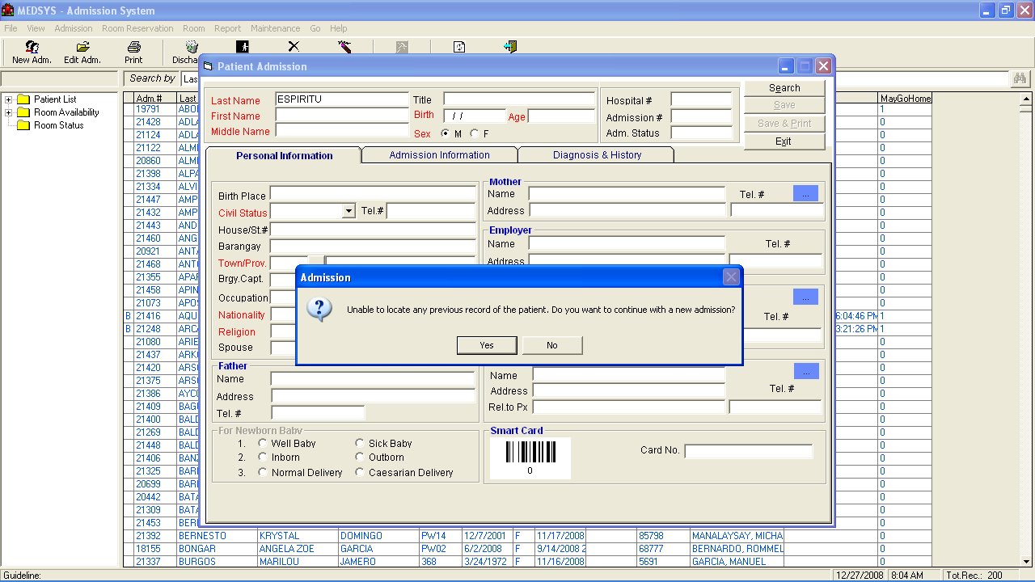

3 Click ’Search’ button to search patient’s record.
4 The 'Master Patient Search' window appears. In here, the program has searched existing record of the patient. In the figure below, a record is found. Double-click the patient’s name to select. The saved information of the patient will be then retrieved. If record is not found (means new admission), click 'Close' button to continue entering patient’s data.
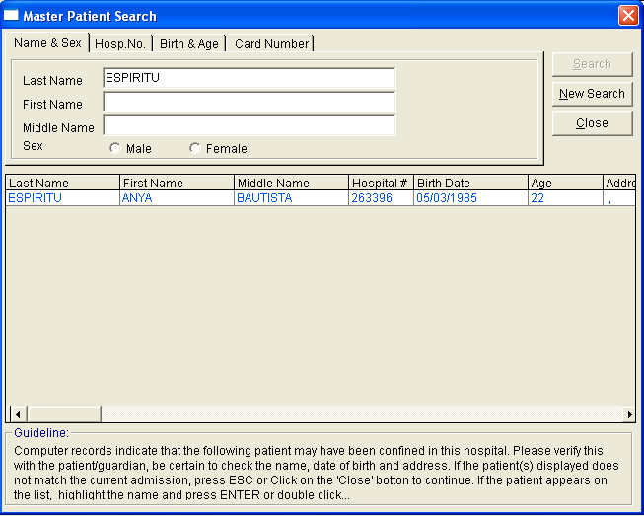

5 Enter the necessary data under 'Personal Information' tab.
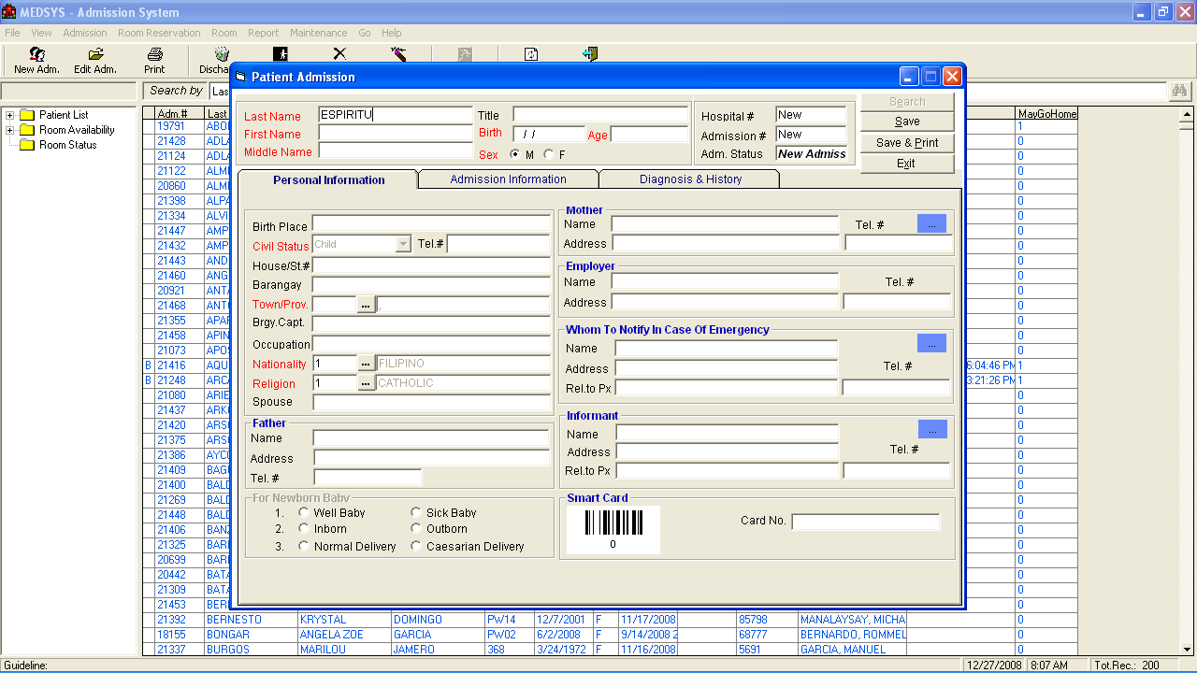

· Birth Place
· Civil Status
· Telephone number
· House/Street number
· Barangay
· Town/Province
· Barangay Captain
· Occupation
· Nationality
· Religion
· Spouse
· Father’s Information (Name, Address, Telephone number)
· Mother’s Information (Name, Address, Telephone number)
· Employer’s Information (Name, Address, Telephone number)
· Whom to Notify in Case of Emergency (Name, Address, Relationship to Patient, Telephone number)
· Informant (Name, Address, Relationship to Patient, Telephone number)
. Card Number
· For New Born Baby, Click if Well Baby, Inborn, Normal Delivery, Sick Baby, Out born or Caesarian Delivery

6 Enter necessary information under 'Admission Information' tab.
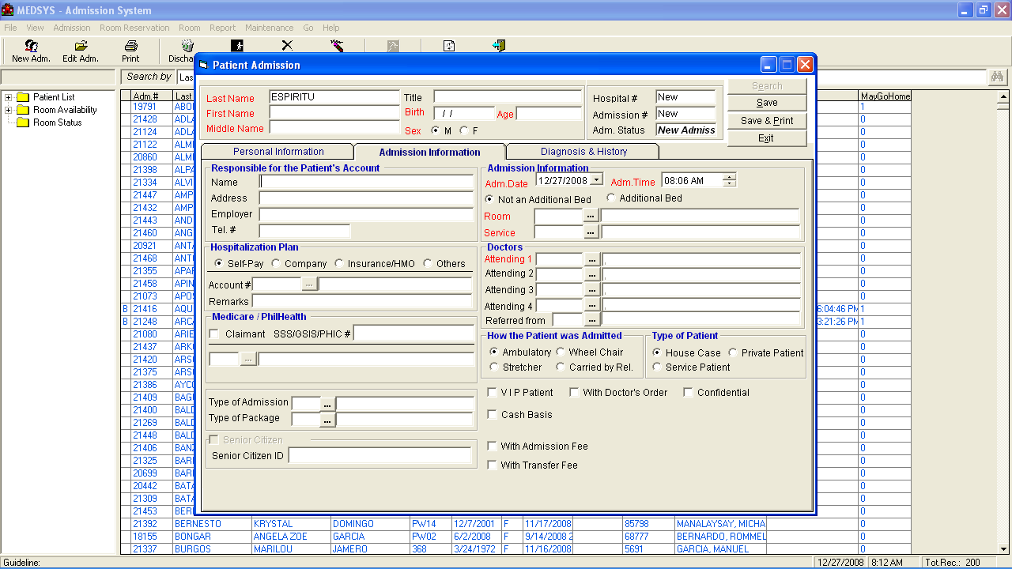
· Responsible for the Patient’s Account (Name, Address, Employer, Telephone Number)
· Hospitalization Plan (Self-Pay/Personal, Company, HMO) - Enter account name if company or HMO is selected.
· Medicare/PhilHealth - If claimant, enter type of membership.
· Type of Package – Choose the type of ECU package if necessary. Patients who are tagged with ECU package will be notified in stations.
· Admission Information (Room, Service)
· Doctors (Attending 1 & 2, Admitting, Coordinator, Referred From)
· How the Patient was Admitted (Ambulatory, Wheel Chair, Stretcher, Carried by Relative)
· Type of Patient (House Case, Private Patient, Service Patient)
· An option to select if 'With Doctor’s Order', 'Direct to Room', 'Confidential', and/or 'VIP Patient'
· Supply Patient’s Senior Citizen ID if available
7 Enter necessary information under 'Diagnosis & History' tab.
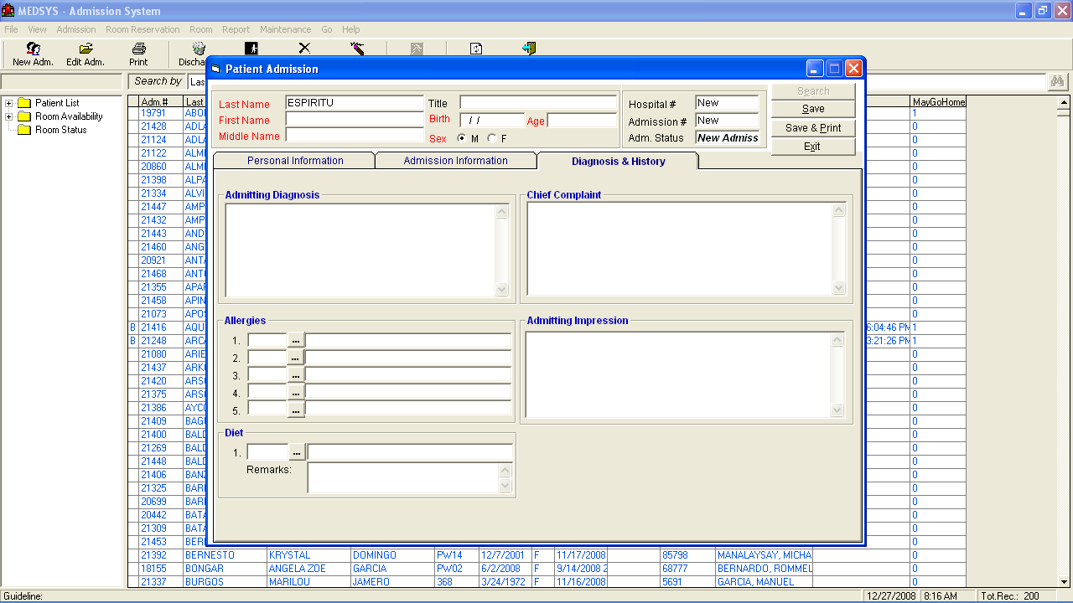

· Admitting Diagnosis
· Allergies
· Chief Complaint
· Admitting Impression
· Diet
· Remarks

8 Click ’Save' button to save patient’s data or ’Save & Print' to save and print the admission data sheet.

Patient Searching
Upon loading the program, you can see the currently confined patients in the list. Patient searching is classified into three options which are All Patients, Confined, and Discharged. Just choose Patient from the View pull-down menu and then click one from the options. You can search for a patient by his last name, hospital #, admission # and room #.
Sample searching:
1 Click on drop-down arrow button to choose from the following options <Last Name, Hospital #, Admission #, Room #>.
2 If the option selected is last name, type the patient’s last name then press <Enter> or click on .
3 All patients having the last name typed will display. Double-clicking on the patient’s name will activate his profile (for viewing only). Single-clicking on the patient can have the following transactions:
· When single-clicked, you can right-click to display the different transactions to be done such as Edit Admission, Discharge Patient, Room Transfer, Revoke Admission, Revoke Discharge, View Admission Info, Print Data Sheet, Patient’s Old Accounts, Print Patient Tag, and Patient History.
You can also search and view a patient by station, accommodation, and service. Double-click on to display options.

Edit Patient Admission
This feature allows you to enter necessary correction on the patient’s admission record for purposes of medical record.

1 Select the patient from the list.
2 Click 'Edit Adm.' toolbar button or click 'Admission' > 'Edit Admission' or press <Ctrl + E>.
3 The 'Patient Admission' window appears displaying the patient’s admission record. You can now edit patient information under 'Personal Information', 'Admission Information', and 'Diagnosis & History' tabs.
4 Click ’Save' button when done to update changes entered.

View Admission Information
This option allows you to view basic information of the patient. Patient’s total bill, payments, balance, and credit limit can also be viewed in here.

1 Select the patient from the list.
2 Information displays such as address, hospital number, admission number, room number, station, admission date, attending doctor, admitting clerk, discharge date, result, disposition, discharge clerk, type of admission, type of package, employer, responsible party, account code, total bill, payments, balance and credit limit.
3 Click 'Close' button to close window.

Room Transfer
This option lets you transfer patient to another room. Once transferred, the selected room’s rate will be saved and will be included in the patient’s summary of room transfer report. Room charging will take effect when it reaches the cut-off time of room charging.

1 Select the patient from the list.
2 Click 'Room Transfer' toolbar button or click 'Admission' > 'Room Transfer' or press <Ctrl + T>.
3 The 'Room Transfer' window appears.
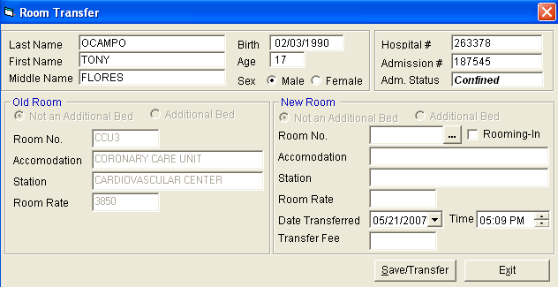

4 Choose new room by clicking on to display the complete list of rooms (The asterisk sign (*) in the first column means that room is fully occupied). Double click the room to select. If message 'Warning! The room is fully occupied, do you want an additional bed to his room?' appears, click 'Yes' button to accept or 'No' to search for another room.
5 Enter transfer fee. This will add an extra charge to patient’s bill.
6 Click ’Save/Transfer' button to transfer the patient.

Room Reservation

New Reservation
This option allows you to enter reservation for the patient. Room charging shall only start when the patient is admitted. However, reserved rooms can still be allocated to other patients if needed.

1 Click 'Room Reservation' > 'New Reservation'.
2 The 'Room Reservation' window appears.
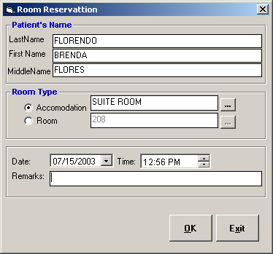

3 Under 'Patient’s Name' entry, type in last name, first name, and middle name.
4 Under 'Room Type' entry, choose the room by clicking . This will display the complete list of rooms (The asterisk (*) sign under the first column means that the room is fully occupied).
5 Type supporting details under the 'Remarks' entry,
6 Click 'OK' button to save reservation.

Edit Reservation
This option lets you edit saved reservation.
1 Click 'Room Reservation' > 'Edit Reservation'.
2 The 'List of Reservations' window appears. Double-click the name to edit.
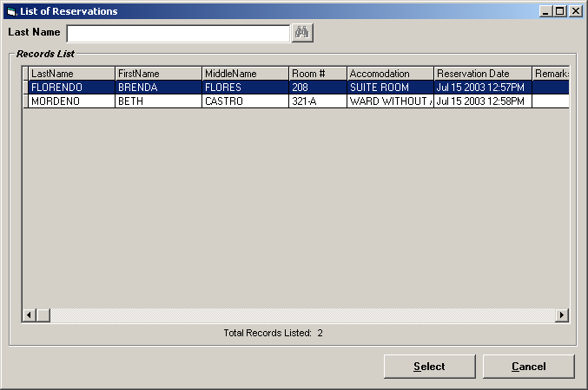

3 You may now correct reservation details. Click 'OK' button to update changes entered.
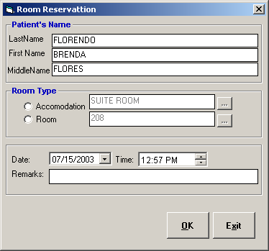

Cancel Reservation
This option lets you cancel saved reservation.

1 Click 'Room Reservation' > 'Cancel Reservation'.
2 The 'List of Reservations' window appears. Double-click the name to cancel.
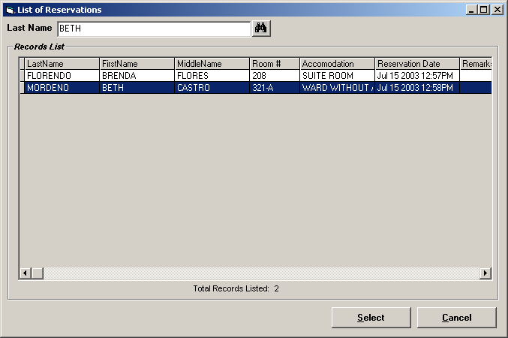

4 Click 'Revoke' button to cancel selected reservation.
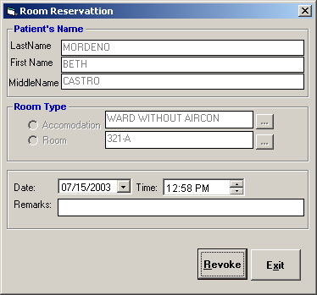

Discharge Patient
To update the availability of room, you need to discharge the patient. All discharged patients will not be included anymore in the census; it will be added in the daily discharge list report. But still, patient’s admission is accessible in Billing for the settlement of charges.

1 Select the patient from the list.
2 Click 'Discharge' toolbar button or click 'Admission' > 'Discharge Patient' or press <Ctrl + D>.
3 The 'Discharge Patient' window appears.
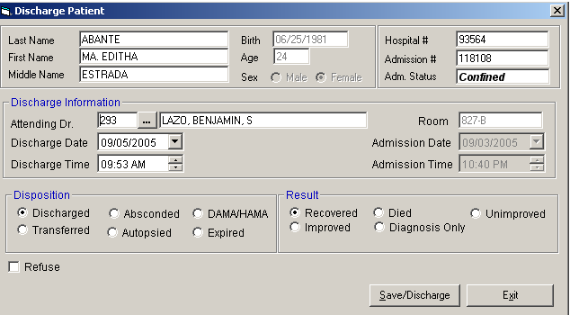

4 Choose attending doctor (if necessary), disposition (Discharged, Transferred, Absconded, Autopsied, DAMA/HAMA, Expired), and result (Recovered, Improved, Died, Diagnosis Only, Unimproved).
5 Click ’Save/Discharge' button to discharge patient.

Revoke Admission
This option revokes the admission of currently registered patient. It will only allow patient’s admission to be revoked if current date equals to admission date and no existing charges are saved.

1 Select the patient from the list.
2 Click 'Rvk Adm' toolbar button or click 'Admission' > 'Revoke Admission' or press <Ctrl + R>.
3 The message 'Patient’s admission successfully revoked!' displays if it is successfully revoked.

Revoke Discharge
This option restores the admission of currently revoked patient’s discharge. It will only allow to restore admission if current date equals to discharge date.

1 Select the patient from the list.
2 Click 'Rvk Dchrg' toolbar button or click 'Admission' > 'Revoke Discharge' or press <Ctrl + K>.
3 The message 'Patient’s admission successfully restored!' displays if it is successfully restored.

Admit Watcher
This option lets you admit a watcher under the patient’s account. Once watcher is admitted, it will be included in the daily watchers list report. Its room accommodation fee will be added to the selected patient.

1 Select the patient from the list.
2 Click 'Admission' > 'Admit a Non - Patient'.
3 The 'Non-Patient Room Occupancy' window appears.
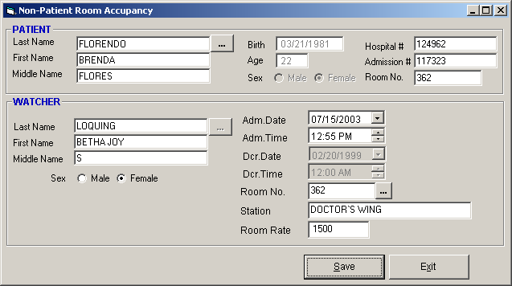

4 Under 'Watcher' entry, type in the watcher’s last name, first name, middle name, gender, and room. There is an option to enter the room rate if necessary.
5 Click ’Save' button to save entry.

Discharge Watcher
This option lets you discharge watcher to update the availability of room. Upon discharge, charging of room will stop and only rates of covered days will be added in the patient’s bill. Discharged watchers will no longer be included in the daily watchers list report.

1 Select the patient from the list.
2 Click 'Admission' > 'Discharge a Non-Patient'.
3 The 'Non-Patient Room Occupancy' window appears.
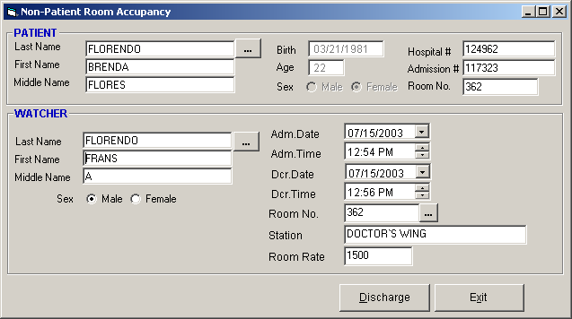

4 Under 'Watcher' entry, click to display list of patient’s watchers. Double-click the watcher from the list to select. The current server’s date and time are used as the default discharge date and time.
5 Click 'Discharge' button to discharge watcher.

Print Data Sheet
This option generates a print preview of admission and discharge record.

1 Select the patient from the list.
2 Click 'Print' toolbar button or click 'Admission' > 'Print Data Sheet' or press <Ctrl + P>.
3 An option window appears. Click the desired option.
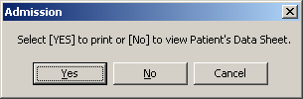

4 The print preview of the selected patient’s admission and discharge record displays.

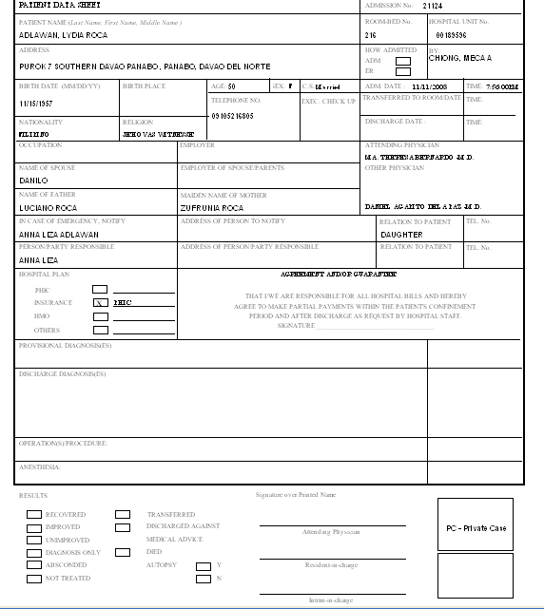

Patient’s Old Accounts
This option generates a print preview of patient’s receivable ledger. It includes unpaid charges in the accounts receivable throughout all patient’s confinements.

1 Select the patient from the list.
2 Click 'Admission' > 'Patient’s Old Accounts'.
3 The print preview of the selected patient’s old accounts displays.

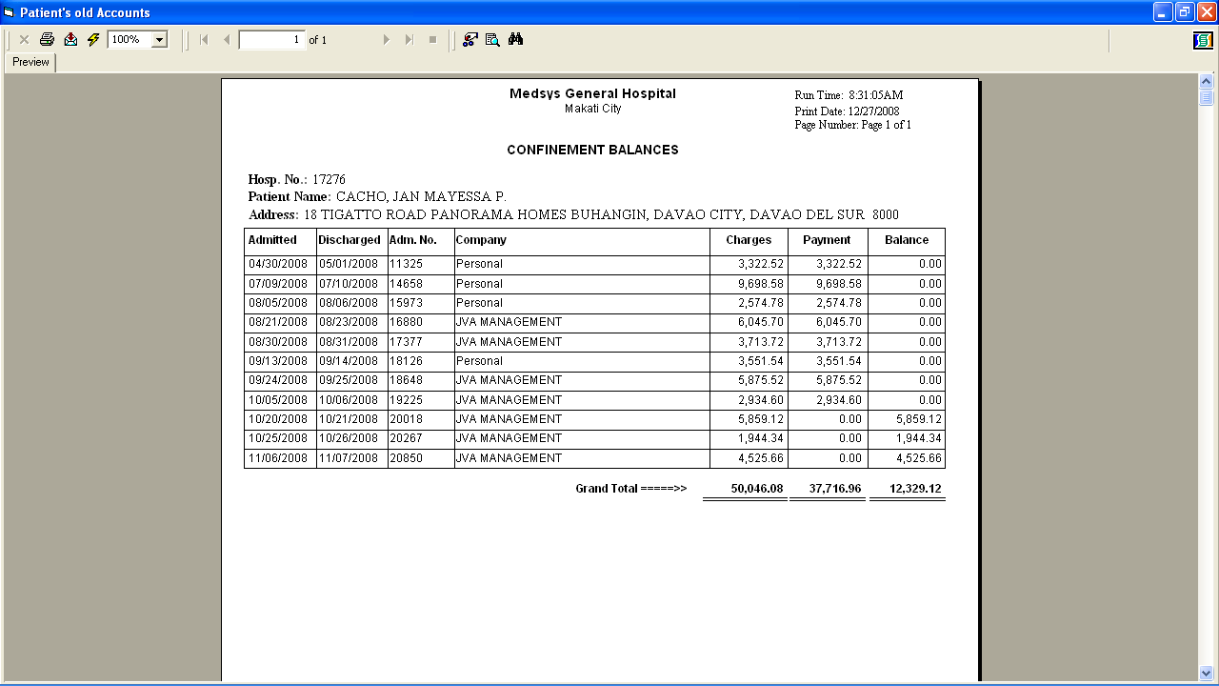

Transfer Summary
This option generates a print preview of the transfer summary of the patient throughout his current admission.

1 Select the patient from the list.
2 Click 'Trnsfr Smry' toolbar button.
3 The print preview of the selected patient’s transfer summary displays.
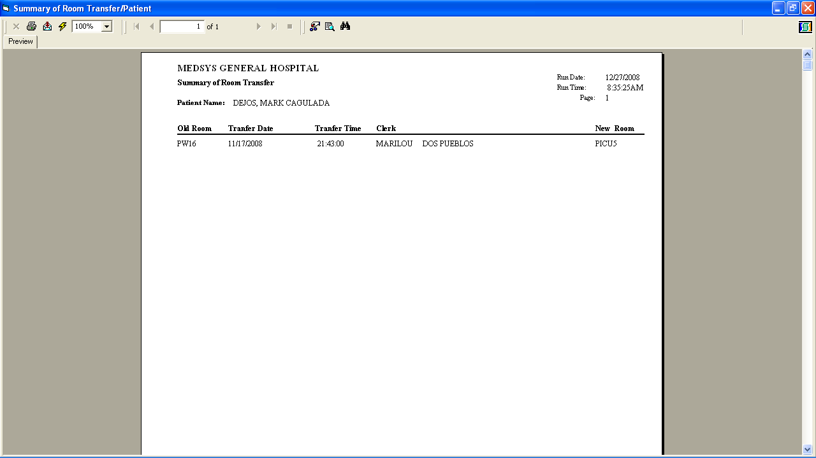

Reports

Daily Reports
It includes daily admission list, daily discharge list, daily summary of room transfer, and daily watchers list.

1 Daily Admission List - A report that generates a list of admitted patients during the day of the selected date.
2 Daily Discharge List - A report that generates a list of discharged patients (by admitting department) during the day of the selected date.
3 Daily Summary of Room Transfer - A report to generate list of patients who have transfer history during the day of the selected date.
4 Daily Watchers List - A report that generates a list of admitted watchers during the day of the selected date.
5. Narrative Report - A report that displays the statistics on the number of admission, discharges, occupied rooms grouped by adult/children, newborn; number of admission and discharge; statistics on number of deaths and list of patients with outstanding balances to prompt the business office during the day of the selected date.

Census Reports
It includes census report by station, grand census report, and census report by station with reservation.

1 Census Report by Station - A report that displays all confined patients during the day of the selected date including case and attending doctor grouped by station and arranged by room number.
2 Grand Census Report - A report that displays all confined patients during the day of the selected date including case and attending doctor.
3 Census Report by Station with Reservation - A report that displays all patients with reservations during the day of the selected date.

Statistical Reports
1 Daily Hospital Statistics - A report that displays statistics on number of admission, discharges, occupied rooms, and occupancy rate classified into station, accommodation, service, and type of admission; and statistics on number of deaths grouped by adults/children, newborn, and rooming-in during the day of the selected date.
2 Monthly Statistical report - A report that displays statistics on number of admission, discharges, occupied rooms, and occupancy rate classified into station, accommodation, service, and type of admission; and statistics on number of deaths grouped by adults/children, newborn, and rooming-in during the month of the selected date.
3 Statistical by Period - A report that displays statistics on number of admission, discharges, occupied rooms, and occupancy rate classified into station, accommodation, service, and type of admission; and statistics on number of deaths grouped by adults/children, newborn, and rooming-in between days of selected date period.

Other Reports
It includes room availability report, summary of room transfer, doctor’s patient list, company list, list of reservations, and list of discharge orders.

1 Room Availability Report - A report that displays statistics on room such as total number of beds, beds left, additional beds, and room rate grouped by station during the day of the selected date.
2 Summary of Room Transfer - A report that displays the selected patient’s room transfer history during his current confinement.
3 Doctor’s Patient List - A report that displays doctor’s list of patients who are scheduled for a service during the current date.
4 Company List - A report that displays the company’s list of patients whose account is named under it.
5 Monthly Summary of Hospital Statistics - A report that displays statistics on number of admission, discharges, occupied rooms, and occupancy rate classified into station during the day of the selected date.
6. List of Reservations - A report that displays a list of patients with reservation during the day of the selected date.
7. List of Discharge Orders – A report that displays a list of patients with discharge order during the day of the selected date.
8. Type of Admission Summary Report – A report that displays a list of patient based on the type of admission during the day of the selected date.
9. Walk-In OPDF Admission – A report that displays a list of Walk-In and OPDF patients during day of the selected date.
10. List of Revoke Discharges – A report that displays a list of revoked discharges during the day of the selected date

Index

—A—
accounts, 28
admission record, 27
admit new patient, 10
admit watcher, 25
—B—
bill, 16
button, 8
—C—
census reports, 31
closing the program, 7
—D—
daily reports, 30
data sheet, 27
discharge non-patient, 26
discharge patient, 22
discharge watcher, 26
—E—
edit patient admission, 15
—I—
icons, 8
—N—
non-patient admission, 25
—O—
other reports, 33
overview, 5
—P—
patient admission, 10
patient searching, 14
patient's old accounts, 28
—R—
revoke admission, 23
revoke discharge, 24
room transfer, 17
—S—
search a patient, 14
shortcut keys, 9
starting the program, 6
statistical reports, 32
—T—
total bill, 16
transfer patient, 17
transfer summary, 29

—V—
view admission information, 16

