Visual Accounting
User's Manual



MEDSYS
Kaiser - dela Cruz Consulting, Inc.
July 28, 2026
©Copyright ALL RIGHTS RESERVED

No part of this document may be reproduced through photocopying or in any means, stored into a retrieval system, and transmitted in any form without the express written permission of Kaiser - dela Cruz Consulting, Incorporated.
Permission is hereby granted to Daniel Mercado Medical Center to copy and distribute this document in any of the above means provided this is for its exclusive on site use.
Although every precaution has been taken in the preparation of this manual, the company assumes no responsibility for errors or omissions. Neither is any liability assumed for any damages resulting from the use of the information contained here.

Table of Contents

Table of Contents 3
SYSTEM OVERVIEW 8
Visual Medsys Accounting Program 8
System Description 8
System Process Flowchart 10
System Objectives and Features 11
Getting Started 12
System Requirements 12
System Menu Operations 13
How to Start the Program 15
How to End the Program 15
Backup and Restore Database Procedures 16
Program Setting Maintenance 25
ACCOUNTING BOOKS 29
Accounts Payable Book 29
Accounts Payable Voucher 29
Entry/Editing of AP Voucher 30
Printing of AP Voucher 32
Cancel AP Voucher 32
AP Voucher Verification 33
Verifify Invoice 34
Post AP Voucher 35
Prior Period Adjustment 35
Credit Memo 36
Entry/Editing of Credit Memo 36
Printing of Credit Memo 37
Cancel Credit Memo 38
REPORTS 39
Accounts Payable Voucher Register 39
Invoice Report per Vendor 39
Accounts Payable Schedule 40
Accounts Payable Aging 40
Accounts Payable Detailed Schedule 41
Accounts Payable Schedule Subsidiary Ledger 41
Vat Reports (Summary, Monthly, Quarterly) 42
Accounts Payable (Detailed) 42
Accounts Payable (Summary) 42
Accounts Payable (Sundry) 42
Accounts Payable Vouchers (Summary) 43
Accounts Payable Vouchers Per Day 43
Fixed Asset Schedule (Summary) 43
Credit Memo Summary 43
MAINTENANCE FILE 44
Update Current Accounts Payable Period 44
Edit / Print Payee Information 45
CASH DISBURSEMENT BOOK 47
Check Voucher Preparation 48
Accounts Payable Vouchers to Pay Tab 49
Invoices 50
Tax 51
Checks 52
Account Entries 53
Check Voucher Printing 54
Check Voucher Cancellation 54
Check Printing 55
Check Cancellation 55
Check Release 56
Check Verification 57
Post Check 57
REPORTS 58
Checks Register (By Date) 58
Checks Register (By Check Number) 58
Checks Register (By Vendor) 58
Cash Disbursement Book Detailed 59
Cash Disbursement Book Summary 59
Cash Disbursement Book Sundry (Detailed) 59
Cash Disbursement Book Sundry (Summary) 59
Check Vouchers Daily 59
Check Voucher Summary 58
Unreleased Checks 60
Released Checks 60
ACCOUNTS RECEIVABLE BOOK 61
Enter / Edit Batch 61
View / Print AR (Batch) 64
Cancel AR (Batch) 64
Post AR (Batch) 65
REPORTS 65
Daily Transaction Audit Trail 65
Accounts Receivable Batch Register 66
Accounts Receivable Detailed Register 67
Accounts Receivable Summary Register 67
CASH RECEIPTS BOOK 68
Add/Edit Batch Entries 68
View/Print Batch 69
Cancel Batch 70
Post Batch 70
REPORTS 71
Cash Receipt Register (Detailed) 71
Cash Receipt Register (Summary) 71
JOURNAL VOUCHER BOOK 72
Standard Entries 72
Errors 72
13th Month Entries 72
Add/Edit Batch (JV) 73
View Print Batch (JV) 74
Cancel Batch (JV) 74
Post Batch (JV) 75
Journal Voucher Register 75
Journal Voucher Detailed 76
Journal Voucher Summary 76
Adjustment of Accounts Payable Summary 76
GENERAL LEDGER BOOK 77
Financial Report Preparation 78
Bank Reconciliation 78
Cleared Check Data Entry 78
Outstanding Checks Data Entry 79
Print Cleared Checks 80
Print Staled Checks 80
Bank Reconciliation Report 81
Beginning Balances 81
Beginning Balance Entry 81
Print Beginning Balance 82
Post Forwarded Balance 82
Post Monthly Beginning Balance 83
Outstanding Checks 83
GENERAL LEDGER 84
TRIAL BALANCE 85
INCOME STATEMENTS 86
Statement of Income and Retained Earnings 86
Schedule of Operational, General and Administrative Expenses 87
Consolidated Income Statement 88
Departmental Income Statement 89
BALANCE SHEET 89
ACCOUNTING FILE MAINTENANCE 71
Chart of Accounts 71
How to Add a new Chart of Account 72
How to Edit a Chart of Accounts 73
GL Group 74
How to Add a new GL Group 74
How to Edit a GL Group 75
Department/Cost Centers 76
How to Add a new Department/Cost Centers 76
How to Edit a Department/Cost Center 77
Periods 78
How to Add a new Period 78
How to Edit a Period 79
Vendors/Payee 80
How to Add a new Vendors/Payee 80
How to Edit a Vendor/Payee Info 82
Refund Rates 80
Terms 80
Payable Type 80
Bank Accounts 80
Equity 80
Hospital Links 80
Payroll Link 80
AR Company Codes 82
Revenue Codes 80
Suppliers 82
Inventory Locations 80
Program Settings 82
User Settings 82

How to Edit Budget File 94
Year-End Processing 96

System Overview

System Description
The Visual Medsys Accounting Program combines the study and practice of accounting with the design, implementation and monitoring of information system. It is a computerized recording, measuring and communicating information about financial transactions. A bookkeeping method involved in making a financial record of hospital transactions and in the preparation of statements concerning the assets, liabilities, and operating results of business.
It is a system that is user-friendly, flexible and simple in design. Its modules are grouped according to the following books.
- Accounts Payable Book

Accounts Payable is a record that shows how much is owed to a company by the hospital on purchased supplies or services rendered on credit.

- Cash Disbursement Book

Cash Disbursement is a record that shows how much money is paid out for the purchased items,
or services rendered to the hospital.

- Accounts Receivable Book

Accounts Receivable is a record that shows how much money is owed to the hospital by customers who purchased supplies or services rendered on credit.

- Journal Voucher Book

Journal Voucher book contains items which alter the General Ledger to correct errors, account for standard recurring items, and make tax adjustments.

  - Standard Entries
Items such as amortization and prepaid expenses, which are periodically being adjusted, are done through Journal voucher entries.

  - Errors
The correction of errors, which posted to the General Ledger, the Journals, or the subsidiary ledgers, is also done through the Journal Voucher.

  - 13th Month Entries
At the end of the taxable year, and prior to the preparation of the Trial Balance, several entries are made which constitute corrections to previously recorded errors and adjustments in yearend account balances for tax purposes. These 13th month entries generally address accruals; write downs to name a few.

- General Ledger

General Ledger is prepared monthly and is cumulative, summarizing entries made to each account
By the journals. Being computerized, source codes are used to post summaries of monthly
journal entries to the General Ledger accounts.
System Process Flowchart
Purchasing & Receiving | | Accounts Payable Department | | Accounts Payable System File | | General Ledger System
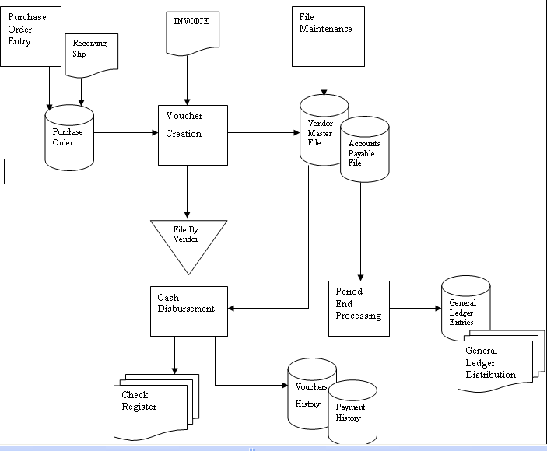

System Objectives:
It is designed to improve the process of recording on the Accounting Books of the hospital by automating faster and more accurate computations. Likewise, this will lessen the clerical work of the Accounting Department.

Features:
- Fully customized and complete bookkeeping like A/P Book, Cash Disbursement Book, Cash Receipts Book, Accounts Receivable Book, Journal Ledger Book and General Ledger Book.
- Linked with other modules of Visual Medsys like Uploading of Cashiers Summary of Collections Report, Billing’s Departmental Income Report, Adjustments from Bank Reconciliation, etc.
- Batch Printing of Vouchers and Checks
- Can generate complete schedules and registers like A/P Schedule w/ Aging, APV Register, Check Register, Batch Register. Etc.
- Imbedded controls and warnings for unbalanced and incorrect entries
- Can generate reports of any previous periods
- Can generate departmental income reports
- Automated Year End Processing and closing of entries
- Password-protected - The use of password is necessary to restrict unauthorized access. Thus the program only accepts passwords which are registered into it. This feature ensures the confidentiality and integrity of data entered in the program.
- User-friendly - The program user is guided by instructions in doing the next step providing an easy-use to process transactions.
- Data retrieval - Backtracking of previous report can be generated on the system.

Getting Started

System Requirements
Workstation
PC-CPU PENTIUM (Clone or Branded)
At least 512 Random Access Memory
At least 10 GB Hard disk Capacity
Minimum of 500 MHz CPU speed
Server
PC-CPU PENTIUM
At least 1 Gig Random Access Memory
At least 10 GB Hard disk Capacity
Minimum of 500 MHz CPU Speed
Must have UPS
Software Requirements
Visual Medsys Accounting
SQL 2000, SQL 2003 or SQL 2005
XP

System Menu Operations
The Opening Screen serves as the passage way to the system. The name of the current user is shown on the lower left side of the window.

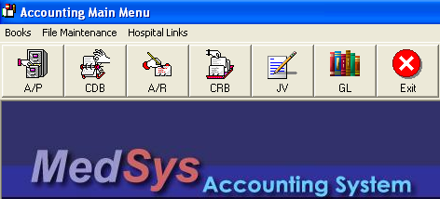
Accounting Main Menu Window

The Menu selections appear on the menu bar at the top of the screen same with a toolbar on the left side. Each of these menus contains a group of similar, commonly used options. Although each of thee options has an associated menu icons that performs the same functions, the Menu system provides a quick way for the user to learn how to use this system. To access the menu simply click on the desired menu on the menu bar or on the toolbar.

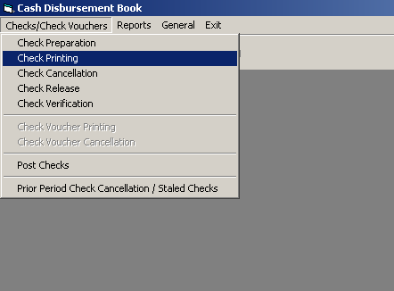
Once inside a menu, the up arrow and down arrow keys move the highlight bar up and down, the list option. To select an option, simply highlight the desired option and click it.

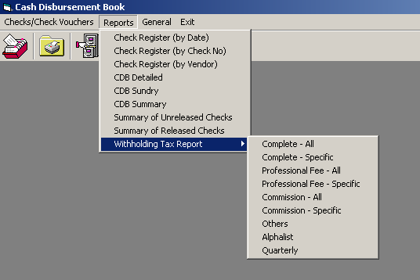

When selecting a menu option, pressing up arrow on the first option causes the highlight bar to wrap around to the last option. The reverse is true if you press down arrow on the last option.

How to start the Program
1 Click on  Visual Accounting program executable file icon located in your
Computer desktop.
- The Login window will display asking you to type in your employee number and password for security purposes.
The password gives you security for illegal access of the system



3 If the program has validated your employee number and password, you may now start a transaction. Otherwise, a message will display prompting “Unauthorized User”.

How to End the Program
It is recommended to close your program when you are done to end-up your session. Other users might use the open program using the same password.

There are three ways to close the program.
1 Click on  button located at the right corner of the toolbar (possible only if no
other window is open) or
2 Click Exit menu or
3 Press <Ctrl + X>

Backup and Restore Database Procedures

Backup Procedure
It is necessary to back up your hospital’s database file regularly. Back up is a process of saving an exact copy of your database files to a storage medium like CD, tape or separate hard disk.
Backup copies will serve as your last resort in case your working data at your server are damaged or corrupted due to machine malfunctioning, power fluctuation, computer shutdown while the system is still active, virus infection, etc.
An online transaction processing (OLTP) system captures incoming data and updates a database. To ensure against loss of data, the system logs transactions as they are performed, and administrators develop backup strategies that include periodic full and incremental backups of database. These strategies are designed to prevent loss of data, to minimize interference with operational transaction processing, and to provide for rapid recovery from system malfunctions.
A back up rotation plan will provide assurance against losing data if the back up copy is destroyed. Increasing the number of sets in the rotation plan is better for precautionary measure

BACK UP ROTATION PLAN
It is necessary to ROTATE at least three daily and three period-end of back up set. Your period-end back up sets should be kept off the premises (off site back up). A set may require 1 or more tapes/CDs/hard disks to back up a copy of your data.
A log sheet shall be maintained with complete status like a date of back up, restore, actions taken, etc.

How to create a logical disk backup device (Enterprise Manager)
To create a logical disk backup device
- Expand a server group, and then expand a server.
- Expand Management, right-click Backup, and then click New Backup Device.
- In the Name box, type a name for the named backup device.
- Click File name, and then do one of the following:
  - Type the name of the file used by the disk backup device.
  - Click the browse (...) button to display the Backup Device Location dialog box, and then select the file on the local computer used by the disk backup device.

To Backup
- Select the database you want to backup, for example accounting. Right click accounting database and select ALL TASK, BACKUP DATABASE. See sample below:

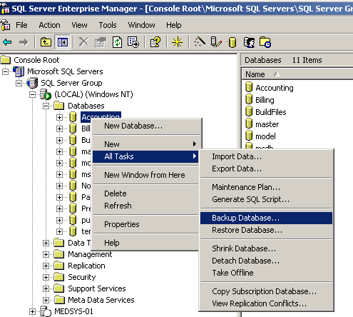
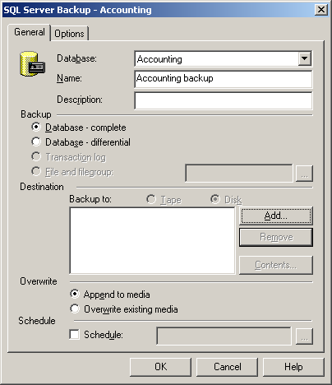
- Click on add button. The window below will appear:
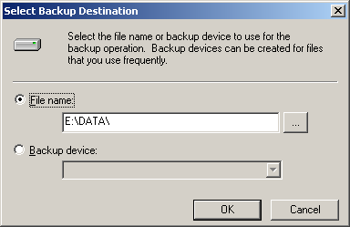
- Click on (…) button to select the filename where you want to backup the database.
- Click on OK button. This will display the selected file.
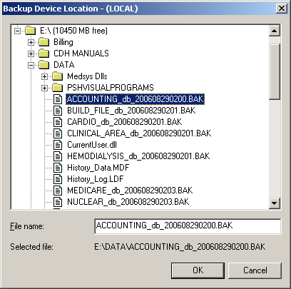
- Just click on OK button.
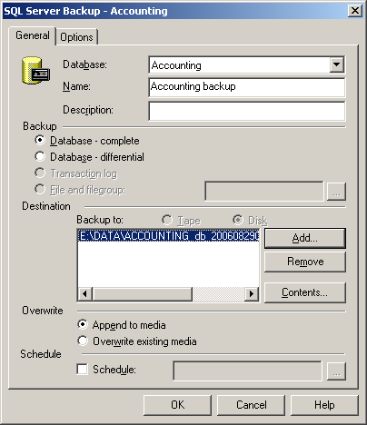
6. After checking the location where to save, click on OK button.

Restore Procedure
In case of corrupted data, you need to restore your latest back up copy.
Restore is a process of retrieving from the files from the backup CD, tape or hard disk.

How to restore a backup from a backup device (Enterprise Manager)
To restore a backup from a backup device
- Expand a server group, and then expand a server.
  - Open SQL Enterprise Manager and choose for the SQL SERVER NAME you have created. After that click the Database option under the
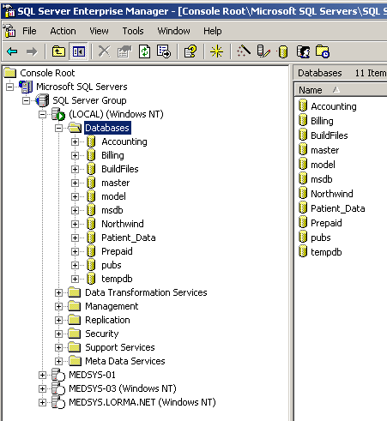
- Expand Databases, right-click the database, point to All Tasks, and then click Restore Database.
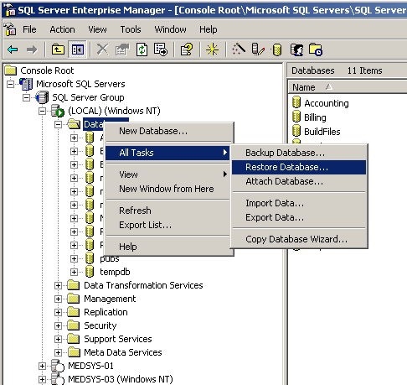
Right Click the DATABASE option under the database name you have created. Select All Task -> Click Restore Database
- In the Restore as database box, type or select the name of the database to restore if different from the default. To restore the database with a new name, type the new name of the database.
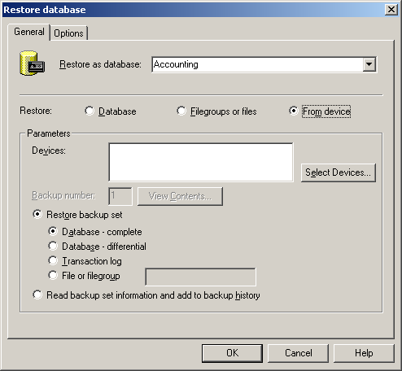
  - Choose what database you want to restore
Note Specifying a new name for the database determines automatically the new names for the database files restored from the database backup.
- Click From device, and then click Select devices.
If no devices appear, click Add to add an existing backup device or to create a new one. In the Restore Database dialog box, click View Contents and select the backup set to restore.
Note This option scans the backup set for the backup content information and can be time consuming, especially when using tape devices. If you already know the backup set to restore, type the backup set number in Backup number instead.

- Under Restore from, click Tape or Disk, click Add button and then select a device from which to restore.
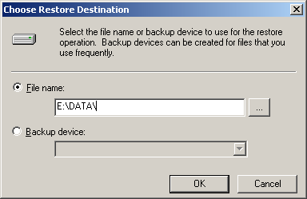
Click on to search for the backup file where you save it.
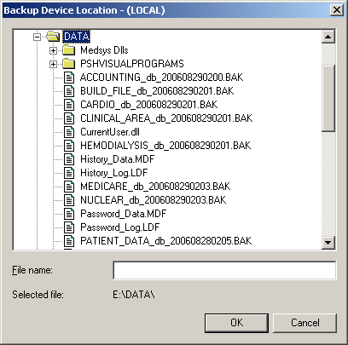

  - Select the database to restore. For example the ACCOUNTING Database, select accounting.bak then select OK button.

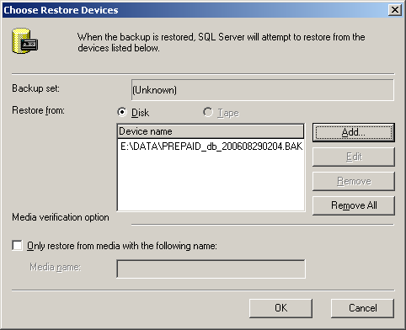
  - Click on OK button

- Under Restore backup set, do one of the following:
  - Click Database - complete to restore a database backup.
  - Click Database - differential to restore a differential database backup.
  - Click Transaction log to apply a transaction log backup.
  - Click File or file group to restore a file or file group backup. Specify the name of the file or file group.
- Optionally, click the Options tab, and then do one of the following:
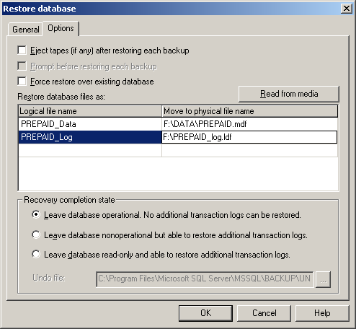
  - Click Leave database operational. No additional transaction logs can be restored if no further transaction log backups are to be applied.
  - Click Leave database non-operational, but able to restore additional transaction logs if another transaction log backup is to be applied.
  - Click the checkbox option for Force Restore over existing database. Be sure that the path on the MOVE TO PHYSICAL FILE NAME is correct before clicking OK button.
Program Settings Maintenance
This option allows authorized users to Add / Update or edit the accounting set-up.
To do this, click on Set-up on the main menu, from the pull-down menu click on Accounting Set-up.
A password window will appear. This is to restrict unauthorized person to Update or edit the Set-up. Enter the correct password for this set-up and this will display the window below.
Hospital Information Window
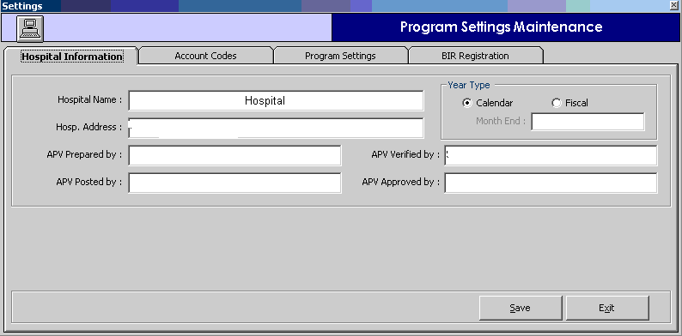
Hospital Information Tab
- Hospital Name : Name of the Hospital
- Hosp. Address : Address of the Hospital
- APV Prepared by : Default name of signatory in the report who prepared the Account Payable
Voucher
- APV Posted by : Default name of signatory in the report who posted the Accounts Payable
Voucher
- APV Verified by : Default name of signatory in the report who verified the Accounts Payable
Voucher
- APV Approved by: Default name of signatory in the report who approved the Accounts Payable
Voucher
- Year Type
      - Fiscal year – (Financial year or Accounting reference date)
It is a12-month period used for calculating annual (“yearly”) financial reports in the hospital. Regulatory laws regarding accounting require such reports once per twelve months, but do not require that the twelve months constitute a calendar year.
      - Calendar Year – begins on January 1 and ends on December 31.
- Click the SAVE button to save the data entered
- Click the CANCEL button to disregard the data entered
Account Codes Window
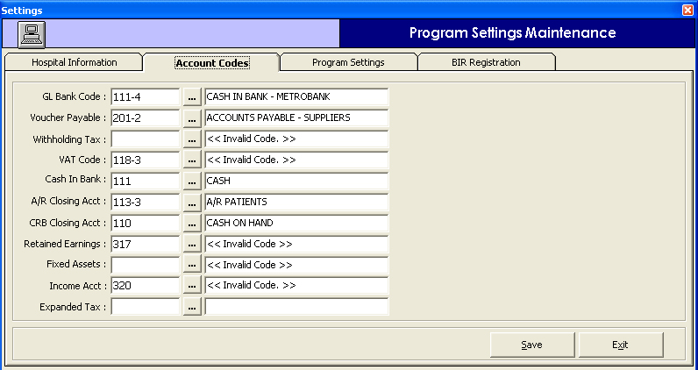
The chart of accounts coding structure used in this system identifies the financial activity concerning Hospital assets, liability and fund balances. This activity includes cash, receivables, payables, expenses and cash receipts.
Example: 000-106-4-05

Group Code | Account Type | Sub-Category | Company Code
XXX | XXX | X | XX
000 | 106 | 4 | 05

- The first digit (000 indicates the account is for balance sheet) of the 3-digit account number identifies the accounts as a General Ledger Account
- The second through 3 digits (106 refers to Accounts Receivable) serve as an account identifier (Asset, Liability or capital/fund)
- The third through 1 digit (4 refers to Account Receivable Company) identify the category which represents the specific asset, liabilities, or capital balance activity recorded with the fund.
- The fourth through 2 digits (05 refers to specific company code like Ayala Life) refers to company / account code.
- Click the SAVE button to save the data entered
- Click the EXIT button to disregard the data entered
Program Setting Window
This option allows the user to choose the format or numbering system to adopt in the operation of Visual Accounting system.
- Check Numbering: It refers to the series of number to use by the computer in the check preparation.
  - CVNo=check no : It means, the check number to use is the computer generated check voucher number.
  - Sys.CheckNo+1 : It refers to a unique series of number solely for check number.
- Check Printing: It refers to the type and size of paper to use in printing the check.
- Formatted CV+Check : It refers to a whole page paper with check voucher printed on top and the other half is for the check
- Blank ½ Paper : Use of ½ blank papers which will only serve as duplicate copy for the manual preprinted check.
  - AP Voucher Printing: It refers to the size of paper to use in printing the Accounts Payable Voucher.
- 1 Whole Page
- ½ Page
  - AP Voucher Numbering: It refers to the format of computer generated series of number to use for Accounts Payable Voucher number.
- Yyyymmxxxx+1: The number will start with the 4 digits year (2006), followed by 2 digits month (10 for October) and the incremental digits. The last 4 digits number will start to zero every start of the New Year.
- Sys.Voucher+1 : The number is a continues series of computer generated voucher number
  - Comparative Reporting: A default option for a report to be compared last month of the same year or comparing the month to the same month of last year.
  - Direct Disbursement – An option for the user to tag if they will use direct disbursement or none at all.

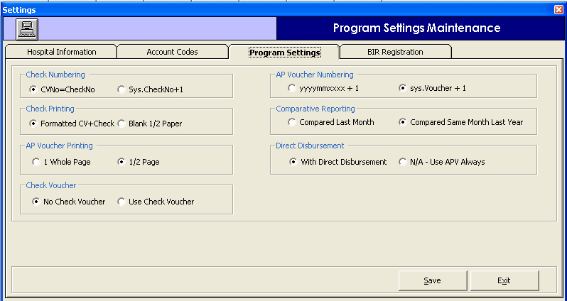

BIR Registration Window
This option is the build file for Bureau of Internal Revenue Registration information.

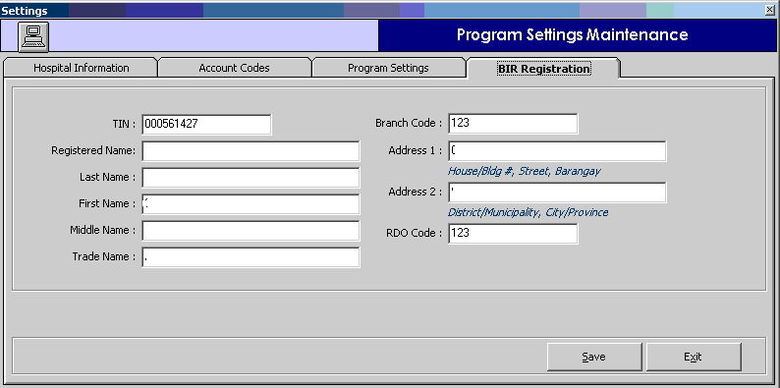

Accounting Books

Accounts Payable Book

This book is known as the current liability in the Balance Sheet. These are the debts resulting from purchasing assets or receiving services on credit or on an open account. This deals with money owed by the organization to vendors. It summarizes the amount owed, handles partial payments and vendor credits and also manages vendor terms and sales taxes payable.
To load the AP window, click on 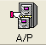 button in the main menu to display the window below.

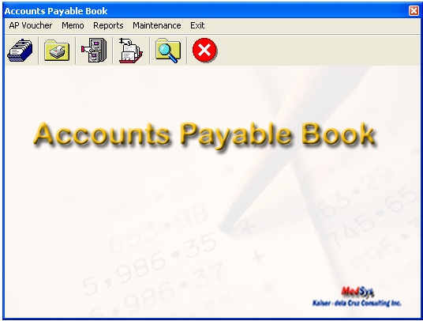

AP VOUCHER
A ] Entry / Editing of AP Voucher
This option allows you to enter the AP vouchers. To do this click on AP Voucher in the AP Main Menu then Enter / Edit AP Voucher Option or click on button.

Enter the following data.
- Period
- Voucher No.
- Date – This refers to the data of the vendors invoice. it should be within the Period date
- Vendor Id – click on ( ) to display list of Vendors/payees. Double click on the item
- Payable Type – click on ( ) to display list of item. Double click on the item.
- Terms – This refers to the vendor’s payment terms.
- Particulars – This refers to the expenditure being requested such as the item(s) purchased, services rendered and reimbursement
- Payee – This refer to the Vendor/payee.
* Below is the ENTRY AP VOUCHER WINDOW
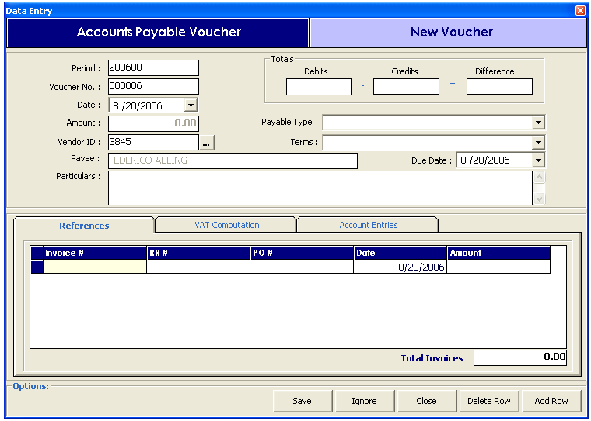
In the References tab enter the following data
- Invoice Number
- Receiving Report Number ( RR # )
- Purchase Order Number ( PO # )
- Date – Invoice Date
- Amount of Invoice

In the Vat Computation tab enter the following data
- Payee Name
- Gross Amount
- Vat Percentage in the % column
- Vat Amount

In the Account Entries tab enter the following data
- Account Code
- Description
- Debit and Credit

Click the Save button to save the data entered.
Click the Ignore button to disregard the data entered.
Click the Delete button to remove an item entered. Highlight the specific item
Click the Add button to add another item

B ] Printing of AP Vouchers
This option allows you to print AP Vouchers entered within a period.
To do this click on AP Voucher in the AP Main Menu then Print AP Voucher Option or click on button to display the window below.
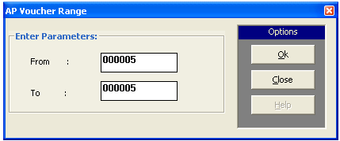
To Print
- Enter the AP Voucher Range
Click the OK button to generate the report
Click the Close button to go out from this option

C } Cancel AP Voucher
This option allows you to cancel a specific AP Voucher. To do this, click on Cancel AP Voucher option in the Accounts Payable Main Menu or click on  button. This will display the window below
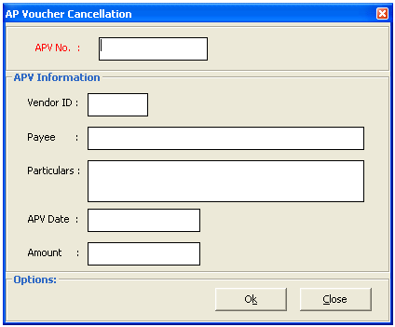
Enter the APV No. you want to cancel. If found, it will display the APV Information such as the Vendor Id, Payee, Particulars, APV Date and Amount.
Click OK button to cancel the APV.
Click Close button to go out from this option.

D ] AP Voucher Verification

This option allows you to verify or recheck the information in a specific AP Voucher. To do this, click on Verify AP Voucher option in the AP Main Menu. This will display the window below

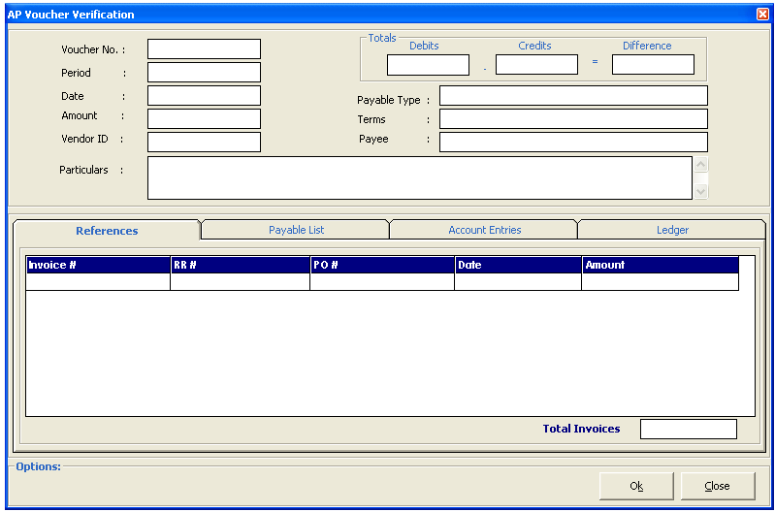
This option allows you to verify or recheck the data entered in a specific AP Voucher. If the entered Voucher No. is found, it will display the details of that specific voucher else it will prompt a message that the entered voucher number is not found on the file.

Click the OK button if the data are correct or the Close button to go out from this window.

E ] Verify Invoice
This option allows you to verify the information of a specific invoice. To do this, click on Verify option button in the AP Main Menu to display the window below.

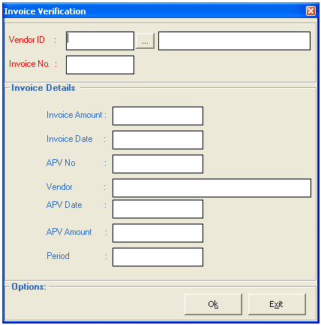
Enter the vendor then the specific invoice #. If the entered invoice number is found, it will display the details on the screen else it will prompt a message that the invoice number doesn’t exist.

If the data are correct, click OK button or click the Exit window to go out from this option

F] Post AP Vouchers
This option allows you to post a specific voucher. If the voucher is already posted, you are not allowed to edit or cancel that specific voucher. To do this, click on Post AP Vouchers in the AP Main Menu or click on  button to display the window below.

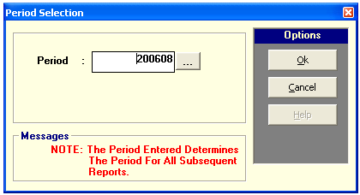

Enter the Period Date. The default format is (year-month) for example the date you wanted to determine is September 2006 the period would be 200609.
Click the OK button to Post otherwise click on Cancel button close this option.

G] Prior Period Adjustment
This option allows the user to cancel a voucher made under a report period that was already posted to General Ledger. This will mark the voucher as “Cancelled” and the reversing account entries will be recorded under the Journal Voucher Book. To do this, click on Prior Period Adjustment in the AP Main Menu.

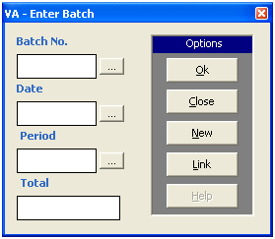
CREDIT MEMO
Credit Memo is used to apply credit to your accounts for goods returned or overpayments.

A] Enter or Edit Credit Memo
This option allows you to enter or edit credit memo. To do this, click on Enter / Edit Credit Memo in the AP Book Main menu. This will display the window below

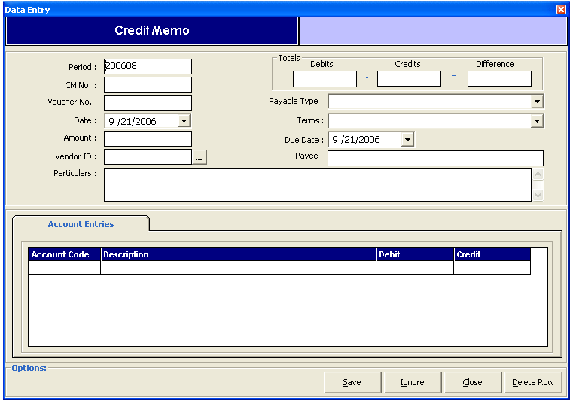
Enter the following data
- Period – this defaults to the current posting period based on the posting date
- CM No. ( Credit Memo No )
- Voucher No.
- Date - Date of the Credit Memo
- Amount – Enter the total amount to be paid by the vendor as indicated on the credit memo
- Vendor Id – This refers to the vendor account number
- Particulars – Item Description
- Payable Type - click on ( ) button to display list of choices
- Particulars – Item description

Account Entries Tab
Enter the following data
- Account Code – type the first few letter(s) of the Account description to display list of items that corresponds to the entered items or key in the account code then press Enter key
- Enter the amount in the Debit / Credit column

Click on save button to save or update the entered credit memo
Click on Ignore button to disregard the entered data
Click on Delete Row button to remove an entered data.
Click on Close button to go out from this option

B ] Print Credit Memo
This option allows you to print credit memos. To do this, click on Print Credit Memo option in the Accounts Payable Main menu and this will display the window below

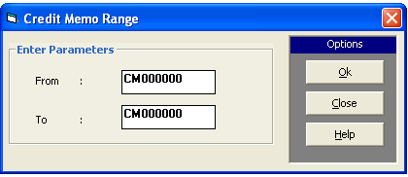

Enter Credit Memo Range, see sample in the loaded window then click OK button to display the data
Or Close button to go out from this option

C] Cancel Credit Memo
This option allows you to cancel a specific credit memo. To do this, click on Cancel Credit Memo option in the Accounts Payable Main Menu and this will display the window below

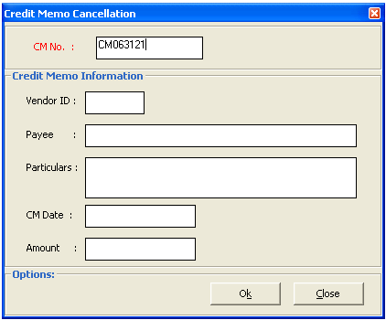

Enter Credit Memo No. If the entered CM # is found in the database, it will display the information else it will prompt a message that it is already posted or doesn’t exist. Click on OK button to cancel the item or CLOSE button to go out from this option.

REPORTS

The following report can be generated in this book

- APV per Vendor – This generate a report on the accounts payable grouped by vendor. The following data can be viewed such as the AP Voucher #, AVP Date, Name/Particulars, APV Amount, Check/Credit Memo #, Check Amount, Released Date, Received by, Grand Total, Invoice Report per Vendor, APV Amount and Balance.

Sample Report:
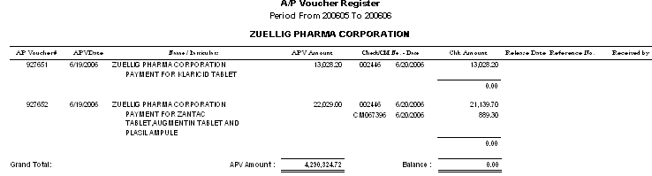

- Invoice Report per Vendor – This generate a report of invoices per vendor on a specific vendor. The following data can be viewed such as the AP Voucher, AP Date, AP Amount, AP Invoice, Invoice Number, Invoice Date and Invoice Amount.

Sample Report:

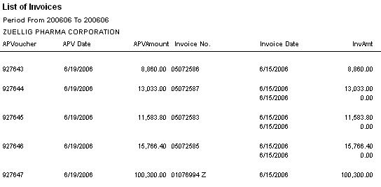

- AP Schedule – This generate a report on the schedule of payable for a specific period. The following data can be viewed such as the vendor id, company name and the amount to be paid.

Sample Report

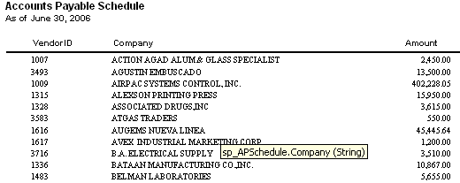

- AP Schedule with Aging – This generate a report on the schedule of payable with aging (30 days, 60 days, 90 days and over 90 days) for a specific period. The following data can be viewed such as the payable type (e.g. medicines, laboratory supplies, csr supplies), current payable amount, terms of payment and the total amount.

Sample Report

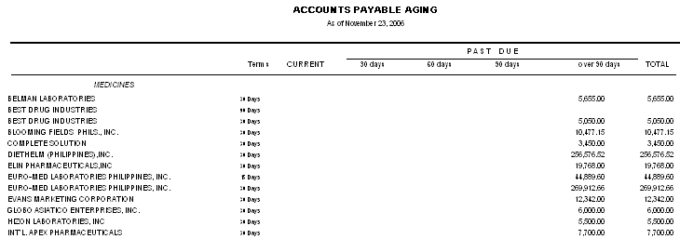

- AP Schedule (Detailed) – This generate a report on the detailed schedule of payable for a specific period. The following data can be viewed such as the AP Voucher#, APV Date, Name, APV Amount, Check/CM No., Check/CM Date, Check Amount and APV Amount.

Sample Report
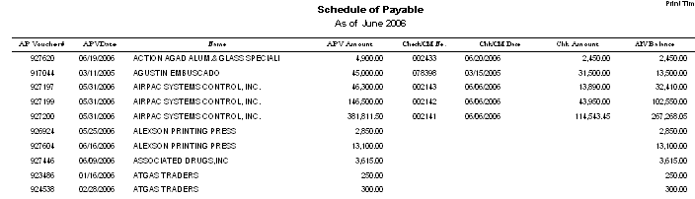

- AP Schedule Subsidiary Ledger – This generate an individual vendors account in a subsidiary ledger. The following data can be viewed such as the voucher number, apv date, apv amount, invoice no, purchase order no., receiving report no and payments.

Sample Report
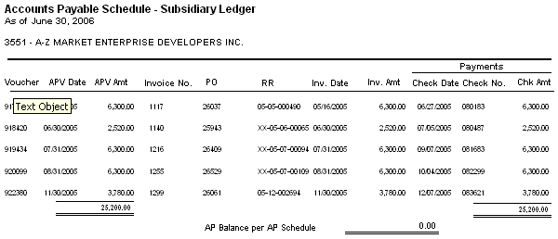
- Vat Reports (Summary, Monthly, Quarter) – This generate a report on value added tax per suppliers / vendor. The following data can be viewed such as the supplier name, TIN, Vat Amount and the Total Vat computed per vendor.

Sample Report
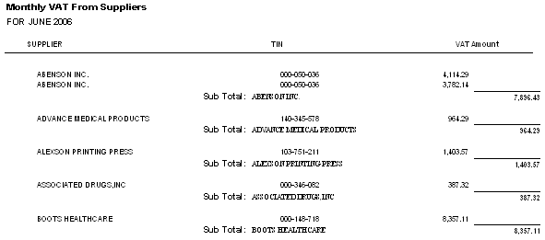

- AP – Detailed – This generates a detailed accounts payable of a specific period. It is grouped by date and sorted by accounts payable voucher number.
- AP – Summary – This generates a summarized accounts payable grouped by account number. The following data can be viewed such as the account code, account description, debit and credit.
- AP – Sundry – This generates a summary of sundry accounts.

Sample Report
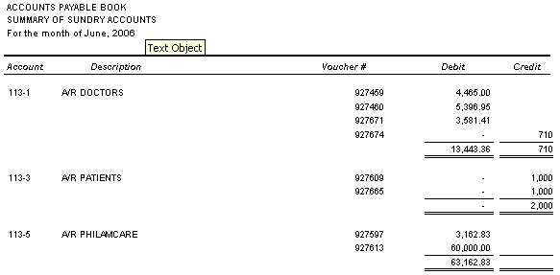

- AP Vouchers Summary – This generate a report on vouchers entered for specific vendor / payee and it is grouped by ap voucher # by payee.

Sample Report
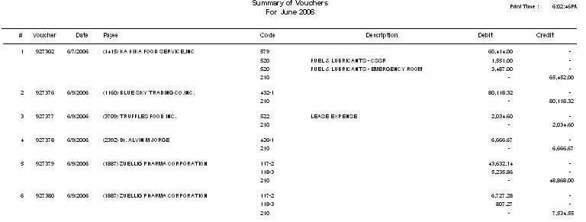

- AP Vouchers Per Day – This generate a report on vouchers entered for a specific vendor / payee sorted by date.

Sample Report
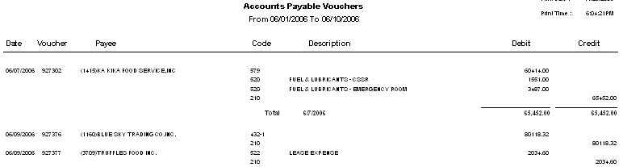

- Fixed Asset Schedule (Summary) – This generate a report on schedule of fixed assets acquisitions on a specific period.
- Credit Memo Summary – This generate a report on credit memo’s entered on a specific vendor / payee on a specific period.
Maintenance
A] Update Current AP Period

This option allows the user to change the default Period appears in the entry of new vouchers and
reports under the Accounts Payable Book.
To do this, click General on the menu bar and select on Update Current AP Period to display the window below.
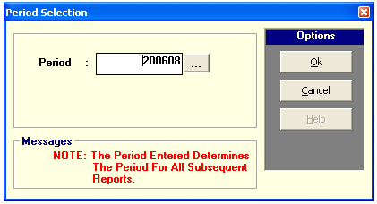

Enter the New Period Date then click OK button to update it or the Cancel button to go out from this option.

B] Edit / Print Payee Info
This option allows you to edit the information(s) of the payee or vendor. To do this, choose Edit / Print Payee Info option in the Maintenance Menu of the Accounts Payable Main Menu. This will display the window below
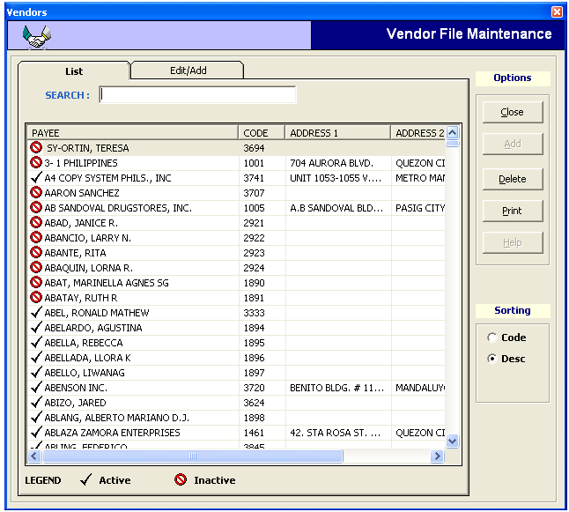

Choose or double click on the Vendor’s name then click on Edit/Add tab to display the information(s) of the payee. See the window displayed below
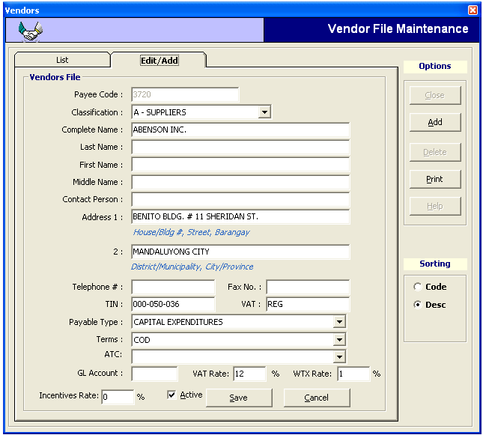

Edit / update the payee information then Click on Save button to save the data entered or Cancel button to disregard the data entered.

In here, you can also update the status of a payee if he is still an Active or Inactive payee of the hospital, Check or uncheck ( )

To add a new payee, click on Add button.
To print information of payee, click on Print button.

Cash Disbursement Book
Cash Disbursement is a record that shows how much money is paid out for the purchased items,
or services rendered to the hospital.

This book is used to record all payments made in cash such as for accounts payable, merchandise purchases, and operating expenses.

To load the Cash Disbursement Book window, click on 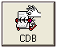 button in the main menu.

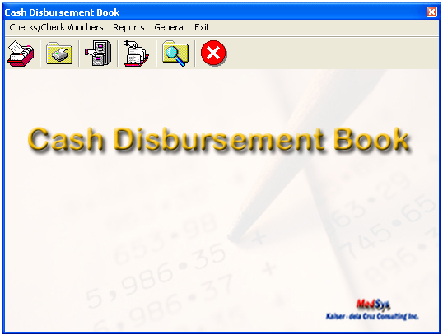

CHECK VOUCHERS
A ] Check Voucher Preparation
This option allows the user to prepare a check for a specific vendor. To do this, click on Check Preparation option on the Check/Checks Vouchers menu of the CDB Main Menu or click  button in the CDB window. This will load the window below

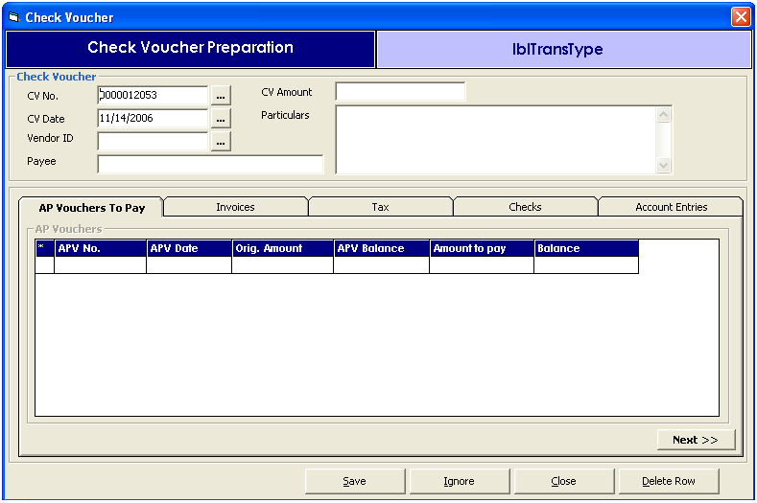

In this option, enter the check details to be prepared :
- CV No. – Check Voucher Number
- CV Date – Check Voucher Date
- Vendor Id – code of the vendor / payee
- Payee – name of the vendor / check’s recipient
- CV Amount – Check Voucher Amount
- Particulars – description of the voucher

AP Vouchers to Pay Tab
This option allows you to enter the specific APV to be included on the check being prepared or automatically gets the ap vouchers entered in the Accounts Payable book.
Click on the APV to pay tab
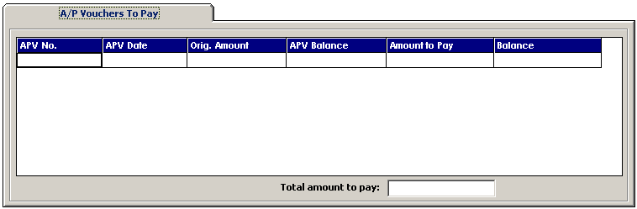
Enter the following data.
- APV No.
- APV Date
- Orig. Amount
- APV Balance
- Amount to Pay
- Balance
The total amount to be paid is automatically added and displayed in the Total Amount to Pay box

Click on Save button to save the data entered.
Click on Ignore button to disregard the data entered.
Click on Delete Row button to remove a specific data or entry.
Click on Add Row button to add new entry.
Click on Close button to go out from this window.

Invoices
This option allows the user to enter the invoice(s) included in the voucher. To go on this option, click Invoices tab in the Check Voucher Preparation menu. This will display the window below.

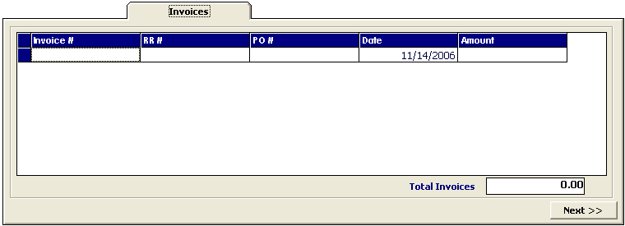
The user can enter the following data:
    - Invoice #
    - RR # - Receiving Report Number
    - PO # - Purchase Order Number
    - Date – Invoice Date
    - Amount

Click on Save button to save the data entered.
Click on Ignore button to disregard the data entered.
Click on Delete Row button to remove a specific data or entry.
Click on Add Row button to add new entry.
Click on Close button to go out from this window.

Tax
This option allows the user to enter the computed withholding tax. To go on this option, click the Withholding Tax Computation tab in the Check Voucher Preparation menu. This will display the window below

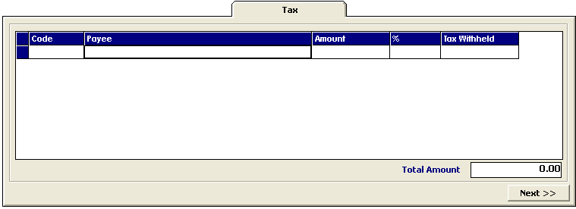
Enter the following data
- Code – this refers to the Vendor ID. Click on( ) button to display lists of vendors
- Payee
- Amount
- % - tax percentage
- Tax withheld – computed withholding tax
The total withholding tax will be displayed on the Total Amount box.

Click on Save button to save the data entered.
Click on Ignore button to disregard the data entered.
Click on Delete Row button to remove a specific data or entry.
Click on Add Row button to add new entry.
Click on Close button to go out from this window.

Checks
This option allows the user to enter the data for check printing. To go on this option, click on Checks tab in the Check Voucher Preparation menu to display the window below.
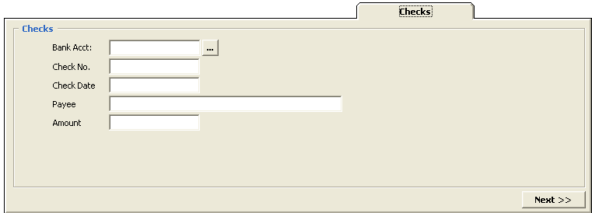
The following data should be entered:
- Bank Account – click on ( ) to display list of banks
- Check No. – Enter the check number
- Check Date
- Payee – automatically gets the name of the vendor entered in the check voucher
- Amount

Click on Save button to save the data entered.
Click on Ignore button to disregard the data entered.
Click on Delete Row button to remove a specific data or entry.
Click on Add Row button to add new entry.
Click on Close button to go out from this window.

Account Entries
Click the Account Entries tab in the Check Preparation menu of the CDB book. This will display the window below

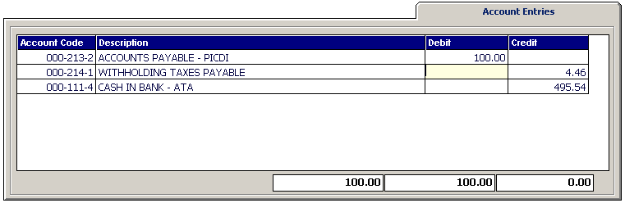
The following data should be entered:
- Account Code – based on the Chart of Accounts
- Description – Account Code description
- Debit and Credit Amount

Click on Save button to save the data entered.
Click on Ignore button to disregard the data entered.
Click on Delete Row button to remove a specific data or entry.
Click on Add Row button to add new entry.
Click on Close button to go out from this window.

B] Check Voucher Printing
This option allows the user to print the voucher prepared. To do this, click on Check Voucher Printing in the Check/Checks Voucher menu of the CDB . This will display the window below.

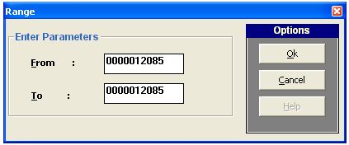

Enter the range of Check Voucher Number you want to print then click OK button to print or Cancel to go out from this window.

C] Check Voucher Cancellation
This option allows the user to cancel a specific check voucher. To do this, click on Check Voucher Cancellation in the Check/Checks menu of the CDB. This will display the window below.
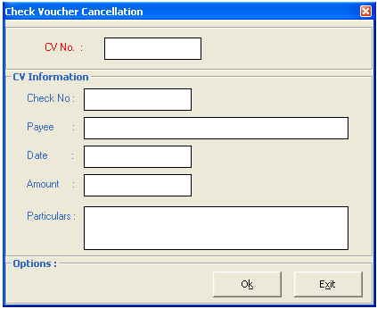
Enter the Check Voucher Number you want to cancel in the CV NO. textbox then press Enter Key. The details of the entered CV No will be displayed on the screen. To cancel it, click on OK button or Exit to go out from this window.

D] Check Printing
This option allows the user to print the checks as per check or per batch. To do this, click on the Check Printing option in the Checks Voucher menu of the CDB or click on  button. This will display the window below
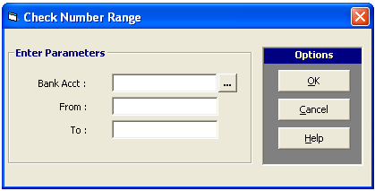
Enter Bank Account then Check Number Range of the checks you want to print. Click on OK button to print checks or CANCEL button to go out from this option.

E] Check Cancellation
This option allows the user to cancel a specific check. To do this, click on Check Cancellation option in the Check Voucher menu of CDB or click on  button. This will display the window below

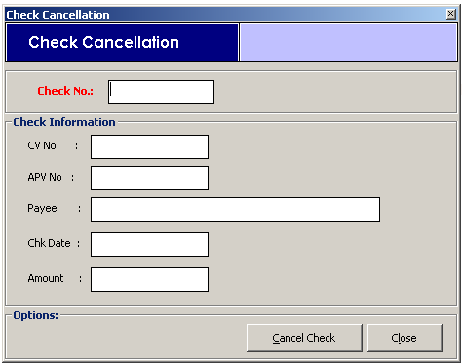

Enter the check no. you want to cancel. If not yet posted, it will display check details for verification. To cancel it, click Cancel Check button or Close button to go out from this option.

F] Check Release
This option allows the user to enter release information of checks released. Below is the check release window

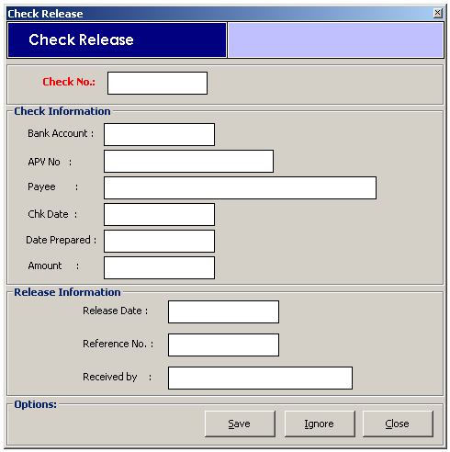

Enter the Check No. of the Check to be released. The checks information will be displayed on the screen. In the release information window, enter the following information
    - Release Date
    - Reference No.
    - Received by

Click the Save button to save the data entered.
Click the Ignore button to disregard the data entered
Click the Close button to go out from this option

G] Check Verification
This option allows the user to view the status of a specific check if it is cancelled, released and others. Below is the check verification window
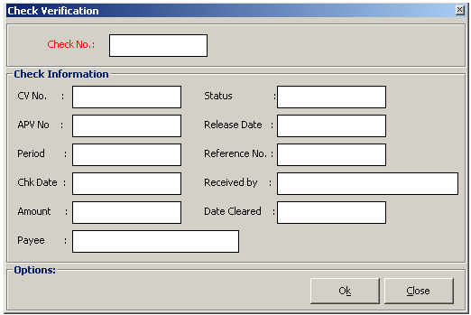
Enter the Check No. of the check you want to verify or see status.

H] Post Checks
This option allows you to post checks and once checks are posted, it can no longer be edited or cancelled. To do this, click on Post Checks option in the Check/Checks Vouchers menu of CDB or click on button to display the window below.

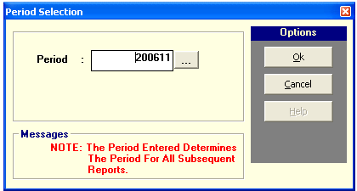

Enter the Period ( format year – month ) where you want to post checks then click OK to post or Cancel to go out from this option.

REPORTS
The following reports can be generated.
- Check Register (By Date) – This generates a report on checks payments on a selected date of time. The following data can be viewed such as the check date, payee, APV No. Check No, Check Amount and Due Date.
- Check Register (By Check No) – This generates a report on list of checks payments based on the entered range of check numbers. The following data can be viewed such as the Check No, Check Date, Payee, APV No and Check Amount.

Sample Report

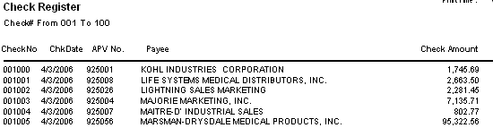

- Check Register (By Vendor) – This generates a report on list of checks payments for a specific vendor. The following data can be viewed such as the Check No, Check Date, Payee, APV No and Check Amount.

Sample Report

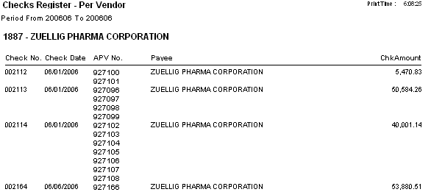

- CDB Detailed – This generates a detailed lists of Cash Disbursements sorted by date on a specific period.
- CDB Summary – This generates a summary of Cash Disbursement grouped by account number on a specific period. The following data can be viewed such as the Account No, Particulars and Debit & Credit.

Sample Report
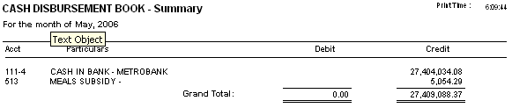

- CDB Sundry (Detailed) – This generates a detailed list of sundry accounts of a specific period. The following data can be viewed such as Account Code, Account Name, CV No and Debit & Credit.
- CDB Sundry (Summary) – This generates a summary of sundry accounts of a specific period. The following data can be viewed such as Account Code, Account Name and Debit & Credit.
- Check Vouchers Daily – This generates a list of check vouchers in a selected date of time. It is sorted by date and the following data can be viewed such as the CV No, Payee, Account Code, Account Description and Debit & Credit.
- Check Voucher Summary – This generates a summary of check vouchers of a specific period and sorted by CV No.

Sample Report
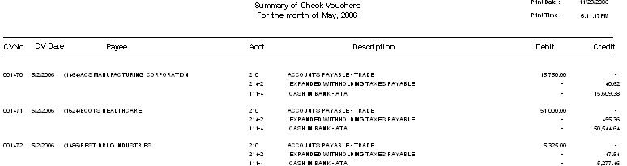

- Unreleased Checks – This generates a summary of unreleased checks by Bank Account of a specific period. The following data can be viewed such as the Check #, Check Date, Date Prepared, Payee and Amount.

Sample Report

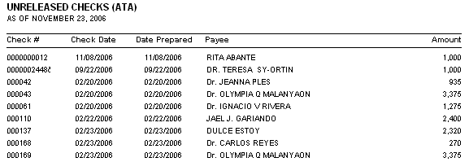

- Released Checks – This generates a summary of released checks by bank account of a specific period. The following data can be viewed such as the Check No, Check Date, Release Date, OR No, Payee, Received by and Amount.

Sample Report

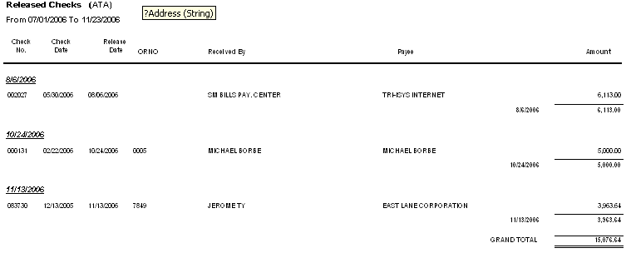

ACCOUNTS RECEIVABLE

Accounts receivable are amounts owed by customers for supplies purchased and services rendered.
To load the Accounts Receivable window, click on  button in the main menu to display the AR window.
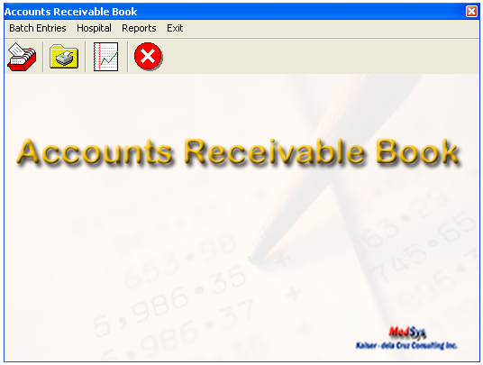

Batch Entries

A] Enter / Edit Batch

This option allows the user to enter new AR batch entries or allows you to edit an existing entry. To do this, go to Enter / Edit Batch in the Batch Entries menu of the AR book or click on button to display the window below.
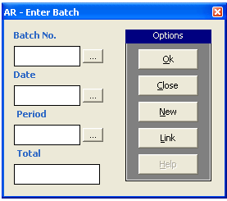

Click on NEW button for new AR batch number. It is a computer generated number.

If the entered batch number already exists, it will display the data automatically or if not, the following data should be entered
- date
- period - choose from the lists of period displayed
- total AR amount
After entering the data, click on OK button to load the AR batch entry window for the details
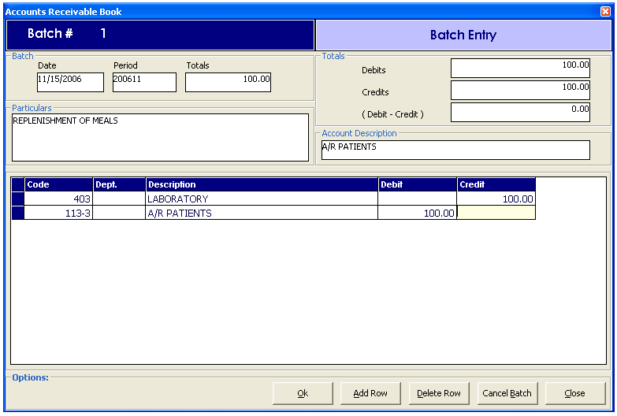

Enter the following data:
- Code - choose from the list of Chart of Account(s) the specific account description that will be included in the entry
- Dept – Department
- Description – Automatically gets the description of the Chart of Account
- Debit / Credit

Click the OK button to save the data entered
Click on Add Row button to add another code
Click on Delete Row button to remove a specific entry
Click on Cancel Batch button to cancel the batch entered
Click on Close button to go out from this window.

B] View / Print Batch

This option allows the user to print the AR entries. To do this, click on View/Print batch option of The Batch Entries menu in the AR Book or click on button to load the window below

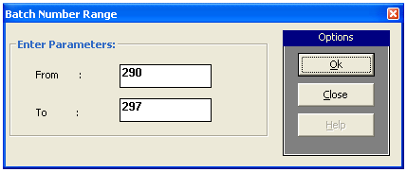

Enter the range of the batch number to be printed then click on OK button to generate the data or click on CLOSE button to go out from this window.

C] Cancel Batch

This option allows the user to cancel a specific AR batch number. To do this, click on Cancel Batch option of the Batch Entries menu in the AR Book to display the window below.

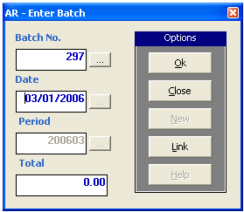
Enter the Batch Number to be cancelled. If the number entered exists, the date, period and total will be displayed. To cancel, click on OK button or CLOSE button to go out from this option.

D] Post Batches

This option allows the user to post AR entries. Once posted, it can no longer be edited. To do this, click on POST Batches of the Batch Entries menu in the AR book or click on  button to display the window below.
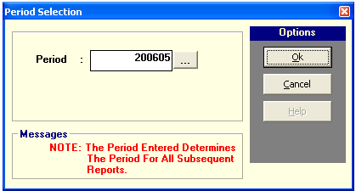

Enter the period where you want to post AR entries. Click on OK button to post it or Cancel button to go out from this option.
HOSPITAL
This option allows the user to generate Daily Transaction of Audit Trail and Summary of Daily Transaction of Audit Trail for Inpatient and Outpatient.
Sample Audit Report

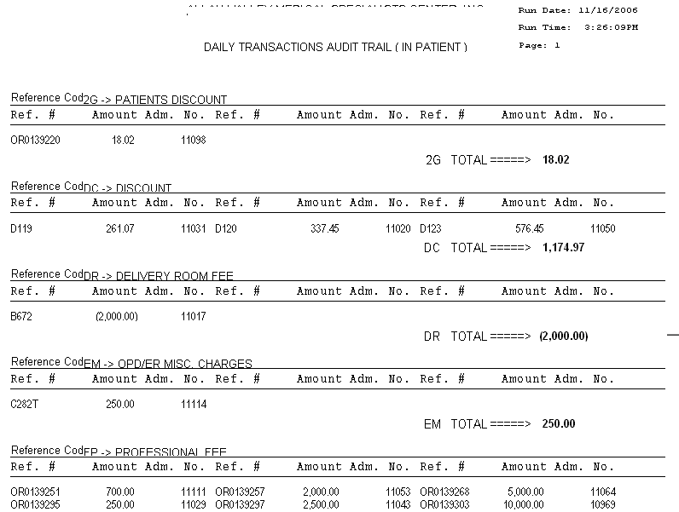

REPORTS

The following reports can be generated from AR Book

- Batch Register – This generate a report on AR entries based on the data uploaded from hospital transactions. The following data can be viewed such as the Account Code, Description and Debit & Credit Amount. Below is a sample report :
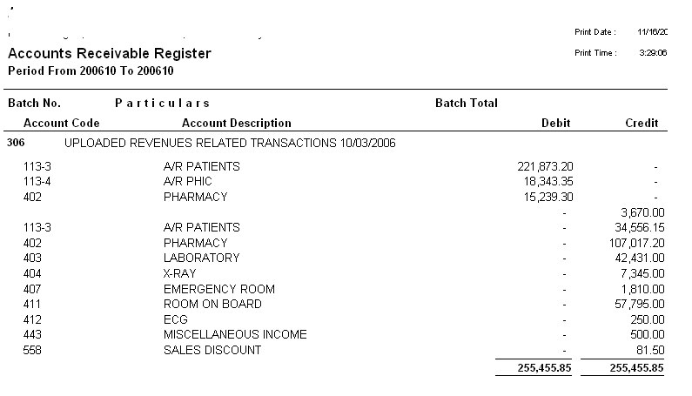

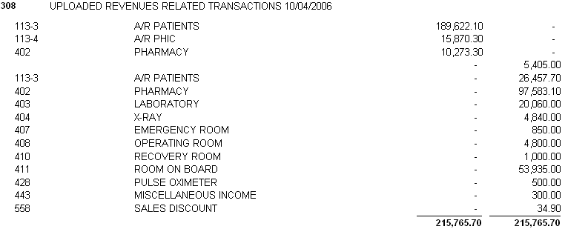

- Detailed Register – This generate a Detailed AR transactions based on data uploaded from hospital transactions.
- Summary – This generate a Summary of AR for a specific period. Below is a sample report.

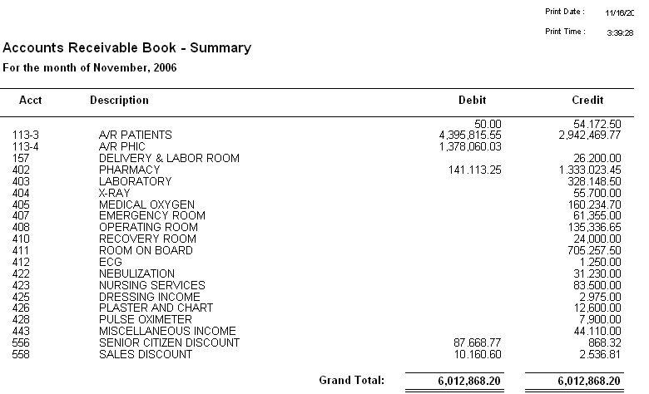

CASH RECEIPTS BOOK

Cash receipts are evidenced by source documents like pre-numbered official receipts (OR), cash register tapes (CRT) or cash slips, and bank credit memorandum.

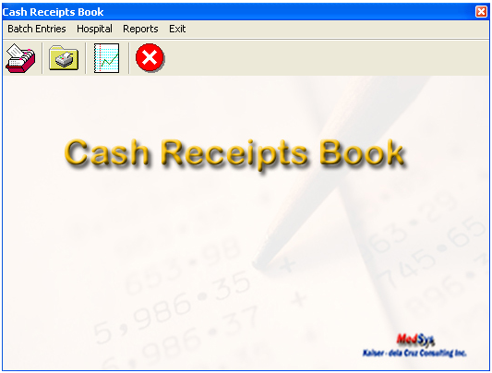

BATCH ENTRIES

A] Enter / Edit Batch

This option allows the user to enter new Cash Receipts on batch entries or allows you to edit an existing entry. To do this, go to Enter / Edit Batch in the Batch Entries menu of the Cash Receipt book or click on  button to display the window below.
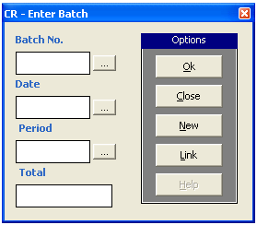

Click on NEW button for new CR batch number. It is a computer generated number.

If the entered batch number already exists, it will display the data automatically or if not, the following data should be entered
- date
- period - choose from the lists of period displayed
- total AR amount
After entering the data, click on OK button to load the AR batch entry window.

B] View / Print Batch

This option allows the user to print the CR entries. To do this, click on View/Print batch option of The Batch Entries menu in the CR Book or click on  button to load the window below

Enter the range of the batch number to be printed then click on OK button to generate the data or click on CLOSE button to go out from this window.
C] Cancel Batch

This option allows the user to cancel a specific CR batch number. To do this, click on Cancel Batch option of the Batch Entries menu in the CR Book to display the window below.
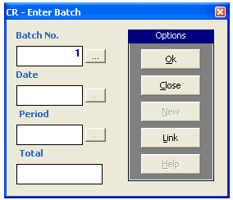
Enter the Batch Number to be cancelled. If the number entered exists, the date, period and total will be displayed. To cancel, click on OK button or CLOSE button to go out from this option.

D] Post Batches

This option allows the user to post CR entries. Once posted, it can no longer be edited. To do this, click on POST Batches of the Batch Entries menu in the CR book or click on  button to display the window below.

Enter the period where you want to post CR entries. Click on OK button to post it or Cancel button to go out from this option.

REPORTS

The following reports can be generated

- Batch Register – This generate a report on CR entries on a specific period. The following data can be viewed such as Account Code, Account Description and Debit & Credit and it is grouped by date of transaction.
Sample Report
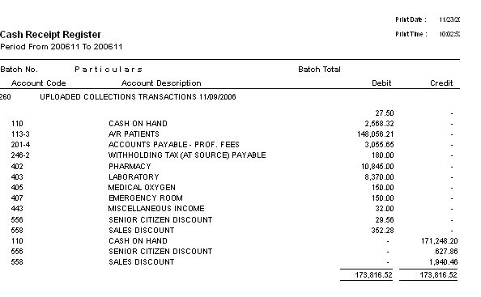
- Detailed Report - This generates detailed report on cash receipts of a specific period.
- Summary Report - This generate a summary on cash receipts of a specific period.
Sample Report:

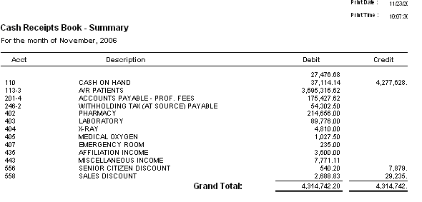

JOURNAL VOUCHERS BOOK

Journal Vouchers contains items which alter the General Ledger to correct errors, account for standard recurring items, and make tax adjustments.

  - Standard Entries
Items such as amortization and prepaid expenses, which are periodically being adjusted, are done through Journal voucher entries.

  - Errors
The correction of errors, which posted to the General Ledger, the Journals, or the subsidiary ledgers, is also done through the Journal Voucher.

  - 13th Month Entries
At the end of the taxable year, and prior to the preparation of the Trial Balance, several entries are made which constitute corrections to previously recorded errors and adjustments in yearend account balances for tax purposes. These 13th month entries generally address accruals; write downs to name a few.

To Load the Journal Vouchers Book, click on  button to display the window below.

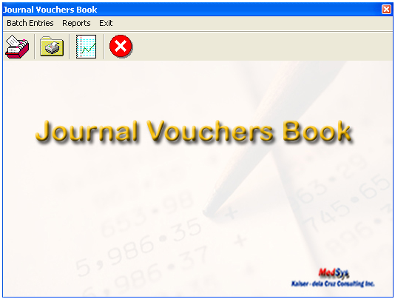

BATCH ENTRIES

A] Enter / Edit Batch

This option allows the user to enter new JV on batch entries or allows you to edit an existing entry. To do this, go to Enter / Edit Batch in the Batch Entries menu of the JV book or click on  button to display the window below.
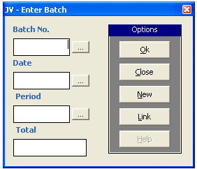

Click on NEW button for new JV batch number. It is a computer generated number.

If the entered batch number already exists, it will display the data automatically or if not, the following data should be entered
- date
- period - choose from the lists of period displayed
- total AR amount
After entering the data, click on OK button to load the AR batch entry window.

B] View / Print Batch

This option allows the user to print the JV entries. To do this, click on View/Print batch option of the Batch Entries menu in the JV Book or click on  button to load the window below

Enter the range of the batch number to be printed then click on OK button to generate the data or click on CLOSE button to go out from this window.

C] Cancel Batch

This option allows the user to cancel a specific JV batch number. To do this, click on Cancel Batch option of the Batch Entries menu in the JV Book to display the window below.

Enter the Batch Number to be cancelled. If the number entered exists, the date, period and total will be displayed. To cancel, click on OK button or CLOSE button to go out from this option.

D] Post Batches

This option allows the user to post JV entries. Once posted, it can no longer be edited. To do this, click on POST Batches of the Batch Entries menu in the JV book or click on  button to display the window below.

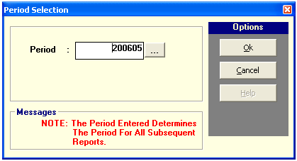

Enter the period where you want to post CR entries. Click on OK button to post it or Cancel button to go out from this option.
REPORTS
The following reports can be generated
- Batch Register - This generate a report on JV entries per batch number of a specific period. The following data can be viewed such as batch no, particulars and batch total.
Sample Report

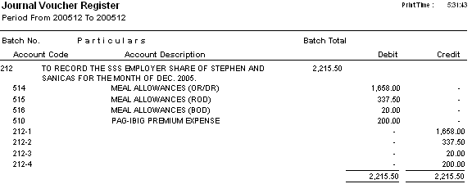
- Detailed Report - This generate a detailed JV entries of a specific period.

Sample Report
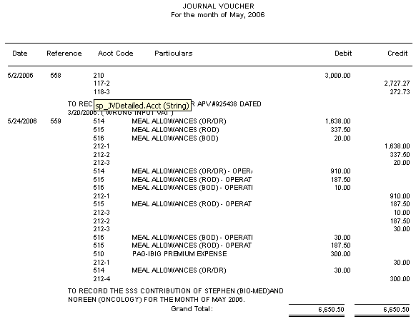
- Summary Report – This generate a summary report on JV entries of a specific period.
Sample Report
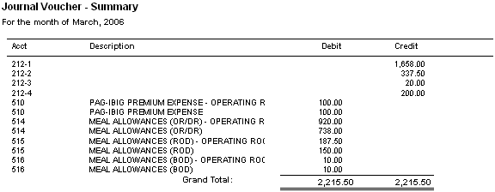

- Adjustment of Accounts Payable Summary – This generate a report on the Adjustment done on Accounts Payable of a specific period.
GENERAL LEDGER BOOK

General Ledger is prepared monthly and is cumulative, summarizing entries made to each account by the journals. Being computerized, source codes are used to post summaries of monthly journal entries to the general ledger accounts. This contains a summary or details of all transactions affecting the accounts of the hospital.

To load the General Ledger Book, click on  button to display the window below

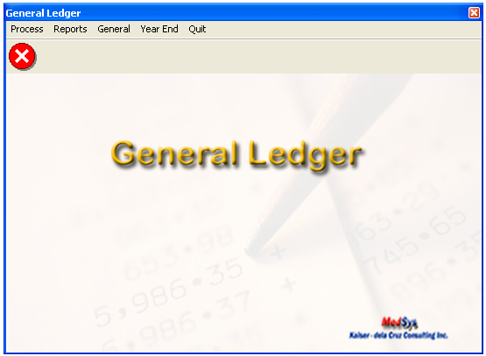

PROCESS

A] Financial Report Preparation
This option allows the user to prepare a financial statement of a specific period. The purpose of this is to provide information about the financial position, performance and cash flows of the hospital.

To do this, click on Financial Report Preparation of the Process menu in the GL book and this will load the window below.

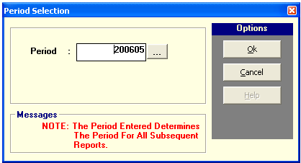

Enter the period for the financial statement ( format :yyyymm ) then click on OK button and to go out from this option, click on Cancel button.

B] Bank Reconciliation
Bank Reconciliation is use to reconcile the cash balance per books with the balance per bank statement to ensure that all cash transactions are accounted for and that both records are correct.

- Cleared Checks Data Entry
This option allows the user to tag cleared checks of a specific period. To do this, click on Process > Bank Reconciliation > Cleared Checks Data Entry option to load the window below
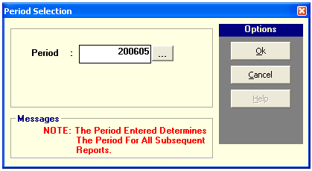
a) Enter the period date where you want to tag checks then click on OK button to load the sample window below.

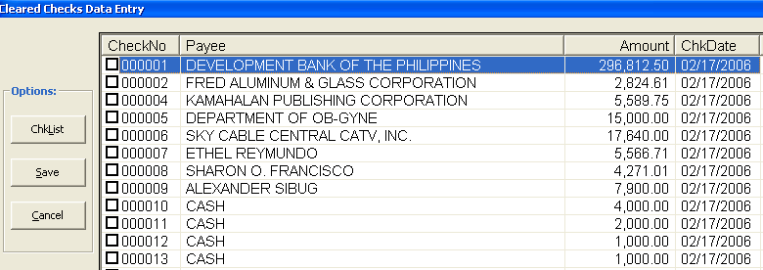

b) Check the box of the check number to be cleared then click on Save button. To print a print-out of the checks tagged, click on ChkList button to display a report.

Sample Report:
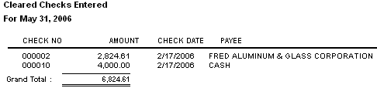

- Print Outstanding Checks
Outstanding Checks: These checks are already issued by the entity but not yet cleared or paid by the bank.
To do this, click on Process > Bank Reconciliation > Print Outstanding Checks option. Enter the period where to print outstanding checks (period format: yyyymm; Example: 200606 (June 2006)

Sample Report:
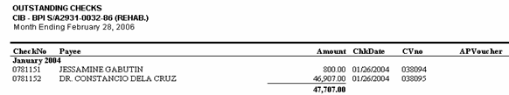

- Print Cleared Checks
Cleared Checks: These are the issued checks paid by the bank.
This option allows the user to generate lists of cleared checks of a specific period.
To do this, click on Process > Bank Reconciliation > Print Cleared Checks.
Enter the period where to print cleared checks (period format: yyyymm; Example: 200606 (June 2006)

- Print Staled Checks
Staled Checks: These are the cancelled Checks
This option allows the user to generate lists of cancelled checks of a specific period.
To do this, click on Process > Bank Reconciliation > Print Staled Checks.
Enter the period where to print cleared checks (period format: yyyymm; Example: 200606 (June 2006)

- Bank Reconciliation
This option allows the user to generate a Bank Reconciliation Report.
To do this, click on Process > Bank Reconciliation > Bank Reconciliation Report
Enter the period where to print cleared checks (period format: yyyymm; Example: 200606 (June dd2006)

Sample Report
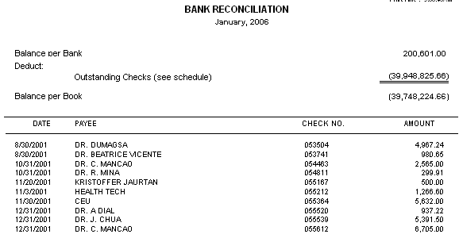

C ] Beginning Balances

- Enter Beginning Balance
This option allows the user to enter beginning balance of a specific account in a year.
To do this, click on Process > Beginning Balances > Enter Beg. Balance to load the window below
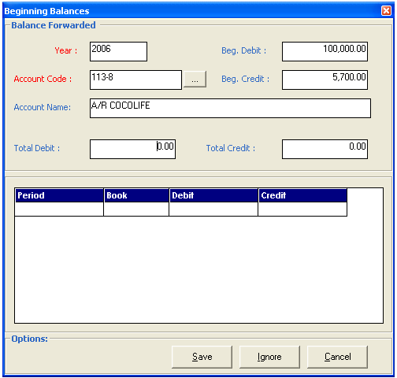
Enter the following data
  - Year
  - Account Code
  - Beginning Debit
  - Beginning Credit

Click on Save button to save the data entered
Click on Ignore button to disregard or cancel the data entered
Click on cancel button to go out from this option

- Print Beginning Balance
This option allows the user to generate report on beginning balances of a year.
To do this, click on Process > Beginning Balances > Print Beginning Balance to load the window below
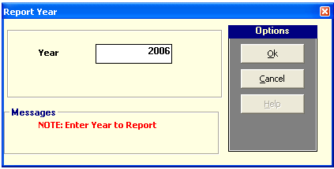
Enter the year where to generate the beginning balances entered then click on OK button.

- Post Forwarded Balance
This option allows the user to post the balances entered.
To do this, click on Process > Beginning Balances > Post Forwarded Balance
Enter the year where to post the forwarded balances then click on OK button to load a verification message
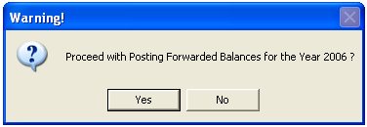
Click on YES button to continue posting the balances of the year entered or NO button to discontinue / cancel posting.

- Post Monthly Beginning Balance
This option allows the user to post beginning balances of a specific period. Once posted, transactions can no longer be edited.
To do this, click on Process > Beginning Balances > Post Monthly Beginning Balance
Enter the period (example: 200606 (For June 2006)) then click on OK button to load a verification message
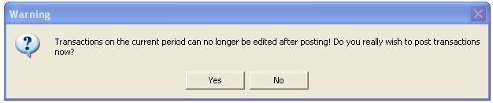
Click YES button to continue posting the transactions of the period entered or NO to discontinue posting.

- Outstanding Checks
This option allows the user to enter outstanding checks.
To do this, click on Process > Beginning Balances > Outstanding Checks to load the window below

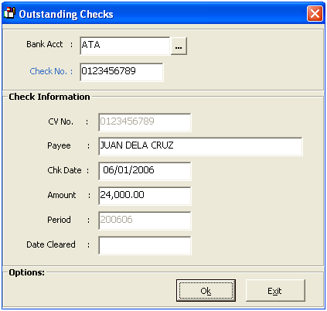
Enter the following data
- Bank Account – Refers to the name of the bank
- Check No – Refers to the check number issued but not paid
- Payee – Refers to the Name of the Payee
- Chk Date – Refers to the Check Date
- Amount – Refers to the check amount
Click on OK button to save data entered or click on EXIT button to disregard the data entered.

REPORTS

A ] General Ledger
This option allows the user to generate general ledger of a specific account or a summary of all accounts in a year.
To do this, click on Reports > General Ledger to load the window below

General Ledger of a Specific Account
Enter the year and the specific account. Click on OK button to generate the report or CANCEL to go out from this option.

Sample Report

General Ledger of All Accounts

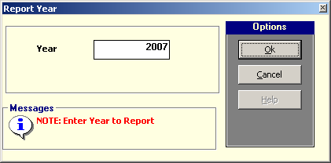
Enter the year for the generation of GL then click on OK button to generate report or Cancel button to go out from this option.
Sample Report

B ] Trial Balance
Trial Balance is a list of all accounts with their respective debit or credit balances. It is prepared to verify the equality of debits and credits in the ledger at the end of each accounting period or at any time the postings are updated.
To generate, click on Reports > Trial Balance to load the window below
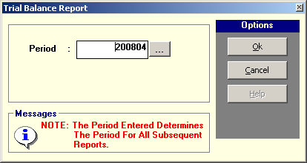
Enter the period where to generate trial balance (Ex. 200804 (For April 2008)) then click on OK button or Cancel button to go out from this option.
Sample Report

C] Income Statements
Income Statement is a report showing the performance of the hospital for a given period of time.
To generate it, click on Reports > Income Statements
- Statement of Income and Retained Earnings
Sample Report
- Schedule of Operational , General and Administrative Expenses

Sample Report

- Consolidated Income Statement

Sample Report

- Departmental Income Statement

Sample Report

D] Balance Sheet
Balance Sheet is a statement that shows the financial position or condition of an entity by listing the assets, liabilities and owner’s equity at a specific period of time
Sample Report:
E] Expenses by Department

Sample Report

GENERAL
This option allows the user to update the Current GL period, edit budget and un-post book.
A ] Current GL Period
This option allows you to change the current period of the GL book.
To do this, click on General > Update Current GL Period to load the window below
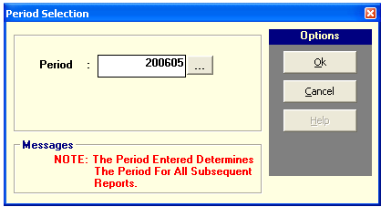
Enter the NEW GL Period ( Ex. 200606 (For June 2006)) then click on OK button or click on Cancel to go out from this option.
B] Edit Budget
This option allows the user to update the budget of a specific GL group.
To do this, click on General > Edit Budget to load the window below
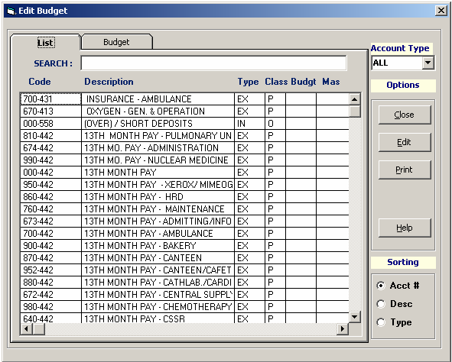
Click on the specific account where to edit and another window will be loaded for the entry

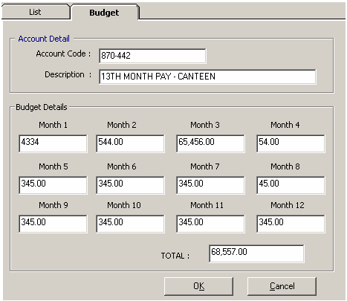

The monthly budget
detail of specific account is displayed on the screen.

YEAR END PROCESSING

This option is executed once a year at the end of the year before setting the period dates for the month of January of the following year. This is to initialize all tables needed for the New Year.
To do this, click on Year End > Process Year End Closing to load the window below

