MEDSYS
Information System

Visual Dietary Program
User's Manual



Visual Medsys
Kaiser dela Cruz Consulting Incorporated
July 31, 2026
Copyright© 2009

ALL RIGHTS RESERVED

No part of this document may be reproduced through photocopying or in any means, stored into a retrieval system, and transmitted in any form without the express written permission of Kaiser dela Cruz Consulting Incorporated.
Permission is hereby granted to Medsys Information System to copy and distribute this document in any of the above means provided this is for its exclusive on site use.
Although every precaution has been taken in the preparation of this manual, the company assumes no responsibility for errors or omissions. Neither is any liability assumed for any damages resulting from the use of the information contained here.

Table of Contents
INTRODUCTION 4
Overview 4
Objectives 5
Features 5
Getting Started 6
How to Start the Program 6
How to Change Password 7
How to End the Program 8
Program Operation 9
Patient Searching 9
Updating of Diet 11
Charging of Diet 14
Viewing of Diet History 16
Charge Slip Reprinting 17
Viewing of Discharge Patients 18
Viewing of Admitted Patients 18
Processing of Pending Requests 19
Clearing of Patient for Discharge 22
Reports and Census 24
Diet List Maintenance 26
Diet Type Maintenance 27
Room Classification Maintenance 28
Assessment Entry 30
Assessment Status 30
Index 32

Introduction

Overview



The Visual Dietary Program is a computerized processing of patient’s diet requests from the nursing stations. Through a computer network, the program can receive requests, can view discharge notice and can access list of patients to use for the transaction. The program automatically provides the reports needed to lessen legwork.
The use of password protects the entry of unauthorized users. Only users with registered employee number and password can use the Visual Dietary Program.

Objectives

To lessen the steps involve in processing diet requests by automating the communication between departments in the Dietetics and Nutrition and Nurse Stations, and Dietetics and Nutrition and other hospital departments.

Features

Data-entry restriction - Warning messages are flashed for possible invalid entries. This ensures all data inputted would be made useful for any transaction that may occur.
Auto-report generation - The program is capable of generating reports and can be readily printed.
Password-protected - The use of password is necessary to restrict unauthorized access. Thus the program only accepts passwords which are registered into it. This feature ensures the confidentiality and integrity of data entered in the program.
User-friendly - The program user is guided by instructions in doing the next step providing an easy-use to process transactions.

Getting Started

How to Start the Program

1 Click the Visual Dietary Program executable file icon located in your computer desktop.
2 The Login window will be displayed asking the user to type his employee number and password for security purposes.
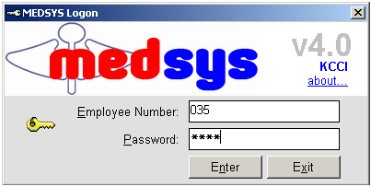
Figure 1: Login Window
3 If accepted, the user can now start a transaction. Otherwise, a message will be displayed prompting “Unauthorized User”.

How to Change Password

It is advisable to change your password as often as possible for security reasons. To change you current password, follow these steps.

1 From the Login window, type your employee number and then press <Enter>.

2 Under the Password entry, press <F12>. Pressing this function key will invoke the Change Password window.

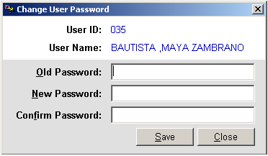
Figure 2: Change Password Window

3 Under the Change Password window, type the following data.
Old Password - Type your existing password.
New Password - Type your new password not exceeding to 15 characters.
Confirm Password - Retype your new password to confirm and then press <Enter> or you can click the Save button.

How to End the Program

It is important for users to close the program when they are done to end-up their session. Other users might use the open program using the same password.

To close the program:
In the Patient Searching window, click Exit or
Click the located at the upper right corner of the main window.

Program Operation

Patient Searching

To start a transaction, you should first search a patient. Initially, all currently confined patients will be listed in the patients list after the program had accepted the user’s employee number and password.

From the main window (default window), fill-up the following data under the patient searching window.

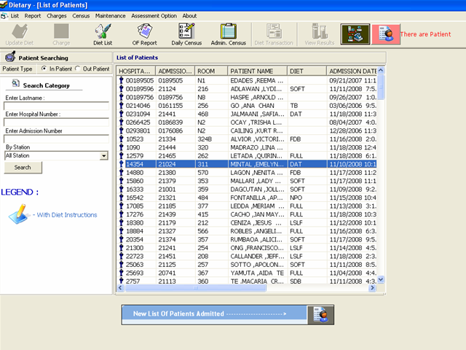
Figure 3: Patient Searching
1 Under Patient Type, click 'Inpatient“ to search for inpatients , ”Outpatient“ to search for current outpatients, “Previously Confined” to search for previous inpatients, “Previous Out Patient” to search for previous outpatients or “Walk-In” to search for cash patients.
2 Under Search Category, type one of the needed data. It is advisable to just type the patient’s last name for fast searching.
Enter Lastname: - Type the patient’s last name and then click the Search button or
Enter Hospital Number: - Type the patient’s hospital number and then click the Search button or
Enter Admission Number: - Type the patient’s admission number and then click the Search button.

3 Upon clicking the Search button, patients listing will be displayed in the patient list window matching the query typed. Patients who have maintained room are also shown at the bottom part of the window. To start a transaction, you should choose a patient from the list by clicking the patient’s name.

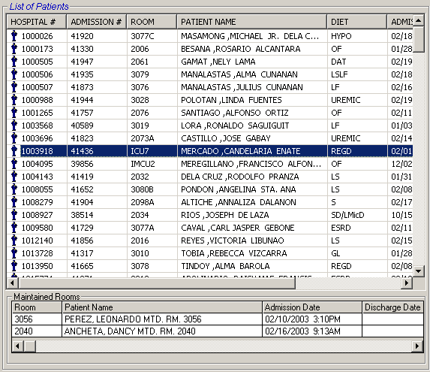
Figure 4: Patients Listing

Updating of Diet

This allows you to change the present patient’s diet. Posted diet from the nursing station is displayed in the window for previous diet reference.

1 After searching a patient (see page 9), click Update Diet toolbar button.
2 The Updating of Diet window will be displayed. Under the New Diet entry, enter the needed data.
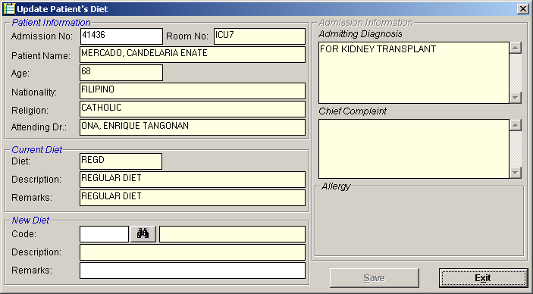
Figure 5: Update Diet Window

Code - Type the first few letters of the diet and then press <Enter>. A window will appear matching the query. Just double-click on the diet name to select. Or you can type directly the diet code to automatically display the diet description. Or you can click to display the complete list of diet codes. Just double-click on the diet name to select.
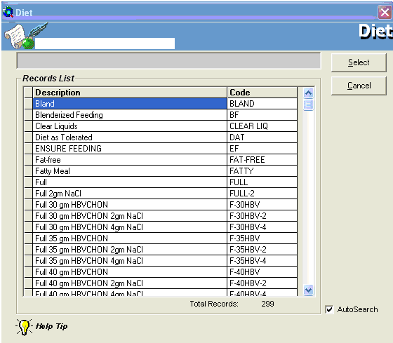
Figure 6: Diet Codes Listing

Description - This will be automatically displayed by the program in relation with the selected diet.
Remarks - Type additional notes about the selected diet.

3 The following button options can be clicked from.
Save - This will save the entered diet.
Exit - This will close the Updating of Diet window.

Charging of Diet

This option allows you to charge diet, dietary miscellaneous, and diet plan of the patient.

1 After searching a patient (see page 9), click Charge toolbar button.
2 The Charging of Diet window will be displayed.

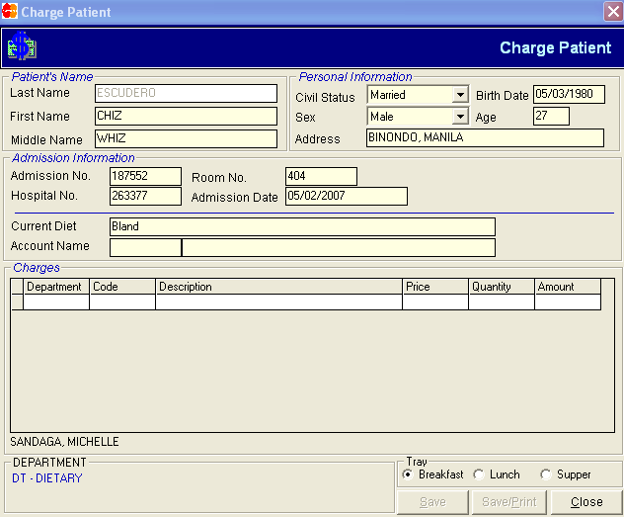
Figure 7: Charging of Diet Window

Type the needed data.
Department - Type the department code and then press <Enter>. Refer to the bottom part of the window to view the list of department codes.
Code - Press <Enter> if code is still blank to display the complete list of codes of the selected department. Just double-click on the code to select.
Description - This will be automatically displayed by the program.
Price - This will be automatically displayed by the program in relation with the selected item.
Quantity - Type the number of item and then press <Enter> to enter move the cursor into the next row for the next entry of item.
Amount - This will be automatically displayed by the program in relation with price and quantity of the item selected.

3 The following button options can be clicked from after completing the needed data.
Save - This will save the entered items.
Save/Print - This will save and print the list of entered items
Close - This will close the Charging of Diet window.

Viewing of Diet History

This allows you to view all posted diets of the selected current patient’s confinement.

1 After searching a patient (see page 9), click View Diet History located in the patient searching window.
2 The Patient’s Diet History window will be displayed showing all the diets posted.

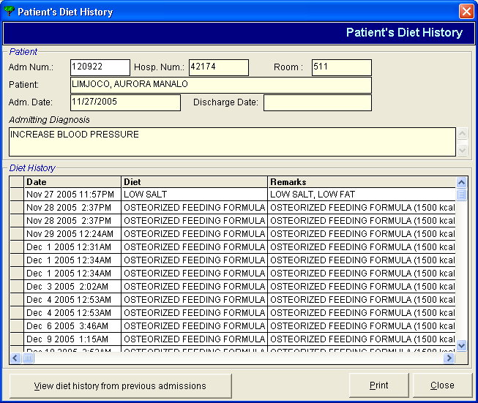
Figure 8: Diet History Window

- Click the Print button to print patient’s diet history. Click the Close button to close the window.
- Click the View Diet History from Previous Admissions button to view previous diet of patients from previous admission.

Charge-slip Reprinting

This allows you to reprint charge-slip of posted patient’s diet.

1 After searching a patient (see page 9), click Charge Slip Reprinting located in the patient searching window.
2 The Charge-slip Reprinting window will be displayed showing all posted diets.

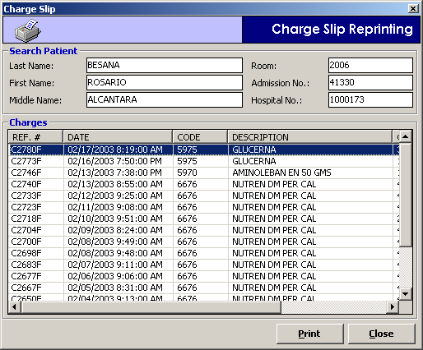
Figure 9: Charge-slip Reprinting Window

3 Select the item you want to print by single-clicking on it. Click the Print button to print the selected item.

Viewing of Discharged Patients

This allows you to view all discharged patients since the selected date of patient’s discharge.

1 Click List > Discharged Patients from the menu.
2 A window for date entry will appear. Select a report date by clicking on the drop-down arrow to display calendar and then click on the day of the month.
3 A printable report will be displayed. Click to print.

Viewing of Admitted Patients

This allows you to view all admitted patients since the selected date of patient’s admission.

1 Click List > Admitted Patients from the menu.
2 A window for date entry will appear. Select a report date by clicking on the drop-down arrow to display calendar and then click on the day of the month.
- A printable report will be displayed. Click to print.

Processing of Pending Requests

This allows you to view and process diet requests posted from the nursing station.
1 Click the blinking button .
2 The Pending Requests window will be displayed showing the list of posted requests from the nursing stations. To process a particular request, double-click the row where the diet is aligned. The Process Request window will appear. Click the Save button to accept the request. Otherwise, click the Exit button to close the Process Request window.

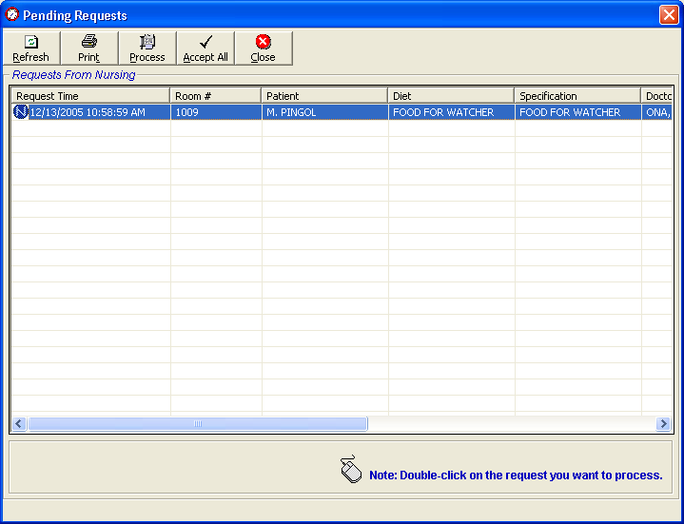
Figure 10: Pending Requests Window

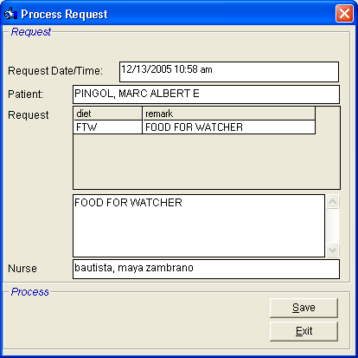
Figure 11: Process Request Window

3 The following button options can be clicked from.
Refresh - This button when clicked will display the current list of pending requests from the database.
Print - This will print the meal card of the posted diet requests.
Process - This will process the selected request from the list.
Accept All - This will process at once all pending requests.
Close - This will close the Pending Request window.

Clearing of Patient for Discharge

This option allows you to discharge patients in your department. Discharged patients will automatically be reflected in the Billing department.

1 Double-click on . Its window will be displayed showing the list of cleared and not cleared patients. (The legend of “Cleared” and “Not Cleared” patients can be seen at the bottom part of the window)

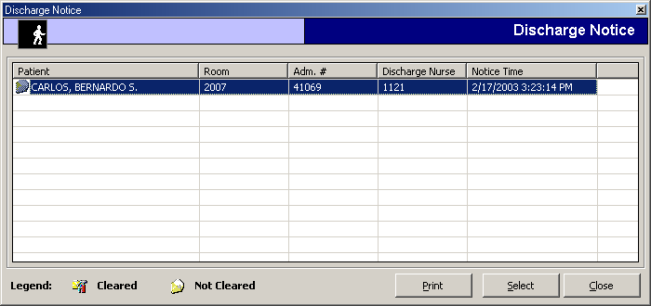
Figure 12: List of Discharge Notice(s) Window

2 Select an uncleared patient from the list and then click the Select button

3 A window for clearing patients will be displayed. Just type your remarks for clearing the patient.

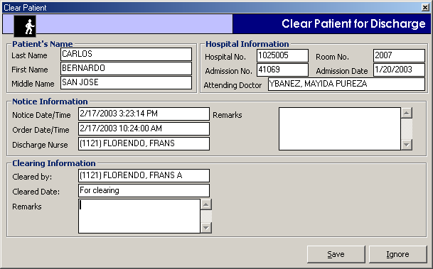
Figure 13: Clearing of Patient for Discharge Window

4 The following button option can be clicked from
Save - Click this button to clear the patient in your department.
Ignore - Click this button to ignore clearing the patient.

Reports and Census

Reports
1 OF Report - To view osterized feeding report, click OF Report toolbar button. A window for date entry will appear. Select a report date by clicking on the drop-down arrow to display calendar and then click on the day of the month. A printable report will be displayed. Click to print.

2 Diet Report - Click Diet List toolbar button. The Diet List window will be displayed. You need to fill-in the following data.
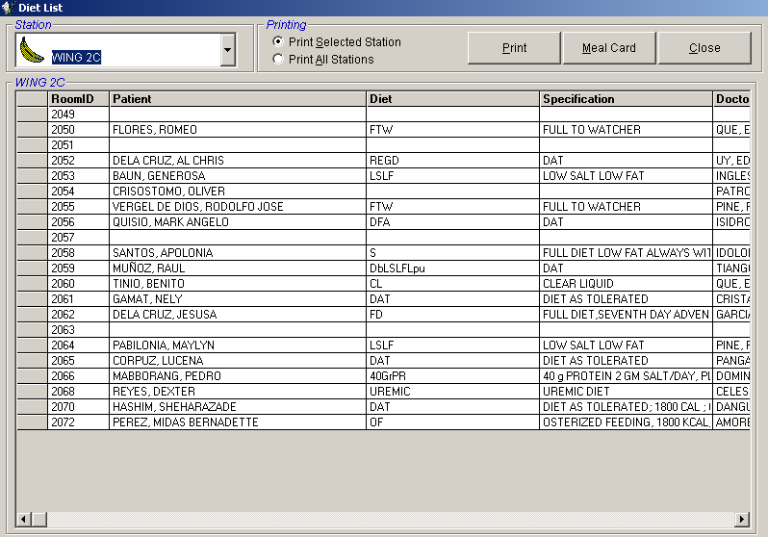
Figure 14: Diet List Window

Under Station entry, click the drop down arrow to display list of stations. Click the station you want to view. The diet list of the selected station will be then displayed just below it.
Under Printing option, select one from the given options.
Print Selected Station - This will only display diet list from the selected station.
Print All Station - This will display all diet list from all stations.
The following button options can be clicked from.
Print - This will display a printable report of the diet list in relation with the printing option selected.
Close - This will close the Diet List window.

Census
1 Daily Census - Click Daily Census toolbar button. A window for date entry will appear. Select a report date by clicking on the drop-down arrow to display calendar and then click on the day of the month. A printable report will be displayed. Click to print.

2 Administrative Census - Click Administrative Census toolbar button. A printable report will be displayed. Click to print.

Diet List Maintenance

This option helps you maintain currently used diet list. In here, you can add or edit a particular diet.

1 Click Maintenance > Diet List from the menu.
2 The Build Diet List window will be displayed showing the diet list.

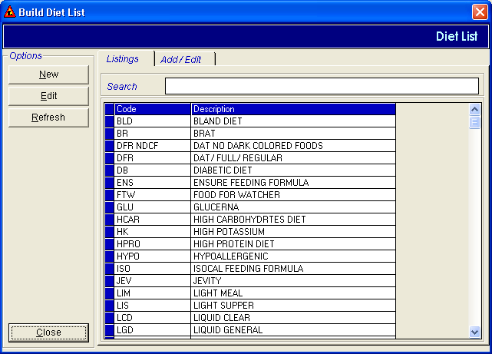
Figure 15: Diet List Maintenance Window

To add a new diet, click the New button. Enter the needed data.
Code - Type a code of the new diet.
Description - Type a description of the new diet.
Diet Type - Click to display the list of diet types. Double-click on the diet type to select.
Classification - Choose one from Full or Therapeutic.
To edit an existing diet, click a diet from the list and then click the Edit button. You can now make changes on the existing data.

3 The following button options can be clicked from.
Save - This will save the new diet or the edited diet.
Cancel - This will undo the saving option.

Diet Type Maintenance

This option helps you maintain currently used diet types. In here, you can add or edit a particular diet type.

1 Click Maintenance > Diet Type from the menu.
2 The Build Diet Type window will be displayed showing the list of diet types.

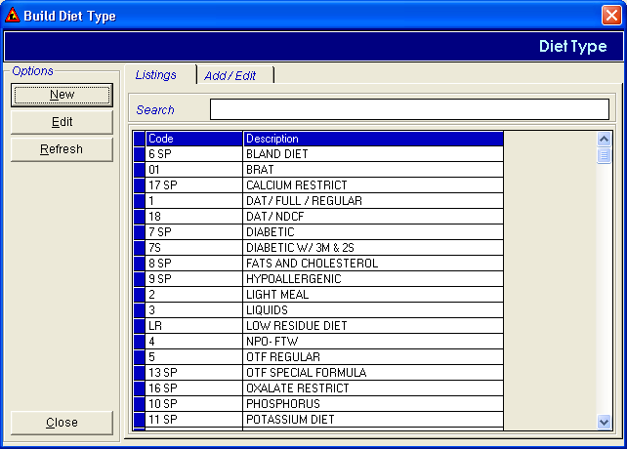
Figure 16: Diet Type Maintenance Window
To add a new diet type, click the New button. Enter the needed data.
Code - Type a code of the new diet type.
Description - Type a description of the new diet type.
To edit an existing diet type, click a diet type from the list and then click the Edit button. You can now make changes on the existing data.

3 The following button options can be clicked from.
Save - This will save the new diet type or the edited diet type.
Cancel - This will undo the saving option.

Room Classification Maintenance

This option helps you maintain currently utilized room classification. In here, you can add or edit a particular room classification.

1 Click Maintenance > Room Classification from the menu.
2 The Room Classification window will be displayed showing the list of rooms.

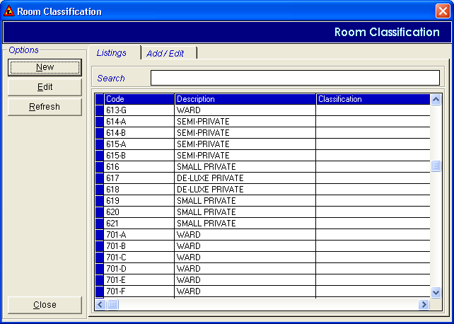
Figure 17: Room Classification Maintenance Window

To add a new room, click the New button. Enter the needed data.
Code - Type a code of the new room classification.
Description - Type a description of the new room classification.
Classification - Click to display the list of room class. Double-click on the room class to select.
To edit an existing room, click a room from the list and then click the Edit button. You can now make changes on the existing data.

3 The following button options can be clicked from.
Save - This will save the new room or the edited room.
Cancel - This will undo the saving option.

Assessment Entry

This option is for the request entry for cash-basis patients.

1 Click Assessment Option > Assessment Entry from the menu.
2 The Assessment Entry window will be displayed. Enter the following data.

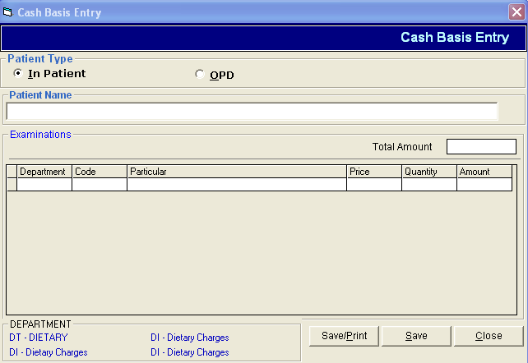
Figure 18: Assessment (Cash-basis) Entry Window

Under Patient Type entry, choose one from the given options ( In-patient / OPD ).
Under Patient Name entry, type the patient’s last name and then press <Enter>. This is for confined and regular patients only. A window with patients listing will appear. Double-click on the patient name to select. For walk-in patient, you need to type the patient’s full name.
Under Examinations entry, complete the following data.
Department - Type the department code and then press <Enter>. Refer to the bottom part of the window to view department codes.
Code - Type the first few letters of the item and then press <Enter>. A window will appear matching the query. Double-click on the item to select. Or press <Enter> if it is still blank to display the complete list of item codes. Double-click on the item to select. Or you can directly type the code to automatically display particular.
Particular - This will be automatically displayed in relation with the selected item.
Price - This will be automatically displayed in relation with the selected item.
Quantity - Type the number of item and then press <Enter> to move the cursor into the next line for the next entry of item.
Amount - This will be automatically displayed in relation with price and quantity typed.

3 The following button options can be clicked from after completing the needed data.
Save - This will save the entered items.
Save/Print - This will save and print the list of entered items
Close - This will close the Assessment Entry window.

Assessment Status

This allows you to view the status of the assessed items. In here, you can also reprint charge- slip and revoke items that are not yet processed.

1 Click Assessment Option > Assessment Status.
2 The Assessment Status window will be displayed showing all posted assessments. The status of the assessment can be viewed at the end of the list.

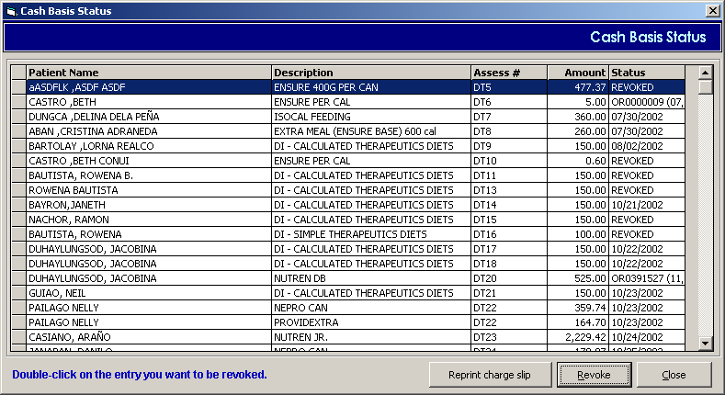
Figure 19: Assessment Status (Cash-basis) Window

3 The following button options can be clicked from.
Reprint Charge Slip - This button will print the selected charge-slip from the list.
Revoke - This will revoke the selected charge-slip from the list.
Close - This will close the Assessment Status window.

Index

—A—
adding of diet, 26
adding of diet type, 27
adding of room classification, 28
administrative census, 22
admitted patients (viewing of), 17
assessment entry, 31
assessment status, 33
—C—
census, 23
changing of password, 7
charge-slip reprinting, 17
charging of diet, 14
closing the program, 8
—D—
daily census, 22
diet (charging of), 13
diet (updating of), 11
diet history (viewing of), 15
diet list maintenance, 27
diet report, 22
diet type maintenance, 28
discharge notice (viewing of), 20
discharged patients (viewing of), 17
—E—
editing of diet, 26
editing of diet type, 27
editing of room classification, 28
ending the program, 8
—F—
features, 5
—M—
meal card, 22
—O—
objectives, 5
osterized feeding report, 22
overview, 4
—P—
password (changing of), 7
patient searching, 9
pending requests (processing of), 18
printing of charge-slip, 16
processing of pending requests, 19
—R—
report, 23
reprinting of charge-slip, 16
reprinting of charge-slip (assessed items), 31
revoking of charge-slips (assessed items), 31
room classification maintenance, 30
—S—
searching a patient, 9
starting the program, 6
—U—
updating of diet, 11
—V—
vieiwing of assessment status, 31
viewing of admitted patients, 18
viewing of diet history, 16
viewing of discharged patients, 18
viewing of disharge notice, 20

