MEDSYS
Information System

Build File Program
User's Manual

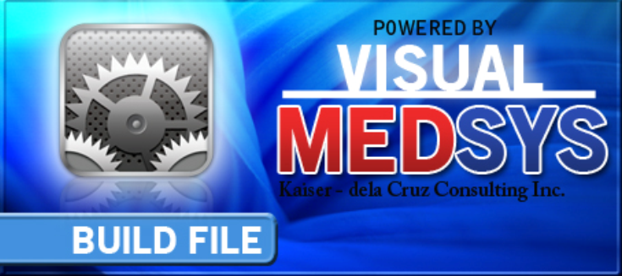

Visual MEDSYS
Kaiser dela Cruz Consulting Incorporated
July 31, 2026

© Copyright

ALL RIGHTS RESERVED

No part of this document may be reproduced through photocopying or in any means, stored into a retrieval system, and transmitted in any form without the express written permission of Kaiser dela Cruz Consulting Incorporated.
Permission is hereby granted to Medsys Information System to copy and distribute this document in any of the above means provided this is for its exclusive on site use.
Although every precaution has been taken in the preparation of this manual, the company assumes no responsibility for errors or omissions. Neither is any liability assumed for any damages resulting from the use of the information contained here.
Table of Contents

Introduction 5
Overview 5
Objectives 6
Features 6
Getting Started 7
How to Start the Program 7
How to Change Password 8
How to End the Program 9
Program Operation 10
Revenue 10
Revenue Exam 122
Company 15
Address 18
Telephone 20
Business Class 22
Nationality 24
Religion 26
Doctor 28
Doctor's Schedule 30
Doctor's Rate (Service Fee) 30
Doctor's Utility and Monthly Rental 31
Standard Operating Procedures 32
Room 34
Station 388
Room Class 40
Room Accommodation 422
Service 444
Laboratory Code 466
Supply Package 511
Dosage 533
Laboratory Section 55
Xray Section 57
Ultrasound Section 59
CT Scan Section 61
Heart Station Section 63
Nuclear Medicine Section 65
RTS/Pulmonary Laboratory Section 67
Rehabilitation Section 69
Executive Package 71
Index
74

Introduction

Overview
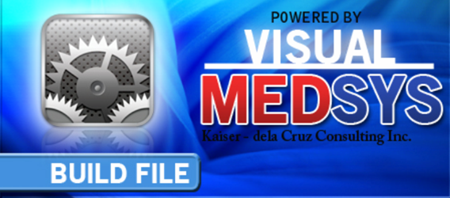
The Build File Program is the central repository program of Medsys Hospital Information applications.
The following data can be entered using this program.

1 Revenue
2 Revenue Exam
3 Company
4 Address
5 Telephone
6 Business Class
7 Nationality
8 Religion
9 Doctor
10 Room
11 Station
12 Room Class
13 Room Accommodation
14 Service
15 Laboratory Specimen
16 Supply Package
17 Dosage
18 Laboratory Code
19 Laboratory Section
20 Radiology Sections
21 Cardio Section
22 Nuclear Medicine section
23 RTS/Laboratory Section
24 Physical Therapy Section
25 Discount Rates
26 Doctor’s Profile
27 Company Rates

Objectives

- To ensure the institution is using data that’s accurate and dynamically updated
- To synchronize and integrate data across applications into a central repository
- Make cleansed data available for cross-referencing and analysis in the hospital information system programs
- Provide greater consistency of data across all applications
- Establish a foundation for data governance and data quality initiatives

Features
- It logs the changes made and reports who and when the changes were applied
- Information is always reliable and always up-to-date. Build file repository is created with active links to live, real-time data sources.
- Data-entry restriction - Warning messages are flashed for possible invalid entries. This ensures all data inputted would be made useful for any transaction that may occur.
- Password-protected - The use of password is necessary to restrict unauthorized access. Thus the program only accepts passwords which are registered into it. This feature ensures the confidentiality and integrity of data entered in the program.
- Auto-report generation - The program is capable of generating reports and can be readily printed
- User-friendly - The program user is guided by instructions in doing the next step providing an easy-use to process transactions. Tool-tips are also incorporated to give users an idea of what a particular button does.

Getting Started

How to Start the Program

1 Click the Build File Program executable file icon located in your computer desktop.

2 The Login window will be displayed asking you to type your employee number and password for security purposes.

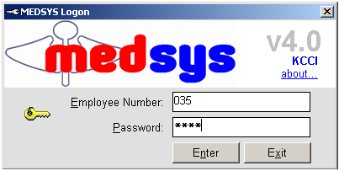
Figure 1: Login Window

3 If accepted, you can now start a transaction. Otherwise, a message will be displayed prompting “Unauthorized User”.

How to Change Password

1 From the Login window, type your employee number and then press <Enter>.

2 Under the Password entry, press <F12>. Pressing this function key will invoke the Change Password window.

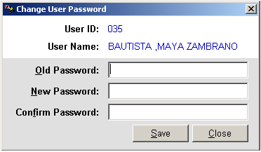
Figure 2: Change Password Window
3 Under the Change Password window, type the following data.
Old Password - Type your existing password.
New Password - Type your new password not exceeding to 15 characters.
Confirm Password - Retype your new password to confirm and then press <Enter> or you can click the Save button.

How to End the Program

It is important for users to close the program when they are done to end-up their session. Other users might use the open program using the same password.

To close the program:
Click located at the upper right corner of the main window or
Click the 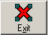 Exit toolbar button.

Program Operation

Revenue

This option allows you to add new revenues and/or edit existing revenue information.

1 How to Open the Window - Click the 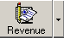 toolbar button. The window below will be shown.

Figure 3: Revenue Code Build File Window

2 How to Search - You can search a revenue by 'By Name' or 'By Code'. Just type the name or code under the ’Search Revenue' entry. The program automatically highlights the revenue if found.

3 How to Edit: Search first the revenue and then click the Edit button. You can now enter necessary changes on the item information. Click the Save button afterwards to save changes entered.

4 How to Add - Click the Add button at the bottom part of the window. Then complete the following data.

Code - This refers to the two-digit character of the account code.
Description - This is the name of the revenue.
Classification - Select the classification of the revenue by clicking on the drop-down arrow.
Account Side - Determine if the revenue is a debit, a credit, or a professional/medical fee. Just click on the option listed.
Properties - Three properties are listed to choose from.
Variable Rate - Click this if revenue price is changing.
Active - Click this to become readily available once saved.
With Other Item - Click this if exam/procedure is necessary to include in the revenue.
Medicare Type - Determine the medicare type of the revenue by clicking the drop-down arrow. Listed are '1=Room and Board', '2=Pharmacy', '3=Others', '4=Operating Room', and 'N=Non-medicare'.
Access - Click the department(s) where you would like to access the revenue.
Account Code - Type the account code of the revenue to be used in accounting and in cashiering.

Sample Entry
Code: OM
Description: ER/OPD MEDICINES
Classification: M-Miscellaneous Fee
Account Side: (Choose 'debit')
Properties: (Choose 'Variable Rate', 'Active', and 'With Other Item')
Medicare Type: (Choose 'N=Non-Medicare')
Access: (Choose 'ER')
Account Code: Leave it blank

5 How to Save - Click the Save button.

6 How to Abort Adding or Editing of Item - Click the Cancel button.

7 How to Close the Window - Click the Exit button.

Revenue Exam

This option allows you to add new revenue exams and/or edit existing revenue exam information

1 How to Open the Window - Click the drop-down arrow to display option and then click 'Charging Code'. The window below will be shown.
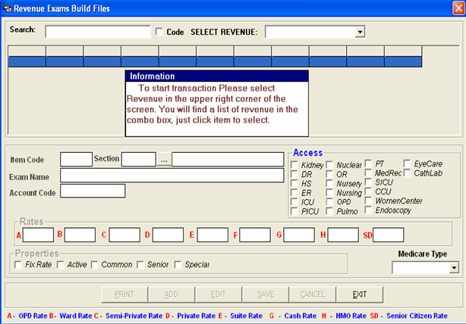

Figure 4: Revenue Exam Build File Window

2 First Thing to Do - Select a revenue under ’SELECT REVENUE' entry. Just click the drop-down arrow to display options.

3 How to Search - By default, searching is by exam name. Type the first few letters of the exam name and the program automatically highlights and displays exam information. To search by exam code, click the check box beside 'Code'.

4 How to Edit - Search first the item and then click the Edit button. You can now make necessary changes on the item information. Click the Save button afterwards to save the changes entered.

5 How to Add - Click the Add button at the bottom part of the window. Complete the following data.

Item Code - This is a program-generated exam code.
Exam Name - This is the name of the item.
Rates - This refers to the rate of the item in rooms OPD=A, Pay Ward=B, Private=C, and Suite=D.
Properties - Listed are 'Fix Rate', 'Active', and 'Common'. Just click on the option(s) intended for the item name.
Medicare Type - Determine the medicare type of the revenue by clicking the drop-down arrow. Listed are '1=Room and Board', '2=Pharmacy', '3=Others', '4=Operating Room', and 'N=Non-medicare'.
Senior Citizen - Click the option box beside the word ’senior Citizen' if senior citizens can avail a discount of the item.

*Additional entries for revenue 'Laboratory' only:
Short Name - This refers to the short name of the item.
ISO Form Code -
Classification - Select from the options listed ('Charging' or 'Result Entry')
Open Prof. Fee - Click this if the laboratory item professional fee requires data-entry.
IsProcedure - Click this if the item is a procedure.
Stat - Select from the options listed ('Routine/Stat', 'Routine', or ’stat'). The default entry is 'Routine'.

Sample Entry
Revenue: LB-LABORATORY
Item Code: 62
Exam Name: CELL BLOCK
Short Name: CBBLOCK
Section: HIS-HISTOPATHOLOGY
Rates:
A - 160.00
B - 200.00
C - 240.00
D - 280.00
ISO Form Code: Leave it blank
Classification: (Choose 'Charging')
Medicare Type: (Choose '3-Others')
Properties: (Choose 'Fix Rate' and 'Active')
Stat: (Choose 'Routine')
Senior Citizen: Leave it blank
Open Quantity: Check this
Open Prof. Fee - Leave it blank
IsProcedure - Leave it blank
Auto-Markup - (Choose “NO')

6 How to Save - Click the Save button.

7 How to Abort Adding or Editing of Item - Click the Cancel button.

8 How to Close the Window: Click the Exit button.

Company

This option allows you to add a new company and/or edit existing company information.

1 How to Open the Window - Click the 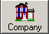 toolbar button. The window below will be shown.

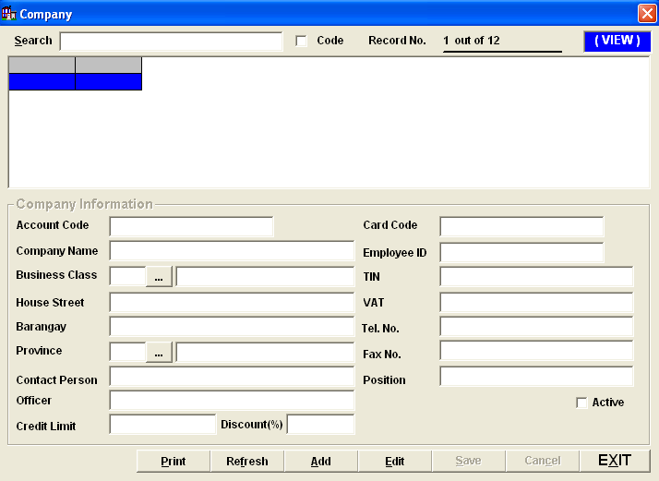
Figure 5: Company Build File Window

2 How to Search - Under ’search' entry, type the first few letters of the company name. The program automatically highlights the company and displays its information if found.

3 How to Edit - Search first the company name and then click the Edit button. You can now edit the company information. Click the Save button afterwards to save the changes entered.

- How to Add - Click the Add button at the bottom part of the window. Complete the following data afterwards.
Account Code - Type the account code (can be a combination of a letter and a number) of the company.
Company Name - Type the name of the company
Business Class - Press <Enter> while entry is still blank to display list of business class. Double-click the business class name to select.

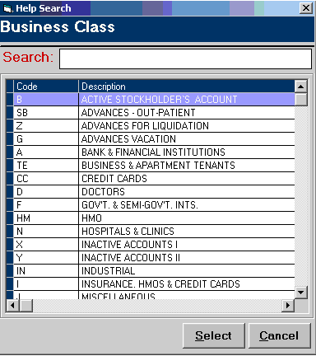
Figure 6: List of Business Class

House Street - optional entry
Barangay - optional entry
Province - optional entry. Click the to display list of towns and provinces. Double-click the town/province to select.

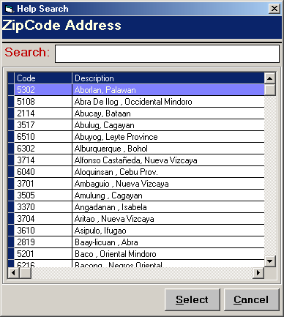
Figure 7: List of Towns/Provinces

TIN - optional entry
VAT - optional entry
Tel No - optional entry
Fax No - optional entry
Active - Click this if you want the item to become readily available for use.

5 How to Save - Click the Save button.

6 How to Abort Adding or Editing of Item - Click the Cancel button.

7 How to Close the Window - Click the Exit button.

Address

This option allows you to add new address, edit, and/or delete an existing address.

1 How to Open the Window - Click the 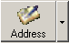 toolbar button. The window below will be shown.

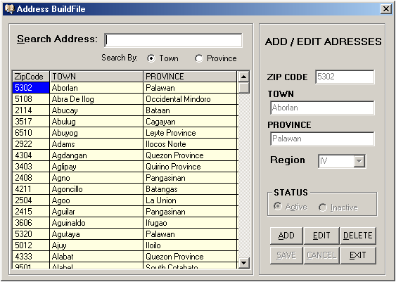
Figure 8: Address Build File Window

2 How to Search - You can search an address by 'Town' or 'Province'. Type town or province under the ’Search Address' entry. The program automatically highlights the item from the list and displays its information if found.

3 How to Edit - Search the town from the list and then click the Edit button. You can now edit the address information. Click the Save button to save the changes entered.

4 How to Delete: Search first the item from the list and then click the Delete button.

5 How to Add - Click the Add button and then complete the following data.

Zip Code - Type the zip code of the town and then press <Enter>.
Town - Type the town and then press <Enter>.
Province - Type the province and then press <Enter>.
Region - Click the drop-down arrow to select region.
Status - Click the option you want from the listed options ('Active' or 'Inactive'). 'Active' if selected automatically make the status of the address available for use.

6 How to Save - Click the Save button.

7 How to Abort Adding or Editing of Item - Click the Cancel button.

8 How to Close the Window - Click the Exit button.

Telephone

This option allows you to add new telephone numbers, edit, and/or delete an existing telephone number.

1 How to Open the Window - Click the drop-down arrow and then click 'Telephone'. The window below will be shown.

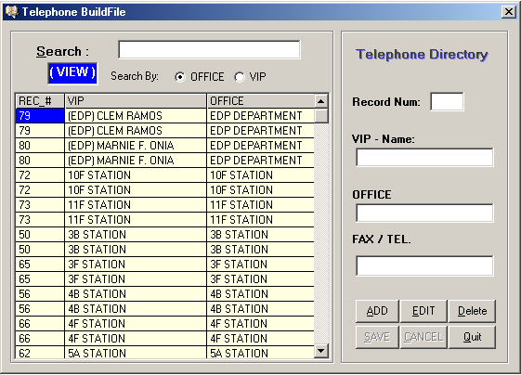
Figure 9: Telephone Build File Window

2 How to Search - You can search a telephone by 'OFFICE' (office/department) or 'VIP' (employee name). Type department/station or employee name under the ’search' entry. The program automatically highlights the item from the list and displays its information if found.

3 How to Add - Click the Add button and then complete the following data.

Record Num - This is a program-generated record number of the telephone.
VIP -Name - Type the name of the employee or VIP.
Office - Type the department name or station name of employee.
Fax/Tel - Type the fax/telephone number of the department or station.

4 How to Save - Click the Save button.

5 How to Edit - Search the town from the list and then click the Edit button. You can now edit the address information. Click the Save button to save the changes entered.

6 How to Abort Adding or Editing of Item - Click the Cancel button.

7 How to Delete: Search first the item from the list and then click the Delete button.

8 How to Close the Window - Click the Quit button.

Business Class

This option allows you to add a new business class and/or edit existing business class information.

1 How to Open the Window - Click the 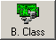 toolbar button. The window below will be shown.

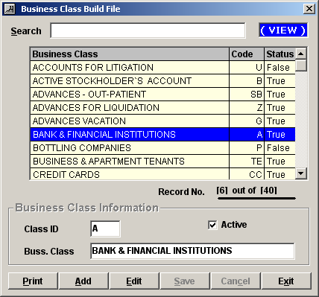
Figure 10: Business Class Build File Window

2 How to Search - Under ’search' entry, type the first few letters of the business class name. The program automatically highlights the item and displays the item information.

3 How to Edit - Search first the item from the list and then click the Edit button. You can enter necessary changes on the business class information. Click the Save button afterwards to save the changes entered.
4 How to Add - Click the Add button and then complete the following data.

Class ID - Type the ID of the business class.
Business Class - Type the business class name.
Active - The default entry is active meaning it will be readily available once saved.

5 How to Save - Click the Save button.

6 How to Abort Adding or Editing of Item - Click the Cancel button.

7 How to Close the Window - Click the Exit button.

Nationality

This option allows you to add a new nationality and/or edit an existing nationality.

1 How to Open the Window - Click the 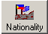 toolbar button. The window below will be shown.

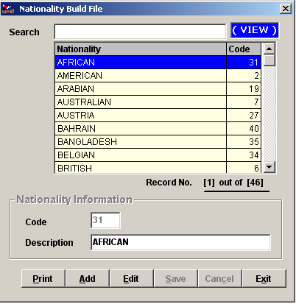
Figure 11: Nationality Build File Window

2 How to Search - Under ’search' entry, type the first few letters of the nationality. The program automatically highlights the item and displays its information.

3 How to Edit - Search first the item name and then click the Edit button. You can now edit the description of the nationality. Click the Save button afterwards to save modification entered.

4 How to Add - Click the Add button and complete the following datum.

Code - This is a program-generated code.
Description - Type the name of nationality.

5 How to Save - Click the Save button.

6 How to Abort Adding or Editing of Item - Click the Cancel button.

7 How to Close the Window - Click the Exit button.

Religion

This option allows you to add a new religion and/or edit an existing religion.

1 How to Open the Window - Click the 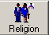 toolbar button. The window below will be shown.

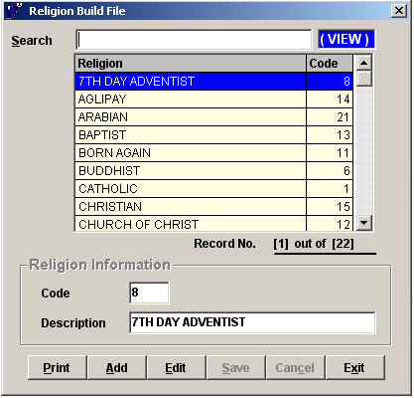
Figure 12: Religion Build File Window

2 How to Search - Under ’search' entry, type the first few letters of the religion. The program automatically highlights the item and displays its information.

3 How to Edit - Search first the item name and then click the Edit button. You can now edit the description of the religion. Click the Save button afterwards to save modification entered.

4 How to Add - Click the Add button and complete the following datum.
Code - This is a program-generated code.
Description - Type the name of religion.

5 How to Save - Click the Save button.

6 How to Abort Adding or Editing of Item - Click the Cancel button.

7 How to Close the Window - Click the Exit button.

Doctor

This option allows you to add new doctors and/or edit existing doctor information.

1 How to Open the Window - Click the 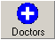 toolbar button. The window below will be shown.
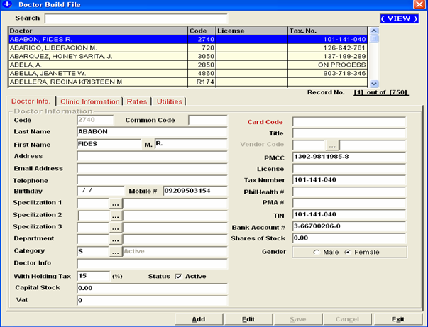
Figure 13: Doctor Build File Window

2 How to Search - Under ’search' entry, type the first few letters of the doctor’s last name. The program automatically highlights the name and displays its information.

3 How to Edit - Search first the doctor’s name and then click the Edit button. You can now edit the doctor’s information. Click the Save button afterwards to save changes entered.
4 How to Add - Click the Add button and then complete the following data.
Doctor’s Information
Code - This is a program-generated code.
Last Name - Type the doctor’s last name and then press <Enter>.
First Name - Type the doctor’s first name and then press <Enter>.
Middle Name - Type the doctor’s middle name and then press <Enter>.
Address - Type the doctor’s home address and then press <Enter>.
Specialization - Click the to display list of specializations. Double-click the specialization name to select.

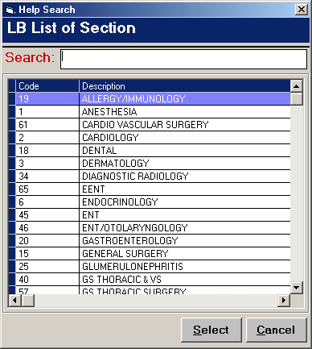
Figure 14: List of Specializations

Title - optional entry
Telephone - optional entry
PMCC - optional entry
Tax Number - optional entry
Sex - Select the doctor’s gender from the option listed ('Male' or 'Female')
Active - If checked, the doctor will be automatically available for use once saved.
Resident - Check this if the doctor is a resident one.
Bank Account # - The doctors personal bank account number
Vendor Code –
Tax Rate
Clinic Schedule
This option allows you to enter the Doctors schedule in a week ( day and time ).

5 How to Save - Click the Save button.

6 How to Abort Adding or Editing of Item - Click the Cancel button.

7 How to Close the Window - Click the Exit button.

How to Enter Doctors Schedule

This option allows the user to enter doctors schedule in a week. To do this, go to Build Files General then choose Doctor or click on the Doctors button in the menu to load the Doctors Entry window. Choose the doctor then click on the Clinic Schedule tab to load the window below
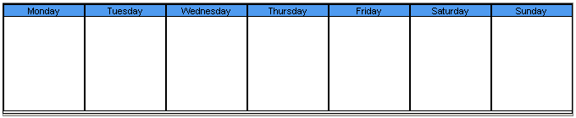
To save the data entered, click on Save button.
To disregard the data entered, click on Cancel button.
To go out from this option, click on Exit button.

How to Enter Professional Fees or Doctors Rates

This option allows the user to enter the rates of the doctor. To do this, click on Doctors button to display list(s) of doctors. Choose the specific doctor then click on Rates tab to load the window below

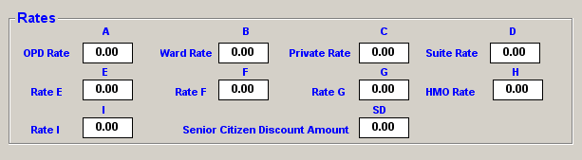

To save the data entered, click on Save button.
To disregard the data entered, click on Cancel button.
To go out from this option, click on Exit button.

How to Enter Doctors Utility Fixed Monthly Expenses

This option allows the user to enter doctors rentals and other utility fixed monthly expenses for automatic preparation of Utility Bill/Invoice. To do this, go to Build Files General then choose Doctor or click on the Doctors button in the menu to load the Doctors Entry window. Choose the doctor then click on the Rental tab to load the window below
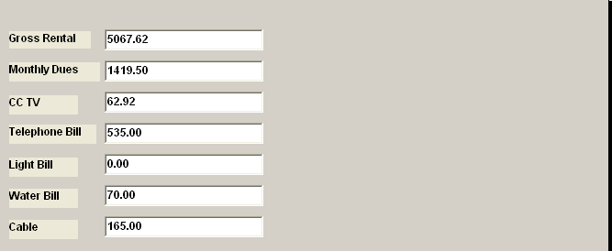
To save the data entered, click on Save button.
To disregard the data entered, click on Cancel button.
To go out from this option, click on Exit button.

How to Build Standard Operating Procedures ( SOP )
This option allows the user to create standard operating procedures that can be used by the patient(s). To do this, click on 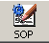 button to display the window below.
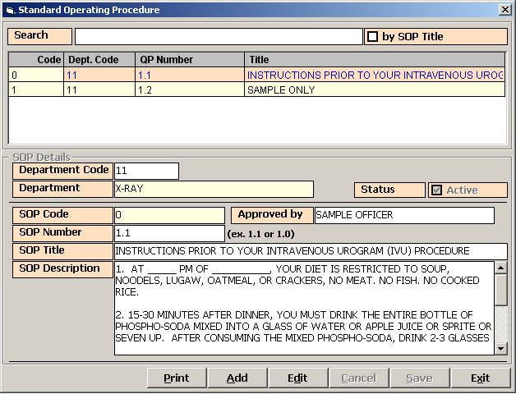

To add new sop, click on Add button.
Enter the following information:
1 Department Code – Press Enter key to display list(s) of departments. Double click on the specific item
2 Department – Description of the Department chosen
3 SOP Code
4 SOP Number
5 SOP Title
6 SOP Description
7 SOP Status

To save the data entered, click on Save button.
To edit an existing data, click on Edit button.
To print the procedure, click on Print button.
To disregard the data entered, click on Cancel button.
To go out from this option , click on Exit button.

Room
This option allows you to add a new room and/or edit existing room information.

1 How to Open the Window - Click the 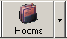 toolbar button. The window below will be shown.

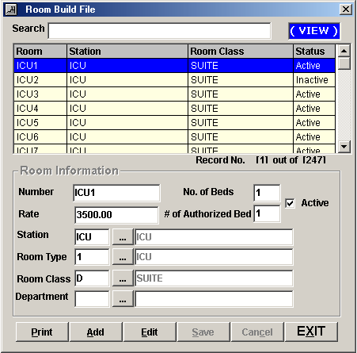
Figure 15: Room Build File Window

2 How to Search - Under ’search' entry, type the first few characters of the room number. The program automatically highlights the item and displays its information.

3 How to Edit - Search first the room from the list and then click the Edit button.

4 How to Add - Click the Add button and then complete the following data.

Number - Type the room number (can be a combination of a letter and a number) and then press <Enter>.
Rate - Type the room rate and then press <Enter>.
Station - Click the to display list of stations. Double-click the station name to select.

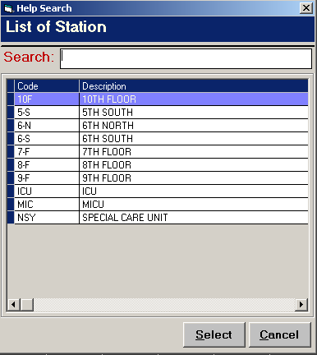
Figure 16: List of Stations

Room Type - Click the to display list of room types. Double-click the room type name to select.

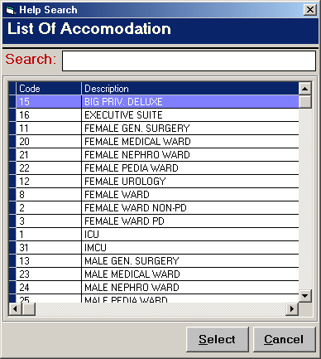
Figure 17: List of Accommodations

Room Class - Click the to display list of room classes. Double-click the room class name to select.

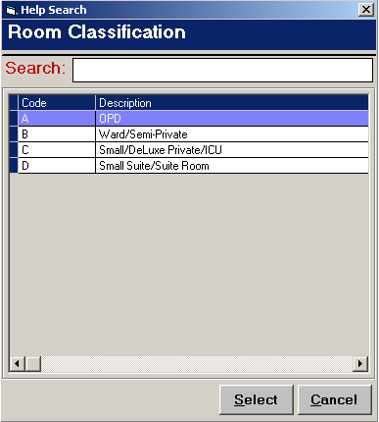
Figure 18: List of Room Classifications

Department - Click the to display list of departments. Double-click the department name to select.
No. of Beds - Type the number of beds in the room and then press <Enter>.
# of Authorized Beds - Type the number of authorized number of beds in the room.
Active - The default entry is 'Active' meaning the room can be readily available for used once saved.

5 How to Save - Click the Save button.

6 How to Abort Adding or Editing of Item - Click the Cancel button.

7 How to Close the Window - Click the Exit button.

Station

This option allows you to add a new station and/or edit existing station.

1 How to Open the Window - Click the drop-down arrow and then click ’station'. The window below will be shown.

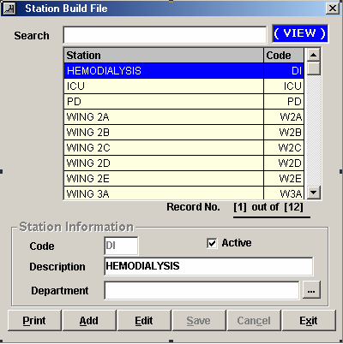
Figure 19: Station Build File Window

2 How to Search - Under ’search' entry, type the first few letters of the station name. The program automatically highlights the item and displays its information.

3 How to Edit - Search the item first and then click the Edit button. You may now edit the station information. Click the Save button afterwards to save changes entered.

4 How to Add - Click the Add button and then complete the following data.

Code - Type the code (can be a combination of a letter and a number) of the station and then press <Enter>.
Description - Type the name of the station and then press <Enter>.
Department - Fill-in if necessary.

5 How to Save - Click the Save button.

6 How to Abort Adding or Editing of Item - Click the Cancel button.

7 How to Close the Window - Click the Exit button.

Room Class

This option allows you to add a new room class and/or edit existing room class.

1 How to Open the Window - Click the drop-down arrow and then click 'Room Class'. The window below will be shown.

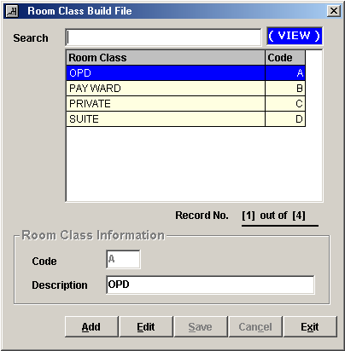
Figure 20: Room Class Build File

2 How to Search - Under ’search' entry, type the first few letters of the room class name. The program automatically highlights the item and displays its information.

3 How to Edit - Search first the item and then click the Edit button. You may now change room class description. Click the Save button afterwards to save the modification entered.

4 How to Add - Click the Add button and then complete the following data.

Code - Type the code of the room class.
Description - Type the room class name.

5 How to Save - Click the Save button.

6 How to Abort Adding or Editing of Item - Click the Cancel button.

7 How to Close the Window - Click the Exit button.

Room Accommodation

This option allows you to add a new room accommodation and/or edit existing room accommodation.

1 How to Open the Window - Click the drop-down arrow and then click Accommodation'. The window below will be shown.

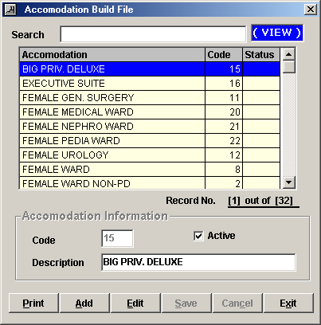
Figure 21: Room Accommodation Build File Window

2 How to Search - Under ’search' entry, type the first few letters of the room accommodation name. The program automatically highlights the item and displays its information.

3 How to Edit - Search first the item from the list and then click the Edit button. You nay now change the item information. Click the Save button afterwards to save modification entered.

4 How to Add - Click the Add button and complete the following data.

Code - Type the code of the room accommodation and then press <Enter>.
Description - Type the room accommodation name.
Active - The default entry is 'Active' meaning the item can be readily available for use once saved.

5 How to Save - Click the Save button.

6 How to Abort Adding or Editing of Item - Click the Cancel button.

7 How to Close the Window - Click the Exit button.

Service
This option allows you to add a new service and/or edit existing service.

1 How to Open the Window - Click the 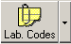 drop-down arrow and then click ’service'. The window below will be shown.

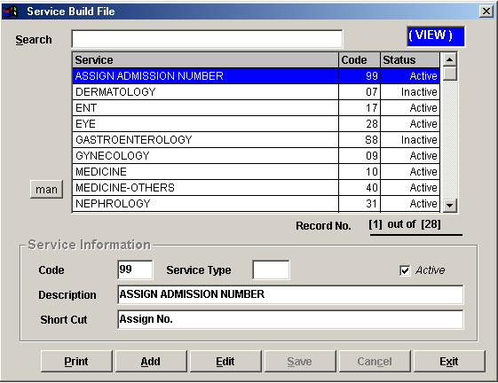
Figure 22: Service Build File Window

2 How to Search - Under ’search' entry, type the first few letters of the service name. The program automatically highlights the item and displays its information.

3 How to Edit - Search first the item and then click the Edit button. You may now change the necessary information. Click the Save button afterwards to save the modifications entered.

4 How to Add - Click the Add button and then complete the following data.

Code - This is a program-generated code.
Service Type - Leave it blank.
Description - Type the service name and then press <Enter>.
Short Cut - Type the short name of the service.
Active - The default entry is 'Active' meaning the item can be readily available for use once saved.

5 How to Save - Click the Save button.

6 How to Abort Adding or Editing of Item - Click the Cancel button.

7 How to Close the Window - Click the Exit button.

Laboratory Code

This option allows you to add new ova and parasites, antibiotics, and amoeba, and edit existing ova and parasites, antibiotics, and amoeba.

1 How to Open the Window - Click the toolbar button. The window below will be shown.

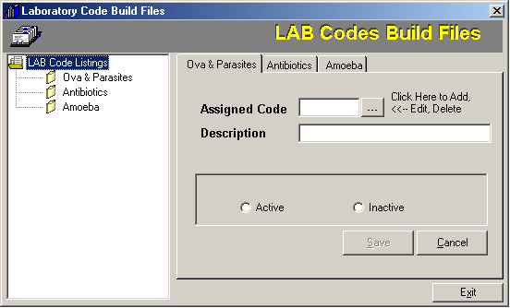
Figure 23: Laboratory Codes Build File

2 How to Close the Window - Click the Exit button.

Ova and Parasites

1 How to Open the Window - Click the 'Ova and Parasites' tab (default tab).

2 First Thing to Do - Click the to display list of ova and parasites.

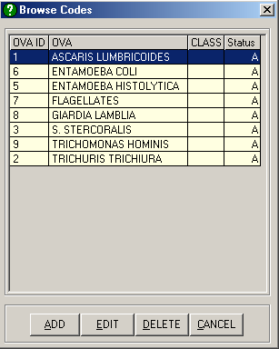
Figure 24: List of Ova and Parasites

Select the item from the list and you can now edit or delete it. Once the item is double-clicked, you may now edit its information. To add, click the Add button and complete the following data.

Code - A program-generated code. This refers to the item ID.
Description - Type the name of the ova/parasite.
Active - Click this option to automatically use the item once saved.
Inactive - Click this to just save the item but unavailable yet for use.

3 How to Save - Click the Save button.

4 How to Clear Entry - Click the Cancel button.

Antiobiotics

1 How to Open the Window - Click the 'Antiobiotics' tab.

2 First Thing to Do - Click the to display list of antiobiotics.

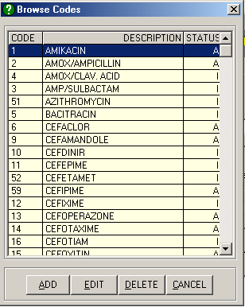
Figure 25: List of Antibiotics

Select the item from the list and you can now edit or delete it. Once the item is double-clicked, you may now edit its information. To add, click the Add button and complete the following data.

Code - A program-generated code. This refers to the item ID.
Description - Type the name of the antibiotic.
Active - Click this option to automatically use the item once saved.
Inactive - Click this to just save the item but unavailable yet for use.

3 How to Save - Click the Save button.

4 How to Clear Entry - Click the Cancel button.

Amoeba

1 How to Open the Window - Click the 'Amoeba' tab.

2 First Thing to Do - Click the to display list of amoebas.

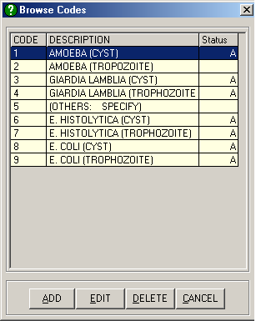
Figure 26: List of Amoebas

Select the item from the list and you can now edit or delete it. Once the item is double-clicked, you may now edit its information. To add, click the Add button and complete the following data.

Code - A program-generated code. This refers to the item ID.
Description - Type the name of the amoeba.
Active - Click this option to automatically use the item once saved.
Inactive - Click this to just save the item but unavailable yet for use.

3 How to Save - Click the Save button.

4 How to Clear Entry - Click the Cancel button.

Supply Package

This option allows you to add a new supply package, delete an item under supply package, and/or edit existing supply package.

1 How to Open the Window - Click the 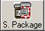 toolbar button. The window below will be shown.

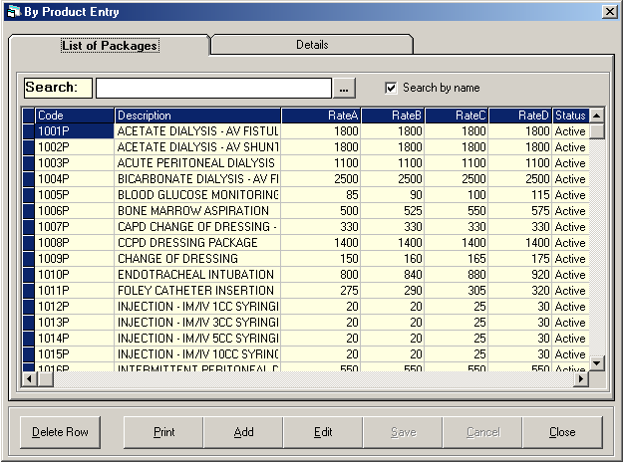
Figure 27: Supply Package Build File Window

2 How to Search - Under ’search' entry, type the first few letters of the supply package name and then press <Enter>.

3 How to Edit - Search first the supply package name and then click the Edit button. Its details will be shown. You may now enter necessary changes on the supply package information. Click the Save button afterwards to save changes entered.

4 How to Add - Click the Add button and then complete the following data.

Package ID - This is a program-generated code.
Description - Type the name of the supply package.
Active - The default entry is 'Active' meaning the supply package is readily available for use once saved.
Rate A - Type a rate for OPD room.
Rate B - Type a rate for Pay Ward.
Rate C - Type a rate for Private room.
Rate D - Type a rate for Suite room.
Under the grid entry first column, press <Enter> while entry is still blank to display list of CSR items. Double-click the item name to select. Its description will be automatically displayed in column 2. Type a remarks (if any) under column 3. Press <Enter> afterwards for the next entry.

5 How to Save - Click the Save button.

6 How to Delete - Click the supply package item from the list and then click the Delete Row button.

7 How to Abort Adding or Editing of Item - Click the Cancel button.

8 How to Close the Window - Click the Close button.

Dosage
This option allows you to add a new dosage and /or edit existing dosage.

1 How to Open the Window - Click Build Files General > Dosage. The window below will be shown.

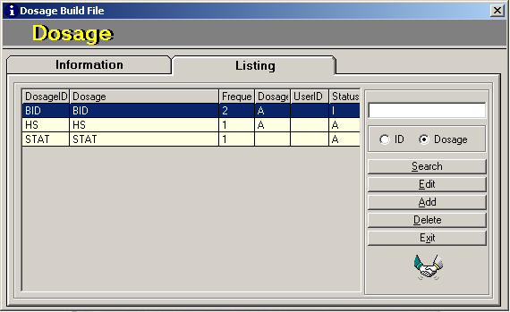
Figure 28: Dosage Build File Window

2 How to Search - Type the first few characters of the dosage name and then press <Enter>. The program automatically highlights it from the list.

3 How to Edit - After searching the item, click the Edit button. The item information will be displayed. You may now enter necessary changes. Click the Save button afterwards to save changes entered.

4 How to Delete - After searching the item, click the Delete button. The item will be automatically removed from the list.

5 How to Add - Click the Add button and then complete the following data.

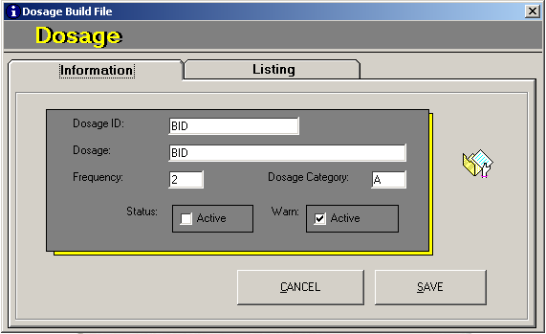
Figure 29: New Dosage Data Entry

Dosage ID - Type the ID of the dosage (can be a combination of a letter and a number) and then press <Enter>.
Dosage - Type the dosage name and then press <Enter>.
Frequency - Type the frequency of the dosage and then press <Enter>.
Dosage Category - Type the dosage category and then press <Enter>.
Status - Click the check box beside 'Active' to automatically make the dosage available for use once saved.
Warn - Click the check box beside 'Active' to automatically warn the user if the dosage is selected.

6 How to Abort Adding or Editing of Item - Click the Cancel button.

7 How to Close the Window - Click the Exit button.

Laboratory Section
This option allows you to add a new laboratory section and edit existing laboratory section.

1 How to Open the Window - Click Clinical > Section Build File > Laboratory Section. The window below will be shown.

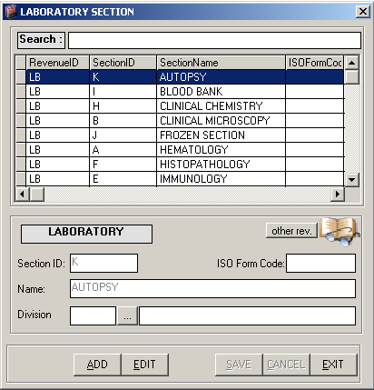
Figure 30: Laboratory Section Build File Window

2 How to Search - Type the first few letters of the section name. The program automatically highlights the item from the list.

3 How to Edit - Search first the item and then click the Edit button. You may now enter necessary changes. Click the Save button afterwards to save changes entered.

4 How to Add - Click the Add button and then complete the following data.

Section ID - Type the ID of the section and then press <Enter>. This can be the three letters from the section name.
Name - Type the name of the section.
Division - Click the to display list of divisions. Double-click the division name to select.

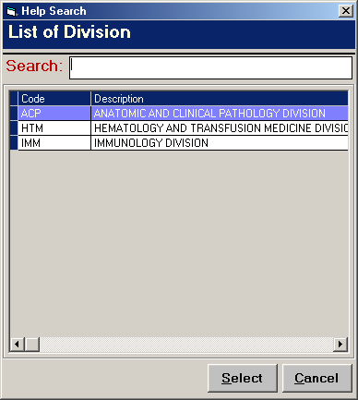
Figure 31: List of Divisions

ISO Form Code - Type the code of the ISO Form.

5 How to Save - Click the Save button.

6 How to Abort Adding or Editing of Item - Click the Cancel button.

7 How to Close the Window - Click the Exit button.

Xray Section

This option allows you to add a new xray section and edit existing xray section.

1 How to Open the Window - Click Clinical > Section Build File > Xray Section. The window below will be shown.

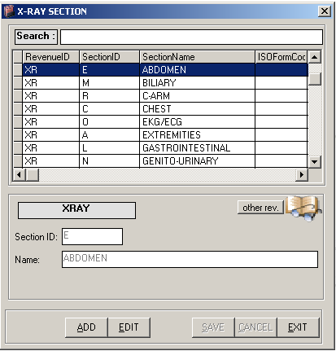
Figure 32: Xray Section Build File Window

2 How to Search - Type the first few letters of the section name. The program automatically highlights the item from the list.

3 How to Edit - Search first the item and then click the Edit button. You may now enter necessary changes. Click the Save button afterwards to save changes entered.

4 How to Add - Click the Add button and then complete the following data.

Section ID - Type the ID of the section and then press <Enter>. This can be the three letters from the section name.
Name - Type the name of the section.

5 How to Save - Click the Save button.

6 How to Abort Adding or Editing of Item - Click the Cancel button.

7 How to Close the Window - Click the Exit button.

Ultrasound Section

This option allows you to add a new ultrasound section and edit existing ultrasound section.

1 How to Open the Window - Click Clinical > Section Build File > Ultrasound Section. The window below will be shown.

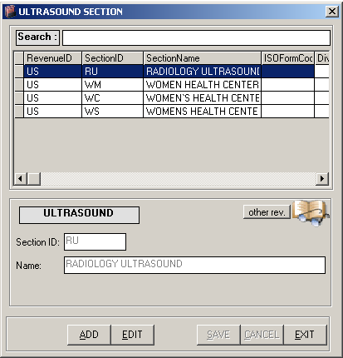
Figure 33: Ultrasound Section Build File Window

2 How to Search - Type the first few letters of the section name. The program automatically highlights the item from the list.

3 How to Edit - Search first the item and then click the Edit button. You may now enter necessary changes. Click the Save button afterwards to save changes entered.

4 How to Add - Click the Add button and then complete the following data.

Section ID - Type the ID of the section and then press <Enter>. This can be the three letters from the section name.
Name - Type the name of the section.

5 How to Save - Click the Save button.

6 How to Abort Adding or Editing of Item - Click the Cancel button.

7 How to Close the Window - Click the Exit button.

CT Scan Section

This option allows you to add a new CT section and edit existing CT section.

1 How to Open the Window - Click Clinical > Section Build File > CT Scan Section. The window below will be shown.

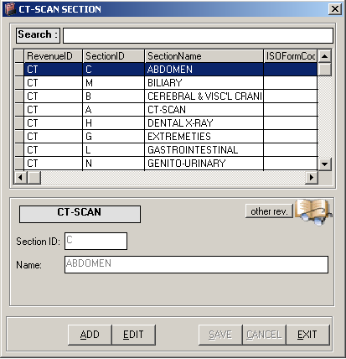
Figure 34: CT Scan Section Build File Window

2 How to Search - Type the first few letters of the section name. The program automatically highlights the item from the list.

3 How to Edit - Search first the item and then click the Edit button. You may now enter necessary changes. Click the Save button afterwards to save changes entered.

4 How to Add - Click the Add button and then complete the following data.

Section ID - Type the ID of the section and then press <Enter>. This can be form from the three letters of the section name.
Name - Type the name of the section.

5 How to Save - Click the Save button.

6 How to Abort Adding or Editing of Item - Click the Cancel button.

7 How to Close the Window - Click the Exit button.

Heart Station Section

This option allows you to add a new heart station section and edit existing heart station section.

1 How to Open the Window - Click Clinical > Section Build File > Heart Station Section. The window below will be shown.

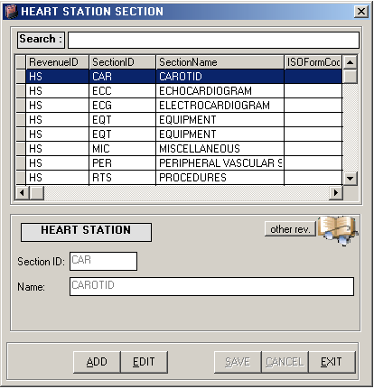
Figure 35: Heart Station Section Build File Window

2 How to Search - Type the first few letters of the section name. The program automatically highlights the item from the list.

3 How to Edit - Search first the item and then click the Edit button. You may now enter necessary changes. Click the Save button afterwards to save changes entered.

4 How to Add - Click the Add button and then complete the following data.

Section ID - Type the ID of the section and then press <Enter>. This can be the three letters from the section name.
Name - Type the name of the section.

5 How to Save - Click the Save button.

6 How to Abort Adding or Editing of Item - Click the Cancel button.

7 How to Close the Window - Click the Exit button.

Nuclear Medicine Section

This option allows you to add a new nuclear medicine section and edit existing nuclear medicine section.

1 How to Open the Window - Click Clinical > Section Build File > Nuclear Medicine Section. The window below will be shown.

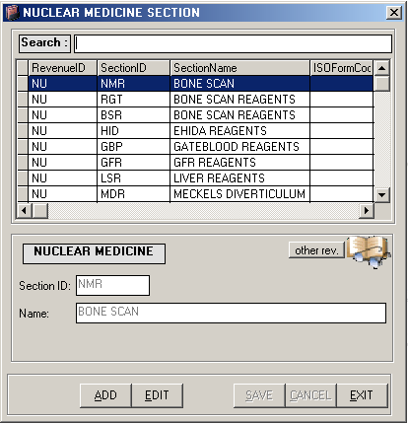
Figure 36: Nuclear Medicine Section Build File Window
2 How to Search - Type the first few letters of the section name. The program automatically highlights the item from the list.

3 How to Edit - Search first the item and then click the Edit button. You may now enter necessary changes. Click the Save button afterwards to save changes entered.

4 How to Add - Click the Add button and then complete the following data.

Section ID - Type the ID of the section and then press <Enter>. This can be the three letters from the section name.
Name - Type the name of the section.

5 How to Save - Click the Save button.

6 How to Abort Adding or Editing of Item - Click the Cancel button.

7 How to Close the Window - Click the Exit button.

RTS/Pulmonary Laboratory Section

This option allows you to add a new RTS/Pulmonary Laboratory section and edit existing RTS/Pulmonary Laboratory section.

1 How to Open the Window - Click Clinical > Section Build File > PA Section. The window below will be shown.

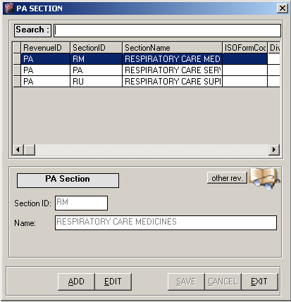
Figure 37: PA Section Build File Window

2 How to Search - Type the first few letters of the section name. The program automatically highlights the item from the list.

3 How to Edit - Search first the item and then click the Edit button. You may now enter necessary changes. Click the Save button afterwards to save changes entered.

4 How to Add - Click the Add button and then complete the following data.

Section ID - Type the ID of the section and then press <Enter>. This can be the three letters from the section name.
Name - Type the name of the section.

5 How to Save - Click the Save button.

6 How to Abort Adding or Editing of Item - Click the Cancel button.

7 How to Close the Window - Click the Exit button.

Rehabilitation Section

This option allows you to add a new rehabilitation section and edit existing rehabilitation section.

1 How to Open the Window - Click Clinical > Section Build File > Rehabilitation Section. The window below will be shown.

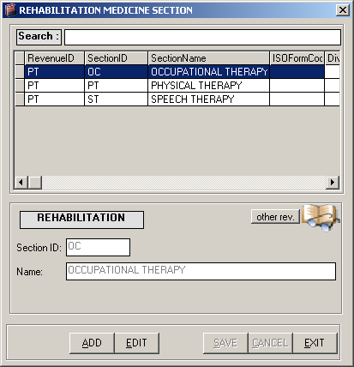
Figure 38: Rehabilitation Section Build File Window

2 How to Search - Type the first few letters of the section name. The program automatically highlights the item from the list.

3 How to Edit - Search first the item and then click the Edit button. You may now enter necessary changes. Click the Save button afterwards to save changes entered.

4 How to Add - Click the Add button and then complete the following data.

Section ID - Type the ID of the section and then press <Enter>. This can be the three letters from the section name.
Name - Type the name of the section.

5 How to Save - Click the Save button.

6 How to Abort Adding or Editing of Item - Click the Cancel button.

7 How to Close the Window - Click the Exit button.

Executive Package
This option allows you to build executive packages for different departments. To do this, go to Build Files General then Executive Package or click on 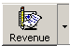 button then choose Executive Package to load the window below
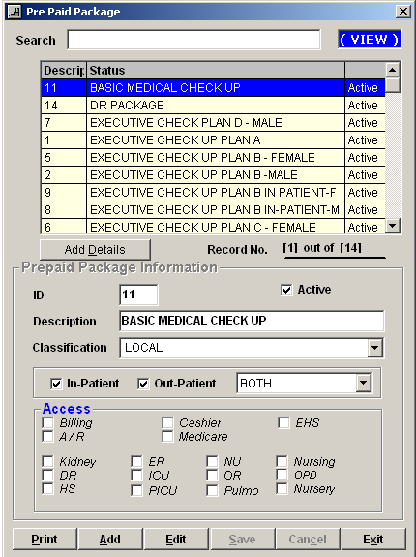
The following information should be entered
- Id – computer generated
- Description – Package Name
- Classification – choose either from OCW, Local and ECU
- Patient Type – choose from Inpatient and Outpatient
- Patient Sex – Female , Male or Both Male and Female
- Access – Choose from the department listed below who will going to charge the specific package created
Click on Save button to save the data entered.
Click on Cancel button to disregard the data entered.
Click on Exit button to go out from this window.

To add new package, click on Add button.
To edit / update an existing package, click on Edit button.

How to add detail(s) of the package

To do this, click on the ADD DETAILS button in the Executive Package Entry to load the window below
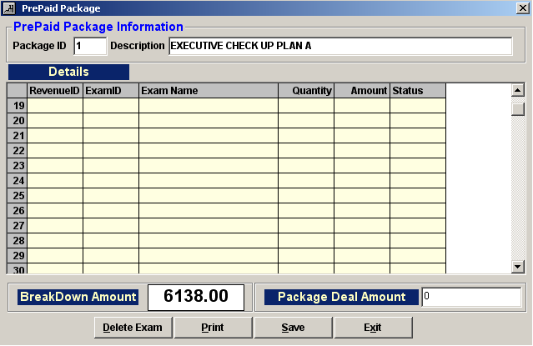
Enter the following information:
1 RevenueId – Press Enter key to load list(s) of departments then double click on the specific item
2 ExamId – Press Enter key to load list(s) of items of the chosen department
3 ExamName – Description of the item chosen.
4 Quantity
5 Amount
6 Status – Active or Inactive

The total amount of the package is located in the Package Deal Amount box.

To remove an item, highlight then click on Delete Exam button
To save the item(s) entered, click on Save button to save the data entered.
To go out from this option, click on Exit button.

Index

—A—
address, 17
—B—
business class, 21
—C—
close the program, 8
company, 14
CT scan section, 57
—D—
doctor, 27
doctor's professional fee, 67
dosage, 49
—E—
end the program, 8
—F—
features, 6
—H—
heart station section, 59
—L—
laboratory code, 42
laboratory section, 51
—N—
nationality, 23
nuclear medicine section, 61
—O—
objectives, 6
—R—
rehabilitation section, 65
religion, 25
revenue, 8
revenue exam, 11
room, 30
room accommodation, 38
room class, 36
RTS/pulmonary laboratory section, 63
—S—
service, 40
start the program, 7
station, 34
supply package, 47
—T—
telephone, 19
—U—
ultrasound section, 55
—X—
xray section,53

