University of Perpetual Help Dr. Jose G. Tamayo Medical Center

Cashier Program
User's Manual



MEDSYS
Kaiser - dela Cruz Consulting Incorporated
July 31, 2026

Copyright© 2010
ALL RIGHTS RESERVED

No part of this document may be reproduced through photocopying or in any means, stored into a retrieval system, and transmitted in any form without the express written permission of Kaiser dela Cruz Consulting Incorporated.
Permission is hereby granted to University of Perpetual Help Dr. Jose G. Tamayo Medical Center to copy and distribute this document in any of the above means provided this is for its exclusive on site use.
Although every precaution has been taken in the preparation of this manual, the company assumes no responsibility for errors or omissions. Neither is any liability assumed for any damages resulting from the use of the information contained here.

Table of Contents
Introduction 4
Overview 4
Objectives 5
Features 5
Getting Started 6
How to Start the Program 6
Changing of User's Password 7
How to End the Program 8
Program Operation 9
Cashier's Environment Setting 9
Payment Entry Form 11
Cash Transaction 12
Deposit Entry 15
Inpatient Bill Payment Entry 16
OPD Bill Payment Entry 18
Lump Sum Payment Entry 20
Company Payment Entry 21
OR Cancellation / Adjustment 21
Receipt Inquiry 23
Receipt Reprinting 24
Receipt Information Updating 25
Card Transaction Maintenance 26
Credit Memo 27
How to Adjust Items of Official Receipt Individually 28
Reports 29

Introduction

Overview


The Cashier Program is the software used by a cashier (is a person who rings up the goods or services that the costumer wishes to purchase). After all of the goods have been rung up, the cashier then collects payment for the goods or services exchanged and posts this payment to the cashier’s program. It captures not only cash payment but also checks, credit cards, debit cards etc.
Like with other MEDSYS programs, this is connected to other departments especially to cost-centers where it derives mainly the patient data to process.

Objectives

- To increase staff production while reducing overtime
- To prepare collection reports fast, easy and accurate
- To provide business (financial) information to management and process
- To provide quality control monitoring and performance reports

Features

- Medsys Cashier program is tailored made according to specific hospital’s policy, internal controls and standards
- Cashier program’s interfacing features with different clinical modules help make the posting of payment fast, easy, efficient, completely traceable electronic process that saves time, reduces cost, minimizes effort and eliminates potential for error and pricing oversights.
- It serves as a tool in processing only paid clinical procedures for walk-in patients
- It processes monthly doctors utility and clinic rentals
- It keeps track of unpaid doctors utility and clinic rentals
- Data-entry restriction - Warning messages are flashed for possible invalid entries. This ensures all data inputted would be made useful for any transaction that may occur.
- Password-protected - The use of password is necessary to restrict unauthorized access. Thus the program only accepts passwords which are registered into it. This feature ensures the confidentiality and integrity of data entered in the program.
- Auto-report generation - The program is capable of generating reports and can be readily printed
- User-friendly - The program user is guided by instructions in doing the next step providing an easy-use to process transactions. Tool-tips are also incorporated to give users an idea of what a particular button does.

Getting Started

How to Start the Program
1 Click on Cashier program executable file icon located in your computer desktop.
2 The Login window will display asking you to type your employee number and password for security purposes.
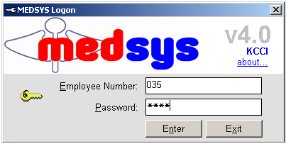
Figure 1: Login Window
3 If the program has validated your employee number and password, the Cashier Setting Window will be displayed. This window serves as the data entry for principal O.R., collection date, remittance date and shift.

Changing of User’s Password
It is advisable to change your password frequently for security reasons. To change your current password, follow these steps.
1 From the Login window, type your employee number and then press <Enter>.

2 Under the password entry, press <F12> Pressing this function key will invoke the Change Password window.
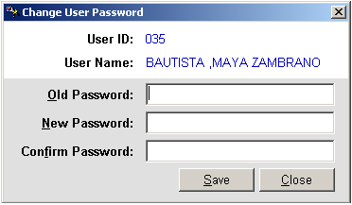
Change Password Window
3 Under the Change Password Window, type the following data.
Old Password – Type your existing password
New Password – Type your new password not exceeding to 15 characters
Confirm Password – Retype your new password to confirm and then press <Enter> or you can click the Save button.

How to End the Program
It is important for users to close the program when they are done to end-up their session. Other users might use the open program using the same password.
To close the program:

1 Click on at the upper right corner of the screen or
2 Click File > Exit.

Program Operation
Cashier’s Environment Setting
Before starting, each cashier operates the eight-key pad of the keyboard to enter the cashier code assigned to him. Once accepted, the cashier’s Environment Setting will appear.
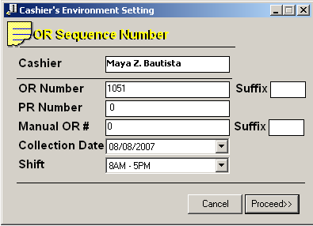
The Cashier’s Setting serves to identify the cashier using the Cashier system and to prevent use of same official receipt by someone other than the assigned cashier who has access to the same program.

1 Update the cashier’s setting information and they are as follows:
- OR Number – refers to the number on the official receipt loaded in the printer. The program compares the default starting Official receipt number already stored in the database. If the series to used is not the same, the cashier has to change the OR number in the setting and the program will validate for any duplicate or used series in the database. If, in this operation, the cashier code thus entered does not exist with one preset in the server, then the cashier can carry out a registering operation; however, if not, he cannot.
- SHIFT – refers to the working period of a cashier or group of cashiers that relieve another on a regular schedule. The EDP or supervisor assigns cashier shifts responsible for cashier’s program. The purpose of the cashier’s code (for every user/cashier) and SHIFT information is to identify the cashier who has carried out the registering operation on a given schedule and to monitor the sales of each cashier in case the hospital has multiple cashiers windows operating at the same time.
- Collection Date – it is also called cut-off date. If collection date is active or included in the cashier’s reports, all payments/transactions will be reported not on the day they were posted but on the collection date. For this institution, the reports are based on transaction date.
2 Click on Proceed button to save the setting.

PAYMENT ENTRY FORM is the main transaction entry of this program.
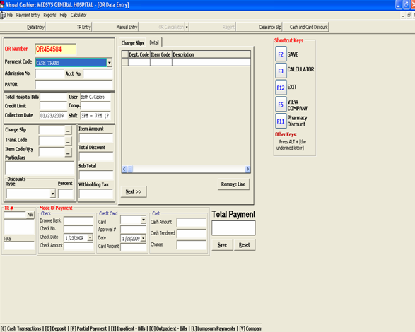 If the above form is not appearing on your screen, click on data entry toolbar button or press Ctrl + C if no other window is loaded to open it. To ensure that your current setting is correct, check the OR number appearing on the screen and compare it with the pre-printed OR number loaded in the printer.
It captures all types of payments such deposit, payment, company, lump sum payment and others.

There are 3 types of Payment Entry Form
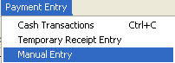
- Cash Data Entry form or On-Line entry form using Hospital’s Official receipt number
- Temporary Receipt Entry form using Hospital Provisional Receipt and no printing of receipt
- Manual Entry form is similar to Cash Transaction using Hospital’s official receipt number but the entries made will not be printed (no printing of official receipt)

Cash Transaction A transaction that is settled with cash on the same day as the trade.
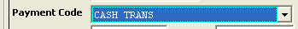 Press Enter or click twice to select the Cash Transaction and fill up the following data:
1 – The default OR number is taken from the Cashier’s Environment Setting of the cashier who accessed this program. The program will automatically increment after saving the transaction.

2 – For clinical assessed procedure(s), if patient has confinement or consultation record within the hospital, cashier may type in the hospital number if available. This will greatly help in the faster retrieval of patient’s results and consolidation of his/her medical records.

3 – one that pays, the person by whom a bill or note has been and this person’s name will be printed on the official receipt.
It is advisable to enter the full name following the format: last name, first name, middle initial for reference. In this field also, you may type the charge slip number if the charge slip is a computerized one. The program will automatically display the amount to be paid by the patient.

4 -type the charge slip number then press <Enter>.The program will automatically display the amount to be paid by the patient if it is a computerized one. For inpatient’s bill payment, HB is used as its charge slip. If professional fee is to be paid under inpatient’s bill payment, used MD as its charge slip.

5 -type the transaction code or revenue code of the charged item and then press <Enter>. You can press <Enter> or <F1> if it is still blank to display the complete list of revenue codes. To select, double click on the name of the code

6 Type the specific item code if available or press <Enter> or <F1> if it is still blank to display the complete list of items included in the revenue code. To select, double click on the name of the code.
7 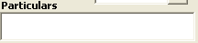 item description will automatically displayed by the program in reference with the entered transaction and item codes. Data written here will be printed on the official receipt.
8 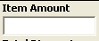 it refers to the amount/rate corresponding to the item code posted
For manual entry, supply the amount related to the charged item. If with computerized charge slip or assessment slip, the amount per item will automatically be displayed.

9 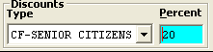 – Leave the discount type blank if with patient will not avail the discount or select from the drop down list of the different type of discounts then press enter to select. If the discount type has a built in percentage then it will automatically displayed in the percent column if none, then supply the rate.

10 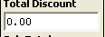 If with discount type, the total discount per item expects the user to accept the computed discount amount or overwrite it then press enter to confirm.

11 Click the button for another charge slip entry or go to mode of payment if no more charges to process.

12 Mode of Payment – it means by which a payment is made, such as cash, check, or credit card.
- Check is a negotiable instrument instructing a financial institution to pay a specific amount of a specific currency from a specified demand account held in the maker/depositor’s name with that institution.
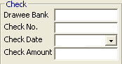
Fill up the following:
> Drawee Bank– Type the name of the bank
> Check No. – type the check number
> Check Date – type the check’s date of issuance.
> Amount
- Credit Card is part of a system of payments named after the small plastic card issued to users of the system. The issuer of the card grants a line of credit to the consumer (or the user) from which the user can borrow money for payment to a merchant or as a cash advance to the user
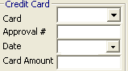
Fill up the following:
> Card – click on the arrow down to display lists of credit card companies.
> Approval number
> Date
> Card Amount

- Cash refers to money in the physical form of currency, such as banknotes and coins.
. 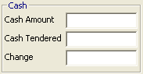
> Total Amount – this is the total amount of charges to be paid by the patient
> Cash Tendered – Type the cash amount received from the patient
> Change – this is the cash amount as change to be given back to the patient

13 Choose the button to complete the process. The official receipt form will be displayed afterwards. Click on to print official receipt.
Select if you wish to cancel all entries made on the screen without saving the data posted

Deposit Entry
A transaction type wherein advance payment for the confinement or treatment of patient in Hospital is recorded and updates the patient’s billing record.

Press Enter or click twice to select the Deposit Option and fill up the following data:
1 – The default OR number is taken from the Cashier’s Environment Setting of the cashier who accessed this program. The program will automatically increment after saving the transaction.

2 – Admission number is the 10 digit number assigned to a patient per confinement or consultation in the hospital. This number is generated at the admitting or Outpatient department upon patient’s registration in the computer.
If you know the patient’s admission number, just type the admission number and then press <Enter>. Or type the patient’s last name and then press <Enter>. Matches will be displayed. Double click the name of the patient from the list having the correct admission number. The program will automatically display the payor’s name

3 it refers to the deposit amount. The default amount will be the outstanding balance of patient but you may overwrite it based on the actual amount given by patient as deposit.

4 Mode of Payment – it means by which a payment is made, such as cash, check, or credit card. ( refer to page 13 for the instruction on Mode of Payment entry)

5 Choose the button to complete the process. This will save the deposit entry. The official receipt form will be displayed afterwards. Click on to print official receipt.
Select if you wish to cancel all entries made on the screen without saving the data posted

Inpatient-Bill
Payment for inpatient bill refers to the settlement of charges incurred of the patient admitted in the hospital and stays overnight or for an indeterminate time, usually several days or weeks. Direct application of payment to patient’s previous inpatient accounts (Receivables) is recorded in this option.
Click on the drop-down arrow to display options Press Enter or click twice to select the Inpatient-Bill and fill up the following data:
1 – The default OR number is taken from the Cashier’s Environment Setting of the cashier who accessed this program. The program will automatically increment after saving the transaction.

2 – Admission number is the 10 digit number assigned to a patient per confinement in the hospital. This number is generated at the admitting department upon patient’s registration in the computer.
If you know the patient’s admission number, just type the admission number and then press <Enter>. Or type the patient’s last name and then press <Enter>. Matches will be displayed. Double click the name of the patient from the list having the correct admission number. The program will automatically display the payor’s name

3 – The account number will automatically appear after typing the admission number.

4 - the company or person by whom a bill or note has been and this person’s name will be printed on the official receipt. It is advisable to enter the full name following the format: last name, first name, middle initial if the person is other than the patient.

5 -type HB to identify that the payment is for the hospital bill. If professional fee is to be paid, use MD.

6 item description will automatically displayed by the program in reference with number 5. You may overwrite the particular/description that will be printed on the Official receipt.
7 it refers to the amount received by the cashier. The default amount will be the outstanding Receivable balance of patient but you may overwrite it based on the actual amount given.

8 Mode of Payment – it means by which a payment is made, such as cash, check, or credit card. ( refer to page 13 for the instruction on Mode of Payment entry)

9 Choose the button to complete the process. This will save the transactions posted. The official receipt form will be displayed afterwards. Click on to print official receipt.
Select if you wish to cancel all entries made on the screen without saving the data posted

OPD-Bill
Payment for OPD (Outpatient) bill refers to the settlement of charges incurred of the patient who is not hospitalized overnight but who visits the hospital or associated facility for diagnosis or treatment. Direct application of payment to patient’s previous outpatient accounts (Receivables) is recorded in this option.
Click on the drop-down arrow to display options Press Enter or click twice to select the OPD-Bill and fill up the following data:
1 – The default OR number is taken from the Cashier’s Environment Setting of the cashier who accessed this program. The program will automatically increment after saving the transaction.

2 – Admission number is the 10 digit number assigned to a patient per consultation in the hospital. This number is generated at the ER or Outpatient department upon patient’s registration in the computer.
If you know the patient’s admission number, just type the admission number and then press <Enter>. Or type the patient’s last name and then press <Enter>. Matches will be displayed. Double click the name of the patient from the list having the correct admission number. The program will automatically display the payor’s name

3 – The account number will automatically appear after typing the admission number.

4 - the company or person by whom a bill or note has been and this person’s name will be printed on the official receipt. It is advisable to enter the full name following the format: last name, first name, middle initial if the person is other than the patient.

5 -type HB to identify that the payment is for the hospital bill. If professional fee is to be paid, use MD.

6 item description will automatically displayed by the program in reference with number 5. You may overwrite the particular/description that will be printed on the Official receipt.
7 it refers to the amount received by the cashier. The default amount will be the outstanding Receivable balance of patient but you may overwrite it based on the actual amount given.

8 Mode of Payment – it means by which a payment is made, such as cash, check, or credit card. ( refer to page 13 for the instruction on Mode of Payment entry)

9 Choose the button to complete the process. This will save the transactions posted. The official receipt form will be displayed afterwards. Click on to print official receipt.
Select if you wish to cancel all entries made on the screen without saving the data posted

Lump Sum
It is a one-time payment of money from company, hmo or individual with multiple outstanding account balances in the hospital. The amount will be allocated or applied to the different inpatient and/or outpatient receivables.
Click on the drop-down arrow to display options. Press Enter or click twice to select the Lump Sum and fill up the following data:
1 – The default OR number is taken from the Cashier’s Environment Setting of the cashier who accessed this program. The program will automatically increment after saving the transaction.
2 – Type the account code where the payment was received and then press <Enter>. You can press <Enter> or <F1> if it is still blank to display the complete list of account codes. To select, double click on the account name.
3 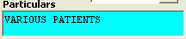 Various patients will be the default particular. You may overwrite the particular/description that will be printed on the Official receipt.
4 it refers to the amount received by the cashier.

5 Mode of Payment – it means by which a payment is made, such as cash, check, or credit card. ( refer to page 13 for the instruction on Mode of Payment entry)

6 Choose the button to complete the process. This will save the transactions posted. The official receipt form will be displayed afterwards. Click on to print official receipt.
Select if you wish to cancel all entries made on the screen without saving the data posted

Company Payment
The concept of this payment code is the combination of Inpatient/OPD bill payment and lump sum. For Inpatient or OPD bill payment, the amount received came from an individual and directly applying the amount paid to his/her specific confinement/consultation account while for company payment, the money came from an institution (Company / HMO etc) directly applying to patient’s receivable account. It is similar to lump sum because the payor or the name that will appear on the receipt is the institution’s name and not the patient’s name.
Click on the drop-down arrow to display options. Press Enter or click twice to select the Lump Sum and fill up the following data:

1 – The default OR number is taken from the Cashier’s Environment Setting of the cashier who accessed this program. The program will automatically increment after saving the transaction.

2 – Type the account code where the payment was received and then press <Enter>. You can press <Enter> or <F1> if it is still blank to display the complete list of account codes. To select, double click on the account name.

3 – Admission number is the 10 digit number assigned to a patient per consultation in the hospital. This number is generated at the ER or Outpatient department upon patient’s registration in the computer.
If you know the patient’s admission number, just type the admission number and then press <Enter>. Or type the patient’s last name and then press <Enter>. Matches will be displayed. Double click the name of the patient from the list having the correct admission number. The program will automatically display the payor’s name

4 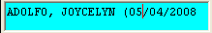 patient name, confinement and admission number will be the default particular that will be printed on the Official receipt.

5 it refers to the amount received by the cashier.

6 Mode of Payment – it means by which a payment is made, such as cash, check, or credit card. ( refer to page 13 for the instruction on Mode of Payment entry)

7 Choose the button to complete the process. This will save the transactions posted. The official receipt form will be displayed afterwards. Click on to print official receipt.
Select if you wish to cancel all entries made on the screen without saving the data posted

O.R. Cancellation / Adjustment
This option allows you to make correction or modification on the previously entered payment details to reflect actual conditions. This process is done due to some unavoidable situations like withdrawing the patient’s procedure in which payment was already saved. Unlike in adjustment, you can still reuse the receipt. This also happens when wrong discount type was entered or wrong account code for a particular item was saved.
NOTE:
To cancel or adjust receipt, the date of collection when the transaction occurred should be the same with the user’s current date.

1 Click on Cancel/Adjust toolbar button.
2 The O.R. Cancellation / Adjustment window will be displayed.
3 Enter the O.R. # you want to adjust or cancel. If the OR number is found, the program will automatically display its details.
4 The following button options can be click from
    - Cancel O.R. – when this is clicked, it will cancel the receipt
    - Adjust – when this is clicked, it will adjust the receipt.
    - Close – when this is clicked, it will close the O.R. Cancellation/Adjustment window

Receipt Inquiry
This option allows you to know the details of a particular issued Official Receipt number.
1 Click on Inquiry toolbar button to open the window
2 In the Inquiry window, type the receipt number or payor’s first name/last name/ middle name and then press <Enter>. Matches of the query will be displayed under the issued official receipts. The following data are displayed.
      - Receipt #
      - Payor’s name
      - Report Date
      - Status
      - Cashier
      - Shift
NOTE: To inquire receipts from past transactions, you must click the check box beside Include Past Issuances.
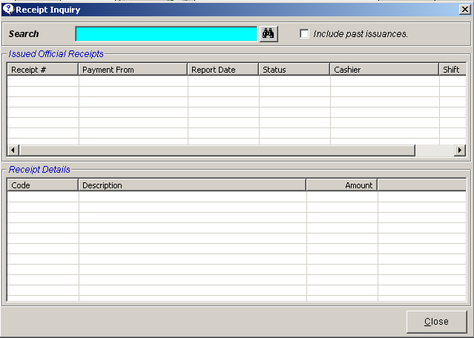
Inquiry Window
3 Double click the row where the receipt is aligned. The details of the receipt are displayed on the Receipt Details. The following data can be viewed
- Code
- Description
- Amount
4 Close – click this to close the Inquiry window

Receipt Reprinting
This option lets the user reprint the receipt that was already saved by the user.
1 Click on Reprint toolbar button
2 In the Receipt entry window, type the receipt number and then click on view button.
3 The printable receipt form will be displayed. Click on to print

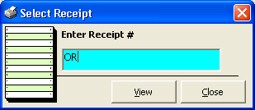
Receipt Reprinting

Receipt Information Updating
To correct wrong entry of receipts entered in a particular principal O.R., the program provides this option to change the old principal O.R. info into a new one.

1 Click File > Receipt Info Update
2 Its window will be displayed. Type the receipt number and then press <Enter>. If found, the original receipt information will be displayed.
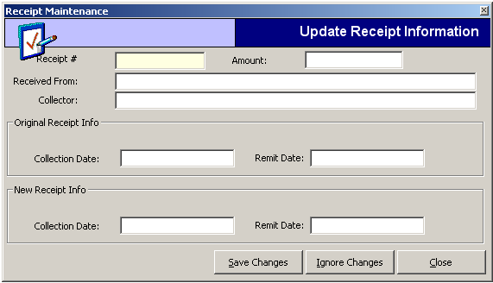
3 Under the New Receipt Info, type the new principal O.R. of the receipt.
4 The following button options can
be clicked from.
- Save Changes – click this to save the changes entered
- Ignore Changes – click this to disregard the changes entered
- Close – this will close the window

Card Transaction Maintenance
This option lets user to maintain the accuracy of credit card transactions. This can cancel and adjust saved credit card of current and past transactions.

1 Click File > Card Transaction Maintenance
2 Its window will be displayed. Enter the following datum
Trans # - type the transaction number and then press <Enter>. Once the number is found, its details will be displayed on the Receipt Details. Data displayed are code, description and amount.
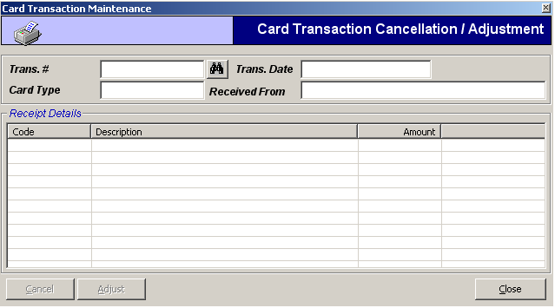
3 The following button options can be clicked from
- Cancel – this will cancel the entered credit card transaction. Cancellation implies that the entered credit card transaction number will be considered void.
- Adjust – this will adjust the entered credit card transaction. Adjustment implies that the changes will be made from the entered credit card transaction number
- Close – this will close the window

Credit Memo
A Credit Memo (short for "credit memorandum") is a commercial document issued by a seller to a buyer, listing the products, quantities and agreed prices for products or services the seller provided the buyer, but the buyer did not receive or returned. It may be issued in the case of damaged goods, errors or allowances. In respect of the previously issued invoice, a Credit Memo will reduce or eliminate the amount the buyer has to pay.

This option allows the cashier to process returns of items that is already paid. To do this, go to File then CREDIT MEMO, this will load a sample window below.
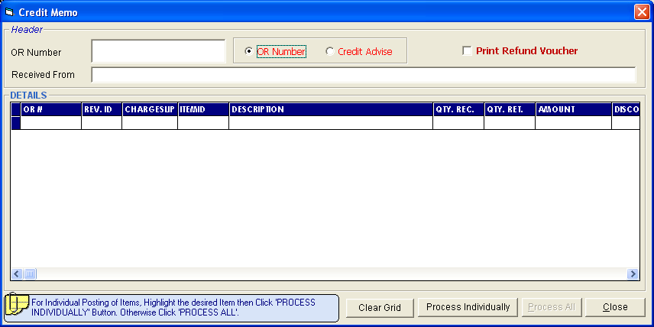
Enter the Credit Advise Number generated by the department and it will load the item(s) to be returned. Click on Process Individually button or Process All button to process transactions. Click on Close button to go out from this option.
Click the box beside Print Refund Voucher if the item to be process is a refund or the cash will be given back to the patient.

How Adjust Items of Official Receipt Individually
This option allows the user to cancel a specific item in the issued official receipt incase wrong item is posted or included. To do this, click the arrow down in the OR Cancellation button to load a sample window below.
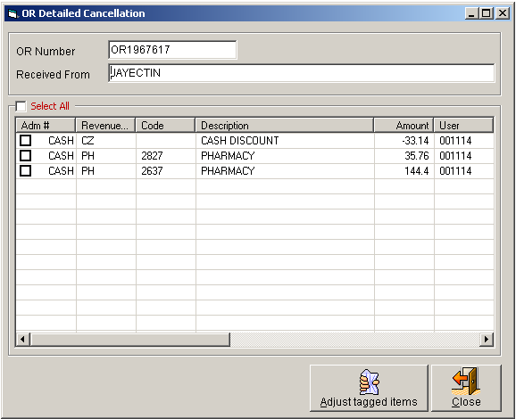

List of items of the OR entered will be displayed. Tag the item to be adjusted / removed then click on Adjust Tagged Items button to totally remove the item from the Official Receipt or click on Close button to go out from this option.

Reports
- Daily Collection Report (Summary)
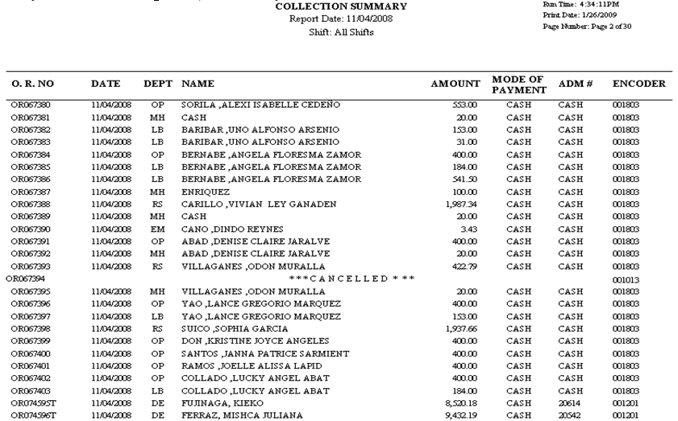
- Daily Collection Summary (Detailed)
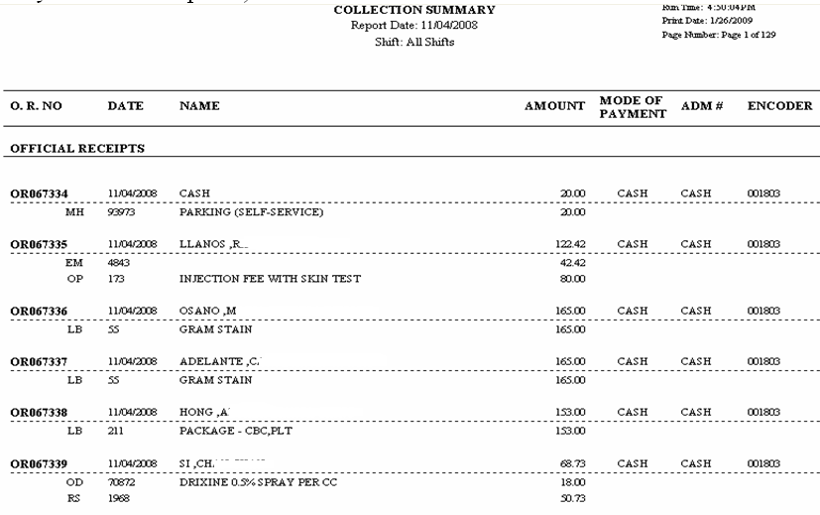
- Daily Cash Report Summary
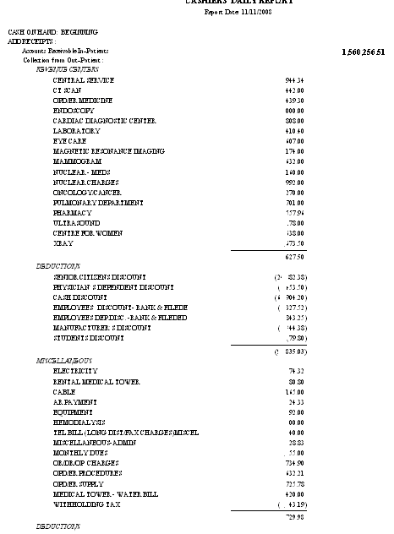
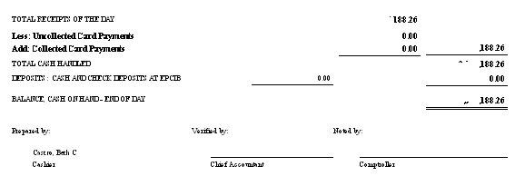

- List of Payments
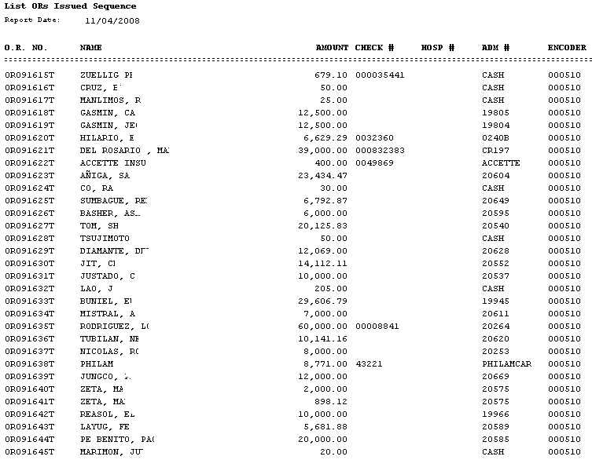

- Daily Cash Report
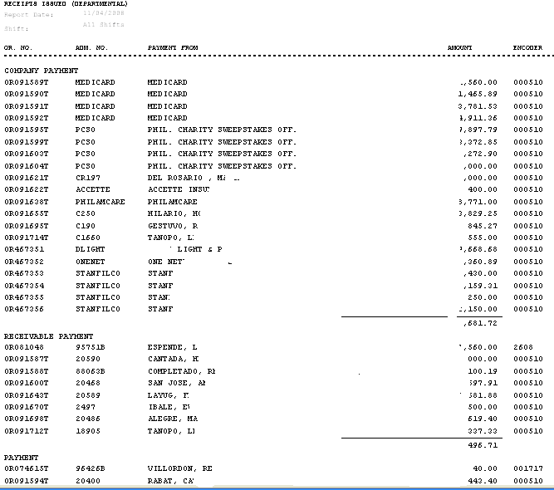

- Credit Card Report
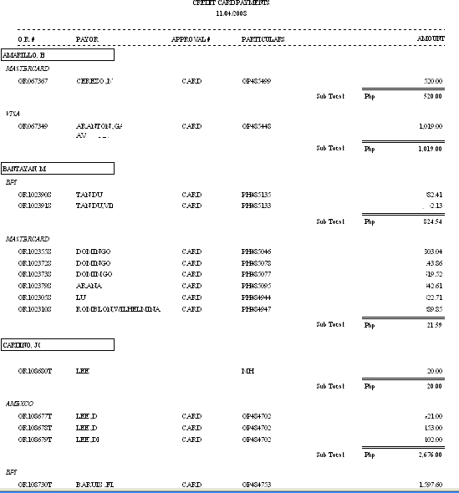

- Checks Payment
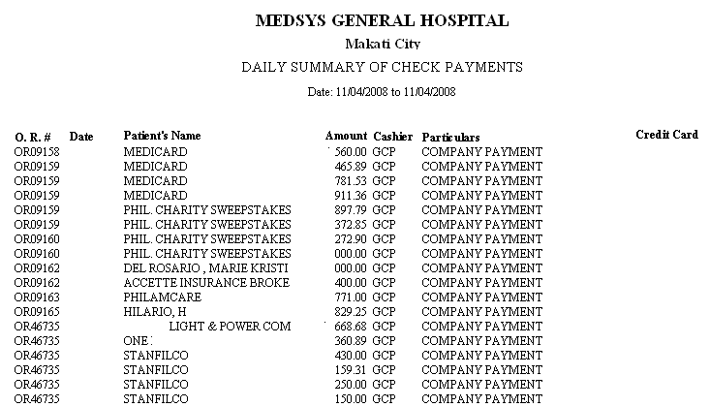
- Daily Collection Summary Per Department
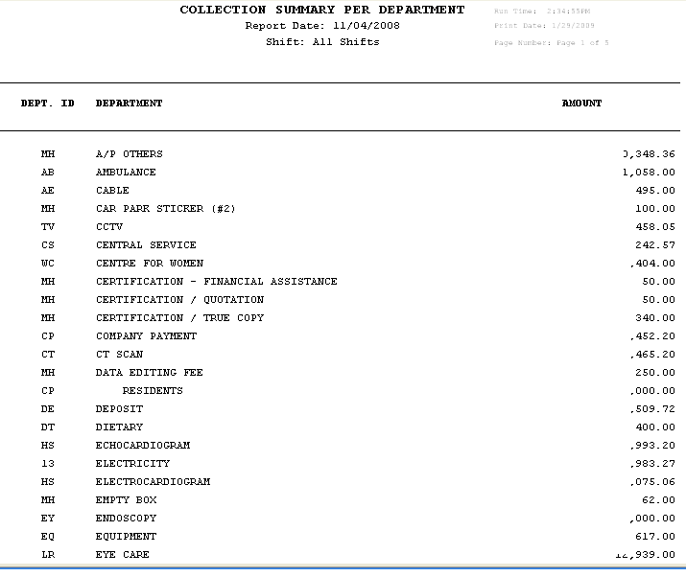

- Monthly Collection Summary Per Department
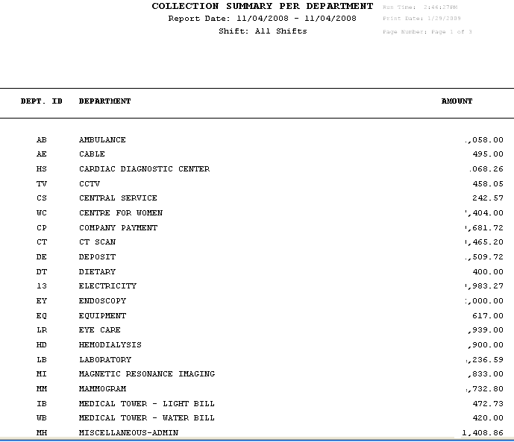
- Temporary Receipts Report – Outstanding TR Request
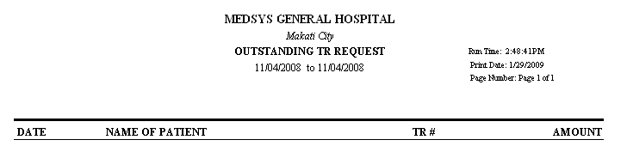

- Temporary Receipts Report – Posted Temporary Receipts
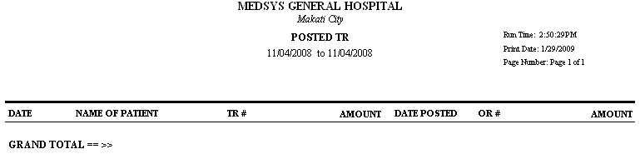
- Doctor’s Report- By Period – Per Doctor/Per Range
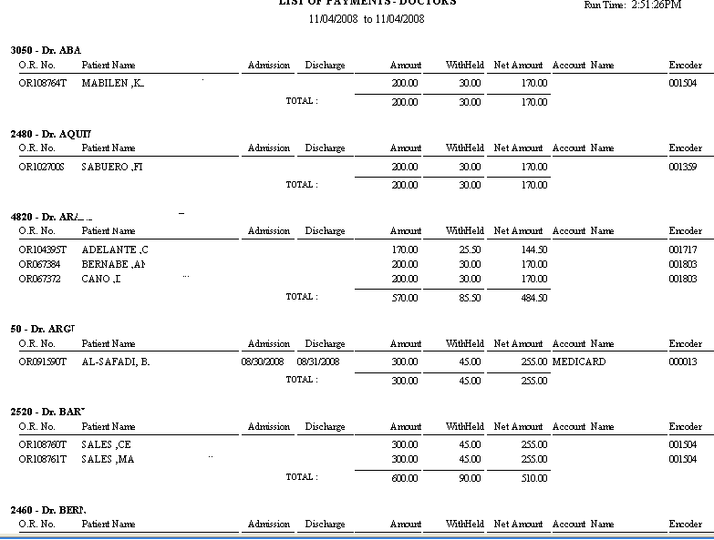

- Doctor’s Report – By Period – Doctor’s Copy
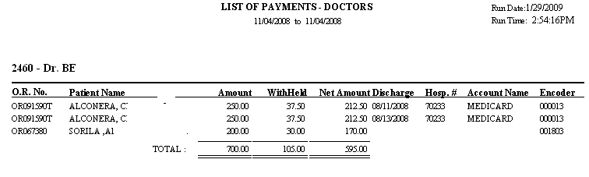
- Doctor’s Report – By Period – Sorted Per Official Receipt
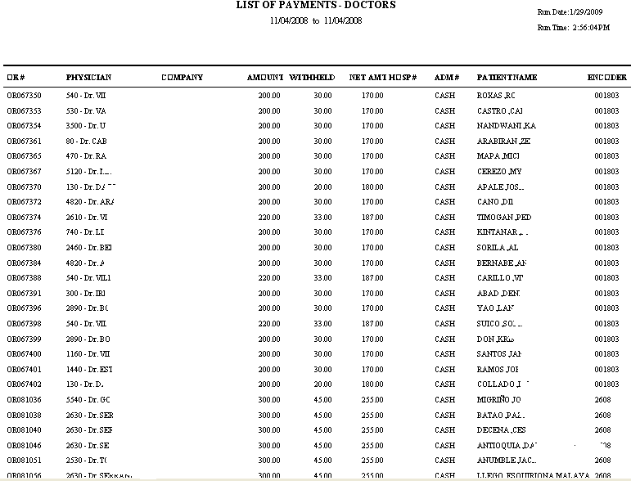

- Doctor’s Report – By Period – Sorted Per Official Receipt – By Doctor
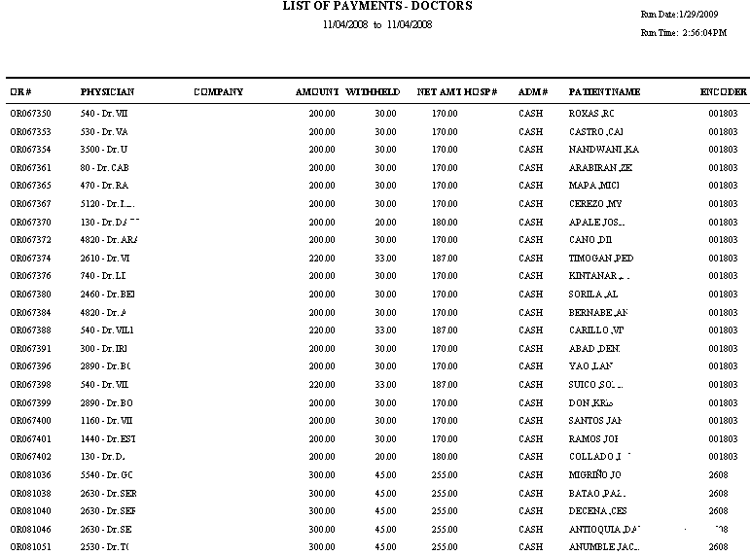
- Withholding Tax on Professional Fees by Period
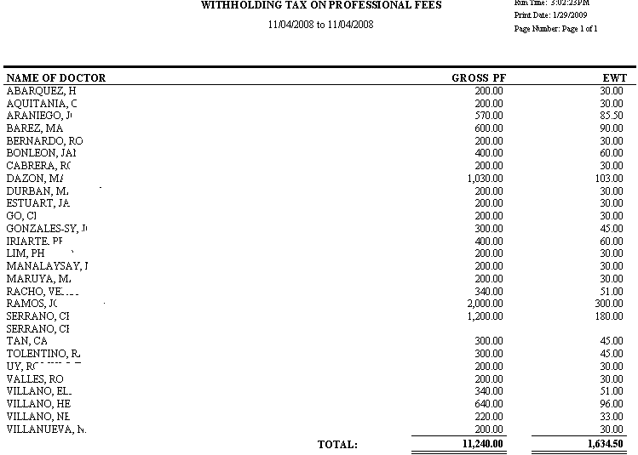
- Doctors Professional Fees Voucher
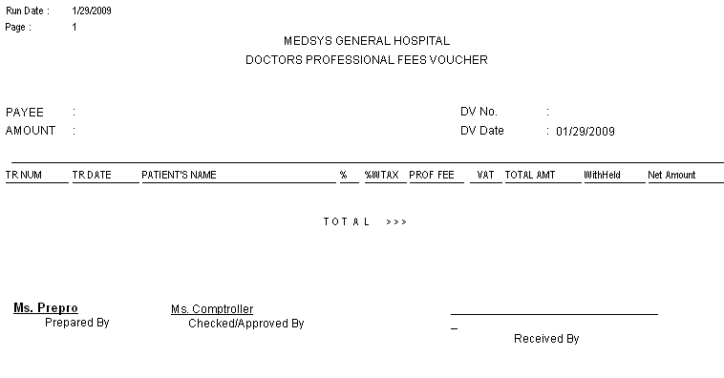
- Doctor’s Report – Quarterly – Quarterly List of Medical Practitioner
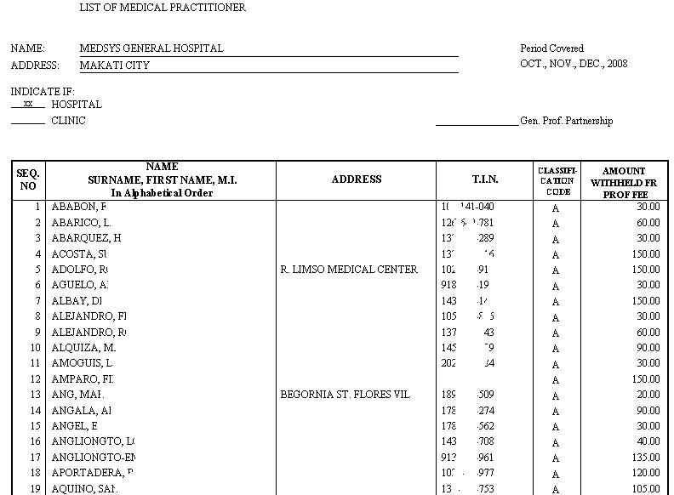
- Doctor’s Report – Quarterly – Withholding Tax on Professional Fees Per Quarter
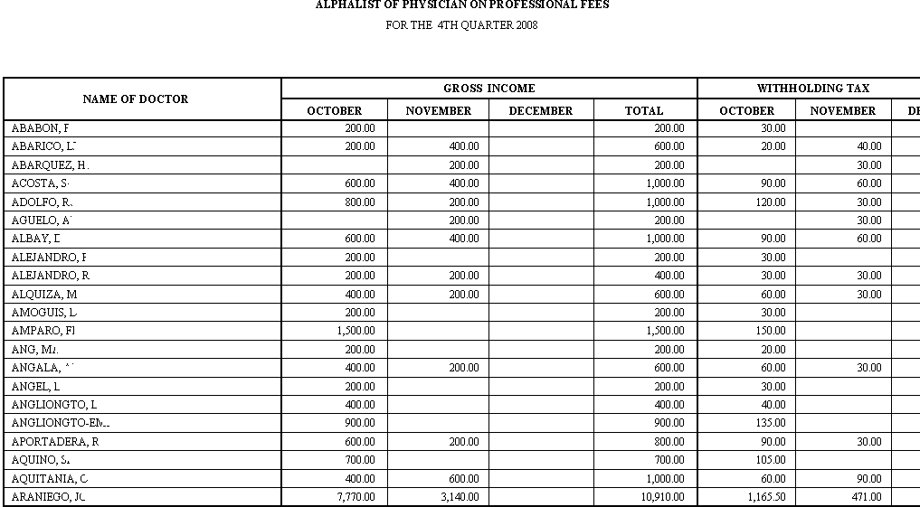
- Doctor’s Report – Annual Reports – Year End Alpha List of Physician on Professional Fees
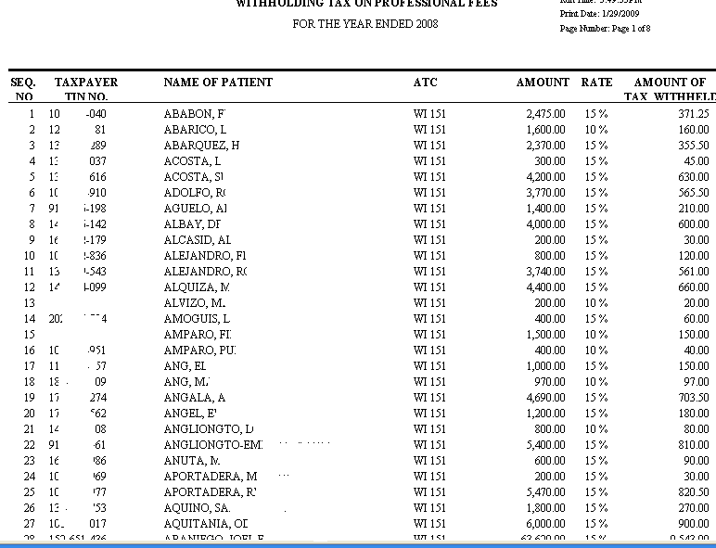
- Doctor’s Report – Annual Reports – Year End Alpha List of Physician on Professional Fees (Quarterly)
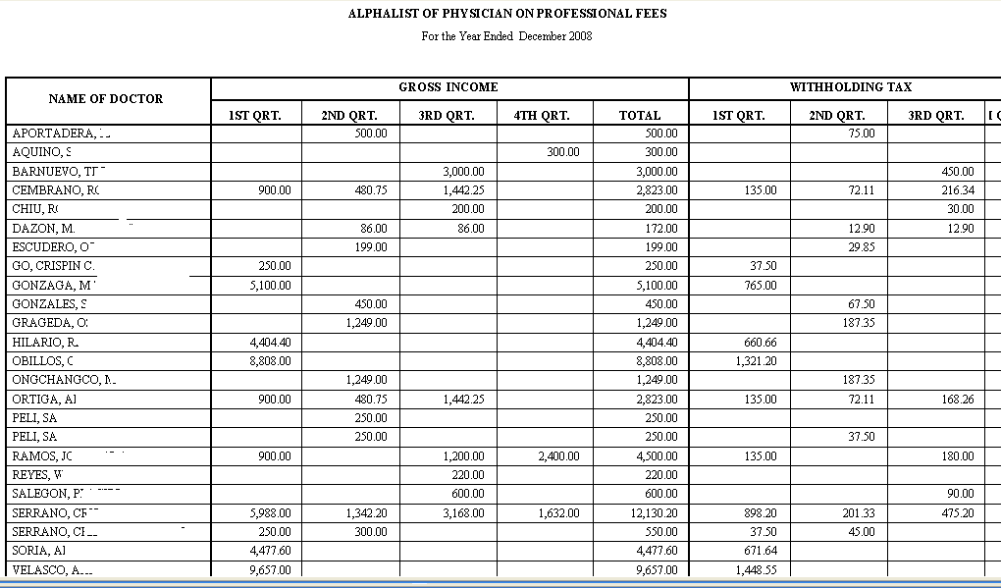
- Refund Voucher
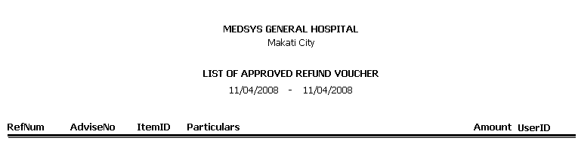

- Credit Memo Report
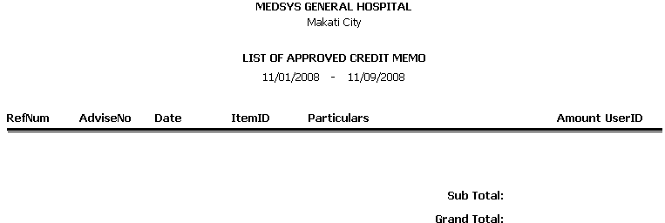
- Clearance Slip
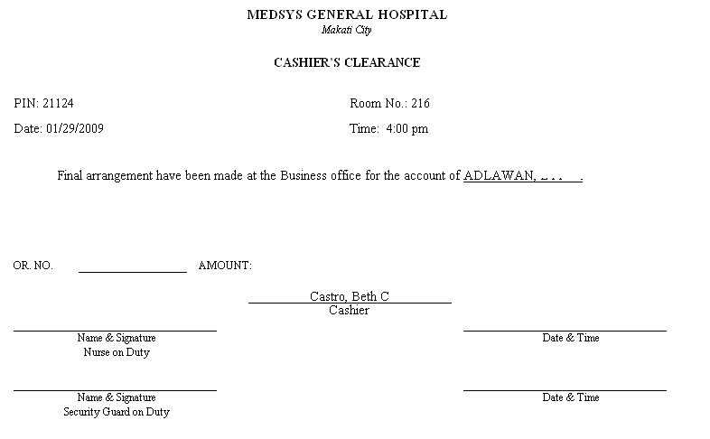

Index

—A—
Account code, 9

—B—
Batch, 9
—C—
Card Transaction Maintenance, 16
Cash Transaction, 8
Changing of users password, 6
Charge slip, 9
—D—
discount, 10
—F—
features, 4
—H—
How to start the program, 5
How to end the program, 7
—I—
Index, 19
Inquiry Window, 13
Issued Official Receipts, 13
—M—
Mode of payment, 10
—N—
Net amount, 10
—O—
objectives, 4
O.R. Cancellation / Adjustment
overview, 4
—P—
Particulars, 9
Payment, 10
Payment code, 9
Payor, 9
Principal O.R. Printing, 11

—R—
Receipt Information Updating, 15
Receipt Inquiry, 13
Reports, 18

