MedSys eClaims Manual
Contents
MedSys e-Claims 2
A. Member Eligibility 3
1. Pin Verification Utility 4
2. Online searching of Employer 4
B. Upload Documents 5
C. Electronic Claim Submission 6
D. Checking of Claim Status 6
E. Checking of Voucher Details 7
Electronic Claim Processing 7

MedSys e-Claims
- Objectives:
  - To serve as an initial step towards a paperless hospital claims reimbursement
  - To speed up the period of filing and processing of claims
  - Provide mechanism for hospitals to verify status of already submitted claims by using the Claims Series LHIO number generated by PhilHealth

These are the online functionalities that would be used for e-Claims transactions.
- Member Eligibility
- Upload Documents
- Electronic Claim Submission
- Claims Status
- Check Voucher Details
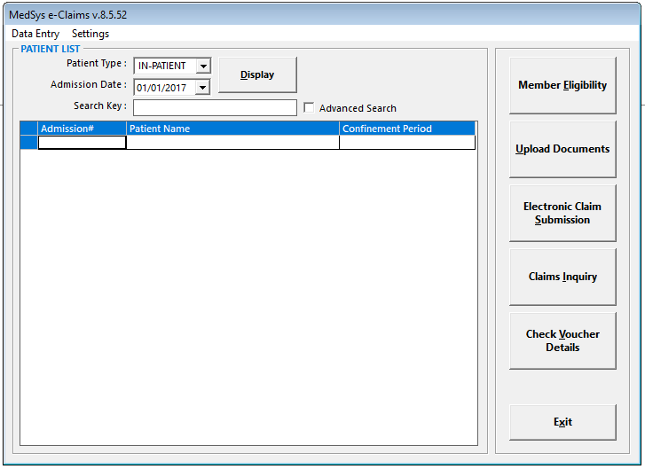

Member Eligibility
Verification should be made upon admission (initial call) and after discharge (final call).
The (final call) is where the Tracking Number is generated for confirming eligibility for member to avail of his/her appointment.
- Under Check Member Eligibility Module, there are two functions that would be very useful for the end user.
- Forgot PIN? (PIN Verification Utility)
- Search Employer Online? (Online searching of Employer)
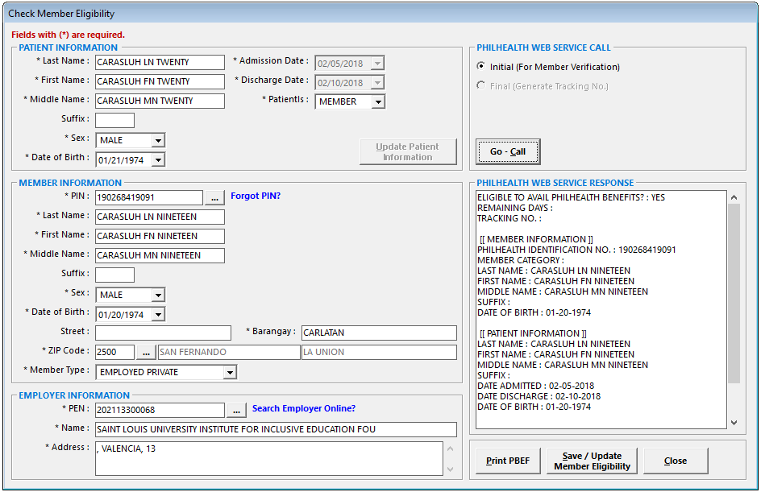

Pin Verification Utility
This utility allows member through the IHCP to look up its PhilHealth Identification Number (PIN) in the event the member does not know his PIN.
The hospital needs to enter the information of the member such as the complete name including the suffix if applicable and birth date.
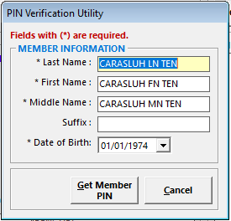

Online searching of Employer
This can be used in searching employer with PhilHealth Employer Number
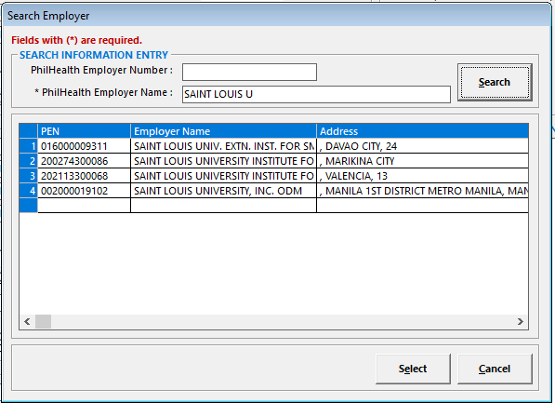

Upload Documents
This can be used to upload claim supporting documents. Ex: (CSF, SOA, CF1, CF2)
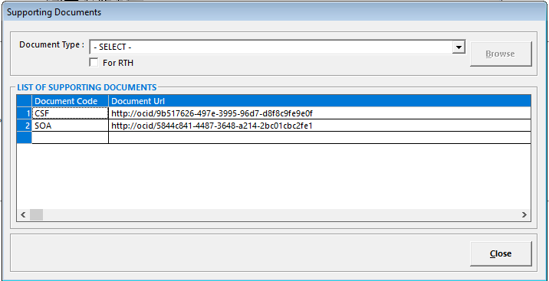

Electronic Claim Submission
This can be used by the hospitals to make their Claim files upload to PhilHealth.
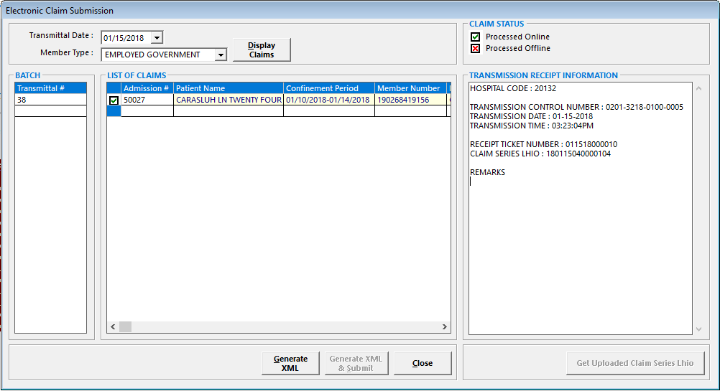

Checking of Claim Status
This can be used to check the submitted claims status.
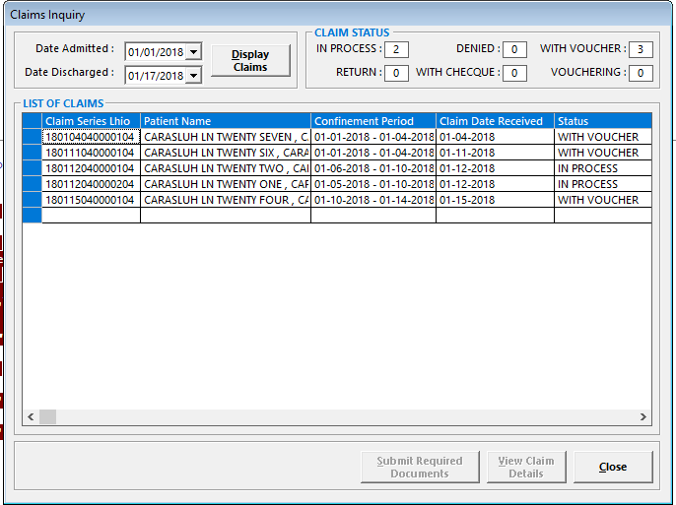

Checking of Voucher Details
Facilitate reconciliation between paid claims.
The input parameter here is the voucher number.
Take note that there could be more than one claim in a voucher.
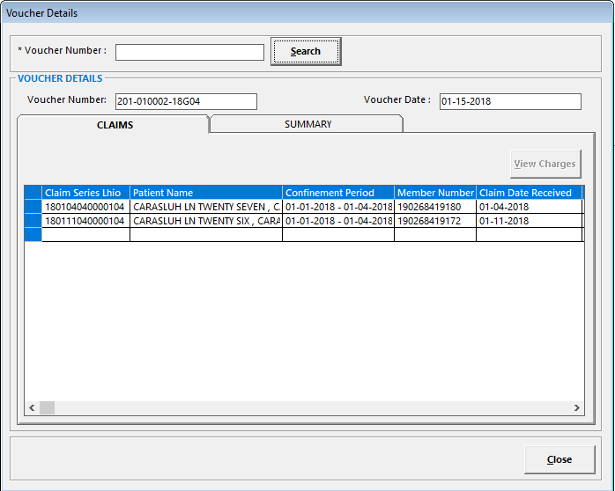

Electronic Claim Processing
