MEDSYS
Kaiser dela-Cruz Consulting Incorporated
April 30, 2020

Introduction

Overview

The PHILHEALTH Program is an approach to a better processing of PHILHEALTH computation. This is connected to Billing Program to retrieve the consolidated patient’s charges. Computation is done automatically based on the rate conditions that are programmed in the computer in line with the rules of PHILHEALTH computation.
Needed forms to be submitted in PHILHEALTH are also incorporated in the program. Its printout is automatically generated once needed.
To maintain the confidentiality of data, the program only accepts users who are registered to PHILHEALTH program. This is the importance of using password and assigning defined rights to users to prevent unauthorized access.

- Main Window

What’s New?

- Restriction of Data Entry icon if no PhilHealth Benefits are applied.
- Restriction of Auto-Computation icon if no Claim Form (CF1) posted.

- ‘View Patient’s Diagnosis’ allows you to view Patient’s Admission and Final (written) Diagnoses from Nurse Stations, and ICD-10 Codes from what were posted in Medical Records Module.
To view this, right-click the Patient's name on any clickable Tabs (In-Patient, Out-Patient, Discharge, Computed or Posted); select View Patient's Diagnosis.
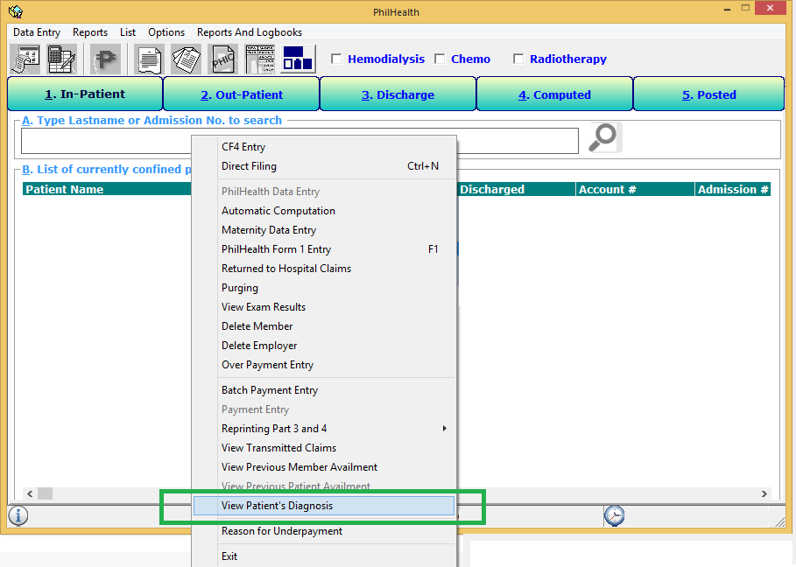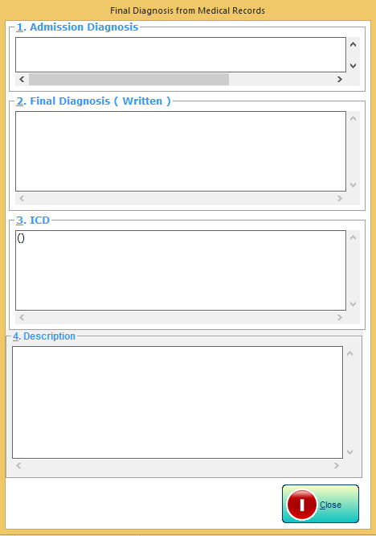

- Claim Form (CF1) Entry
What’s New?
  - Additional fields include Patient’s PIN, sex, contact number, Attending Physician, and Footer Remarks for notes to be reflected on the Patient’s Statement of Account.
To access:
- Select a patient from the In-patient/Out-Patient Tab.
- 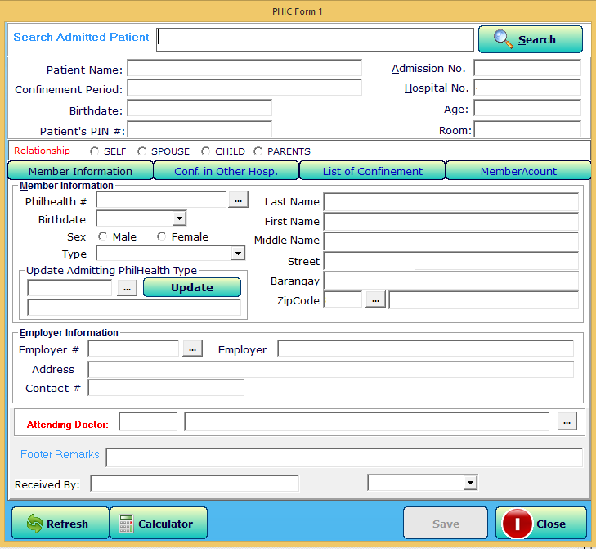Click Data Entry Menu, select PhilHealth Form 1 Entry or press F1.
  - Attending Doctor Entry
This allows you to validate the patient’s confinement not within the accreditation period of Doctor.
    - If Patient’s admission date is not within the Doc's PHIC Validation Period.
    - If Doc's PHIC Validation Period is already expired.
    - If Doc's PHIC Validation Period will expire in [No. of Days] days.
    - If Doctor has no PHIC Accreditation Number.
To access:
- Click the 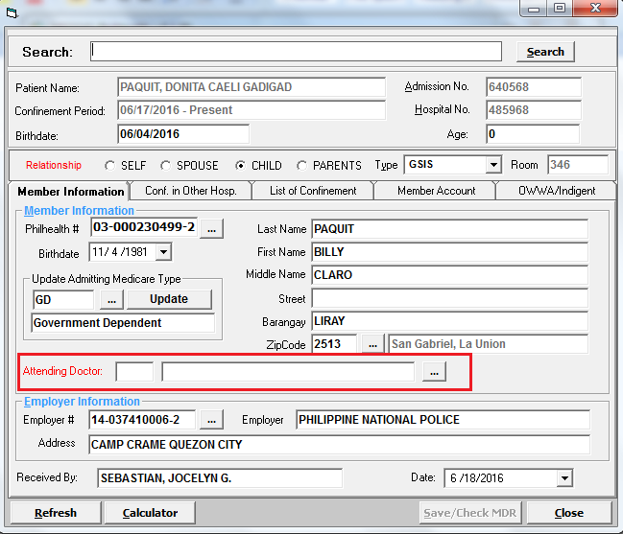 button to view the List of Doctors Window; Auto-Searching of Doctors by Last Name.
- 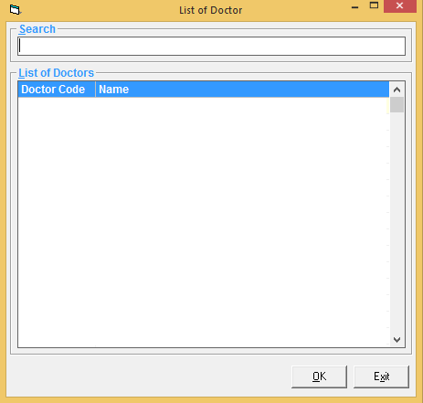Double-click selected doctor to proceed.

- Claim Form(CF3) Entry
This is incorporated in CF4 Entry.
To access, the patient must be tagged as Female in gender, and is Pregnant.

- Claim Form(CF4) Entry
What’s New?
To allow access on the Patient’s Medical data.

To allow a manual entry for Patient’s Outside Medicines.

- Auto-Computation
What’s New?

    - Manual Allocation of Professional Fee PhilHealth Benefits
To allocate 1st Case and 2nd Case Benefits in completion with the PhilHealth PF Benefits policy.
    - Enhanced PhilHealth Specialization Options
    - 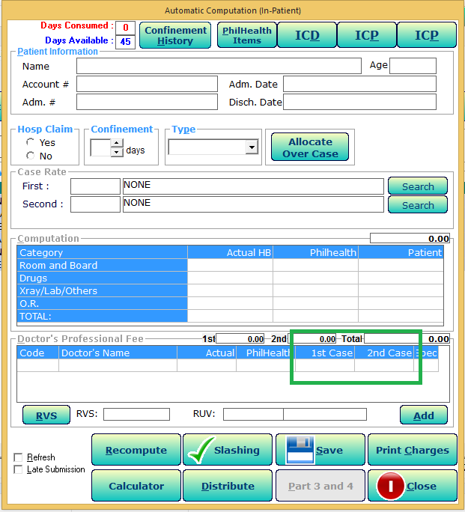NET of Discount Computation for Senior and Person With Disability(PWD) Patients

- PhilHealth Case Rates Terms and Condition Policy
This feature allows to validate patient’s confinement consent under PHILHEALTH Case rates policy.
- If Inpatient, restriction is based on patient’s age and hours of stay; refer to Build File Case Rates (Case Rate Terms and Condition) for valid age/s and confinement hours.
- No restrictions if out-patient, chemo, hemo or expired patients.

To Validate,
- Select Patient from the In-patient/Out-Patient Tab.
- Click on the button to view List of Case rates; Searching option by Description, ICD, RVS code.
- Double-click selected patient or click ‘Select’ button to proceed.

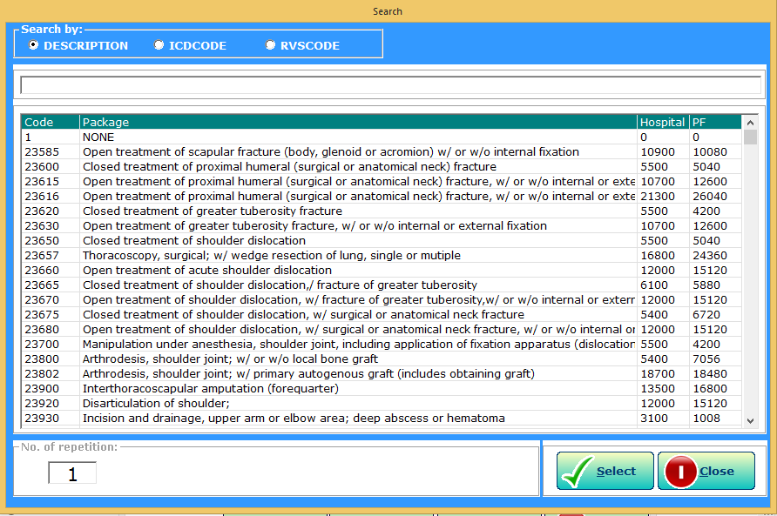

- 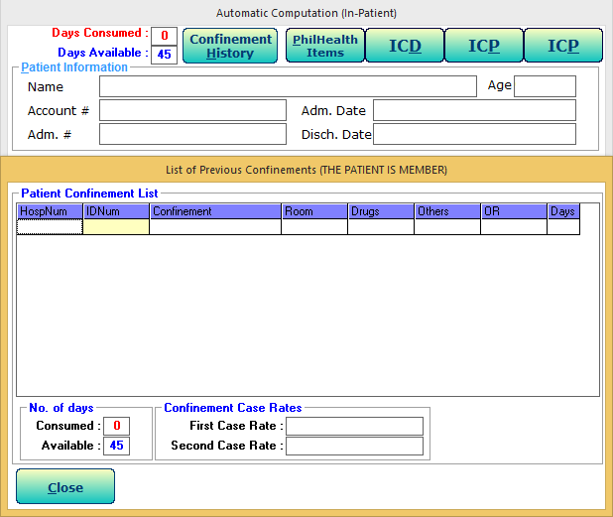Confinement History
This allows you to view Patient’s Confinement as Member or as Dependent.

- Doctor’s Fee
This allows to view Doctor’s Fee entered in Nurse Module.
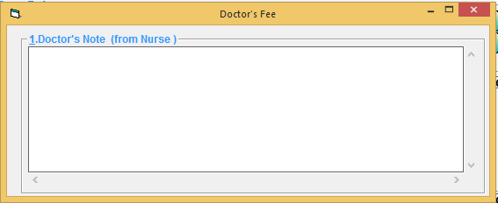

- Payment Entry
What’s New?

- Batch Payment Entry
This option allows you to enter PhilHealth Payment by batch. One official receipt is used for batch of payments.
To access, click Data Entry Menu and then select Batch Payment Entry.
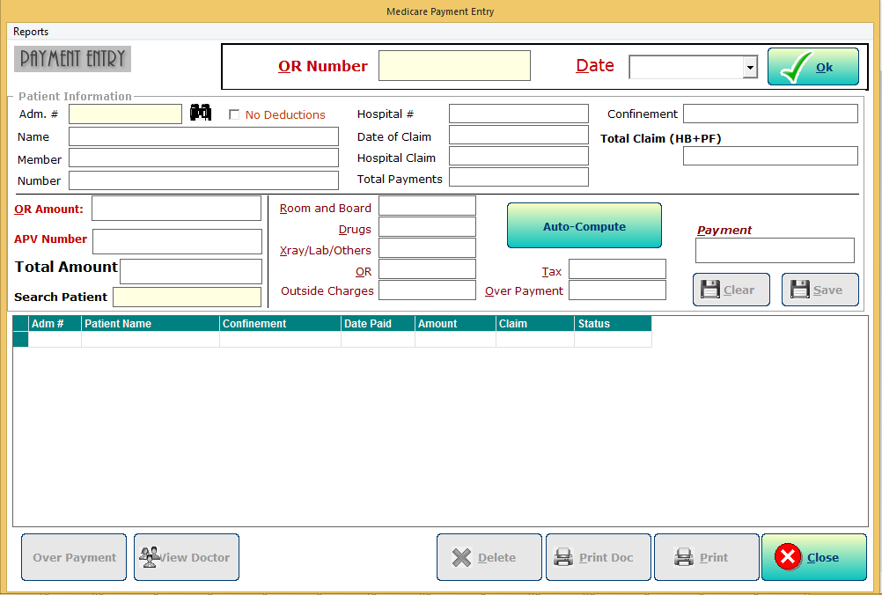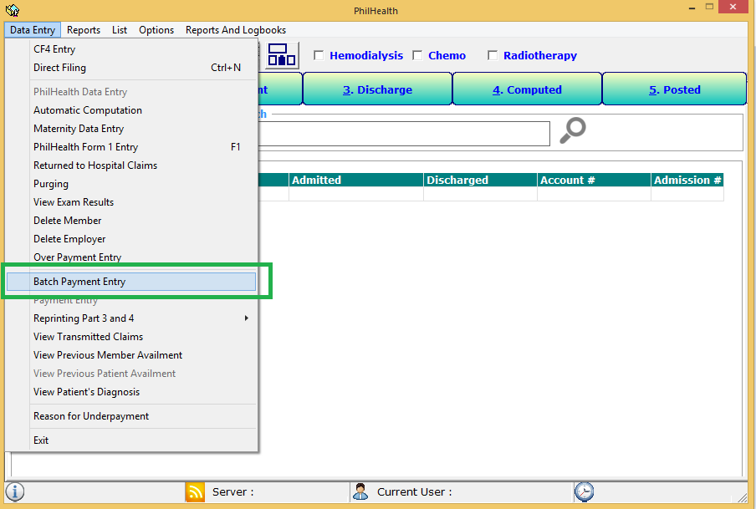
- Doctors Payment Entry
This allows you to enter payment for Doctor’s Professional Fee. You can view this through Individual or Batch Payment Entry Window.
This is to automatically compute the Doctor’s VAT, Taxable PF, W/tax and NET. The reflected Tax rate and VAT are based on Build File Module.
And, to generate computed values for the auto-posting of payments for Doctor’s Professional Fee needed on Accounting Module.

To access, double-click the patient name on the list, and click Update. Then, click View Doctor button.

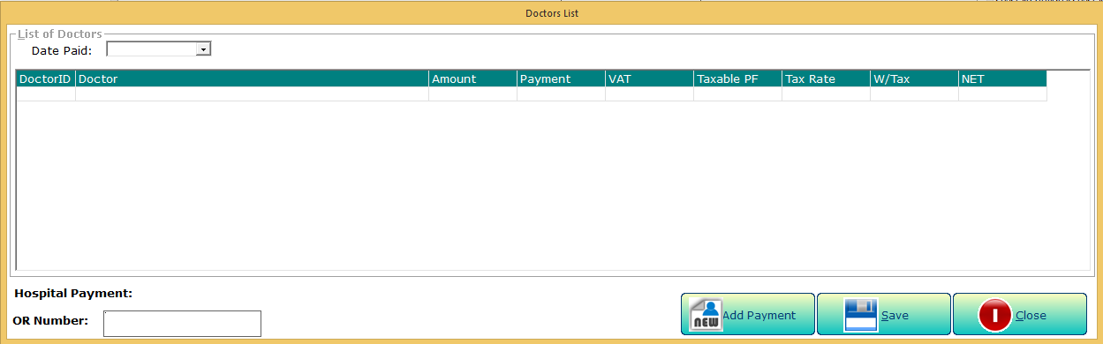

- Claim Form 2 Entry
What’s New?

  - Additional fields include Patient’s PIN, sex, HCI Referral Name and Address, HCP Accreditation Code.
  - 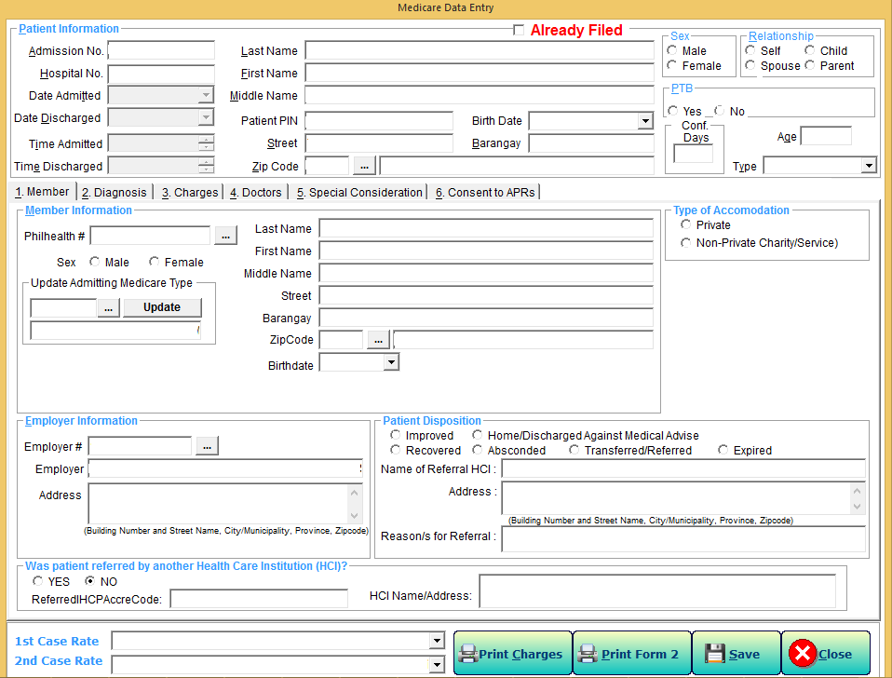New Format of Claim Form (CF2).

  - 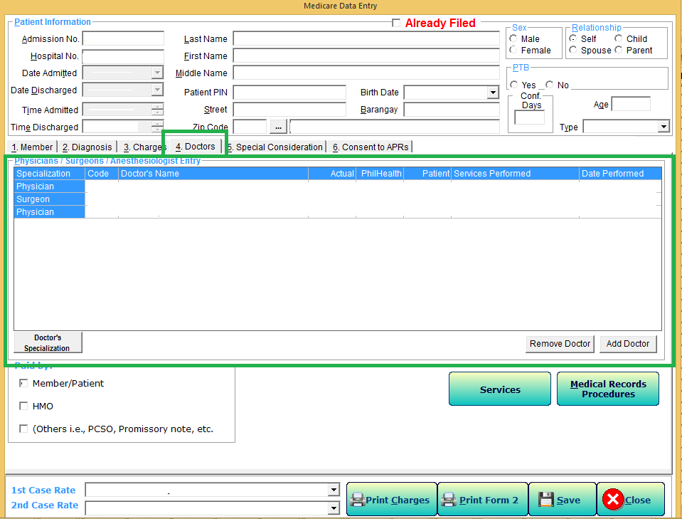Revised Doctor’s Fee and Benefits Entry

  - Special Consideration Tab
Additional fields includes:
- Radiotherapy(IMRT)
- NTP Card No.
- Newborn Screening Test Filter Card No.
- Newborn Hearing Screening Test
- Registry Card No.
- 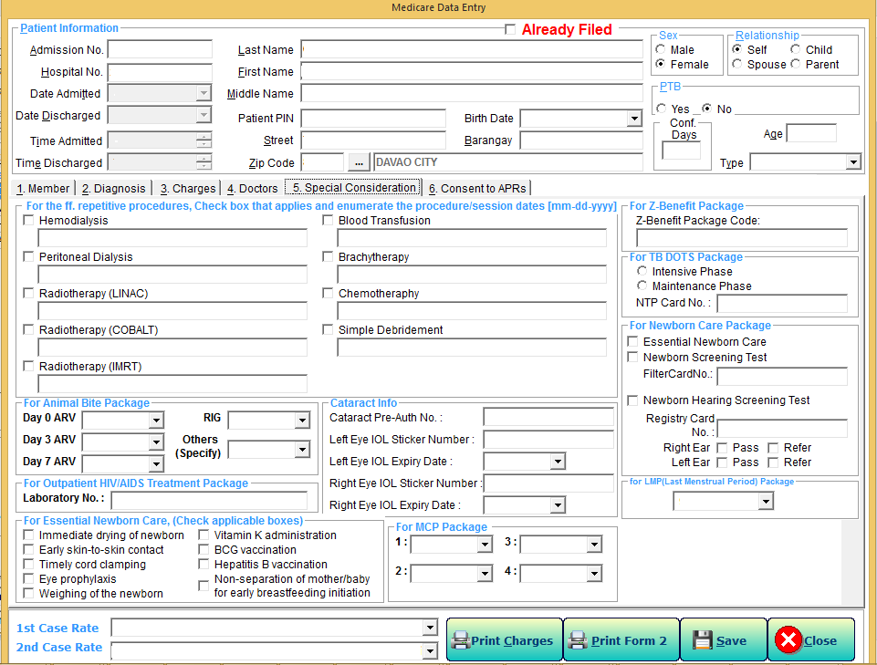Last Menstrual Period
  - 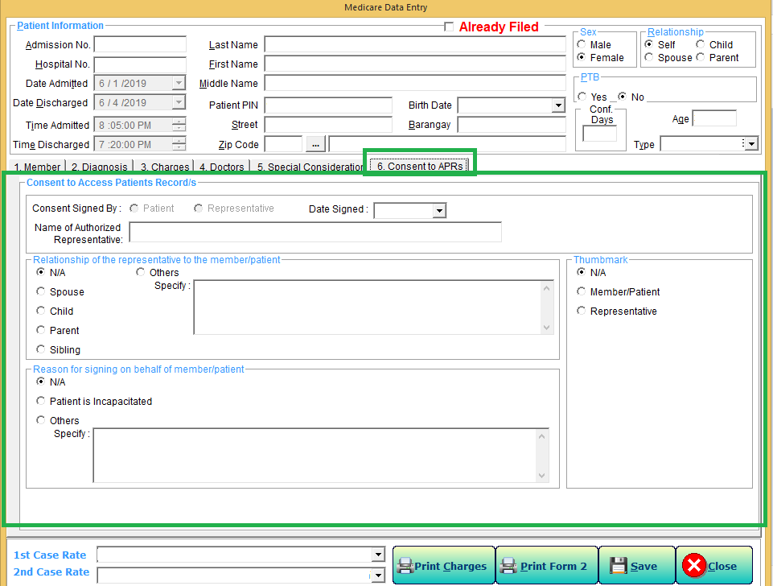Consent To Access Patient Records

- Transmittal Report
What’s New?

    - This feature restricts adding patients with unprinted Claim Form 2 (CF2) on Transmittal Window.

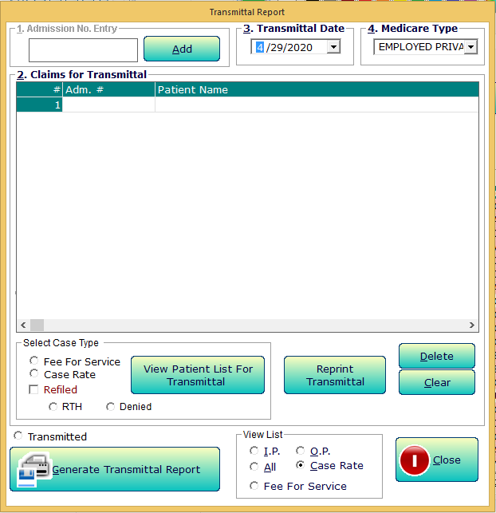
    - Additional Tagging for Re-Filed Denied Claims.

- Reports

- New Format of Statement of Accounts mandated by PhilHealth.
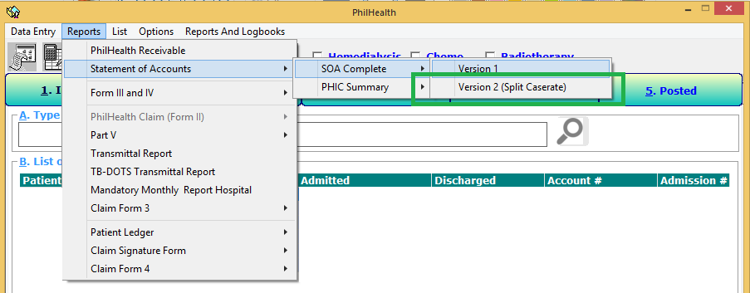
- New Format of Claim Form (CF2) Part III and IV
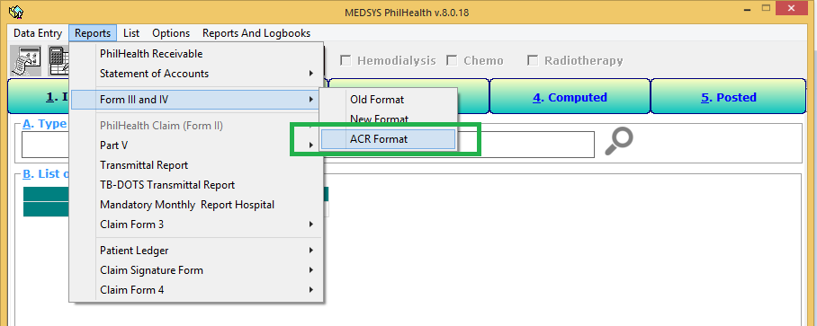
- New Format of Claim Form (CF3)
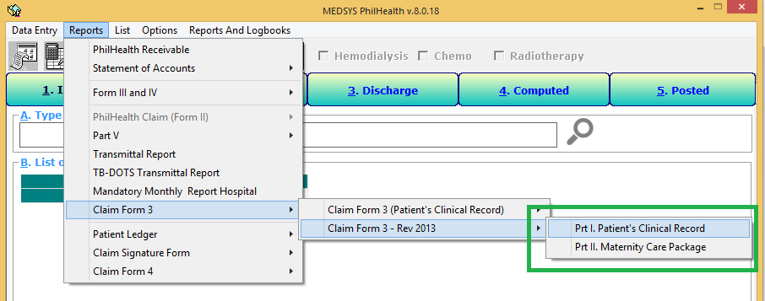
- Claim Signature Form (CSF)

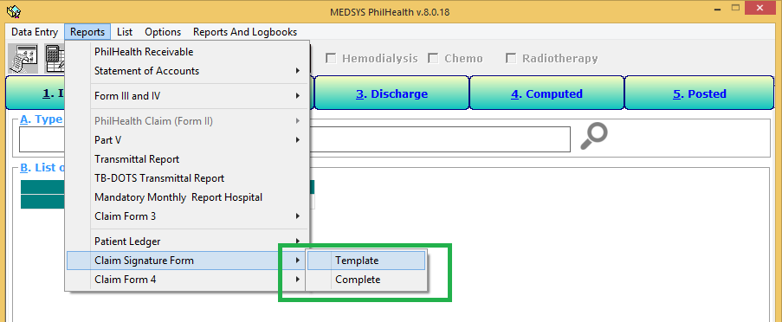

- 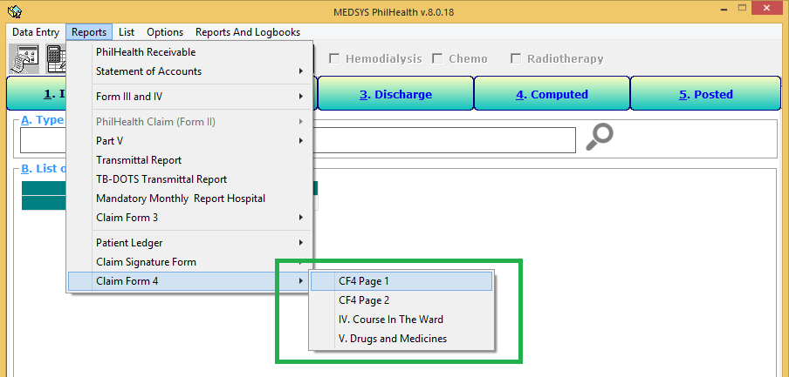Claim Form (CF4)

- Checklist

- 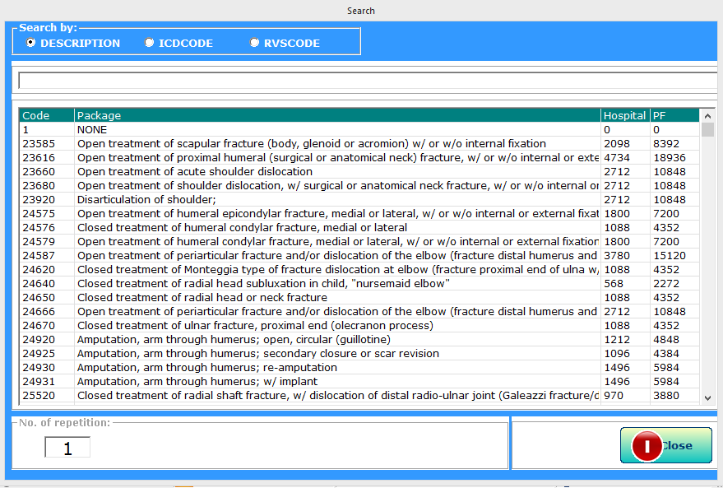PhilHealth Case Rates
To search PhilHealth Case Rates by description, and code.
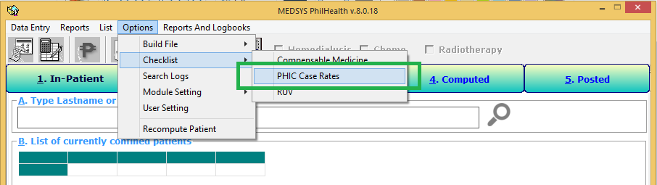
- Relative Unit Value
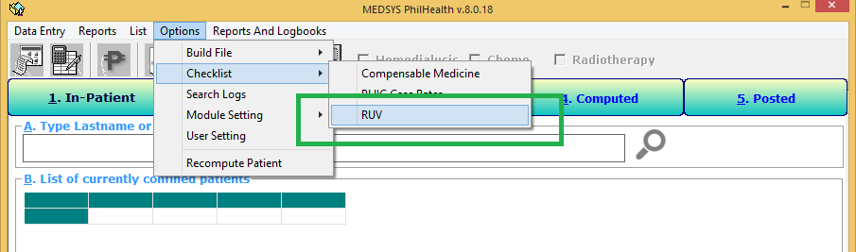

- Logs

- Search Logs
This feature allows to view and print patient’s data logs.
To access, click Option Menu and then Search Logs.
To Search logs by Name or Admission No.
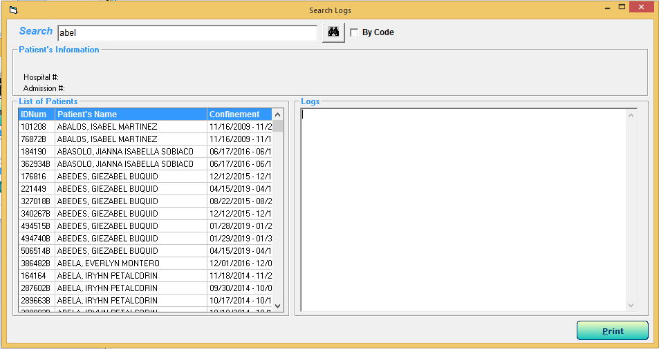To View logs (at the right pane), click the patient name on the list.

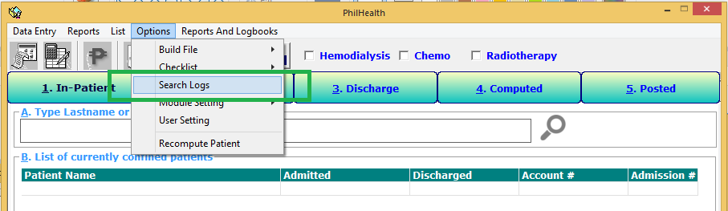

- Build File

- PhilHeath Case Rates
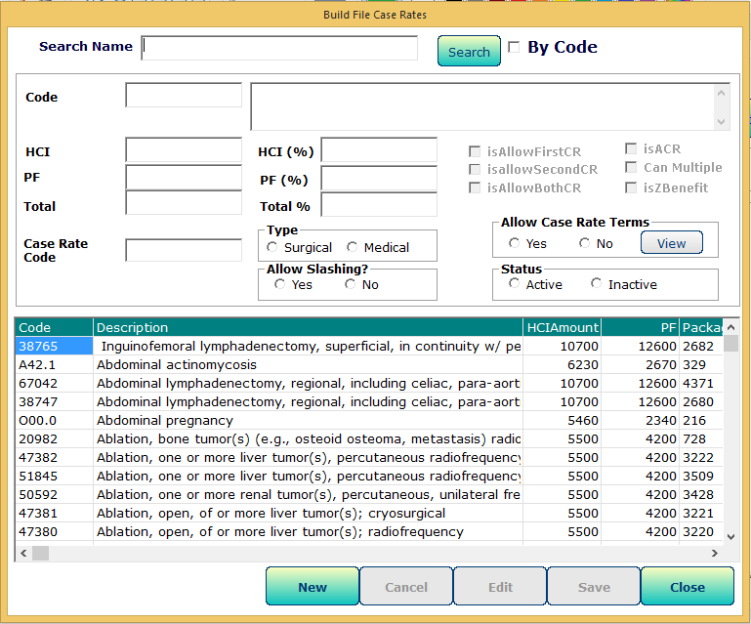This feature allows to create, edit and view PhilHeath Case Rates.
To access, click Option Menu -> Build File, and select Case Rates.
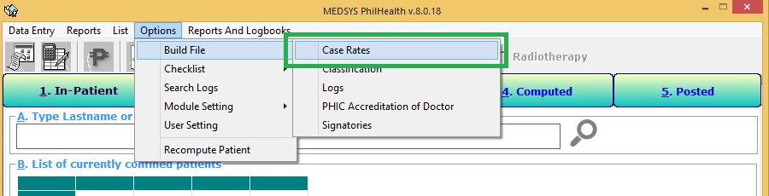
- PhilHealth Case Rate Terms and Conditions
This feature allows to add, update, view and delete Case Rate’s terms and conditions.
The terms and conditions include Age bracket and Hours of stay.
To Add, click “Add” button and fill-in the fields. Then click “Save” button to save entry.
To Update, double-click the item. Then click “Save” button to save changes.
To Disable, double-click the item. Uncheck the Active checkbox, then click save.
To Delete, select/ click the item. Then click “Delete” button.
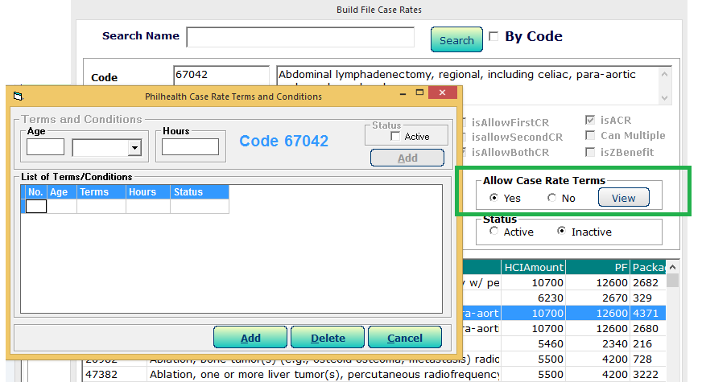
- Doctor's PhilHealth Accreditation
This feature allows you to update Doctor’s PhilHealth Accreditation and Validation Period. And is connected to Build File Module.
To access, click Options Menu -> Build File, and select Case Rates.

To Search:
By Code – check the By Code check box.
By Last name – uncheck the By Code check box.
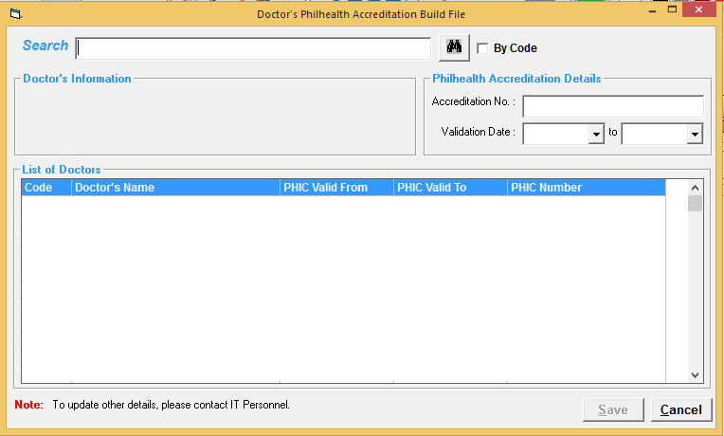To Update, double-click Doctor’s name. Fill-in then necessary details and then click “Save” button to save changes.
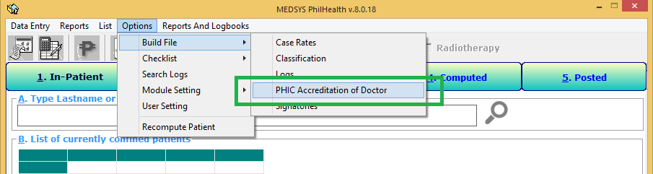

Prepared by:
Angelika A. Casuga
Philhealth Software Developer
Kaiser dela-Cruz Consulting, Inc.

