Source Codes
eClaims Modules
- The eClaims Module, implemented using vb6, c#.net, mssql. Vb6 for User Interface, C#.net for API connectivity, and MSSQL for database.

eClaimsApp.exe
- It acts as a launcher for the prjMedSysEClaims.dll. It doesn’t contains business logic, but responsible for the initialization of the other MedSys dlls prerequisites.
Path: \Sourcecodes\eClaims\VB6\ElectronicClaims\eClaims.UI
Path: VSS → Billing Database → eClaims Folder → eClaims.UI Folder

prjMedSysEClaims.dll
- This project/library contains the business logic related to the e-Claims standard requirements and custom requirements based on clients business needs.
Path: \Sourcecodes\eClaims\VB6\ElectronicClaims
Path: VSS → Billing Database → eClaims Folder

MedSys.PhicSoap.Gateway.dll
- This project/library handles the data communication of MedSys e-Claims and PhilHealth e-Claims Web Service API (PECWS-API) of PhilHealth Corp..
Path: \Sourcecodes\eClaims\CSharp\MedSysPhicSoapGateway

MedSys.ClaimStatus.Synchronize.Console.exe
- This project/library responsible for the synchronization of MedSys e-Claims Dashboard Data with PhilHealth Central Data.
Path: \Sourcecodes\eClaims\CSharp\MedSys.ClaimStatus.Synchronize.Console

eClaims Storage API
- eClaims Storage API, it stand as storage server for PhilHealth claims attachments.
Path: \Sourcecodes\eClaims\CSharp\MedSys.UploadDocs

System Flow
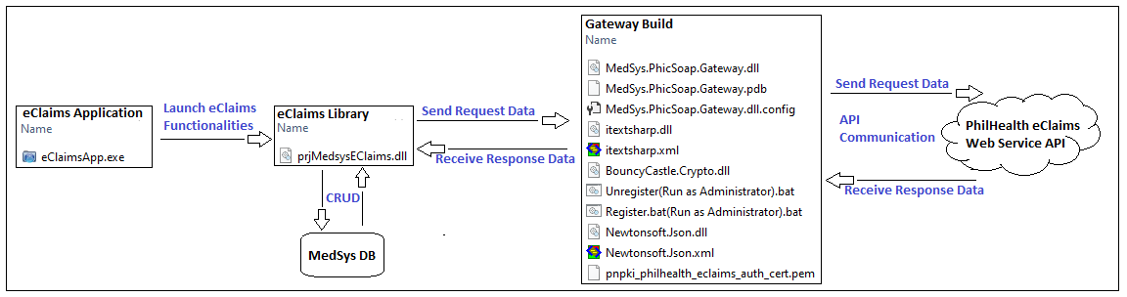
SQL Scripts
There are 2 scenarios of SQL scripts used specifically for e-Claims Installation and Update.
Scenario 1-is for new client installation.
- All scripts located inside the “New Installation” folder must be executed.
Path: \Sourcecodes\eClaims\Scripts\New Installation
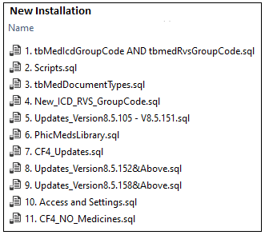
Scenario 2-is used for system update.
Path: \Sourcecodes\eClaims\Scripts\Updates.sql
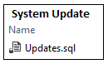
Feature switch—MedSys e-Claims has its own feature switch
- Feature switch is used to activate/deactivate a certain feature based on clients requirements or needs.
Path: \Sourcecodes\eClaims\Scripts\Program_Switch.sql
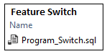
How to create MedSys e-Claims deployment package.
Step 1: Build the project MedSys.PhicSoap.Gateway. It would build deployment package.
(See below image)
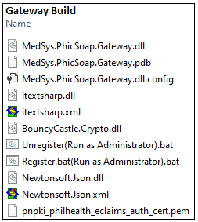
Step 2: Compile the project prjMedsysEClaims. It would build a library named prjMedsysEClaims.dll. (See below image)
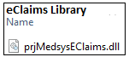
Step 3: Compile the project eClaimsApp. It would build an executable file named eClaimsApp.exe.
(See below image)
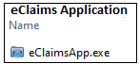
Step 4: Create a new folder named ‘eClaimsWebService’.
(See below image)
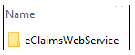
Step 5: Put it all together. Copy all the Gateway Build files, the eClaims Library file, and the eClaimsApp.exe file. Place it in “eClaimsWebService” folder.
(See below image)
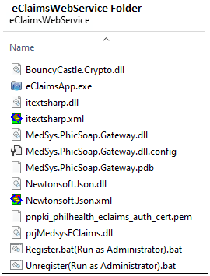
Done! e-Claims Deployment Package is now ready for deployment/installation.

How to deploy/install e-Claims to the Clients.
Step 1: Update Windows .Net Framework via this link >> https://www.microsoft.com/en-us/download/confirmation.aspx?id=42643
Step 2: Copy "eClaimsWebService" folder onto "c:\" or “d:\” folder.
Step 3: Run "\eClaimsWebService\Register.bat" as Administrator.

Done! e-Claims Application is now ready use.
(See below image)
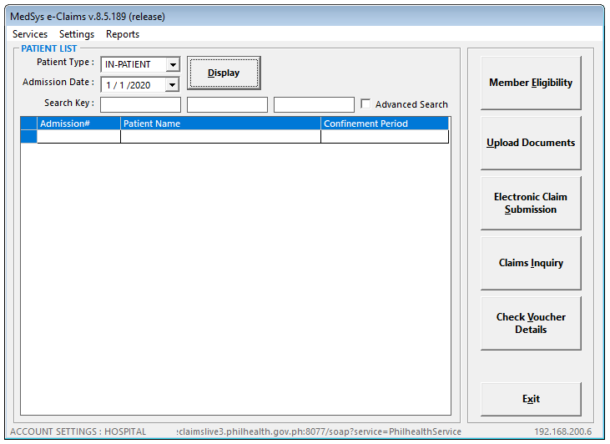
How to generate the Application key?
Note: When generating an application key, be sure that the MedSys e-Claims Application is connected to apps.gomedsys.com server or using the local network server ‘192.168.200.6’.

Steps to generate application key
Step 1: Open MedSys e-Claims Module
Step 2: Click Settings Menu, then click Generate App Key
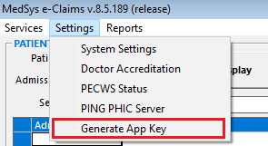
Step 3: Generate Application Key form pop-up. There are 2 input fields and 1 read-only field on the form—PMCC is the Hospital Code of the Facility, Expiration Date is when to expire the Application Key to be generated. App Key is a read-only field.
PMCC can be found in ‘\eClaims Other Supporting Documents - For Reference\Registered_HCIs.xlsx’ document.
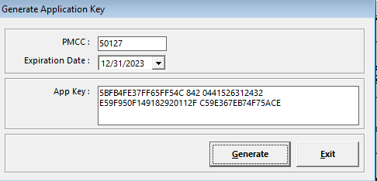
Done! App Key can now be use by the client.

How to renew the expired Client Application Key with the newly generated App Key?
There are two ways to renew the Application Key. First is via updating the application key on ‘key.xml’ file, or second is by executing an update script on the Client Sql Database.

Steps via ‘key.xml’ file.
Step 1: Open file from ftp://apps.gomedsys.com/CLIENT/eClaimsApp/client.key/keys.xml, or \\192.168.200.6\medsysapps\CLIENT\eClaimsApp\client.key\keys.xml.
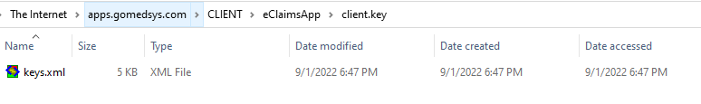
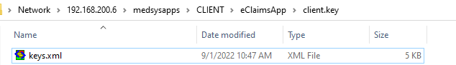
Step 2: Change the Code value of the Facility based on the generated App Key.
Step 3: Save the file.

After saving the file. Kindly inform the client to click the [Get Application Key] button on their end. It would download the renewed App Key and will be saved onto their database.

Steps via Client SQL Database
Step 1: Execute the below sample update script to the Client SQL Database.
Sample: UPDATE MEDICARE..tbMedEClaimsSettings SET AppKey = '5BFB4FE37FF65FEA45 743 0441526302036 E59FF48 45DEE421D7DDC72C185C68BD59685BB' WHERE HospitalCode = '50127'

Done! After execution, the Client Application Key is now renewed.

Note: There is a setting to make [Generate App Key] Menu be available on the screen.
Make sure that the IsDemoMode field has a value of ‘1’ on the tbMedEClaimsSettings table, and the id field with value ‘62B57019-EA47-47C8-B760-62EA040399E0’ is available on the tbMedEClaimsProgramSettings table.
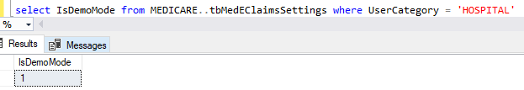
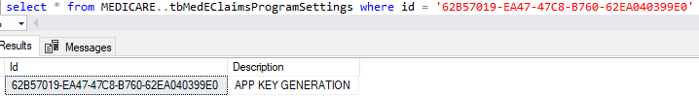
How to change PECWS Server address URL
Step 1: Open C:\eClaimsWebService\MedSys.PhicSoap.Gateway.dll.config
Step 2: Change endpoint address value

List of available PECWS Server URL
Server 0: https://eclaimslive.philhealth.gov.ph:8077/soap?service=PhilhealthService
Server 1: https://eclaimslive1.philhealth.gov.ph:8077/soap?service=PhilhealthService
Server 2: https://eclaimslive2.philhealth.gov.ph:8077/soap?service=PhilhealthService
Server 3: https://eclaimslive3.philhealth.gov.ph:8077/soap?service=PhilhealthService
Server 4: https://eclaimslive4.philhealth.gov.ph:8077/soap?service=PhilhealthService
Server 5: https://eclaimslive5.philhealth.gov.ph:8077/soap?service=PhilhealthService

Server 1B: https://eclaimslive1b.philhealth.gov.ph:8077/soap?service=PhilhealthService
Server 2B: https://eclaimslive2b.philhealth.gov.ph:8077/soap?service=PhilhealthService
Server 3B: https://eclaimslive3b.philhealth.gov.ph:8077/soap?service=PhilhealthService
Server 4B: https://eclaimslive4b.philhealth.gov.ph:8077/soap?service=PhilhealthService
Server 5B: https://eclaimslive5b.philhealth.gov.ph:8077/soap?service=PhilhealthService

Done! Login to e-Claims and verify if successfully connected to the specified server.
(See below image)

Common Issues
Common Prompt Message:
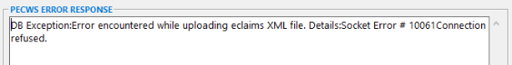
Cause: PhilHealth Internal Server problem / PECWS intermittent connection
Solution: Report to PhilHealth IT Support Team via PhilHealth OS Ticket (https://itsupport.philhealth.gov.ph/osticket/)

Prompt Message:
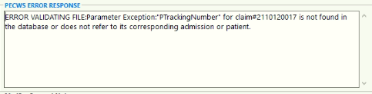
Cause: Inconsistent claim data versus the Final Call data of Member Eligibility
Solution: Proper encoding of Patient and Member data must be followed in Member Eligibility
Work-around: Set TrackingNumber value as blank, then re-Submit the claim

Common Prompt Message:
Cause: PhilHealth Internal Server problem
Solution: Report to PhilHealth IT Support Team via PhilHealth OS Ticket (https://itsupport.philhealth.gov.ph/osticket/)

Common Prompt Message:
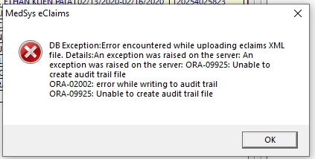
Cause: PhilHealth Internal Server problem
Solution: Report to PhilHealth IT Support Team via PhilHealth OS Ticket (https://itsupport.philhealth.gov.ph/osticket/)

Common Prompt Message:
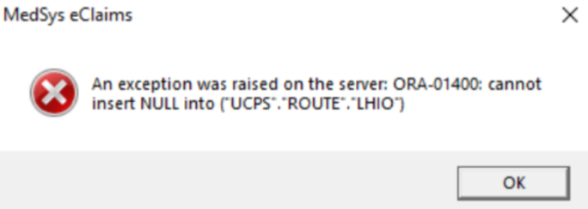
Cause: PhilHealth Internal Server problem
Solution: Report to PhilHealth IT Support Team via PhilHealth OS Ticket (https://itsupport.philhealth.gov.ph/osticket/)

Common Prompt Message:
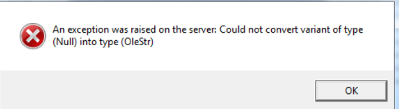
Cause: PhilHealth Internal Server problem
Solution: Report to PhilHealth IT Support Team via PhilHealth OS Ticket (https://itsupport.philhealth.gov.ph/osticket/)

KONSULTA

Source Codes
Konsulta.UI
- This project/library contains the business logic related to the Konsulta standard requirements and based on clients business needs.
Path: \Endorsement\Sourcecodes\Konsulta\Konsulta.UI

Konsulta.DataService
- This project/library handles the input/output data from the Database.
Path: \Endorsement\Sourcecodes\Konsulta\Konsulta.DataService

Konsulta.Soap.Gateway
- This project/library handles the communication between MedSys Konsulta and Konsulta Web Service API.
Path: \Endorsement\Sourcecodes\Konsulta\Konsulta.Soap.Gateway

How to create Konsulta Deployment Package
Step 1: Build the project Konsulta.Win. See below image of successful Build.
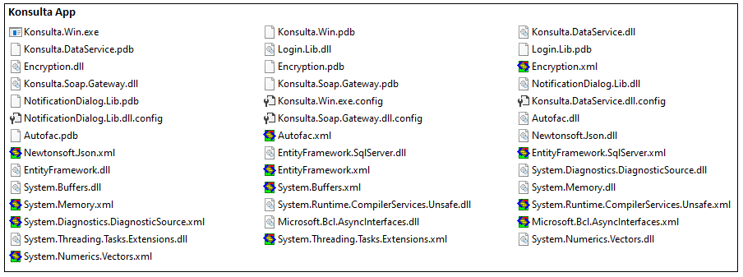
Done! Open Konsulta.Win.exe to open the application.

Konsulta App is still an on-going project development. There are still some business rules needed to be implemented based on the latest Konsulta Implementation Guidelines.

DOH ONLINE REPORTING
Source Codes
DOH Online Reporting Module
- DOH Statistical Online Reporting is responsible for transmitting the Hospital Statistical Reports to DOH Central Server.
Path: \Endorsement\Sourcecodes\DOH\

How to create DOH Online Reporting Deployment Package
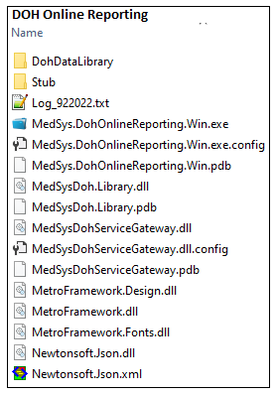
Step 1: Build the procject MedSys.DohOnlineReporting.Win. See below image of successful Build.
Done! Open MedSys.DohOnlineReporting.Win.exe to open the application.
Live implementation of DOH Online Reporting System is deferred by the DOH until further notice.

DOH Module
- It would allow the user to prepare all the DOH Statistical reports data to be submitted to DOH
  - DOH Statistical reports (22)
I. General Information:
- Classification
- Quality Management
- Bed Capacity / Occupancy
II. Hospital Operations:
- Summary of Patients in the Hospital
- Discharges
  - Type of Service and Total Discharges According to Specialty,
  - Type of Service and Total Discharges According to Specialty – Others
  - Ten Leading causes of Morbidity/Diseases Disaggregated as to Age and Sex
  - Total Number of Deliveries.
  - Outpatient Visits, including Emergency Care, Testing and Other Services
  - Ten Leading OPD Consultations
  - Ten Leading ER Consultations
  - Testing and Other Services
  - Emergency Visits
- Deaths
  - Total Number of Deaths
  - Ten Leading causes of Mortality/Deaths Disaggregated as to Age and Sex
- Healthcare Associated Infections (HAI)
- Ten Leading Major Operations
- Ten Leading Minor Operations
III. Staffing Pattern
- Staffing Pattern
- Staffing Pattern – Others
IV. Expenses
V. Revenues

DOH Module - Installation Prerequisite:
Properly installed MedSys Dll’s

DOH Online Reporting Module
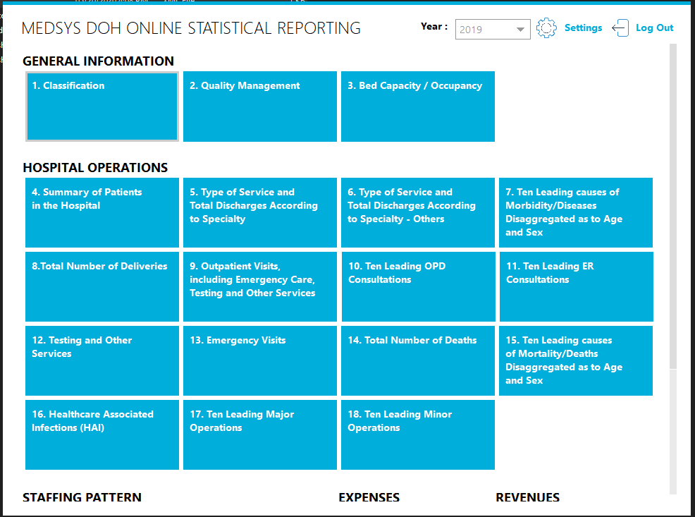
- A Module where the user could prepare and submit all the (22) DOH Statistical reports data DOH Central Data Server

There are 22 DOH Statistical Reports (Screenshots)

General Information

Classification
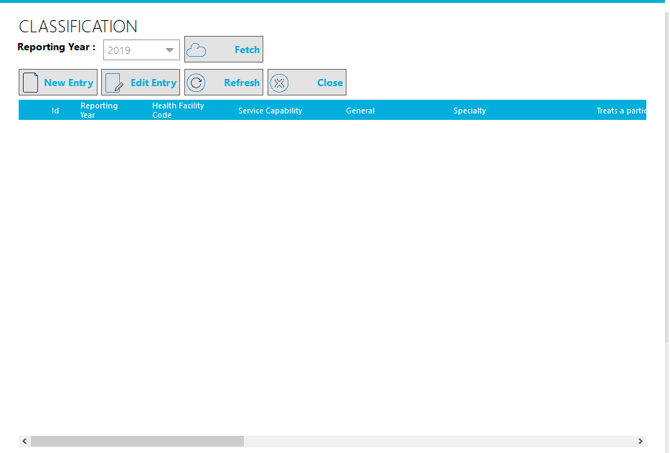

Quality Management
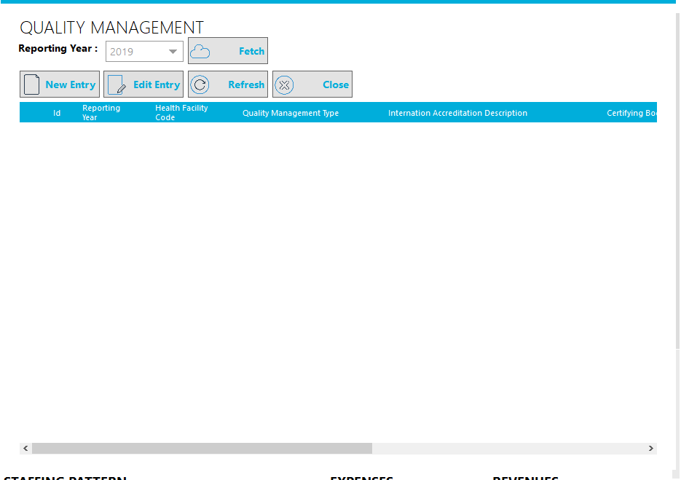

Bed Capacity / Occupancy
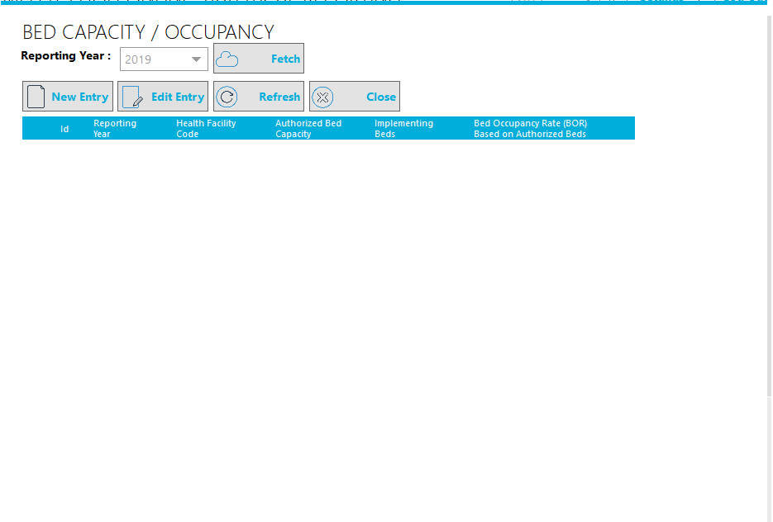

Hospital Operations

Summary of Patients in the Hospital
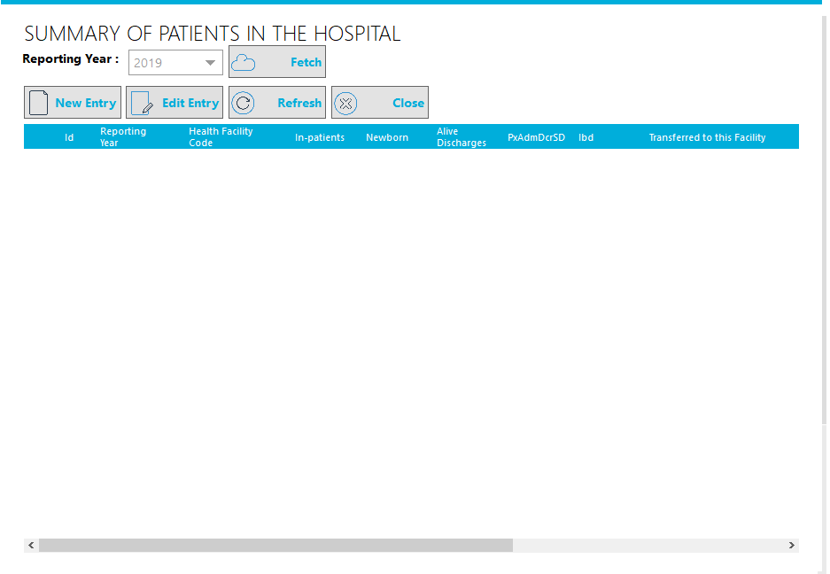

Type of Service and Total Discharges According to Specialty
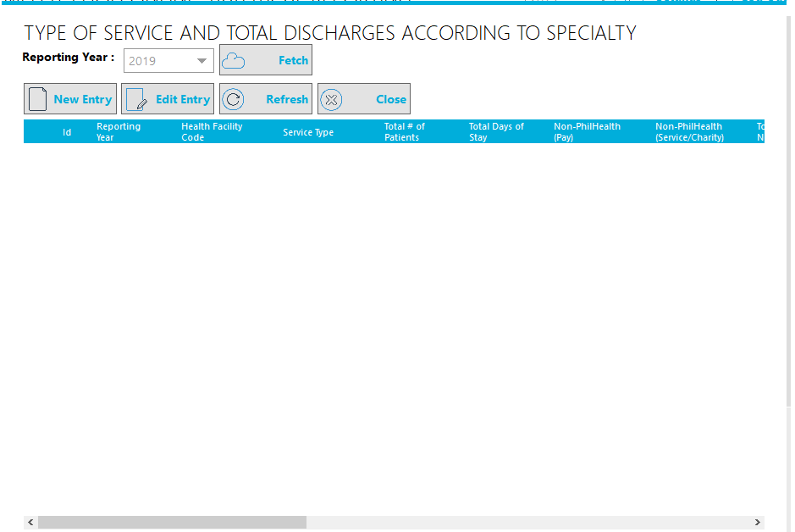

Type of Service and Total Discharges According to Specialty – Others
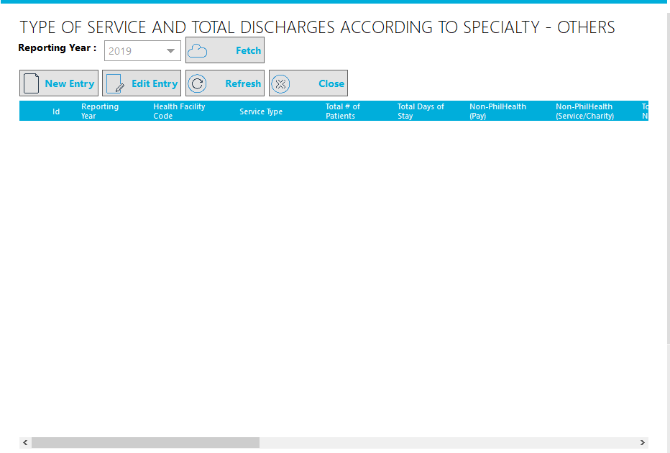

Ten Leading causes of Morbidity/Diseases Disaggregated as to Age and Sex
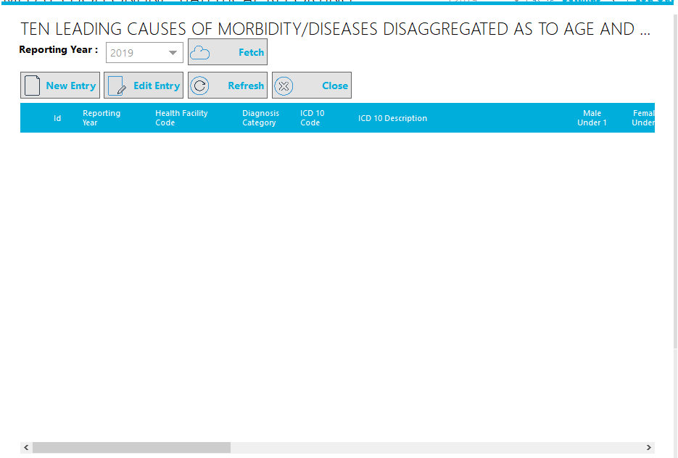

Total Number of Deliveries
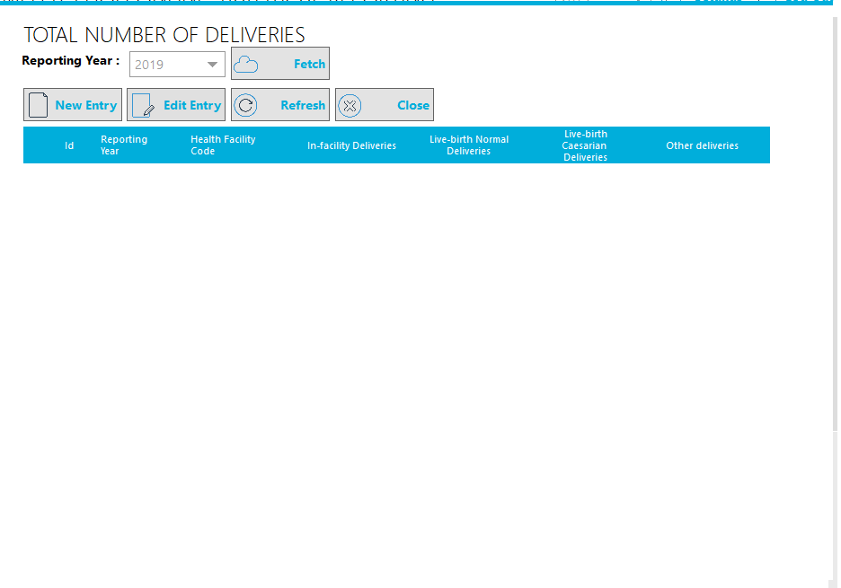

Outpatient Visits, including Emergency Care, Testing and Other Services
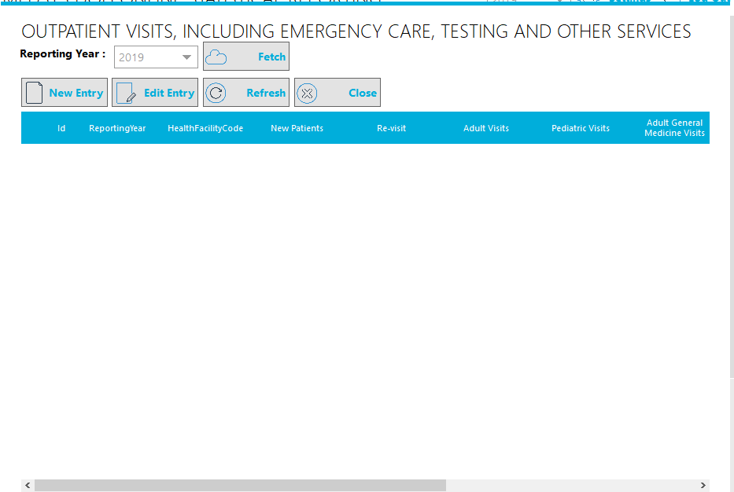

Ten Leading OPD Consultations
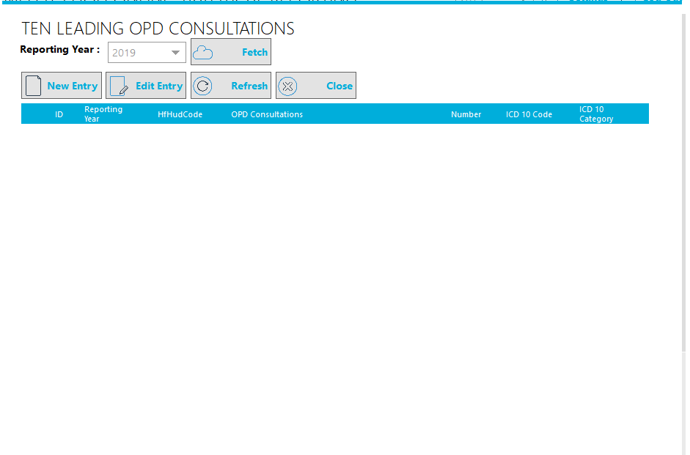

Ten Leading ER Consultations
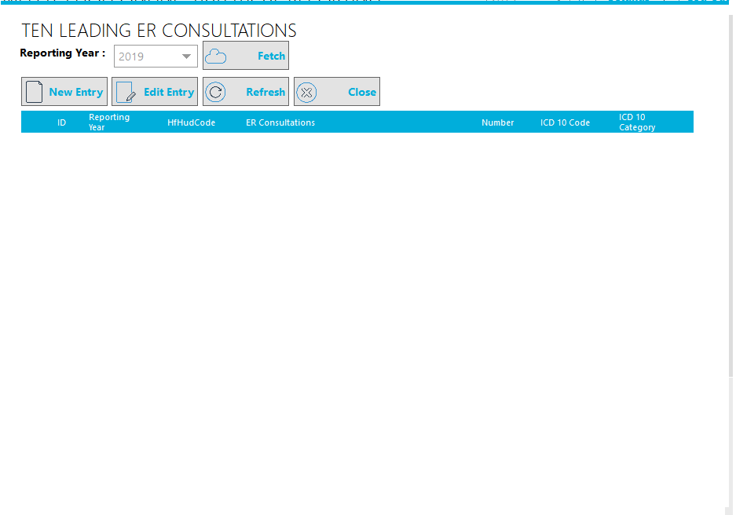

Testing and Other Services
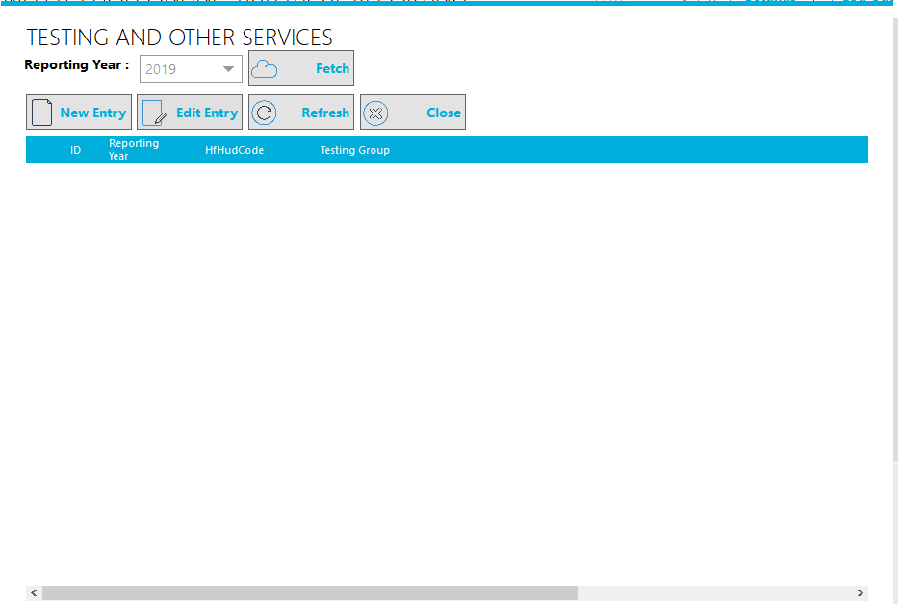

Emergency Visits
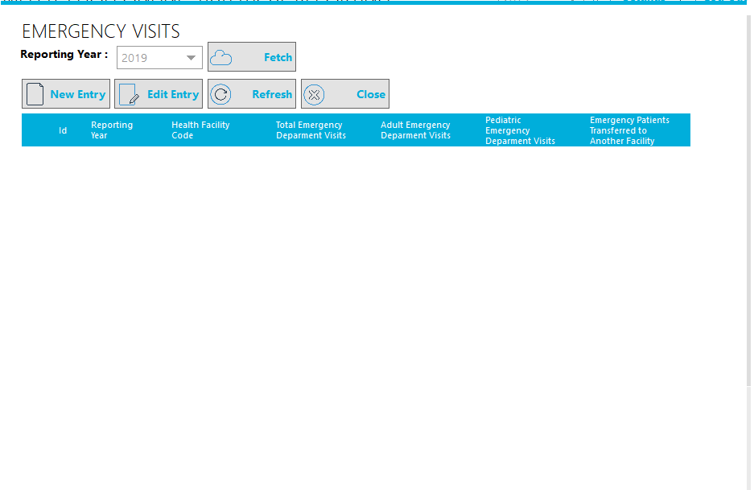

Deaths

Total Number of Deaths
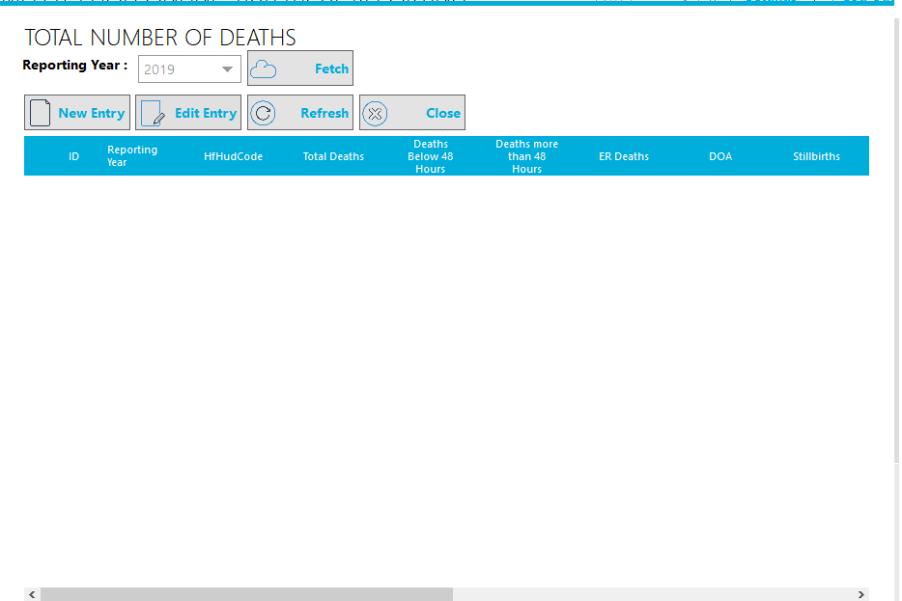

Ten Leading causes of Mortality/Deaths Disaggregated as to Age and Sex
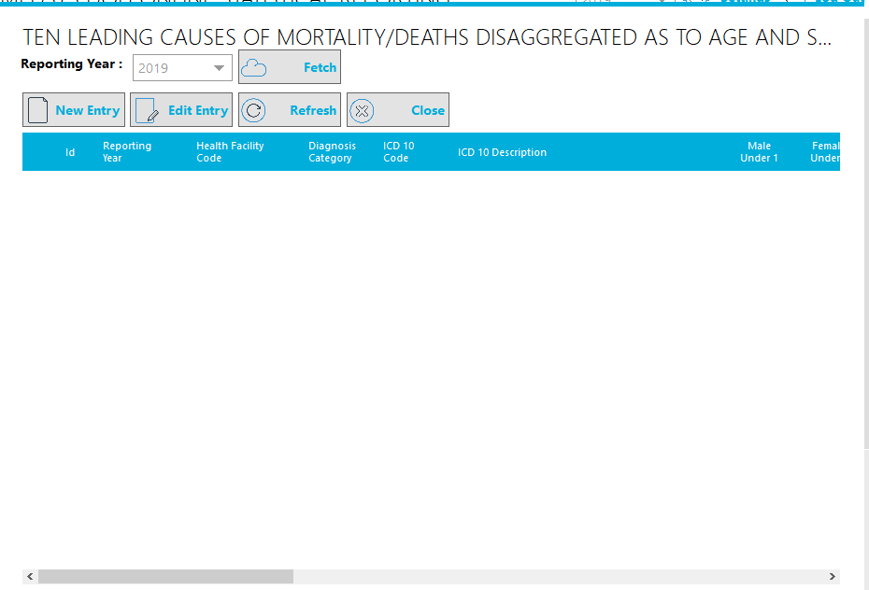

Healthcare Associated Infections (HAI)
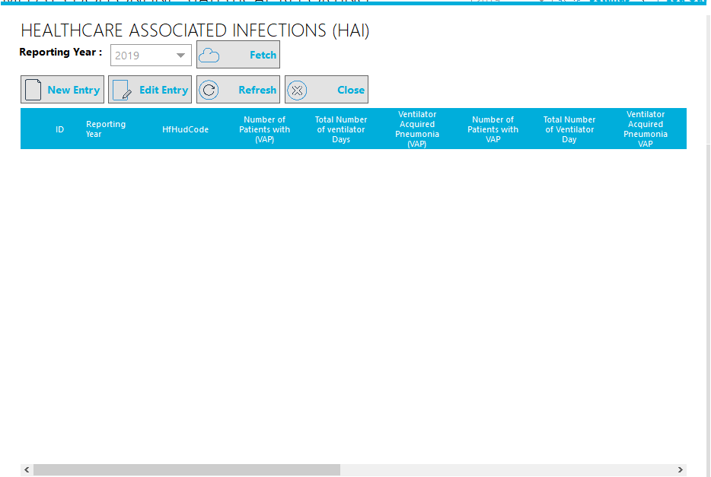

Ten Leading Major Operations
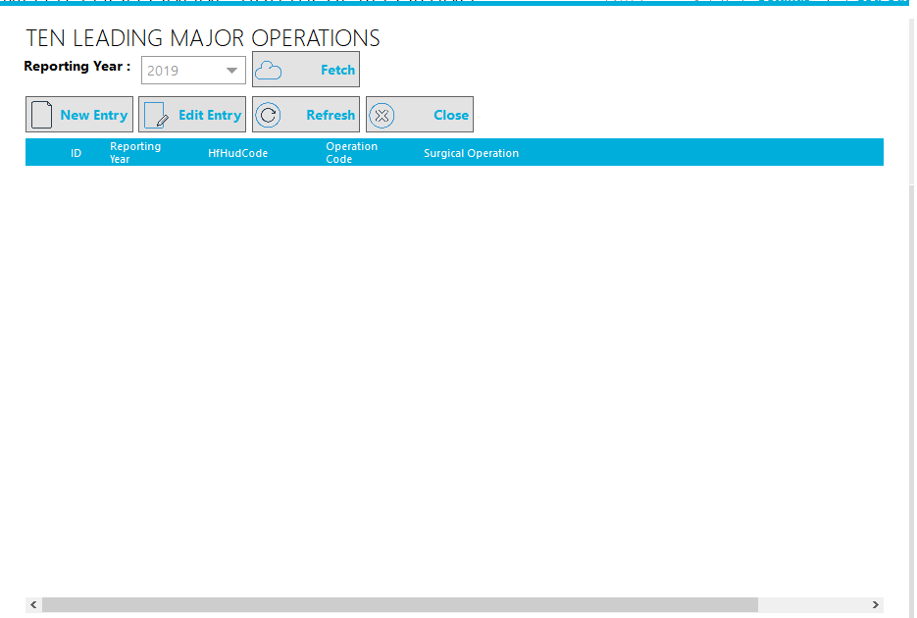

Ten Leading Minor Operations
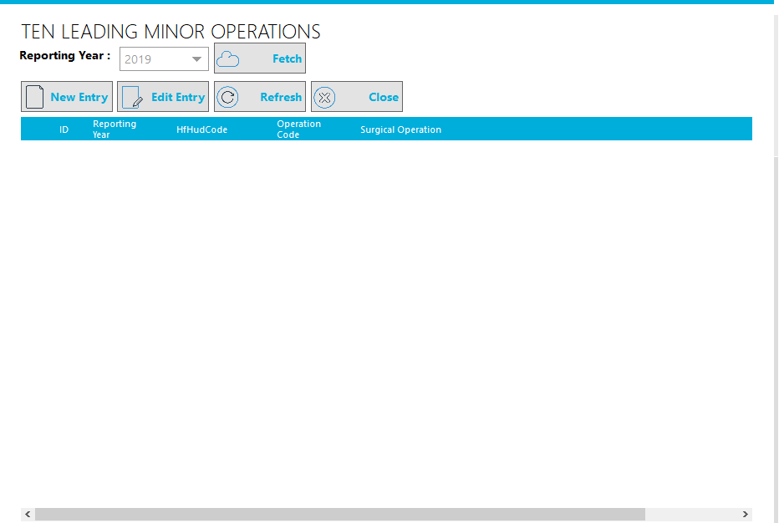

Staffing Pattern

Staffing Pattern
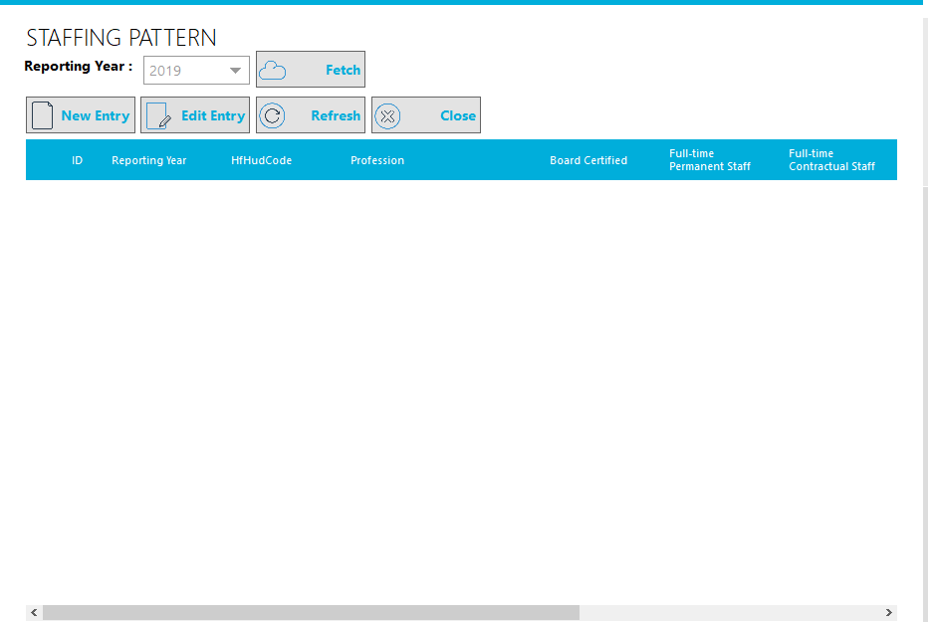

Staffing Pattern – Others
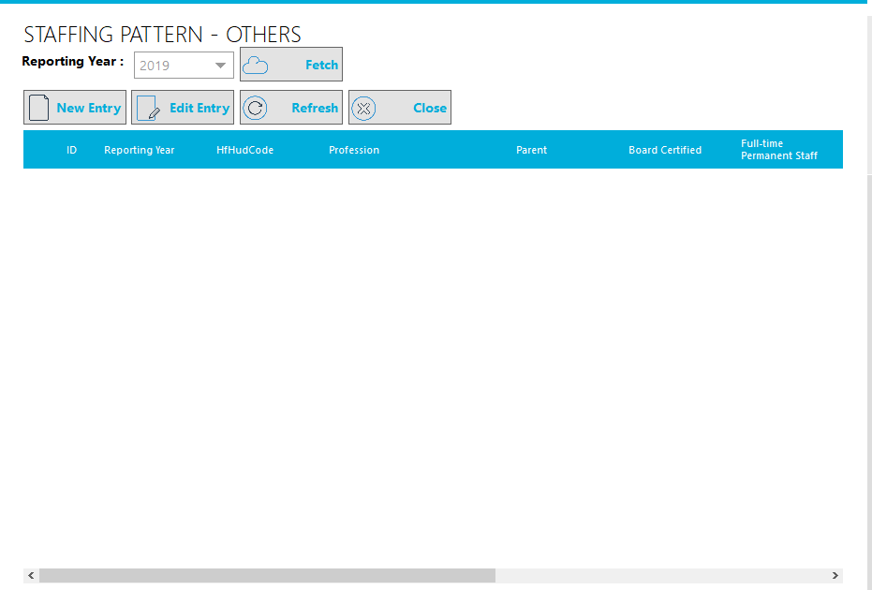

Expenses
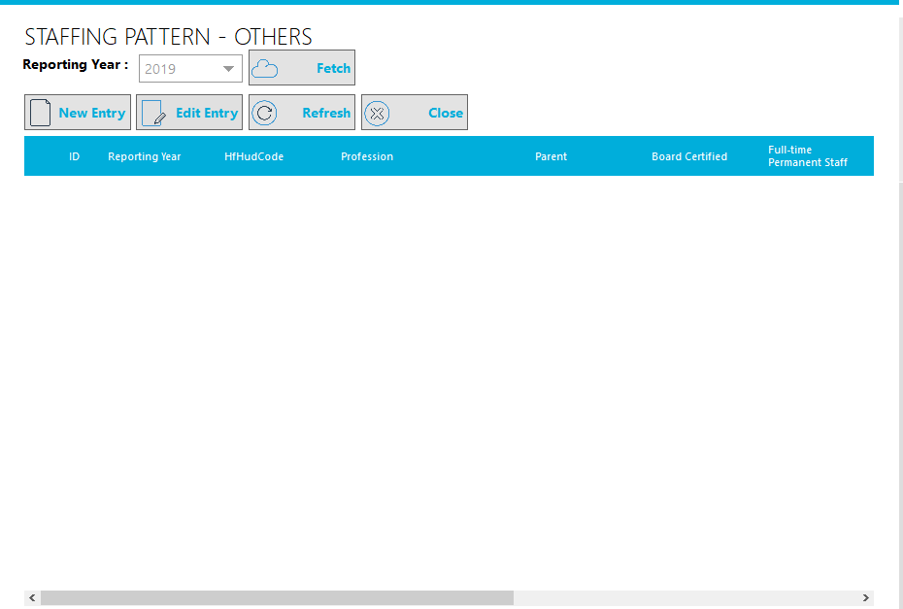

Revenues
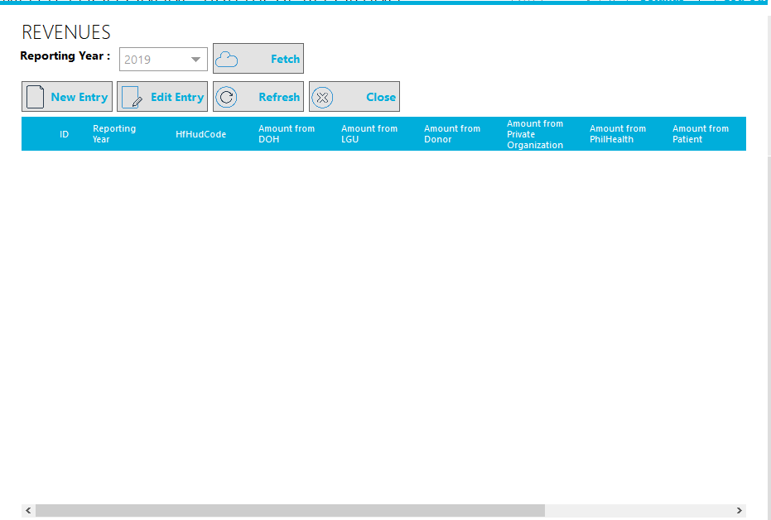

Button Functionalities
Reporting year selection box – it would allow user to choose which year of DOH Statistical report should be prepared
Fetch button – it would allow user to collate all data prepared previously from DOH Module
New Entry button – it would allow user to prepare the data manually base on the manual data
Edit Entry button – it would allow user to edit the data
Refresh button – it would allow user to refresh the listed data
Close button – it would allow user to close the current window

DOH Statistical Reports Submission
- It would allow the user to submit all the prepared (22) DOH Statistical Reports to the DOH Central Server. After submission, the user would no longer be allowed to Add or Edit entries on those (22) DOH Statistical Reports.
- 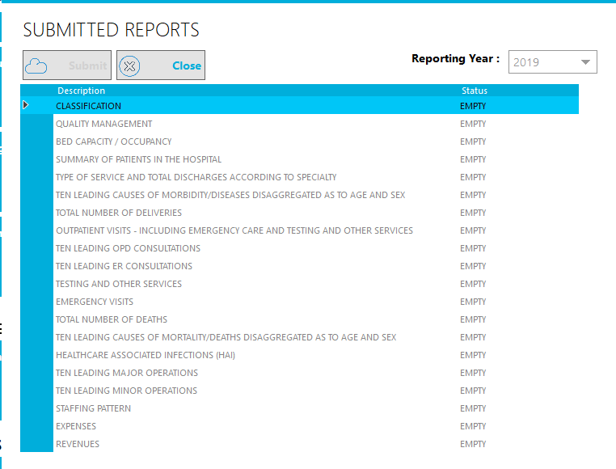
Reporting year selection box – it would allow user to choose which year of DOH Statistical report should be submitted
Submit button – it would allow the user to submit the (22) DOH Statistical Reports to DOH Central Server
Close button – it would allow user to close the current window

DOH Online Reporting – Installation Prerequisite:
- MedSys CurrentUser.dll
- DOH Module

ADVANCED CRYSTAL REPORT VIEWER RUNTIME
Source Codes
Crystal Report Viewer
- The Crystal Report Viewer, it is implemented using C#.net. It was developed to support MedSys modules to directly export the Reports into PDF file.
Path: \Sourcecodes\CrystalReportViewer

How to create Advanced Crystal Report Viewer Deployment Package
Step 1: Build the procject Medsys.CrystalViewer. See below image of successful Build.
Done! Run as admin the Install.bat file to install.
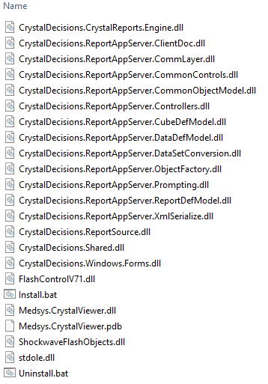

FIXED ASSET
Source Codes
FixedAsset Module
- Is responsible for purchasing and managing the Hospital Fixed Assets.
Path: \Endorsement\Sourcecodes\FixedAssets\Vb6\FixedAsset.vb6
Path: VSS → Billing Database → FixedAsset Management

SQL Scripts
There are 2 parts of SQL scripts used for FixedAsset Installation and Update.
Part 1—is for new client installation.
- All scripts inside the “New Installation” folder must be executed.
Path: \Sourcecodes\FixedAssets\Scripts\For New Installation or Upgrade
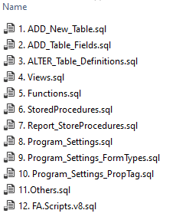
Part 2—is for system update.
Path: \Sourcecodes\FixedAssets\Scripts\FA.New_Fields_And_Update_Sps.sql
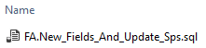
How to add a Prefix for PR/RIV Number
Set the value for RIVPrefix field of tbFAAssigna Table

How to add a Prefix for PO Number
Set the value for POPrefix field of tbFAAssigna Table

How to add a Prefix for JO Number
Set the value for JOPrefix field of tbFAAssigna Table

How to add a Prefix for RR/CA Number
Set the value for CAPrefix field of tbFAAssigna Table

How to add a Prefix separator for PR/PO/JO/RR Number
Set the value for PrefixSeparator field of tbFAAssigna Table

How to add a separator for Property Number
Set the value for AssetTagSeparator field of tbFAAssigna Table

FixedAsset Barcode Reader
FixedAsset Barcode Reader
- FixedAsset Barcode Reader is responsible for monitoring the Asset via the Asset Barcode Tag.
Path: \Endorsement\Sourcecodes\FixedAssets\CSharp\MedSys.FixedAsset.BarcodeReader

How to create FixedAsset Barcode Reader Deployment Package
Step 1: Build the procject MedSys.FixedAsset.BarcodeReader. See below image of successful Build.
Done! Install the package to the IIS Server.
