Philhealth letter problem
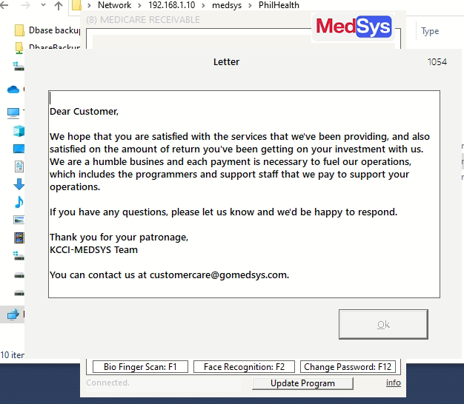

Work around (only medsys, don’t give to clients)
