Using Widzler to Test SOAP Web Services

Here is the steps in using Wizdler in testing a SOAP service method:
- Install the Wizdler Chrome extension. Wizdler is available also in Firefox).
  - Open Chrome web browser.
  - Google “Wizdler Chrome extension”
  - Among the search results, search and click “Wizdler – Chrome Extension”.
  - In the dialog box that will appear, click the “Add to Chrome” button
- After installing, browse the URL of the WSDL in address bar of Chrome
  - Chrome will show the contents of the WSDL of PECWS. Whenever the displayed page is an WSDL, the Wizdler icon at the right of the address bar will be activated. (cf Figure 1)
- Click the Wizdler icon. The available web service methods will pop-up. (cf Figure 2)
- Select the the target service method . (cf Figure 3)
- You may need to change the address of the WSDL from “http” to “https”
- The Wizdler Request tab will be visible and the list of the input parameters will be shown.
- Supply the values of the input parameters. (cf Figure 4, 5)
- Clikc the “Go” button. (Figure
- Wizdler will make show the “Response” tab together with the output of the target service method (cf Figure 6)

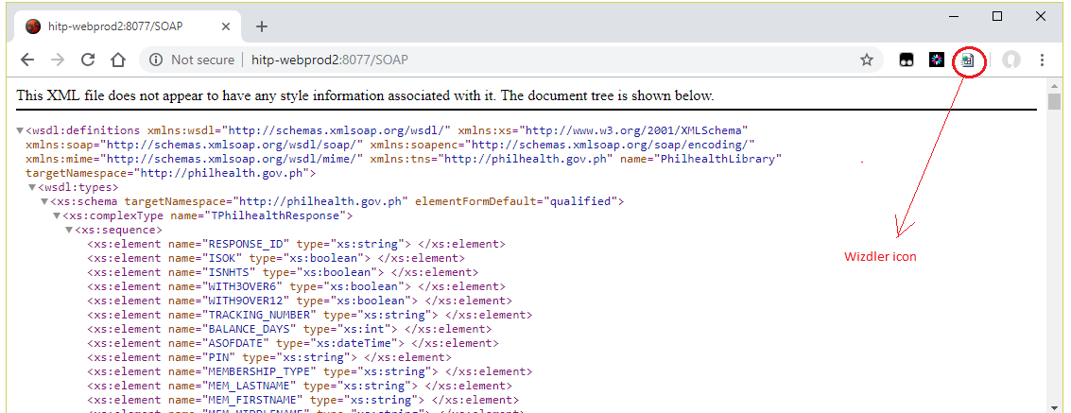
Figure 1

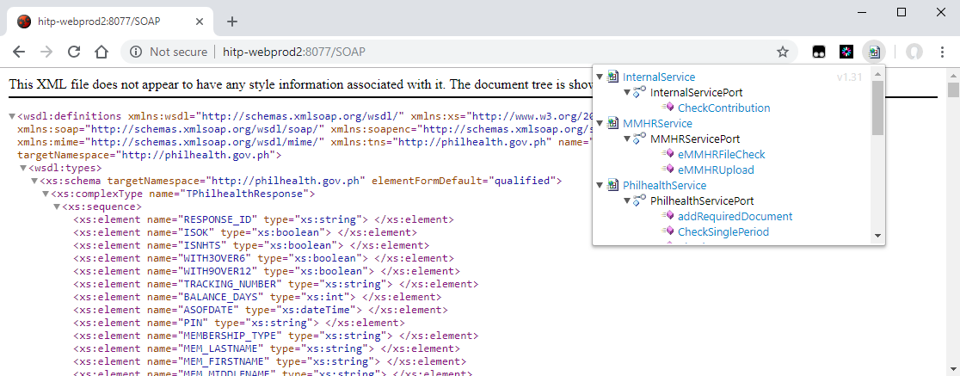
Figure 2

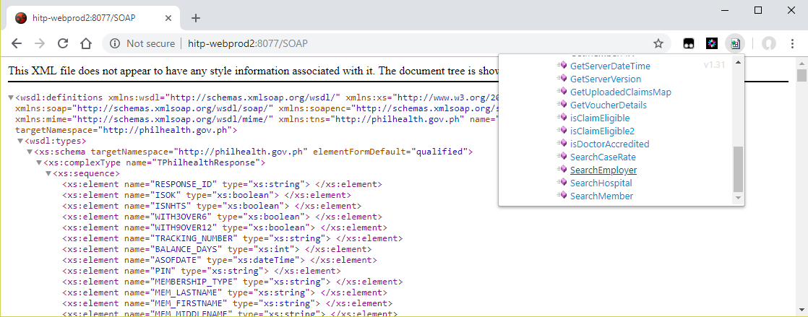
Figure 3

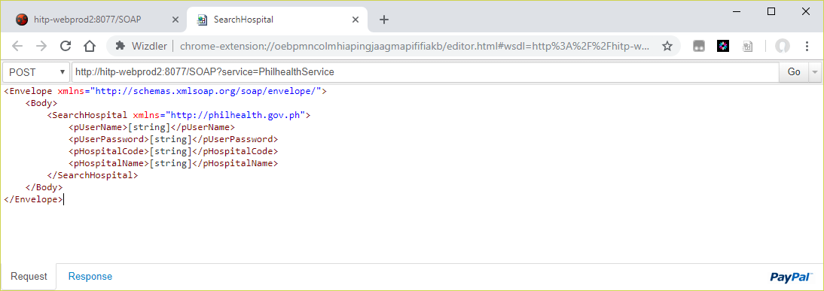
Figure 4

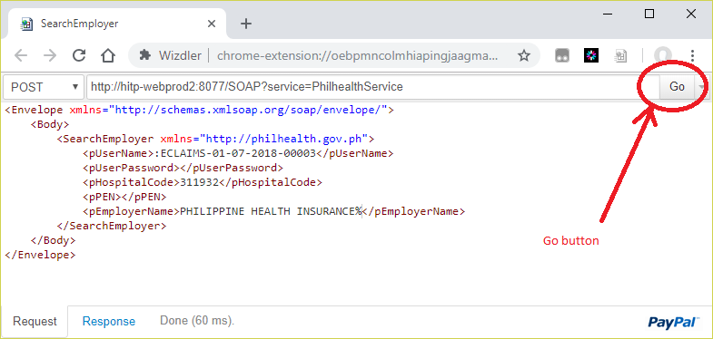
Figure 5

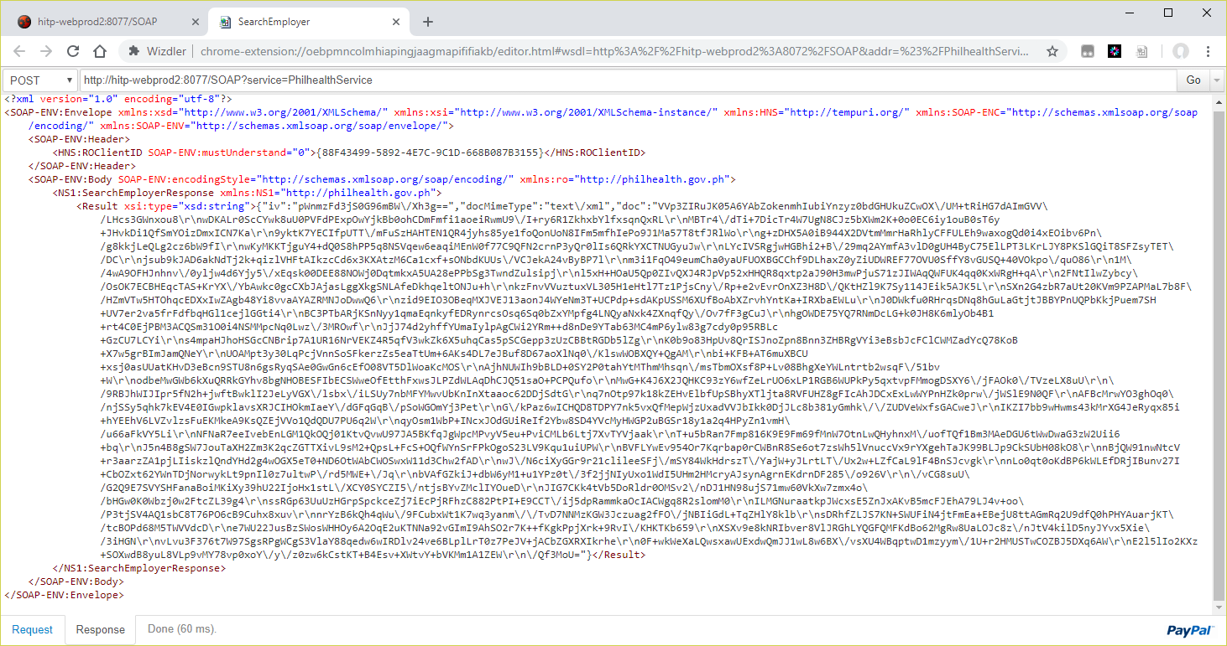
Figure 6

