RESOLVING CONNECTION PROBLEM IN CONSUMING PECWS

ADDING REFERENCE to pecws using local file instead of the pecws wsdl url
One of the resolutions for the reported connection problems in consuming PECWS is changing how the web/service reference to PECWS is added to the development environment. Instead of using the actual URL of the PECWS WSDL in adding web/service reference, one may save the WSDL to a file and use the local file in adding the web/service reference. The steps of saving the PECWS WSDL to a local file is outlined below. Please note that the URL of the PECWS WSDL used in this document is the PECWS deployed in the test environment.
The PECWS in the testing/staging environment was configured with HTTPS protocol using self-signed certificate. Most of applications issues security error messages when they try to consume web services with self-signed certificate. One workaround for that issue is to let the application bypass the SSL authentication.

SAVING PECWS WSDL AS A LOCAL FILE
- In a browser, navigate the given PECWS WSDL URL, for example https://210.4.103.170:8077/SOAP .
- The browser may prompt a security warning. Add the PECWS WSDL to the certificate security exceptions. Each browser may have a different way of doing this. In Google Chrome, click the Advanced link, then click the Proceed to 210.4.103.170 (unsafe) link. After this, Chrome will show the text of the WSDL. Right click on the text and click the “Save As…” button. Depending on your setting, Chrome may prompt a save file dialog box. You may want to rename the file as PECWS.wsdl.
- Open the downloaded file in a text editor. Search and replace all occurrence of “http” to “https”. Save the file
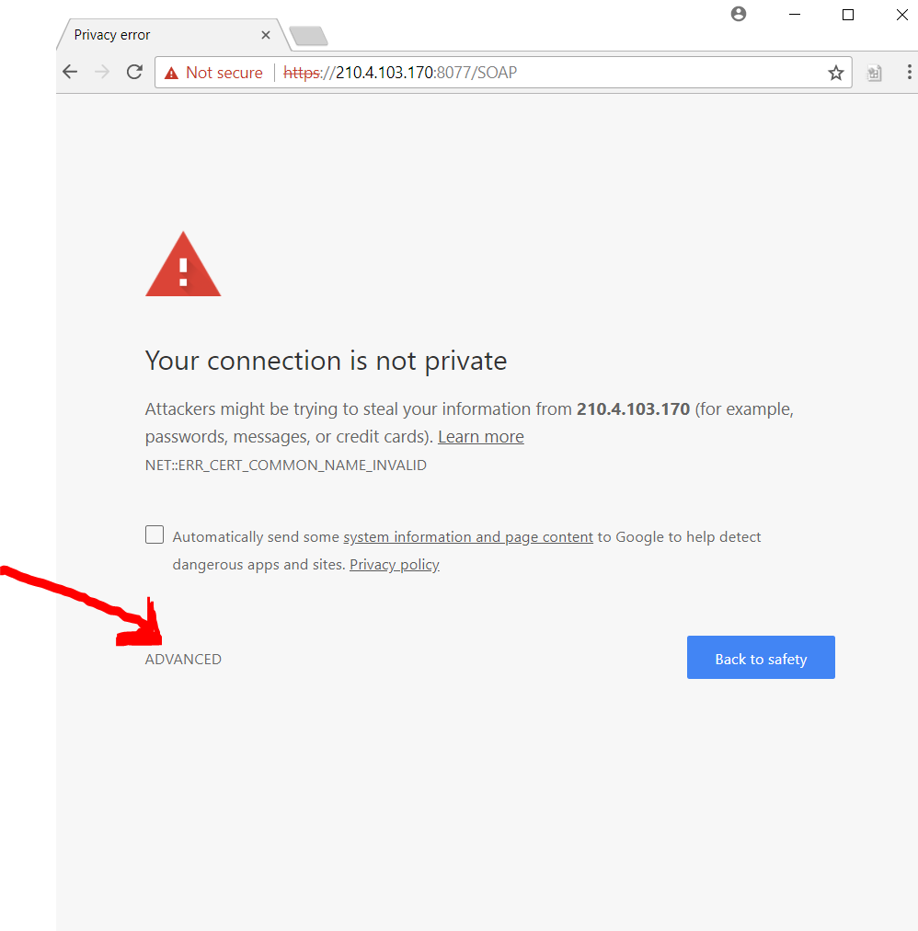
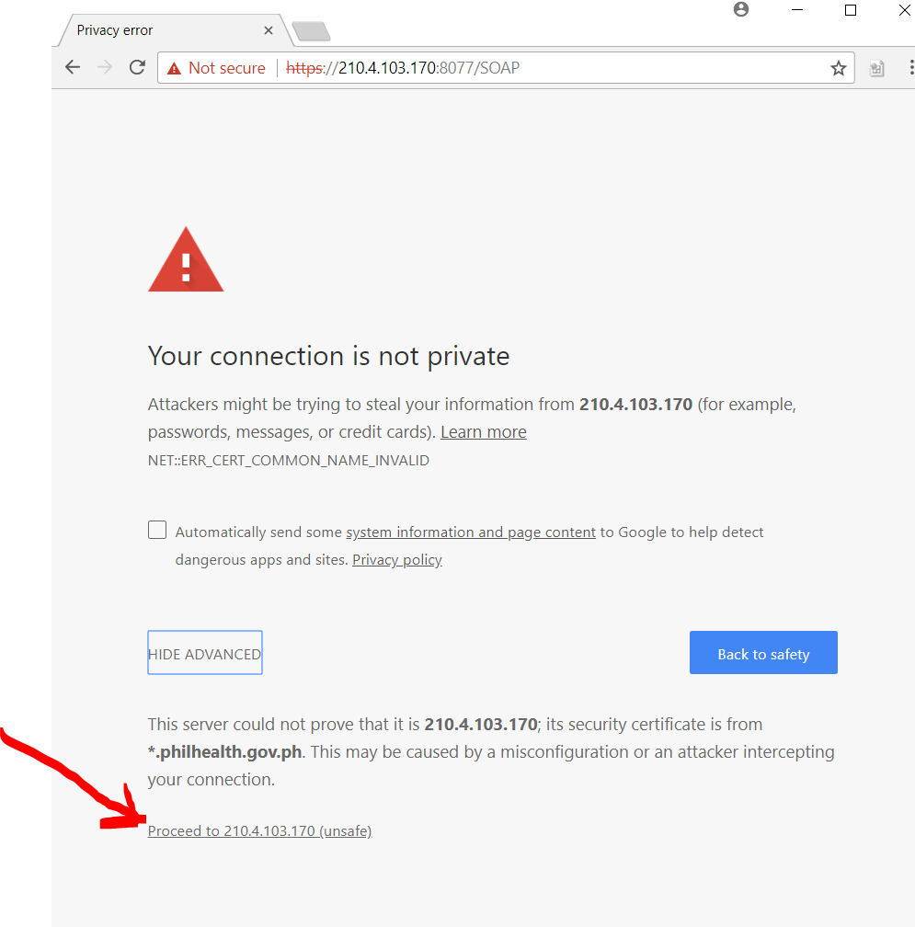
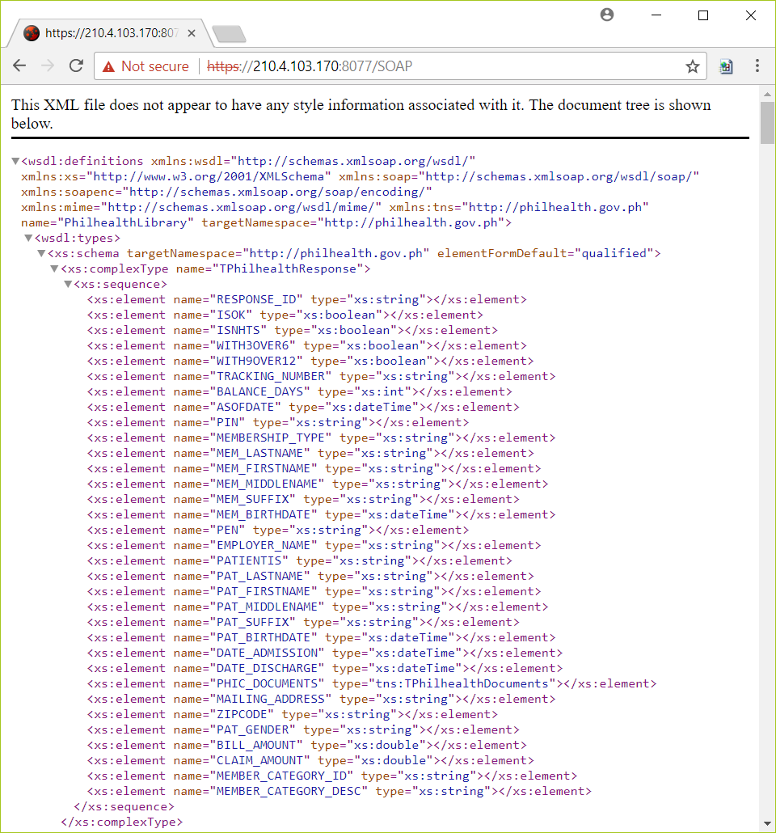
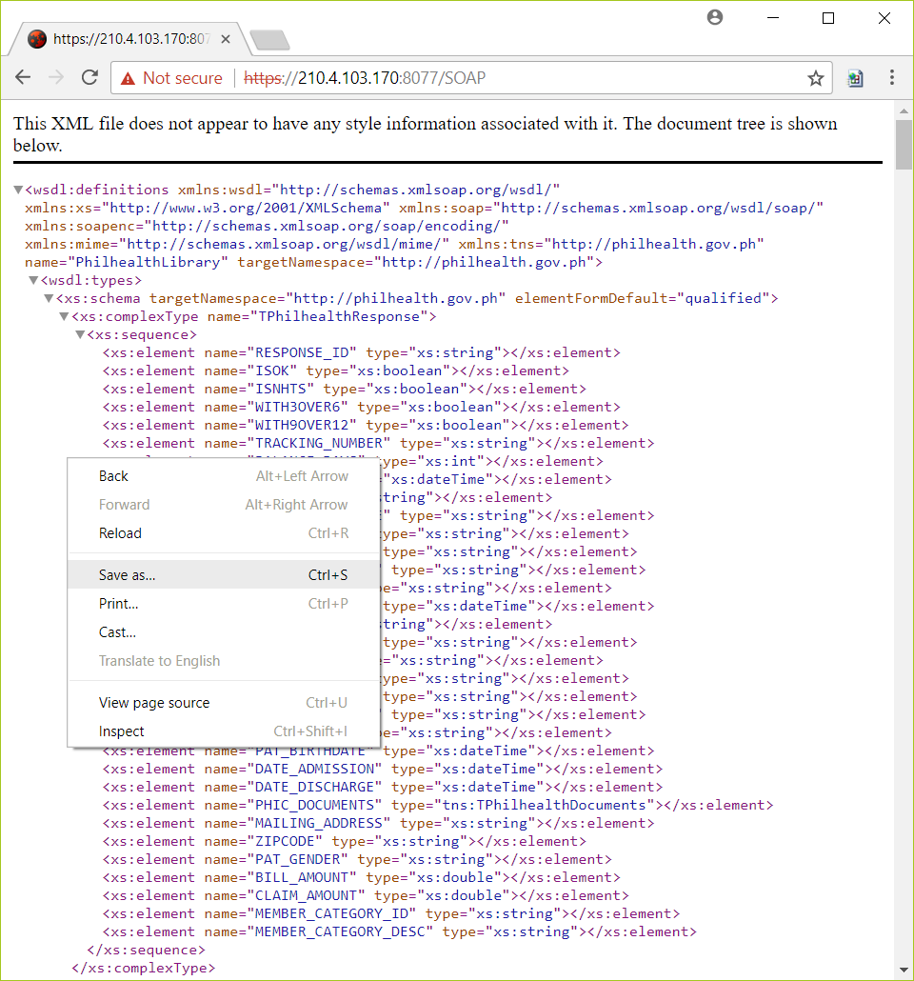
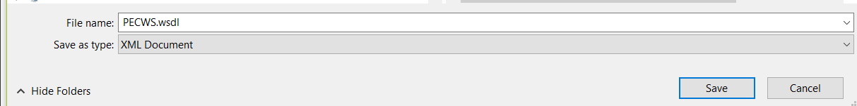

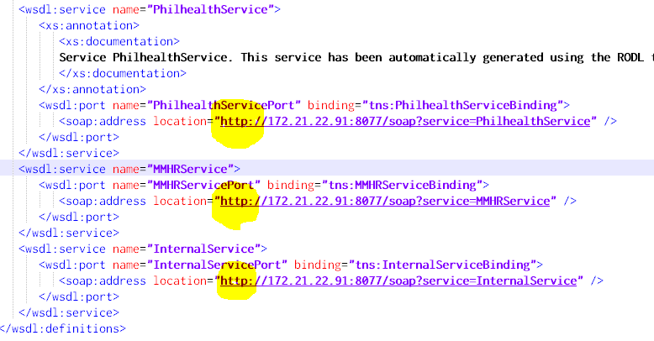
Downloaded WSDL showing web service endpoint address as using http

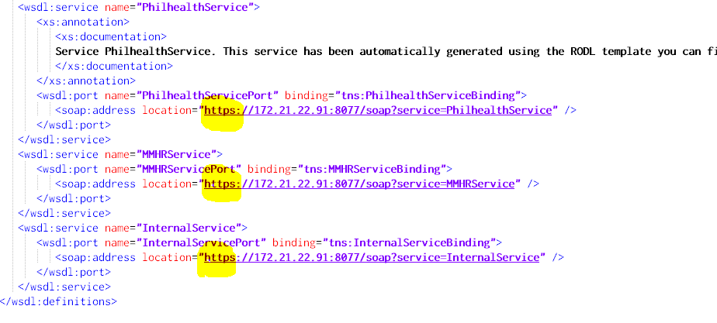
WSDL with the web service endpoint address changed from http to https

