


PhilHealth

Implementation Guide

202208031
PECWS v2.5

Amendment History
Version | Date | Remarks
Version 1.0 | 20090500 | Parameters for Phase 1 & 2 , re:submission of claims physical documents
Version 2.0 | 20120709 | Updated version converted eClaims Phases into Modules re: Full eClaims with PDF attachment
Version 2.5 | 20120718 | Parameters for Z-BITS observation feature included
Version 3.0 | 20120727 | Included Parameters for Module 3: Claim Status Verification re: Field/Attributes, Web service method of eClaims Status and eClaims Voucher
Version 3.0 | 20120924 | -Provision for copyright and disclaimer in the introduction  - Attached PC Circular on the accreditation of HITP  - On-site validation Tool , component 1 of Part II,  Conformance and Compliance Testing
Version 3.0 | 20121016 | - Included provision of Confidentiality
Version 3.1 | 20121030 | - Added web services for PIN verification, Doctor accreditation code, Doctor accredited and Single Period of Confinement
Version 3.1 | 20121109 | - Excluded live urls
Version 3.1 | 20121219 | -Modified validation tools re:  *Component 1: item K (deleted)  *Component 2: module 1, item 9  1, item 13  module 2, item A  module 3, item G (deleted)  3, deleted email capability to reply  within 1 day  - Created Component 3 for policy document and technical support
Version 3.1 | 20130109 | Included document type codes and descriptions
 | 20130322 | Updated IHCP eClaims account form for IHCP for digital certificate generation
Version 4.0 | 20130912 | - Updated the fields/attributes/parameter definition of Module 2: Electronic Claims Submission in conformity with the revised PhilHealth claim forms (pages 26-32)  - Updated the file structure of Module 2 (pages 33-36)  - Updated the Document Type Definition of Module 2 (page 37)  - prescribed PhilHealth Benefit Eligibility Form for CEWS response  (Yes response – page 21 )  (No response – page 23 )
 | 20131104 | - Updated the fields/attributes/parameter definition of Module 2: Electronic Claims Submission in conformity with the revised PhilHealth claim forms (pages 26-31)  - Updated the file structure of Module 2 (pages 34-37)  - Updated the Document Type Definition of Module 2 (page 38)
 | 20160120 | - Added PhilHealth Member Registration Form, Anesthesia Record and Hemodialysis Record in the list of document type in Annex K  - Added “P” (for Lifetime Member) as an acceptable value for the pMembershipType attribute
 | 20160217 | - Removed embedded hyphens in the values of pMemberPin attribute in the sample XMF files  - Updated the parameter definition and the sample XML result of the SearchCaseRate method
 | 20160303 | - Removed pCataractPreAuth attribute and added pPatientType and pIsEmergency attributes in in the CLAIM element in the sample eClaims XML file and in Module 2 file structure
 | 20160406 | - Removed procedures related to the use of digital certificates for connection with between systems of HITPs and the PhilHealth’s e-claims web service  - Included in the annexes the guidelines for the decryption of the images files of the supporting documents of claims submitted through e-claims web service  - Made some changes to the formats and layout of the document
 | 20160930 | - Added “IMRT” element to add IMRT to the supported repetitive procedures  - Added “pHasAttachedSOA” attribute to CF2 element for indicating whether a claim has corresponding SOA  - Added new "CATARACTINFO" element to hold info about data like IOL sticker number for cataract operation. The "CATARACT" element will be deprecated later  - Added the element “APR” that will hold the information about the permission to access patient record
 | 20161206 | - Added SearchEmployer method, which can be used for getting the employer information of an employed member  - Added AddRequiredDocument method, which will be used to submit/re-submit the PDF files of supporting documents of claims that were tagged as “pending” or “RTH” (returned to hospital) due to problem with missing, incomplete or unreadable PDF files of required supporting documents
 | 20170118 | - Added the description for the “pPreauthDate” attribute of e-claims XML file
 | 20170206 | - Added the description for the “pThumbmarkedBy” attribute
 | 20170329 | - Added the support for wildcard in the description of the pEmployerName parameter of the SearchEmployer method.
 | 20170529 | - Made some changes on the documentation of the GetDoctorPAN service, especially about its return values
 | 20170606 | - Corrected the value for “No” from ‘Y’ to ‘N’ for the “pEssentialNewbornCare”,  “pNewbornHearingScreeningTest” and “pNewbornScreeningTest” attributes
 | 20170623 | - Changed the specified length of the value for pICDCode from 10 to 15
 | 20170703 | - Added pServiceProvider attribute to the eCLAIMS element to indicate the provider of the system used to encode and submit the e-claims XML file
 | 20170802 | - Removed and replaced annexes about guidelines that are directly related to HITPs
ECWS 2.5 | 20171120 | - Renamed some of the subsection titles  - Added the specifications for the encryption and decryption of XML payload data  - Removed annexes that pertains to HITPs
 | 20180313 | - Removed the occurences of the pCertificateId attribute. The value of the Software Certificate ID is to be “embedded” with pUserName attribute
 | 20180322 | - Changed the description of “hash” in in the Item #6 of the “ENCRYPTION OF THE XML PAYLOAD DATA” section of Annex E
 | 20220831 | - Corrected the size of the initialization vector mentioned in Step 7 of the Annex D from “128 bytes” to “16 bytes (for a total of 128 bits)”.

Contents
1. INTRODUCTION 1
2. PREPARATIONS 2
3. Application Programming Interface (API) of the 3
PhilHealth e-Claims Web Service (PECWS) 3
Notes ABOUT Input and Output Parameters 4
Module 1: Claims Eligibility Web-Service 5
Module 1a: PIN Verification Utility 12
Module 1b: Doctor Accreditation Check 12
Module 1c: HCP Accreditation Number Utility 13
Module 1d: Check Single Period of Confinement 14
Module 1e: Employer Search 14
Module 2: Electronic Claims Submission 15
Module 2a: e-Claims XML data Submission 15
Module 2b: Hospital and Philhealth Claims Mapping 32
Module 2b: Health Institution Search 32
Module 2c: Case Rate Search 33
Module 2d: Add Required Document 33
Module 3: Claim Status Verification 34
Module 3a: Getting the Current Status of a Claim 36
Module 3b: Getting the Voucher Details 37
5. ANNEXES 44
Annex A: Sample e-Claims XML 45
Annex B: Sample e-Claims Voucher Formatted With Value.xml 52
Annex C: Consuming the PhilHealth e-Claims Web Service 56
Viewing the API Specification of the web service 56
Consuming the Web Service 56
Annex D: Guidelines for the Encryption of Image Files of the supporting documents of claims Submitted through e-Claims web servce 64
Procedures 64
Format of the Output File 64
Demo Kits 65
Annex E: Guidelines for the Encryption and Decryption of Parameters that are to be passed as xml 70
GUIDELINES AND Procedures 70
Annex F: Non-disclosure Agreement 72
Annex G: Software Testing and Validation 73
Annex G: List of document types and codes 75

1. INTRODUCTION

Philippine Health Insurance Corporation (PhilHealth), Republic of the Philippines (2012)

Copyright to this material belongs to PhilHealth. Apart from any fair dealing for personal, academic, research or non-commercial use, no part may be reproduced without written permission of PhilHealth. PhilHealth is under no obligation to grant this permission. Please acknowledge the Philippine Health Insurance Corporation when reproducing or quoting material from this source

Important Disclaimer:
All information and content in this Material is provided in good faith by PhilHealth, and is based on sources believed to be reliable and accurate at the time of development. The Philippine Health Insurance Corporation, and their respective officers, employees and agents, do not accept legal liability or responsibility for the Material, or any consequences arising from its use.

Philippine Health Insurance Corporation (PhilHealth) is committed to ensuring ease of availment at the point of care for all its beneficiaries.

As such, in 2011, the Corporation launched the eClaims Project through PhilHealth Circular No.14 and Office Order No. 69 which broadly aims to streamline key processes such as eligibility check, claims submission, verification and payment in order to serve both members and partner providers better. The eClaims Project had three phases, namely

- Phase I or Claims Eligibility Web Service (CEWS)
- Phase II or Electronic Claims Submission (ECS)
- Phase III or Claims Status Verification/Payment (CSV)

Republic Act 8792 or the e-Commerce Act was signed into law on June 14, 2000, and mandated all government agencies to, among others, transact government business and perform government functions using electronic data messages or electronic documents. It therefore provides for the legal recognition of electronic documents, data messages, electronic signatures and electronic contracts. RA 8792 provides the legal framework and environment for the PhilHealth eClaims System.

In view thereof, PhilHealth is scaling up the eClaims project to ensure key processes are performed with utmost efficiency. The goal of the enhanced eClaims system is to reform business transactions between PhilHealth and IHCPs by establishing an efficient web-based online information technology scheme in all IHCPs that would effectively improve claims processing systems.

The enhanced eClaims system shall introduce the following features, to wit: 1) a paper-free claims transaction through a fully electronic and online submission of reimbursement claim documents by IHCPs; 2) online evaluation and processing of claims in PhilHealth regional and service offices; and 3) online tracking and status verification of claims; and,

This document applies to accredited IHCP and Service Provider (SP), which will serve as conduits between PhilHealth and IHCPs and provide the latter with utilities to enable access to the PhilHealth e-Claims Web Service or PECWS.

2. PREPARATIONS

PROCEDURES ON HOW TO CONNECT TO eCLAIMS WEB SERVICE (ECWS)

Step 1. Check for internet connectivity requirements

- A good internet connection between the system of the HCI and ECWS of PhilHealth is needed. HCI should have at least a bandwidth of 1mbps. HCI should have an internet connection dedicated to ECWS.

Step 2. Submit the public IP address
- HCI should have a public IP

- A good internet connection between the system of the HCI and ECWS of PhilHealth is needed. HCI should have at least a bandwidth of 1mbps. HCI should have an internet connection dedicated to ECWS. HCI should have a public ID.

3. Application Programming Interface (API) of the

PhilHealth e-Claims Web Service (PECWS)

This section shows the Application Programming Interface (API) of the PhilHealth e-Claim Web Service (PECWS). The input and output parameters of the different methods of the web service are defined here. The different available methods are loosely grouped based the following “modules”

- Module 1: Claims Eligibility Web Service
- Module 2: Electronic Claims Submission
- Module 3: Claim Status Verification

Notes ABOUT Input and Output Parameters

About the Software Certification ID and the pUserName Input Parameter

Starting with version 2.5 of PECWS, all applications that will access PECWS are required to be certified by PhilHealth beforehand. Each certification is targeted for a specific version of PECWS. To check whether an application calling a service method of ECWS is certified, the calling application should indicate the Software Certification ID issued by PhilHealth after an application has been certified. To minimize the change in the existing applications of HCIs, the pUserName parameter is re-defined to allow appending the Software Certification ID. The pUserName input parameter is a parameter common to most of the service methods of PECWS. This parameter is used to pass the user ID assigned by PhilHealth to an HCI to access the PECWS. The pUserName parameter should be encoded using this convention:

{HciUserID}:{SoftwareCertificationID}

where HciUserID represents the user ID assigned by PhilHealth followed by a colon (“:”) and, then, followed by the software certification ID.

Encryption and Decryption of the xml Payload dATA

For added security measures, starting with version 2.5 of PECWS, HCI applications should encrypt all input parameters that are to be encoded as XML text. HCI applications should also decrypt all output parameters that are returned in XML format.

Please refer to the “Guidelines for the Encryption and Decryption of Parameters that are to be Passed as XML” included in the annexes.

Module 1: Claims Eligibility Web-Service

The CEWS addresses eligibility of a member and valid dependents. Particularly it validates status the profile information of the following:
  - Member validity;
  - Patient who is a dependent of the member;
  - 45 days confinement
  - Qualifying posted contribution (3/6 and 9/12)

Verification should be made upon admission (initial call). The final call is where the authorization code (AC) is generated for confirming eligibility for member to avail of his/her appointment.

The following are the proposed format to be used as guide for developing the prototype for claims eligibility function:

Web Service Method:

isClaimEligible ( pUserName, pUserPassword, pHospitalCode, pPIN, pMemberLastName, pMemberFirstName, pMemberMiddleName, pMemberSuffix, pMemberBirthDate, pMailingAddress, pZipCode, pPatientIs, pAdmissionDate, pDischargeDate, pPatientLastName, pPatientFirstName, pPatientMiddleName, pPatientSuffix, pPatientBirthDate, pPatientGender, pMemberShipType, pPEN, pEmployerName, pRVS, pTotalAmountActual, pTotalAmountClaimed, pIsFinal)

Parameter Definition

Name | Length | Description | Valid Values
pUserName | String(20) | Provider user id | Convention: {UserId}:{SoftwareCertifcationId}  where  - UserId is the user ID assigned by PhilHealth given for each provider  - SoftwareCertifcationId is the software certification ID reflected in the Software Certification issued by PhilHealth after the software passed the software validation process
pUserPassword | String(20) | Provider user password | To be provided by PhilHealth
pHospitalCode | String(12) | Facility Accreditation Number | For now PMCC number should be used
pPIN | String(12) | PhilHealth Identification Number – a unique 12 digit number assigned to a member. | The last character in the PIN is a modulus 11 check digit.
pMemberLastName | String(60) | Member’s Complete Surname | Any value consisting of : ‘A’ to ‘Z’, ‘Ñ’. Can include a space in between characters
pMemberFirstname | String(60) | Member’s Complete First name
pMemberMiddleName | String(60) | Member’s Complete Middle name
pMemberSuffix | String(5) | Member’s Suffix name | ‘JR’, ‘SR’, ‘III’, …etc  Suffixes can be blank
pMemberBirthDate | String(10) | Member’s Birth Date | Date Format should be :  ‘MM-DD-YYYY’
pMailingAddress | String(150) | Mailing Address (address where the benefit payment notice will be sent) | Should not be blank
pZipCode | String(4) | Philippine Zip Code of the municipality | Should not be blank
pPatientIs | String(1) | Flag whether patient is the member or if dependent the relationship of patient with the member. | - ‘M’ – patient is member(Self)  - ‘S’ – patient is spouse  - ‘C’ – patient is child  - ‘P’ – patient is parent
pAdmissionDate | String(10) | Admission Date | Date Format should be :  ‘MM-DD-YYYY’
pDischargeDate | String(10) | Discharge Date | Date Format should be :  ‘MM-DD-YYYY’
pPatientLastName | String(60) | Patient’s Complete Surname | Same as for the member. These can be blank since these are disregarded if the value of pPatientIs is ‘M’
pPatientFirstName | String(60) | Patient’s Complete First name
pPatientMiddleName | String(60) | Patient’s Complete Middle name
pPatientSuffix | String(5) | Patient’s Suffix name | ‘JR’, ‘SR’, ‘III’, …etc  Suffixes can be blank
pPatientBirthDate | String(10) | Patient’s Birth Date | Date Format should be :  ‘MM-DD-YYYY’
pPatientGender | String(1) | Patient’s Gender | M – Male  F - Female
pMemberShipType | String(2) | PhilHealth membership type of the member | (Not limited to the following :)  ‘S’ – Employed Private  ‘G’ – Employer Government  ‘I’ – Indigent  ‘NS’ – Individually Paying  ‘NO’ – OFW  ‘PS’ – Non Paying Private  ‘PG’ – Non Paying Government  ‘P’ – Lifetime member
pPEN | String(12) | PhilHealth Employer Number – a unique 12 digit number assigned to an employer | These are disregarded if pMemberShipType is not (‘S’ or ‘G’)
pEmployerName | String(100) | The Registered name of the employer | These are disregarded if pMemberShipType is not (‘S’ or ‘G’)
pRVS | String(6) | RVS code of the surgical procedure to be done to the patient. | Leave blank if no surgery is to be done.
pTotalAmountActual | String(12) | Actual Amount of the Hospital Bill | Hospital Charges only. Formatted as: ‘#######.##’
pTotalAmountClaimed | String(12) | Amount to be reimbursed by PhilHealth | Hospital Charges only. Formatted as: ‘#######.##’
pIsFinal | String(1) | Flag for Initial and Final Call. | Limited to the following:  ‘0’ – Initial  ‘1’ - Final
Note : All the fields are required unless otherwise specified that it can be blank or disregarded.

Draft Revised claim form 1

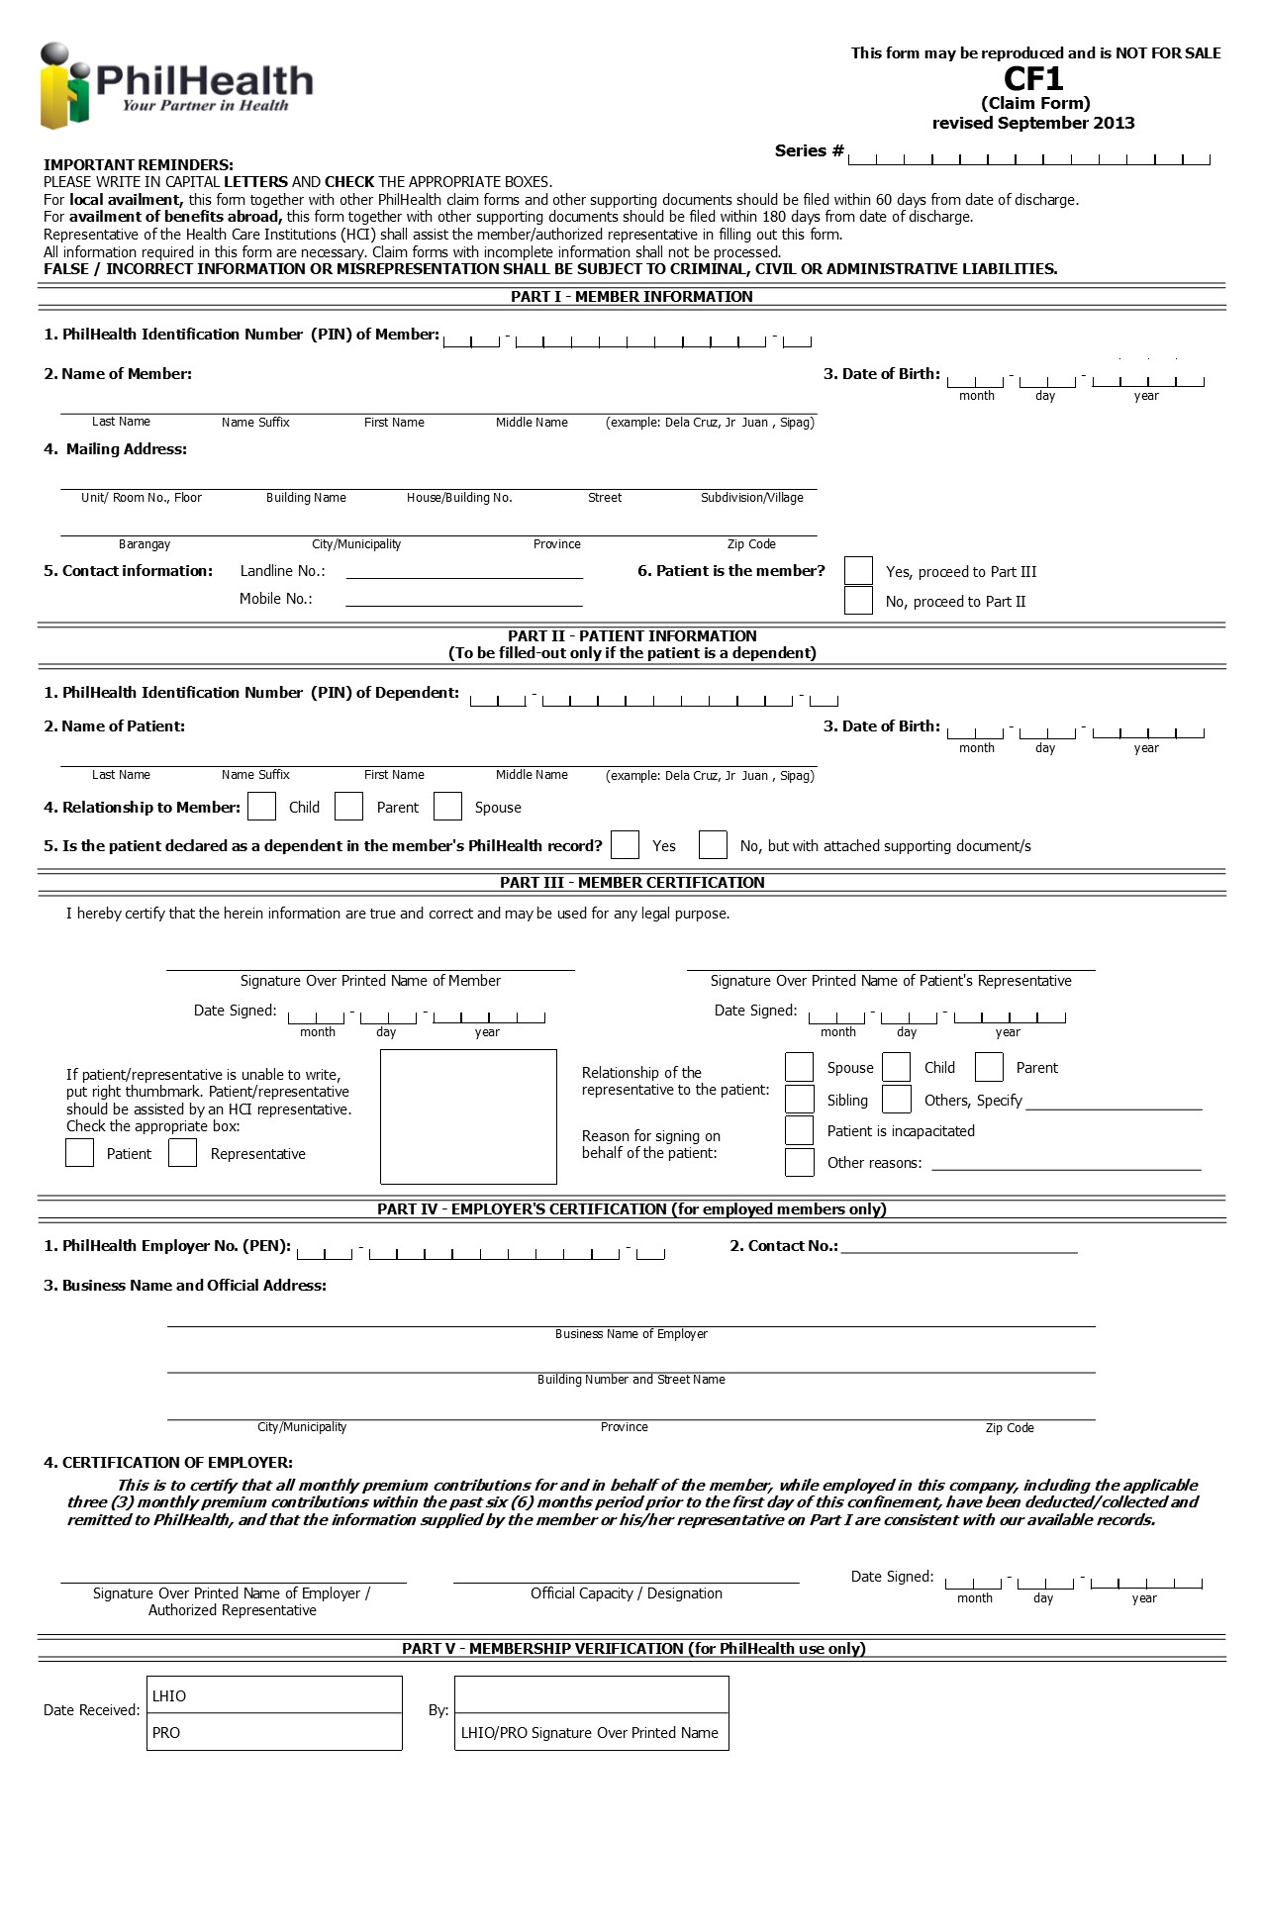

Response Definition
The response of the service is in the form of an XML file.

An example “YES” Xml Response :

<RESPONSE
ISOK="YES"
TRACKING_NUMBER="1234561212000011"
REMAINING_DAYS="44"
ASOF="12-19-2012">
<PATIENT
PATIENTIS="M"
LASTNAME="DELA CRUZ"
FIRSTNAME="JUAN"
MIDDLENAME="OCAMPO"
SUFFIX="JR"
BIRTHDATE="09-15-1970"
></PATIENT>
<CONFINMENT>
ADMITTED="12-19-2012"
DISCHARGE="12-19-2012"
</CONFINMENT>
<MEMBER
PIN="190905703882"
MEMBER_TYPE="P"
LASTNAME="DELA CRUZ"
FIRSTNAME="JUAN"
MIDDLENAME="OCAMPO"
SUFFIX="SR"
BIRTHDATE="09-15-1970"
></MEMBER>
<EMPLOYER>
PEN="019000029665"
NAME="SAMPLE HOSPITAL"
</EMPLOYER>
<DOCUMENTS>
</DOCUMENTS>
</RESPONSE>

For the “YES” Response, the developer of the module 1 should be able to display the Tracking Number (TN) . The same TN will later be used for the uploading of electronic claims.

The following below sample format must be used:

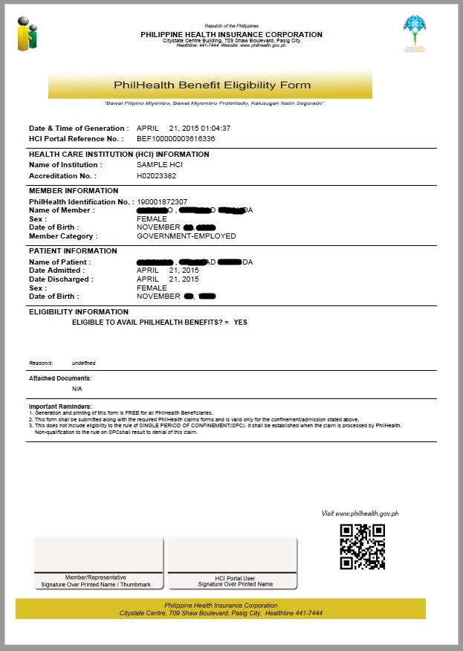

An example “NO” Xml Response :

<RESPONSE
ISOK="NO"
TRACKING_NUMBER=""
REMAINING_DAYS=""
ASOF="12-19-2012">
<PATIENT
PATIENTIS="D"
LASTNAME="DELA CRUZ"
FIRSTNAME="MARIA"
MIDDLENAME="BAUTISTA"
SUFFIX=""
BIRTHDATE="01-01-2005"
></PATIENT>
<CONFINMENT>
ADMITTED="12-19-2012"
DISCHARGE="12-19-2012"
</CONFINMENT>
<MEMBER
PIN="190905703882"
MEMBER_TYPE="S"
LASTNAME="DELA CRUZ"
FIRSTNAME="JUAN"
MIDDLENAME="OCAMPO"
SUFFIX="JR"
BIRTHDATE="09-15-1970"
></MEMBER>
<EMPLOYER>
PEN="019000029665"
NAME="SAMPLE HOSPITAL"
</EMPLOYER>
<DOCUMENTS>
<DOCUMENT
CODE="PBC"
NAME="PATIENT'S BIRTH CERTIFICATE">UNDECLARED DEPENDENT
</DOCUMENT>
<DOCUMENT
CODE="MBC"
NAME="MEMBER'S BIRTH CERTIFICATE">DISCREPANCY-MEMBER’S FIRSTNAME;DISCREPANCY-
MEMBER’S LAST NAME
</DOCUMENT>
</DOCUMENTS>
</RESPONSE>

The message remarks should be relayed to the member or authorized representative of the member for compliance of the listed documents to be submitted to the hospital for document scanning which will be part of module 2.

The next sample format must be used.

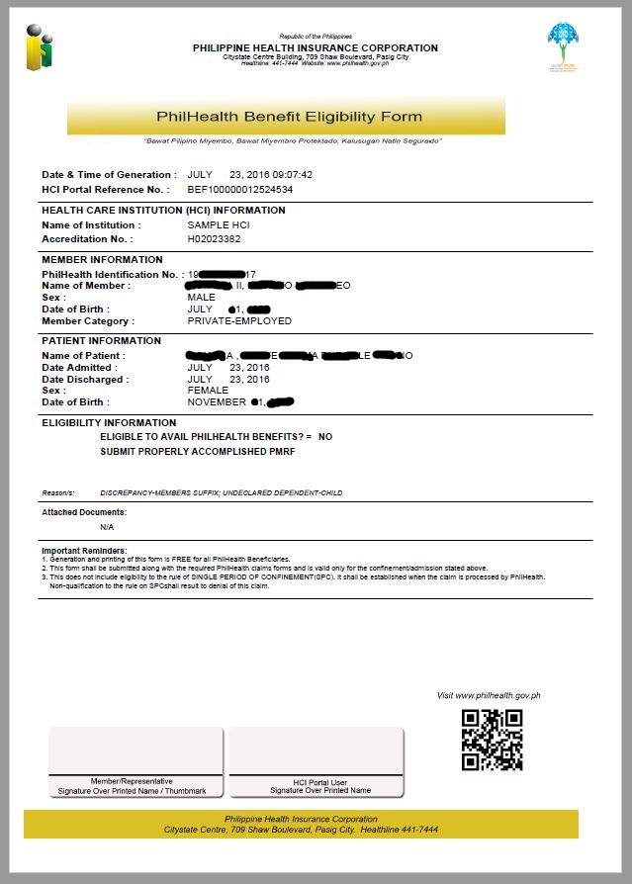

For the service methods of PECWS starting with version 2.5, the all service methods of the PECWS, all input and output parameters of the

Module 1a: PIN Verification Utility

This utility allows member through the IHCP to look up its PhilHealth Identification Number (PIN) in the event the member does not know his PIN. The hospital needs to enter the information of the member such as the complete name including the suffix if applicable and birth date.

Web Service Method

GetMemberPIN (pUserName, pUserPassword, pHospitalCode, pMemberLastName, pMemberFirstName, pMemberMiddleName, pMemberSuffix, pMemberBirthDate)

Parameter Definition
Name | Length | Description | Valid Values
pUserName | String(20) | Provider user id | To be provided by PhilHealth
pUserPassword | String(20) | Provider user password | To be provided by PhilHealth
pHospitalCode | String(12) | Facility Accreditation Number | For now PMCC number should be used
pMemberLastName | String(60) | Member Last Name
pMemberFirstName | String(60) | Member First Name
pMemberMiddleName | String(60) | Member Middle Name
pMemberSuffix | String(7) | Member Suffix Name
pMemberBirthDate | String(10) | Member Birth Date | Date Format should be :  ‘MM-DD-YYYY’

- For successful transaction, a PhilHealth Number will be returned:
e.g.
19-0000220202

- For unsuccessful transaction, the method will return either of the following:
- If no corresponding PhilHealth Identification Number was found:
NO RECORD FOUND. REGISTER ONLINE OR PROCEED TO ANY PHILHEALTH OFFICE

- If Multiple PINs were found:
MULTIPLE RECORDS FOUND. PLEASE PROCEED TO ANY PHILHEALTH OFFICE FOR PIN CLEANUP

Module 1b: Doctor Accreditation Check

For case rates, cases attended by non-accredited doctors are denied. Another functionality of the system is its capacity to check whether or not the attending doctor is accredited. The hospital clerk needs to enter the information of the doctor such as doctor accreditation code, admission date and discharge date. The admission date and discharge date will be checked against the validity of the doctor’s accreditation.

Web Service Method

isDoctorAccredited (pUserName, pUserPassword, pHospitalCode, pDoctorAccreCode, pAdmissionDate, pDischargeDate)

Parameter Definition
Name | Length | Description | Valid Values
pUserName | String(20) | Provider user id | To be provided by PhilHealth
pUserPassword | String(20) | Provider user password | To be provided by PhilHealth
pHospitalCode | String(12) | Facility Accreditation Number | For now PMCC number should be used
pDoctorAccreCode | String(12) | Health Care Professional Accreditation Number
pAdmissionDate | String(10) | Date of Admission | Date Format should be :  ‘MM-DD-YYYY’
pDischargeDate | String(10) | Date of Discharge | Date Format should be :  ‘MM-DD-YYYY’

Sample XML Response

< eACCREDITATION
IsAccredited=””
pDoctorAccreCode=””
pAdmissionDate=””
pDischargeDate=””>

- For successful transaction,

PhilHealth will return “Doctor is accredited based on admission or discharge date”

- For unsuccessful transaction,

PhilHealth will return “Doctor is not accredited based on admission or discharge”

Module 1c: HCP Accreditation Number Utility

In the event the attending health care professionals (HCP) do not know their PhilHealth accreditation numbers (PAN), they can check using the Doctor Accreditation Number Utility. The HCI clerk needs to enter the information of the doctor such as complete name and date of birth.

Web Service Method

GetDoctorPAN (pUserName, pUserPassword, pHospitalCode, pDoctorTIN, pDoctorLastName, pDoctorFirstName, pDoctorMiddleName, pDoctorSufix, pDoctorBirthDate)

Parameter Definition
Name | Length | Description | Valid Values
pUserName | String(20) | Provider user id | To be provided by PhilHealth
pUserPassword | String(20) | Provider user password | To be provided by PhilHealth
pHospitalCode | String(12) | Facility Accreditation Number | For now PMCC number should be used
pDoctorTIN | String(12) | Health Care Professional TIN
pDoctorLastName | String(60) | Health Care Professional Last Name
pDoctorFirstName | String(60) | Health Care Professional First Name
pDoctorMiddleName | String(60) | Health Care Professional Middle Name
pDoctorSufix | String(7) | Health Care Professional Suffix Name
pDoctorBirthDate | String(10) | Health Care Professional Birth Date | Date Format should be :  ‘MM-DD-YYYY’

- If ECWS finds a matching record for the passed data of the HCP, ECWS will return the 12-digit PAN in the format “0000-0000000-0”

- If ECWS does not find a matching record, ECWS will return a blank string (“”);

- If ECWS encountered an exception/error while querying for the records of the HCP, ECWS will return the exception/error message using the format “ERROR: <error message>”

Module 1d: Check Single Period of Confinement

Web Service Method [Not yet implemented!!!]

CheckSinglePeriod (pUserName, pUserPassword, pHospitalCode, pPIN, pPatientIs, pPatientLastName, pPatientFirstName, pAdmissionDate, PhilhealthClaimType, pICDCodes, pHighRVSs, pCaseRateCode)

Single period of confinement refers to a confinement or series of confinements for the same illness with intervals of not more than 90 days. In such cases, they can only avail of the unused portion of the benefits and room and board allowance until the 45 days allowance is exhausted.

PhilHealth will display “ Same illness within 90 days”

Module 1e: Employer Search

This can be used in searching employer with PhilHealth Employer Number.

Web Service Method

SearchEmployer (pUserName, pUserPassword, pHospitalCode, pPEN, pEmployerName)

Parameter Definition
Name | Length | Description | Valid Values
pUserName | String(20) | Provider user id | To be provided by PhilHealth
pUserPassword | String(20) | Provider user password | To be provided by PhilHealth
pHospitalCode | String(12) | Facility Accreditation Number | For now PMCC number should be used
pPEN | String(12) | PhilHealth Employer Number
pEmployerName | String(60) | PhilHealth Employer Name | Minimum length: 10 characters. Wildcard characters are supported. The percent (%) wildcard matches one or more characters. For example, passing “PHILIPPINE%” matches names of employers starting with “PHILIPPINE”

Sample XML Response

<eEMPLOYERS
ASOF=””>
<employer
pPEN=””
pEmployerName=””
pEmployerAddress=””>
</eEMPLOYERS>

Module 2: Electronic Claims Submission

Module 2a: e-Claims XML data Submission

Web Service Method

eClaimsUpload (pUserName, pUserPassword, pHospitalCode, pXML)

This can be used by the hospitals to make their application upload the eClaims file to philhealth. This method also checks for DTD compliance and validate the values of the xml attributes if they are valid based on the

Unsuccessful upload, the method will return:

<eRECEIPT
pUserName="XXXXXX"
pUserPassword="xxx123"
pHospitalCode="123456"
pHospitalTransmittalNo="001"
pTotalClaims="1"
pTransmissionControlNumber=""
pTransmissionDate="08-26-2009"
pTransmissionTime="00:00:00AM" >
<REMARKS pErrCode="T01" pErrDescription="Invalid parameter value: pAmtActual" />
<REMARKS pErrCode="T02" pErrDescription="Invalid parameter value: pOperationDate" />
</eRECEIPT>

Successful upload, the method will return:

<eRECEIPT
pUserName="XXXXXX"
pUserPassword="xxx123"
pHospitalCode="123456"
pHospitalTransmittalNo="001"
pTotalClaims="1"
pTransmissionControlNumber="1234-5601-1234-1253"
pTransmissionDate="08-26-2009"
pTransmissionTime="00:00:00AM"
pReceiptTicketNumber="1234-5601-1234">
</eRECEIPT>

The values for the pReceiptTicketNumber should be saved. This will be used later to retrieve the mapping of the hospital claim id against the philhealth claim series number.

The transmission date will be the official date received for the uploaded claims upon which the Turn- around Time (TAT) will be measured.

The following are the proposed format to be used as guide for hospital systems accomplishing and transmitting electronic PhilHealth claims. These files should be submitted together with scanned images of the actual claim documents to support electronic version. These documents shall be uploaded to a web server provided by the hospital and later on will be viewed by PhilHealth via https.

e-Claims XML elements attribute Definition

Name | Length | Description | Valid Values
pUserName | String(20) | Provider user id | To be provided by PhilHealth
pUserPassword | String(20) | Provider user password | To be provided by PhilHealth
pHospitalCode | String(12) | Facility Accreditation Number | For now PMCC number should be used
pHospitalEmail | String(150) | Hospital Email Address where communication will be sent | Must not be blank
pHospitalTransmittalNo |  | Hospital Transmittal Number | Generated by the Hospital own batching system. This should be unique per hospital.
pTotalClaims | String(3) | Claims counter | Integer format
pClaimNumber | String(12) | Hospital Claim Number | Hospital Generated Claim Case #, this should be unique per hospital
pTrackingNumber | String(20) | The Claims Eligibility Tracking number assigned if undergone the Online Eligibility Checking | Formatted as:  ‘####-####-####-####’  Can be blank
pCataractPreAuth | String(20) | Cataract Pre-Authorization Application Number
pPhilhealthClaimType | String(20) | Flag whether Claims Payment Mechanism | - ‘ALL-CASE-RATE’  - ‘Z-BENEFIT’
pPatientType | String(1) | Patient Type | - ‘I’ – Inpatient  - ‘O’ – Outpatient
pIsEmergency | String(1) | Flag if Emergency Case | • ‘Y’ – Yes  - ‘N’ – No
pClaimSeriesLhio | String(15) | Philhealth Generated and Assigned Unique Number per Claim | Can be used by the hospital to reconcile their records with Philhealth  This will be returned after the claim are uploaded to Philhealth
pMemberPIN | String(12) | PhilHealth Identification Number – a unique 12 digit number assigned to a member. | The last character in the PIN is a modulus 11 check digit.
pMemberLastName | String(60) | Member’s Complete Surname | Any value consisting of : ‘A’ to ‘Z’, ‘Ñ’. Can include a space in between characters
pMemberFirstname | String(60) | Member’s Complete First name
pMemberMiddleName | String(60) | Member’s Complete Middle name
pMemberSuffix | String(5) | Member’s Suffix name | ‘JR’, ‘SR’, ‘III’, …etc  Suffixes can be blank
pMemberBirthDate | String(10) | Member’s Birth Date | Date Format should be :  ‘MM-DD-YYYY’
pMemberShipType | String(2) | Philhealth membership type of the member | (Not limited to the following :)  - ‘S’ – Employed Private  - ‘G’ – Employer Government  - ‘I’ – Indigent  - ‘NS’ – Individually Paying  - ‘NO’ – OFW  - ‘PS’ – Non Paying Private  - ‘PG’ – Non Paying Government  - ‘P’ – Lifetime Member
pMailingAddress | String(150) | Mailing Address (address where the benefit payment notice will be sent) | This is where the notices will be mailed.
pZipCode | String(4) | Philippine Zip Code of the municipality | 4 digit Philippine zip code value of the municipality/city
pMemberSex | String(1) | Member Sex | - ‘M’ – Male  - ‘F’ – Female
pLandlineNo | String(20) | Members Landline Number | Can be blank
pMobileNo | String(20) | Members Cell Number | Can be blank
pEmailAddress | String(150) | Email Address | Can be blank
pPatientIs | String(1) | Flag whether patient is the member or if dependent the relationship of patient with the member. | - ‘M’ – patient is member(Self)  - ‘S’ – patient is spouse  - ‘C’ – patient is child  - ‘P’ – patient is parent
pPatientPIN | String(12) | PhilHealth Identification Number – a unique 12 digit number assigned to a patient. | The last character in the PIN is a modulus 11 check digit.
pPatientLastName | String(60) | Patient’s Complete Surname | Same as for the member. These can be blank since these are disregarded if the value of pPatientIs is ‘M’
pPatientFirstName | String(60) | Patient’s Complete First name
pPatientMiddleName | String(60) | Patient’s Complete Middle name
pPatientSuffix | String(5) | Patient’s Suffix name | ‘JR’, ‘SR’, ‘III’, …etc  Suffixes can be blank
pPatientBirthDate | String(10) | Patient’s Birth Date | Date Format should be :  ‘MM-DD-YYYY’
pPatientSex | String(1) | Member Sex | - ‘M’ – Male  - ‘F’ – Female
pPEN | String(12) | Philhealth Employer Number – a unique 12 digit number assigned to an employer | These are disregarded if pMemberShipType is not (‘S’ or ‘G’)
pEmployerName | String(100) | The Registered name of the employer | These are disregarded if pMemberShipType is not (‘S’ or ‘G’)
pPatientReferred | String(1) | Referred Patient | - ‘Y’ – Yes  - ‘N’ – No
pReferredIHCPAccreCode | String(12) | Referring Facility Accreditation Code | Required if the patient is referred by another IHCP
pAdmissionDate | String(10) | Admission Date | Date Format should be :  ‘MM-DD-YYYY’
pDischargeDate | String(10) | Discharge Date | Date Format should be :  ‘MM-DD-YYYY’
pAdmissionTime | String(10) | Admission Time | Time Format should be :  ‘HH:MM:SSAM/PM’
pDischargeTime | String(10) | Discharge Time | Time Format should be :  ‘HH:MM:SSAM/PM’
pDisposition | String(1) | Patient’s Disposition | - ‘I’ – Improved  - ‘R’ – Recovered  - ‘H’ – Home/Discharged Against Medical Advise  - ‘A’ – Absconded  - ‘E’ – Expired  - ‘T’ – Transferred/Referred
pExpiredDate | String(10) | Date of Death of patient | Date Format should be :  ‘MM-DD-YYYY’  Required when pDisposition = ‘E’
pExpiredTime | String(10) | Time of Death of patient | Time Format should be :  ‘HH:MM:SSAM/PM’  Required when pDisposition = ‘E’
pReferralIHCPAccreCode | String(12) | Referral Facility Accreditation Code | Required when  pDisposition = ‘T’
pReferralReasons | String(150) | Reason/s for referral/transfer | Required when  pDisposition = ‘T’
pAccommodationType | String(1) | Type of Accommodation | - ‘P’ – Private  - ‘N’ – Non-Private (Charity/Service)
pAdmissionDiagnosis | String(500) | Admission Diagnosis | Can be multiple lines
pDischargeDiagnosis | String(500) | Discharge Diagnosis
pICDCode | String(15) | ICD 10 Code of the illness | Refer to ICD10 library
pRelatedProcedure | String(150) | Related Procedure | Any value consisting of : ‘A’ to ‘Z’, ‘Ñ’. Can include a space in between characters
pRVSCode | String(6) | Relative Value Scale Code of the procedure/operation performed | See RVS Library  Required for Operating Room, Surgeons and Anesthesiologist claims only
pProcedureDate | String(10) | Date of Procedure | Date Format should be :  ‘MM-DD-YYYY’
pLaterality | String(1) | Laterality | - ‘L’ – Left  - ‘R’ – Right  - ‘B’ – Both  - ‘N’ – N/A
pSessionDate | String(10) | Inclusive Date of Session | Date Format should be :  ‘MM-DD-YYYY’
pCheckUpDate1 | String(10) | 1stCheckup Date for MCP Package | Date Format should be :  ‘MM-DD-YYYY’  Required for prenatal claims under non-hospital facility
pCheckUpDate2 | String(10) | 2ndCheckup Date for MCP Package
pCheckUpDate3 | String(10) | 3rdCheckup Date for MCP Package
pCheckUpDate4 | String(10) | 4thCheckup Date for MCP Package
pTBType | String(1) | Type of TB-Dots claim | - ‘I’ – Intensive Phase  - ‘M’ – Maintenance  NOTE  For ‘I’, admission and discharge dates should be the first and last days of treatment in the intensive phase respectively.  For ‘M’, admission and discharge dates should be the first and last days of treatment in the maintenance phase respectively.  Required for TB-DOTS claims only
pNTPCardNo | String(10) | NTP Card No | Required for TB-DOTS claims only
pDay0ARV | String(10) | Day 0 ARV (Anti Rabies Vaccine) | Date Format should be :  ‘MM-DD-YYYY’  Required for Animal Bite Package claims only
pDay3ARV | String(10) | Day 3 ARV (Anti Rabies Vaccine)
pDay7ARV | String(10) | Day 7 ARV (Anti Rabies Vaccine)
pRIG | String(10) | RIG (Rabies Immunoglobulin)
pABPOthers | String(10) | Other Date
pABPSpecify | String(50) | Others (Specify) | Required for Animal Bite Package claims only
pEssentialNewbornCare | String(1) | Essential Newborn Care | Flag whether Yes (Y) or No (N)  Required for Newborn Care Package
pNewbornHearingScreeningTest | String(1) | Newborn Hearing Screening Test
pNewbornScreeningTest | String(1) | Newborn Screening Test
pFilterCardNo | String(20) | Filter Card Number | Required when the pNewbornScreeningTest = ‘Y’
pDrying | String(1) | Immediate drying of newborn | Flag whether Yes (Y) or No (Y)  Required when the pEssentialNewbornCare = ‘Y’
pSkinToSkin | String(1) | Early skin-to-skin contact
pCordClamping | String(1) | Timely cord clamping
pProphylaxis | String(1) | Eye prophylaxis
pWeighing | String(1) | Weighing of the newborn
pVitaminK | String(1) | Vitamin K administration
pBCG | String(1) | BCG vaccination
pNonSeparation | String(1) | Non-separation of mother/baby for early breastfeeding initiation
pHepatitisB | String(1) | Hepatitis B vaccination
pLaboratoryNumber | String(20) | Laboratory Number | Required for Outpatient HIV/AIDS Treatment Package
pDoctorAccreCode | String(12) | Doctor’s Accreditation Number | Formatted as: ‘####-######-##’
pDoctorLastName | String(60) | Doctor’s Complete Surname | Same as for the member.
pDoctorFirstName | String(60) | Doctor’s Complete First name | Same as for the member.
pDoctorMiddleName | String(60) | Doctor’s Complete Middle name | Same as for the member.
pDoctorSuffix | String(5) | Doctor’s Suffix name | ‘JR’, ‘SR’, ‘III’, …etc  Suffixes can be blank
pWithCoPay | String(1) | Flag whether the professional fee is no co-pay or with co-pay | - ‘Y’ – With co-pay  - ‘N’ –Noco-pay
pDoctorCoPay | String(12) | Amount of co-pay | Formatted as: ‘#######.##’  Required when pWithCoPay=’Y’
pEnoughBenefits | String(1) | (Y) – if the PhilHealth benefit is enough to cover HCI and PF charges. No purchases of drugs/medicines, supplies, diagnostics, and co-pay for professional fees by the member/patient.  (N) –if the benefit of the member/patient was completely consumed prior to co-pay OR the benefit of the member/patient is not completely consumed BUT with  purchases/expenses for drugs/medicines, supplies, diagnostics and others. | Flag whether Yes(Y) or No(N)
pTotalHCIFees | String(12) | Total Health Care Institution Fees | Formatted as: ‘#######.##’  Required whenpEnoughBenefits = ‘Y’
pTotalProfFees | String(12) | Total Professional Fees
pGrandTotal | String(12) | Grand Total is equal to the HCI and Prof Fees
pTotalActualCharges | String(12) | Total Actual Charges | Formatted as: ‘#######.##’  Required whenpEnoughBenefits = ‘N’
pDiscount | String(12) | Amount after Application of Discount
pPhilhealthBenefit | String(12) | PhilHealth Benefit
pTotalAmount | String(12) | Amount after PhilHealth Deduction
pMemberPatient | String(1) | Member/Patient | Flag whether Yes(Y) or No(N) if applicable
pHMO | String(1) | HMO | Flag whether Yes(Y) or No(N) if applicable
pOthers | String(1) | Others (i.e., PCSO, Promissory note, etc.) | Flag whether Yes(Y) or No(N) if applicable
pDrugsMedicinesSupplies | String(1) | (Y) –if there is a purchase/s for drugs/medicines and/or medical supplies bought by the patient/member within/outside the HCI during confinement  (N) – None | Flag whether Yes(Y) or No(N)
pDMSTotalAmount | String(12) | Total Amount for Drugs, Medicines and Supplies | Formatted as: ‘#######.##’  Required when  pDMSTotalAmount = ‘Y’
pExaminations | String(1) | (Y) – if there is a diagnostic/laboratory examinations paid for by the patient/member done within/outside the HCI during confinement  (N) – None | Flag whether Yes(Y) or No(N)
pExamTotalAmount | String(12) | Total Amount for Diagnostic | Formatted as: ‘#######.##’  Required when  pExamTotalAmount = ‘Y’
pCaseRateCode | String(6) | Case Rate Codes for All Case Rates | See Case Rate Library
pZBenefitCode | String(7) | Z-Benefit Codes | Standard Risk Acute Lymphocytic (lymphoblastic) Leukemia for Children  - Z0011 – 1st tranche  - Z0012 – 2nd tranche  - Z0013 – 3rd tranche  Early Stage Breast Cancer (Stage 0 to III-A)  - Z0021 –1st tranche  - Z0022 –2nd tranche  Low to Intermediate Risk Prostate Cancer Requiring Prostatectomy  - Z003 – full payment  End Stage Renal Disease Eligible for Kidney Transplant (Low Risk)  - Z0041 –1st tranche  - Z0042 –2nd tranche  Elective Surgery for Standard Risk Coronary Artery Bypass Graft (CABG)  - Z0051 – 1st tranche  - Z0052 – 2nd tranche  Tetralogy of Fallot (TOF)  - Z0061 – 1st tranche  - Z0062 – 2nd tranche  Ventricular Septal Defect(VSD)  - Z0071 – 1st tranche  - Z0072 – 2nd tranche  Cervical Cancer Chemoradiation with Cobalt & Brachytherapy (Low Dose) or Primary Surgery for Stage IA1, IA2 – IIA1  - Z0081 – 1st tranche  - Z0082 – 2nd tranche  Cervical Cancer Chemoradiation with Linear Accelerator & Brachytherapy (High Dose)  - Z0091 – 1st tranche  - Z0092 – 2nd tranche
pChiefComplaint | String(200) | Chief Complaint or Reason for Admission | Text/Memo
pBriefHistory | String(2500) | Brief History of Present Illness (OB Score/OB History) | Text/Memo
pCourseWard | String(500) | Course in the Wards | Text/Memo
pPertinentFindings | String(500) | Pertinent Laboratory and Diagnostic Findings | Text/Memo
pPrenatalConsultation | String(10) | Initial Prenatal Consultation | Date Format should be :  ‘MM-DD-YYYY’
pMCPOrientation | String(1) | Orientation to MCP/Availment of Benefits | Flag whether Yes(Y) or No(N)
pExpectedDeliveryDate | String(10) | Expected data of delivery | Date Format should be :  ‘MM-DD-YYYY’
pVitalSigns | String(1) | Vital Signs are Normal | Flag whether Yes(Y) or No(N)
pPregnancyLowRisk | String(1) | Ascertain the Present. Pregnacy is low-risk | Flag whether Yes(Y) or No(N)
pLMP | String(10) | Last Menstrual Period | Date Format should be :  ‘MM-DD-YYYY’
pMenarcheAge | String(2) | Age of Menarche | Must be an integer
pObstetricG | String(10) | Obstetric History | Text
pObstetricP | String(10) | Obstetric History | Text
pObstetric_T | String(10) | Obstetric History | Text
pObstetric_P | String(10) | Obstetric History | Text
pObstetric_A | String(10) | Obstetric History | Text
pObstetric_L | String(10) | Obstetric History | Text
pMultiplePregnancy | String(1) | Multiple Pregnancy | Obstetric Risk Factors  Flag whether Yes(Y) or No(N)
pOvarianCyst | String(1) | Ovarian Cyst | Obstetric Risk Factors  Flag whether Yes(Y) or No(N)
pMyomaUteri | String(1) | Myoma Uteri | Obstetric Risk Factors  Flag whether Yes(Y) or No(N)
pPlacentaPrevia | String(1) | Placenta Previa | Obstetric Risk Factors  Flag whether Yes(Y) or No(N)
pMiscarriages | String(1) | History of 3 miscarriages | Obstetric Risk Factors  Flag whether Yes(Y) or No(N)
pStillBirth | String(1) | History of stillbirth | Obstetric Risk Factors  Flag whether Yes(Y) or No(N)
pPreEclampsia | String(1) | History of pre-eclampsia | Obstetric Risk Factors  Flag whether Yes(Y) or No(N)
pEclampsia | String(1) | History of eclampsia | Obstetric Risk Factors  Flag whether Yes(Y) or No(N)
pPrematureContraction | String(1) | Premature contraction | Obstetric Risk Factors  Flag whether Yes(Y) or No(N)
pHypertension | String(1) | Hypertension | Medical/Surgcal risk factors  Flag whether Yes(Y) or No(N)
pHeartDisease | String(1) | Heart Disease | Medical/Surgcal risk factors  Flag whether Yes(Y) or No(N)
pDiabetes | String(1) | Diabetes | Medical/Surgcal risk factors  Flag whether Yes(Y) or No(N)
pThyroidDisaster | String(1) | Thyroid Disorder | Medical/Surgcal risk factors  Flag whether Yes(Y) or No(N)
pObesity | String(1) | Obesity | Medical/Surgcal risk factors  Flag whether Yes(Y) or No(N)
pAsthma | String(1) | Moderate to severe asthma | Medical/Surgcal risk factors  Flag whether Yes(Y) or No(N)
pEpilepsy | String(1) | Epilepsy | Medical/Surgcal risk factors  Flag whether Yes(Y) or No(N)
pRenalDisease | String(1) | Renal Disease | Medical/Surgcal risk factors  Flag whether Yes(Y) or No(N)
pBleedingDisorders | String(1) | Bleeding disorders | Medical/Surgcal risk factors  Flag whether Yes(Y) or No(N)
pPreviousCS | String(1) | History of previous caesarian section | Medical/Surgcal risk factors  Flag whether Yes(Y) or No(N)
pUrineMyomectomy | String(1) | History of uterine myomectomy | Medical/Surgcal risk factors  Flag whether Yes(Y) or No(N)
pVisitDate | String(10) | Date of visit | Date Format should be :  ‘MM-DD-YYYY’
pAOGWeeks | String(3) | AOG in weeks | Text
pWeight | String(10) | Weight | Weight & Vital Signs
pCardiacRate | String(10) | Cardiac Rate | Weight & Vital Signs
pRespiratoryRate | String(10) | Respiratory Rate | Weight & Vital Signs
pBloodPressure | String(10) | Blood Pressure | Weight & Vital Signs
pTemperature | String(10) | Temperature | Weight & Vital Signs
pDeliveryDate | String(10) | Date of Delivery | Date Format should be :  ‘MM-DD-YYYY’
pDeliveryTime | String(10) | Time of Delivery | Time Format should be :  ‘HH:MM:SSAM/PM’
pObstetricIndex | String(50) | Obstetric Index | Text
pAOGLMP | String(50) | AOG by LMP | Text
pDeliveryManner | String(50) | Manner of Delivery | Text
pPresentation | String(50) | Presentation | Text
pFetalOutcome | String(50) | Fetal Outcome | Text
pSex | String(1) | Sex | - ‘M’ – Male  - ‘F’ –Female
pBirthWeight | String(10) | Birth Weight (gram) | Must be an integer
pAPGARScore | String(10) | APGAR Score
pPostpartum | String(10) | Scheduled Posparum follow-up consultation 1 week after delivery | Date Format should be :  ‘MM-DD-YYYY’
pPerinealWoundCare | String(1) | Perineal wound care | Flag whether Yes(Y) or No(N)
pPerinealRemarks | String(100) | Remarks | Text/Memo
pMaternalComplications | String(1) | Signs of Maternal Postparum Complications | Flag whether Yes(Y) or No(N)
pMaternalRemarks | String(100) | Remarks | Text/Memo
pBreastFeeding | String(1) | Breastfeeding and Nutrition | Flag whether Yes(Y) or No(N)
pBreastFeedingRemarks | String(100) | Remarks | Text/Memo
pFamilyPlanning | String(1) | Family Planning | Flag whether Yes(Y) or No(N)
pFamilyPlanningRemarks | String(100) | Remarks | Text/Memo
pPlanningService | String(1) | Provided family planning service to patient  (as requested by patient) | Flag whether Yes(Y) or No(N)
pPlanningServiceRemarks | String(100) | Remarks | Text/Memo
pSurgicalSterilization | String(1) | Referred to partner physician for Voluntary Surgical Sterilization  (as requested by patient) | Flag whether Yes(Y) or No(N)
pSterilizationRemarks | String(100) | Remarks | Text/Memo
pFollowupSchedule | String(1) | Schedule the next postpartum follow-up | Flag whether Yes(Y) or No(N)
pFollowupScheduleRemarks |  | Remarks | Text/Memo
pReferredReason | String(500) | Reason for referral from other HCI | Text/Memo
pIntensive | String(1) | Completed Intensive Phase | Flag whether Yes(Y) or No(N)
pMaintenance | String(1) | Completed Maintenance Phase | Flag whether Yes(Y) or No(N)
pCriteria | String(200) | Clinical Criteria and/or Laboraties/Diagnositics Criteria | Text/Memo
pBP | String(20) | Blood Pressure | Text
pCR | String(20) |  | Text
pRR | String(20) | Respiratory Rate | Text
pTemp | String(20) | Temperature | Text
pHEENT | String(20) | Head, Ears, Eyes, Nose and Throat | Text
pChestLungs | String(20) | Chest/Lungs | Text
pCVS | String(20) |  | Text
pAbdomen | String(20) | Abdomen | Text
pGUIE | String(20) |  | Text
pSkinExtremities | String(20) | Skin Extremities | Text
pNeuroExam | String(20) | Neuro Examination | Text
pCourseDate | String(10) | Date in the Course in the Ward | Date Format should be :  ‘MM-DD-YYYY’
pFindings | String(200) | Pertinent PE/Lab Findings | Text/Memo
pAction | String(200) | Doctors Order/Action | Text/Memo
pPurchaseDate | String(10) | Date of Purchased | Date Format should be :  ‘MM-DD-YYYY’
pDrugCode | String(20) | Hospital Assigned Drug Code | Can be any format
pPNDFCode | String(20) | PNDF Code (Blank until PNDF lib is available) | Can be Blank for now
pGenericName | String(50) | Generic Name of Medicines/Drugs taken | Must not be blank
pBrandName | String(50) | Brand Name of Medicines/Drugs taken | Must not be blank
pPreparation | String(30) | Dose/ Cap/ Syrup/ Injectible/ Tab with ml/mg/gm content | Must not be blank
pQuantity | String(10) | Unit quantity of item | Integer format
pDiagnosticDate | String(10) | Date of Diagnostic | Date Format should be :  ‘MM-DD-YYYY’
pDiagnosticType | String(20) | Type of diagnostic/test done | - ‘IMAGING’  - ‘LABORATORY’  - ‘SUPPLIES’  - ‘OTHERS’
pDiagnosticName | String(50) | Name of Imaging procedure for Imaging,  Name of Laboratory procedure for Laboratory,  Name of Supplies for Supplies or Others for Supplies and Others | Must not be blank
pCompanyName | String(100) | Company’s Name | Text
pCompanyTIN | String(15) | Company’s TIN | Formatted as: ‘###-###-###-###’
pBIRPermitNumber | String(20) | BIR Permit Number
pReceiptNumber | String(20) | Official Receipt Number
pReceiptDate | String(12) | Official Receipt Date | Date Format should be :  ‘MM-DD-YYYY’
pVATExemptSale | String(10) | VAT Exempt Sale | Formatted as: ‘#######.##’
pVAT | String(10) | VAT – 12% | Formatted as: ‘#######.##’
pTotal | String(10) | Total Amount in the Receipt | Formatted as: ‘#######.##’
pUnitPrice | String(10) | Unit price of item | Formatted as: ‘#######.##’
pDescription | String(100) | Item Description | Text
pAmount | String(10) | Total Amount of the Specific Item | Formatted as: ‘#######.##’
pDocumentType | String(3) | Document to support the claim | See Document Library
pDocumentURL | String(250) | URL of the document accessible via https. | The document must first be encrypted using philhealth public key before publishing online. Please see the Annex for the guidelines for encryption.
pHospitalTransmittalNo | String(20) | Hospital Generated Transmittal Number
pTransmissionControlNumber | String(18) | Philhealth Generated Transmittal file control number. | Will be blank if the transmission is failed
pErrCode | String(3) | Claim file error Code
pErrDescription | String(100) | Claim file error Description
pReceiptTicketNumber | String(18) | Philhealth Generated Upload Comfirmation Receipt ticket number
pTransmissionDate | String(10) |  | Date Format should be :  ‘MM-DD-YYYY’
pTransmissionTime | String(10) |  | TIME Format should be :  ‘HH:MM:SSAM/PM’
pReceivedDate | String(10) | Date when the transmitted file received by PhilHealth | Date Format should be :  ‘MM-DD-YYYY’
pHasAttachedSOA | String(1) | Type of Accommodation | - ‘Y’ – With attached SOA  - ‘N’ –Without attached SOA
pDateSigned | String(10) | Date signed | Date Format should be :  ‘MM-DD-YYYY’
pRelCode | String(1) | Code indicating the relation of the representative who signed the consent to access patient record | Valid values:  - S = Spouse  - C = Child  - P = Parent  - I = Sibling  - O = Others (pRelDesc should have a value)
pRelDesc | String(50) | Specified relation of the representative who signed the consent on behalf of the patient to access patient records. This include relation not included in the list of defined values of relation of pRelCode
pReasonCode | String(1) | Code indicating the reason why a representative signed the consent to access patient record | Valid values:  - I = Patient is incapacitated  - O = Patient is incapacitated (pReasonDesc should have a value)
pReasonDesc | String(50) | Text indicating reason why a reason why a representative signed the consent to access patient record
pPreAuthDate | String(10) | Z-Benefit pre-authorization date | Date Format should be :  ‘MM-DD-YYYY’
pThumbmarkedBy | String(1) | Indicates whether the thumbmark is from the member/patient or from the representative of the member | Valid values:  - P = of the patient/member  - R = of a representative
pServiceProvider | String(50) | The acronym or short name of the company/institution that provided the system used in submitting the e-claims XML file
The above table defines the valid values for the attributes in the xml. These attributes will hold the actual value they represent.
Draft Revised Claim Form 2 (front)
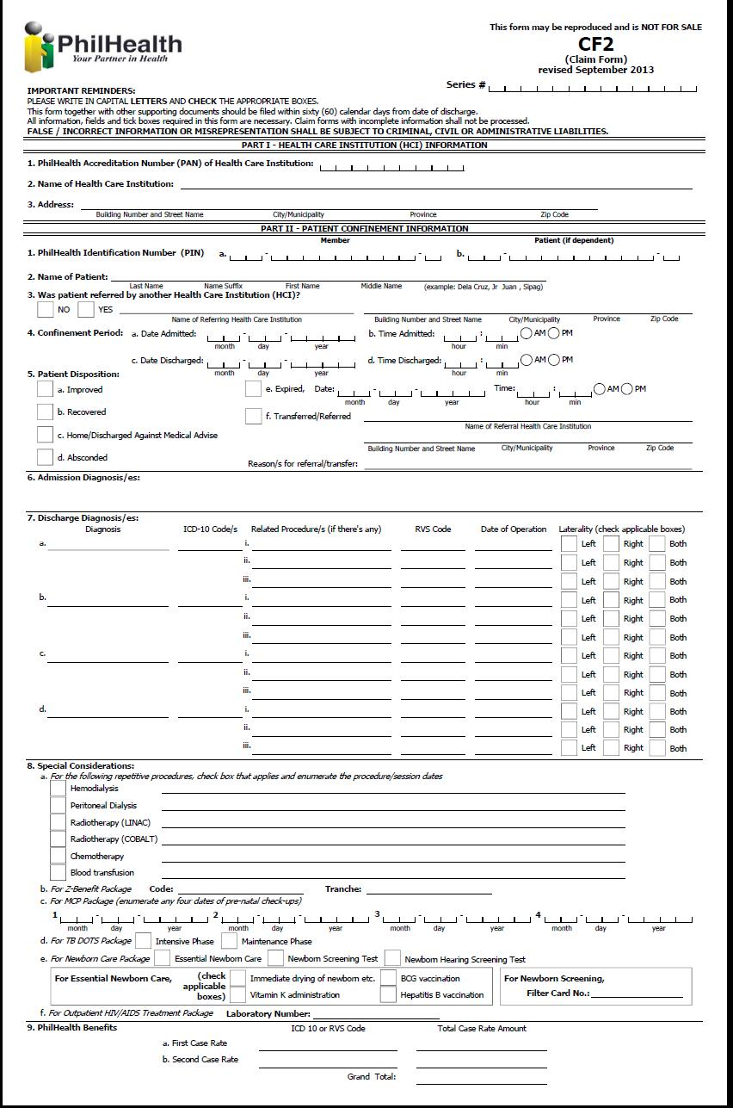

Revised Claim Form 2 (back)

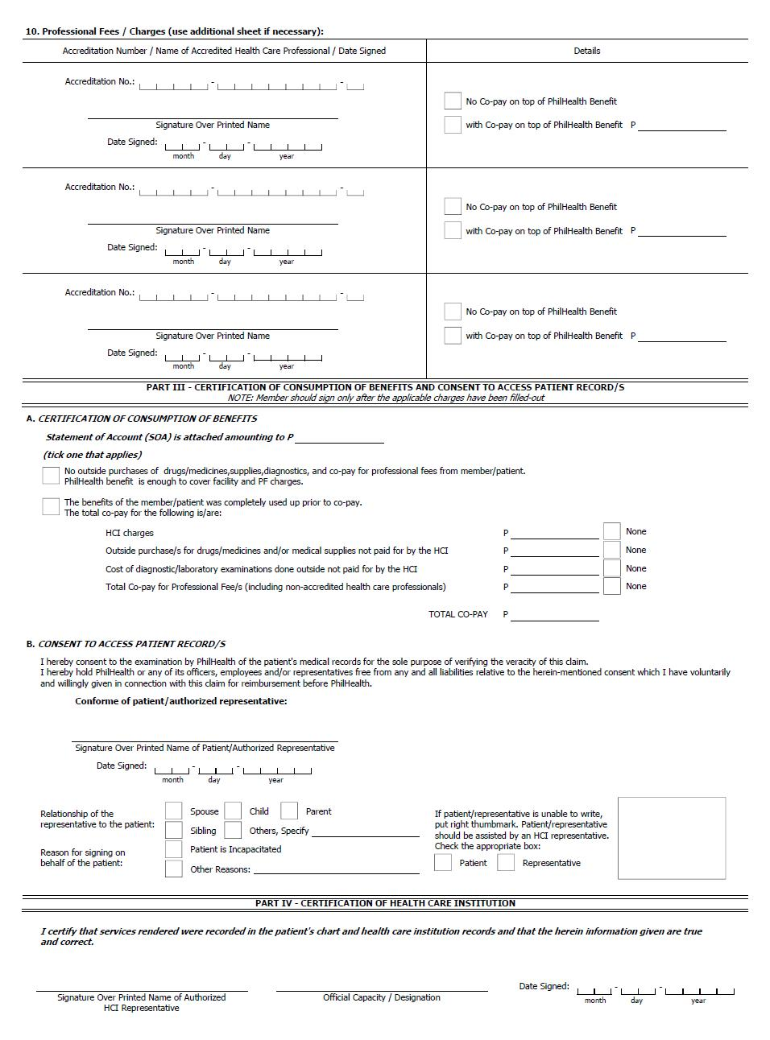

e-Claims XML Layout

Pertinent claims information will be transformed electronically by using the Extensible Markup Language (XML). The following sample is an illustration:

<eCLAIMS
pUserName=""
pUserPassword=""
pHospitalCode="123456"
pHospitalEmail=email@yahoo.com
pServiceProvider="ACMESOFT">
<eTRANSMITTAL
pHospitalTransmittalNo="20160901"
pTotalClaims="1">
<CLAIM
pClaimNumber="123456-20160930-2"
pTrackingNumber=""
pPhilhealthClaimType="ALL-CASE-RATE"
pPatientType="I"
pIsEmergency="N">
<CF1
pMemberPIN="072007271094"
pMemberLastName="DELA CRUZ"
pMemberFirstName="JUAN"
pMemberSuffix=""
pMemberMiddleName="OCAMPO"
pMemberBirthDate="09-19-1973"
pMemberShipType="G"
pMailingAddress="PHILIPPINES"
pZipCode="1234"
pMemberSex="M"
pLandlineNo=""
pMobileNo=""
pEmailAddress="delacruzjuan@yahoo.com.ph"
pPatientIs="M"
pPatientPIN="072007271094"
pPatientLastName="DELA CRUZ"
pPatientFirstName="JUAN"
pPatientSuffix=""
pPatientMiddleName="OCAMPO"
pPatientBirthDate="09-19-1973"
pPatientSex="M"
pPEN="11-047400000-2"
pEmployerName="PHILHEALTH"/>
<CF2
pPatientReferred="Y"
pReferredIHCPAccreCode="H12345678"
pAdmissionDate="09-01-2016"
pAdmissionTime="01:00:00PM"
pDischargeDate="09-03-2016"
pDischargeTime="03:00:00PM"
pDisposition="I"
pExpiredDate=""
pExpiredTime=""
pReferralIHCPAccreCode=""
pReferralReasons=""
pAccommodationType="N"
pHasAttachedSOA="Y">
<DIAGNOSIS
pAdmissionDiagnosis="PNEUMONIA">
<DISCHARGE
pDischargeDiagnosis="END STAGE RENAL DISEASE">
<ICDCODE pICDCode="O13.012"/>
<ICDCODE pICDCode="O13.013"/>
<RVSCODES
pRelatedProcedure="HEMODIALYSIS"
pRVSCode="90935"
pProcedureDate="08-26-2009"
pLaterality="L"/>
</DISCHARGE>
<DISCHARGE
pDischargeDiagnosis="DENGUE">
<ICDCODE pICDCode="A90.0"/>
</DISCHARGE>
</DIAGNOSIS>
<SPECIAL>
<!-- For Repetitive Procedures -->
<PROCEDURES>
<HEMODIALYSIS>
<SESSIONS pSessionDate="08-25-2009"/>
<SESSIONS pSessionDate="08-26-2009"/>
</HEMODIALYSIS>
<CHEMOTHERAPY>
<SESSIONS pSessionDate="08-27-2009"/>
</CHEMOTHERAPY>
</PROCEDURES>
<!-- For MCP Package -->
<!--MCP
pCheckUpDate1="08-25-2009"
pCheckUpDate2="08-26-2009"
pCheckUpDate3="08-27-2009"
pCheckUpDate4="08-28-2009"/-->
<!-- For TB DOTS Package -->
<!--TBDOTS
pTBType="I"
pNTPCardNo=""/-->
<!-- For Animal Bite Package -->
<!--ABP
pDay0ARV="08-25-2009"
pDay3ARV="08-25-2009"
pDay7ARV="08-25-2009"
pRIG="08-25-2009"
pABPOthers=""
pABPSpecify=""/-->
<!-- For Newborn Care Package -->
<!--NCP
pEssentialNewbornCare="Y"
pNewbornHearingScreeningTest="N"
pNewbornScreeningTest="N"
pFilterCardNo="">
<ESSENTIAL
pDrying="Y"
pSkinToSkin="Y"
pCordClamping="Y"
pProphylaxis="Y"
pWeighing="Y"
pVitaminK="Y"
pBCG="Y"
pNonSeparation="Y"
pHepatitisB="Y"/>
</NCP-->
<!-- For Outpatient HIV/AIDS Treatment Package -->
<!--HIVAIDS
pLaboratoryNumber=""/-->
<!--CATARACTINFO
pCataractPreAuth=""
pLeftEyeIOLStickerNumber=""
pLeftEyeIOLExpiryDate=""
pRightEyeIOLStickerNumber=""
pRightEyeIOLExpiryDate=""/-->
</SPECIAL>
<PROFESSIONALS
pDoctorAccreCode="1234-1527066-1"
pDoctorLastName="TEST2"
pDoctorFirstName="TEST2"
pDoctorMiddleName="TEST2"
pDoctorSuffix=""
pWithCoPay="Y"
pDoctorCoPay="1000"
pDoctorSignDate="08-25-2009"/>
<CONSUMPTION
pEnoughBenefits="Y">
<!-- if pEnoughBenefits="Y"-->
<BENEFITS
pTotalHCIFees="1000"
pTotalProfFees="1000"
pGrandTotal="2000"/>
<!-- if pEnoughBenefits="N"-->
<!--
<HCIFEES
pTotalActualCharges="2000"
pDiscount="1800"
pPhilhealthBenefit="1500"
pTotalAmount="300"
pMemberPatient="Y"
pHMO="N"
pOthers="N"/>
<PROFFEES
pTotalActualCharges="3000"
pDiscount="2500"
pPhilhealthBenefit="1500"
pTotalAmount="1000"
pMemberPatient="Y"
pHMO="Y"
pOthers="N"/>
<PURCHASES
pDrugsMedicinesSupplies="Y"
pDMSTotalAmount="1000"
pExaminations="N"
pExamTotalAmount=""/>
-->
</CONSUMPTION>
<APR>
<APRBYPATREPSIG pDateSigned="08-26-2009">
<DEFINEDPATREPREL pRelCode="S" />
<OTHERREASONFORSIGNING pReasonDesc="MEMBER IS MISSING" />
</APRBYPATREPSIG>
</APR>
</CF2>
<!-- pPhilhealthClaimType="ALL-CASE-RATE" -->
<ALLCASERATE>
<CASERATE
pCaseRateCode="CR0001"
pICDCode="A90"
pRVSCode=""
pCaseRateAmount="10000"/>
<CASERATE
pCaseRateCode="CR0002"
pICDCode=""
pRVSCode="90935"
pCaseRateAmount="2600"/>
</ALLCASERATE>
<!-- pPhilhealthClaimType="Z-BENEFIT" -->
<!--ZBENEFIT
pZBenefitCode="Z0011">
</ZBENEFIT-->
<CF3>
<CF3_OLD
pChiefComplaint=""
pBriefHistory=""
pCourseWard=""
pPertinentFindings="">
<PHEX
pBP=""
pCR=""
pRR=""
pTemp=""
pHEENT=""
pChestLungs=""
pCVS=""
pAbdomen=""
pGUIE=""
pSkinExtremities=""
pNeuroExam=""/>
<MATERNITY>
<PRENATAL
pPrenatalConsultation="08-26-2009"
pMCPOrientation="Y"
pExpectedDeliveryDate="08-26-2009">
<CLINICALHIST
pVitalSigns="Y"
pPregnancyLowRisk="Y"
pLMP="08-26-2009"
pMenarcheAge="21"
pObstetricG=""
pObstetricP=""
pObstetric_T=""
pObstetric_P=""
pObstetric_A=""
pObstetric_L=""/>
<OBSTETRIC
pMultiplePregnancy="N"
pOvarianCyst="N"
pMyomaUteri="N"
pPlacentaPrevia="N"
pMiscarriages="N"
pStillBirth="N"
pPreEclampsia="N"
pEclampsia="N"
pPrematureContraction="N"/>
<MEDISURG
pHypertension="N"
pHeartDisease="N"
pDiabetes="N"
pThyroidDisaster="N"
pObesity="N"
pAsthma="N"
pEpilepsy="N"
pRenalDisease="N"
pBleedingDisorders="N"
pPreviousCS="N"
pUterineMyomectomy="Y"/>
<CONSULTATION
pVisitDate="08-20-2009"
pAOGWeeks=""
pWeight="50"
pCardiacRate=""
pRespiratoryRate="26"
pBloodPressure="160/100"
pTemperature="38.5 C"/>
<CONSULTATION
pVisitDate="08-25-2009"
pAOGWeeks=""
pWeight="60"
pCardiacRate=""
pRespiratoryRate="26"
pBloodPressure="160/100"
pTemperature="38.5 C"/>
<CONSULTATION
pVisitDate="08-30-2009"
pAOGWeeks=""
pWeight="65"
pCardiacRate=""
pRespiratoryRate="26"
pBloodPressure="160/100"
pTemperature="38.5 C"/>
</PRENATAL>
<DELIVERY
pDeliveryDate="09-01-2009"
pDeliveryTime="12:00AM"
pObstetricIndex=""
pAOGLMP=""
pDeliveryManner=""
pPresentation=""
pFetalOutcome=""
pSex="M"
pBirthWeight="5000"
pAPGARScore=""
pPostpartum=""/>
<POSTPARTUM
pPerinealWoundCare="Y"
pPerinealRemarks=""
pMaternalComplications="Y"
pMaternalRemarks=""
pBreastFeeding="Y"
pBreastFeedingRemarks=""
pFamilyPlanning="Y"
pFamilyPlanningRemarks=""
pPlanningService="Y"
pPlanningServiceRemarks=""
pSurgicalSterilization="Y"
pSterilizationRemarks=""
pFollowupSchedule="Y"
pFollowupScheduleRemarks=""/>
</MATERNITY>
</CF3_OLD>
<!--CF3_NEW>
<ADMITREASON
pBriefHistory=""
pReferredReason=""
pIntensive="N"
pMaintenance="N">
<CLINICAL pCriteria="COUGH"/>
<CLINICAL pCriteria="COLDS"/>
<CLINICAL pCriteria="FEVER"/>
<CLINICAL pCriteria="RR=26"/>
<CLINICAL pCriteria="T= 38.5 C"/>
<CLINICAL pCriteria="BP = 160/100"/>
<LABDIAG pCriteria="CHEST X-RAY- PNEUMONIA"/>
<LABDIAG pCriteria="CBC-INCREASE WBC"/>
<LABDIAG pCriteria="URINALYSIS"/>
<PHEX
pBP=""
pCR=""
pRR=""
pTemp=""
pHEENT=""
pChestLungs=""
pCVS=""
pAbdomen=""
pGUIE=""
pSkinExtremities=""
pNeuroExam=""/>
</ADMITREASON>
<COURSE>
<WARD
pCourseDate=""
pFindings="CHEST X-RAY"
pAction="FOR ADMISSION"/>
<WARD
pCourseDate=""
pFindings="URINALYSIS"
pAction="START PENICILLIN IV EVERY 6 HRS."/>
</COURSE>
</CF3_NEW-->
</CF3>
<PARTICULARS>
<DRGMED
pPurchaseDate="08-26-2009"
pDrugCode="X0001234"
pPNDFCode=""
pGenericName="PARACETAMOL"
pBrandName="GAYAGESIC"
pPreparation="TABLET 250MG"
pQuantity="3"/>
<DRGMED
pPurchaseDate="08-26-2009"
pDrugCode="X0001235"
pPNDFCode=""
pGenericName="PARACETAMOL"
pBrandName="GAYAGESIC"
pPreparation="TABLET 250MG"
pQuantity="3"/>
<XLSO
pDiagnosticDate="08-26-2009"
pDiagnosticType="IMAGING"
pDiagnosticName="ULTRASOUND"
pQuantity="2"/>
<XLSO
pDiagnosticDate="08-26-2009"
pDiagnosticType="IMAGING"
pDiagnosticName="ULTRASOUND"
pQuantity="2"/>
</PARTICULARS>
<RECEIPTS>
<RECEIPT
pCompanyName="COMPANY"
pCompanyTIN="123-456-789"
pBIRPermitNumber="12345"
pReceiptNumber="00001"
pReceiptDate="08-25-2009"
pVATExemptSale="0.00"
pVAT="12.00"
pTotal="100.00">
<ITEM
pQuantity="10"
pUnitPrice="5"
pDescription="BIOGESIC"
pAmount="50.00"/>
<ITEM
pQuantity="5"
pUnitPrice="10"
pDescription="NEOZEP"
pAmount="50.00"/>
</RECEIPT>
</RECEIPTS>
<DOCUMENTS>
<DOCUMENT
pDocumentType="CSF"
pDocumentURL=
"https://hospitalwebserver/eclaims/claimnumber/yyyymmdd000001.pdf"/>
<DOCUMENT
pDocumentType="OPR"
pDocumentURL=
"https://hospitalwebserver/eclaims/claimnumber/yyyymmdd000002.pdf"/>
<DOCUMENT
pDocumentType="SOA"
pDocumentURL=
"https://hospitalwebserver/eclaims/claimnumber/yyyymmdd000003.pdf"/>
</DOCUMENTS>
</CLAIM>
</eTRANSMITTAL>
</eCLAIMS>

NOTE: <!-- and --> in the sample xml above are used to treat the block as commented out. To explain further when the value for pPhilhealthClaimType="ALL-CASE-RATE", the element tags for “Z-BENEFIT” (<ZBENEFIT>) must be omitted.

e-Claims XML Document Type Definition (DTD)

A document type definition (DTD) defines the legal building blocks of an XML document. The PECWS development kit contains the DTD for the structure of the e-claims XML text that will be passed in the eclaimsUpload method. The URL of the published DTD will be provided also in the development kit. The table below shows the hierarchy of the XML elements of the e-claims XML data.

XML elements are the entries in the XML text that is enclosed between the opening angle brackets “<” and the closing angle bracke “>”. These elements or tags should always be terminated either with “/>” or “</elementname>”. To illustrate, the element eCLAIMS starts with “<eCLAIMS>” tag and ends with the end tag “</eCLAIMS>”. As another illustration, the DOCUMENT element starts with the “<DOCUMENT” tag and ends with “/>”.

Element/Tag | Definition | Occurence
eCLAIMS | Root Element | only once
eTRANSMITTAL | Transmittal Header | only once
CLAIM | Patient Claim Data | 1 or more
CF1 | Claim Form 1 Details | only once
CF2 | Claim Form 2 Details | only once
DIAGNOSIS | Diagnosis Details | only once
DISCHARGE | FinalDiagnosis Details | 1 or more
ICDCODE | ICD Details | 0 or more
RVSCODES | Related Procedure Details | 0 or more
SPECIAL | Special Considerations | 0 or 1
PROCEDURES | Repetitive Procedures | 0 or 1
HEMODIALYSIS | Hemodialysis | 0 or 1
PERITONEAL | Peritoneal | 0 or 1
LINAC | Radiotherapy (LINAC) | 0 or 1
COBALT | Radiotherapy (COBALT) | 0 or 1
TRANSFUSION | Blood Transfusion | 0 or 1
BRACHYTHERAPHY | Brachytherapy | 0 or 1
CHEMOTHERAPY | Chemotherapy | 0 or 1
DEBRIDEMENT | Simple Debridement | 0 or 1
IMRT | IMRT | 0 or 1
SESSIONS | Session Dates | 1 or more
MCP | MCP Package Details | 0 or 1
TBDOTS | TB DOTS Package Details | 0 or 1
ABP | Animal Bite Package Details | 0 or 1
NCP | New Born Care Package Details | 0 or 1
ESSENTIAL | Essential Newborn Details | 0 or 1
HIVAIDS | HIV/AIDS Package Details | 0 or 1
CATARACTINFO | Cataract Package detail | 0 or 1
PROFESSIONALS | Professional Details | 1 or more
CONSUMPTION | Consumption Details | only once
BENEFITS | Benefits Details | 0 or 1
HCIFEES | HCI Fees Details | 0 or 1
PROFFEES | Prof Fees Details | 0 or 1
PURCHASES | Purchases Details | 0 or 1
APR | Consent to Access Patient Records | 0 or 1
APRBYPATSIG | Consent in indicated by signature of patient | 0 or 1
APRBYPATREPSIG | Consent is indicated by signature of representative | 0 or 1
APRBYTHUMBMARK | Consent is indicated by thumbmark | 0 or 1
ALLCASERATE | All Case Rate Details | only once
CASERATE | Case Rate Benefits | 1 or more
ZBENEFIT | Z Benefit Charges | only once
CF3 | Claim Form 3 Details | 0 or 1
CF3_OLD | Old Format of CF3 | 0 or 1
PHEX | Physical Examination | only once
MATERNITY | Maternity Details | 0 or 1
PRENATAL | Prenatal Details | only once
CLINICALHIST | Clinical History Details | only once
OBSTETRIC | Obstetric Risk Factors | only once
MEDISURG | Medical/Surgical Risk Factors | only once
CONSULTATION | Consultation Details | 1 or more
DELIVERY | Delivery Outcome Details | only once
POSTPARTUM | Postparum Care Details | only once
CF3_NEW | New Format of CF3 | 0 or 1
ADMITREASON | Reason for admission | only once
CLINICAL | Clinical Criteria | 0 or more
LABDIAG | Laboratories/Diagnostics | 0 or more
PHEX | Physical Examination | only once
COURSE | Course in the Ward | only once
WARD | Day in the Ward details | 1 or more
PARTICULARS | Drugs/Diagnostic Data | 0 or 1
DRGMED | Drug particulars | 0 or more
XLSO | XRay,Lab,Supplies,etc.. | 0 or more
RECEIPTS | Receipts | 0 or 1
RECEIPT | Receipt Data | 1 or more
ITEM | Item Details | 1 or more
DOCUMENTS | Supporting Documents | only once
DOCUMENT | Document Details | 1 or more

After understanding the above, you can now proceed with creating your prototype system to generate an eclaims xml file. There are several ways to check if the xml file you have created is compliant with the eclaims dtd.

Validating an xml file against a Document Type Definition (DTD) using the Internet ExploreR

Things you need:
- URL of the DTD
- An e-claims XML file
- An online XML-DTD Validator Site like http://www.w3schools.com/XML/xml_validator.asp
- Internet Explorer browser

Steps:
- Only Internet Explorer will actually check your XML against the DTD. Firefox, Mozilla, Netscape, and Opera will not.
- Navigate to the http://www.w3schools.com/XML/xml_validator.asp
- Find the “Validate Your XML Against a DTD” portion. Paste the following in the window provided to define the location of the dtd.

<?xml version="1.0"?>
<!DOCTYPE eCLAIMS PUBLIC "-//PHIC-ITMD//DTD eClaims File 1.0//EN" "http://cdp.philhealth.gov.ph/allcaserates/eClaimsDef.dtd" >

- Append your eClaims XML there after.
- Click validate button. This will check if the xml file you created conforms to the document type definition we have created.
- This will validate conformity to the DTD, however upon load to PHIC additional check will be made like existence checks, valid parameter values etc…. a prototype web page is already available now for loading of eClaims XML file. The same functionality is made available as a webservice for loading the xml files.

Module 2b: Hospital and Philhealth Claims Mapping

To facilitate claims reconciliation and verification, hospital and philhealth must have a common reference when pertaining to the same case/claim. The philhealth claim series number will be used for this purpose. This is generated everytime a receipt ticket number is generated when calling the eClaimsUpload method.

Web Service Method

GetUploadedClaimsMap (pUserName, pUserPassword, pHospitalCode, pReceiptTicketNumber)

<eCONFIRMATION
pReceiptTicketNumber="071311000005"
pHospitalCode="300832"
pHospitalTransmittalNo="3008321107000008"
pTotalClaims="1"
pReceivedDate="09-13-2009">
<MAPPING
pClaimNumber="09-08-01-006"
pPatientLastName="DELA CRUZ"
pPatientFirstName="MARIA"
pPatientMiddleName="C"
pPatientSuffix=""
pAdmissionDate="08-25-2009"
pDischargeDate="08-25-2009"
pClaimSeriesLhio="090801990000199" />
</eCONFIRMATION>

Each hospital claim number (pClaimNumber) has a corresponding philhealth claim series number (pClaimSeriesLhio). This should be saved to a database which will be used when verifying claims status and for purposes of claims reconciliation.

Module 2b: Health Institution Search

Web Service Method

SearchHospital (pUserName, pUserPassword, pHospitalCode, pHospitalName)

This can be used in searching health care institution.

Parameter Definition
Name | Length | Description | Valid Values
pUserName | String(20) | Provider user id | To be provided by PhilHealth
pUserPassword | String(20) | Provider user password | To be provided by PhilHealth
pHospitalCode | String(12) | Facility Accreditation Number | For now PMCC number should be used
pHospitalName | String(100) | Health Care Institution Name to be search

Sample XML Result

<eHospitals>
<HOSPITAL
pAccreCode="TEST1"
pPMCCNo="654321"
pHospitalName="TEST HOSPITAL ONE"/>
<HOSPITAL
pAccreCode="TEST2"
pPMCCNo="123456"
pHospitalName="TEST HOSPITAL TWO"/>
</eHospitals>

Module 2c: Case Rate Search

Web Service Method

SearchCaseRate (pUserName, pUserPassword, pHospitalCode, pICD, pRVS, pDescription)

This can be used in searching case rates.

Parameter Definition
Name | Length | Description | Valid Values
pUserName | String(20) | Provider user id | To be provided by PhilHealth
pUserPassword | String(20) | Provider user password | To be provided by PhilHealth
pHospitalCode | String(12) | Facility Accreditation Number | For now PMCC number should be used
pICD | String(10) | ICD10 Code
pRVS | String(6) | RVS Code
pDescription | String(60) | Case Rate Description

Sample XML Result

<eCASERATES>
<CASERATES
pCaseRateCode="CR0079"
pCaseRateDescription="DENGUE FEVER"
pItemCode="A90"
pItemDescription="DENGUE WITHOUT WARNING SIGNS"
pEffectivityDate=" January 1, 2014 onwards">
<AMOUNT
pPrimaryHCIFee="7000"
pPrimaryProfFee="3000"
pPrimaryCaseRate="10000"
pSecondaryHCIFee="0"
pSecondaryProfFee="0"
pSecondaryCaseRate="0"
pCheckFacilityH1="T"
pCheckFacilityH2="T"
pCheckFacilityH3="T"
pCheckFacilityASC="F"
pCheckFacilityPCF="F"
pCheckFacilityMAT="F"
pCheckFacilityFSDC="F"/>
<AMOUNT
pPrimaryHCIFee="4900"
pPrimaryProfFee="2100"
pPrimaryCaseRate="7000"
pSecondaryHCIFee="0.00"
pSecondaryProfFee="0.00"
pSecondaryCaseRate="0.00"
pCheckFacilityH1="F"
pCheckFacilityH2="F"
pCheckFacilityH3="F"
pCheckFacilityASC="F"
pCheckFacilityPCF="T"
pCheckFacilityMAT="F"
pCheckFacilityFSDC="F"/>
</CASERATES>
</eCASERATES>

Module 2d: Add Required Document

Web Service Method

addRequiredDocument (pUserName, pUserPassword, pHospitalCode, pSeriesLhioNo, pXML)

This can be used in adding scanned documents needed or required in processing the claims.

Parameter Definition
Name | Length | Description | Valid Values
pUserName | String(20) | Provider user id | To be provided by PhilHealth
pUserPassword | String(20) | Provider user password | To be provided by PhilHealth
pHospitalCode | String(12) | Facility Accreditation Number | For now PMCC number should be used
pSeriesLhioNo | String(18) | Series Lhio Number
pXML |  | XML String – list of documents to be added to the claim submitted | Sample XML Format:  <DOCUMENTS>  <DOCUMENT pDocumentType="CF1" pDocumentURL="http://sample/file/other/cf1.pdf"/>  <DOCUMENT pDocumentType="CF2" pDocumentURL="http://sample/file/other/cf2.pdf"/>  <DOCUMENT pDocumentType="OPR" pDocumentURL="http://sample/file/other/opr.pdf"/>  </DOCUMENTS>

- For successful transaction,

The web service method response will be TRUE.

- For unsuccessful transaction,

For those claim that has been paid already:
PhilHealth will return “Claim has already been paid.”

For those claim that has been denied already:
PhilHealth will return “Claim has already been denied.”

Module 3: Claim Status Verification
Electronic Claims Verification/Reconciliation (Version 1.0)

This module will facilitate claims status inquiry on the side of the hospital and provide an online means of claims reconciliation between hospital and Philhealth.

FIELD/ATTRIBUTE/PARAMETER DEFINITION
pClaimSeriesLhio | String(15) | Philhealth Generated and Assigned Unique Number per Claim, Acquired in module 2, which is mapped to a specific hospital claim number. | Will be used in verifying status/payment details for a specific hospital case.
pClaimSeriesLhios |  | Comma-separated values of one or more pClaimSeriesLhio | e.g.  121234567890119, 129876543211119, 120000000002119
pPIN | String(12) | PhilHealth Identification Number – a unique 12 digit number assigned to a member.
pStatus | String(50) | Describes the status of a claim | - ‘WITH CHEQUE’  - ‘WITH VOUCHER’  - ‘VOUCHERING’  - ‘IN PROCESS’  - ‘RETURN’  - ‘DENIED’
pAsOf | String(10) | Date of Inquiry | Date Format: ‘MM-DD-YYYY’
pAsOfTime | String(10) | Time of Inquiry | TIME Format: ‘HH:MM:SSAM/PM’
pPatientLastName | String(60) | Patient’s Complete Surname
pPatientFirstName | String(60) | Patient’s Complete First name
pPatientMiddleName | String(60) | Patient’s Complete Middle name
pPatientSuffix | String(5) | Patient’s Suffix name
pAdmissionDate | String(10) | Admission Date | Date Format: ‘MM-DD-YYYY’
pDischargeDate | String(10) | Discharge Date | Date Format: ‘MM-DD-YYYY’
pDateReceived | String(10) | Date of Claim was received in Philhealth/ same as the date the claim was electronically submitted using Module 2, When Claim was return/ this would be the date of Refiling/ electronically sending the additional documents | Date Format: ‘MM-DD-YYYY’
pDateRefile | String(10) | Just in case the Claim was return/ this would be the date of Refiling. Synonymous to the date of electronically sending the additional requested documents. | Date Format: ‘MM-DD-YYYY’
pDeficiency | String(100) | Describes the reason why the status of the claims is RETURN.
pRequirement | String(100) | For pStatus=’RETURN’, this is the needed documents that has to be complied with in order to facilitate/continue the claims process.
pReason | String(100) | Describes the reason why the status of the claims is DENIED.
pProcessStage | String(100) | Describes the process stage.
pProcessDate | String(10) | Date of process | Date Format: ‘MM-DD-YYYY’
pVoucherNo | String(5) |  | Formatted as: ‘###-######-##X##’  X can be:  - ‘I’  - ‘S’  - ‘G’  - ‘W’
pVoucherDate | String(10) | Date voucher was generated | Date Format: ‘MM-DD-YYYY’
pCheckNo | String(10) | Check Number of reimbursement | If value=’AC’ this is autocredit for doctors otherwise it is the check number
pCheckDate | String(10) | Date when check was generated | Date Format should be :  ‘MM-DD-YYYY’
pCheckAmount | String(12) | Amount reflected in Cheque,  Note: Amount in Cheque is the sum of all claims included in a voucher. | Formatted as: ‘#######.##’
pClaimAmount | String(12) | Amount claimed | Formatted as: ‘#######.##’
pClaimPayeeName | String(100) | Name of payee reflected in Cheque | Alpha-numeric
pTotalClaimAmountPaid | String(12) | Sum of all payment for a particular claim | Formatted as: ‘#######.##’
pPayeeCode | String(14) | Payee Code | If pPayeeType=’H’ this is the Hospital accreditation code,  if pPayeeType=’D’ this is the Doctor accreditation code,  if pPayeeType=’M’ this is the Member PIN code,  if pPayeeType=’C’ this is the Hospital accreditation code.
pPayeeType | String(1) | Type of Payee | - ‘H’ – Hospital  - ‘D’ – Doctor  - ‘M’ – Member  - ‘C’ – Chief of Hospital
pTaxAmount | String(12) | Payee Tax Amount | Formatted as: ‘#######.##’
pGrossAmount | String(12) | Payee Gross Amount | Formatted as: ‘#######.##’
pRMBD | String(10) | Room and Board | Formatted as: ‘#######.##’
pDRUGS | String(10) | Drugs and medicines | Formatted as: ‘#######.##’
pXRAY | String(10) | X-ray, Laboratories and othera | Formatted as: ‘#######.##’
pOPRM | String(10) | Operating Room fee | Formatted as: ‘#######.##’
pGPFee | String(10) | General Practitioner | Formatted as: ‘#######.##’
pSPFee | String(10) | Specialist | Formatted as: ‘#######.##’
pSURFee | String(10) | Surgeon | Formatted as: ‘#######.##’
pANESFee | String(10) | Anesthesiologist | Formatted as: ‘#######.##’
pNetAmount | String(10) | Net Amount (Gross less tax) | Formatted as: ‘#######.##’
pIsAdjustment | String(3) | Flag if claim is an adjustment | - ‘T’ – True  - ‘F’ – False
pIsAutoCredit | String(3) | Flag if payee was paid through auto credit payment scheme | - ‘T’ – True  - ‘F’ – False

Module 3a: Getting the Current Status of a Claim

eClaimsStatus Document Type Definition Version 1.0

<!ELEMENT STATUS (CLAIM+)>
<!ATTLIST STATUS
pAsOf CDATA #REQUIRED
pAsOfTime CDATA #REQUIRED >

<!ELEMENT CLAIM (TRAIL|RETURN|DENIED|PAYMENT) >
<!ATTLIST CLAIM
pClaimSeriesLhio CDATA #REQUIRED
pPin CDATA #REQUIRED
pPatientLastName CDATA #REQUIRED
pPatientFirstName CDATA #REQUIRED
pPatientMiddleName CDATA #REQUIRED
pPatientSuffix CDATA #REQUIRED
pAdmissionDate CDATA #REQUIRED
pDischargeDate CDATA #REQUIRED
pClaimDateReceived CDATA #REQUIRED
pClaimDateRefile CDATA #REQUIRED
pStatus CDATA #REQUIRED >

<!ELEMENT TRAIL (PROCESS+)>
<!ELEMENT PROCESS EMPTY>
<!ATTLIST PROCESS
pProcessStage CDATA #REQUIRED
pProcessDate CDATA #REQUIRED >

<!ELEMENT RETURN (DEFECTS+)>

<!ELEMENT DEFECTS (REQUIREMENT+)>
<!ATTLIST DEFECTS
pDeficiency CDATA #REQUIRED >

<!ELEMENT REQUIREMENT EMPTY>
<!ATTLIST REQUIREMENT
pRequirement CDATA #REQUIRED >

<!ELEMENT DENIED (REASON+)>

<!ELEMENT REASON EMPTY>
<!ATTLIST REASON
pReason CDATA #REQUIRED >

<!ELEMENT PAYMENT (PAYEE+)>
<!ATTLIST PAYMENT
pTotalClaimAmountPaid CDATA #REQUIRED >
<!ELEMENT PAYEE EMPTY>
<!ATTLIST PAYEE
pVoucherNo CDATA #REQUIRED
pVoucherDate CDATA #REQUIRED
pCheckNo CDATA #REQUIRED
pCheckDate CDATA #REQUIRED
pCheckAmount CDATA #REQUIRED
pClaimAmount CDATA #REQUIRED
pClaimPayeeName CDATA #REQUIRED >

Module 3: GET CLAIM STATUS Web Service Method

The following method will facilitate this functionality. The pSeriesLhioNos can contain multiple claims by separating each parameter by comma (CSV, comma-separated value).

GetClaimStatus(pUserName, pUserPassword, pHospitalCode, pSeriesLhioNos)

The method will return the status of a claim, formatted in xml based on the eClaimStatusDef.dtd, sample is shown below

<STATUS
pAsOf="07-25-2012"
pAsOfTime="04:46:23PM">
<CLAIM
pClaimSeriesLhio="120723190000119"
pPin="190892937994"
pPatientLastName="ALARCON"
pPatientFirstName="MAMERTO"
pPatientMiddleName="TRIA"
pPatientSuffix=""
pAdmissionDate="05-02-2012"
pDischargeDate="05-06-2012"
pClaimDateReceived="05-15-2012"
pClaimDateRefile=""
pStatus="IN PROCESS"
<!-- pStatus="IN PROCESS"-->
<TRAIL>
<PROCESS pProcessStage="VALIDATION" pProcessDate="07-25-2012"/>
<PROCESS pProcessStage="EDITING" pProcessDate="07-25-2012"/>
<PROCESS pProcessStage="VALIDATION" pProcessDate="07-23-2012"/>
<PROCESS pProcessStage="EDITING (RECEIVING)" pProcessDate="07-23-2012"/>
<PROCESS pProcessStage="ENCODING" pProcessDate="07-23-2012"/>
<PROCESS pProcessStage="RECEIVING" pProcessDate="07-23-2012"/> </TRAIL>
<!-- pStatus="RETURN"-->
<!--
<RETURN>
<DEFECTS pDeficiency="">
<REQUIREMENT pRequirement=""/>
<REQUIREMENT pRequirement=""/>
</DEFECTS>
</RETURN>
-->
<!-- pStatus="DENIED"-->
<!--
<DENIED>
<REASON pReason=""/>
</DENIED>
-->
<!-- pStatus="WITH CHEQUE" or “WITH VOUCHER” or “VOUCHERING”-->
<!--
<PAYMENT>
PTotalClaimAmountPaid="1000.00"
<PAYEE
pVoucherNo=""
pVoucherDate=""
pCheckNo=""
pCheckDate=""
pCheckAmount=""
pClaimAmount="600.00"
pClaimPayeeName=""/>
<PAYEE
pVoucherNo=""
pVoucherDate=""
pCheckNo=""
pCheckDate=""
pCheckAmount=""
pClaimAmount="400.00"
pClaimPayeeName=""/>
</PAYMENT>
-->
</CLAIM>
</STATUS>

Module 3b: Getting the Voucher Details

eClaimsVoucher Document Type Definition Version 1.0

<!ELEMENT VOUCHER (CLAIM+, SUMMARY)>
<!ATTLIST VOUCHER
pVoucherNo CDATA #REQUIRED
pVoucherDate CDATA #REQUIRED>

<!ELEMENT CLAIM (CHARGE+) >
<!ATTLIST CLAIM
pClaimSeriesLhio CDATA #REQUIRED
pPin CDATA #REQUIRED
pPatientLastName CDATA #REQUIRED
pPatientFirstName CDATA #REQUIRED
pPatientMiddleName CDATA #REQUIRED
pPatientSuffix CDATA #REQUIRED
pAdmissionDate CDATA #REQUIRED
pDischargeDate CDATA #REQUIRED
pClaimDateReceived CDATA #REQUIRED
pClaimDateRefile CDATA #REQUIRED
pIsAdjustment CDATA #REQUIRED >

<!ELEMENT CHARGE EMPTY>
<!ATTLIST CHARGE
pPayeeType CDATA #REQUIRED
pPayeeCode CDATA #REQUIRED
pPayeeName CDATA #REQUIRED
pRMBD CDATA #REQUIRED
pDRUGS CDATA #REQUIRED
pXRAY CDATA #REQUIRED
pOPRM CDATA #REQUIRED
pSPFee CDATA #REQUIRED
pGPFee CDATA #REQUIRED
pSURFee CDATA #REQUIRED
pANESFee CDATA #REQUIRED
pGrossAmount CDATA #REQUIRED
pTaxAmount CDATA #REQUIRED
pNetAmount CDATA #REQUIRED >

<!ELEMENT SUMMARY (PAYEE+)>
<!ATTLIST SUMMARY
pTotalAmount CDATA #REQUIRED
pNumberOfClaims CDATA #REQUIRED >
<!ELEMENT PAYEE EMPTY>
<!ATTLIST PAYEE
pPayeeType CDATA #REQUIRED
pPayeeCode CDATA #REQUIRED
pPayeeName CDATA #REQUIRED
pRMBD CDATA #REQUIRED
pDRUGS CDATA #REQUIRED
pXRAY CDATA #REQUIRED
pOPRM CDATA #REQUIRED
pSPFee CDATA #REQUIRED
pGPFee CDATA #REQUIRED
pSURFee CDATA #REQUIRED
pANESFee CDATA #REQUIRED
pGrossAmount CDATA #REQUIRED
pTaxAmount CDATA #REQUIRED
pNetAmount CDATA #REQUIRED
pCheckNo CDATA #REQUIRED
pCheckDate CDATA #REQUIRED
pIsAutoCredit CDATA #REQUIRED >

Get Voucher Details Web Service Method

To facilitate reconciliation between paid claims. The following method will return the payment details. The input parameter here is the voucher number. Take note that there could be more than one claim in a voucher.

GetVoucherDetails(pUserName, pUserPassword, pHospitalCode, pVoucherNo)

After payment is made an electronic copy of the voucher will be sent to the hospital. This can be used by the hospital to reconcile with their records. The following is a sample:

<VOUCHER
pVoucherNo="201-062001-06I03"
pVoucherDate="06-14-2006">
<CLAIM
pClaimSeriesLhio="060516030019903"
pPin="192003610605"
pPatientLastName="ALOXXX"
pPatientFirstName="BERNAXXX"
pPatientMiddleName="B"
pPatientSuffix=""
pAdmissionDate="04-18-2006"
pDischargeDate="04-20-2006"
pClaimDateReceived="05-12-2006"
pClaimDateRefile=""
pIsAdjustment="F">
<CHARGE
pPayeeType="C"
pPayeeCode="2XX25"
pPayeeName="DR. DJXXXXX XXX X. SXXX"
pRMBD="0.00"
pDRUGS="0.00"
pXRAY="0.00"
pOPRM="0.00"
pSPFee="0.00"
pGPFee="0.00"
pSURFee="4000.00"
pANESFee="0.00"
pGrossAmount="4000.00"
pTaxAmount="0.00"
pNetAmount="4000.00"/>
<CHARGE
pPayeeType="C"
pPayeeCode="3XX25"
pPayeeName="DR. IXX OLXXXX A. CANXXXX"
pRMBD="0.00"
pDRUGS="0.00"
pXRAY="0.00"
pOPRM="0.00"
pSPFee="0.00"
pGPFee="0.00"
pSURFee="0.00"
pANESFee="1200.00"
pGrossAmount="1200.00"
pTaxAmount="0.00"
pNetAmount="1200.00"/>
<CHARGE
pPayeeType="H"
pPayeeCode="30XX04"
pPayeeName="XXXX CITY XXXXXX HOSPITAL"
pRMBD="800.00"
pDRUGS="507.50"
pXRAY="994.40"
pOPRM="3490.00"
pSPFee="0.00"
pGPFee="0.00"
pSURFee="0.00"
pANESFee="0.00"
pGrossAmount="5791.90"
pTaxAmount="0.00"
pNetAmount="5791.90"/>
<CHARGE
pPayeeType="M"
pPayeeCode="P192003617072"
pPayeeName="ALOXXX , BERNAXXX X"
pRMBD="0.00"
pDRUGS="2544.00"
pXRAY="141.00"
pOPRM="0.00"
pSPFee="0.00"
pGPFee="0.00"
pSURFee="0.00"
pANESFee="0.00"
pGrossAmount="2685.00"
pTaxAmount="0.00"
pNetAmount="2685.00"/>
</CLAIM>
<CLAIM
pClaimSeriesLhio="060516030031234"
pPin="192005981034"
pPatientLastName="ANDXXX"
pPatientFirstName="CONCHXXX"
pPatientMiddleName="XXXX"
pPatientSuffix=""
pAdmissionDate="04-21-2006"
pDischargeDate="04-27-2006"
pClaimDateReceived="05-12-2006"
pClaimDateRefile=""
pIsAdjustment="F">
<CHARGE
pPayeeType="C"
pPayeeCode="27XX2"
pPayeeName="DR. VIRXXX XX. X. DXXXO"
pRMBD="0.00"
pDRUGS="0.00"
pXRAY="0.00"
pOPRM="0.00"
pSPFee="0.00"
pGPFee="600.00"
pSURFee="0.00"
pANESFee="0.00"
pGrossAmount="600.00"
pTaxAmount="0.00"
pNetAmount="600.00"/>
<CHARGE
pPayeeType="H"
pPayeeCode="3XXX04"
pPayeeName="XXXX CITY XXXXX HOSPITAL"
pRMBD="2400.00"
pDRUGS="240.00"
pXRAY="671.25"
pOPRM="0.00"
pSPFee="0.00"
pGPFee="0.00"
pSURFee="0.00"
pANESFee="0.00"
pGrossAmount="3311.25"
pTaxAmount="0.00"
pNetAmount="3311.25"/>
<CHARGE
pPayeeType="M"
pPayeeCode="P19200XX31034"
pPayeeName="ANDXXX , CONCHXXX X"
pRMBD="0.00"
pDRUGS="1157.50"
pXRAY="863.00"
pOPRM="0.00"
pSPFee="0.00"
pGPFee="0.00"
pSURFee="0.00"
pANESFee="0.00"
pGrossAmount="2020.50"
pTaxAmount="0.00"
pNetAmount="2020.50"/>
</CLAIM>
<SUMMARY
pTotalAmount="19608.65"
pNumberOfClaims="2">
<PAYEE
pPayeeType="C"
pPayeeCode="30XX04"
pPayeeName="HC- XXXX CITY XXXXX HOSPITAL "
pRMBD="0.00"
pDRUGS="0.00"
pXRAY="0.00"
pOPRM="0.00"
pSPFee="0.00"
pGPFee="600.00"
pSURFee="4000.00"
pANESFee="1200.00"
pGrossAmount="5800.00"
pTaxAmount="0.00"
pNetAmount="5800.00"
pCheckNo="0000XXX429"
pCheckDate="06-19-2006"/>
<PAYEE
pPayeeType="H"
pPayeeCode="30XX04"
pPayeeName="XXXX CITY XXXXX HOSPITAL"
pRMBD="3200.00"
pDRUGS="747.50"
pXRAY="1665.65"
pOPRM="3490.00"
pSPFee="0.00"
pGPFee="0.00"
pSURFee="0.00"
pANESFee="0.00"
pGrossAmount="9103.15"
pTaxAmount="0.00"
pNetAmount="9103.15"
pCheckNo="0000XXX430"
pCheckDate="06-19-2006"/>
<PAYEE
pPayeeType="M"
pPayeeCode="P1920XX987072"
pPayeeName="ALOXXX , BERNXXXX X"
pRMBD="0.00"
pDRUGS="2544.00"
pXRAY="141.00"
pOPRM="0.00"
pSPFee="0.00"
pGPFee="0.00"
pSURFee="0.00"
pANESFee="0.00"
pGrossAmount="2685.00"
pTaxAmount="0.00"
pNetAmount="2685.00"
pCheckNo="0000XXX431"
pCheckDate="06-19-2006"/>
<PAYEE
pPayeeType="M"
pPayeeCode="P1920XX731034"
pPayeeName="ANXXXX , CONXXXXX X"
pRMBD="0.00"
pDRUGS="1157.50"
pXRAY="863.00"
pOPRM="0.00"
pSPFee="0.00"
pGPFee="0.00"
pSURFee="0.00"
pANESFee="0.00"
pGrossAmount="2020.50"
pTaxAmount="0.00"
pNetAmount="2020.50"
pCheckNo="0000XXX432"
pCheckDate="06-19-2006"/>
</SUMMARY>
</VOUCHER>

This data can then be saved and match against hospital records facilitating reconciliation.

4. CONFIDENTIALITY

Given the nature PhilHealth mandate, it is vital that we maintain the confidentiality of patient information. PhilHealth is committed in ensuring utmost confidentiality of health records and related information of all patient because the right to privacy is personal and fundamental; likewise it is the responsibility of PhilHealth to safeguard all confidential information.

Confidential Information

Confidential information includes, but is not limited to, protected health information, personal financial information, patients records, or information gained from committee meetings, hospital or facility visits during accreditation and investigation, inquiries from members, patients or other PhilHealth employees. Example include: data contained on claim forms, past and current medical and psychiatric record member employment data, patient insurance and billing of records, computerized patient data, visual observation of patients/members or any verbal information provided by or about a patient. These information may be contained via any communication medium, including verbal, written or electronic.

Protection Policies and Procedures

All information that can be used to identify a Patient or a commercial entity in a commercially sensitive context is considered Confidential Health Information (CHI).

It is required that all partners develop, institute, educate staff and periodically update standard operating policies and procedures that protect CHI. The policies and procedures must be available for inspection and their use must be demonstrate upon request. PhilHealth will make available default policies and procedures.

Necessary and authorized access. Each party is required to ensure that only minimum necessary personnel have access to CHI. Additionally, each party must have appropriate means to secure CHI and its use within its operations including when exchanging CHI with other partners. Each party must provide a means to authenticate authorized users.

Unauthorized access. Every party should keep CHI from unauthorized access. PhilHealth must be notified, however, as soon as unauthorized access is detected. This notice must include what was disclosed, how it was obtained (means and methods), who gained unauthorized access if known, if the data has been subsequently unlawfully disclosed and the risk mitigation plan the party is now pursuing to prevent any further unauthorized access. Confidentiality breaches can occur from external and internal sources. Each party must have a published sanction policy and ensure that is effectively communicated to staff periodically. For external breaches appropriate law enforcement officials will be involved in the investigation and prosecution as necessary.

Storage of CHI. Each party is required to develop, maintain and implement policies and procedures for protecting CHI stored electronically or via paper. This is especially true for off-site storage in the case of paper records and back-ups, archives and live storage of electronic records. The storage policies and procedures apply irrespective of the purpose of storage, for instance whether the CHI is stored on a CD for archiving or transmission purposes.

Transmission of CHI. Each party must protect CHI during the full life cycle of transformations, whether electronic or not. This includes preparation of data transmission, transmitting data, and receiving transmitted data. For the electronic transmission of CHI

- If the public internet is used for electronic data exchange, policies and procedures should cover the secure transmission of data, which includes encryption of data.
- If private secure point-to-point connections are used for electronic data exchange, policies and procedures should cover their provisioning and maintenance. Data encryption is recommended even when using secure private point-to-point connections

5. ANNEXES

Annex A: Sample e-Claims XML

<eCLAIMS
pUserName=""
pUserPassword=""
pHospitalCode="123456"
pHospitalEmail="email@yahoo.com">
<eTRANSMITTAL
pHospitalTransmittalNo="0671"
pTotalClaims="1">
<CLAIM
pClaimNumber="01-31-12-671"
pTrackingNumber=""
pPhilhealthClaimType="ALL-CASE-RATE"
pPatientType="I"
pIsEmergency="N">
<CF1
pMemberPIN="072007271094"
pMemberLastName="DELA CRUZ"
pMemberFirstName="JUAN"
pMemberSuffix=""
pMemberMiddleName="OCAMPO"
pMemberBirthDate="09-19-1973"
pMemberShipType="G"
pMailingAddress="PHILIPPINES"
pZipCode="1234"
pMemberSex="M"
pLandlineNo=""
pMobileNo=""
pEmailAddress="delacruzjuan@yahoo.com.ph"
pPatientIs="M"
pPatientPIN="07-200727109-4"
pPatientLastName="DELA CRUZ"
pPatientFirstName="JUAN"
pPatientSuffix=""
pPatientMiddleName="OCAMPO"
pPatientBirthDate="09-19-1973"
pPatientSex="M"
pPEN="11-047400000-2"
pEmployerName="PHILHEALTH"/>
<CF2
pPatientReferred="Y"
pReferredIHCPAccreCode="H12345678"
pAdmissionDate="08-25-2009"
pAdmissionTime="01:00:00PM"
pDischargeDate="08-27-2009"
pDischargeTime="03:00:00PM"
pDisposition="I"
pExpiredDate=""
pExpiredTime=""
pReferralIHCPAccreCode=""
pReferralReasons=""
pAccommodationType="N">
<DIAGNOSIS
pAdmissionDiagnosis="PNEUMONIA">
<DISCHARGE
pDischargeDiagnosis="END STAGE RENAL DISEASE">
<ICDCODE pICDCode="O13.012"/>
<ICDCODE pICDCode="O13.013"/>
<RVSCODES
pRelatedProcedure="HEMODIALYSIS"
pRVSCode="90935"
pProcedureDate="08-26-2009"
pLaterality="L"/>
</DISCHARGE>
<DISCHARGE
pDischargeDiagnosis="DENGUE">
<ICDCODE pICDCode="A90.0"/>
</DISCHARGE>
</DIAGNOSIS>
<SPECIAL>
<!-- For Repetitive Procedures -->
<PROCEDURES>
<HEMODIALYSIS>
<SESSIONS pSessionDate="08-25-2009"/>
<SESSIONS pSessionDate="08-26-2009"/>
</HEMODIALYSIS>
<CHEMOTHERAPY>
<SESSIONS pSessionDate="08-27-2009"/>
</CHEMOTHERAPY>
</PROCEDURES>
<!-- For MCP Package -->
<!--MCP
pCheckUpDate1="08-25-2009"
pCheckUpDate2="08-26-2009"
pCheckUpDate3="08-27-2009"
pCheckUpDate4="08-28-2009"/-->
<!-- For TB DOTS Package -->
<!--TBDOTS
pTBType="I"
pNTPCardNo=""/-->
<!-- For Animal Bite Package -->
<!--ABP
pDay0ARV="08-25-2009"
pDay3ARV="08-25-2009"
pDay7ARV="08-25-2009"
pRIG="08-25-2009"
pABPOthers=""
pABPSpecify=""/-->
<!-- For Newborn Care Package -->
<!--NCP
pEssentialNewbornCare="Y"
pNewbornHearingScreeningTest="N"
pNewbornScreeningTest="N"
pFilterCardNo="">
<ESSENTIAL
pDrying="Y"
pSkinToSkin="Y"
pCordClamping="Y"
pProphylaxis="Y"
pWeighing="Y"
pVitaminK="Y"
pBCG="Y"
pNonSeparation="Y"
pHepatitisB="Y"/>
</NCP-->
<!-- For Outpatient HIV/AIDS Treatment Package -->
<!--HIVAIDS
pLaboratoryNumber=""/-->
</SPECIAL>
<PROFESSIONALS
pDoctorAccreCode="1234-3265954-1"
pDoctorLastName="TEST"
pDoctorFirstName="TEST"
pDoctorMiddleName=""
pDoctorSuffix=""
pWithCoPay="Y"
pDoctorCoPay="1000" />
<PROFESSIONALS
pDoctorAccreCode="1234-3265954-1"
pDoctorLastName="TEST"
pDoctorFirstName="TEST"
pDoctorMiddleName=""
pDoctorSuffix=""
pWithCoPay="N"
pDoctorCoPay="" />
<CONSUMPTION
pEnoughBenefits="Y">
<!-- if pEnoughBenefits="Y"-->
<BENEFITS
pTotalHCIFees="1000"
pTotalProfFees="1000"
pGrandTotal="2000"/>
<!-- if pEnoughBenefits="N"-->
<!--
<HCIFEES
pTotalActualCharges="2000"
pDiscount="1800"
pPhilhealthBenefit="1500"
pTotalAmount="300"
pMemberPatient="Y"
pHMO="N"
pOthers="N"/>
<PROFFEES
pTotalActualCharges="3000"
pDiscount="2500"
pPhilhealthBenefit="1500"
pTotalAmount="1000"
pMemberPatient="Y"
pHMO="Y"
pOthers="N"/>
<PURCHASES
pDrugsMedicinesSupplies="Y"
pDMSTotalAmount="1000"
pExaminations="N"
pExamTotalAmount=""/>
-->
</CONSUMPTION>
</CF2>
<!-- pPhilhealthClaimType="ALL-CASE-RATE" -->
<ALLCASERATE>
<CASERATE
pCaseRateCode="CR0001"
pICDCode="A90"
pRVSCode=""/>
<CASERATE
pCaseRateCode="CR0002"
pICDCode=""
pRVSCode="90935"/>
</ALLCASERATE>
<!-- pPhilhealthClaimType="Z-BENEFIT" -->
<!--ZBENEFIT
pZBenefitCode="Z0011">
</ZBENEFIT-->
<CF3>
<CF3_OLD
pChiefComplaint=""
pBriefHistory=""
pCourseWard=""
pPertinentFindings="">
<PHEX
pBP=""
pCR=""
pRR=""
pTemp=""
pHEENT=""
pChestLungs=""
pCVS=""
pAbdomen=""
pGUIE=""
pSkinExtremities=""
pNeuroExam=""/>
<MATERNITY>
<PRENATAL
pPrenatalConsultation="08-26-2009"
pMCPOrientation="Y"
pExpectedDeliveryDate="08-26-2009">
<CLINICALHIST
pVitalSigns="Y"
pPregnancyLowRisk="Y"
pLMP="08-26-2009"
pMenarcheAge="21"
pObstetricG=""
pObstetricP=""
pObstetric_T=""
pObstetric_P=""
pObstetric_A=""
pObstetric_L=""/>
<OBSTETRIC
pMultiplePregnancy="N"
pOvarianCyst="N"
pMyomaUteri="N"
pPlacentaPrevia="N"
pMiscarriages="N"
pStillBirth="N"
pPreEclampsia="N"
pEclampsia="N"
pPrematureContraction="N"/>
<MEDISURG
pHypertension="N"
pHeartDisease="N"
pDiabetes="N"
pThyroidDisaster="N"
pObesity="N"
pAsthma="N"
pEpilepsy="N"
pRenalDisease="N"
pBleedingDisorders="N"
pPreviousCS="N"
pUrineMyomectomy="N"/>
<CONSULTATION
pVisitDate="08-20-2009"
pAOGWeeks=""
pWeight="50"
pCardiacRate=""
pRespiratoryRate="26"
pBloodPressure="160/100"
pTemperature="38.5 C"/>
<CONSULTATION
pVisitDate="08-25-2009"
pAOGWeeks=""
pWeight="60"
pCardiacRate=""
pRespiratoryRate="26"
pBloodPressure="160/100"
pTemperature="38.5 C"/>
<CONSULTATION
pVisitDate="08-30-2009"
pAOGWeeks=""
pWeight="65"
pCardiacRate=""
pRespiratoryRate="26"
pBloodPressure="160/100"
pTemperature="38.5 C"/>
</PRENATAL>
<DELIVERY
pDeliveryDate="09-01-2009"
pDeliveryTime="12:00AM"
pObstetricIndex=""
pAOGLMP=""
pDeliveryManner=""
pPresentation=""
pFetalOutcome=""
pSex="M"
pBirthWeight="5000"
pAPGARScore=""
pPostpartum=""/>
<POSTPARTUM
pPerinealWoundCare="Y"
pPerinealRemarks=""
pMaternalComplications="Y"
pMaternalRemarks=""
pBreastFeeding="Y"
pBreastFeedingRemarks=""
pFamilyPlanning="Y"
pFamilyPlanningRemarks=""
pPlanningService="Y"
pPlanningServiceRemarks=""
pSurgicalSterilization="Y"
pSterilizationRemarks=""
pFollowupSchedule="Y"
pFollowupScheduleRemarks=""/>
</MATERNITY>
</CF3_OLD>
<!--CF3_NEW>
<ADMITREASON
pBriefHistory=""
pReferredReason=""
pIntensive="N"
pMaintenance="N">
<CLINICAL pCriteria="COUGH"/>
<CLINICAL pCriteria="COLDS"/>
<CLINICAL pCriteria="FEVER"/>
<CLINICAL pCriteria="RR=26"/>
<CLINICAL pCriteria="T= 38.5 C"/>
<CLINICAL pCriteria="BP = 160/100"/>
<LABDIAG pCriteria="CHEST X-RAY- PNEUMONIA"/>
<LABDIAG pCriteria="CBC-INCREASE WBC"/>
<LABDIAG pCriteria="URINALYSIS"/>
<PHEX
pBP=""
pCR=""
pRR=""
pTemp=""
pHEENT=""
pChestLungs=""
pCVS=""
pAbdomen=""
pGUIE=""
pSkinExtremities=""
pNeuroExam=""/>
</ADMITREASON>
<COURSE>
<WARD
pCourseDate=""
pFindings="CHEST X-RAY"
pAction="FOR ADMISSION"/>
<WARD
pCourseDate=""
pFindings="URINALYSIS"
pAction="START PENICILLIN IV EVERY 6 HRS."/>
</COURSE>
</CF3_NEW-->
</CF3>
<PARTICULARS>
<DRGMED
pPurchaseDate="08-26-2009"
pDrugCode="X0001234"
pPNDFCode=""
pGenericName="PARACETAMOL"
pBrandName="GAYAGESIC"
pPreparation="TABLET 250MG"
pQuantity="3"/>
<DRGMED
pPurchaseDate="08-26-2009"
pDrugCode="X0001235"
pPNDFCode=""
pGenericName="PARACETAMOL"
pBrandName="GAYAGESIC"
pPreparation="TABLET 250MG"
pQuantity="3"/>
<XLSO
pDiagnosticDate="08-26-2009"
pDiagnosticType="IMAGING"
pDiagnosticName="ULTRASOUND"
pQuantity="2"/>
<XLSO
pDiagnosticDate="08-26-2009"
pDiagnosticType="IMAGING"
pDiagnosticName="ULTRASOUND"
pQuantity="2"/>
</PARTICULARS>
<RECEIPTS>
<RECEIPT
pCompanyName="COMPANY"
pCompanyTIN="123-456-789"
pBIRPermitNumber=""
pReceiptNumber="00001"
pReceiptDate="08-25-2009"
pVATExemptSale="0.00"
pVAT="12.00"
pTotal="100.00">
<ITEM
pQuantity="10"
pUnitPrice="5"
pDescription="BIOGESIC"
pAmount="50.00"/>
<ITEM
pQuantity="5"
pUnitPrice="10"
pDescription="NEOZEP"
pAmount="50.00"/>
</RECEIPT>
</RECEIPTS>
<DOCUMENTS>
<DOCUMENT
pDocumentType="CSF"
pDocumentURL=
"https://hospitalwebserver/eclaims/claimnumber/yyyymmdd000001.pdf"/>
<DOCUMENT
pDocumentType="OPR"
pDocumentURL=
"https://hospitalwebserver/eclaims/claimnumber/yyyymmdd000002.pdf"/>
<DOCUMENT
pDocumentType="SOA"
pDocumentURL=
"https://hospitalwebserver/eclaims/claimnumber/yyyymmdd000003.pdf"/>
</DOCUMENTS>
</CLAIM>
</eTRANSMITTAL>
</eCLAIMS>

Annex B: Sample e-Claims Voucher Formatted With Value.xml
<?xml version="1.0" encoding="utf-8"?>
<VOUCHER pVoucherNo="201-062001-06I03" pVoucherDate="06-14-2006">
<CLAIM
pClaimSeriesLhio="060516030019903"
pPin="192003610605"
pPatientLastName="ALOXXX"
pPatientFirstName="BERNAXXX"
pPatientMiddleName="B"
pPatientSuffix=""
pAdmissionDate="04-18-2006"
pDischargeDate="04-20-2006"
pClaimDateReceived="05-12-2006"
pClaimDateRefile=""
pIsAdjustment="F">
<CHARGE
pPayeeType="C"
pPayeeCode="29325"
pPayeeName="DR. DJXXXXX XXX X. SXXX"
pRMBD="0.00"
pDRUGS="0.00"
pXRAY="0.00"
pOPRM="0.00"
pSPFee="0.00"
pGPFee="0.00"
pSURFee="4000.00"
pANESFee="0.00"
pGrossAmount="4000.00"
pTaxAmount="0.00"
pNetAmount="4000.00"/>
<CHARGE
pPayeeType="C"
pPayeeCode="30325"
pPayeeName="DR. IXX OLXXXX A. CANXXXX"
pRMBD="0.00"
pDRUGS="0.00"
pXRAY="0.00"
pOPRM="0.00"
pSPFee="0.00"
pGPFee="0.00"
pSURFee="0.00"
pANESFee="1200.00"
pGrossAmount="1200.00"
pTaxAmount="0.00"
pNetAmount="1200.00"/>
<CHARGE
pPayeeType="H"
pPayeeCode="300804"
pPayeeName="QUEZON CITY XXXXXX HOSPITAL"
pRMBD="800.00"
pDRUGS="507.50"
pXRAY="994.40"
pOPRM="3490.00"
pSPFee="0.00"
pGPFee="0.00"
pSURFee="0.00"
pANESFee="0.00"
pGrossAmount="5791.90"
pTaxAmount="0.00"
pNetAmount="5791.90"/>
<CHARGE
pPayeeType="M"
pPayeeCode="P192003617072"
pPayeeName="ALOXXX , BERNAXXX X"
pRMBD="0.00"
pDRUGS="2544.00"
pXRAY="141.00"
pOPRM="0.00"
pSPFee="0.00"
pGPFee="0.00"
pSURFee="0.00"
pANESFee="0.00"
pGrossAmount="2685.00"
pTaxAmount="0.00"
pNetAmount="2685.00"/>
</CLAIM>
<CLAIM
pClaimSeriesLhio="060516030031234"
pPin="192005981034"
pPatientLastName="ANDXXX"
pPatientFirstName="CONCHXXX"
pPatientMiddleName="XXXX"
pPatientSuffix=""
pAdmissionDate="04-21-2006"
pDischargeDate="04-27-2006"
pClaimDateReceived="05-12-2006"
pClaimDateRefile=""
pIsAdjustment="F">
<CHARGE
pPayeeType="C"
pPayeeCode="27392"
pPayeeName="DR. VIRXXX XX. X. DXXXO"
pRMBD="0.00"
pDRUGS="0.00"
pXRAY="0.00"
pOPRM="0.00"
pSPFee="0.00"
pGPFee="600.00"
pSURFee="0.00"
pANESFee="0.00"
pGrossAmount="600.00"
pTaxAmount="0.00"
pNetAmount="600.00"/>
<CHARGE
pPayeeType="H"
pPayeeCode="300804"
pPayeeName="QUEZON CITY XXXXX HOSPITAL"
pRMBD="2400.00"
pDRUGS="240.00"
pXRAY="671.25"
pOPRM="0.00"
pSPFee="0.00"
pGPFee="0.00"
pSURFee="0.00"
pANESFee="0.00"
pGrossAmount="3311.25"
pTaxAmount="0.00"
pNetAmount="3311.25"/>
<CHARGE
pPayeeType="M"
pPayeeCode="P192005731034"
pPayeeName="ANDXXX , CONCHXXX X"
pRMBD="0.00"
pDRUGS="1157.50"
pXRAY="863.00"
pOPRM="0.00"
pSPFee="0.00"
pGPFee="0.00"
pSURFee="0.00"
pANESFee="0.00"
pGrossAmount="2020.50"
pTaxAmount="0.00"
pNetAmount="2020.50"/>
</CLAIM>
<SUMMARY pTotalAmount="19608.65" pNumberOfClaims="2">
<PAYEE
pPayeeType="C"
pPayeeCode="XXX"
pPayeeName="XXX"
pRMBD="0.00"
pDRUGS="0.00"
pXRAY="0.00"
pOPRM="0.00"
pSPFee="0.00"
pGPFee="600.00"
pSURFee="4000.00"
pANESFee="1200.00"
pGrossAmount="5800.00"
pTaxAmount="0.00"
pNetAmount="5800.00"
pCheckNo="0000XXX429"
pCheckDate="06-19-2006"/>
<PAYEE
pPayeeType="H"
pPayeeCode="300804"
pPayeeName="QUEZON CITY XXXXX HOSPITAL"
pRMBD="3200.00"
pDRUGS="747.50"
pXRAY="1665.65"
pOPRM="3490.00"
pSPFee="0.00"
pGPFee="0.00"
pSURFee="0.00"
pANESFee="0.00"
pGrossAmount="9103.15"
pTaxAmount="0.00"
pNetAmount="9103.15"
pCheckNo="0000XXX430"
pCheckDate="06-19-2006"/>
<PAYEE
pPayeeType="M"
pPayeeCode="P192003987072"
pPayeeName="ALOXXX , BERNXXXX X"
pRMBD="0.00"
pDRUGS="2544.00"
pXRAY="141.00"
pOPRM="0.00"
pSPFee="0.00"
pGPFee="0.00"
pSURFee="0.00"
pANESFee="0.00"
pGrossAmount="2685.00"
pTaxAmount="0.00"
pNetAmount="2685.00"
pCheckNo="0000XXX431"
pCheckDate="06-19-2006"/>
<PAYEE
pPayeeType="M"
pPayeeCode="P192005731034"
pPayeeName="ANXXXX , CONXXXXX X"
pRMBD="0.00"
pDRUGS="1157.50"
pXRAY="863.00"
pOPRM="0.00"
pSPFee="0.00"
pGPFee="0.00"
pSURFee="0.00"
pANESFee="0.00"
pGrossAmount="2020.50"
pTaxAmount="0.00"
pNetAmount="2020.50"
pCheckNo="0000XXX432"
pCheckDate="06-19-2006"/>
</SUMMARY>
</VOUCHER>

Annex C: Consuming the PhilHealth e-Claims Web Service

Viewing the API Specification of the web service

A web service was setup as a SOAP web service. The API Specification of the web service can be viewed in a browser using the URL of the WSDL (Web Service Description Language) of the web service. The screenshot below shows how the WSDL appears in Internet Explorer. This is also a way to checking whether the web service is available or not.

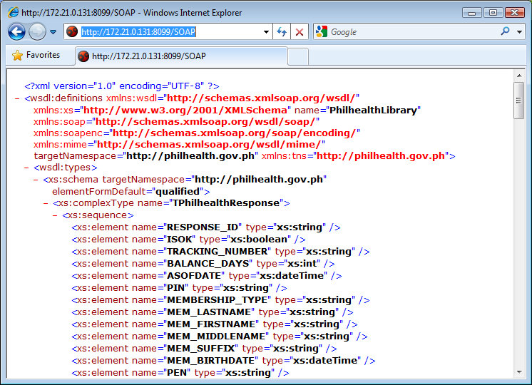

The documentation of the web service can also be viewed by replacing “/SOAP” with “/doc”.

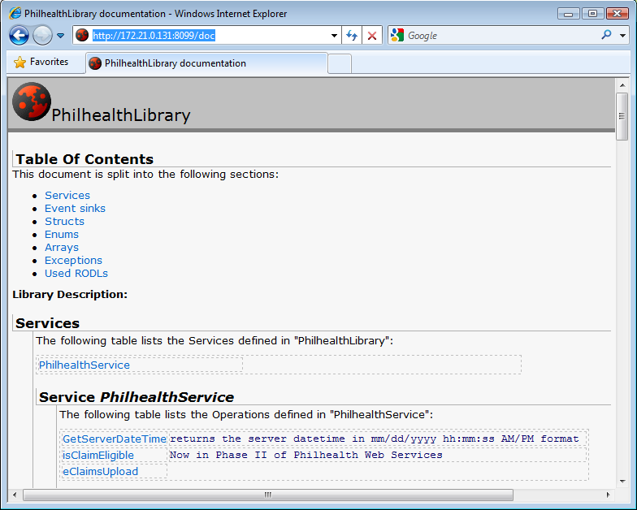

Consuming the Web Service

Web services are designed for the interoperability between systems, which, could be running in different platforms and could have been developed using different programming languages and tools. A web service can be consumed using different programming languages. And even with the same language, a web service can be consumed in a variety of ways. This section just illustrates how the web service can be consumed in some of the programming languages. The web service exposes a function named GetServerDateTime and this function will be used in the following sample codes. This function just returns as string the current date and time of the server where web service is hosted.

Consuming the Web Service in PHP using the SoapClient Extension
This section shows how the web service can be consumed in PHP using the SoapClient extension of PHP. The SoapClient extension can be enabled by including the line “extension=php_soap.dll” in the configuration file (PHP.ini) of PHP. The image below shows the codes PHP page that will call GetServerDateTime function after clicking the Submit button. As shown, one line is needed to instantiate the SoapClient with the WSDL URL as the first parameter. Then another line to call the GetServerDateTime function. The next images shows the output pages.

<?php
error_reporting(E_ALL);
$serverDateTime ="";
if(isset($_POST['Submit'])){
try{
$client = new SoapClient('http://172.21.0.131:8099/SOAP');
$serverDateTime = $client->GetServerDateTime();
}catch(SoapFault $fault){
die($fault->faultstring);
}
}
?>
<!DOCTYPE html PUBLIC "-//W3C//DTD HTML 4.01 Transitional//EN">
<html>
<head>
<meta http-equiv="Content-Type" content="text/html; charset=utf-8" />
</head>
<body>
<h1>Test e-Claims Web Services using PHP</h1>
<h2>Test GetSeverDateTime function</h2>
<form name="form" method="post">
<input type="submit" value="Submit" name="Submit"/><br/>
</form>
Server Date/Time: <b><?php echo $serverDateTime; ?></b> <br/>
</body>
</html>

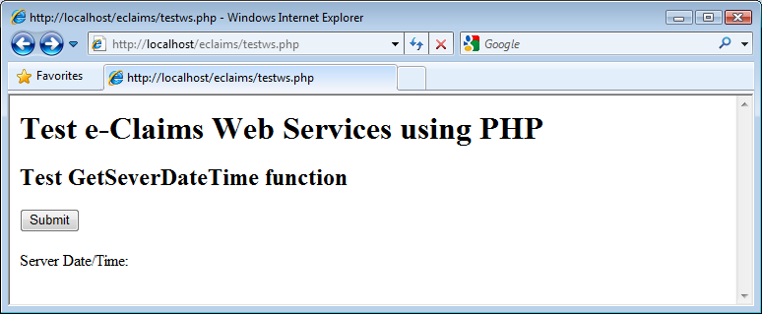

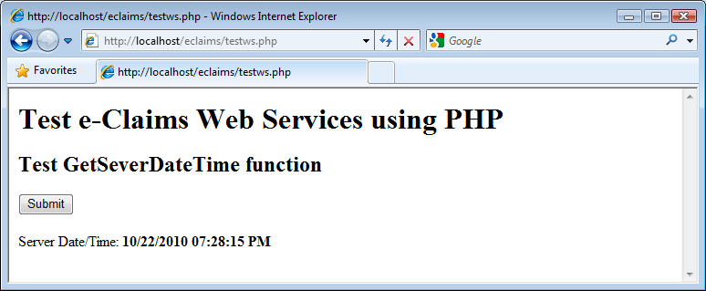

Consuming the Web Service in Java using Eclipse
This section shows how the web service can be consumed in Java using Eclipse IDE.

Creating a Sample Eclipse Project that Consumes the Web Service
- Create a Dynamic Web Project. One of the ways to do this is by clicking the File > New > Other menu.
- In the New dialog box that appears, select the Dynamic Web Project item under the Web folder.
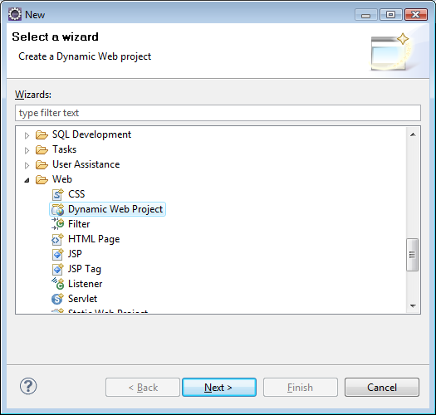
- In the New dialog box that appears, select the Dynamic Web Project item under the Web folder. Click the Next button.
- In the project name, you can enter “eclaimsjava2”.
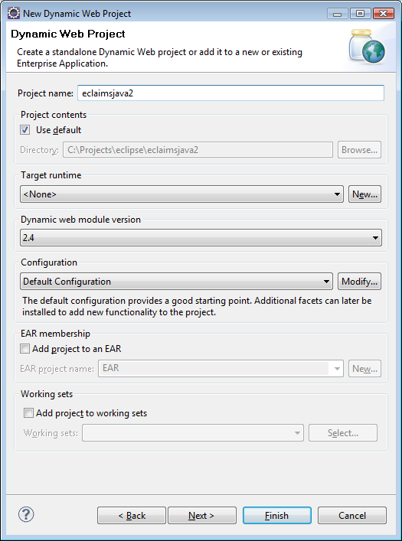
- Just click the Next buttons until Next button became disabled, the click Finish button. The New dialog box will be closed.
- Select the eclaimsjava2 item in the Project Explorer. Right click on it and the New dialog box will appear. Click the Web Service Client item under the Web Services folder. Click the Next button. The Web Service Client dialog box will appear.
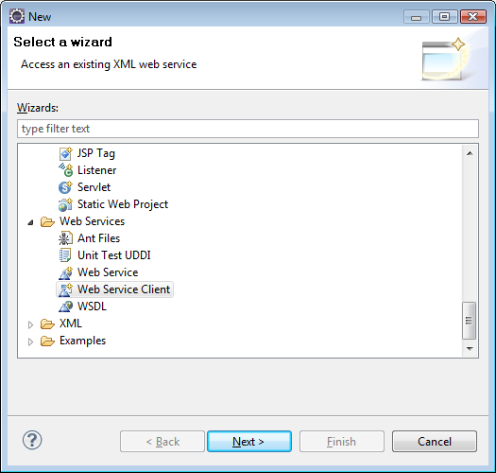
- In the Web Service Client dialog box, enter the URL of the WSDL of the web service. Do what the wizard asks you to do. After clicking the Finish button, elipse will generate the classes for the web service.
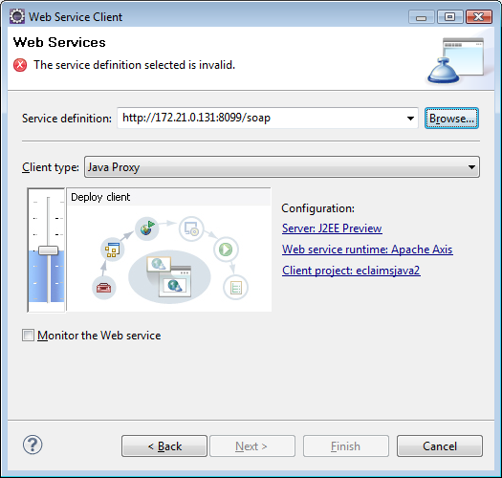

- Right click again on the eclaimsjava2 on the Project Explorer. Click New menu and select JSP menu. In the Editor, replace the codes of the JSP with the codes below. Compile the codes.
<%@ page language="java" contentType="text/html; charset=ISO-8859-1"
pageEncoding="ISO-8859-1"%>
<%@ page import="ph.gov.PhilHealth.*"%>

<!DOCTYPE html PUBLIC "-//W3C//DTD HTML 4.01 Transitional//EN" "http://www.w3.org/TR/html4/loose.dtd">
<html>
<head>
<meta http-equiv="Content-Type" content="text/html; charset=ISO-8859-1">
<title>Test e-Claims Web Services using JAVA</title>
</head>
<body>

<h1>Test e-Claims Web Services using JAVA</h1>
<h2>Test GetServerDateTime function</h2>
<form method="post"><input type="submit" name="submit" /></form>

<%
String serverDateTime = "";
if (request.getParameter("submit") != null ){
try{
PhilHealthService_ServiceLocator ws = new PhilHealthService_ServiceLocator();
PhilHealthService_PortType app = ws.getPhilHealthServicePort();
serverDateTime = app.getServerDateTime();
}catch(Exception e){
e.printStackTrace();
}
}
%>
Server Date/Time:
<%= serverDateTime %>

</body>
</html>

- Run the project.

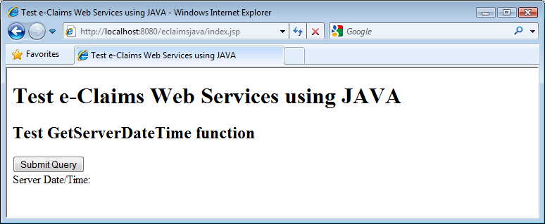
- Run the project. Click the Submit Query button to display the date and time of the server where the webser

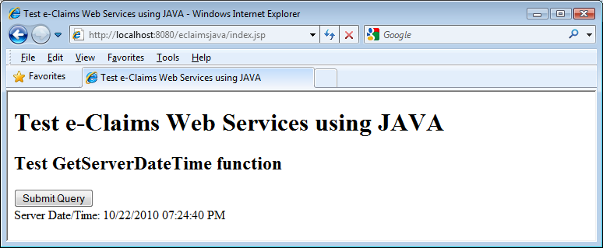

Consuming the PhilHealth e-Claims Web Services in Visual Basic.

This tutorial on Building a Service implementer for PhilHealth Web Service assumes that the developer already has a cached copy of the WSDL (XML) file and saved as “c:\wsdlFiles\PhilHealthHospWebServices” and the necessary changes has been applied to the WSDL file.
The IP address of the connecting party should also be registered with PhilHealth.

This tutorial starts from building a new Project/Solution with a form, a button on the form, and an event handler for the button click.
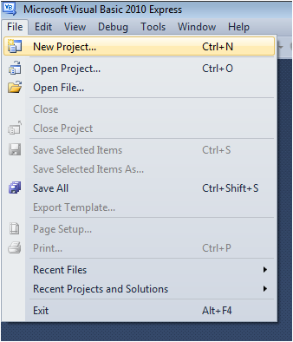

To add the Service Reference for the Web Service using the WSDL file,
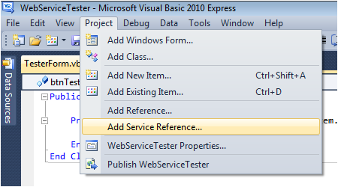
- Click Project-Add Service Reference. A window will appear.

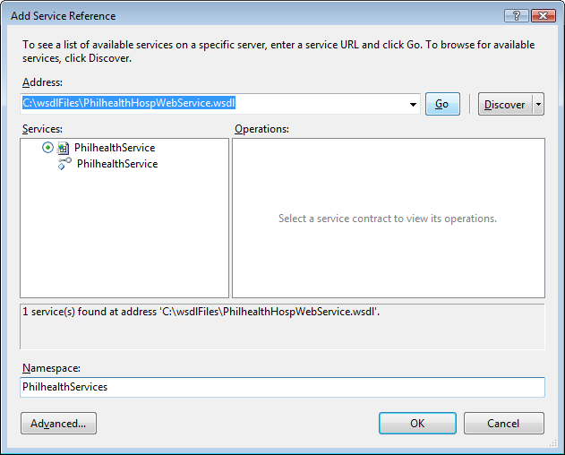
- Type in the full path of the WSDL file and click Go. The services will be shown on the left side and all available functions and operations will be shown on the right.

- Change the Namespace to PhilHealthServices.

- Press OK to add the service reference to your project.

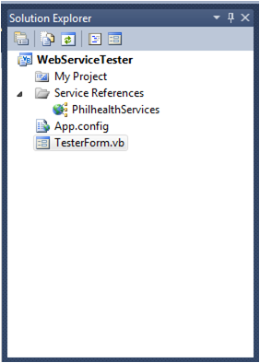
- To verify if the Services has been added to your project, View the Solution Explorer and check if PhilHealthServices is included in the Services References folder.

- To use the services in your code, declare a variable “aService” as “PhilHealthServices.PhilHealthServiceClient”.
- Declare a variable for the response.
- Initialize the connection for the services by assigning aService with a new instance of PhilHealthServiceClient.
- To test the Connection with PhilHealth Server, use the GetServerDateTime() function.
- The isClaimEligible function has many parameters, most of which require values other than an empty string. Supply the values to the parameters as necessary.
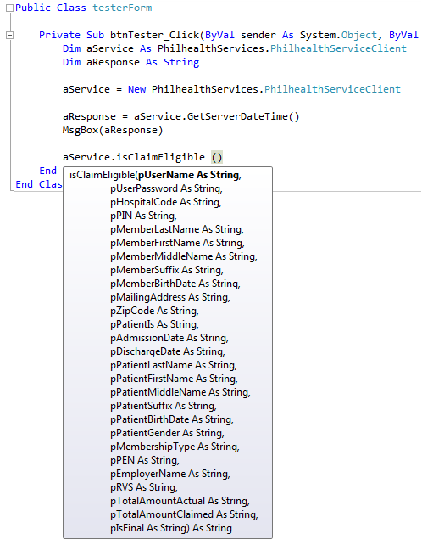
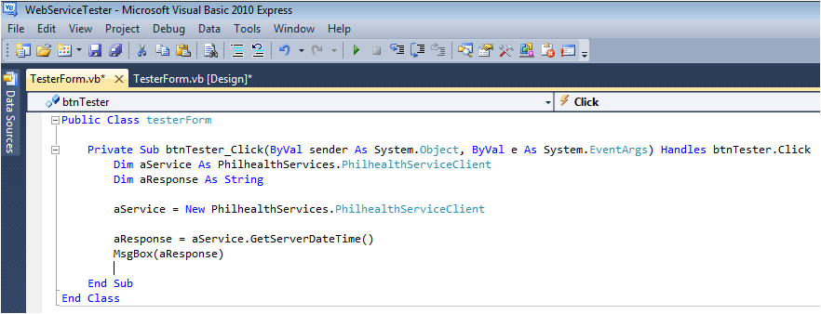

Annex D: Guidelines for the Encryption of Image Files of the supporting documents of claims Submitted through e-Claims web servce

Procedures

- The supporting documents will be scanned and converted to PDF/A format. The scanned image files should be saved temporarily to a directory and be deleted after they have been encrypted.
- Each file will be encrypted individually. Encryption will be done on the side of HCI. PhilHealth will not include file encryption in the e-Claims web service. This will avoid overhead of web service calls both on the side of HCI and PhilHealth.
- Before encrypting the file, compute for the hash of file using SHA-256 hash method. (This hash will be compared to the hash that will be computed later after the file has been extracted on from decrypted file on PhilHealth side. If the hash values match, it assures that the file has been encrypted and decrypted correctly.)
- As recommended by online articles about encrypting files, two different encryption methods will be used. The image file itself will be encrypted using AES-256-CBC. To be able to decrypt the file, PhilHealth needs to have the password used in the encryption. The password will be sent together with the encrypted data. But the password will be themselves encrypted using public key encryption. PhilHealth will provide a separate digital certificate or file containing the public key that will be used in encrypting the password.
- HCIs/SPs may use their preferred programming language or tools in doing the encryption.
- The password to be used should be composed of 32 random bytes of data. Two arrays of random 16 bytes long will be used. On calling the AES encryption, these two arrays will be merged or concatenated but the two “keys” will be encrypted separately.
- For the initialization vector (IV) parameter for the AES, an array of random 16 bytes (containing a total of 128 bits) will be used. This IV will also be encrypted using public key encryption and then sent to PhilHealth.
- The resulting encrypted document will be saved using the original file name appended with “.enc”. Other information about the file such as the MIME type of the image file will also be included in the file. The encrypted data elements will be encoded in the file using Base64 encoding. All data elements will be included in a single file in JSON format.

Format of the Output File

{
"docMimeType": "<MIME type of the image file e.g. ‘application/pdf >",
"hash": "<SHA-256 hash of the image file before encryption>",
"key1" : "<Encoded in Base64 format, the public key encrypted first 128 bytes of the password>",
"key2" : "<Encoded in Base64 format, the public key encrypted second 128 bytes of the password>",
"iv" : "<Encoded in Base64 format, the public key encrypted initialization vector>",
"doc" : "<Encoded in Base64 format, AES-256-CBC encrypted image file data>
}
Figure 1: Output File Format/Layout
The figure above shows the format of the output file. As it can be observed, the output file is basically a representation in JSON format of the four encrypted data elements and 2 unencrypted data elements. The figure shows the description and format of the data elements.

Demo Kits

The soft copy of this guide comes with two demo kits with each demo kit packaged in one zip file. The file Demo Kit for PHP.zip contains the demo kit for PHP. It contains PHP source codes which can be used to setup a demo PHP web application. The file Demo Kit for C#.zip contains the demo kit for kit for C#. It contains Visual Studio solution and project files which can be used to generate a demo Windows Forms application. Although the demo kits uses PHP and C#, HCI/SPs can use their preferred programming languages. The demo kits are provided to serve just as a guide.
Both demo kits contains a folder named “@Files”. It has the following folders and files:
@Files
Input
pnpki_philhealth_eclaims_auth_cert.pem | The public key file generated from the sample digital certificate. This file should replace the previous public key file name sample_public_key.pem which was generated by another certificate authority.
SAMPLE_BIRTH_CERTIFICATE.pdf | Can be passed as the target PDF file for encryption. Note the demo app will delete the target PDF file after encryption.
SAMPLE_BIRTH_CERTIFICATE.orig.pdf | Original copy of the sample PDF file
Recreate file to be encrypted.bat | A batch file that can be used to recreate the SAMPLE_BIRTH_CERTIFICATE.pdf from SAMPLE_BIRTH_CERTIFICATE.orig.pdf after the demo app has deleted it
Output
SAMPLE_BIRTH_CERTIFICATE-usingCSharp.pdf.enc | Sample generated encrypted e-claims document

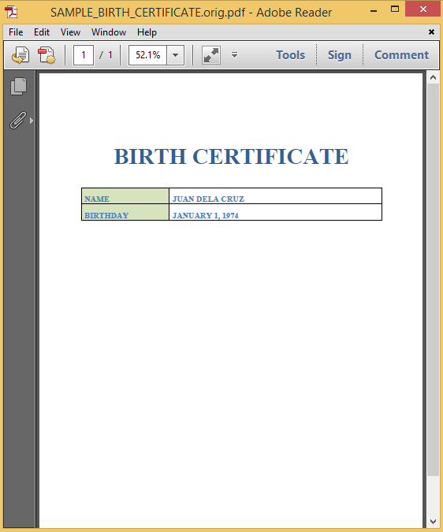
Figure 2 Sample PDF file (SAMPLE_BIRTH_CERTIFICATE.orig.pdf)

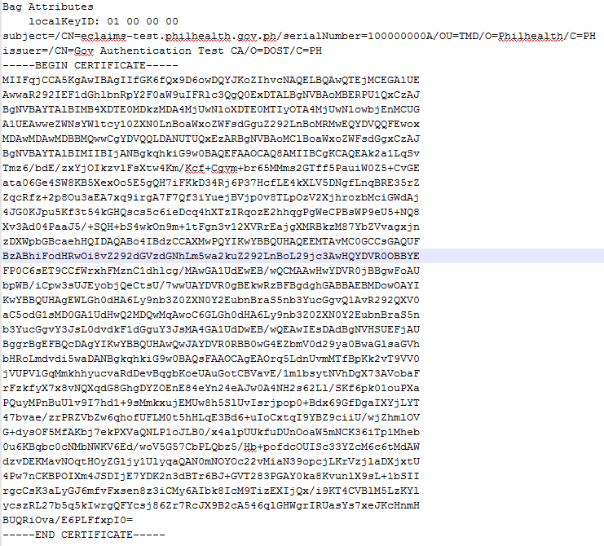
Figure 3 Content of the test public key file (pnpki_philhealth_eclaims_auth_cert.pem)

Demo Kit for PHP

The contents of the file Demo Kit for PHP.zip are shown below. The folder EclaimsDocEncryption can just be copied to the root or any directory of a PHP installation to be able to setup the demo application. Please enable the openssl extension to run the demo application. The file encryptEClaimsDoc.php is the entry point of the demo application. Please see below the screenshot of the PHP demo application.
EclaimsEncryption
@Files | The contents of this folder has been described on previous page
encryptEClaimsDoc.php | Provides a sample user interface for passing gathering inputs parameters in encrypting scanned image files of the supporting documents of an electronically-submitted claim
testEncryptAndDecryptXml.php | Provides a demo application for the encryption and decryption of the input and output parameters that are to be passed as XML text
PhilHealthEClaimsEncryptor.php | Contains the class implementing the encryption procedures

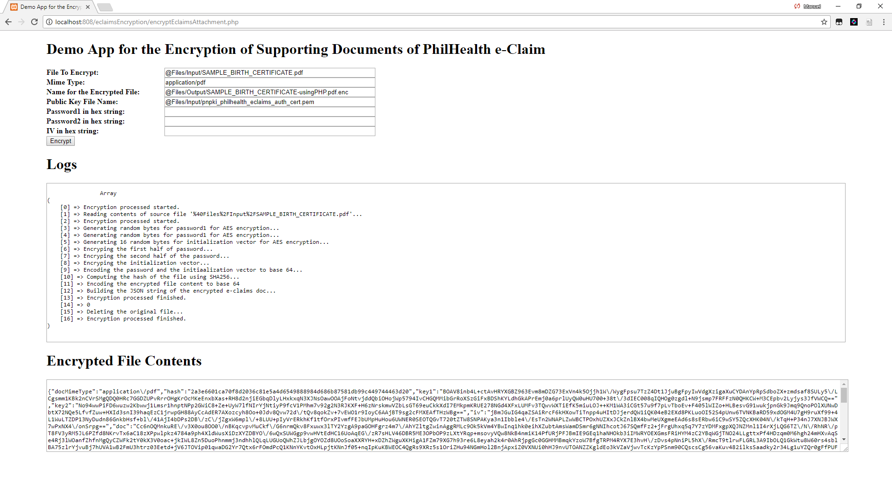
Figure 4: Screenshot of the PHP demo application

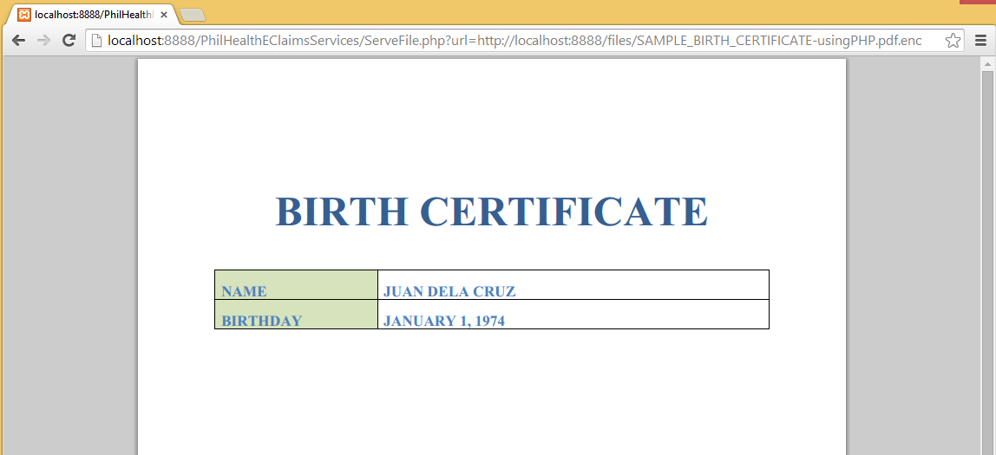
Figure 5: Output of PhilHealth's test application after decrypting the file encrypted by the PHP demo application

Demo Application for C#

The contents of the file Demo Kit for C#.zip are shown below. It contains a Visual Studio solution/project files. Open the solution file and build the PhilHealthEClaimsEncryptionDemoApp project to generate the executable file of the demo Windows Forms application file. See the screenshot of the C# demo application.

PhilHealthEClaimsEncryptionDemoApp
@Files | The contents of this folder has been described on previous section
bin
Helpers | Contains one helper/utility class
Obj
Properties
App.config
Form1.cs
Form1.Designer.cs
Form1.resx
PhilHealthEClaimsDocEncryption.cs | A class that implements the guide for encrypting a e-claims document
PhilHealthEClaimsEncryptionDemoApp.csproj | The C# project file
Program.cs
EClaimsDocEncryption.sln | Visual Studio solution file
EClaimsDocEncryption.v12.suo

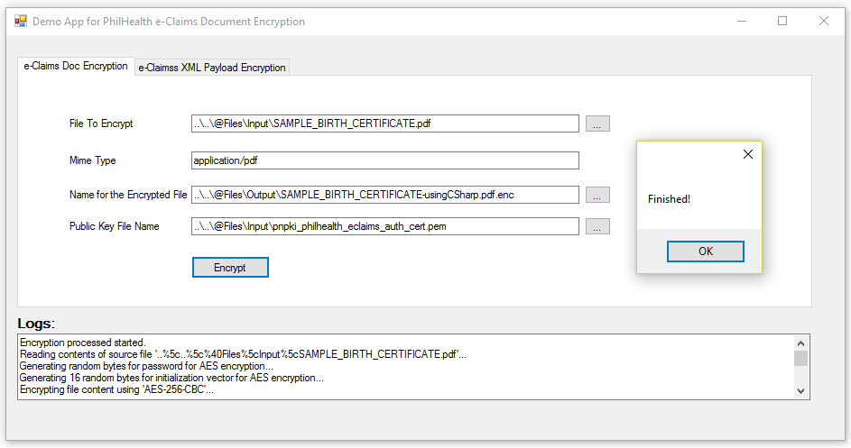
Figure 6 Screenshot of the C# demo application
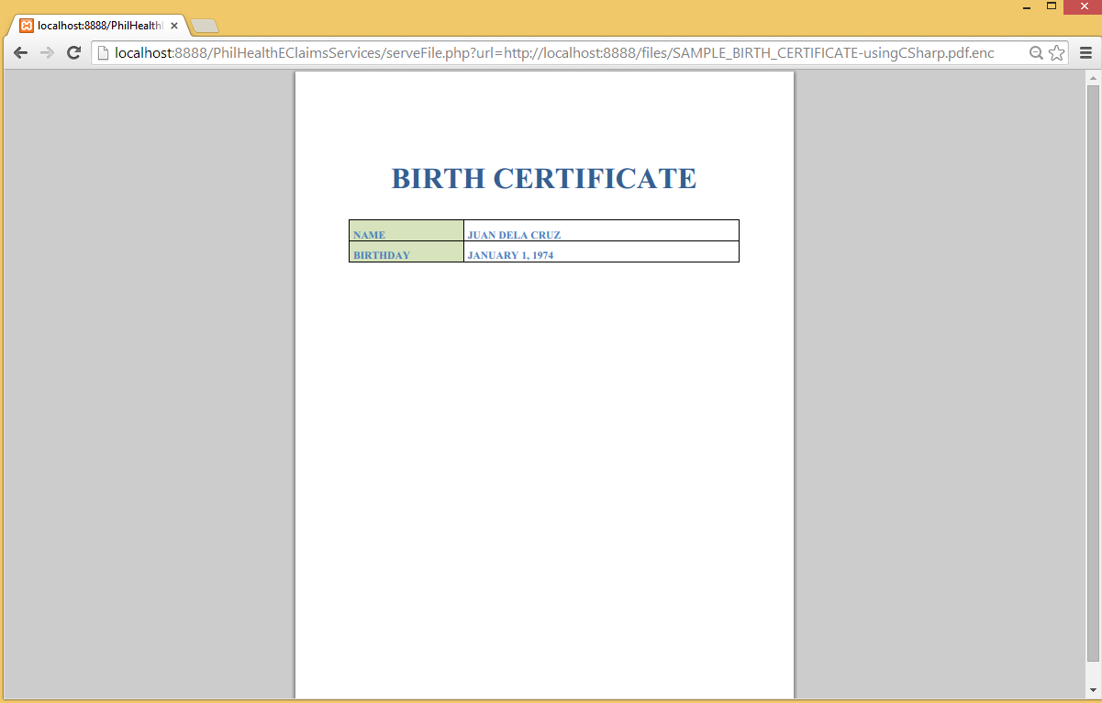
Figure 7 Output of PhilHealth's test application after decrypting the file encrypted by the C# demo application

Annex E: Guidelines for the Encryption and Decryption of Parameters that are to be passed as xml

GUIDELINES AND Procedures
- The application of HCI should encrypt input parameters that are supposed to be passed as XML. HCI applications should also decrypt all the output parameters that are supposed to be returned by PECWS as XML.
- The input and output parameters that are to be passed as XML text will be referred in this section as XML payload data.

Encryption of the xml payload data
- The procedures for the encryption of the XML payload data will be similar to the procedures in the encryption of the image files of the supporting documents of electronically submitted claims. The difference is that encryption of the XML payload data will not use public-key encryption.
- The XML payload data will be encrypted using “AES-256-CBC” algorithm.
- PhilHealth will issue the passphrase/password/cipher key to be used by each HCI. The password should be hashed using SHA-256 algorithm. The first 32 bytes of the hashed value should be passed as the password for the AES encryption. If the resulting hashed value is less than 32-bytes, the value should be padded with ‘0x00’ or null character.
- An array of random 128 bytes should be used as the initialization vector.
- Before encrypting the data, compute for the hash of file using SHA-256 hash method. (This hash will be compared to the hash that will be computed later after the file has been extracted on from decrypted file on PhilHealth side. If the hash values match, it assures that the file has been encrypted
- The expected output of these encryption procedures is to be encoded in JSON. The figure below shows the expected key-value pairs that are to be included in the JSON text.
  - The “docMimeType” key, should have fixed value of “<text/xml>”.
  - The value for the “hash” item is the computed hash of the raw unencrypted XML text using the SHA-256 hash algorithm.
  - The value for “key1” should be an empty string.
  - The value for “key2” should also be set to empty string.
  - The value for “iv” key should be the base-64 encoded value of the initialization vector mentioned in Step#6.
  - The value for the “doc” key should the base-64 encoded value of the result of the AES-256 encryption of the XML payload data.
{
"docMimeType": "<text/xml>",
"hash": "<SHA-256 hash of the XML text (before encryption)>",
"key1" : "",
"key2" : "",
"iv" : "<Encoded in Base64 format, the public key encrypted initialization vector>",
"doc" : "<Encoded in Base64 format, AES-256-CBC encrypted image file data>
}
Figure 1: Format/Layout of encrypted data
- SPs/HCIs may use their preferred programming language or tools in doing the encryption and decryption. The PECWS development kit includes sample codes in C# and PHP. For the sample source codes in PHP, the encryptXmlPayloadData method of the PhilHealthEClaimsEncryptor class contains an implementation of the encryption procedures outlined above.

Decryption of the xml payload data

The decryption process is just the reverse of the encryption process outlined in previous section.For the service methods that are supposed to return an XML, PECWS will encrypt the supposed XML data and return a text encoded in JSON whose key-value pairs as described in the previous section.
- After receiving the JSON text, the HCI application should parse it.
- Get the value of the “iv” key. That is the base-64 encoded value of the initialization vector used in the AES-256 encryption of the XML payload data. Decode the value of the initialization vector from base-64 encoding to its corresponding raw array of bytes.
- Get the password, passphrase or cipher key of the HCI.
- Get the SHA-256 hash value of that value. . If the length in bytes of the resulting hashed value is less than 32, pad the value with ‘\0’’ or null character.
- Get the value of the “doc” key. That value is the base-64 encoding of the encrypted data. Decode the data from base-64 encoding to the raw array of bytes of the encrypted data, With values of the passphrase, initialization vector and actual encrypted data, decrypt the data using AES-256-CBC.
- You may get the hash value of the decrypted data and compare it with the value of the “hash” key.
- After the decryption, the application of HCI may now process and parse the target XML data.
SPs/HCIs may use their preferred programming language or tools in doing the encryption and decryption. The PECWS development kit includes sample codes in C# and PHP. For the sample source codes in PHP, the decryptPayloadDataToXmlmethod of the PhilHealthEClaimsEncryptor class contains an implementation of the decryption procedures outlined above.

Annex F: Non-disclosure Agreement

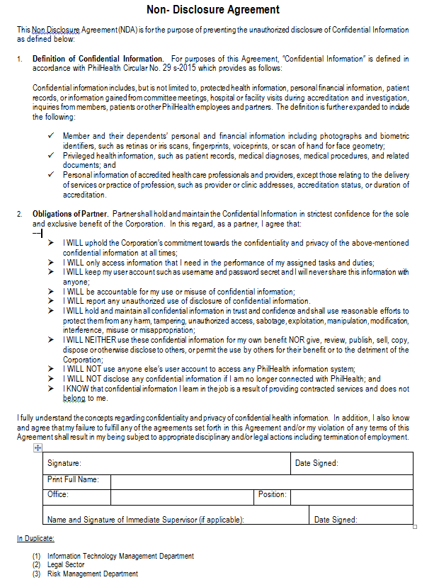

Annex G: Software Testing and Validation

COMPONENT 1: Technical Capabilities

Part of the certification process is the system and testing validation to be conducted by the PhilHealth Regional Offices (PROs). Below is Software Solutions Validation Test Form -eClaims. This test shall check for conformance and compliance with the PhilHealth eClaims Implementation Guide. Check P (for Passed) if the test was successfully demonstrated and F (for Failed) if not. Notable observations should be listed under REMARKS. The system will be acceptable as “PASSED” upon successful completion of the 3 cycles, passing all criteria.

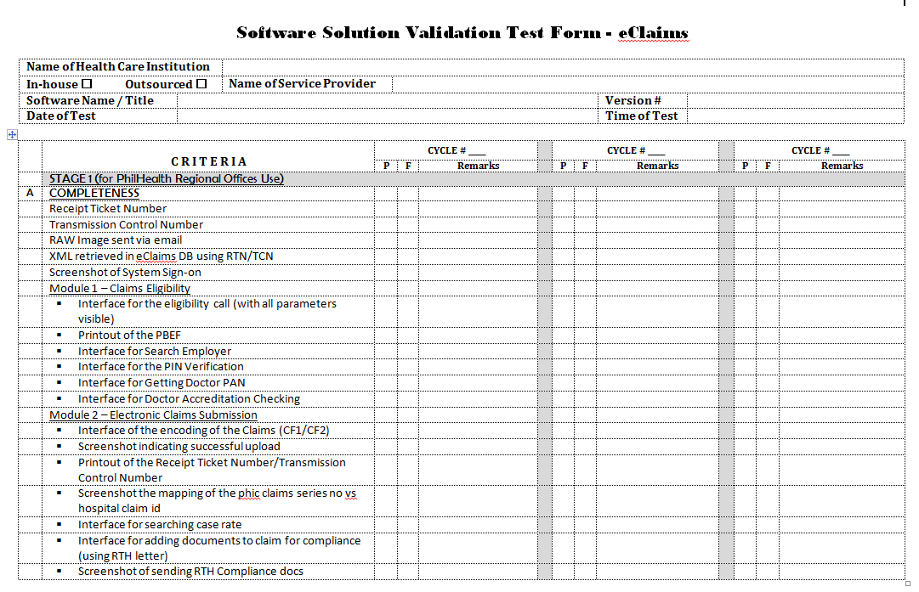

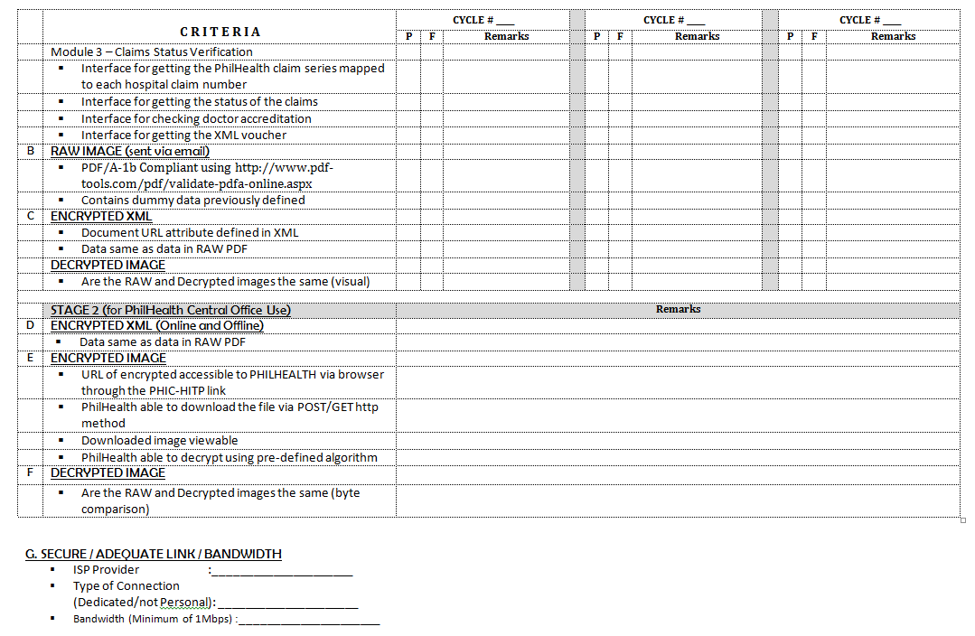

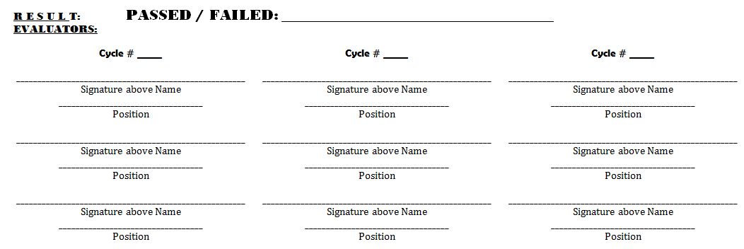

Annex G: List of document types and codes

Document Type Code and Description
Document Code | Description
CAB | Clinical Abstract
CAE | Certification of Approval/Agreement from the Employer
CF1 | Claim Form 1
CF2 | Claim Form 2
CF3 | Claim Form 3
COE | Certificate of Eligibility
CSF | Claim Signature Form
CTR | Confirmatory Test Results by SACCL or RITM
DTR | Diagnostic Test Result
MBC | Member's Birth Certificate
MDR | Proof of MDR with Payment Details
MEF | Member Empowerment Form
MMC | Member's Marriage Contract
MSR | Malarial Smear Results
MWV | Waiver for Consent for Release of Confidential Patient Health Information
NTP | NTP Registry Card
OPR | Operative Record
ORS | Official Receipts
PAC | Pre-Authorization Clearance
PBC | Patient's Birth Certificate
PIC | Valid Philhealth Indigent ID
POR | PhilHealth Official Receipts
SOA | Statement of Account
STR | HIV Screening Test Result
TCC | TB-Diagnostic Committee Certification (-) Sputum
TYP | Three Years Payment of (2400 x 3 years of proof of payment)
MRF | PhilHealth Member Registration Form
ANR | Anesthesia Record
HDR | Hemodialysis Record
OTH | Other documents

Recommended steps for PDF attachments of files:
1. Create web server with https.
2. Create a folder where the pdfs will be publish.
3. In the system, provide facility for opening and uploading the pdfs in the web server, taking note
of the urls.
4. When creating the xml, include the urls of the uploaded documents.

To test if the pdfs are accessible via browser, paste the url on the address bar of a browser. the pdf document can either be downloaded or loaded on the browser to be successful.

PhilHealth Office Order 0050, s.,2011
www.shafafiya.org/HAAD, s2008

