PACS
(Picture Archiving and Communication System)
Manual

MEDSYS
- User Login
Enter username (employee number) and password.
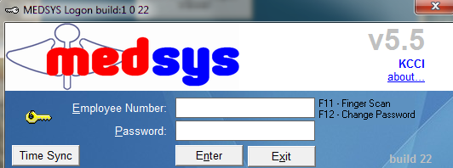
Note: To change password, enter username and press F12 on keyboard. The window below will appear.
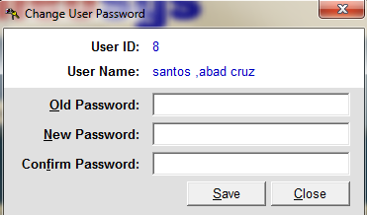
Enter your old password and new password on the box.

- Viewing Patient List
After logging in, the list of patients for the day will automatically show on the screen. You can also search patients by Lastname, Accession/Req.Number, File/Study Number, Hosp.Number/Patient ID, or by Firstname.
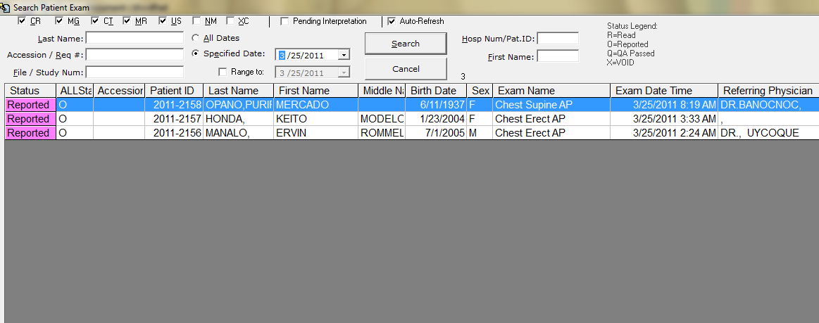

By default, the patient with the latest procedure processed is displayed on top of the list.
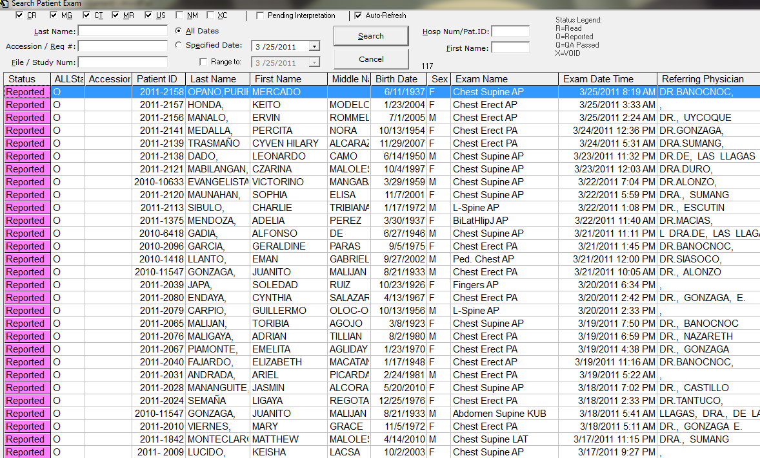
To view all patients from the previous dates to current one, click on All Dates button and all the list of patients will be displayed on the screen.

- Viewing Images of Patient
Double-click on patient's name to view image.
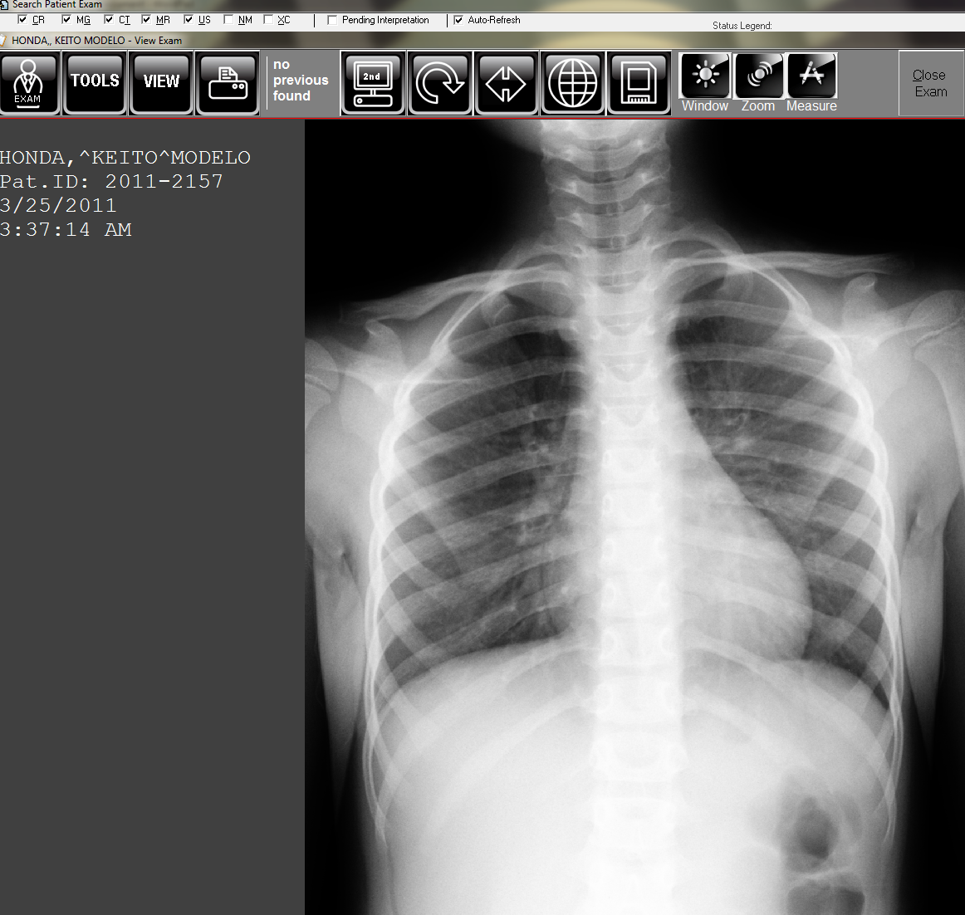
Note: By default, you can zoom in and zoom out image by using the mouse scroll.
- Right Mouse Functions
Right click on mouse and options like zooming, windowing and others will be displayed. Choose one by right-clicking on it. Click and hold right mouse button and drag it up, side, down to apply the selected option.
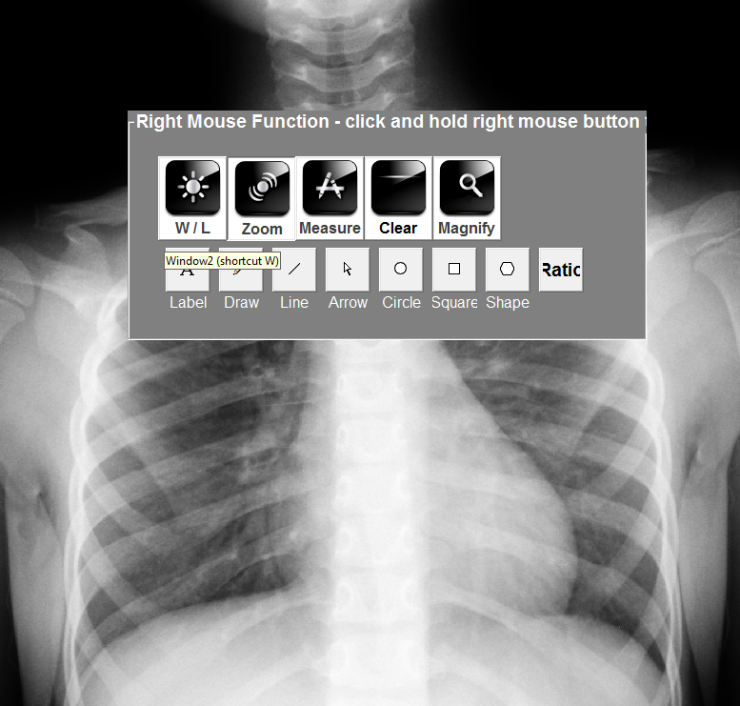

- Comparing Images
To COMPARE previous image of patient to the current image, click on HISTORY and patient's record of the past will be displayed.
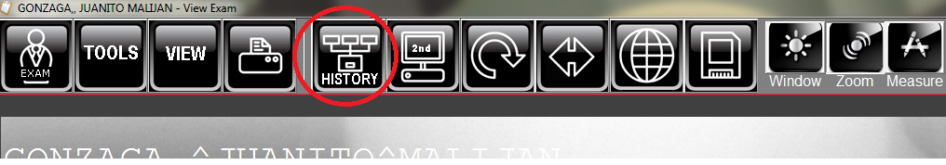
Note: If the patient has no previous exam or history found on the system, the encircled icon below (no previous found) will be the one to appear.
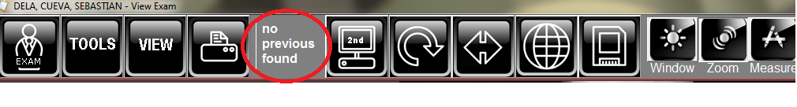

- Result Entry / Inquiry.
To ENTER and VIEW patient's result, point your mouse on Exam icon (or Press “R” on keyboard for shortcut) and the options below will appear.
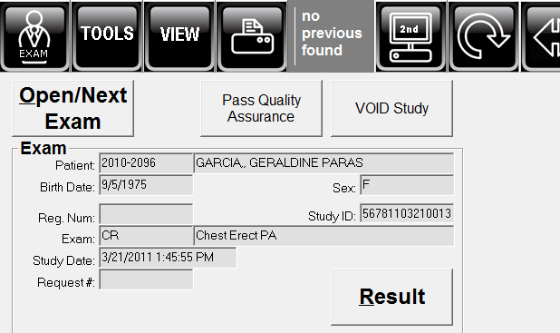
Note: NOT all users can access the Result. ONLY those who were given rights can access it.
Click on the Result button to enter or view patient's result. Information of patients entered on the machine will automatically appear here.
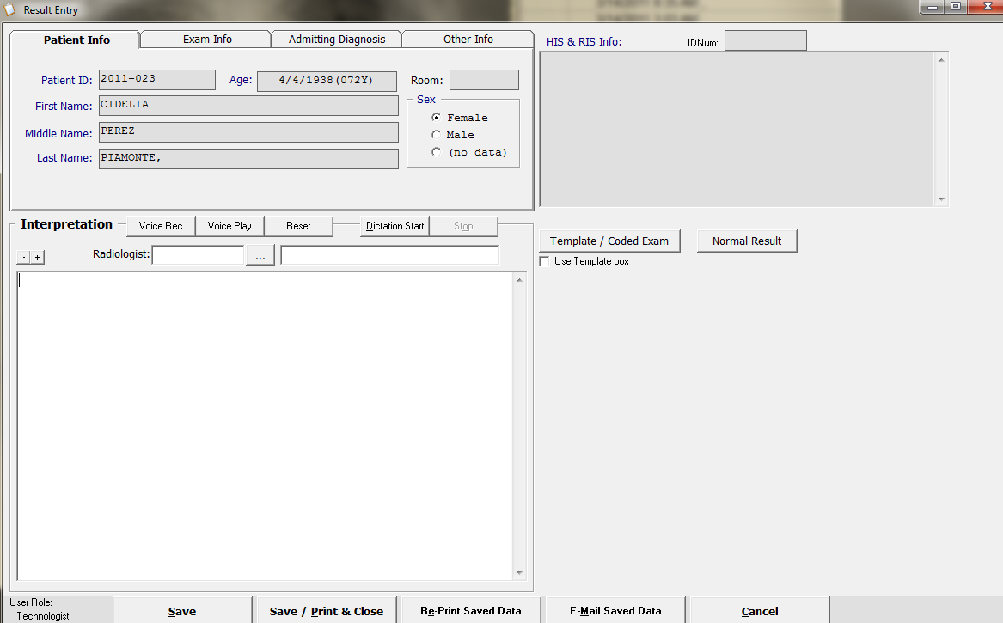
The user can directly enter interpretation of result if she/he will not use the coded templates or interpretation.

Click on the to view results templates. By default, the “Area” field will display the name of procedure being done to patient.
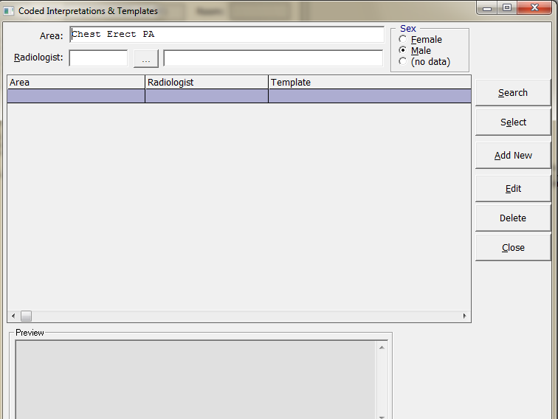
To search for existing templates, remove the default field by highlighting it and then delete.
Click on button located on the left side of the window to display result templates.
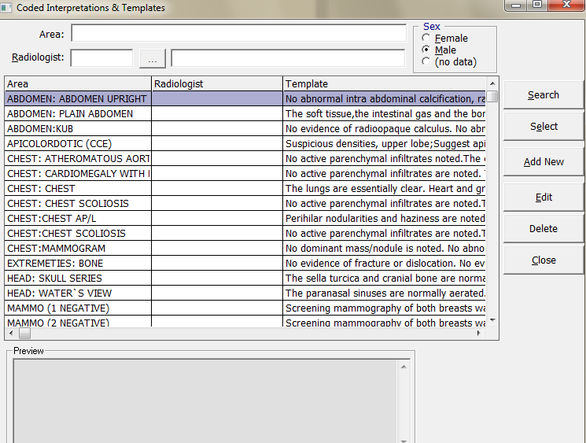
Select a template by clicking on the 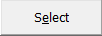 button or you can simply double-click the desired template.

Once you have selected the result template, it will go back to the main result entry window.
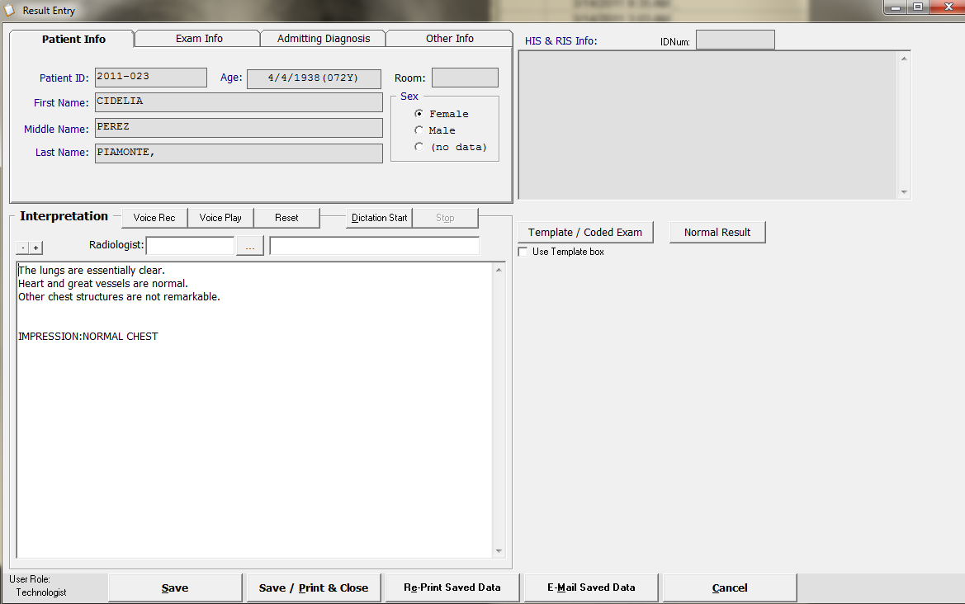
Select Radiologist by typing the first three or four letters of radiologist last name on the box beside Radiologist field and then hit the “Enter” key in keyboard. To display the list of radiologists, click the button.
Click Save/Print & Close to save and print the result and close the result entry window. Reprint result by selecting on the Re-Print Saved Data button.
Note: Upon saving, a window will prompt asking user’s login. This is to ensure that ONLY authorized user accounts can enter or edit results.
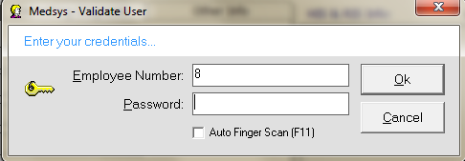
There’s a message window that will pop up if the result was successfully saved.
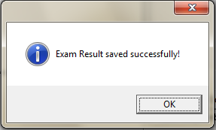

- Sending Result Through SMS and Email.
This window will automatically appear once the result was Save/Print & Close.
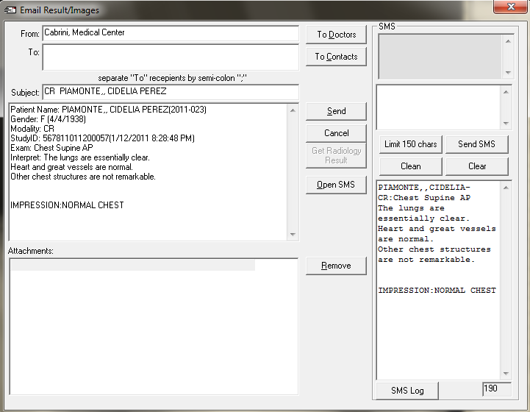
To send result via SMS / Email
Click on or to select a recipient.
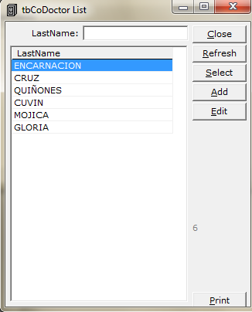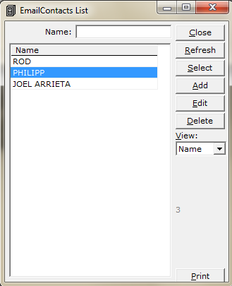
List of Doctors List of Contacts

Click on button to send result to SMS.
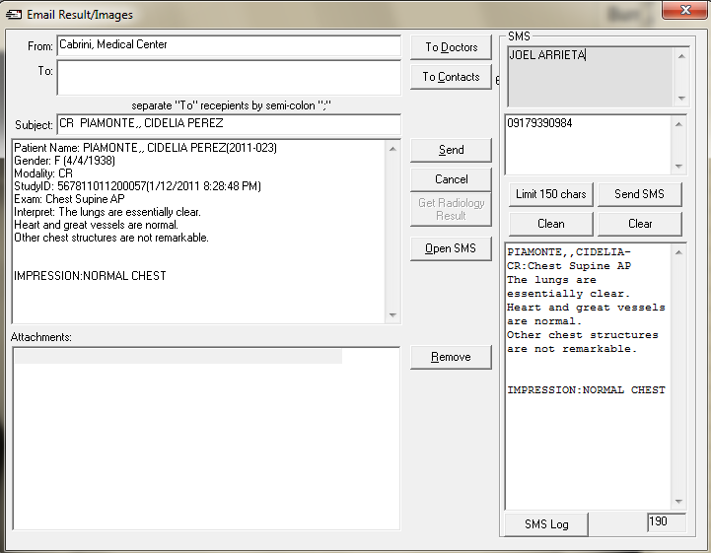
Click on button to send result to Email.

How to Add Contacts
Click on the button and fill up the contact form. Click on button afterwards.
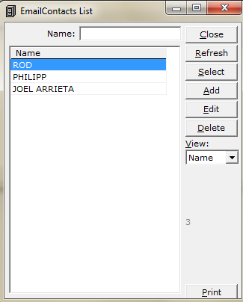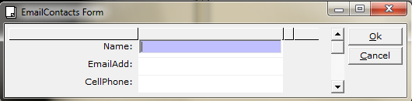

- CD Burning
Open patient’s image and point your mouse to 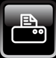 (Print/Output) icon.
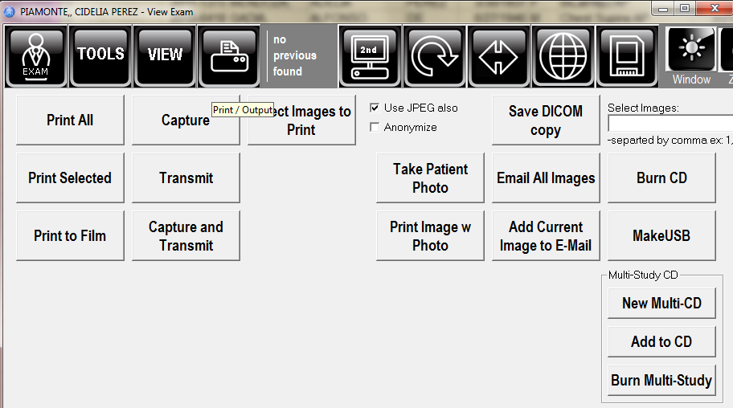
- Burning Images of a Single Patient
Click on 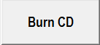 button to burn image of a single patient. Then select “Burn” button to burn the image.
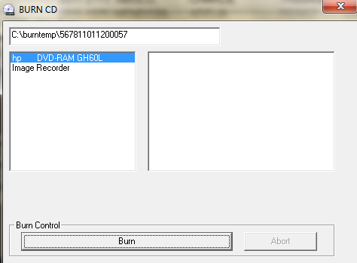
- Burning Images of Multiple Patients
Click on 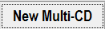 button to create new cd for multiple patients. To select a patient to be added on the multiple burning, open patient’s name, point mouse on the (Print/Output) icon and then click 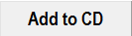 button. A window below will appear if the patient image is successfully added on the list.
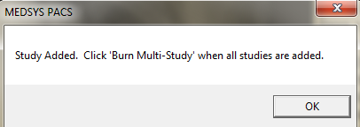

Click on  button to burn images of multiple patients.

- Printing of Images
Open patient’s image and point your mouse to (Print/Output) icon.
- Select “Print All” button if printing all images of patient on that single study.
- Select “Print Selected” button if printing only a selected image on the study.

