Contents
1. System Flow and Modality Worklist
2. MEDSYS RIS w PACS Viewer
3. MEDSYS by Location Viewer
4. Doctors Module Image Viewing
5. E-MAIL / SMS
6. CD / USB Image Viewing
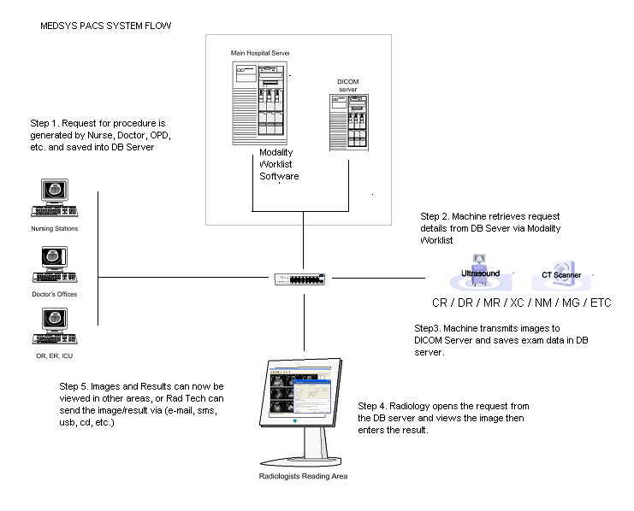
MEDSYS Modality Worklist Server / Broker
- Sends Patient Demographic and Exam information to Machine through DICOM communication
- Increases the accuracy of patient demographics entry (name, birth date, sex, patient ID, and request number) and speeds up procedure time.
- Ensures that the Image is linked to the HIS Patient and HIS Request (by Patient ID and Request Number respectively).
- Type of Examination procedure will also be returned. Will ensure that the correct procedure is to be done. (e.g. The CR will display only display requests for X-Ray.)
- Examinations that have results will be excluded from the Worklist.
- Can be installed on current MEDSYS Server.
NOTE: Machine must have Modality Worklist enabled

Screenshots Walkthrough

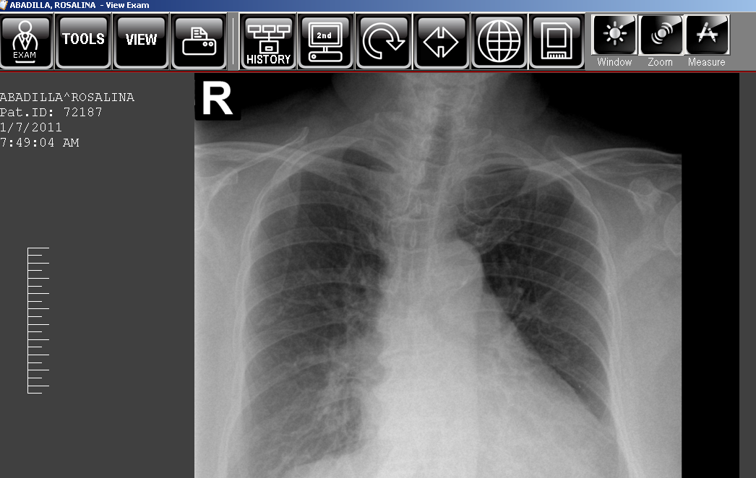
2. MEDSYS RIS w PACS Viewer - Exam is selected and PACS images are automatically brought up on screen 2. Historical images/results are brought up also.
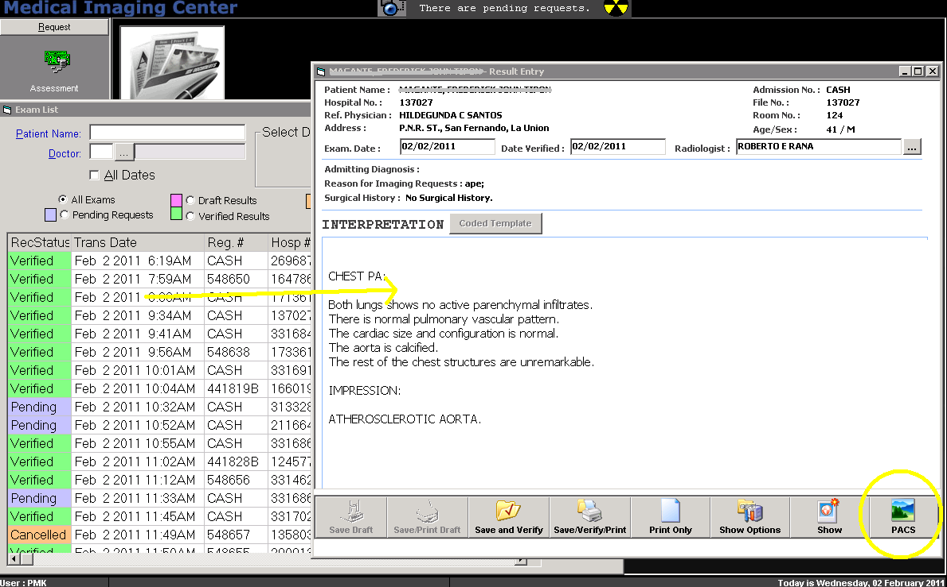

- Capture and Re-Transmit (to add images to PACS Server with added annotations, measurements, etc. and focused on area of concern)
- Patient Chief Complaint (out-patient) or Admitting Diagnosis (in-patient) will be prompted before entering of result
- Prompts the reason for x-ray so radiologists have a better idea what to look for
- Option to print Images on paper together with result
- Capability for Dual-Radiologist verification before result is released
- Biometric thumb reader capable
- Radiologist can sign result digitally, thus no need for actual signature (depending on hospital policy)

- MEDSYS by Location Viewer

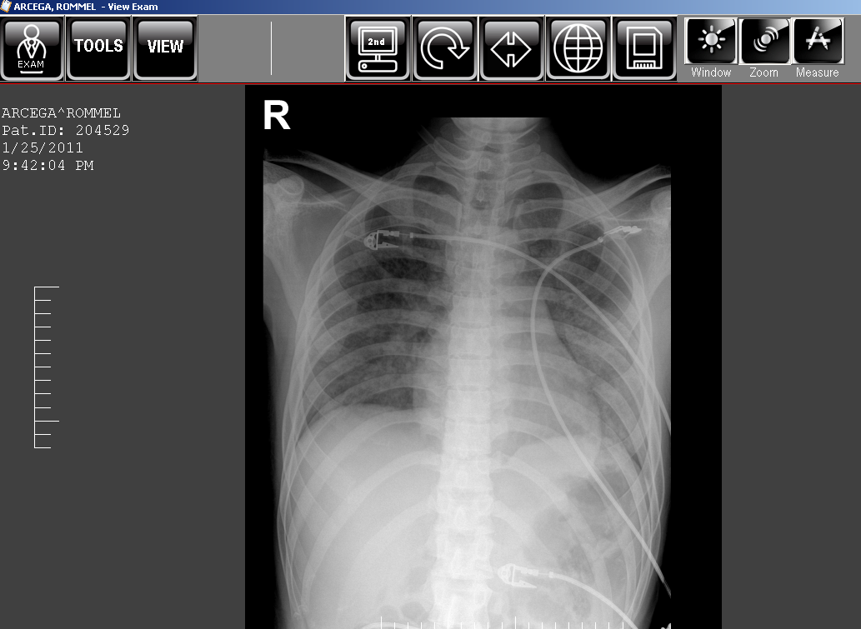
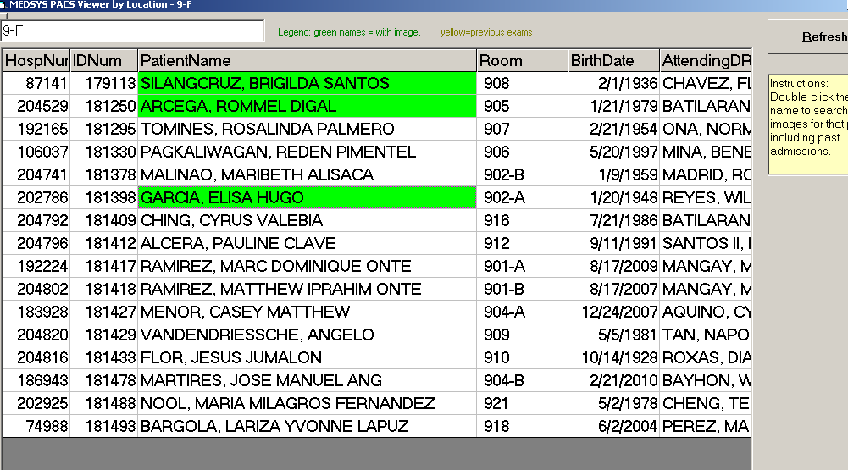

- Allows access of patient images on the same location which provides better patient confidentiality that being able to search all images.
- Patients with images are highlighted
- Images can be Quality approved before departments can access
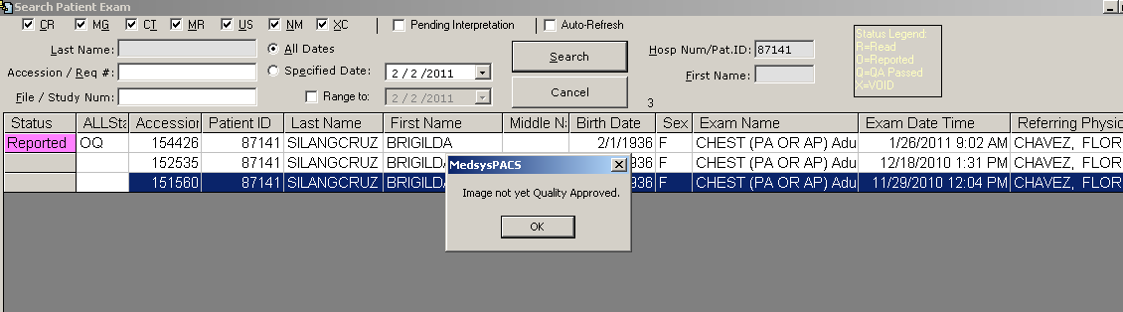
- The image status is displayed (Read | Reported | QA Approved | Void)
- Image is linked with HIS info and result
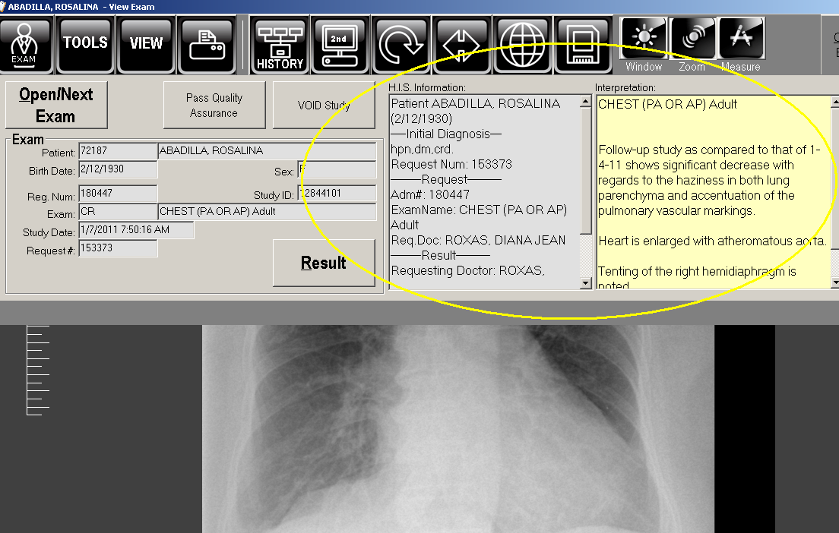

4. Doctors Module Image Viewing
- View images over Web using Doctors Module
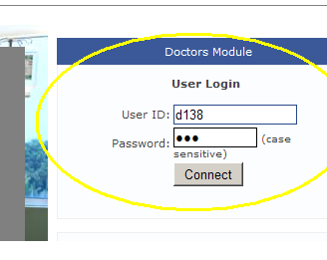

- Doctors can access only the images of their patients
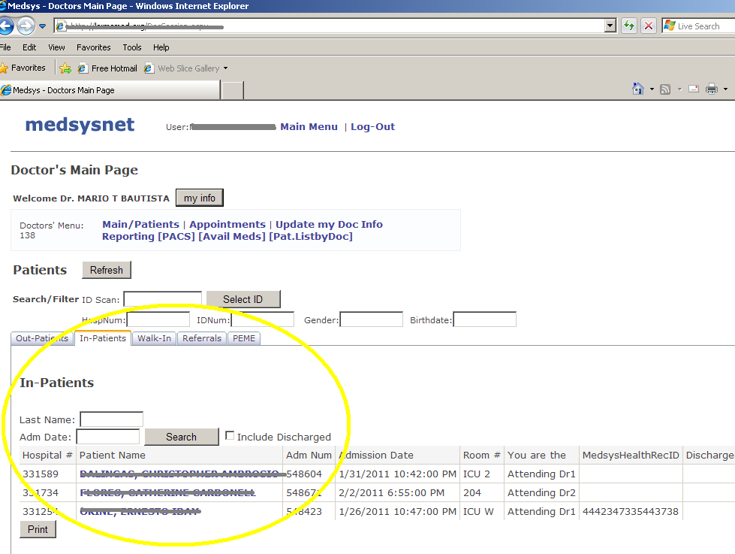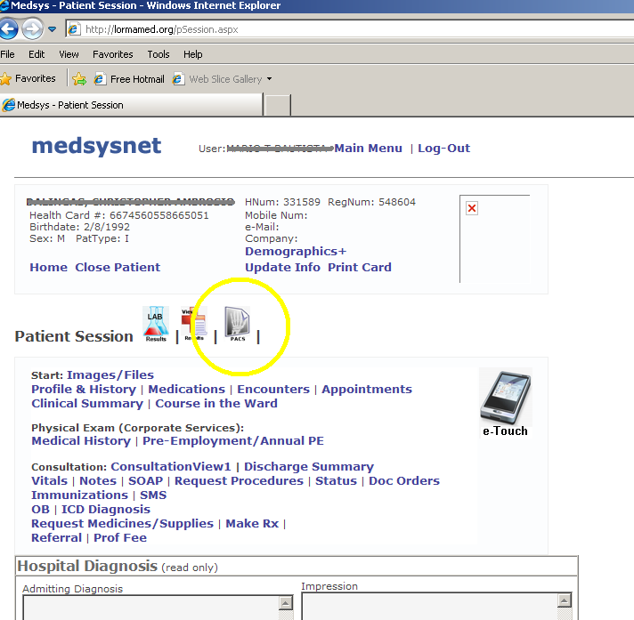

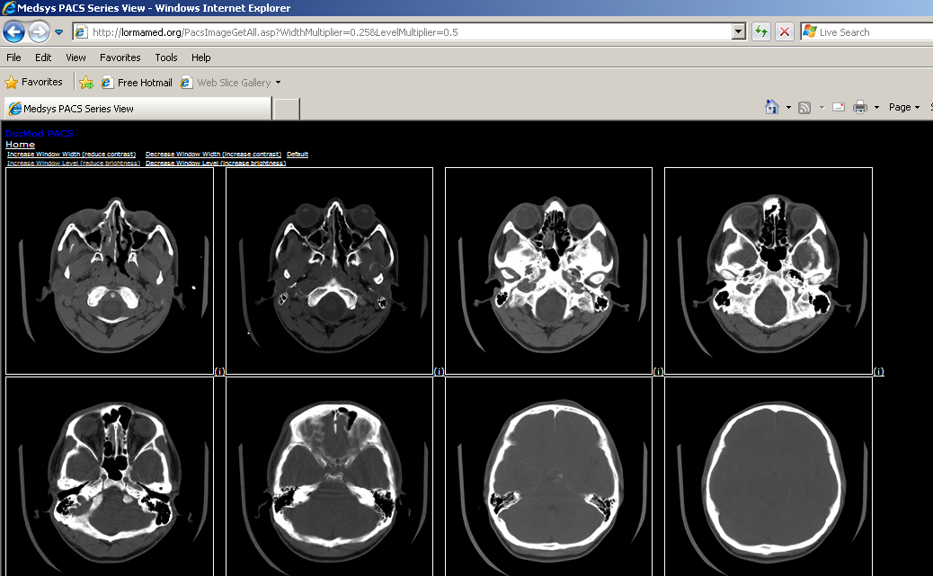

- Result can be entered and saved. (Existing results can not be over written for additional security).
- Features two types of viewing: by JPG and ActiveX DICOM

5. E-MAIL / SMS
- Send images as attachments to e-mail
- Doctors e-mail and phone numbers are retrieved from MEDSYS Database
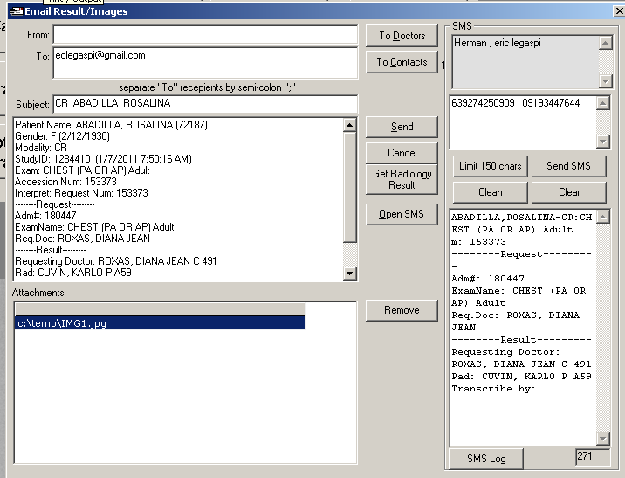

6. CD / USB Image Viewing
- Includes mini-DICOM Viewer which is easy to use, images in JPG are also included
- Auto-play
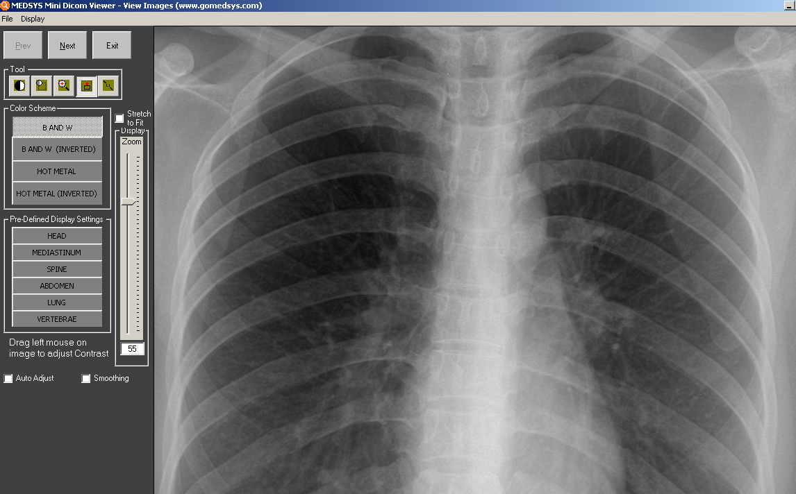

- CDs can be labeled using printer; Images can be saved to USB devices
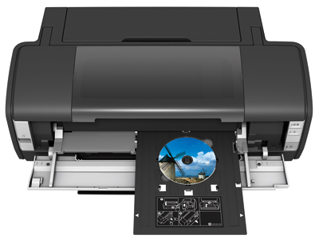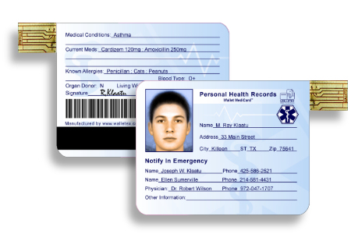

02/11

