MEDSYS

DOCTORS MODULE

User's Manual

MEDSYS
Kaiser - dela Cruz Consulting, Inc.
January 19, 2023

Table of Contents

Introduction 4
Overview 4
Objectives 4
Getting Started 5
How to Access the Program 5
Program Operation 5
Patient Searching 5
Patient Dashboard 7
Patient Menu 9
Admission Record/Consultation Record 11
a. Clinical Summary 11
b. Vital Signs 12
c. Allergies 12
d. Admission Record 13
e. Review of Systems 14
f. Discharge Home Instructions 15
Claim Form 4(CF4) 15
Course in the Ward 18
Claim Form 3(CF3) 18
Doctor's Order 19
Lab Results 21
Imaging/PACS 22
Other Results 23
Doc Referral 24
Prescription 25
Physical Exam 27
Patient Care Plan 28
Input/Output 28
Discharge Notes/Professional Fee 29
Pending Actions 29
Documents 29
Procedure Request 30
Pharmacy Request 31
Central Supplies 33
Nurses Notes 34
Operative Record 34
Medical Checkup 35
Patient Information 35
Review of Systems 37
Medication Profile 37
Diagnostics Data Sheet 38
Clinical Notes 38
Doctors Page 38
More Features 39
Diagrams 39
Chest 39
Dental 40
ENT 41
Kidney 42
Allergies 42
Check-up for P.E. 43
Request Status 43
Schedule O.R 44
Home Meds 45
Immunization Schedule. 45
Medical Certificate 46
Appointments 47

OVERVIEW

Doctors Module is an electronic medical record (EMR) system used by physicians to create, gather and manage health-related information of an individual. This helps to improve the overall patient-doctors services and outcomes.

OBJECTIVE

- To improve the quality of health care and patient safety

GETTING STARTED
How to Access the Module
- Open browser and key in the address/IP in the URL tab (address bar).
NOTE: The module is optimized for chrome. The use of Google Chrome is highly recommended.

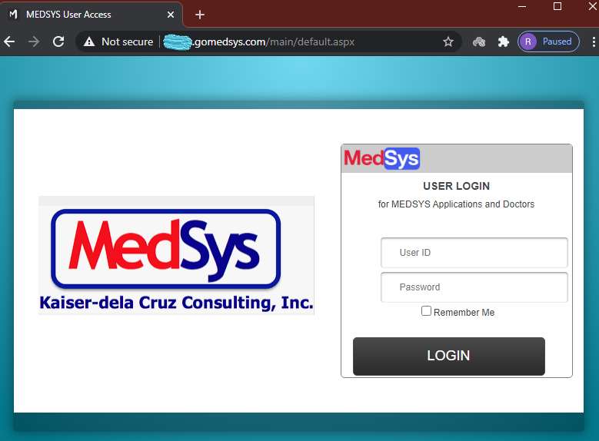

- Enter your user login and password.
- Click/Tap the LOGIN button (or hit the <Enter> key on keyboard) to log in.

PROGRAM OPERATION
Patient Searching
Once logged in, all current consultations/admissions tagged under doctor’s service will be displayed. Patients are displayed per category (Out-Patients, In-Patients, Referrals, ER, Philhealth and Orders).

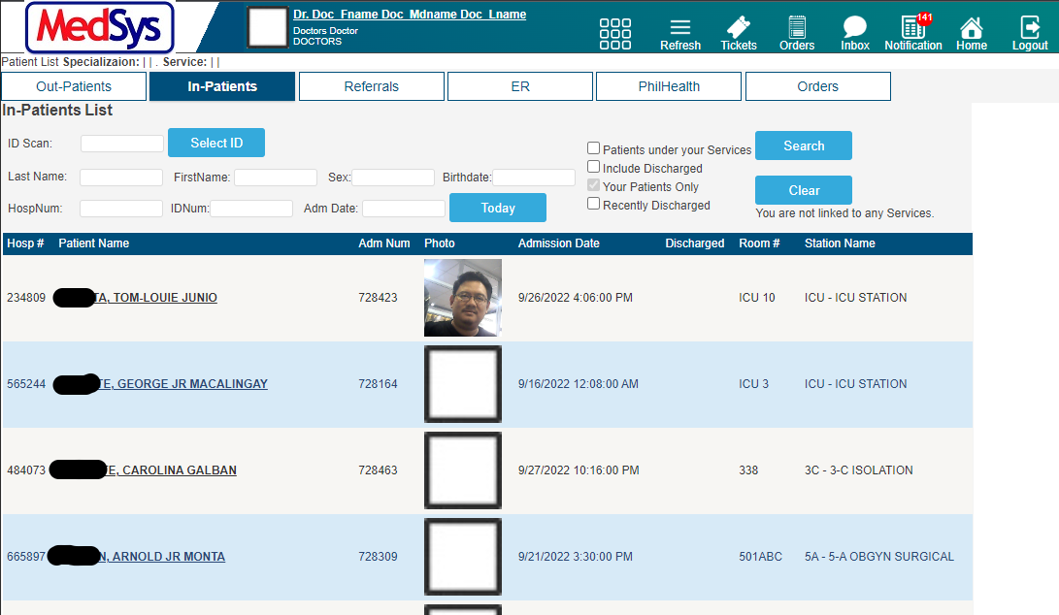

IN-PATIENTS

- ADMITTED PATIENTS
These are the currently confined patients.

    - To search for a certain patient, input either one of the following on the textbox:
      - ID Scan – the consultation or admission ID number of patient
      - Last Name – family name of patient
      - HospNum – the MRN or unique number identifier of patient

    - Click/Tap the Search button afterwards (or hit the Enter key of keyboard)
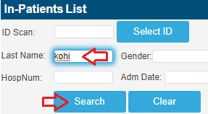

- DISCHARGED PATIENTS
Patients who were discharged already can still be searchable.

- Click/Tap the Include Discharged checkbox.
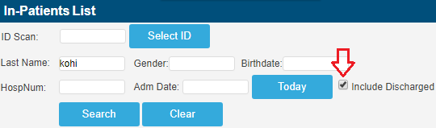

- Input the patient’s IDNum or LastName and click/tap the Search button.

- Select a patient by clicking/tapping on the Name link.

PATIENT DASHBOARD
To access the Patient Dashboard, click/tick the DashBoard in the hyperlink navigation below the name of the patient.
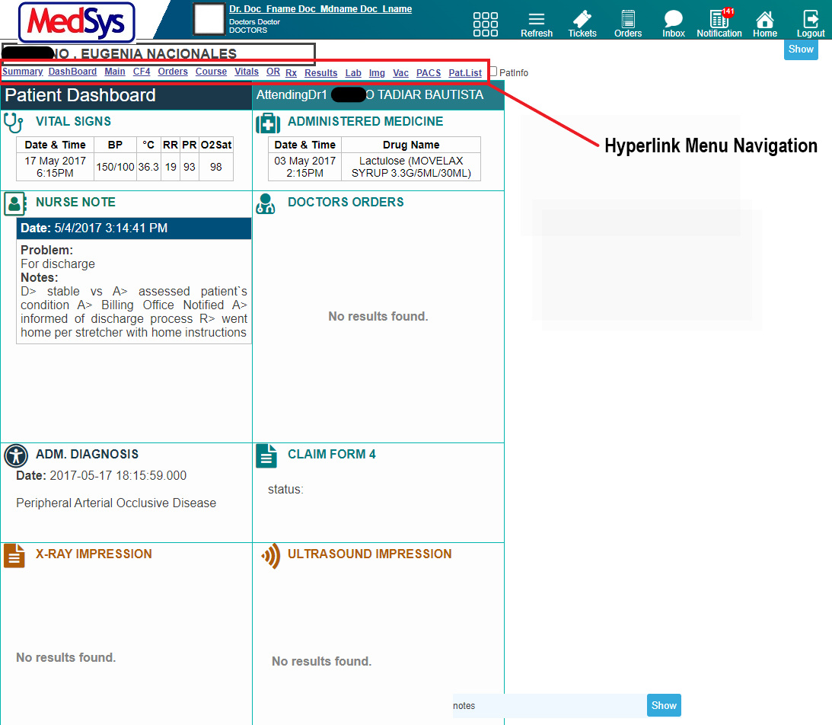

Patient’s Dashboard displays the necessary information vital to patient’s condition monitoring.

VITAL SIGNS – shows the latest vital signs taken by nurse at bedside
ADMINISTERED MEDICINE – shows the latest medicine administered by nurse
NURSE NOTE – shows the progress notes of nurses
DOCTORS ORDER – shows the most recent doctor’s order entered
ADMITTING DIAGNOSIS – shows the admitting diagnosis of the patient
CLAIM FORM 4 – shows the status of form 4 for claiming
X-RAY IMPRESSION – shows the most recent x-ray result of the patient
ULTRASOUND IMPRESSION – shows the most recent ultrasound result of the patient
RECENT LAB EXAMS – shows the most recent laboratory results of the patient
CT-SCAN IMPRESSION – shows the most recent laboratory results of the patient

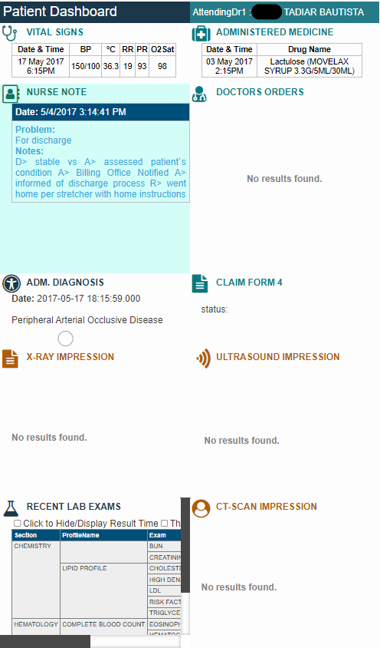

- Click/Tap on any of the menu under the name of the patient. It will automatically be redirected to the page of the said menu.

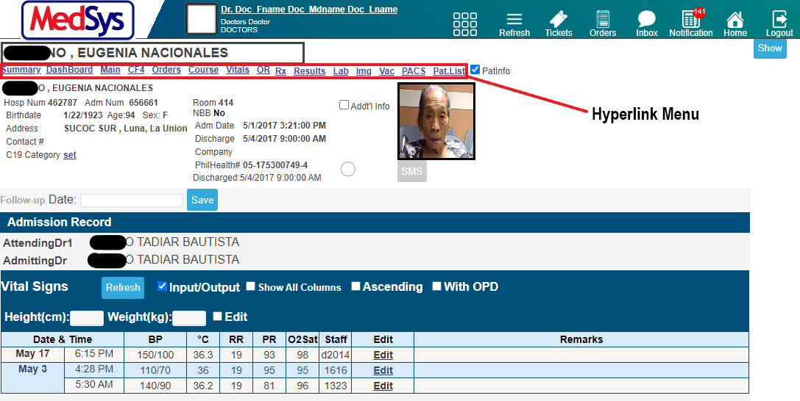
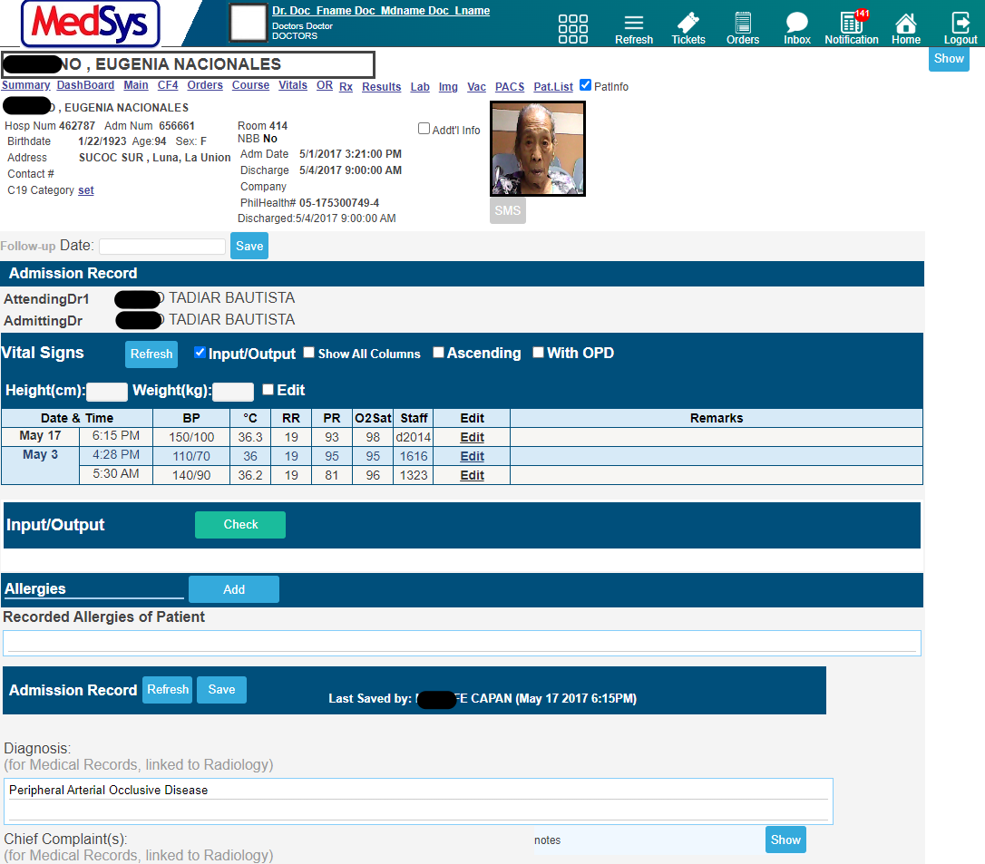

ADMISSION RECORD is where you can Enter, Edit or View patient’s records on the present confinement or consultation like Vital Signs, Recently Administered Meds, Brief History and other patient data. This is linked to CF4 entries of PhilHealth.

PATIENT MENU
The right pane of the screen is the PATIENT MENU. The data in this navigation bar is unique to each patient. Each tab redirects to results, requests, prescription and more. A highlighted tab has data. The user can show and hide the PATIENT MENU by clicking/tapping show and hide.

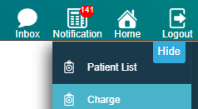
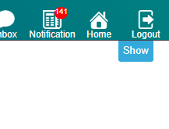

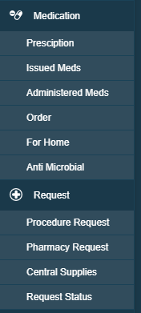
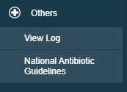
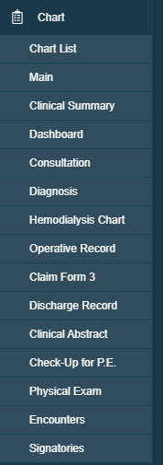
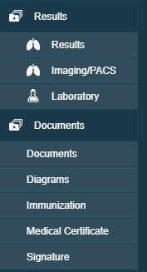
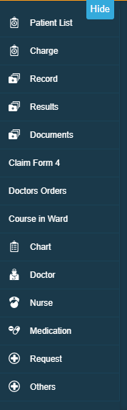

- ADMISSION RECORD/ CONSULTATION RECORD

  - Clinical Summary

This is where you can view the previous consultations and confinements of patient. To go to the page, click or tap on the Summary in the Hyperlink Menu.

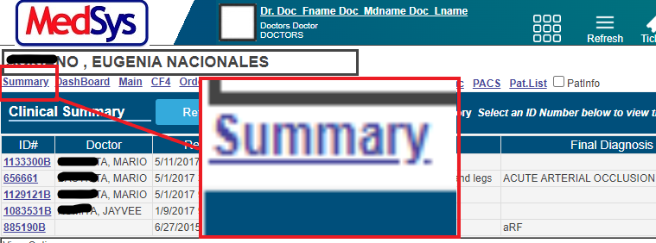

Then View Options and select Clinical Summary to view more options and information.

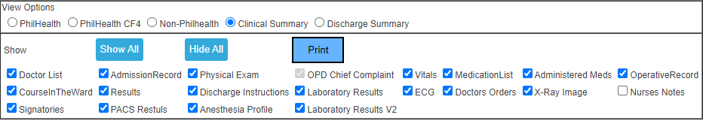

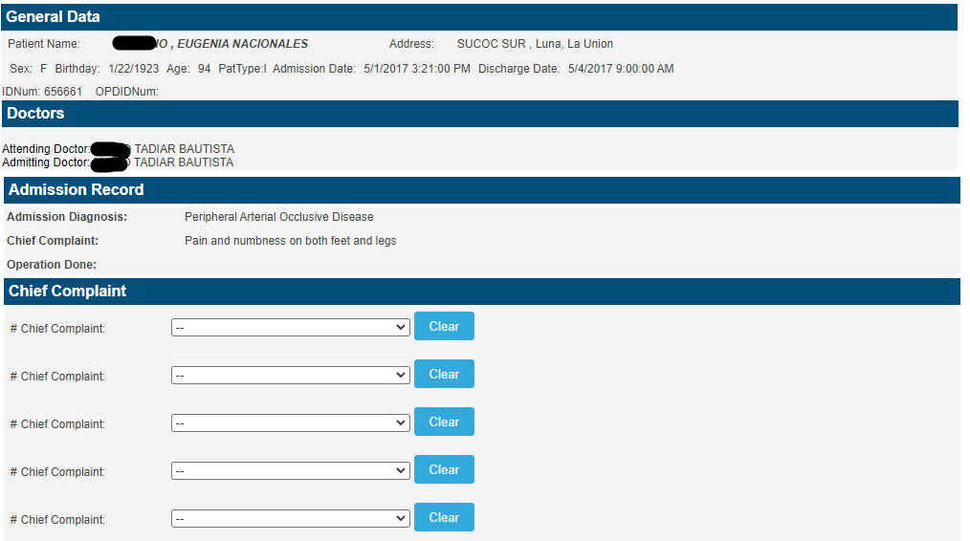

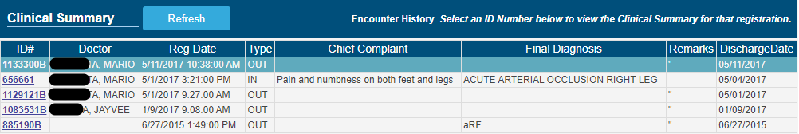

Click/tap on the ID# link located on the left side of the screen to open patient’s clinical record.
To print it, click or tap on the Print button located just below the History screen.

  - Vital signs
    - To access Vital Signs, click/tap Vital in the Hyperlink Menu.
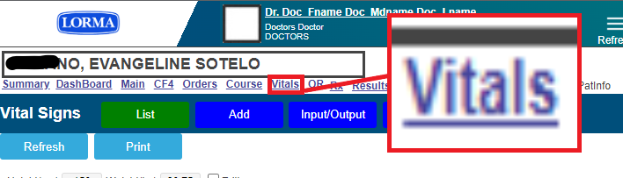
    - View of the latest vitals of the patient
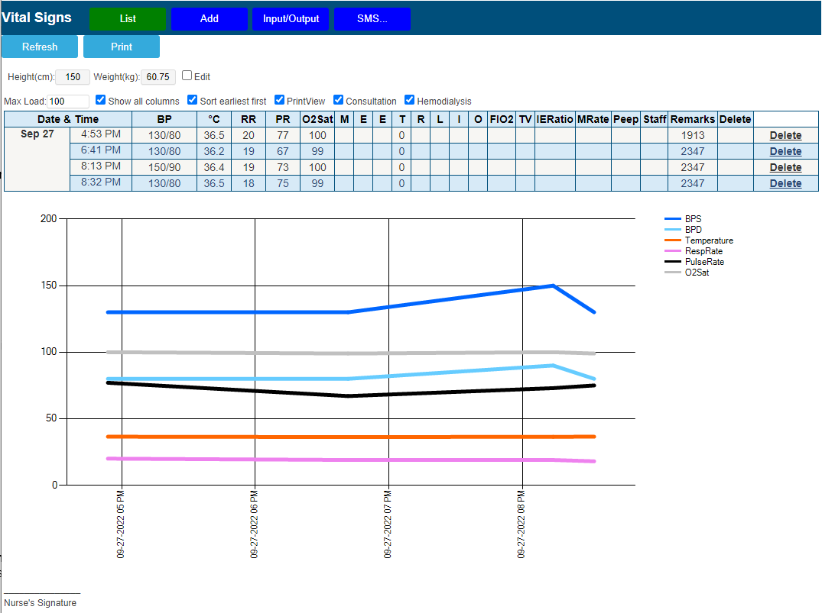

  - Allergies
    - To access Allergies section/feature, click/tap Main in the Hyperlink Menu.

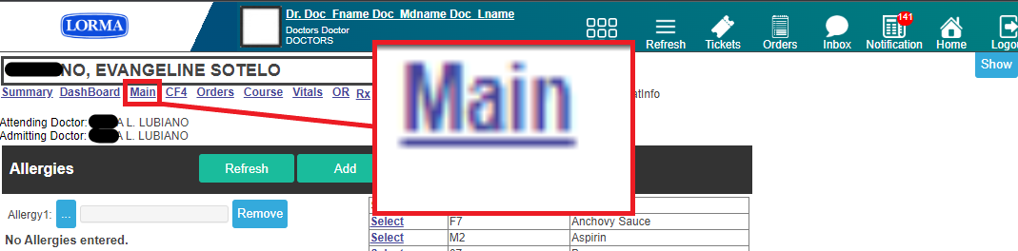

    - To view the list, click/tap the button (enclose inside the red box). Select the applicable allergies from the list. Then click/ tap on Save button. If the patient has multiple allergies, select the Add button.
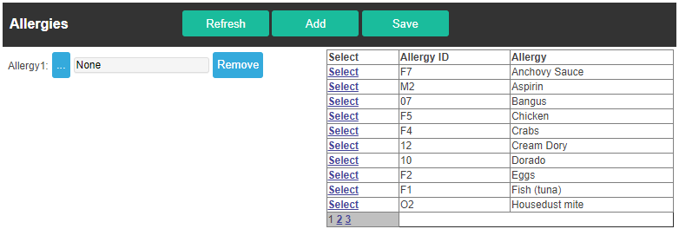

  - Admission Record. The data displayed here is synced with the information entered during patient’s registration in ER/Admitting department. User(s) can also edit the admission record here. To access Admission Record section/feature, click/tap Summary in the Hyperlink Menu.

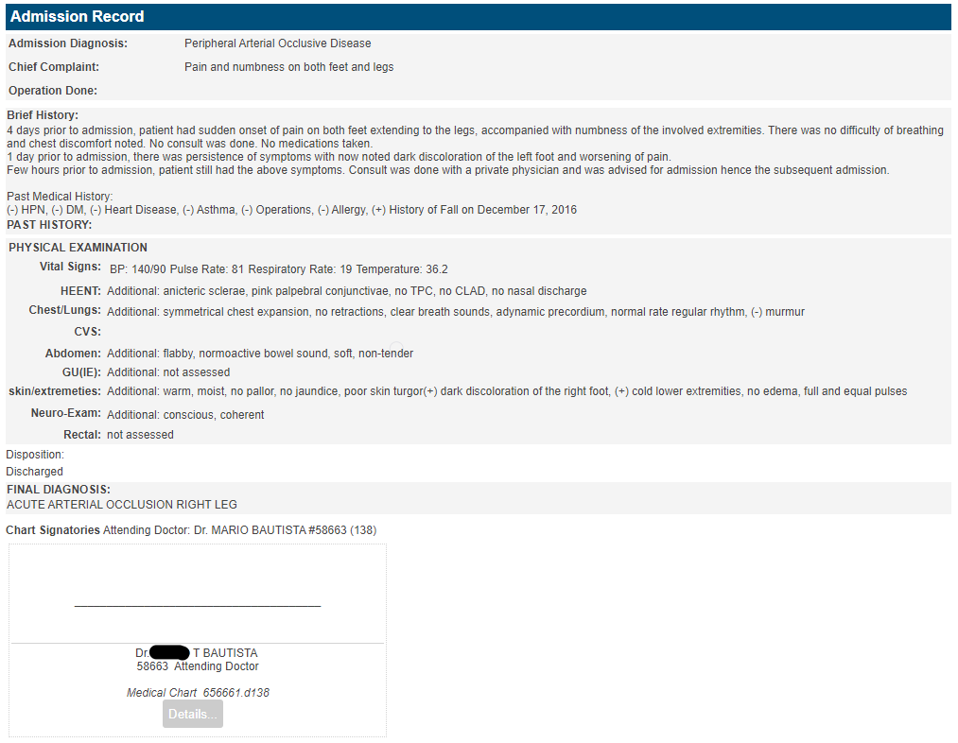

  - Review of Systems
The figure below is the entry for review of systems of the patient. Click or tap all buttons applicable to the patient categorized by system.

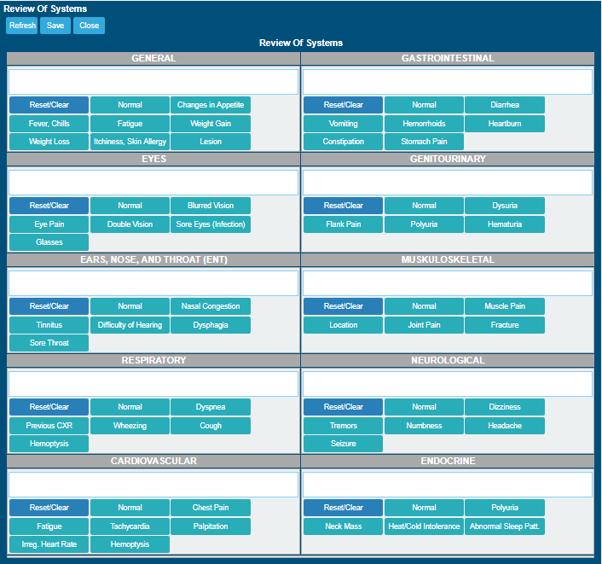

  - Discharge Home Instructions. Before patient discharge, the attending doctor or nurse can enter the patient’s discharge instructions together with the take home medications. Furthermore, the user can include the day/date for the follow up check-up and to which doctor to return to for their follow up check-up. To access Allergies section/feature, click/tap Summary in the Hyperlink Menu.

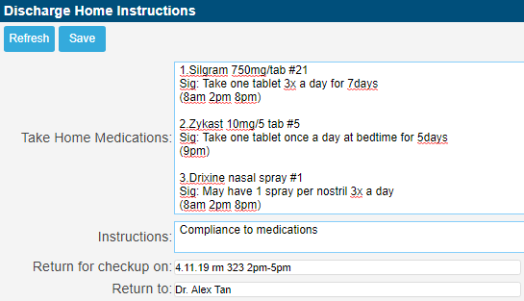

Click/Tap the Save button to save entries for discharge home instructions.

- CLAIM FORM 4 (CF4)

This is the entry of CF4 required by PhilHealth. Some of the entries from the Admission Record will be auto-populated here like Chief Complaint, Diagnosis among others.

NOTE: Once connected to Medsys e-Claims, printing of CF4 will be disregarded. All CF4 will be submitted through an XML format which will be provided by Medsys module.
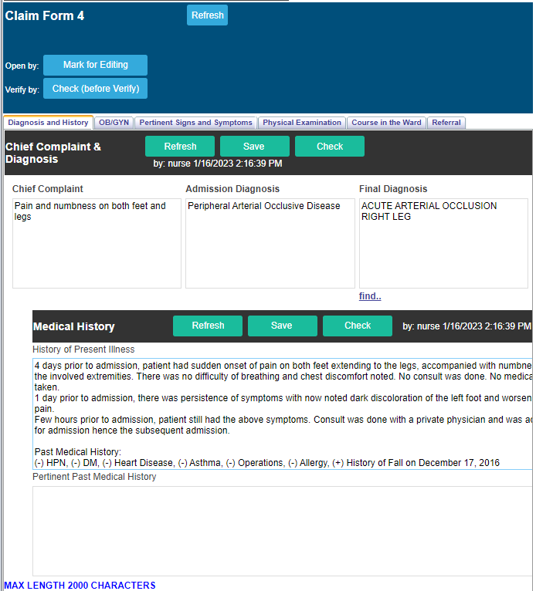

To Add or Edit entries, click/tap the Mark for Editing located on top of the entries.

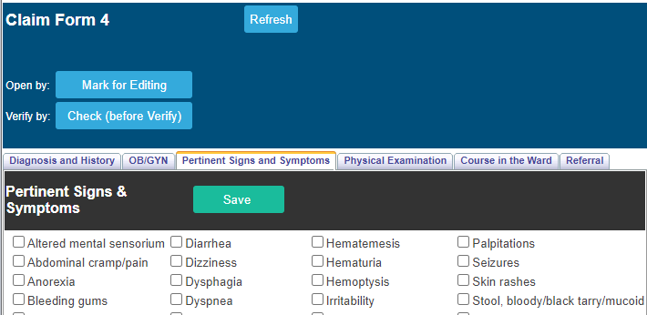

Each entry has a corresponding Save button. Make sure to click/tap it to save changes on your entries before going to the next tab. After saving click Done Edit
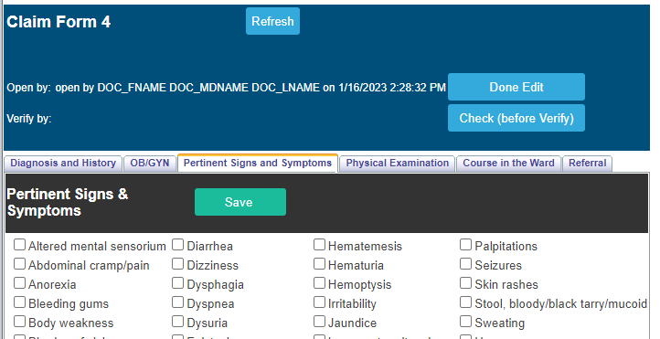

To disregard changes, click/tap/tap the Cancel Edit button located on top of the entries.

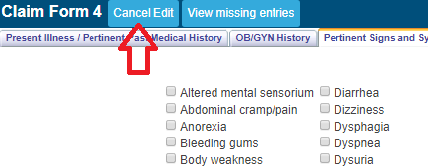

To view missed entries, click/tap the Check (before Verify). All missed entries will appear below the button
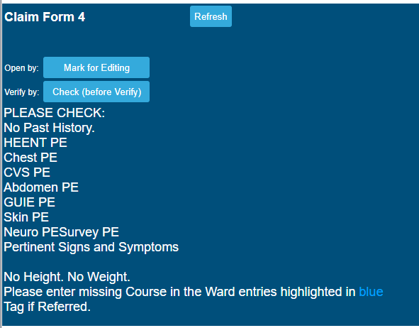
NOTE: Make sure to fill in all the fields as required by PhilHealth. Incomplete entry will result to RTH of claims.

- COURSE IN THE WARD

This is the progress notes entry and is connected to CF4 as well. All entries from the Doctors Orders page will reflect here. (Please see Doctors Order guideline on page 19).

To enter a new course in the ward, click/tap the Add New button located on top of the entry. Select the Date and hit the Save button after completion.
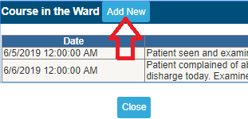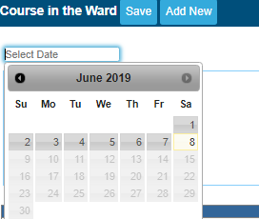
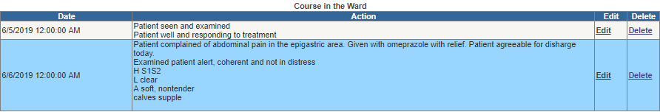

To make any changes on the saved notes, click/tap the Edit button. If you wish to remove it, click/tap the Delete link.

- CLAIM FORM 3 (CF3)
This is the CF3 entry for OB patients. Once you tagged the patient as Pregnant on the CF4 entry, the CF3 form entry will automatically be enabled on the Patient Menu.

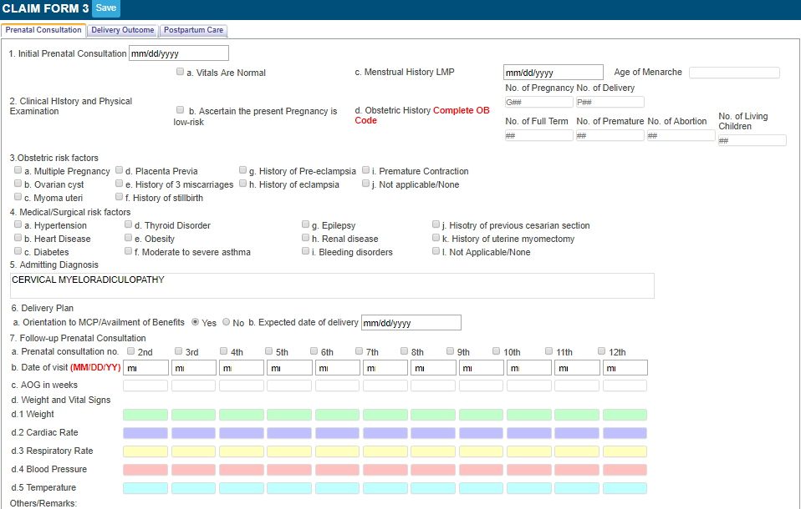
NOTE: Make sure to fill in all the fields as required by PhilHealth. Incomplete entry will result to RTH of claims.

- DOCTOR’S ORDER

This is the doctor’s order or progress notes entry. Orders should have a corresponding compliance from nurses. All entries here is linked to COURSE IN THE WARD.

Orders communicated by doctors to nurses through telephone, text or verbal needs to be confirmed. To do this, go to Orders and Referrals located on top of the screen.

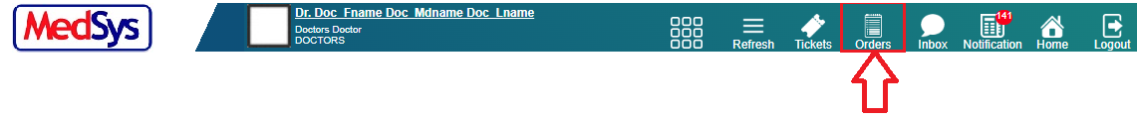

The list of pending doctor’s order without nurses’ compliance will be displayed.

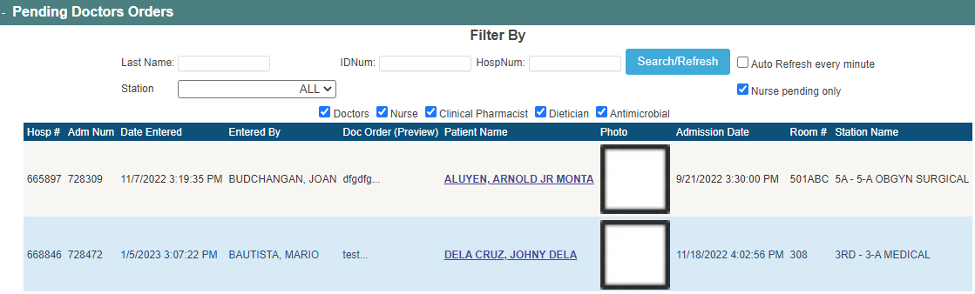

- To UPDATE and confirm order, click/tap on the patient’s name. The window below will appear.
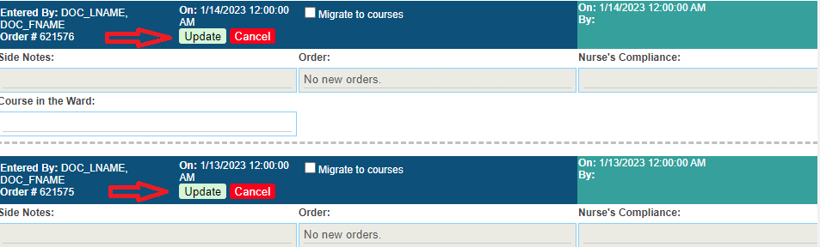

- Click/tap on the Update to verify that the listed order is correct. Confirmation status will be changed to Confirmed once done. Otherwise, click/tap on the Cancel button.

- To enter NEW ORDER, select the I’m the Ordering Doctor radio button (If you are the one entering the said order) and input your order together with the corresponding Side Notes (if there’s any).

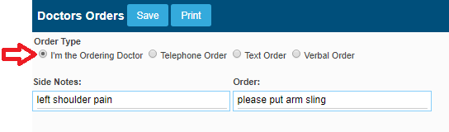

- Click/tap on the Save button to save your order. Make sure to verify it before saving. You can’t make any changes afterwards.
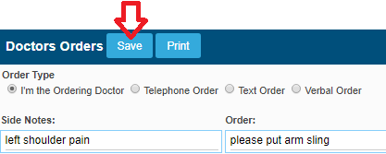

- Input UserID and Password for validation. Click/Tap the Save button (or hit the Enter key on your keyboard) afterwards. Otherwise, click/tap the Close button.
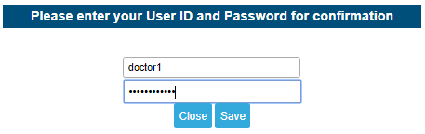

- If you wish to make changes on your side notes, click/tap the Edit Side Notes link.
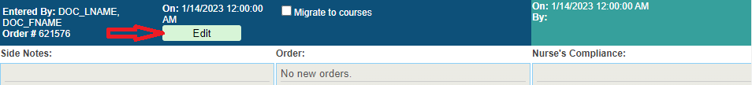

NOTE: Editing of side notes could only be done by the same doctor who entered it.

- Click/Tap the Update link once done. Otherwise, click/tap the Cancel button to disregard changes.

- You may want to review the Vital Signs and Administered Medicines before making orders. Just click/tap the Vital Signs and Administered Medicines to see the complete list.
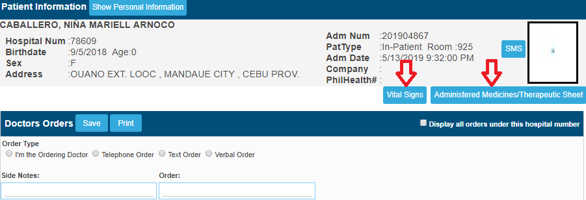
- LAB RESULTS

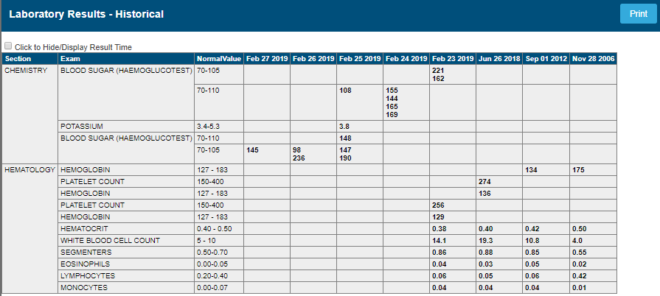
This is where you can access the laboratory results of the patient. Historical format of clinical chemistry exams is provided for easier comparison of the previous to present result.

On the latter part of the page is the PDF/ printable version of the patient’s lab results. Click on the ‘view’ button to open the PDF printable result.
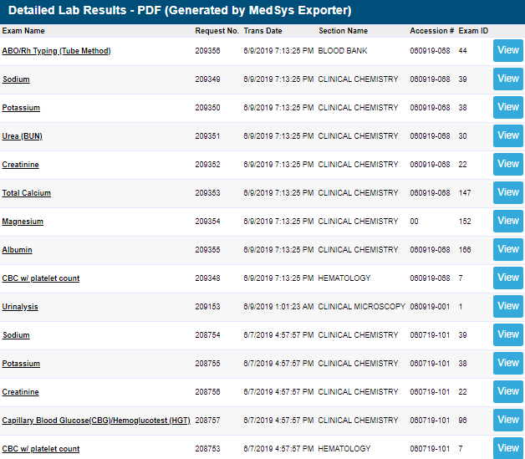
- IMAGING/PACS

All digital images of patient transmitted from the Radiology department can be viewed here together with the exam interpretation. Click/Tap on the Patient’s Name or Study Description to access it.

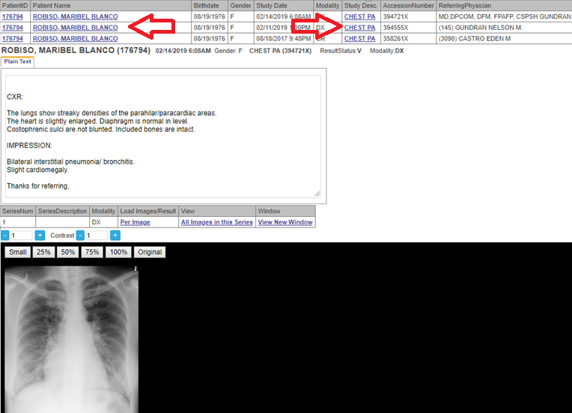
You can manipulate image sizes depending on your preference. Just select on the image size options located on top of the image window.
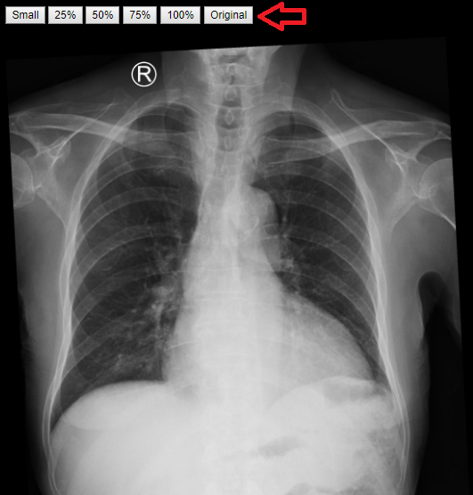

To open image in new tab, click/tap on the Open link located on the grid. A new tab window will appear displaying a bigger image size.

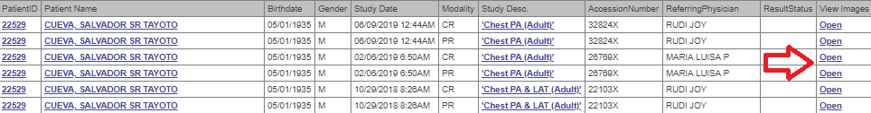

- OTHER RESULTS

This is where you can access other results like X-ray, Ultrasound, CT, MRI, Cardio and other results.

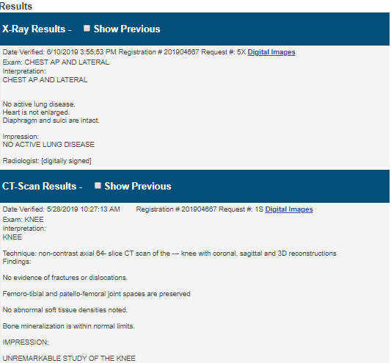

- DOC REFERRAL

This is your viewing and entry of referrals.

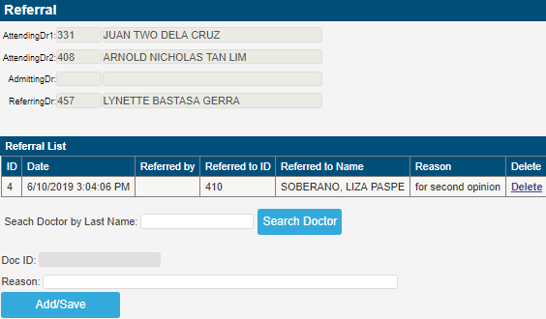

- To add a new referral, enter the physician’s Last Name and click/tap the Search Doctor button (or hit the Enter key in keyboard).
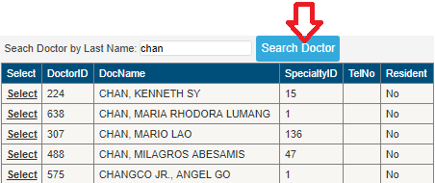

- To select a physician on the list, click/tap on the Select link located on the right side of the window.
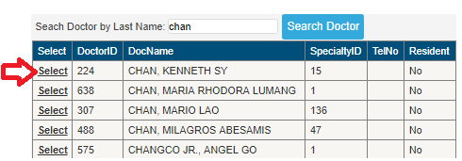

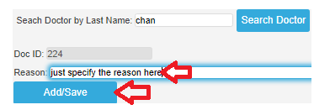

- PRESCRIPTION
This is used in prescribing medicines to patients and can also be used as digital prescription.
NOTE: Entries here is linked to Discharge Instructions and Medications of nurses for MAY GO HOME PATIENTS when Take Home Meds is used.

- Click/Tap the Search From Formulary button.
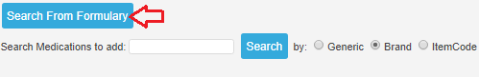

- Input the medicine name (by Generic or Brand) on the textbox entry and click the Search button (or hit the <Enter> key in keyboard).
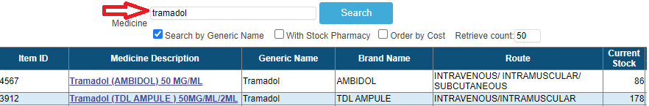
- Click/Tap the Select link to select medication.
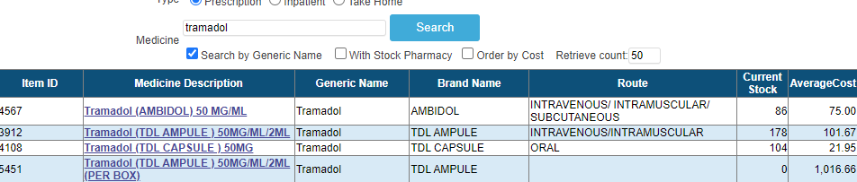

- Select Dosage, input Quantity and Sig. For MAY GO HOME patient(s), fill in the Instructions and don’t forget to click the Take Home Meds entry after saving.
- Click/Tap the Add and Save button once done with item selection.
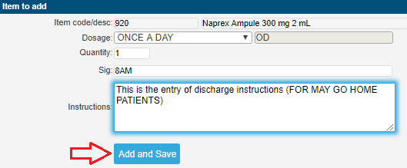
- To EDIT the saved entry, click/tap the Edit link.
Click/Tap the Update link once done. Otherwise, select Cancel disregard changes.
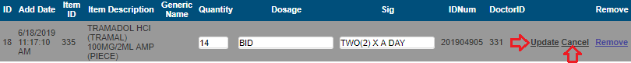

- To REMOVE item, select the Remove link.
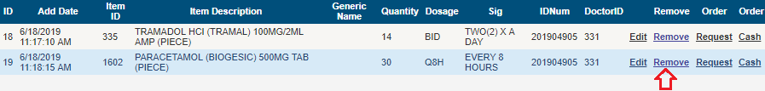
- To PRINT the Prescription slip, click/tap the Print Rx Slip.
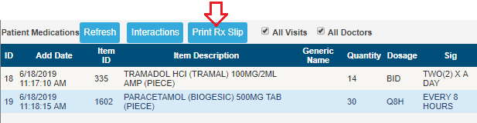
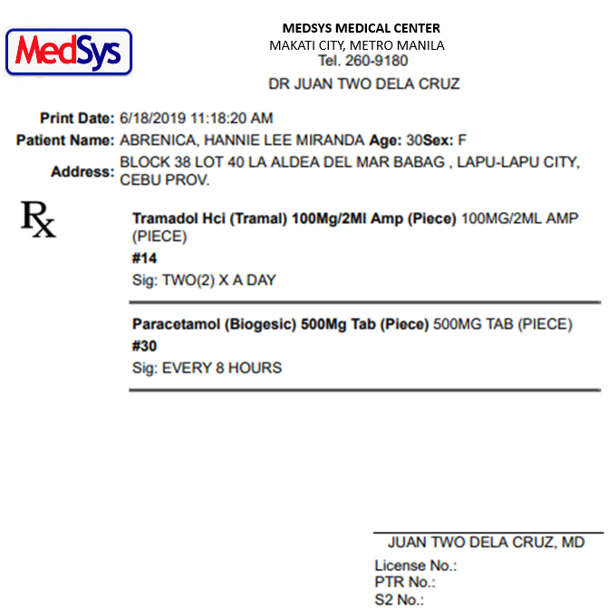
TAKE HOME MEDS
For MAY GO HOME PATIENTS, click/tap the Take Home Meds button located on the lower left side of the screen.
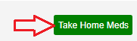
Fill in the textbox and click/tap Save button afterwards.
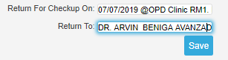
Once saved, it will be seen to nurses’ module for PRINTING.

- PHYSICAL EXAM

For P.E. entry, please use the one located under CF4 entry.
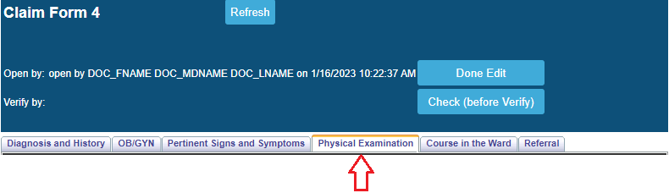
- PATIENT CARE PLAN

This is usually used for OUTPATIENTS for admission.

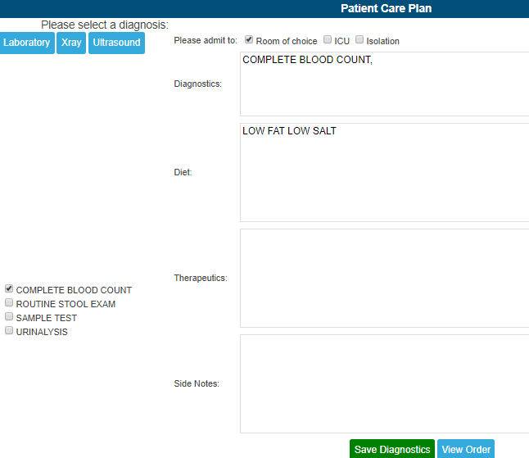
    - Input orders (Laboratory, X-ray, Ultrasound, CT). Fill in the Please Admit To option. Input Diet, Therapeutics and Side Notes and click/tap the Save Diagnostics button. Nurses will be notified on Doc Orders once saved.

- INPUT/OUTPUT

This is usually done by nurses.
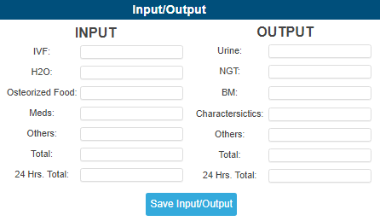
- DISCHARGE NOTES/PROFESSIONAL FEE

This is the entry of PF (supports Inpatient only)

ICD/RVS SEARCHING
- Enter keyword and click/tap the Search ICD button (or hit the Enter key in keyboard).
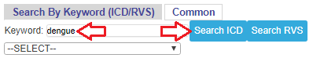

- Select the particular ICD/RVS on the dropdown and the amount will be displayed.

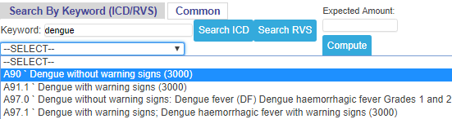
- Enter the Expected Amount and click/tap Compute to view the computation of your PF. Once done, click/tap the Save button.
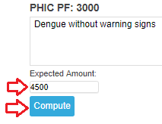
- PENDING ACTIONS
Please see the V. DOCTORS ORDERS on the previous pages.

- DOCUMENTS
  - A summary of all the printable files of the patient
  - User can also upload other files/images of the patient
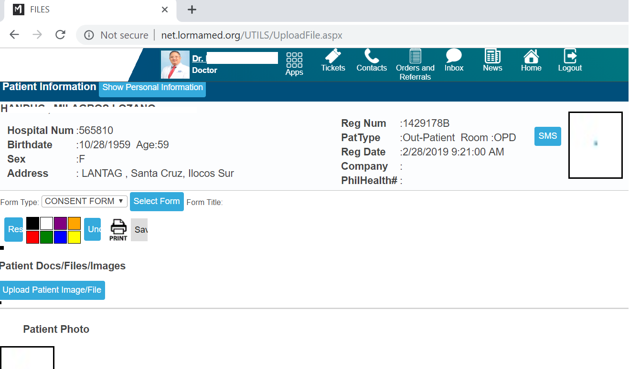

- PROCEDURE REQUEST
This is where you can make request(s) which is linked to clinical departments like Laboratory, X-ray, etc.

    - Input the exam/procedure description on the textbox and click/tap the Search button (or hit the Enter key on your keyboard). Tick the by Department box on the left side if you prefer to search exams per department.

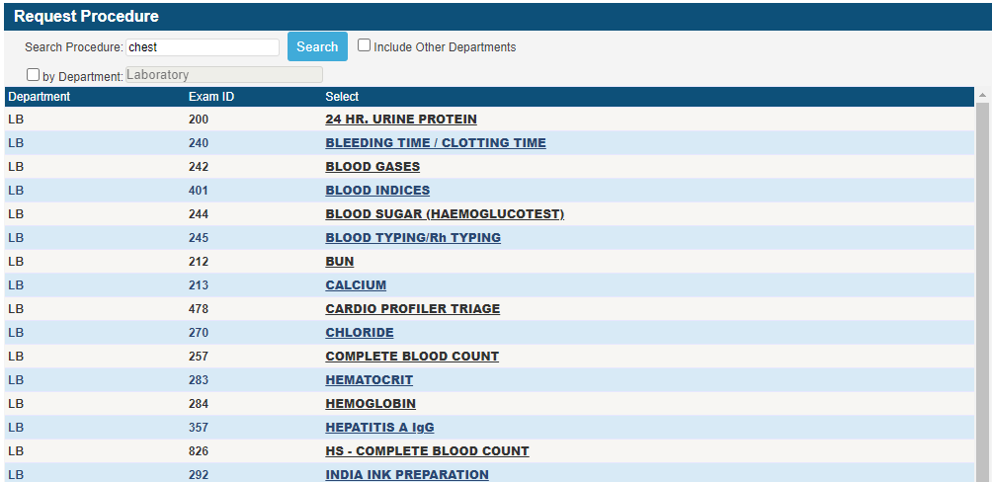

    - Select the exam to be requested and click/tap the Save button. Otherwise, click/tap the Cancel button to return to the requesting window without saving the selected exam.
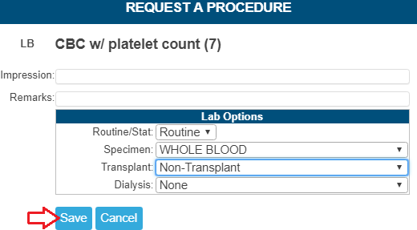

NOTE: Once saved, it will be sent instantly to the department.

REQUEST COMMON EXAMS
This is an alternate option of exam searching. It displays the common exams frequently requested to departments.
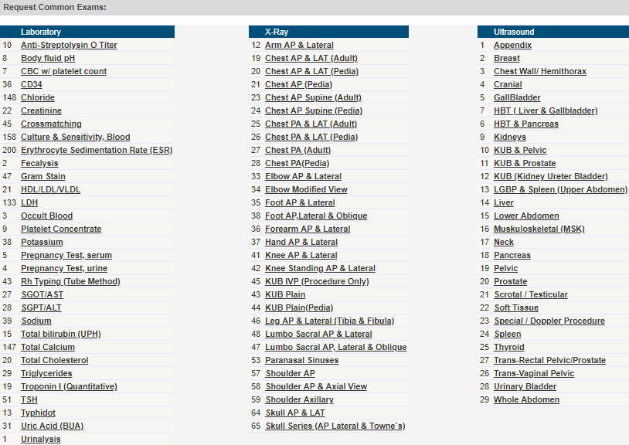

- PHARMACY REQUEST
This feature is linked to the Pharmacy Dispensing module. Any medications requested using this entry will automatically be in the list of requested meds of the patient in the pharmacy dispensing.

    - Input the generic name or brand name of medicine on the textbox and click/tap the Search button.
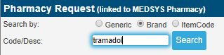

    - Select the appropriate medicine found on the list by clicking/tapping the Select link on the left side.
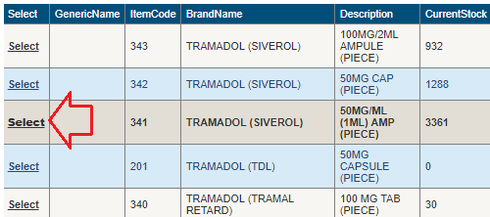

    - Select Dosage afterwards.
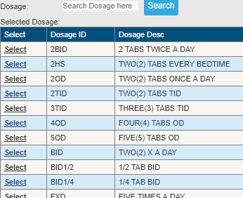

    - Input Quantity.
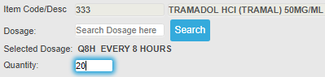

    - Add Remarks (if there’s any).
    - Click/Tap the Add to List option if you wish to queue your order and Add another medicine.
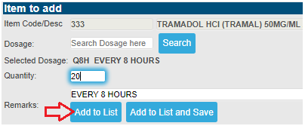

    - All queued orders will be enlisted on Current Requests. Click/Tap the Save button to save and send your requests to the Pharmacy department.

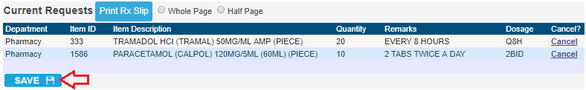
    - To CANCEL the selected entry, click/tap the Cancel link located on the right side of the screen.
    - Once saved, a green-colored message “Successfully saved items” will appear.
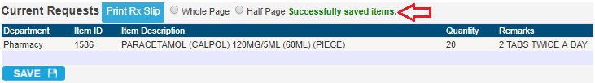

- CENTRAL SUPPLIES
This is linked to CSD department. Any requests made here will be seen on their list of pending requests.

    - Input item name on the textbox and click/tap the Search button.

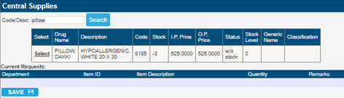

    - Select the item by clicking the Select link on the left side
    - Input the Quantity.
    - Click/Tap the Save button to send the request to the CSD department.

- NURSES NOTES
This is the progress notes of nurses
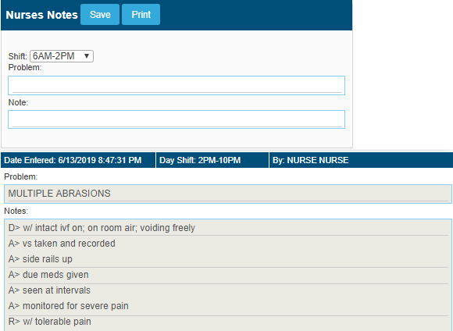

- OPERATIVE RECORD
This is the list of all operations/procedures done to patient (from previous to present).
s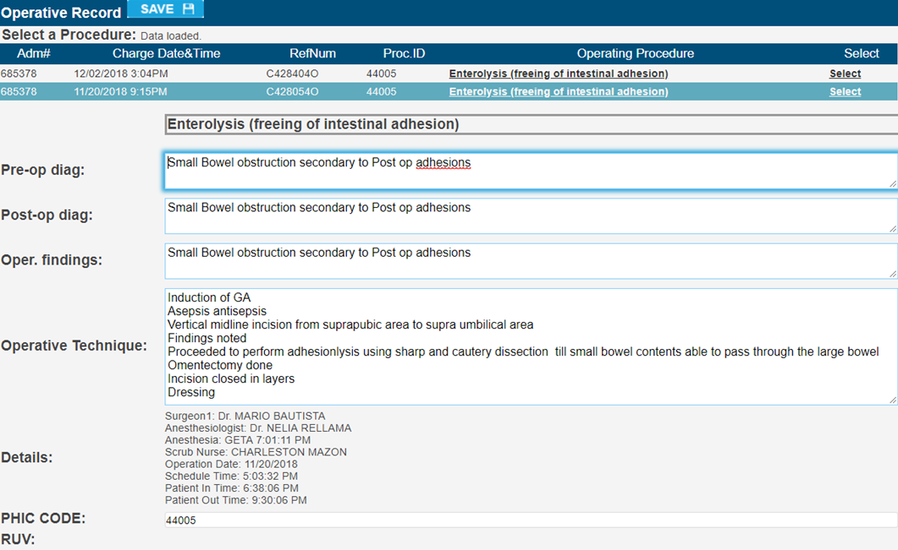
    - Select the operative from the list to input or view the operative entries. Click/Tap the Save button if new entry.

- MEDICAL CHECKUP
This is usually used for OUTPATIENTS’ medical checkup.

- PATIENT INFORMATION
This is where you can view, input and edit patient’s information, history and SOAP.

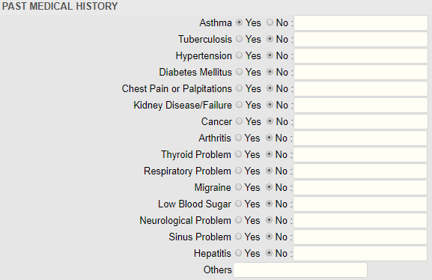

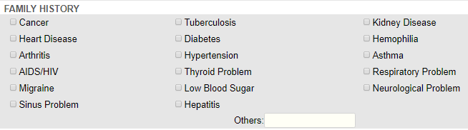
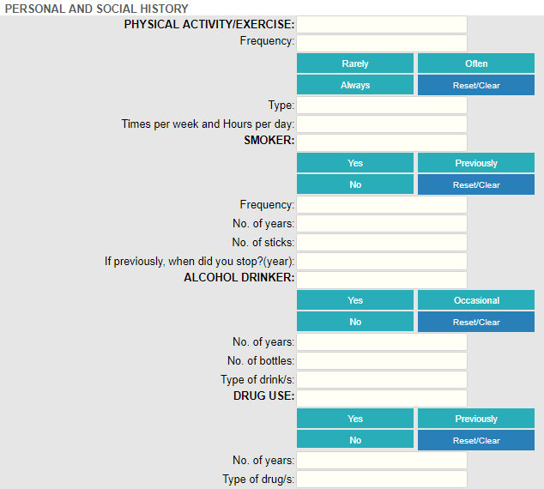
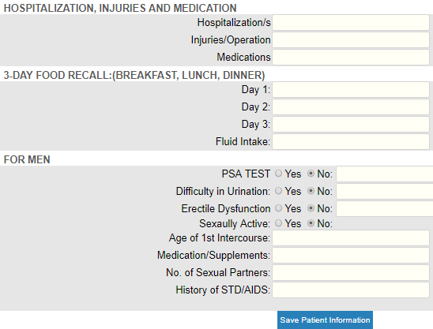
Click/Tap the Save Patient Information button once done.

- REVIEW OF SYSTEMS
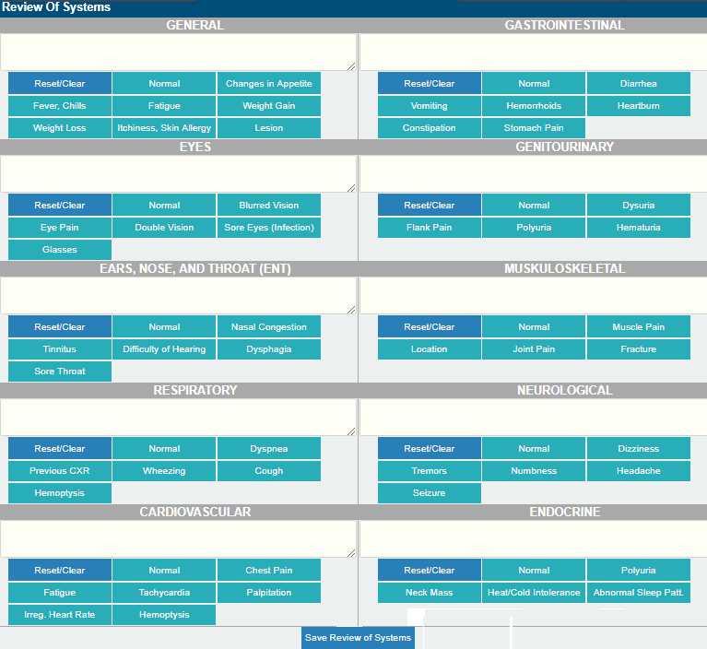
Click/Tap the Save Review of Systems button once done.

- MEDICATION PROFILE

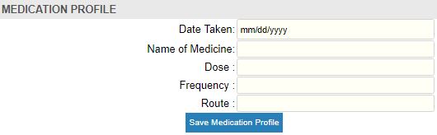
Click/Tap the Save Medication Profile button once done.

- DIAGNOSTICS DATA SHEET
This is connected to LIS (Laboratory Information System) .
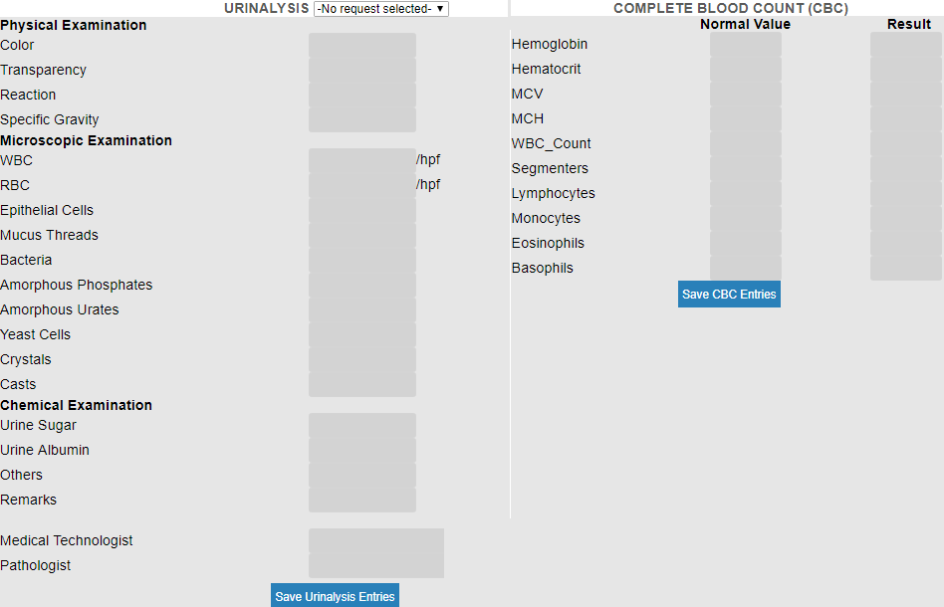

- CLINICAL NOTES
This includes the Vital Signs, Input/Output and Clinical Notes (please see Doctors Orders page for more info)

- DOCTORS PAGE
This is the summary view of all the entries under Medical Checkup. You can still add, edit and save entries while on this page.

To go back to the Main Patient List, click/tap the Back button located on the upper left side of the screen
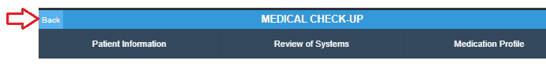

Or click/tap the Back arrow of the browser to go back to the previous page.

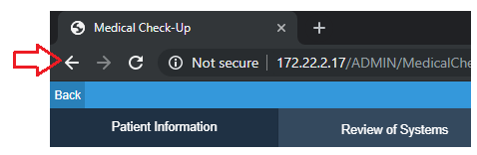

MORE FEATURES
Click/Tap to expand the additional features of patient menu. (See page 19 for reference.)

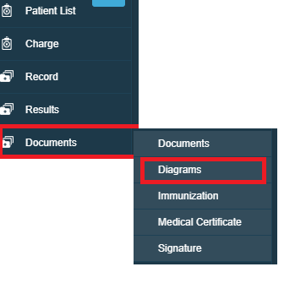

- DIAGRAMS
This feature is usually used for OPD consultations.

- CHEST
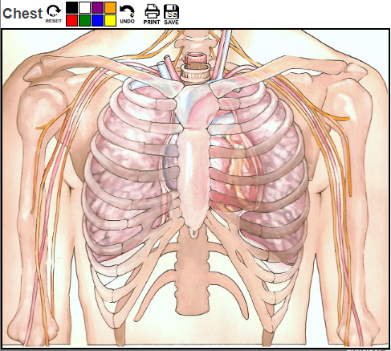

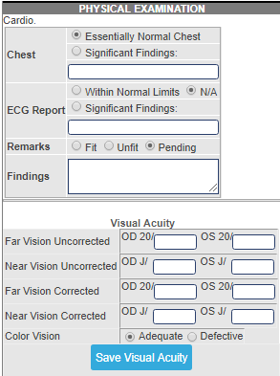

- DENTAL
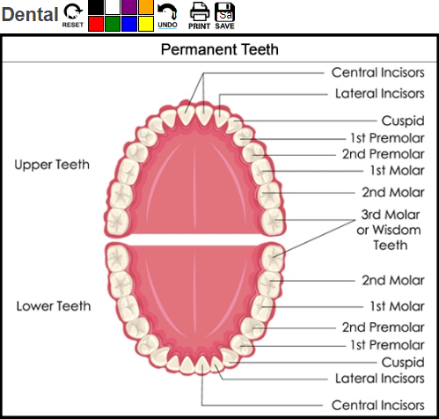
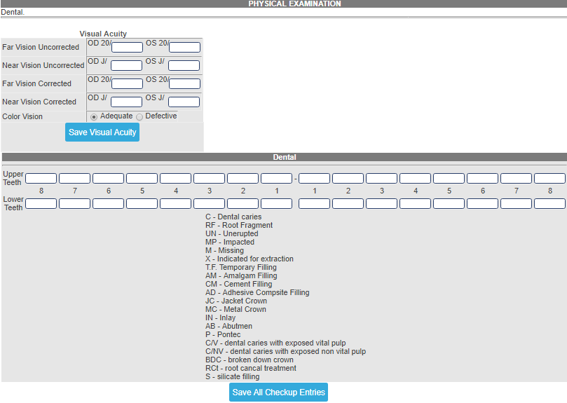
- DENTAL 2
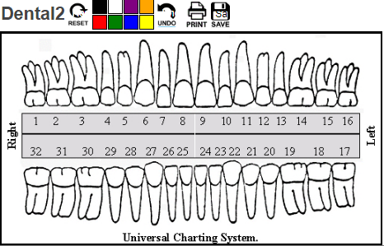
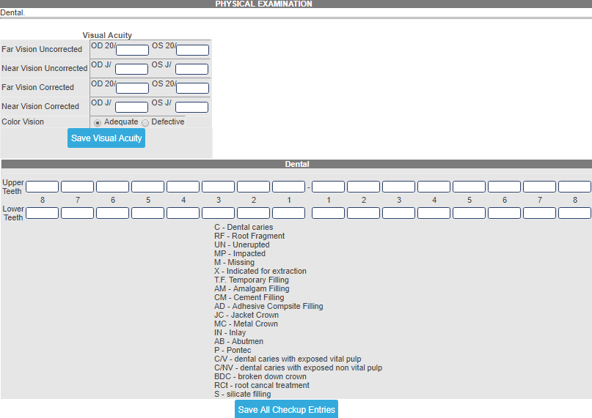

- ENT
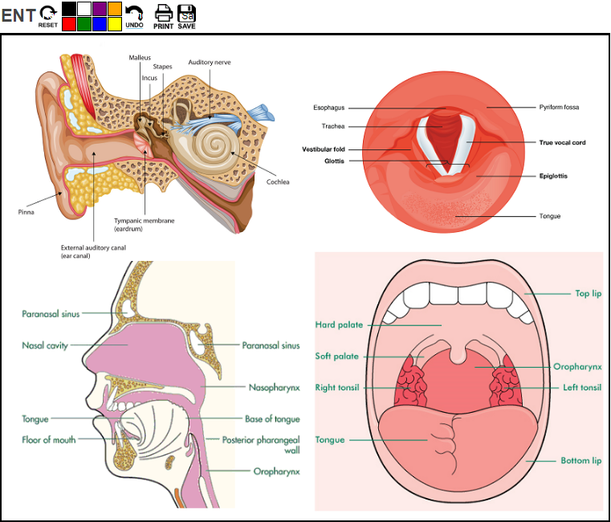

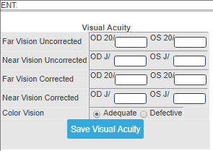

- KIDNEY
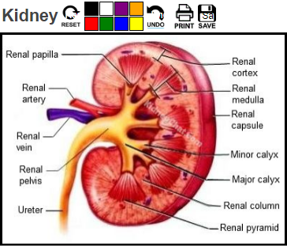
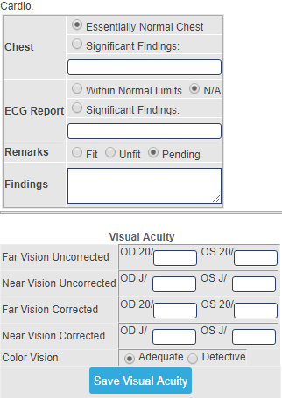

- ALLERGIES
This refers to the allergies entered for the patient.

- * CHECK-UP FOR P.E.
This is the entry of Physical Exam which is also linked to the Diagram entry.

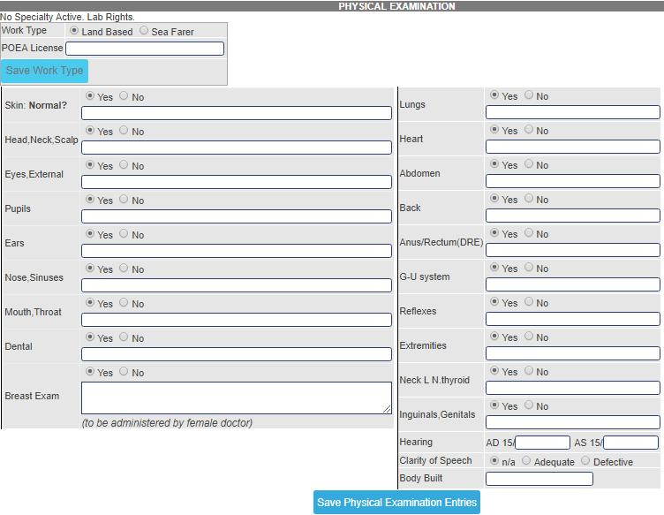
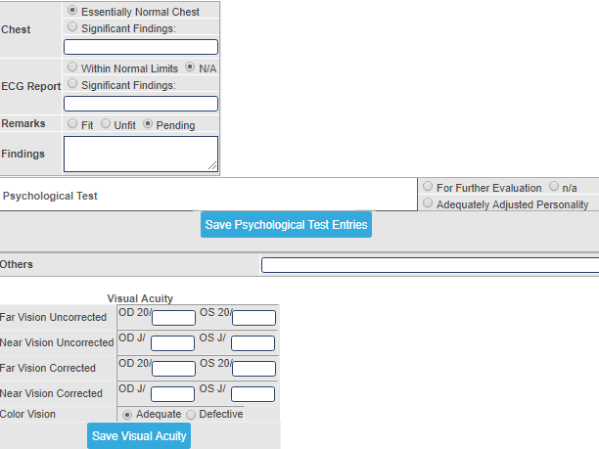
Note: Don’t forget to SAVE once done with the entries.

- REQUEST STATUS
This refers to the list of request(s) done for the patient. It is grouped by List Processed Requests, List of Exams with Results and Pending Requests.

- SCHEDULE O.R.
This is the entry and viewing of patient’s operation schedules.
To make a new schedule, fill-in the entries needed:
    - Select the DATE of operation on the calendar on the left side
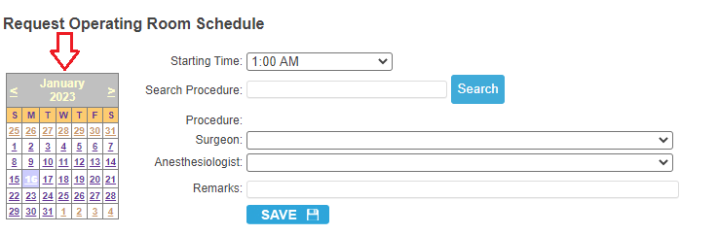

  - Select the Starting Time of operation
  - Input the procedure name (per description is accepted) and click/tap the Search button afterwards.
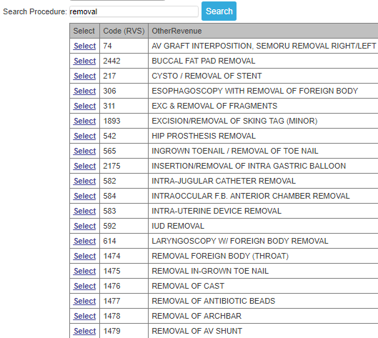
  - Select operation by clicking the Select link on the left side.
  - Choose the Surgeon and Anesthesiologist on the dropdown list.
  - Add additional remarks on the Remarks textbox (if there’s any).
  - Click/Tap the SAVE button to save the entries. Once saved, it will automatically be sent to the OR department for confirmation.
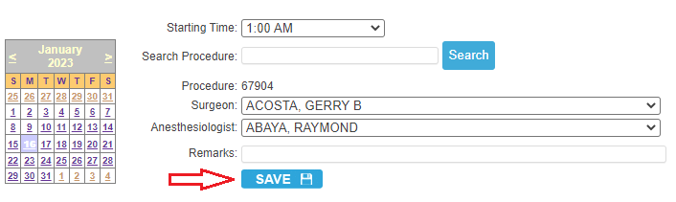
CONFIRMED O.R. SCHEDULES
To view confirmed schedules, click/tap on the View OR Schedule link
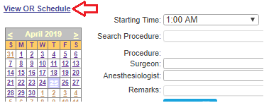
** Select the scheduled date and the list of confirmed patients for operation will be displayed.
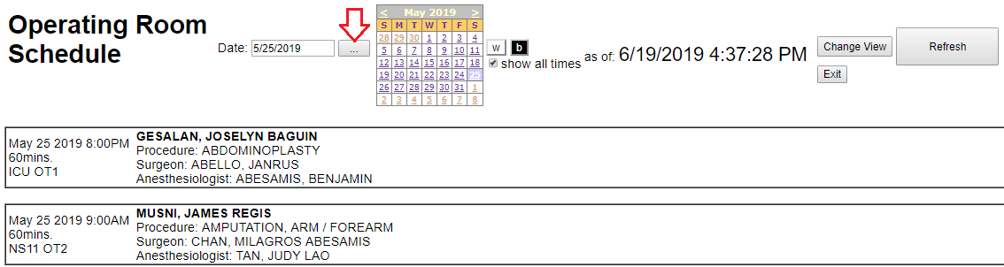

- HOME MEDS
This is the entry for take home medications of patients which is linked to the Pharmacy department for processing.

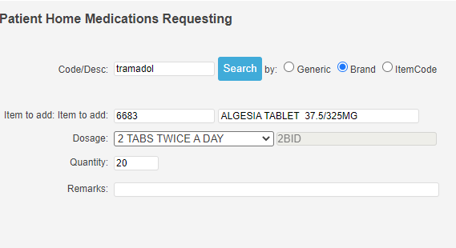
Input entries and click/tap the SAVE button afterwards. Once saved, it will automatically be sent to the Pharmacy department.

- IMMUNIZATION SCHEDULE
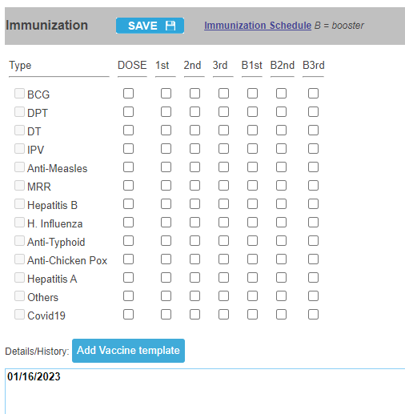
To view the immunization schedule, click/tap the Immunization Schedule link.
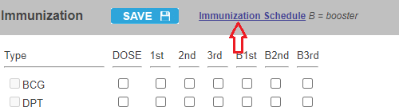
- MEDICAL CERTIFICATE
This is an optional feature where you can print the Medical Certificate of patient.

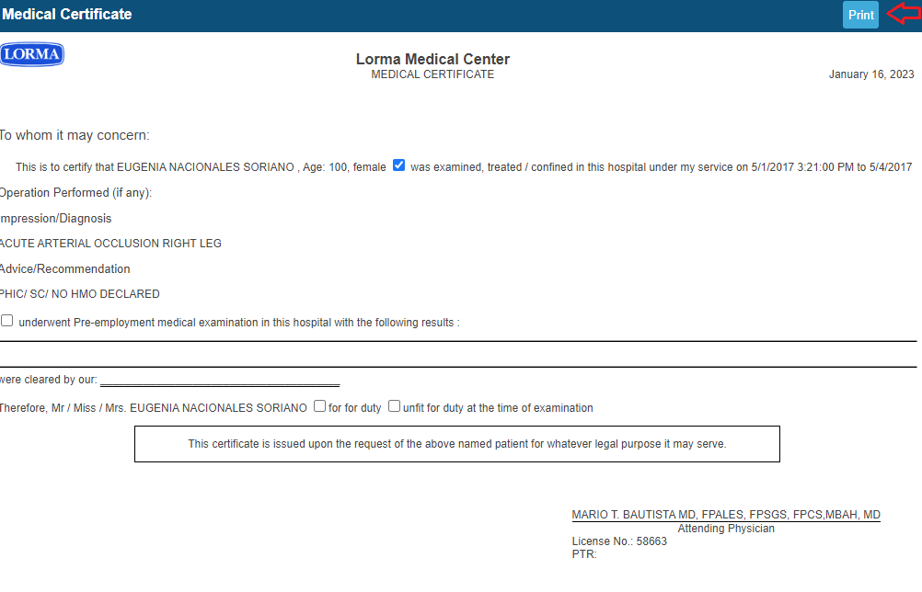
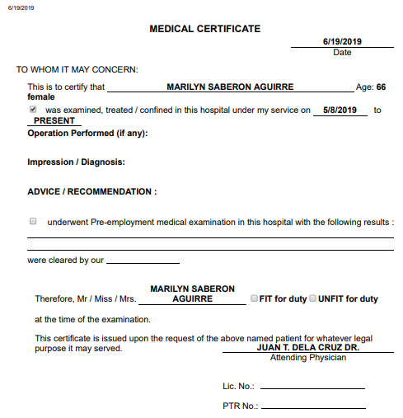
- APPOINTMENTS
This is where you can schedule and monitor appointments of your patient(s).

    - For the default patient, select the DATE and time.

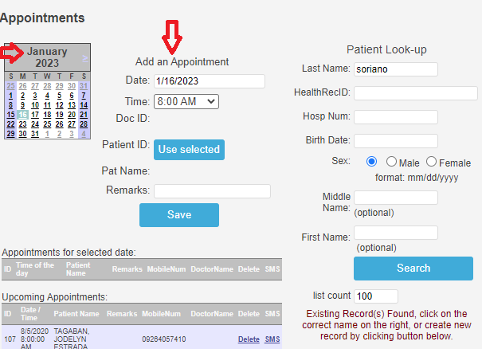

    - Click/Tap Save once done.
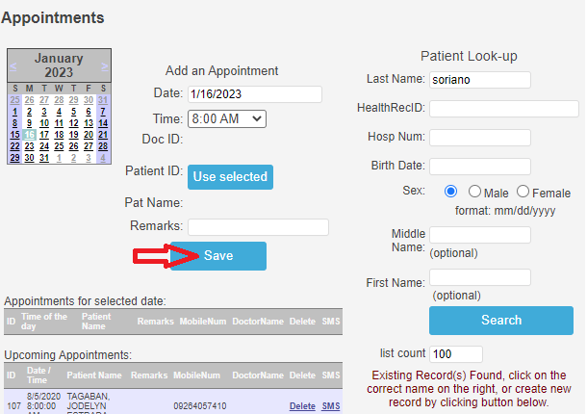
    - To appoint OTHER PATIENTS, input the Last Name on the Patient Look-up and hit the Enter key in keyboard to search patient.
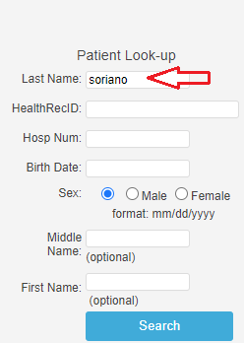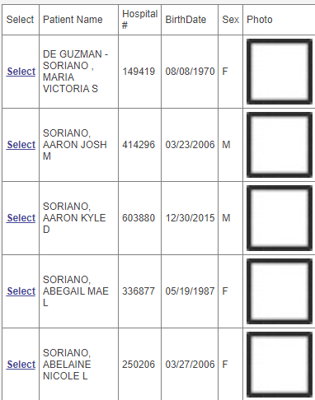

    - Choose patient by clicking/tapping on the Select link on the right side.

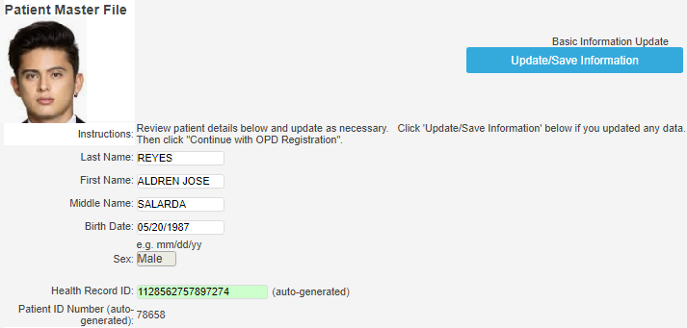

    - Once selected, you have the option to change patient information. Click/Tap the Update/Save Information to save changes (skip this if no changes).
    - Input the appointment date and time and click/tap the Use Selected button to save appointment.
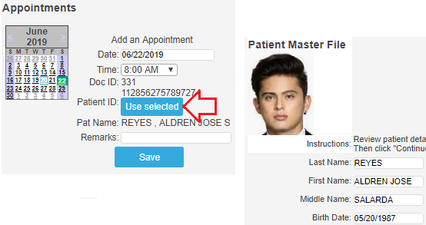
UPCOMING APPOINTMENTS
All upcoming appointments will be displayed on the left side of the screen. You can also filter it per date by selecting the date on the calendar.
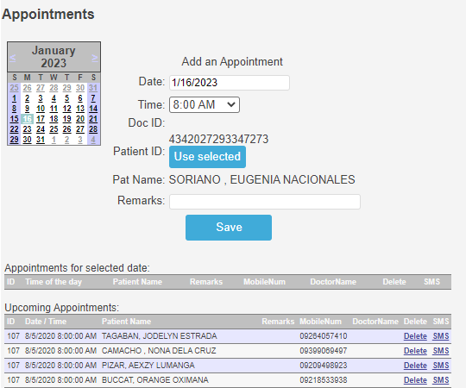
If you wish to REMIND the patient on the said appointment, click/tap the SMS link. A message window will appear below. Click/Tap the Send SMS button to send the text message.

