Medsys Medical Center

Inventory Program
User's Manual



MEDSYS
Kaiser - dela Cruz Consulting, Inc.
July 28, 2026

Copyright© 2010
ALL RIGHTS RESERVED

No part of this document may be reproduced through photocopying or in any means, stored into a retrieval system, and transmitted in any form without the express written permission of Kaiser - dela Cruz Consulting, Incorporated.
Permission is hereby granted to University of Medsys Medical Center to copy and distribute this document in any of the above means provided this is for its exclusive on site use.
Although every precaution has been taken in the preparation of this manual, the company assumes no responsibility for errors or omissions. Neither is any liability assumed for any damages resulting from the use of the information contained here.

Table of Contents
Introduction 4
Overview 4
Objectives 5
Features 6
Getting Started 7
How to Start the Program 7
How to Change Password 8
How to End the Program 9
Program Operation 10
Maintenance 10
System Settings 10
User Settings 12
Adding/Editing of Item in the Master File 15
Adding/Editing of Item in a Location 21
Adding/Editing of Location/Department 25
Adding/Editing of Supplier 28
Adding/Editing of Item Classification 31
Adding/Editing of Terms of Payment 34
Adding/Editing of Unit of Measurement 37
Adjusting of Item’s Physical Count 39
Updating of Inpatient Selling Price 41
Updating of Outpatient Selling Price 42
Inventory Procedure 43
Step 1: Purchase Requisition Entry 43
Step 1: Purchase Order Entry 45
Step 2: Receiving Stock Entry 48
Step 3: Stock Transfer (Withdrawal Posting) Entry 51
Step 4: Return to Supplier Entry 54
Reports 57
Reports 57
Stock Card Report 58
Index 60

Introduction

Overview


The Inventory Program is an approach to a better processing of Drugs & Supplies inventory. Clerical works are lessened due to its features and design. It records the in-and-out of materials which is important to keep track how much stock of supplies and medicines are needed to purchase and distribute to different hospital locations. Changes on supplies and medicines such as inpatient and outpatient selling price, and markup will be automatically reflected to all cost-centers.
The processes involved are simple and easy-to-follow because all the data required such as lists of suppliers, locations, item classifications, terms of payment, and units of measurement are already entered.
The program itself is protected by the use of password and defined rights to secure all user-entered data and to maintain its confidentiality.

Objectives

- To become a seamless part of the hospital’s operations whereby staff will have immediate access to patient information whenever and wherever required
- To reduce clerical workload
- To improve service and management will have a powerful new information tool for decision making purposes
- To automate and improve the procurement and withdrawal of hospital drugs and supplies.

Features:

- Data-entry restriction – Users can update inventory files, make adjustments, print reports according to the access rights given to them
- Real- Time system – Real time update of stock balance all dispensed items per location
- Electronic communication – Purchasing module linked to receiving, informs for expiring drugs or for order items
- Monitoring Features – Tracks items in all departments/locations and monitors status of item from requisition, purchase order to delivery

Getting Started

How to Start the Program
1 Double-click the Inventory Program executable file icon located in your computer desktop.
2 The Login window will be displayed asking you to type your employee number and password for security purposes.

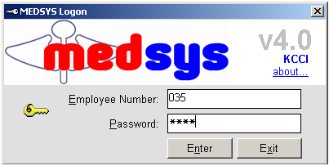
Figure 1: Login Window
3 If accepted, you can now start a transaction. Otherwise, a message will be displayed prompting “Unauthorized User”.

How to Change Password
It is advisable to change your password as often as possible for security reasons. To change you current password, follow these steps.

1 From the Login window, type your employee number and then press <Enter>.
2 Under the Password entry, press <F12>. Pressing this function key will invoke the Change Password window.
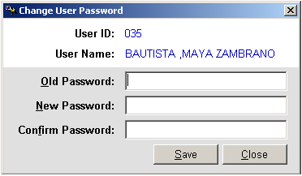
Figure 2: Change Password Window

3 Under the Change Password window, type the following data.
Old Password - Type your existing password.
New Password - Type your new password not exceeding to 15 characters.
Confirm Password - Retype your new password to confirm and then press <Enter> or you can click the Save button.

How to End the Program
It is important for users to close the program when they are done to end-up their session. Other users might use the open program using the same password.

To close the program:
Click which is located at the upper right corner of the main window or
Click Exit from Transaction Entry pull-down menu or
Press Ctrl + X

Program Operation

Maintenance

System Settings
Use this option to enter the default settings of data to be used in all transactions.

- Click Maintenance > System Setting to open the window below.
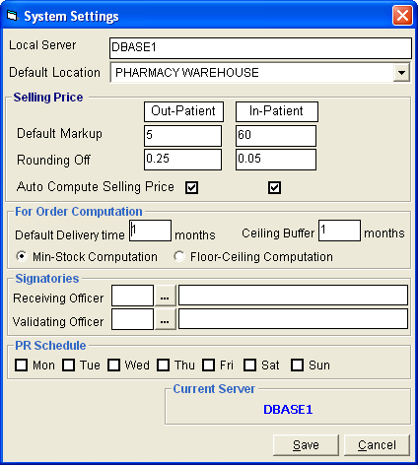
Figure 3: System Settings Window

- Enter local server in the ‘Local Server’ textbox. Refer to EDP for information.
- Select default location in the ‘Default Location’ drop-down combo box.
- Enter default markup for inpatient and outpatient.
- Enter the decimal number to be used in rounding off.
- Click check box beside ‘Auto Compute Selling Price’ to automatically compute selling price.
- Enter the default delivery time in the ‘Default Delivery Time’ textbox.
- Enter the default ceiling buffer in the ‘Ceiling Buffer’ textbox
- Click if the computation is for Min. Stock Computation or Floor-ceiling Computation
- Enter the default receiving officer.
- Enter the default validating officer.
- Click the day for PR Schedule
- Click Save button to save the default settings.

User Settings
This option is where you can control the rights of a particular user, what locations he can access and his restrictions for that particular location.

1 To open its window,
Click User Settings from Maintenance pull-down menu. The window below will appear.
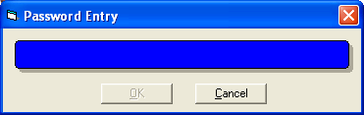
Figure 4: User Settings: Password Entry

This window asks for a password to restrict the access of unauthorized users. Just type the password and then click the OK button. If accepted, the User Setting window will be displayed. Under the User List entry, select the user you want to assign location and restriction. See figure below.
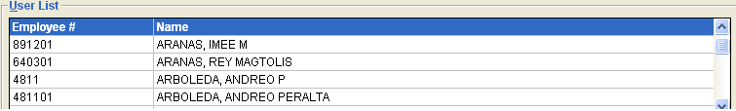
Figure 5: User Settings: List of Users

Under Available Locations entry (see figure below), click the check box beside the location/department and then click the Add>> button at the center. The list of assigned locations can be seen to its right side under Assigned Location grid. To remove location from Assigned Location, click the check box beside the location and then click the <<Remove button. Selected locations are those that can be accessed by the selected user.
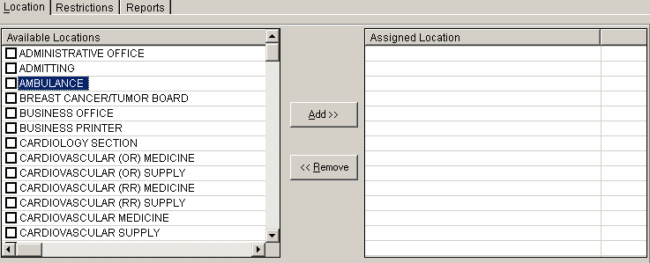
Figure 6: User Settings: Location Entry

To assign restrictions to the selected locations/departments of the user, click the Restrictions tab. The window below will be displayed.
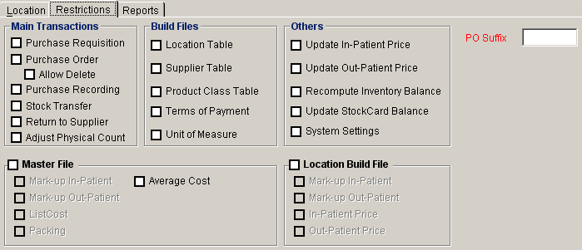
Figure 7: User Settings: Restrictions Entry

Under Restrictions tab, the following can be selected. Just click the check box beside its right side.
Main Transactions - This controls the right to purchase order, purchase recording, stock transfer, return to supplier, and adjust physical count.
Build Files - This controls the right to add/edit location, supplier and product class tables, terms of payment, unit of measure, and foreign currency.
Others - This controls the right to update inpatient/outpatient selling price, recompute inventory balance, update stock card balance, and system settings.
Certificate of Acceptance - This controls the right to generate certificate of miscellaneous, job order, and blank C.A.
Master File - This controls the right to mark-up inpatient/outpatient, and entries to list cost and packing, and average cost.
Location Build File - This controls the right to mark-up inpatient/outpatient, and update inpatient/outpatient selling price in a particular location/department.

To assign restrictions to user’s access on reports, click on REPORTS Tab. The window below will be displayed.

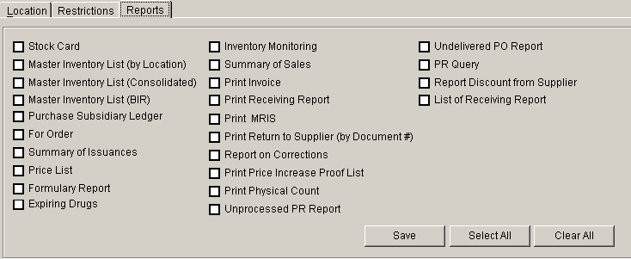

- Click on Select All button to select all reports for user’s access
- Click on Clear all button to deselect all reports selected.

Click on Save button to update the users account.

Adding/Editing of Item in the Master File
This option allows you to add items into the master file. The master file holds all the items to be dispensed into a particular location.

1 To open its window,
Press Ctrl + I or
Click Product Table (Master File) from Maintenance pull-down menu.
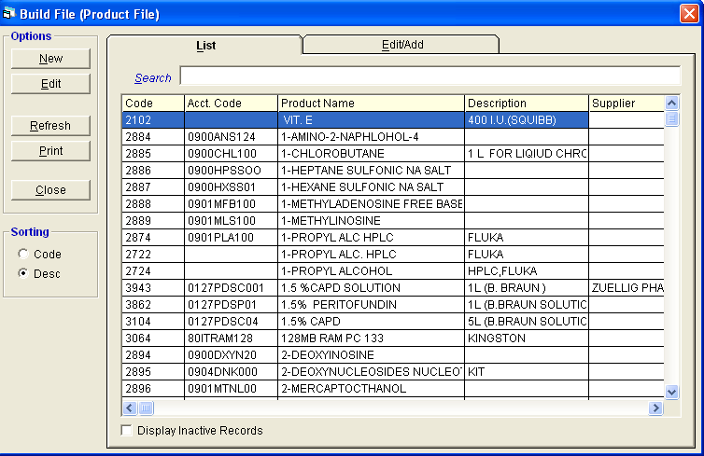
Figure 8: Adding/Editing of Item in the Master File: Main Window

2 To search for a particular item, type its first few characters under ’Search' textbox and then press <Enter>. Listings will be displayed just below it to match your query. You can arrange the listings by the item code or product name. Just click on the option you want under the ’Sorting' options. To display inactive items, click the check box beside Display Inactive Records at the bottom of the window.

After searching the item, you can now edit it. Double-click the item to display its information or you can click the Edit button on the left side of the window under the List tab. Under the Edit/Add tab, you can now edit the item’s information. Click the Save button afterwards to save change(s) done.

To add an item to the master file, click the New button under the Options entry. The window below will be displayed.
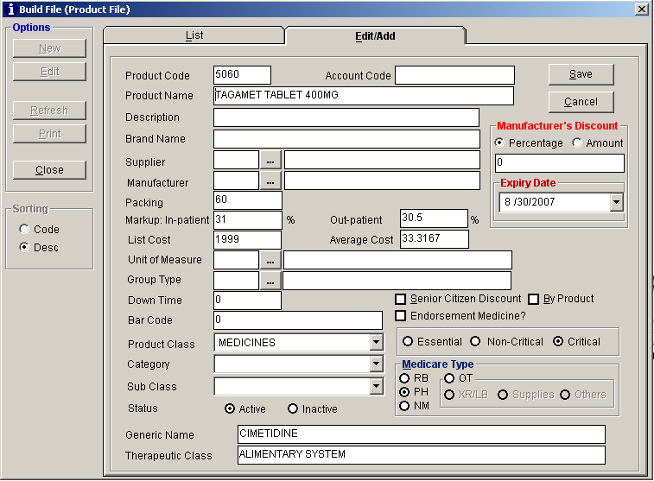
Figure 9: Item (Master File) Entry

Type the following data.
Product Code – A program - generated code.
Account Code - Type the account code of the item. This will be used to link to Accounting program.
Product Name - Type the item name and then press <Enter>.
Description - Type the item description and then press <Enter>.
Supplier - Type the first few characters of the supplier name and then press <Enter>. Or you can click on to display the complete list of suppliers.
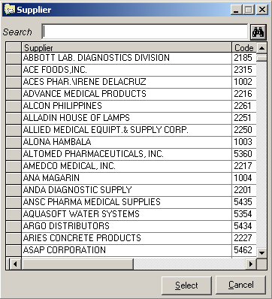
Figure 10: List of Suppliers

Double-click on the supplier name to select.
Manufacturer - Type the first few characters of the manufacturer name and then press <Enter>. Or you can click on to display the complete list of manufacturers.
Packing - Type the number of packs of the item and then press <Enter>.
Markup: Inpatient - Type a markup percentage to be covered by inpatients and then press <Enter>.
Markup: Outpatient - Type a markup percentage to be covered by outpatients and then press <Enter>.
List Cost - Type the list cost of the item and then press <Enter>.
Average Cost - Type the average cost of the item and then press <Enter>.
Unit of Measure - Type the first few characters of the unit of measure and then press <Enter>. Or you can click on to display the complete list of unit of measures.
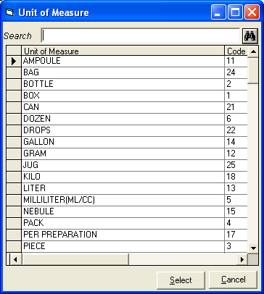
Figure 11: Unit of Measurement

Double-click on the unit of measurement name to select.

Bar Code - Type the bar code of the item.
Product Class - Click the drop-down arrow to display list of product classes. Click on the class name to select.
Category - Click the drop-down arrow to display list of categories. Click on the category name to select.
Type - Click the drop-down arrow to display list of types. Click on the type name to select.
Status - The default entry is set to “Active”. This means that the item can already be used for transaction. Otherwise, click “Inactive” to just include the item but unavailable for transaction yet.
Click if the drug is Essential, Non-critical and Critical
Manufacturer’s Discount – You can enter amount or percentage.
- Category – Click the drop-down arrow to display lists of category. Click on the type name to select.
- Subclass – Click the drop-down arrow to display lists of subclass. Click on the type name to select.
Senior Citizen Discount - Click the check box beside it if necessary.
- Medicare Type – Choose the specific medicare category of item ( RB – Room and Board, PH – Pharmacy, NM – Non Medicare, OR – Operating Room )
- Expiry Date – Expiry date of item can be entered in the Expiry Date box.
Endorsement Medicine - Click the check box beside it if necessary. This is used for unit dose items.
The following button options can be clicked from.
Save - This will add entered item into the master file. After clicking this button, the window below will appear. Base on the entered, you can view here the old and new list cost, inpatient/outpatient markup, packing, and inpatient/outpatient selling price. The new inpatient/outpatient selling price is then automatically computed.
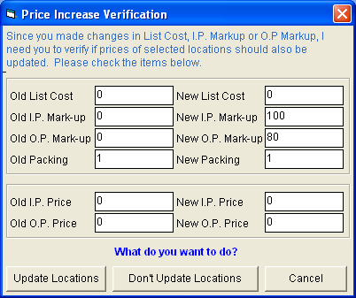
Figure 12: Price Increase Verification Window

The following button options can be clicked from.
Update Locations - When clicked, the item will be automatically included to all locations.
Don’t Update Locations - This will not save the item to all locations. You have the option to specify the item into a particular location under “Update Location Table (Location)”.
Cancel - Click this to go back to the window without saving the added item.

Cancel - This will close the add/edit window without saving the item entered.

To print the complete list of items from master file, click the Print button under the List tab.

3 To close the window,
Click at the upper right corner of the window or
Click the Close button under the List tab.

Adding/Editing of Item in a Location
After adding the item in the master file list, you can now dispense it to the location you want. This option allows you to specify the item into the selected location so that it will be available for transaction. In here also is where you can enter the inpatient and outpatient selling prices of the item.

1 To open its window,
Click Update Product Table (Location) from Maintenance pull-down menu.

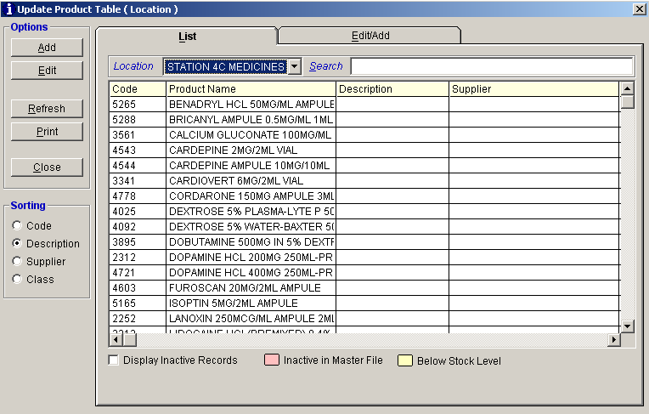
Figure 13: List of Items by Location: Main Window

2 To add an item into a particular location, click the drop-down arrow under Location entry to display list of locations. Click on the location name to select. Saved items under the selected location will be displayed. (You can arrange the listings by the item code, product name, supplier or class. Just click on the option you want under the Sorting entry. To display inactive items, click the check box beside Display Inactive Records below the window.) Click the Add button under Options entry. The following window will be displayed.
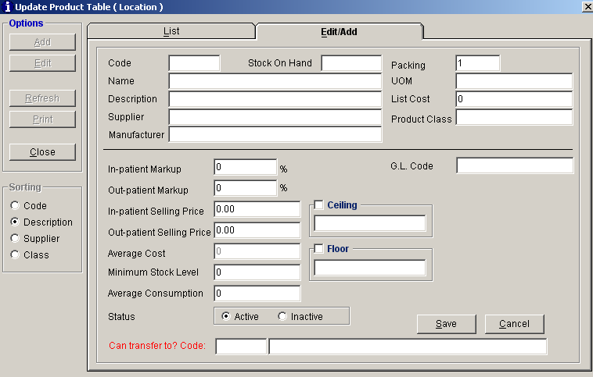
Figure 14: Item by Location Entry Window

Type the following data.
Code - Type the first few characters of the item name and then press <Enter>. A window with items listing matching the query typed will be displayed.
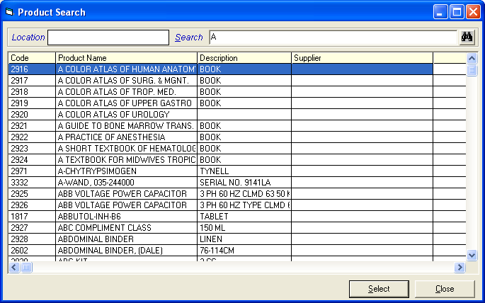
Figure 15: Items by Location Entry: List of Items

Double-click on the item name to select. The item’s information will be automatically displayed. The following data can still be edited.
Inpatient Markup - Type a markup percentage to be covered by inpatients.
Outpatient Markup - Type a markup percentage to be covered by outpatients.
Inpatient Selling Price - Type the item’s selling price for inpatients.
Outpatient Selling Price - Type the item’s selling price for outpatients.
Average Cost - Type the item’s average cost.
Minimum Stock Level - Type the item’s minimum stock level. This will be the basis when to inform the user that the item’s minimum stock level was already reached.
Average Consumption - Type the item’s minimum consumption.
Status - If the item is set to “Active”, it can already be used for transaction in the specified location. Otherwise, click “Inactive” to just include the item but unavailable for transaction yet.
G.L. Code - Type the G.L. code of the item. This code will be used to link into Accounting program.

The following button options can be clicked from.
Save - This will add and save the item to the selected location.
Cancel - This will close the window without saving the entered item.

To edit saved item from a particular location, select the location and then search the item under the Search entry. When searched, double-click it to display item’s information. You can now edit its information. Click the Save button afterwards to save change(s) done.
To print the complete list of items under the selected location, click the Print button under the List tab.

Adding / Editing of Location / Department
In this option is where you can add a location/department classifying it into warehouse, dispensing area or allowable for purchase order. A saved location can also be edited using this feature.

1 To open its window,
Click Location Table from Maintenance pull-down menu or
Click Ctrl + L
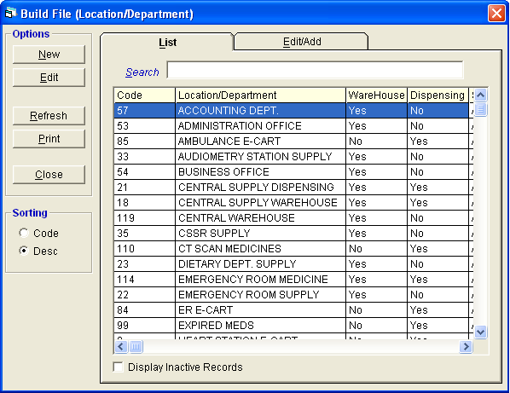
Figure 16: Location/Department: List of Locations

2 To search for a particular location, type its first few characters under ’search' textbox and then press <Enter>. Listings will be displayed just below it to match your query. You can arrange the listings by the location code or location name. Just click on the option you want under the ’sorting' options. Or to display inactive location/department, click the check box beside Display Inactive Records below the window.

After searching the location, you can now edit it. Double-click it to display its information or you can click the Edit button on the left side of the window under the List tab. Under the Edit/Add tab, you can now edit the location’s information. Click the Save button afterwards to save change(s) done.

To add a location/department, click the Add button under the List tab. Its window will be displayed.
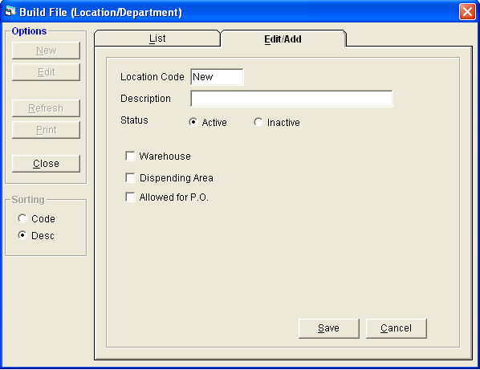
Figure 17: Location Entry Window

Type the following data.
Location Code – A program-generated code.
Description - Type the location name and then press <Enter>.
Status - The default entry is set to “Active”. This means that the location can already be used for transaction. Otherwise, click “Inactive” to just include the location but unavailable for transaction yet.
Warehouse - Click the check box beside it if necessary.
Dispensing Area - Click the check box beside it if necessary.
Allowed for P.O. - Click the check box beside it if necessary.

The following button options can be clicked from.
Save - This will add and save the location/department.
Cancel - This will close the window without saving the entered location/department.

To print the complete list of locations, click the Print button under the List tab.

3 To close the window,
Click at the upper right corner of the window or
Click the Close button under the List tab.

Adding / Editing of Supplier
In here is where you can add a supplier. A saved supplier can also be edited using this feature.

1 To open its window,
Click Supplier Table from Maintenance pull-down menu or
Press Ctrl + D
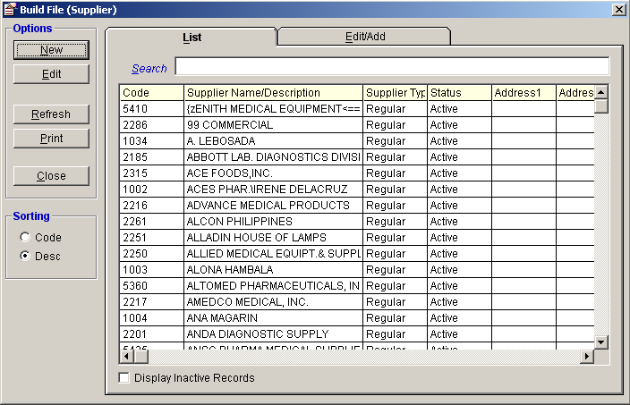
Figure 18: Supplier Maintenance: Main Window

2 To search for a particular supplier, type its first few characters under ’search' textbox and then press <Enter>. Listings will be displayed just below it to match your query. You can arrange the listings by the supplier code or supplier name. Just click on the option you want under the ’sorting' options. Or to display inactive suppliers, click the check box beside Display Inactive Records below the window.

After searching the supplier, you can now edit it. Double-click it to display its information or you can click the Edit button on the left side of the window under the List tab. Under the Edit/Add tab, you can now edit the supplier’s information. Click the Save button afterwards to save change(s) done.

To add a supplier, click the Add button under the List tab. Its window will be displayed.
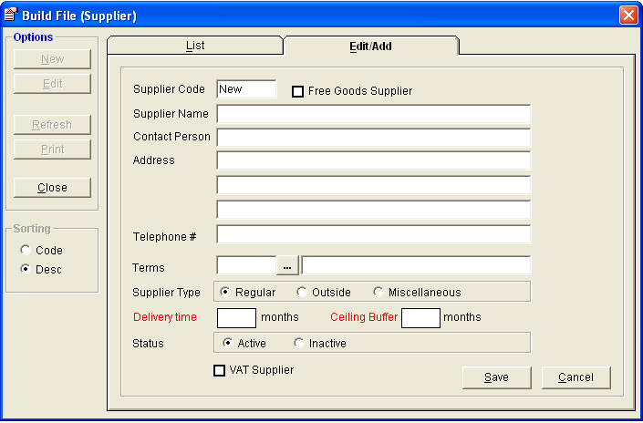
Figure 19: Supplier Entry Window

Type the following data.
Supplier Code – A program-generated code.
Supplier Name - Type the supplier name and then press <Enter>.
Address - Type the supplier’s address and then press <Enter>.
Telephone # - Type the supplier’s telephone number.
Fax # - Type the supplier’s fax number.
Terms - Type the first few characters of the term name and then press <Enter>. Or to display the complete list of terms, click the . Double-click on the term name to select.
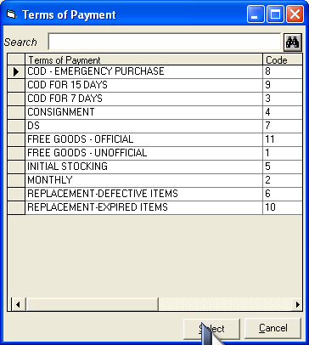
Figure 20: Terms of Payment

- Supplier Type - Click one from the listed options (Regular, Outside, Miscellaneous)
- Status - If the supplier is set to “Active”, it can already be used for transaction. Otherwise, click “Inactive” to just include the supplier but unavailable for transaction yet.
- Enter Delivery Time and Ceiling Buffer

The following button options can be clicked from.
Save - This will add and save the supplier.
Cancel - This will close the window without saving the entered supplier.

To print the complete list of suppliers, click the Print button under the List tab.

3 To close the window,
Click at the upper right corner of the window or
Click the Close button under the List tab.

Adding / Editing of Item Classification
This option allows you to add item classifications. The saved item classification can also be edited using this feature.

1 To open its window,
Click Product Classification Table from Maintenance pull-down menu or
Press Ctrl + G
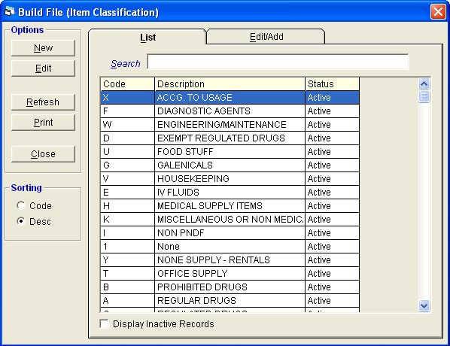
Figure 21: Item Classification Maintenance: Main Window

2 To search for a particular item classification, type its first few characters under ’Search' textbox and then press <Enter>. Listings will be displayed just below it to match your query. You can arrange the listings by the item classification code or item classification name. Just click on the option you want under the ’sorting' options. Or to display inactive item classifications, click the check box beside Display Inactive Records below the window.
After searching the item classification, you can now edit it. Double-click it to display its information or you can click the Edit button on the left side of the window under the List tab. Under the Edit/Add tab, you can now edit the item classification’s information. Click the Save button afterwards to save change(s) done.

To add an item classification, click the Add button under the List tab. Its window will be displayed.
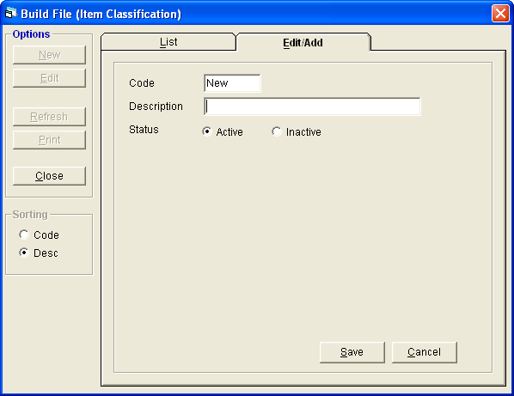
Figure 22: Item Classification Entry Window

Type the following data.
Code - A program-generated program.
Description - Type the item classification name and then press <Enter>.
Status - If the item classification is set to “Active”, it can already be used for transaction. Otherwise, click “Inactive” to just include the item classification but unavailable for transaction yet.

The following button options can be clicked from.
Save - This will add and save the item classification.
Cancel - This will close the window without saving the entered item classification.

To print the complete list of item classifications, click the Print button under the List tab.

3 To close the window,
Click at the upper right corner of the window or
Click the Close button under the List tab.

Adding / Editing of Terms of Payment
In here is where you can add terms of payment. The saved term of payment can also be edited using this feature.

1 To open its window,
Click Terms of Payment Table from Maintenance pull-down menu or
Press Ctrl + T
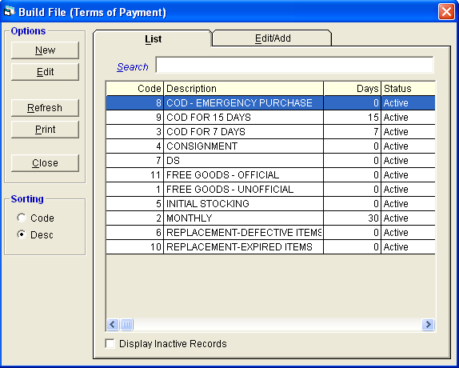
Figure 23: Terms of Payment Maintenance: Main Window

2 To search for a particular term of payment, type its first few characters under ’search' textbox and then press <Enter>. Listings will be displayed just below it to match your query. You can arrange the listings by the term of payment code or term of payment name. Just click on the option you want under the Sorting options. Or to display inactive terms of payment, click the check box beside Display Inactive Records below the window.
After searching the term of payment, you can now edit it. Double-click it to display its information or you can click the Edit button on the left side of the window under the List tab. Under the Edit/Add tab, you can now edit the term of payment’s information. Click the Save button afterwards to save change(s) done.

To add a term of payment, click the Add button under the List tab. Its window will be displayed.
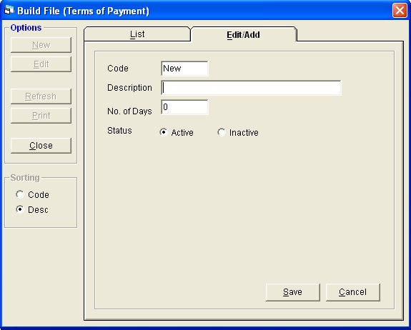
Figure 24: Term of Payment Entry Window

Type the following data.
Code - A program-generated code.
Description - Type the term of payment name and then press <Enter>.
No. of Days - Type the number of days and then press <Enter>.
Status - If the term of payment is set to “Active”, it can already be used for transaction. Otherwise, click “Inactive” to just include the term of payment but unavailable for transaction yet.

The following button options can be clicked from.
Save - This will add and save the term of payment.
Cancel - This will close the window without saving the entered term of payment.

To print the complete list of terms of payment, click the Print button under the List tab.

3 To close the window,
Click at the upper right corner of the window or
Click the Close button under the List tab.

Adding / Editing of Unit of Measurement
This option allows you to add a unit of measurement. The saved unit of measurement can also be edited using this feature.

1 To open its window,
Click Unit of Measure Table from Maintenance pull-down menu.
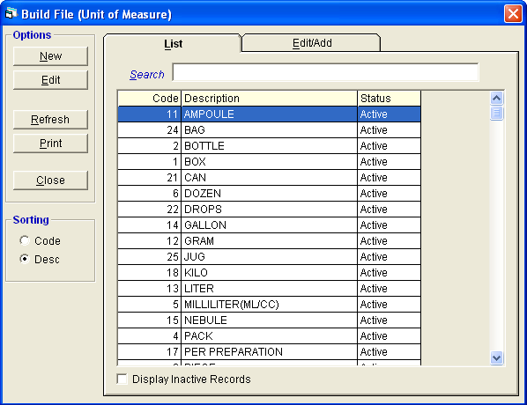
Figure 25: Unit of Measurement Maintenance: Main Window

2 To search for a particular unit of measurement, type its first few characters under ’search' textbox and then press <Enter>. Listings will be displayed just below it to match your query. You can arrange the listings by the unit of measure code or unit of measure name. Just click on the option you want under the Sorting options. Or to display inactive unit of measure, click the check box beside Display Inactive Records below the window.

After searching the unit of measure, you can now edit it. Double-click it to display its information or you can click the Edit button on the left side of the window under the List tab. Under the Edit/Add tab, you can now edit the term of unit of measure’s information. Click the Save button afterwards to save change(s) done.

To add a unit of measure, click the Add button under the List tab. Its window will be displayed.
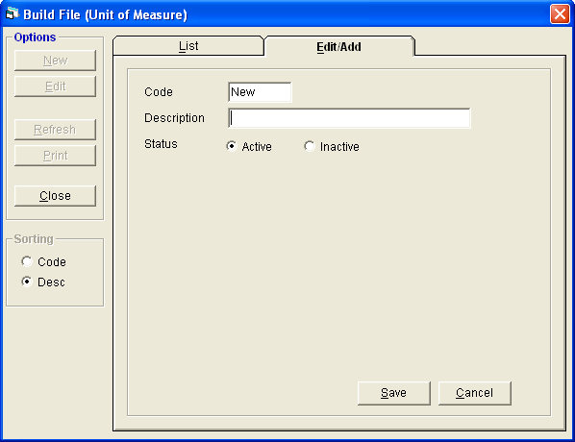
Figure 26: Unit of Measure Entry Window

Type the following data.
Code - A program-generated code.
Description - Type the unit of measure name and then press <Enter>.
Status - If the unit of measure is set to “Active”, it can already be used for transaction. Otherwise, click “Inactive” to just include the unit of measure but unavailable for transaction yet.

The following button options can be clicked from.
Save - This will add and save the unit of measure.
Cancel - This will close the window without saving the entered unit of measure.
To print the complete list of units of measure, click the Print button under the List tab.

3 To close the window,
Click at the upper right corner of the window or
Click the Close button under the List tab.

Adjusting of Item’s Physical Count
This option allows you to update the computer count of a particular item in a particular location basing from its manual count.

1 To open its window,
Press Ctrl + A or
Click Adjust Physical Count from Maintenance pull-down menu.
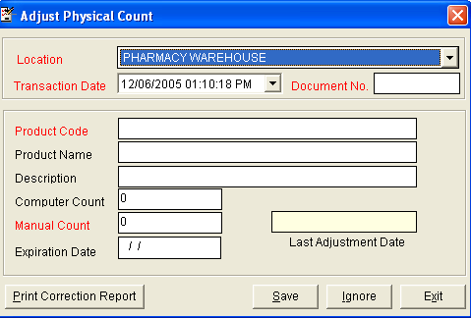
Figure 27: Adjust Physical Count Window

2 The following data are needed to enter.
Location - Click the drop-down arrow to display list of locations. Click the location name of the item you want to update.
Transaction Date - The current server time is used as the default entry.
Document No. - Type a document number not exceeding to 10 characters.
Product Code - Type the first few letters of the item name and then press <Enter>. A window will be displayed matching the query typed.

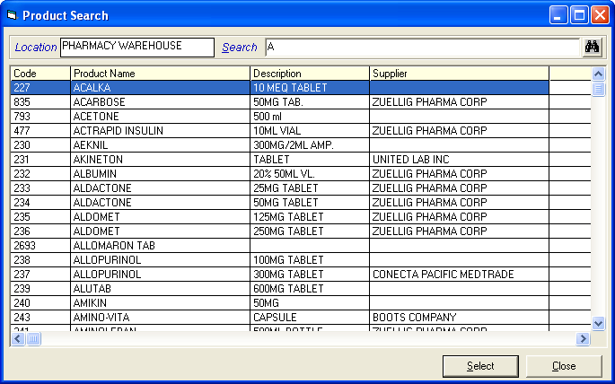
Figure 28: Adjust Physical Count: Product Search Window

Double-click on the item name to select. Its product name, description, and computer count will be automatically displayed.

Manual Count - Type the manual count of the item selected.
Expiration Date - Type the expiration date of the item’s manual count (format: mm/dd/yyyy where mm is month, dd is year, and yyyy is year).

3 The following buttons can be clicked from.
Save - This will save and update the computer count basing from the entered manual count.
Print Correction Report - After saving, you can click this button to print correction report.
Ignore - This will ignore (clear) the currently selected item.
Exit - When clicked, a message “Are you sure you want to exit w/o saving?” will appear. Click the Yes button to close the window without saving change(s) done or click the No button to go back into the window.

Updating of Inpatient Selling Price
Use this option to automatically update the inpatient selling price based on the stocks delivered by supplier or stocks from warehouse.

- Click Maintenance > Update Inpatient Selling Price > based on Stocks delivered by Supplier or based on Stocks from Warehouse.
Sample updating of inpatient selling price based on stocks delivered by supplier. The window below will appear.
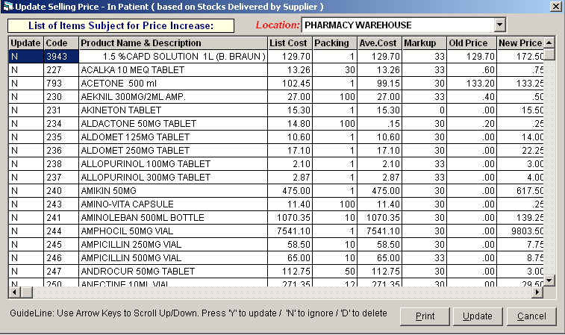
Figure 29: Update Inpatient Selling Price based on Stocks Delivered by Supplier Window

- Use arrow keys to scroll up or down. Press ‘Y’ to update, ‘N’ to ignore, or ‘D’ to delete.
- Click Update button to save changes made.

Updating of Outpatient Selling Price
Use this option to automatically update the outpatient selling price based on the stocks delivered by supplier or stocks from warehouse.

- Click Maintenance > Update Inpatient Selling Price > based on Stocks delivered by Supplier or based on Stocks from Warehouse.

Sample updating of outpatient selling price based on stocks delivered by supplier. The window below will appear.
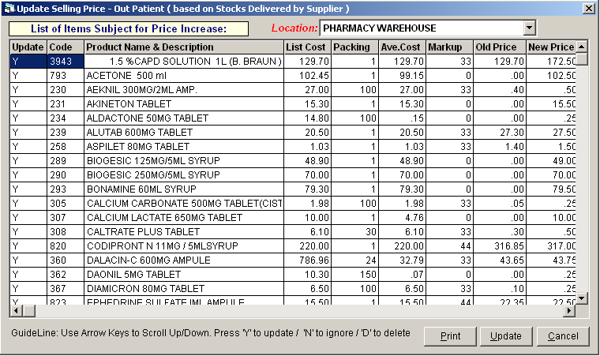
Figure 30: Update Outpatient Selling Price based on Stocks Delivered by Supplier Window

- Use arrow keys to scroll up or down. Press ‘Y’ to update, ‘N’ to ignore, or ‘D’ to delete.
- Click Update button to save changes made.

Inventory Procedure

Step 1: Purchase Requisition Entry
This option allows you to enter purchase requests.
1. Click Transaction Entry > Purchase Requisition. The window below will appear
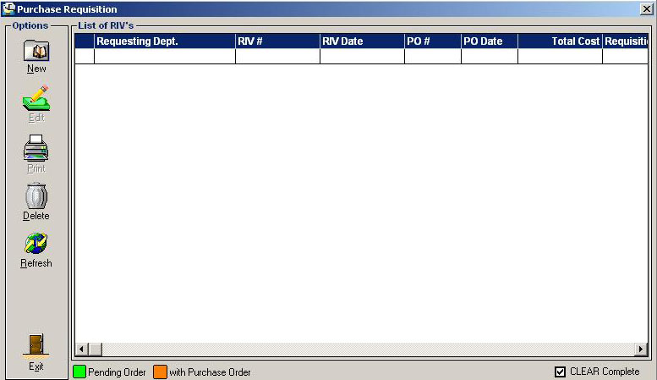
Figure 32 : Purchase Requisition : Main Window
Note: You can view the status of purchase requisition at the bottom of the window. Green color indicates ‘pending order’; orange color indicates ‘with purchase order’.

To edit purchase requisition :
- Select the request invoice number from the list.
- Click Edit button. The list of items under the selected request invoice number will be displayed. You can now add or delete items from the grid.
- Click Save Entries button to update changes made.

To delete purchase requests
- Select the requests invoice number from the lists
- Click Delete button. A message will appear. Choose Yes to confirm. The RIV number including its ordered items will be removed automatically from the list.

To add purchase requests
    - Click New button. The window below will appear.
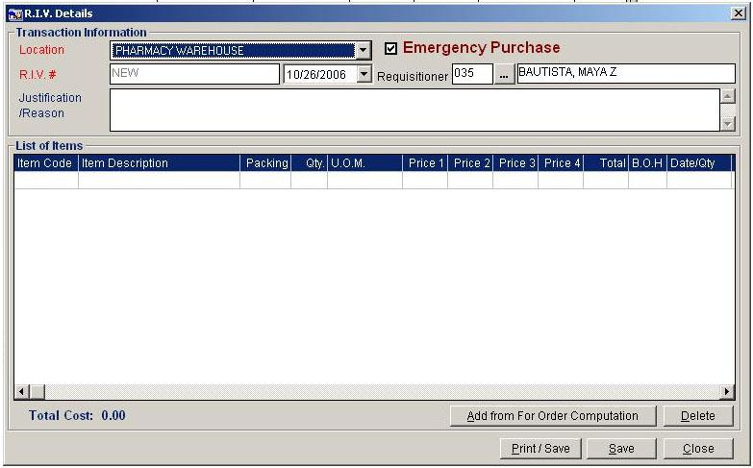
Figure 33: New Purchase Requisition Window
    - Select the location in the ‘Location combo box’. (Location in here refers to the requesting department)
    - Enter name of the requisitioner.
    - Enter Justification / Reason for the requests.
    - Click Add from For Order Computation button to display lists of items.
    - If you want to delete an item, click on Delete button to remove from the lists.
    - To save the items, click Save button or Print/Save button.

Step 2: Purchase Order Entry

This step is where you can enter purchase order number, requisitioner number, supplier, list of items for order and others.
    - Click Transaction Entry > Purchase Order. The window below will appear.
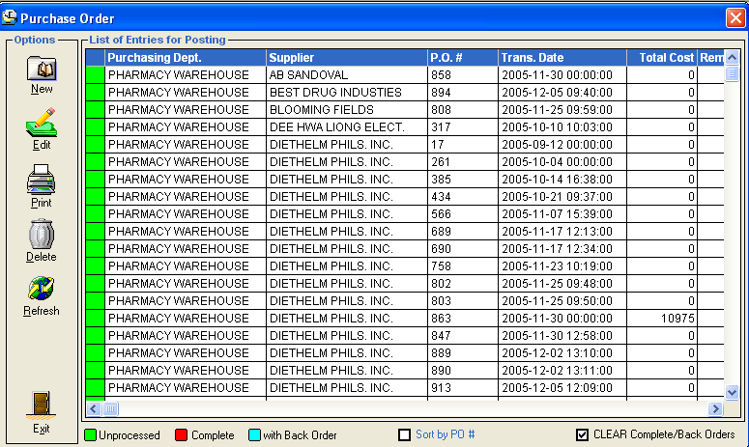
Figure 34: Purchase Order: Main Window
Note: You can view the status of purchase order at the bottom of the window. Green color indicates ‘unprocessed’; orange color indicates ‘pending in purchase recording’; red color indicates ‘complete’; and cyan color indicates ‘with back order’.

To edit purchase order:
    - Select the purchase order number from the list.
    - Click Edit button. The list of items under the selected purchase order number will be displayed. You can now add or delete items from the grid.
    - Click Save Entries button to update changes made.

To delete purchase order:
    - Select the purchase order number from the list.
    - Click Delete button. A message will appear. Choose Yes to confirm. The RIV number including its ordered items will be removed automatically from the list.

To add purchase order:
    - Click New button. The window below will appear.
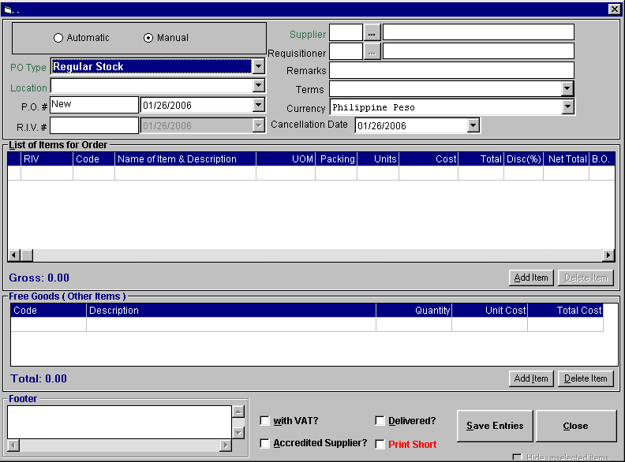
Figure 35: New Purchase Order Entry Window

    - Select the location in the ‘Location combo box’. (Location in here refers to the requesting department which issued the request invoice voucher)
    - Enter the purchase order number and date of purchase in the ‘PO # textbox and date drop-down combo box’ respectively.
    - Enter the P.R. #
    - Select the supplier.
    - Select the requisitioner.
    - Enter remarks in the ‘Remarks’ textbox
    - Select the term of payment in the ‘Terms’ drop-down combo box.
    - Click Add Item button. Type the item code under the ‘Code’ column and then press <Enter> to select.

    - Under the ‘Item Details’, you can update the item details such as packing, number of units, number of free goods and others. You must then click then on ‘Update List’ button to refresh the data on the grid.
    - Click on ‘Process Orders’ button when done.

Step 3: Receiving Stock Entry
This is used to enter quantity of items delivered by the supplier. The quantity of received items from supplier is entered for the preparation of the final dispensing to departments.

- Click Transaction Entry > Purchase Recording or press <Ctrl + P>. The window below will appear.

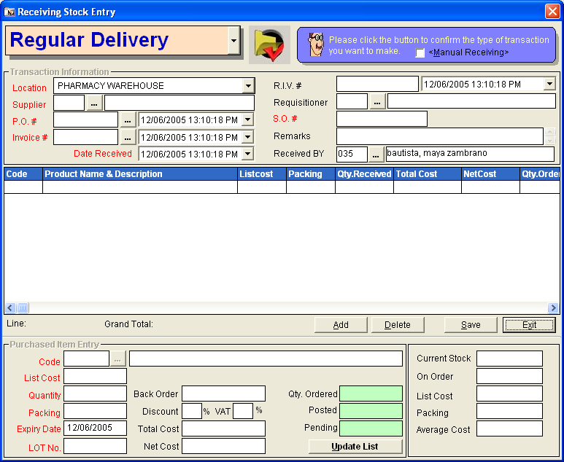
Figure 36: New Receiving Stock Entry Window

- Select location in the ‘Location’ drop-down combo box.
- Select supplier in the ’supplier’ textbox. The supplier to be entered here should match the supplier entered in the purchase order entry.
- Select purchase order by clicking . The window below will appear.
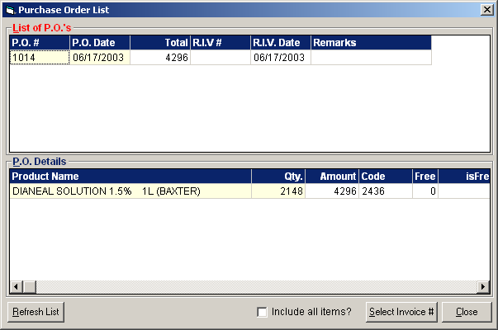
Figure 37: List of Purchase Orders

    - Double-click the purchase order number from the ‘List of P.O.s’. The P.R. # and Requesting staff will be automatically displayed.
    - Enter the invoice number in the ‘Invoice #’ textbox. The date received will be automatically displayed. (The current date will be used).
    - Type remarks in the ‘Remarks’ textbox
    - Under the ‘Purchased Item Entry’, enter the code of the item by clicking . The window below will appear.
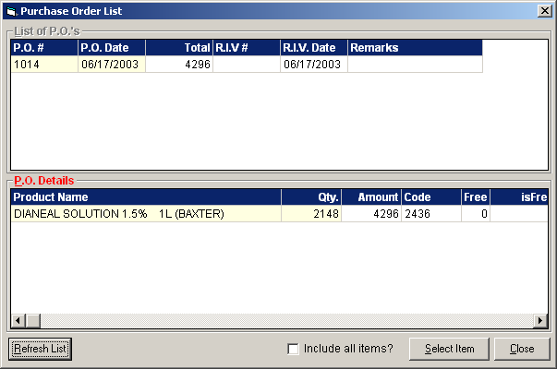
Figure 38: List of Purchase Order Details

    - Double-click the item from the list of ‘P.O. Details’. The item’s list cost, quantity, and packing will be automatically displayed. You may edit them if necessary. The item’s back order will also be automatically displayed once quantity received entered is lesser than the quantity ordered.
    - Enter LOT number in the ‘LOT No’ textbox.
    - Enter discount percentage in the ‘Discount’ textbox. (This entry has been entered in the purchase order entry but you may edit it if necessary)
    - Enter VAT percentage in the ‘VAT’ textbox.
    - Click OK button for the next entry of item. The complete list of items entered is displayed in the grid portion of the window.
    - Click Save button to save current entry of items in the grid.

To post received stock: (Use this option to post the entered received stock for the preparation of the final dispensing to departments.)
    - From the Receiving Stock Entry main window, select the purchase order number/invoice number from the grid.
    - Click Post button. A message will appear. Click Yes to proceed. Posted items are now ready to process under Stock Transfer (step 4).

Step 4: Stock Transfer (Withdrawal Posting) Entry
Posted items under purchase recording entry will be processed here. This is used in the final issuance of stocks into different departments based on the received quantity of stocks from supplier.

    - Click Transaction Entry > Withdrawal Posting or press <Ctrl + W>. The window below will appear.
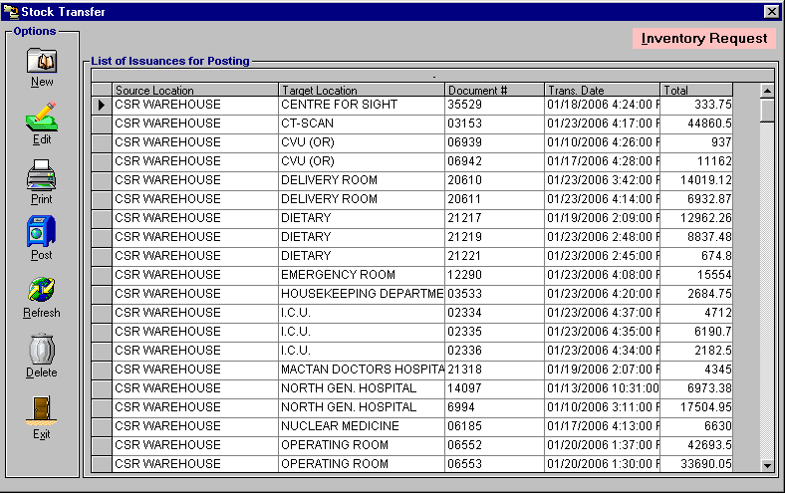
Figure 39: Stock Transfer Main Window

To edit posted stock:
    - Select document number from the grid.
    - Click Edit button. The list of items under the selected purchase order number will be displayed. You can now add or delete items from the grid.
    - Click Save button to update changes made.

To delete posted stock:
    - Select document number from the grid.
    - Click Delete button. A message will appear. Click Yes button to confirm. Deleted items will be automatically removed from the list.

To enter items for stock transfer:
    - Click New button. The window below will appear.
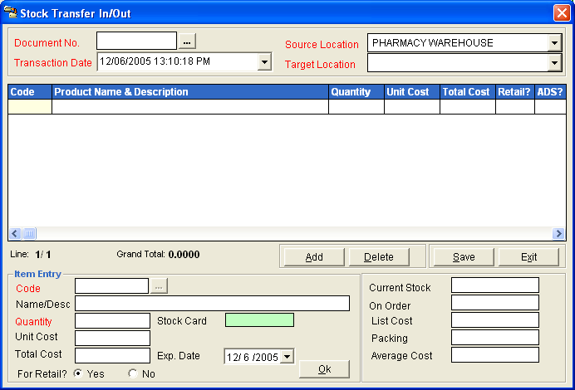
Figure 40: New Stock Transfer Entry Window

    - Select source location in the ’source Location ’ drop-down combo box.
    - To enter new document number, enter document number in the ‘Document No.’ textbox. To have a correction on the posted document number, click to display posted document numbers from the selected source location. Any saved transaction here will be deducted from the quantity of the selected item.
    - Enter transaction date in the ‘Transaction Date’ drop-down combo box.
    - Select target location in the ‘Target Location’ drop-down combo box.
    - Under Item Entry, select code by clicking . The window below will be displayed.
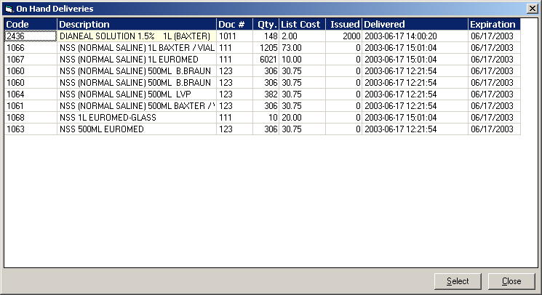
Figure 41: List of Items for Stock Transfer
Note: Under the ‘Issued’ column in the above window, you can view the issued quantity of a particular item. The quantity under the ‘Qty’ column refers to the available quantity o f the item to be issued.

    - Select the item from the list then double-click it.
    - Enter the quantity to be dispensed into the selected target location.
    - Identify if item is for retail or not.
    - Click OK button. Follow the same procedure when entering additional items.
    - Click Save button after completed the items to be dispensed into the target location. The selected items will be displayed into the Stock Transfer main window.

How to post items for stock transfer: (Use this option to finally dispense the items to the selected target location)
    - From the Stock Transfer main window, select the document number in the grid.
    - Click Post button. A message will appear. Click Yes to proceed. Quantity of posted items will be automatically added into the target location.

Step 5: Return to Supplier Entry
This option is used to return items from source location to the supplier.

Note: Before doing this step, you should also update the quantity of the item from the target location to the source location using Step 3: Stock Transfer (Withdrawal Posting).

- Click Transaction Entry > Return to Supplier or press <Ctrl + R> to open the window below.
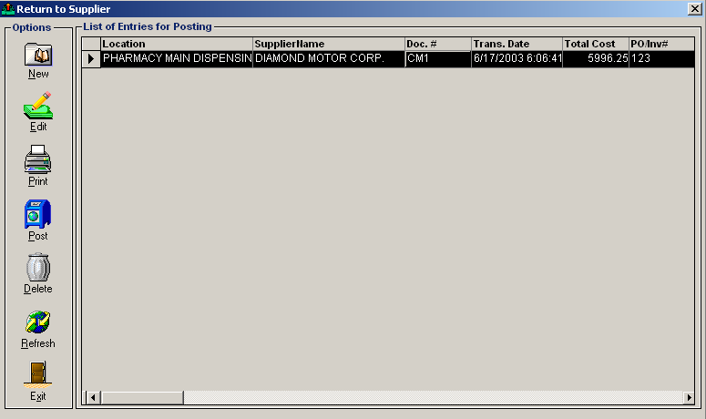
Figure 42: Return to Supplier Main Window

To edit retuned items:
    - Select the credit memo number (Doc. #) from the list.
    - Click Edit button. The list of items under the selected credit memo number will be displayed. You can now add or delete items from the grid.
    - Click Save button to update the changes made.

To delete returned items:
    - Select the credit memo number (Doc. #) from the list.
    - Click Delete button. A message will appear. Click Yes button to confirm. Deleted items will be automatically removed from the list.

To enter returned items:
    - Click New button. The window below will appear.
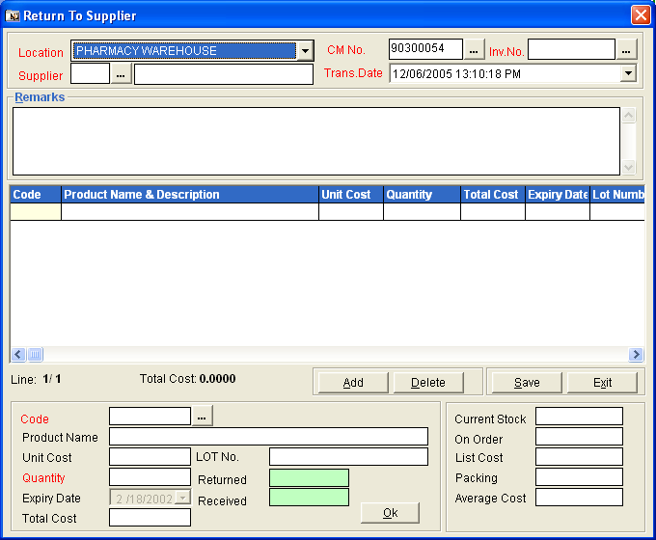
Figure 43: New Return to Supplier Entry Window

    - Select location (source location) in the ‘Location’ drop-down combo box.
    - Enter supplier.
    - Enter credit memo number. (To have a correction on the posted credit memo, click . This will display list of posted credit memo. Double-click it from the list to select)
    - Select invoice number in the ‘Inv. No.’ entry by clicking . This will display list of invoice numbers posted under the source location and supplier. Double-click the invoice number to select.
    - Enter code by clicking . The window below will be displayed.
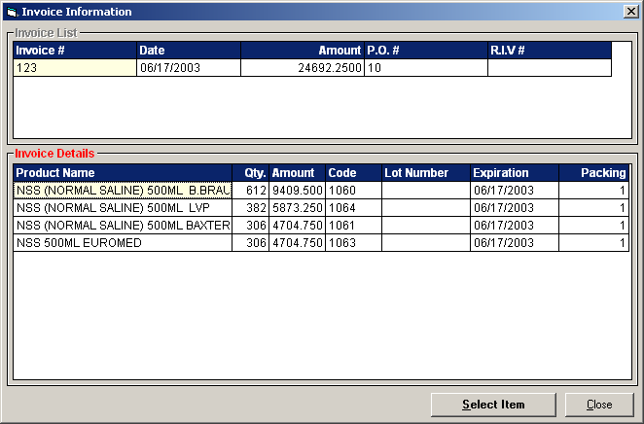
Figure 44: List of Invoice Details

    - Under ‘Invoice Details’ in the above window, double-click the item from the list.
    - Enter the quantity to return.
    - Click OK button. Do the same procedure when entering items to return.
    - Click Save button after completing the items to return.
To post items for return: (Use this option to finally return items to the supplier. Quantity of returned items will be automatically deducted from the source location)
    - From the Return Supplier main window, select the credit memo number (Doc. #).
    - Click Post button. A message will appear. Click Yes to proceed. Posted items will be automatically removed from the list.

Reports

Reports
The following list of reports is generated by the program. Just click on the Reports menu and then select the desired report to be generated.

- Stock Card
- Master Inventory List ( by Location )
- Master Inventory List ( Consolidated )
- Master Inventory List ( BIR )
- Purchase Subsidiary Ledger
- For Order
- Summary of Issuances
- Price List
- Formulary Report
- Expiring Drugs
- Inventory Monitoring
- Summary of Sales
- Print Invoice
- Print Receiving Report
- Print MRIS
- Print Return to Supplier
- Report on Corrections
- Print Price Increase Proof List
- Print Physical Count
- Unprocessed PR Report
- Undelivered PO Report
- PR Query
- List of Receiving Report

Stock Card Report
This generates a printable report of the item’s summary of transactions since the entered beginning to ending dates.

1 To open its window,
Press Ctrl + K or
Click Stock Card from Reports pull-down menu or
Click the  Stock Card toolbar button.
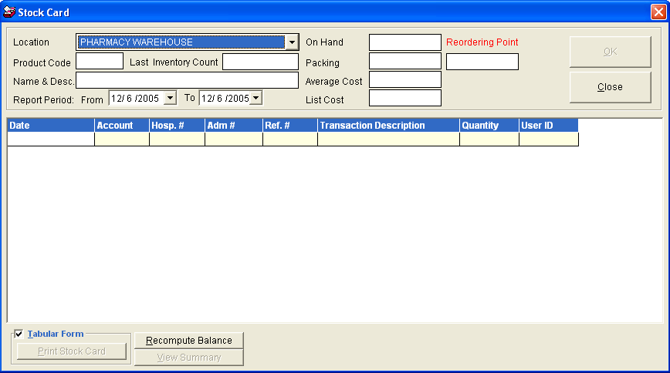
Figure 42: Stock Card Tabular Format Window

Enter the following data.
Location - Click the drop-down arrow to select location name.
Product Code - Type the first few characters of the item name and then press <Enter>. A window with items list will appear matching your query. To select, double-click the item name. Its name and description, on hand, packing, average cost and list cost will be automatically displayed.
Report Period - Select beginning date under From and ending date under To.

2 Click the OK button afterwards. Its details and summary will be displayed. To view its details, click the Details tab or to view its summary, click the Summary tab. Its tab has a printing option. Click it to print the stock card report.
Click the Close button to close the window.

Index

—C—
classification (adding/editing of), 29
computer count (updating of), 41
currency list entry, 40
—D—
department (adding/editing of), 25
—F—
features, 6
—I—
inpatient selling price (updating of), 43
item (adding/editing in location), 15, 21
item classification (adding/editing of), 31
item count (updating of), 41
—L—
location (adding/editing of), 25
—O—
objectives, 5
outpatient selling price (updating of), 44
overview, 4
—P—
password (changing of), 8
physical count (adjusting of), 41
program (closing), 9
program (starting of), 7
purchase order, 45
—R—
reports, 57
—S—
stock card balance (updating of), 45
stock card report, 58
supplier (adding/editing of), 28
system settings, 10
—T—
term of payment (adding/editing of), 34
—U—
unit of measure (adding/editing of), 37
user settings, 12

