



**PhilHealth**



**Implementation Guide**

20171120

PECWS v2.5

**Amendment History**

|  |  |  |
| --- | --- | --- |
| **Version** | **Date** | **Remarks** |
| Version 1.0 | 20090500 | Parameters for Phase 1 & 2 , re:submission of claims physical documents |
| Version 2.0 | 20120709 | Updated version converted eClaims Phases into Modules re: Full eClaims with PDF attachment |
| Version 2.5 | 20120718 | Parameters for Z-BITS observation feature included |
| Version 3.0 | 20120727 | Included Parameters for Module 3: Claim Status Verification re: Field/Attributes, Web service method of eClaims Status and eClaims Voucher |
| Version 3.0 | 20120924 | -Provision for copyright and disclaimer in the introduction  - Attached PC Circular on the accreditation of HITP  - On-site validation Tool , component 1 of Part II,  Conformance and Compliance Testing |
| Version 3.0 | 20121016 | - Included provision of Confidentiality |
| Version 3.1 | 20121030 | - Added web services for PIN verification, Doctor accreditation code, Doctor accredited and Single Period of Confinement |
| Version 3.1 | 20121109 | - Excluded live urls |
| Version 3.1 | 20121219 | -Modified validation tools re:  *Component 1: item K (deleted)  *Component 2: module 1, item 9  1, item 13  module 2, item A  module 3, item G (deleted)  3, deleted email capability to reply  within 1 day   * Created Component 3 for policy document and technical support |
| Version 3.1 | 20130109 | Included document type codes and descriptions |
|  | 20130322 | Updated IHCP eClaims account form for IHCP for digital certificate generation |
| Version 4.0 | 20130912 | - Updated the fields/attributes/parameter definition of Module 2: Electronic Claims Submission in conformity with the revised PhilHealth claim forms *(pages 26-32)*  - Updated the file structure of Module 2 *(pages 33-36)*  - Updated the Document Type Definition of Module 2 *(page 37)*  *-* prescribed PhilHealth Benefit Eligibility Form for CEWS response  (Yes response – page 21 )  (No response – page 23 ) |
|  | 20131104 | - Updated the fields/attributes/parameter definition of Module 2: Electronic Claims Submission in conformity with the revised PhilHealth claim forms *(pages 26-31)*  - Updated the file structure of Module 2 *(pages 34-37)*  - Updated the Document Type Definition of Module 2 *(page 38)* |
|  | 20160120 | * Added PhilHealth Member Registration Form, Anesthesia Record and Hemodialysis Record in the list of document type in Annex K * Added “P” (for Lifetime Member) as an acceptable value for the pMembershipType attribute |
|  | 20160217 | * Removed embedded hyphens in the values of pMemberPin attribute in the sample XMF files * Updated the parameter definition and the sample XML result of the SearchCaseRate method |
|  | 20160303 | * Removed pCataractPreAuth attribute and added pPatientType and pIsEmergency attributes in in the CLAIM element in the sample eClaims XML file and in Module 2 file structure |
|  | 20160406 | * Removed procedures related to the use of digital certificates for connection with between systems of HITPs and the PhilHealth’s e-claims web service * Included in the annexes the guidelines for the decryption of the images files of the supporting documents of claims submitted through e-claims web service * Made some changes to the formats and layout of the document |
|  | 20160930 | * Added “IMRT” element to add IMRT to the supported repetitive procedures * Added “pHasAttachedSOA” attribute to CF2 element for indicating whether a claim has corresponding SOA * Added new "CATARACTINFO" element to hold info about data like IOL sticker number for cataract operation. The "CATARACT" element will be deprecated later * Added the element “APR” that will hold the information about the permission to access patient record |
|  | 20161206 | * Added *SearchEmployer* method, which can be used for getting the employer information of an employed member * Added *AddRequiredDocument* method, which will be used to submit/re-submit the PDF files of supporting documents of claims that were tagged as “pending” or “RTH” (returned to hospital) due to problem with missing, incomplete or unreadable PDF files of required supporting documents |
|  | 20170118 | * Added the description for the “pPreauthDate” attribute of e-claims XML file |
|  | 20170206 | * Added the description for the “pThumbmarkedBy” attribute |
|  | 20170329 | * Added the support for wildcard in the description of the pEmployerName parameter of the SearchEmployer method. |
|  | 20170529 | * Made some changes on the documentation of the GetDoctorPAN service, especially about its return values |
|  | 20170606 | * Corrected the value for “No” from ‘Y’ to ‘N’ for the “pEssentialNewbornCare”,   “pNewbornHearingScreeningTest” and “pNewbornScreeningTest” attributes |
|  | 20170623 | * Changed the specified length of the value for pICDCode from 10 to 15 |
|  | 20170703 | * Added pServiceProvider attribute to the eCLAIMS element to indicate the provider of the system used to encode and submit the e-claims XML file |
|  | 20170802 | * Removed annex for |
| ECWS 2.5 | 20171120 | * Renamed some of the subsection titles * Added the specifications for the encryption and decryption of XML payload data * Removed annexes that pertains to HITPs |

Contents

1. INTRODUCTION 1

2. PREPARATIONS 2

3. eClaims System Parameter Definition 9

Module 1: Claims Eligibility Web-Service (CEWS) 10

Module 1A: PIN Verification Utility (PVU) 17

Module 1B: Doctor Accreditation Check 17

Module 1C: Doctor Accreditation Number Utility 18

Module 1D: Check Single Period of Confinement 19

Module 1E: Employer Search 19

Module 2: Electronic Claims submission 20

Module 2: FILE STRUCTURE 29

Document Type Definition 34

Checking for xml conformity 35

Accessing the eClaims Test Portal 36

XML FILE Transmission 36

Hospital and Philhealth Claims Mapping 37

Health Institution Search 37

Case Rate Search 38

Add Required Document 39

Module 3: Claim Status Verification 40

Module 3A: Getting the Current Status of a Claim 41

Module 3b: Getting the Voucher Details 43

5. ANNEXES 49

Annex A: Sample e-Claims XML 50

Annex B: Sample e-Claims Voucher Formatted With Value.xml 57

Annex C: Consuming the PhilHealth e-Claims Web Service 61

Viewing the API Specification of the web service 61

Consuming the Web Service 61

Annex D: Guidelines for the Encryption of Image Files of the supporting documents of claims Submitted through e-Claims web servce 69

Procedures 69

Format of the Output File 69

Demo Kits 70

Annex E: Non-disclosure Agreement

Annex F:Software Validation and Testing

Annex G: List of document types and codes

# 1. INTRODUCTION

|  |
| --- |
| Philippine Health Insurance Corporation (PhilHealth), Republic of the Philippines (2012)  Copyright to this material belongs to PhilHealth. Apart from any fair dealing for personal, academic, research or non-commercial use, no part may be reproduced without written permission of PhilHealth. PhilHealth is under no obligation to grant this permission. Please acknowledge the Philippine Health Insurance Corporation when reproducing or quoting material from this source  **Important Disclaimer:**  All information and content in this Material is provided in good faith by PhilHealth, and is based on sources believed to be reliable and accurate at the time of development. The Philippine Health Insurance Corporation, and their respective officers, employees and agents, do not accept legal liability or responsibility for the Material, or any consequences arising from its use. |

Philippine Health Insurance Corporation (PhilHealth) is committed to ensuring ease of availment at the point of care for all its beneficiaries.

As such, in 2011, the Corporation launched the eClaims Project through PhilHealth Circular No.14 and Office Order No. 69 which broadly aims to streamline key processes such as eligibility check, claims submission, verification and payment in order to serve both members and partner providers better. The eClaims Project had three phases, namely

* Phase I or Claims Eligibility Web Service (CEWS)
* Phase II or Electronic Claims Submission (ECS)
* Phase III or Claims Status Verification/Payment (CSV)

Republic Act 8792 or the e-Commerce Act was signed into law on June 14, 2000, and mandated all government agencies to, among others, transact government business and perform government functions using electronic data messages or electronic documents. It therefore provides for the legal recognition of electronic documents, data messages, electronic signatures and electronic contracts. RA 8792 provides the legal framework and environment for the PhilHealth eClaims System.

In view thereof, PhilHealth is scaling up the eClaims project to ensure key processes are performed with utmost efficiency. The goal of the enhanced eClaims system is to reform business transactions between PhilHealth and IHCPs by establishing an efficient web-based online information technology scheme in all IHCPs that would effectively improve claims processing systems.

The enhanced eClaims system shall introduce the following features, to wit: 1) a paper-free claims transaction through a fully electronic and online submission of reimbursement claim documents by IHCPs; 2) online evaluation and processing of claims in PhilHealth regional and service offices; and 3) online tracking and status verification of claims; and,

This document applies to accredited IHCP and Service Provider (SP), which will serve as conduits between PhilHealth and IHCPs and provide the latter with utilities to enable access to the PhilHealth e-Claims Web Service or PECWS.

# 2. PREPARATIONS

**PROCEDURES ON HOW TO CONNECT TO eCLAIMS WEB SERVICE (ECWS)**

***Step 1. Check for internet connectivity requirements***

1. A good internet connection between the system of the HCI and ECWS of PhilHealth is needed. HCI should have at least a bandwidth of 1mbps. HCI should have an internet connection dedicated to ECWS.

***Step 2. Submit the public IP address***

1. HCI should have a public IP
2. A good internet connection between the system of the HCI and ECWS of PhilHealth is needed. HCI should have at least a bandwidth of 1mbps. HCI should have an internet connection dedicated to ECWS. HCI should have a public ID.

# 3. Application Programming Interface (API) of the

# PhilHealth e-Claims Web Service (PECWS)

This section shows the Application Programming Interface (API) of the PhilHealth e-Claim Web Service (PECWS). The input and output parameters of the different methods of the web service are defined here. The different available methods are loosely grouped based the following “modules”

1. Module 1: Claims Eligibility Web Service
2. Module 2: Electronic Claims Submission
3. Module 3: Claim Status Verification

### Notes ABOUT Input and Output Parameters

#### About the Software Certification ID and the pUserName Input Parameter

Starting with version 2.5 of PECWS, all applications that will access PECWS are required to be certified by PhilHealth beforehand. Each certification is targeted for a specific version of PECWS. To check whether an application calling a service method of ECWS is certified, the calling application should indicate the Software Certification ID issued by PhilHealth after an application has been certified. To minimize the change in the existing applications of HCIs, the pUserName parameter is re-defined to allow appending the Software Certification ID. The pUserName input parameter is a parameter common to most of the service methods of PECWS. This parameter is used to pass the user ID assigned by PhilHealth to an HCI to access the PECWS. The pUserName parameter should be encoded using this convention:

{HciUserID}:{SoftwareCertificationID}

where HciUserID represents the user ID assigned by PhilHealth followed by a colon (“:”) and, then, followed by the software certification ID.

#### Encryption and Decryption of the xml Payload dATA

For added security measures, starting with version 2.5 of PECWS, HCI applications should encrypt all input parameters that are to be encoded as XML text. HCI applications should also decrypt all output parameters that are returned in XML format.

Please refer to the “Guidelines for the Encryption and Decryption of Parameters that are to be Passed as XML” included in the annexes.

## Module 1: Claims Eligibility Web-Service

The CEWS addresses eligibility of a member and valid dependents. Particularly it validates status the profile information of the following:

* 1. Member validity;
  2. Patient who is a dependent of the member;
  3. 45 days confinement
  4. Qualifying posted contribution (3/6 and 9/12)

Verification should be made upon admission (initial call). The final call is where the authorization code (AC) is generated for confirming eligibility for member to avail of his/her appointment.

The following are the proposed format to be used as guide for developing the prototype for claims eligibility function:

Web Service Method:

**isClaimEligible** ( pUserName, pUserPassword, pHospitalCode, pPIN, pMemberLastName, pMemberFirstName, pMemberMiddleName, pMemberSuffix, pMemberBirthDate, pMailingAddress, pZipCode, pPatientIs, pAdmissionDate, pDischargeDate, pPatientLastName, pPatientFirstName, pPatientMiddleName, pPatientSuffix, pPatientBirthDate, pPatientGender, pMemberShipType, pPEN, pEmployerName, pRVS, pTotalAmountActual, pTotalAmountClaimed, pIsFinal)

Parameter Definition

|  |  |  |  |
| --- | --- | --- | --- |
| **Name** | **Length** | **Description** | **Valid Values** |
| pUserName | String(20) | Provider user id | Convention: {UserId}:{SoftwareCertifcationId}  where   * UserId is the user ID assigned by PhilHealth given for each provider * SoftwareCertifcationId is the software certification ID reflected in the Software Certification issued by PhilHealth after the software passed the software validation process |
| pUserPassword | String(20) | Provider user password | To be provided by PhilHealth |
| pHospitalCode | String(12) | Facility Accreditation Number | For now PMCC number should be used |
| pPIN | String(12) | PhilHealth Identification Number – a unique 12 digit number assigned to a member. | The last character in the PIN is a modulus 11 check digit. |
| pMemberLastName | String(60) | Member’s Complete Surname | Any value consisting of : ‘A’ to ‘Z’, ‘Ñ’. Can include a space in between characters |
| pMemberFirstname | String(60) | Member’s Complete First name |
| pMemberMiddleName | String(60) | Member’s Complete Middle name |
| pMemberSuffix | String(5) | Member’s Suffix name | ‘JR’, ‘SR’, ‘III’, …etc  Suffixes can be blank |
| pMemberBirthDate | String(10) | Member’s Birth Date | Date Format should be :  ‘MM-DD-YYYY’ |
| pMailingAddress | String(150) | Mailing Address (address where the benefit payment notice will be sent) | Should not be blank |
| pZipCode | String(4) | Philippine Zip Code of the municipality | Should not be blank |
| pPatientIs | String(1) | Flag whether patient is the member or if dependent the relationship of patient with the member. | * ‘M’ – patient is member(Self) * ‘S’ – patient is spouse * ‘C’ – patient is child * ‘P’ – patient is parent |
| pAdmissionDate | String(10) | Admission Date | Date Format should be :  ‘MM-DD-YYYY’ |
| pDischargeDate | String(10) | Discharge Date |
| pPatientLastName | String(60) | Patient’s Complete Surname | Same as for the member. These can be blank since these are disregarded if the value of pPatientIs is ‘M’ |
| pPatientFirstName | String(60) | Patient’s Complete First name |
| pPatientMiddleName | String(60) | Patient’s Complete Middle name |
| pPatientSuffix | String(5) | Patient’s Suffix name | ‘JR’, ‘SR’, ‘III’, …etc  Suffixes can be blank |
| pPatientBirthDate | String(10) | Patient’s Birth Date | Date Format should be :  ‘MM-DD-YYYY’ |
| pPatientGender | String(1) | Patient’s Gender | M – Male  F - Female |
| pMemberShipType | String(2) | PhilHealth membership type of the member | (Not limited to the following :)  ‘S’ – Employed Private  ‘G’ – Employer Government  ‘I’ – Indigent  ‘NS’ – Individually Paying  ‘NO’ – OFW  ‘PS’ – Non Paying Private  ‘PG’ – Non Paying Government  ‘P’ – Lifetime member |
| pPEN | String(12) | PhilHealth Employer Number – a unique 12 digit number assigned to an employer | These are disregarded if pMemberShipType is not (‘S’ or ‘G’) |
| pEmployerName | String(100) | The Registered name of the employer |
| pRVS | String(6) | RVS code of the surgical procedure to be done to the patient. | Leave blank if no surgery is to be done. |
| pTotalAmountActual | String(12) | Actual Amount of the Hospital Bill | Hospital Charges only. Formatted as: ‘#######.##’ |
| pTotalAmountClaimed | String(12) | Amount to be reimbursed by PhilHealth |
| pIsFinal | String(1) | Flag for Initial and Final Call. | Limited to the following:  ‘0’ – Initial  ‘1’ - Final |

Note : All the fields are required unless otherwise specified that it can be blank or disregarded.

Draft Revised claim form 1

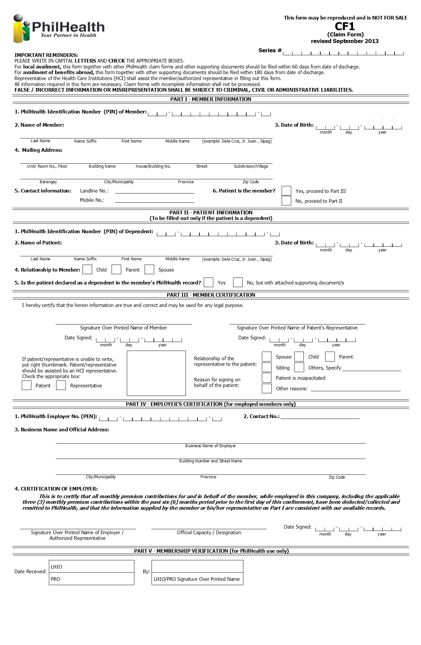

Response Definition

The response of the service is in the form of an XML file.

An example “YES” Xml Response :

<RESPONSE

ISOK="YES"

TRACKING_NUMBER="1234561212000011"

REMAINING_DAYS="44"

ASOF="12-19-2012">

<PATIENT

PATIENTIS="M"

LASTNAME="DELA CRUZ"

FIRSTNAME="JUAN"

MIDDLENAME="OCAMPO"

SUFFIX="JR"

BIRTHDATE="09-15-1970"

></PATIENT>

<CONFINMENT>

ADMITTED="12-19-2012"

DISCHARGE="12-19-2012"

</CONFINMENT>

<MEMBER

PIN="190905703882"

MEMBER_TYPE="P"

LASTNAME="DELA CRUZ"

FIRSTNAME="JUAN"

MIDDLENAME="OCAMPO"

SUFFIX="SR"

BIRTHDATE="09-15-1970"

></MEMBER>

<EMPLOYER>

PEN="019000029665"

NAME="SAMPLE HOSPITAL"

</EMPLOYER>

<DOCUMENTS>

</DOCUMENTS>

</RESPONSE>

For the “YES” Response, the developer of the module 1 should be able to display the Tracking Number (TN) . The same TN will later be used for the uploading of electronic claims.

The following below sample format must be used:

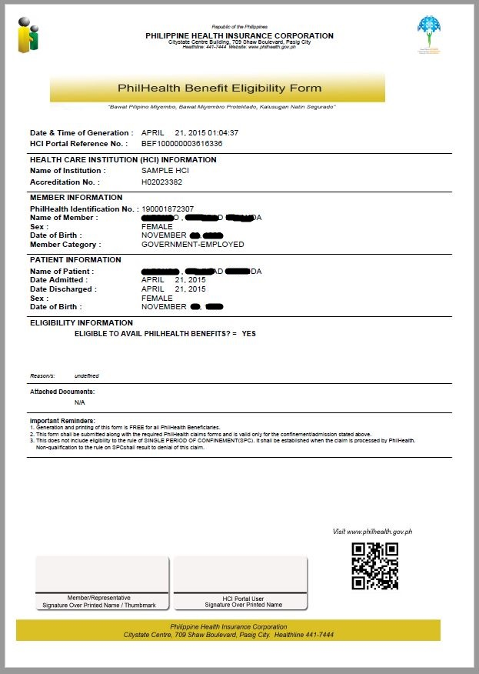

An example “NO” Xml Response :

<RESPONSE

ISOK="NO"

TRACKING_NUMBER=""

REMAINING_DAYS=""

ASOF="12-19-2012">

<PATIENT

PATIENTIS="D"

LASTNAME="DELA CRUZ"

FIRSTNAME="MARIA"

MIDDLENAME="BAUTISTA"

SUFFIX=""

BIRTHDATE="01-01-2005"

></PATIENT>

<CONFINMENT>

ADMITTED="12-19-2012"

DISCHARGE="12-19-2012"

</CONFINMENT>

<MEMBER

PIN="190905703882"

MEMBER_TYPE="S"

LASTNAME="DELA CRUZ"

FIRSTNAME="JUAN"

MIDDLENAME="OCAMPO"

SUFFIX="JR"

BIRTHDATE="09-15-1970"

></MEMBER>

<EMPLOYER>

PEN="019000029665"

NAME="SAMPLE HOSPITAL"

</EMPLOYER>

<DOCUMENTS>

<DOCUMENT

CODE="PBC"

NAME="PATIENT'S BIRTH CERTIFICATE">UNDECLARED DEPENDENT

</DOCUMENT>

<DOCUMENT

CODE="MBC"

NAME="MEMBER'S BIRTH CERTIFICATE">DISCREPANCY-MEMBER’S FIRSTNAME;DISCREPANCY-

MEMBER’S LAST NAME

</DOCUMENT>

</DOCUMENTS>

</RESPONSE>

The message remarks should be relayed to the member or authorized representative of the member for compliance of the listed documents to be submitted to the hospital for document scanning which will be part of module 2.

The next sample format must be used.

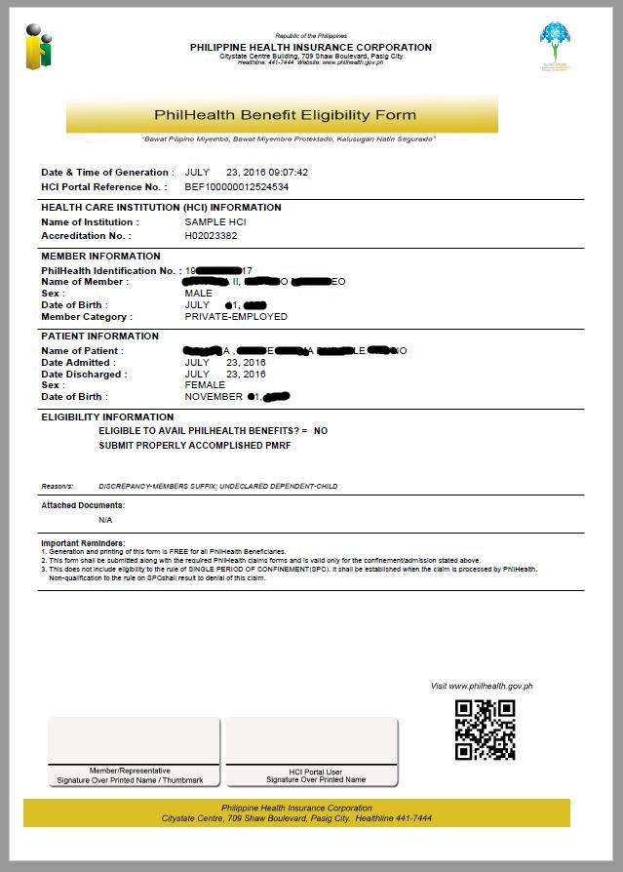

For the service methods of PECWS starting with version 2.5, the all service methods of the PECWS, all input and output parameters of the

### Module 1a: PIN Verification Utility

This utility allows member through the IHCP to look up its PhilHealth Identification Number (PIN) in the event the member does not know his PIN. The hospital needs to enter the information of the member such as the complete name including the suffix if applicable and birth date.

**Web Service Method**

GetMemberPIN (pUserName, pUserPassword, pHospitalCode, pMemberLastName, pMemberFirstName, pMemberMiddleName, pMemberSuffix, pMemberBirthDate)

Parameter Definition

|  |  |  |  |
| --- | --- | --- | --- |
| **Name** | **Length** | **Description** | **Valid Values** |
| pUserName | String(20) | Provider user id | To be provided by PhilHealth |
| pUserPassword | String(20) | Provider user password | To be provided by PhilHealth |
| pHospitalCode | String(12) | Facility Accreditation Number | For now PMCC number should be used |
| pMemberLastName | String(60) | Member Last Name |  |
| pMemberFirstName | String(60) | Member First Name |  |
| pMemberMiddleName | String(60) | Member Middle Name |  |
| pMemberSuffix | String(7) | Member Suffix Name |  |
| pMemberBirthDate | String(10) | Member Birth Date | Date Format should be :  ‘MM-DD-YYYY’ |

* For successful transaction, a PhilHealth Number will be returned:

e.g.

**19-0000220202**

* For unsuccessful transaction, the method will return either of the following:

1. If no corresponding PhilHealth Identification Number was found:

**NO RECORD FOUND. REGISTER ONLINE OR PROCEED TO ANY PHILHEALTH OFFICE**

1. If Multiple PINs were found:

**MULTIPLE RECORDS FOUND. PLEASE PROCEED TO ANY PHILHEALTH OFFICE FOR PIN CLEANUP**

### Module 1b: Doctor Accreditation Check

For case rates, cases attended by non-accredited doctors are denied. Another functionality of the system is its capacity to check whether or not the attending doctor is accredited. The hospital clerk needs to enter the information of the doctor such as doctor accreditation code, admission date and discharge date. The admission date and discharge date will be checked against the validity of the doctor’s accreditation.

**Web Service Method**

isDoctorAccredited (pUserName, pUserPassword, pHospitalCode, pDoctorAccreCode, pAdmissionDate, pDischargeDate)

Parameter Definition

|  |  |  |  |
| --- | --- | --- | --- |
| **Name** | **Length** | **Description** | **Valid Values** |
| pUserName | String(20) | Provider user id | To be provided by PhilHealth |
| pUserPassword | String(20) | Provider user password | To be provided by PhilHealth |
| pHospitalCode | String(12) | Facility Accreditation Number | For now PMCC number should be used |
| pDoctorAccreCode | String(12) | Health Care Professional Accreditation Number |  |
| pAdmissionDate | String(10) | Date of Admission | Date Format should be :  ‘MM-DD-YYYY’ |
| pDischargeDate | String(10) | Date of Discharge | Date Format should be :  ‘MM-DD-YYYY’ |

**Sample XML Response**

< eACCREDITATION

IsAccredited=””

pDoctorAccreCode=””

pAdmissionDate=””

pDischargeDate=””>

* For successful transaction,

***PhilHealth will return “Doctor is accredited based on admission or discharge date”***

* For unsuccessful transaction,

***PhilHealth will return “Doctor is not accredited based on admission or discharge”***

### Module 1c: HCP Accreditation Number Utility

In the event the attending health care professionals (HCP) do not know their PhilHealth accreditation numbers (PAN), they can check using the Doctor Accreditation Number Utility. The HCI clerk needs to enter the information of the doctor such as complete name and date of birth.

**Web Service Method**

GetDoctorPAN (pUserName, pUserPassword, pHospitalCode, pDoctorTIN, pDoctorLastName, pDoctorFirstName, pDoctorMiddleName, pDoctorSufix, pDoctorBirthDate)

Parameter Definition

|  |  |  |  |
| --- | --- | --- | --- |
| **Name** | **Length** | **Description** | **Valid Values** |
| pUserName | String(20) | Provider user id | To be provided by PhilHealth |
| pUserPassword | String(20) | Provider user password | To be provided by PhilHealth |
| pHospitalCode | String(12) | Facility Accreditation Number | For now PMCC number should be used |
| pDoctorTIN | String(12) | Health Care Professional TIN |  |
| pDoctorLastName | String(60) | Health Care Professional Last Name |  |
| pDoctorFirstName | String(60) | Health Care Professional First Name |  |
| pDoctorMiddleName | String(60) | Health Care Professional Middle Name |  |
| pDoctorSufix | String(7) | Health Care Professional Suffix Name |  |
| pDoctorBirthDate | String(10) | Health Care Professional Birth Date | Date Format should be :  ‘MM-DD-YYYY’ |

* If ECWS finds a matching record for the passed data of the HCP, ECWS will return the 12-digit PAN in the format ***“0000-0000000-0”***
* If ECWS does not find a matching record, ECWS will return a blank string (“”);
* If ECWS encountered an exception/error while querying for the records of the HCP, ECWS will return the exception/error message using the format “***ERROR: <error message>****”*

### Module 1d: Check Single Period of Confinement

**Web Service Method** [Not yet implemented!!!]

CheckSinglePeriod (pUserName, pUserPassword, pHospitalCode, pPIN, pPatientIs, pPatientLastName, pPatientFirstName, pAdmissionDate, PhilhealthClaimType, pICDCodes, pHighRVSs, pCaseRateCode)

Single period of confinement refers to a confinement or series of confinements for the same illness with intervals of not more than 90 days. In such cases, they can only avail of the unused portion of the benefits and room and board allowance until the 45 days allowance is exhausted.

***PhilHealth will display “ Same illness within 90 days”***

### Module 1e: Employer Search

This can be used in searching employer with PhilHealth Employer Number.

**Web Service Method**

SearchEmployer (pUserName, pUserPassword, pHospitalCode, pPEN, pEmployerName)

Parameter Definition

|  |  |  |  |
| --- | --- | --- | --- |
| **Name** | **Length** | **Description** | **Valid Values** |
| pUserName | String(20) | Provider user id | To be provided by PhilHealth |
| pUserPassword | String(20) | Provider user password | To be provided by PhilHealth |
| pHospitalCode | String(12) | Facility Accreditation Number | For now PMCC number should be used |
| pPEN | String(12) | PhilHealth Employer Number |  |
| pEmployerName | String(60) | PhilHealth Employer Name | Minimum length: 10 characters. Wildcard characters are supported. The percent (%) wildcard matches one or more characters. For example, passing “PHILIPPINE%” matches names of employers starting with “PHILIPPINE” |

**Sample XML Response**

<eEMPLOYERS

ASOF=””>

<employer

pPEN=””

pEmployerName=””

pEmployerAddress=””>

</eEMPLOYERS>

## Module 2: Electronic Claims Submission

### Module 2a: e-Claims XML data Submission

**Web Service Method**

eClaimsUpload (pUserName, pUserPassword, pHospitalCode, pXML)

This can be used by the hospitals to make their application upload the eClaims file to philhealth. This method also checks for DTD compliance and validate the values of the xml attributes if they are valid based on the

Unsuccessful upload, the method will return:

<eRECEIPT

pUserName="XXXXXX"

pUserPassword="xxx123"

pHospitalCode="123456"

pHospitalTransmittalNo="001"

pTotalClaims="1"

pTransmissionControlNumber=""

pTransmissionDate="08-26-2009"

pTransmissionTime="00:00:00AM" >

<REMARKS pErrCode="T01" pErrDescription="Invalid parameter value: pAmtActual" />

<REMARKS pErrCode="T02" pErrDescription="Invalid parameter value: pOperationDate" />

</eRECEIPT>

Successful upload, the method will return:

<eRECEIPT

pUserName="XXXXXX"

pUserPassword="xxx123"

pHospitalCode="123456"

pHospitalTransmittalNo="001"

pTotalClaims="1"

pTransmissionControlNumber="1234-5601-1234-1253"

pTransmissionDate="08-26-2009"

pTransmissionTime="00:00:00AM"

pReceiptTicketNumber="1234-5601-1234">

</eRECEIPT>

The values for the pReceiptTicketNumber should be saved. This will be used later to retrieve the mapping of the hospital claim id against the philhealth claim series number.

The transmission date will be the official date received for the uploaded claims upon which the Turn- around Time (TAT) will be measured.

The following are the proposed format to be used as guide for hospital systems accomplishing and transmitting electronic PhilHealth claims. These files should be submitted together with scanned images of the actual claim documents to support electronic version. These documents shall be uploaded to a web server provided by the hospital and later on will be viewed by PhilHealth via https.

#### e-Claims XML elements attribute Definition

|  |  |  |  |
| --- | --- | --- | --- |
| **Name** | **Length** | **Description** | **Valid Values** |
| pUserName | String(20) | Provider user id | To be provided by PhilHealth |
| pUserPassword | String(20) | Provider user password | To be provided by PhilHealth |
| pHospitalCode | String(12) | Facility Accreditation Number | For now PMCC number should be used |
| pHospitalEmail | String(150) | Hospital Email Address where communication will be sent | Must not be blank |
| pHospitalTransmittalNo |  | Hospital Transmittal Number | Generated by the Hospital own batching system. This should be unique per hospital. |
| pTotalClaims | String(3) | Claims counter | Integer format |
| pClaimNumber | String(12) | Hospital Claim Number | Hospital Generated Claim Case #, this should be unique per hospital |
| pTrackingNumber | String(20) | The Claims Eligibility Tracking number assigned if undergone the Online Eligibility Checking | Formatted as:  ‘####-####-####-####’  Can be blank |
| pCataractPreAuth | String(20) | Cataract Pre-Authorization Application Number |  |
| pPhilhealthClaimType | String(20) | Flag whether Claims Payment Mechanism | * ‘ALL-CASE-RATE’ * ‘Z-BENEFIT’ |
| pPatientType | String(1) | Patient Type | * ‘I’ – Inpatient * ‘O’ – Outpatient |
| pIsEmergency | String(1) | Flag if Emergency Case | •   ‘Y’ – Yes   * ‘N’ – No |
| pClaimSeriesLhio | String(15) | Philhealth Generated and Assigned Unique Number per Claim | Can be used by the hospital to reconcile their records with Philhealth  This will be returned after the claim are uploaded to Philhealth |
| pMemberPIN | String(12) | PhilHealth Identification Number – a unique 12 digit number assigned to a member. | The last character in the PIN is a modulus 11 check digit. |
| pMemberLastName | String(60) | Member’s Complete Surname | Any value consisting of : ‘A’ to ‘Z’, ‘Ñ’. Can include a space in between characters |
| pMemberFirstname | String(60) | Member’s Complete First name |
| pMemberMiddleName | String(60) | Member’s Complete Middle name |
| pMemberSuffix | String(5) | Member’s Suffix name | ‘JR’, ‘SR’, ‘III’, …etc  Suffixes can be blank |
| pMemberBirthDate | String(10) | Member’s Birth Date | Date Format should be :  ‘MM-DD-YYYY’ |
| pMemberShipType | String(2) | Philhealth membership type of the member | (Not limited to the following :)   * ‘S’ – Employed Private * ‘G’ – Employer Government * ‘I’ – Indigent * ‘NS’ – Individually Paying * ‘NO’ – OFW * ‘PS’ – Non Paying Private * ‘PG’ – Non Paying Government * ‘P’ – Lifetime Member |
| pMailingAddress | String(150) | Mailing Address (address where the benefit payment notice will be sent) | This is where the notices will be mailed. |
| pZipCode | String(4) | Philippine Zip Code of the municipality | 4 digit Philippine zip code value of the municipality/city |
| pMemberSex | String(1) | Member Sex | * ‘M’ – Male * ‘F’ – Female |
| pLandlineNo | String(20) | Members Landline Number | Can be blank |
| pMobileNo | String(20) | Members Cell Number | Can be blank |
| pEmailAddress | String(150) | Email Address | Can be blank |
| pPatientIs | String(1) | Flag whether patient is the member or if dependent the relationship of patient with the member. | * ‘M’ – patient is member(Self) * ‘S’ – patient is spouse * ‘C’ – patient is child * ‘P’ – patient is parent |
| pPatientPIN | String(12) | PhilHealth Identification Number – a unique 12 digit number assigned to a patient. | The last character in the PIN is a modulus 11 check digit. |
| pPatientLastName | String(60) | Patient’s Complete Surname | Same as for the member. These can be blank since these are disregarded if the value of pPatientIs is ‘M’ |
| pPatientFirstName | String(60) | Patient’s Complete First name |
| pPatientMiddleName | String(60) | Patient’s Complete Middle name |
| pPatientSuffix | String(5) | Patient’s Suffix name | ‘JR’, ‘SR’, ‘III’, …etc  Suffixes can be blank |
| pPatientBirthDate | String(10) | Patient’s Birth Date | Date Format should be :  ‘MM-DD-YYYY’ |
| pPatientSex | String(1) | Member Sex | * ‘M’ – Male * ‘F’ – Female |
| pPEN | String(12) | Philhealth Employer Number – a unique 12 digit number assigned to an employer | These are disregarded if pMemberShipType is not (‘S’ or ‘G’) |
| pEmployerName | String(100) | The Registered name of the employer |
| pPatientReferred | String(1) | Referred Patient | * ‘Y’ – Yes * ‘N’ – No |
| pReferredIHCPAccreCode | String(12) | Referring Facility Accreditation Code | Required if the patient is referred by another IHCP |
| pAdmissionDate | String(10) | Admission Date | Date Format should be :  ‘MM-DD-YYYY’ |
| pDischargeDate | String(10) | Discharge Date |
| pAdmissionTime | String(10) | Admission Time | Time Format should be :  ‘HH:MM:SSAM/PM’ |
| pDischargeTime | String(10) | Discharge Time |
| pDisposition | String(1) | Patient’s Disposition | * ‘I’ – Improved * ‘R’ – Recovered * ‘H’ – Home/Discharged Against Medical Advise * ‘A’ – Absconded * ‘E’ – Expired * ‘T’ – Transferred/Referred |
| pExpiredDate | String(10) | Date of Death of patient | Date Format should be :  ‘MM-DD-YYYY’  Required when pDisposition = ‘E’ |
| pExpiredTime | String(10) | Time of Death of patient | Time Format should be :  ‘HH:MM:SSAM/PM’  Required when pDisposition = ‘E’ |
| pReferralIHCPAccreCode | String(12) | Referral Facility Accreditation Code | Required when  pDisposition = ‘T’ |
| pReferralReasons | String(150) | Reason/s for referral/transfer |
| pAccommodationType | String(1) | Type of Accommodation | * ‘P’ – Private * ‘N’ – Non-Private (Charity/Service) |
| pAdmissionDiagnosis | String(500) | Admission Diagnosis | Can be multiple lines |
| pDischargeDiagnosis | String(500) | Discharge Diagnosis |  |
| pICDCode | String(15) | ICD 10 Code of the illness | *Refer to ICD10 library* |
| pRelatedProcedure | String(150) | Related Procedure | Any value consisting of : ‘A’ to ‘Z’, ‘Ñ’. Can include a space in between characters |
| pRVSCode | String(6) | Relative Value Scale Code of the procedure/operation performed | *See RVS Library*  Required for Operating Room, Surgeons and Anesthesiologist claims only |
| pProcedureDate | String(10) | Date of Procedure | Date Format should be :  ‘MM-DD-YYYY’ |
| pLaterality | String(1) | Laterality | * ‘L’ – Left * ‘R’ – Right * ‘B’ – Both * ‘N’ – N/A |
| pSessionDate | String(10) | Inclusive Date of Session | Date Format should be :  ‘MM-DD-YYYY’ |
| pCheckUpDate1 | String(10) | 1stCheckup Date for MCP Package | Date Format should be :  ‘MM-DD-YYYY’  Required for prenatal claims under non-hospital facility |
| pCheckUpDate2 | String(10) | 2ndCheckup Date for MCP Package |
| pCheckUpDate3 | String(10) | 3rdCheckup Date for MCP Package |
| pCheckUpDate4 | String(10) | 4thCheckup Date for MCP Package |
| pTBType | String(1) | Type of TB-Dots claim | * ‘I’ – Intensive Phase * ‘M’ – Maintenance   NOTE  For ‘I’, admission and discharge dates should be the first and last days of treatment in the intensive phase respectively.  For ‘M’, admission and discharge dates should be the first and last days of treatment in the maintenance phase respectively.  Required for TB-DOTS claims only |
| pNTPCardNo | String(10) | NTP Card No | Required for TB-DOTS claims only |
| pDay0ARV | String(10) | Day 0 ARV (Anti Rabies Vaccine) | Date Format should be :  ‘MM-DD-YYYY’  Required for Animal Bite Package claims only |
| pDay3ARV | String(10) | Day 3 ARV (Anti Rabies Vaccine) |
| pDay7ARV | String(10) | Day 7 ARV (Anti Rabies Vaccine) |
| pRIG | String(10) | RIG (Rabies Immunoglobulin) |
| pABPOthers | String(10) | Other Date |
| pABPSpecify | String(50) | Others (Specify) | Required for Animal Bite Package claims only |
| pEssentialNewbornCare | String(1) | Essential Newborn Care | Flag whether Yes (Y) or No (N)  Required for Newborn Care Package |
| pNewbornHearingScreeningTest | String(1) | Newborn Hearing Screening Test |
| pNewbornScreeningTest | String(1) | Newborn Screening Test |
| pFilterCardNo | String(20) | Filter Card Number | Required when the pNewbornScreeningTest = ‘Y’ |
| pDrying | String(1) | Immediate drying of newborn | Flag whether Yes (Y) or No (Y)  Required when the pEssentialNewbornCare = ‘Y’ |
| pSkinToSkin | String(1) | Early skin-to-skin contact |
| pCordClamping | String(1) | Timely cord clamping |
| pProphylaxis | String(1) | Eye prophylaxis |
| pWeighing | String(1) | Weighing of the newborn |
| pVitaminK | String(1) | Vitamin K administration |
| pBCG | String(1) | BCG vaccination |
| pNonSeparation | String(1) | Non-separation of mother/baby for early breastfeeding initiation |
| pHepatitisB | String(1) | Hepatitis B vaccination |
| pLaboratoryNumber | String(20) | Laboratory Number | Required for Outpatient HIV/AIDS Treatment Package |
| pDoctorAccreCode | String(12) | Doctor’s Accreditation Number | Formatted as: ‘####-######-##’ |
| pDoctorLastName | String(60) | Doctor’s Complete Surname | Same as for the member. |
| pDoctorFirstName | String(60) | Doctor’s Complete First name |
| pDoctorMiddleName | String(60) | Doctor’s Complete Middle name |
| pDoctorSuffix | String(5) | Doctor’s Suffix name | ‘JR’, ‘SR’, ‘III’, …etc  Suffixes can be blank |
| pWithCoPay | String(1) | Flag whether the professional fee is no co-pay or with co-pay | * ‘Y’ – With co-pay * ‘N’ –Noco-pay |
| pDoctorCoPay | String(12) | Amount of co-pay | Formatted as: ‘#######.##’  Required when pWithCoPay=’Y’ |
| pEnoughBenefits | String(1) | (Y) – if the PhilHealth benefit is enough to cover HCI and PF charges. No purchases of drugs/medicines, supplies, diagnostics, and co-pay for professional fees by the member/patient.  (N) –if the benefit of the member/patient was completely consumed prior to co-pay OR the benefit of the member/patient is not completely consumed BUT with  purchases/expenses for drugs/medicines, supplies, diagnostics and others. | Flag whether Yes(Y) or No(N) |
| pTotalHCIFees | String(12) | Total Health Care Institution Fees | Formatted as: ‘#######.##’  Required whenpEnoughBenefits = ‘Y’ |
| pTotalProfFees | String(12) | Total Professional Fees |
| pGrandTotal | String(12) | Grand Total is equal to the HCI and Prof Fees |
| pTotalActualCharges | String(12) | Total Actual Charges | Formatted as: ‘#######.##’  Required whenpEnoughBenefits = ‘N’ |
| pDiscount | String(12) | Amount after Application of Discount |
| pPhilhealthBenefit | String(12) | PhilHealth Benefit |
| pTotalAmount | String(12) | Amount after PhilHealth Deduction |
| pMemberPatient | String(1) | Member/Patient | Flag whether Yes(Y) or No(N) if applicable |
| pHMO | String(1) | HMO |
| pOthers | String(1) | Others (i.e., PCSO, Promissory note, etc.) |
| pDrugsMedicinesSupplies | String(1) | (Y) –if there is a purchase/s for drugs/medicines and/or medical supplies bought by the patient/member within/outside the HCI during confinement  (N) – None | Flag whether Yes(Y) or No(N) |
| pDMSTotalAmount | String(12) | Total Amount for Drugs, Medicines and Supplies | Formatted as: ‘#######.##’  Required when  pDMSTotalAmount = ‘Y’ |
| pExaminations | String(1) | (Y) – if there is a diagnostic/laboratory examinations paid for by the patient/member done within/outside the HCI during confinement  (N) – None | Flag whether Yes(Y) or No(N) |
| pExamTotalAmount | String(12) | Total Amount for Diagnostic | Formatted as: ‘#######.##’  Required when  pExamTotalAmount = ‘Y’ |
| pCaseRateCode | String(6) | Case Rate Codes for All Case Rates | *See Case Rate Library* |
| pZBenefitCode | String(7) | Z-Benefit Codes | Standard Risk Acute Lymphocytic (lymphoblastic) Leukemia for Children   * Z0011 – 1st tranche * Z0012 – 2nd tranche * Z0013 – 3rd tranche   Early Stage Breast Cancer (Stage 0 to III-A)   * Z0021 –1st tranche * Z0022 –2nd tranche   Low to Intermediate Risk Prostate Cancer Requiring Prostatectomy   * Z003 – full payment   End Stage Renal Disease Eligible for Kidney Transplant (Low Risk)   * Z0041 –1st tranche * Z0042 –2nd tranche   Elective Surgery for Standard Risk Coronary Artery Bypass Graft (CABG)   * Z0051 – 1st tranche * Z0052 – 2nd tranche   Tetralogy of Fallot (TOF)   * Z0061 – 1st tranche * Z0062 – 2nd tranche   Ventricular Septal Defect(VSD)   * Z0071 – 1st tranche * Z0072 – 2nd tranche   Cervical Cancer Chemoradiation with Cobalt & Brachytherapy (Low Dose) or Primary Surgery for Stage IA1, IA2 – IIA1   * Z0081 – 1st tranche * Z0082 – 2nd tranche   Cervical Cancer Chemoradiation with Linear Accelerator & Brachytherapy (High Dose)   * Z0091 – 1st tranche * Z0092 – 2nd tranche |
| pChiefComplaint | String(200) | Chief Complaint or Reason for Admission | Text/Memo |
| pBriefHistory | String(2500) | Brief History of Present Illness (OB Score/OB History) | Text/Memo |
| pCourseWard | String(500) | Course in the Wards | Text/Memo |
| pPertinentFindings | String(500) | Pertinent Laboratory and Diagnostic Findings | Text/Memo |
| pPrenatalConsultation | String(10) | Initial Prenatal Consultation | Date Format should be :  ‘MM-DD-YYYY’ |
| pMCPOrientation | String(1) | Orientation to MCP/Availment of Benefits | Flag whether Yes(Y) or No(N) |
| pExpectedDeliveryDate | String(10) | Expected data of delivery | Date Format should be :  ‘MM-DD-YYYY’ |
| pVitalSigns | String(1) | Vital Signs are Normal | Flag whether Yes(Y) or No(N) |
| pPregnancyLowRisk | String(1) | Ascertain the Present. Pregnacy is low-risk |
| pLMP | String(10) | Last Menstrual Period | Date Format should be :  ‘MM-DD-YYYY’ |
| pMenarcheAge | String(2) | Age of Menarche | Must be an integer |
| pObstetricG | String(10) | Obstetric History | Text |
| pObstetricP | String(10) | Text |
| pObstetric_T | String(10) | Text |
| pObstetric_P | String(10) | Text |
| pObstetric_A | String(10) | Text |
| pObstetric_L | String(10) | Text |
| pMultiplePregnancy | String(1) | Multiple Pregnancy | Obstetric Risk Factors  Flag whether Yes(Y) or No(N) |
| pOvarianCyst | String(1) | Ovarian Cyst |
| pMyomaUteri | String(1) | Myoma Uteri |
| pPlacentaPrevia | String(1) | Placenta Previa |
| pMiscarriages | String(1) | History of 3 miscarriages |
| pStillBirth | String(1) | History of stillbirth |
| pPreEclampsia | String(1) | History of pre-eclampsia |
| pEclampsia | String(1) | History of eclampsia |
| pPrematureContraction | String(1) | Premature contraction |
| pHypertension | String(1) | Hypertension | Medical/Surgcal risk factors  Flag whether Yes(Y) or No(N) |
| pHeartDisease | String(1) | Heart Disease |
| pDiabetes | String(1) | Diabetes |
| pThyroidDisaster | String(1) | Thyroid Disorder |
| pObesity | String(1) | Obesity |
| pAsthma | String(1) | Moderate to severe asthma |
| pEpilepsy | String(1) | Epilepsy |
| pRenalDisease | String(1) | Renal Disease |
| pBleedingDisorders | String(1) | Bleeding disorders |
| pPreviousCS | String(1) | History of previous caesarian section |
| pUrineMyomectomy | String(1) | History of uterine myomectomy |
| pVisitDate | String(10) | Date of visit | Date Format should be :  ‘MM-DD-YYYY’ |
| pAOGWeeks | String(3) | AOG in weeks | Text |
| pWeight | String(10) | Weight | Weight & Vital Signs |
| pCardiacRate | String(10) | Cardiac Rate |
| pRespiratoryRate | String(10) | Respiratory Rate |
| pBloodPressure | String(10) | Blood Pressure |
| pTemperature | String(10) | Temperature |
| pDeliveryDate | String(10) | Date of Delivery | Date Format should be :  ‘MM-DD-YYYY’ |
| pDeliveryTime | String(10) | Time of Delivery | Time Format should be :  ‘HH:MM:SSAM/PM’ |
| pObstetricIndex | String(50) | Obstetric Index | Text |
| pAOGLMP | String(50) | AOG by LMP | Text |
| pDeliveryManner | String(50) | Manner of Delivery | Text |
| pPresentation | String(50) | Presentation | Text |
| pFetalOutcome | String(50) | Fetal Outcome | Text |
| pSex | String(1) | Sex | * ‘M’ – Male * ‘F’ –Female |
| pBirthWeight | String(10) | Birth Weight (gram) | Must be an integer |
| pAPGARScore | String(10) | APGAR Score |  |
| pPostpartum | String(10) | Scheduled Posparum follow-up consultation 1 week after delivery | Date Format should be :  ‘MM-DD-YYYY’ |
| pPerinealWoundCare | String(1) | Perineal wound care | Flag whether Yes(Y) or No(N) |
| pPerinealRemarks | String(100) | Remarks | Text/Memo |
| pMaternalComplications | String(1) | Signs of Maternal Postparum Complications | Flag whether Yes(Y) or No(N) |
| pMaternalRemarks | String(100) | Remarks | Text/Memo |
| pBreastFeeding | String(1) | Breastfeeding and Nutrition | Flag whether Yes(Y) or No(N) |
| pBreastFeedingRemarks | String(100) | Remarks | Text/Memo |
| pFamilyPlanning | String(1) | Family Planning | Flag whether Yes(Y) or No(N) |
| pFamilyPlanningRemarks | String(100) | Remarks | Text/Memo |
| pPlanningService | String(1) | Provided family planning service to patient  (as requested by patient) | Flag whether Yes(Y) or No(N) |
| pPlanningServiceRemarks | String(100) | Remarks | Text/Memo |
| pSurgicalSterilization | String(1) | Referred to partner physician for Voluntary Surgical Sterilization  (as requested by patient) | Flag whether Yes(Y) or No(N) |
| pSterilizationRemarks | String(100) | Remarks | Text/Memo |
| pFollowupSchedule | String(1) | Schedule the next postpartum follow-up | Flag whether Yes(Y) or No(N) |
| pFollowupScheduleRemarks |  | Remarks | Text/Memo |
| pReferredReason | String(500) | Reason for referral from other HCI | Text/Memo |
| pIntensive | String(1) | Completed Intensive Phase | Flag whether Yes(Y) or No(N) |
| pMaintenance | String(1) | Completed Maintenance Phase |
| pCriteria | String(200) | Clinical Criteria and/or Laboraties/Diagnositics Criteria | Text/Memo |
| pBP | String(20) | Blood Pressure | Text |
| pCR | String(20) |  | Text |
| pRR | String(20) | Respiratory Rate | Text |
| pTemp | String(20) | Temperature | Text |
| pHEENT | String(20) | Head, Ears, Eyes, Nose and Throat | Text |
| pChestLungs | String(20) | Chest/Lungs | Text |
| pCVS | String(20) |  | Text |
| pAbdomen | String(20) | Abdomen | Text |
| pGUIE | String(20) |  | Text |
| pSkinExtremities | String(20) | Skin Extremities | Text |
| pNeuroExam | String(20) | Neuro Examination | Text |
| pCourseDate | String(10) | Date in the Course in the Ward | Date Format should be :  ‘MM-DD-YYYY’ |
| pFindings | String(200) | Pertinent PE/Lab Findings | Text/Memo |
| pAction | String(200) | Doctors Order/Action | Text/Memo |
| pPurchaseDate | String(10) | Date of Purchased | Date Format should be :  ‘MM-DD-YYYY’ |
| pDrugCode | String(20) | Hospital Assigned Drug Code | Can be any format |
| pPNDFCode | String(20) | PNDF Code (Blank until PNDF lib is available) | Can be Blank for now |
| pGenericName | String(50) | Generic Name of Medicines/Drugs taken | Must not be blank |
| pBrandName | String(50) | Brand Name of Medicines/Drugs taken | Must not be blank |
| pPreparation | String(30) | Dose/ Cap/ Syrup/ Injectible/ Tab with ml/mg/gm content | Must not be blank |
| pQuantity | String(10) | Unit quantity of item | Integer format |
| pDiagnosticDate | String(10) | Date of Diagnostic | Date Format should be :  ‘MM-DD-YYYY’ |
| pDiagnosticType | String(20) | Type of diagnostic/test done | * ‘IMAGING’ * ‘LABORATORY’ * ‘SUPPLIES’ * ‘OTHERS’ |
| pDiagnosticName | String(50) | Name of Imaging procedure for Imaging,  Name of Laboratory procedure for Laboratory,  Name of Supplies for Supplies or Others for Supplies and Others | Must not be blank |
| pCompanyName | String(100) | Company’s Name | Text |
| pCompanyTIN | String(15) | Company’s TIN | Formatted as: ‘###-###-###-###’ |
| pBIRPermitNumber | String(20) | BIR Permit Number |  |
| pReceiptNumber | String(20) | Official Receipt Number |  |
| pReceiptDate | String(12) | Official Receipt Date | Date Format should be :  ‘MM-DD-YYYY’ |
| pVATExemptSale | String(10) | VAT Exempt Sale | Formatted as: ‘#######.##’ |
| pVAT | String(10) | VAT – 12% |
| pTotal | String(10) | Total Amount in the Receipt |
| pUnitPrice | String(10) | Unit price of item | Formatted as: ‘#######.##’ |
| pDescription | String(100) | Item Description | Text |
| pAmount | String(10) | Total Amount of the Specific Item | Formatted as: ‘#######.##’ |
| pDocumentType | String(3) | Document to support the claim | *See Document Library* |
| pDocumentURL | String(250) | URL of the document accessible via https. | The document must first be encrypted using philhealth public key before publishing online. Please see the Annex for the guidelines for encryption. |
| pHospitalTransmittalNo | String(20) | Hospital Generated Transmittal Number |  |
| pTransmissionControlNumber | String(18) | Philhealth Generated Transmittal file control number. | Will be blank if the transmission is failed |
| pErrCode | String(3) | Claim file error Code |  |
| pErrDescription | String(100) | Claim file error Description |  |
| pReceiptTicketNumber | String(18) | Philhealth Generated Upload Comfirmation Receipt ticket number |  |
| pTransmissionDate | String(10) |  | Date Format should be :  ‘MM-DD-YYYY’ |
| pTransmissionTime | String(10) |  | TIME Format should be :  ‘HH:MM:SSAM/PM’ |
| pReceivedDate | String(10) | Date when the transmitted file received by PhilHealth | Date Format should be :  ‘MM-DD-YYYY’ |
| pHasAttachedSOA | String(1) | Type of Accommodation | * ‘Y’ – With attached SOA * ‘N’ –Without attached SOA |
| pDateSigned | String(10) | Date signed | Date Format should be :  ‘MM-DD-YYYY’ |
| pRelCode | String(1) | Code indicating the relation of the representative who signed the consent to access patient record | Valid values:   * S = Spouse * C = Child * P = Parent * I = Sibling * O = Others (pRelDesc should have a value) |
| pRelDesc | String(50) | Specified relation of the representative who signed the consent on behalf of the patient to access patient records. This include relation not included in the list of defined values of relation of pRelCode |  |
| pReasonCode | String(1) | Code indicating the reason why a representative signed the consent to access patient record | Valid values:   * I = Patient is incapacitated * O = Patient is incapacitated (pReasonDesc should have a value) |
| pReasonDesc | String(50) | Text indicating reason why a reason why a representative signed the consent to access patient record |  |
| pPreAuthDate | String(10) | Z-Benefit pre-authorization date | Date Format should be :  ‘MM-DD-YYYY’ |
| pThumbmarkedBy | String(1) | Indicates whether the thumbmark is from the member/patient or from the representative of the member | Valid values:   * P = of the patient/member * R = of a representative |
| pServiceProvider | String(50) | The acronym or short name of the company/institution that provided the system used in submitting the e-claims XML file |  |
| pCertificateId | String(50) | The software validation certificate number issued upon passing the software compliance testing |  |

The above table defines the valid values for the attributes in the xml. These attributes will hold the actual value they represent.

Draft Revised Claim Form 2 (front)

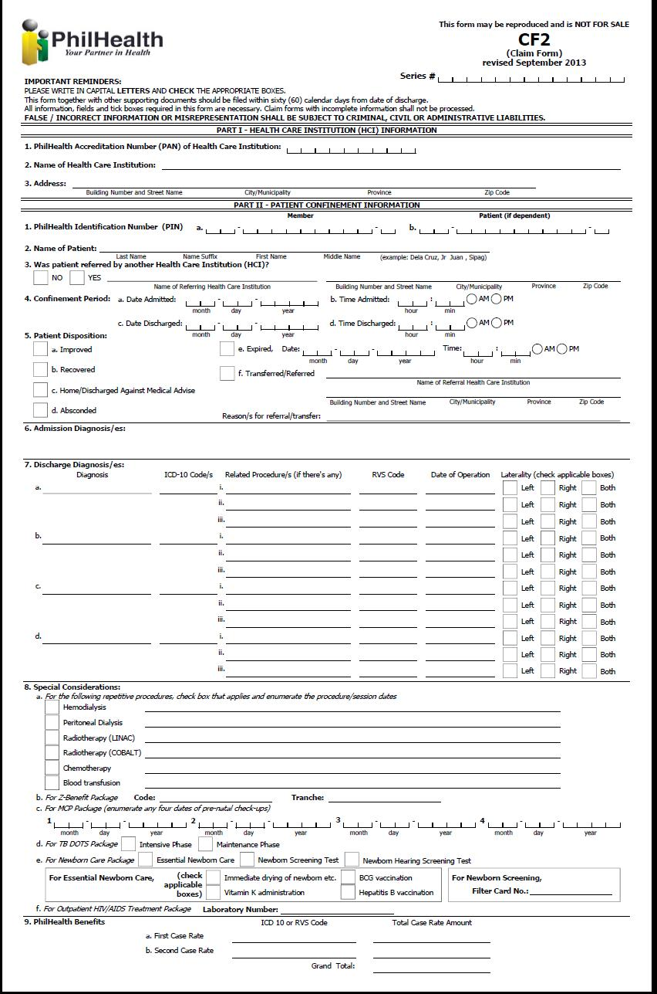

Revised Claim Form 2 (back)

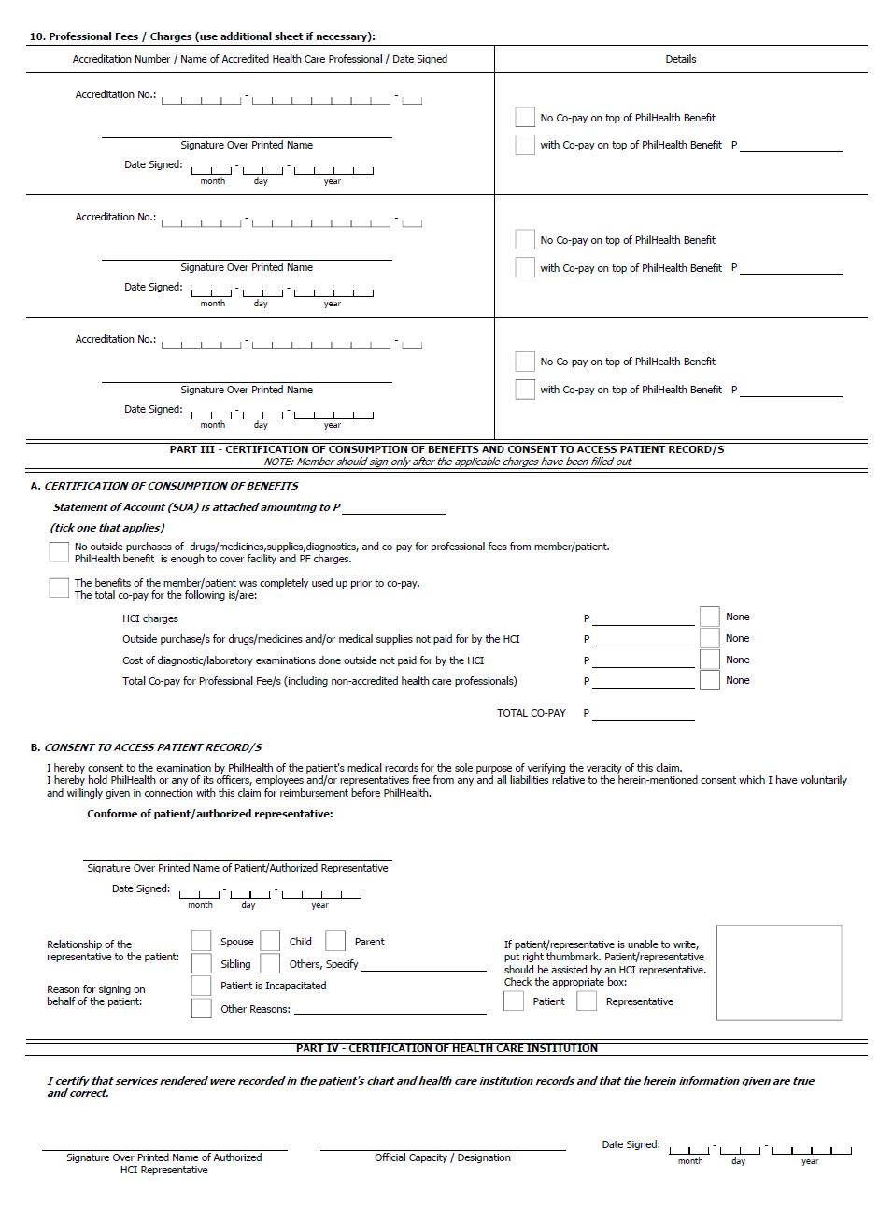

#### e-Claims XML Layout

Pertinent claims information will be transformed electronically by using the Extensible Markup Language (XML). The following sample is an illustration:

<eCLAIMS

pUserName=**""**

pUserPassword=**""**

pHospitalCode=**"123456"**

pHospitalEmail=[**email@yahoo.com**](mailto:email@yahoo.com)

pServiceProvider=**"ACMESOFT"**

pCertificateId=**"200107123433"**>

<eTRANSMITTAL

pHospitalTransmittalNo=**"20160901"**

pTotalClaims=**"1"**>

<CLAIM

pClaimNumber=**"123456-20160930-2"**

pTrackingNumber=**""**

pPhilhealthClaimType=**"ALL-CASE-RATE"**

pPatientType=**"I"**

pIsEmergency=**"N"**>

<CF1

pMemberPIN=**"072007271094"**

pMemberLastName=**"DELA CRUZ"**

pMemberFirstName=**"JUAN"**

pMemberSuffix=**""**

pMemberMiddleName=**"OCAMPO"**

pMemberBirthDate=**"09-19-1973"**

pMemberShipType=**"G"**

pMailingAddress=**"PHILIPPINES"**

pZipCode=**"1234"**

pMemberSex=**"M"**

pLandlineNo=**""**

pMobileNo=**""**

pEmailAddress=**"delacruzjuan@yahoo.com.ph"**

pPatientIs=**"M"**

pPatientPIN=**"072007271094"**

pPatientLastName=**"DELA CRUZ"**

pPatientFirstName=**"JUAN"**

pPatientSuffix=**""**

pPatientMiddleName=**"OCAMPO"**

pPatientBirthDate=**"09-19-1973"**

pPatientSex=**"M"**

pPEN=**"11-047400000-2"**

pEmployerName=**"PHILHEALTH"**/>

<CF2

pPatientReferred=**"Y"**

pReferredIHCPAccreCode=**"H12345678"**

pAdmissionDate=**"09-01-2016"**

pAdmissionTime=**"01:00:00PM"**

pDischargeDate=**"09-03-2016"**

pDischargeTime=**"03:00:00PM"**

pDisposition=**"I"**

pExpiredDate=**""**

pExpiredTime=**""**

pReferralIHCPAccreCode=**""**

pReferralReasons=**""**

pAccommodationType=**"N"**

pHasAttachedSOA=**"Y"**>

<DIAGNOSIS

pAdmissionDiagnosis=**"PNEUMONIA"**>

<DISCHARGE

pDischargeDiagnosis=**"END STAGE RENAL DISEASE"**>

<ICDCODE pICDCode=**"O13.012"**/>

<ICDCODE pICDCode=**"O13.013"**/>

<RVSCODES

pRelatedProcedure=**"HEMODIALYSIS"**

pRVSCode=**"90935"**

pProcedureDate=**"08-26-2009"**

pLaterality=**"L"**/>

</DISCHARGE>

<DISCHARGE

pDischargeDiagnosis=**"DENGUE"**>

<ICDCODE pICDCode=**"A90.0"**/>

</DISCHARGE>

</DIAGNOSIS>

<SPECIAL>

<!-- For Repetitive Procedures -->

<PROCEDURES>

<HEMODIALYSIS>

<SESSIONS pSessionDate=**"08-25-2009"**/>

<SESSIONS pSessionDate=**"08-26-2009"**/>

</HEMODIALYSIS>

<CHEMOTHERAPY>

<SESSIONS pSessionDate=**"08-27-2009"**/>

</CHEMOTHERAPY>

</PROCEDURES>

<!-- For MCP Package -->

<!--MCP

pCheckUpDate1="08-25-2009"

pCheckUpDate2="08-26-2009"

pCheckUpDate3="08-27-2009"

pCheckUpDate4="08-28-2009"/-->

<!-- For TB DOTS Package -->

<!--TBDOTS

pTBType="I"

pNTPCardNo=""/-->

<!-- For Animal Bite Package -->

<!--ABP

pDay0ARV="08-25-2009"

pDay3ARV="08-25-2009"

pDay7ARV="08-25-2009"

pRIG="08-25-2009"

pABPOthers=""

pABPSpecify=""/-->

<!-- For Newborn Care Package -->

<!--NCP

pEssentialNewbornCare="Y"

pNewbornHearingScreeningTest="N"

pNewbornScreeningTest="N"

pFilterCardNo="">

<ESSENTIAL

pDrying="Y"

pSkinToSkin="Y"

pCordClamping="Y"

pProphylaxis="Y"

pWeighing="Y"

pVitaminK="Y"

pBCG="Y"

pNonSeparation="Y"

pHepatitisB="Y"/>

</NCP-->

<!-- For Outpatient HIV/AIDS Treatment Package -->

<!--HIVAIDS

pLaboratoryNumber=""/-->

<!--CATARACTINFO

pCataractPreAuth=""

pLeftEyeIOLStickerNumber=""

pLeftEyeIOLExpiryDate=""

pRightEyeIOLStickerNumber=""

pRightEyeIOLExpiryDate=""/-->

</SPECIAL>

<PROFESSIONALS

pDoctorAccreCode=**"1234-1527066-1"**

pDoctorLastName=**"TEST2"**

pDoctorFirstName=**"TEST2"**

pDoctorMiddleName=**"TEST2"**

pDoctorSuffix=**""**

pWithCoPay=**"Y"**

pDoctorCoPay=**"1000"**

pDoctorSignDate=**"08-25-2009"**/>

<CONSUMPTION

pEnoughBenefits=**"Y"**>

<!-- if pEnoughBenefits="Y"-->

<BENEFITS

pTotalHCIFees=**"1000"**

pTotalProfFees=**"1000"**

pGrandTotal=**"2000"**/>

<!-- if pEnoughBenefits="N"-->

<!--

<HCIFEES

pTotalActualCharges="2000"

pDiscount="1800"

pPhilhealthBenefit="1500"

pTotalAmount="300"

pMemberPatient="Y"

pHMO="N"

pOthers="N"/>

<PROFFEES

pTotalActualCharges="3000"

pDiscount="2500"

pPhilhealthBenefit="1500"

pTotalAmount="1000"

pMemberPatient="Y"

pHMO="Y"

pOthers="N"/>

<PURCHASES

pDrugsMedicinesSupplies="Y"

pDMSTotalAmount="1000"

pExaminations="N"

pExamTotalAmount=""/>

-->

</CONSUMPTION>

<APR>

<APRBYPATREPSIG pDateSigned=**"08-26-2009"**>

<DEFINEDPATREPREL pRelCode=**"S"** />

<OTHERREASONFORSIGNING pReasonDesc=**"MEMBER IS MISSING"** />

</APRBYPATREPSIG>

</APR>

</CF2>

<!-- pPhilhealthClaimType="ALL-CASE-RATE" -->

<ALLCASERATE>

<CASERATE

pCaseRateCode=**"CR0001"**

pICDCode=**"A90"**

pRVSCode=**""**

pCaseRateAmount=**"10000"**/>

<CASERATE

pCaseRateCode=**"CR0002"**

pICDCode=**""**

pRVSCode=**"90935"**

pCaseRateAmount=**"2600"**/>

</ALLCASERATE>

<!-- pPhilhealthClaimType="Z-BENEFIT" -->

<!--ZBENEFIT

pZBenefitCode="Z0011">

</ZBENEFIT-->

<CF3>

<CF3_OLD

pChiefComplaint=**""**

pBriefHistory=**""**

pCourseWard=**""**

pPertinentFindings=**""**>

<PHEX

pBP=**""**

pCR=**""**

pRR=**""**

pTemp=**""**

pHEENT=**""**

pChestLungs=**""**

pCVS=**""**

pAbdomen=**""**

pGUIE=**""**

pSkinExtremities=**""**

pNeuroExam=**""**/>

<MATERNITY>

<PRENATAL

pPrenatalConsultation=**"08-26-2009"**

pMCPOrientation=**"Y"**

pExpectedDeliveryDate=**"08-26-2009"**>

<CLINICALHIST

pVitalSigns=**"Y"**

pPregnancyLowRisk=**"Y"**

pLMP=**"08-26-2009"**

pMenarcheAge=**"21"**

pObstetricG=**""**

pObstetricP=**""**

pObstetric_T=**""**

pObstetric_P=**""**

pObstetric_A=**""**

pObstetric_L=**""**/>

<OBSTETRIC

pMultiplePregnancy=**"N"**

pOvarianCyst=**"N"**

pMyomaUteri=**"N"**

pPlacentaPrevia=**"N"**

pMiscarriages=**"N"**

pStillBirth=**"N"**

pPreEclampsia=**"N"**

pEclampsia=**"N"**

pPrematureContraction=**"N"**/>

<MEDISURG

pHypertension=**"N"**

pHeartDisease=**"N"**

pDiabetes=**"N"**

pThyroidDisaster=**"N"**

pObesity=**"N"**

pAsthma=**"N"**

pEpilepsy=**"N"**

pRenalDisease=**"N"**

pBleedingDisorders=**"N"**

pPreviousCS=**"N"**

pUterineMyomectomy=**"Y"**/>

<CONSULTATION

pVisitDate=**"08-20-2009"**

pAOGWeeks=**""**

pWeight=**"50"**

pCardiacRate=**""**

pRespiratoryRate=**"26"**

pBloodPressure=**"160/100"**

pTemperature=**"38.5 C"**/>

<CONSULTATION

pVisitDate=**"08-25-2009"**

pAOGWeeks=**""**

pWeight=**"60"**

pCardiacRate=**""**

pRespiratoryRate=**"26"**

pBloodPressure=**"160/100"**

pTemperature=**"38.5 C"**/>

<CONSULTATION

pVisitDate=**"08-30-2009"**

pAOGWeeks=**""**

pWeight=**"65"**

pCardiacRate=**""**

pRespiratoryRate=**"26"**

pBloodPressure=**"160/100"**

pTemperature=**"38.5 C"**/>

</PRENATAL>

<DELIVERY

pDeliveryDate=**"09-01-2009"**

pDeliveryTime=**"12:00AM"**

pObstetricIndex=**""**

pAOGLMP=**""**

pDeliveryManner=**""**

pPresentation=**""**

pFetalOutcome=**""**

pSex=**"M"**

pBirthWeight=**"5000"**

pAPGARScore=**""**

pPostpartum=**""**/>

<POSTPARTUM

pPerinealWoundCare=**"Y"**

pPerinealRemarks=**""**

pMaternalComplications=**"Y"**

pMaternalRemarks=**""**

pBreastFeeding=**"Y"**

pBreastFeedingRemarks=**""**

pFamilyPlanning=**"Y"**

pFamilyPlanningRemarks=**""**

pPlanningService=**"Y"**

pPlanningServiceRemarks=**""**

pSurgicalSterilization=**"Y"**

pSterilizationRemarks=**""**

pFollowupSchedule=**"Y"**

pFollowupScheduleRemarks=**""**/>

</MATERNITY>

</CF3_OLD>

<!--CF3_NEW>

<ADMITREASON

pBriefHistory=""

pReferredReason=""

pIntensive="N"

pMaintenance="N">

<CLINICAL pCriteria="COUGH"/>

<CLINICAL pCriteria="COLDS"/>

<CLINICAL pCriteria="FEVER"/>

<CLINICAL pCriteria="RR=26"/>

<CLINICAL pCriteria="T= 38.5 C"/>

<CLINICAL pCriteria="BP = 160/100"/>

<LABDIAG pCriteria="CHEST X-RAY- PNEUMONIA"/>

<LABDIAG pCriteria="CBC-INCREASE WBC"/>

<LABDIAG pCriteria="URINALYSIS"/>

<PHEX

pBP=""

pCR=""

pRR=""

pTemp=""

pHEENT=""

pChestLungs=""

pCVS=""

pAbdomen=""

pGUIE=""

pSkinExtremities=""

pNeuroExam=""/>

</ADMITREASON>

<COURSE>

<WARD

pCourseDate=""

pFindings="CHEST X-RAY"

pAction="FOR ADMISSION"/>

<WARD

pCourseDate=""

pFindings="URINALYSIS"

pAction="START PENICILLIN IV EVERY 6 HRS."/>

</COURSE>

</CF3_NEW-->

</CF3>

<PARTICULARS>

<DRGMED

pPurchaseDate=**"08-26-2009"**

pDrugCode=**"X0001234"**

pPNDFCode=**""**

pGenericName=**"PARACETAMOL"**

pBrandName=**"GAYAGESIC"**

pPreparation=**"TABLET 250MG"**

pQuantity=**"3"**/>

<DRGMED

pPurchaseDate=**"08-26-2009"**

pDrugCode=**"X0001235"**

pPNDFCode=**""**

pGenericName=**"PARACETAMOL"**

pBrandName=**"GAYAGESIC"**

pPreparation=**"TABLET 250MG"**

pQuantity=**"3"**/>

<XLSO

pDiagnosticDate=**"08-26-2009"**

pDiagnosticType=**"IMAGING"**

pDiagnosticName=**"ULTRASOUND"**

pQuantity=**"2"**/>

<XLSO

pDiagnosticDate=**"08-26-2009"**

pDiagnosticType=**"IMAGING"**

pDiagnosticName=**"ULTRASOUND"**

pQuantity=**"2"**/>

</PARTICULARS>

<RECEIPTS>

<RECEIPT

pCompanyName=**"COMPANY"**

pCompanyTIN=**"123-456-789"**

pBIRPermitNumber=**"12345"**

pReceiptNumber=**"00001"**

pReceiptDate=**"08-25-2009"**

pVATExemptSale=**"0.00"**

pVAT=**"12.00"**

pTotal=**"100.00"**>

<ITEM

pQuantity=**"10"**

pUnitPrice=**"5"**

pDescription=**"BIOGESIC"**

pAmount=**"50.00"**/>

<ITEM

pQuantity=**"5"**

pUnitPrice=**"10"**

pDescription=**"NEOZEP"**

pAmount=**"50.00"**/>

</RECEIPT>

</RECEIPTS>

<DOCUMENTS>

<DOCUMENT

pDocumentType=**"CSF"**

pDocumentURL=

**"https://hospitalwebserver/eclaims/claimnumber/yyyymmdd000001.pdf"**/>

<DOCUMENT

pDocumentType=**"OPR"**

pDocumentURL=

**"https://hospitalwebserver/eclaims/claimnumber/yyyymmdd000002.pdf"**/>

<DOCUMENT

pDocumentType=**"SOA"**

pDocumentURL=

**"https://hospitalwebserver/eclaims/claimnumber/yyyymmdd000003.pdf"**/>

</DOCUMENTS>

</CLAIM>

</eTRANSMITTAL>

</eCLAIMS>

NOTE: <!-- and --> in the sample xml above are used to treat the block as commented out. To explain further when the value for pPhilhealthClaimType="ALL-CASE-RATE", the element tags for “Z-BENEFIT” (<ZBENEFIT>) must be omitted.

#### e-Claims XML Document Type Definition (DTD)

A document type definition (DTD) defines the legal building blocks of an XML document. The PECWS development kit contains the DTD for the structure of the e-claims XML text that will be passed in the eclaimsUpload method. The URL of the published DTD will be provided also in the development kit. The table below shows the hierarchy of the XML elements of the e-claims XML data.

XML elements are the entries in the XML text that is enclosed between the opening angle brackets “<” and the closing angle bracke “>”. These elements or tags should always be terminated either with “/>” or “</elementname>”. To illustrate, the element eCLAIMS starts with “<eCLAIMS>” tag and ends with the end tag “</eCLAIMS>”. As another illustration, the DOCUMENT element starts with the “<DOCUMENT” tag and ends with “/>”.

|  |  |  |
| --- | --- | --- |
| **Element/Tag** | **Definition** | **Occurence** |
| eCLAIMS | Root Element | only once |
| eTRANSMITTAL | Transmittal Header | only once |
| CLAIM | Patient Claim Data | 1 or more |
| CF1 | Claim Form 1 Details | only once |
| CF2 | Claim Form 2 Details | only once |
| DIAGNOSIS | Diagnosis Details | only once |
| DISCHARGE | FinalDiagnosis Details | 1 or more |
| ICDCODE | ICD Details | 0 or more |
| RVSCODES | Related Procedure Details | 0 or more |
| SPECIAL | Special Considerations | 0 or 1 |
| PROCEDURES | Repetitive Procedures | 0 or 1 |
| HEMODIALYSIS | Hemodialysis | 0 or 1 |
| PERITONEAL | Peritoneal | 0 or 1 |
| LINAC | Radiotherapy (LINAC) | 0 or 1 |
| COBALT | Radiotherapy (COBALT) | 0 or 1 |
| TRANSFUSION | Blood Transfusion | 0 or 1 |
| BRACHYTHERAPHY | Brachytherapy | 0 or 1 |
| CHEMOTHERAPY | Chemotherapy | 0 or 1 |
| DEBRIDEMENT | Simple Debridement | 0 or 1 |
| IMRT | IMRT | 0 or 1 |
| SESSIONS | Session Dates | 1 or more |
| MCP | MCP Package Details | 0 or 1 |
| TBDOTS | TB DOTS Package Details | 0 or 1 |
| ABP | Animal Bite Package Details | 0 or 1 |
| NCP | New Born Care Package Details | 0 or 1 |
| ESSENTIAL | Essential Newborn Details | 0 or 1 |
| HIVAIDS | HIV/AIDS Package Details | 0 or 1 |
| CATARACTINFO | Cataract Package detail | 0 or 1 |
| PROFESSIONALS | Professional Details | 1 or more |
| CONSUMPTION | Consumption Details | only once |
| BENEFITS | Benefits Details | 0 or 1 |
| HCIFEES | HCI Fees Details | 0 or 1 |
| PROFFEES | Prof Fees Details | 0 or 1 |
| PURCHASES | Purchases Details | 0 or 1 |
| APR | Consent to Access Patient Records | 0 or 1 |
| APRBYPATSIG | Consent in indicated by signature of patient | 0 or 1 |
| APRBYPATREPSIG | Consent is indicated by signature of representative | 0 or 1 |
| APRBYTHUMBMARK | Consent is indicated by thumbmark | 0 or 1 |
| ALLCASERATE | All Case Rate Details | only once |
| CASERATE | Case Rate Benefits | 1 or more |
| ZBENEFIT | Z Benefit Charges | only once |
| CF3 | Claim Form 3 Details | 0 or 1 |
| CF3_OLD | Old Format of CF3 | 0 or 1 |
| PHEX | Physical Examination | only once |
| MATERNITY | Maternity Details | 0 or 1 |
| PRENATAL | Prenatal Details | only once |
| CLINICALHIST | Clinical History Details | only once |
| OBSTETRIC | Obstetric Risk Factors | only once |
| MEDISURG | Medical/Surgical Risk Factors | only once |
| CONSULTATION | Consultation Details | 1 or more |
| DELIVERY | Delivery Outcome Details | only once |
| POSTPARTUM | Postparum Care Details | only once |
| CF3_NEW | New Format of CF3 | 0 or 1 |
| ADMITREASON | Reason for admission | only once |
| CLINICAL | Clinical Criteria | 0 or more |
| LABDIAG | Laboratories/Diagnostics | 0 or more |
| PHEX | Physical Examination | only once |
| COURSE | Course in the Ward | only once |
| WARD | Day in the Ward details | 1 or more |
| PARTICULARS | Drugs/Diagnostic Data | 0 or 1 |
| DRGMED | Drug particulars | 0 or more |
| XLSO | XRay,Lab,Supplies,etc.. | 0 or more |
| RECEIPTS | Receipts | 0 or 1 |
| RECEIPT | Receipt Data | 1 or more |
| ITEM | Item Details | 1 or more |
| DOCUMENTS | Supporting Documents | only once |
| DOCUMENT | Document Details | 1 or more |

After understanding the above, you can now proceed with creating your prototype system to generate an eclaims xml file. There are several ways to check if the xml file you have created is compliant with the eclaims dtd.

#### Validating an xml file against a Document Type Definition (DTD) using the Internet ExploreR

**Things you need**:

* URL of the DTD
* An e-claims XML file
* An online XML-DTD Validator Site like <http://www.w3schools.com/XML/xml_validator.asp>
* Internet Explorer browser

**Steps**:

1. Only Internet Explorer will actually check your XML against the DTD. Firefox, Mozilla, Netscape, and Opera will not.
2. Navigate to the <http://www.w3schools.com/XML/xml_validator.asp>
3. Find the “**Validate Your XML Against a DTD**” portion. Paste the following in the window provided to define the location of the dtd.

<?xml version="1.0"?>

<!DOCTYPE eCLAIMS PUBLIC "-//PHIC-ITMD//DTD eClaims File 1.0//EN" "<http://cdp.philhealth.gov.ph/allcaserates/eClaimsDef.dtd>" >

1. Append your eClaims XML there after.
2. Click validate button. This will check if the xml file you created conforms to the document type definition we have created.
3. This will validate conformity to the DTD, however upon load to PHIC additional check will be made like existence checks, valid parameter values etc…. a prototype web page is already available now for loading of eClaims XML file. The same functionality is made available as a webservice for loading the xml files.

### Module 2b: Hospital and Philhealth Claims Mapping

To facilitate claims reconciliation and verification, hospital and philhealth must have a common reference when pertaining to the same case/claim. The philhealth claim series number will be used for this purpose. This is generated everytime a receipt ticket number is generated when calling the eClaimsUpload method.

**Web Service Method**

GetUploadedClaimsMap (pUserName, pUserPassword, pHospitalCode, pReceiptTicketNumber)

<eCONFIRMATION

pReceiptTicketNumber="071311000005"

pHospitalCode="300832"

pHospitalTransmittalNo="3008321107000008"

pTotalClaims="1"

pReceivedDate="09-13-2009">

<MAPPING

pClaimNumber="09-08-01-006"

pPatientLastName="DELA CRUZ"

pPatientFirstName="MARIA"

pPatientMiddleName="C"

pPatientSuffix=""

pAdmissionDate="08-25-2009"

pDischargeDate="08-25-2009"

pClaimSeriesLhio="090801990000199" />

</eCONFIRMATION>

Each hospital claim number (pClaimNumber) has a corresponding philhealth claim series number (pClaimSeriesLhio). This should be saved to a database which will be used when verifying claims status and for purposes of claims reconciliation.

### Module 2b: Health Institution Search

**Web Service Method**

SearchHospital (pUserName, pUserPassword, pHospitalCode, pHospitalName)

This can be used in searching health care institution.

Parameter Definition

|  |  |  |  |
| --- | --- | --- | --- |
| **Name** | **Length** | **Description** | **Valid Values** |
| pUserName | String(20) | Provider user id | To be provided by PhilHealth |
| pUserPassword | String(20) | Provider user password | To be provided by PhilHealth |
| pHospitalCode | String(12) | Facility Accreditation Number | For now PMCC number should be used |
| pHospitalName | String(100) | Health Care Institution Name to be search |  |

**Sample XML Result**

<eHospitals>

<HOSPITAL

pAccreCode="TEST1"

pPMCCNo="654321"

pHospitalName="TEST HOSPITAL ONE"/>

<HOSPITAL

pAccreCode="TEST2"

pPMCCNo="123456"

pHospitalName="TEST HOSPITAL TWO"/>

</eHospitals>

### Module 2c: Case Rate Search

**Web Service Method**

SearchCaseRate (pUserName, pUserPassword, pHospitalCode, pICD, pRVS, pDescription)

This can be used in searching case rates.

Parameter Definition

|  |  |  |  |
| --- | --- | --- | --- |
| **Name** | **Length** | **Description** | **Valid Values** |
| pUserName | String(20) | Provider user id | To be provided by PhilHealth |
| pUserPassword | String(20) | Provider user password | To be provided by PhilHealth |
| pHospitalCode | String(12) | Facility Accreditation Number | For now PMCC number should be used |
| pICD | String(10) | ICD10 Code |  |
| pRVS | String(6) | RVS Code |  |
| pDescription | String(60) | Case Rate Description |  |

**Sample XML Result**

<eCASERATES>

<CASERATES

pCaseRateCode="CR0079"

pCaseRateDescription="DENGUE FEVER"

pItemCode="A90"

pItemDescription="DENGUE WITHOUT WARNING SIGNS"

pEffectivityDate=" January 1, 2014 onwards">

<AMOUNT

pPrimaryHCIFee="7000"

pPrimaryProfFee="3000"

pPrimaryCaseRate="10000"

pSecondaryHCIFee="0"

pSecondaryProfFee="0"

pSecondaryCaseRate="0"

pCheckFacilityH1="T"

pCheckFacilityH2="T"

pCheckFacilityH3="T"

pCheckFacilityASC="F"

pCheckFacilityPCF="F"

pCheckFacilityMAT="F"

pCheckFacilityFSDC="F"/>

<AMOUNT

pPrimaryHCIFee="4900"

pPrimaryProfFee="2100"

pPrimaryCaseRate="7000"

pSecondaryHCIFee="0.00"

pSecondaryProfFee="0.00"

pSecondaryCaseRate="0.00"

pCheckFacilityH1="F"

pCheckFacilityH2="F"

pCheckFacilityH3="F"

pCheckFacilityASC="F"

pCheckFacilityPCF="T"

pCheckFacilityMAT="F"

pCheckFacilityFSDC="F"/>

</CASERATES>

</eCASERATES>

### Module 2d: Add Required Document

**Web Service Method**

addRequiredDocument (pUserName, pUserPassword, pHospitalCode, pSeriesLhioNo, pXML)

This can be used in adding scanned documents needed or required in processing the claims.

Parameter Definition

|  |  |  |  |
| --- | --- | --- | --- |
| **Name** | **Length** | **Description** | **Valid Values** |
| pUserName | String(20) | Provider user id | To be provided by PhilHealth |
| pUserPassword | String(20) | Provider user password | To be provided by PhilHealth |
| pHospitalCode | String(12) | Facility Accreditation Number | For now PMCC number should be used |
| pSeriesLhioNo | String(18) | Series Lhio Number |  |
| pXML |  | XML String – list of documents to be added to the claim submitted | Sample XML Format:  <DOCUMENTS>  <DOCUMENT pDocumentType="CF1" pDocumentURL="http://sample/file/other/cf1.pdf"/>  <DOCUMENT pDocumentType="CF2" pDocumentURL="http://sample/file/other/cf2.pdf"/>  <DOCUMENT pDocumentType="OPR" pDocumentURL="http://sample/file/other/opr.pdf"/>  </DOCUMENTS> |

* For successful transaction,

***The web service method response will be TRUE.***

* For unsuccessful transaction,

***For those claim that has been paid already:***

***PhilHealth will return “Claim has already been paid.”***

***For those claim that has been denied already:***

***PhilHealth will return “Claim has already been denied.”***

## Module 3: Claim Status Verification

**Electronic Claims Verification/Reconciliation (Version 1.0)**

This module will facilitate claims status inquiry on the side of the hospital and provide an online means of claims reconciliation between hospital and Philhealth.

FIELD/ATTRIBUTE/PARAMETER DEFINITION

|  |  |  |  |
| --- | --- | --- | --- |
| pClaimSeriesLhio | String(15) | Philhealth Generated and Assigned Unique Number per Claim, Acquired in module 2, which is mapped to a specific hospital claim number. | Will be used in verifying status/payment details for a specific hospital case. |
| pClaimSeriesLhios |  | Comma-separated values of one or more pClaimSeriesLhio | e.g.  121234567890119, 129876543211119, 120000000002119 |
| pPIN | String(12) | PhilHealth Identification Number – a unique 12 digit number assigned to a member. |  |
| pStatus | String(50) | Describes the status of a claim | * ‘WITH CHEQUE’ * ‘WITH VOUCHER’ * ‘VOUCHERING’ * ‘IN PROCESS’ * ‘RETURN’ * ‘DENIED’ |
| pAsOf | String(10) | Date of Inquiry | Date Format: ‘MM-DD-YYYY’ |
| pAsOfTime | String(10) | Time of Inquiry | TIME Format: ‘HH:MM:SSAM/PM’ |
| pPatientLastName | String(60) | Patient’s Complete Surname |  |
| pPatientFirstName | String(60) | Patient’s Complete First name |  |
| pPatientMiddleName | String(60) | Patient’s Complete Middle name |  |
| pPatientSuffix | String(5) | Patient’s Suffix name |  |
| pAdmissionDate | String(10) | Admission Date | Date Format: ‘MM-DD-YYYY’ |
| pDischargeDate | String(10) | Discharge Date | Date Format: ‘MM-DD-YYYY’ |
| pDateReceived | String(10) | Date of Claim was received in Philhealth/ same as the date the claim was electronically submitted using Module 2, When Claim was return/ this would be the date of Refiling/ electronically sending the additional documents | Date Format: ‘MM-DD-YYYY’ |
| pDateRefile | String(10) | Just in case the Claim was return/ this would be the date of Refiling. Synonymous to the date of electronically sending the additional requested documents. | Date Format: ‘MM-DD-YYYY’ |
| pDeficiency | String(100) | Describes the reason why the status of the claims is RETURN. |  |
| pRequirement | String(100) | For pStatus=’RETURN’, this is the needed documents that has to be complied with in order to facilitate/continue the claims process. |  |
| pReason | String(100) | Describes the reason why the status of the claims is DENIED. |  |
| pProcessStage | String(100) | Describes the process stage. |  |
| pProcessDate | String(10) | Date of process | Date Format: ‘MM-DD-YYYY’ |
| pVoucherNo | String(5) |  | Formatted as: ‘###-######-##X##’  X can be:   * ‘I’ * ‘S’ * ‘G’ * ‘W’ |
| pVoucherDate | String(10) | Date voucher was generated | Date Format: ‘MM-DD-YYYY’ |
| pCheckNo | String(10) | Check Number of reimbursement | If value=’AC’ this is autocredit for doctors otherwise it is the check number |
| pCheckDate | String(10) | Date when check was generated | Date Format should be :  ‘MM-DD-YYYY’ |
| pCheckAmount | String(12) | Amount reflected in Cheque,  Note: Amount in Cheque is the sum of all claims included in a voucher. | Formatted as: ‘#######.##’ |
| pClaimAmount | String(12) | Amount claimed | Formatted as: ‘#######.##’ |
| pClaimPayeeName | String(100) | Name of payee reflected in Cheque | Alpha-numeric |
| pTotalClaimAmountPaid | String(12) | Sum of all payment for a particular claim | Formatted as: ‘#######.##’ |
| pPayeeCode | String(14) | Payee Code | If pPayeeType=’H’ this is the Hospital accreditation code,  if pPayeeType=’D’ this is the Doctor accreditation code,  if pPayeeType=’M’ this is the Member PIN code,  if pPayeeType=’C’ this is the Hospital accreditation code. |
| pPayeeType | String(1) | Type of Payee | * ‘H’ – Hospital * ‘D’ – Doctor * ‘M’ – Member * ‘C’ – Chief of Hospital |
| pTaxAmount | String(12) | Payee Tax Amount | Formatted as: ‘#######.##’ |
| pGrossAmount | String(12) | Payee Gross Amount | Formatted as: ‘#######.##’ |
| pRMBD | String(10) | Room and Board | Formatted as: ‘#######.##’ |
| pDRUGS | String(10) | Drugs and medicines | Formatted as: ‘#######.##’ |
| pXRAY | String(10) | X-ray, Laboratories and othera | Formatted as: ‘#######.##’ |
| pOPRM | String(10) | Operating Room fee | Formatted as: ‘#######.##’ |
| pGPFee | String(10) | General Practitioner | Formatted as: ‘#######.##’ |
| pSPFee | String(10) | Specialist | Formatted as: ‘#######.##’ |
| pSURFee | String(10) | Surgeon | Formatted as: ‘#######.##’ |
| pANESFee | String(10) | Anesthesiologist | Formatted as: ‘#######.##’ |
| pNetAmount | String(10) | Net Amount (Gross less tax) | Formatted as: ‘#######.##’ |
| pIsAdjustment | String(3) | Flag if claim is an adjustment | * ‘T’ – True * ‘F’ – False |
| pIsAutoCredit | String(3) | Flag if payee was paid through auto credit payment scheme | * ‘T’ – True * ‘F’ – False |

### Module 3a: Getting the Current Status of a Claim

eClaimsStatus Document Type Definition Version 1.0

<!ELEMENT STATUS (CLAIM+)>

<!ATTLIST STATUS

pAsOf CDATA #REQUIRED

pAsOfTime CDATA #REQUIRED >

<!ELEMENT CLAIM (TRAIL|RETURN|DENIED|PAYMENT) >

<!ATTLIST CLAIM

pClaimSeriesLhio CDATA #REQUIRED

pPin CDATA #REQUIRED

pPatientLastName CDATA #REQUIRED

pPatientFirstName CDATA #REQUIRED

pPatientMiddleName CDATA #REQUIRED

pPatientSuffix CDATA #REQUIRED

pAdmissionDate CDATA #REQUIRED

pDischargeDate CDATA #REQUIRED

pClaimDateReceived CDATA #REQUIRED

pClaimDateRefile CDATA #REQUIRED

pStatus CDATA #REQUIRED >

<!ELEMENT TRAIL (PROCESS+)>

<!ELEMENT PROCESS EMPTY>

<!ATTLIST PROCESS

pProcessStage CDATA #REQUIRED

pProcessDate CDATA #REQUIRED >

<!ELEMENT RETURN (DEFECTS+)>

<!ELEMENT DEFECTS (REQUIREMENT+)>

<!ATTLIST DEFECTS

pDeficiency CDATA #REQUIRED >

<!ELEMENT REQUIREMENT EMPTY>

<!ATTLIST REQUIREMENT

pRequirement CDATA #REQUIRED >

<!ELEMENT DENIED (REASON+)>

<!ELEMENT REASON EMPTY>

<!ATTLIST REASON

pReason CDATA #REQUIRED >

<!ELEMENT PAYMENT (PAYEE+)>

<!ATTLIST PAYMENT

pTotalClaimAmountPaid CDATA #REQUIRED >

<!ELEMENT PAYEE EMPTY>

<!ATTLIST PAYEE

pVoucherNo CDATA #REQUIRED

pVoucherDate CDATA #REQUIRED

pCheckNo CDATA #REQUIRED

pCheckDate CDATA #REQUIRED

pCheckAmount CDATA #REQUIRED

pClaimAmount CDATA #REQUIRED

pClaimPayeeName CDATA #REQUIRED >

#### Module 3: GET CLAIM STATUS Web Service Method

The following method will facilitate this functionality. The pSeriesLhioNos can contain multiple claims by separating each parameter by comma (CSV, comma-separated value).

GetClaimStatus(pUserName, pUserPassword, pHospitalCode, pSeriesLhioNos)

The method will return the status of a claim, formatted in xml based on the eClaimStatusDef.dtd, sample is shown below

<STATUS

pAsOf="07-25-2012"

pAsOfTime="04:46:23PM">

<CLAIM

pClaimSeriesLhio="120723190000119"

pPin="190892937994"

pPatientLastName="ALARCON"

pPatientFirstName="MAMERTO"

pPatientMiddleName="TRIA"

pPatientSuffix=""

pAdmissionDate="05-02-2012"

pDischargeDate="05-06-2012"

pClaimDateReceived="05-15-2012"

pClaimDateRefile=""

pStatus="IN PROCESS"

<!-- pStatus="IN PROCESS"-->

<TRAIL>

<PROCESS pProcessStage="VALIDATION" pProcessDate="07-25-2012"/>

<PROCESS pProcessStage="EDITING" pProcessDate="07-25-2012"/>

<PROCESS pProcessStage="VALIDATION" pProcessDate="07-23-2012"/>

<PROCESS pProcessStage="EDITING (RECEIVING)" pProcessDate="07-23-2012"/>

<PROCESS pProcessStage="ENCODING" pProcessDate="07-23-2012"/>

<PROCESS pProcessStage="RECEIVING" pProcessDate="07-23-2012"/> </TRAIL>

<!-- pStatus="RETURN"-->

<!--

<RETURN>

<DEFECTS pDeficiency="">

<REQUIREMENT pRequirement=""/>

<REQUIREMENT pRequirement=""/>

</DEFECTS>

</RETURN>

-->

<!-- pStatus="DENIED"-->

<!--

<DENIED>

<REASON pReason=""/>

</DENIED>

-->

<!-- pStatus="WITH CHEQUE" or “WITH VOUCHER” or “VOUCHERING”-->

<!--

<PAYMENT>

PTotalClaimAmountPaid="1000.00"

<PAYEE

pVoucherNo=""

pVoucherDate=""

pCheckNo=""

pCheckDate=""

pCheckAmount=""

pClaimAmount="600.00"

pClaimPayeeName=""/>

<PAYEE

pVoucherNo=""

pVoucherDate=""

pCheckNo=""

pCheckDate=""

pCheckAmount=""

pClaimAmount="400.00"

pClaimPayeeName=""/>

</PAYMENT>

-->

</CLAIM>

</STATUS>

### Module 3b: Getting the Voucher Details

#### eClaimsVoucher Document Type Definition Version 1.0

<!ELEMENT VOUCHER (CLAIM+, SUMMARY)>

<!ATTLIST VOUCHER

pVoucherNo CDATA #REQUIRED

pVoucherDate CDATA #REQUIRED>

<!ELEMENT CLAIM (CHARGE+) >

<!ATTLIST CLAIM

pClaimSeriesLhio CDATA #REQUIRED

pPin CDATA #REQUIRED

pPatientLastName CDATA #REQUIRED

pPatientFirstName CDATA #REQUIRED

pPatientMiddleName CDATA #REQUIRED

pPatientSuffix CDATA #REQUIRED

pAdmissionDate CDATA #REQUIRED

pDischargeDate CDATA #REQUIRED

pClaimDateReceived CDATA #REQUIRED

pClaimDateRefile CDATA #REQUIRED

pIsAdjustment CDATA #REQUIRED >

<!ELEMENT CHARGE EMPTY>

<!ATTLIST CHARGE

pPayeeType CDATA #REQUIRED

pPayeeCode CDATA #REQUIRED

pPayeeName CDATA #REQUIRED

pRMBD CDATA #REQUIRED

pDRUGS CDATA #REQUIRED

pXRAY CDATA #REQUIRED

pOPRM CDATA #REQUIRED

pSPFee CDATA #REQUIRED

pGPFee CDATA #REQUIRED

pSURFee CDATA #REQUIRED

pANESFee CDATA #REQUIRED

pGrossAmount CDATA #REQUIRED

pTaxAmount CDATA #REQUIRED

pNetAmount CDATA #REQUIRED >

<!ELEMENT SUMMARY (PAYEE+)>

<!ATTLIST SUMMARY

pTotalAmount CDATA #REQUIRED

pNumberOfClaims CDATA #REQUIRED >

<!ELEMENT PAYEE EMPTY>

<!ATTLIST PAYEE

pPayeeType CDATA #REQUIRED

pPayeeCode CDATA #REQUIRED

pPayeeName CDATA #REQUIRED

pRMBD CDATA #REQUIRED

pDRUGS CDATA #REQUIRED

pXRAY CDATA #REQUIRED

pOPRM CDATA #REQUIRED

pSPFee CDATA #REQUIRED

pGPFee CDATA #REQUIRED

pSURFee CDATA #REQUIRED

pANESFee CDATA #REQUIRED

pGrossAmount CDATA #REQUIRED

pTaxAmount CDATA #REQUIRED

pNetAmount CDATA #REQUIRED

pCheckNo CDATA #REQUIRED

pCheckDate CDATA #REQUIRED

pIsAutoCredit CDATA #REQUIRED >

#### Get Voucher Details Web Service Method

To facilitate reconciliation between paid claims. The following method will return the payment details. The input parameter here is the voucher number. Take note that there could be more than one claim in a voucher.

GetVoucherDetails(pUserName, pUserPassword, pHospitalCode, pVoucherNo)

After payment is made an electronic copy of the voucher will be sent to the hospital. This can be used by the hospital to reconcile with their records. The following is a sample:

<VOUCHER

pVoucherNo="201-062001-06I03"

pVoucherDate="06-14-2006">

<CLAIM

pClaimSeriesLhio="060516030019903"

pPin="192003610605"

pPatientLastName="ALOXXX"

pPatientFirstName="BERNAXXX"

pPatientMiddleName="B"

pPatientSuffix=""

pAdmissionDate="04-18-2006"

pDischargeDate="04-20-2006"

pClaimDateReceived="05-12-2006"

pClaimDateRefile=""

pIsAdjustment="F">

<CHARGE

pPayeeType="C"

pPayeeCode="2XX25"

pPayeeName="DR. DJXXXXX XXX X. SXXX"

pRMBD="0.00"

pDRUGS="0.00"

pXRAY="0.00"

pOPRM="0.00"

pSPFee="0.00"

pGPFee="0.00"

pSURFee="4000.00"

pANESFee="0.00"

pGrossAmount="4000.00"

pTaxAmount="0.00"

pNetAmount="4000.00"/>

<CHARGE

pPayeeType="C"

pPayeeCode="3XX25"

pPayeeName="DR. IXX OLXXXX A. CANXXXX"

pRMBD="0.00"

pDRUGS="0.00"

pXRAY="0.00"

pOPRM="0.00"

pSPFee="0.00"

pGPFee="0.00"

pSURFee="0.00"

pANESFee="1200.00"

pGrossAmount="1200.00"

pTaxAmount="0.00"

pNetAmount="1200.00"/>

<CHARGE

pPayeeType="H"

pPayeeCode="30XX04"

pPayeeName="XXXX CITY XXXXXX HOSPITAL"

pRMBD="800.00"

pDRUGS="507.50"

pXRAY="994.40"

pOPRM="3490.00"

pSPFee="0.00"

pGPFee="0.00"

pSURFee="0.00"

pANESFee="0.00"

pGrossAmount="5791.90"

pTaxAmount="0.00"

pNetAmount="5791.90"/>

<CHARGE

pPayeeType="M"

pPayeeCode="P192003617072"

pPayeeName="ALOXXX , BERNAXXX X"

pRMBD="0.00"

pDRUGS="2544.00"

pXRAY="141.00"

pOPRM="0.00"

pSPFee="0.00"

pGPFee="0.00"

pSURFee="0.00"

pANESFee="0.00"

pGrossAmount="2685.00"

pTaxAmount="0.00"

pNetAmount="2685.00"/>

</CLAIM>

<CLAIM

pClaimSeriesLhio="060516030031234"

pPin="192005981034"

pPatientLastName="ANDXXX"

pPatientFirstName="CONCHXXX"

pPatientMiddleName="XXXX"

pPatientSuffix=""

pAdmissionDate="04-21-2006"

pDischargeDate="04-27-2006"

pClaimDateReceived="05-12-2006"

pClaimDateRefile=""

pIsAdjustment="F">

<CHARGE

pPayeeType="C"

pPayeeCode="27XX2"

pPayeeName="DR. VIRXXX XX. X. DXXXO"

pRMBD="0.00"

pDRUGS="0.00"

pXRAY="0.00"

pOPRM="0.00"

pSPFee="0.00"

pGPFee="600.00"

pSURFee="0.00"

pANESFee="0.00"

pGrossAmount="600.00"

pTaxAmount="0.00"

pNetAmount="600.00"/>

<CHARGE

pPayeeType="H"

pPayeeCode="3XXX04"

pPayeeName="XXXX CITY XXXXX HOSPITAL"

pRMBD="2400.00"

pDRUGS="240.00"

pXRAY="671.25"

pOPRM="0.00"

pSPFee="0.00"

pGPFee="0.00"

pSURFee="0.00"

pANESFee="0.00"

pGrossAmount="3311.25"

pTaxAmount="0.00"

pNetAmount="3311.25"/>

<CHARGE

pPayeeType="M"

pPayeeCode="P19200XX31034"

pPayeeName="ANDXXX , CONCHXXX X"

pRMBD="0.00"

pDRUGS="1157.50"

pXRAY="863.00"

pOPRM="0.00"

pSPFee="0.00"

pGPFee="0.00"

pSURFee="0.00"

pANESFee="0.00"

pGrossAmount="2020.50"

pTaxAmount="0.00"

pNetAmount="2020.50"/>

</CLAIM>

<SUMMARY

pTotalAmount="19608.65"

pNumberOfClaims="2">

<PAYEE

pPayeeType="C"

pPayeeCode="30XX04"

pPayeeName="HC- XXXX CITY XXXXX HOSPITAL "

pRMBD="0.00"

pDRUGS="0.00"

pXRAY="0.00"

pOPRM="0.00"

pSPFee="0.00"

pGPFee="600.00"

pSURFee="4000.00"

pANESFee="1200.00"

pGrossAmount="5800.00"

pTaxAmount="0.00"

pNetAmount="5800.00"

pCheckNo="0000XXX429"

pCheckDate="06-19-2006"/>

<PAYEE

pPayeeType="H"

pPayeeCode="30XX04"

pPayeeName="XXXX CITY XXXXX HOSPITAL"

pRMBD="3200.00"

pDRUGS="747.50"

pXRAY="1665.65"

pOPRM="3490.00"

pSPFee="0.00"

pGPFee="0.00"

pSURFee="0.00"

pANESFee="0.00"

pGrossAmount="9103.15"

pTaxAmount="0.00"

pNetAmount="9103.15"

pCheckNo="0000XXX430"

pCheckDate="06-19-2006"/>

<PAYEE

pPayeeType="M"

pPayeeCode="P1920XX987072"

pPayeeName="ALOXXX , BERNXXXX X"

pRMBD="0.00"

pDRUGS="2544.00"

pXRAY="141.00"

pOPRM="0.00"

pSPFee="0.00"

pGPFee="0.00"

pSURFee="0.00"

pANESFee="0.00"

pGrossAmount="2685.00"

pTaxAmount="0.00"

pNetAmount="2685.00"

pCheckNo="0000XXX431"

pCheckDate="06-19-2006"/>

<PAYEE

pPayeeType="M"

pPayeeCode="P1920XX731034"

pPayeeName="ANXXXX , CONXXXXX X"

pRMBD="0.00"

pDRUGS="1157.50"

pXRAY="863.00"

pOPRM="0.00"

pSPFee="0.00"

pGPFee="0.00"

pSURFee="0.00"

pANESFee="0.00"

pGrossAmount="2020.50"

pTaxAmount="0.00"

pNetAmount="2020.50"

pCheckNo="0000XXX432"

pCheckDate="06-19-2006"/>

</SUMMARY>

</VOUCHER>

This data can then be saved and match against hospital records facilitating reconciliation.

**4. CONFIDENTIALITY**

Given the nature PhilHealth mandate, it is vital that we maintain the confidentiality of patient information. PhilHealth is committed in ensuring utmost confidentiality of health records and related information of all patient because the right to privacy is personal and fundamental; likewise it is the responsibility of PhilHealth to safeguard all confidential information.

*Confidential Information*

Confidential information includes, but is not limited to, protected health information, personal financial information, patients records, or information gained from committee meetings, hospital or facility visits during accreditation and investigation, inquiries from members, patients or other PhilHealth employees. Example include: data contained on claim forms, past and current medical and psychiatric record member employment data, patient insurance and billing of records, computerized patient data, visual observation of patients/members or any verbal information provided by or about a patient. These information may be contained via any communication medium, including verbal, written or electronic. [1]

*Protection Policies and Procedures*

All information that can be used to identify a Patient or a commercial entity in a commercially sensitive context is considered Confidential Health Information (CHI).

It is required that all partners develop, institute, educate staff and periodically update standard operating policies and procedures that protect CHI. The policies and procedures must be available for inspection and their use must be demonstrate upon request. PhilHealth will make available default policies and procedures.

**Necessary and authorized access**. Each party is required to ensure that only minimum necessary personnel have access to CHI. Additionally, each party must have appropriate means to secure CHI and its use within its operations including when exchanging CHI with other partners. Each party must provide a means to authenticate authorized users.

**Unauthorized access.** Everyparty should keep CHI from unauthorized access. PhilHealth must be notified, however, as soon as unauthorized access is detected. This notice must include what was disclosed, how it was obtained (means and methods), who gained unauthorized access if known, if the data has been subsequently unlawfully disclosed and the risk mitigation plan the party is now pursuing to prevent any further unauthorized access. Confidentiality breaches can occur from external and internal sources. Each party must have a published sanction policy and ensure that is effectively communicated to staff periodically. For external breaches appropriate law enforcement officials will be involved in the investigation and prosecution as necessary.

**Storage of CHI**. Each party is required to develop, maintain and implement policies and procedures for protecting CHI stored electronically or via paper. This is especially true for off-site storage in the case of paper records and back-ups, archives and live storage of electronic records. The storage policies and procedures apply irrespective of the purpose of storage, for instance whether the CHI is stored on a CD for archiving or transmission purposes.

Transmission of CHI. Each party must protect CHI during the full life cycle of transformations, whether electronic or not. This includes preparation of data transmission, transmitting data, and receiving transmitted data. For the electronic transmission of CHI

* If the public internet is used for electronic data exchange, policies and procedures should cover the secure transmission of data, which includes encryption of data.
* If private secure point-to-point connections are used for electronic data exchange, policies and procedures should cover their provisioning and maintenance. Data encryption is recommended even when using secure private point-to-point connections**[2]**

5. ANNEXES

## Annex A: Sample e-Claims XML

<eCLAIMS

pUserName=""

pUserPassword=""

pHospitalCode="123456"

pHospitalEmail="email@yahoo.com">

<eTRANSMITTAL

pHospitalTransmittalNo="0671"

pTotalClaims="1">

<CLAIM

pClaimNumber="01-31-12-671"

pTrackingNumber=""

pPhilhealthClaimType="ALL-CASE-RATE"

pPatientType="I"

pIsEmergency="N">

<CF1

pMemberPIN="072007271094"

pMemberLastName="DELA CRUZ"

pMemberFirstName="JUAN"

pMemberSuffix=""

pMemberMiddleName="OCAMPO"

pMemberBirthDate="09-19-1973"

pMemberShipType="G"

pMailingAddress="PHILIPPINES"

pZipCode="1234"

pMemberSex="M"

pLandlineNo=""

pMobileNo=""

pEmailAddress="delacruzjuan@yahoo.com.ph"

pPatientIs="M"

pPatientPIN="07-200727109-4"

pPatientLastName="DELA CRUZ"

pPatientFirstName="JUAN"

pPatientSuffix=""

pPatientMiddleName="OCAMPO"

pPatientBirthDate="09-19-1973"

pPatientSex="M"

pPEN="11-047400000-2"

pEmployerName="PHILHEALTH"/>

<CF2

pPatientReferred="Y"

pReferredIHCPAccreCode="H12345678"

pAdmissionDate="08-25-2009"

pAdmissionTime="01:00:00PM"

pDischargeDate="08-27-2009"

pDischargeTime="03:00:00PM"

pDisposition="I"

pExpiredDate=""

pExpiredTime=""

pReferralIHCPAccreCode=""

pReferralReasons=""

pAccommodationType="N">

<DIAGNOSIS

pAdmissionDiagnosis="PNEUMONIA">

<DISCHARGE

pDischargeDiagnosis="END STAGE RENAL DISEASE">

<ICDCODE pICDCode="O13.012"/>

<ICDCODE pICDCode="O13.013"/>

<RVSCODES

pRelatedProcedure="HEMODIALYSIS"

pRVSCode="90935"

pProcedureDate="08-26-2009"

pLaterality="L"/>

</DISCHARGE>

<DISCHARGE

pDischargeDiagnosis="DENGUE">

<ICDCODE pICDCode="A90.0"/>

</DISCHARGE>

</DIAGNOSIS>

<SPECIAL>

<!-- For Repetitive Procedures -->

<PROCEDURES>

<HEMODIALYSIS>

<SESSIONS pSessionDate="08-25-2009"/>

<SESSIONS pSessionDate="08-26-2009"/>

</HEMODIALYSIS>

<CHEMOTHERAPY>

<SESSIONS pSessionDate="08-27-2009"/>

</CHEMOTHERAPY>

</PROCEDURES>

<!-- For MCP Package -->

<!--MCP

pCheckUpDate1="08-25-2009"

pCheckUpDate2="08-26-2009"

pCheckUpDate3="08-27-2009"

pCheckUpDate4="08-28-2009"/-->

<!-- For TB DOTS Package -->

<!--TBDOTS

pTBType="I"

pNTPCardNo=""/-->

<!-- For Animal Bite Package -->

<!--ABP

pDay0ARV="08-25-2009"

pDay3ARV="08-25-2009"

pDay7ARV="08-25-2009"

pRIG="08-25-2009"

pABPOthers=""

pABPSpecify=""/-->

<!-- For Newborn Care Package -->

<!--NCP

pEssentialNewbornCare="Y"

pNewbornHearingScreeningTest="N"

pNewbornScreeningTest="N"

pFilterCardNo="">

<ESSENTIAL

pDrying="Y"

pSkinToSkin="Y"

pCordClamping="Y"

pProphylaxis="Y"

pWeighing="Y"

pVitaminK="Y"

pBCG="Y"

pNonSeparation="Y"

pHepatitisB="Y"/>

</NCP-->

<!-- For Outpatient HIV/AIDS Treatment Package -->

<!--HIVAIDS

pLaboratoryNumber=""/-->

</SPECIAL>

<PROFESSIONALS

pDoctorAccreCode="1234-3265954-1"

pDoctorLastName="TEST"

pDoctorFirstName="TEST"

pDoctorMiddleName=""

pDoctorSuffix=""

pWithCoPay="Y"

pDoctorCoPay="1000" />

<PROFESSIONALS

pDoctorAccreCode="1234-3265954-1"

pDoctorLastName="TEST"

pDoctorFirstName="TEST"

pDoctorMiddleName=""

pDoctorSuffix=""

pWithCoPay="N"

pDoctorCoPay="" />

<CONSUMPTION

pEnoughBenefits="Y">

<!-- if pEnoughBenefits="Y"-->

<BENEFITS

pTotalHCIFees="1000"

pTotalProfFees="1000"

pGrandTotal="2000"/>

<!-- if pEnoughBenefits="N"-->

<!--

<HCIFEES

pTotalActualCharges="2000"

pDiscount="1800"

pPhilhealthBenefit="1500"

pTotalAmount="300"

pMemberPatient="Y"

pHMO="N"

pOthers="N"/>

<PROFFEES

pTotalActualCharges="3000"

pDiscount="2500"

pPhilhealthBenefit="1500"

pTotalAmount="1000"

pMemberPatient="Y"

pHMO="Y"

pOthers="N"/>

<PURCHASES

pDrugsMedicinesSupplies="Y"

pDMSTotalAmount="1000"

pExaminations="N"

pExamTotalAmount=""/>

-->

</CONSUMPTION>

</CF2>

<!-- pPhilhealthClaimType="ALL-CASE-RATE" -->

<ALLCASERATE>

<CASERATE

pCaseRateCode="CR0001"

pICDCode="A90"

pRVSCode=""/>

<CASERATE

pCaseRateCode="CR0002"

pICDCode=""

pRVSCode="90935"/>

</ALLCASERATE>

<!-- pPhilhealthClaimType="Z-BENEFIT" -->

<!--ZBENEFIT

pZBenefitCode="Z0011">

</ZBENEFIT-->

<CF3>

<CF3_OLD

pChiefComplaint=""

pBriefHistory=""

pCourseWard=""

pPertinentFindings="">

<PHEX

pBP=""

pCR=""

pRR=""

pTemp=""

pHEENT=""

pChestLungs=""

pCVS=""

pAbdomen=""

pGUIE=""

pSkinExtremities=""

pNeuroExam=""/>

<MATERNITY>

<PRENATAL

pPrenatalConsultation="08-26-2009"

pMCPOrientation="Y"

pExpectedDeliveryDate="08-26-2009">

<CLINICALHIST

pVitalSigns="Y"

pPregnancyLowRisk="Y"

pLMP="08-26-2009"

pMenarcheAge="21"

pObstetricG=""

pObstetricP=""

pObstetric_T=""

pObstetric_P=""

pObstetric_A=""

pObstetric_L=""/>

<OBSTETRIC

pMultiplePregnancy="N"

pOvarianCyst="N"

pMyomaUteri="N"

pPlacentaPrevia="N"

pMiscarriages="N"

pStillBirth="N"

pPreEclampsia="N"

pEclampsia="N"

pPrematureContraction="N"/>

<MEDISURG

pHypertension="N"

pHeartDisease="N"

pDiabetes="N"

pThyroidDisaster="N"

pObesity="N"

pAsthma="N"

pEpilepsy="N"

pRenalDisease="N"

pBleedingDisorders="N"

pPreviousCS="N"

pUrineMyomectomy="N"/>

<CONSULTATION

pVisitDate="08-20-2009"

pAOGWeeks=""

pWeight="50"

pCardiacRate=""

pRespiratoryRate="26"

pBloodPressure="160/100"

pTemperature="38.5 C"/>

<CONSULTATION

pVisitDate="08-25-2009"

pAOGWeeks=""

pWeight="60"

pCardiacRate=""

pRespiratoryRate="26"

pBloodPressure="160/100"

pTemperature="38.5 C"/>

<CONSULTATION

pVisitDate="08-30-2009"

pAOGWeeks=""

pWeight="65"

pCardiacRate=""

pRespiratoryRate="26"

pBloodPressure="160/100"

pTemperature="38.5 C"/>

</PRENATAL>

<DELIVERY

pDeliveryDate="09-01-2009"

pDeliveryTime="12:00AM"

pObstetricIndex=""

pAOGLMP=""

pDeliveryManner=""

pPresentation=""

pFetalOutcome=""

pSex="M"

pBirthWeight="5000"

pAPGARScore=""

pPostpartum=""/>

<POSTPARTUM

pPerinealWoundCare="Y"

pPerinealRemarks=""

pMaternalComplications="Y"

pMaternalRemarks=""

pBreastFeeding="Y"

pBreastFeedingRemarks=""

pFamilyPlanning="Y"

pFamilyPlanningRemarks=""

pPlanningService="Y"

pPlanningServiceRemarks=""

pSurgicalSterilization="Y"

pSterilizationRemarks=""

pFollowupSchedule="Y"

pFollowupScheduleRemarks=""/>

</MATERNITY>

</CF3_OLD>

<!--CF3_NEW>

<ADMITREASON

pBriefHistory=""

pReferredReason=""

pIntensive="N"

pMaintenance="N">

<CLINICAL pCriteria="COUGH"/>

<CLINICAL pCriteria="COLDS"/>

<CLINICAL pCriteria="FEVER"/>

<CLINICAL pCriteria="RR=26"/>

<CLINICAL pCriteria="T= 38.5 C"/>

<CLINICAL pCriteria="BP = 160/100"/>

<LABDIAG pCriteria="CHEST X-RAY- PNEUMONIA"/>

<LABDIAG pCriteria="CBC-INCREASE WBC"/>

<LABDIAG pCriteria="URINALYSIS"/>

<PHEX

pBP=""

pCR=""

pRR=""

pTemp=""

pHEENT=""

pChestLungs=""

pCVS=""

pAbdomen=""

pGUIE=""

pSkinExtremities=""

pNeuroExam=""/>

</ADMITREASON>

<COURSE>

<WARD

pCourseDate=""

pFindings="CHEST X-RAY"

pAction="FOR ADMISSION"/>

<WARD

pCourseDate=""

pFindings="URINALYSIS"

pAction="START PENICILLIN IV EVERY 6 HRS."/>

</COURSE>

</CF3_NEW-->

</CF3>

<PARTICULARS>

<DRGMED

pPurchaseDate="08-26-2009"

pDrugCode="X0001234"

pPNDFCode=""

pGenericName="PARACETAMOL"

pBrandName="GAYAGESIC"

pPreparation="TABLET 250MG"

pQuantity="3"/>

<DRGMED

pPurchaseDate="08-26-2009"

pDrugCode="X0001235"

pPNDFCode=""

pGenericName="PARACETAMOL"

pBrandName="GAYAGESIC"

pPreparation="TABLET 250MG"

pQuantity="3"/>

<XLSO

pDiagnosticDate="08-26-2009"

pDiagnosticType="IMAGING"

pDiagnosticName="ULTRASOUND"

pQuantity="2"/>

<XLSO

pDiagnosticDate="08-26-2009"

pDiagnosticType="IMAGING"

pDiagnosticName="ULTRASOUND"

pQuantity="2"/>

</PARTICULARS>

<RECEIPTS>

<RECEIPT

pCompanyName="COMPANY"

pCompanyTIN="123-456-789"

pBIRPermitNumber=""

pReceiptNumber="00001"

pReceiptDate="08-25-2009"

pVATExemptSale="0.00"

pVAT="12.00"

pTotal="100.00">

<ITEM

pQuantity="10"

pUnitPrice="5"

pDescription="BIOGESIC"

pAmount="50.00"/>

<ITEM

pQuantity="5"

pUnitPrice="10"

pDescription="NEOZEP"

pAmount="50.00"/>

</RECEIPT>

</RECEIPTS>

<DOCUMENTS>

<DOCUMENT

pDocumentType="CSF"

pDocumentURL=

"https://hospitalwebserver/eclaims/claimnumber/yyyymmdd000001.pdf"/>

<DOCUMENT

pDocumentType="OPR"

pDocumentURL=

"https://hospitalwebserver/eclaims/claimnumber/yyyymmdd000002.pdf"/>

<DOCUMENT

pDocumentType="SOA"

pDocumentURL=

"https://hospitalwebserver/eclaims/claimnumber/yyyymmdd000003.pdf"/>

</DOCUMENTS>

</CLAIM>

</eTRANSMITTAL>

</eCLAIMS>

## Annex B: Sample e-Claims Voucher Formatted With Value.xml

<?xml version="1.0" encoding="utf-8"?>

<VOUCHER pVoucherNo="201-062001-06I03" pVoucherDate="06-14-2006">

<CLAIM

pClaimSeriesLhio="060516030019903"

pPin="192003610605"

pPatientLastName="ALOXXX"

pPatientFirstName="BERNAXXX"

pPatientMiddleName="B"

pPatientSuffix=""

pAdmissionDate="04-18-2006"

pDischargeDate="04-20-2006"

pClaimDateReceived="05-12-2006"

pClaimDateRefile=""

pIsAdjustment="F">

<CHARGE

pPayeeType="C"

pPayeeCode="29325"

pPayeeName="DR. DJXXXXX XXX X. SXXX"

pRMBD="0.00"

pDRUGS="0.00"

pXRAY="0.00"

pOPRM="0.00"

pSPFee="0.00"

pGPFee="0.00"

pSURFee="4000.00"

pANESFee="0.00"

pGrossAmount="4000.00"

pTaxAmount="0.00"

pNetAmount="4000.00"/>

<CHARGE

pPayeeType="C"

pPayeeCode="30325"

pPayeeName="DR. IXX OLXXXX A. CANXXXX"

pRMBD="0.00"

pDRUGS="0.00"

pXRAY="0.00"

pOPRM="0.00"

pSPFee="0.00"

pGPFee="0.00"

pSURFee="0.00"

pANESFee="1200.00"

pGrossAmount="1200.00"

pTaxAmount="0.00"

pNetAmount="1200.00"/>

<CHARGE

pPayeeType="H"

pPayeeCode="300804"

pPayeeName="QUEZON CITY XXXXXX HOSPITAL"

pRMBD="800.00"

pDRUGS="507.50"

pXRAY="994.40"

pOPRM="3490.00"

pSPFee="0.00"

pGPFee="0.00"

pSURFee="0.00"

pANESFee="0.00"

pGrossAmount="5791.90"

pTaxAmount="0.00"

pNetAmount="5791.90"/>

<CHARGE

pPayeeType="M"

pPayeeCode="P192003617072"

pPayeeName="ALOXXX , BERNAXXX X"

pRMBD="0.00"

pDRUGS="2544.00"

pXRAY="141.00"

pOPRM="0.00"

pSPFee="0.00"

pGPFee="0.00"

pSURFee="0.00"

pANESFee="0.00"

pGrossAmount="2685.00"

pTaxAmount="0.00"

pNetAmount="2685.00"/>

</CLAIM>

<CLAIM

pClaimSeriesLhio="060516030031234"

pPin="192005981034"

pPatientLastName="ANDXXX"

pPatientFirstName="CONCHXXX"

pPatientMiddleName="XXXX"

pPatientSuffix=""

pAdmissionDate="04-21-2006"

pDischargeDate="04-27-2006"

pClaimDateReceived="05-12-2006"

pClaimDateRefile=""

pIsAdjustment="F">

<CHARGE

pPayeeType="C"

pPayeeCode="27392"

pPayeeName="DR. VIRXXX XX. X. DXXXO"

pRMBD="0.00"

pDRUGS="0.00"

pXRAY="0.00"

pOPRM="0.00"

pSPFee="0.00"

pGPFee="600.00"

pSURFee="0.00"

pANESFee="0.00"

pGrossAmount="600.00"

pTaxAmount="0.00"

pNetAmount="600.00"/>

<CHARGE

pPayeeType="H"

pPayeeCode="300804"

pPayeeName="QUEZON CITY XXXXX HOSPITAL"

pRMBD="2400.00"

pDRUGS="240.00"

pXRAY="671.25"

pOPRM="0.00"

pSPFee="0.00"

pGPFee="0.00"

pSURFee="0.00"

pANESFee="0.00"

pGrossAmount="3311.25"

pTaxAmount="0.00"

pNetAmount="3311.25"/>

<CHARGE

pPayeeType="M"

pPayeeCode="P192005731034"

pPayeeName="ANDXXX , CONCHXXX X"

pRMBD="0.00"

pDRUGS="1157.50"

pXRAY="863.00"

pOPRM="0.00"

pSPFee="0.00"

pGPFee="0.00"

pSURFee="0.00"

pANESFee="0.00"

pGrossAmount="2020.50"

pTaxAmount="0.00"

pNetAmount="2020.50"/>

</CLAIM>

<SUMMARY pTotalAmount="19608.65" pNumberOfClaims="2">

<PAYEE

pPayeeType="C"

pPayeeCode="XXX"

pPayeeName="XXX"

pRMBD="0.00"

pDRUGS="0.00"

pXRAY="0.00"

pOPRM="0.00"

pSPFee="0.00"

pGPFee="600.00"

pSURFee="4000.00"

pANESFee="1200.00"

pGrossAmount="5800.00"

pTaxAmount="0.00"

pNetAmount="5800.00"

pCheckNo="0000XXX429"

pCheckDate="06-19-2006"/>

<PAYEE

pPayeeType="H"

pPayeeCode="300804"

pPayeeName="QUEZON CITY XXXXX HOSPITAL"

pRMBD="3200.00"

pDRUGS="747.50"

pXRAY="1665.65"

pOPRM="3490.00"

pSPFee="0.00"

pGPFee="0.00"

pSURFee="0.00"

pANESFee="0.00"

pGrossAmount="9103.15"

pTaxAmount="0.00"

pNetAmount="9103.15"

pCheckNo="0000XXX430"

pCheckDate="06-19-2006"/>

<PAYEE

pPayeeType="M"

pPayeeCode="P192003987072"

pPayeeName="ALOXXX , BERNXXXX X"

pRMBD="0.00"

pDRUGS="2544.00"

pXRAY="141.00"

pOPRM="0.00"

pSPFee="0.00"

pGPFee="0.00"

pSURFee="0.00"

pANESFee="0.00"

pGrossAmount="2685.00"

pTaxAmount="0.00"

pNetAmount="2685.00"

pCheckNo="0000XXX431"

pCheckDate="06-19-2006"/>

<PAYEE

pPayeeType="M"

pPayeeCode="P192005731034"

pPayeeName="ANXXXX , CONXXXXX X"

pRMBD="0.00"

pDRUGS="1157.50"

pXRAY="863.00"

pOPRM="0.00"

pSPFee="0.00"

pGPFee="0.00"

pSURFee="0.00"

pANESFee="0.00"

pGrossAmount="2020.50"

pTaxAmount="0.00"

pNetAmount="2020.50"

pCheckNo="0000XXX432"

pCheckDate="06-19-2006"/>

</SUMMARY>

</VOUCHER>

## Annex C: Consuming the PhilHealth e-Claims Web Service

### Viewing the API Specification of the web service

A web service was setup as a SOAP web service. The API Specification of the web service can be viewed in a browser using the URL of the WSDL (Web Service Description Language) of the web service. The screenshot below shows how the WSDL appears in Internet Explorer. This is also a way to checking whether the web service is available or not.

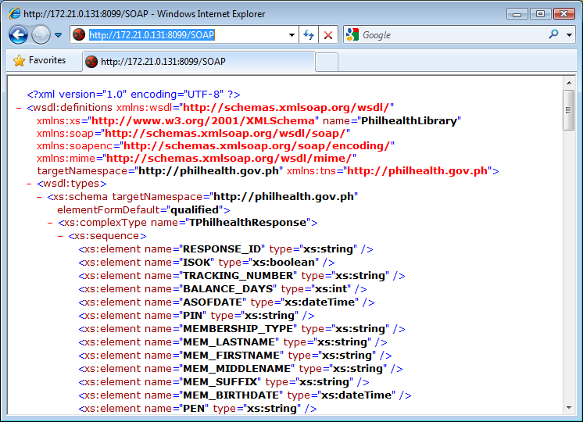

The documentation of the web service can also be viewed by replacing “/SOAP” with “/doc”.

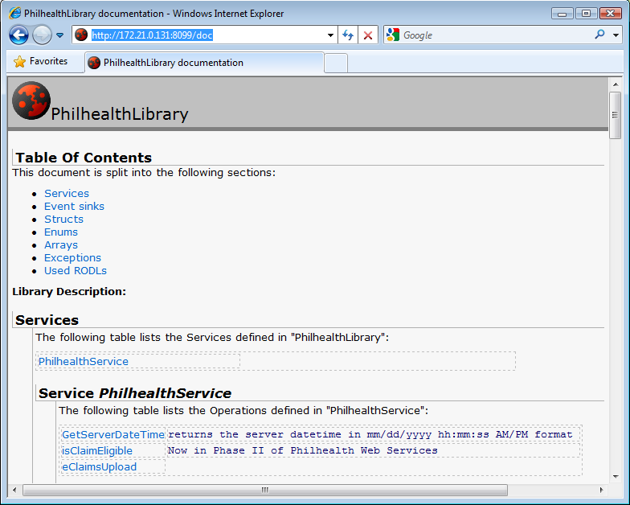

### Consuming the Web Service

Web services are designed for the interoperability between systems, which, could be running in different platforms and could have been developed using different programming languages and tools. A web service can be consumed using different programming languages. And even with the same language, a web service can be consumed in a variety of ways. This section just illustrates how the web service can be consumed in some of the programming languages. The web service exposes a function named GetServerDateTime and this function will be used in the following sample codes. This function just returns as string the current date and time of the server where web service is hosted.

#### Consuming the Web Service in PHP using the SoapClient Extension

This section shows how the web service can be consumed in PHP using the SoapClient extension of PHP. The SoapClient extension can be enabled by including the line “extension=php_soap.dll” in the configuration file (PHP.ini) of PHP. The image below shows the codes PHP page that will call GetServerDateTime function after clicking the Submit button. As shown, one line is needed to instantiate the SoapClient with the WSDL URL as the first parameter. Then another line to call the GetServerDateTime function. The next images shows the output pages.

|  |
| --- |
| <?php  error_reporting(E_ALL);  $serverDateTime ="";  if(isset($_POST['Submit'])){  try{  $client = new SoapClient('http://172.21.0.131:8099/SOAP');  $serverDateTime = $client->GetServerDateTime();  }catch(SoapFault $fault){  die($fault->faultstring);  }  }  ?>  <!DOCTYPE html PUBLIC "-//W3C//DTD HTML 4.01 Transitional//EN">  <html>  <head>  <meta http-equiv=*"Content-Type"* content=*"text/html; charset=utf-8"* />  </head>  <body>  <h1>Test e-Claims Web Services using PHP</h1>  <h2>Test GetSeverDateTime function</h2>  <form name=*"form"* method=*"post"*>  <input type=*"submit"* value=*"Submit"* name=*"Submit"*/><br/>  </form>  Server Date/Time: <b><?php echo $serverDateTime; ?></b> <br/>  </body>  </html> |

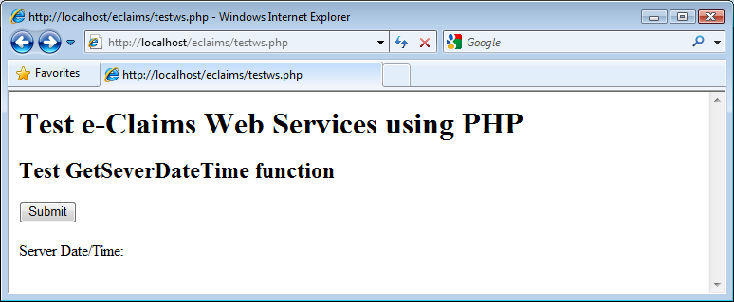

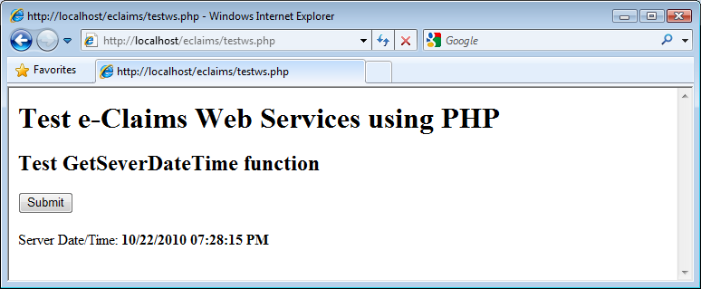

#### Consuming the Web Service in Java using Eclipse

This section shows how the web service can be consumed in Java using Eclipse IDE.

Creating a Sample Eclipse Project that Consumes the Web Service

1. Create a Dynamic Web Project. One of the ways to do this is by clicking the File > New > Other menu.
2. In the New dialog box that appears, select the *Dynamic Web Project* item under the *Web* folder.

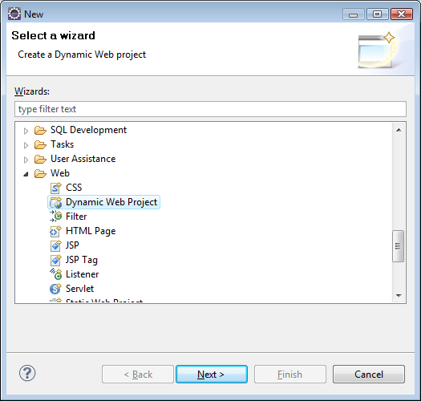

1. In the New dialog box that appears, select the *Dynamic Web Project* item under the *Web* folder. Click the *Next* button.
2. In the project name, you can enter “eclaimsjava2”.

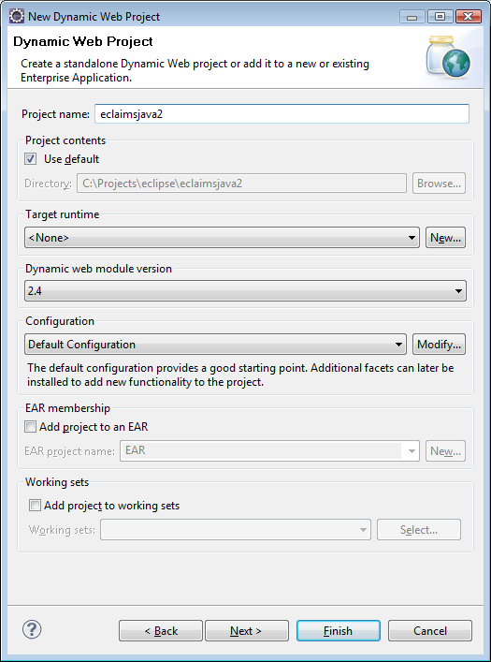

1. Just click the Next buttons until Next button became disabled, the click Finish button. The *New* dialog box will be closed.
2. Select the eclaimsjava2 item in the Project Explorer. Right click on it and the *New* dialog box will appear. Click the *Web Service Client* item under the *Web Services* folder. Click the Next button. The Web Service Client dialog box will appear.

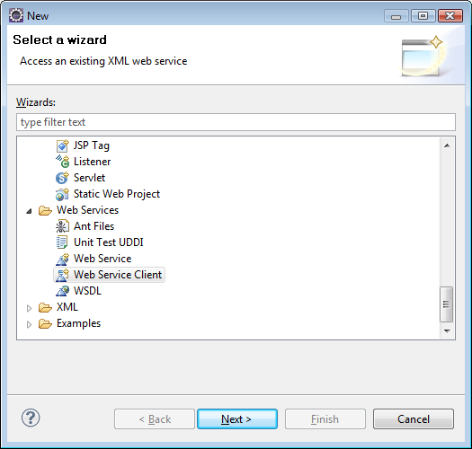

1. In the *Web Service Client* dialog box, enter the URL of the WSDL of the web service. Do what the wizard asks you to do. After clicking the Finish button, elipse will generate the classes for the web service.

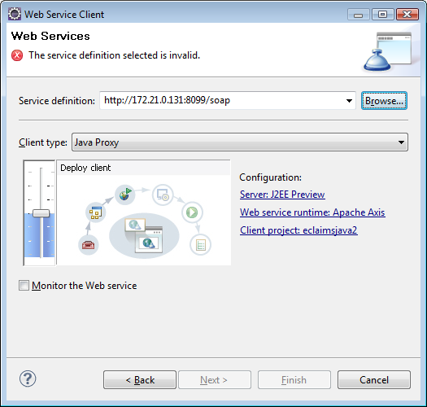

1. Right click again on the eclaimsjava2 on the Project Explorer. Click New menu and select JSP menu. In the Editor, replace the codes of the JSP with the codes below. Compile the codes.

|  |
| --- |
| <%@ page language=*"java"* contentType=*"text/html; charset=ISO-8859-1"*  pageEncoding=*"ISO-8859-1"*%>  <%@ page import=*"ph.gov.PhilHealth.*"*%>  <!DOCTYPE html PUBLIC "-//W3C//DTD HTML 4.01 Transitional//EN" "http://www.w3.org/TR/html4/loose.dtd">  <html>  <head>  <meta http-equiv=*"Content-Type"* content=*"text/html; charset=ISO-8859-1"*>  <title>Test e-Claims Web Services using JAVA</title>  </head>  <body>  <h1>Test e-Claims Web Services using JAVA</h1>  <h2>Test GetServerDateTime function</h2>  <form method=*"post"*><input type=*"submit"* name=*"submit"* /></form>  <%  String serverDateTime = "";  **if** (request.getParameter("submit") != **null** ){  **try**{  PhilHealthService_ServiceLocator ws = **new** PhilHealthService_ServiceLocator();  PhilHealthService_PortType app = ws.getPhilHealthServicePort();  serverDateTime = app.getServerDateTime();  }**catch**(Exception e){  e.printStackTrace();  }  }  %>  Server Date/Time:  <%= serverDateTime %>  </body>  </html> |

1. Run the project.

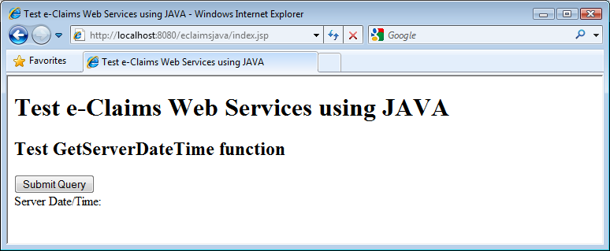

1. Run the project. Click the Submit Query button to display the date and time of the server where the webser

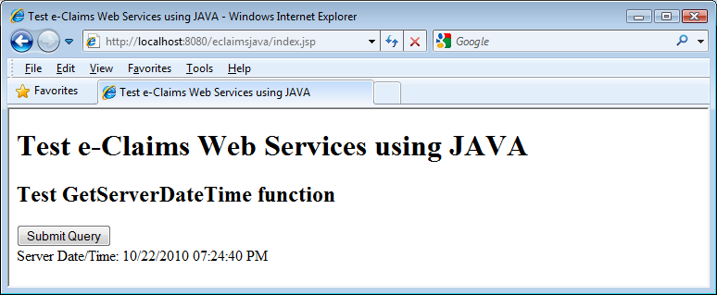

#### Consuming the PhilHealth e-Claims Web Services in Visual Basic.

This tutorial on Building a Service implementer for PhilHealth Web Service assumes that the developer **already has a cached copy of the WSDL (XML) file** and saved as “c:\wsdlFiles\PhilHealthHospWebServices” and the necessary changes has been applied to the WSDL file.

The IP address of the connecting party should also be registered with PhilHealth.

This tutorial starts from building a new Project/Solution with a form, a button on the form, and an event handler for the button click.

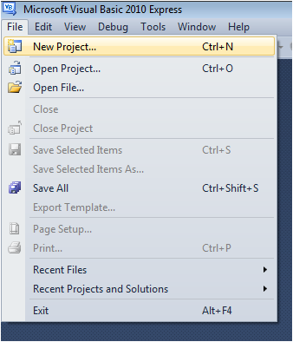

**To add the Service Reference for the Web Service using the WSDL file,**

1. 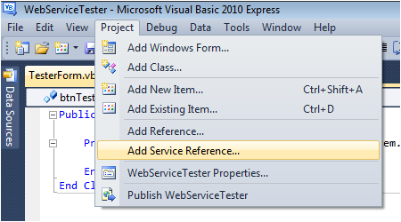Click Project-Add Service Reference. A window will appear.
2. 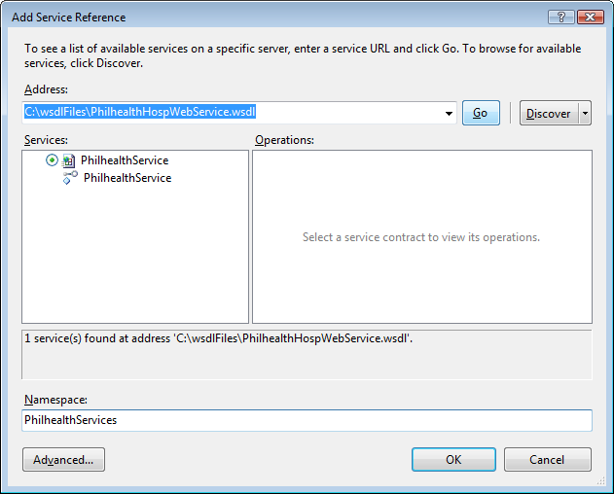Type in the full path of the WSDL file and click Go. The services will be shown on the left side and all available functions and operations will be shown on the right.
3. Change the Namespace to PhilHealthServices.
4. Press OK to add the service reference to your project.
5. 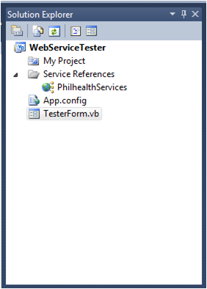**To verify if the Services has been added** to your project, View the Solution Explorer and check if PhilHealthServices is included in the Services References folder.
6. To use the services in your code**,** declare a variable “aService” as “PhilHealthServices.PhilHealthServiceClient”.
7. Declare a variable for the response.
8. Initialize the connection for the services by assigning aService with a new instance of PhilHealthServiceClient.
9. To test the Connection with PhilHealth Server, use the GetServerDateTime() function.
10. **The isClaimEligible function** has many parameters, most of which require values other than an empty string. Supply the values to the parameters as necessary.

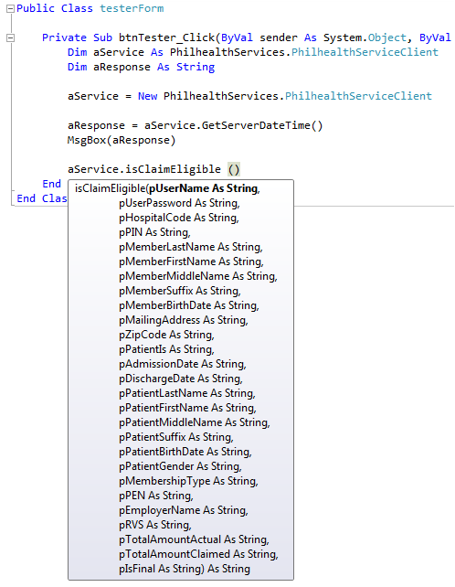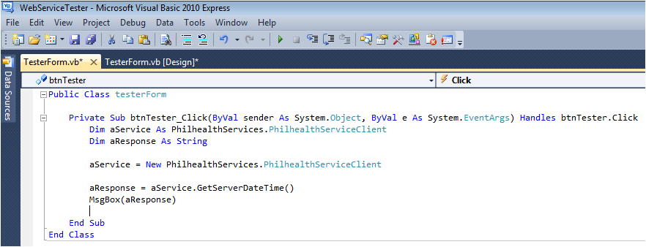

## Annex D: Guidelines for the Encryption of Image Files of the supporting documents of claims Submitted through e-Claims web servce

### Procedures

1. The supporting documents will be scanned and converted to PDF/A format. The scanned image files should be saved temporarily to a directory and be deleted after they have been encrypted.
2. Each file will be encrypted individually. Encryption will be done on the side of HCI. PhilHealth will not include file encryption in the e-Claims web service. This will avoid overhead of web service calls both on the side of HCI and PhilHealth.
3. Before encrypting the file, compute for the hash of file using SHA-256 hash method. (This hash will be compared to the hash that will be computed later after the file has been extracted on from decrypted file on PhilHealth side. If the hash values match, it assures that the file has been encrypted and decrypted correctly.)
4. As recommended by online articles about encrypting files, two different encryption methods will be used. The image file itself will be encrypted using AES-256-CBC. To be able to decrypt the file, PhilHealth needs to have the password used in the encryption. The password will be sent together with the encrypted data. But the password will be themselves encrypted using public key encryption. PhilHealth will provide a separate digital certificate or file containing the public key that will be used in encrypting the password.
5. HCIs/SPs may use their preferred programming language or tools in doing the encryption.
6. The password to be used should be composed of 32 random bytes of data. Two arrays of random 16 bytes long will be used. On calling the AES encryption, these two arrays will be merged or concatenated but the two “keys” will be encrypted separately.
7. For the initialization vector (IV) parameter for the AES, an array of random 128 bytes will be used. This IV will also be encrypted using public key encryption and then sent to PhilHealth.
8. The resulting encrypted document will be saved using the original file name appended with “.enc”. Other information about the file such as the MIME type of the image file will also be included in the file. The encrypted data elements will be encoded in the file using Base64 encoding. All data elements will be included in a single file in JSON format.

### Format of the Output File

|  |
| --- |
| {  "docMimeType": "*<MIME type of the image file e.g. ‘application/pdf >*",  "hash": "*<SHA-256 hash of the image file before encryption>*",  "key1" : "*<Encoded in Base64 format, the public key encrypted first 128 bytes of the password>*",  "key2" : "*<Encoded in Base64 format, the public key encrypted second 128 bytes of the password>*",  "iv" : "*<Encoded in Base64 format, the public key encrypted initialization vector>*",  "doc" : "*<Encoded in Base64 format, AES-256-CBC encrypted image file data>*  } |

Figure : Output File Format/Layout

The figure above shows the format of the output file. As it can be observed, the output file is basically a representation in JSON format of the four encrypted data elements and 2 unencrypted data elements. The figure shows the description and format of the data elements.

### Demo Kits

The soft copy of this guide comes with two demo *kits* with each demo kit packaged in one zip file. The file *Demo Kit for PHP.zip* contains the demo kit for PHP. It contains PHP source codes which can be used to setup a demo PHP web application. The file *Demo Kit for C#.zip* contains the demo kit for kit for C#. It contains Visual Studio solution and project files which can be used to generate a demo Windows Forms application. Although the demo kits uses PHP and C#, HCI/SPs can use their preferred programming languages. The demo kits are provided to serve just as a guide.

Both demo kits contains a folder named “@Files”. It has the following folders and files:

|  |  |
| --- | --- |
| 🗁@Files |  |
| 🗁Input |  |
| 🖹pnpki_philhealth_eclaims_auth_cert.pem | The public key file generated from the sample digital certificate. This file should replace the previous public key file name sample_public_key.pem which was generated by another certificate authority. |
| 🖹SAMPLE_BIRTH_CERTIFICATE.pdf | Can be passed as the target PDF file for encryption. Note the demo app will delete the target PDF file after encryption. |
| 🖹SAMPLE_BIRTH_CERTIFICATE.orig.pdf | Original copy of the sample PDF file |
| 🖹Recreate file to be encrypted.bat | A batch file that can be used to recreate the SAMPLE_BIRTH_CERTIFICATE.pdf from SAMPLE_BIRTH_CERTIFICATE.orig.pdf after the demo app has deleted it |
| 🗁Output |  |
| 🖹SAMPLE_BIRTH_CERTIFICATE-usingCSharp.pdf.enc | Sample generated encrypted e-claims document |

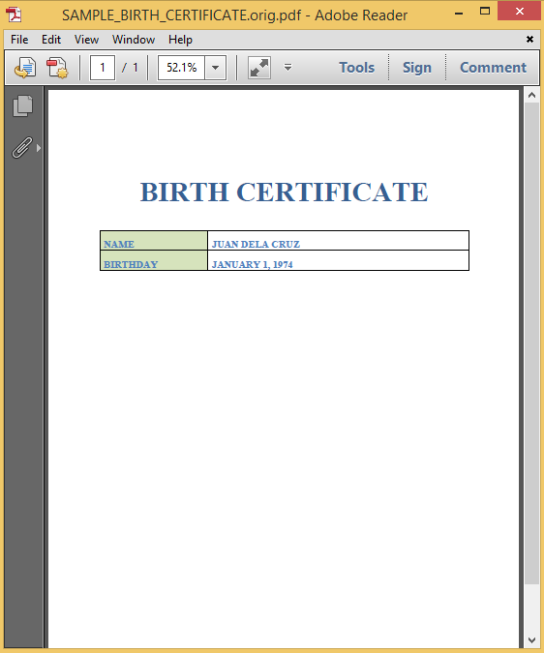

Figure Sample PDF file (SAMPLE_BIRTH_CERTIFICATE.orig.pdf)

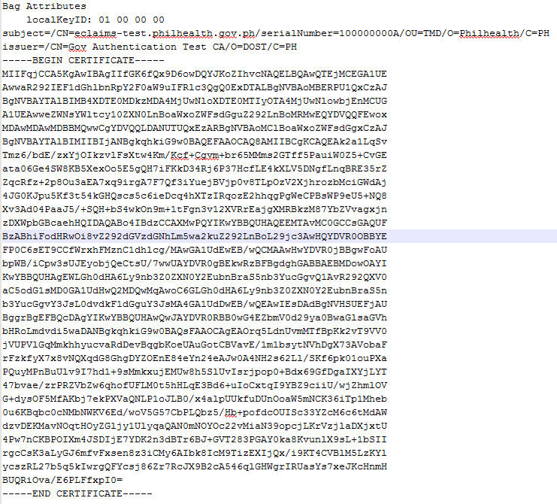

Figure Content of the test public key file (pnpki_philhealth_eclaims_auth_cert.pem)

#### Demo Kit for PHP

The contents of the file *Demo Kit for PHP.zip* are shown below. The folder EclaimsDocEncryption can just be copied to the root or any directory of a PHP installation to be able to setup the demo application. Please enable the openssl extension to run the demo application. The file encryptEClaimsDoc.php is the entry point of the demo application. Please see below the screenshot of the PHP demo application.

|  |  |
| --- | --- |
| 🗁EclaimsEncryption |  |
| 🗀@Files | The contents of this folder has been described on previous page |
| 🖹encryptEClaimsDoc.php | Provides a sample user interface for passing gathering inputs parameters in encrypting scanned image files of the supporting documents of an electronically-submitted claim |
| 🖹testEncryptAndDecryptXml.php | Provides a demo application for the encryption and decryption of the input and output parameters that are to be passed as XML text |
| 🖹PhilHealthEClaimsEncryptor.php | Contains the class implementing the encryption procedures |

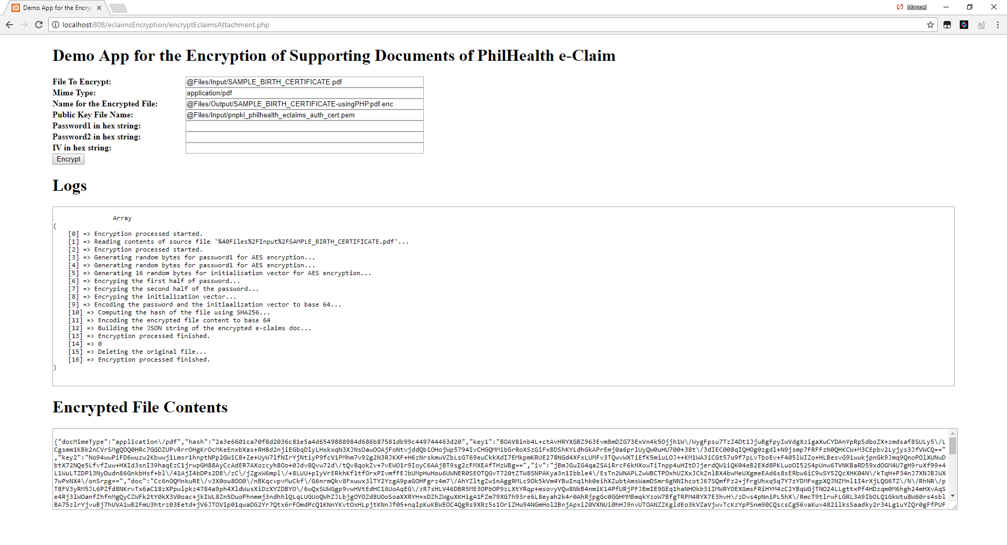

Figure : Screenshot of the PHP demo application

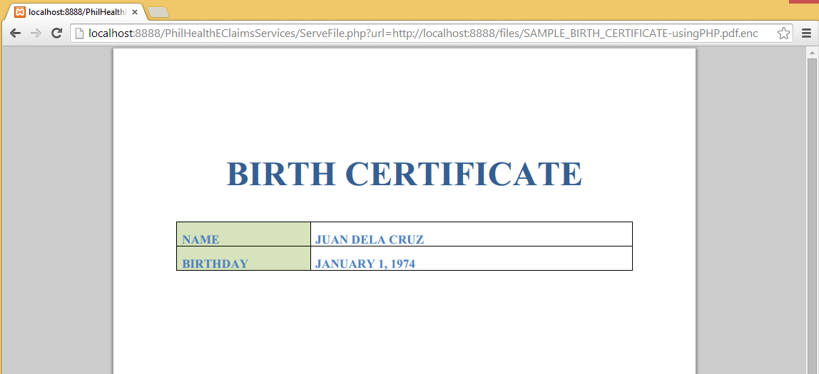

Figure : Output of PhilHealth's test application after decrypting the file encrypted by the PHP demo application

#### Demo Application for C#

The contents of the file *Demo Kit for C#.zip* are shown below. It contains a Visual Studio solution/project files. Open the solution file and build the PhilHealthEClaimsEncryptionDemoApp project to generate the executable file of the demo Windows Forms application file. See the screenshot of the C# demo application.

|  |  |
| --- | --- |
| 🗁PhilHealthEClaimsEncryptionDemoApp |  |
| 🗀@Files | The contents of this folder has been described on previous section |
| 🗀bin |  |
| 🗀Helpers | Contains one helper/utility class |
| 🗀Obj |  |
| 🗀Properties |  |
| 🖹App.config |  |
| 🖹Form1.cs |  |
| 🖹Form1.Designer.cs |  |
| 🖹Form1.resx |  |
| 🖹PhilHealthEClaimsDocEncryption.cs | A class that implements the guide for encrypting a e-claims document |
| 🖹PhilHealthEClaimsEncryptionDemoApp.csproj | The C# project file |
| 🖹Program.cs |  |
| 🖹EClaimsDocEncryption.sln | Visual Studio solution file |
| 🖹EClaimsDocEncryption.v12.suo |  |
|  |  |

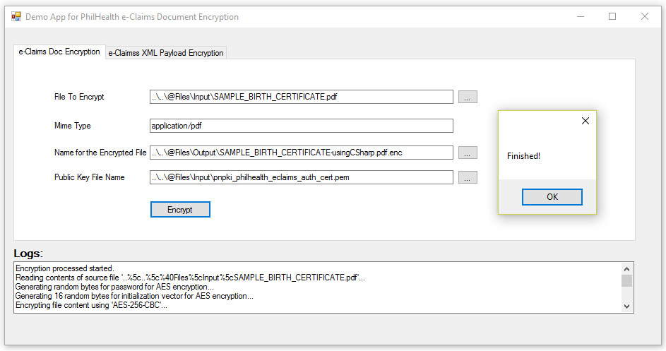

Figure Screenshot of the C# demo application

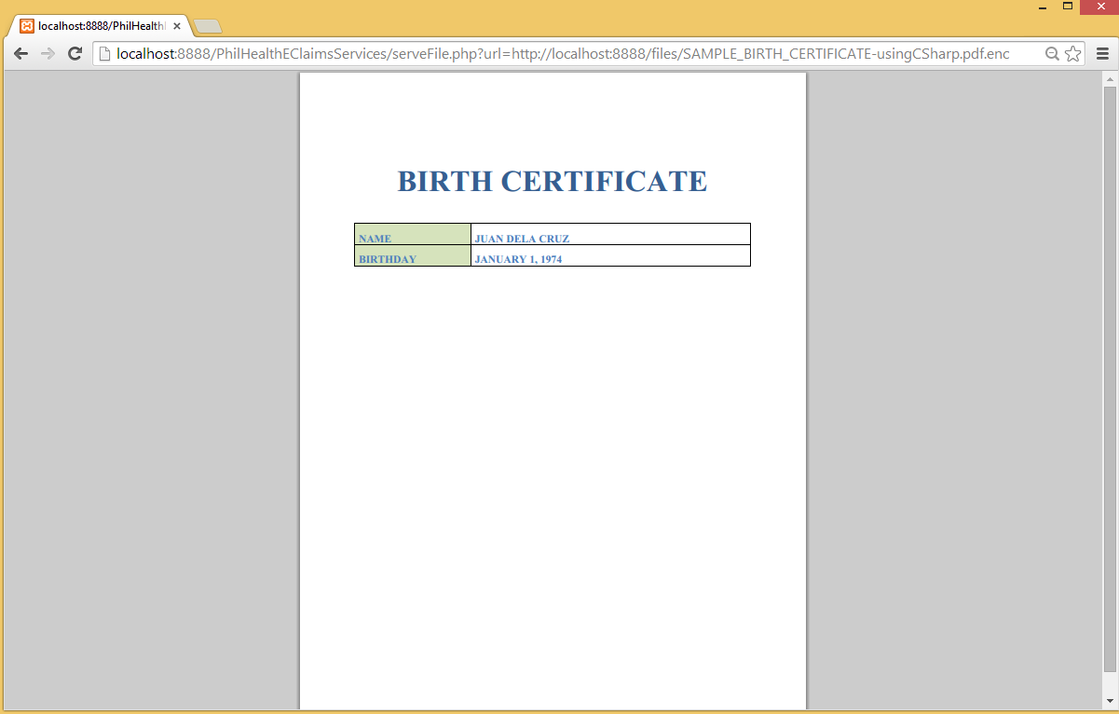

Figure Output of PhilHealth's test application after decrypting the file encrypted by the C# demo application

## Annex E: Guidelines for the Encryption and Decryption of Parameters that are to be passed as xml

### GUIDELINES AND Procedures

* The application of HCI should encrypt input parameters that are supposed to be passed as XML. HCI applications should also decrypt all the output parameters that are supposed to be returned by PECWS as XML.
* The input and output parameters that are to be passed as XML text will be referred in this section as XML payload data.

#### Encryption of the xml payload data

1. The procedures for the encryption of the XML payload data will be similar to the procedures in the encryption of the image files of the supporting documents of electronically submitted claims. The difference is that encryption of the XML payload data will not use public-key encryption.
2. The XML payload data will be encrypted using “AES-256-CBC” algorithm.
3. PhilHealth will issue the passphrase/password/cipher key to be used by each HCI. The password should be hashed using SHA-256 algorithm. The first 32 bytes of the hashed value should be passed as the password for the AES encryption. If the resulting hashed value is less than 32-bytes, the value should be padded with ‘0x00’ or null character.
4. An array of random 128 bytes should be used as the initialization vector.
5. Before encrypting the data, compute for the hash of file using SHA-256 hash method. (This hash will be compared to the hash that will be computed later after the file has been extracted on from decrypted file on PhilHealth side. If the hash values match, it assures that the file has been encrypted
6. The expected output of these encryption procedures is to be encoded in JSON. The figure below shows the expected key-value pairs that are to be included in the JSON text.
   1. The “docMimeType” key, should have fixed value of “<text/xml>”.
   2. The value for “key1” should be an empty string.
   3. The value for “key2” should also be set to empty string.
   4. The value for “iv” key should be the base-64 encoded value of the initialization vector mentioned in Step#6.
   5. The value for the “doc” key should the base-64 encoded value of the result of the AES-256 encryption of the XML payload data.

|  |
| --- |
| {  "docMimeType": "<text/xml>",  "hash": "*<SHA-256 hash of the image file before encryption>*",  "key1" : "",  "key2" : "",  "iv" : "*<Encoded in Base64 format, the public key encrypted initialization vector>*",  "doc" : "*<Encoded in Base64 format, AES-256-CBC encrypted image file data>*  } |

Figure : Format/Layout of encrypted data

1. SPs/HCIs may use their preferred programming language or tools in doing the encryption and decryption. The PECWS development kit includes sample codes in C# and PHP. For the sample source codes in PHP, the encryptXmlPayloadData method of the PhilHealthEClaimsEncryptor class contains an implementation of the encryption procedures outlined above.

#### Decryption of the xml payload data

1. The decryption process is just the reverse of the encryption process outlined in previous section.
2. For the service methods that are supposed to return an XML, PECWS will encrypt the supposed XML data and return a text encoded in JSON whose key-value pairs as described in the previous section.
3. After receiving the JSON text, the HCI application should parse it.
4. Get the value of the “iv” key. That is the base-64 encoded value of the initialization vector used in the AES-256 encryption of the XML payload data. Decode the value of the initialization vector from base-64 encoding to its corresponding raw array of bytes.
5. Get the password, passphrase or cipher key of the HCI. Get the SHA-256 hash value of that value. . If the length in bytes of the resulting hashed value is less than 32, pad the value with ‘\0’’ or null character.
6. Get the value of the “doc” key. That value is the base-64 encoding of the encrypted data. Decode the data from base-64 encoding to the raw array of bytes of the encrypted data, With values of the passphrase, initialization vector and actual encrypted data, decrypt the data using AES-256-CBC.
7. You may get the hash value of the decrypted data and compare it with the value of the “hash” key.
8. After the decryption, the application of HCI may now process and parse the target XML data.
9. SPs/HCIs may use their preferred programming language or tools in doing the encryption and decryption. The PECWS development kit includes sample codes in C# and PHP. For the sample source codes in PHP, the decryptPayloadDataToXmlmethod of the PhilHealthEClaimsEncryptor class contains an implementation of the decryption procedures outlined above.

## Annex F: Non-disclosure Agreement

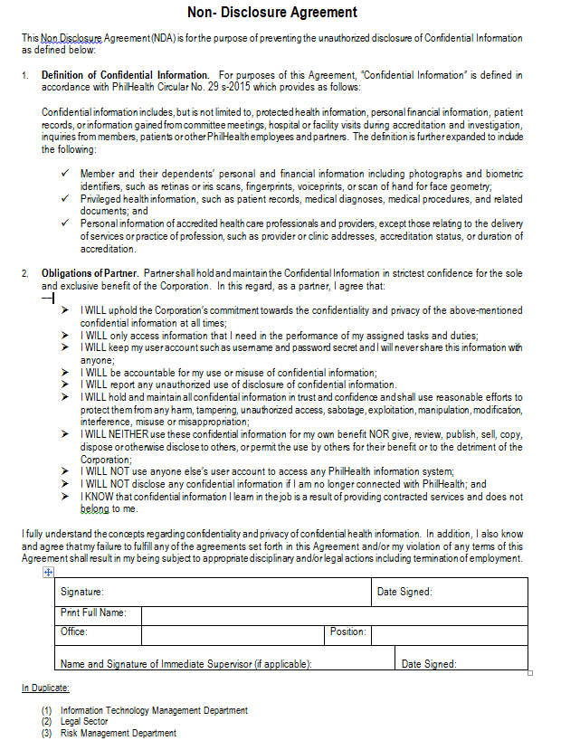

## Annex G: Software Testing and Validation

**COMPONENT 1: Technical Capabilities**

Part of the certification process is the system and testing validation to be conducted by the PhilHealth Regional Offices (PROs). Below is Software Solutions Validation Test Form -eClaims. This test shall check for conformance and compliance with the PhilHealth eClaims Implementation Guide. Check **P (for Passed)** if the test was successfully demonstrated and **F (for Failed)** if not. Notable observations should be listed under **REMARKS**. The system will be acceptable as “PASSED” upon successful completion of the 3 cycles, passing all criteria.

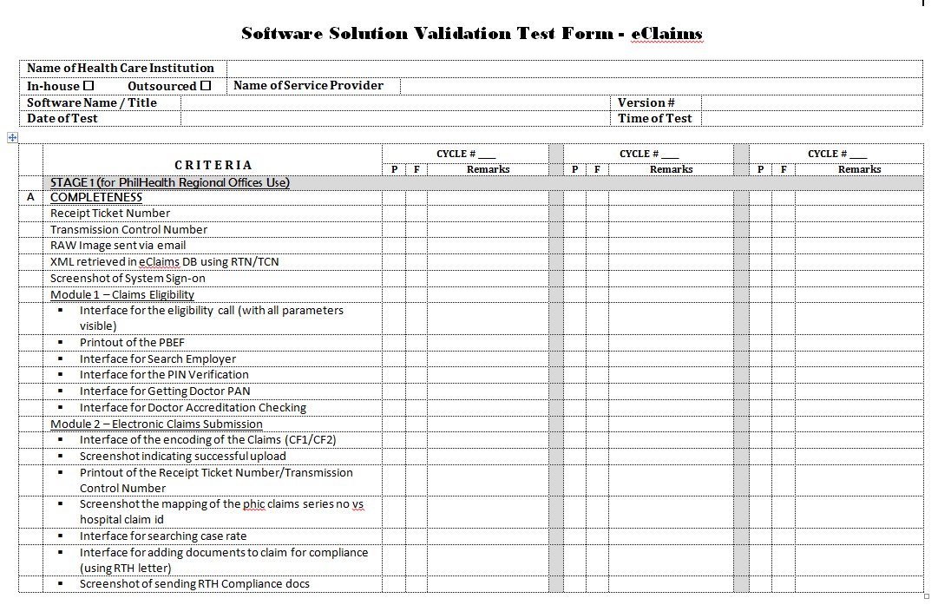

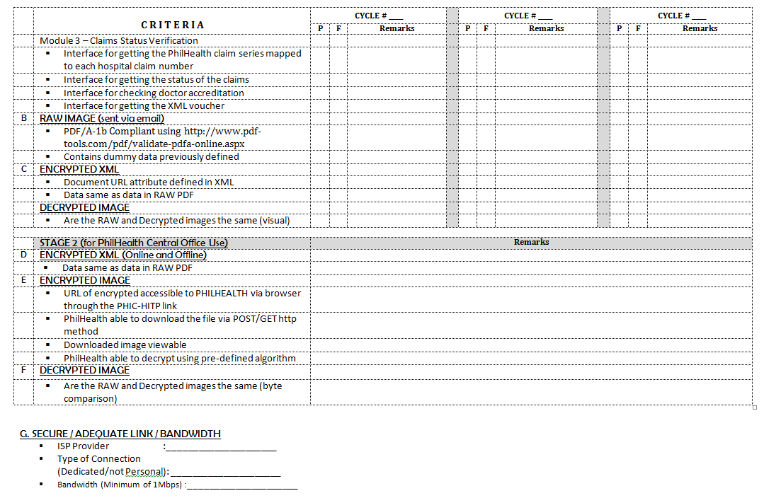

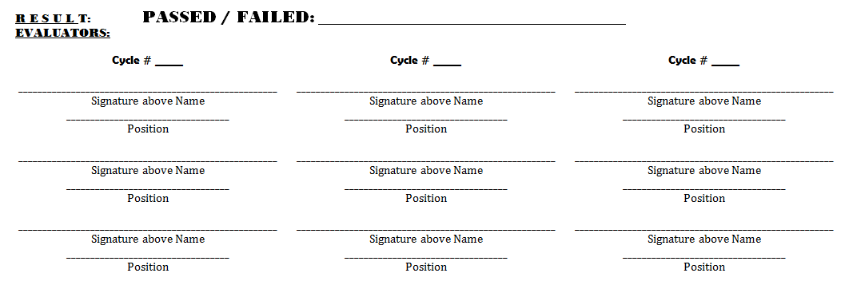

## Annex G: List of document types and codes

**Document Type Code and Description**

|  |  |
| --- | --- |
| **Document Code** | **Description** |
| CAB | Clinical Abstract |
| CAE | Certification of Approval/Agreement from the Employer |
| CF1 | Claim Form 1 |
| CF2 | Claim Form 2 |
| CF3 | Claim Form 3 |
| COE | Certificate of Eligibility |
| CSF | Claim Signature Form |
| CTR | Confirmatory Test Results by SACCL or RITM |
| DTR | Diagnostic Test Result |
| MBC | Member's Birth Certificate |
| MDR | Proof of MDR with Payment Details |
| MEF | Member Empowerment Form |
| MMC | Member's Marriage Contract |
| MSR | Malarial Smear Results |
| MWV | Waiver for Consent for Release of Confidential Patient Health Information |
| NTP | NTP Registry Card |
| OPR | Operative Record |
| ORS | Official Receipts |
| PAC | Pre-Authorization Clearance |
| PBC | Patient's Birth Certificate |
| PIC | Valid Philhealth Indigent ID |
| POR | PhilHealth Official Receipts |
| SOA | Statement of Account |
| STR | HIV Screening Test Result |
| TCC | TB-Diagnostic Committee Certification (-) Sputum |
| TYP | Three Years Payment of (2400 x 3 years of proof of payment) |
| MRF | PhilHealth Member Registration Form |
| ANR | Anesthesia Record |
| HDR | Hemodialysis Record |
| OTH | Other documents |

Recommended steps for PDF attachments of files:

1.       Create web server with https.

2.       Create a folder where the pdfs will be publish.

3.       In the system, provide facility for opening and uploading the pdfs in the web server, taking note

of the urls.

4.       When creating the xml, include the urls of the uploaded documents.

To test if the pdfs are accessible via browser, paste the url on the address bar of a browser. the pdf document can either be downloaded or loaded on the browser to be successful.

1. PhilHealth Office Order 0050, s.,2011
2. www.shafafiya.org/HAAD, s2008