MEDSYS-PhilHealth Claim Eligibility Web Service (CEWS)
MANUAL
Overview
Communicate to PhilHealth through the internet. Module will confirm that the Patient/Member is valid. Also, returns a tracking number (with remaining days) that could be printed with PhilHealth Form 2 as a barcode. PhilHealth has a special lane for claims with a tracking number (pre-verified) to speed up processing.

Electronic Claims Advantages
- Less clerical time
- No mailing hassles
- Less paper
- More accurate
- Secured Patient information-confidentiality
- Can communicate to PhilHealth system digitally

Phase 1 – Fast MDR
- Patient is Registered at Admitting or OPD Registration
- PhilHealth details like Member Number is entered
- Clerk clicks on “Verify Member”
- If response is Yes, a printout will be attached to claim for faster processing by PhilHealth
- If response is No, a printout indicating what documents are needed is given to member.

PhilHealth has disclaimer which does not include claims in transit.

Requirements:
- Internet connection. Send Philipp the public IP (http://www.whatismyip.com). Philipp will send back the Hospital Code. Ports must be open on the computer with the connection.
- MEDSYS Database

Two Steps:
- Initial Call – Check if member is valid and response “YES” if valid and “NO” if not (will indicate the deficiencies).
- Final Call – will generate tracking number

Instructions:
- Select the Transmittal date to list all claims on that date.
- Highlight an individual Claim and click “Go Call”
- Result can be printed.

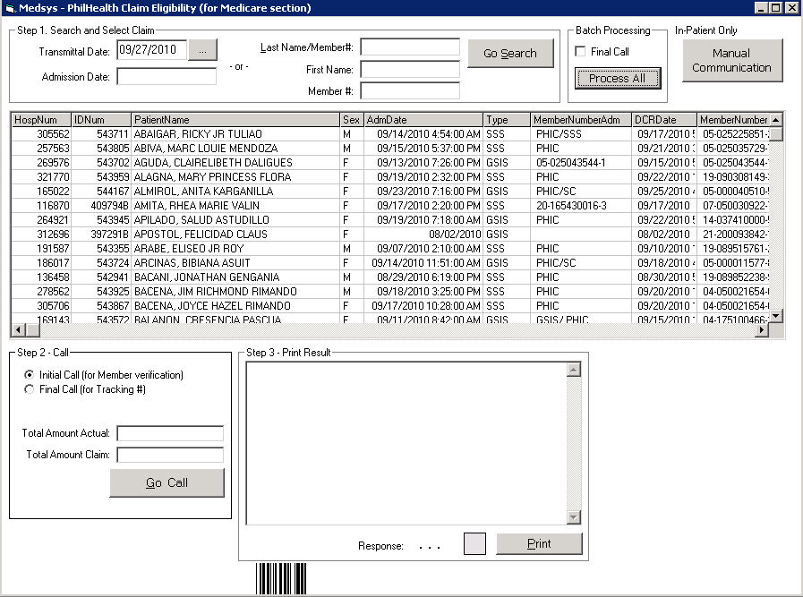

To go through all the claims, click “Process All”

If Claim has “NO” response, fields data transmitted can be manually changed by clicking “Manual Communication” to narrow down the problem. The data would have to be corrected using Registration and Medicare modules.

For v5.5 clients click “Use Relationship Table” under options.

SETUP

Steps on how to install the trust certificate
1. Double Click on the file “dingsha.cer”
2. Click on the “Install Certificate…” button
3. Click “Next” button. Click “Place all certificates in the following store”, then click “Browse…” button
4. Click “Trusted Root Certificate Authorities”, and click “OK” button.
5. Click “Next” button, Finished.

Installation:
- Register all DLLs in this folder.

- Install soapsdk.exe

- Install barcodewiz.exe (without samples and macros)

- currentuser.dll must be registered (user must have medicare rights '8')

- Run MEDSYSPHCEWS.exe , and enter the Hospital Code (e.g. 50127) and Hospital Name

- Under Options click Update Database

